Art Analysis on Aphrodite and Pan and Eros

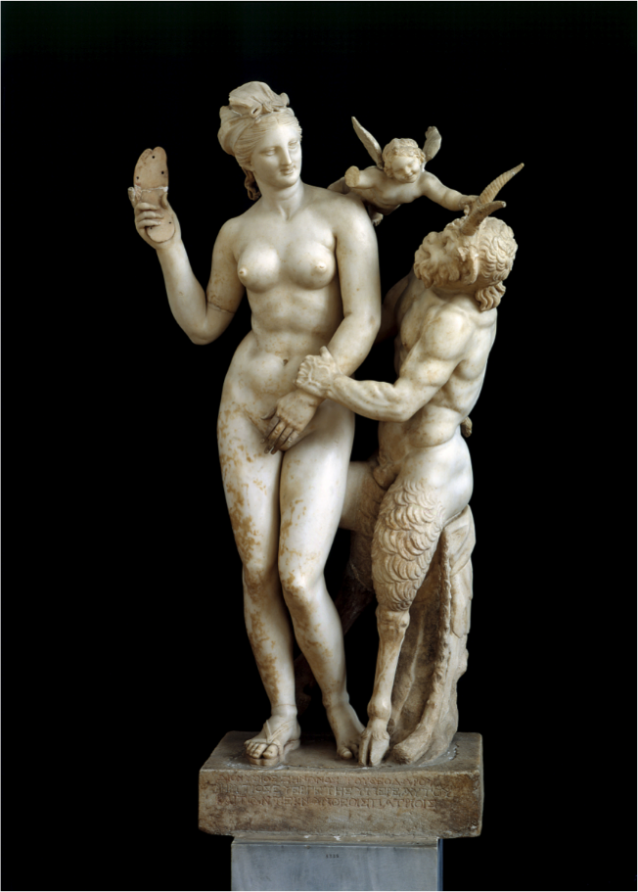
In this analysis I will be critically looking at Aphrodite and Pan and Eros. A sculpture from 100 BCE, by an unknown artist. Which is now housed in the National Archaeological Museum in Athens. This sculpture is made from parian marble which is very common for the time. It stands at 6 meters in Hight. It shows us Aphrodite the Greek goddess of love, desire and beauty (which is what she mostly known for) Pan a half goat creature know as a faun who god is of the wild, shepherds, and flocks, along with Eros Greek god of love and Aphrodite’s son in some myths and other he is a primordial god.
This shows the myth of how Pan met Aphrodite when he was in a drunk state and was over come with her beauty and how Aphrodite wanted nothing to do with Pan while in this drunken state. The story indicates Pan of wanting Aphrodite but then the goddess not wanting to get involved with the faun god and her having to threaten the god off with her sandal. Which Pan ignores till Eros steps in to come to rescue Aphrodite, who I believe to be Eros mother in this story.
There is a size difference between Aphrodite and Pan. This symbolises power and a higher social standing between the two. Obviously, Aphrodite is a goddess, so she is made to look divine in her features unlike Pan. Who is made to look like a beastly creature, even when he himself is also a god he is still shown with a contrasting, attractive face then Aphrodite. But this symbolises that love, regardless of what beast or human be in the sense of what beauty is, can be deserving of love, which is what Aphrodite is portraying. Even though in this myth she is trying to get free from Pan because she doses not want his love.
Pan is like I mentioned before is made to look beastly compared to Aphrodite. But Pan is also shown to look stronger in build then the goddess who looks more delicate in build. Which shows the power he has in the situation as his lager hand is wrapped around Aphrodite’s wrist. But this can also symbolical Pan lack of respect of Aphrodite who is threating him with a sandal. This then connects back to why he shown so beastly looking in his appears because he seems to be running on animal like instincts.
Eros is dramatically smaller then Aphrodite and Pan. This is because he is shown in a childlike form. This symbolise a lost of innocents for all involved. But more importantly is shows Eros childlike action in trying to stop Pan with Aphrodite, who might be his mother in this myth because he is just pulling on Pan horn. It also shows how weak Eros is compared to Pan though Eros being in childlike form shows the hope of Eros stopping Pan which he does in the end.

References.
Meeting Myths APHRODITE, PAN, AND EROS by Kevin who last name is unknown. Available: https://meetingmyths.wordpress.com/kevin-art-4/ [Last accessed: 1st January 2018].
Marble group of Aphrodite with Pan and Eros by unknown writer. Available: http://www.namuseum.gr/object-month/2010/jun/jun10-en.html# [Last accessed: 1st January 2018].

