University of Wales Trinity Saint David
Wales Institute of Science & Art



Electronic Ignition & Fuel injection systems
Electrical Control Systems ACHA4010

Parry Hill
2004858
01/02/2022
Table of Contents
1. Introduction 3
2. Literature Review 4
2.1. Testing Equipment 4
2.2. Live testing 4
2.3. History of the LE3 and Motronic management Systems 5
2.4. System Improvements 6
3. Methodology 7
3.1 Health and Safety 9
4. Results 10
4.1. Motronic NTC2 Graphs 11
4.2. LE3 NTC2 Graphs 13
5. Analysis 18
5.1. Motronic 18
5.2. LE3 22
5.3. LE3 Scope Patterns 23
6. Discussion 24
7. Conclusion 27
8. References 28
9. Appendix 30
9.1. LE3 Data 30
9.2. Motronic Data 32

Table 1 - LE3 Dynamic test data 10
Table 2 - Motronic Dynamic test data 10
Table 4 – Motronic Pin Data Continued (Kay,2001) 21
Table 3 – Motronic Pin Data (Kay,2001) 21

Figure 1 – Motronic Pin 4 Idle Control Valve % 11
Figure 2 - Motronic Pin 16 injection on time 11
Figure 3 - Motronic Pin 45 Voltage 12
Figure 4 - Motronic Pin 45 Resistance 12
Figure 5 – LE3 Pin 8 Coolant Temperature Sensor Resistance 13
Figure 6 – LE3 Pin 8 Coolant Temperature Sensor Voltage 13
Figure 7 – LE3 Pin 3 Injection Pulse Time 14
Figure 8- Secondary Voltage 15
Figure 9 – Crank Signal 15
Figure 10 – Spark Advance 15
Figure 11- Amplifier 16
Figure 12 - Injector pulse idle 16
Figure 13 -Injection pulse under acceleration 16
Figure 14 – Injection pulse under deceleration 17
Figure 15 – Speed Reference 17
Figure 16 – Amplifier supply and earth 17

Introduction
This report will be investigating and assessing both Bosch LE3-jetronic and Bosch Motronic M1.5 fuelling and ignition systems in a live testing situation, the aim is to provide a clear static and dynamic test data set that will be compared to that of the manufacturers specification. Various components within each system will then be assessed with recommendations for change based on today’s emission standards being made to bring these engines closer to modern vehicles in terms of fuel efficiency and emissions.
Live testing is an integral part of vehicle development, it allows engineers and manufacturers to assess the longevity of components and how adaptive control systems adjust to the requirements needed when components in an engine begin to wear, this ensures maximum efficiency is maintained throughout a vehicles service life.

Since 1993 when European emission standards (Euro 1) were introduced to limit how much nitrogen oxide a vehicle could produce manufacturers have had to ensure that emissions produced by a vehicle conform to and remain in the limitations, in this legislation a petrol vehicle could create no more than 0.49g/km and diesel cars no more than 0.78g/km, comparatively with today’s Euro 6 standard, almost 30 years later, a petrol car can produce just 0.06g/km and a diesel car 0.08g/km (Minjares, 2016).
With the ever-increasing standards for lower emissions, the introduction of post combustion devices such as catalytic converters to aid in this and Euro 7 standards expected to be introduced in 2025 manufacturers must strive to create systems on vehicles to meet these regulations and stay effective in controlling these emissions indefinitely.

Literature Review

2.1. Testing Equipment
When testing electrical components on a vehicle the primary tools used are a digital multimeter, which can give accurate voltage and resistance readings in a numerical form, and an oscilloscope.
Oscilloscopes allow these readings to be taken as well as display wave form in a graphical manor showing things such as wave shape and signal strength (Scott Partnership, 2010, p.400).
For components such as injectors oscilloscopes provide an invaluable insight when testing,
pulse time can be accurately measured with the graph produced showing the potential voltage, injection on time in milliseconds followed by the EMF spike as the injector is turned off, these results can then be compared to a manufacturers specification.

2.2. Live testing
For live vehicle testing environment-controlled testing cells are often used, this ensures that accurate and repeatable test data can be collected which is needed in order to validate any testing that takes place, when looking at a test cell design several objectives need to be met, objectives such as temperature, air pressure and exhaust extraction are essential to produce reliable data sets (Schuett and Peckham, 1986 p.912-923). Being able to control these conditions also allows engineers to accurately test vehicles under different circumstances, for example a cold environment at high altitude can be artificially created using these parameters within the test cell (SGS, 2022).
From a health and safety point of view, test cells are beneficial as cells are often fitted with
a fuel delivery system, this reduces the risk when dealing with substances such as petrol and diesel which come under COSH regulations. These systems also enable engineers to accurately measure fuel consumption during testing through a fuel flow meter.

2.3. History of the LE3 and Motronic management Systems
The L-Jetronic engine management system was developed from advancements in control units and sensors from the D-Jetronic leading to a more efficient operation system decreasing fuel consumption and fulfilling emissions requirements (Bosch,1982, p.4). The LE3 System was developed from the L-Jetronic without lambda closed loop as emissions regulations were not as stringent in Europe at the time as others such as the USA where the LU-Jetronic system with closed loop lambda was introduced (Bosch, 1995, p.30).
This was then replaced by the Bosch Motronic system, combining the separate fuel and ignition ECUs into one, this was done to increase reliability and reduce costs of production by making a more efficient system (Bosch, 1982, p.20).
The Bosch Motronic system utilises open and closed loop circuits within a single ECU, the Motronic system was introduced to fulfil several functions, firstly to operate the engine in the most fuel-efficient way possible and to comply with increasing emissions control by means of adjusting the torque required by the engine from different loads being applied, also to increase the level of driving comfort for the user of the vehicle (Bosch, 2007). The Motronic system was also one of the first to utilise on board diagnostics (OBD) as well as introducing a previously not required lambda sensor alongside a catalytic converter into the system to combat the newly introduced Euro 1 emissions standards.

2.4. System Improvements
Since the introduction of fuel injection-based engine management systems, the technology of these systems has greatly improved, this is partially due to two main contributing factors, vehicle safety and emissions control. The ever-increasing stringent emissions controls have forced manufacturers to constantly improve vehicles efficiency as well as decrease emissions, this has resulted in an advancement of sensor technology to keep every vehicle operating within these constraints.
Maintaining a stoichiometric ratio of 14:1 (air: fuel) is key in improving fuel consumption and minimising emissions and therefore is the primary objective in automotive research, systems such as a feedforward fuelling control actively predict the amount of fuel required to maintain stoichiometric ratio however these systems still rely on the input of other sensors such as universal exhaust gas oxygen sensors in the feedback fuelling control to compensate for any errors that are made by the system, measures like this have replaced sensors such as mass air flow sensors in order to reduce communication delay within the ECU as well as improving accuracy of the system (Feng et al, 2016).

Other methods such as continuous variable valve lift (CVVL) have been developed as alternative to direct injection, which improves fuel consumption by minimising pumping losses, the system achieves this by continuously adjusting maximum valve lift and cam phasing, maximising torque produced by the engine. It is also a method of adjusting engine load from base idle to full load under a dynamic situation, by using CVVL to control engine load intake pressure is kept around atmospheric pressure, further minimising any losses (Kawasumi and Yasui, 2007).

Methodology
Equipment used:
- Digital multimeter
- Bosch digital Oscilloscope
When testing the engines, a digital multimeter and an oscilloscope were used for higher accuracy over analogue alternatives. A digital oscilloscope has the benefit of being able to record data that can be viewed after the test has been completed whereas an analogue oscilloscope can only provide a live view as the test is being carried out, this enables the test engineer to take accurate readings from the graphs produced as well as store these graphs within the systems memory and compare them with other tests.

Testing Procedure
Both Engines were presented in the workshop cold with an average temperature of 18°C, the workshop sits at sea level, with an average air pressure of 1012mbar at the time of the test on 17/02/2022.
First readings were taken from each engine with the ignition off then with the ignition on, a multimeter was used by placing the negative wire to an earth and using the live wire to test each pin individually, the components tested were as follows:

LE3
- Battery voltage
- Amplifier pins voltage
- Fuel ECU pins voltage
- Ignition ECU pins voltage
- Throttle position sensor resistance
- Auxiliary air resistance
- Injector resistance

Motronic
- Battery voltage
- ECU pins voltage
- Injector resistance
- Rotary idle valve resistance
- Throttle position sensor resistance
- Air Flow meter resistance

It is important to note that for any resistance values the lead resistance of 0.2Ω was subtracted from the readings.

After this was completed, the values found using the multimeter were recorded and the resistance values were compared to the manufacturer’s recommendation using the workshop manuals provided.
Following this each engine was dynamically tested using the Bosch oscilloscope, for the LE3 the cold crank injection on time was recorded then NCT2 readings were taken at 10°c intervals, the same process for the Motronic was followed with the addition of NTC1 readings taken at 20°c then at 80°c.
The full data set for the testing can be found in the appendix, any pins with no voltage reading taken were not being used on the engine being tested.

3.1 Health and Safety
Whilst the tests are carried out, it is highly important correct health and safety measures are always followed whilst within the workshop area, the correct measures can be defined into different categories.
- Clothing – Dust coats and steel toe capped safety boots must always be worn, if required safety glasses must also be used.
- Ventilation – During the test a Co meter was used to periodically check the workshop for dangerous amounts of harmful gasses produced as a by-product from the combustion process, the exhaust must also be connected to a ventilation hose to safely remove these gasses. The workshop also has large roller doors that can be opened if the room needs to be ventilated quickly and efficiently if the Co levels were to rise too high.
- Engine checks – Before working on an engine several checks must be made; oil and fluid levels must be ensured to be within the operating levels, this minimises the risk of catastrophic failure of the engine therefore increasing safety. All guards on the engine must be secure so nothing can come loose and potentially cause harm.
- COSH – COSH regulations must always be followed when dealing with fluids such as fuel or engine oil.

Results
Data for the dynamic testing of the LE3 engine can be found in table 1 below and for the Motronic engine in table 2.
Table 1 - LE3 Dynamic test data
Test: | LE3 NCT2 Dynamic | Start Engine Temperature 18°c
Engine Temperature (°c) | pin 8 (Ω) | pin 8 (v) | pin 3 (ms) | Cold crank time (ms)
20 | 1824 | 1.6 | 3.6 | 63.5
30 | 1058 | 1.1 | 3.2
40 | 780 | 0.9 | 3
50 | 526 | 0.7 | 2.8
60 | 387 | 0.5 | 2.7

Table 2 - Motronic Dynamic test data
Test: | Motronic NCT2 Dynamic | Start Engine Temperature 17.9°c |  |  |  |  | NTC1
Engine Temperature (°c) | Pin 45 (Ω) | Pin 45 (v) | Pin 16 (ms) | Pin 4 (%) | Pin 5 | Pin 28 | Pin 44 (v) | Cold Crank  Time (ms)
20 | 1730 | 3.2 | 3.3 |  | off |  | 3.7 | 24
30 | 970 | 2.5 | 3.3 | 43 | off | switching
40 | 662 | 2.1 | 3 | 44 | off
50 | 398 | 1.5 | 3 | 44 | on
60 | 302 | 1.2 | 2.8 | 43 | on
70  (Fan ON) | 245 | 1 | 3.3 | 44 | on
80 | 261 | 1.1 | 2.8 | 44 | on |  | 3.4

The data from testing was used to create a series of graphs for each engine for the individual dynamic tests that were undertaken which are presented in the sections of this report underneath.

Motronic NTC2 Graphs
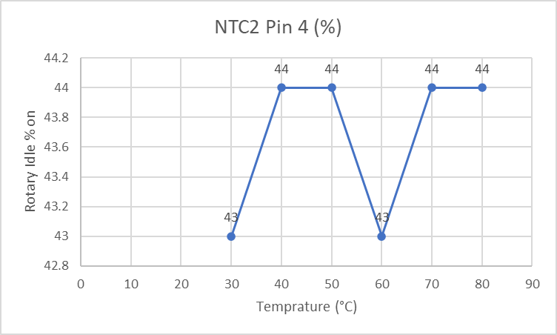
Figure 1 – Motronic Pin 4 Idle Control Valve %

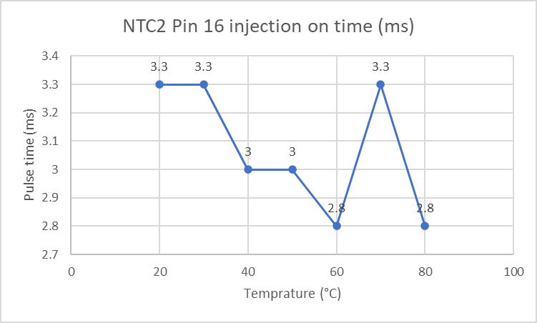
Figure 2 - Motronic Pin 16 injection on time
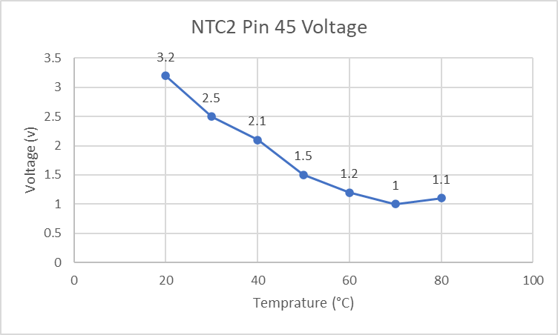
Figure 3 - Motronic Pin 45 Voltage
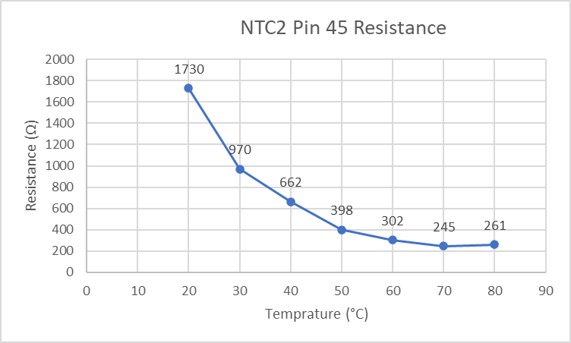
Figure 4 - Motronic Pin 45 Resistance

LE3 NTC2 Graphs
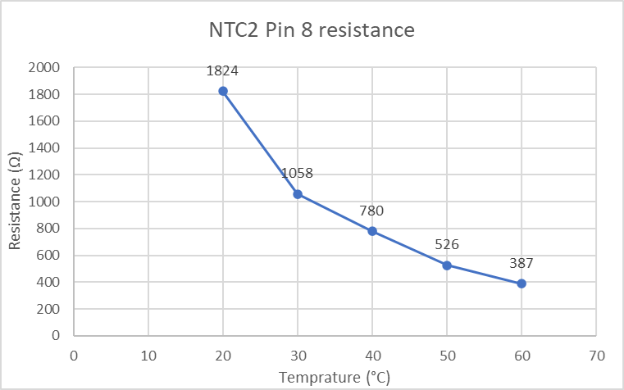
Figure 5 – LE3 Pin 8 Coolant Temperature Sensor Resistance
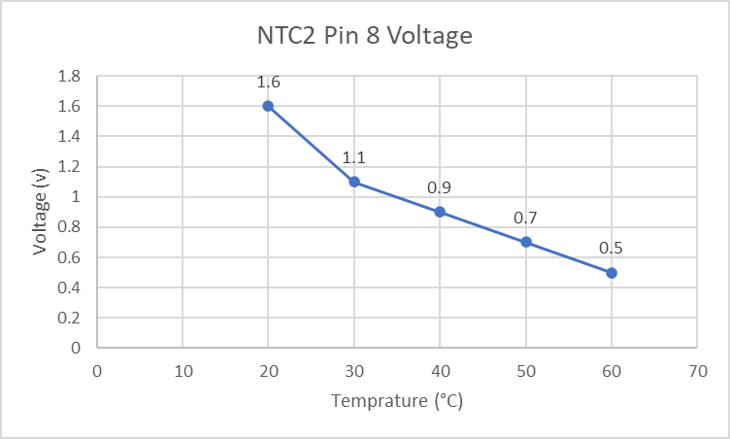
Figure 6 – LE3 Pin 8 Coolant Temperature Sensor Voltage

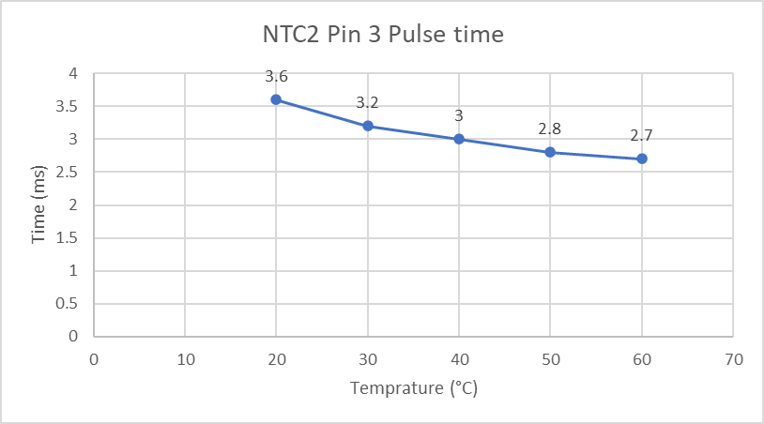
Figure 7 – LE3 Pin 3 Injection Pulse Time
4.3 LE3 Scope Patterns
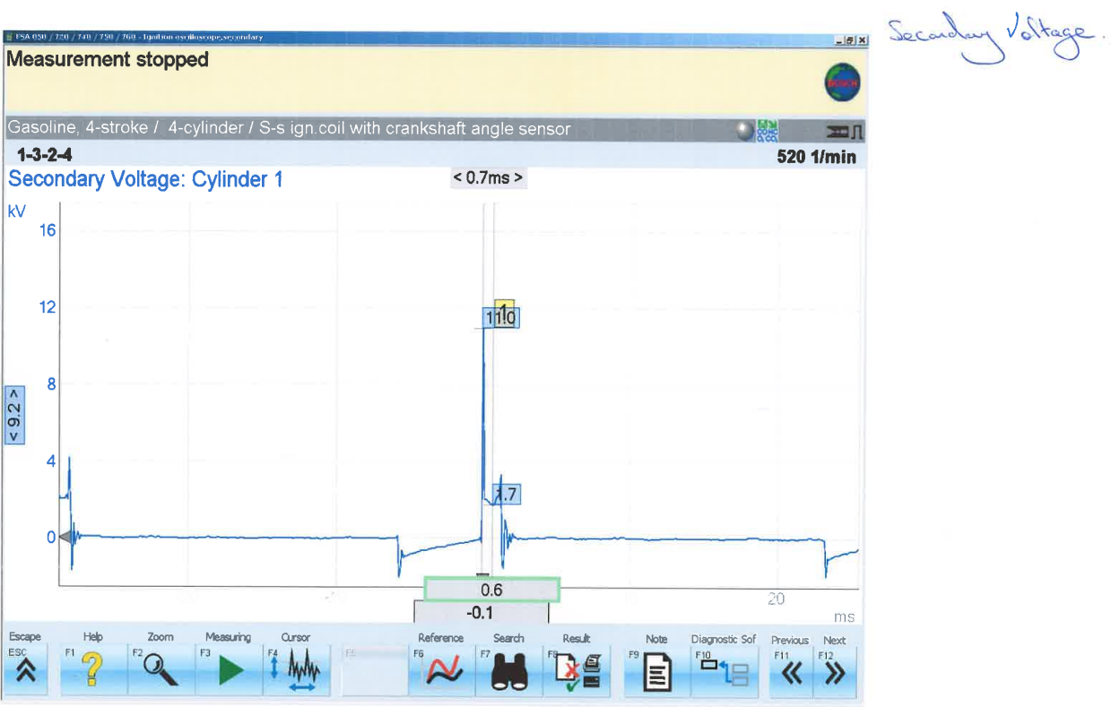
Figure 8- Secondary Voltage
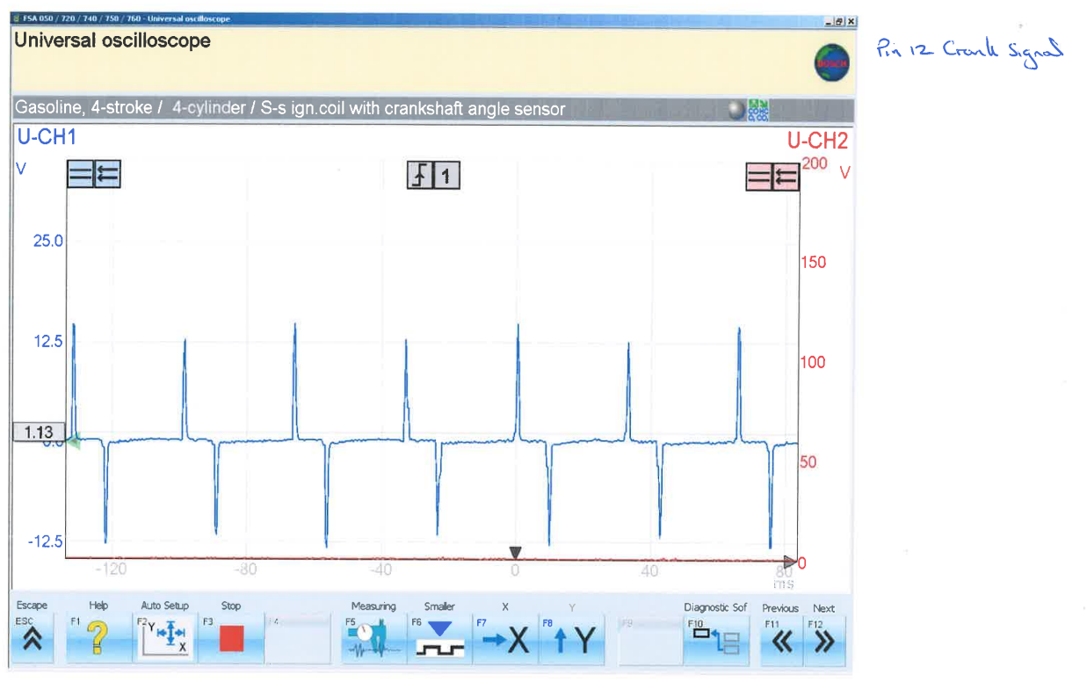
Figure 9 – Crank Signal
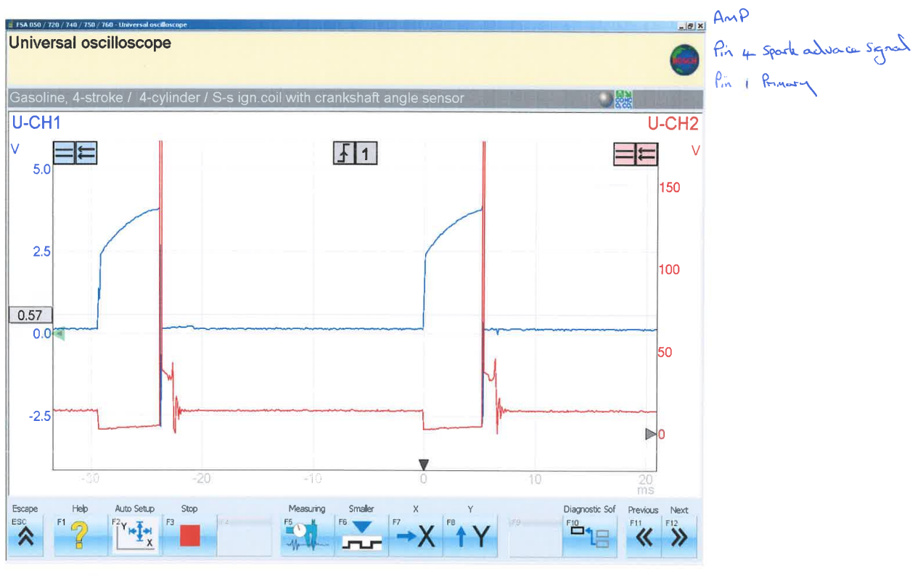
Figure 10 – Spark Advance
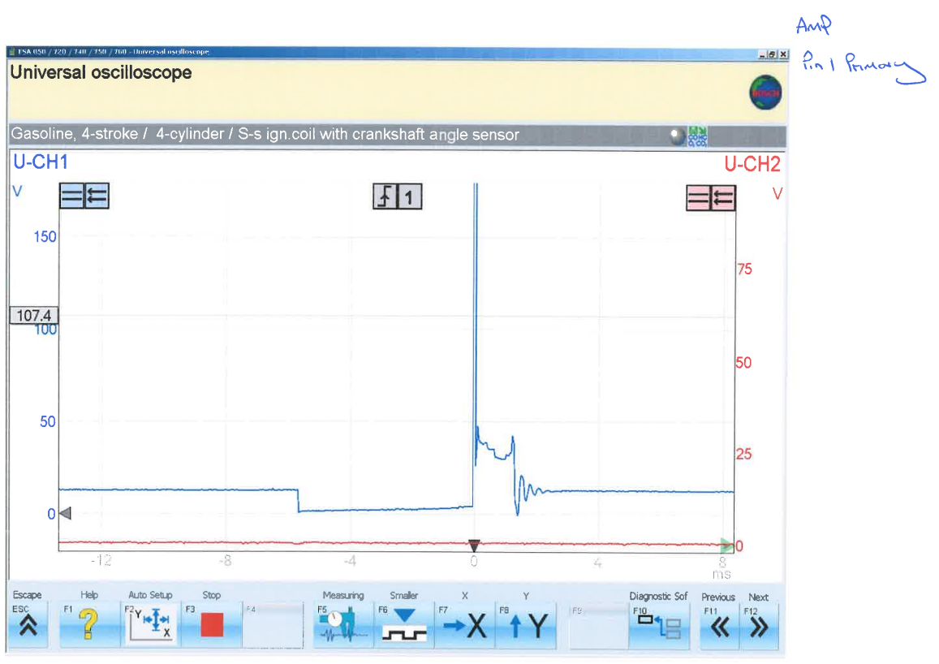
Figure 11- Amplifier
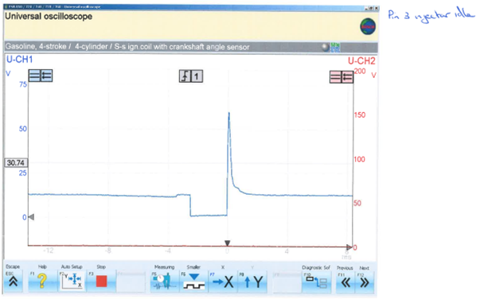
Figure 12 - Injector pulse idle
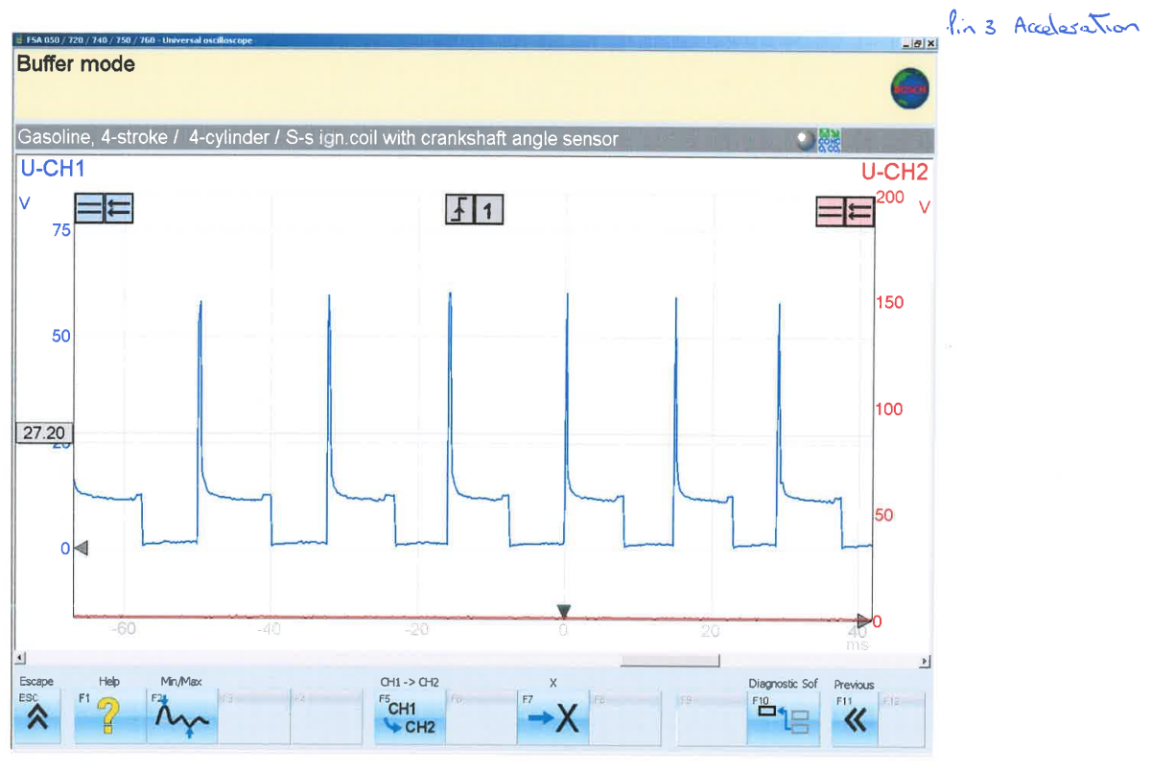
Figure 13 -Injection pulse under acceleration
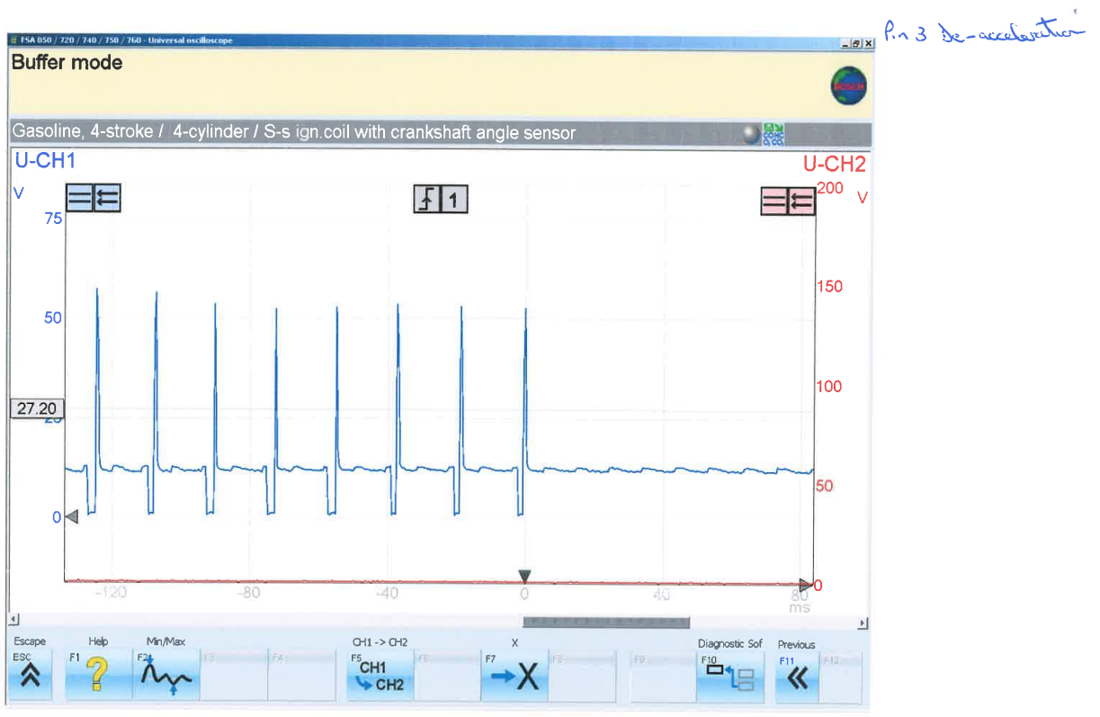
Figure 14 – Injection pulse under deceleration

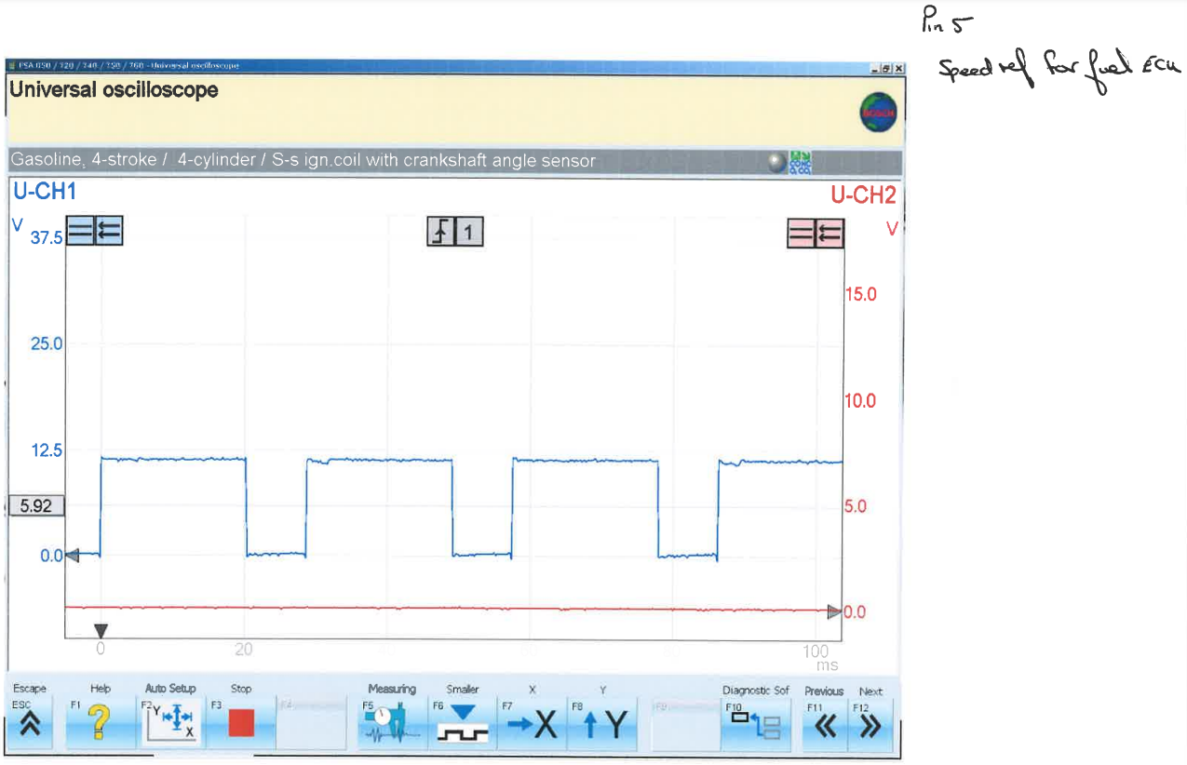
Figure 15 – Speed Reference
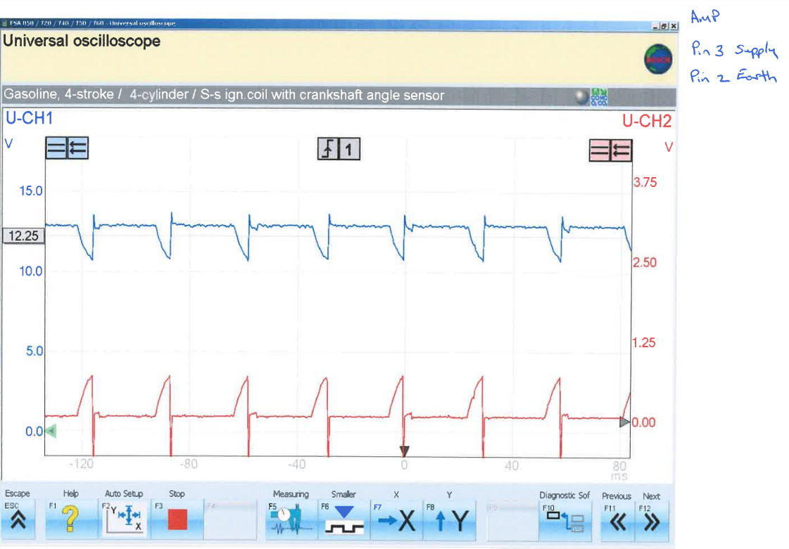
Figure 16 – Amplifier supply and earth

Analysis
When looking at the results of static testing of the LE3 and Motronic systems with ignition on, of which the data can be found in the appendix, all active pins show a voltage reading, this can be determined as potential voltage, ready for the engine to be started. (Gibson,2022)
After a reading was taken from the individual components, the data collected was compared to the manufacture’s specification.
For the Motronic, it was found the rotary idle valve had a 0.3 Ω higher resistance than the tolerance specified, it was also discovered that the throttle position sensor pin 3 had a reading of 500 Ω more than the maximum resistance, however pin 3 of the airflow sensor had a reading of 660 Ω, the minimum resistance of this pin is 1000 Ω.
For the LE3 it was only found that the Auxiliary Air had a resistance outside the manufacturer’s specification, a reading of 5.8 Ω over the upper limit.

Motronic
When the engine is started, known as cold crank, an injection on time of 24ms was recorded from pin 16. This extended injection on time is due to the engine being cold and more fuel being required due to poor mixing of air and fuel, poor fuel vaporization and potential condensation being built up within the cylinder, all three factors are a result of low temperatures within the engine and therefore the system requires an increase in fuel to start the engine (Bosch, 2000, p.9).
As seen in figure 2 after cold crank the injection on time reduces drastically to 3.3ms, this can be deemed as the post start phase where a richer mixture is required briefly to heat the cylinder, this also creates an increase in torque aiding the engine to reach base idle, following this at 40°c injection time is reduced again to 3ms, this is the warmup phase where a slightly richer mixture is required to combat any fuel condensation until 60°c where injection time is 2.8ms and the engine has reached base idle where it can burn fuel efficiently (Bosch, 2000, p.42).
At 70°c there is an increase back to 3.3ms, this is caused by the fan being turned on and therefore the load on the engine is increased requiring a richer mixture to maintain base idle.
Comparing the Motronic static test data to the manufacturer’s specifications found in table 3 and 4 below several pin readings draw an interest:
- Pin 4 (Rotary Idle Valve) – In figure 1 the graph shows a 1% drop at 60°c, this can be explained by the engine reaching operating temperature and therefore having less mechanical friction as components expand to running tolerances, however at 70°c it increases by 1% as the fan was turned on, increasing the electrical load on the engine.
The rotary idle control valve is designed to maintain base idle regardless of load, when an engine is at base idle there is no input from the throttle, therefore the engine must maintain an exact torque to overcome any friction from the engine to remain at base idle, however additional loads such as electrical components require an increase in the airflow and fuel into the engine to maintain base idle (Ribbens, 2017, p.177)
- Pin 7 (Air flow sensor) – this pin should read between 0.5v to 1.5v however this is when the engine is at base idle, therefore the reading of pin 3 is inaccurate due to the engine being off.
- Pin 44 (Intake air temperature) this pin shows a reading of 3.7v however once the engine is tested warm there is a voltage drop to 3.37v as expected showing this sensor is working correctly, this is known as NTC1.
NTC1 is a negative temperature resistance resistor that operates with a 5v supply, the ECU monitors the voltage drop using an analogue-digital converter which provides a reference point to the temperature using a table stored within the ECU memory, the data from NTC1 then influences ignition advance angle by providing corrections to compensate change in temperature to optimize and maintain minimal fuel consumption as well as emissions (Bosch, 2000, p.37-41)

- Pin 45 (Coolant temperature sensor) –this shows a drop in voltage as expected when the engine is retested once warm. This can be further demonstrated in the dynamic test results and graphs produced from this data in figures 3 and 4 which show a gradual drop in both voltage and resistance as the temperature of the engine increases however once the engine reaches an operating temperature of 80°C the data shows a slight increase in both voltage and resistance, however using the manufacturer’s reference point of 1.4v at 80°C it is clear the sensor is still working within its tolerances.
Coolant temperature actively influences injection pulse time providing a reference point for engine operating temperature, the ECU measures the voltage and calculates the engine temperature from this data, this data is then used to either enrich the air fuel mixture in the case of cold cranking or create a leaner mixture as the engine reaches operating temperature (Ribbens, 2017, p.167-268)
- Pin 48 (Crank position sensor) – this pin shows a reading of 0.05v, this is due to the engine not running and the pin being tested as static
- Pin 55 (Throttle position signal) – This pin shows a reading of 0.02v, this is due to the throttle being closed at the time of testing.


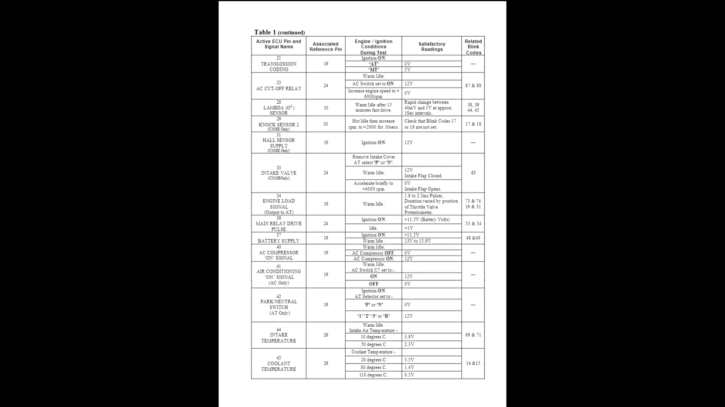
Table 4 – Motronic Pin Data Continued (Kay,2001)
Table 3 – Motronic Pin Data (Kay,2001)


LE3
When starting the LE3 system in cold crank, an injection on time of 63.5ms was recorded, following this the injection time reduced to 3.6ms this was then gradually reduced to 2.7ms when the engine reached its operating temperature of 60°c, this is shown in figure 7, this shows as the engine goes from post start to warm up phase followed by operating temperature, the system gradually reduces the fuel being injected into the cylinder creating a leaner mixture as the engine warms, this also helps to vaporize any large fuel droplets that are left from condensation during the warm up phase (Bosch, 1995)
This reduction of injection time is partly controlled by the coolant temperature sensor, Figures 5 and 6 show a gradual reduction in voltage and resistance as the engine heats up, this voltage and resistance is used by the system via a negative temperature resistor (NTC) to provide a reference point to the current temperature of the engine, this ensures that minimal fuel is used and increases fuel economy (Bosch, 1995, p.24).

LE3 Scope Patterns
When looking at the scope patterns produced from the LE3 testing figure 9 shows the crank angle sensor producing a voltage spike followed by a negative voltage spike, this sensor sends a signal to the ecu, this data is used to calculate engine speed as well as injection time. Injection pulses occur twice for each cylinder, the system then injects once for every turn of the crank shaft, if the inlet valve is closed, the unused fuel is then stored until it opens where it drawn in with air entering the cylinder (Bosch, 1982, p. 11)

Figure 12 shows the injection pulse at idle; the scope pattern first shows a supply voltage, a current limiting hump can be seen at this point, this is followed by a voltage drop to almost 0v as the injector is earthed, here injection on time has started for around 3ms, a spike in voltage known as EMF is then produced, this is due to the coil being inductive so any unused energy converts into voltage, the voltage spike then drops and returns to the supply voltage (Garage Lube, 2017).
In figure 13 the same wave shape is shown with a much higher frequency of injection pulses due to the engine accelerating and therefore increasing the load, figure 14 shows a decrease in frequency due to the engine decelerating, this is followed by the voltage levelling off as the injectors are shut off due to the ecu registering the engine in a state of over run.

Discussion
From the data collected as a result of the testing carried out in live conditions and the research outlined within this report, it is clear that both the LE3 and Motronic systems were efficient and reliable systems of the time, they both hold many similarities in terms of sensors used such as, coolant temperature, crank position, throttle position and air flow.
However, the Motronic is a clear development and advancement in technology over the LE3 system by adding sensors such as closed loop lambda to measure post combustion oxygen levels, this allows the system to adjust the air-fuel ratio to increase fuel economy and control emissions. When comparing both systems to modern day equivalents several improvements could be made to bring the systems closer to todays standards of fuel consumption and emissions control.

Firstly, the rotary arm distributor would need to be replaced, the distributor sequentially connects the coils output voltage to each spark plug by using a rotary arm, it also causes the coil to generate the spark by interrupting the primary current within the coil (Ribbens, 2017, p.309). Having a mechanical device such as a rotary arm is an inherent weakness due to the risk of mechanical failure and the possibility of it needing maintenance, therefore a suitable replacement would be coil on plug, for this each spark plug has its own coil which is controlled by the ECU providing the spark directly to the spark plug. Coil on plug ignition systems have an advantage over traditional distributor types due to the improved reliability of the ignition system, this is achieved by the lack of excess wiring as the is no voltage loss, each coil also has a longer saturation time which increases its output making the system more reliable at higher RPM where misfires can occur, as a by product coil on plug also reduces cost for the manufacturer (Carley,2000).

The second component for recommended replacement would be the volume sensor , this is for several reasons; it operates on a vacuum line and is therefore liable to leaks, and can also cause a restriction of flow within the system, lastly as this sensor takes a reading the ECU is then required to convert this data to mass, which causes a delay between the sensor and appropriate action being taken by the ECU to adjust to different conditions, a modern alternative to this would be a manifold absolute pressure (MAP) sensor.
Manifold pressure and engine load are proportional to one another; therefore, a MAP sensor is deemed as a pressure transducer, using this data of pressure the ECU can then retard or advance the timing to compensate for different dynamic situations (Denton, 2004, p.171).
Due to the MAP sensor detecting pressure within the manifold as opposed to measuring volume passing, the issue of restriction is removed. The introduction of piezoresistive MAP sensors has also reduced calculation time for the ECU to adjust to the system’s needs based on applied load, improving efficiency as well as reducing the cost for manufacturer (Baney et al, 1997).

The next recommendation to be made would be to replace the throttle position sensor and idle control valve with a drive by wire system. Drive by wire (DBW) systems do not require a mechanical connection from the accelerator to the throttle valve, this in turn eliminates the potential for mechanical failure.
DBW systems utilise a throttle actuator, this is controlled by a system that balances driver request along side external factors such as driving conditions and emissions control,
It also acts as a control measure for idle speed and cold start management. This system improves reliability and performance alongside safety features which can be integrated such as anti-lock braking, traction control and anti-collision systems, it also improves fuel consumption when features such as cruise control as utilised (Rossi et al, 2000).

The systems would also benefit from the addition of knock sensors, knock sensors are a piezoelectric accelerometer which can detect ionization during the combustion process and can either retard or advance the ignition timing accordingly, this would benefit the system as it allows greater control over the ignition timing.
Knock, more known as detonation is caused by advancing the ignition timing too much, under normal operating conditions an engine will run most efficiently when the ignition is advanced as far as possible, therefore the timing map will be set as close to the knock limit as possible. The knock sensor sends a signal to the ECU a few degrees either side of top dead centre to avoid a false reading from valve chatter, if knock is then detected the ignition will be retarded on the fourth ignition pulse after detection until the signal shows no knock (Denton, 2004, p.181)

Conclusion
To conclude, the testing of the Bosch Motronic and LE3 engine management control systems was carried out in a timely and effective manor, a digital multimeter was used to find static results for voltages presented at each pin, an oscilloscope was then used to validate this data under dynamic conditions providing an insight into how the system operates and how the adaptive control measures have adjusted to the systems requirements over time. To further validate the data collected the test would need to be repeated several times to provide a wider data set where the results can be measured against one another to see any variations within the data. Another suggestion that could be made is testing a newer vehicle with similar mileage to compare the data and actively see how adaptive control measures have progressed and advanced.

The recommendations made in this report would support the engines to be bought closer to todays standards in terms of emissions control and fuel consumption, with growing concerns globally of emissions and sustainability the overhaul of aged engine control systems could soon become a viable alternative to producing cars.

References
- Baney, Chilcott, Huang, Long, Siekkinen, Sparks and Staller (1997) ‘A Comparison Between Micromachined Piezoresistive and Capacitive Pressure Sensors’ SAE Transactions, Journal of Commercial Vehicles. Vol.106 (2), pp.562-565
- Bosch (1981) Technical Instruction L-Jetronic 1st Edition, Germany: Robert Bosch GmbH
- Bosch (1995) Gasoline Fuel-Injection System L-Jetronic 2nd Edition, Germany: Robert Bosch GmbH
- Bosch (2000) M-Motronic Engine management Technical Instruction. 4th Edition, Germany: Robert Bosch GmbH
- Bosch (2007) Bosch Automotive Electric and Automotive Electronic Systems 5th Edition, Germany: Robert Bosch GmbH
- Carley (2000) ‘Going Wireless: Coil-on-Plug Ignition Systems’ Underhood Service; Akron, Vol 6 (9) pp.22-28
- Denton (2004) Automobile Electrical and Electronic Systems 3rd Edition, Oxford: Elsevier Butterworth-Heinemann
- Feng, Jiao and Wang (2016) ‘Adaptive and predictive control of fuel injection with time delay consideration for air–fuel ratio regulation of gasoline direct injection engines’ Proceedings of the Institution of Mechanical Engineers, Part D: Journal of Automobile Engineering. Vol.231 (8) pp.1022-1033
- Garage Lube (2017) Test 4 - Injector Current and Voltage. Available at URL: https://www.garagelube.com/tests/injector-current-and-voltage/ (Accessed 8th April 2022)
- Gibson (2022) In Person Lecture, University of Wales Trinity St David
- Kawasumi and Yasui (2007) ‘Adaptive Air-fuel Ratio Controls for Continuously Variable Valve Lift Gasoline Engines’ 2007 SAE World Congress Detroit. Michigan April 16-19, 2007, United States of America: SAE International
- Kay (2001) Fault Diagnosis on Motronic M1.5 Engine Management System. Available at URL: https://docplayer.net/31708250-Fault-diagnosis-on-motronic-m1-5-engine-management-system.html (Accessed 5th April 2022)
- Minjares (2016) A technical summary of Euro 6/VI vehicle emission standards. Washington: The International Council on Clean Transportation
- Ribbens (2017) Understanding Automotive Electronics an Engineering Perspective. Oxford: Elsevier Inc.
- Rossi, Tilli, Tonielli (2000) ‘Robust control of a throttle body for drive by wire opening of automotive engines’ Control Systems Technology, IEEE Transactions vol. 8 (6), pp.993-1002
- Schuett and Peckham (1986) ‘Advancements in Test Cell Design’ SAE Transactions, Vol.96 (4) pp.912-923
- Scott partnership (2010) ‘Oscilloscopes’ Nature Photonics 2010-06, Vol.4 (6), p.400-401
- SGS (2022) Vehicle & Engine Testing: Research, Development and Certification Testing with Environmental Conditions. Available at URL: https://www.sgs.com/-/media/global/documents/brochures/sgs-trp-aurora-engine-and-vehicle-us-en.pdf (Accessed 2nd April 2022)

Appendix



LE3 Data




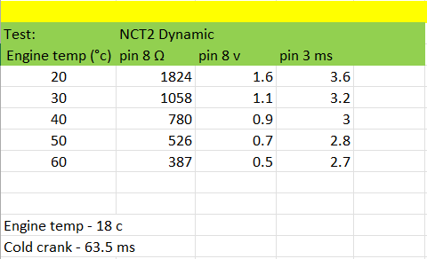

Motronic Data





