UNIVERSITY OF WALES TRINITY SAINT DAVID

Student Name: DENISA-ROXANA STOICA

Student ID: 2211503

Module Title: ACCOUNTING FUNDAMENTALS

Module Code: LCBB4001

Lecturer: IVANA ROZIC

Table of Contents
QUESTION 1 1
a) Income statement for the year ended 31st December 2022 1
Statement of Financial Position 2
b) Why does the statement of financial position balance? 3
QUESTION 2 4
a) Ratio Analysis 4
b) Analysis of Financial Statements 5
References 6

QUESTION 1

Income statement for the year ended 31st December 2022

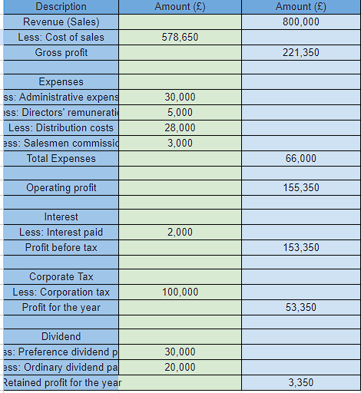

Statement of Financial Position
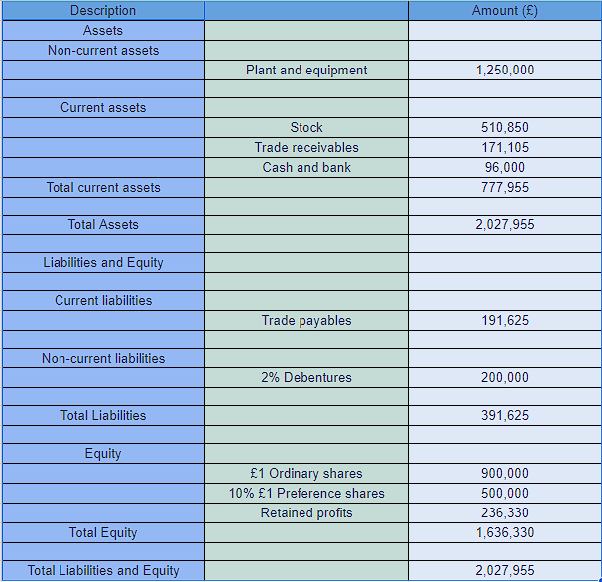

b) Why does the statement of financial position balance?

In order to have a balanced statement of financial position, the basic accounting equation Assets = Liabilities + Equity must be used. Each transaction must affect at least two accounts in the same way, with one account being debited and the other being credited by the same amount, per the double-entry accounting system upon which this equation is based. The accounting equation shows that debits plus credits always equal credits plus debits.

The statement of financial status is a document which summarizes the financial health of a corporation. The assets, liabilities, and owner equity of a business are listed in a document called a balance sheet. The assets of a company are its assets, whereas its liabilities are its obligations(Alvarez and Fridson, 2011).

Investigating the core ideas and variables of the accounting equation reveals why the statement of financial position is in a state of equilibrium.

1. Assets: The company possesses resources that could be turned into cash flow. Examples of acquisitions include the purchase of machinery, the realization of a profit, and the taking out of a loan. Unlike noncurrent assets, which take more time to turn into cash, current assets can be quickly put to use.

2. Liabilities: These are the firm's promises to deliver cash, goods, or services. Liabilities arise whenever one takes on debt, whether in the form of a loan, a sizable purchase made on credit, or substantial outlays of cash. Like assets, liabilities can be classified as "current" or "noncurrent" depending on when they are expected to be paid in full(Brealey et al., 2016).

3. Equity: This is what is left over after all liabilities have been paid off in terms of ownership of the company's assets. The equity of a firm is comprised of the initial investment made by its owners, the retained earnings of the business (profits not distributed as dividends), and other factors such as the share premium and reserves. Equity, or the owners' stake in the company, is a measure of a business's financial well-being and growth potential(Penman, 2020

In conclusion, by recording all accounts twice, the double-entry accounting system guarantees that the statement of financial position will always be in balance. The stakeholders of a company can evaluate its financial health, stability, and growth potential with the use of a timely and accurate balance sheet. In addition, it aids management in making future-oriented decisions, which is critical to the company's health and growth.
QUESTION 2

Ratio Analysis
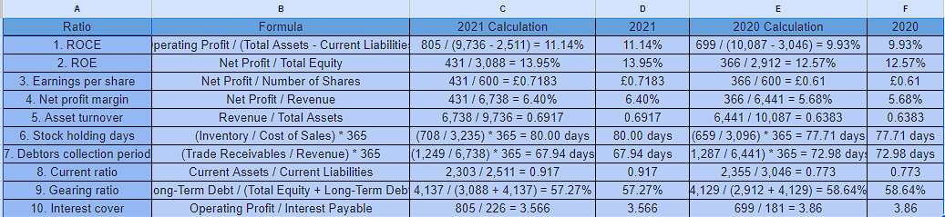

Analysis of Financial Statements

By calculating financial ratios, one can gain insight into Sweets plc's financial performance and standing:

ROCE: In 2021, the company was able to generate 11.14% more profit with the same level of capital employed compared to the previous year, when it only generated 9.93%(Alvarez and Fridson, 2011).

ROE: There was also an improvement in the company's ability to return capital to investors, as measured by Return on Equity, which rise from 12.57% in 2020 to 13.95% in 2021.

Earnings per share: In 2021, the company's earnings per share (EPS) rise from £0.61 to £0.7183, indicating an improvement in profitability per share that may make the stock more appealing to investors(Jordan, 2019).

Net profit margin: The company's capacity to turn revenue into net profit improved in 2021, as seen by a rise from 2020's 5.68% net profit margin to 2021's 6.40%.

Asset turnover: The asset turnover ratio for Sweets plc improved from 0.6383 in 2020 to 0.6917 in 2021, showing a higher level of efficiency in the company's revenue generation(Brigham and Ehrhardt, 2019).

Stock holding days: The number of days a company held its stock grew from 77.71 in 2020 to 80.00 in 2021, indicating a small rise in the time it took to sell goods(Brown et al., 2016).

Debtors collection period: With a shorter debtors collection duration of 67.94 days in 2021 compared to 72.98 days in 2020, the organization appears to have become more effective at obtaining payment from its clientele(Baginski et al., 2017).

Current ratio: The improvement in the company's short-term liquidity situation, as measured by the current ratio, from 0.773 in 2020 to 0.917 in 2021 is indicative of a stronger ability to meet the company's short-term obligations(Brealey et al., 2016).

Gearing ratio: The company's reliance on debt financing somewhat dropped from 2020 levels to 2021 levels, as measured by a drop from a gearing ratio of 58.64% to a ratio of 57.27%.

Interest cover: The company is still able to satisfy its interest commitments despite a minor decline in its ability to cover interest expenses (as measured by the interest cover ratio), which fell from 3.86 in 2020 to 3.566 in 2021(Baginski et al., 2017).

In the final two years of the 2020s, Sweets plc saw a considerable uptick in its financial performance and position(Goedhart et al., 2016). Profitability, asset utilization, and liquidity have all increased as a result of the company's increased efficacy. However, it is important to monitor the interest cover in case it begins to fall. It would seem that Sweets plc is making progress.

References

Alvarez, F., and Fridson, M. S. ,2011. Financial Statement Analysis: A Practitioner's Guide (4th ed.). Wiley.

Baginski, S., Bradshaw, M., and Wahlen, J. ,2017. Financial Reporting, Financial Statement Analysis and Valuation (9th ed.). Cengage Learning.

Brealey, R. A., Myers, S. C., and Allen, F., 2016. Principles of Corporate Finance (12th ed.). McGraw-Hill Education.

Brigham, E. F., and Ehrhardt, M. C., 2019. Financial management: Theory and practice (16th ed.). Cengage Learning.

Brown, P. R., Stickney, C. P., and Wahlen, J. M., 2012. Financial Reporting, Financial Statement Analysis and Valuation: A Strategic Perspective (7th ed.). Cengage Learning.

Goedhart, M., Koller, T., and Wessels, D., 2015. Valuation: Measuring and Managing the Value of Companies (6th ed.). Wiley.

Healy, P. M., Palepu, K. G., and Peek, E., 2016. Business Analysis and Valuation: IFRS Edition (4th ed.). Cengage Learning.

Jordan, B. D., Ross, S. A., and Westerfield, R. W., 2019. Fundamentals of Corporate Finance (12th ed.). McGraw-Hill Education.

Penman, S. H., 2020. Financial Statement Analysis and Security Valuation (6th ed.). McGraw-Hill Education.

