
Title: Impact of entrepreneurial leadership on innovation management within fashion retail SMEs in the UK
Research Project submitted as part of the requirement for the
Master of Business administrative
at University of wales trinity Saint David
20th October 2023
Name : Patel Komalben Babubhai
Student Id : 2211067

Declaration


Acknowledgements
The completion of this research has been made possible with the contribution of many people whom I would like to thank. My gratitude is firstly presented towards my research supervisor who guided me through the process of conducting an academic investigation. The valuable feedback gained for the drafts of the dissertation helped me in improving the scope of my research. I also appreciate the research participants who were managers from fashion retail SMEs in the UK as they provided their valuable responses which contributed to the research findings. My appreciation is also for my friends and family who supported me through the study.
Abstract
The leadership style implemented by leaders of small and medium-sized enterprises (SMEs) plays an important role in achieving organisational growth in the target industry. This research aimed to evaluate the impact of entrepreneurial leadership on innovation management within fashion retail SMEs in the UK. The lack of primary investigation in this sector led to the rationale for this research which adopted the quantitative methodology. A questionnaire based on research constructs and guided by the Likert Scale was provided to 50 managers from fashion retail SMEs in the UK. This was done during an online survey conducted on Google Forms and the responses gathered from the participants were analysed through frequency analysis. The findings obtained from the analysis revealed that improvement in business model and achievement of better performance along with sustainability highlight the significance of entrepreneurial leadership. The strategies adopted towards innovation management include the use of artificial intelligence, strategic management and big data analytics. It is also revealed by the findings that financial issues, restrictive open innovation and inappropriate innovation policies are challenges faced by fashion retail SMEs. This research recommends that a focus on employees’ self-efficacy and the adoption of cross-cultural perspectives along with risk-oriented behaviour should be considered while adopting entrepreneurial leadership to positively impact innovation management in fashion retail SMEs in the UK.
Table of Contents
Chapter 1. Introduction 10
1.1 Overview 10
1.2 Research context 10
1.3 Rationale and problem statement 11
1.4 Aim and objectives 11
1.5 Research questions 12
1.6 Research significance 12
1.7 Dissertation outline 12
1.8 Chapter summary 13
Chapter 2. Literature review 14
2.1 Overview 14
2.2 Significance of entrepreneurial leadership and innovation management for fashion retail SMEs 14
2.3 Strategies adopted by managers in fashion retail SMEs towards innovation management 16
2.4 Challenges faced by fashion retail SMEs during innovation management 18
2.5 Recommendations for better innovation management of fashion retail SMEs through entrepreneurial leadership 20
2.6 Conceptual framework 22
2.7 Literature gap 23
2.8 Chapter summary 23
Chapter 3. Research methodology 25
3.1 Overview 25
3.2 Philosophical stance 26
3.3 Research approach 26
3.4 Methodological choice 27
3.5 Research strategy 27
3.6 Time horizon 28
3.7 Research sample 28
3.8 Data collection technique 29
3.9 Method of data analysis 29
3.10 Ethical considerations 30
3.11 Chapter summary 30
Chapter 4. Data analysis, findings and discussion 31
4.1 Overview 31
4.2 Frequency analysis 31
4.2.1 Analysis of the data based on demographic questions 31
4.2.2 Analysis of the data based on the first research objective 34
4.2.3 Analysis of the data based on the second research objective 38
4.2.4 Analysis of the data based on the third research objective 42
4.2.5 Analysis of the data based on the fourth research objective 46
4.3 Discussion of research findings 50
4.4 Chapter summary 53
Chapter 5. Conclusions and recommendations 54
5.1 Overview 54
5.2 Validation of achieving research aim and objectives 54
5.3 Research limitations 55
5.4 Implications of the study 56
5.5 Recommendations for future investigations 57
5.6 Chapter summary 57
References 59
Appendix 66
Survey questionnaire 66

Table of Figures
Figure 1 Conceptual framework 23
Figure 2 Research onion 25
Figure 3 Pie chart depicting the data collected for the first question 31
Figure 4 Pie chart depicting the data collected for the second question 32
Figure 5 Pie chart depicting the data collected for the third question 33
Figure 6 Pie chart depicting the data collected for the first scale item 34
Figure 7 Pie chart depicting the data collected for the second scale item 36
Figure 8 Pie chart depicting the data collected for the third scale item 37
Figure 9 Pie chart depicting the data collected for the fourth scale item 38
Figure 10 Pie chart depicting the data collected for the fifth scale item 40
Figure 11 Pie chart depicting the data collected for the sixth scale item 41
Figure 12 Pie chart depicting the data collected for the seventh scale item 42
Figure 13 Pie chart depicting the data collected for the eighth scale item 44
Figure 14 Pie chart depicting the data collected for the ninth scale item 45
Figure 15 Pie chart depicting the data collected for the tenth scale item 47
Figure 16 Pie chart depicting the data collected for the eleventh-scale item 48
Figure 17 Pie chart depicting the data collected for the twelfth scale item 49

List of Tables
Table 1 Frequency table for the first question 31
Table 2 Frequency table for the second question 32
Table 3 Frequency table for the third question 33
Table 4 Frequency table for the first scale item 35
Table 5 Frequency table for the second scale item 36
Table 6 Frequency table for the third scale item 37
Table 7 Frequency table for the fourth scale item 39
Table 8 Frequency table for the fifth scale item 40
Table 9 Frequency table for the sixth scale item 41
Table 10 Frequency table for the seventh scale item 43
Table 11 Frequency table for the eighth scale item 44
Table 12 Frequency table for the ninth scale item 45
Table 13 Frequency table for the tenth scale item 47
Table 14 Frequency table for the eleventh scale item 48
Table 15 Frequency table for the twelfth scale item 49

Chapter 1. Introduction

1.1 Overview
The purpose of this chapter is to focus on the context of the study and the background which can help in understanding the research phenomenon being considered. Section 1.2 provides this context and a further discussion is done in section 1.3 for the research problem which needs to be addressed. A rationale is also provided in this section which indicates the purpose of the study regarding which aim and objectives are made in section 1.4. Furthermore, research questions related to the objectives are presented in section 1.5 which are to be addressed in this study. Section 1.6 deals with a discussion on research significance and the outline of the dissertation is provided in section 1.7 of this chapter.

1.2 Research context
A business organisation is driven by the leadership style implemented by its leaders for better performance and growth. Entrepreneurial leadership is concerned with the guidance to a group of people for achieving a collective objective through risk optimisation, innovation and dynamic management (Leitch and Volery, 2017). The significance of entrepreneurial leadership comes from the skills implemented by the leader for the collaborative growth of the members of the organisation. A more risk-oriented approach is used while adopting this leadership style instead of a traditional corporate mindset. For a small and medium-enterprise (SME), adequate leadership is essential so that gradual growth over time can be achieved. Communication and vision are integral parts of entrepreneurial leadership as they are used to reliably exchange thoughts and communicate the overall objectives of the organisation with the managers and employees (Nguyen et al., 2021). Supportive initiatives are taken by entrepreneurial leaders so that calculated risks can be taken while conducting internal as well as external operations.
Innovation management deals with the process of introducing and managing new and innovative approaches for the better growth of the organisation (Tidd and Bessant, 2020). The current operations and procedures are made efficient after the inclusion of innovative techniques such as technological implementation. The importance of innovation management for an SME comes from the new approaches that the enterprise can use to make the operations efficient and attempt to gain a competitive advantage. Organisational structure as well as strategies are improved when innovative approaches are managed effectively. The capabilities of the working professionals in the firm are enhanced after the new techniques are implemented within the organisation. SMEs can benefit from innovation management because it provides the opportunity to attain long-term growth and perform better in the target market (Kim-Soon et al., 2017). The contribution of entrepreneurial leadership to the extent of innovation within SMEs must be analysed to attain better insights into this area.

1.3 Rationale and problem statement
The scope of exploration in a particular area with a specific gap which is needed to be addressed provides the research problem statement (Tigor, 2020). From the research background discussed above, it is evident that entrepreneurial leadership is a significant aspect when it comes to the performance of an organisation. However, the problem statement is the lack of studies in the fashion retail sector with regard to SMEs. The need is to consider the opinions of managers in these SMEs about the achievement of innovation management through entrepreneurial leadership. This indicates the rationale for a primary investigation based on this area regarding which the aim and objectives below are developed.

1.4 Aim and objectives
The proposed study aims to evaluate the impact of entrepreneurial leadership on innovation management within fashion retail SMEs in the UK.
Objectives
- To analyse the significance of innovation management and entrepreneurial leadership in fashion retail SMEs in the UK.
- To identify the strategies used by managers in fashion retail SMEs in the UK towards innovation management.
- To recognise the challenges faced by fashion retail SMEs in the UK while managing innovation.
- To provide recommendations so that entrepreneurial leadership can be utilised by fashion retail SMEs in the UK to achieve better innovation management.

1.5 Research questions
- What is the significance of innovation management and entrepreneurial leadership in fashion retail SMEs in the UK?
- Which strategies are used by managers in fashion retail SMEs in the UK towards innovation management?
- What are the challenges faced by fashion retail SMEs in the UK while managing innovation?

1.6 Research significance
An important contribution will be provided by this research to the fashion retail SMEs operating in the UK because they can facilitate their innovation management with the use of the results obtained by this study. The significance is for their leadership strategies because entrepreneurial leadership would be prioritised by them to achieve innovation after considering this research. It is also determined that the current challenges in fashion retail SMEs of the UK will be mitigated after the managers implement the insights that will be provided by this research. Furthermore, a contribution is also to the literature because primary findings based on the fashion retail sector in the UK will be added to the literature that can be useful for researchers in the future.

1.7 Dissertation outline
The roadmap of various chapters of this dissertation is as follows:
Chapter 2 – Literature review
The purpose of this chapter is to provide a critical analysis of insights obtained by other researchers based on the same area explored in this study. A comparison and contrast will be done for the views and findings of scholars to identify the existing gap in the current literature.
Chapter 3 – Research methodology
In this chapter, the methods of the research will be selected to implement an approach for addressing the research objectives. The methodological use as well as the ethical considerations for this primary study will also be discussed in this chapter.
Chapter 4 – Data analysis, findings and discussion
This chapter will provide a critical analysis of the collected information using the technique selected in the previous chapter. The findings will be obtained and discussed in this chapter with a comparison to the reviewed literature.
Chapter 5 – Conclusions and recommendations
A conclusion to the research will be provided in this chapter with the validation of achieving the aim and objectives. Limitations of the study will be discussed along with research implications and possible recommendations for future studies.

1.8 Chapter summary
This chapter concludes that entrepreneurial leadership is significant for the growth of SMEs and should be implemented for better organisational performance. Innovation management is a critical aspect for an SME and should be explored in the fashion retail sector of the UK as identified in the problem statement. The need for analysing primary data provides the rationale for conducting this research regarding which the developed aim and objectives along with questions have been provided in this chapter. The significance for fashion retail SMEs and the existing literature is identified which highlights the contribution of the research. Furthermore, an overview of the chapters in this dissertation has also been discussed in this chapter.

Chapter 2. Literature review

2.1 Overview
The purpose of this chapter is to explore a gap in the literature through the critical evaluation of the views of different authors. These views will be considered about the research area being investigated i.e., innovation management and its achievement through entrepreneurial leadership among SMEs in the fashion retail sector. A comparison and contrast technique is implemented in this chapter which is first concerned with section 2.2 based on the importance of innovation management as well as entrepreneurial leadership. Furthermore, the strategies related to innovation management that are adopted by managers are discussed in section 2.3 whereas the challenges related to this are evaluated in section 2.4. Section 2.5 in this chapter provides the literature review on recommendations related to entrepreneurial leadership and its contribution to innovation management. In addition, the constructs are identified in section 2.6 to make the research conceptual framework and section 2.7 provides the literature gap.

2.2 Significance of entrepreneurial leadership and innovation management for fashion retail SMEs
According to Zainol et al. (2018), the performance of an SME is directly dependent on the entrepreneurial leadership style adopted by its leaders. This is because of the risk-oriented approach adopted within the enterprise which eventually contributes to its overall performance. It is analysed from this study conducted by scholars that the advancement of an existing product or the launch of a new product becomes beneficial when entrepreneurial leadership is implemented within an SME. The analysis of this argument leads to the result that a fashion retail SME can enhance its organisational performance with this leadership style. On the other hand, Nguyen et al. (2021) argue that many factors are present within an SME that can affect the relationship between entrepreneurial leadership and organisational performance. This style is significant because it provides technological innovation capabilities that come with organisational factors. It is also analysed from the above arguments that the promotion and management of entrepreneurial inspiration obtained from this leadership style is beneficial for the SME. The alignment of organisational factors with entrepreneurial actions is thus essential for an SME in the fashion retail sector so that better performance is achieved. Therefore, it is evident from the arguments of Zainol et al. (2018) and Nguyen et al. (2021) that better performance is attained by a fashion retail SME after the adoption of entrepreneurial leadership.
The secondary research conducted by Rahman, Yaacob and Radzi (2016) revealed that the management of innovation within an SME is important for its survival. In particular, the focus on technological innovation is given by the authors so that the importance of technologies within an enterprise can be identified. It is analysed from this study that the development of an SME in a target market is dependent on the extent to which innovation management is facilitated by its leaders. However, a lack of primary investigation is identified from the above exploration which should be addressed with respect to SMEs in the fashion industry. As compared to the above study, Saunila (2020) conducted a systematic review of the literature to provide insight into how innovation capability in a small business context plays an important role when it comes to long-term growth. Different characteristics are present for this type of capability which are essential because of the scope provided by innovation that leads to methods contributing to growth. New approaches are implemented by the managers working in a fashion retail SME towards the functions of the enterprise such as production design or marketing. The findings of Rahman, Yaacob and Radzi (2016) along with Saunila (2020) thus reveal the significance of innovation management for the development and growth of fashion retail SMEs.
The results obtained in the research by Kim-Soon et al. (2017) also highlighted the importance of innovation management because these researchers focused on factors such as marketing, process, products and their relationship with financial performance and innovation. It is appreciable that data from managers of SMEs was collected in this study which provided primary and novel insights into this area. The results help in interpreting that innovation management contributes directly to product and marketing leading to a better financial performance. The significance is also in relation to the operational performance because the steps towards current operations are enhanced after adequately managing the extent of innovation by fashion retail SMEs. In contrast, Nor-Aishah, Ahmad and Thurasamy (2020) focused on entrepreneurial leadership and its contribution to the sustainable performance of small and medium enterprises. It is interpreted from the findings provided by these scholars that the skills of managers and leaders improve after the adoption of entrepreneurial leadership which eventually becomes beneficial for achieving sustainable operations. The extent of sustainability within a fashion retail SME is thus improved leading to the mitigation of the negative impact on the natural environment. The insights of Kim-Soon et al. (2017) and Nor-Aishah, Ahmad and Thurasamy (2020) thus highlight that financial performance and sustainability highlight the significance of innovation management and entrepreneurial leadership respectively.
Teoh et al. (2022) argue that the business model of an SME is improved in the presence of entrepreneurial leaders. Different elements present in the business model such as supply chain, marketing, targeting customers and revenue streams are positively impacted by this leadership style. On comparing this study to the ones discussed above, it is evaluated that the benefit of gaining a competitive advantage to a fashion retail SME through business model changes is provided by entrepreneurial leadership. It is analysed that better results can be obtained in the fashion industry by an SME compared to its competitors after the utilisation of this leadership style. On the other hand, the findings obtained by Zeng, Lo and Chen (2023) highlight that a fashion innovation system plays an essential role for an organisation operating in this sector. This is due to the changes in trends which occur in the range of fashion products in different markets. The capability to innovate the current products offered by the SME is attained after innovation management which provides the opportunity to provide the target customers with new products. So, it is evident from the findings of Teoh et al. (2022) along with Zeng, Lo and Chen (2023) that entrepreneurial leadership and innovation management have significance towards business model improvement and innovation system of SMEs in the fashion industry.

2.3 Strategies adopted by managers in fashion retail SMEs towards innovation management
The extent to which innovation is implemented is dependent on the actions taken by the managers as revealed by Frishammar et al. (2019). Three different strategies were evaluated by these authors in their study that are servitization, openness and digitization. The shift from physical products to industrial product services is related to servitization whereas openness is associated with the shift from closed to open innovation models. In addition, the transformation from analogue to digital operations is referred to as the strategy of digitalization. The analysis of the above information leads to the insight that innovation management is done effectively with the use of these strategies. On the other hand, Leonidou et al. (2020) argue that stakeholder engagement is ensured by managers in organisations so that innovation management can be done effectively. In the context of fashion retail SMEs, the necessity of engaging stakeholders such as investors and business partners is identified because the growth is dependent on the contribution of these stakeholders. It is further analysed that this strategy is related to entrepreneurship development as argued by Leonidou et al. (2020) in their research. So, on applying this concept in the fashion industry, the importance of stakeholder engagement strategy is realised. The insights provided by Frishammar et al. (2019) and Leonidou et al. (2020) thus reveal that stakeholder engagement, servitization, digitization and openness are effective innovation management strategies for fashion retail SMEs.
According to Del Vecchio et al. (2018), open innovation in SMEs is facilitated by the utilisation of big data. This type of data is concerned with the large amount of information present in the organisational structure of an SME and is useful for the analysis of consumer insights and operational performance. It is analysed from this research that open innovation strategies through big data analytics are effective for SMEs in generating business opportunities and innovative solutions. The application of these findings in the fashion industry also highlights the significance of this method for fashion retail SMEs. On the other hand, Tonț and Tonţ (2016) provided different findings based on the sources of innovation among SMEs. The analysis of secondary i.e., pre-published data was done by the authors which highlights the demerit of lack of primary information. It is interpreted from the insights provided by the authors that cost reduction in R&D and commercialisation cost reduction is done by managers in SMEs while opting for open innovation. So, effective strategies for utilising big data analytics and cost reduction have been identified towards innovation management from the results provided by Del Vecchio et al. (2018) along with Tonț and Tonţ (2016).
The alignment of strategic management with innovation management can be interpreted from the arguments of Abosede, Obasan and Alese (2016) who evaluated that the development of SMEs is dependent on the utilisation of planning as well as relevant measures in the structure. SWOT analysis is used by these enterprises for their survival so that strategic management can be attained by addressing the current issues and utilising the new opportunities. It is also analysed that innovation can be facilitated within an SME in the fashion industry when strategies are manged through effective decision-making. When compared to the above insights, Love and Roper (2015) argue that there is a direct relationship between exports done by an SME and its growth when it comes to the extent of innovation in the enterprise. It is evaluated from the results of the scholars that the importance of external and internal eco-system is considered by the managers of SMEs to facilitate growth. In the context of the fashion industry, it can be analysed that the strategy involves the integration of innovation and exporting so that such internal and external ecosystems can be better addressed. The arguments of Abosede, Obasan and Alese (2016) and Love and Roper (2015) make it evident that SWOT analysis through strategic management and exporting are strategies which are also prevalent for the innovation of SMEs in the fashion industry.
Another strategy is the use of artificial intelligence in innovation management as identified by Haefner et al. (2021) in their research. The entire innovation process of an organisation can be changed with the use of AI within the structure. Machine-learning-based AI systems are significantly beneficial for analysing the data related to the company as well as the customers and play an important role in the growth of an SME. It is analysed from this study that the digital organisation of innovation is enhanced by the inclusion of AI within the organisational structure. A positive impact on innovation management is achieved through AI algorithms leading to the long-term development of an SME which is also true in the context of the fashion industry. In contrast, a focus on sustainability was given by Wecht et al. (2021) who argue that sustainability business models facilitate innovation management within an organisation. These models are based on revising the current operations so that the impact of the natural environment is addressed. It is also interpreted that managers in SMEs foster a transformation which leads to sustainable actions and eventually contributes to innovation management. So, it is evident from the findings of Haefner et al. (2021) and Wecht et al. (2021) that artificial intelligence and sustainability business models are strategies used by managers for innovation management in fashion retail SMEs.

2.4 Challenges faced by fashion retail SMEs during innovation management
As per the comments of Uvarova and Vitola (2019), despite the number of strategies used in SMEs, challenges are also faced while dealing with the extent of innovation within the organisational structure. A study among rural SMEs in Europe was performed by scholars based on this aspect which led to the finding that inappropriate innovation policies come with significant challenges as they restrict the extent to which formal innovative steps are taken by the managers and the leaders. It is also analysed that a lack of skills and knowledge within an SME such as the one operating in the fashion retail sector can also hinder the adequate implementation of innovative approaches. Similarly, another research on the issues prevalent in the innovation management of SMEs was conducted by Telukdarie et al. (2023) who argue that a demand-driven ecosystem is present in an SME which is considered by the leaders when implementing innovative approaches. However, approaches such as the use of digital technologies are challenging because the organisational members do not have the expertise to handle such technologies adequately. It is analysed that fashion retail SMEs might also face this challenge which can restrict their extent of innovation management. Therefore, the interpretation of the insights provided by Uvarova and Vitola (2019) along with Telukdarie et al. (2023) indicates the challenges related to inappropriate innovation policies and digitalisation.
Furthermore, Paul, Parthasarathy and Gupta (2017) argue that human resource managers face the challenge of recruiting and managing talent within the organisation when it comes to the scope of SMEs. The extent to which human resources face issues is also related to the export-marketing problems that become prevalent in the organisational structure of an SME. It is analysed from the above insights that fashion retail SMEs might also face this challenge which makes it essential for the HR managers to take relevant actions. The integration of export and marketing also needs to be enhanced to address the identified challenge. On the other hand, the findings of Ahn, Minshall and Mortara (2015) make it evident that open innovation is not easy for an SME as it requires effective market-oriented OI models. The absence of these models leads to the challenge of lack of innovation in the target market. It is also evaluated from the arguments of Ahn, Minshall and Mortara (2015) that non-competing partners can also become an issue that needs to be addressed by an SME. In the context of fashion retail SMEs, this challenge is also evident which requires the adoption of OI models as well as better business partners. So, the innovation management challenges for SMEs in the fashion industry regarding human resources and open innovation have been identified from the findings of Paul, Parthasarathy and Gupta (2017) along with Ahn, Minshall and Mortara (2015).
The findings obtained by Eniola and Entebang (2015) in their research revealed that financial challenges are faced by SMEs as they do not have adequate financial resources for implementing innovative actions. Financial provisions are sometimes not reliable when it comes to the operations conducted by SMEs and the result is that the desired organisational outcomes are halted. It is further interpreted that a regulatory environment is not considered adequate in the absence of funds by a small business that acts as a challenge for it. With respect to the fashion industry, leaders must address this issue so that innovation management can be done effectively. Compared to the above study, a completely different factor i.e., crisis time was evaluated by Eggers (2020) during an investigation that led to the finding that SMEs find it hard to survive during a crisis such as the COVID-19 pandemic. A negative impact is made by this challenge on the extent to which innovation management is implemented by the managers of SMEs. It is also interpreted that innovation in fashion retail SMEs is also halted by the restriction at such times. Therefore, the critical evaluation done above using the insights of Eniola and Entebang (2015) along with Eggers (2020) reveals that financial and crisis challenges are faced by fashion retail SMEs while opting for innovation management.
Radziwon and Bogers (2019) argue that there can be a shortcoming in the inter-organisational relationships when a specific ecosystem is considered. This ecosystem is related to the industry that the SME is operating in and thus has to be considered by the mangers. However, a secondary data evaluation was done by the authors in this study which led to the insights based on only the existing information. It is determined that an inter-organisational ecosystem might not be better understood by the organisational managers and thus leads to an issue in the capability of being innovative and risk-oriented. The above findings can also be applied to fashion retail SMEs which leads to the possibility of the misalignment of the ecosystem with their business model. In comparison, a similarity is identified in the research of Sağ, Sezen and Güzel (2016) who revealed that there are many factors which prevent the adoption of open innovation in SMEs. The extent to which innovation is implemented by SMEs is dependent on factors such as collaboration, policies and conflicting measures. However, the absence of strategies for addressing conflicts and fostering collaboration acts as a challenge. This can also be true for fashion retail SMEs as they would get restricted in innovation management in the presence of such factors. Therefore, it is evident from the arguments of Radziwon and Bogers (2019) and Sağ, Sezen and Güzel (2016) that lack of alignment with the ecosystem and restrictive open innovation factors are challenges regarding innovation management that are encountered by SMEs in the fashion industry.

2.5 Recommendations for better innovation management of fashion retail SMEs through entrepreneurial leadership
Renko et al. (2015) argue that an entrepreneurial leadership style provides the chance for a leader to become risk-oriented when it comes to the development and growth of the organisation. This is because of the ability it provides to take risks in the target market so that better areas are explored to conquer. A critical evaluation of the views of Renko et al. (2015) highlights that entrepreneurial leadership provides the alignment of efforts with organisational goals. This can significantly help a fashion retail SME in addressing the challenges identified in the previous section so that the risk-oriented approach can be utilised for effective innovation. Furthermore, the insights of Leitch and Volery (2017) highlighted that the perpetual view of leading the followers with innovative approaches is obtained when there is an adoption of entrepreneurial leadership. So, it is recommended in this study that the current operations within a business should be improved with such innovative approaches so that new ways of conducting the same activities can be identified. It is evident from the insights of Renko et al. (2015) and Leitch and Volery (2017) that entrepreneurial leadership should be implemented in fashion retail SMEs to become risk-oriented and innovative.
According to Newman et al. (2018), the self-efficacy of employees improves and they achieve innovative behaviour when they are present in a workplace where entrepreneurial leadership is adopted by the leaders. It is analysed from this research that a transformational characteristic is provided by this leadership style which fosters innovative behaviour among employees. They proactively participate in decision-making and thus help the managers in exploiting entrepreneurial opportunities. So, within an SME, better decisions of employees can lead to consistent growth which becomes the rationale for recommending this leadership style. The extent to which self-efficacy is increased is also determined by this approach. On the other hand, Koryak et al. (2015) recommend that entrepreneurial leadership should be adopted for the achievement of dynamic capabilities which are directly related to substantive growth. A direct relationship is evaluated from the arguments of the authors among dynamic capabilities, substantial capabilities and leadership. It is further suggested that innovation within SMEs should be fostered through the decisions and cognitive motivations derived from entrepreneurial leadership. Thus, the implementation of this style should also be done by fashion retail SMEs as determined from the findings of Newman et al. (2018) along with Koryak et al. (2015) to take advantage of employees’ self-efficacy and dynamic capabilities.
When compared to the above insights, a similarity is identified in the evaluations of Akbari et al. (2021) who revealed that self-efficacy is facilitated by the adoption of entrepreneurial leadership in small and medium enterprises. A difference from the above information is that innovative work behaviour is achieved by employees which eventually contributes to the innovative management capabilities of an SME. However, a study on high-technology SMEs was conducted by Akbari et al. (2021) which indicates the absence of any exploration in the fashion industry. On the other hand, the aspect of learning orientation was considered by Sawaean and Ali (2020) who recommended that the mediating role of innovation capacity should be taken into account while adopting entrepreneurial leadership. This is related to the identification of issues present within the SME and taking appropriate actions for the mitigation of such issues so that better organisational performance is attained. It is analysed from this study performed by the scholars that innovation capacity increases from the mitigation of issues and increment in performance that provides the potential of the recommendation. Therefore, the strategies towards innovative work behaviour and identification of issues can be beneficial for fashion retail SMEs towards entrepreneurial leadership as interpreted from the arguments of Akbari et al. (2021) and Sawaean and Ali (2020).
As per the findings of Paudel (2019), there is an impact of environmental dynamism on the performance of an SME. This is due to the better innovation achieved after being in a stable business environment as compared to a dynamic environment. It is analysed that a positive effect is made by entrepreneurial leadership on the innovation extent of the organisation as well as performance. The recommendation revealed by this research is that the adoption of this leadership style should be done by the managers in an SME by considering the type of external business environment. On the other hand, Bagheri and Harrison (2020) argue that cross-cultural perspectives should be adopted by entrepreneurial leaders so that better performance among employees from different backgrounds can be achieved. The competencies, knowledge and skills of leaders of an SME directly contribute to such cross-cultural perspectives. Therefore, it is evident from the recommendations of Paudel (2019) along with Bagheri and Harrison (2020) that dynamic environment and cross-cultural perspectives should be considered by the leaders of fashion retail SMEs to achieve innovation management through entrepreneurial leadership.

2.6 Conceptual framework
The exploration of constructs and their presentation in an investigation is provided by a conceptual model that highlights the relationship between such constructs (Bharti, Agrawal and Sharma, 2015). Figure 1 depicts the conceptual framework of this research which includes the independent construct of entrepreneurial leadership and the dependent construct of innovation management. Their relationship is impacted by various factors concerning the significance, strategies, challenges and recommendations identified from the literature review.

Significance
- Organisational performance
- Sustainability
- Business model improvement
Recommendations
- Risk-oriented behaviour
- Employees’ self-efficacy
- Cross-cultural perspectives
Entrepreneurial leadership
Strategies
- Big data analytics
- Strategic management
- Artificial Intelligence
Challenges
- Inappropriate innovation policies
- Restrictive open innovation
- Financial issues
Innovation management

Figure 1 Conceptual framework
Source: By author

2.7 Literature gap
The critical evaluation done for the literature above highlights that there is a lack of investigation in the UK about the entrepreneurial leadership contribution to the innovation management of SMEs in the fashion retail sector. It is determined that many studies based on secondary data have been conducted by authors such as Rahman, Yaacob and Radzi (2016) along with Tonț and Tonţ (2016). However, there is a lack of analysis of the opinions of managers in the fashion retail sector which is a literature gap that should be addressed. The extent to which innovation management is facilitated in the UK fashion retail sector with respect to SMEs should be evaluated by conducting primary research.

2.8 Chapter summary
It is concluded that many insights are provided by the existing literature when it comes to entrepreneurial leadership and innovation management. The performance of an SME is enhanced by the implementation of this type of leadership and a better scope of innovation is achieved. The strategies towards the management of innovation have been identified that can be effective for SMEs but the presence of challenges requires the recommendations. The constructs related to the study have been identified from the reviewed studies which helped in formulating the conceptual framework. There is a lack of primary exploration among fashion retail SMEs which highlights the literature gap that will be addressed through the consideration of methodology taken into account in the next chapter.

Chapter 3. Research methodology

3.1 Overview
The methodological considerations are related to the data collection and the evaluation of information which is necessary to explore a specific area. Research onion is a model that has the potential to help in selecting research methods through the consideration of various layers (Saunders, Lewis and Thornhill, 2019). Section 3.2 in this particular chapter is based on the first research onion layer that highlights the philosophical stance. Section 3.3 is concerned with the research approach and the type of reasoning applied to the data selected in this section. The choice of methodology is related to the data type and is discussed in section 3.4 and section 3.5 is about the research strategy which is to be implemented during the investigation. Furthermore, the time horizon associated with the research is discussed in section 3.6 and the research sample is selected in section 3.7 of this chapter. A consideration of the data collection method is done in section 3.8 whereas section 3.9 deals with the data analysis technique. A discussion of research ethics is further provided in section 3.10 due to the primary investigation which is being conducted.
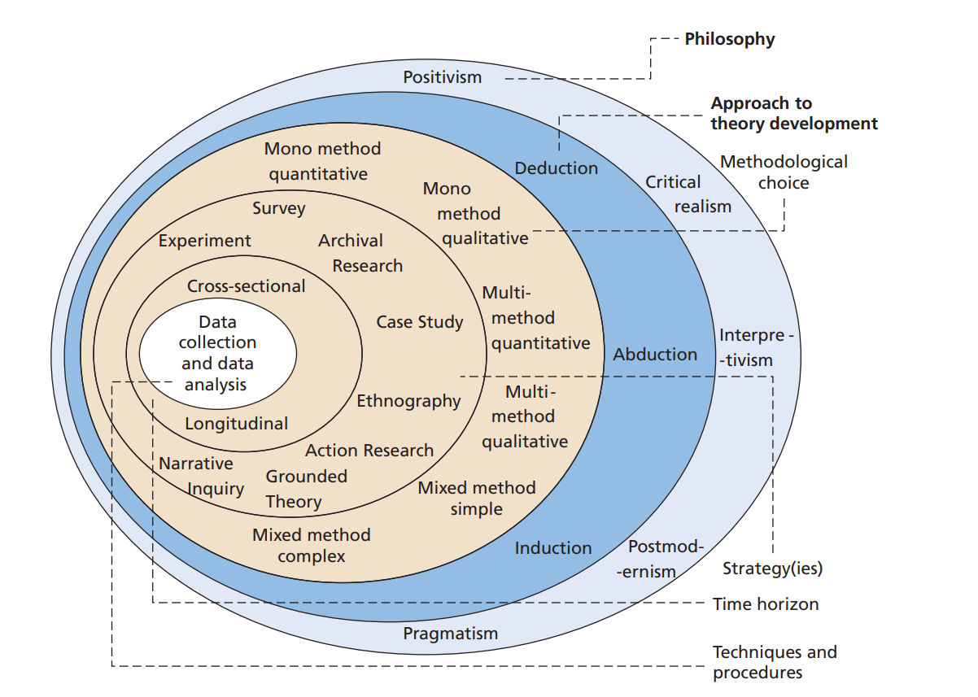
Figure 2 Research onion
Source: Saunders, Lewis and Thornhill (2019)

3.2 Philosophical stance
A research philosophy is based on the research paradigm that should be selected while exploring a specific area. The view of the investigator towards reality is provided by the paradigm that has two elements i.e., ontology and epistemology (Al-Ababneh, 2020). The type of data present in the reality or its nature is the aspect related to the ontology element whereas the philosophical stance is based on the set of principles followed towards the interpretation of the reality. Positivism, interpretivism and other types of philosophies are provided by the research onion. In the ongoing research, the investigator has decided to adopt the positivism philosophy so that an objective type of ontology is adopted. The benefit of an objective reality considered by positivism is that accurate findings are obtained while exploring a phenomenon (Alharahsheh and Pius, 2020). Also, the comparison of the knowledge in reality can be done with the existing information. The primary data evaluation from fashion retail SMEs in the UK can be compared with the studies reviewed in the previous chapter through the adoption of positivism.

3.3 Research approach
Reasoning is important for the interpretation of a piece of information related to a subject matter which is the consideration of the research approach as it provides the elements related to the research theory (Thomas, 2022). This aspect comes in the second layer of the research onion and can be deduction, abduction or induction based on the type of reasoning required in a study. An induction approach is about making a theory based on the current information whereas testing the information is the consideration of deduction (Woiceshyn and Daellenbach, 2018). It is essential in the present research that the data about innovation management and entrepreneurial leadership provided by other authors should be tested by analysing data from the fashion retail sector of the UK which indicates the relevance of the deduction approach. An alignment is also present between positivism and deduction because of the objective type of data considered by both. The collection of data from many people is allowed by the deductive research approach and thus will be effective for implementation while gathering information from people about the research area and within the fashion retail sector. It is evident that an effective primary study can be performed with the adoption of a deductive approach while implementing the positivism philosophy. However, data collection cannot be done in the absence of a research strategy and methodology which is discussed below.

3.4 Methodological choice
The methodology of a study refers to both the number of data types and the characteristics of data which leads to a mono method containing only one data type or multi and mixed methodologies which contain different types of data (Flick, 2015). Various choices are present in the research onion shown in figure 2 which include the mono qualitative or mono quantitative methods which are related to either only non-numerical or numerical data. The latter i.e., mono-quantitative methodology is adopted in the current study because an accurate view of the data is provided by numerical information. Statistical findings can be obtained with the use of numerical data related to a quantitative methodology which provides the chance to achieve precision in research outcomes (Walter and Andersen, 2016). It is also evaluated that this data will be related to the extent of entrepreneurial leadership in fashion retail SMEs is implemented. Another benefit of choosing the quantitative methodology is that it coincides with the deductive approach. A contribution to the research objectives will be given by this selection and thus the below strategy should also consider this selection.

3.5 Research strategy
A strategic consideration in research is based on the research framework providing guidance to the procedure as well as the plan towards data collection (Melnikovas, 2018). So, the selection of an adequate framework is required in this study so that relevant data is gathered during the research. A case study, ethnography, survey, action research, archival research, etc. have been provided by the framework of research onion from which adequate selection should be done. The survey strategy is adopted by the researcher because of the rationale to collect primary data. A cost-effective approach is provided by the survey strategy as it takes less cost and less time to gather data from a large number of individuals at once (Vaske, 2019). So, an ease in data collection procedure will be obtained from this potential of the survey strategy. Furthermore, the limited time present for completing the study will also be better addressed using the expedite approach used by the survey. It is chosen that an online survey should be performed because of the ease of sharing the survey link with the participants instead of distributing the data collection instrument in a paper-based survey. Google Forms is a free-to-use online platform selected for conducting the survey in this research so that data collection from the participants can be facilitated.

3.6 Time horizon
The extent to which gaps are present in the data collection process is identified by the time horizon of the study that is concerned by the layer after the research strategy. The patterns related to data gathering are considered in a time horizon and the cross-sectional type of time horizon provides a single instance of data collection. In contrast, various processes are required in this collection when a longitudinal time horizon is implemented because intervals are given among different instances of the gathering process (Sahay, 2016). There is only a limited time in the present scenario which cannot allow the presence of any gaps during data collection. So, this research adopts the cross-sectional time horizon as the survey will be conducted in a single instance and the data collection process will not include any intervals leading to the collection in one go. It is further interpreted that a cross-sectional investigation will provide the opportunity to adequately utilise the time allocated to the research process.

3.7 Research sample
A primary characteristic of a study requires the selection of participants who can provide relevant data for further evaluation. The target population is considered in the research sample which is a subset of this population and is reached so that the necessary information can be collected from the participants present in this subset (Taherdoost, 2017). The current study will include a sample of 50 individuals who satisfy the inclusion criteria i.e., being managers in fashion retail SMEs operating in the UK and should be more than 18 years old when it comes to age. The rationale for choosing managers as relevant participants because they can provide reliable information about the contribution of entrepreneurial leadership. In addition, the recruitment of research participants requires a sampling procedure which can help reach only relevant individuals. A snowball sampling procedure is implemented when people have the capability to refer the research to other similar individuals (Parker, Scott and Geddes, 2019). Therefore, the current study can benefit from this sampling method because managers can help in reaching other managers and this chain reaction can be continued until the research sample size is reached. Email and social media platforms will be used to approach and contact the participants and a consent form attached to the participant information sheet will also be shared to acquire their consent for participation.

3.8 Data collection technique
The subsequent approach of the sampling strategy is the method by which data will be collected from the research participants. A method of either focus group or interview is used when detailed data is required in a qualitative study whereas the data collection instrument of a questionnaire is selected when it comes to the necessity to gather numerical data in a quantitative study (Mazhar et al., 2021). So, it is evident that a questionnaire is beneficial because of the mono-quantitative method adopted in this research. Close-ended questions will be provided to the participants because of the objective and numerical data collection opportunity offered by a close-ended questionnaire. The questionnaire (refer to appendix) will be shared with each of the participants through a link to Google Forms where this questionnaire will be pasted. The agreement, disagreement or neutral nature of the responses can be identified from the adoption of the Likert Scale while developing a questionnaire (Taherdoost, 2019). So, this scale has been used so that an equal measurement to each question can be provided and the scale is made for items based on the research constructs which include the significance and challenges related to entrepreneurial leadership and the strategies and recommendations related to innovation management in UK’s fashion retail SMEs.

3.9 Method of data analysis
The extent to which reliable outcomes are obtained during a study is dependent on the data analysis method aligned with the research methodology. A descriptive method such as thematic analysis, discourse analysis or content analysis is used when qualitative data is collected whereas numerical data analysis is done when quantitative research methods are adopted (Wickham and Wickham, 2016). In the present research, a statistical method of data analysis is required because of the quantitative methodology adopted in the above sections. The close-ended data collected from the questionnaire should be analysed through a quantitative data analysis method. The frequency analysis approach is used when there is a dataset in which patterns are present based on the occurrence of different entities (Chambers, 2018). It is determined that the dataset of the current research also presents the occurrences of participants’ responses towards the questions asked of them. So, the frequency analysis method will be implemented to obtain the research findings. Another rationale for this choice is that graphs and tables developed during frequency analysis can be useful in interpreting the collected data and obtaining meaningful insights from the responses provided by the participants.

3.10 Ethical considerations
The confidentiality of collected data, the privacy of participants’ information, their informed consent and secure disposal are the critical elements present in ethical considerations of a primary investigation (Dooly, Moore and Vallejo, 2017). So, the evaluation of these aspects is also important in the ongoing research for which the first step will be using OneDrive so that the responses provided by the survey participants can be secured through a strong password. Regular monitoring of the storage will be done so that any breach of the data can be avoided. Furthermore, the questionnaire provided in this chapter does not contain any such questions which can disclose the personal information of the participants. This step has been taken so that the anonymity of the data is achieved to complete the research ethically. It is also determined that the disposal of the information is done on time to avoid any misuse. For this, the deletion of participants’ responses from the OneDrive storage will be done as soon as the objectives of the study are accomplished. The consent of individuals towards participation is also required and thus a participant information sheet along with a consent form will be shared with the participants before conducting the online survey.

3.11 Chapter summary
This chapter concludes that reliable outcomes can be obtained from the implementation of methods selected in the above section. The positivism philosophy has been considered relevant when it comes to the first research onion layer whereas the second selection has been the deductive research approach. It is determined that the mono-quantitative methodology is useful because of the accuracy and precision characteristics attained by its implementation. The online survey on Google Forms is chosen as the research strategy which is required for collecting objective data. Furthermore, a timely completion is facilitated by the selection of the cross-sectional time horizon and the questionnaire based on the Likert Scale provided in this chapter will be effective in the data collection process. The research participants have been selected as the managers working in UK’s SMEs in the fashion retail industry. The questionnaire will be distributed among 50 participants and they will be reached using the snowball sampling technique. The approach of frequency analysis has been chosen to analyse the collected data for achieving the research objectives. Mitigation of the possible ethical concerns will also be done through the ethical considerations discussed in this chapter.

Chapter 4. Data analysis, findings and discussion

4.1 Overview
This chapter has the purpose of conducting the frequency analysis methods for reaching the results of the research and accomplishing its objectives. The survey has been conducted among the research participants which now makes it essential to interpret the collected responses to gain meaningful insights. Section 4.2 implements frequency analysis to interpret the information and find pattens in the collected dataset based on participants’ responses. An interpretation of responses towards the demographic questions is first achieved which is then done for the Likert Scale measurement items. A discussion of the results is provided in section 4.3 which has the purpose of assessing the literature in relation to the research findings.

4.2 Frequency analysis

4.2.1 Analysis of the data based on demographic questions
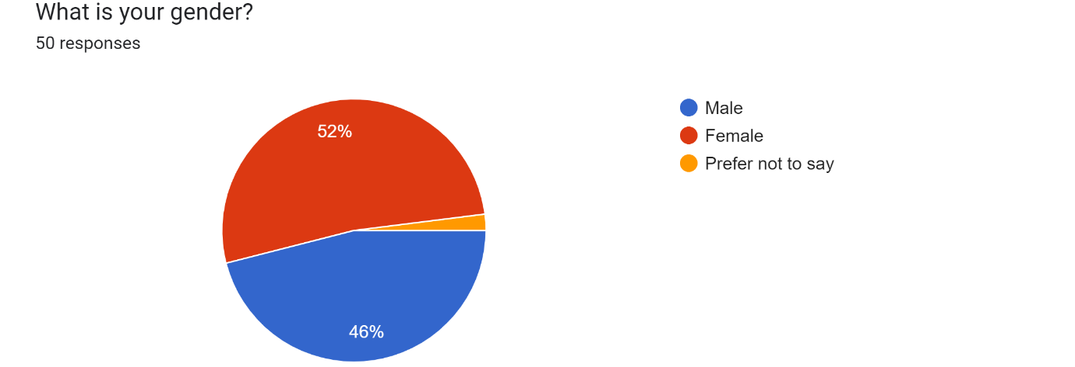
Figure 3 Pie chart depicting the data collected for the first question
Source: Google Forms
Table 1 Frequency table for the first question
Q1) | What is your gender? | Frequency
a) | Male | 23
b) | Female | 26
c) | Prefer not to say | 1
Total |  | 50
Source: By author
Interpretation
The demographic factors associated with the managers of fashion retail SMEs were considered in the first three questions of the survey. Gener of the participants was the first factor based on which the collected data is depicted in figure 3. A total of 50 people participated in the survey containing 23 males, 26 females and 1 preferred not to disclose as mentioned in the above frequency table. During a survey, the issue of gender bias is related to a greater number of responses from one gender as compared to another which can lead to unreliable data (Vehovar and Manfreda, 2017). It is analysed that the present study does not include such a bias as data is almost equally collected from male and female managers. So, the contribution of the gender demographic factor is determined towards the results of the study.
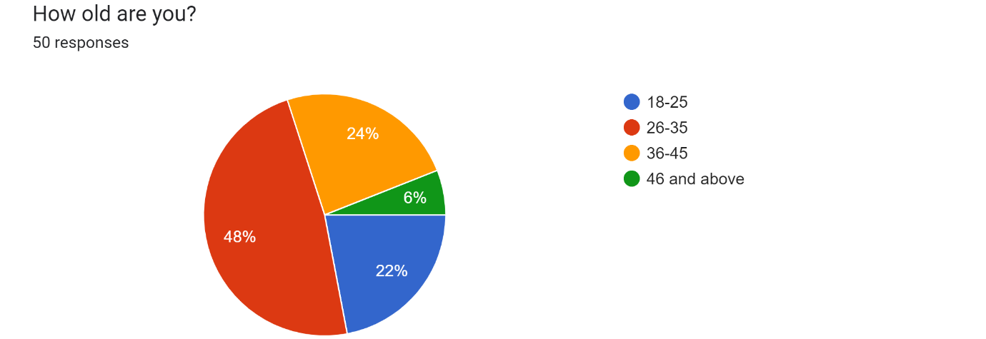
Figure 4 Pie chart depicting the data collected for the second question
Source: Google Forms
Table 2 Frequency table for the second question
Q2) | How old are you? | Frequency
a) | 18-25 | 11
b) | 26-35 | 24
c) | 36-45 | 12
d) | 46 and above | 3
Total |  | 50
Source: By author
Interpretation
A further exploration of demographics leads to the factor of age which has been the focus of the second question asked of the participants. The pie chart shown in figure 4 indicates that the highest number of respondents i.e., 48% were from the 26-35 age group whereas the second highest i.e., 24% were from the age group 36-45. Another close number was for the 18-25 age group. It is evident that opinions about innovation management and entrepreneurial leadership have been collected from managers of different ages which provides the reliability of the outcomes. A dependency on a certain age is not there which indicates that not only the perspectives of young managers but also the old ones have been considered during the research.
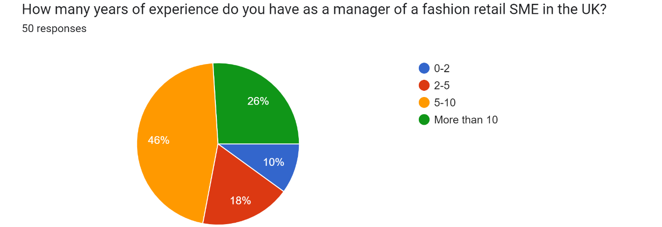
Figure 5 Pie chart depicting the data collected for the third question
Source: Google Forms
Table 3 Frequency table for the third question
Q3) | How many years of experience do you have as a manager of a fashion retail SME in the UK? | Frequency
a) | 18-25 | 5
b) | 26-35 | 9
c) | 36-45 | 23
d) | 46 and above | 13
Total |  | 50
Source: By author
Interpretation
The focus on SMEs is given by this study for which it was essential to collect data from managers who have adequate years of work experience in any fashion retail SME in the UK. 46% i.e., 23 participants have experience of 5 to 10 years as interpreted from the table and pie chart given above whereas 13 managers have work experience of more than 10 years out of the total 50 participants. The analysis of these frequencies highlights that the collected data is reliable because the opinions about innovation management and entrepreneurial leadership have been collected from managers of fashion retail SMEs who have adequate work experience.

4.2.2 Analysis of the data based on the first research objective
The first objective of this study is based on the significance of entrepreneurial leadership based on which three measurement scale items were developed in the Likert Scale questionnaire. The responses towards these three items are provided below the analysis of which is important for obtaining the research findings.
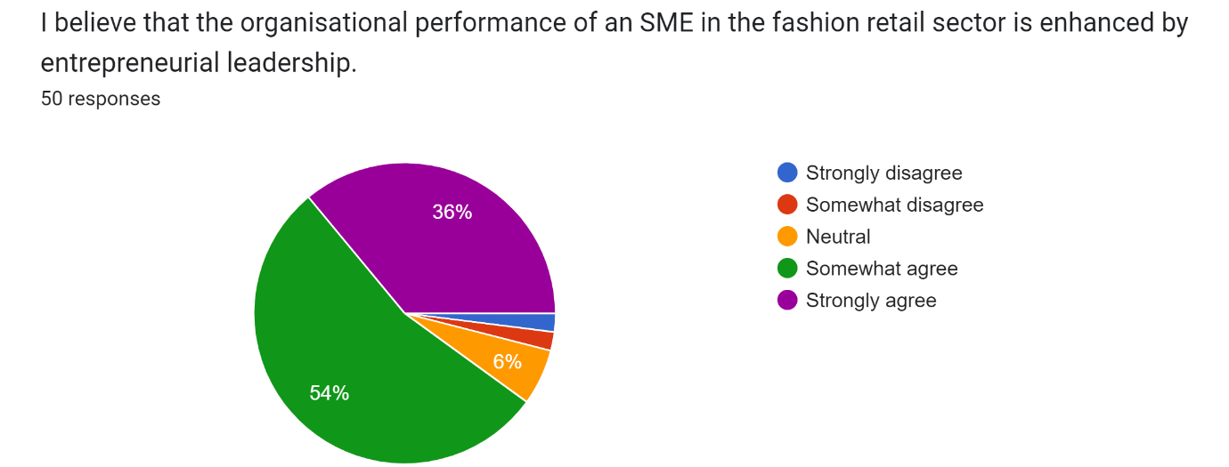
Figure 6 Pie chart depicting the data collected for the first scale item
Source: Google Forms
Table 4 Frequency table for the first scale item
1. | I believe that the organisational performance of an SME in the fashion retail sector is enhanced by entrepreneurial leadership. | Frequency
a) | Strongly disagree | 1
b) | Somewhat disagree | 1
c) | Neutral | 3
d) | Somewhat agree | 27
e) | Strongly agree | 18
Total |  | 50
Source: By author
Interpretation
The first measurement scale item based on the significance of entrepreneurial leadership is regarding the contribution of this leadership style to organisational performance. This factor was determined during the literature review and needed to be analysed in relation to the SMEs operating in the UK fashion retail industry. 27 out of 50 participants somewhat agreed and 18 strongly agreed that entrepreneurial leadership enhances the performance of fashion retail SMEs in the UK. A very low disagreement was obtained for this aspect which highlights the importance of the above contribution given by the leadership style. A common objective is fulfilled by the followers of an entrepreneurial leader and the efforts are aligned with each other eventually leading to better productivity (Cai et al., 2019). Therefore, it is analysed that the performance increases from the increment in the overall productivity of the workplace after the adoption of entrepreneurial leadership by the managers. The target market of fashion retail can be better tackled by an SME from this leadership style as the increased organisational performance would provide the chance to gain a competitive advantage in the fashion industry of the UK.
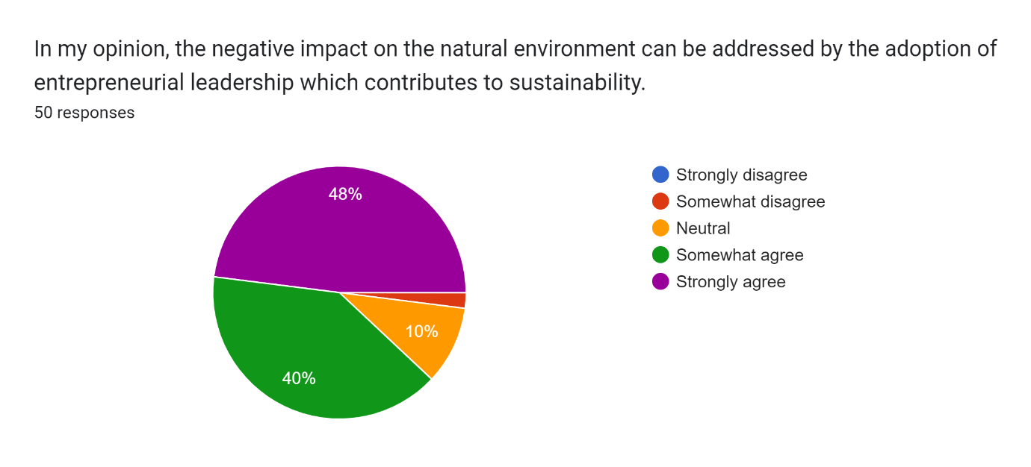
Figure 7 Pie chart depicting the data collected for the second scale item
Source: Google Forms
Table 5 Frequency table for the second scale item
2. | In my opinion, the negative impact on the natural environment can be addressed by the adoption of entrepreneurial leadership which contributes to sustainability. | Frequency
a) | Strongly disagree | 0
b) | Somewhat disagree | 1
c) | Neutral | 5
d) | Somewhat agree | 20
e) | Strongly agree | 24
Total |  | 50
Source: By author
Interpretation
The second aspect considered with the significance of entrepreneurial leadership is sustainability regarding which the above data was collected. It is interpreted from the pie chart shown in figure 7 that most of the participants agreed with the mitigation of the negative impact on the environment made by the organisation through the adoption of entrepreneurial leadership. A neutrality was highlighted by 5 out of 50 participants but the mostly agreement provides the significance towards sustainability. Green operations management in an SME is fostered by the actions of entrepreneurial leaders who opt for long-term growth through the assurance of sustainable activities (Rae, 2017). It is also analysed with respect to fashion retail SMEs in the UK after the evaluation of the above data. Sustainable actions such as recycling and reverse logistics can be implemented by such enterprises from the instructions related to such practices and thus long-term growth can be achieved.
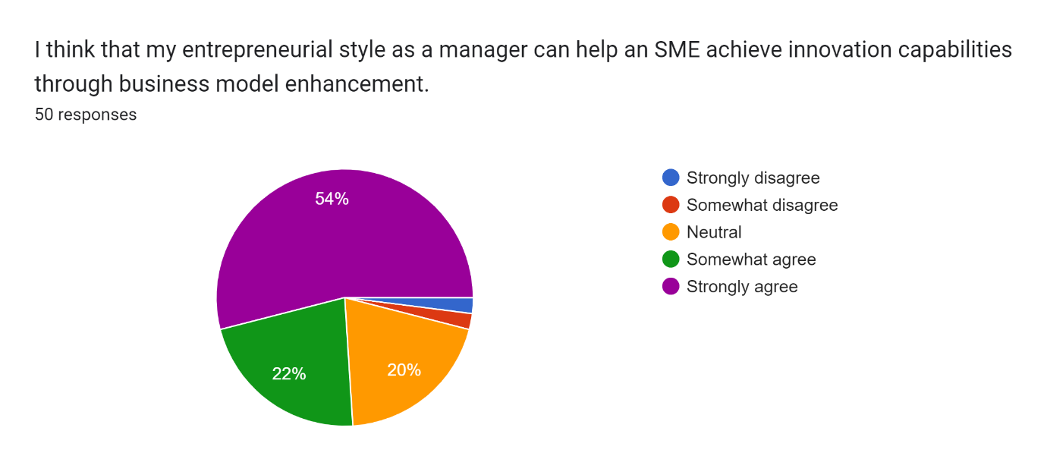
Figure 8 Pie chart depicting the data collected for the third scale item
Source: Google Forms
Table 6 Frequency table for the third scale item
3. | I think that my entrepreneurial style as a manager can help an SME achieve innovation capabilities through business model enhancement. | Frequency
a) | Strongly disagree | 1
b) | Somewhat disagree | 1
c) | Neutral | 10
d) | Somewhat agree | 11
e) | Strongly agree | 27
Total |  | 50
Source: By author
Interpretation
The contribution of the entrepreneurial leadership style to the business model enhancement is considered by the third scale item. It is essential to identify the extent to which an SME can foster innovation capabilities in the UK fashion retail sector. The above frequency table highlights that 10 participants have a neural nature with the provided scale item whereas the 11 participants somewhat agreed and 27 participants strongly agreed. It is analysed that to enhance the business model of the SME, the leaders should adopt the entrepreneurial leadership style. The entities present in the business model of a small and medium enterprise are improved from the efforts made by entrepreneurial leaders (Harrison, Burnard and Paul, 2018). With respect to the fashion retail sector of the UK, this significance has been identified because the business model can be enhanced as the innovation capabilities can be improved. It is analysed that new approaches should be adopted by fashion retail SMEs so that the leadership can contribute towards the innovation management related to the fashion industry.

4.2.3 Analysis of the data based on the second research objective
The second objective was regarding the strategies adopted by SMEs in the UK fashion retail sector towards innovation management. The fourth, fifth and sixth measurement scale items were related to this construct of the study the responses to which are depicted by the pie charts given below.
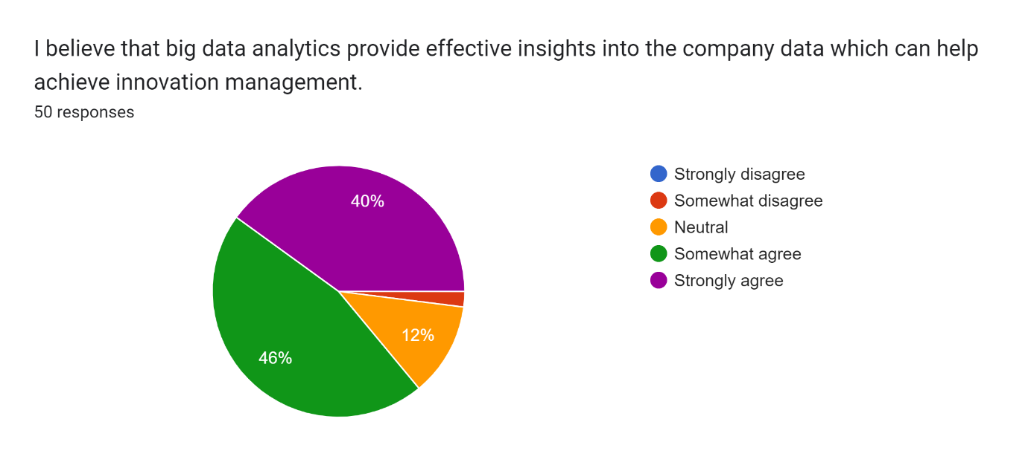
Figure 9 Pie chart depicting the data collected for the fourth scale item
Source: Google Forms
Table 7 Frequency table for the fourth scale item
4. | I believe that big data analytics provide effective insights into the company data which can help achieve innovation management. | Frequency
a) | Strongly disagree | 0
b) | Somewhat disagree | 1
c) | Neutral | 6
d) | Somewhat agree | 23
e) | Strongly agree | 20
Total |  | 50
Source: By author
Interpretation
An additional factor related to fashion retail SMEs was considered by the next measurement scale item which was big data analytics. The extent to which innovation management is achieved within the organisation is facilitated by this as interpreted from the collected data. 23 out of 50 participants somewhat agreed and 20 participants strongly agreed that the innovation management of a fashion retail SME in the UK can be facilitated by the implementation of big data analytics. The analysis of previous as well as current company data can be effectively done by the use of big data analytics which provides meaningful insights that are reliable towards a better performance in the target market (Marr, 2015). Therefore, an SME in the fashion retail sector of the UK can perform better after the utilisation of big data analytics that increases the innovation capabilities of the organisation. It is also interpreted that the adoption of entrepreneurial leadership can be effective for better utilisation of big data analytics.
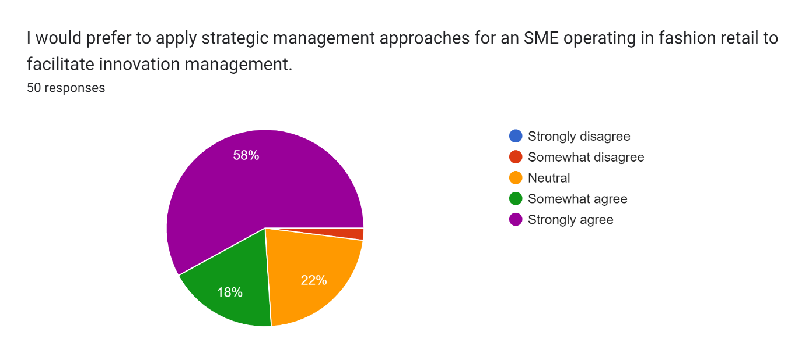
Figure 10 Pie chart depicting the data collected for the fifth scale item
Source: Google Forms
Table 8 Frequency table for the fifth scale item
5. | I would prefer to apply strategic management approaches for an SME operating in fashion retail to facilitate innovation management. | Frequency
a) | Strongly disagree | 0
b) | Somewhat disagree | 1
c) | Neutral | 11
d) | Somewhat agree | 9
e) | Strongly agree | 29
Total |  | 50
Source: By author
Interpretation
The second method related to innovation management was considered by the next scale item in which the focus was on the strategic management done within SMEs. The pie chart shown above reveals that 58% of the total managers who participated in the survey strongly agreed that this is a significant method that can be utilised towards innovation management. A very low disagreement was identified during the survey which indicates the tendency of the managers to adopt this method while working in a fashion retail SME in the UK. Strategic management is concerned with the alignment of internal operations with the organisational goals so that workforce operations are innovated (Henry, 2021). This is also true for the enterprises operating in the fashion retail sector of the UK as determined from the data collected from the research participants. It is recommended that new approaches towards company operations should be conducted by the managers in fashion retail SMEs so that innovation is effectively managed.
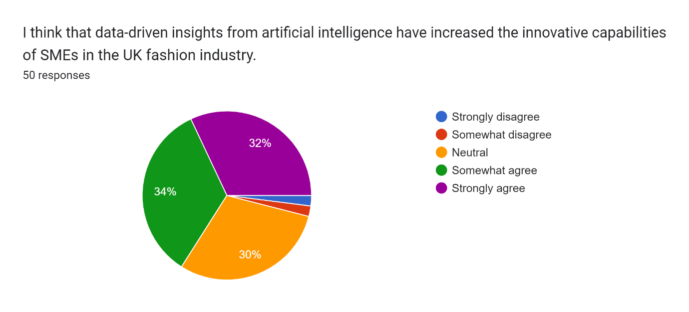
Figure 11 Pie chart depicting the data collected for the sixth scale item
Source: Google Forms
Table 9 Frequency table for the sixth scale item
6. | I think that data-driven insights from artificial intelligence have increased the innovative capabilities of SMEs in the UK fashion industry. | Frequency
a) | Strongly disagree | 1
b) | Somewhat disagree | 1
c) | Neutral | 15
d) | Somewhat agree | 17
e) | Strongly agree | 16
Total |  | 50
Source: By author
Interpretation
The use of artificial intelligence is prevalent among business organisations because of the opportunities provided towards data analysis and interpretation. This has been considered as another method used for innovation management and was asked of the research participants. It is analysed from the above frequency table and pie chart that a low agreement is obtained as compared to other questions because of the 30% neutrality and 4% disagreement. However, the majority of the respondents agreed that the innovation capabilities of SMEs operating in the fashion industry of the UK are increased by the data-driven insights provided by artificial intelligence. Decision-making in an SME is enhanced by the data-driven decisions made by the leaders after the implementation of AI algorithms by data analysts (Duft and Durana, 2020). It is analysed that better innovative steps can be taken by the leaders of fashion retail SMEs in the UK after the utilisation of such data-driven decisions. The contribution towards the growth in the fashion retail sector is also determined from the data collected during the survey which indicates the importance of this strategy.

4.2.4 Analysis of the data based on the third research objective
After the analysis of the number of methods adopted by SMEs towards innovation management, it is essential to identify the extent to which innovation management is hindered by the prevalent challenges. The third objective of this study was based on these challenges regarding which the collected data is provided below representing the responses towards the seventh, eighth and ninth measurement scale items.
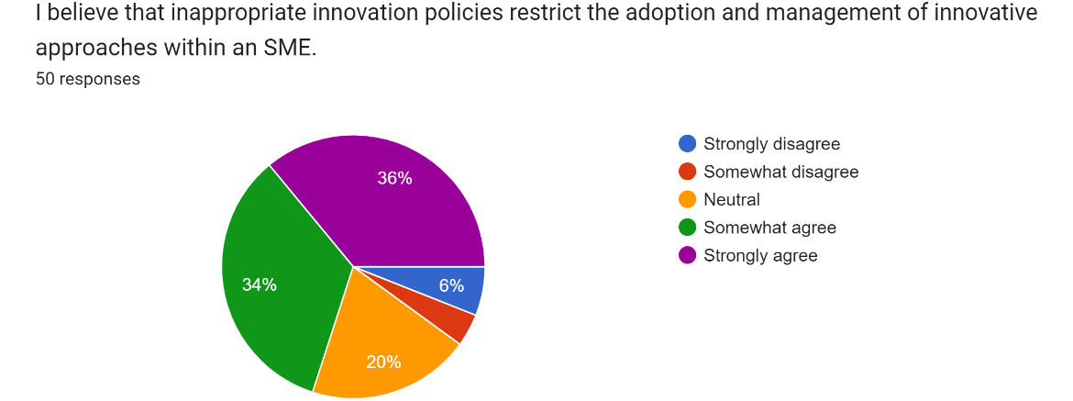
Figure 12 Pie chart depicting the data collected for the seventh scale item
Source: Google Forms
Table 10 Frequency table for the seventh scale item
7. | I believe that inappropriate innovation policies restrict the adoption and management of innovative approaches within an SME. | Frequency
a) | Strongly disagree | 3
b) | Somewhat disagree | 2
c) | Neutral | 10
d) | Somewhat agree | 17
e) | Strongly agree | 18
Total |  | 50
Source: By author
Interpretation
The first challenge regarding which data was collected from the participants is the absence of adequate innovation policies within the SME. The analysis of the collected highlights from the interpretation of the pie chart given above that 18 out of 50 participants strongly agreed and 17 somewhat agreed towards the existence of this challenge. However, a strong disagreement was also obtained from 3 participants along with the neutrality of 10 managers out of the total 50 who took part in the online survey. Innovative policies play the role of making the innovation capability of the organisation resilient so that any disruptions can be tackled in the industry and a better outcome is obtained (Mafabi, Munene and Ahiauzu, 2015). Therefore, it is evident that inappropriate innovation policies are challenges that need to be addressed by the leaders. With respect to fashion retail SMEs in the UK, the prevalence of this challenge has been determined from the data collected during the survey. It is evaluated that the adoption and management of innovative approaches cannot be done effectively in the absence of such policies which makes it essential for the managers to adopt the appropriate policies related to innovation management in the fashion retail sector of the UK.
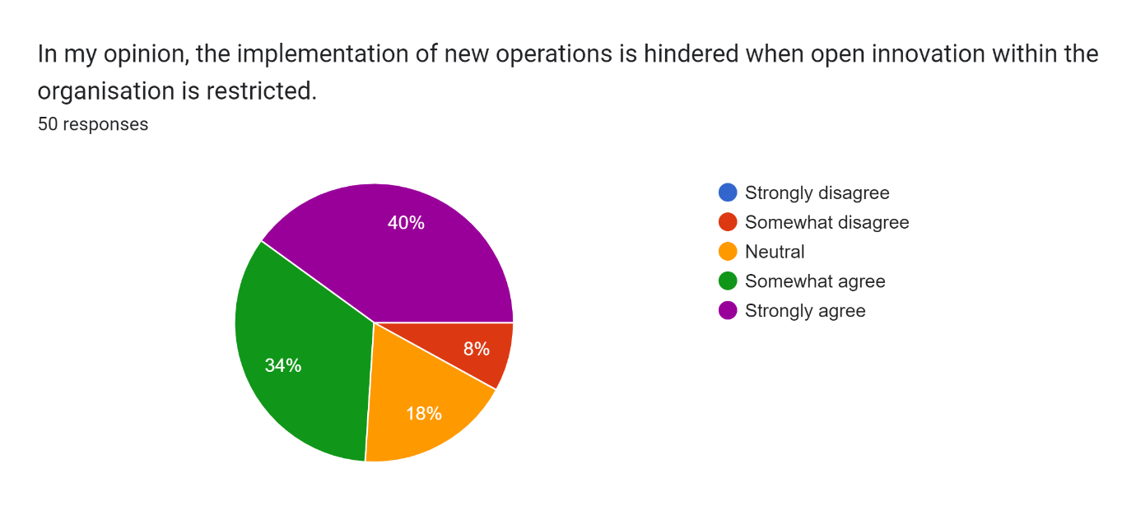
Figure 13 Pie chart depicting the data collected for the eighth scale item
Source: Google Forms
Table 11 Frequency table for the eighth scale item
8. | In my opinion, the implementation of new operations is hindered when open innovation within the organisation is restricted. | Frequency
a) | Strongly disagree | 0
b) | Somewhat disagree | 4
c) | Neutral | 9
d) | Somewhat agree | 17
e) | Strongly agree | 20
Total |  | 50
Source: By author
Interpretation
The restriction towards innovation was another consideration of the questionnaire regarding which the eighth scale item was asked of the research participants. 8% of participants somewhat disagreed with this challenge as interpreted from the graphical representation given in figure 13 whereas a total of 74% agreement was obtained while combining the responses to the fourth and fifth options. It is analysed that the managers working in the fashion retail SMEs of the UK consider the prevalence of this challenge a great deal while operating in the target industry and opting for innovation within the enterprise. The extent to which innovative approaches are implemented is restricted by the limitations related to new operations (Frow et al., 2015). This has been found true with respect to the fashion industry of the UK due to the agreement obtained from the managers who participated in the online survey. Therefore, it is recommended that the restriction in innovation should be addressed by the managers and the leaders so that new operations are effectively implemented for the growth of the SME in the fashion industry of the UK.
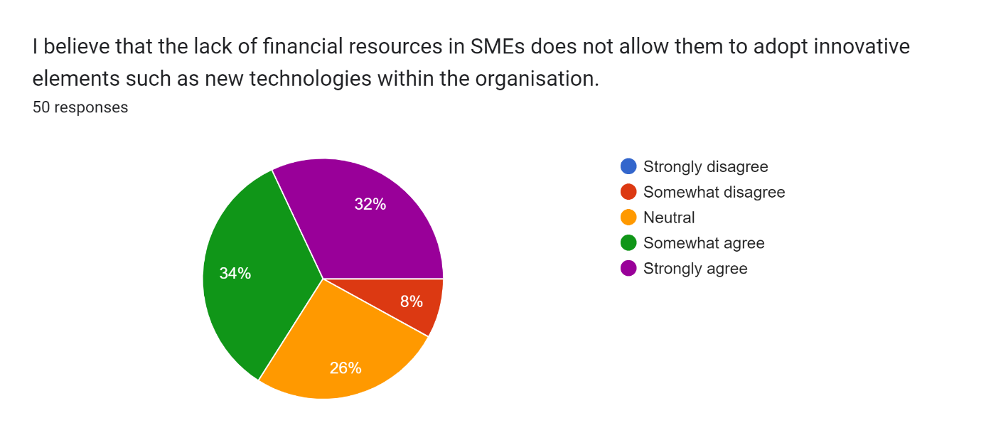
Figure 14 Pie chart depicting the data collected for the ninth scale item
Source: Google Forms
Table 12 Frequency table for the ninth scale item
9. | I believe that the lack of financial resources in SMEs does not allow them to adopt innovative elements such as new technologies within the organisation. | Frequency
a) | Strongly disagree | 0
b) | Somewhat disagree | 4
c) | Neutral | 13
d) | Somewhat agree | 17
e) | Strongly agree | 16
Total |  | 50
Source: By author
Interpretation
It is also important to consider the financial factors when it comes to SMEs because of the lack of financial resources among them as identified from the literature. The last scale item based on the construct of challenges was related to the challenge of lack of financial resources and its impact on the innovation management of an SME. The analysis of the collected data reveals the frequency of 16 for the strongly agree option, 13 for the neutral option and 17 for the somewhat agree option out of the 50 responses achieved during the survey. The managers agreed that the adoption of innovative elements such as new technologies is restricted by the lack of financial resources which is a challenge that needs to be addressed. The extent to which innovation is implemented within a small and medium enterprise is dependent on the security of the finance achieved by its management (Fraser, Bhaumik and Wright, 2015). In the fashion retail sector of the UK, this has been determined as a major problem as the lack of finance security can act as a restriction in the innovation management of an SME. It is necessary that adequate funding is procured and loans are taken so that the finances are required for implementing innovative methods.

4.2.5 Analysis of the data based on the fourth research objective
The recommendations towards better innovation management after the adoption of entrepreneurial leadership are considered by the fourth and last research objective. The last three measurement scale items in the questionnaire were based on these recommendations the responses towards which are provided below.
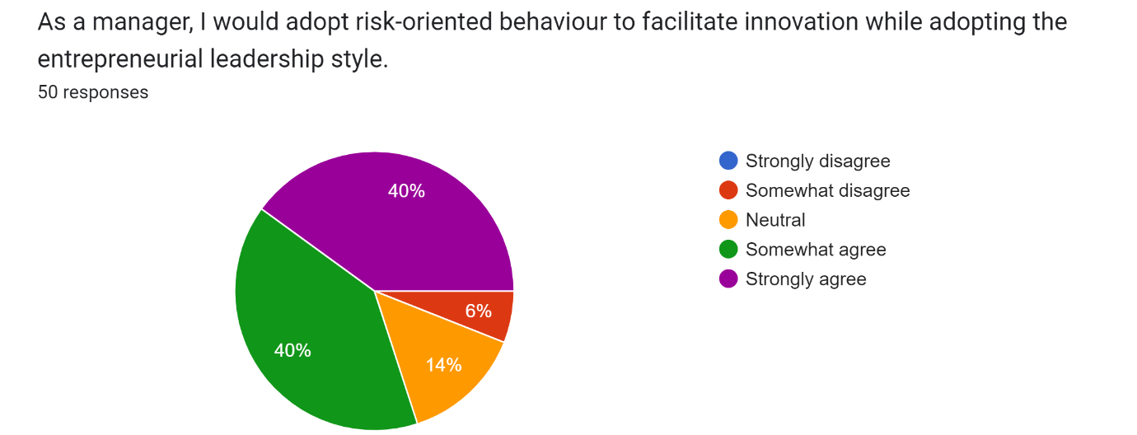
Figure 15 Pie chart depicting the data collected for the tenth scale item
Source: Google Forms
Table 13 Frequency table for the tenth scale item
10. | As a manager, I would adopt risk-oriented behaviour to facilitate innovation while adopting the entrepreneurial leadership style. | Frequency
a) | Strongly disagree | 0
b) | Somewhat disagree | 3
c) | Neutral | 7
d) | Somewhat agree | 20
e) | Strongly agree | 20
Total |  | 50
Source: By author
Interpretation
The first suggestion which was asked of the managers was the adoption of risk-oriented behaviour through entrepreneurial leadership. An 80% agreement from them was obtained during the survey as interpreted from the response frequency shown in the above pie chart. Nonetheless, 3 participants disagreed with this recommendation along with the 7 who remained neutral. The attributes of entrepreneurial leaders also include being risk-oriented as they take unconventional steps towards the achievement of organisational goals (Emeh and Ugwu, 2023). The potential of this attribute in the context of the UK fashion industry has been identified from the above-collected data. It is evident that after the adoption of this leadership style, managers can facilitate innovation within the SME because of the risk-oriented behaviour. Taking risks can be beneficial while implementing new approaches in processes, production, design or supply chain which can eventually contribute to the organisational performance in the fashion industry. A contribution towards a competitive advantage is thus identified from this relationship between innovation management and entrepreneurial leadership.
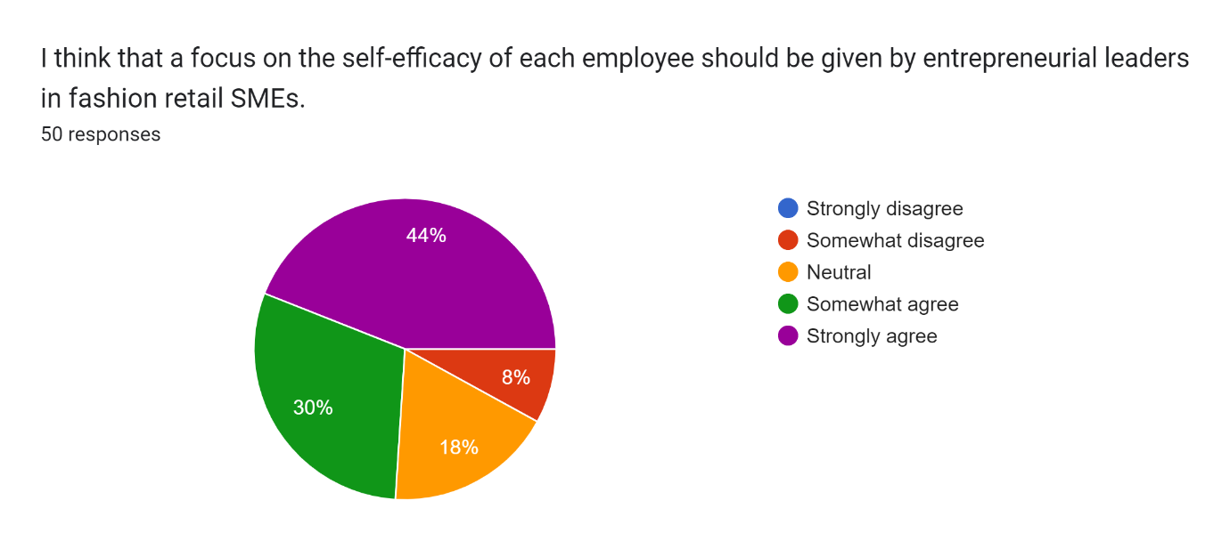
Figure 16 Pie chart depicting the data collected for the eleventh-scale item
Source: Google Forms
Table 14 Frequency table for the eleventh scale item
11. | I think that a focus on the self-efficacy of each employee should be given by entrepreneurial leaders in fashion retail SMEs. | Frequency
a) | Strongly disagree | 0
b) | Somewhat disagree | 4
c) | Neutral | 9
d) | Somewhat agree | 15
e) | Strongly agree | 22
Total |  | 50
Source: By author
Interpretation
Employees are essential parts of the workplace present in an SME and thus should be considered while dealing with innovation management. The data collected from the participants about the recommendation of increasing the self-efficacy of employees is favourable when it comes to the fashion retail sector of the UK. Despite the disagreement from 4 managers as shown in Table 4, the large number of responses towards agreement out of the total responses indicates the potential of this recommendation. Entrepreneurial leadership focuses on each of the followers and the development of their individual skills and knowledge (Harrison, Paul and Burnard, 2016). So, this development can be beneficial for implementing innovative approaches within the organisation and increasing the self-efficacy of employees. The recommendation is therefore more focused on this aspect by the leaders of SMEs in the fashion industry of the UK. A contribution to the productivity of the workforce and the performance of the SME will be given by the adoption of this recommendation.
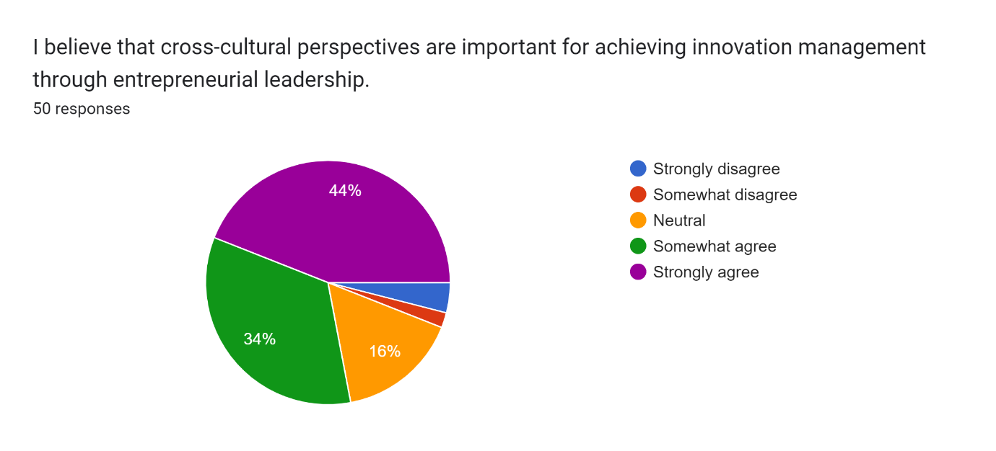
Figure 17 Pie chart depicting the data collected for the twelfth scale item
Source: Google Forms
Table 15 Frequency table for the twelfth scale item
12. | I believe that cross-cultural perspectives are important for achieving innovation management through entrepreneurial leadership. | Frequency
a) | Strongly disagree | 2
b) | Somewhat disagree | 1
c) | Neutral | 8
d) | Somewhat agree | 17
e) | Strongly agree | 22
Total |  | 50
Source: By author
Interpretation
The last strategic option asked of the participants was based on cross-cultural perspectives because of its role identified in an organisation. Favourable frequencies have been obtained during the survey and the frequency analysis reveals that 22 participants strongly agree and 17 participants somewhat agree with this recommendation. 2 respondents strongly disagreed whereas 8 remained neutral. The adoption of new methods within an organisation by the working employees is dependent on the understanding among people from different backgrounds that is done through the cross-cultural management of the entrepreneurial leader (Hanges et al., 2016). It is also understood that the communication between the members will improve from the environment obtained after the cross-cultural consideration. Therefore, leaders of fashion retail SMEs in the UK should foster innovation management by attaining cross-cultural perspectives while implementing entrepreneurial leadership.

4.3 Discussion of research findings
A number of insights were provided by the results of frequency analysis as identified above the reliability of which should now be assessed by comparing them with the literature that was previously reviewed in this study. According to Nor-Aishah, Ahmad and Thurasamy (2020), the sustainable performance of an SME is enhanced after an entrepreneurial leadership style has been implemented by the leaders. It is further identified from the arguments of these authors that a restriction towards the negative impact on the environment is achieved by SMEs through this type of leadership. The findings obtained in the present study also revealed an agreement among managers towards the significance of entrepreneurial leadership. So, the insights of Nor-Aishah, Ahmad and Thurasamy (2020) are confirmed by this research. In addition, the strategy of utilising artificial intelligence was explored by Haefner et al. (2021) in their study which revealed that the innovation process of an SME is enhanced after AI algorithms are leveraged for analysing the data present in the enterprise. The extent to which innovation is managed is increased from the adoption of AI as one of the main strategies. It is also determined that the machine-learning-based AI system provides the opportunity towards innovation management. This has been agreed upon by managers from the fashion retail sector of the UK and thus there is an alignment between the research findings and the arguments of Haefner et al. (2021).
According to Zainol et al. (2018), the performance of an SME increases to a great extent when it comes to the implementation of entrepreneurial leadership. A significant relationship between organisational performance and this leadership style was identified by the authors leading to the result that the internal operations are enhanced and more innovative approaches are implemented by the leaders of SME with this style. The results of the present study revealed from frequency analysis also provide the relationship between better organisational performance of SMEs in the UK fashion retail sector and entrepreneurial leadership which substantiates the arguments of Zainol et al. (2018). On the other hand, the importance of engaging stakeholders was emphasized by the exploration of Leonidou et al. (2020) as the authors revealed that SMEs obtain better outcomes when stakeholder engagement is ensured to an adequate extent. It is also determined from these insights that the relationship between growth and the satisfaction of stakeholders makes it essential for leaders to work towards their engagement. However, no factor of stakeholder engagement was identified in the present study and thus the results of Leonidou et al. (2020) are not confirmed by this research.
Sağ, Sezen and Güzel (2016) argue that open innovation is a critical aspect of SMEs which provides them the chance to grow in the target market. This is related to conflicting, collaborative and policy measures taken so that innovation can be done effectively. However, the desired results are not obtained when there are restrictions on open innovation among SMEs as revealed by the scholars. The extent of this challenge was also identified in the results of the frequency analysis obtained above and thus the arguments of Sağ, Sezen and Güzel (2016) coincide with the present research. On the other hand, the challenge related to inadequate innovation policies was determined by Uvarova and Vitola (2019) who revealed that the extent of innovation in an SME is restricted by the absence of such policies. These are important for taking formal innovative steps by the leaders so that the knowledge and skill of every member are utilised. However, the SME becomes unable to manage innovation and grow in the target industry when the policies are not present or are ineffective. The challenge of inappropriate innovation policies is also identified in the present study with respect to fashion retail SMEs in the UK. So, this study substantiates the arguments of Uvarova and Vitola (2019).
The significance of entrepreneurial leadership with respect to business model was determined by Teoh et al. (2022) who revealed that a significant improvement in the existing business model of an SME is achieved after this type of leadership is adopted by the leaders. It is further evaluated that revenue streams, marketing, supply chain and marketing are elements of the business model which are improved for an SME. The survey conducted among the managers of SMEs in the fashion retail industry of the UK also revealed positive responses from them about the significance of entrepreneurial leadership towards business model improvement. In addition, Del Vecchio et al. (2018) explored the area of big data analytics when it comes to SMEs and the innovation management achieved in them by the organisational members. Both the operational performance and consumer insights are improved after big data analytics is utilised effectively. The authors also revealed that innovation adoption, as well as management, are done to an optimum extent by SMEs when they utilise big data analytics. When it comes to fashion retail SMEs, the significance of big data analytics for open innovation has been determined from the outcomes of frequency analysis. So, the exploration of Del Vecchio et al. (2018) is substantiated by this research.
A focus on recommendations towards the adoption of entrepreneurial leadership was also given in the literature regarding which Renko et al. (2015) revealed that a risk-oriented behaviour should be adopted by the leaders so that innovation can be effectively managed. This contributes directly to the organisational goals of an SME and thus is an important suggestion for entrepreneurial leaders. The current research, while obtaining responses from the participants, also found that risk-oriented behaviour should be adopted by the leaders of fashion retail SMEs in the UK. So, there is a confirmation of the comments given by Renko et al. (2015). Another study in the same year was conducted by Koryak et al. (2015) whose arguments were also analysed during the literature review. It is determined from these arguments that a focus on dynamic capabilities should be given by the leaders of an SME so that innovation is achieved effectively. The extent to which entrepreneurial leadership becomes beneficial is dependent on the enhancement of such dynamic capabilities. However, the present study did not reveal this factor when exploring the SMEs operating in the UK fashion retail sector which does not confirm the arguments of Koryak et al. (2015).
According to Eniola and Entebang (2015), financial issues are faced by SMEs which do not allow them to implement innovation policies and ensure effective innovation management. The progressive nature and the new establishment of the enterprise highlight the absence of financial resources and the whole dependency on loans. The lack of capital and inability to secure financial provisions lead to such a challenge that does not allow any new innovative step such as the inclusion of a new technology. A confirmation of the insights of Eniola and Entebang (2015) has been achieved from the positive results obtained in the current investigation. Newman et al. (2018) recommended that a focus should be given to the leaders of SMEs on the self-efficacy of employees while implementing entrepreneurial leadership. Better decision-making is achieved by the members of the workforce when they are guided by these types of leaders. The suggestion of the author is towards individual performance enhancement leading to better self-efficacy. While exploring fashion retail SMEs in the UK, the results of frequency analysis also revealed the agreement of managers towards this recommendation which aligns with the insights of Newman et al. (2018).

4.4 Chapter summary
Frequency analysis has been effective in interpreting and analysing the data collected from the online survey which was conducted among managers of fashion retail SMEs in the UK. Positive responses are collected from them leading to the realisation that innovation management in these SMEs can be achieved with the implementation of entrepreneurial leadership. The alignment of the questionnaire with the conceptual framework of the study has been beneficial in obtaining relevant findings. It is also evident that the literature reviewed previously in this research prior to the selection of methodology has been confirmed by the findings. Most of the information aligns with the achieved results eventually highlighting the reliability of the outcomes.

Chapter 5. Conclusions and recommendations

5.1 Overview
This chapter holds the purpose of validating whether or not the research outcomes have been able to accomplish the aim of the research and its objectives. It also has the purpose of discussing the contribution provided by this study and the associated limitations. The significance of the outcomes achieved through primary data collection analysis will be realised from the evaluation of research implications. In addition, the scope of the research which has shortcomings can be better addressed through the identification of limitations. Various recommendations for future investigators are also provided in this chapter which have a focus on the recognised limitations.

5.2 Validation of achieving research aim and objectives
The aim was “To evaluate the impact of entrepreneurial leadership on innovation management within fashion retail SMEs in the UK.” This has been achieved by determining from the findings that a significant and positive impact is made by entrepreneurial leadership on innovation management. A further realisation of achieving this aim can be done by validating the research objectives. The first objective was “To analyse the significance of innovation management and entrepreneurial leadership in fashion retail SMEs in the UK.” The findings of this investigation highlighted that entrepreneurial leadership is significant for increasing the organisational performance of fashion retail SMEs in the UK. Innovation management is significant for long-term growth in the target market and gaining a competitive advantage. Entrepreneurial leadership is further significant for the achievement of sustainability and improving the existing business model of an SME operating in the fashion retail sector of the UK. A realisation of these listed benefits has led to the accomplishment of the first objective.
The second objective of this study was “To identify the strategies used by managers in fashion retail SMEs in the UK towards innovation management.” The survey has been effective in obtaining information about the implemented strategies. It is revealed by the outcomes of frequency analysis that artificial intelligence is used to make data-driven decisions towards innovation management. Big data analytics is also utilised so that effective steps can be taken after analysing the data related to the customers and the SME itself. In addition, the method of using strategic management techniques for achieving innovation management is adopted by managers of fashion retail SMEs in the UK.
The third research objective was “To recognise the challenges faced by fashion retail SMEs in the UK while managing innovation.” It is evaluated that the absence of appropriate innovation policies is a major challenge faced by these SMEs as determined from the research outcomes. Moreover, there is sometimes a restriction towards open innovation done by SMEs in the fashion retail sector which becomes a hindrance towards an adequate management of innovation. Financial challenges are also faced while implementing new and innovative ways of conducting company operations.
It is also essential that the identified challenges are addressed and thus the fourth objective was “To provide recommendations so that entrepreneurial leadership can be utilised by fashion retail SMEs in the UK to achieve better innovation management.” According to the data collected from the managers, risk-oriented behaviour must be adopted by entrepreneurial leaders of fashion retail SMEs. They should also focus on enhancing the self-efficacy of employees in the workplace so that innovation management can be facilitated. It is also recommended by the findings that cross-cultural perspectives should be adopted by entrepreneurial leaders to manage innovation effectively.

5.3 Research limitations
A restriction towards the extent of validity of the research outcomes as well as their reliability is made by the limitations related to each of the methods implemented while exploring a phenomenon (Queirós, Faria and Almeida, 2017). So, the identification of such limitations is necessary in the context of the performed research. One significant limitation is that the size of the study sample only included 50 individuals which hindered the overall extent of the findings. Sample size in research becomes the determinant of the primary data collected for evaluation and provides the reliability of the findings (Oribhabor and Anyanwu, 2019). So, a restriction towards the extent of primary data has been made by the small sample size of 50 participants which is an area that should be addressed in the future.
The second limitation is all about the type of methodology used in this primary investigation. A quantitative methodology was adopted in this research so that numerical findings are obtained against the research objectives. It is determined that the restriction towards the acquisition and interpretation of comprehensive insights is present due to the absence of open-ended data. A mixed methodology has the potential to not only provide objective outcomes through numerical data but also subjective outcomes from the collection and analysis of open-ended information (Almalki, 2016). However, the absence of this methodology provided the dependency on objective data analysis. The third limitation, on the other hand, is concerned with the sample characteristics because the sample only included managers from SMEs in the UK fashion retail sector. Their opinions were beneficial in achieving the research objectives but there was no comparison with the perspectives of employees about how innovation can be achieved and managed through entrepreneurial leadership. So, the limitation regarding the sample characteristics becomes evident for mitigation.

5.4 Implications of the study
The extent of significance associated with the research outcomes should now be realised with a focus on research implications that highlight the contribution of the study. The contribution towards the literature is based on the new data added to the literature or a gap addressed (Boudah, 2019). It is determined that the lack of investigation on fashion retail SMEs is the gap addressed by this study and primary data is now added eventually extending the existing scope of the literature. Another contribution is for the theory related to this research because a better understanding of entrepreneurial leadership style can be achieved from the interpretation of the findings. A theoretical implication is identified from this contribution which will help the managers of fashion retail SMEs in the UK to better implement the entrepreneurial leadership style. It is also determined that better outcomes towards innovation management will be achieved from this theoretical implication.
Policy implication is another aspect associated with a study and with respect to the current exploration, it is evident that better innovation policies can be implemented by fashion retail SMEs from the use of the results. Each of the findings will be effective for them to reform the policies that are implemented by them currently and make new policies based on the recommendations provided by this research. Practical implications are further related to the use of insights from a study in practice with the consideration of the new outcomes (Bakker, 2018). When it comes to the practical implications of the present study, it is evident that the findings about entrepreneurial leadership can be practically implemented by the managers so that better innovation management is accomplished in the UK’s fashion retail SMEs. They can put the recommendations into practice so that each of the benefits of entrepreneurial leadership style is leveraged to obtain effective outcomes.

5.5 Recommendations for future investigations
The scope of the existing study can be increased by researchers in the future through the consideration of various options. One such option is the implementation of the mixed research methodology to eliminate the dependency on numerical data. The data collection and analysis methods in a mixed-method study are based on qualitative and quantitative types of information (McCusker and Gunaydin, 2015). So, comprehensive insights into the contribution of entrepreneurial leadership towards innovation management will be achieved from the adoption of the mixed methodology. It is suggested that interviews should also be conducted among research participants along with a survey while adopting this methodology so that open-ended responses are collected by asking questions during interviews. The questions should be based on the factors identified from the literature and the purpose of conducting research. It is recommended to future investigators that an assessment should be done between the qualitative and quantitative results obtained by them.
Another suggestion is based on the research sample the size of which should be increased while opting for the data collection process. It was determined that only 50 managers were contacted for conducting the survey which should be addressed in the future by taking a sample size of more than 50. A large number of opinions either similar or different from the ones collected during the present study will be obtained from the implementation of this recommendation. Furthermore, an additional suggestion is that employees working in UK’s fashion retail SMEs should be contacted and their opinions should be gathered regarding the factors of innovation management and entrepreneurial leadership. The findings of the present study are only based on the responses of managers and thus this scope will be extended from the interpretation of employees’ perspectives. A comparison can then be made between the perspectives of managers and employees leading to more meaningful insights.

5.6 Chapter summary
This chapter succeeded in realising the validation of aim and objectives made at the commencement of this study. The overall aim of the research along with each of the four objectives have been accomplished by the research findings as identified in this chapter. Meaningful insights were provided by the results that contributed to the research area. The practical implication of using the findings into practice and understanding the theory of entrepreneurial leadership style have been determined. It is also concluded that innovation policies can be reformed by policymakers in fashion retail SMEs and effective literature implications are provided by this research by addressing the identified gap. Despite these implications, potential limitations were identified with respect to sample characteristics, sample size and the quantitative methodology. The recommendations offered for future investigators in this chapter will be beneficial in the mitigation of the limitations.

References
Abosede, A.J., Obasan, K.A. and Alese, O.J., 2016. Strategic management and Small and Medium Enterprises (SMEs) development: A review of literature. International Review of Management and Business Research, 5(1), p.315.
Ahn, J.M., Minshall, T. and Mortara, L., 2015. Open innovation: a new classification and its impact on firm performance in innovative SMEs. Journal of Innovation Management, 3(2), pp.p33-54.
Akbari, M., Bagheri, A., Imani, S. and Asadnezhad, M., 2021. Does entrepreneurial leadership encourage innovation work behavior? The mediating role of creative self-efficacy and support for innovation. European Journal of Innovation Management, 24(1), pp.1-22.
Al-Ababneh, M.M., 2020. Linking ontology, epistemology and research methodology. Science & Philosophy, 8(1), pp.75-91.
Alharahsheh, H.H. and Pius, A., 2020. A review of key paradigms: Positivism VS interpretivism. Global Academic Journal of Humanities and Social Sciences, 2(3), pp.39-43.
Almalki, S., 2016. Integrating Quantitative and Qualitative Data in Mixed Methods Research--Challenges and Benefits. Journal of education and learning, 5(3), pp.288-296.
Bagheri, A. and Harrison, C., 2020. Entrepreneurial leadership measurement: a multi-dimensional construct. Journal of Small Business and Enterprise Development, 27(4), pp.659-679.
Bakker, A., 2018. Design research in education: A practical guide for early career researchers. Routledge.
Bharti, K., Agrawal, R. and Sharma, V., 2015. Literature review and proposed conceptual framework. International Journal of Market Research, 57(4), pp.571-604.
Boudah, D.J., 2019. Conducting Educational Research:" Guide to Completing a Thesis, Dissertation, Or Action Research Project". SAGE Publications.
Cai, W., Lysova, E.I., Khapova, S.N. and Bossink, B.A., 2019. Does entrepreneurial leadership foster creativity among employees and teams? The mediating role of creative efficacy beliefs. Journal of Business and Psychology, 34, pp.203-217.
Chambers, J.M., 2018. Graphical methods for data analysis. CRC Press.
Del Vecchio, P., Di Minin, A., Petruzzelli, A.M., Panniello, U. and Pirri, S., 2018. Big data for open innovation in SMEs and large corporations: Trends, opportunities, and challenges. Creativity and Innovation Management, 27(1), pp.6-22.
Dooly, M., Moore, E. and Vallejo, C., 2017. Research ethics. Research-publishing. net.
Duft, G. and Durana, P., 2020. Artificial intelligence-based decision-making algorithms, automated production systems, and big data-driven innovation in sustainable industry 4.0. Economics, Management and Financial Markets, 15(4), pp.9-18.
Eggers, F., 2020. Masters of disasters? Challenges and opportunities for SMEs in times of crisis. Journal of business Research, 116, pp.199-208.
Emeh, N.C. and Ugwu, F.I., 2023. Designing An Entrepreneurial Firm: Implications For Entrepreneurial Culture And Leadership. Advance Journal Of Business and Entrepreneurship Development, 7(2).
Eniola, A.A. and Entebang, H., 2015. SME firm performance-financial innovation and challenges. Procedia-Social and Behavioral Sciences, 195, pp.334-342.
Flick, U., 2015. Introducing research methodology: A beginner's guide to doing a research project. Sage.
Fraser, S., Bhaumik, S.K. and Wright, M., 2015. What do we know about entrepreneurial finance and its relationship with growth?. International small business journal, 33(1), pp.70-88.
Frishammar, J., Richtnér, A., Brattström, A., Magnusson, M. and Björk, J., 2019. Opportunities and challenges in the new innovation landscape: Implications for innovation auditing and innovation management. European Management Journal, 37(2), pp.151-164.
Frow, P., Nenonen, S., Payne, A. and Storbacka, K., 2015. Managing co‐creation design: A strategic approach to innovation. British journal of management, 26(3), pp.463-483.
Haefner, N., Wincent, J., Parida, V. and Gassmann, O., 2021. Artificial intelligence and innovation management: A review, framework, and research agenda✰. Technological Forecasting and Social Change, 162, p.120392.
Hanges, P.J., Aiken, J.R., Park, J. and Su, J., 2016. Cross-cultural leadership: Leading around the world. Current Opinion in Psychology, 8, pp.64-69.
Harrison, C., Burnard, K. and Paul, S., 2018. Entrepreneurial leadership in a developing economy: a skill-based analysis. Journal of Small Business and Enterprise Development, 25(3), pp.521-548.
Harrison, C., Paul, S. and Burnard, K., 2016. Entrepreneurial leadership: A systematic literature review. International Review of Entrepreneurship, 14(2).
Henry, A., 2021. Understanding strategic management. Oxford University Press.
Kim-Soon, N., Ahmad, A.R., Kiat, C.W. and Sapry, H.R.M., 2017. SMEs are embracing innovation for business performance. Journal of Innovation Management in Small & Medium Enterprises, 1, pp.1-17.
Kim-Soon, N., Ahmad, A.R., Kiat, C.W. and Sapry, H.R.M., 2017. SMEs are embracing innovation for business performance. Journal of Innovation Management in Small & Medium Enterprises, 1, pp.1-17.
Koryak, O., Mole, K.F., Lockett, A., Hayton, J.C., Ucbasaran, D. and Hodgkinson, G.P., 2015. Entrepreneurial leadership, capabilities and firm growth. International Small Business Journal, 33(1), pp.89-105.
Leitch, C.M. and Volery, T., 2017. Entrepreneurial leadership: Insights and directions. International Small Business Journal, 35(2), pp.147-156.
Leonidou, E., Christofi, M., Vrontis, D. and Thrassou, A., 2020. An integrative framework of stakeholder engagement for innovation management and entrepreneurship development. Journal of Business Research, 119, pp.245-258.
Love, J.H. and Roper, S., 2015. SME innovation, exporting and growth: A review of existing evidence. International small business journal, 33(1), pp.28-48.
Mafabi, S., Munene, J.C. and Ahiauzu, A., 2015. Creative climate and organisational resilience: the mediating role of innovation. International Journal of Organizational Analysis, 23(4), pp.564-587.
Marr, B., 2015. Big Data: Using SMART big data, analytics and metrics to make better decisions and improve performance. John Wiley & Sons.
Mazhar, S.A., Anjum, R., Anwar, A.I. and Khan, A.A., 2021. Methods of data collection: A fundamental tool of research. Journal of Integrated Community Health (ISSN 2319-9113), 10(1), pp.6-10.
McCusker, K. and Gunaydin, S., 2015. Research using qualitative, quantitative or mixed methods and choice based on the research. Perfusion, 30(7), pp.537-542.
Melnikovas, A., 2018. Towards an Explicit Research Methodology: Adapting Research Onion Model for Futures Studies. Journal of futures Studies, 23(2).
Newman, A., Herman, H.M., Schwarz, G. and Nielsen, I., 2018. The effects of employees' creative self-efficacy on innovative behavior: The role of entrepreneurial leadership. Journal of business research, 89, pp.1-9.
Nguyen, P.V., Huynh, H.T.N., Lam, L.N.H., Le, T.B. and Nguyen, N.H.X., 2021. The impact of entrepreneurial leadership on SMEs’ performance: the mediating effects of organizational factors. Heliyon, 7(6).
Nor-Aishah, H., Ahmad, N.H. and Thurasamy, R., 2020. Entrepreneurial leadership and sustainable performance of manufacturing SMEs in Malaysia: The contingent role of entrepreneurial bricolage. Sustainability, 12(8), p.3100.
Oribhabor, C.B. and Anyanwu, C.A., 2019. Research sampling and sample size determination: a practical application. Journal of Educational Research (Fudjer), 2(1), pp.47-57.
Parker, C., Scott, S. and Geddes, A., 2019. Snowball sampling. SAGE research methods foundations.
Paudel, S., 2019. Entrepreneurial leadership and business performance: Effect of organizational innovation and environmental dynamism. South Asian Journal of Business Studies, 8(3), pp.348-369.
Paul, J., Parthasarathy, S. and Gupta, P., 2017. Exporting challenges of SMEs: A review and future research agenda. Journal of world business, 52(3), pp.327-342.
Queirós, A., Faria, D. and Almeida, F., 2017. Strengths and limitations of qualitative and quantitative research methods. European journal of education studies.
Radziwon, A. and Bogers, M., 2019. Open innovation in SMEs: Exploring inter-organizational relationships in an ecosystem. Technological Forecasting and Social Change, 146, pp.573-587.
Rae, D., 2017. Developing entrepreneurial leadership: the challenge for sustainable organisations. International Journal of Work Innovation, 2(1), pp.76-100.
Rahman, N.A., Yaacob, Z. and Radzi, R.M., 2016. An overview of technological innovation on SME survival: a conceptual paper. Procedia-Social and Behavioral Sciences, 224, pp.508-515.
Renko, M., El Tarabishy, A., Carsrud, A.L. and Brännback, M., 2015. Understanding and measuring entrepreneurial leadership style. Journal of small business Management, 53(1), pp.54-74.
Sağ, S., Sezen, B. and Güzel, M., 2016. Factors that motivate or prevent adoption of open innovation by SMEs in developing countries and policy suggestions. Procedia-Social and Behavioral Sciences, 235, pp.756-763.
Sahay, A., 2016. Peeling Saunder's research onion. Research Gate, Art, 3(2), pp.1-5.
Saunders, M., Lewis, P. and Thornhill, A., 2019. Research methods for business students. 8th ed. Pearson.
Saunila, M., 2020. Innovation capability in SMEs: A systematic review of the literature. Journal of Innovation & knowledge, 5(4), pp.260-265.
Sawaean, F. and Ali, K., 2020. The impact of entrepreneurial leadership and learning orientation on organizational performance of SMEs: The mediating role of innovation capacity. Management Science Letters, 10(2), pp.369-380.
Taherdoost, H., 2017. Determining sample size; how to calculate survey sample size. International Journal of Economics and Management Systems, 2.
Taherdoost, H., 2019. What is the best response scale for survey and questionnaire design; review of different lengths of rating scale/attitude scale/Likert scale. Hamed Taherdoost, pp.1-10.
Telukdarie, A., Dube, T., Matjuta, P. and Philbin, S., 2023. The opportunities and challenges of digitalization for SME's. Procedia Computer Science, 217, pp.689-698.
Teoh, M.F., Ahmad, N.H., Halim, H.A. and Ong, C.H., 2022. Digital Business Model Innovation and SMEs' Competitiveness: Insights from Malaysian SMEs. Global Business and Management Research, 14(3s), pp.412-433.
Thomas, G., 2022. How to do your research project: A guide for students. How to do your research project, pp.1-100.
Tidd, J. and Bessant, J.R., 2020. Managing innovation: integrating technological, market and organizational change. John Wiley & Sons.
Tigor, M., 2020. How to State the Research Problem/Problem Statement?. Rudang Mayang Publisher, 1(1), pp.1-2.
Tonț, D.M. and Tonţ, M.D., 2016. An overview of innovation sources in SMEs. Oradea Journal of Business and Economics, 1(1), pp.58-67.
Uvarova, I. and Vitola, A., 2019. Innovation challenges and opportunities in European rural SMEs. Mykolas Romeris University.
Vaske, J.J., 2019. Survey research and analysis. Sagamore-Venture. 1807 North Federal Drive, Urbana, IL 61801.
Vehovar, V. and Manfreda, K.L., 2017. Overview: online surveys. The SAGE handbook of online research methods, pp.143-161.
Walter, M. and Andersen, C., 2016. Indigenous statistics: A quantitative research methodology. Routledge.
Wecht, C.H., Cesinger, B., Vallaster, C. and Aleksic, N., 2021. Refocusing innovation management activities on sustainable circular business models-a framework and pathway for further research. In ISPIM Conference Proceedings (pp. 1-16). The International Society for Professional Innovation Management (ISPIM).
Wickham, H. and Wickham, H., 2016. Data analysis (pp. 189-201). Springer International Publishing.
Woiceshyn, J. and Daellenbach, U., 2018. Evaluating inductive vs deductive research in management studies: Implications for authors, editors, and reviewers. Qualitative research in organizations and management: An International Journal, 13(2), pp.183-195.
Zainol, F.A., Daud, W.N.W., Shamsu, L., Abubakar, H.S. and Halim, H.A., 2018. A linkage between entrepreneurial leadership and SMEs performance: An integrated review. International Journal of Academic Research in Business and Social Sciences, 8(4), pp.104-118.
Zeng, L., Lo, C.K. and Chen, Z., 2023. Fashion innovation through an innovation ecosystem–a research agenda. International Journal of Fashion Design, Technology and Education, pp.1-14.

Appendix

Survey questionnaire
Demographic Questions
Question 1. What is your gender?
a) Male
b) Female
c) Prefer not to say
Question 2. How old are you?
a) 18-25
b) 26-35
c) 36-45
d) 46 and above
Question 3. How many years of experience do you have as a manager of a fashion retail SME in the UK?
a) 0-2
b) 2-5
c) 5-10
d) More than 10
Measurement items based on the Likert Scale
Significance of entrepreneurial leadership
1. I believe that the organisational performance of an SME in the fashion retail sector is enhanced by entrepreneurial leadership.
a) Strongly disagree
b) Somewhat disagree
c) Neutral
d) Somewhat agree
e) Strongly agree
2. In my opinion, the negative impact on the natural environment can be addressed by the adoption of entrepreneurial leadership which contributes to sustainability.
a) Strongly disagree
b) Somewhat disagree
c) Neutral
d) Somewhat agree
e) Strongly agree
3. I think that my entrepreneurial style as a manager can help an SME achieve innovation capabilities through business model enhancement.
a) Strongly disagree
b) Somewhat disagree
c) Neutral
d) Somewhat agree
e) Strongly agree
Strategies towards innovation management
4. I believe that big data analytics provide effective insights into the company data which can help achieve innovation management.
a) Strongly disagree
b) Somewhat disagree
c) Neutral
d) Somewhat agree
e) Strongly agree
5. I would prefer to apply strategic management approaches for an SME operating in fashion retail to facilitate innovation management.
a) Strongly disagree
b) Somewhat disagree
c) Neutral
d) Somewhat agree
e) Strongly agree
6. I think that data-driven insights from artificial intelligence have increased the innovative capabilities of SMEs in the UK fashion industry.
a) Strongly disagree
b) Somewhat disagree
c) Neutral
d) Somewhat agree
e) Strongly agree
Challenges related to innovation management
7. I believe that inappropriate innovation policies restrict the adoption and management of innovative approaches within an SME.
a) Strongly disagree
b) Somewhat disagree
c) Neutral
d) Somewhat agree
e) Strongly agree
8. In my opinion, the implementation of new operations is hindered when open innovation within the organisation is restricted.
a) Strongly disagree
b) Somewhat disagree
c) Neutral
d) Somewhat agree
e) Strongly agree
9. I believe that the lack of financial resources in SMEs does not allow them to adopt innovative elements such as new technologies within the organisation.
a) Strongly disagree
b) Somewhat disagree
c) Neutral
d) Somewhat agree
e) Strongly agree
Recommendations towards entrepreneurial leadership
10. As a manager, I would adopt risk-oriented behaviour to facilitate innovation while adopting the entrepreneurial leadership style.
a) Strongly disagree
b) Somewhat disagree
c) Neutral
d) Somewhat agree
e) Strongly agree
11. I think that a focus on the self-efficacy of each employee should be given by entrepreneurial leaders in fashion retail SMEs.
a) Strongly disagree
b) Somewhat disagree
c) Neutral
d) Somewhat agree
e) Strongly agree
12. I believe that cross-cultural perspectives are important for achieving innovation management through entrepreneurial leadership.
a) Strongly disagree
b) Somewhat disagree
c) Neutral
d) Somewhat agree
e) Strongly agree

