A personal report on how much I learned and understood of the module of professional career development!
I will start talking firstly about the role play we did with my classmate and how we present it, from my point of view I could have probably added more information make created a leaflet with the information for the job position and like that helped my classmate much more to understand the job they would be applying for and treat it more like an interview then just a role play. But what I did I feel like I did well was the fact that I spoke loud and clear also me and my classmate had a lot of out of class practices so we can perfect it which was good as well as eye contact and confident and loud speaking which is incredibly important during a job interview. This is the job description that I created:
Job Information:
Permanent Full-time Career in a Nursing home
Reference: Alisia Rodrigo
Position title: Permanent Full-time Medical Carer
Driver: Bonus
Postcode: SE21 4RN
County: Greater London
Ideal start date: 21st November 2021
Days and Hours Required:
Monday - Sunday 9:00 am - 8:00pm (additional hours may be required on an ad hoc basis)
Job Description:
Working with the elderly and attending all their needs as per example:
- giving out pills
-toilet breaks
-feeding them
- keeping them away from dangerous areas of the care facilities
You might also work with people with dementia but that will require additional training fully provided by us.
Most of our patients are 65+ years of age and could be challenging but we search for people with patience and well-trained communication skills as their families often visit...

Questions for the applicant:
My name is Yoana Karanova the head manager of The Well share Care Facilities I read through your cv and was impressed by your interview those are my final questions for you:

1.How did you hear about us?
- Friends
- Facebook
- Instantjob.uk
- Family
- Job leaflet
2.Can you tell me why should I hire your fir this position?
- Personal skills
- Experience
- Good qualities
3.What days of the week are you available to for and can we call you in off hours?
- weekdays
- weekend days
- night or day shifts
4. What skills do you possess that will help you for this job position?
- More in depth how your skills can benefit this job position
That is what I presented my interview idea and those were the questions that I asked as well as I said to my current subject that I will be sending further information like payment and stat date in a further email as that I feel like it’s something important and most people ask for when they first go into a job interview.

In this next part of my report, I would like to reflect on the different skills and knowledge and what it means as well as how does it make work more efficient in all deferent areas. For an example let’s talk about a works place efficiency and how it happens all organizations pay for the diligence and efficiency of their employees. Individuals need to achieve their assigned goals within the desired time frame. It is important for employees to meet deadlines and deliver results on time. Why does an organization have to sponsor you when you can`t get things done on time? Employees need to be efficient and proactive to be more productive. The 4,444 employees must work on time to expect timely evaluations and ratings from executives as well as external customers. Delaying work does not lead to a solution. To be more efficient in the workplace, you need to take a systematic approach. Do not start a new task until the previous task is completed. Employees tend to be efficient if they take their work seriously and do not consider it just a source of stress. The motives of your life must be very clear.
Ask yourself why you come to work. Is it just for money?
Or do you want to grow up as a professional and draw your own picture? 44 If you go to the office just to get a monthly salary, think again.
Who will ask you to stay in the office for a long time? Finish your work on time, go home and have fun with your friends and family. Sitting in the office for a long time does not prove that you are a hard-working employee, but that you are poorly time-managed, completely chaotic, and inefficient. Indicates. Your organization doesn't pay you for socializing or gossip with colleagues. Interactions between employees are important, but make sure your tasks are done on time. Organize your workplace. Throw away what you no longer need. Save important documents in the appropriate folders to avoid unnecessary searches. Organize and organize and get rid of clutter. Don't waste your chat with friends and family on the phone, social networking sites, games on your computer and more.
Prioritize your work and perform one step at a time. Important and urgent tasks must be performed first. Focus on work. Focusing on your necessities will increase your efficiency. Being efficient does not mean doing more work in less time and ignoring the quality of work. Do not compromise on quality. To get quality results,
people need to focus on their work, not just their time. Employees are labelled as efficient only if they complete their assigned tasks on time with minimal error. You need to do a high-quality job right away.
Do not work alone. Rather, each team member works with a team that maximizes their skills to reach their goals within a specific time frame. Managers should delegate work based on their expertise, educational background, experience, and employee interests. That way, people tend to enjoy their work and help the company outperform its competitors. Set a deadline to get the job done on time or sooner. When you're in time for the deadline and you're done on time, tap behind. For an organization to run smoothly, it is imperative that
employees complete their tasks within a specific time frame. Why do customers have to come back to you when you can't deliver their project on time? Employees need to be motivated and entertained so that they can get results on time with minimal errors.
Let's look at some simple tips for improving workplace efficiency.
Let employees talk to each other. What is the harm of discussing a problem with a colleague? After all, we
know that there are certain things that are mature and confidential and should not be discussed at any cost.
Responsibilities should be assigned based on individual interests, disciplines, previous experience, and expertise. Job mismatches always cause problems. How can you expect an accountant to be effective in promoting you?
brand and increasing sales within the
time frame you want. Even if you don't know the basics of marketing, joining a marketing or branding team won't give you results.

As a team manager, you need to understand the areas where your employees can bring their maximum. Don't let her feel overwhelmed.
She advises her to appear in the office on her time, and
advises her to leave on time. Don't ask your employees to stay in the office until late. Believe me, such habits not only reduce an individual's performance, but also increase stress levels. Individuals need to take a
break and
spend time with
friends and family. So, you will be fresh and happy the next day.
employees need to clean up at least
workplaces once a week. Throw away anything you don't think will be useful in the future. Keep your desk clean. Stationery should be stored in a suitable location. Keep all your important documents
in one folder. Label all
files. believe me. So, you don't waste your time searching unnecessarily. Get in the habit of using planners and desktop calendars with the
. Write down all the important activities of the planner at the right time. Keep all important contact numbers handy.
Learn to prioritize things. Don't focus on what you don't need now. The urgent task must be performed first. Create a to-do list. Before you leave, make a note of
what you must do. When the task is complete, put a check mark in front of it. I managed
hours well. Be logical to yourself. There is nothing wrong with talking to your spouse or relatives or checking your personal email at work. Believe me, everyone does. Jobs suffer when employees waste their time talking about rumours and spreading unnecessary rumours. Limit the length of face-to-face conversations at work. If you're not smart enough to understand that you're being paid for your efforts and efficiency, nothing helps. Your boss does not always control you. Ignore unwanted pop-ups, websites with jokes, money-making tricks, games, and more. 4,444 employees should be able to make some decisions on their own. Why do you always wait for manager approval, even if you have a small problem? It slows a person's performance and ultimately delays work.
Filter emails. You don't have to reply to every email. Ignore emails that you think are not important.

Kolb’s Theory on career development cycle is interesting because "We are ... gaining knowledge of species, and our survival isn't most effective withinside the reactive experience of adapting to the bodily and social worlds, however additionally withinside the fantastic experience of making and forming those worlds. It relies upon at the cap potential to adapt. "
Quote: David Kolb, Hands-on Learning (1984, p.2).
David Kolb`s "Experiential Learning Cycle" (1984) remains a broadly used model, in person education. In an experience, it resonates. Especially after formal training, we adults generally tend to analyse high-quality from enjoy. From this enjoy, we expand an idea approximately the world. Driving time (Giles)
However, I argue that the pictures from Unsplashed.com of Orkin Asap Kolb aren't with out
critics and that they want to be aware about what they say. Therefore, this newsletter
first offers an outline of Kolb's model. Next,
the critic's argument is considered. Finally, I
draw conclusions from the coach's factor of view.
Model of Kolb the gaining knowledge of cycle of the unique shape of
Kolb is a circle:
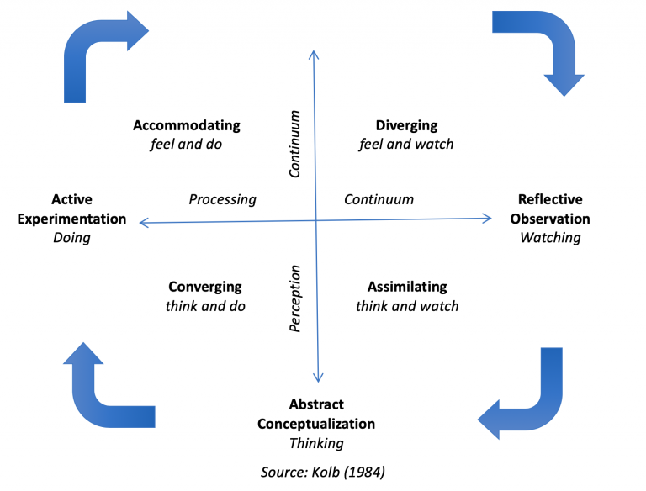
First there may be a "concrete enjoy" of an occasion or enjoy. When you reflect on consideration on it, you're in a kingdom of "summary conceptualization." These summary standards then result in in addition levels of "energetic experimentation", and then the cycle is restarted from the beginning. As beginners undergo the cycle, they change "from actor to observer" and "from precise participation to fashionable analytical distance" (Kolb1984).
Kolb additionally compares his experiential gaining knowledge of cycle with Piaget's collection of developmental levels (quoted with the aid of using Piaget 1971,
Moon 1999: 25). Both fashions are primarily based totally at the manner of assimilation (taking records from the environment) and adaptation (converting what's already acknowledged
withinside the mild of recent gaining knowledge of).
Read greater
Kolb argues that the experiential gaining knowledge of cycle may be implemented in a whole lot of situations. In a few cases, conduct and regret can arise greater or much less simultaneously, however he shows that gaining knowledge of primarily based totally on enjoy over
longer durations or timelines is likewise possible.
Criticism of Model
However, for a few, the simple illustration of Kolb's enjoy cycle is just too clear.
Moon (1999) argues that "stay enjoy" (direct involvement withinside the scenario) and conceptual fabric already found out aren't processed withinside the equal manner. Reprocessing of enjoy may be qualitatively extraordinary and might arise on the equal time as a try to recognize something new. In addition, Eisner (1991, quoted from Moon 1999: 32) argues that the sensory belief of the scenario actively entails us. In his view, "interpretation is crucial, now no longer discovery." The manner we understand enjoy has already contributed to the formation of meaning.
Bound and Walker (1990; 1993: quoted with the aid of using Moon 1999: 32) make a comparable factor. Our interpretation of what we understand may be cultural. You trust Eisner that the act of belief can influence what takes place later withinside the cycle.
Finally, Eisner makes some other exciting factor. Writing down your mind can make contributions to gaining knowledge of. Targeted questions from
greater skilled human beings are remarkable thoughts, however they're now no longer the most effective manner to feed your mind. Writing down our thoughts
additionally, way that new discoveries come to the fore (quoted from Eisner 1991,
Moon 1999: 32).
So how beneficial is Kolb`s model?
Overall, Moon has made a legitimate factor: “raw” enjoy and earlier gaining knowledge of are probably to be extraordinary things. The cycle can be an oversimplification of what surely takes place withinside the brain (Moon 1999).
Moreover, we must know no longer be naïve. Kolb isn't suggesting short fixes are to be had whilst all isn't properly at work. Instead, you could cope with long-time period problems along with motivation and commitment (Cartwright2011).
Nevertheless, Kolb's idea nevertheless appears to provide numerous trainers. Perhaps it is time to appearance lower back on current experiences. In addition, the remarks from the instructor can draw the trainee's interest to what's maximum crucial after the observation. Thinking approximately, it could assist trainees reorganize their considering common situations (Laurillard2012).
Overall, I might argue that Kolb`s experiential gaining knowledge of cycle remains a beneficial model. Yes, it can be oversimplified in practice. But Kolb remains proper to mention that mirrored image on enjoy is the start line for expert growth. Trainers and trainees can honestly each relate to that.

Refference List:

1. Role play presentation
2. kolbs cycle wikipedia
3. Wikipedia work efficiency

