History & Theory 1
Barcelona Pavilion
Mies van der Roche

By
Zeke Hann

Word count: 1359

Historical Background
The Barcelona Pavillion, once known as the German Pavillion was originally built for the German entry in the 1929 World’s fair by the renowned Bauhaus director and German avant-garde architect Ludwig Mies van der Roche, usually referred to by his surname only. Worlds’ Fairs have been in existence since the mid-19th century in over 20 countries and began being governed by the Bureaux International des Expositions (BIE), a Paris based organisation from its creation after being set up in 1928. Its goal was to regulate international expositions considered worlds’ fairs and set responsibilities of host cities and its participants. Although their guidelines were refined over time, it was in the early 21st century a “registered exhibition” was determined as one which could be held once every five years, following which a smaller exhibition termed “recognised”, could be held in the interim, with restrictions to one exhibition of each within the five year span (Finding, 2018). Their primary purpose was to provide immersive and interactive exhibitions, facilitated and organised by governments and renowned for uniting countries and international organisations around the world in order to find solutions to fundamental issues facing humanity. After the World’s fair the pavilion was dismantled, and its parts were sold off to recoup some of the cost of construction, due to the economic downturn in post war Germany. However, an initiative from the Ayuntamiento de Barcelona saw an almost exact replica built in the exact same place, the construction started in 1983 and was completed in 1986. The pavilion sits at the foot of the National Art Museum of Catalonia and Montjuic at Av. Francesc Ferrer i Guàrdia, 7 and is considered as one of the four conical pieces of the modernist architecture movement, alongside Le Corbusier’s Villa Savoye, the Bauhaus by Walter Gropius and Frank Lloyd Wright’s Fallingwater. (Kroll, A, 2011)

Plan and Section
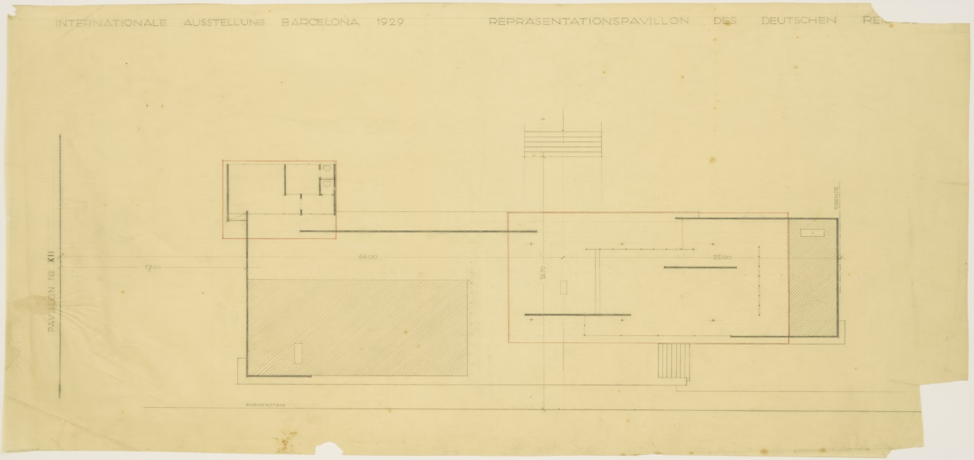
Figure 1 Moma.org

Mies van der Roche’s design for the pavilion is one of the first ideas of neoplasticism. He chose the buildings position carefully, moving it away from the more central position originally chosen to somewhere more secluded. Mies designed the pavilion with his “more is less” philosophy and recognised that the design of pavilion would be nothing more than simply a building, an exhibit-free space that wouldn’t hold any artwork, except for the now infamous Barcelona chair and The nude figurative statue of Dawn by German sculptor Georg Kolbe, which sits in the north west corner of the inner court’s reflecting pool. The building has two more statue bases, in which Mies originally intended to place statues, one in the terrace pool and the other in the alcove facing the garden path, but only the Kolbe statue made it in to the final design. The building sits atop of a plinth, the access is via a seven tread steps that run parallel to the main body of the building. You enter into an open court that houses the large reflecting pool, which sits to the left, a path a wall runs across the rear of the court, with the wall continuing down the left side and pat the way across the front. The pavilion sits to the right of the plinth. The roof is held up by eight cruciform pillars. It has two walls running length ways down the plot, one makes up the entrance external wall and the other is in the main space. With an open plan free façade design, Mies eliminated the need for structural internal walls. Mies uses various glass walls to close off the building and give a sense of space throughout. The inner walled court included a smaller reflection pool. Two seating areas were introduced, one internal in the main space and the other external behind the large pool. (kroll, A, 2011)
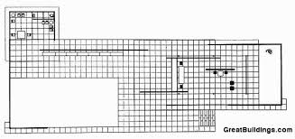

Materials and Light
Mies van der Roche’s philosophy was to use the highest quality materials available. Whilst he used a simple concrete covered steel beam design for the roof and pillars made of four L-profile steel beams bolted together. Mies covered his design in some the most exquisite 1m long tiles of varying colours and texture, while the walls in the open court, plinth and the whole floor were covered in Ancient Roman Travertine, giving a light, warm, calming feeling inviting visitors to enter. The green marble Tinos tiles cladding the entrance gives a dark contrast to mark the entrance out. The African Onyx tiled wall inside the main space gives a darkened focal point to which the gloss white Barcelona seats contrast against. The green Alpine marbled walls of the inner court continue the green theme through, contrasting the floor and Dawn statue. The high gloss chrome sheet cladding around the pillars and windows frames give a feeling of grandeur, whilst the various colour glass windows give a varying colouration to the materials he chose depending where in the building a person views them from (Kroll, A, 2011). If the design of the furniture does not complete the structure of a building, there is no harmony in the interior. This concept almost forced Mies van der Rohe to design the matching furniture for his buildings. (Barcelona.de)
Idea and Theories Underpinning the Design
Mies van der Rohe developed the Barcelona Pavillion in line with the Bauhaus style, which is evident in its design using a “less is more” sentiment. Clear lines and smooth forms are what pitches the pavilion as a style template for modern architecture. Mies van der Rohe is now considered as one of the most important architects of the modern era because of his ability to design and develop effective supporting structures that allowed for flexibility in its use. In 1913, he developed his own independent architectural business where for a long time he pursued the more conventional design of buildings. But in 1921, Mies van der Rohe joined the artists association “November Group”. Here he presided over their architectural section, which gave him licence to develop his style into the modern architectural style that gained him much attention, although at the time he was still considered by some as too avant-garde. However, in 1929, he was assigned the artistic chief designer of the German Pavilion for the World Exhibition.
Mies van der Rohe implemented two important principles of modern architecture through the design of the pavilion. He freed the building of its limitations by removing all supporting interior walls and appointing these supportive elements to the exterior, by means of exterior walls or supporting stilts. This is now known as “free façade” construction. He also created the “open plan” principle, allowing the space inside the building to be cohesive, yet defining spaces within the building for particular functions, avoiding physical divides between rooms. In order to do this, he cleverly utilised lighting, different floor tiling, various colour and carefully positioned furniture in order to act as separating elements. The functionless pavilion became one of the main attractions of the exhibition because of its unconventional architecture and design. (Barcelona.de)

Conclusion
The Barcelona Pavillion was designed by architect Ludwig Mies van der Rohe as Germany’s entry into the 1929 Worlds’ Fair exhibition merely to demonstrate Germany’s pioneering creativity in the world of architecture. Even though it was dismantled shortly afterwards, and pieces sold for reimbursement for expenditures, it made such a lasting impression that it was resurrected as close to its original design as possible, given the availability of materials, many years later. Ludwig Mies van der Rohe sadly died almost 20 years before the accolade to him began construction. Yet he is now known as one of the famous architects to influence the modern architectural era.
His style is of simple “less is more” construction, with solely exterior supportive structures, allowing for spacious open plan design are popular principles among modern architects today as it allows for versatility of designs which can be easily altered, even after completion. Despite the versatility, there is equally congruency in the flow of the design, both internally and externally, which is complimentary of each other. His influence through this and his use of lighting can be seen in modern structures being developed worldwide even today, which proves that his world was influential and catalyst for change in this field.

References
Barcelona.de, Pavilion Mies van der Rohe, German Pavilion at the World Exhibition 1929, Barcelona.de : https://www.barcelona.de/en/pavillon-mies-van-der-rohe-barcelona.html [accessed 21.04.20]
Beureaux International des Expositions, What is an Expo? Beureaux International des Expositions: https://bie-paris.org/site/en/what-is-an-expo [accessed 21.04.20]
Findling, J (2018) Worlds’ Fair, Encyclopaedia Britannica : https://www.britannica.com/topic/worlds-fair [accessed 21.04.20]
Great Buildings (2020), Figure 2 Barcelona Pavilion Layout 2: http://www.greatbuildings.com/buildings/Barcelona_Pavilion.html [Accessed: 21/04/2020]
Kroll, A (2011). AD classics: Barcelona Pavilion/ Mies van der Roche: https://www.archdaily.com/109135/ad-classics-barcelona-pavilion-mies-van-der-rohe. [Accessed: 21/04/2020}
Moma (2020). Figure 1 Barcelona Pavilion Layout 1. https://www.moma.org/collection/works/87529 [Accessed: 21/04/2020]

