Programme: Certificate in Higher Education – Employability Skills
Module: Effective Team-working and Communication
Module code: BMSW4009
Student ID and Name

Table of Contents
1. Introduction 3
1.1 Overview of the importance of effective teamwork in organisational success 3
1.2 Purpose and objectives of the report 3
2. Theoretical Framework 3
2.1 Overview of each model and its main concepts 3
2.1.1 Belbin 3
2.1.2 Tuckman 4
2.1.3 Kilmann 5
2.2 Importance of theoretical models to understand team dynamics 5
3. Team Roles 6
3.1 Explanation of the Belbin model and its purpose 6
3.2 Discussion of the nine team roles identified by Belbin 6
3.3 Real-world examples of how organisations have applied the Belbin model to optimise team composition and task allocation. 6
4. Understanding Team Development 7
4.1 Introduction to the Tuckman model's stages of team development 7
4.2 Discussion of each stage in detail, highlighting the challenges and opportunities associated with team development 7
4.3 Examples of how teams can navigate each stage effectively to achieve high performance. 8
5. Managing Conflict in the Workplace 8
5.1 Explanation of the Thomas Kilmann model's five conflict-handling styles 8
5.2 Discussion of the significance of understanding these styles in managing conflicts within teams. 9
5.3 Examples of how organisations have utilised the Thomas Kilmann model to resolve conflicts and maintain positive relationships. 9
6. Conclusion 9
6.1 Key findings and insights from the report 9
6.2 Reflection on the importance of effective teamwork in organisational success. 9
6.3 Recommendations for organisations seeking to build and maintain high-performing teams 10
List of References 11

1. Introduction

1.1 Overview of the importance of effective teamwork in organisational success
Organisational success largely relies on the proper working of a team. It combines different types of knowledge and approaches and encourages innovative approaches while working on multifaceted tasks. When skills and tasks are interdependently integrated the teams address objectives and deliver results in a shorter span with enhanced efficiency (Mullins, 2016).

1.2 Purpose and objectives of the report
The main purpose of the report is based on the information concerning the models of team building (Belbin, Tuckman, Kilmann), as well as understanding teamwork, the development of teams, conflicts, and the identification of successful functioning factors of a team. Additionally, the objective of the report is based on assessing the possibility of applying these models in organisations for the enhancement of the teamwork process for achieving high organisational performance.

2. Theoretical Framework

2.1 Overview of each model and its main concepts

2.1.1 Belbin
Belbin’s Team Roles framework is commonly referred to as specific contributions that any individual member can make in a group setting (Belbin, 2010). It has 9 roles namely Plant, Resource Investigator, Co-ordinator, Shaper, Monitor Evaluator, Team worker, Implementer, Completer Finisher, and Specialist. It is effective to identify these roles when strategizing on the composition of the team to strike a balance, that is, to ensure individual role and their effectiveness in the team.
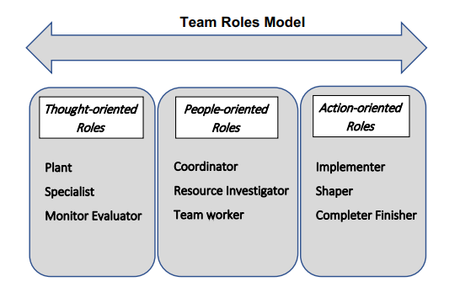
Figure 1: Belbin Team Roles Theory
(Source: Rahmani et al., 2022)

2.1.2 Tuckman
Tuckman's model outlines five stages of team development including Forming, Storming, Norming, Performing, and Adjourning (Jones, 2019). The following is a model that captures the dynamic nature of teams as well as their evolution process to optimize their output. It has been found that, if these stages are identified and managed, timely intervention can be used to improve the teams’ functioning within the organizations.
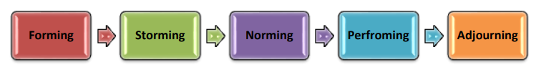
Figure 2: Tuckman's model
(Source: Jones, 2019)

2.1.3 Kilmann
The Thomas-Kilmann model identifies five conflict-handling styles, including viewing the organisation as competing, collaborating, compromising, avoiding, and accommodating (Qadir, 2020). 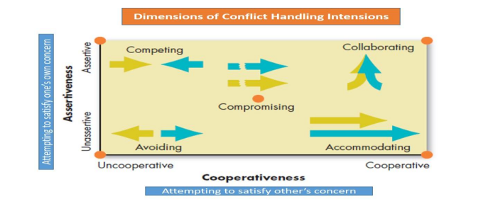
Figure 3: Thomas-Kilmann conflict handling models
(Source: Qadir, 2020)

2.2 Importance of theoretical models to understand team dynamics
All the three models discussed above are useful instruments tostudy varied aspects of teamwork. In this view, a team must consider the use of these models for improving interaction and improving teamwork in organisations. Similarly, the Belbin model could be very helpful in real time scenarios, when it comes to narrowing down and suggesting functionality in a set group in a group undertaking (Rahmani et al., 2022). Concerning the types of work groups, Tuckman’s stages illustrate the process of teaming to address complex issues, specify how such issues should be dealt with, and overcome difficulties during the teaming process. Besides, the Thomas-Kilmann model offers an approach towards conflict solving which can be implemented to work towards proactive resolution without damaging the relationships and foster teamwork (Adham, 2023).

3. Team Roles

3.1 Explanation of the Belbin model and its purpose
The Belbin team roles model has been conceptualized to utilise a person’s innate team role on an organisational team for maximum productivity (Belbin, 2010). This model asserts that each member offers an individual way, which portrays nine important roles, of working on the team.

3.2 Discussion of the nine team roles identified by Belbin
Plant: They refer to good ideas.
Resource Investigators: They are social and look at exposure and building relations.
Coordinator: They have established collaboration and sub-grouping.
Shaper: They follow objectives and direct the group.
Monitor Evaluator: They help to follow the rationale for making bias-free decisions (Aranzabalet al., 2022).
Team players: They cooperate and negotiate to emphasise cooperation within a team.
Implementer: They are disciplined to emphasise transforming ideas into solid action steps.
Finisher: Serving with commitment and precision, with respect to professionalism and optimum performance.
Specialists: They are dedicated, knowledgeable and provide detailed information.

3.3 Real-world examples of how organisations have applied the Belbin model to optimise team composition and task allocation.
Organizations have diversely adopted Belbin’s formulation of building teams that address comprehensiveness by including team members from various functional areas to cover all aspects of problem-solving. For example, in NASA functioning the model is used when assigning tasks where more proficiency and preference are assigned to any person or group in NASA (Nasa, 2024). In turn, it has helped in the enhancement of project management and the success rate of their mission. Concerning how organizations can put into practice the ideas put forth by the Belbin model, three primary ways present themselves giving direction on team composition and work distribution. In this view, it has been considered three ways including competencies of team members, fostering team collaboration, and retaining desired outcomes with effective teamwork (Adair, 2015).

4. Understanding Team Development

4.1 Introduction to the Tuckman model's stages of team development
Tuckman’s framework outlines the process that most teams follow over time and their developmental cycles.

4.2 Discussion of each stage in detail, highlighting the challenges and opportunities associated with team development
Forming: The forming stage in Tuckman’s model entails team members becoming familiar with one another, creating interpersonal rapport, and setting organizational aims and objectives (Patterson, 2022). Amidst these challenges, the unclear allocations of roles and responsibilities frequently constitute the focus.
Storming: The storming stage revolves around conflict and confrontation as the individuals in the team try to contest for authority. However, the communication analysis at this stage of the project is subject to clarifying expectations, managing conflicts, and creating norms for interaction.
Norming: The norming stage involves the establishment and recognition of various norms within the team including, cooperation, responsibility, communication, and interdependence (Patterson, 2022).
Performing: The performing stage thus can be viewed as the final sequence where the team is well-coordinated and highly productive in achieving set goals (Tuckman and Harper, 2012). Transparency, accountability, structure, and authority are all well defined in respect to each of the reducing roles for the organisation’s power structures.
Adjourning: This stage is the adjourning stage which takes place when the team is dissolved once it has accomplished all its work and goals (Patterson, 2022). Nevertheless, it is also a good time for people or organizations to review the accomplishments of the past period, people’s awards, and organizational successes.

4.3 Examples of how teams can navigate each stage effectively to achieve high performance.
Googlerecruits’ diverse employees and provides effective training which are aligned with individuals’ roles and learning preferences. In addition, developing open communication culture has helped Google in managing more effectively to get to these stages performing well. In addition, the team building stages could be used in different settings (Toombs, 2020). Such as forming a stage where there is definite structure with the aims and responsibilities of each member. The storming stage is where disagreements are voiced and resolved, where the team spirit is maintained through potential communication and appreciation (Zirar et al., 2023). Moreover, performing is where the team is made responsible and enabled to accomplish the set goals, and adjourning is where the activities are summed up and discussed.

5. Managing Conflict in the Workplace

5.1 Explanation of the Thomas Kilmann model's five conflict-handling styles
The Thomas-Kilmann model outlines five conflict-handling styles (Benke, 2023). The five identified negotiation styles are,
Conflict-Handling Style | Assertiveness | Cooperativeness
Competing | High | Low
Collaborating | High | High
Avoiding | Low | Low
Compromising | Moderate | Moderate
Accommodating | Low | High

5.2 Discussion of the significance of understanding these styles in managing conflicts within teams.
This model helps understand conflict patterns within the teams and apply the right strategies based on the style used.This includes challenges related Power struggles, and communication barriers, within the organizations. It is essential for detecting potential conflicts and implementing strategies. This will help in keeping up the drive and increasing performance, with a focus on goal-oriented objectives being aligned with current goals. Similarly, applying such models helps organisations to understand the behavioural patterns of their teams(Stadler, 2019). This further helps in developing conflict management tactics to bring out the best in the organisational systems to successfully fulfil organisational goals and objectives on set time.

5.3 Examples of how organisations have utilised the Thomas Kilmann model to resolve conflicts and maintain positive relationships.
For example, Google supports collaboration where people from different departments with different perspectives are used to solve a given problem (Maedche et al., 2019). This aspect refers to the fact that by using the Thomas-Kilmann model, conflicts are managed, and this improves teamwork and even healthy relations among the various groups or parties.

6. Conclusion

6.1 Key findings and insights from the report
This report has focused on the theoretical foundations of Belbin’s Team Roles, Tuckman’s Stages of Team Development, as well as Thomas-Kilmann Conflict Mode Instrument that fosters growth in teams. These models give an understanding of what is expected by an individual in collaboration, dealing with phases in team development as well as behaviour in conflict situations.

6.2 Reflection on the importance of effective teamwork in organisational success.
Consequently, understanding teamwork and promoting it has been proven to be an essential factor in any organisation as it enhances organisational performance and organisational commitment. Other important evidence about the contribution of teams pointed to the idea that utilizing different and complementary skills and perspectives always results in better outcomes.

6.3 Recommendations for organisations seeking to build and maintain high-performing teams
Belbin roles should be implemented when selecting the right team that an organisation needs to form a better team through Tuckman’s model and to handle these conflicts that arise throughout the team development, the Thomas-Kilmann model should be used. It is also imperative that organizations pay much attention to improving the communication pathways and incorporating frequent team-building activities for high-quality teams (Mullins and Christy, 2016).

List of References
Adair, J.E., (2015). Effective teambuilding : how to make a winning team (revised.edition). London : Pan Books
Adham, T.K.I., (2023). Conflict Resolution in Team: Analyzing the of Conflicts and Best Skills for Resolution. Sch J Eng Tech, 8, pp.152-162.
Aranzabal, A., Epelde, E. and Artetxe, M., (2022). Team formation on the basis of Belbin’s roles to enhance students’ performance in project based learning. Education for Chemical Engineers, 38, pp.22-37.
Belbin, R. M., (2010). Team roles at work, (2nd edition). London: Routledge
Benke, M., (2023). How To Solve Conflict Situations Better With The Model Of Thomas And Kilmann. Economic and Social Development: Book of Proceedings, pp.229-238.
Jones, D.A., (2019). The Tuckman’s model implementation, effect, and analysis & the new development of Jones LSI Model on a small group. Journal of Management, 6(4).
Maedche, A., Legner, C., Benlian, A., Berger, B., Gimpel, H., Hess, T., Hinz, O., Morana, S. and Söllner, M., (2019). AI-based digital assistants: Opportunities, threats, and research perspectives. Business & Information Systems Engineering, 61, pp.535-544.
Mullins, L.J. (2016). Organisational Behaviour in the Workplace. 11th ed. [online] Harlow: Pearson. Available at: https://www.google.co.in/books/edition/Management_and_Organisational_Behaviour/SH0PswEACAAJ?hl=en [Accessed 28 May 2024].
Mullins, L.J. and Christy, G., (2016). Management & organisational behaviour Eleventh.(11th Edition).Harlow:Pearson
Nasa, (2024). Human Integration Design Processes (HIDP). [online] Available at: <https://www.nasa.gov/wp-content/uploads/2015/03/human_integration_design_processes.pdf> [Accessed 28 May 2024]
Patterson, D., (2022). 4.5. In-depth Look: Tuckman’s Model–Five Stages of Team Development. Strategic Project Management: Theory and Practice for Human Resource Professionals.
Qadir, A., (2020). Resolving conflicts at workplace–a discourse, using Thomas-Kilmann instrument mode framework. ZENITH Int. J. Multidisc. Res, 10(6), pp.28-46.
Rahmani, F., Scott-Young, C., Tadayon, A. and van der Walt, J.D., (2022). Team composition in relational contracting (RC) in large infrastructure projects: a Belbin’s team roles model approach. Engineering, Construction and Architectural Management, 29(5), pp.2027-2046.
Stadler, S., (2019). Conflict, Culture and Communication. Milton: Routledge.
Toombs, T. (2020).3 Ways Google Creates a High-Performance Culture. [online] Available at: <https://www.entrepreneur.com/leadership/3-ways-google-creates-a-high-performance-culture/353628>[Accessed 28 May 2024]
Tuckman, B.W. and Harper, B.E. (2012). Conducting educational research. 6th edn. United States: Rowman & Littlefield Publishers.
Zirar, A., Muhammad, N., Upadhyay, A., Kumar, A. and Garza-Reyes, J.A., (2023). Exploring lean team development from the Tuckman’s model perspective. Production Planning & Control, pp.1-22.

