
DOMESTIC SOLAR TRACKING SYSTEM
Group Project ACMA5009

May 27, 2026
University of Wales Trinity Saint David

Craig Turner (2320125) / Georgia Cox (2510065) / Goncalo Gois Fonseca (2517833) / James Levi (2416761)
Nathan Rees (2319664)
Table of Contents
1
Table of Figures 5
Introduction 6
Craig Turner (2320125) - Project Manager 7
Project Management and Organisation. 7
Project planning and strategy. 7
Gantt Chart and Scheduling 8
Teams, Roles and Leadership. 9
Communication and Coordination 10
Risk Management 11
Progress monitoring and Performance Evaluation 11
Achievement against initial plan. 12
Critical Reflection 13
Conclusion 14
Nathan Rees (2319664) Design Specialist 15
Role of Design Specialist 15
Design Requirements 15
Functional Requirements 16
Design Constraints 16
Concept Development 17
Market Research 17
Initial Design Concepts 19
Concept Selection 19
Final Design Configuration 22
Design Evaluation 23
Design Conclusion 24
Gonçalo Fonseca (2517833) – Material Specialist 26
Materials Introduction 26
Material requirements 26
Materials Selection and Justification 28
Grade A Photovoltaic Panel 28
Anodised Aluminium Frame and Base Plate 29
Standard Off-the-Shelf Components 30
Material comparison table 31
Risk Assessment Analysis 33
Conclusion 35
Georgia Cox (2510065) - Sustainability Specialist 37
Sustainability Introduction 37
Sustainability Design Drivers and Pre-Design Impact Considerations 37
Pre-Design Sustainability Assessment 37
Sustainability Considerations 38
Sustainability Rationale 38
Environmental Legislation and Regulations 39
Life Cycle Analysis 40
Material Extraction 40
Manufacturing and Assembly 41
Transportation 42
Use Phase 43
End-of-Life 43
LCA Interpretation and Overall Assessment 45
Environmental Product Declaration (EPD) 46
Conclusion 47
James Levi (2416761) – Analysis Specialist 48
Introduction 48
Customer Needs 48
Single Vs Dual Axis Tracking 49
Quality Function Development Analysis 52
Weather Conditions, Lifespan & Maintenance 52
Solar Tracking System and Accuracy 54
Higher Energy Outputs & Affordable Costs 55
Competitive Analysis 56
Future Improvements 57
Conclusion 58
Project Conclusion 60
Bibliography 62
Craig Turner (Project Manager) 62
Nathan Rees – (Design) 62
Goncalo Gois Fonseca – (Materials) 63
Georgia Cox – Sustainability 64
James Levi – Analysis 67
Appendix 70
Meeting Minutes 13/02/2026 70
Meeting Minutes 20/02/2026 71
Meeting Minutes 27/02/2026 73
Meeting Minutes 06/03/2026 75
Meeting Minutes 13/02/2026 77
Meeting Minutes 10/04/2026 79
Meeting Minutes 17/04/2026 82
Meeting Minutes 24/04/2026 83
Meeting Minutes 01/05/2026 85
Meeting Minutes 08/05/2026 87
Meeting Minutes 15/05/2026 89

Table of Figures
Figure 1- Gantt chart 8
Figure 2- Dual Axis Commercial System 17
Figure 3 - Fixed Residential System 18
Figure 4 - Single Axis System 18
Figure 5 - Concept Design 1 19
Figure 6 - Concept Design 2 19
Figure 7 - Concept Design 3 20
Figure 8 - Pugh Decision Matrix 21
Figure 9 - Final Design Configuration 22
Figure 10- Frame Material Comparison 31
Figure 11- Solar Panel Comparison 32
Figure 12- Design Risk Assessment 33
Figure 13 - 5×5 likelihood and severity risk matrix adapted from ISO 31000 risk assessment principles (ISO, 2018) 34
Figure 14-Cradle to Grave LCA structure (Barnes, 2023). 40
Figure 15. Solar panel recycling methodologies (Mdallal et al., 2025). 44
Figure 16-Lifecycle energy input and CO₂ emissions across system stages (Antonanzas, Arbeloa-Ibero and Quinn, 2019). 45
Figure 17. GHG emissions during life cycle (a), installation (b), Operation & Maintenance (Antonanzas, Arbeloa-Ibero and Quinn, 2019). 45
Figure 18. Comparison of lifecycle energy investment and total energy generated (Paliyal et al., 2024; Baker and Ghosh, 2026; IEA, 2020). 46
Figure 19-Efficiency increase from Single Axis Tracking (Levi, 2026) 49
Figure 20-Customer Needs Table (Levi, 2026) 49
Figure 21- Decisions Table (Levi, 2026) 50
Figure 22 - Domestic Solar Tracking System QFD (Levi, 2026) 51
Figure 23 - Domestic Solar Tracking System, 'Home' position (Rees, 2026) 54
Figure 24 - Solar tracking VS Standard Solar Panels ROI (Levi, 2026) 55
Figure 25 - Comparison of Profit Over Time (Levi, 2026) 56
Figure 26-EcoFlow Single Axis Solar Tracker (EcoFlow, 2026) 56
Figure 27- DSTS Vs EcoFlow Comparison Table (Levi, 2026) 57
Figure 28 - Kano Model (University of Cambridge, 2016) 58

Equation 1 - Wind Speed Calculations (Levi, 2026) 50
Equation 2 – Maximum Operating Wind Speed Calculation (Levi, 2026) 51

Introduction
With energy prices increasing and growing concerns about climate change, more people are looking for reliable and sustainable ways to power their homes. Solar energy has become one of the most popular renewable energy sources for domestic use because it is clean, widely available and environmentally friendly. In today’s market most domestic solar panels are fixed in one position, meaning they cannot follow the movement of the sun throughout the day. This reduces the amount of solar energy that can be collected and lowers the overall efficiency of the system.
The aim of this project is to design a domestic solar tracking system that can be mounted at the apex of a roof and automatically follow the sun’s movement from sunrise to sunset. By constantly adjusting the position of the solar panel, the system is designed to maximise sunlight exposure and improve energy generation compared to a traditional fixed panel setup.
This Project brings together different areas of engineering and design, the Project Manager was tasked with structuring the project into clear phases, ensuring effective communication and aligned decision making and adapting plans when required to keep the project on track and meet quality objectives. The design specialist focused on creating a practical and compact structure suitable for domestic homes, while the materials specialist considered strength, durability and ensuring all materials are weather resistant. The sustainability specialist assessed the environmental impact of the system and explored how the design could support greener energy use while the analysis specialist evaluated performance, stability and the efficiency of the overall system.
Throughout this report, the development of the solar tracking systems will be explained, including the research carried out, design process, material selection, sustainability consideration and a technical analysis. This project will demonstrate how innovative design and engineering can help improve the efficiency and practicality of renewable energy systems for everyday domestic use.

Craig Turner (2320125) - Project Manager

Project Management and Organisation.
Effective project management is widely recognised as a key factor in the success of engineering projects, particularly those involving multi-disciplinary collaboration and tight time constraints. Kerzner (2017) highlights that engineering projects require careful coordination of technical, financial and organisational elements in order to achieve their intended objectives.
In this project, the development of a domestic solar tracking system required a structured management approach to ensure that all aspects of the design process progressed in a coordinated and logical manner. The project manager was responsible for providing direction, maintaining organisation and ensuring the teams work aligned with the project timeline. The role involves planning and scheduling tasks, ensuring clear communication between all team members and monitoring progress, activities identified by the Project Management Institute (2021) as a fundamental too effective project delivery.

Project planning and strategy.
A structured planning strategy was established at the start of the project to clearly define its scope, objectives and key deliverables. The work was organised into different phases including research, concept development, design, analysis and final evaluation. Dividing the project in this way helped improve overall control and made it easier to manage the complexity of the engineering tasks involved, and approach supported by Meredith and Mantel (2019).
The planning approach adopted followed a sequential methodology, where each phase was completed before progressing to the next. As noted by Lock (2020), this approach is particularly effective when decisions made early in a project have a strong influence on later stages, which is often the case in engineering design.
This was clearly demonstrated in the project through the early selection between single-axis and dual-axis tracking systems. This decision had a direct impact on the design complexity, cost consideration and the performance analysis. By establishing this choice early, phases could be developed with greater, consistency clarity and efficiency.

Gantt Chart and Scheduling
A Gantt chart was created as shown in Figure 1 to provide a clear visual overview of the project timeline and to support effective scheduling. As noted by Lock (2020), Gantt charts are commonly used in engineering projects because they clearly show task durations, sequences and dependencies.
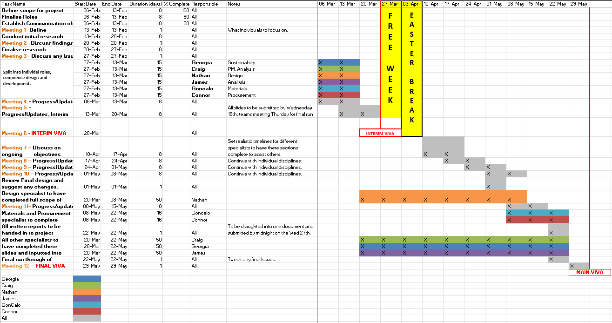
Figure 1- Gantt chart
In this Project, the Gantt chart included all major activities, such as research, concept development, design and analysis. One of its main advantages was the ability to identify dependencies between tasks. For example, detailed design work could only begin once the concept selection stage had been completed, while cost analysis depended on both designs and material selection.
Consideration was also given to the projects critical path, particularly for activities such as concept evaluation and system analysis. Kerzner (2017) explains that identifying critical tasks is essential, as delays in these areas can directly affect the overall project timeline. By recognising these critical dependencies, the team was able to prioritise key activities and reduce the risk of their delays.
Throughout the project, the Gantt chart was updated regularly, allowing it to function as a dynamic planning tool for tracking progress and responding effectively to changes as they arose.

Teams, Roles and Leadership.
The allocation of roles within the team was a key factor in supporting effective organisation and coordination throughout the project. Responsibilities were assigned based on individual strengths, skills and areas of interest. This helped ensuring tasks were approached with a high level of competence and engagement. This role allocation enabled team members to focus more effectively on their specific contributions, while still maintaining awareness of the wider project objectives.
Belbin (2010) emphasises that clearly defined team roles can significantly improve group performance by reducing duplication of effort, minimising uncertainty and ensuring all essential tasks are adequately covered. This principle was reflected in the project, where roles such as design, sustainability assessment, procurement and analytical evaluation were clearly assigned at an early stage. By allocating these responsibilities, the team was able to work more efficiently with each member taking ownership of their designated area while contributing to shared decision-making where necessary.
A collaborative leadership approach was adopted throughout the project, with the project manager acting in a facilitative role, encouraging collaboration rather than applying directive authority. This involved encouraging open discussion, supporting consensus-based questions and ensuring that all team members had the opportunity to contribute their perspectives. According to the Project Management Institute (2021), collaborative leadership can enhance team engagement, improve communication and lead to higher-quality outcomes by incorporating diverse viewpoints. This approach was particularly beneficial during the concept development stage, where multiple design options were explored and evaluated.
However, while the leadership style promoted inclusivity and shared responsibility, it also introduced certain challenges. In particular, extended discussions during the concept selection phase occasionally delayed decision-making, as differing viewpoints required additional time to resolve. this experience highlights the importance of being collaborative with decisive leadership, especially in engineering projects where time constraints and fixed deadlines are critical. While collaborative input can improve the quality of decisions, the ability to reach timely conclusions remains essential for maintaining project momentum and meeting overall schedule requirements.

Communication and Coordination
Effective communication was maintained throughout the project through the use of regular weekly meetings, which provided a structured opportunity for the team to review progress, discuss upcoming tasks and address any challenges as they arose. These meetings helped ensure that all team members had a clear understanding of project expectations and current priorities. To support accountability and clarity, minutes were taken and recorded after each meeting and shared with the team, allowing actions, responsibilities and decisions to be clearly documented and followed up.
Meredith and Mantel (2019) emphasise that effective communication is essential for maintaining coordination and alignment within project teams, particularly in complex engineering projects involving multiple interdependent tasks. Communication during this project played an important role during key decision-making stages, where collaboration between different disciplines was required. Regular discussions helped reduce misunderstandings and ensured the technical, financial and sustainability considerations were addressed collectively.
In addition to face-to-face meetings, digital collaboration tools (Microsoft Teams) were used to share documents, updates and analysis results. These tools improved accessibility to key information and allowed team members to contribute as and when they needed to. As a result, communication was not limited to scheduled meetings, helping maintain momentum and supporting more efficient workflow. The combination of formal meetings and digital platforms ensured that all team members remained informed and aligned with the overall project objectives.
A clear example off effective communication occurred during the cost analysis phase of the project, which required close collaboration between the procurement and design specialists. By sharing information on material selection, manufacturing requirements and supplier costs the team was able to develop a more accurate and realistic cost estimate. This collaborative approach improved the quality of the final analysis and demonstrated the value of consistent and well-structured communication in supporting informed decision-making throughout the project.

Risk Management
Risk management was a critical component of the project, as it allowed potential issues to be identified, assessed and mitigated at an early stage. By taking a proactive approach to risk management, the team was able to reduce uncertainty and limit the likelihood of unexpected challenges affecting project progress. Hillson (2017) highlights that, effective risks management plays a key role in reducing uncertainty in projects, while Chapman and Ward (2011) emphasise its particular importance in engineering projects due to their technical complexity and reliance on multiple interdependent factors.
A range of risks were considered throughout the project. Including technical, organisational and financial risks. Technical risks were primarily associated with system complexity, particularly when evaluating the feasibility of a dual-axis tracking design. Increased mechanical complexity introduced a higher risk of component failure and maintenance issues. Ashby (2013) highlights the importance of careful material selection in ensuring durability and long-term performance, reinforcing the need to minimise complexity through informed design decisions. As a result, design simplification and the selection of durable, weather resistant materials were prioritised to reduce technical risk.
Organisational risks related to coordination, communication and time management were mitigated through structured planning and regular progress reviews. Weekly meetings and clear task allocation helped reduce the likelihood of misunderstanding and delays. Financial risks, including potential variations in supplier costs, were addressed through conservative cost estimation and the consideration of multiple supplier options. This structured approach to risk management supported informed decision-making and contributed to maintaining project stability throughout this duration.

Progress monitoring and Performance Evaluation
Project progress was monitored continuously through weekly review meetings and regular comparisons against the planned schedule outlined in the Gantt chart. This approach allowed the team to track task completion, identify deviations from the original plan and respond promptly to emerging issues. Kerzner (2017) emphasises that continuous progress monitoring is essential for maintaining control over engineering projects, particularly where tasks are interdependent and time constraints are significant.
Where minor delays were identified, adjustments were made to ensure that overall progress was maintained and key milestones were achieved. In some cases, this involved reallocating effort or prioritising critical tasks. For example, additional time and focus was directed towards system analysis activities to ensure that key deadlines were met without compromising the quality of work. This flexible approach helped minimise the impact of delays on the overall project timeline.
Performance evaluation focused not only on schedule adherence but also on the quality of outputs produced at each stage of the project. Deliverables were reviewed to ensure they met the required technical and academic standards, and feedback from team discussions was used to inform improvements where necessary. By considering both progress and performance quality, the team was able to maintain a balanced approach that supported timely completion while ensuring that the project outcomes met the expected level of engineering standards.

Achievement against initial plan.
Overall, the project progressed broadly in line with the initial plan, with most key milestones achieved within the intended timeframes. The structured planning approach and use of scheduling tools supported by steady progress across the main project phases, including research, concept development, design and analysis. This alignment with the original plan indicates that the initial project scope and timeline were generally realistic and achievable.
However, some deviations from the planned schedule did occur, most notably during the design selection phase. The evaluation of multiple design options, combined with the need to balance performance, cost and complexity resulted in extended decision-making. While this led to short delays, it also allowed for a more thorough consideration of alternatives and ultimately supported a more informed final design choice.
Meredith and Mantel (2019) note that such deviation is common in engineering projects, particularly during early design stages where uncertainty is higher. They emphasise that effective project management does not aim to eliminate deviations entirely, but rather to respond to them through adaptive and flexible management approaches. In this project, the ability to adjust task priorities and reallocate effort helped limit the impact of delays and ensured that overall project objectives were still achieved.

Critical Reflection
The project management approach adopted for this project was largely effective in providing structure, coordination and overall direction throughout the design and development process. The use of formal planning tools, clearly defined project phases and regular progress monitoring helped ensure that tasks were completed in a logical sequence and the project remained aligned with its original objectives. These measures supported steady progress across key stages, including research, concept development, detailed design and analysis and contributed to the successful completion of the project deliverables.
Despite this overall effectiveness, there were opportunities for improvement. Particularly in relation to decision-making and early risk planning. Delays experienced during the design selection phase highlighted the challenges associated with evaluating multiple design options under time-constraints. Earlier implementation of structured decision-making tools, such as decision matrices or weighted score methods could have helped streamline this process and reduced the time required to reach a final design decision. In addition, a more detailed risk assessment during the initial planning stages may have improved efficiency by better anticipating potential technical, organisational and financial challenges.
Kerzner (2017) emphasises the importance of adaptability in project management, particularly in engineering contexts where uncertainty and evolving requirements are common. This adaptability was demonstrated throughout the project, as the team responded to emerging challenges by adjusting task priorities, reallocating effort and refining planning assumptions when necessary. These adjustments helped minimise the impact of delays and ensured that progress towards the overall objectives were maintained.

Conclusion
Overall, the project shoed how important good project management and organisation are when working on an engineering design project. Careful planning, clear communication and regular progress checks helped the team stay organised and work effectively throughout each stage of the project. Although there were some difficulties during the design selection process, the team was able to adapt and work through these challenges by good communication and adjusting priorities when required. The project also provided valuable experience in teamwork, leadership and time management, while reinforcing the importance of flexibility and coordination in achieving successful engineering outcomes.

Nathan Rees (2319664) Design Specialist

Role of Design Specialist
The role of the design specialist within the group was to develop a practical and mechanically functional solar tracking system suitable for domestic rooftop use. This involved producing the overall system configuration, designing the tracking mechanism, and ensuring the structural arrangement could operate effectively within the physical constraints of a pitched roof environment. According to (Pahl, et al., 2007), successful engineering design requires consideration of functionality, manufacturability, reliability, and integration throughout the development process.
The design process included concept development, configuration evaluation and integration of mechanical components such as the actuator system. Previous research has shown that effective solar tracking systems improve solar energy capture compared to fixed photovoltaic installations (Seme , et al., 2020).

Design Requirements
The design requirements for the domestic solar tracking system were established prior to concept development to ensure the final solution achieved the intended operational and structural performance. In engineering design, clearly defined requirements are essential for guiding decision-making throughout the development process and ensuring that the completed system fulfils its intended function effectively (Pahl, et al., 2007).
The requirements for the proposed system were influenced by rooftop installation limits, environmental conditions, loading requirements and relevant legislation like MCS standards (MCS, 2008). Emphasis was placed on achieving reliable solar tracking functionality while maintaining the structural integrity of the roof and ease of assembly while adhering to the correct regulations.
The design requirements were divided into functional requirements and design constraints, which collectively guided the development and evaluation of the final design.

Functional Requirements
The Domestic Solar Tracking System was required to perform several key functions to operate effectively within a residential rooftop environment. The primary functional requirement of the system is to support and position a solar panel while enabling controlled tracking movement throughout daylight hours. Solar tracking systems are commonly used to improve panel orientation relative to the sun and maximize solar exposure during operation (Seme , et al., 2020).
The system is required to accommodate installation on top of a pitched roof while maintaining sufficient structural stability and operational reliability. In addition, the design needs to allow controlled angular movement through either one or two axis to track the sun’s movement from east to west.
Additional functional requirements included resistance to outdoor environmental conditions, accessibility for maintenance, and use of a compact mechanical arrangement suitable for domestic installation.

Design Constraints
Several constraints were identified prior to the development of the domestic solar tracking system, as these factors would significantly influence the selection and refinement of potential design concepts. One of the primary constraints involved the limited installation space available on a domestic pitched roof, requiring any proposed system to maintain a compact and mechanically practical arrangement.
Mechanical constraints were expected to influence integration of the tracking system without introducing excessive structural complexity. Research by (Seme , et al., 2020) highlights that solar tracking systems generally require more mechanically complex arrangements than fixed systems, making efficient component integration an important design consideration.
Environmental exposure represented an additional constraint, as the proposed system would operate continuously in outdoor conditions and therefore be subjected to factors such as wind, rainfall, and varying temperatures. Installation practicality and maintenance accessibility were also identified as important considerations, as the system is intended for domestic application. These constraints established the design boundaries that would guide concept generation and subsequent development stages.

Concept Development
Following identification of the functional requirements and design constraints, a concept development process was undertaken to explore potential solutions for the system. Concept generation is an important stage of engineering design, as it allows alternative configurations and mechanical arrangements to be evaluated before progressing towards a final solution (Ulrich & Eppinger, 2012).
Several design concepts were assessed against the design and functional requirements. The concept development process aimed to identify a configuration capable of providing effective solar tracking function while remaining suitable for domestic rooftop installation.
The following sections outline the market research undertaken, initial concepts explored and the reasoning behind the selection of the final design configuration.

Market Research
Market Research was conducted to investigate existing domestic and commercial solar tracking systems to guide the development of concept designs. This process focuses on identifying common mechanical configurations, tracking strategies and structural arrangements that are used in current installations.
Existing systems broadly fall into three categories: fixed-tilt systems, single-axis tracking systems, and dual-axis tracking systems. Fixed systems remain the most widely used in domestic applications due to their simplicity and low maintenance requirements. However, tracking systems are increasingly utilized where improved energy capture is required without the complexity of full dual-axis motion. These systems typically rotate along an east-west axis to follow the sun’s path, improving energy yield compared to static installations (Abdallah & Nijmeh, 2004)
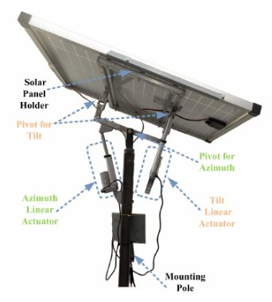
Figure 2- Dual Axis Commercial System
As shown in Figure 2, dual-axis systems rely on linear actuators attached to a pivoting frame, allowing for controlled angular adjustment. These systems require more complex support and movement mechanisms. Research conducted by (Seme , et al., 2020) highlights that dual-axis systems generally involve higher installation and maintenance demands when compared to other systems.
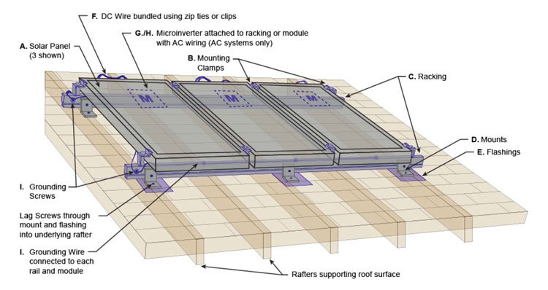
Figure 3 - Fixed Residential System
Shown in Figure 3, fixed systems are the most used solar installations for domestic applications due to their simple structural arrangement and minimal maintenance requirements. These systems use rigid mounting frames fixed to the roof pitch.
Although fixed systems provide a mechanically simple solution, they are unable to adjust panel orientation throughout the day and therefore cannot continuously optimise solar exposure. Research by (Seme , et al., 2020) identified that fixed systems are structurally efficient but less effective than tracking systems when considering solar capture.
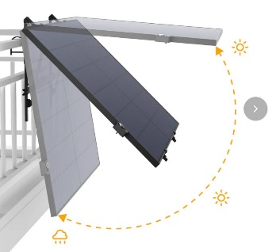
Figure 4 - Single Axis System
As shown in Figure 4, single axis tracking systems often use a single linear actuator to allow movement along one axis to follow the sun. The system show in Figure 4 is designed for residential use on balconies or fences. According to (Seme , et al., 2020), single axis trackers are frequently preferred for smaller-scale installations due to their reduced complexity.
The market research demonstrated that each solar panel configuration presented distinct advantages and limitations relating to mechanical complexity, tracking capability and rooftop suitability. The research also showed that domestic tracking systems have not been sufficiently developed, thus making a domestic tracking system the most appropriate direction for further concept development.

Initial Design Concepts
Following the completion of market research, several initial design concepts were developed as rough sketches to explore potential mechanical arrangements for the system. The concepts primarily focused on achieving effective solar tracking capability while ensuring the design was compatible with a domestic rooftop environment.

Concept Selection
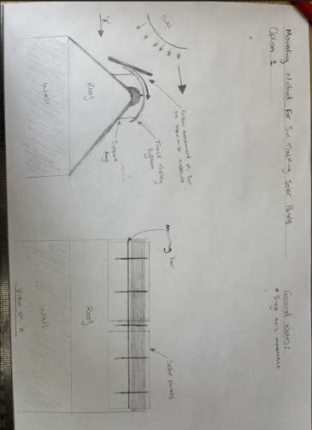
Figure 5 - Concept Design 1
The first concept was developed as a single axis tracker with a track and pulley system. The panel and frame would lay atop equally spaced rails to spread weight. The system was designed to pull the panel over the apex of the roof to maximize solar capture. A motor and chain attached to the panel would provide controlled angular movement. This concept offered strong rigidity, low set-up cost but high maintenance needs.
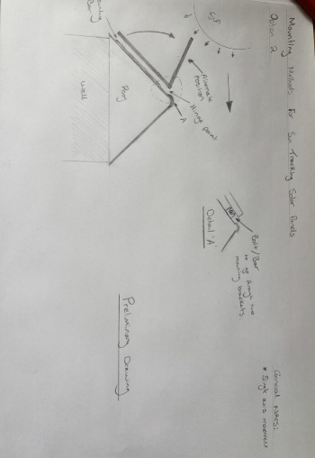
Figure 6 - Concept Design 2
The second concept investigated a single axis tracker system using a linear actuator and a rotational shaft positioned near the roof apex. The rotational shaft would be used as a hinge point for the frame to pivot around. One advantage of this system is that the panel would not be seen from the front of the house. However, a disadvantage of this design is that it takes space away from traditional fixed solar panel set-ups.
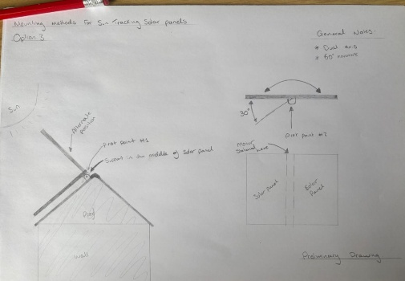
Figure 7 - Concept Design 3
The third concept design explored the implementation of a dual-axis tracking system to provide both horizontal and vertical movement. Using a similar method of attachment to concept 2, concept 3 would involve an extra linear actuator to provide horizontal adjustment. The main advantage of this system is the ability to maximize the amount of solar capture throughout the day. However, the increased mechanical and structural complexity of the design when compared to other systems made the dual axis design unsuitable for domestic applications.
Following the development of the initial design concepts, a comparative evaluation process was undertaken to identify the most suitable configuration for further development. To complete this a Pugh decision matrix was used. The Pugh method is a structured engineering design tool commonly used to compare multiple concepts against a series of predefined criteria. Thus, allowing for objective assessment during the concept selection (Olabanji & Mpofu, 2014).
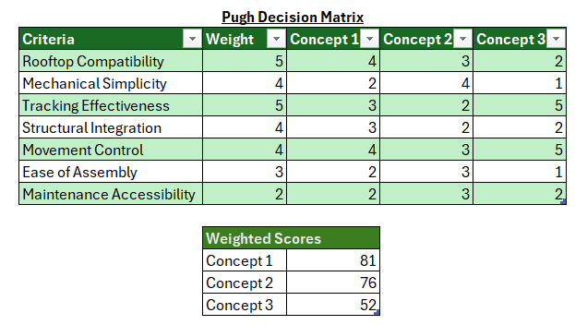
Figure 8 - Pugh Decision Matrix
As shown in Figure 8, concept design 3 achieved the lowest overall score due to its increased mechanical complexity, reduced rooftop practicality and additional structural integration requirements. Although the dual-axis arrangement provided the highest solar tracking capability, the complexity of the system was considered unsuitable for domestic rooftop applications.
Concept 1 achieved the highest overall score and demonstrated advantages in structural rigidity and simplicity of manufacture; however, the rail and pulley arrangement introduce increased maintenance requirements and a larger overall mechanical footprint across the roof structure.
Concept 2 showcased that its mechanical simplicity and ease of assembly were superior to the other designs. Also, Concept 2 provided the most balanced overall performance.
Once the Pugh matrix was completed, further refinement of Concept 1 was undertaken. However, during preliminary wind loading investigations, concerns were identified regarding the rail and chain drive mechanism used to translate panel movement (BSI, 2005). It was determined that under severe weather conditions, the torque required to return the system to its original position could place excessive loading on the rail and chain, potentially reducing reliability and increasing the risk of mechanically damaging the system.
As a result, features from Concept 2 were incorporated into the refined design. The original track and pulley mechanism was replaced with a linear actuator system connected directly to the rafters and panel frame. Combining elements from both concepts reduced mechanical complexity while maintaining effective movement control.
This resulted in a final design configuration with the structural rigidity and load distribution advantages identified in concept 1 and the compact actuator driven movement system in concept 2. The refined design positioned the system on top of the roofs apex with a rotational shaft connected to the frame and supported by two pillow block bearings to allow controlled movement. A linear actuator connected between the roof and the frame was incorporated to provide controlled angular adjustment in operation. Finally, two spreader bars were added underneath the support frame to spread weight across the rafters. This configuration allowed the design to maintain mechanical simplicity while improving structural practicality.

Final Design Configuration
The final design configuration was developed following the evaluation of the initial concepts and combines the effective features identified during the concept selection stage. The finalised and refined design is a single-axis roof mounted solar tracking system designed for installation along the apex of a pitched domestic roof.
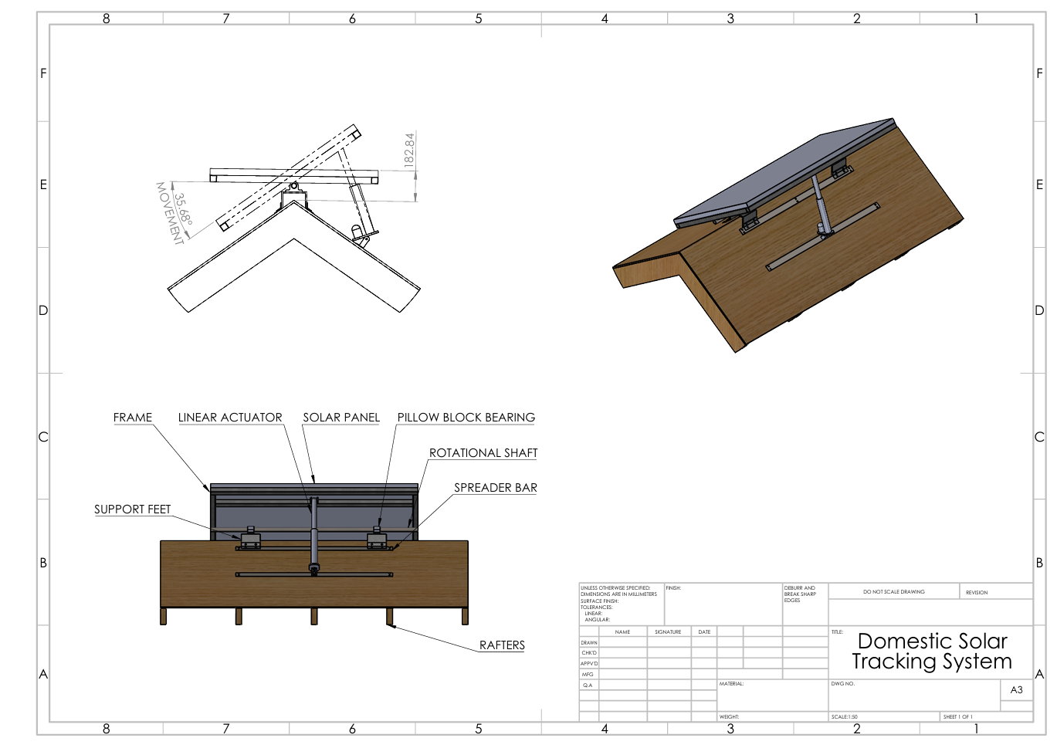
Figure 9 - Final Design Configuration
As shown in Figure 9, the system is mounted centrally along the apex of the roof using a rotational shaft supported by two pillow block bearings. The pillow block bearings lay on top of support feet with spreader bars connecting both sides. It is vital that the spreader bars are not placed on top of the tiles but beneath them and attached to the rafters. This ensures that the operational and environmental loads generated by the system are transferred directly into the primary roof structure. The shaft acts as the primary pivot point for the system allowing controlled angular movement of the panel assembly on a single axis.
When undertaking refinement of the final design it was vital to consider relevant rooftop installation requirements and structural loading standards. Rooftop-mounted systems must safely transfer imposed loads, including wind loading, into the supporting structure in accordance with relevant structural guidance such as BS EN 1991-1-4. As recommended by MCS, securing the system directly to the roof rafters reduces the risk of localised loading, tile failure and mounting instability during severe weather conditions.
A linear actuator is connected between the roof structure and the rear section of the support frame. Extension and retraction of the actuator rotates the shaft, enabling the panel to adjust throughout the day in response to solar positioning. The tracking mechanism would automatically operate using a programmed control system linked to predefined solar positioning data. The actuator would automatically adjust the panel orientation throughout the day to follow the suns movement
In a situation of extreme weather, where the wind loadings exceed safety margins the system would default to a neutral position to decrease drag. This feature minimises the exposed surface area subjected to direct wind forces, reducing the likelihood of excessive structural loading and mechanical damage during severe weather events.

Design Evaluation
The final design configuration was evaluated against the original functional requirements and design constraints established during the early stages of development. The evaluation considered the systems’ mechanical practicality, rooftop integration, movement capability and suitability for domestic application.
One of the primary strengths of the design is the reduction in mechanical complexity compared to alternative dual axis or rail-based systems. By utilising a single-axis rotational shaft and a linear actuator, the system maintains controlled angular movement while limiting the amount of high wear components, thereby improving reliability and reducing maintenance requirements (Budynas & Nisbett, 2015).
The design also performs well in terms of structural integration within a pitched roof environment. The load transfer through the spreader bars and direct fixation to the rafters provide a practical approach to distributing forces into the primary roof structure. This improves installation feasibility and reduces the likelihood of localised loading issues on the roof tiles. Another advantage of this system is the compact and modular layout, meaning that multiple of these systems can be built on the same roof.
However, the design does present several functional limitations. The single-axis configuration limits the system’s ability to optimize solar orientation when compared to dual-axis systems. In addition, the reliance on a single powered actuator introduces a mechanical dependency, meaning that failure of this component would directly impact operation. Another issue the system faces is the limited degree of movement at 35° due to the length of the actuator when fully retracted.
Future improvements could focus on improving the system’s range of motion and tracking efficiency. One potential improvement would be the implementation of an alternative actuator strategy, such as a repositioned or sliding actuator base allowing increased angular movement. In addition to this, further improvement to the frame could be made by potentially optimizing the support frame. Any modifications made in the future would need to remain complaint with relevant wind loading and rooftop installation requirements.

Design Conclusion
The final design presents a practical single-axis rooftop solar tracking system developed through structured concept generation, evaluation and refinement. The selected configuration effectively balances mechanical simplicity with functional tracking capabilities. Resulting in a system that is suitable for a domestic pitched roof environment while maintaining structural practicality and controlled movement performance.
Through the design process, key trade-offs between tracking efficiency and mechanical complexity were addressed, leading to a solution that prioritised reliability, ease of installation and reduced maintenance over maximum solar optimization. The final design demonstrated effective load transfer into the roof structure and incorporates a linear actuator that enables controlled angular adjustment within defined operation limits.
In conclusion, the design meets the primary functional requirements established at the start of the project and provides a realistic foundation for further development in domestic renewable energy applications.

Gonçalo Fonseca (2517833) – Material Specialist

Materials Introduction
This section emphasises on the material selection and design considerations associated with the development of the domestic solar tracking system project. The system was designed to have the capability to allow a photovoltaic panel to pivot on the apex of the roof structure in order to maximise solar exposure and system efficiency throughout the day. Due to the system being expose to environmental aspects and continuous movement produced by the mechanism, material selection played a critical role in the overall design requirement for this system.
The final design of the system consisted of Grade A photovoltaic panel supported by an anodised aluminium frame and base plate, as well as several standard off-the-shelf components including pillow block bearings, shafts, fasteners, and a linear actuator. The requirements of the selected materials and standard components were to provide critical structural support while lowering overall system weight and resistance to outdoor environmental conditions.
This section of the report evaluates the reasoning and critical thinking behind the material choices used within the design. Consideration is also given to the influence of material selection on manufacturability, maintenance, sustainability, and long-term operational performance. In addition, a design risk assessment is included to demonstrate how potential mechanical and environmental risks were considered during the development of the solar tracking system.

Material requirements
When carrying out the analysis on the material requirements for the solar tracking system There were some aspects that largely influenced engineering decisions such as environmental exposure and structural demands associated with how the design would be secured to the roof while minimising maintenance requirements and increasing system longevity. As the system is designed for continuous repetitive operations, the selected materials were required to provide sufficient mechanical strength, corrosion resistance, durability, waterproof capabilities and low maintenance characteristics to ensure reliable long-term performance.
One of the primary system considerations during material selection was the reduction of overall system weight. As the mechanism is mounted on an apex roof structure, excessive weight would increase the total load applied to the roof and supporting fixings. Having this into consideration the use of lightweight materials were preferred while still maintaining material toughness to be able to withstand long term use and support the weight of the solar panel and other required components. Materials with high strength-to-weight ratios are commonly used within structural engineering applications to reduce loading without significantly compromising mechanical performance (Ashby, 2011).
Secondly, corrosion resistance was also considered a critical requirement due to continuous exposure to rain, atmospheric moisture, and temperature variation to which can case accelerated component degradation and directly affect material lifecycle.
Outdoor mechanical systems tend to show more vulnerability to environmental degradation, particularly when exposed to cyclic weather conditions over extended operational periods. Materials with strong natural corrosion resistance or protective surface treatments were therefore prioritised to improve long-term durability and reduce maintenance requirements (Davis, 1999).
In addition to structural and environmental considerations, the materials selected for the system also required suitable manufacturability and availability has the system was design with the intention of long-term usage. The use of standard off-the-shelf components reduced manufacturing complexity and simplified future maintenance requirements or part replacement procedures complexity. This approach to the design was to try and give the end user a weather though reliable product without increasing both manufacturing and purchasing costs.
Sustainability was another important consideration during the material selection process. Recyclable materials and durable components were prioritised during the analysis and selection phase contributing towards reducing lifecycle environmental impact and improving long-term environmental footprint. Materials capable of maintaining structural and functional performance over extended service periods are particularly beneficial within renewable energy systems, as increasing operational lifespan improves the overall energy return of the system (Kalogirou, 2014).

Materials Selection and Justification
The material selection procedure for the domestic solar tracking system was focused on ensuring that the system had the appropriate structural performance, weight reduction capabilities, durability, and long-term outdoor reliability to justify the higher price point. Due to the rooftop installation of the solar tracking system, the selected materials were required to withstand continuous environmental exposure including rain, wind loading, temperature variations, and moisture ingress while maintaining sufficient structural strength to support the photovoltaic panel and associated mechanical components during operation.

Grade A Photovoltaic Panel
When selecting the solar panels, the category can be divided into 3 sections, Grade A, Grade B and Grade C. For the purpose of this design grade A was selected due to its higher overall performance when compared to the other 2 grades.
A Grade A photovoltaic panel was selected for the solar tracking system due to its increased reliability, and operational efficiency when compared to lower-grade alternatives. Grade A panels are manufactured using defect-free photovoltaic cells and typically demonstrate improved electrical performance, reduced degradation rates, and increased operational lifespan (Green, 2019). Since the effectiveness of the tracking system is directly related to the energy output of the solar panel itself, the use of a high-quality panel was considered essential to maximise overall system performance.
In addition to how these panels perform electrically, Grade A panels generally demonstrate lower annual cell degradation rates, commonly estimated at approximately 0.3–0.8% per year, allowing improved long-term power generation when compared to lower-grade photovoltaic modules decreasing return on investment periods (Jordan and Kurtz, 2013). Since the reliability of the solar tracking system is directly related to the energy output of the panel itself, using a higher grade panel will maximize the energy output of the system but also increasing system reliability.

Anodised Aluminium Frame and Base Plate
Anodised aluminium was selected as the primary structural material for the support frame and base plate due to its favourable combination of low density, corrosion resistance properties, and structural performance. Aluminium possesses a density of approximately 2700 kg/m³, which is significantly lower than mild steel that is approximately 7850 kg/m³, this core choice in the design provides the system with essential reductions in structural loading while still maintaining sufficient mechanical strength for the application (Ashby, 2011). The reduction of the load was a particular critical point due to the system being mounted in the apex of the roof.
The selection of the aluminium components was also required to provide sufficient structural toughness to support the photovoltaic panel and associated mechanical parts during the pivot operation. Engineered aluminium alloys such as 6061-T6 typically possess tensile strengths in the region of 250–310 MPa while maintaining good machinability and corrosion resistance (Davis, 1993). This combination of moderate high strength and low weight characteristics makes aluminium highly viable for this system.
Corrosion resistance was another major factor influencing material selection. Aluminium when exposed to air forms a small layer of oxidisation, providing protection against atmospheric corrosion and environmental degradation (Davis, 1999). Furthermore, improve its longevity when installed, the structural components are anodised. The anodising process increases surface hardness and enhances resistance to corrosion, wear, and moisture protection, improving the suitability of the material for long-term outdoor applications (Habazaki et al., 2007).
There were other material alternative including mild steel and stainless steel that were considered during the material selection process. Mild steel was not selected due to its increased density, susceptibility to corrosion without protective coatings and high load characteristics. Stainless steel however provides excellent corrosion resistance but material cost made it less viable for this design application.

Standard Off-the-Shelf Components
The solar tracking system includes several standard off-the-shelf mechanical and electrical components that include pillow block bearings, shafts, shaft supports, fasteners, a linear actuator, actuator brackets, and light sensors. The aim of the use of many of the shelf components was to reduce manufacturing complexity and simplifying the installation process while improving long term system maintainability for the end user. Standardised components are commonly used within engineering applications due to their proven reliability, availability, and reduced production costs when compared to bespoke manufactured parts (Groover, 2020).
The use of off-the-shelf components also improved the practicality of the design by reducing part replacement waiting lists due to the lack of special machined parts. In the event of component wear or failure from the repetitive action, standard parts can be replaced more efficiently without requiring custom manufacturing processes. Components such as pillow block bearings were selected to give stable shaft support while reducing rotational friction providing a smoother pivoting movement. Similarly, the linear actuator provided controlled and repeatable movement of the photovoltaic panel by choosing this part the overall complexity of the pivoting movement was reduced by reducing the number of moving parts in the system.
The selection and sourcing of these components was also influenced by considerations including cost, availability, and ease of procurement. However, a more detailed evaluation of supplier selection, component sourcing, component description and procurement considerations is included within the procurement section of the report.

Material comparison table

Material option | Density (kg/m³) | Typical tensile/yield strength | Young’s modulus | Main advantage | Main limitation
Aluminium alloy 6061-T6 | 2700 | UTS 267–310 MPa; yield 253–276 MPa | 69 GPa | Lightweight and corrosion resistant | Lower stiffness than steel
Mild steel | 7850 | Yield 250 MPa | 200 GPa | High stiffness and low cost | Heavy and corrosion prone
Stainless steel 304/304L | 7900–8000 | Yield ~200–300 MPa | 190–200 GPa | Excellent corrosion resistance | Heavy and expensive
Glass fiber (GFRP) composite | 1800–2200 | >300 MPa | 20–50 GPa | Very lightweight | Difficult manufacture and repair
Figure 10- Frame Material Comparison
Full reference list can be found in the bibliography: Comparison of candidate structural materials for the solar tracking system. Material property data adapted from ASM International (1990), Callister and Rethwisch (2020), Davis (1994), and Stanciu et al. (2021).
The comparison table highlights that aluminium provides the most suitable balance between mechanical properties, weight reduction, corrosion resistance, and manufacturability for the solar tracking system. Mild steel and stainless-steel offer higher stiffness which could enhance the system durability, however their densities are almost three times greater than aluminium, which would increase the load applied to the apex roof structure and the force required from the actuator to apply the turning moving on the panel. This made steel-based options less suitable for a lightweight rooftop mechanism.
GFRP was also considered in this design however it offered the lowest density and good corrosion resistance; however, its mechanical properties make the product highly brittle. This could increase design uncertainty and make durability and system maintenance more difficult compared with metallic components. For this project, aluminium was selected because it provided an even balance between low mass, strength, corrosion resistance, repairability, and long-term environmental durability.

Solar Panel Grade | Cell Quality | Typical Efficiency | Main Advantages | Main Limitations
Grade A | Defect-free cells | 18–22% | Highest reliability, lower degradation, improved lifespan | Higher initial cost
Grade B | Minor visual or manufacturing defects on cells | 15–18% | Lower purchase cost | Reduced efficiency and lifespan
Grade C | Visible defects or recycled/reworked cells | <15% | Very low cost | Poor reliability and reduced operational performance
Figure 11- Solar Panel Comparison
Full reference list can be found in bibliography: Comparison of photovoltaic panel grading classifications. Data adapted from Green (2019), Jordan and Kurtz (2013), and Messenger and Ventre (2010).
The comparison between solar panel grades highlights that Grade A panels provide the highest operational efficiency, reliability, and long-term performance when compared to lower-grade alternatives providing a higher return on investment. Although Grade B and Grade C panels offer reduced initial cost, they commonly contain manufacturing defects or damaged cells which can negatively affect electrical performance and increase cell degradation rates over time. Since the design aims to reduce the amount of solar panel installs with the use of the turning mechanism the effectiveness of the solar tracking system is directly dependent on the energy output of the photovoltaic panel, maximising panel efficiency was considered the most important design requirement.

Risk Assessment Analysis

Action No. | Area of Design | Issue Identified | Initial Risk Score (5x5) |  |  | Corrective Action Implemented | Residual Risk Score
Action No. | Area of Design | Issue Identified | Sr | L | Risk | Corrective Action Implemented | Sr | L | Risk
1 | Support Frame | Excessive roof loading caused by structural mass | 5 | 4 | 20 | Use of lightweight anodized aluminum frame to reduce dead load | 5 | 2 | 10
2 | Support Frame | Corrosion caused by continuous environmental exposure | 3 | 4 | 12 | Anodized aluminum and IP65 material selected. | 3 | 1 | 3
3 | Rotating Assembly | Bearing wear caused by repetitive pivoting movement | 3 | 3 | 9 | Use of pillow block bearings to reduce rotational friction and wear | 3 | 1 | 3
4 | Linear Actuator | Mechanical failure due to continuous operational cycling | 3 | 4 | 12 | Commercially rated actuator selected with suitable load capacity | 3 | 3 | 9
5 | Electrical Components | Water ingress causing Linear actuator failure and solar sensor malfunction | 4 | 5 | 20 | Use of IP rated equipment and electrical enclosures to protect from water/ moisture ingress | 4 | 1 | 4
6 | Roof Mounting System | Fastener loosening caused by vibration and wind loading | 4 | 3 | 12 | Nylock nuts to be used with spring washers. | 4 | 1 | 4
7 | Solar Panel Operation | Excessive wind loading during movement operation | 5 | 4 | 20 | Rigid aluminum support structure and reduced system mass | 5 | 2 | 10
8 | Maintenance Access | Difficulty replacing damaged or worn components | 4 | 3 | 12 | Use of standard off-the-shelf components for easy replacement | 4 | 1 | 4
Figure 12- Design Risk Assessment
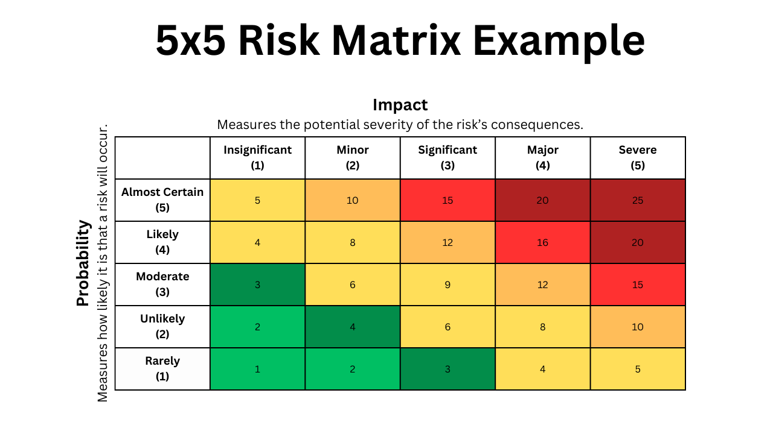
Figure 13 - 5×5 likelihood and severity risk matrix adapted from ISO 31000 risk assessment principles (ISO, 2018)
The risk assessment aim was to identify key problem areas prior to the design being built so solutions could be developed in order to help mitigate some of these risks. Due to the rooftop installation of the system, the assembly is continuously exposed to external environmental conditions including wind, rain and moisture. These conditions create risks relating to structural loading, corrosion, and electrical component reliability. Initial risk scores for excessive roof loading, wind loading during panel operation, and electrical water ingress were all classified as high-risk areas with scores that reach 20 helping to identify key problem areas.
The substitution of galvanised steel for anodised aluminium within the support frame significantly reduced multiple risks identified on the assessment table. Roof loading and wind loading during operation both achieved high-risk scores of 20, this was due to the mounting position of the mechanism and environmental conditions it is exposed to. By carrying out the substitution as aluminium as the primary structural material, the overall system weight was reduced while still maintaining sufficient structural strength to support the photovoltaic panel and associated mechanical components. Reducing the loading transferred on to the apex roof structure and also lowering the amount of stress applied to the linear actuator during movement operation, risk scores were reduced from 20 to 10.
Corrosion resistance was another major improvement identified within the final design. Continuous exposure to rain and moisture initially produced risk score of 12. To reduce this risk, anodised aluminium and IP65-rated materials selected. The anodising process improves surface hardness and environmental resistance while reducing the oxidisation chance of aluminium in the long term. As a result of these decisions, the residual risk score was reduced from 12 to 3.
The implementation of standard off-the-shelf components also contributed towards reducing operational and maintenance risks within the assembly system. Components used such as pillow block bearings, shafts, and linear actuators improved the system maintainability while reducing manufacturing complexity. As an example, pillow block bearings minimised wear in the pivoting mechanism, decreasing the repetitive movement risk score from 9 to 3. Furthermore, the use of standardised components allows damaged or worn parts to be replaced more efficiently without requiring bespoke manufacturing procedures, reducing maintenance-related risks from 12 to 4.
The overall final design actions implemented significantly reduced most risks within the assembly. Through a combination of lightweight structural materials, IP-rated electrical components, and standardised mechanical components were all major deciding factors to the successful design of the system.

Conclusion
The material selection and design risk assessment completed for the domestic solar tracking system highlights the importance of balancing structural integrity, component durability, system sustainability, and long-term operational reliability in order to achieve a viable system. The final design successfully different components to create a system capable of maximising solar exposure by minimising structural loading on the roof installation and providing a market alternative.
The comparison between alternative materials and solar panel grades further emphasises the final material choices by highlighting that aluminium and Grade A photovoltaic panels offered the most balanced solution for the desired result of this system. Although alternative materials were considered they presented certain disadvantages when compared to the ones chosen, their limitations relating to weight, cost, corrosion susceptibility, or manufacturability reduced their suitability for this particular system application.
Additionally, the design risk assessment highlighted the importance of identifying and mitigating potential risks during system's development stage. Risks associated with roof loading, corrosion, wind exposure, component wear, and water ingress were significantly reduced through different design choices and material selection. As a result, the final design presents a practical and sustainable engineering solution capable of improving photovoltaic efficiency while maintaining the required material properties for a successful and sustainable system.

Georgia Cox (2510065) - Sustainability Specialist

Sustainability Introduction
The sustainability role contributed throughout the project by actively supporting design decisions through a structured understanding of environmental legislation, lifecycle impacts, and regulatory risk. Rather than acting as a post-design evaluation, sustainability functioned as a guiding design discipline, shaping material choice, system configuration, and operational strategy. Key decisions were assessed against environmental performance to ensure that environmental benefit was not limited to increased energy generation alone but extended across the full system lifespan. For domestic consumers, trust in renewable technologies is increasingly linked to responsible material use, long-term durability, and end-of-life accountability. By applying Life Cycle Assessment (LCA) principles and structuring the assessment around an Environmental Product Declaration (EPD) framework, the project ensures that the proposed solar tracking system aligns with both regulatory expectations and environmentally conscious consumer priorities.

Sustainability Design Drivers and Pre-Design Impact Considerations

Pre-Design Sustainability Assessment
A pre-design sustainability assessment was undertaken to identify the primary environmental risks and opportunities associated with domestic solar tracking systems before technical concepts were finalised. This stage was used to position sustainability as a design driver rather than a constraint, ensuring that major environmental impacts could be addressed early, when design flexibility was greatest.
From a sustainability perspective, early identification of risks such as embodied carbon intensity, system durability, noise impact, and end-of-life treatment was critical in setting boundaries for acceptable system performance. The outcome of this stage directly informed the design brief, ensuring that subsequent technical development occurred within clearly defined environmental and regulatory.

Sustainability Considerations
From a Sustainability Specialist perspective, the following considerations were prioritised as key decision-making criteria alongside technical performance:
Materials and Embodied Carbon: Embodied carbon was identified as a primary lifecycle risk, driving the selection of lightweight, recyclable materials and design strategies that maximise energy output per unit of embodied impact.
Energy Efficiency: The tracking system was required to deliver a clear net energy benefit, with actuator power demand and movement frequency treated as critical optimisation parameters.
Durability and Lifespan: Resistance to corrosion, wear, and environmental degradation was prioritised to ensure effective operation over the typical 25-year photovoltaic lifespan.
Maintenance Requirements: Low-maintenance, reliable components were prioritised to minimise material consumption and environmental burden over the system lifetime.
Visual and Noise Impact: Visual presence and motor noise were recognised as sustainability considerations due to their influence on domestic acceptance and regulatory compliance.
End-of-Life Management: Design-for-disassembly, material separation, and compliance with waste legislation were treated as essential to reduce long-term environmental risk and support circular economy principles.

Sustainability Rationale
The primary sustainability benefit of the proposed solar tracking system is the increased efficiency of energy generation compared to fixed panels. By continuously aligning with the sun’s trajectory, solar tracking systems can increase energy yield by approximately 20-40% (Oxford Academic, 2024). This improvement directly supports the UK’s legally binding net-zero target under the Climate Change Act 2008, as increased on-site renewable generation reduces reliance on grid electricity and associated carbon emissions (Burnett, Edwards and Watson, 2024). Domestic energy use represents about 26% of the UK’s final energy consumption and is responsible for around 20% of the UK’s total CO₂ emissions (Bolton, 2026). An average UK household installing solar panels could reduce emissions by about 0.782 tonnes of CO₂ per year, resulting in a cumulative reduction of around 19.6 tonnes over 25 years (PES Renewables, 2024).

Environmental Legislation and Regulations
Failure to comply with UK environmental and planning legislation presents significant legal, financial, and operational risk, therefore, regulatory compliance was embedded as a core design requirement for domestic deployment. The Climate Change Act 2008 establishes the UK’s legally binding target of net-zero greenhouse gas emissions by 2050, requiring renewable technologies to demonstrate genuine carbon reduction over their full lifecycle rather than through operational performance alone (Climate Change Committee, 2024). An LCA was therefore essential to ensure that embodied and operational impacts do not undermine decarbonisation objectives.
The Environment Act 2021 further influenced design decisions through its emphasis on resource efficiency, waste prevention, and environmental responsibility, informing material selection, recyclability, and design-for-disassembly strategies (UK Government, 2021). Electrical components within the tracking mechanism fall under the Waste Electrical and Electronic Equipment (WEEE) Regulations 2013, requiring compliant end-of-life treatment and recovery. Modular construction was therefore prioritised to support separation and recycling (Government Digital Service, 2012).
Noise emissions were addressed in accordance with the Noise Act 1996, which enables local authorities to act on excessive domestic noise, particularly during night-time hours, particularly during night-time hours between 23:00 and 07:00 (UK Government, 2012). If noise exceeds permitted levels, of 45-55 dB during the day and 35-45 dB at night (Hushtec Solutions, 2025), after a warning notice, authorities may issue fixed penalty notices or confiscate equipment (UK Government, 2012). To mitigate this risk, low-noise motors, polymer guide strips, and vibration-damping mounts were incorporated. Planning compliance was also considered under the Town and Country Planning Act 1990 and the Town and Country Planning (General Permitted Development) (England) Order 2015, ensuring installation dimensions remain within permitted limits and avoid enforcement action (UK Government, 2023).

Life Cycle Analysis
A Life Cycle Analysis was conducted in accordance with ISO 14040 principles using a cradle-to-grave approach, capturing environmental impacts from raw material extraction through to end-of-life disposal (ISO, 2020), ensuring that the full environmental burden of the system is considered. The initial system configuration comprised a Grade A photovoltaic panel mounted on aluminium guide rails with a polypropylene wear strip, supported by a roof-mounted structure and driven by a rotary tracking mechanism to follow the sun’s movement. An initial LCA identified opportunities to reduce component complexity, improve durability, and enhance end-of-life performance, prompting a targeted sustainability-led redesign.
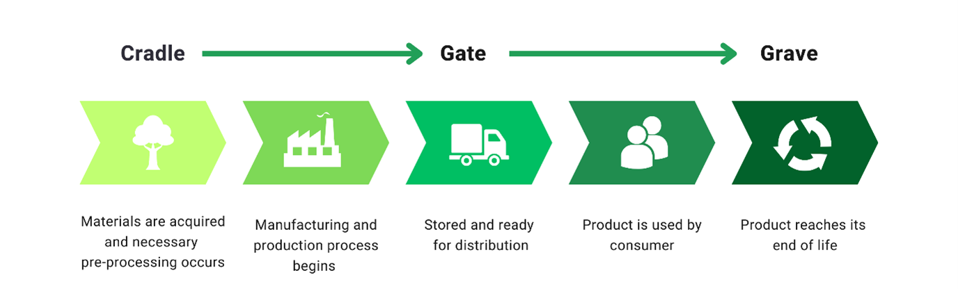
Figure 14-Cradle to Grave LCA structure (Barnes, 2023).

Material Extraction
Material extraction represents one of the most significant contributors to the system’s embodied environmental impact. Photovoltaic modules require high-purity silicon, extracted from quartz through energy-intensive, high-temperature processes. Industry data report total silicon demand of approximately 595-635 g/m², with production losses of 199-215 g/m², indicating substantial material inefficiency during early lifecycle stages (IEA, 2020; Ryan, 2022). These losses contribute directly to embodied carbon and resource depletion. Aluminium production from bauxite is similarly energy-intensive, particularly where virgin aluminium is used (UKGBC, 2025). Typical embodied emissions for primary aluminium range from 8-12 kg CO₂e per kg, highlighting the importance of material selection in reducing lifecycle impacts (Adisa Amanor-Wilks, 2024). Virgin polypropylene production is also dominated by upstream fossil-based energy demand, with cradle-to-gate lifecycle assessments showing that approximately 94% of total energy demand arises from raw material extraction and feedstock processing (Franklin Associates, 2021). The rotatory mechanism introduces additional materials, including steel, copper windings, and electronic control components. Copper production is particularly energy-intensive, with embodied emissions of approximately 4.6 CO₂e per kg (International Copper Association, 2023). Although the mass of these components is relatively small compared to structural materials, they contribute to the system’s embodied impact and must be considered within the lifecycle assessment.
In response to these extraction-stage findings, the design was revised to reduce reliance on energy-intensive primary materials and polymer feedstocks. Recycled anodised aluminium was retained selectively for the frame and base plate, reducing production energy demand by up to 95% compared with primary aluminium (The Aluminium Association, 2021). The aluminium guide rails and polypropylene wear strip were removed and replaced by a linear-actuator-based tracking system supported by standard galvanised steel components. Galvanised steel typically exhibits lower embodied emissions of approximately 1.8-2.5 kg CO₂e per kg (Arup, 2023) and benefits from well-established extraction and recycling routes. The adoption of a linear actuator consolidates motion control into a single electromechanical unit, reducing overall material diversity and extraction intensity while maintaining tracking functionality.

Manufacturing and Assembly
Manufacturing impacts are dominated by photovoltaic panel production, particularly during wafer slicing and cell processing. The wafer cutting process is associated with kerf losses of approximately 65 μm per wafer, with total silicon losses during manufacturing estimated at 30-40%, contributing significantly to both embodied energy use and material waste (IEA, 2020). Electricity demand during wafer and cell processing is also substantial, with reported values of 4.9-5.7 kWh/m² of panel area. The initial tracking system configuration required the manufacture of aluminium guide rails through extrusion and anodising, introducing additional energy demand and chemical use. While polypropylene extrusion associated with the guide strip contributed comparatively minor impacts due to low material mass, the LCA highlighted that the combined use of bespoke extruded aluminium components and polymer wear interfaces increased manufacturing complexity and process intensity (Franklin Associates, 2021). The manufacture of the tracking motor and control system additionally introduces impacts associated with electrical component production, including motor assembly, wiring, and control electronics; however, these impacts remain relatively small due to low component mass.
In response to these LCA findings, the rail-based rotary mechanism was replaced with a linear-actuator-based system supported by standardised galvanised steel components. This redesign removes the need for bespoke aluminium extrusions, consolidates motion control into a single factory-assembled unit, and reduces the number of precision-aligned interfaces required during assembly. Aluminium is now limited to the frame and base plate, where lightweight corrosion-resistant structural performance is justified. Combined with the use of a grade A photovoltaic panel and increased energy yield from tracking, the revised configuration reduces the energy payback period and reduces cumulative manufacturing impacts.

Transportation
The initial rail-based tracking configuration relied on bespoke aluminium extrusions and polymer wear components. Although aluminium (2.73 g/cm³) and polypropylene (0.895-0.92 g/cm³) have relatively low densities (Tagmakers, 2025; Plastics Europe, 2024), the bespoke nature of these components increased the likelihood of non-standard sourcing and repeat transport associated with alignment, wear, and replacement over the system lifespan. The LCA highlighted that transport emissions are influenced more by component availability and lifetime replacement frequency than by material mass, with designs requiring more maintenance incurring additional transport impacts over time.
In response, the design was revised to remove non-standard components and adopt a linear-actuator-based system using standard galvanised steel elements widely available through national supply chains. Industry data show that transport usually makes up only a small part of steel’s total upfront carbon footprint, approximately 5-15%, especially when materials are sourced through local or national supply chains (Arup, 2023). Crucially, the increased durability and reduced wear interfaces of the revised system extend component service life, reducing the frequency of replacement and associated transport over the 25-year design lifespan. Aluminium was retained only where functionally justified. As a result, transportation impacts are reduced both at installation and across the system lifetime, demonstrating how the LCA facilitated a more transport-efficient and durable configuration.

Use Phase
Single-axis solar tracking systems can increase electricity generation by approximately 25% compared with fixed installations, significantly improving lifetime energy output (Paliyal et al., 2024). The additional operational energy demand associated with tracking is low, typically estimated at <0.5-3% of the total energy generated, meaning net energy gains remain substantial (Baker and Ghosh, 2026). The initial design, containing a polypropylene wear strip, introduces continuous friction interfaces that increase wear and maintenance requirements over time.
In response, the system was redesigned to use an electric linear actuator, which operates with noise levels of <65 dB (Greig, 2017). Incremental movement further reduces audible impact by minimising activation duration and frequency. From a maintenance perspective, the adoption of galvanised steel structural components significantly improves durability during the operational phase. In typical outdoor environments, galvanised steel can achieve service lives of 25-50 years with minimal maintenance due to the sacrificial zinc coating that protects against corrosion (American Galvanizers Association, 2025). This represents a clear improvement over polymer wear components, which are more susceptible to abrasion, UV degradation, and replacement.

End-of-Life
Figure 15 illustrates that photovoltaic panels require disassembly and material separation before recycling due to their multi-material construction. While materials such as glass, aluminium frames, and copper conductors can be recovered through established mechanical separation routes, the recycling of silicon cells remains energy-intensive, typically requiring thermal and chemical processing. Consequently, although approximately 80-95% of photovoltaic panel materials can be recovered, end-of-life treatment remains resource and energy-demanding (SolarLove, 2026). In the initial system, additional end-of-life complexity was introduced through the use of aluminium guide rails, polypropylene wear strips, and a rail-based rotary tracking mechanism with multiple integrated components. While aluminium benefits from well-developed recycling pathways with relatively low secondary processing energy demand (The Aluminium Association, 2021). Although polypropylene is highly recyclable, there is an increased contamination risk during recycling and are more likely to require premature replacement. Furthermore, the rotary mechanism and associated electronics must be treated separately under the WEEE Regulations 2013, requiring specialist recycling processes and increasing end-of-life handling complexity.
These outcomes led to a targeted redesign, which aligns with circular-economy principles, concentrating structural components into standard aluminium and galvanised steel elements, both of which benefit from mature, high-recovery recycling infrastructure. The selection of a Grade A photovoltaic panel extends operational life and delays panel replacement, reducing the frequency of end-of-life processing. The linear actuator and control system are modular and easily removable, enabling compliant WEEE treatment without extensive disassembly. Additionally, the improved durability of galvanised steel components, combined with the removal of the polypropylene wear strip, reduces the likelihood of premature disposal and limits end-of-life events over the system's lifespan.

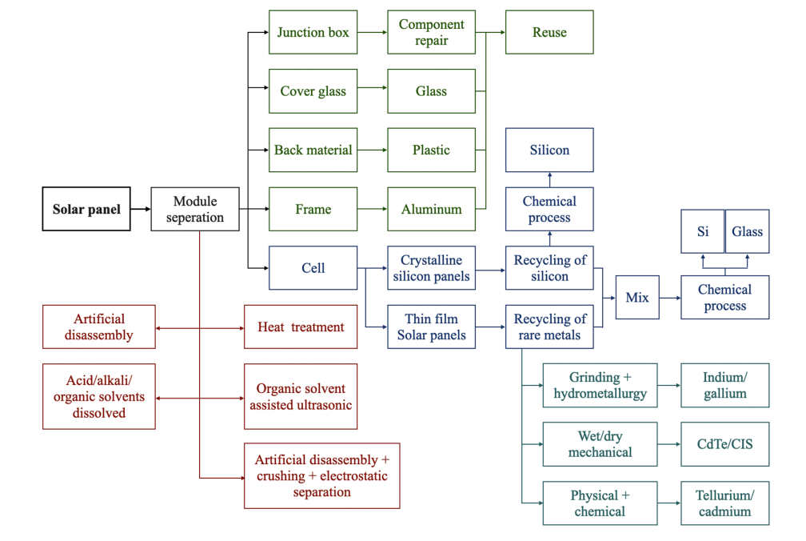
Figure 15. Solar panel recycling methodologies (Mdallal et al., 2025).

LCA Interpretation and Overall Assessment
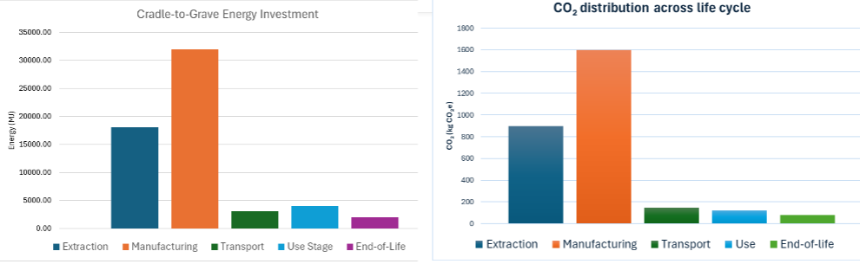
As shown in Figure 16, extraction and manufacturing are dominant contributors to both lifecycle energy demand and carbon emissions, reflecting the energy-intensive processes associated with silicon purification and photovoltaic cell production. This demonstrates that environmental impact is concentrated in early lifecycle stages, indicating that sustainability performance is primarily influenced by embodied energy rather than operational energy demand.
Figure 16-Lifecycle energy input and CO₂ emissions across system stages (Antonanzas, Arbeloa-Ibero and Quinn, 2019).
This is consistent with published lifecycle assessments, as shown in Figure 17, where the inclusion of a tracking system increases the contribution of structural and mechanical components while maintaining manufacturing as the dominant impact category.
Although the tracking system introduces additional embodied impact through structural components, this increase is relatively small compared to the total impact, which is dominated by photovoltaic manufacturing. This reinforces that optimisation efforts should prioritise improving system performance and longevity.
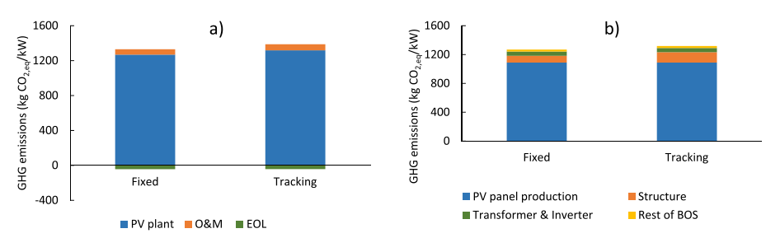
Figure 17. GHG emissions during life cycle (a), installation (b), Operation & Maintenance (Antonanzas, Arbeloa-Ibero and Quinn, 2019).

Environmental Product Declaration (EPD)
With a rapid increase in demand, an EPD is a Type III environmental declaration prepared in accordance with ISO 14025, providing transparent and third-party-verifiable information on environmental performance across a product’s full life cycle. For the proposed solar tracking system, an EPD would communicate the results of the LCA in a standardised format, enabling whole-life comparison with fixed photovoltaic systems and demonstrating how increased energy yield influences overall lifecycle performance.
For the proposed solar tracking system, the lifecycle assessment results presented in Figure 18 demonstrate that approximately 53,000 MJ of energy is required across extraction, manufacturing, and transport stages, while over 445,000 MJ is generated during the system’s 25-30 year operational lifespan. These values indicate a net energy return of approximately 8-10 times the initial investment. This demonstrates that the embodied environmental cost is effectively offset through sustained energy generation, aligning with the reporting principles of EPDs. Beyond environmental assessment, EPDs support transparency, responsible procurement, and alignment with environmental and social governance objectives across the supply chain. Although full certification would require Product Category Rule alignment and independent verification beyond the scope of this project, structuring the assessment in accordance with EPD principles embeds lifecycle thinking within the design and demonstrates engagement with industry standards.
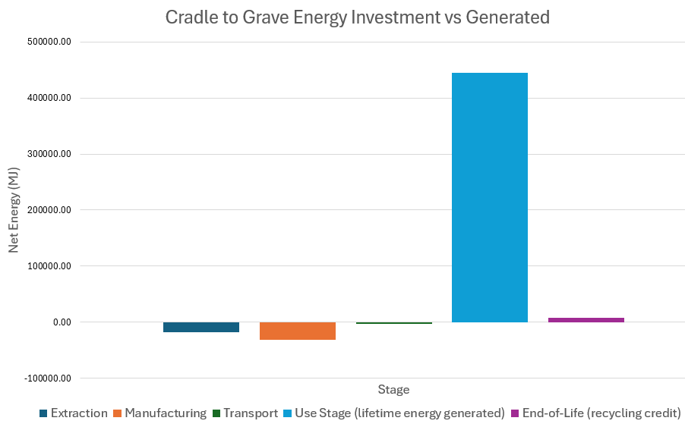
Figure 18. Comparison of lifecycle energy investment and total energy generated (Paliyal et al., 2024; Baker and Ghosh, 2026; IEA, 2020).

Conclusion
The role of Sustainability Specialist positioned sustainability as an active design function, directly influencing material selection, system architecture, regulatory strategy, and end-of-life planning. By embedding lifecycle thinking from the outset, sustainability considerations shaped not only environmental performance but also feasibility for domestic deployment and long-term compliance. The LCA demonstrates that while the single-axis tracking system introduces marginally higher embodied impacts than fixed installations, these are proportionate and largely offset by increased lifetime electricity generation, resulting in a lower carbon intensity per unit of energy produced. Beyond carbon reduction, the sustainability role ensured alignment with UK environmental legislation by treating compliance with planning, noise control, and waste regulation as an enabler of responsible design rather than a constraint. The integration of recycled materials, durability-focused design, and design-for-disassembly supports circular economy principles and reduces long-term environmental risk. Finally, applying an EPD framework demonstrates professional awareness of how sustainability performance is communicated and verified in industry, while acknowledging the limitations of early-stage data. Overall, this sustainability contribution evidences informed judgement, standards-led decision-making, and clear added value by balancing technical performance with regulatory and whole-life environmental responsibility.

James Levi (2416761) – Analysis Specialist

Introduction
Analysis has been completed during this project to help determine a final specification for the design of the Domestic Solar Tracking System. Analysis is necessary to improve the final product produced by using relevant research and data to assist its development. Specification targets have been set, and evaluation of customer values has been carried out by completing a Quality Function Analysis (QFD). To develop comprehensive analysis, research has been conducted into existing solutions, analysis tools such as a decision table have been utilized to develop targets for the expected performance of the product.
QFD is a focused methodology for carefully listening to the voice of the customer and then effectively responding to those needs and expectations. A QFD has been completed Figure 22 to communicate the needs of the customer. Each specialist can develop their contributions to suit the customer needs, liaising to develop a product with a high customer perceived value.

Customer Needs
Domestic solar panels reduce a household's carbon footprint by up to 0.7 to 1 tonne of CO₂ every year (Mainboard, 2026) and save up to 90% on customers electricity bills if they utilize export tariffs to profit from their energy (Octopus Energy, 2023), on top of this, solar panels also increase a property’s value anywhere between 2-3% (Baringa, 2023).
However, domestic use solar panels are fixed in position, and therefore, as the sun moves through the day, they produce less energy… causing customers to miss out on potential earnings. To resolve this issue our goal is to develop and implement a Single Axis Domestic Solar Tracking System. By utilizing live weather data from sources such as Met Office, the Domestic Solar Tracking System aims to accurately follow the position of the sun throughout the day. This system’s purpose is to improve energy harvesting by up to ~25% per day (Repsol, 2023), an increase of $0.31kWh$ per day Figure 19. A summary of customer needs for this product has been developed, ‘Customer Needs Table’ Figure 20.

Figure 19-Efficiency increase from Single Axis Tracking (Levi, 2026)

Customer Need | Importance | Engineering Requirement
Low Complexity | 5 | System must be as simple as possible, use of standardised parts etc.
Customer ROI | 4 | Affordable installation and maintenance with notable return
Solar Tracking Accuracy | 5 | Accurate solar tracking to maximise energy output
Durability | 3 | Must withstand weather and last lifetime of solar panels
Maintenance | 2 | Maintenance requirements must be similar to standard solar panels
Efficiency improvement | 5 | Justifiable improvement on energy harvesting
Figure 20-Customer Needs Table (Levi, 2026)
During group meetings it was significant for each specialist to have their input as to what requirements the final product should meet. From working collaboratively, a customer needs table has been developed to outline the criteria for the final product. By ranking their importance and requirements clear objectives could be set for each specialist and a QFD was developed from these core qualities.

Single Vs Dual Axis Tracking
Early development of the product consisted of investigating whether to develop a single axis solar tracking system or a dual axis system. By using data from existing solutions and assessing the customer needs in Figure 20, a decision table was developed to score each system’s viability. A decision table is a technique used for trade off analysis by giving customers’ needs a weight and then scoring the products ability to satisfy those needs. Trade off analysis is the process of comparing, prioritizing, and deciding among different requirements or design options (ScienceDirect, 2012).

Dual VS Single Axis Solar Tracking – Decision Table
Characteristic | Weightage | Single Axis | Dual Axis
Low Complexity | 5 | 5 | 1
Customer ROI | 4 | 3 | 1
Solar Tracking Accuracy | 5 | 3 | 5
Durability | 3 | 4 | 2
Maintenance | 2 | 5 | 2
Efficiency improvement | 5 | 4 | 5
Total Marks |  | 94 | 69
Figure 21- Decisions Table (Levi, 2026)
The decision table compares single axis and dual axis solar tracking system across against the criteria set by the customer needs table. It can be observed from the decision table that the dual axis system has higher tracking accuracy, as the system is able to track the sun both from east to west and from north to south. This results in approximately 5% to 10% further improvement to solar panel efficiency than single axis trackers (Repsol, 2023). Figure 19 visualizes this improvement in energy efficiency. A system capable of dual axis tracking would require more components and development compared to a single axis system, this increase in required R&D combined with a complex system would drive up the system’s cost to customers. Therefore, a dual axis system fails to satisfy the high weighted needs for low complexity and would reduce customer return on interest (ROI).
When comparing the systems against other criteria, the single axis system fits those customers’ needs significantly better. Due to its less complex system, with less failure points, it still manages to offer similar performance gains – at a lower cost and with better reliability. Working collaboratively with the other specialists, it was decided that Single Axis tracking was the best option to satisfy customer needs.

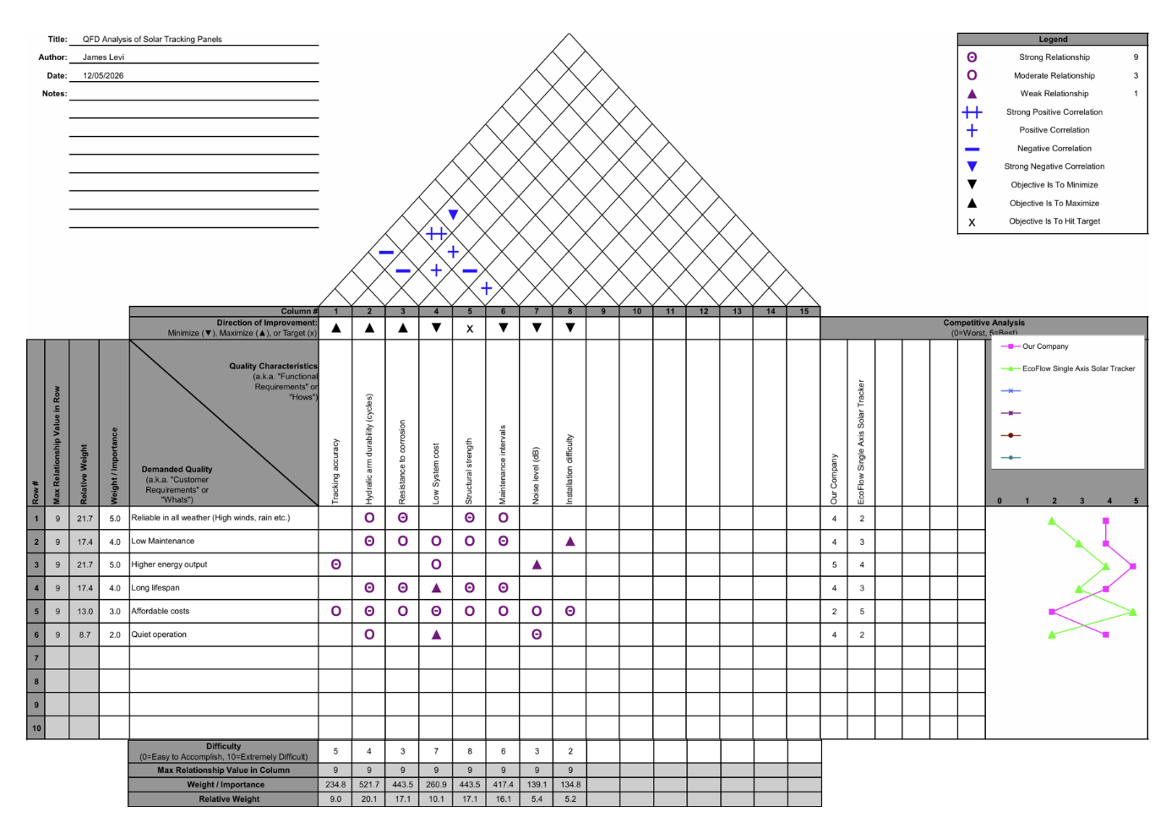
Figure 22 - Domestic Solar Tracking System QFD (Levi, 2026)

Quality Function Development Analysis
QFD is a tool which is used by engineers to design a product that listens to the voice of the customer. QFD has been used to identify several key customer requirements of the Domestic Solar Tracking System, which are each assigned a relative importance weighting. Observing ‘Domestic Solar Tracking System QFD’ Figure 22 above, it’s noticeable that the customers’ requirements are:
- Reliable operation in all weather conditions (5.0)
- Long lifespan (5.0)
- Higher energy output (5.0)
- Low maintenance (4.0)
- Affordable cost (3.0)
- Easy installation (3.0)

Weather Conditions, Lifespan & Maintenance
A challenge to designing Domestic Solar tracking panels is weather. Solar Tracking is standard practise for industrial solar farms, as the increased energy output is a non-negotiable benefit with very few drawbacks. However, when installed on roofs for domestic use weather becomes more of an issue, especially wind, as the panels are more exposed to high gusts on a roof. When wind is stopped by a surface the energy in the wind is transformed into pressure, this pressure transforms into a force (The EngineeringToolBox, 2011). The system must be structurally solid to withstand this, and by using a Wind Force equation, the forces exerted on the panel can be calculated.

Equation 1 - Wind Speed Calculations (Levi, 2026)
$$F_{W}=\frac{1}{2}ρ v^{2}A$$
$$F_{W}=\frac{1}{2}×1.2×{20}^{2}×2$$
$$F_{W}=480N$$

Where:
$F_{W}$= wind force ($N$)
$A$ = surface area of Panel ($2m^{2}$) (EcoFlow, 2026)
$ρ$= density of air ($1.2 \frac{kg}{m^{3}}$) (The EngineeringToolBox, 2011)
$v$ = wind speed ($m/s$)
Wind speed value used is typical strong wind speed ~45Mph

The design specialist has considered this customer requirement, and designed the system around procuring an affordable, suitable actuator, which has ample push/pull force of $750N$. By rearranging Equation 1, we can calculate the maximum wind speed at which the solar panel can operate within safe working limits.

Equation 2 – Maximum Operating Wind Speed Calculation (Levi, 2026)
$$v_{max}=\sqrt{\frac{F_{W}×2}{ρA}}$$
$$v_{max}=\sqrt{\frac{(750×0.8)×2}{1.2×2}}$$

$$v_{max}=22.36 m/s$$
$$v_{max}=\sim 50mph$$

A value of 80% for the maximum force the actuator can pull/push has been used to calculate the maximum wind speed within safe operating limits for the tracker. This value for force has been used as a safeguard, to ensure that the operation of machinery is safe and doesn’t pose a risk to customers (ISO, 2012). Once gusts of these windspeeds are detected, the solar tracking system automatically returns to its ‘home’ position Figure 23. At this position the system is less vulnerable to lift and pressure forces exerted by wind (The EngineeringToolbox, 2011).

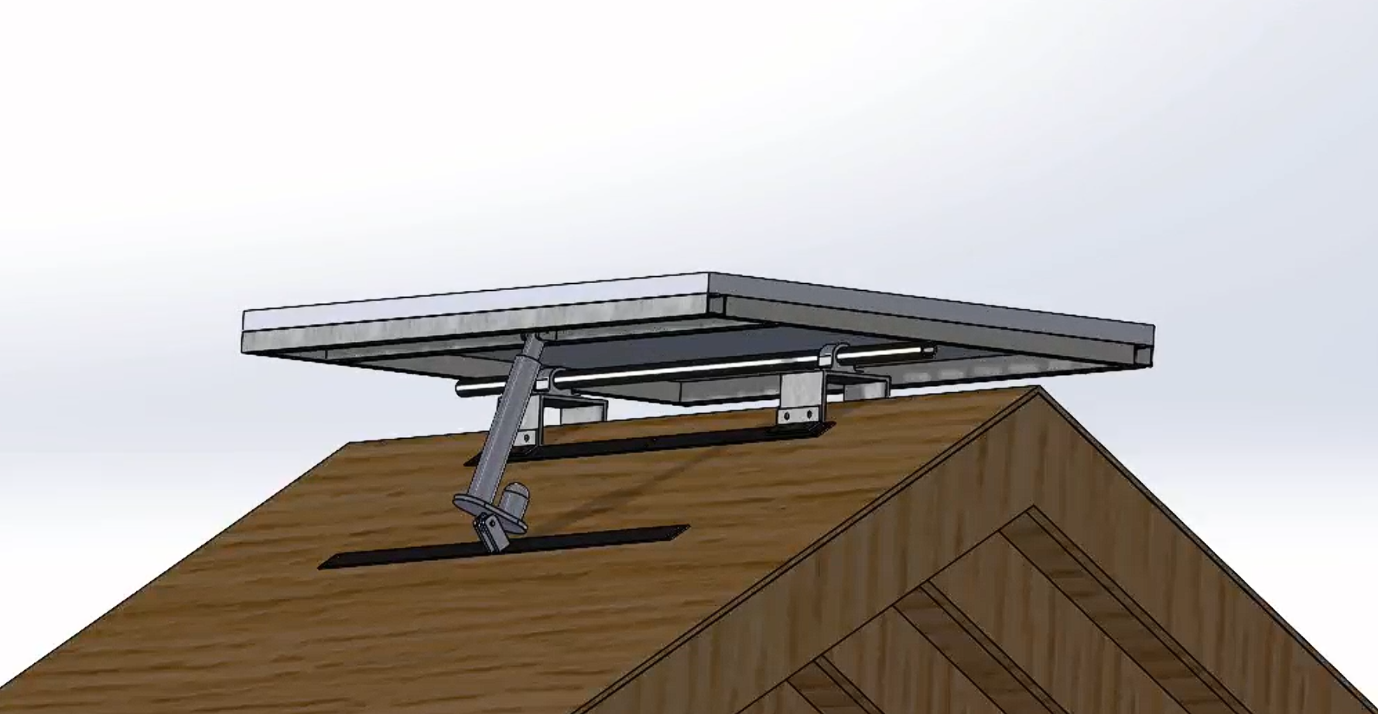
Figure 23 - Domestic Solar Tracking System, 'Home' position (Rees, 2026)
The use of standard components, such as the actuator, also ensures the system is just as easy to maintain and as reliable as standard solar panels. As this system doesn’t include any complicated systems with several failure points – compared to the initial rail design – reliability can be assured to the customer. The actuators material is an Aluminium alloy which has very good corrosion resistances, the supplier rates the actuator to be functional in ambient temperatures from -26℃ up to 50 ℃.
To ensure a long lifespan to the system, our materials specialist ensured the product used strong and weather resistive material. Anodised aluminium has been selected as our material choice, as it has very good corrosive resistances while also having excellent tensile strength, $180MPa$. (TagMakers, 2025)

Solar Tracking System and Accuracy
By utilizing live weather data from providers which advises airlines operating globally (Met Office, n.d), it is ensured that the solar tracking system receives up to date and accurate area specific weather forecasts and live data. The solar tracking system will benefit from the over 350 weather monitoring stations (Met Office, n.d) across the UK to monitor the sun as well as other weather conditions, such as high winds, to operate safely and efficiently.

Higher Energy Outputs & Affordable Costs
Single Axis solar tracking increases energy output of solar panels by anywhere from 25-30% (Repsol, 2023). This energy increase converts to additional savings of approximately 25% per year. The increased earnings ensures that customers see a faster Return on Investment (ROI) from the Domestic Solar Tracking System, see Figure24. Although there’s a higher installation cost per panel, the systems increased efficiency covers the cost of installation for each panel much faster, in just over 2 years.
The product is expected to match current market options; Octopus Energy offer a 25-year lifetime warranty on all solar panels (Octopus Energy, 2022). Over the 25-year lifespan of the product, customers can expect to see an increase in earnings of around £4,220 Figure 25.
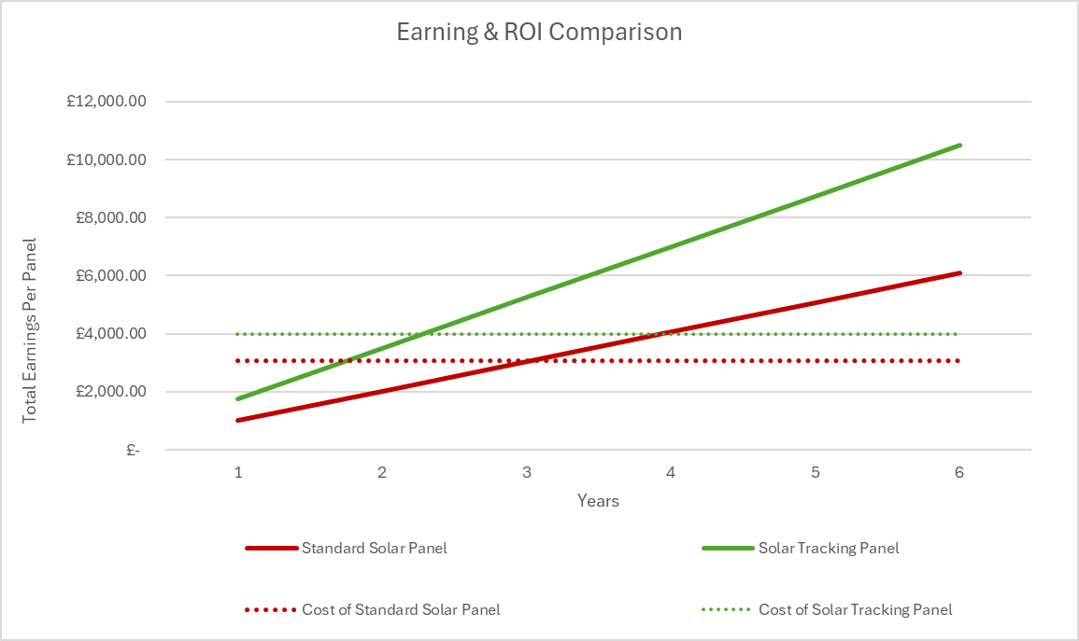
Figure 24 - Solar tracking VS Standard Solar Panels ROI (Levi, 2026)

Figure 25 - Comparison of Profit Over Time (Levi, 2026)
Data above referenced from Octopus Energy (2023).

Competitive Analysis
Competitive analysis is the process of identifying direct and indirect competitors to evaluate their strengths, weaknesses, pricing, and market position. An existing market solution which has been researched is the ‘EcoFlow Single Axis Solar Tracker 2’ (EcoFlow, 2026), which is a plug and play solar tracking solution designed for small scale residential use, for example fitting to balcony railings Figure 26. EcoFlow claim at least a ‘20% gain in efficiency over the local best installation’ and offer features such as app control and built in rain and light sensors. A comparison table has been created to compare the systems Figure 27.
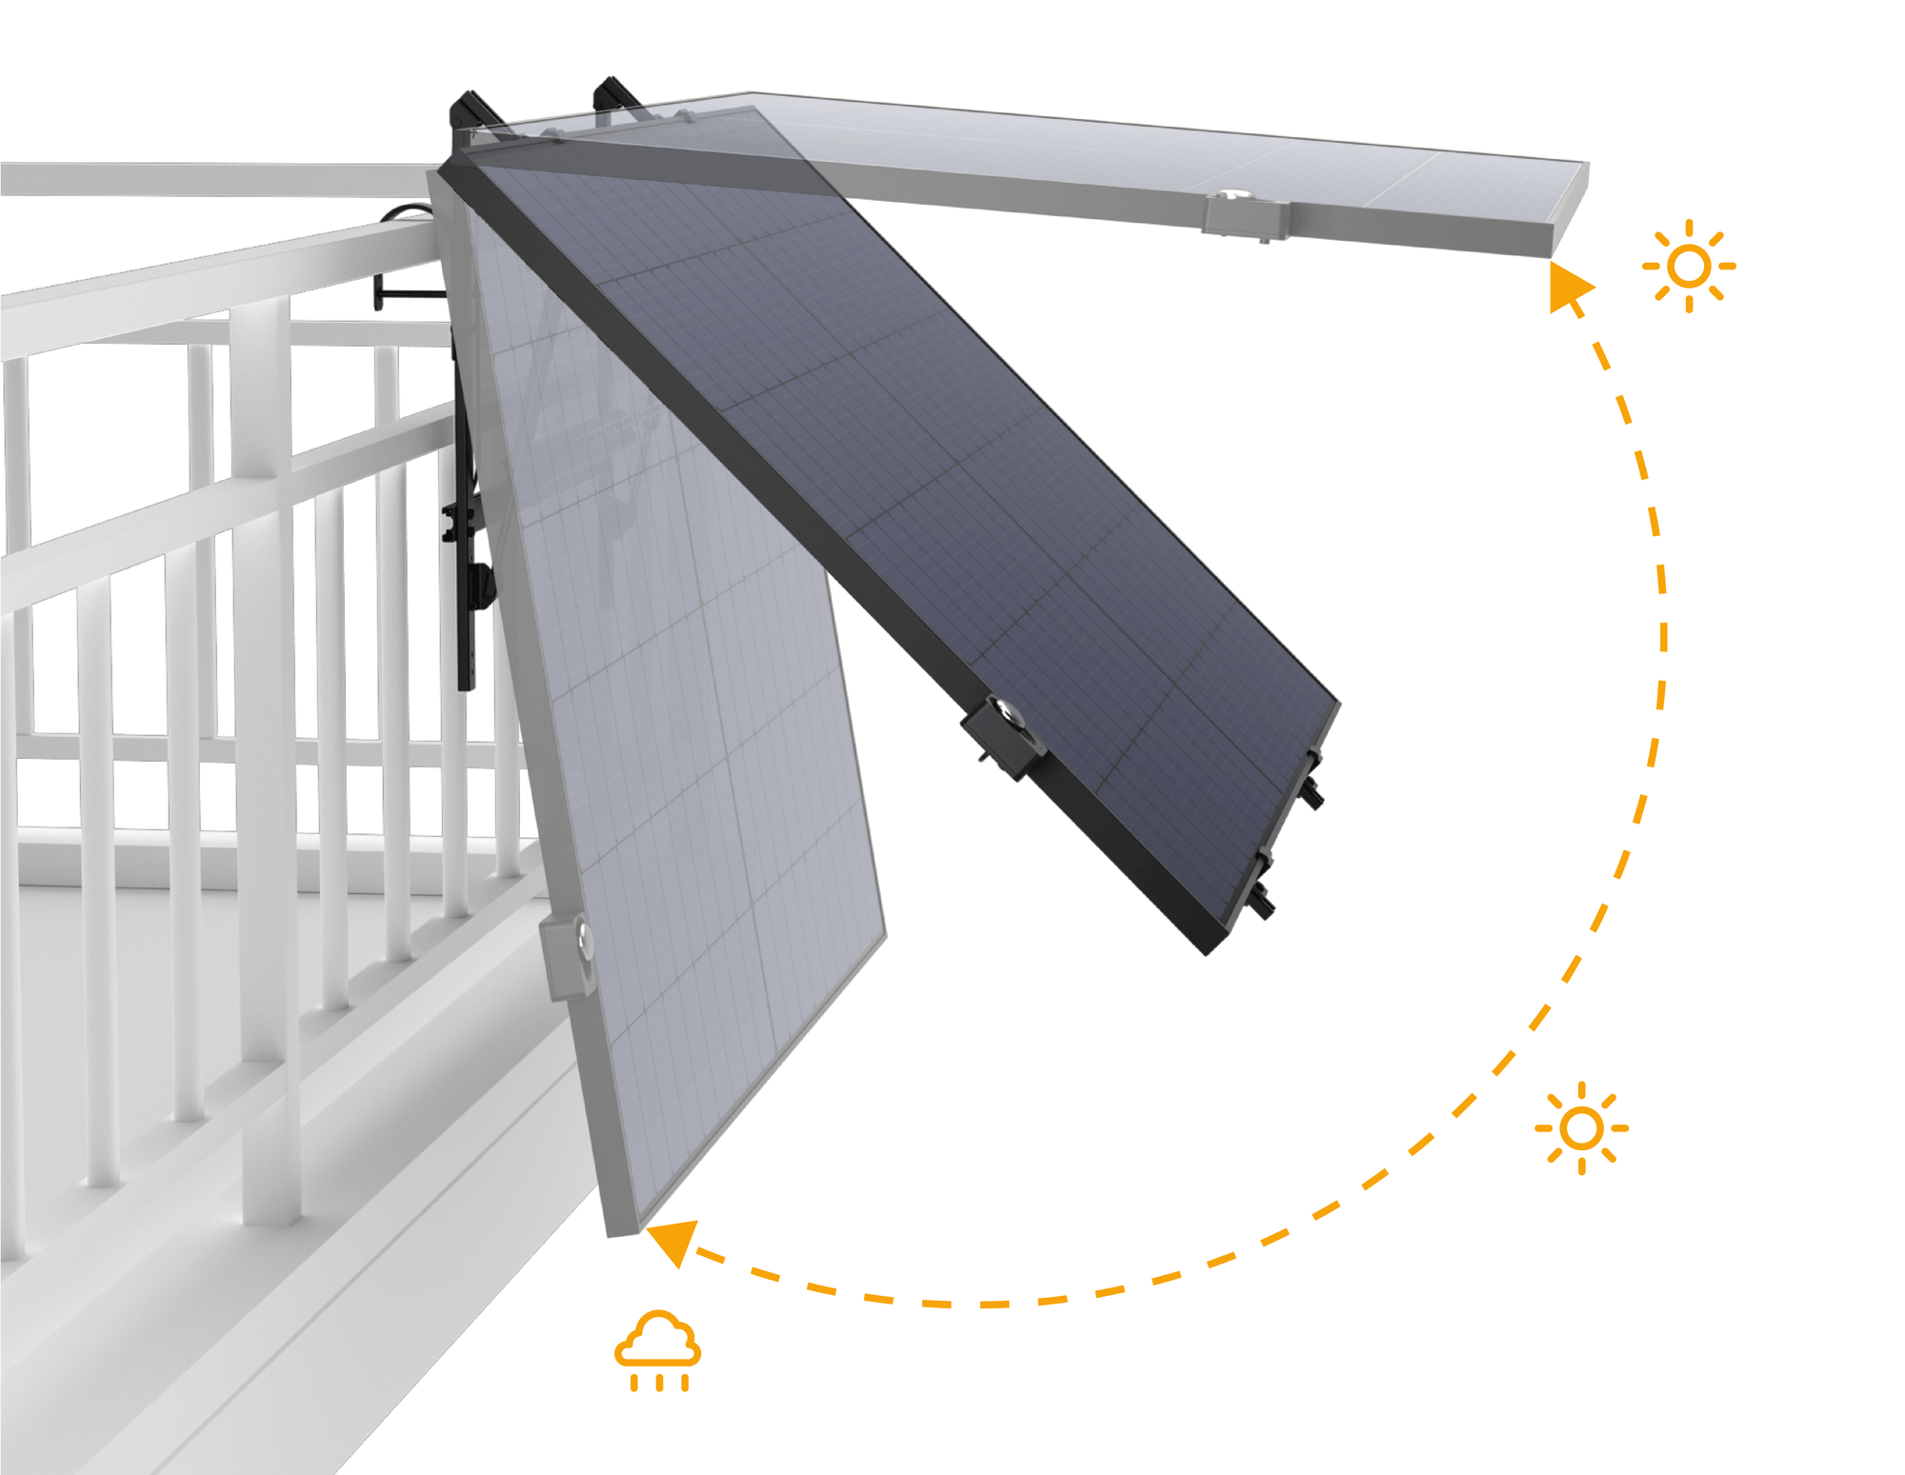
Figure 26-EcoFlow Single Axis Solar Tracker (EcoFlow, 2026)

Criteria | DSTS | EcoFlow
Max operating wind speed | 50Mph | 38-45Mph
Efficiency gains | 25-30% | 20%
Tracking Method | Weather Data | Sensors
Structural design | Fixed to roof | Freestanding
Target cost | Higher initial, with strong ROI | Low Upfront cost
Lifespan | 25 Years | 3 Year warranty offered
Figure 27- DSTS Vs EcoFlow Comparison Table (Levi, 2026)
Analysing the table above, combined with the competitive analysis completed in the QFD Figure 22, it has been deduced that the EcoFlow Single Axis Solar Tracker represents a more accessible solution that prioritises simplicity and ease of installation. However, its performance, scalability, and robustness are limited compared to the Domestic Solar Tracking System, as we have prioritised developing a structural design which provides long-term performance gains. EcoFlow’s app and in-built rain and light sensor offers a superior end user experience, however this doesn’t improve the performance of the system – which holds significance in a performance driven market.
Therefore, while EcoFlow offers strong competition in the low-cost, small-scale market segment, the Domestic Solar Tracking System holds a clear competitive advantage in full-scale domestic energy optimisation, as a more viable solution for long-term domestic solar investment.

Future Improvements
To further improve the Domestic Solar Tracking System product in the future, the use of analysis models such as the Kano model could be implemented to improve the robustness and efficiency of the development of the product. Unlike QFD, which prioritises technical importance, the Kano Model distinguishes between basic expectations, performance drivers, and delighters, enabling better design and innovation decisions. This could be applied to our Domestic Solar Tracking System as we could improve the end user experience, by developing a mobile application for customers to interact with the solar tracking system. This feature could be considered as a delighter, which customers would have great satisfaction from – and would be willing to pay a price premium for it (University of Cambridge, 2016).
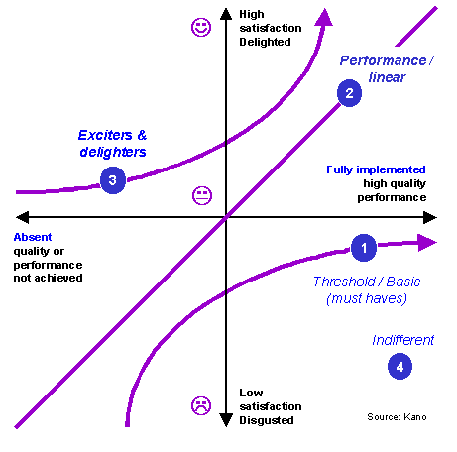
Figure 28 - Kano Model (University of Cambridge, 2016)
To improve the quality of analysis carried out in the future further calculations can be carried out to account for the angle of the panel when wind is exerting force onto it, as the calculations for wind speed fail to account for this factor. The solar tracking system itself can be improved to use its own solar detection system using state-the-art sensors combined with AI analysis to provide accurate information on environmental conditions and solar position in real time (Repsol, 2023), in combination with its current source of weather data to maximise efficiency.

Conclusion
Analysis serves a critical role in the development and engineering of a product, by influencing decisions made using research and data. Analysis has influenced the development of the Domestic Solar Tracking System, with a strong emphasis on aligning technical design decisions with customer needs. Through the application of tools such as Quality Function Deployment (QFD) and decision table analysis, the project successfully translated customer requirements into measurable engineering specifications, ensuring that the final design delivers both functional performance and high customer value.
The evaluation of single-axis versus dual-axis tracking systems highlighted the importance of trade-off analysis while designing the solar tracking system. Although a dual-axis system offers superior tracking accuracy and hence better energy harvesting - the increased complexity, cost, and maintenance requirements reduce the systems suitability for domestic use. From this, the single-axis tracking system was identified as the optimal solution as it offers a balanced combination of improved energy output, reliability, lower complexity, and enhanced return on investment.
Analysis was applied during this project to address operational challenges such as wind loading, by defining safe working limits for the Domestic Solar Tracking System. This allowed for the integration of safety features, and the calculations for wind speed were used to define the limits for the panel to return to the ‘home’ position for adverse weather conditions.
Analysis into the performance of single axis solar tracking finds that the proposed system achieves a significant improvement in energy harvesting, anywhere between 25–30% compared to fixed solar panels. This proves that there’s a tangible market for the product, as there are financial benefits for consumers over the product lifecycle. By combining robust engineering design, data-driven analysis, and customer-focused methodologies, the project presents a viable and commercially attractive solution for improving domestic solar energy systems.

Project Conclusion
Overall, the project successfully demonstrated how different areas of engineering can work together to create a practical solution for improving renewable energy use in domestic homes. The aim of designing a solar tracking system capable of following the sun throughout the day was achieved through the development of a single-axis rooftop tracking mechanism that balanced performance, simplicity and reliability. Compared to traditional fixed solar panels, the proposed system offers improves solar exposure and increased energy generation while remaining suitable for domestic installation.
One of the strongest aspects of the project was the collaborative approach taken by the team. Each specialist contributed to different stages of the development process, allowing technical, environmental, material and managerial considerations to be explored together rather than independently. This helped ensure that decisions were not based solely on performance, but also considered cost, manufacturability, sustainability and long-term practicality. The use of regular meetings, structured planning and clear communication also played an important role in keeping the project organised and progressing effectively.
The final design proved to be a realistic compromise between efficiency and mechanical complexity. Although dual-axis tracking systems can provide greater solar optimisations, the team recognised that they would introduce higher costs, increased maintenance and greater structural complexity for domestic applications. As a result, the single-axis system was considered the most suitable option because still provided significant improvements in energy capture while remaining mechanically practical and easier to maintain.
The project also highlighted the importance of sustainability within engineering design. Consideration was given not only to the renewable energy generation, but also to the environmental impact of materials, manufacturing, maintenance and end of life disposal. The use of recyclable materials, lightweight structural components and modular of the shelf parts helped improve the overall sustainability of the system and supported current environmental regulations and economy principles.
Despite the success of the project overall, there were several limitations identified during development. Some aspects of technical analysis, such as wind loading and system movement calculations were simplified due to time and project scope restrictions. In addition, the system relies heavily on the actuator for movement, meaning failure of this component would directly affect the systems operation. The range of movement was also limited by the actuator’s configuration, which reduced the maximum tracing angle of the panel.
If the project was to be developed further, additional testing and more advanced engineering analysis would be beneficial. Future improvements could include using real-time solar sensors, improving actuator positionings to increase movement range and carrying out a more detailed simulation under different environmental conditions. Further investigations into manufacturing costs and long-term economic performance would also help determine the feasibility of commercial domestic implementation.
In conclusion, the project provided valuable practical experience in engineering design, teamwork and problem-solving while demonstrating how innovative technologies can improve the efficiency of renewable energy systems. The final design successfully met its main objectives and provided a strong foundation for future development and refinement.

Bibliography

Craig Turner (Project Manager)
Ashby, M.F. (2013). Materials and the Environment. Oxford: Elsevier Science & Technology.
Belbin, M. (2010). Team Roles at Work. 2nd ed. Routledge.
Chapman, C.B. and Ward, S. (2011). How to manage project opportunity and risk : why uncertainty management can be a much better approach than risk management. Chichester, West Sussex ; Hoboken, Nj: Wiley.
Hillson, D. (2020). PRACTICAL PROJECT RISK MANAGEMENT : the atom methodology. S.L.: Berrett-Koehler.
Kerzner, H. (2017). Project management: a Systems Approach to planning, scheduling, and Controlling. 12th ed. John Wiley & Sons, Inc.
Lock, D. (2019). Project management. London: Routledge.
Meredith, J.R. and Mantel, S.J. (2017). Project management : A managerial approach. 8th ed. Hoboken, Nj: Wiley.
PMI (2021). A Guide to the Project Management Body of Knowledge (PMBOK® Guide) – Seventh Edition and the Standard for Project Management. 7th ed. Project Management Institute.

Nathan Rees – (Design)
Abdallah, S. & Nijmeh, S., 2004. Two axes sun tracking system with PLC control.. Energy conversion and Management, 45(12), pp. 1931-1939.
BSI, 2005. BS EN 1991-1-4:Eurocode 1 - Actions on Structures - Parrt 1-4. London: British Standards Institution.
Budynas, R. G. & Nisbett, J. K., 2015. Shignley's Mechanical Engineering Design. 10 ed. New York: McGraw-Hill Education.
MCS, 2008. Solar PV: Installation Standard. London: Microgeneration Certification Scheme.
Olabanji, M. O. & Mpofu, K., 2014. Comparison of Weighted Decision Matrix, And Analytical Hierarchy Process for CAD design of Reconfigurable Assembly Fixture. Procedia CIRP, Volume 23, pp. 264-269.
Pahl, G., Beitz, W., Feldhusen, J. & Grote, K.-H., 2007. Enginering Design: A Systematic Approach. 3rd ed. London: Springer.
Seme , S., Stumberger, B., Hadziselimovic, M. & Sredensek, K., 2020. Solar Photovoltaic Tracking Systems for Electricity Generation: A Review. Energies, 13(16), p. 4224.
Ulrich, K. T. & Eppinger, S. D., 2012. Product design and development. 5th ed. s.l.:McGraw-Hill.

Goncalo Gois Fonseca – (Materials)
Ashby, M.F. (2011) Materials Selection in Mechanical Design. 4th edn. Oxford: Butterworth-Heinemann.
ASM International (1990) Properties and Selection: Nonferrous Alloys and Special-Purpose Materials. ASM Handbook, Volume 2. Materials Park, Ohio: ASM International. Available at: https://dl.asminternational.org/handbooks/book/34/chapter/1190671/Properties-and-Selection-Nonferrous-Alloys-and
Callister, W.D. and Rethwisch, D.G. (2020) Materials Science and Engineering: An Introduction. 10th edn. Hoboken: Wiley. Available at: https://www.wiley.com/en-gb/Materials+Science+and+Engineering%3A+An+Introduction%2C+10th+Edition-p-9781119721772
Davis, J.R. (1993) Aluminum and Aluminum Alloys. Materials Park, Ohio: ASM International. Available at: https://dl.asminternational.org/handbooks/book/34/chapter/1190671/Properties-and-Selection-Nonferrous-Alloys-and
Davis, J.R. (1994) Stainless Steels. ASM Specialty Handbook. Materials Park, Ohio: ASM International. Available at: https://dl.asminternational.org/handbooks/book/35/chapter/1190846/Stainless-Steels
Davis, J.R. (1999) Corrosion of Aluminum and Aluminum Alloys. Materials Park, Ohio: ASM International. Available at: https://dl.asminternational.org/handbooks/book/118/chapter/2162485/Corrosion-of-Aluminum-and-Aluminum-Alloys
Green, M.A. (2019) Solar Cells: Operating Principles, Technology and System Applications. UNSW Sydney. Available at: https://www.unsw.edu.au
Groover, M.P. (2020) Fundamentals of Modern Manufacturing: Materials, Processes, and Systems. 7th edn. Hoboken: Wiley.
Habazaki, H., Shimizu, K., Skeldon, P. and Thompson, G.E. (2007) ‘Advanced surface engineering of aluminium for corrosion protection’, Transactions of Nonferrous Metals Society of China, 17(s1), pp. s94–s99. Available at: https://www.sciencedirect.com/science/article/pii/S1003632607606005
ISO (2018) ISO 31000:2018 Risk Management – Guidelines. Geneva: International Organization for Standardization.
Jordan, D.C. and Kurtz, S.R. (2013) ‘Photovoltaic Degradation Rates—An Analytical Review’, Progress in Photovoltaics: Research and Applications, 21(1), pp. 12–29. Available at: https://onlinelibrary.wiley.com/doi/10.1002/pip.1182
Kalogirou, S.A. (2014) Solar Energy Engineering: Processes and Systems. 2nd edn. Academic Press. Available at: https://www.sciencedirect.com/book/9780123972705/solar-energy-engineering
Messenger, R.A. and Ventre, J. (2010) Photovoltaic Systems Engineering. 3rd edn. Boca Raton: CRC Press.
Stanciu, M.D., Ursache, M. and Teaca, C.A. (2021) ‘Mechanical Properties of GFRP Composites Exposed to Tensile Loading’, Materials, 14(18), p. 5358. Available at: https://pmc.ncbi.nlm.nih.gov/articles/PMC8469386/

Georgia Cox – Sustainability
Adisa Amanor-Wilks (2024). Global Aluminium Industry Greenhouse Gas Emissions Intensity Reduction Continues, With Total Emissions Below 2020 Peak - International Aluminium Institute. [online] International Aluminium Institute. Available at: https://international-aluminium.org/global-aluminium-industry-greenhouse-gas-emissions-intensity-reduction-continues-with-total-emissions-below-2020-peak/.
Alsabri, A., Tahir, F. and Al-Ghamdi, S.G. (2021). Life-Cycle Assessment of Polypropylene Production in the Gulf Cooperation Council (GCC) Region. Polymers, 13(21), p.3793. doi:https://doi.org/10.3390/polym13213793.
American Galvanizers Association (2025). Galvanizing Basics: FAQs. [online] American Galvanizers Association. Available at: https://galvanizeit.org/hot-dip-galvanizing/what-is-galvanizing/faq.
Antonanzas, J., Arbeloa-Ibero, M. and Quinn, J.C. (2019). Comparative life cycle assessment of fixed and single axis tracking systems for photovoltaics. Journal of Cleaner Production, 240, p.118016. doi:https://doi.org/10.1016/j.jclepro.2019.118016.
Arup (2023). Buildings & Infrastructure Priority Actions for Sustainability Embodied Carbon Steel. [online] Available at: https://www.istructe.org/IStructE/media/Public/Resources/ARUP-Embodied-carbon-steel_1.pdf.
Associates, F. (2021). CRADLE-TO-GATE LIFE CYCLE ANALYSIS OF POLYPROPYLENE (PP) RESIN Final Report. [online] Available at: https://britishrecycledplastic.co.uk/wp-content/uploads/2022/07/Final-ACC-LCA-Report-PP-Resin.pdf?srsltid=AfmBOorU_LT-LwO2HaxORN5FxMY4LmKaOzwb7vs6w19CfUkAfcHymOQ0 [Accessed 1 May 2026].
Baker, J. and Ghosh, A. (2026). Investigation of fixed and East-West, North-South, and azimuthal single-axis tracking for floating photovoltaics (Floatovoltaics) in the UK. Energy 360, 5, p.100052. doi:https://doi.org/10.1016/j.energ.2025.100052.
Barnes, M. (2023). A Short Guide to Product Life Cycle Analyses. [online] Green Element. Available at: https://www.greenelement.co.uk/blog/a-short-guide-to-product-life-cycle-analyses/.
Bolton, P. (2026). Energy efficiency of UK homes. [online] Available at: https://researchbriefings.files.parliament.uk/documents/CBP-9889/CBP-9889.pdf.
Boustead , I. (2005). Eco-profiles of the European Plastics Industry POLYPROPYLENE (PP). [online] Available at: https://www.inference.org.uk/sustainable/LCA/elcd/external_docs/pp_31116f04-fabd-11da-974d-0800200c9a66.pdf.
Burnett, N., Edwards, T. and Watson, N. (2024). The UK’s Plans and Progress to Reach Net Zero by 2050. [online] Available at: https://researchbriefings.files.parliament.uk/documents/CBP-9888/CBP-9888.pdf.
Climate Change Committee (2024). Climate Action - Climate Change Committee. [online] Climate Change Committee. Available at: https://www.theccc.org.uk/climate-action/.
Daniela-Abigail, H.-L., Vega-De-Lille, M.I., Sacramento-Rivero, J.C., Ponce-Caballero, C., El-Mekaoui, A. and Navarro-Pineda, F. (2024). Life cycle assessment of photovoltaic panels including transportation and two end-of-life scenarios: Shaping a sustainable future for renewable energy. Renewable Energy Focus, [online] 51, p.100649. doi:https://doi.org/10.1016/j.ref.2024.100649.
Enexion Group (n.d.). LCA Report -Asistal Aluminium LIFE CYCLE ASSESSMENT OF. [online] Available at: https://asistal.com/storage/sustainabilityfiles/media/3722/asistalaluminyum-enx-lca-20240610.pdf [Accessed 1 May 2026].
Government Digital Service (2012). Electrical waste: retailer and distributor responsibilities. [online] GOV.UK. Available at: https://www.gov.uk/electricalwaste-producer-supplier-responsibilities/non-compliance.
Greig, M. (2017). Quiet Linear Actuators. [online] Actuonix.com. Available at: https://www.actuonix.com/quiet-linear-actuators.
Hushtec Solutions (2025). Solar Farms are Getting Louder | Hushtec Noise Control. [online] Hushtec Solutions. Available at: https://www.hushtecsolutions.com/blog/solar-farms-are-getting-louder/ [Accessed 2 May 2026].
IEA (2020). Life Cycle Inventories and Life Cycle Assessments of Photovoltaic Systems 2020 Task 12 PV Sustainability. [online] Available at: https://iea-pvps.org/wp-content/uploads/2020/12/IEA-PVPS-LCI-report-2020.pdf.
International Copper Association (2023). COPPER- THE PATHWAY TO NET ZERO SUMMARY See full report via QR code or copperalliance.org/resource/copper-pathway-to-net-zero. [online] Available at: https://internationalcopper.org/wp-content/uploads/2023/03/ICA-GlobalDecarb-Summary-A4-202302-R3.pdf.
International EPD System (2025). Environmental Product Declaration | EPD International. [online] Environdec.com. Available at: https://www.environdec.com/services/what-is-epd.
ISO (2020). ISO 14040:2006(en) Environmental Management — Life Cycle Assessment — Principles and Framework. [online] Iso.org. Available at: https://www.iso.org/obp/ui/#iso:std:iso:14040:ed-2:v1:en.
Mdallal, A., Yasin, A., Mahmoud, M., Abdelkareem, M.A., Alami, A.H. and Olabi, A.G. (2025). A comprehensive review on solar photovoltaics: Navigating generational shifts, innovations, and sustainability. Sustainable Horizons, [online] 13, p.100137. doi:https://doi.org/10.1016/j.horiz.2025.100137.
Paliyal, P.S., Mondal, S., Layek, S., Kuchhal, P. and Pandey, J.K. (2024). Automatic solar tracking system: a review pertaining to advancements and challenges in the current scenario. Clean Energy, 8(6), pp.237–262. doi:https://doi.org/10.1093/ce/zkae085.
pes renewables (2024). How Much Can a Solar PV System Reduce Your Household’s Carbon Emissions? - PES Renewables. [online] PES Renewables. Available at: https://pesrenewables.com/how-much-can-a-solar-pv-system-reduce-your-households-carbon-emissions.
Plastics Europe (2024). Polyolefins. [online] Plastics Europe. Available at: https://plasticseurope.org/plastics-explained/a-large-family/polyolefins/.
Ryan, C. (2022). How are Solar Panels Made? Step by Step Process. [online] Ossila. Available at: https://www.ossila.com/pages/how-are-solar-panels-made.
SolarLove (2026). Solar Panel Recycling UK: Complete End of Life Guide. [online] Solarlove.org. Available at: https://solarlove.org/solar-panel-recycling-uk/.
Tagmakers (2025). Anodised Aluminium Technical Specifications : TagMakers, TagMakers. [online] Tagmakers. Available at: https://tagmakers.co.uk/anodised-aluminium-technical-specifications.
The Aluminum Association (2021). Infinitely Recyclable. [online] www.aluminum.org. Available at: https://www.aluminum.org/Recycling.
The Association of Plastic Recyclers (2020). Virgin vs. Recycled Plastic Life Cycle Assessment Energy Profile and Life Cycle Assessment Environmental Burdens. [online] Available at: https://plasticsrecycling.org/wp-content/uploads/2024/08/APR-Recycled-vs-Virgin-LCA-May2020.pdf.
UK Government (2008). Climate Change Act 2008. [online] Legislation.gov.uk. Available at: https://www.legislation.gov.uk/ukpga/2008/27/contents.
UK Government (2012). Noise Act 1996. [online] Legislation.gov.uk. Available at: https://www.legislation.gov.uk/ukpga/1996/37/section/2.
UK Government (2021). Environment Act 2021. [online] Legislation.gov.uk. Available at: https://www.legislation.gov.uk/ukpga/2021/30/contents.
UK Government (2023). The Town and Country Planning (General Permitted Development) (England) Order 2015 No. 596. [online] Legislation.gov.uk. Available at: https://www.legislation.gov.uk/uksi/2015/596/schedule/2/part/14/data.xht?view=snippet&wrap=true [Accessed 2 May 2026].
UKGBC (2025). Environmental Impacts of Aluminium & Bauxite Mining. [online] UKGBC. Available at: https://ukgbc.org/our-work/topics/embodied-ecological-impacts/aluminium/.

James Levi – Analysis
mainboard (2026). How Much CO₂ Can the Average UK Home Cut with Solar? - Save Energy UK. [online] Save Energy UK. Available at: https://saveenergyuk.co.uk/how-much-co%E2%82%82-can-the-average-uk-home-cut-with-solar/.
[Accessed 19 May 2026]
Octopus Energy (2023). Running on Sunshine: Octopus Energy enters solar installation market. [online] Octopus Energy. Available at: https://octopus.energy/press/running-on-sunshine-octopus-energy-enters-solar-installation-market/
[Accessed 18 May 2026].
Baringa (2024). Cleantech Homes: Lower Bills, Healthier Living. [online] Baringa. Available at: https://www.baringa.com/globalassets/insights/low-carbon-futures/a-baringa-report_cleantech-homes-healthier-living-lower-bills.pdf
[Accessed 19 May 2026].
The Engineering ToolBox (2011). Wind Load vs. Wind Speed. [online] The Engineering ToolBox. Available at: https://www.engineeringtoolbox.com/wind-load-d_1775.html
[Accessed 19 May 2026].
EcoFlow (2026). Photovoltaic Panel Dimensions in the UK: Standard Sizes and Roof Planning Guide | EcoFlow UK. [online] Ecoflow.com. Available at: https://energy.ecoflow.com/uk/blog/photovoltaic-panel-dimensions
[Accessed 20 May 2026].
Tagmakers (2025). Anodised Aluminium Technical Specifications : TagMakers, TagMakers. [online] Tagmakers. Available at: https://tagmakers.co.uk/anodised-aluminium-technical-specifications
[Accessed 21 May 2026].
Repsol (2023). Solar trackers: What they are, types, and advantages | Repsol. [online] REPSOL. Available at: https://www.repsol.com/en/energy-move-forward/energy/solar-trackers/index.cshtml
[Accessed 18 Apr. 2026].
BSI.Knowledge (2024). Actions on structures - General actions - Wind actions [online] Bsigroup.com. Available at: https://knowledge.bsigroup.com/products/eurocode-1-actions-on-structures-general-actions-wind-actions
[Accessed 22 May 2026].
International Organization for Standardization (ISO) (2012). ISO 13849-2 - Safety of machinery — Safety-related parts of control systems. [online] Iso.org. Available at: ISO 13849-2:2012(en), Safety of machinery — Safety-related parts of control systems — Part 2: Validation
[Accessed 24 May 2026].
Science Direct (2012). Tradeoff Analysis - An Overview. [online] Science Direct. Available at: https://www.sciencedirect.com/topics/computer-science/tradeoff-analysis
[Accessed 24 May 2026].
University of Cambridge (2016). Kano model. [online] www.ifm.eng.cam.ac.uk. Available at: https://www.ifm.eng.cam.ac.uk/research/dmg/tools-and-techniques/kano-model/ [Accessed 24 May 2026].
Met Office (n.d.). How accurate are our public forecasts? [online] Met Office. Available at: https://www.metoffice.gov.uk/about-us/who-we-are/accuracy
[Accessed 24 May 2026].

Appendix

Meeting Minutes 13/02/2026

Meeting Minutes
Meeting Information
Date: 13th February 2026
Time: 15:30
Location: IQ Building / teams call
Meeting Called By: Craig Turner
Note Taker: Craig Turner

Attendees & Roles
Name | Role
Craig Turner | Project Manager
Georgia Cox | Sustainability
Gonçalo Santos Gois Velez da Fonseca  Nathan Rees | Materials  Design
James Levi | Analysis
Meeting Purpose
Align team of project direction, confirm and understand tasks and agree next steps moving forward.
Key Discussion Points
• Initial timeline
• Project Direction
• Technical Directions
Decisions Made
• Finalise project concept
• To understand similar agricultural products on the market and how we could scale down.
5. Action Items
Role Area | Assigned To | Notes
Project Manger | Craig | Research existing products.
Design & modelling | Nathan | Research existing products.
Materials | Gonçalo | Research materials currently used.
Analysis | James | Research existing products
Sustainability / environmental impact | Georgia | Set up powerpoint.
Action Items

Meeting Minutes 20/02/2026

Meeting Minutes
Meeting Information
Date: 20th February 2026
Time: 15:30
Location: IQ Building / teams call
Meeting Called By: Craig Turner
Note Taker: Craig Turner

Attendees & Roles
Name | Role
Craig Turner | Project Manager
Georgia Cox | Sustainability
Gonçalo Santos Gois Velez da Fonseca  Nathan Rees | Materials  Design
James Levi | Analysis
Meeting Purpose
To discuss the following week and the expectations required from each individual. Discuss scope. Project aims and team roles.

Key Discussion Points
• Interim Viva and timelines.
Each individual’s role within the making of the PowerPoint who is to focus on what. (etc)
• Project Scope. Try to define scope.
Discuss the Design and build of solar tracking device which mechanically rotates to follow the sun throughout the day. Does the solar panel require a battery storage device.

• Agree team roles for the week ahead and allocate slides to be worked on.

Decisions Made
Meeting booked with Richard Sutton for 27th February to discuss expectations gong forward.
Each individual given a slide to start inputting info on throughout the week.
Agreed Battery storage was going to be pulled from scope.

Action Items

Role Area | Assigned To | Notes
Project Manager | Craig | To continue with project timeline.
Design & modelling | Nathan | Initial sketches and modelling.
Materials | Gonçalo | Research materials used for the turning mechanism.
Analysis | James | Continue research.
Sustainability / environmental impact | Georgia | Full ownership of sustainability section.

Meeting Minutes 27/02/2026

Meeting Minutes
Meeting Information
Date: 27th February 2026
Time: 15:30
Location: IQ Building / team’s call
Meeting Called By: Craig Turner
Note Taker: Craig Turner

Attendees & Roles
Name | Role
Craig Turner | Project Manager
Georgia Cox | Sustainability
Gonçalo da Fonseca (vía teams)  Nathan Rees | Materials  Design
James Levi | Analysis
Meeting Purpose
Meeting with Richard Sutton to discuss scope and to ensure we are on correct path and that all criteria is met.

Key Discussion Points
• Discussed project scope.
Wanted to understand we was going down the correct path in regards to the design and project.
• Understanding roles
Discussed the roles with Richard and wanted to understand the expectations for each role, we put across what we had originally put in place and on this instant Richard agreed with out progress.
Decisions Made
Continue on path already agreed week prior and to continue creating slideshow for interim VIVA
Action Items

Role Area | Assigned To | Notes
Project Manager | Craig | To continue with project timeline.
Design & modelling | Nathan | Initial sketches and modelling.
Materials | Gonçalo | Research materials used for the turning mechanism.
Analysis | James | Analyse panels in todays market.
Sustainability / environmental impact | Georgia | Full ownership of sustainability section.

Meeting Minutes 06/03/2026

Meeting Minutes
Meeting Information
Date: 6th March 2026
Time: 15:30
Location: IQ Building / team’s call
Meeting Called By: Craig Turner
Note Taker: Craig Turner

Attendees & Roles
Name | Role
Craig Turner | Project Manager
Georgia Cox | Sustainability
Gonçalo da Fonseca (vía teams)  Nathan Rees | Materials  Design
James Levi | Analysis
Meeting Purpose
After meeting with Richard previous week, discussed what came from that. And with a good understanding of roles discussed moving forward and finalizing Interim VIVA.

Key Discussion Points

• Discussed individual PowerPoints
So as a team we went through each individuals slides and made sure there was enough info and that each person was on the correct path in regards to what information they were relaying across. We discussed what can be added and also what can be removed at this stage of the project. We made notes on each slide with pointers on what to research in the week ahead.

Decisions Made
We decided on what was to be inputted and to be removed from the PowerPoint, and was now working towards the Final Interim VIVA completion by next Friday.

Action Items

Role Area | Assigned To | Notes
Project management | Craig | To finish slides, do revision of full PowerPoint.
Design & modelling | Nathan | Complete sketches and finish slides.
Materials | Gonçalo | Finish slides as per meeting. .
Analysis | James | Research a little more into solar panel efficiency and input into slide.
Sustainability / environmental impact | Georgia | Complete sustainability slides.

Meeting Minutes 13/02/2026

Meeting Minutes
Meeting Information
Date: 13th March 2026
Time: 15:30
Location: IQ Building / team’s call
Meeting Called By: Craig Turner
Note Taker: Craig Turner
Attendees & Roles
Name | Role
Craig Turner | Project Manager
Georgia Cox | Sustainability
Gonçalo da Fonseca (vía teams)  Nathan Rees | Materials  Design
Meeting Purpose
Run through Interim VIVA before presentation the following week. Ensure everyone is happy with their slides and how they are going to present their individual slides.

Key Discussion Points
• Interim VIVA
Spoke about what was good and bad in the VIVA
Decided what was to stay, what was to remove and what was to be added in.
Deadline for completion is Wednesday 18th March 11am for myself to go through and ensure all is good and to hand in.

Decisions Made
Final run through, few key points to add to some slides and unnecessary bit to be removed.
Action Items

Role Area | Assigned To | Notes
Project management | Craig | Remove full Gantt chart, do final review after Wednesday deadline.
Design & modelling | Nathan | Upload final sketches
Materials (focus on mechanism) | Gonçalo | Show material locations
Sustainability / environmental impact | Georgia | Edit slides to show less information, agreed to keep back for Main VIVA.

Meeting Minutes 10/04/2026

Meeting Minutes
Meeting Information
Date: 10th April 2026
Time: 15:30
Location: IQ Building / team’s call
Meeting Called By: Craig Turner
Note Taker: Craig Turner

Attendees & Roles
Name | Role
Craig Turner | Project Manager
Georgia Cox | Sustainability
Gonçalo da Fonseca (vía teams)  Nathan Rees | Materials  Design
James Levi | Analysis
Meeting Purpose
Discuss feedback from Richard from interim VIVA, talk about our next steps in regard to our main VIVA and Report. Working off the Gantt chart to show team where expected hand in dates are in order to get everything finalized and submitted.
Key Discussion Points
- Review of how are Interim VIVA went.
- Assess feedback from Richard and use it constructively moving forward.
- Talk about next steps.
Decisions Made
- Plan moving forward and understanding roles and responsibilities of each team member.
- Dates of submission, originally in Gantt chart, but needed team to be aware of date and agree.
- Nathan to finish design by 8th May to allow Materials specialist and

Role Area | Assigned To | Notes
Project management | Craig | Focus on VIVA and Report
Design & modelling | Nathan | Continue with design finish by 8th May.
Materials | Gonçalo | Focus on VIVA and Report
Analysis | James | Focus on VIVA and Report
Sustainability / environmental impact | Georgia | Focus on VIVA and Report

Action Items

Meeting Minutes 17/04/2026

Meeting Minutes
Meeting Information
Date: 17th April 2026
Time: 15:30
Location: IQ Building / team’s call
Meeting Called By: Craig Turner
Note Taker: Craig Turner

Attendees & Roles
Name | Role
Craig Turner | Project Manager
Georgia Cox | Sustainability
Gonçalo da Fonseca (vía teams)  Nathan Rees | Materials  Design
James Levi | Analysis
Meeting Purpose

Brief chat this week to see how progression is moving on and to ensure everyone is happy with where they are.

Key Discussion Points
- To continue with progression, everyone seems happy.
Decisions Made
- To continue with progression, everyone seems happy.

Action Items
Role Area | Assigned To | Notes
Project management | Craig | Focus on VIVA and Report
Design & modelling | Nathan | Continue with design finish by 8th May.
Materials | Gonçalo | Focus on VIVA and Report
Analysis | James | Focus on VIVA and Report
Sustainability / environmental impact | Georgia | Focus on VIVA and Report

Meeting Minutes 24/04/2026

Meeting Minutes
1. Meeting Information
Date: 1st May 2026
Time: 15:30
Location: IQ Building / team’s call
Meeting Called By: Craig Turner
Note Taker: Craig Turner

Attendees & Roles
Name | Role
Craig Turner | Project Manager
Georgia Cox | Sustainability
Gonçalo da Fonseca (vía teams)  Nathan Rees | Materials  Design
James Levi | Analysis
Meeting Purpose
Brief chat this week to see how progression is moving on and to ensure everyone is happy with where they are.

Key Discussion Points
- To continue with progression, everyone seems happy.
Decisions Made
- To continue with progression, everyone seems happy.

Action Items
Role Area | Assigned To | Notes
Project management | Craig | Focus on VIVA and Report
Design & modelling | Nathan | Continue with design finish by 8th May.
Materials | Gonçalo | Focus on VIVA and Report
Analysis | James | Focus on VIVA and Report
Sustainability / environmental impact | Georgia | Focus on VIVA and Report

Meeting Minutes 01/05/2026

Meeting Minutes
Meeting Information
Date: 1st May 2026
Time: 15:30
Location: IQ Building / team’s call
Meeting Called By: Craig Turner
Note Taker: Craig Turner

Attendees & Roles
Name | Role
Craig Turner | Project Manager
Georgia Cox | Sustainability
Gonçalo da Fonseca (vía teams)  Nathan Rees | Materials  Design
James Levi | Analysis
Meeting Purpose
Brief chat this week to see how progression is moving on and to ensure everyone is happy with where they are.

Key Discussion Points
- To continue with progression, everyone seems happy.
Decisions Made
- To continue with progression, everyone seems happy.

Action Items
Role Area | Assigned To | Notes
Project management | Craig | Focus on VIVA and Report
Design & modelling | Nathan | Continue with design finish by 8th May.
Materials | Gonçalo | Focus on VIVA and Report
Analysis | James | Focus on VIVA and Report
Sustainability / environmental impact | Georgia | Focus on VIVA and Report

Meeting Minutes 08/05/2026

Meeting Minutes
Meeting Information
Date: 8th May 2026
Time: 15:30
Location: IQ Building / team’s call
Meeting Called By: Craig Turner
Note Taker: Craig Turner

Attendees & Roles
Name | Role
Craig Turner | Project Manager
Georgia Cox | Sustainability
Gonçalo da Fonseca (vía teams)  Nathan Rees | Materials  Design
James Levi | Analysis
Meeting Purpose
Brief chat this week to see how progression is moving on and to ensure everyone is happy with where they are.

Key Discussion Points
- To continue with progression, everyone seems happy.
Decisions Made
- To continue with progression, everyone seems happy.

Action Items
Role Area | Assigned To | Notes
Project management | Craig | Focus on VIVA and Report
Design & modelling | Nathan | Focus on VIVA and Report
Materials | Gonçalo | Focus on VIVA and Report
Analysis | James | Focus on VIVA and Report
Sustainability / environmental impact | Georgia | Focus on VIVA and Report

Meeting Minutes 15/05/2026

Meeting Minutes
Meeting Information
Date: 15th May 2026
Time: 15:30
Location: IQ Building / team’s call
Meeting Called By: Craig Turner
Note Taker: Craig Turner

Attendees & Roles
Name | Role
Craig Turner | Project Manager
Georgia Cox | Sustainability
Gonçalo da Fonseca (vía teams)  Nathan Rees | Materials  Design
James Levi | Analysis
Meeting Purpose
Final week to communicate with others hand in date to project Manager is next week.

Key Discussion Points
- Hand in date 22/05/2026.
Decisions Made
- Finish both VIVA and report submit to Craig by Friday so it can be put into one document and proof read.

Action Items
Role Area | Assigned To | Notes
Project management | Craig | Expect everyone’s report and structure final document.
Design & modelling | Nathan | Complete VIVA and Report and hand in.
Materials | Gonçalo | Complete VIVA and Report and hand in.
Analysis | Craig & James | Complete VIVA and Report and hand in.
Sustainability / environmental impact | Georgia | Complete VIVA and Report and hand in.

