ACMA5009 Group Project
Reflective Project Report


Emyr Hunnam (2216571)
Renishaw PLC

Table of Contents

Table of Contents 1
1. Introduction 2
1.1.1 Aims and Objectives of the report 2
1.1.2 Aims of the report 2
1.1.3 Objectives of the report 2
1.1.4 Research and practical limitations/implications 2
1.2 Aims and objectives of the project 2
1.2.1 Project background 3
1.2.2 Aims of the project 3
1.2.3 Objectives of the project 3
2. The importance of project management for commissioning engineering facilities 6
3. Literature review on project management frameworks 8
4. Outlining the framework used Agile (Kanban) 11
4.1 Critical evaluation of the Agile framework application to the Custom Workshop project 17
4.2 Pros & Cons of the Agile project management theory 19
5. Recommendations 20
6. Conclusions 21
7. Reference List 22
Works cited 26
Appendix 27

1. Introduction

1.1.1 Aims and Objectives of the report
This reflective report, which was produced one year after the project under analysis (Styli Custom Workshop/training facility) was finished, is a retrospective analysis that focuses on the academic research around the framework for change management and the efficiency of the change management techniques employed.

Renishaw PLC, a UK-based engineering, and technology business that specialises in the development and manufacture of cutting-edge precision measurement and control equipment, is the company where the change was applied. The Miskin production facility was the Renishaw manufacturing facility that implemented the change.

1.1.2 Aims of the report
The purpose of this report is to evaluate the management and technical aspects used to set up the new workshop facility at Renishaw's Miskin location. Additionally, the report will examine the sociological impact of this implementation and review the management style and techniques.

1.1.3 Objectives of the report
The objective of this report is to conduct academic research on management strategies and collect relevant data on the custom workshop. The success of the management strategy employed by Renishaw's Miskin management will then be evaluated using the case study of the custom workshop project as a guide. The report will then discuss alternative techniques and suggest enhancements for the current change management methods.

1.1.4 Research and practical limitations/implications
There are restrictions on how accurate research from other nations may be given that this study is centred on a project completed on Renishaw's Miskin facility. Despite being utilised throughout the world, management strategies' efficiency can vary depending on cultural and sociological factors. The reflective data was gathered a year after the project ended, which could be a limitation because certain project participants may no longer be present and new employees may not be as familiar with the project.

1.2 Aims and objectives of the project
The project subject to analysis in this report is the Custom Workshop project. The workshop facility was designed to provide apprentices, graduates and staff exposure to manual engineering machines helping develop skills and talent throughout the workforce. The project aim was to create a manual machining facility that is available to all Engineering & Technical Personnel on the Miskin site and would also serve as part of each technical apprentice and graduates training in basic machine shop practice. The facility will also be utilised to reduce lead time and cost of bespoke products.

1.2.1 Project background
The Miskin workshop project was driven by numerous factor such as all ad hoc and modified tooling had to be made in the New Mills machine shop (Gloucestershire) or by subcontract tool rooms. This includes jigs, fixtures, breakdown spare parts, new or modified parts for process improvements & the manufacture of parts for evaluation of new & improved design ideas. Plans for future growth at the Miskin facility meant that action was needed to prevent further delays as the manufacturing output at the site grows.

It was discovered that the equipment at this facility would propose an opportunity to provide apprentices and graduates with a hands-on experience of manual manufacturing techniques, which would prove beneficial as they progress into other roles.

1.2.2 Aims of the project
The project aim was to create a manual machining facility that is available to all Engineering & Technical Personnel on the Miskin site. This includes CPEG, Additive Manufacturing Design & Development and Works Engineering. This would also serve as part of each technical apprentice and graduates training in basic machine shop practice. The machine shop facility aims to contain all the basic (manually operated) machining equipment (material preparation, machining, and finishing), comprising cutting, turning, milling, grinding, drilling & finishing. It is proposed that the consumable tooling would be issued from the already existing machine shop budget.

To ensure a safe working environment, access to the proposed equipment is to be controlled to ensure that only authorised & trained personnel use the facility. It is proposed that all equipment is “locked off” at the mains supply and keys issued to trained and authorised people only. The area is to be supervised and co-ordinated by the machine shop management team. This will ensure the area is kept clean, maintained & is operated in a safe manner. The supervision team would also allocate time slots for the use of the equipment. The area will be in an open environment to allow easy supervision and maintain a safe, clean, organised, and disciplined work principles.

1.2.3 Objectives of the project
There were many objectives listed for this project, the main one being the facility must have the ability to manufacture bespoke parts such as Custom Styli. Custom styli are subgroup withing the Styli family, Styli are contact components in touch-trigger measurement probes. The custom styli range are bespoke low quantity parts designed for a unique application, which the standard styli range are unsuitable. With more and more companies investing in metrology equipment as part of their quality control the custom styli product group is growing. By reviewing the costs involved with manufacturing just a few of the custom styli designs it was clear that a significant saving could be made, not only with cost but also time. Therefore, the main objective of this project was to create a facility which could manufacture majority of the custom styli range. However, the equipment needed to manufacture these products could also be useful to other areas of the business, these are discussed below.

Objective 1: Create a facility that can manufacture 85% of the custom styli designs, then utilise the workshop to reduce lead time and cost of parts and make a saving of £60,000 each year based on current requirements shown below in figure 1:

Figure 1 – Styli Quote Conversion Rates

Objective 2: Enhancing Apprentices' Practical Machining Skills An objective of the project was to provide Miskin Technical Apprentices with comprehensive "hands-on" training in basic machining principles and techniques. This objective aimed to reinforce and consolidate their foundational training received in a college environment. Moreover, the apprentices would benefit from ongoing education and experience throughout their four-year training programme. To facilitate this, experienced toolmakers were available on-site to mentor and develop the apprentices' skills, ensuring continuous growth and competence.

Objective 3: Streamlining Jig and Fixture Manufacturing Another objective focused on the ad hoc manufacture or modification of jigs and fixtures required for both new and existing products produced at the Miskin site. This objective aimed to ensure efficient and seamless production processes by promptly addressing the specific needs for jigs and fixtures in manufacturing operations.

Objective 4: Manufacturing Jig and Fixture Tooling Spares To meet customer deadlines and maintain equipment availability, an objective was set to manufacture jig and fixture tooling spares. This objective aimed to guarantee the availability of necessary equipment, avoiding delays, and ensuring uninterrupted production activities.

Objective 5: Improving Manufacturing Processes and Innovation The project aimed to achieve a quicker reaction time for manufacturing parts, testing out concepts, and introducing new ideas into production. This objective focused on enhancing manufacturing processes and fostering innovation by allowing for rapid experimentation and implementation of improvements.

Objective 6: Time and Cost Savings through Local Machining Facilities To minimize time and cost expenditure, an objective was to eliminate the need for personnel to travel to New Mills for machining facilities. With a minimum round trip of two hours from Miskin to New Mills, this objective aimed to save valuable resources by leveraging the capabilities of Styli Custom Special Workshop within the local premises.

Objective 7: Enhancing equipment design and reducing manufacturing costs for the design and development departments, the objective was to manufacture and test new and modified parts. This objective aimed to improve equipment design and optimize parts for manufacturing, ultimately resulting in a reduction over all manufacturing costs.

Objective 8: Supporting Low Volume Bespoke Part Testing the Low Volume Machine Shop could utilize the workshop to test one-off bespoke parts before proceeding with larger-scale manufacturing. This objective aimed to ensure the feasibility and quality of custom parts, mitigating potential risks and optimizing production processes.

Objective 9: Enabling Parts Manufacturing and Replacement for Maintenance the Works Engineering department aimed to utilize the workshop for the manufacture and replacement of parts required for maintenance purposes. Currently limited by existing facilities, this objective sought to enhance the department's capabilities in addressing maintenance needs efficiently.

Objective 10: Upskilling and Developing Engineering Talent An objective of the project was to upskill and develop the current operators and staff members who expressed an interest in advancing their engineering skills. This objective aimed to provide opportunities for talent development within the current workforce, supporting the growth and competency of Renishaw's personnel.

Objective 11: Graduate Skills Training Program The project included a graduate skills training programme aimed at exposing graduates to machines and manual engineering skills utilised in the manufacturing environment. This objective aimed to equip them with transferable skills to support their engineering roles across the manufacturing site, facilitating their professional development from graduates into full-time engineering positions.

2. The importance of project management for commissioning engineering facilities
Project management has become a key structure in many organisations (Bakker, 2010). They are of utmost importance for commissioning engineering facilities due to several key reasons. Project management is of huge economic importance says Turner et al. (2010) and Winter et al. (2006). Commissioning engineering facilities involves a series of complex tasks and activities that need to be executed in a coordinated manner. Effective project management ensures that all activities are properly planned, scheduled, and executed, leading to timely completion of the commissioning process. This is crucial to avoid delays, cost overruns, and any negative impacts on project objectives. Although the range and complexity of projects have drastically changed over the years Koskela and Howell (2002) suggest that project management itself has remained unchanged.

Project management helps in controlling costs associated with commissioning engineering facilities. By establishing a comprehensive budget, monitoring expenses, and implementing cost-effective strategies, project managers can optimize resource allocation and minimize unnecessary expenditures. They can also identify potential cost risks, take preventive actions, and ensure the project stays within the allocated budget.

Commissioning engineering facilities involves inherent risks, including technical challenges, safety concerns, regulatory compliance, and stakeholder expectations. Project management enables proactive risk identification, assessment, and mitigation planning. By addressing these risks early on, project managers can develop contingency plans, allocate appropriate resources, and implement mitigation measures to minimize any potential negative impacts on the commissioning process.

Commissioning engineering facilities requires close collaboration and effective communication among various stakeholders, including engineers, contractors, suppliers, and regulatory bodies. Project management provides a structured framework for coordination, ensuring clear lines of communication, efficient information sharing, and timely decision-making. It promotes collaboration, resolves conflicts, and fosters a cohesive team environment, enhancing the overall effectiveness of the commissioning process.

Project management plays a vital role in ensuring the quality of commissioning engineering facilities. Through proper planning, documentation, and adherence to industry standards and best practices, project managers can establish quality control processes. They monitor and evaluate the implementation of engineering designs, construction activities, and testing procedures, ensuring that the facilities meet the required specifications and performance criteria.

Successful commissioning of engineering facilities often involves meeting the expectations of various stakeholders, such as clients, end-users, regulatory agencies, and the public. Project management facilitates effective stakeholder engagement and management. By understanding their needs, addressing concerns, and incorporating feedback, project managers can enhance stakeholder satisfaction and promote a positive project outcome.

In summary, project management plays a critical role in the successful commissioning of engineering facilities by ensuring timely completion, cost control, risk management, coordination, quality assurance, and stakeholder satisfaction. It provides a structured approach to manage the complexities of the commissioning process, leading to improved project outcomes and long-term operational effectiveness.

3. Literature review on project management frameworks
Project management is the disciplined practice of planning, organizing, and managing resources to successfully achieve specific project goals and deliver desired outcomes within defined constraints, Project Management Institute (2021). This literature review was conducted through a comprehensive search of academic databases, scholarly articles, conference proceedings, and industry reports.

Literature discusses the application of established project management frameworks, such as the Project Management Body of Knowledge (PMBOK), Projects in Controlled Environments (PRINCE2) and Agile, Ahsan et al. (2013). According to Keil et al (2013) these frameworks provide guidelines, processes, and tools for commissioning project management, including project planning, resource allocation, risk management, and communication. According to Svejvig and Andersen (2015) they maintain and endorse the traditional perspective on project management.

PMBOK is a comprehensive guidebook published by the Project Management Institute (PMI) that outlines the fundamental principles, best practices, and knowledge areas essential for effective project management. The PMBOK Guide provides a standardized framework and terminology for project management, covering topics such as project initiation, planning, execution, monitoring and controlling, and project closure. It serves as a valuable resource for project managers and professionals seeking to enhance their understanding and application of project management practices.

Figure 2 (below) is a diagram by Piskurich (2003) that demonstrates how one process group's result might serve as one or more inputs for another process group, or even how an output might serve as the main deliverable for the entire project.
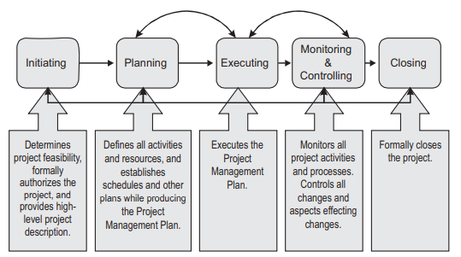

Figure 2 – Piskurich’s project management group interactions

According to Malsam (2021), PRINCE2 is a widely used project management methodology developed by the UK government. It provides a structured approach for managing projects, focusing on delivering projects on time, within budget, and to the required quality standards. PRINCE2 divides projects into stages, each with defined processes, roles, and responsibilities. It emphasizes effective project governance, risk management, stakeholder engagement, and continuous monitoring and control. PRINCE2 is widely recognized for its scalability and adaptability, making it applicable to various types and sizes of projects. It provides a common language and framework for project management, promoting consistency and best practices across organizations.

Figure 3 (below) is a diagram from Tuttle (2012) that shows the seven principles of the PRINCE2 methodology.

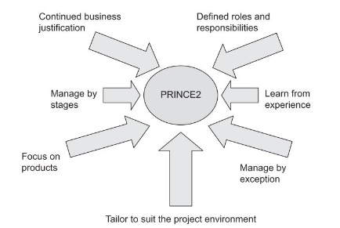

Figure 3 – PRINCE2 principles by Tuttle

Agile project management is an iterative and collaborative approach to managing projects that prioritizes adaptability and customer satisfaction. It involves breaking down projects into short iterations, allowing for frequent communication and feedback. Agile teams are empowered and self-organizing, with the flexibility to make decisions and adjust their approach as needed. Customer engagement is a crucial aspect, ensuring that the final product meets their requirements and expectations. Agile projects promote continuous improvement through regular retrospectives, enabling teams to learn from their experiences and adjust for future iterations. By embracing agility, organizations can respond effectively to changing circumstances, deliver value incrementally, and foster a collaborative and innovative project environment.

Figure 4 (below) is a diagram from Morris and Carroll (2015) that illustrates the difference between traditional projects and agile projects.

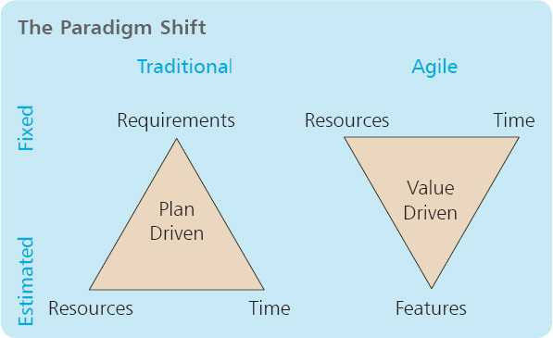

Figure 4 – The difference between traditional and agile project by Morris and Carroll

4. Outlining the framework used Agile (Kanban)
The framework used by Renishaw during the setup of the custom workshop was the Agile project management theory, more specifically the Kanban theory was used. This was chosen as it is used in many other applications of the business, primarily in the manufacturing divisions, meaning company documents and tools were available to use. According to (Parnas & Clements, 1985) managing complex projects like the development of a new product is difficult because the tasks have variable levels of uncertainty, and requirements may not be known or constant. This framework was also chosen as the project as the project needed adaptability, allowing teams to respond quickly to changing requirements and improve overall project performance.

Kanban is a project management methodology that originated from the Toyota Production System (TPS) in the 1940s. It focuses on visualizing work, limiting work in progress (WIP), and optimizing the flow of tasks or items through a system. The term "kanban" means "visual signal" or "card" in Japanese. The methodology uses visual boards and cards to represent work items and their status.

Kanban is often used in production environments and agile software development methodologies but can be applied to various project management contexts. It promotes transparency, collaboration, and adaptability, allowing teams to respond quickly to changing requirements and improve overall project performance. Here are some of the Kanban practices.
Top of Form

Visualize Workflow: A Kanban board is used to represent the workflow of a project or process. It consists of columns representing different stages of work (e.g., "To Do," "In Progress," "Done"). Each work item is represented by a card or sticky note, which moves across the board as it progresses through the stages.

Renishaw used a traffic light report to visualise the status of the project. The engineer commissioning the facility would provide a report weekly to the project manager, giving a more in-depth update on the project. This traffic light report (see figure 5) was taken from week 6 of the project and covers multiple aspects of the project such as training and documentation, layout, equipment and services, and machine prove outs. Reviewing each area individually, enables the understanding of its significance and relevance to the overall assessment. The sections are colour coded to provide information visually to assist the reader.

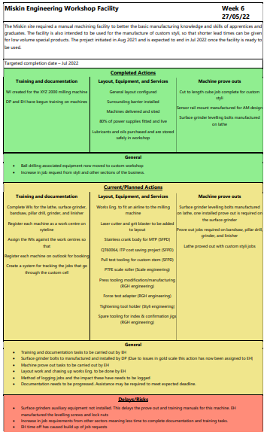

Figure 5 – Project traffic light report

According to Usmani (2022) traffic light reports, also known as red-amber-green (RAG) reports, are a widely used management technique for monitoring and communicating performance or progress. This technique employs a color-coded system to visually represent the status of various indicators, allowing managers to quickly assess areas of concern and areas performing well.
Traffic light reports provide a concise and visual representation of performance or progress, making complex information easily understandable at a glance. The color-coded system, with red indicating critical issues, amber/yellow signifying caution, and green representing satisfactory performance, allows managers to quickly identify areas that require attention or intervention (Dolan, 2021).

This technique facilitates effective communication and decision-making within an organization. The use of standardized colours and indicators enables managers and stakeholders to share a common understanding of the status of various areas or projects. By presenting information in a simple and intuitive manner, traffic light reports enable efficient discussions and facilitate informed decision-making processes. Furthermore, traffic light reports promote transparency and accountability. The clear visual representation of performance or progress helps to foster a culture of transparency within teams and departments. By clearly identifying areas of concern, managers can hold responsible individuals or teams accountable and allocate resources where they are most needed.

However, it is important to note that traffic light reports have limitations. The simplicity of the color-coded system can oversimplify complex situations, potentially leading to an incomplete understanding of underlying issues. Additionally, the interpretation of colours may vary among individuals, necessitating clear communication and shared understanding of the color-coding system.

In conclusion, traffic light reports serve as an effective management technique for monitoring and communicating performance or progress. They provide a visual and standardized representation of status, promoting transparency, accountability, and informed decision-making. However, it is essential to supplement traffic light reports with additional contextual information to ensure a comprehensive understanding of the underlying factors influencing performance.

Limit Work in Progress (WIP): Kanban emphasizes limiting the number of work items in progress at any given time. This helps prevent overloading team members and ensures that focus is maintained on completing tasks before starting new ones. WIP limits promote flow, reduce multitasking, and enable teams to identify bottlenecks and address them.

Manage Flow: Kanban aims to optimize the flow of work items through the system. The focus is on reducing lead times and increasing output. By visualizing the workflow and managing WIP limits, teams can identify and address issues that hinder smooth flow, such as resource constraints, dependencies, or process inefficiencies.

Renishaw followed the Kanban framework stages limiting WIP and managing flow by using a Gantt chart, see figure 6. This Gantt chart covers an eight-month period between August 2021 and April 2022, when the budget for the facility was approved to when the facility was planned to be fully functional. The Gantt chart was created at the beginning of the project and apart from the progression updates, remained unchanged until completion of the project.

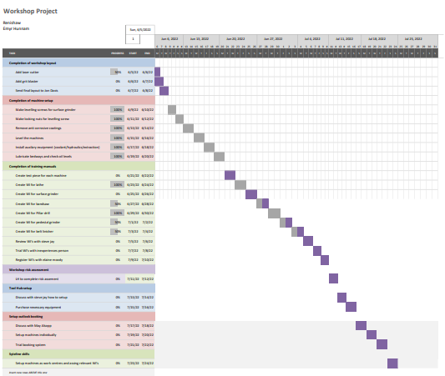

Figure 6 – Project Gantt Chart

The chart uses their descriptions to identify each activity individually, and colours are used to identify groups of tasks. The tasks' start and end dates are noted next to them and in the chart's main body. This has the advantage of making regular progress updates quick and simple to comprehend.

Task dependencies are a key component that the chart is missing. Task dependencies are frequently depicted on Gantt charts using arrows or lines. The order in which the tasks must be done is indicated by these dependencies, such as "Task B can only start after Task A is finished." Assessing project feasibility and critical routes, which indicate the order of actions that must be done on time for the entire project to finish as planned, require a thorough understanding of dependencies. Finding the tasks that have the biggest influence on the project's overall schedule can be done with the help of the critical path analysis.

The task durations are yet another flaw in this graph. The length of the horizontal bar represents the anticipated completion time of the task. Longer bars indicate activities that take more time and could potentially represent bottlenecks. Many of the activities in this chart have similar durations, indicating that this is not an accurate assessment.

There are no Gantt-marked milestones or key events on the chart. Milestones are specific points in a project that are particularly significant or represent significant accomplishments. By putting the milestones in line with the overall project, these are crucial for monitoring progress. The chart fails to take resource allocation into account. Information on resource allocation, such as team members assigned to tasks, may be included in Gantt charts. This can be used to guarantee that tasks are manned and resourced appropriately.

Overall, the Gantt chart indicated the timeline from budget approval to full functionality of the facility successfully. It uses task descriptions and color-coded groups for easy understanding. However, it lacks task dependencies, which are crucial for assessing project feasibility and critical paths. Task durations are also not accurately estimated, as most activities have the same duration. Milestones or significant events are not marked on the chart, making it difficult to track progress. Additionally, resource allocation information is not included, hindering effective staffing and resourcing of tasks.

Continuous Improvement: Kanban encourages continuous improvement of the process. Teams regularly reflect on their work, identify areas for improvement, and make incremental changes. This can involve adjusting WIP limits, optimizing the workflow, or addressing bottlenecks to improve efficiency and quality.

The method Renishaw chose to address continuous improvement was a Failure Mode and Effects Analysis (FMEA), see figure 7.

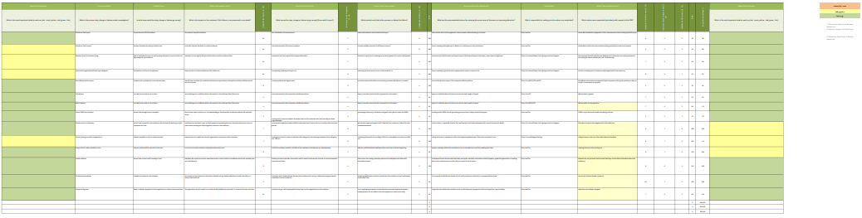

Figure 7 – Project FMEA

FMEA is a widely recognized management technique used to identify, analyse, and mitigate potential failures or risks in processes, products, or systems. It is a proactive approach that helps organizations anticipate and prevent failures before they occur. Here is a review of FMEA as a management technique:

FMEA enables organizations to systematically assess and prioritise potential failure modes and their associated effects. By analysing failure modes and their potential impact on performance, quality, safety, and customer satisfaction, organizations can identify critical areas that require attention and allocate resources effectively.

This technique facilitates cross-functional collaboration and communication. FMEA encourages multidisciplinary teams to work together, bringing together diverse perspectives and expertise. Through collaborative efforts, organizations can gather a comprehensive understanding of potential failures and their causes, enhancing problem-solving and decision-making processes.

FMEA promotes a proactive risk management culture. By systematically identifying and assessing potential failures, organizations can proactively implement preventive measures and control strategies to mitigate risk. This approach reduces the likelihood of failures occurring, improves product or process reliability, and enhances overall organizational performance.

Moreover, FMEA provides a structured framework for continuous improvement. By periodically reviewing and updating FMEA assessments, organizations can adapt to changing conditions, incorporate lessons learned, and continuously enhance their risk management practices. This iterative approach fosters a culture of continuous learning and improvement within the organization.

However, it is important to acknowledge the potential limitations of FMEA. The effectiveness of FMEA heavily relies on the expertise and knowledge of the team involved. Inaccurate or incomplete information can lead to flawed analysis and inadequate risk mitigation strategies. Therefore, it is crucial to ensure that the team conducting FMEA possesses the necessary domain knowledge and experience.

In conclusion, FMEA is a valuable management technique for identifying and mitigating potential failures or risks in processes, products, or systems. It promotes proactive risk management, cross-functional collaboration, and continuous improvement by systematically analysing failure modes and their effects, so that organizations can enhance their overall performance, reliability, and customer satisfaction.

4.1 Critical evaluation of the Agile framework application to the Custom Workshop project
At the beginning of the project the iterative development element of agile was well implemented. In the initial iteration the team focused on sourcing suppliers, training staff, and regularly communicating progress to stakeholders. The overall project was broken down into multiple phases with different team members owning these phases.

The team's ability to communicate with one another and with stakeholders decreased as the project went on. According to Damorelos (2018) there are several theories as to why communication can decrease as a project moves forward. The factors that might lead to poor company culture, disengaged workers, poor management style, lack of preparation and over reliance on digital communication, Vaughan (2021). Since this project adopted an agile framework, timeframes were not precisely established, which made it more likely than in a typical project that team members would leave. When the facility was up and running, fewer products was transferred to this route than originally anticipated because one individual who was involved in identifying the Styli products that could be manufactured through this facility left their role within the company. The coexistence of other projects with shared team members was another problem with the ambiguous timeframe; this resulted in a resource shortage at several points and slowed down the project.

In order to quantify the satisfaction and help ascertain whether the project was managed successfully, a survey of 47 employees was conducted via Microsoft forms, see below (figure 8). The raw data used in the graph can be found in the appendix. The employees invited to answer the five questions in the survey were technicians, engineers, production supervisors and Senior management staff. The surveys were asked to be filled in anonymously in hopes that honest answers would be given. Job roles were not required in the survey as the purpose of the data would be to review the management of the project team, however only certain roles were asked to respond to the survey as other roles such as operators and sales were not involved in the project nor is there any scope to involve these.

Figure 8 – Miskin Custom Workshop survey

The chart demonstrates that most of the participants would agree that the project management was successful. The mean result for all the questions combined is 4.06, or 81.2% successful. The question that received the highest average response was question five, “How well do you believe the project achieved its defined goals?”. Whereas the question that receives the lowest average response was question two,” Rate the project management processes and practices on a scale of 1-5.” This suggests that employees agree with the project goals, and that the project has achieved this goal however, a different framework may have been more successful. This could be influenced by previous project involvement, where traditional project management methods may have been used.

4.2 Pros & Cons of the Agile project management theory
Agile project management is an iterative and flexible approach that focuses on delivering value incrementally while accommodating change throughout the project. It has gained popularity due to its ability to adapt to evolving requirements and its emphasis on collaboration and customer satisfaction. Here are some pros and cons of agile project management:

One strength to the Agile project management theory is that it allows for frequent iterations and welcomes changes in project requirements, providing flexibility to respond to customer feedback and market demands. This enables teams to continuously improve the product and adapt to evolving circumstances. Agile also encourages close collaboration with customers or stakeholders throughout the project. Their active involvement in the process allows for better alignment of deliverables with their needs, resulting in higher customer satisfaction and a higher likelihood of delivering a successful product. Agile also promotes the concept of delivering a minimum viable product (MVP) or incremental releases. This enables the team to provide tangible value to the customer earlier in the project lifecycle, ensuring faster time-to-market and the opportunity to gather valuable feedback for subsequent iterations. Agile methodologies also emphasize open and transparent communication within the team and with stakeholders. Frequent communication through ceremonies like daily stand-ups and regular demonstrations promotes collaboration, knowledge sharing, and early issue identification, fostering a more efficient and effective project environment.

However, the flexibility of agile can sometimes lead to challenges in managing scope. Without proper control, scope creep may occur, where additional requirements are continuously added, potentially impacting project timelines, resources, and budget. Agile also encourages lightweight documentation and a focus on working software rather than extensive documentation. While this can increase efficiency, it may lead to a lack of comprehensive documentation, which can be challenging for knowledge transfer, compliance, or maintenance purposes. Agile also requires dedicated team members who can actively participate in project activities. This can be a challenge in organizations where resources are shared across multiple projects or have conflicting priorities, potentially leading to resource constraints or overburdened team members. Another limitation of the agile management theory is that it relies heavily on collaboration and effective communication within the team. If team members lack the necessary skills, experience, or collaboration abilities, it can hinder the project's progress and impact the quality of deliverables.

It's important to note that the suitability of agile project management depends on the project's nature, organizational culture, and stakeholder expectations. While agile offers numerous benefits, it may not be the best fit for every project or organization. Assessing the project context and considering the strengths and limitations of agile methodologies is crucial in making an informed decision about adopting agile project management.

5. Recommendations
Renishaw is advised to use the agile framework in addition to other project management theories like PMBOK and PRINCE2. To ensure resource use and greater impact, larger initiatives should be coordinated by the project team.

The attitudes and behaviours of the management team are of utmost importance during a project. They set the tone for the entire project team, influencing motivation, engagement, and collaboration. Positive attitudes and supportive behaviours create an environment of trust, open communication, and shared vision. Effective leadership and transparent communication foster team morale and facilitate problem-solving and decision-making. The management team's attitudes also impact stakeholder management and the ability to navigate risks and changes. Therefore, by exhibiting positive attitudes and behaviours, the management team plays a crucial role in driving project success, creating a productive and cohesive team, and ensuring the project's smooth execution.

It is also advised that Renishaw employ a feedback survey or questionnaire when using the agile framework, since this would enable honest anonymous feedback and increase the amount of feedback methods that come directly from the groups affected, as opposed to depending on the presumptions of the project management team.

In the custom workshop case study, survey responses show that there was not enough communication from the project team regarding the phases of the project.

6. Conclusions
The Custom Workshop Project aimed to build a facility that could make custom styli, as well as manufacture and modify tooling, all while educating apprentices and graduates. Results from the survey demonstrate that the project's objective was achieved, indicating that it was a success. The effectiveness of the project management process and team member collaboration, however, received the two lowest marks, according to survey results. This indicates that a different project management framework may have produced better results. However, because there are numerous variables that might influence the results, more research would be needed to reach a more accurate conclusion.

Two essential elements of project management are missing from the Agile project management framework, according to an assessment conducted during the project management research. One of the elements is the unpredictability of planning and estimation, and the other is team member dependability.

In addition, research indicates that the Agile framework has a weakness related to team member availability. This is clear from the survey findings, which indicate that teamwork was not one of the key elements in the project's success. However, it is also evident that the framework was followed correctly, hence the project's outcomes may also be a good indicator of how effective the Agile framework is in general.

Overall, the project was successful because it adhered to the framework. However, by merging components from multiple frameworks, including PMBOK and PRINCE2, improvements could be made.

7. Reference List

Works cited
Ahsan, K., Ho, M. and Khan, S. (2013). Recruiting Project Managers: A Comparative Analysis of Competencies and Recruitment Signals from Job Advertisements. Project Management Journal, 44(5), pp.36–54. doi:https://doi.org/10.1002/pmj.21366.

Bakker, A.B. (2010). Weekly work engagement and performance: A study among starting teachers. Journal of Occupational and Organizational Psychology, [online] 83(1), pp.189–206. doi:https://doi.org/10.1348/096317909x402596.

Damorelos (2018). Why Do Projects Fail Because of a Lack of Communication? - Proceso Pro. [online] https://proceso.pro/. Available at: https://proceso.pro/en/blog/why-do-projects-fail-because-of-a-lack-of-communication/.

Dolan, M. (2021). The Use of RAG Reporting in Project Management – Integrated Cloud. [online] Integrated Cloud. Available at: https://integratedcloud.co.uk/the-use-of-rag-reporting-in-project-management/.

Keil, M., Lee, H.K. and Deng, T. (2013). Understanding the most critical skills for managing IT projects: A Delphi study of IT project managers. Information & Management, 50(7), pp.398–414. doi:https://doi.org/10.1016/j.im.2013.05.005.
Kiran, D.R. (2016). Total Quality Management : Key Concepts and Case Studies. S.L.: Elsevier Ltd.

Koskela, L. and Howell, G. (2002). The Underlying Theory of Project Management Is Obsolete. IEEE Engineering Management Review, 36(2), pp.22–34. doi:https://doi.org/10.1109/emr.2008.4534317.

Malsam, W. (2021). What Is PRINCE2? Principles, Aspects, Roles & Processes. PROJECTMANAGAGER. Available at: https://www.projectmanager.com/blog/prince2-methodology.

Morris, D. and Carroll, J. (2015). Agile project management in easy steps. United Kingdom: In Easy Steps.

Parnas, D.L. and Clements, P.C. (1986). A rational design process: How and why to fake it. IEEE Transactions on Software Engineering, SE-12(2), pp.251–257. doi:https://doi.org/10.1109/tse.1986.6312940.

Piskurich, G.M. and American Management Association (2003). The AMA handbook of e-learning : effective design, implementation, and technology solutions. New York: Amacom, p.29.

Project Management Institute (2021). Guide to the project management body of knowledge. 7th ed. Pennsylvania: Project Management Institute.
Raydugin, Y. (2013). Project risk management : essential methods for project teams and decision makers. Hoboken, N.J.: Wiley.

Svejvig, P. and Andersen, P. (2015). Rethinking project management: A structured literature review with a critical look at the brave new world. International Journal of Project Management, 33(2), pp.278–290. doi:https://doi.org/10.1016/j.ijproman.2014.06.004.

Turner, R. and Al, E. (2010). Perspectives on projects. New York: Routledge.

Tuttle, S. (2012). Illustrating PRINCE2 : project management in real terms. Cambridgeshire, U.K.: It Governance Pub.

Usmani, F. (2022). RAG Status Reporting in Project Management: Definition, Example & Template |. [online] PM Study Circle. Available at: https://pmstudycircle.com/rag-status-reporting/.

Vaughan, T. (2021). 7 Factors that influence ineffective communication | Poppulo. [online] poppulo.com. Available at: https://www.poppulo.com/blog/factors-that-influence-ineffective-communication.

Winter, M., Andersen, E.S., Elvin, R. and Levene, R. (2006). Focusing on business projects as an area for future research: An exploratory discussion of four different perspectives. International Journal of Project Management, 24(8), pp.699–709. doi:https://doi.org/10.1016/j.ijproman.2006.08.005.

Appendix

ID | On a scale of 1-5, how well do you believe the project achieved its defined goals? | Rate the level of collaboration among team members on a scale of 1-5. | On a scale of 1-5, how satisfied do you think the project stakeholders are with the project outcomes? | Rate the effectiveness of project management processes and practices on a scale of 1-5. | On a scale of 1-5, how would you rate the overall success of the project?
1 | 4 | 3 | 4 | 3 | 4
2 | 3 | 2 | 2 | 2 | 3
3 | 4 | 5 | 4 | 4 | 5
4 | 4 | 3 | 5 | 5 | 4
5 | 4 | 4 | 5 | 4 | 5
6 | 4 | 4 | 4 | 4 | 4
7 | 4 | 5 | 4 | 5 | 5
8 | 3 | 5 | 3 | 5 | 3
9 | 5 | 3 | 5 | 3 | 5
10 | 4 | 2 | 4 | 2 | 4
11 | 5 | 4 | 4 | 5 | 5
12 | 3 | 4 | 3 | 2 | 3
13 | 4 | 5 | 4 | 4 | 4
14 | 4 | 4 | 5 | 5 | 5
15 | 3 | 2 | 3 | 4 | 3
16 | 5 | 4 | 3 | 4 | 5
17 | 2 | 2 | 2 | 2 | 2
18 | 3 | 3 | 3 | 3 | 3
19 | 5 | 4 | 5 | 5 | 5
20 | 4 | 4 | 4 | 4 | 4
21 | 4 | 5 | 5 | 4 | 5
22 | 5 | 5 | 5 | 5 | 5
23 | 3 | 4 | 5 | 5 | 5
24 | 4 | 3 | 5 | 4 | 3
25 | 5 | 3 | 5 | 5 | 5
26 | 5 | 4 | 4 | 4 | 5
27 | 1 | 2 | 3 | 4 | 5
28 | 4 | 5 | 4 | 5 | 5
29 | 5 | 4 | 3 | 2 | 1
30 | 5 | 4 | 4 | 5 | 4
31 | 5 | 4 | 4 | 4 | 5
32 | 4 | 4 | 5 | 5 | 5
33 | 3 | 5 | 2 | 2 | 4
34 | 5 | 4 | 5 | 5 | 5
35 | 5 | 4 | 4 | 4 | 4
36 | 4 | 4 | 4 | 5 | 5
37 | 3 | 4 | 2 | 4 | 4
38 | 5 | 5 | 5 | 5 | 5
39 | 4 | 3 | 4 | 4 | 4
40 | 4 | 4 | 5 | 4 | 5
41 | 5 | 4 | 5 | 4 | 5
42 | 4 | 4 | 5 | 4 | 4
43 | 4 | 3 | 5 | 3 | 5
44 | 4 | 3 | 5 | 3 | 4
45 | 5 | 4 | 5 | 5 | 5
46 | 4 | 4 | 5 | 4 | 5
47 | 5 | 5 | 5 | 5 | 5

