Feasibility Plan for an International Meeting
International Meeting Management for Hotel Industry
BMIH6007
Syeda Shajna Begum
2128506

Slide 2: Introduction
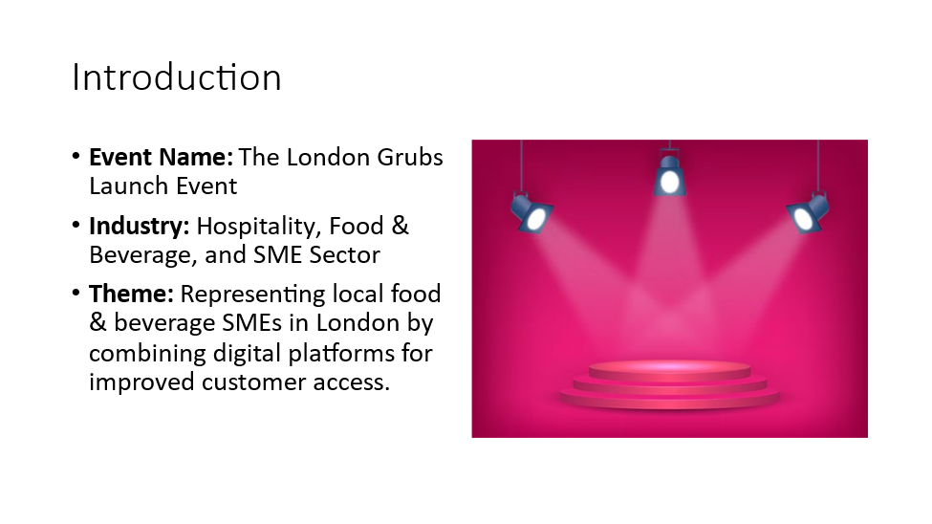
Slide 3: Market Factors
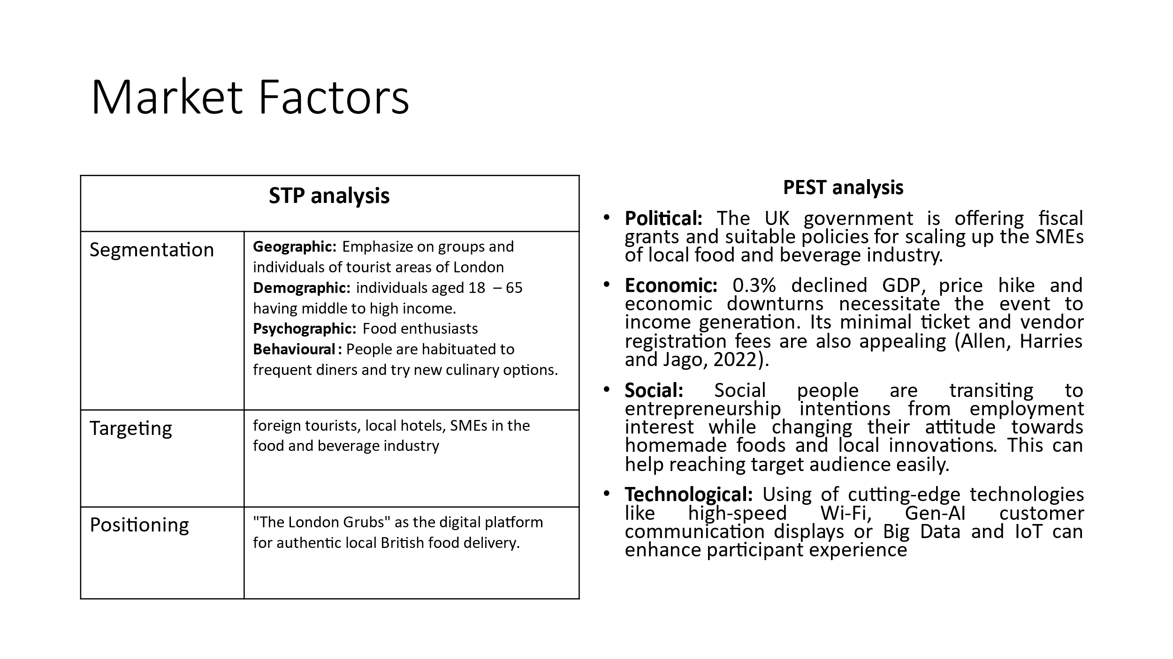

Slide 4:
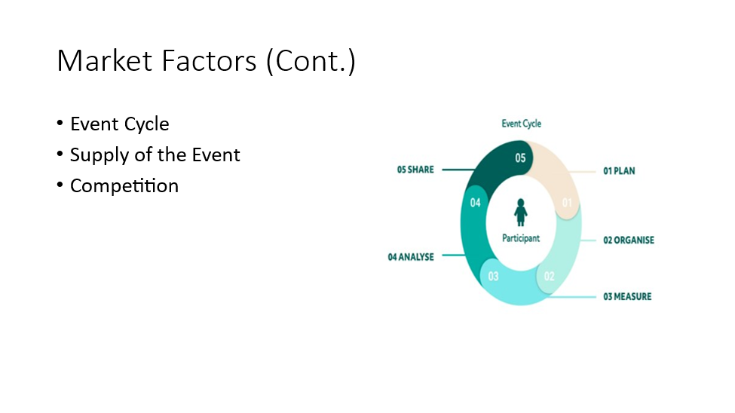
Slide 5: Operational Factors
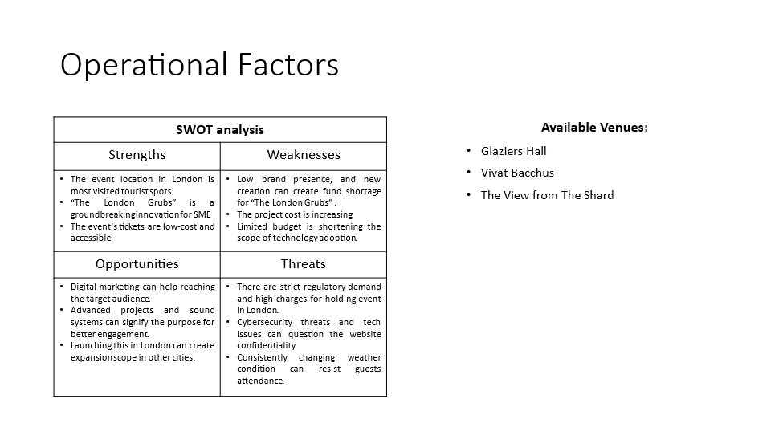
Slide 6:
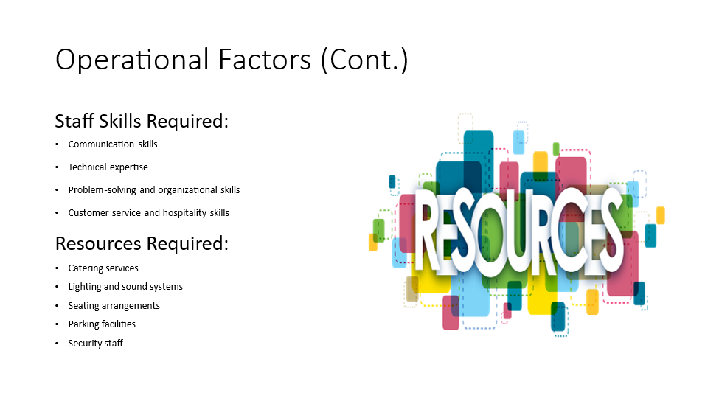
- Slide 7: Financial Factors
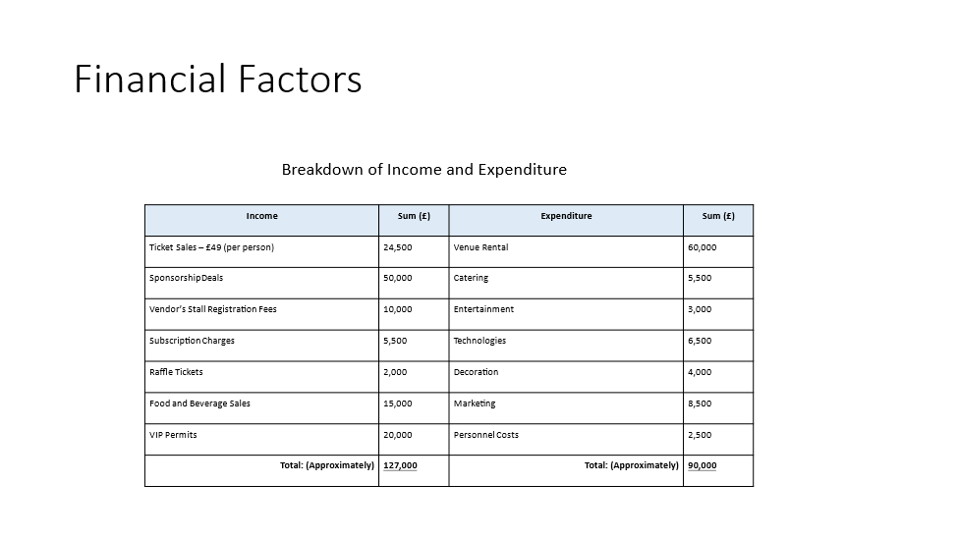
Slide 8:
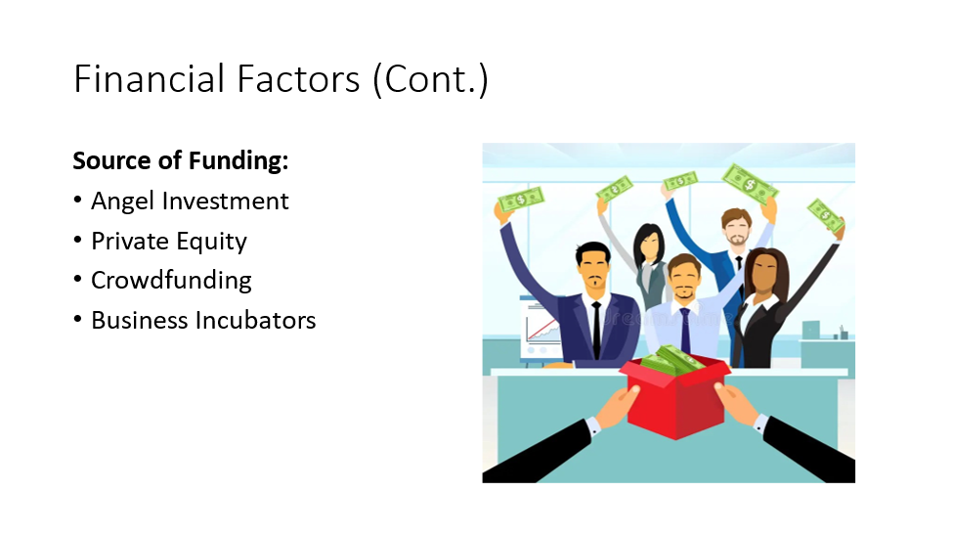
Slide 9:
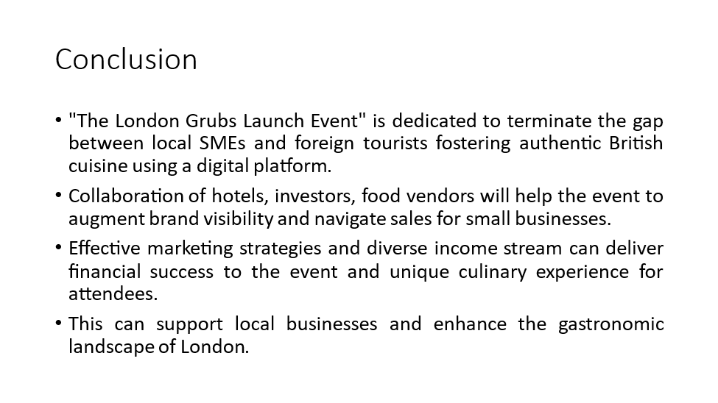
Slide 10
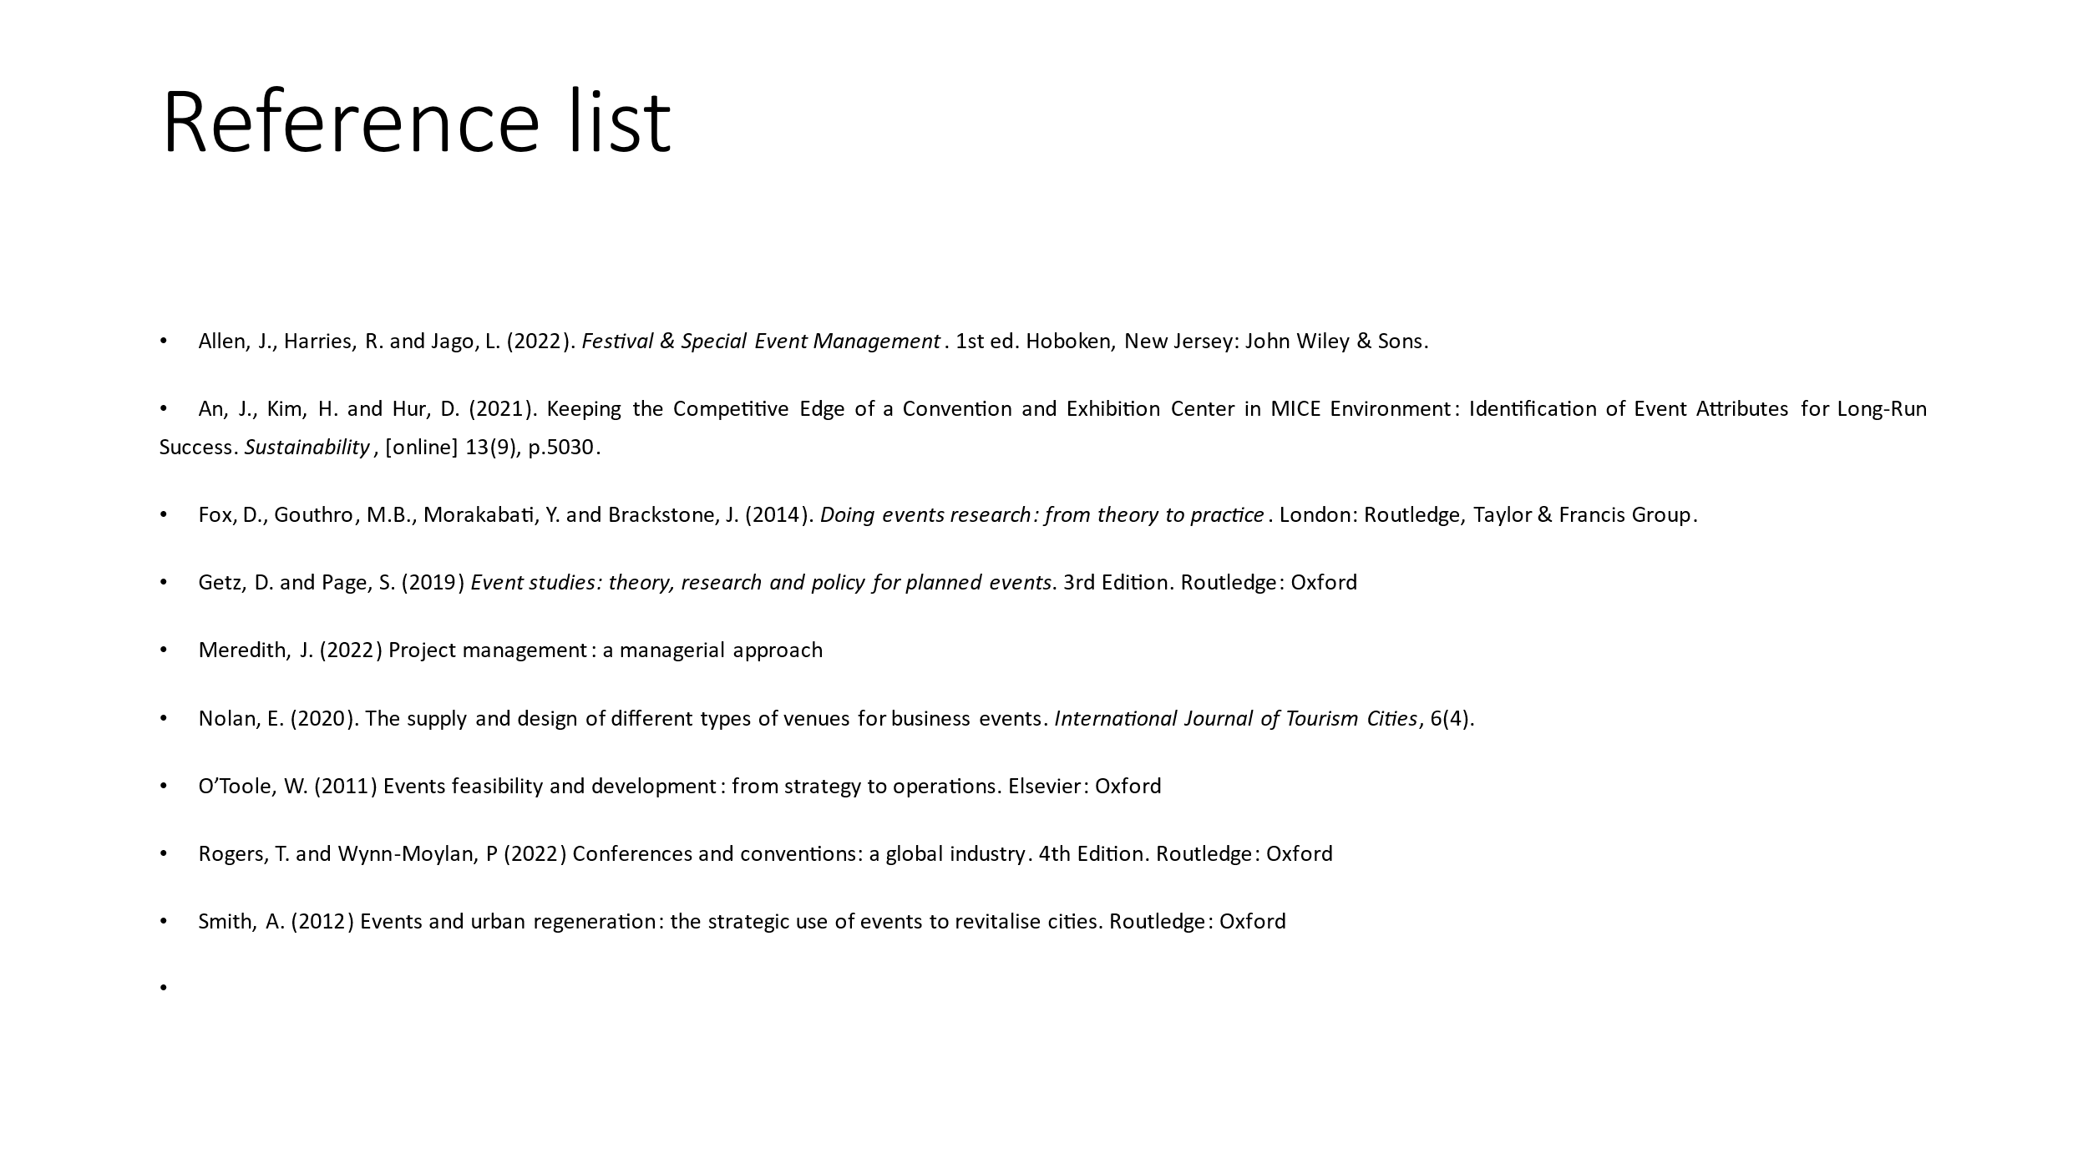
Reference list
Allen, J., Harries, R. and Jago, L. (2022). Festival & Special Event Management. 1st ed. Hoboken, New Jersey: John Wiley & Sons.
An, J., Kim, H. and Hur, D. (2021). Keeping the Competitive Edge of a Convention and Exhibition Center in MICE Environment: Identification of Event Attributes for Long-Run Success. Sustainability, [online] 13(9), p.5030.
Fox, D., Gouthro, M.B., Morakabati, Y. and Brackstone, J. (2014). Doing events research: from theory to practice. London: Routledge, Taylor & Francis Group.
Getz, D. and Page, S. (2019) Event studies: theory, research and policy for planned events. 3rd Edition. Routledge: Oxford
Meredith, J. (2022) Project management: a managerial approach
Nolan, E. (2020). The supply and design of different types of venues for business events. International Journal of Tourism Cities, 6(4).
O’Toole, W. (2011) Events feasibility and development: from strategy to operations. Elsevier: Oxford
Rogers, T. and Wynn-Moylan, P (2022) Conferences and conventions: a global industry. 4th Edition. Routledge: Oxford
Smith, A. (2012) Events and urban regeneration: the strategic use of events to revitalise cities. Routledge: Oxford

