

Stop and Search - Public Perceptions in 2021

Student name: Bart Nowak (2009619)

SWANSEA BUSINESS CAMPUS

BSc Policing and Criminology

May 2021

Word count: 8789

Impact of COVID-19
In light of the continuing impact of the global pandemic, it is important to include a statement at the start of my dissertation which outlines the effects that COVID-19 has had on the research that I have undertaken towards my undergraduate degree.

The University of Wales Trinity Saint David recognises that the COVID-19 pandemic, and consequent closures of our campus (18th March 2020) and national and international lockdowns, has directly or indirectly impacted the work of many of our undergraduate researchers. Although the campus had periods of re-opening in 2020 and 2021, some research will have been disrupted and some personal circumstances difficult to manage. Teaching was arranged via suitable meeting software and documents shared electronically. All research data collection was designed to utilise digital data collection.

The inclusion of this statement is to facilitate the reader’s awareness, both now and in the future, that the pandemic may have had an effect on the scope, direction, and presentation of the research.

The academic standards and quality threshold for the award remains unchanged. I wish to reassure readers that this statement is not evidencing a lack of original research or quality.

DECLARATION
This work has not previously been accepted in substance for any degree and is not being concurrently submitted in candidature for any degree.

STATEMENT 1
This dissertation is being submitted in partial fulfilment of the requirements for the degree of BSc.
STATEMENT 2
This dissertation is the result of my own independent work/investigation, except where otherwise stated.
Other sources are acknowledged by footnotes giving explicit references. A bibliography is appended.

STATEMENT 3
I hereby give consent for my dissertation, if accepted, to be available for photocopying and for interlibrary loan, and for the title and summary to be made available to outside organisations.
STATEMENT 4
I hereby give consent for my dissertation, if accepted, to be available on the university’s IT system to those who have consent to use the system.

Acknowledgements
First and foremost, I dedicate this dissertation to my grandfather who passed away in the summer of 2016. He has always pushed me towards education, even when I was reluctant to study. It was his dream for me to one day graduate, and after many years of waiting that has finally become a reality.

I wish to thank my family for their endless support and understanding. I am deeply sorry that I could not have dedicated as much time to you as I would like. I must also thank my dear friends Sasha and Oday Hani Al Omoush, who were always keen to share their knowledge, their input was invaluable. Special thanks go to my supervisor, Senior Lecturer Wynne Jones, and Dr. Caroline Jawad for their ongoing support throughout the duration of this project and having the patience to deal with me. I do apologise for pestering the both of you with a consistent stream of emails. I should also express my gratitude to Lecturer Jane Thomas, for inspiring me to pursue my dreams and ambitions, and to push myself beyond my limits. Finally, my thanks go out to Mark Burns, Mark Swindin, Nigel Wright, Dave Gibbs, and Dave Rowe of Leicester College, all of whom have, in significant measure, contributed to my academic journey.

Abstract
The power to stop and search can be tracked to the Vagrancy Act of 1824. For long it was perceived as controversial, particularly for the disproportionate number of searches on ethnic minorities. This study has analysed the factors which affect the likelihood of being searched and explored the public views on stop and search. Such research is fundamental as previous quantitative social studies on the perception of stop and search are limited. Past research is vague in analysing public perception against the variables of age, gender, and region. The research approach adopted in this study involves a review of literature to fulfil objective one, and quantitative research to achieve objective three as set out in the introductory chapter of this dissertation. A survey was constructed and distributed to 425 participants recruited via social media. The findings show that the public does support the use of stop and search. However, females were more likely to support the tactic and be aware of its pitfalls, which suggests they are more conversant with societal issues than males. Participants aged 18-24 believed that stop and search is used too much on certain groups in society. That age group, along with 35-44 year old’s were mostly not confident in the police to conduct objective searches. The main conclusion, and a contribution to the body of knowledge is that gender and age are variables which affect the views on stop and search. This research argues for an increase in educational police visits to schools. Through education, the safety and confidence in the police of young adults and older age groups could be revived. This dissertation proffers prioritising communication and the importance of a diplomatic approach among police forces, to prevent interactions escalating into conflicts. Future researchers should analyse the variables of region, ethnicity, and socioeconomic background of participants.

Key words: Stop and search, police forces, public views, likelihood, gender, age

Table of contents
Chapter One: Introduction 1
1.0 Background and rationale 1
1.1 Hypothesis 2
1.2 Aim and objectives 2
1.2.1 Aim 2
1.2.2 Research objectives 2
1.3 Structure outline 3
1.4 Conclusion 4
Chapter Two: Literature Review 5
2.0 Introduction 5
2.1 Background information 5
2.1.1 Stop and search 6
2.1.2 Discretionary power 6
2.2 Factors associated with stop and search 6
2.2.1 Ethnicity 7
2.2.2 Age 8
2.2.3 Geographical area (England) 8
2.2.4 Gender 9
2.3 Reason for search 10
2.3.1 Public views 11
2.3.2 Crime reduction 12
2.4 Summary of findings 13
Chapter Three: Research methodology 14
3.0 Introduction 14
3.1 Research Onion 14
3.1.2 Philosophy 15
3.1.2 Approach 16
3.1.3 Choice 16
3.1.4 Strategy 17
3.1.5 Time Horizon 17
3.2 Techniques and procedures 17
3.2.1 Sampling 17
3.2.2 Survey design 18
3.2.3 Literature Review Matrix 18
3.2.4 Pilot Study 24
3.2.5 Reliability and validity 25
3.2.6 Limitations 25
3.2.7 Ethical Considerations 25
3.3 Conclusion 26
Chapter Four: Data Analysis 27
4.0 Introduction 27
4.1 Data analysis 27
4.2 Methods 27
4.3 Demographics 27
4.4 Analysis and tests 29
4.5 Views on stop and search (Chi-square) 29
4.5.1 Region (ANOVA) 30
4.5.2 Gender (Chi-square) 31
4.5.3 Age (ANOVA) 31
4.5.4 Appearance (gender - Chi-square) 33
4.5.4.2 Appearance (age - ANOVA) 33
4.5.5 Likelihood (gender - Chi-square) 34
4.5.5.2 Likelihood (age - ANOVA) 35
4.5.5.3 Concern (gender Chi-square) 35
4.5.6 Confidence (gender - Mann-Whitney U-test) 36
4.5.6.2 Confidence (age - ANOVA) 37
4.5.7 Community safety (gender - Mann-Whitney U-Test) 38
4.5.8 Distrust in the police (gender - Mann-Whitney U-Test) 38
4.5.8.2 Distrust in the police (age - ANOVA) 39
4.5.9 Perceived reason for search (age - ANOVA) 40
4.5.10 List of objective factors (gender - Chi-square) 40
4.5.10.2 List of objective factors (age - ANOVA) 41
4.5.10.3 Objective factors and transparency (gender - Mann-Whitney U Test) 41
4.5.11 Summary of tests 42
4.6 Findings and discussion 43
4.7 Conclusion 45
Chapter Five: Conclusions and Recommendations 46
5.1 Introduction 46
5.2 Conclusion 46
5.3 Implications 46
5.4 Limitations 47
5.5 Recommendations 47
5.6 Achievement of objectives 48
5.7 Conclusion 49
6.0 References 50
7.0 Appendices 64
7.1 Appendix 1. Ethics form 64
7.2 Appendix 2. Copy of questionnaire 81
7.3 Appendix 3. Distribution of questionnaire 94
7.4 Appendix 4. SPSS Analysis 98
7.4.1 Cross Tabulation (Gender and Age) 98
7.4.2 Cross Tabulation (Gender and Region) 99
7.4.3 Cross Tabulation (Age and Region) 100
7.4.4 Ethnicity 102
7.5 Appendix 5. Chi-Square tests 102
7.6 Appendix 6. ANOVA Analysis of variance 103
7.7 Appendix 7. Mann-Whitney U-Tests 104
7.8 Appendix 8. Summary of statistical tests (including analysis and appendices) 110

List of Figures
Figure 2.1: Searches per 1,000 population, by ethnicity. England and Wales 2019/20. ………..p.7

Figure 2.2: Collective number of s.1 PACE searches by region and resultant arrests. England 2019/20. ………………………………………………………………………………………………….p.8

Figure 2.3: Searches by reason for search, England and Wales 2019. …………………………p.10

Figure 2.3.2: Number of searches against knife crime statistics between 2013 and 2020, England and Wales. ……………………………………………………………………………………………..p.11

Figure 3.1: The Research Onion (Saunders et.al., 2019). ………………………………………..p.15

Figure 4.5: Showing that the majority is in support of stop and search in question 18 (p= .000) ……………………………………………………………………………………………………………p.30

Figure 4.5.1: Showing no significant statistical difference between regions and participants views on stop and search in question 18, F(5, 408)= 2.627, p.= .024. …………………………………p.30

Figure 4.5.2: Showing a significant relationship between gender and the views on stop and search in question 18 (p.= .000). …………………………………………………………………….p.31

Figure 4.5.3: Showing a significant statistical difference between age and the views on stop and search, F(5, 408)= 8.788, p.= .000. …………………………………………………………………p.32

Figure 4.5.4: Showing a significant relationship between gender and participants' answers to question eight (p.=.000). ……………………………………………………………………………...p.33

Figure 4.5.4.2: Showing a significant statistical difference between age and the suggestion that appearance affects the likelihood of being searched, F(3, 410)= 6.625, p.= .000). ……………p.34

Figure 4.5.5: Showing a significant relationship between gender, specific groups in society and the use of stop and search against them (p.=.000). ……………………………………………….p.34

Figure 4.5.5.2: Showing a significant statistical difference between age and answers to question 12, F(3, 410)= 16.871, p.= .000. ……………………………………………………………………..p.35

Figure 4.5.5.3: Showing a significant statistical relationship between participant’s gender and their concern for the use of stop and search (p.= .000). …………………………………………..p.36

Figure 4.5.6: Showing a statistical significance between gender and confidence in the police in relation to stop and search (Mean ranks: male= 170.15, female= 230.09, U= 14927, p.= .000). ……………………………………………………………………………………………………………p.36

Figure 4.5.6.2: Showing a significant statistical difference between age and confidence in the police to conduct objective searches, F(4, 409)= 11.533, p.= .000. ……………………………….p.37

Figure 4.5.7: Showing a significant difference between gender and the perception of safety emerging from search powers (Mean ranks: male = 172.96, female = 228.39, U= 14735, p.= .000). ……………………………………………………………………………………………………p.38

Figure 4.5.8: Showing a significant statistical correlation between gender and the idea that abusing search powers causes distrust in the police (Mean rank: male= 234.29, female= 191.30, U= 15944, p.= .000). …………………………………………………………………………………..p.38

Figure 4.5.8.2: Showing a significant statistical difference between age groups and the notion that abusing search powers causes distrust in the police, F(4, 409)= 5.788, p.= .000. ……….p.39

Figure 4.5.9: Showing no significant statistical difference between the variable of age and the participants' answer to Q16, F(4, 409)= .347, p.= .845. …………………………………………..p.40

Figure 4.5.10: Showing a significant relationship between participants’ gender and their opinion on a list of objective factors (p.= .000). ……………………………………………………………..p.40

Figure 4.5.10.2: Showing no significant statistical difference between age and the opinion on an objective list of factors, F(1, 412)= 6.780, p.= .010. ……………………………………………….p.41

Figure 4.5.10.3: Showing a significant statistical relationship between gender and the notion of Q11 (Mean ranks: male= 251.84, female= 180.69, U= 13207, p.= .000). ………………………p.41

Figure 7.4.1: Gender and age cross tabulation. ……………………………………………………p.98

Figure 7.4.2: Gender and region cross tabulation. ………………………………………………...p.99

Figure 7.4.3: Age and region cross tabulation. …………………………………………………...p.100

Figure 7.5.1: Showing a significant statistical relationship between gender and the understanding of stop and search following an explanation (p.= .001). …………………………………………p.102

Figure 7.5.2: Showing no significant relationship between gender and the knowledge of how frequently stop and search is applied in participants' local area (p.= .009). …………………..p.103

Figure 7.6.1: Showing no significant statistical difference between age and the participants’ understanding of stop and search following an explanation F(3, 410)= 2.242, p.= .083. ……p.103

Figure 7.6.2: Showing no significant statistical difference between age and participants’ knowledge on the frequency of stop and search in their region F(4, 409)= 1.977, p.= .097....p.104

Figure 7.7.1: Showing a significant statistical relationship between gender and the idea that implementing a list of objective factors would reduce the misuse of stop and search (Mean ranks: male= 262.47, female= 174.26, U= 11549, p.= .000). …………………………………………...p.104

Figure 7.7.2: Showing a significant statistical association exists between gender and the suggestion that establishing a list of objective factors will reduce the frequency of particular groups in society experiencing searches (Mean ranks: male= 246.60, female= 183.86, U= 14025, p.= .000). ……………………………………………………………………………………………...p.105

Figure 7.7.3: Showing a significant statistical relationship between gender and participants’ views to the suggestion excessive searches can over time lead to violence or hostility towards police (Mean ranks: male= 237.29, female= 189.49, U= 15476.5, p.= .000). ………………………..p.105
Figure 7.7.4: Showing a significant statistical association between gender and participants’ answers to the idea that excessive searches on particular groups or incriminate them (Mean ranks: male= 258.71, female= 176.54, U= 12135.5, p.= .000). …………………………………p.106

Figure 7.7.5: Showing a significant statistical relationship between the variable of gender and answers to the notion that stop and search is effective in reducing crime (Mean ranks: male= 173.23, female= 228.22, U= 14778.5, p.= .000). …………………………………………………p.106

Figure 7.7.6: Showing a significant statistical association between gender and the idea that stop and search is effective at identifying criminals (Mean ranks: male= 174.68, female= 227.34, U= 15004, p.= .000). ……………………………………………………………………………………..p.107

Figure 7.7.7: Showing a significant statistical relationship between gender and the opinion that stop and search helps to discourage, disrupt, or prevent criminal activity (Mean ranks: male= 168.95, female= 230.81, U= 14109.5, p.= .000). …………………………………………………p.108

Figure 7.7.8: Showing a significant association between gender and the opinion that stop and search indirectly promotes social order and maintenance (Mean ranks: male= 180.67, female= 223.72, U= 15938, p.= .000). ……………………………………………………………………….p.108

Figure 7.7.9: Showing a significant statistical relationship between gender and the notion of question 17, that crime reduction is not a primary objective of stop and search (Mean ranks: male= 240.66, female= 187.45, U= 14951.5, p.= .000). …………………………………………p.109

List of Tables
Table 3.2: Questionnaire and Literature Review Matrix. ...…………………………………..pp.18-24

Table 4.3: Participants by age and gender. ………………………………………………………...p.28
Table 4.3.2: Participants by region. ……………………………………………………………pp.28-29

Table 4.5.3: Relationship between age groups and views on stop and search. ……………p.32-33

Table 4.5.11: Summary of statistical tests. …………………………………………………………p.42

Table 7.4.1: Gender and age cross tabulation. …………………………………………………….p.98

Table 7.4.2: Gender and region cross tabulation. ……………………………………………p.99-100

Table 7.4.3: Age and region cross tabulation. ………………………………………………p.100-101

Table 7.4.4: Ethnicity. ………………………………………………………………………………..p.102

Table 7.8: Summary of statistical tests (including analysis and appendices). …………….p.110-11

List of Abbreviations
ANOVA: Analysis of variance
BAME: Black, Asian and minority ethnic
EHRC: Equality and Human Rights Commission
HMIC: Her Majesty’s Inspectorate of Constabulary
HMICFRS: Her Majesty’s Inspectorate of Constabulary and Fire & Rescue Services
MoJ: Ministry of Justice
ONS: Office for National Statistics.
PACE: Police and Criminal Evidence Act 1984
s.1: Section One of the Police and Criminal Evidence Act 1984
Searches: stops and searches conducted under any relevant legislation, unless specified.
Search powers: Used by the author when referring to stop and search, to avoid repetitiveness.
SPSS v.26: Statistical Package for the Social Sciences version 26
The tactic: Used by the author when referring to stop and search, to avoid repetitiveness.
UWTSD: University of Wales Trinity Saint David

Chapter One: Introduction
The purpose of this chapter is to provide a background and rationale for the study accompanied by an explanation of research objectives and the structure of this dissertation. This research aims to gather and analyse the public’s views on stop and search against the variables of age and gender.

1.0 Background and rationale
Stop and search was introduced under the Police and Criminal Evidence Act 1984 (PACE), it is a collection of police powers to detain for the purpose of a search, for instance for illicit articles (Newburn, 2007; Bryant and Bryant, 2015). An emerging trend in contemporary society is the disproportionate number of stops and searches conducted on young adults and ethnic minorities (City of London Police, 2020; Flatley, 2020; Home Office, 2020). Brown (2021) acknowledges the lack of an objective list of factors on which to base a search. Thus, constables must make a judgement when deciding to conduct a search (Maguire et.al., 2002, Ellis, 2010), which cannot be based cannot be based on personal factors (Bryant and Bryant, 2015; Bradford and Loader, 2015). However, the definition of reasonable suspicion which constitutes a search is vague (Fitzgerald, 1999).

Consequently, stop and search is frequently critiqued. A valid argument is the lack of known impact on crime reduction. However, a consensus among academic’s states that crime reduction could be attributed to visible policing (Quinton et.al., 2017; Bradford and Tiratelli, 2019; Brown, 2021). Moreover, individuals who identify as black are nine times more likely to be searched than white people, which highlights the consequent racial disparities of stop and search (Brown, 2021). Nevertheless, there is no conclusive evidence which states that black or ethnic minority groups are more likely to engage in criminal behavior (ibid.). Hence, the disproportionate use of stop and search appears to be unjustified, this study will identify the factors which affect the likelihood of being searched.

Public perception is paramount, the Scottish Police Authority (p.4, 2016) states “...the frequent application of stop and search in an area is affecting the way that people view the police, and their willingness to engage with them in a positive or supportive manner.” This research aims to determine the current public views on stop and search in comparison to previous studies. The case may be that the public is indeed supportive of the tactic, despite its pitfalls. A survey was constructed to question participants about the different aspects of stop and search (see Appendix 2).

1.1 Hypothesis
Out of the three alternative hypotheses presented in chapter four, two state that the public is in support of stop and search and that there is a difference between age groups and the views on stop and search. The final hypothesis suggests a difference between gender and concern for the use of stop and search. This social study hopes to contribute to the field of policing and criminology by presenting the public opinion on stop and search emerging from empirical research. The analysis of the questionnaire will be accompanied by recommendations for practice aimed at police forces, and future researchers as per the limitations identified in chapter five.

1.2 Aim and objectives

1.2.1 Aim

The aim of this study is to conduct social research into the public views on stop and search. It will determine whether the public are supportive of the tactic or alternatively, are opposed to it. The dissertation will also analyse the factors associated with the likelihood of being searched.

1.2.2 Research objectives

(1) Analyse the factors which impact the likelihood of being stopped and searched.

(2) Select appropriate research methods to conduct social research on the public views of stop and search.

(3) Conduct social research and analyse the current social standpoint on stop and search.

1.3 Structure outline
To achieve the research objectives, the researcher has constructed five chapters which respectively, discuss the interdependent sections of this project.

Chapter One: Introduction

Chapter one provides the reader with an introduction to research, background information on stop and search and rationale for the study. The focus of this study is discussed in research aims and objectives. Secondary data was relied upon for the first part of the study, empirical research involved the use of a social survey, the findings were compared against existing literature.

Chapter Two: Literature Review
Chapter two accommodates a review of the most relevant and significant research on stop and search, in relation to this project’s aims and objectives. Emphasis was placed on research objective one and an analysis of factors associated with the likelihood of being stopped. The research gap was identified in the literature review which led on to the selection of methods for conducting social research.
Chapter Three: Research Methodology
In chapter three the researcher has identified and justified the most suitable methods and methodology of conducting primary research. The purpose of this social research is to contribute to the field of policing and criminology by addressing the research gap identified in literature. The limitations of the adopted approach were discussed alongside the principles of validity and reliability of this research. Once collected, the data was subject to analysis.
Chapter Four: Data Analysis
Chapter four reports the findings based on the analysis of primary data collected using a survey and methods discussed in chapter three. A variety of statistical tests were conducted, and the findings were presented in graphs, charts, and tables. This chapter analyses and synthesises empirical findings by drawing comparisons against previous literature. Conclusions and implications of research were discussed in chapter five.
Chapter Five: Conclusions and Recommendations
This chapter develops the discussion held in chapter four. The researcher has identified the limitations and implications of his research and offered recommendations for practice directed at police forces and future researchers. Chapter five revisits the research objectives set out in the inductonary chapter of this project, and the contribution of this research to knowledge is clarified.
6.0 References
This section presents in the Harvard system of referencing, an alphabetical listing of credible academic sources used in this dissertation.
7.0 Appendices
This section contains data and information excluded from the main body of this dissertation.

1.4 Conclusion
The first inductonary chapter has provided a brief outline and understanding of the controversies surrounding the use of stop and search. The researcher has justified the purpose for the study, set out clear, appropriate, and achievable research objectives, and introduced the reader to the structure of this dissertation. Next, chapter two will put forward a review of literature to elaborate on the aforementioned issues of stop and search discussed, and thereby attempt to achieve objective one and provide grounds for primary research.

Chapter Two: Literature Review

2.0 Introduction
This chapter will critically review past and contemporary literature to highlight the main concerns of stop and search. The purpose of reviewing existing literature is to fulfil research objective one, and support the researcher in achieving objective three:

(1) Analyse the factors which impact the likelihood of being stopped and searched.

(3) Conduct social research and analyse the current social standpoint on stop and search.

To achieve these objectives, this chapter exhibits the researcher's critical understanding of academic sources including journals, textbooks, government and governing bodies publications and sources accessed through the UWTSD’s online library. The literature will contribute to the dissertation by supporting the researcher in his choosing of questions which will be included within the proposed survey. Thereby, the review provides grounds to identify a suitable research methodology and data collection methods. An effective review will identify a clear research gap in what is known about the subject matter, in relation to research aims and objectives (Saunders and Rojon, 2011).

2.1 Background information
The Police and Criminal Evidence Act 1984 (PACE) introduced the fundamental nation-wide stop and search powers which are widely employed in contemporary policing (Maguire et.al., 2002). PACE emerged from the recommendations of the Royal Commission on Criminal Procedures which called for a reform in investigative powers (Brown, 1997; Newburn, 2007). Prior to 1984, similar powers were available under the Vagrancy Act 1824 whereby suspicious persons could be stopped for frequenting without an apparent purpose a public place with intent to commit a crime or cause public disorder (Qureshi and Farrell, 2006). Hence, the act is an example of a ‘sus’ law because it required suspicion from a constable prior to conducting a search (The Police Foundation, 2012). The then existing and dated legislation concerning searches was applied on a local and national scale (Miller, 2010).

2.1.1 Stop and search

Stop and search encompasses more than 19 powers to detain for the purpose of a search. Searches can be conducted under a range of legislation such as s.23 of the Misuse of Drugs Act 1971 if a constable suspects to find drugs, firearms under s.47 of the Firearms Act 1968 or stolen and prohibited articles concluded within s.1 of PACE. Also, searches under s.60 of the Public Order Act 1994 are known as ‘no-suspicion’ searches and require no reasonable grounds but a senior officer’s authorisation (Brown, 2021). The search may extend to anything concealed on a person or anything within or on a vehicle. Searches must be justified by reasonable suspicion, or the emergent suspicion of an officer that they will find illicit objects (Bryant and Bryant, 2015). The suspicion must be reasonable, objective and preferably supported by intelligence. Moreover, a reasonable person who is not an officer of law should thereby reach the same conclusions (ibid.).

2.1.2 Discretionary power

Stop and search is a discretionary power, officers are required to make a judgement when deciding to conduct a search (Maguire et.al., 2002, Ellis, 2010). Fitzgerald (1999) critiques the ill-defined requirement of ‘reasonable suspicion’, implying that the legislation is subject to the officer’s interpretation. Legislation cannot predict every outcome, therefore police constables rely upon discretion. Discretion requires officers to stereotype those available for search based on their place of residence, lifestyle or looks (Maguire et.al., 2002).

Sanders and Young (p.233, 2003) concur with Maguire et.al., (2002), stating “Some people look less ‘suspicious’ than others, and multitudes of actual or likely offences have to be prioritised.”. Ultimately, it appears that discretion is used more often than intelligence led policing, which conflicts with the content of PACE - Code of Practice A (Home Office, 2014b), and the conclusions drawn by Newburn (2007), Bryant and Bryant (2015) and Brown (2021) that officers must not consider personal factors such as age, ethnicity, or previous offending history. Yet, no definite list of objective factors on which to base a search exists (Brown, 2021).

2.2 Factors associated with stop and search
Searches must be objective, not based on personal variables or protected characteristics, and be free from stereotyping people into those more or less likely to commit crime (Miller et.al., 2000; Maguire et.al., 2002; Bowling and Phillips, 2007; HMIC, 2013; Bryant and Bryant, 2015; Bradford and Loader, 2015; Brown, 2020). Searches are dependent upon the ‘available population’, or the number of citizens using the streets when stop and searches take place (Newburn, 2007), however, the profile of the ‘available’ population often contradicts the resident population (Waddington et.al., 2004; Parmar, 2011; Bradford et.al., 2016). A greater proportion of ethnic minorities could be concentrated in one district. Likewise, more youths and young adults could be present outdoors during later hours, which puts them at a greater risk of being searched as they contribute to the ‘available population’.

2.2.1 Ethnicity

Previous research confirms a greater prevalence of black males being stopped than individuals of other ethnic groups (McKenzie, 2000, Waddington et.al., 2004; Delsol and Shiner, 2006; Eastwood et.al., 2013; Parpworth, 2014; Flacks, 2018). The EHRC (2010) revealed that black people were six times more likely to experience stop and search compared to white people. Henceforth, the likelihood of a black person being searched has continued to increase. Almost 70% of the public agree that certain individuals are more likely to be searched than others (HMIC, 2013b). Currently, persons of black ethnicity are nine times more likely to be searched (Brown, 2020; Home Office, 2020). This is illustrated below in Figure 2.1, as much as 54% of searches are conducted on the black ethnic group in comparison to 6% on individuals of white ethnicity (Flatley, 2020).
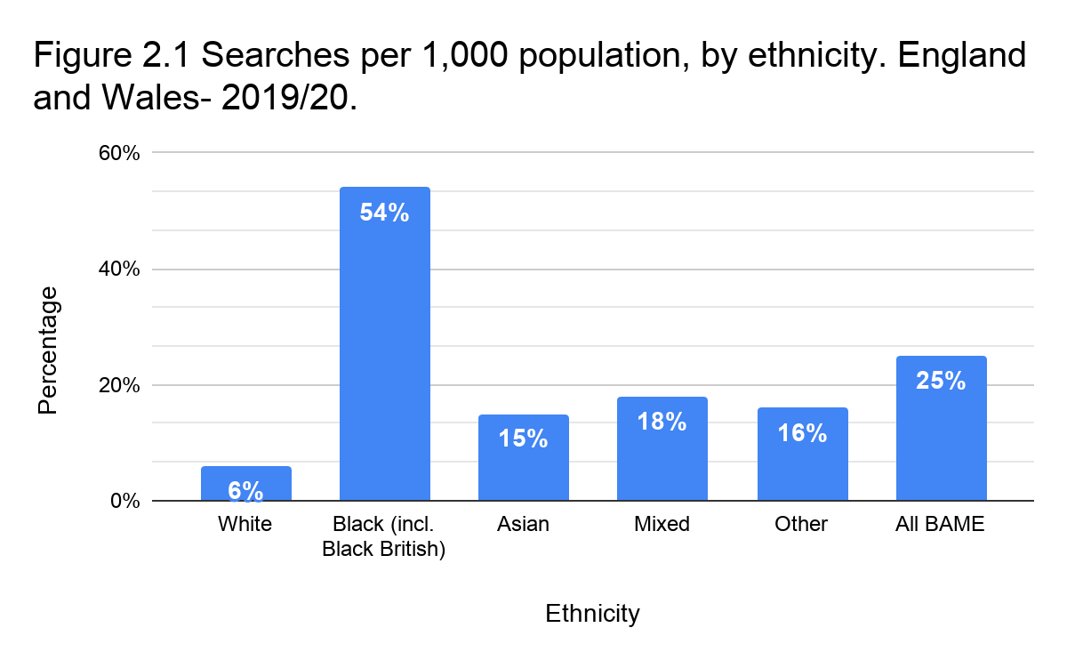

2.2.2 Age

Two decades ago, young males aged 16-29 were significantly more likely to be stopped regardless of ethnicity (Clancy et.al., 2001). In 1999, 39% of black males under the age of 30 were stopped and searched in a vehicle and 32% of black males under 25 were stopped and searched on foot (ibid.). Currently, identical trends continue as the demographic of 18-34 year old’s accounts for 73% of all searches conducted by the City of London Police between April and June 2020 (City of London Police, 2020). Young adults aged 18-24 years old were most searched (39%), followed by 25-34 year old’s at 34%. The Metropolitan Police (2020) observed that 31.5% of positive outcome searches were conducted on 18-24 year old’s. Interestingly, the cohort of 15-19 year old’s represented 30.4% of positive searches. Finally, 25.3% of positive searches were conducted on 25-34 year old’s (ibid.). A positive outcome search involves a ‘hit’ where prohibited articles were found, an arrest, a penalty notice for disorder, or a cannabis or khat warning (Home Office, 2014). The Scottish Police Authority (2016) found that focusing on demographics such as young males deteriorates the relationship with the police, thus such groups are less likely to co-operate.

2.2.3 Geographical area (England)

Stop and search has been linked with geographical areas in which the searches take place (Clancy et.al., 2001; Newburn, 2007; Bryant and Bryant, 2015). The findings of Flatley (2020) were plotted onto Figure 2.2, below, to showcase the connection between the collective number of searches conducted in each respective region of England and resultant arrests.
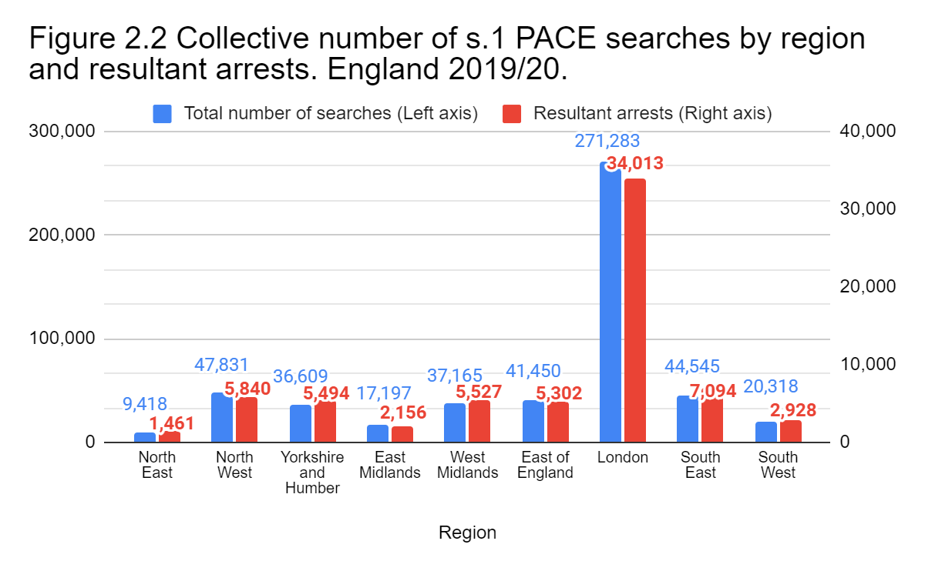
Stop and search is used more frequently in areas of deprivation where crime is higher, the population make-up of these areas also varies (Cuthbertson, 2018; HM Government, 2021). Most recently, 49% of stop and searches in England and Wales were made by the Metropolitan Police in London. Figure 2.2, above, denotes that the highest prevalence of searches and resultant arrests in the year 2019/20 occurred in London. However, London’s population by far exceeds other regions (ONS, 2019). The vast number of searches in London could be explained by the fact the ‘available population’ is greater than elsewhere. Nonetheless, crime is more prevalent in concentrated and densely populated metropolitan areas, such as London (Ladbrook, 1988; Glaeser and Sacerdote 1999; Newburn, 2007; Oliviera et.al., 2017). Only 12.5% of searches conducted in London resulted in an arrest. Figure 2.2, above, demonstrates that a disproportionate number of searches is needed to generate arrests for notifiable offences in all regions. Ultimately, residents of the North East, East Midlands and the South West are least likely to experience stop and search. On the contrary, the volume of searches and arrests in regions such as Yorkshire, West and East of England is comparable.

2.2.4 Gender

Gender is a strong predictor of offending (Muncie, 1999; Maguire et.al., 2002). This is reflected in the prison population which comprises 75,421 male and 3,197 female prisoners, females equate to 4% of the prison population (MoJ, 2020; Sturge, 2020). Males are nine times more likely to receive a custodial sentence than females (MoJ, 2020d). Hence, non-custodial sentences are preferred for women with dependent children, whereas custodial sentences are reserved for serious offences after considering the needs of the child or children (Minson et.al., 2015).

The number of males and females arrested for notifiable offences in the past year is 546,000 and 94,000 respectively (Flatley, 2020b). Males are more likely to engage in criminal behavior, and consequently face a greater likelihood of being searched (Newburn, 2007). As much as 87% of searches conducted by the British Transport Police were on males, and 5% on females (British Transport Police, 2012). However, a relationship may exist between the low frequency of females searched and the low female prison population. From the 129,110 police officers in England & Wales, only 40,319 (31%) were female (Allen and Zayed, 2021). Male officers may be unwilling to search females, as usually, it is males who come to the attention of the criminal justice system (Stanko, 1995). Currently, the Home Office has not published stop and search statistics based on gender.

2.3 Reason for search
Section one searches empower constables, within reasonable grounds to search for prohibited or stolen articles. The Home Office (2020) claims that in a ‘real life’ situation, an officer may have several reasons to conduct a s.1 search such as suspecting the possession of drugs, bladed articles, or firearms. Nonetheless, any arrests originating from the use of stop and search do not have to relate to the initial reason for the search (Bryant and Bryant 2015; Home Office, 2020). Figure 2.3, below, depicts the data gathered by Flatley (2020) on the number of s.1 PACE searches by reason for search.
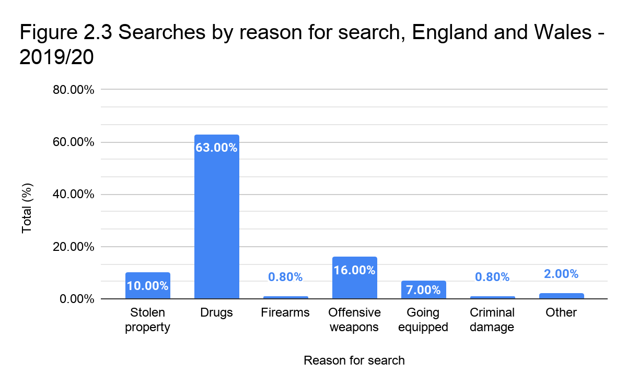
A consensus within the House of Commons Home Affairs Committee (2019) states that the tactic should be used to tackle knife crime. Brown (2020) argues against the Committee, the data provided by Flatley (2020) shows that s.1 PACE searches are oftentimes used to seek drugs (63% or 350,894 searches). Offensive weapons are the second most common reason for search in 16% or 89,450 of searches. There are arguments that stop and search is used to over-police the already vulnerable group of substance users (StopWatch, 2018).

Researchers estimate that in the final quarter of 2008/09, a search was conducted in the UK every 20 seconds (McCandless et.al., 2016). In the year 2020, approximately 46,300 offences involving sharp instruments were recorded (Allen and Kirk-Wade, 2020). It is a 6% increase from the previous year and a continuous incline since 2013/14. Figure 2.3.2, below, illustrates the exponential growth in knife crime as the number of s.1 PACE searches declined in the years 2013-2018 (Flatley, 2020; Allen and Kirk-Wade, 2020). Despite the rise in stop and search since 2018/19, knife crime continued to increase.

However, due to austerity measures and political pressures since 2010, police funding was reduced by 20% which impacted police forces and policing capabilities (HM Treasury, 2010; Millie, 2014). Possibly, in the early years of austerity and until 2013/14, more individuals grew accustomed to carrying knives due to the budgetary challenges of police forces, the subsequent reductions in searches and the consequent increase in knife crime as the chances of facing a search diminished.
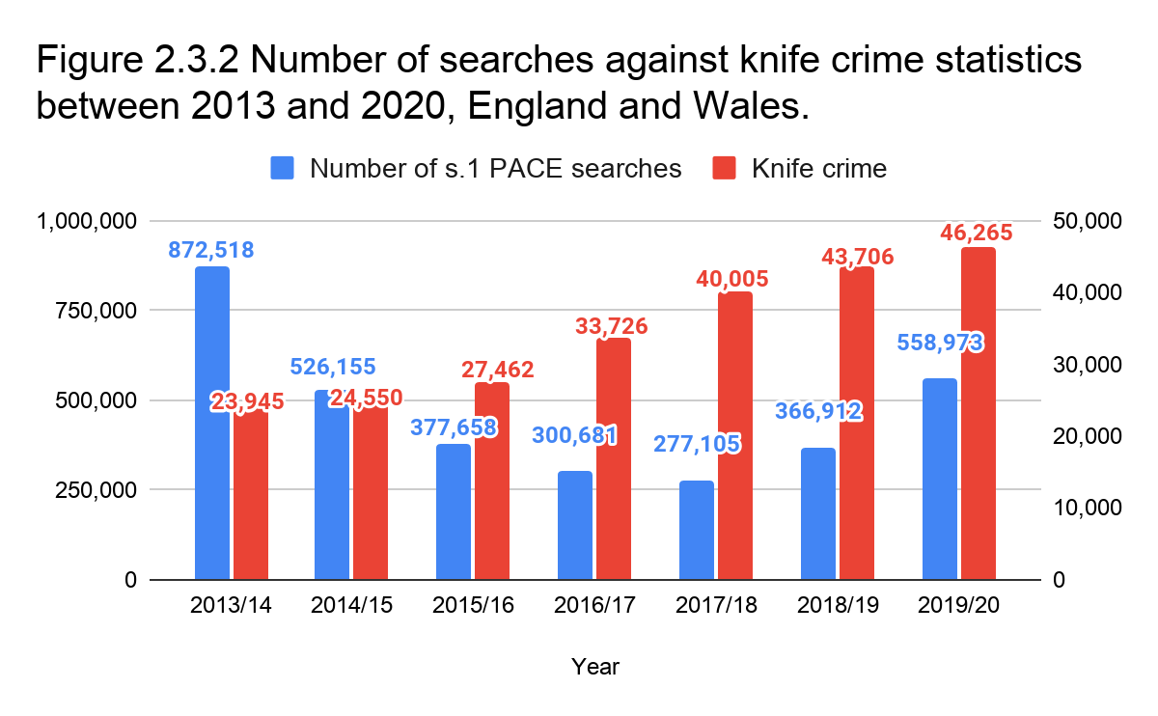

2.3.1 Public views

Early research determined that the public has little understanding of stop and search (Reid Howie Associates, 2002). From a cohort of 304 individuals, 88% reported being stopped more than once (The 1990 Trust, 2004). Furthermore, approximately 25% of participants received no reason for search, others opine that the reasons were inadequate, false, or simply an excuse for a search (ibid.). Girling et.al., (2002) and Fitzgerald et.al., (2002) conclude that the public is decisive in their support for stop and search. However, Reinman (2004) states that usually it is the minority being suspect and subject to searches which leaves the majority untouched.

The public was previously in support of stop and search as demonstrated by Russell et.al., (2013) who found that young people understand the relationship between stop and search and public protection. HMIC (2013b) established that 78% of participants judge stop and search as a useful policing tool in catching criminals, more recently Tiratelli et.al., (2018) arrived at a similar conclusion. Brown (2021) acknowledges that many do support stop and search, whereas Flacks (2018) notes that search powers came under criticism for the disproportionate number of searches carried out on individuals of black minority ethnic groups in England and Wales. However, the use of stop and search on minors and under-18’s has largely escaped comment. Topping and Bradford (2020) relate stop and search to community trust and police legitimacy. Hence, research must be conducted to observe the current views on stop and search and the subsequent possibility of distrust in the police.

2.3.2 Crime reduction

Decrements in crime can be perceived as a by-product of stop and search (Quinton et.al., 2017), there is limited evidence to suggest a positive impact of stop and search on crime (McCandless et.al., 2016; Brown, 2020b). Crime reduction is therefore not a primary objective of the tactic, as its impact on crime reduction remains unclear (Bradford and Tiratelli, 2019). Attempts to calculate the impact of stop and search of crime reduction estimate that searches reduce the number of disruptable crimes by up to 2.3% (Miller et.al., 2000; The Police Foundation, 2012). Lower crime rates could be attributed to proactive policing, or the presence of the police in the community. However, stop and search could be effective in detecting as opposed deterring crime (Brown, 2020). Viewing stop and search as a crime preventing tactic places additional strain on police resources to carry out more searches. Hence, a common understanding among academics is that visible policing contributes to lower crime rates.

2.4 Summary of findings
Objective one has been achieved in this chapter:

“Analyse the factors which impact the likelihood of being stopped and searched.”

Objective three was partially achieved, the researcher has constructed a literature review matrix for his survey.

“Conduct social research and analyse the current social standpoint on stop and search.”

The factors which impact the likelihood of being stopped and searched were analysed. Male adults aged under 34 are the most likely demographic to be searched (Muncie, 1999; Clancy et.al., 2001; City of London Police, 2020; Metropolitan Police, 2020). Individuals of BAME or mixed ethnicity are certainly more likely to experience a search that white ethnic groups (EHRC, 2010; Brown, 2020; Flatley, 2020), and the residents of London are much more likely to experience a search overall (Flatley, 2020). Academics agree on the higher prevalence of crime in highly populated metropolitan areas (e.g., Ladbrook, 1988; Oliviera et.al., 2017), as the ‘available population’ is greater which contributes to more searches.

It is believed that the police use stop and search affects public perception (Scottish Police Authority, 2016). There is a need for more research on the topic of stop and search. The last major contributions were made by Russell et.al., (2013) and HMIC (2013b). However, these studies provided a general insight into the public perception of stop and search, with few references to variables such as age, geographical location, and gender. Henceforth, this topic received more academic attention as shown by Flacks (2018), Tiratelli et.al., (2018) and Topping and Bradford (2020) who advanced our understanding of the subject matter, these were not quantitative social studies, however. This gap will be addressed by gathering the public’s views on stop and search and analysing against the aforementioned variables. Given the changing nature of society, this research may establish if the public supports stop and search in present time.

Chapter three will detail the research methodology to perform primary research based on the issues and gaps identified within the literature review.

Chapter Three: Research methodology

3.0 Introduction
The factors which impact the likelihood of being searched were analysed in chapter two, thereby achieving objective one. An evident lack of consistent social research regarding public perception of stop and search emerged from the literature. Chapter three will identify the most suitable methods of data collection.

This chapter will achieve objective two:

“Select appropriate research methods to conduct social research on the public views of stop and search.”
Academic research is experimental or theoretical work conducted to establish new knowledge of underlying problems, issues, or concerns (Djellal et.al., 2003). Research should at least advance the current understanding of the subject or related practice (Candy, 2006). Social research embedded within this study aims to generate new concepts or knowledge related to human subjects and social constructs (Powell, 2019).

3.1 Research Onion
The research onion of Saunders et.al., (2019) presents stages of the research process, an effective strategy can be established using the model. The onion guides the practitioner through the process of research and can be consulted at any time to highlight the merits and pitfalls of research methodology. Figure 3.1, below, exhibits the research onion and the methods selected by the researcher.
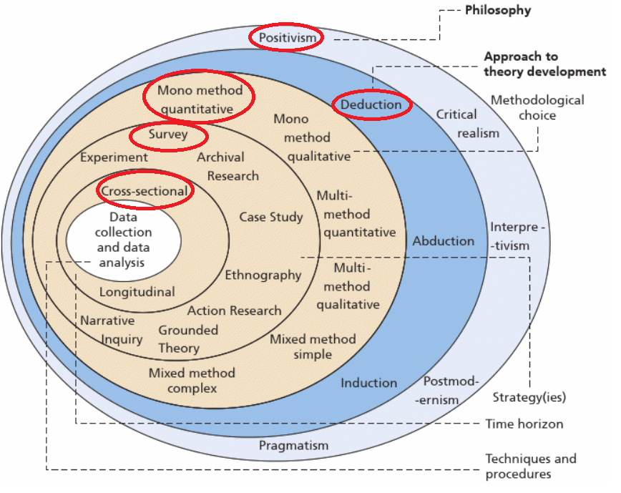
Figure 3.1: The Research Onion (Saunders et.al., 2019)

A fitting research methodology has been identified using Saunders’ et.al., (2019) framework, its use will be justified in the forthcoming subsections. Using tried and tested strategies within the research onion enhances academic credibility and validity (Biggam, 2011).

3.1.2 Philosophy

The two types of philosophy are ontology, the nature of existence and structure of reality, and epistemology, understanding the world around us by making sense of it (Al-Saadi, 2014; Pritchard, 2014). This research maintains a relativist ontological perspective, where no single true reality exists, and reality is experienced differently by individuals at a given time and place (Moon and Blackman, 2014). From this premise, the researcher will conduct a survey to show potential discrepancies against previous research. Namely, a possible social change and a subsequent different reality as the public’s view of stop and search shifted. An etic epistemological view is held which understands social constructs using predetermined characteristics. Epistemology is thus objective, the researcher is separated from his subjects and cannot bias the findings which may support or refute his hypothesis (ibid.).

In criminology, positivism considers social and psychological factors that influence human behavior (Vetter, 1978). For example, increments in crime can be explained using ubiquitous factors found in society (Neuman, 2014), such as poor education. By understanding these factors, criminal and non-criminal behavior is more easily understood, which helps to distinguish the criminal from the non-criminal (Newburn, 2007). Because of its frequent use by researchers in this field, a positivist philosophy will be adopted which favors quantitative data subject to statistical analysis (Neuman, 2014). Emergent observations could be replicated by future researchers. The hypotheses of a positivist researcher may be wholly or partially confirmed, or refuted, thus identifying the need for further research (Saunders and Lewis, 2018). Data is gathered in an objective and value-free way to avoid exerting influence over the findings which contributes to the reliability of this study (Cohen et.al., 2007; Saunders et.al., 2019).

3.1.2 Approach

Deductive reasoning verifies a proposed theory using an intended research strategy fundamental to this test (Saunders and Lewis, 2018). A deductive approach will test the public’s views on stop and search in current time based on the findings of past research (e.g., HMIC, 2013b), with the goal of advancing existing knowledge (Melnikovas, 2018). Deductive reasoning combined with positivism can confirm probable causal laws and predict the patterns of social behavior (Neuman, 2014). Quantitative data will be collected using a survey and analysed in a statistical form which reflects the positivist philosophy, and therefore justifies the use of deductive reasoning (ibid.). Due to political and cultural development since 2013, this study may unveil societal changes and shifts in the public perception of stop and search caused by various possible factors.

3.1.3 Choice

A mono-method methodology exclusively consists of quantitative data (Melnikovas, 2018). Single method quantitative studies are objective and can be replicated by other researchers, however, data is subject to validity testing (Park and Park, 2016). The purpose of quantitative research is to test an existing theory as opposed to developing it with a qualitative approach (ibid.). The researcher has emphasised on using a mono-method quantitative methodology to contribute to existing research.

3.1.4 Strategy

Research strategy discusses the methods and techniques of data collection and analysis (Biggam, 2011). Surveys are one of the main methods of quantitative data collection (Bryman, 2004). A survey will capture societal views on stop and search and provide an understanding of the present social standpoint (Cohen et.al., 2007; Park and Park, 2016). Surveys provide a large amount of data on one theme from many participants, in a relatively short period of time (Kelley et.al., 2003). Thus, it is an efficient way to conduct social research (Saunders and Lewis, 2018). Questions are uniform to all participants, which permits data comparison across different demographics. Surveys often accompany deduction and positivism which are implemented in this study (Saunders et.al., 2019).

3.1.5 Time Horizon

Academic research is time-constrained which justifies the need for a time-horizon (Saunders and Lewis, 2018). Research takes place at single or multiple points in time, known as cross-sectional and longitudinal respectively (Bryman, 2004; Neuman, 2014). This cross-sectional study will create a ‘snapshot’ of social life at one point in time, in this case the public views on stop and search.

3.2 Techniques and procedures

Quantitative data will be collected using a survey. Quantitative research is numerical and has measurable values (Saunders and Lewis, 2018). Variables are represented numerically in charts, graphs or tables and analysed statistically to test the proposed hypotheses (Neuman, 2014). Due to the descriptive nature of survey based research, namely recording answers from many participants, random sampling is frequently applied (ibid.).

3.2.1 Sampling

Collecting data from the entire target population is impractical, thus, data must be collected from a sample of the population (Biggam, 2011). Participants were recruited using random probability sampling to achieve a fair representation of society. Random sampling lacks mathematical patterns, thereby providing an equal opportunity of each element being selected (Neuman, 2014). Hence, the data gathered by chance is unbiased (Saunders et.al., 2019). An advantage of simple random sampling is the possibility to gather data from a target population dispersed over vast geographical distances. However, potential surveys must be computerised and distributed online to complement the aforementioned benefit (ibid.). The researcher has distributed the survey via social media (see Appendix 3).

3.2.2 Survey design

A questionnaire is a list of uniform questions completed by respondents to express their opinions and attitudes towards social dilemmas (Roopa and Rani, 2012). Quantitative data can be gathered from a large population (Saunders and Lewis, 2018). Questions must relate to research aims and be tested to avoid misinterpretation (ibid.). The proposed survey consists of open and closed questions. Open-ended questions enable respondents to input any answer to gain qualitative data, whereas closed questions offer a selection of predetermined answers (Neuman, 2014). Closed questions were further divided into rating questions. The process of rating answers establishes a respondent’s belief or opinion by agreeing or disagreeing with a statement using a Likert scale (Young, 2015; Saunders and Lewis, 2018).

3.2.3 Literature Review Matrix

Table 3.2 Questionnaire and Literature Review Matrix
Questions | Association with Chapter 2
Q1) The answers provided to this survey are confidential and anonymous, you are free to withdraw at any time. Do you consent for your results to be interpreted within this study? (open question) | Questions 1-5 are demographic questions which support the researcher in understanding the cohort of participants.
Q2) Please state the gender that best describes you.
Q3) Please select your age range.
Q4) Please state your ethnic background.
Q5) Please identify your region.
Q6) The following is an open question, please type in your answer. In your opinion, what is meant by the term 'stop and search'? | Q6/7) There is little real understanding of stop and search among the public (Reid Howie Associates, 2002). Later research established that the public have a good understanding of stop and search by comparing the participants' opinion and understanding following an explanation (HMIC, 2013b; Russell et.al., 2013).
Q7) Please read the attached explanation of stop and search. How does it compare to your previous understanding of stop and search?

“The term ‘Stop and search’ relates to police powers to detain for the purpose of a search for stolen or illicit articles such as drugs, firearms or offensive weapons. Investigatory powers may also be used on suspected terrorists or individuals in anticipation of violence. The search may extend to anything concealed within or on a person or a vehicle, provided there are reasonable grounds to conduct a search.”

- It is very similar to my previous understanding of stop and search.
- It is relatively similar to my previous understanding of stop and search.
- It differs slightly from my previous understanding of stop and search.
- It is very different from my previous understanding of stop and search.
Q8) Does looking or dressing a certain way affect the likelihood of being stopped and searched? Consider factors such as clothing, skin or hair colour.  - I think that appearance greatly affects the likelihood of being stopped and searched.  - I think appearance affects the likelihood of being stopped and searched to a certain degree.  - I'm unsure, appearance may impact the likelihood of experiencing a stop and search but it's unclear.  - I disagree, there is no relationship between appearance and the likelihood of being stopped and searched. | Q8) Looking or dressing a certain way (appearance) results in more stop and searches (Farrell et.al., 2004, Russell et.al., 2013; Hargreaves, 2018).
Q9) Please read the attached statement. How confident are you in the police that searches are reasonable, objective and with no prejudice?  “Stop and search is a discretionary power which carries a requirement of ‘reasonable suspicion’. Police constables cannot justify a search based on personal and protected characteristics. However, no definite list of objective factors on which to base a search exist.”  (Very confident to not confident at all) | Q9) Reasonable suspicion cannot be based on personal factors and protected characteristics (Miller et.al., 2000; Maguire et.al., 2002; Bowling and Phillips, 2007; HMIC, 2013; Bryant and Bryant, 2015; Bradford and Loader, 2015; Brown, 2020).  Q9/10) Previous researchers critique the vague definition of ‘reasonable suspicion’ (Fitzgerald, 1999; Maguire et.al., 2002; Sanders and Young, 2003; Ellis, 2010).  Q10/11) Brown (2020) acknowledges that no definite list of objective factors on which to base a search exist. One in five of those stopped and searched claim that the reason for search is false (The 1990 Trust, 2004).
Q10) In your opinion, should policymakers establish an official list of objective factors on which to base a search on?

- Yes
- No
- Difficult to say
Q11) Do you agree with the following statements?

- If a list of objective factors on which to base a search on was established, it would reduce the misuse of stop and search.
- If a list of objective factors was established, stop and search would become more transparent.
- If a list of objective factors was established, certain groups in society would be stopped and searched less frequently.

(Strongly agree to strongly disagree)
Q12) In your opinion, are certain individuals or groups in society more likely to experience stop and search?  - Stop and search is used too much on certain groups in society.  - The use of stop and search appears to be proportional.  - Stop and search is used too little on certain groups in society.  - Don’t know. | Q12) Past research confirms the greater prevalence of black males being stopped than individuals of other ethnic groups (McKenzie, 2000, Waddington et.al., 2004; Delsol and Shiner, 2006; EHRC, 2010; Eastwood et.al., 2013; Parpworth, 2014; Hargreaves, 2018; Flacks, 2018).  Q12/13) In previous research, 70% of respondents agree that certain groups are more susceptible to stop and search (HMIC, 2013b). A study by Russell et.al., (2013) reveals that looking or dressing a certain way results in more searches.
Q13) How concerned are you, if at all, that certain groups of people face a much greater likelihood of being stopped and searched contrary to others?

(Seriously concerned to not concerned at all)
Q14) Based on your current knowledge, how often is stop and search used in your region?  - Very often  - Occasionally  - Rarely  - Not at all  - Don’t know | Q14) A 2013 study found that 34% of participants think that searches are carried out occasionally in their area, 21% claimed that they are carried out a lot (HMIC, 2013b). Some police forces use stop and search a lot more often than others (Bradford and Tiratelli, 2019).  Numerous researchers linked geographical location with the likelihood of being searched which increases in dense metropolitan areas (Ladbrook, 1988; Glaeser and Sacerdote 1999; Clancy et.al., 2001; Bryant and Bryant, 2015; Newburn, 2007; Oliviera et.al., 2017; HM Government, 2021).
Q15) Do you agree or disagree with the following statements?  - Abusing stop and search powers causes public distrust in the police.  - Excessive searches of particular demographics can lead to violence and hostile attitudes towards policing.  - Unreasonable and excessive use of stop and search against particular groups or individuals incriminates them.  (Strongly agree to strongly disagree) | Q15) Statements were drawn from the studies linking personal factors such as age and ethnicity to stop and search. Other studies found officers experiencing abuse from the citizens they serve.  Previous research e.g. (Miller et.al., 2000; Maguire et.al., 2002; Bowling and Phillips, 2007; HMIC, 2013; Bryant and Bryant, 2015; Bradford and Loader, 2015; Hargreaves, 2018; StopWatch, 2018; Brown, 2020; City of London Police, 2020; Metropolitan Police 2020; HM Government, 2021b).
Q16) Stop and search is perceived to be a useful policing tool. In your opinion, under what reason do most searches take place?  - Offensive weapons  - Drugs  - Going equipped (possessing articles made or adapted for use in the course of or in connection with an offence of e.g., burglary or theft)  - Stolen property  - Other | Q16) Police officers and politicians view stop and search as a valuable policing tool (Qureshi and Farrell, 2006; Parpworth, 2014; Tiratelli et.al., 2018; Flacks, 2018)  The most common reason for a s.1 PACE search is drugs (63%), followed by offensive weapons in 16% of searches (StopWatch, 2018; Flatley, 2020). The alleged purpose of stop and search is to target individuals carrying knives and offensive weapons, not drugs (House of Commons Home Affairs Committee, 2019).
Q17) Do you agree or disagree with the following statements?  - I feel safer in my community knowing that the police use stop and search.  - Stop and search is effective in reducing crime.  - Stop and search is effective at identifying criminals.  - The use of stop and search helps to discourage, disrupt, or prevent criminal activity.  - Stop and search indirectly promotes social order and maintenance.  - Crime reduction is not a primary objective of stop and search.  (Strongly agree to strongly disagree) | Q17) Statements in this section are drawn from contrasting ideas of public support for the tactic and its relative lack of impact on crime reduction.  Stop and search keeps the public safe (College of Policing, 2020; Metropolitan Police, 2020b). This question featured in previous research (see HMIC, 2013b).  The public is supportive of stop and search (Russell et.al., 2013; Tiratelli et.al., 2018). More than 70% of participants agree that stop and search is useful in reducing crime (HMIC, 2013b). A similar outcome was recorded by the Scottish Police Authority (2016).  Stop and search tactics have little effect on crime reduction (Miller et.al., 2000; Reid Howie Associates, 2002; McCandless, 2016; Fagan, 2016; Quinton et.al., 2017; Tiratelli et.al., 2018; Bradford and Tiratelli, 2019)
Q18) Which of the following best describes your view of stop and search?  - I am in support of stop and search.  - I am in support of stop and search, whilst still being aware of its pitfalls.  - Indifferent  - I am concerned about stop and search.  - I am strongly against stop and search.  - None of the aforementioned statements reflect my views. | Q18) Previous research found the public are supportive of stop and search despite its pitfalls (Russell et.al., 2013; HMIC, 2013b; Tiratelli et.al., 2018). The Scottish Police Authority (2016) claims that the application of stop and search affects the way people view the police.  This question directly correlates to the third research aim of this study:  “To conduct quantitative social research and analyse the public perception of stop and search”
Q19) Do you think stop and search is working as intended, or is there something that can be improved upon? (open question) | Q19) In 2014 the Best Use of Stop and Search Scheme (BUSSS) commenced, it’s principal aims are to achieve a greater transparency and support intelligence-led policing (Home Office, 2014).

3.2.4 Pilot Study

A pilot study enables the researcher to identify and subsequently adjust any design flaws, it also aids in determining the clarity and appropriateness of a survey (Saunders and Lewis, 2018). Pilot testing questionnaires prior to publication enhances the validity and reliability of research (Biggam, 2011). The questionnaire was pilot tested, the survey was published following minor alterations.

3.2.5 Reliability and validity

Reliability is defined by replicating the study using the same methods and achieving consistent results (Saunders et.al., 2019). Conversely, validity defines the accuracy of data collection such as using tried and tested techniques, research strategies and approaches. The theme is a sensitive societal topic. To limit bias and moral desirability of answers as opposed to truthful opinion (Young, 2015), partaking is anonymous and confidential. The principles of content and construct validity were embedded within the questionnaire. Content validity defines the extent to which the data being collected is large enough to answer the research aims, whereas construct validity relates to the accuracy of the questions to collect data about what they intended to measure (Cohen et.al., 2007; Saunders and Lewis, 2018). Validity is further supported by literature, which identified relevant content for the survey to build upon previous research (e.g., HMIC, 2013b).

3.2.6 Limitations

There is a risk of social desirability bias and conformity to trending social norms (Neuman, 2014; Young, 2015). To counteract this, the researcher promised confidentiality and anonymity to all participants. The questionnaire was published online to allay any concerns about expressing their views openly and to encourage honest answers, rather than conforming with social norms (Neuman, 2014). Because of the impracticality of meeting experts and relying on their availability (Biggam, 2011), a qualitative method was not considered. This study is confined to the deadline of one academic year which limits the possibilities of data collection, alongside personal commitments which restrict the time left to conduct research.

3.2.7 Ethical Considerations

Academic research must follow ethical standards to reduce the risk of harm to participants (Saunders et.al., 2019). Participation was confidential and anonymous, private data was not collected. To reduce the risk to the vulnerable, under 18 year old’s were not surveyed. All respondents knowingly participated in this research, gave informed consent before partaking (Townsend and Wallace, 2016), and were free to withdraw at any stage. This research was approved by the project supervisor to ensure its compliance with the ethical practice of the UWTSD (see Appendix 1).

3.3 Conclusion
Objective two has been achieved:

“Select appropriate research methods to conduct social research on the public views of stop and search.”

Chapter three has provided the rationale and details of the research strategy. Limitations were identified and addressed to minimise the impact of potential criticism. The choice of positivist philosophy, a deductive approach and a mono-method quantitative data collection have been explained, thus achieving objective two. Chapter four contains an analysis of data collected using methods previously discussed in this chapter.

Chapter Four: Data Analysis

4.0 Introduction
In chapter three, the researcher has selected and justified the research methods and methodology, thereby achieving objective two. Chapter four will analyse the results of the questionnaire, achieved by combining a positivist philosophy with deductive reasoning in a mono-method quantitative, cross-sectional study. The data will be described and analysed within this chapter to achieve objective three:

“To conduct social research and analyse the current social standpoint on stop and search.”

4.1 Data analysis
Data analysis is conducted by organising and manipulating values and variables to disclose themes of interest about the social world (Neuman, 2014). Quantitative data should be presented in graphs and tables to highlight emerging trends and to answer the research question (Saunders and Lewis, 2018). Through analysis, the researcher may retrieve meaningful information from the data that has been collected (Richmond, 2006). Data was analysed using SPSS v.26.

4.2 Methods
Respondents were categorised by age and gender. To accurately represent society, the researcher only included male and female genders, as recognised by the decennial census (ONS, 2015, 2019), and to ensure a clear and understandable presentation of the results (Biggam, 2011; Swetnam and Swetnam, 2009).

4.3 Demographics
From the total 425 participants, three identified as ‘non-binary’ (0.7%), five did not state their gender (1.2%) and were excluded from further analysis. Their representation is too small to have a significant contribution. Henceforth, the cohort subject to analysis consists of 414 participants. There were 156 male and 258 female participants. Females surpass males in social media use (Nonaan and Piatt, 2014; Alramadhan et.al., 2018; Tankovska, 2018; Hruska and Maresova, 2020), hence the higher proportion of females.

Participants were categorised into six age groups seen in Table 4.3, below.

Table 4.3 - Participants by age and gender.
SPSS value | Age group | Female number | Female (%) | Male number | Male (%) | Total
1 | 18-24 | 76 | 18.36% | 25 | 6.05% | 101
2 | 25-34 | 32 | 7.73% | 15 | 3.62% | 47
3 | 35-44 | 41 | 9.9% | 20 | 4.83% | 61
4 | 45-54 | 55 | 13.29% | 28 | 6.76% | 83
5 | 55-64 | 40 | 9.66% | 35 | 8.45% | 75
6 | 65 and over | 14 | 3.38% | 33 | 7.97% | 47
Total |  | 258 | 62.32% | 156 | 37.68% | 414

Table 4.3.2, below, shows the frequency and percentage of participants by region.

Table 4.3.2 - Participants by region.
SPSS code | Region | Frequency | Percent | Valid (%) | Cumulative %
1 | East Midlands | 41 | 9.9% | 9.9% | 9.9%
2 | East of England | 22 | 5.3% | 5.3% | 15.2%
3 | London | 46 | 11.1% | 11.1% | 26.3%
4 | North East and Cumbria | 5 | 1.2% | 1.2% | 27.5%
5 | North West | 37 | 8.9% | 8.9% | 36.5%
6 | Northern Ireland | 4 | 1.0% | 1.0% | 37.4%
7 | Scotland | 20 | 4.8% | 4.8% | 42.3%
8 | South East | 55 | 13.3% | 13.3% | 55.6%
9 | South West | 30 | 7.2% | 7.2% | 62.8%
10 | Wales | 93 | 22.5% | 22.5% | 85.3%
11 | West Midlands | 37 | 8.9% | 8.9% | 94.2%
12 | Yorkshire and the Humber | 13 | 3.1% | 3.1% | 97.3%
13 | Prefer not to say | 11 | 2.7% | 2.7% | 100%
Total |  | 414 | 100%

4.4 Analysis and tests
Hypotheses were proposed from previous literature. A null hypothesis (H𝟶) indicates no significant effect of an independent variable on a dependent variable (Neuman, 2014). The hypothesis may be confirmed or refuted, thus accepting or rejecting the alternative hypothesis (H1), which suggests a significant effect of one variable on the other (ibid.). Data was subject to Chi-square testing for the relationship between two categorical variables (Walker, 1995), ANOVA analysis of variance for testing the differences between large groups and independent variables (Sawyer, 2009), and the Mann-Whitney U-test for Likert scale questions which, as stated by de Winter and Dodou (2010) has equivalent value as the t-test. A major point to underline, is that the ANOVA analysis highlights the possible differences between groups but does not cover the statistical extent or numerical value of those discrepancies.

4.5 Views on stop and search (Chi-square)
Question 18 is salient for the purposes of this research, it directly relates to research aim three by questioning the public’s views on stop and search.

- H1) The public is in support of stop and search.

- H𝟶) The public is not in support of stop and search.

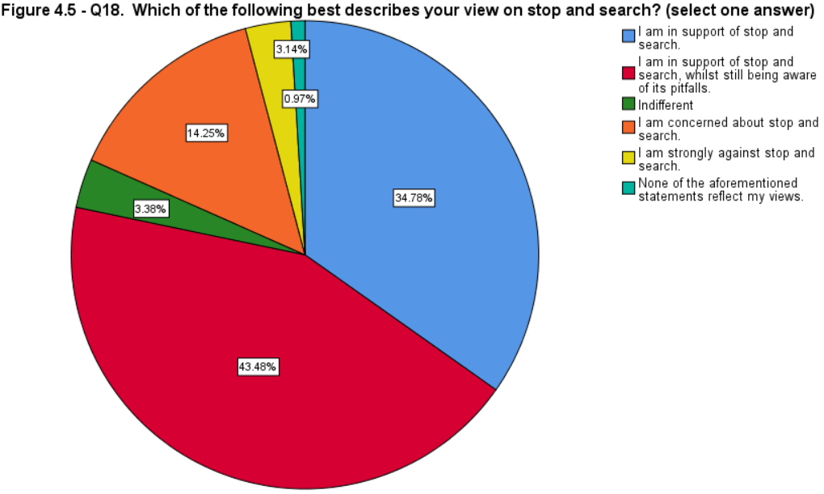
The distribution of views is unequal, Figure 4.5, above, shows that the majority is in support of stop and search, hence confirming H1 (p= .000). The public is in support of stop and search as p < 0.05.

4.5.1 Region (ANOVA)

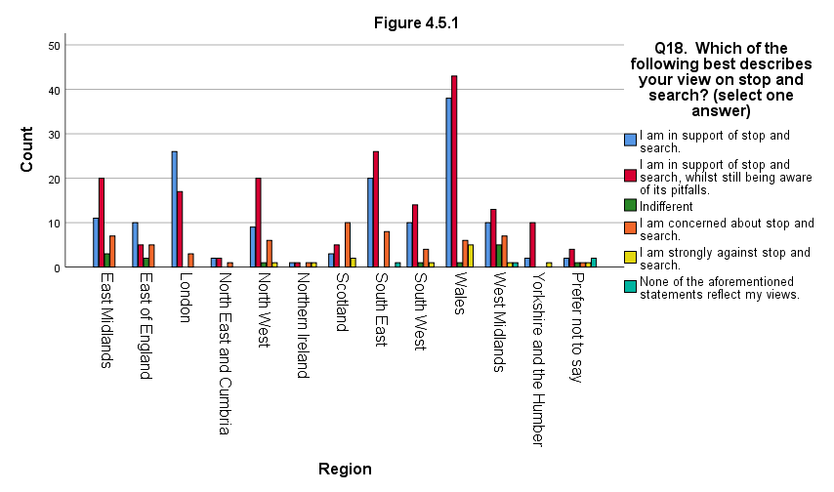
Figure 4.5.1, below, exhibits no significant statistical difference between the geographical location of participants and their views on stop and search F(5, 408)= 2.627, p.= .024).

4.5.2 Gender (Chi-square)

Gender associations disclose the statistical correlation between the responses of male (156) and female (258) participants.

- H1) There is a significant relationship between gender and the views on stop and search.

- H𝟶) There is no significant relationship between gender and the views on stop and search.
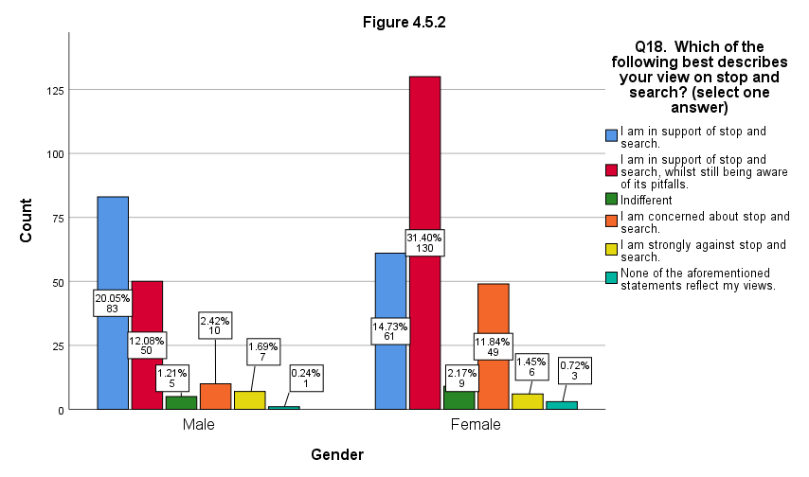
Figure 4.5.2, above, showcases the contrasting views between gender and stop and search (p.= .000). Thus, H1 is confirmed and H𝟶 is rejected as p < 0.05.

4.5.3 Age (ANOVA)

- H1) There is a significant difference between age groups and their views on stop and search.

- H𝟶) There is no significant difference between age groups and their views on stop and search.

Figure 4.5.3, below, exhibits the comparison of the views on stop and search against age. A significant statistical difference exists between age and the views on stop and search F(5, 408)= 8.788, p.= .000, thus confirming H1 because p < 0.05.
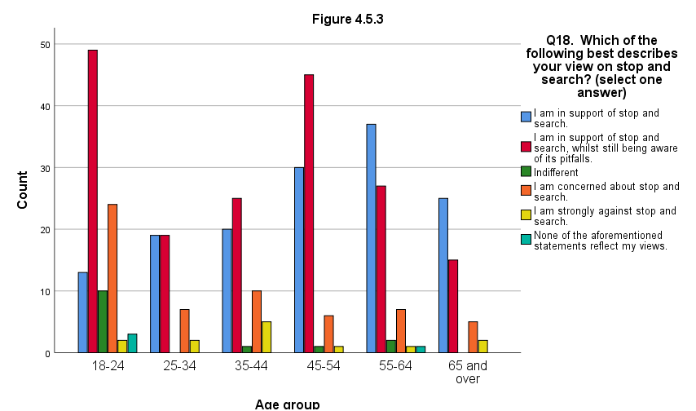
Table 4.5.3, below, illustrates the relationship between age groups and views on stop and search.

Table 4.5.3
 | Key: 1= I am in support of stop and search, 2= I am in support of stop and search whilst being wary of its pitfalls, 3= Indifferent, 4= I am concerned about stop and search, 5= I am strongly against stop and search, 6= None of the aforementioned statements reflect my views.
 | Views (% and count)
Age | 1 | 2 | 3 | 4 | 5 | 6
18-24 | 12.87%  (13) | 48.51%  (49) | 9.9%  (10) | 23.76%  (24) | 1.98%  (2) | 2.97%  (3)
25-34 | 40.43%  (19) | 40.43%  (19) |  | 14.89%  (7) | 4.26%  (2)
35-44 | 32.79% (20) | 40.98%  (25) | 1.64%  (1) | 16.39%  (10) | 8.2%  (5)
45-54 | 36.14%  (30) | 54.22%  (45) | 1.2%  (1) | 7.23%  (6) | 1.2%  (1)
55-64 | 49.33%  (37) | 36%  (27) | 2.67%  (2) | 9.33%  (7) | 1.33%  (1) | 1.33%  (1)
65 and over | 53.19%  (25) | 31.91%  (15) |  | 10.64%  (5) | 4.26%  (2)
Total (414) | 144 | 180 | 14 | 59 | 13 | 4

4.5.4 Appearance (gender - Chi-square)
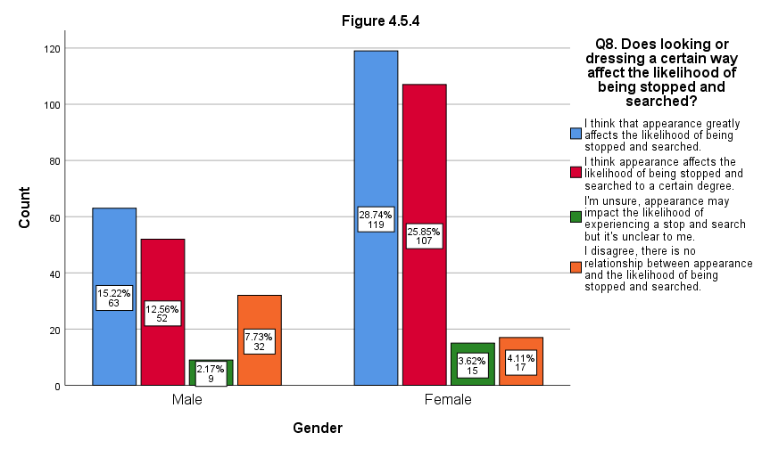
Figure 4.5.4, above, shows a significant relationship between gender and participants' answers to question eight (p.=.000).

4.5.4.2 Appearance (age - ANOVA)

Figure 4.5.4.2, below, shows a significant statistical difference between age and the suggestion that appearance affects the likelihood of being searched F(3, 410)= 6.625, p.= .000).
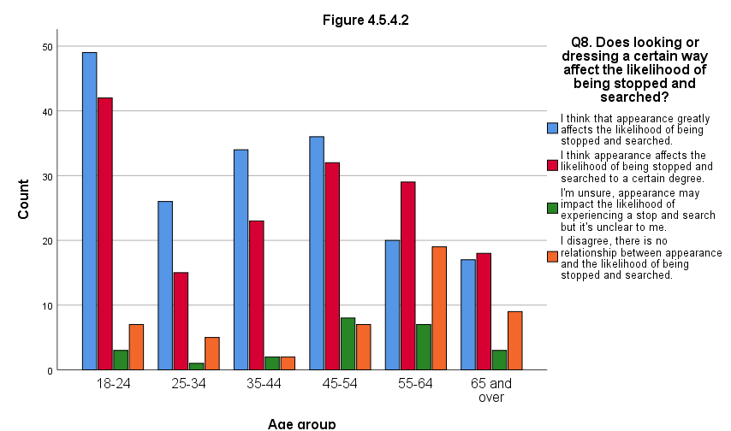

4.5.5 Likelihood (gender - Chi-square)

From Figure 4.5.5, below, a significant relationship exists between gender, specific groups in society and the use of stop and search against them (p.=.000).
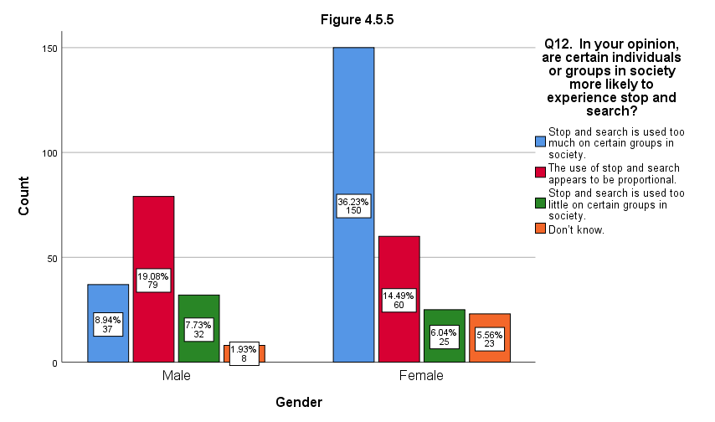

4.5.5.2 Likelihood (age - ANOVA)

Figure 4.5.5.2, below, illustrates a significant statistical difference between age and Q12, which relates to the likelihood of certain groups in society being searched F(3, 410)= 16.871, p.= .000.
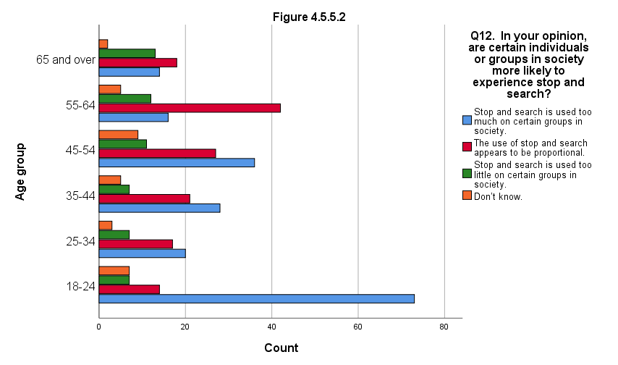

4.5.5.3 Concern (gender Chi-square)

Question 13 continues with the theme of subheading 4.5.5, participants were asked about their concern in relation to certain demographics facing a greater likelihood of being searched.

- H1) There is a significant relationship between gender and concern for the use of stop and search.

- H𝟶) There is no significant relationship between gender and concern for the use of stop and search.
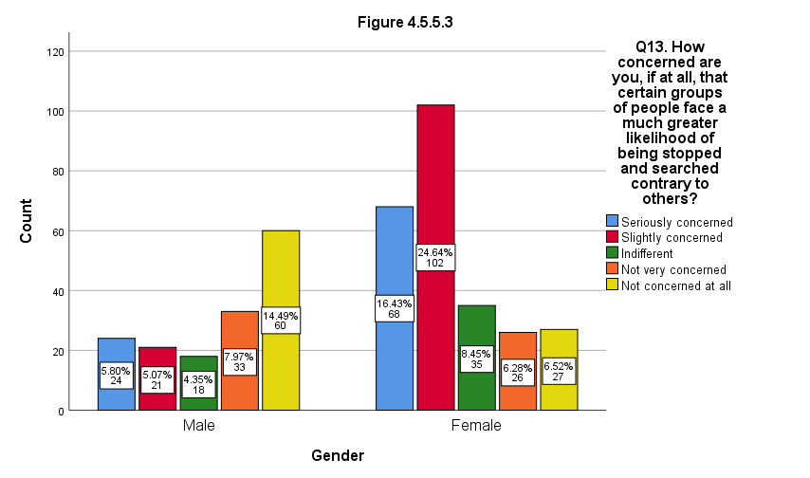
Figure 4.5.5.3, above, indicates a significant statistical relationship between participant’s gender and their concern for the use of stop and search (p.= .000), proving H1 true as p < 0.05.

4.5.6 Confidence (gender - Mann-Whitney U-test)

In Q9, participants were asked about their confidence in the police to conduct searches without bias and prejudice.
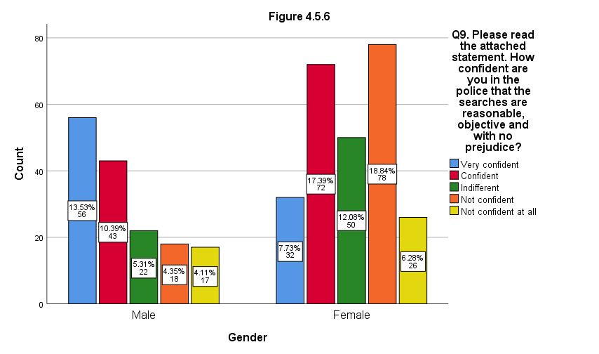
Figure 4.5.6, above, shows a statistical significance between gender and confidence in the police in relation to stop and search (Mean ranks: male= 170.15, female= 230.09, U= 14927, p.= .000).

4.5.6.2 Confidence (age - ANOVA)

Figure 4.5.6.2, below, illustrates a significant statistical difference between age and confidence in the police to conduct objective searches, F(4, 409)= 11.533, p.= .000.
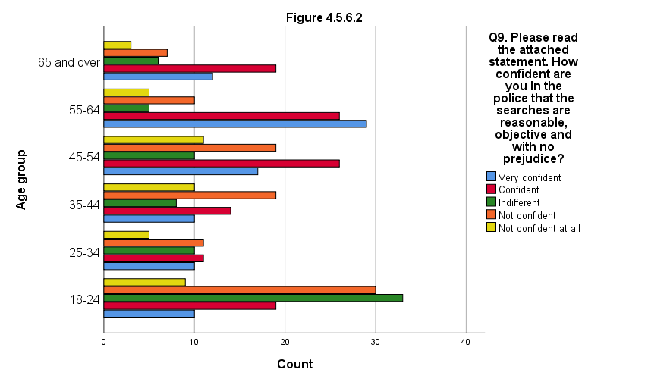

4.5.7 Community safety (gender - Mann-Whitney U-Test)

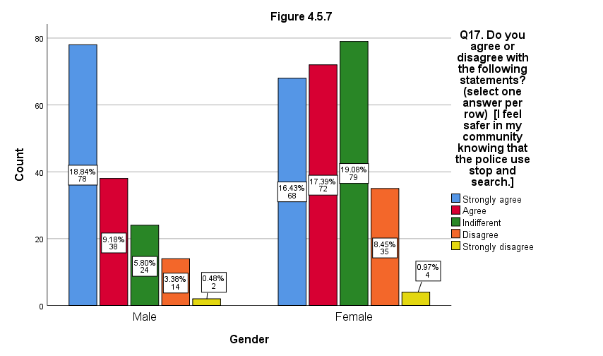
Figure 4.5.7, above, contains the results of statement one (Q17), there is a significant association between gender and the perception of safety emerging from search powers (Mean ranks: male = 172.96, female = 228.39, U= 14735, p.= .000).

4.5.8 Distrust in the police (gender - Mann-Whitney U-Test)
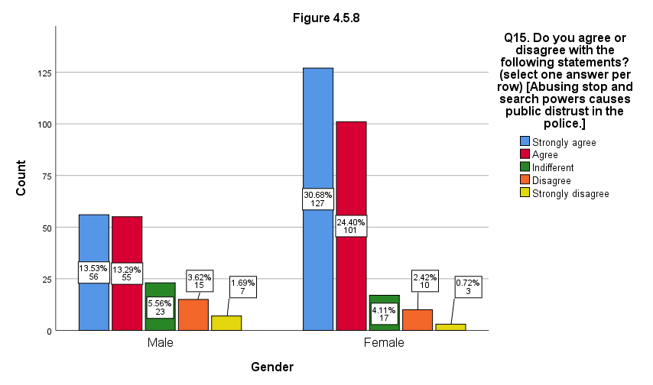
Figure 4.5.8, above, exhibits a significant statistical correlation between gender and the idea that abusing search powers causes distrust in the police (Mean rank: male= 234.29, female= 191.30, U= 15944, p.= .000).

4.5.8.2 Distrust in the police (age - ANOVA)
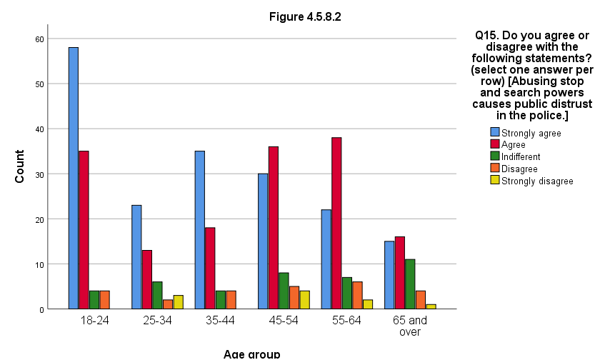
Figure 4.5.8.2, above, demonstrates a significant statistical difference between age groups and the notion that abusing search powers causes distrust in the police, F(4, 409)= 5.788, p.= .000.

4.5.9 Perceived reason for search (age - ANOVA)
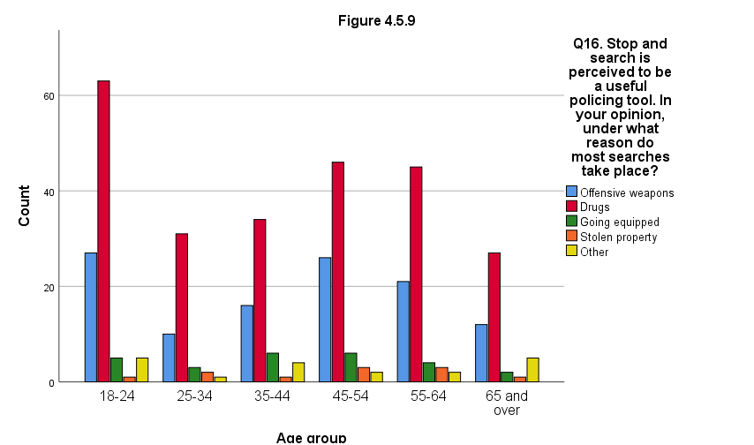
Figure 4.5.9, above, shows no significant statistical difference between the variable of age and the participants' answer to Q16, F(4, 409)= .347, p.= .845.

4.5.10 List of objective factors (gender - Chi-square)

Figure 4.5.10, below, demonstrates a significant relationship between participants’ gender and their opinion on a list of objective factors (p.= .000).
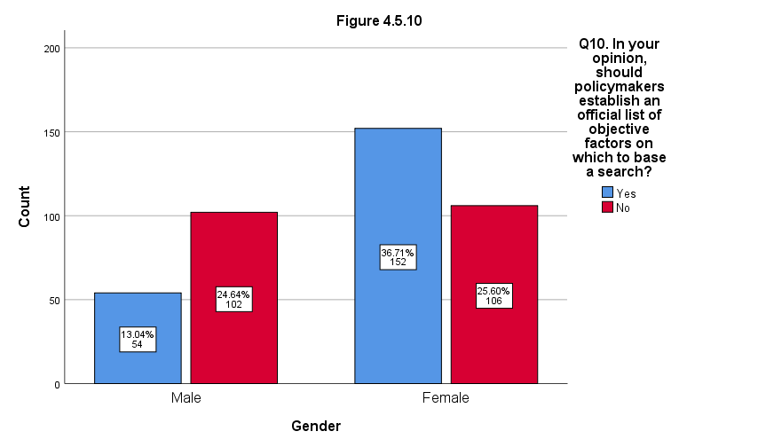

4.5.10.2 List of objective factors (age - ANOVA)

Figure 4.5.10.2, below, illustrates no significant statistical difference between age and the opinion on an objective list of factors, p > 0.05, F(1, 412)= 6.780, p.= .010.
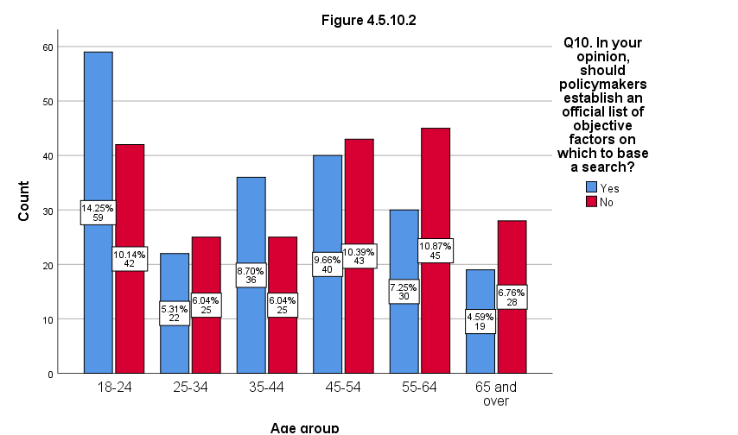

4.5.10.3 Objective factors and transparency (gender - Mann-Whitney U Test)

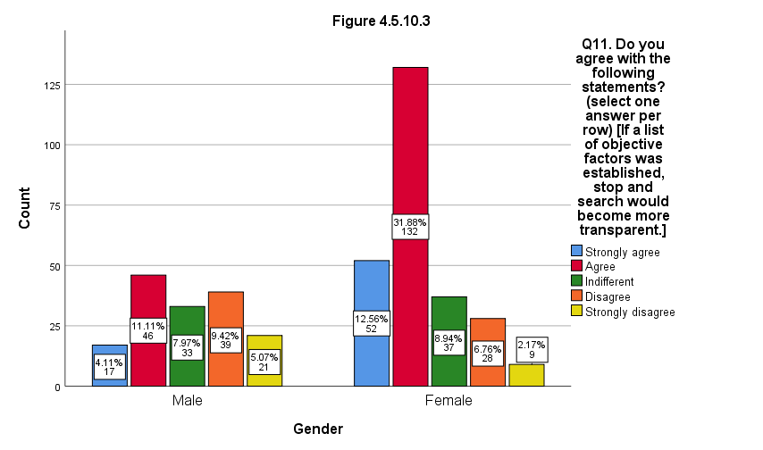
Figure 4.5.10.3, below, indicates a significant statistical relationship between gender and the notion of Q11 (Mean ranks: male= 251.84, female= 180.69, U= 13207, p.= .000).

4.5.11 Summary of tests

Table 4.5.11 - Summary of statistical tests
Question | Test | Variable | Sig. difference | Sig. relationship | No sig. difference | p. value
8 | Chi-square | Gender |  | Yes |  | .000
8 | ANOVA | Age | Yes |  |  | .000
9 | U-Test | Gender |  | Yes |  | .000
9 | ANOVA | Age | Yes |  |  | .000
10 | Chi-square | Gender |  | Yes |  | .000
10 | ANOVA | Age |  |  | Yes | .010
11 | U-Test | Gender |  | Yes |  | .000
12 | Chi-square | Gender |  | Yes |  | .000
12 | ANOVA | Age | Yes |  |  | .000
13 | Chi-square | Gender |  | Yes |  | .000
15 | U-Test | Gender |  | Yes |  | .000
15 | ANOVA | Age | Yes |  |  | .000
16 | ANOVA | Age |  |  | Yes | .845
17 | U-Test | Gender |  | Yes |  | .000
18 | Chi-square | One sample test |  | Yes |  | .000
18 | ANOVA | Region |  |  | Yes | .024
18 | Chi-square | Gender |  | Yes |  | .000
18 | ANOVA | Age | Yes |  |  | .000

4.6 Findings and discussion
The purpose of this research was to determine the public views on stop and search in present time. The findings were consistent with previous studies (e.g., HMIC 2013b; Russell et.al., 2013), the public supports stop and search. Tiratelli et.al., (2018) opine that the public view the tactic as an effective way to fight crime, it therefore possibly explains why the vast majority of participants were in support of stop and search. However, the application of search powers affects the way communities view the police (Scottish Police Authority, 2016).

Of 14 questions from the questionnaire, ten were analysed and a total of 18 statistical tests were conducted using the variables of age, gender, and region. Five significant differences were observed in participants' age and answers to questions 8, 9, 12, 15 and 18. Nine significant relationships between gender and answers to 8, 9, 10, 11, 12, 13, 15, 17 and 18 were identified (see p.42). No differences were observed in tests between age and questions ten and 16, and the variable of region and question 18. The three proposed hypotheses were confirmed (see pp.29-32). This study discovered that males, females, and different age groups have contrasting perceptions of stop and search. Previous research is limited in analysing the public perception of search powers against the previously stated variables.

Fewer females were directly in support of stop and search compared to males. A considerable proportion of females support the tactic whilst being aware of its pitfalls, more than males. Perhaps, females better understand the disadvantages of stop and search compared to males or are acquainted with contemporary societal issues. Also, females are understood to be more empathetic and caring which may explain this pattern (Queller, 1997; Mestre et.al., 2009; Christov-Moore et.al, 2014). Russell et.al., (2013) found males supportive of stop and search because of an enhanced sense of safety. Analysis of Q17 found that equally as many males as females feel safer in their community due to stop and search being used. However, there also was a large proportion of females who were indifferent to that aspect. Latest publications conclude that stop and search keeps the public safe (College of Policing, 2020; Metropolitan Police, 2020b). However, this contradicts with the findings of the Scottish Police Authority (2016) who determined that only a minority felt safe.

A previous study by HMIC (2013b) concluded that individuals aged 55 and over are more likely to be in support of stop and search as they believe it has a positive impact on crime). The findings are consistent with the conclusions of the aforementioned research, older age groups firmly support stop and search. Age groups below the 55-64 years old threshold were more likely to support stop and search whilst being conscious of its pitfalls. Whereas young adults aged 18-24 were most concerned about the use of stop and search, in line with the findings of Russell et.al., (2013) who specifically explored the impact of stop and search on young people.

Additionally, age groups of 25-34 and 35-44 year old’s were concerned about the use of stop and search more than any older age groups. Males under the age of 30 are more likely to be stopped and searched regardless of ethnicity (Clancy et.al., 2001). Last year, 73% of all searches by the City of London Police (2020) were conducted on individuals aged 18-34, those aged 18-24 accounted for 39% of searches and 25-34 year old’s accounted for 34%. Furthermore, 31.5% of positive outcome searches conducted by the Metropolitan Police (2020) were on 18-24 year old’s. Hence, a correlation may exist between the use of stop and search on particular demographics and their concern for the use of the tactic.

Researchers agree that some groups in society, especially black males are more likely to be searched (e.g., Delsol and Shiner, 2006; EHRC, 2010; Hargreaves, 2018). However, no evidence suggests that individuals of BAME groups are more likely to carry illicit items (Brown, 2021). Answers to Q13 show that females were more concerned with the use of stop and search on particular demographics than males. A vast proportion of males were not concerned with the use of stop and search against certain demographics. On the other hand, females were mostly slightly concerned, more females reported serious concern than males. Also, age groups under 55 mostly agree that stop and search is used too much on certain groups in society. Which corroborates the idea that the age affects one’s perception of stop and search.

No list of objective factors on which to base a search exists (Brown 2020). When questioned about the necessity for such a list, responses differed across the two genders. In Q11, from the two genders a vast proportion of females (44.4%) agreed that stop and search would become more transparent if such a list were to be introduced. On the contrary, only 15.2% of males agreed with that statement. Likewise, more females were of the opinion that introducing a list of objective factors would make stop and search more transparent. In response to Q9, a large proportion of females are not confident in the police to conduct unbiased searches, unlike males.

Stop and search should be used predominantly against knife crime (House of Commons Home Affairs Committee, 2019). However, 63% of all searches sought to find drugs, followed by 16% for offensive weapons (Flatley, 2020). In this study, most participants answered that drugs are the most common reason for a search, followed by offensive weapons. There was no significant difference between age and the perceived reason for a search. Thus, it appears that there is a contrast between the public and government ideas on the main use of stop and search. Most recently, HMICFRS (2021) questions the need for the policing of controlled substances through stop and search. Out of all possession based searches, approximately 25% find drugs. Consequently, the tactic is not used against offences that matter the most to the public interest or are a high priority for police forces (ibid.).

4.7 Conclusion
Objective three has been partially achieved:

“Conduct social research and analyse the current social standpoint on stop and search.”

The data on the public views on stop and search was analysed. Objective three will be revisited in the upcoming chapter which will identify new areas for exploration, implications, and recommendations. See Appendices 4-8 for data omitted from the main body of this dissertation.

Chapter Five: Conclusions and Recommendations

5.1 Introduction
The purpose of this chapter is to elaborate upon objective three:

“Conduct social research and analyse the current social standpoint on stop and search.”

5.2 Conclusions
The public supports stop and search in the majority. This research took a different analytical approach of analysing data against variables of age, gender, and geographical location. Hence, it emerged that gender and age affect the views on stop and search alongside other elements of the tactic, which is a distinct contribution to the body of knowledge. Individuals belonging to age groups who are most likely to be searched were most concerned about the use of stop and search. No significant relationship was discovered between regions and the support for stop and search.

5.3 Implications
Research should concentrate on the appropriateness and justification of search powers (Tiratelli et.al., 2018). An implication for police forces is that the responses and reactions to stop and search of different individuals will vary. The ‘Black Lives Matter’ movement relates to racial disparities in the police use of force (Ross et.al., 2020). Numerous protests were held in the time leading up to this study which might have, to an unknown extent, affected the public opinion on search powers. Young people (18-24) were most concerned about stop and search, whereas those aged 35 and over were not confident that police conduct objective searches. Most searches are conducted on young people (City of London Police, 2020; Metropolitan Police, 2020), one suggestion is that parents aged over 35 are protective of their children and subsequently not confident in the police. Public perception can be related to the Peelian principles of policing. In particular, principle two which explains the police dependence on public approval of their existence, actions, and behavior (HM Government, 2012).

5.4 Limitations
Researchers using questionnaires may experience low response rates (Saunders and Lewis, 2018), this study accumulated 425 participants compared to 19,000 responses of past research (HMIC, 2013b). More meaningful data could potentially be obtained using qualitative methods, whereby participants can elaborate on their answers. In the survey, individuals answered fixed choice questions on topics which may not be of their interest. There were significantly more female participants than male, and open-ended questions were not analysed. Consequently, this research has not investigated any possible avenues for improvements to stop and search, suggested by the public. This research has sacrificed depth of study for a generalized approach with respect to the public views on stop and search, not specific to any one demographic. Future researchers should continue to consider target demographics, as shown by Russell et.al., (2013) whose study notably encouraged young people to speak out on stop and search.

The present study welcomed participants from all over the UK, nonetheless, the distribution of participants by region was not balanced. Hence, future research into stop and search should consider the variable of region in-depth, which this study vaguely analysed, and aim to gather a uniform representation of each respective region. Public perception could be compared against the number of searches by region or crime rates for example, to explore further links. Researchers could also use the social class and ethnicity of participants as variables and make use of open questions to identify possible improvements that could be made to the tactic. Subsequent studies may wish to explore the concept of objective factors on which searches could be based. However, such research should consider the views of police officers and thereby incorporate a qualitative element. Because police officers often make the judgement on whether to search a person, it is crucial that their perspective is understood.

5.5 Recommendations
Search powers will always be subject to criticism, recently StopWatch (2021) claims that they are no different to a historical ‘sus law’. Police forces should approach and educate young people who are a group most concerned about the use of stop and search. Increasing the frequency of school visits to ingrain early knowledge of search powers in youngsters can improve police-public relations and enhance the sense of safety in pupils and their parents (Lamont, 2011). Most recently, the West Midlands Police and Crime Commissioner commenced the Stop and Search Know Your Rights campaign to raise young people’s awareness of stop and search, the project which is predominantly implemented in schools has reached an audience of over 15,000 (HM Government, 2021b). According to the public, implementing an objective list of factors could make stop and search more transparent. Transparency could also be achieved using a diplomatic approach which emphasises communication to prevent interaction escalating into conflict (HMICFRS, 2021), hence there is a need for improving interpersonal skills. In the opinion of Boyd and Skelton (p.7, 2020) “the police are the public and that the public are the police”. However, the issues of stop and search cannot be solved through training alone (HM Government, 2021b), and therefore require a multilateral approach by police forces, the government, and the community.

5.6 Achievement of objectives
This dissertation has fulfilled its objectives:

(1) Analyse the factors which impact the likelihood of being stopped and searched.

The first objective was achieved in Chapter two through the means of a thorough literature review which encompassed past and contemporary publications. The literature concludes that searches must be objective and not based on personal factors, however, variables such as age, gender or geographical location impact the likelihood of being searched.

(2) Select appropriate research methods to conduct social research on the public views of stop and search.

Chapter three has identified and detailed the research methodology of this study. In accordance with past criminological research, this dissertation combined positivism and deductive reasoning in a mono-method quantitative study.

(3) Conduct social research and analyse the current social standpoint on stop and search.

The final objective was achieved in chapters four and five. Data was analysed using SPSS v.26, ten questions were analysed and subject to 18 statistical tests including the Chi-square test, ANOVA analysis of variance and Mann-Whitney U-Test.

5.7 Conclusion
Objective three has been achieved in full:

“To conduct social research and analyse the current social standpoint on stop and search.”

The purpose of this study was to determine if the public supports stop and search. This was successfully achieved, and the public were found to support stop and search in the present time. Implications and limitations of this research were identified, alongside the recommendations for police forces on practice related to search powers. In contrast to previous studies, this research has compared the views on stop and search predominantly against personal variables of gender and age.

6.0 References
Allen, G. and Kirk-Wade, E. (2020) Knife Crime Statistics. London. House of Commons Library. Available: https://researchbriefings.files.parliament.uk/documents/SN04304/SN04304.pdf

Allen, G. and Zayed, Y. (2021) Police Service Strength. London, House of Commons Library. Available: https://researchbriefings.files.parliament.uk/documents/SN00634/SN00634.pdf
Alramadhan, A.D. et.al., (2018) Social Media Networking Site Usage Demographics. University of Misan, Iraq. Available: https://www.researchgate.net/profile/Ali-Alramadhan/publication/331453052_Social_Media_Networking_Site_Usage_Demographics/links/5c797538299bf1268d309423/Social-Media-Networking-Site-Usage-Demographics.pdf

Al-Saadi, H. (2014) Demystifying Ontology and Epistemology in research methods. Sheffield. University of Sheffield. Available: https://www.researchgate.net/profile/Hashil_Al-Saadi/publication/260244813_Demystifying_Ontology_and_Epistemology_in_Research_Methods/links/0f3175304964616732000000/Demystifying-Ontology-and-Epistemology-in-Research-Methods.pdf

Biggam, J. (2011) Succeeding with your Master’s Dissertation - A step-by-step handbook. 2nd Ed. Maidenhead, England. McGraw-Hill Education.

Bowling, B. and Phillips, C. (2007) ‘Disproportionate and Discriminatory: Reviewing the Evidence on Police Stop and Search’, The Modern Law Review. 70 (6). pp. 936-961 DOI: https://doi.org/10.1111/j.1468-2230.2007.00671.x

Boyd. E, Skelton. B, (2020), ‘Policing 2020: What kind of police service do we want in 2020?’. London, Policy Exchange. Available at: https://policyexchange.org.uk/wp-content/uploads/2016/09/policing-2020-1.pdf

Bradford, B. and Loader, I. (2015) ‘Police, Crime and Order: The Case of Stop and Search’, SSRN Electronic Journal. 44. pp. 1-46. DOI: 10.2139/ssrn.2637361

Bradford, B. et.al., (2016) The SAGE Handbook of Global Policing. London. SAGE Publications.
Bradford, B. and Tiratelli, M. (2019) Does stop and search reduce crime? London. Centre for Crime and Justice Studies. Available: https://www.crimeandjustice.org.uk/sites/crimeandjustice.org.uk/files/Does%20stop%20and%20search%20reduce%20crime.pdf

British Transport Police. (2012) Freedom of Information Request 208-12. [Online] Available: https://www.btp.police.uk/pdf/FOI%20Request%20208-12%20Stop%20Search%20Stats.pdf (Accessed 07/02/2021)

Brown, D. (1997) PACE ten years on: a review of the research. London. Home Office Research and Statistics Directorate. Available: http://library.college.police.uk/docs/hors/hors155.pdf

Brown, J. (2020) Police powers: stop and search. Westminster, London. House of Commons Library. Available at: http://researchbriefings.files.parliament.uk/documents/SN03878/SN03878.pdf

Brown, J. (2020b) Serious violence and knife crime: Law enforcement and early intervention. [Online] House of Commons Library. Available at: https://commonslibrary.parliament.uk/serious-violence-and-knife-crime-law-enforcement-and-early-intervention/ (Accessed 27/04/2021)

Brown, J. (2021) Police powers: stop and search. Westminster, London. House of Commons Library. Available at: https://researchbriefings.files.parliament.uk/documents/SN03878/SN03878.pdf

Bryant, R. and Bryant, S. (2015) Blackstone’s Handbook for Policing Students. 10th Ed. Oxford, United Kingdom. Oxford University Press.

Bryman, A. (2004) Quantity and Quality in Social Research. 2nd ED. New York, Taylor & Francis e-Library.

Candy, L. (2006) Practice Based Research: A Guide. Sydney. University of Technology. Available at: https://www.researchgate.net/profile/Linda_Candy/publication/257944497_Practice_Based_Research_A_Guide/links/004635266b7c4d1591000000/Practice-Based-Research-A-Guide.pdf
Christov-Moore, L. et.al., (2014). ‘Empathy: Gender effects in brain and behavior’, Neuroscience & Biobehavioral Reviews, 46 (4), pp. 604–627. DOI: 10.1016/j.neubiorev.2014.09.001

City of London Police. (2020) Stop and Search Quarter 1 2020/21 1st April – 30th June 2020. London, Performance Information Unit. Available: https://www.cityoflondon.police.uk/SysSiteAssets/media/downloads/city-of-london/stats-and-data/stop-and-search/stop-and-search-data-april-to-june-2020.pdf

Clancy, A. et.al., (2001) Crime, Policing and Justice: the Experience of Ethnic Minorities Findings from the 2000 British Crime Survey. London. Home Office Research, Development and Statistics Directorate. Available: https://lemosandcrane.co.uk/resources/HO%20-%20Crime,%20policing%20and%20justice.pdf

Cohen, L. et.al., (2007) Research Methods in Education. 6th ED. New York, Taylor & Francis e-Library.

College of Policing. (2020) National police guidance on stop and search updated. [Online] Available: https://www.college.police.uk/News/College-news/Pages/Stop-and-search-APP-updated-July-2020.aspx (Accessed 24/12/2020)
Crotty, M. (1998) The Foundations of Social Research: Meaning and Perspective in the Research Process. 1st ED. St. Leonards, Australia. Allen & Unwin.
Cuthbertson, P. (2018) Poverty and Crime: Why a new war on criminals would help the poor most. London, Civitas: Institute for the Study of Civil Society. Available: https://www.civitas.org.uk/content/files/povertyandcrime.pdf
De Winter, J. and Dodou, D. (2010) ‘Five-Point Likert Items: t Test Versus Mann–Whitney–Wilcoxon’, Practical Assessment, Research, and Evaluation, 15 (11), pp. 1-18. Available at: https://scholarworks.umass.edu/cgi/viewcontent.cgi?article=1237&context=pare
Delsol, R. and Shiner, M. (2006) ‘Regulating Stop and Search: A challenge for police and community relations in England and Wales’, Critical Criminology. 14. pp. 241-263. DOI: 10.1007/s10612-006-9013-1

Duneier, M. (1999) Sidewalk. New York. Farrar, Straus and Giroux.

Djellal, F. et.al., (2003) ‘Revising the definition of research and development in the light of the specificities of services.’, Science and Public Policy. 30 (6). pp. 415–429. DOI: 10.3152/147154303781780227

Eastwood, N. et.al., (2013) The numbers in black and white: Ethnic disparities in the policing and prosecution of drug offences in England and Wales. London. Release Publication. Available: http://fileserver.idpc.net/library/Release-the-numbers-in-black-and-whete.pdf

Ellis, D. (2010) ‘Stop and search: disproportionality, discretion and generalisations’, The Policing Journal. 83 (3). pp. 199-216. DOI: https://doi.org/10.1350/pojo.2010.83.3.476

Equality and Human Rights Commission. (2010) Stop and think - A critical review of the use of stop and search powers in England and Wales. EHRC, Manchester. Available: https://www.equalityhumanrights.com/sites/default/files/ehrc_stop_and_search_report.pdf
Fagan, J. (2016) ‘Terry 's Original Sin’, University of Chicago Legal Forum: Vol. 2016 , Article 3. Available at: https://chicagounbound.uchicago.edu/uclf/vol2016/iss1/3

Farrell, A. et.al., (2004), Massachusetts Racial and Gender Profiling Study. Institute on Race and Justice, Northeastern University, United States. Available: http://vault.blackstonian.org/wp-content/uploads/2016/11/profiling_finalreport.pdf

Firearms Act 1968. s.47. Available at: https://www.legislation.gov.uk/ukpga/1968/27/section/47 (Accessed 19/12/2020)

Fitzgerald, M. (1999). Final Report into Stop and Search. London: Metropolitan Police Service.

Fitzgerald, M. et al. (2002) Policing for London. Cullompton: Willan Publishing

Flacks, S. (2020) ‘Law, necropolitics and the stop and search of young people’, Theoretical Criminology. 24 (2). pp. 387–405. DOI: 10.1177/1362480618774036.
Flatley, J. (2020) Stop and search data tables - second edition Police powers and procedures, 2019/20. Office for National Statistics. (Downloadable electronic data file). Available: https://assets.publishing.service.gov.uk/government/uploads/system/uploads/attachment_data/file/935121/stop-search-police-powers-procedures-mar20-tables.ods (Accessed 20/12/2020).

Flatley, J. (2020b) Arrest statistics data tables: police powers and procedures year ending 31 March 2020. Office for National Statistics. (Downloadable electronic file). Available: https://assets.publishing.service.gov.uk/government/uploads/system/uploads/attachment_data/file/929083/arrest-police-powers-procedures-mar20-tables.ods (Accessed 21/12/2020)

Girling, E. et.al., (2000) Crime and Social Change in Middle England. London: Routledge.

Glaeser, E.L. and Sacerdote, B. (1999) ‘Why is There More Crime in Cities?’, Journal of Political Economy. 107 (6). pp. 225-258. DOI: https://doi.org/10.1086/250109

Hargreaves, J. (2018) ‘Police stop and search within Muslim communities: Evidence from the crime survey 2006–11’, British Journal of Criminology. 58 (6). pp. 1281–1302. DOI: 10.1093/bjc/azy013

HM Government. (2012) Definition of policing by consent. [Online] Available: https://www.gov.uk/government/publications/policing-by-consent/definition-of-policing-by-consent (Accessed 30/03/2021)

HM Inspectorate of Constabulary. (2013) Stop and Search Powers: Are the police using them effectively and fairly?. London. HMIC. Available: https://www.justiceinspectorates.gov.uk/hmicfrs/media/stop-and-search-powers-20130709.pdf

HM Inspectorate of Constabulary. (2013b) Stop and Search Report. London. HMIC. Available: https://www.justiceinspectorates.gov.uk/hmicfrs/media/stop-and-search-survey-summary.pdf

HM Inspectorate of Constabulary and Fire & Rescue Services. (2021) Disproportionate use of police powers - A spotlight on stop and search and the use of force. London, HMICFRS. Available: https://www.justiceinspectorates.gov.uk/hmicfrs/wp-content/uploads/disproportionate-use-of-police-powers-spotlight-on-stop-search-and-use-of-force.pdf
HM Government. (2021) Stop and search data and the effect of geographical differences. [Online] Race Disparity Unit. Available: https://www.gov.uk/government/publications/stop-and-search-data-and-the-effect-of-geographical-differences/stop-and-search-interpreting-and-describing-statistics#conclusions (Accessed 15/04/2021)

HM Government. (2021b) Crime and policing. [Online] Commission on Race and Ethnic Disparities. Available: https://www.gov.uk/government/publications/the-report-of-the-commission-on-race-and-ethnic-disparities/crime-and-policing#understanding-the-disparities-stop-and-search (Accessed 27/04/2021)

HM Treasury. (2010) Spending Review 2010. London, The National Archives. Available: https://assets.publishing.service.gov.uk/government/uploads/system/uploads/attachment_data/file/203826/Spending_review_2010.pdf

Home Office. (2014) Best use of stop and search scheme. Kew, London. The National Archives. Available: https://assets.publishing.service.gov.uk/government/uploads/system/uploads/attachment_data/file/346922/Best_Use_of_Stop_and_Search_Scheme_v3.0_v2.pdf

Home Office. (2014b) CODE A Revised - Code of Practice for the exercise by: Police Officers of Statutory Powers of stop and search and Police Officers and Police Staff of requirements to record public encounters. Norwich, The Stationary Office. Available: https://assets.publishing.service.gov.uk/government/uploads/system/uploads/attachment_data/file/903810/pace-code-a-2015.pdf

Home Office. (2020) Police powers and procedures, England and Wales, year ending 31 March 2020 – Second Edition. Kew, London. The National Archives. Available: https://assets.publishing.service.gov.uk/government/uploads/system/uploads/attachment_data/file/935355/police-powers-procedures-mar20-hosb3120.pdf

House of Commons Home Affairs Committee. (2019) Oral evidence: Serious Violence, HC 1016. London. House of Commons. Available: http://data.parliament.uk/writtenevidence/committeeevidence.svc/evidencedocument/home-affairs-committee/serious-violence/oral/98751.pdf
Hruska, J. and Maresova, P. (2020) ‘Use of Social Media Platforms among Adults in the United States—Behavior on Social Media’, Societies. 10 (27), pp. 1-14. DOI: https://doi.org/10.3390/soc10010027

Kelley, K. et.al., (2003) ‘Good practice in the conduct and reporting of survey research.’ International Journal for Quality in Health Care. 15(3). pp. 261–266. DOI: 10.1093/intqhc/mzg031

Ladbrook, D.A. (1988) ‘Why are crime rates higher in urban than in rural areas? — Evidence from Japan’, Australian & New Zealand Journal of Criminology. 21(2). pp. 81–103. DOI: 10.1177/000486588802100203

Lamont, E. et.al., (2011) Summary report - Police Officers in Schools: A scoping study. Slough, National Foundation for Educational Research. Available: https://www.nfer.ac.uk/media/2682/pcox01summary.pdf

Maguire, M. et.al., (2002) The Oxford Handbook of Criminology. 3rd Ed. Oxford. Oxford University Press.

McCandless, R. et.al., (2016) Do initiatives involving substantial increases in stop and search reduce crime? Assessing the impact of Operation BLUNT 2. Kew, London. The National Archives. Available: https://assets.publishing.service.gov.uk/government/uploads/system/uploads/attachment_data/file/508661/stop-search-operation-blunt-2.pdf

McKenzie, I. (2000) ‘Policing after Macpherson.’, The Police Journal. 73 (4). pp. 323-340. DOI: 10.1177/0032258X0007300403

Melnikovas, A. (2018) ‘Towards an Explicit Research Methodology: Adapting Research Onion Model for Futures Studies’, Journal of Futures Studies. 23 (2). pp. 29–44. Available at: https://jfsdigital.org/wp-content/uploads/2019/01/03-Melnikovas-Onion-Research-Model.pdf

Metropolitan Police. (2020) Stop and search dashboard. [Online] Available: https://www.met.police.uk/sd/stats-and-data/met/stop-and-search-dashboard/ (Accessed 20/12/2020)
Metropolitan Police. (2020b) How we use stop and search. [Online] Available: https://www.met.police.uk/advice/advice-and-information/st-s/stop-and-search/how-we-use-stop-and-search/ (Accessed 24/12/2020)

Mestre, V. et.al., (2009) ‘Are Women More Empathetic than Men? A Longitudinal Study in Adolescence’, The Spanish Journal of Psychology, 12 (1), pp. 76-83. DOI: 10.1017/S1138741600001499

Millie, A. (2014) ‘What are the police for? Re-thinking policing post-austerity’, in Brown, J. (ed.) The Future of Policing, Abingdon: Routledge.
Miller, J. et.al., (2000) The Impact of Stops and Searches on Crime and the Community. London. Home Office, Policing and Reducing Crime Unit Research, Development and Statistics Directorate. Available: https://www.researchgate.net/profile/Paul-Quinton/publication/265004960_The_Impact_of_Stops_and_Searches_on_Crime_and_the_Community/links/55b40a6908ae9289a088971f/The-Impact-of-Stops-and-Searches-on-Crime-and-the-Community.pdf
Miller, J. (2010) ‘Stop and search in England: A Reformed Tactic or Business as Usual?’, The British Journal of Criminology. 50 (5). pp. 954-974. Available: https://www.jstor.org/stable/43610810

Ministry of Justice. (2020c) Population bulletin: weekly 18 December 2020. (Downloadable electronic data file). Available: https://www.gov.uk/government/statistics/prison-population-figures-2020 (Accessed 21/12/2020).

Ministry of Justice. (2020d) Statistics on Women and the Criminal Justice System 2019. London, Criminal Justice Statistics, Ministry of Justice. Available: https://assets.publishing.service.gov.uk/government/uploads/system/uploads/attachment_data/file/938360/statistics-on-women-and-the-criminal-justice-system-2019.pdf

Minson, S. et.al., (2015) Sentencing of mothers: Improving the sentencing process and outcomes for women with dependent children. London, Prison Reform Trust. Available: http://www.prisonreformtrust.org.uk/portals/0/documents/sentencing_mothers.pdf
Misuse of Drugs Act 1971. s.23. Available at: https://www.legislation.gov.uk/ukpga/1971/38/section/23 (Accessed 19/12/2020)

Moon, K. and Blackman, D. (2014) ‘A Guide to Understanding Social Science Research for Natural Scientists’, Conservation Biology. pp. 1-11. DOI: 10.1111/cobi.12326

Muncie, J. (1999) Youth and Crime - A Critical Introduction. London. SAGE Publications Ltd.

Neuman, W.L. (2014) Social Research Methods: Qualitative and Quantitative Approaches. 7th Ed. Harlow, Essex. Pearson Education Limited.

Newburn, T. (2007) Criminology. Uffculme, Devon. Willan Publishing.

Noonan, C.F., and Piatt, A.W. (2014) Global Social Media Directory. Washington, U.S. Pacific Northwest National Laboratory. Available: https://www.pnnl.gov/main/publications/external/technical_reports/PNNL-23805Rev0.pdf

Office for National Statistics. (2015) 2011 Census - General Report for England and Wales. Kew, London. The National Archives. Available: https://www.ons.gov.uk/file?uri=/census/2011census/howourcensusworks/howdidwedoin2011/2011censusgeneralreport/2011censusgeneralreportforenglandandwalesfullreport_tcm77-384987.pdf

Office for National Statistics. (2019) Overview of the UK population: August 2019. Kew, London. The National Archives. Available: https://www.ons.gov.uk/peoplepopulationandcommunity/populationandmigration/populationestimates/articles/overviewoftheukpopulation/august2019/pdf

Oliviera, M. et.al., (2017) ‘The scaling of crime concentration in cities’, PLOS One. 12 (8). pp. 1-13. DOI: doi.org/10.1371/journal.pone.0183110

Parmar, A. (2011). ‘Stop and search in London: counter-terrorist or counter-productive?’ Policing and Society. 21 (4). pp. 369–382. DOI: 10.1080/10439463.2011.617984

Park, J. and Park, M. (2016) ‘Qualitative versus Quantitative Research Methods: Discovery or Justification?’, Journal of Marketing Thought. 3 (1). pp. 1-8. DOI: 10.15577/jmt.2016.03.01.1

Parpworth, N. (2014) ‘Reforming Police Powers of Stop And Search: Voluntary Action’, The Police Journal. 87 (4). pp. 234–244. DOI: 10.1350/pojo.2014.87.4.677

Police and Criminal Evidence Act 1984. s.1. Available at: https://www.legislation.gov.uk/ukpga/1984/60/section/1 (Accessed 19/12/2020)

Powell, T.C. (2019) ‘Can Quantitative Research Solve Social Problems? Pragmatism and the Ethics of Social Research’, Journal of Business Ethics. 167. pp. 41-47. DOI: 10.1007/s10551-019-04196-7

Pritchard, D. (2014) What is this thing called knowledge? 3rd ED. Abingdon, United Kingdom, Routledge.

Public Order Act 1994. s.60. Available at: https://www.legislation.gov.uk/ukpga/1994/33/section/60 (Accessed 19/12/2020)

Queller, D. (1997) ‘Why do females care more than males?’, The Royal Society, 264, pp. 1555-1557. DOI: 10.1098/rspb.1997.0216

Quinton, P. et.al., (2017) Does more stop and search mean less crime? - Analysis of Metropolitan Police Service panel data, 2004–14. Kew, London. The National Archives. Available: https://www.researchgate.net/profile/Paul-Quinton/publication/314209178_Does_more_stop_and_search_mean_less_crime_Analysis_of_Metropolitan_Police_Service_panel_data_2004-14/links/58b9f2c592851c471d4eb50e/Does-more-stop-and-search-mean-less-crime-Analysis-of-Metropolitan-Police-Service-panel-data-2004-14.pdf

Qureshi, F. and Farrell, G. (2006) ‘Stop and search in 2004: a survey of police officer views and experiences.’ International Journal of Police Science and Management. 8 (2). pp. 83-103. DOI: https://doi-org.ezproxy.uwtsd.ac.uk/10.1350/ijps.2006.8.2.83

Reid Howie Associates. (2002) Police stop and search among white and minority ethnic young people in Scotland. Edinburgh. Scottish Executive Central Research Unit. Available: https://lx.iriss.org.uk/sites/default/files/resources/0042088.pdf
Reiman, J. (2004) The Rich Get Richer and the Poor Get Prison: Ideology, Class and Criminal Justice. Boston MA, United States. Pearson.

Richmond, B. (2006) Introduction to Data Analysis Handbook. Washington, Academy for Educational Development. Available: https://files.eric.ed.gov/fulltext/ED536788.pdf

Roopa, S. and Rani, MS. (2012) ‘Questionnaire Designing for a Survey’, The Journal of Indian Orthodontic Society. 46 (4). pp. 273-277. DOI: 10.5005/jp-journals-10021-1104

Ross, C.T. et.al., (2020) ‘Racial Disparities in Police Use of Deadly Force Against Unarmed Individuals Persist After Appropriately Benchmarking Shooting Data on Violent Crime Rates’, Social Psychological and Personality Science, 12 (3), pp. 323-332. DOI: https://doi.org/10.1177/1948550620916071

Russell, C. et.al., (2013) Let’s talk about stop and search. London. The Young Foundation. Available: https://youngfoundation.org/wp-content/uploads/2013/03/Lets-Talk-about-Stop-and-Search-Final-Report.pdf

Sanders, A. and Young, R. (2003). Police Powers. In T. Newburn (Ed.) Handbook of Policing (pp. 228–258). Devon: Willan Press.

Saunders, M. et.al., (2009) Research methods for business students. 5th Ed. Harlow, Essex. Pearson Education Limited.

Saunders, M. N. K. and Rojon, C. (2011). ‘On the attributes of a critical literature review.’ Coaching: An International Journal of Theory, Research and Practice, 4(2), pp. 156-162 DOI: 10.1080/17521882.2011.596485
Saunders, M.N.K. et.al., (2019) Research methods for business students. 8th Ed. Harlow, United Kingdom. Pearson Education Limited.
Saunders, M. and Lewis, P. (2018) Doing Research in Business and Management - An essential guide to planning your project. 2nd ED. Harlow, United Kingdom. Pearson Education Limited.

Sawyer, S. (2009) ‘Analysis of Variance: The Fundamental Concepts’, The Journal of manual & manipulative therapy, 17 (2), pp. 1-12. DOI: DOI: 10.1179/jmt.2009.17.2.27E

Scottish Police Authority. (2016) A qualitative study of the impact of Stop and Search on individuals and communities in Scotland. Edinburgh. Blake Stevenson Ltd. Available: https://www.scotland.police.uk/spa-media/yovd2scn/stop-search-qualitative-survey.pdf?view=Standard
Scotland, J., (2012) ‘Exploring the Philosophical Underpinnings of Research: Relating Ontology and Epistemology to the Methodology and Methods of the Scientific, Interpretive and Critical Research Paradigms’, English Language Teaching. 5 (9). pp. 9-16. DOI: 10.5539/elt.v5n9p9
Stanko, B. (1995) ‘Gender and Crime’, Criminal Justice Matters, No. 19, pp. 3-5. DOI: https://www.crimeandjustice.org.uk/sites/crimeandjustice.org.uk/files/09627259508552614.pdf
StopWatch. (2018) New report: Drug policing drives racial disparity in the criminal justice system. London. StopWatch. Available: https://www.stop-watch.org/uploads/documents/The_Colour_of_Injustice_Press_Release.pdf

StopWatch. (2021) A sus law by any other name stinks as much. [Online] Available: https://www.stop-watch.org/news-comment/story/a-sus-law-by-any-other-name-stinks-as-much (Accessed 01/04/2021).

Sturge, G. (2020) UK Prison Population Statistics. London. House of Commons Library. Available: https://researchbriefings.files.parliament.uk/documents/SN04334/SN04334.pdf

Swetnam, D. and Swetnam, R. (2009) Writing Your Dissertation. 3rd Ed. Oxford, United Kingdom. How To Books Ltd.

Tankovska, H. (2018) Share of users of selected social networks in the United Kingdom (UK) in January 2018, by gender. [Online] Statista. Available: https://www.statista.com/statistics/611848/penetration-of-social-networks-in-the-united-kingdom-by-gender/ (Accessed 15/03/2021)

The 1990 Trust. (2004) Stop and Search: The views and experiences of Black communities on complaining to the police. London. The 1990 Trust.

The Policing Foundation. (2012) The briefing – Stop and Search. London. Available: http://www.police-foundation.org.uk/2017/wp-content/uploads/2017/08/stop_and_search_briefing.pdf

Tiratelli, M. et.al., (2018) ‘Does stop and search deter crime? Evidence from ten years of London-wide data’, The British Journal of Criminology. 58 (5). pp. 1212-1231. DOI: 10.1093/bjc/azx085

Topping, J. and Bradford, B. (2020) ‘Now you see it, now you don’t: On the (in)visibility of police stop and search in Northern Ireland’, Criminology & Criminal Justice, 20 (1), pp. 93-110. DOI: 10.1177/1748895818800742

Townsend, L. and Wallace, C. (2016) Social Media Research: A Guide to Ethics. Aberdeen, Scotland. University of Aberdeen.

Vetter, H.J. (1978) Criminal Justice Study Guide: Criminal Justice Theories and Typologies. Nova Southeastern University. College of Arts, Humanities, and Social Sciences Course Catalogs. Available: https://core.ac.uk/download/pdf/51085975.pdf

Waddington, P.A.J. et.al., (2004) ‘In Proportion: Race, and Police Stop and Search.’, British Journal of Criminology. 44 (6). pp. 889–914. DOI:10.1093/bjc/azh042

Walker, B.F. (1995) ‘The Chi-square test - An introduction’, COMSIG REVIEW, 4 (3), pp. 61-64. Available: https://www.researchgate.net/profile/Bruce-Walker-8/publication/5856449_The_Chi_square_test_an_introduction/links/00b7d5214100e81d7d000000/The-Chi-square-test-an-introduction.pdf
Young, T.J. (2015) ‘Questionnaires and Surveys’, in Hua, Z. Research Methods in Intercultural Communication: A Practical Guide. Chichester, United Kingdom. John Wiley & Sons Inc.

7.0 Appendices

7.1 Appendix 1. Ethics form

APPLICATION FOR ETHICAL APPROVAL

In order for research to result in benefit and minimise risk of harm, it must be conducted ethically. A researcher may not be covered by the University’s insurance if ethical approval has not been obtained prior to commencement.

The University follows the OECD Frascati manual definition of research activity: “creative work undertaken on a systematic basis in order to increase the stock of knowledge, including knowledge of man, culture and society, and the use of this stock of knowledge to devise new applications”. As such this covers activities undertaken by members of staff, postgraduate research students, and both taught postgraduate and undergraduate students working on dissertations/projects.

The individual undertaking the research activity is known as the “principal researcher”.

Ethical approval is not required for routine audits, performance reviews, quality assurance studies, testing within normal educational requirements, and literary or artistic criticism.

Please read the notes for guidance before completing ALL sections of the form.

This form must be completed and approved prior to undertaking any research activity. Please see Checklist for details of process for different categories of application.

Delete the Guidance Notes at the end of the form BEFORE submitting your application

SECTION A: About You (Principal Researcher)
Full Name: |  | Bart Nowak
Tick all boxes which apply: |  | Member of staff: | ☐ | Honorary research fellow: | ☐
Undergraduate Student | ☒ | Taught Postgraduate Student | ☐ | Postgraduate Research Student | ☐

Institute/Academic Discipline/Centre: | Business School Or Other
Campus: | Swansea
E-mail address: | 2009619@student.uwtsd.ac.uk
Contact Telephone Number: | 07944648194
For students:
Student Number: | 2009619
Programme of Study: | Policing and Criminology
Director of Studies/Supervisor: | Bronwen Williams

SECTION B: Approval for Research Activity
Has the research activity received approval in principle?  (please check the Guidance Notes as to the appropriate approval process for different levels of research by different categories of individual) |  | YES | ☒ | NO | ☐
 |  |  |  | Date
If Yes, please indicate source of approval (and date where known): Approval in principle must be obtained from the relevant source prior to seeking ethical approval | Research Degrees Committee |  | ☒
 | Institute Research Committee |  | ☐
 | Other (write in) |  | ☐

SECTION C: Internal and External Ethical Guidance Materials
Please list the core ethical guidance documents that have been referred to during the completion of this form (including any discipline-specific codes of research ethics, and also any specific ethical guidance relating to the proposed methodology). Please tick to confirm that your research proposal adheres to these codes and guidelines.
UWTSD Research Ethics & Integrity Code of Practice | ☒
UWTSD Research Data Management Policy | ☒
 | ☐

SECTION D: External Collaborative Research Activity
Does the research activity involve collaborators outside of the University? |  | YES | ☐ | NO | ☒
If Yes, please provide the name of the external organisation and name and contact details for the main contact person and confirmation this person has consented to their personal data being shared.as part of this collaboration.
Institution
Contact person name
Contact person e-mail address

Has this individual consented to sharing their details on this form? |  | YES | ☐ | NO |  |  | ☒
Are you in receipt of a KESS scholarship? |  | YES | ☐ | NO |  |  | ☒
Is your research externally funded |  | YES | ☐ | NO |  |  | ☒
Are you specifically employed to undertake this research in either a paid or voluntary capacity? | Voluntary | YES | ☐ | NO |  | ☒
 | Employed | YES | ☐ | NO |  | ☒
Is the research being undertaken within an existing UWTSD Athrofa Professional Learning Partnership (APLP) | If YES then the permission question below does not need to be answered. | YES | ☐ | NO |  |  | ☒
Permission to undertake the research has been provided by the partner organisation | (If YES attach copy)  If NO the application cannot continue | YES | ☐ | NO |  |  | ☒

Where research activity is carried out in collaboration with an external organisation
Does this organisation have its own ethics approval system? | YES | ☐ | NO | ☒
If Yes, please attach a copy of any final approval (or interim approval) from the organisation

SECTION E: Details of Research Activity
Indicative title: | The views of young adults on stop and search - data comparison from two contrasting demographics of Swansea and Leicester.
Proposed start date: | 01/12/2020 | Proposed end date: | 02/05/2021
Introduction to the Research (maximum 300 words)
Ensure that you write for a Non-Specialist Audience when outlining your response to the three points below:
- Purpose of Research Activity
- Proposed Research Question
- Aims of Research Activity
- Objectives of Research Activity
Demonstrate, briefly, how Existing Research has informed the proposed activity and explain
- What the research activity will add to the body of knowledge
- How it addresses an area of importance.
Purpose of Research Activity

This research aims to gather and analyse the public views on stop and search in the present time. The disproportionate use of stop and search on ethnic minorities is a contemporary societal issue. The purpose of this research is to gather the public’s and analyse them against the variables of age, gender, and geographical location. The research will be conducted online and will recruit individuals living in the 12 regions of the United Kingdom.

Research Questions

Public views on stop and search

Aims of Research Activity

The research aims to consider the public views on stop and search by surveying participants across the United Kingdom.

Objectives of Research Activity

- Explore the factors which impact the likelihood of being stopped and searched.
- To select appropriate research methods to conduct social research on the public views of stop and search.
- To conduct social research and analyse the current social standpoint on stop and search.

Proposed methods (maximum 600 words)
Provide a brief summary of all the methods that may be used in the research activity, making it clear what specific techniques may be used. If methods other than those listed in this section are deemed appropriate later, additional ethical approval for those methods will be needed.
This research represents the public views on stop and search and thereby involves an interpretivist philosophy. An inductive approach to move from general to specific themes following the data collection and analysis. It is a mono-method study involving a single method of data collection, namely a survey aimed at the target demographic of 18-34 year old’s. The study is cross-sectional as there are time constraints to gather data and submit each stage of the dissertation. The scope of this study is confined to two geographical locations and the researcher cannot guarantee the reliability of participants being in the requested age group.

Location of research activity
Identify all locations where research activity will take place.
Research activity will take place in the cities of Swansea and Leicester.
Research activity outside of the UK
If research activity will take place overseas, you are responsible for ensuring that local ethical considerations are complied with and that the relevant permissions are sought. Specify any local guidelines (e.g. from local professional associations/learned societies/universities) that exist and whether these involve any ethical stipulations beyond those usual in the UK (provide details of any licenses or permissions required). Also specify whether there are any specific ethical issues raised by the local context in which the research activity is taking place, for example, particular cultural and/or legal sensitivities or vulnerabilities of participants.
N/A
Use of documentation not in the public domain: Are any documents NOT publicly available? | NO | ☐
 | YES | ☒
In order to achieve objective two, I will request data relating to stop and search figures from the Leicestershire Police and South Wales Police. Such information can be freely requested under the Freedom of Information Act 2000.

(this box should expand as you type)

SECTION F: Scope of Research Activity
Will the research activity include: | YES | NO
Use of a questionnaire or similar research instrument? | ☒ | ☐
Use of interviews? | ☒ | ☐
Use of diaries? | ☐ | ☒
Participant observation with their knowledge? | ☐ | ☒
Participant observation without their knowledge? | ☐ | ☒
Use of video or audio recording? | ☒ | ☐
Access to personal or confidential information without the participants’ specific consent? | ☐ | ☒
Administration of any questions, test stimuli, presentation that may be experienced as physically, mentally or emotionally harmful / offensive? | ☐ | ☒
Performance of any acts which may cause embarrassment or affect self-esteem? | ☐ | ☒
Investigation of participants involved in illegal activities? | ☐ | ☒
Use of procedures that involve deception? | ☐ | ☒
Administration of any substance, agent or placebo? | ☐ | ☒
Working with live vertebrate animals? | ☐ | ☒
Other primary data collection methods, please explain in this box  For example, ‘focus groups’. Please indicate the type of data collection method(s) in this box and tick the accompany box. | ☐ | ☒
Details of any other primary data collection method:  (this box should expand as you type) | ☐ | ☒
If NO to every question, then the research activity is (ethically) low risk and may be exempt from some of the following sections (please refer to Guidance Notes).

If YES to any question, then no research activity should be undertaken until full ethical approval has been obtained.

SECTION G: Intended Participants
Who are the intended participants: | YES | NO
Students or staff at the University? | ☐ | ☒
Adults (over the age of 18 and competent to give consent)? | ☒ | ☐
Vulnerable adults? | ☐ | ☒
Children and Young People under the age of 18? (Consent from Parent, Carer or Guardian will be required) | ☐ | ☒
Prisoners? | ☐ | ☒
Young offenders? | ☐ | ☒
Those who could be considered to have a particularly dependent relationship with the investigator or a gatekeeper? | ☐ | ☒
People engaged in illegal activities? | ☐ | ☒
Others (please identify specifically any group who may be unable to give consent) please indicate here and tick the appropriate box. | ☐ | ☒
Other – please indicate here:  (this box should expand as you type) | ☐ | ☒

Participant numbers and source
Provide an estimate of the expected number of participants. How will you identify participants and how will they be recruited?
How many participants are expected? | I set a target of 100 participants, preferably with an equal distribution across Leicester and Swansea.
Who will the participants be? | The participants will be both males and females aged 18-34 years old who reside in Swansea or Leicester. Other factors such as ethnic background of participants are not considered in this study. Individuals are divided into two cohorts (Swansea and Leicester) regardless of other factors.
How will you identify the participants? | I propose to use non-probability self selection sampling which involves identifying a target audience and distributing the survey to those individuals. The method is considered ‘non-probable' because the participants must meet certain criteria, be in the correct age range and reside in either geographical location. This research gathers data in clusters defined by area or environment.

Information for participants: | YES | NO | N/A
Will you describe the main research procedures to participants in advance, so that they are informed about what to expect? | ☒ | ☐ | ☐
Will you tell participants that their participation is voluntary? | ☒ | ☐ | ☐
Will you obtain written consent for participation? | ☒ | ☐ | ☐
Will you explain to participants that refusal to participate in the research will not affect their treatment or education (if relevant)? | ☐ | ☐ | ☒
If the research is observational, will you ask participants for their consent to being observed? | ☐ | ☐ | ☒
Will you tell participants that they may withdraw from the research at any time and for any reason? | ☒ | ☐ | ☐
With questionnaires, will you give participants the option of omitting questions they do not want to answer? | ☒ | ☐ | ☐
Will you tell participants that their data will be treated with full confidentiality and that, if published, it will not be identifiable as theirs? | ☒ | ☐ | ☐
Will you debrief participants at the end of their participation, in a way appropriate to the type of research undertaken? | ☒ | ☐ | ☐
If NO to any of above questions, please give an explanation
(this box should expand as you type)

Information for participants: | YES | NO | N/A
Will participants be paid? | ☐ | ☒ | ☐
Is specialist electrical or other equipment to be used with participants? | ☐ | ☒ | ☐
Are there any financial or other interests to the investigator or University arising from this study? | ☐ | ☒ | ☐
Will the research activity involve deliberately misleading participants in any way, or the partial or full concealment of the specific study aims? | ☐ | ☒ | ☐
If YES to any question, please provide full details
(this box should expand as you type)

SECTION H: Anticipated Risks
- Outline any anticipated risks that may adversely affect any of the participants, the researchers and/or the University, and the steps that will be taken to address them.

If you have completed a full risk assessment (for example as required by a laboratory, or external research collaborator) you may append that to this form.
- Full risk assessment completed and appended? |  | - Yes | - ☐
 |  | - No | - ☒
Risks to participants
For example: emotional distress, financial disclosure, physical harm, transfer of personal data, sensitive organisational information
Risk to Participant:  1.Participants facing emotional distress  2.Data protection  3.Participants being unaware of the nature of the project.  4.Risks to vulnerable individuals | How will you mitigate the Risk to Participant  - The participants will be reminded of their option to withdraw from the survey should they feel uncomfortable, experience distress or emotional harm as a result of the questions being asked.  - No private data will be collected throughout this study. Confidentiality and anonymity are guaranteed.  - All participants will be informed of the nature and context of the study and asked for their consent to participate in data collection.  - Care will be taken not to exploit the vulnerable such as children or elderly or those from disadvantaged backgrounds. For this purpose, the project targets an audience of 18-34 year old’s who are not required to provide confidential information or data relating to protected characteristics.
If research activity may include sensitive, embarrassing or upsetting topics (e.g. sexual activity, drug use) or issues likely to disclose information requiring further action (e.g. criminal activity), give details of the procedures to deal with these issues, including any support/advice (e.g. helpline numbers) to be offered to participants. Note that where applicable, consent procedures should make it clear that if something potentially or actually illegal is discovered in the course of a project, it may need to be disclosed to the proper authorities
(this box should expand as you type)
Risks to investigator
For example: personal safety, physical harm, emotional distress, risk of accusation of harm/impropriety, conflict of interest
Risk to Investigator:  1. Risk of participants being outside the target age group (18-34). | How will you mitigate the Risk to Investigator:  1. To mitigate the risk of under 18s and over 34 year old’s participating in the survey the researcher will ask participants to confirm their age prior to commencing the survey. This will aid in upholding validity.
University/institutional risks
For example: adverse publicity, financial loss, data protection
Risk to University:  - Bringing the institution into disrepute  (this box should expand as you type) | How will you mitigate the Risk to University:  I the researcher will be always mindful of the reputation of UWTSD throughout the duration of this project.  (this box should expand as you type)

Disclosure and Barring Service
If the research activity involves children or vulnerable adults, a Disclosure and Barring Service (DBS) certificate must be obtained before any contact with such participants. | YES | NO | N/A
Does your research require you to hold a current DBS Certificate? | ☐ | ☒ | ☐

SECTION I: Feedback, Consent and Confidentiality
Feedback
What de-briefing and feedback will be provided to participants, how will this be done and when?
Participants are welcome to request a copy of the project alongside the questionnaire results after completion of the dissertation.

Informed consent
Describe the arrangements to inform potential participants, before providing consent, of what is involved in participating. Describe the arrangements for participants to provide full consent before data collection begins. If gaining consent in this way is inappropriate, explain how consent will be obtained and recorded in accordance with prevailing data protection legislation.
The participants will be made aware of the nature and purpose of this study and will thereby give their consent to participate by confirming this fact.

Confidentiality / Anonymity
Set out how anonymity of participants and confidentiality will be ensured in any outputs. If anonymity is not being offered, explain why this is the case.
Confidentiality and anonymity will be guaranteed by the researcher. The data entered by participants in the survey will be kept protected using password protected files, if required to send information online I will use encryption methods to enhance security. Information will not be shared with anyone other than the project supervisor. To guarantee anonymity, the subjects names nor any other private information will not be taken.

SECTION J: Data Protection and Storage
In completing this section refer to the University’s Research Data Management Policy and the extensive resources on the University’s Research Data Management web pages (http://uwtsd.ac.uk/library/research-data-management/).
Does the research activity involve personal data (as defined by the General Data Protection Regulation 2016 “GDPR” and the Data Protection Act 2018 “DPA”)? | YES |  | NO
“Personal data” means any information relating to an identified or identifiable natural person (‘data subject’). An identifiable natural person is one who can be identified, directly or indirectly, in particular by reference to an identifier such as a name, an identification number, location data, an online identifier or to one or more factors specific to the physical, physiological, genetic, mental, economic, cultural or social identity of that natural person. | ☐ |  | ☒
If YES, provide a description of the data and explain why this data needs to be collected:
Does it involve special category data (as defined by the GDPR)? | YES |  | NO
“Special category data” means sensitive personal data consisting of information as to the data subjects’ –  (a) racial or ethnic origin,  (b) political opinions,  (c ) religious beliefs or other beliefs of a similar nature,  (d) membership of a trade union (within the meaning of the Trade Union and Labour Relations (Consolidation) Act 1992),  (e) physical or mental health or condition,  (f) sexual life,  (g) genetics,  (h) biometric data (as used for ID purposes), | ☐ |  | ☒
If YES, provide a description of the special category data and explain why this data needs to be collected:
(this box should expand as you type)
Will the research activity involve storing personal data and/or special category data on one of the following: | YES | NO
Manual files (i.e. in paper form)? | ☐ | ☒
University computers? | ☐ | ☒
Private company computers? | ☐ | ☒
Home or other personal computers? | ☒ | ☐
Laptop computers/ CDs/ Portable disk-drives/ memory sticks? | ☒ | ☐
“Cloud” storage or websites? | ☐ | ☒
Other – specify: | ☐ | ☒
For all stored data, explain the measures in place to ensure the security of the data collected, data confidentiality, including details of password protection, encryption, anonymisation and pseudonymisation:
All Data Storage
Will the research activity involve any of the following activities: | YES | NO
Electronic transfer of data in any form? | ☒ | ☐
Sharing of data with others at the University? | ☐ | ☒
Sharing of data with other organisations? | ☐ | ☒
Export of data outside the European Union or importing of data from outside the UK? | ☒ | ☐
Use of personal addresses, postcodes, faxes, emails or telephone numbers? | ☐ | ☒
Publication of data that might allow identification of individuals? | ☐ | ☒
Use of data management system? | ☒ | ☐
Data archiving? | ☒ | ☐
If YES to any question, please provide full details, explaining how this will be conducted in accordance with the GDPR and DPA (and/or any international equivalent):
All data which will be gathered as part of this project will be stored on my personal computer. Backup copies of all files will be made and available to access using portable storage devices or cloud storage. The files containing data acquired during the project will be password protected and encrypted should there be a need to send via the internet. As the researcher, it is my duty to ensure that my own computer has suitable barriers to combat malware at user level, this is achieved through the possession of an up to date anti-virus protection system which alarms the user of harmful content and software and blocks it from manipulating the device.
List all who will have access to the data generated by the research activity:
Myself and the project supervisor.

List who will have control of, and act as custodian(s) for, data generated by the research activity:
Myself and the project supervisor.
Give details of data storage arrangements, including security measures in place to protect the data, where data will be stored, how long for, and in what form. Will data be archived – if so how and if not why not.
The data will be stored in a safe environment which mitigates the risk of loss, manipulation or unauthorised access. Such arrangements will comply with relevant legislation and regulations. Due to the restrictions of Covid-19, institutional storage is not possible. I will therefore ensure that the data stored within my reach is protected and transferred onto a secure location as soon as possible. To protect against loss, I will employ several techniques to backup existing files including the use of portable storage and cloud storage using the UWTSD system. The data will be stored until the completion of the project, henceforth it will be erased.

Please indicate if your data will be stored in the UWTSD Research Data Repository (see https://researchdata.uwtsd.ac.uk/ ). If so please explain. (Most relevant to academic staff)
(this box should expand as you type)
Confirm that you have read the UWTSD guidance on data management (see https://www.uwtsd.ac.uk/library/research-data-management/) | YES | ☒
 | NO | ☐
Confirm that you are aware that you need to keep all data until after your research has completed or the end of your funding | YES | ☒
 | NO | ☐

SECTION K: Declaration
The information which I have provided is correct and complete to the best of my knowledge. I have attempted to identify any risks and issues related to the research activity and acknowledge my obligations and the rights of the participants.

In submitting this application I hereby confirm that I undertake to ensure that the above named research activity will meet the University’s Research Ethics and Integrity Code of Practice which is published on the website: https://www.uwtsd.ac.uk/research/research-ethics/
Signature of applicant: | Bartłomiej Nowak | Date:  30/11/2020

For STUDENT Submissions:
Director of Studies/Supervisor: |  | Date:
Signature: |  | Date:

For STAFF Submissions:
Academic Director/ Assistant Dean: |  | Date:
Signature: |  | Date:

Checklist: Please complete the checklist below to ensure that you have completed the form according to the guidelines and attached any required documentation:
☒ | I have read the guidance notes supplied before completing the form.
☒ | I have completed ALL RELEVANT sections of the form in full.
☒ | I confirm that the research activity has received approval in principle
n/a | I have attached a copy of final/interim approval from external organisation (where appropriate)
n/a | I have attached a full risk assessment (and have NOT completed Section H of this form) (where appropriate) ONLY TICK IF YOU HAVE ATTACHED A FULL RISK ASSESSMENT
☒ | I understand that it is my responsibility to ensure that the above named research activity will meet the University’s Research Ethics and Integrity Code of Practice.
☒ | I understand that before commencing data collection all documents aimed at respondents (including information sheets, consent forms, questionnaires, interview schedules etc.) must be confirmed by the DoS/Supervisor, module tutor or Academic Director.
☒ | I have deleted the guidance notes before submitting the PG2 for consideration

RESEARCH STUDENTS AND STAFF ONLY
All communications relating to this application during its processing must be in writing and emailed to pgresearch@uwtsd.ac.uk , with the title ‘Ethical Approval’ followed by your name.
You will be informed of the outcome of your claim by email; therefore it is important that you check your University and personal email accounts regularly.

STUDENTS ON UNDERGRADUATE OR TAUGHT MASTERS PROGRAMMES should submit this form (and receive the outcome) via systems explained to you by the supervisor/module leader.

This form is available electronically from the Academic Office web pages: https://www.uwtsd.ac.uk/academic-office/appendices-and-forms/

Application Process

All staff research projects and all research students must submit the Ethical Approval Form to the University Research Ethics Committee via the Academic Office (pgresearch@uwtsd.ac.uk). Staff research directly in relation to personal study for taught undergraduate or Masters programmes should be submitted via the Institute procedures explained below.

Taught masters and taught undergraduate research Ethical Approval Forms are considered within Institutes. Institutes will provide details of the specific processes for this. Where the Ethical issues within any single ethical application are of particular concern the Institute will refer these to the University Research Ethics Committee. Any student activity that involves the collection of primary data needs to undergo Ethical approval, this includes assignment work as well as dissertations.

7.2 Appendix 2. Copy of questionnaire
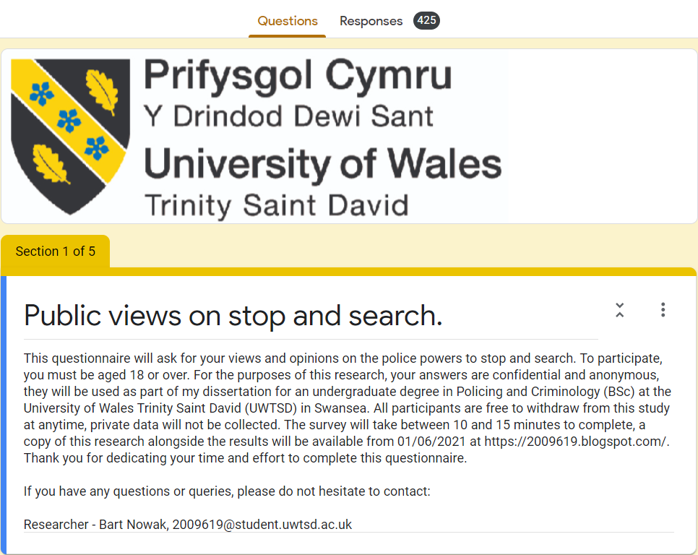

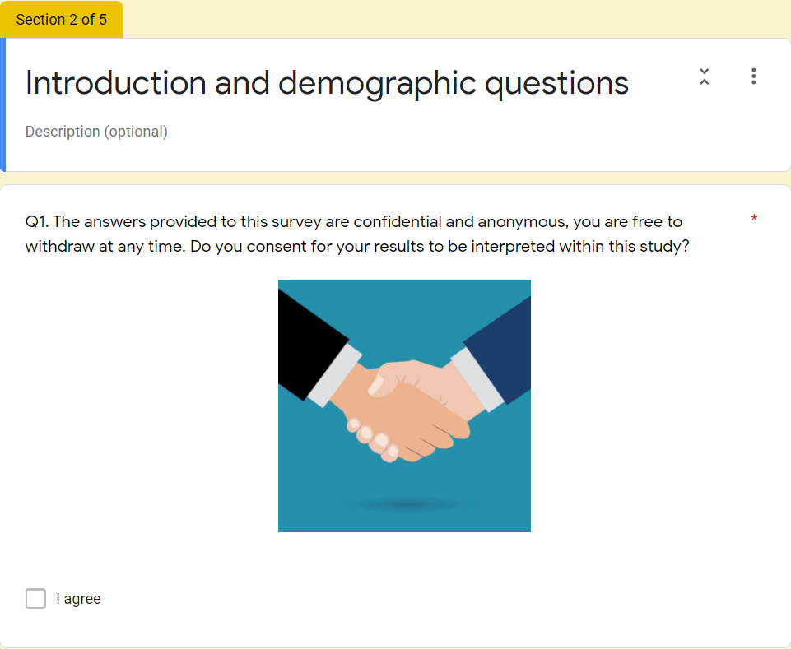
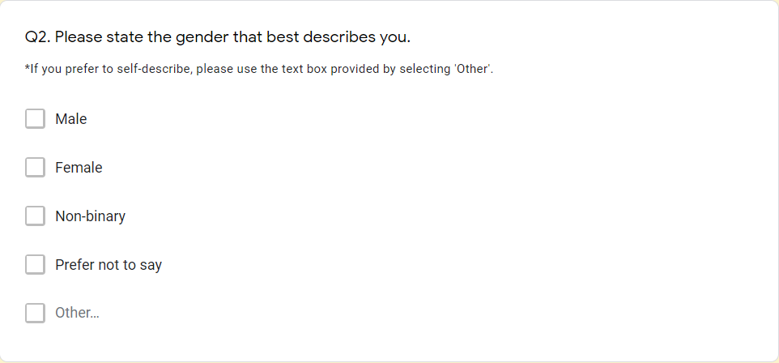

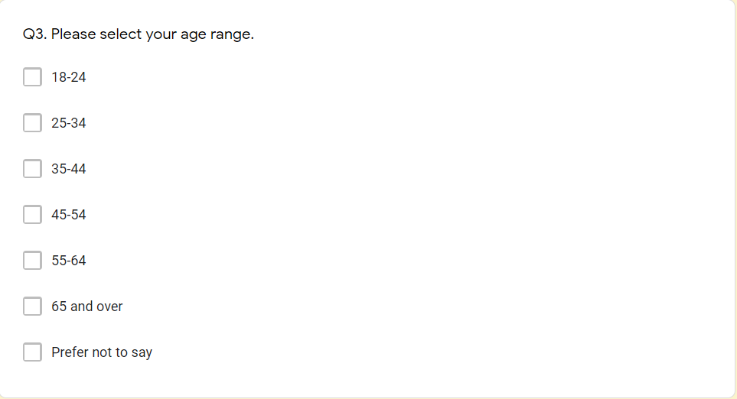
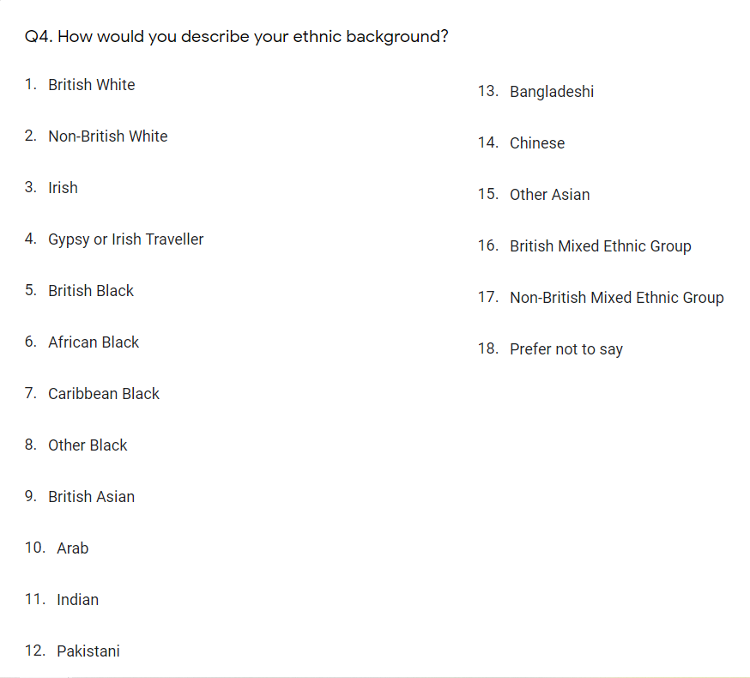
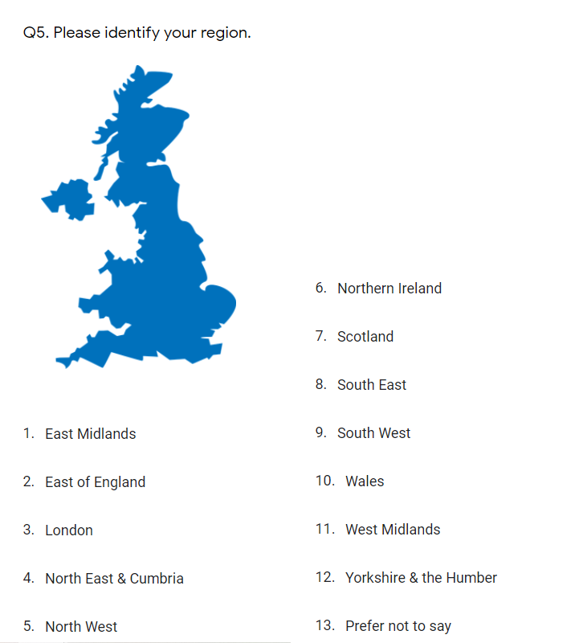
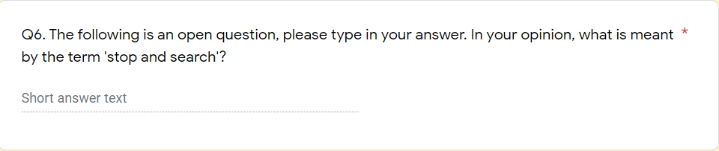
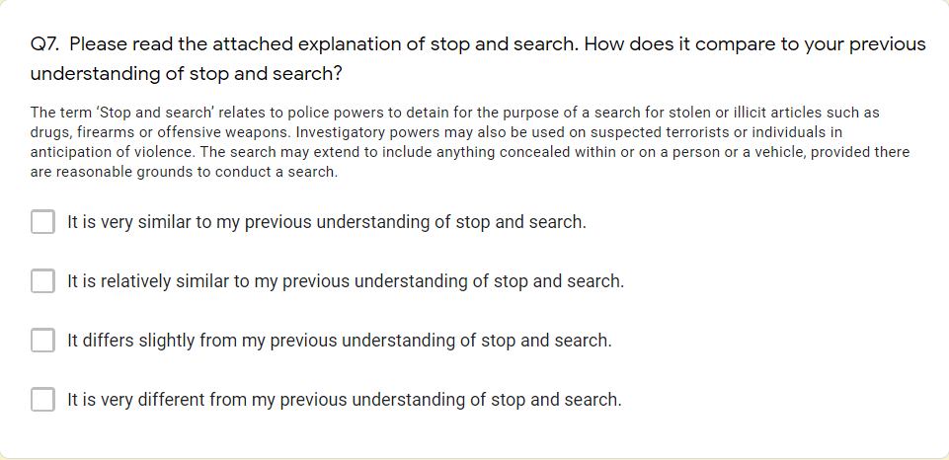
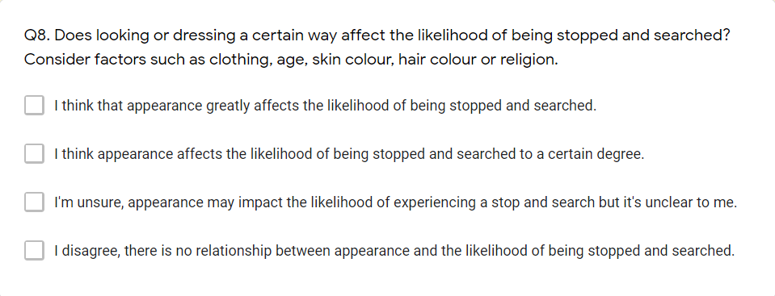
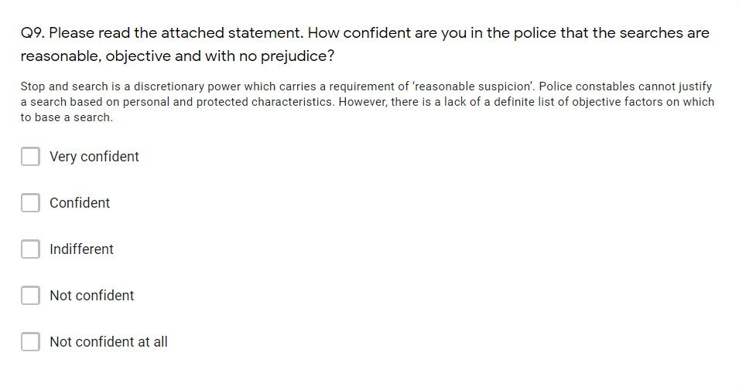
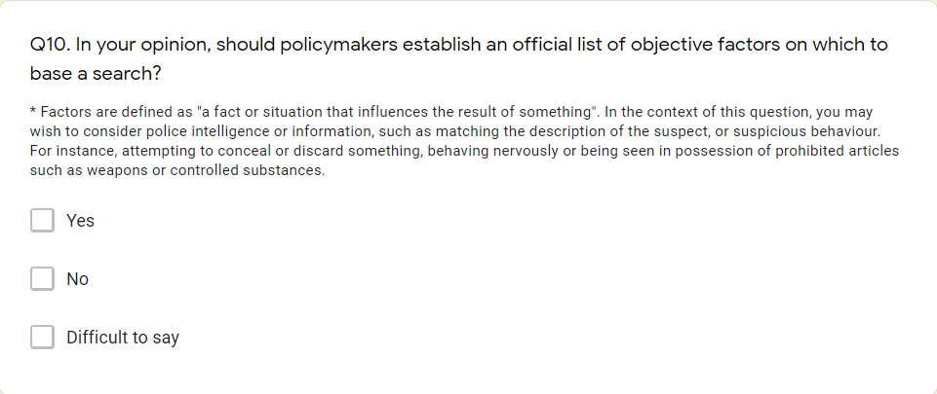
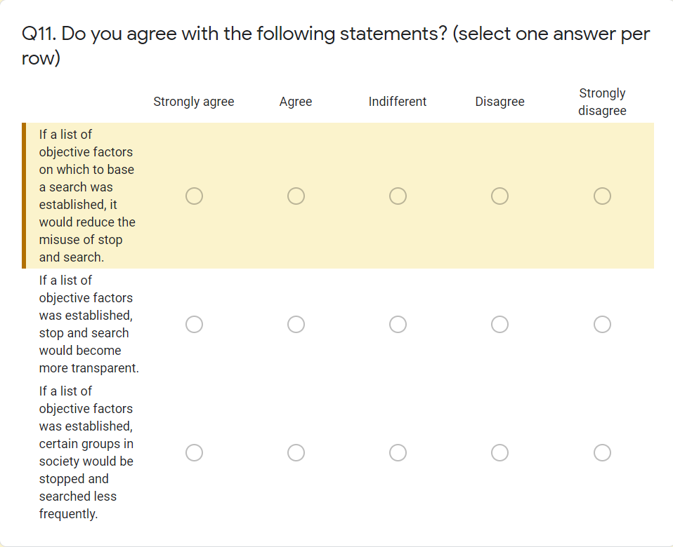
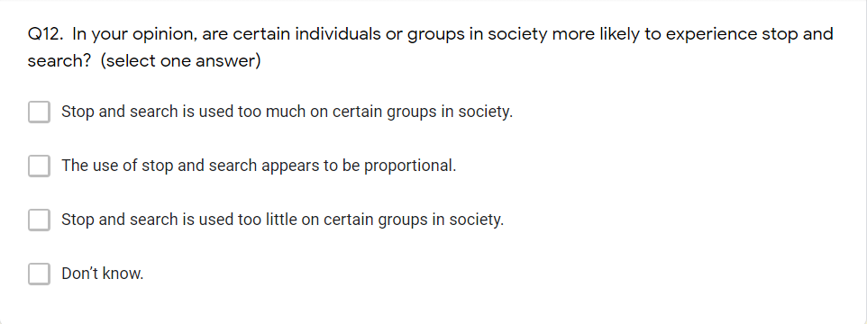

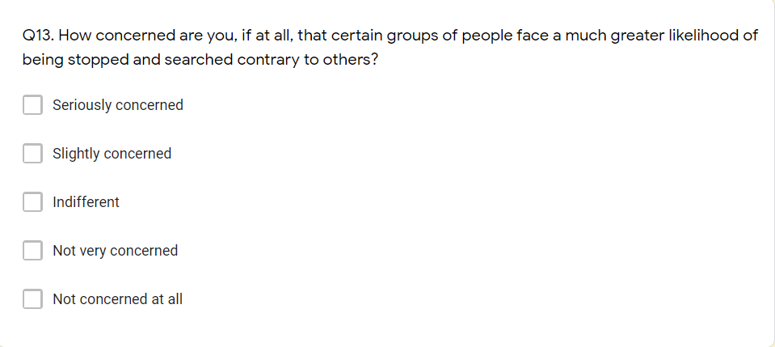
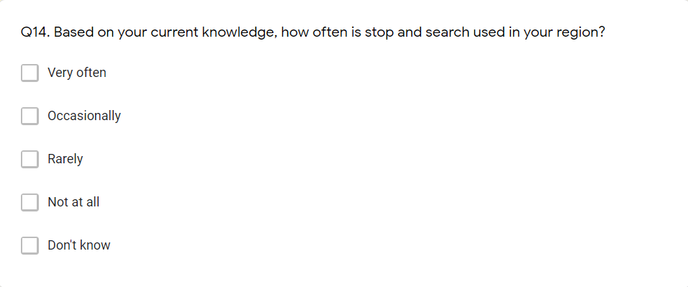
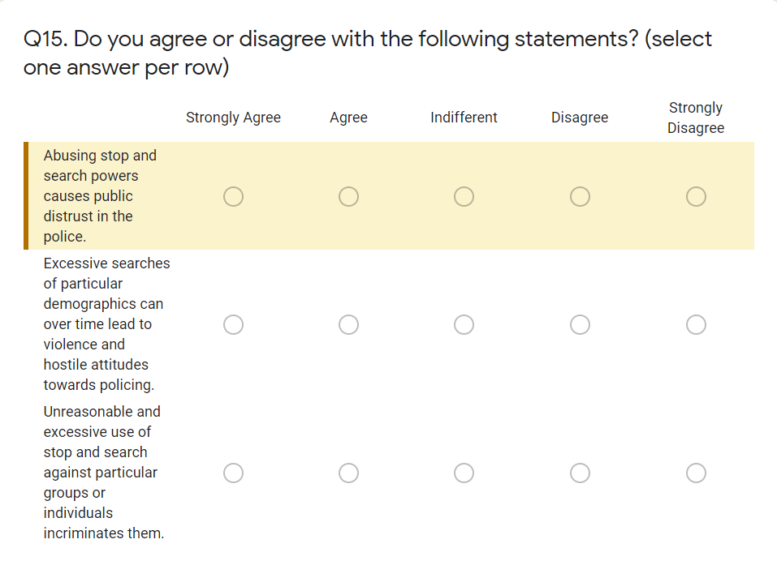
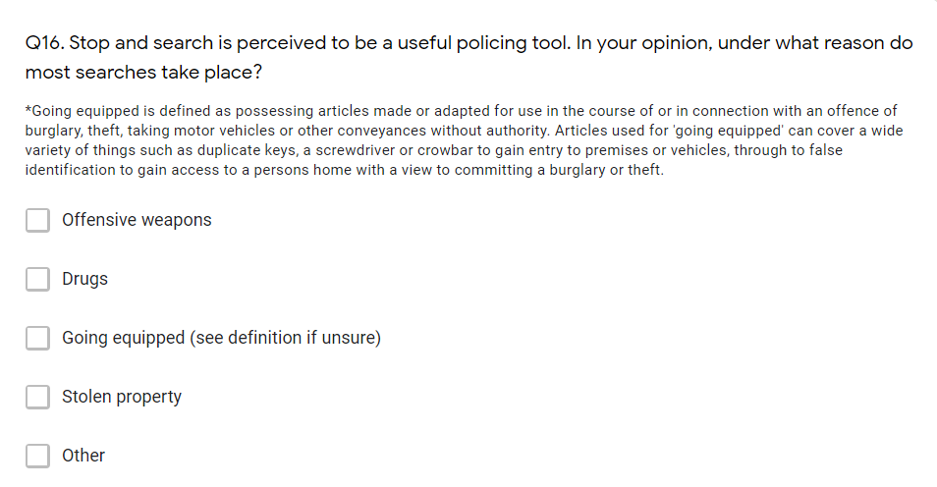
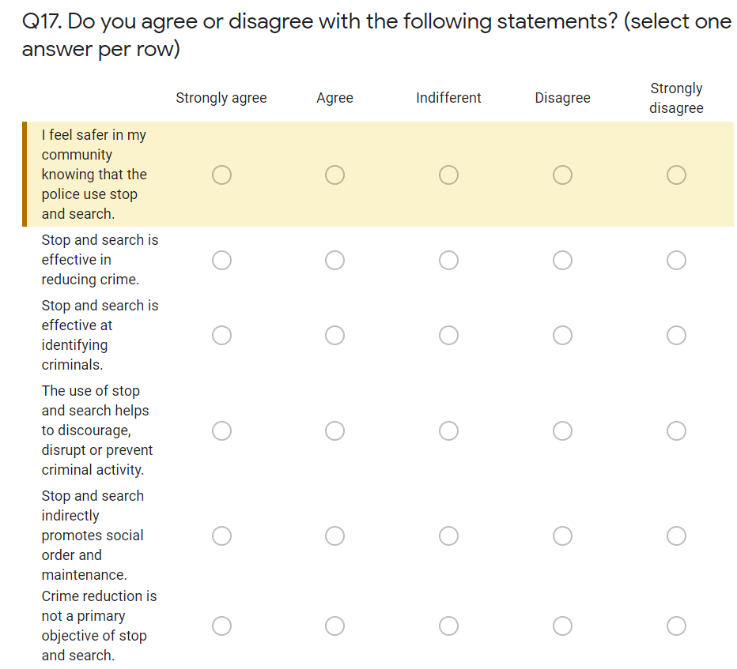
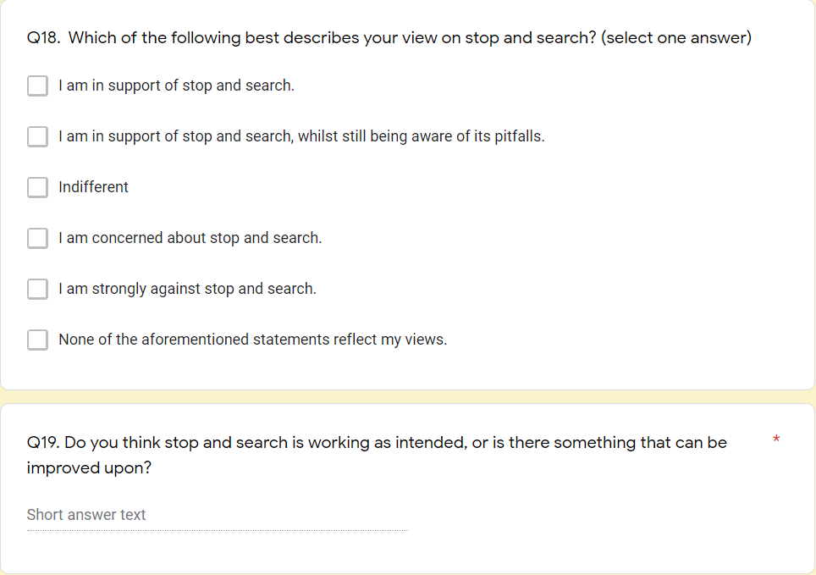
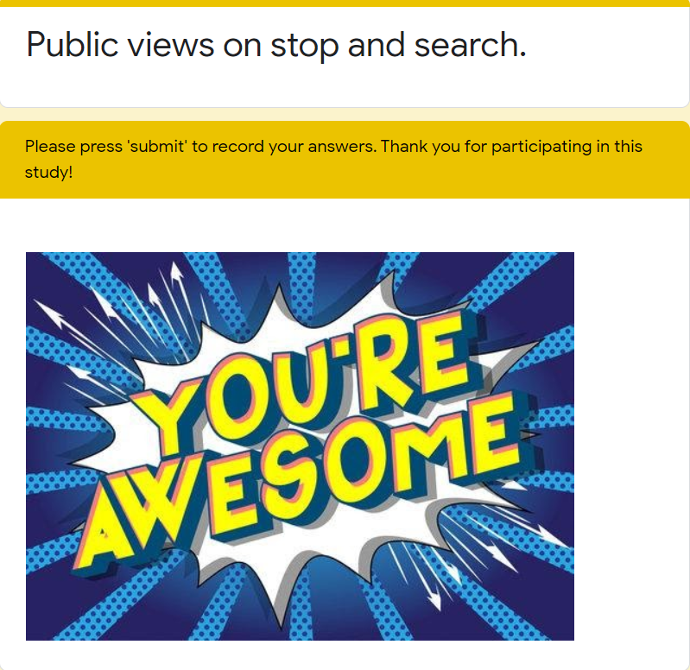

7.3 Appendix 3. Distribution of questionnaire

Appendix 3. Distribution of questionnaire
The questionnaire was distributed to the following Facebook groups:
Name of group | Link to group
Bearwood Dorset Neighbourhood Watch | https://www.facebook.com/groups/200305330525576/
Berkshire crime and in the courts | https://www.facebook.com/groups/berkshirecrimeandcourts/?notif_id=1612912122747199&notif_t=group_r2j_approved&ref=notif
Black Country Crime Watch | https://www.facebook.com/groups/blackcountrycrimewatch/
Brent Crime Watch | https://www.facebook.com/groups/702038733852722/
British Society of Criminology Post Graduate Community | https://www.facebook.com/groups/116889601731834/
Canterbury & District Neighbourhood Watch Association | https://www.facebook.com/groups/canterburyanddistrictneighbourhoodwatch/
Chadderton Neighbourhood Watch Group | https://www.facebook.com/groups/470033530156985/
Colchester Crime and Community Group | https://www.facebook.com/groups/480061952766036/
Coventry & Warwickshire Crime | https://www.facebook.com/groups/1999365216947004/?notif_id=1612952606039498&notif_t=group_r2j_approved&ref=notif
Crime Watch North Wales | https://www.facebook.com/groups/2352902768302042
CRIME WATCH OLDHAM AND SURROUNDING AREAS | https://www.facebook.com/groups/2187221124885149
CRIMEWATCH LIVERPOOL | https://www.facebook.com/groups/388989498313191/
Crime Watch Tunbridge Wells | https://www.facebook.com/groups/326340525042671/
CRIME WATCH UK | https://www.facebook.com/groups/845774059090635
Crimewatch UK | https://www.facebook.com/crimewatch.co.uk
CRIMEWATCH WIRRAL | https://www.facebook.com/groups/crimewatchwirral/?notif_id=1612971092851426&notif_t=group_r2j_approved&ref=notif
Criminal & Forensic Psychology Research | https://www.facebook.com/groups/895154270555434/
Criminology, Correctional Services Management and Criminal Justice Graduate | https://www.facebook.com/groups/634642910283784/
Drayton & Farlington Neighbourhood Watch Group | https://www.facebook.com/groups/1819725761473849
Havering Crime Watch | https://www.facebook.com/groups/2851100058456393
Keyham's Neighbourhood Watch - Official. | https://www.facebook.com/groups/258648840995161/
llangennech neighbourhood watch | https://www.facebook.com/groups/651709858749605/
Leicester Crime Watch | https://www.facebook.com/groups/leicestercrimewatch
London crime and court watch | https://www.facebook.com/groups/londoncrime/
London Crimewatch | https://www.facebook.com/groups/LondonCrimewatch/
Matlock and District Neighbourhood watch | https://www.facebook.com/groups/408440479860547/
Neighbourhood Watch: Blues & Twos - Hull & Surrounding Areas | https://www.facebook.com/groups/bluesandtwoshull/
Neighbourhood Watch Melton Mowbray | https://www.facebook.com/groups/MeltonMowbrayNHW/
Neighbourhood Watch Melton Mowbray 2.0 | https://www.facebook.com/groups/215124882557871/
Official Crime & Community Watch Harwich | https://www.facebook.com/groups/1707237782867543
Olton Crime Prevention / Neighbourhood Watch | https://www.facebook.com/groups/845669328939911/
Open University Future Forensic Psychology and Criminology Group | https://www.facebook.com/groups/1437419266470364/?notif_id=1613114493716691&notif_t=group_r2j_approved&ref=notif
Psychology UK | https://www.facebook.com/groups/2221660842
Redbridge Crime Watch | https://www.facebook.com/groups/447297132900166/
Shoebury CrimeWatch | https://www.facebook.com/groups/370830203300461/
South Wales Argus crime news | https://www.facebook.com/groups/186231075613477/
Swansea Crime Watch. Lets Look Out For One Another! | https://www.facebook.com/groups/242902589623957/
The Great British Political Debate | https://www.facebook.com/groups/326339434428036
Tollesbury Community Page & Neighbourhood Watch | https://www.facebook.com/groups/TollsNW
True Crime Discussion | https://www.facebook.com/groups/2554758464774495
UK Road traffic & police news | https://www.facebook.com/groups/737285556325755?notif_id=1612963065952010&notif_t=group_r2j_approved&ref=notif
UK True Crime | https://www.facebook.com/groups/UKTrueCrime/
Wales court cases | https://www.facebook.com/groups/2195015547398642/?notif_id=1612978212485700&notif_t=group_r2j_approved&ref=notif
Walmersley & Chesham Neighbourhood Watch | https://www.facebook.com/groups/301222214640875/
Worcester Park Neighbourhood Watch - WPNHW | https://www.facebook.com/groups/134266540850720
Queen’s Park Community neighbourhood watch group | https://www.facebook.com/groups/1013005055840594/

7.4 Appendix 4. SPSS Analysis

7.4.1 Cross Tabulation (Gender and Age)

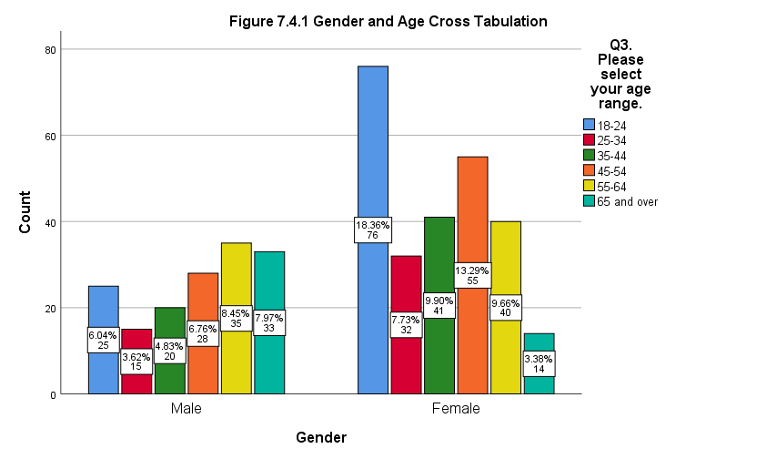
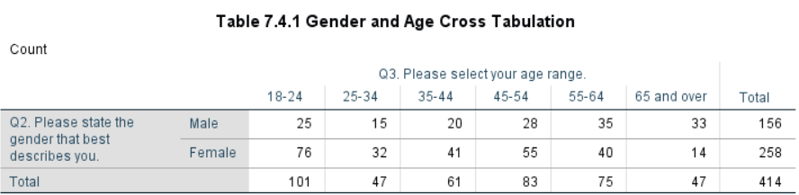

7.4.2 Cross Tabulation (Gender and Region)

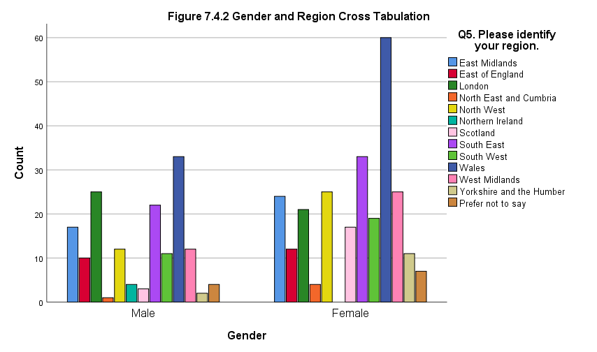

Table 7.4.2 Gender and Region Cross Tabulation
Region | Male (count) | Female (count) | Total
East Midlands | 17 | 24 | 41
East of England | 10 | 12 | 22
London | 25 | 21 | 46
North East and Cumbria | 1 | 4 | 5
North West | 12 | 25 | 37
Northern Ireland | 4 | 0 | 4
Scotland | 3 | 17 | 20
South East | 22 | 33 | 55
South West | 11 | 19 | 30
Wales | 33 | 60 | 93
West Midlands | 12 | 25 | 37
Yorkshire and the Humber | 2 | 11 | 13
Prefer not to say | 4 | 7 | 11
Total | 156 | 258 | 414

7.4.3 Cross Tabulation (Age and Region)

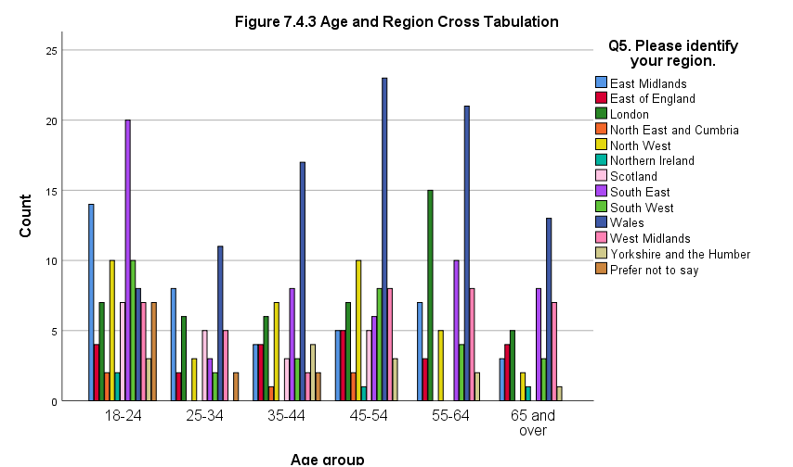

Table 7.4.3 Age and Region Cross Tabulation
 | Age groups
Region | 18-24 | 25-34 | 35-44 | 45-54 | 55-64 | 65 and over | Total
East Midlands | 14 | 8 | 4 | 5 | 7 | 3 | 41
East of England | 4 | 2 | 4 | 5 | 3 | 4 | 22
London | 7 | 6 | 6 | 7 | 15 | 5 | 46
North East and Cumbria | 2 | 0 | 1 | 2 | 0 | 0 | 5
North West | 10 | 3 | 7 | 10 | 5 | 2 | 37
Northern Ireland | 2 | 0 | 0 | 1 | 0 | 1 | 4
Scotland | 7 | 5 | 3 | 5 | 0 | 0 | 20
South East | 20 | 3 | 8 | 6 | 10 | 8 | 55
South West | 10 | 2 | 3 | 8 | 4 | 3 | 30
Wales | 8 | 11 | 17 | 23 | 21 | 13 | 93
West Midlands | 7 | 5 | 2 | 8 | 8 | 7 | 37
Yorkshire and the Humber | 3 | 0 | 4 | 3 | 2 | 1 | 13
Prefer not to say | 7 | 2 | 2 | 0 | 0 | 0 | 11
Total | 101 | 47 | 61 | 83 | 75 | 47 | 414

7.4.4 Ethnicity
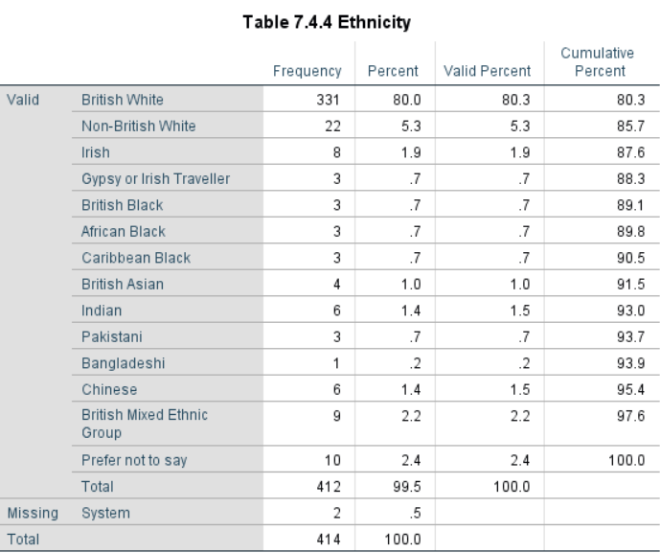

7.5 Appendix 5. Chi-Square tests

Figure 7.5.1, below, shows that a significant relationship exists between gender and the understanding of stop and search following an explanation (p.= .001). The p value is significant but the difference between groups is trivial.
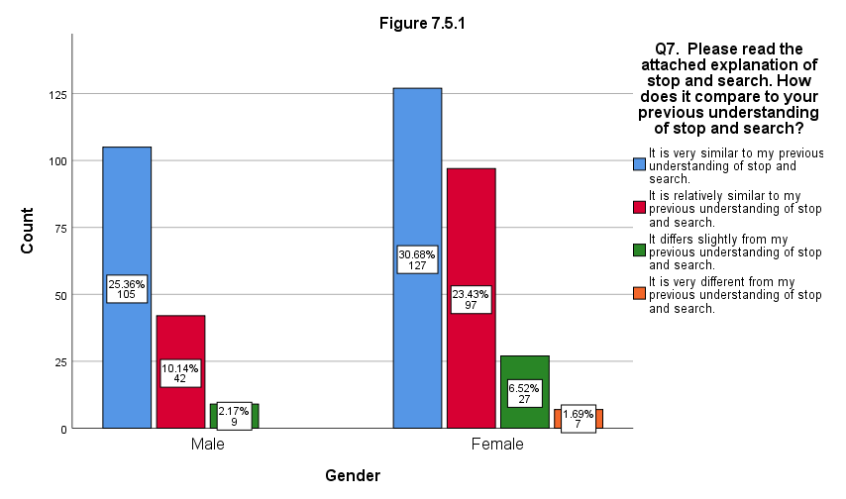
Figure 7.5.2, below, showcases no significant relationship between gender and the knowledge of how frequently stop and search is applied in the participants' local area (p.= .009).
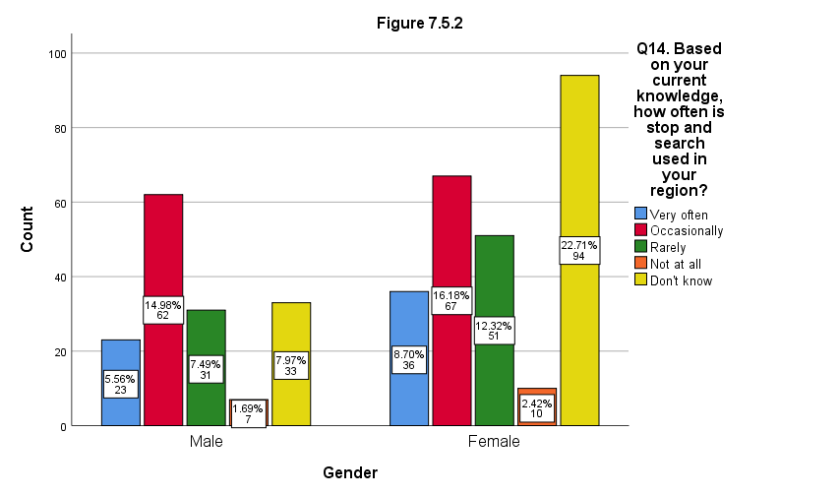

7.6 Appendix 6. ANOVA Analysis of variance

Figure 7.6.1, below, exhibits no significant statistical difference between age and the participants’ understanding of stop and search following an explanation F(3, 410)= 2.242, p.= .083.
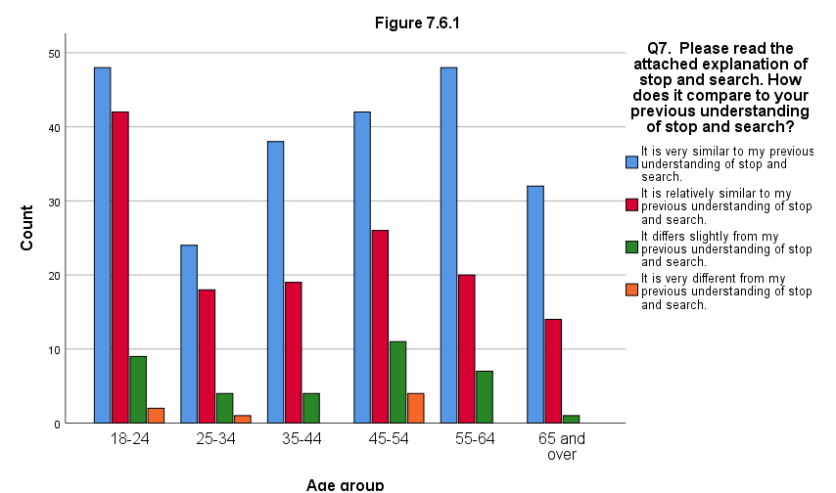
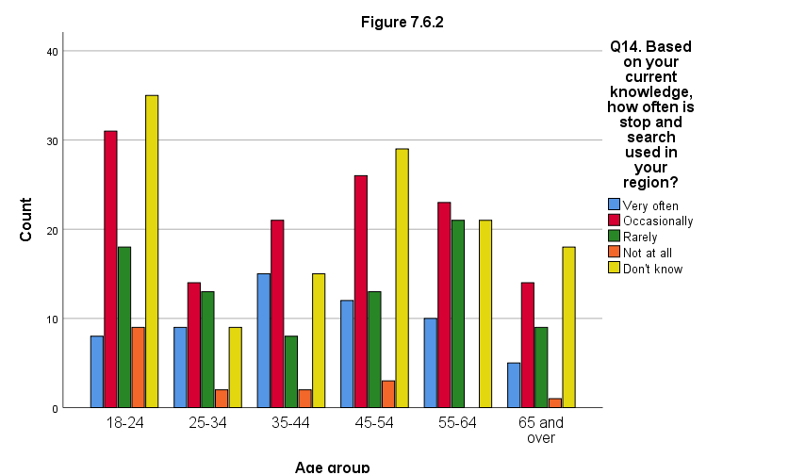
Figure 7.6.2, above, indicates no significant statistical difference between age and participants’ knowledge on the frequency of stop and search in their region F(4, 409)= 1.977, p.= .097.

7.7 Appendix 7. Mann-Whitney U-Tests

Figure 7.7.1, below, showcases a significant statistical relationship between gender and the idea that implementing a list of objective factors would reduce the misuse of stop and search (Mean ranks: male= 262.47, female= 174.26, U= 11549, p.= .000)
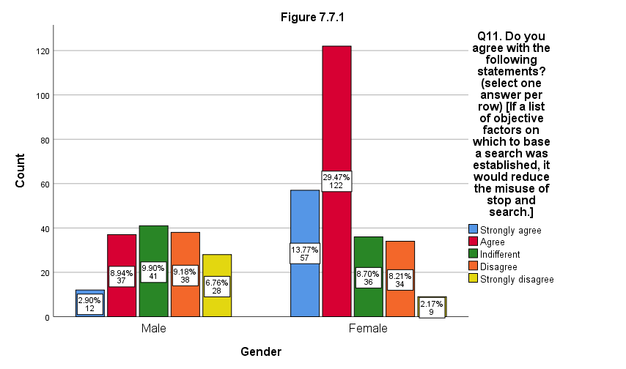

Figure 7.7.2, below, illustrates that a significant statistical association exists between gender and the suggestion that establishing a list of objective factors on which to base a search will reduce the frequency of particular groups in society experiencing searches (Mean ranks: male= 246.60, female= 183.86, U= 14025, p.= .000).

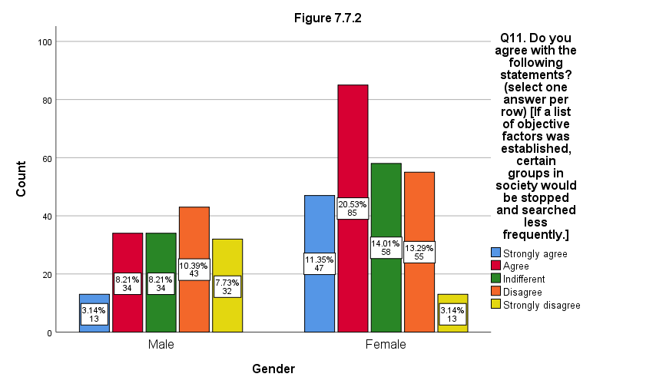
Figure 7.7.3, below, shows a significant statistical relationship between gender and participants’ views to the suggestion excessive searches can over time lead to violence or hostility towards police (Mean ranks: male= 237.29, female= 189.49, U= 15476.5, p.= .000).

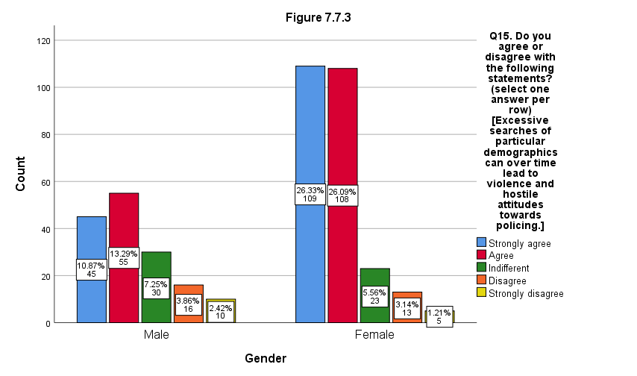
A significant statistical association exists in Figure 7.7.4, below, which considers gender and participants’ answers to the idea that excessive searches on particular groups or incriminate them (Mean ranks: male= 258.71, female= 176.54, U= 12135.5, p.= .000).
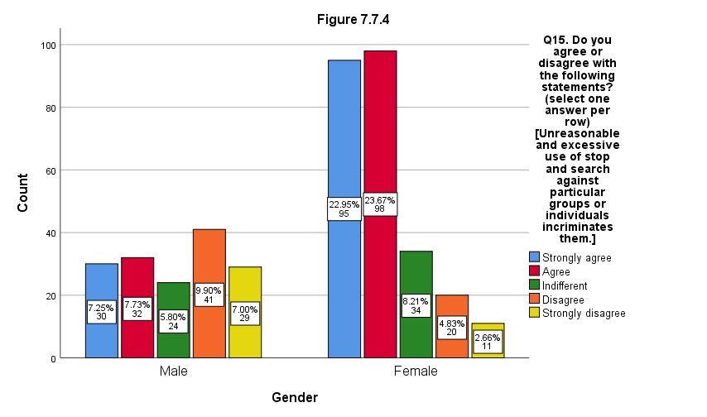
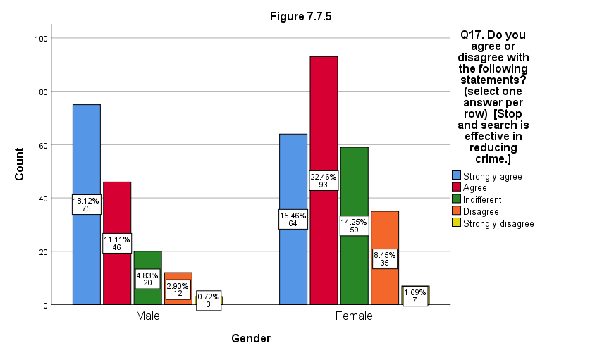
Figure 7.7.5, above, shows a significant statistical relationship between the variable of gender and answers to the notion that stop and search is effective in reducing crime (Mean ranks: male= 173.23, female= 228.22, U= 14778.5, p.= .000).

Likewise, Figure 7.7.6, below, indicates a significant statistical association between gender and the idea that stop and search is effective at identifying criminals (Mean ranks: male= 174.68, female= 227.34, U= 15004, p.= .000).
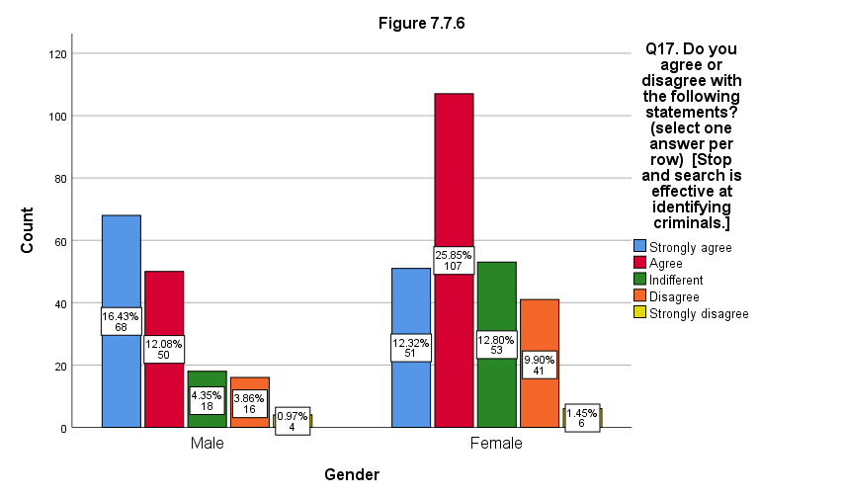

Figure 7.7.7, below, demonstrates a significant statistical relationship between gender and the opinion that stop and search helps to discourage, disrupt, or prevent criminal activity (Mean ranks: male= 168.95, female= 230.81, U= 14109.5, p.= .000)
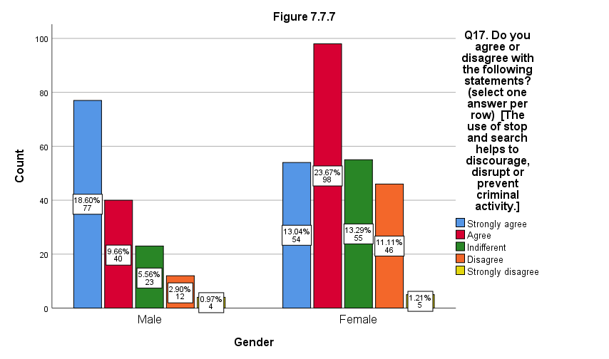
Figure 7.7.8, below, shows a significant association between gender and the opinion that stop and search indirectly promotes social order and maintenance (Mean ranks: male= 180.67, female= 223.72, U= 15938, p.= .000).
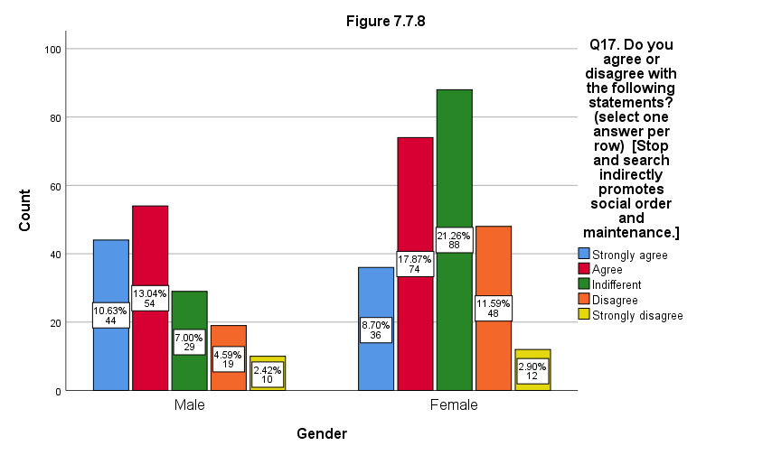

Figure 7.7.9, below showcases a significant statistical relationship between gender and the notion of question 17, that crime reduction is not a primary objective of stop and search (Mean ranks: male= 240.66, female= 187.45, U= 14951.5, p.= .000)
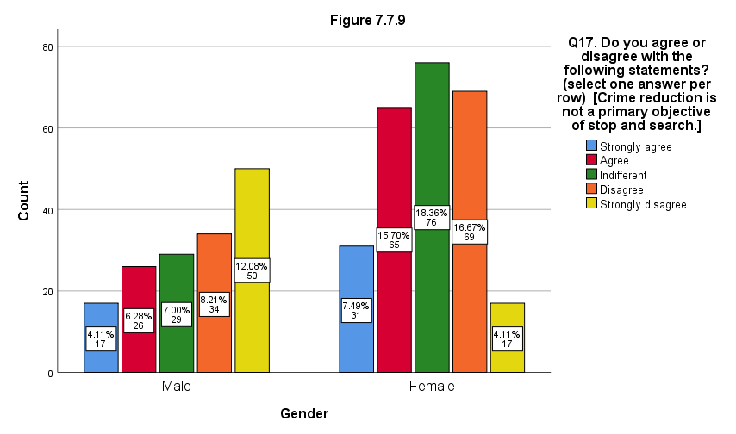

7.8 Appendix 8. Summary of statistical tests (including analysis and appendices)

Table 7.8 - Summary of statistical tests
Question | Test | Variable | Sig. difference | Sig. relationship | No sig. difference | p. value
7 | Chi-square | Gender |  | Yes |  | .001
7 | ANOVA | Age |  |  | Yes | .083
8 | Chi-square | Gender |  | Yes |  | .000
8 | ANOVA | Age | Yes |  |  | .000
9 | U-Test | Gender |  | Yes |  | .000
9 | ANOVA | Age | Yes |  |  | .000
10 | Chi-square | Gender |  | Yes |  | .000
10 | ANOVA | Age |  |  | Yes | .010
11a | U-Test | Gender |  | Yes |  | .000
11b | U-Test | Gender |  | Yes |  | .000
11c | U-Test | Gender |  | Yes |  | .000
12 | Chi-square | Gender |  | Yes |  | .000
12 | ANOVA | Age | Yes |  |  | .000
13 | Chi-square | Gender |  | Yes |  | .000
14 | Chi-square | Gender |  |  | Yes | .009
14 | ANOVA | Age |  |  | Yes | .097
15a | U-Test | Gender |  | Yes |  | .000
15a | ANOVA | Age | Yes |  |  | .000
15b | U-Test | Gender |  | Yes |  | .000
15c | U-Test | Gender |  | Yes |  | .000
16 | ANOVA | Age |  |  | Yes | .845
17a | U-Test | Gender |  | Yes |  | .000
17b | U-Test | Gender |  | Yes |  | .000
17c | U-Test | Gender |  | Yes |  | .000
17d | U-Test | Gender |  | Yes |  | .000
17e | U-Test | Gender |  | Yes |  | .000
17f | U-Test | Gender |  | Yes |  | .000
18 | Chi-square | One sample test |  | Yes |  | .000
18 | ANOVA | Region |  |  | Yes | .024
18 | Chi-square | Gender |  | Yes |  | .000
18 | ANOVA | Age | Yes |  |  | .000

