

To research the concept of progressive web applications and see whether a progressive web app can be used alongside or instead of a native application.

by
Cieran Hughes
1800730

Supervisor: Gaynor Thomas

Project submitted as part of the requirements for the award of BSc (Hons) Computing

April 2021

DECLARATION
I, Cieran Hughes declare that I am the sole author of this Project; that all references cited have been consulted; that I have conducted all work of which this is a record, and that the finished work lies within the prescribed word limits.

This work has not previously been accepted as part of any other degree submission.

Date: April 2021

FORM OF CONSENT
I Cieran Hughes hereby consent that my Project, submitted in candidature for the B.Sc.(Hons) Computing degree, if successful, may be made available for inter-library loan or photocopying (subject to the law of copyright), and that the title and abstract may be made available to outside organisations.

Date: April 2021

Abstract
This project aim is to research and evaluate the functionality, feature usability and requirement specification of a PWA. This was completed by using the methods of implementing a functional PWA and testing the PWA using a number of methods; software testing tool called Lighthouse, user interviews and user focus groups. The key findings were that even though PWAs are in their infancy the potential benefits they offer mean that there is potential for them to rival conventional applications like native app store applications. The recommendations and further work of this study is to implement a PWA with an alternative backend and database server to see if the performance if effected.

Table of Contents
Chapter 1 – Introduction 1
1.1 Introduction to Study 1
1.2 Aim 1
1.3 Objectives 1
1.4 Report Structure 2
Chapter 2 – Literature Review 3
2.1 Introduction 3
2.2 Application Types 3
2.2.1 Native Applications 3
2.2.2 Web Applications 4
2.2.3 Hybrid Applications 4
2.3 What is a PWA? 4
2.3.1 History of a PWA 5
2.3.2 Who has adopted PWAs? 6
2.4 Features of PWAs 6
2.4.1 Performance 6
2.4.2 Accessible and Usability 6
2.4.3 Installable 7
2.4.4 Offline Content 8
2.4.5 Push Notification 8
2.4.6 On-Board Device Hardware 9
2.4.6.1 Geolocation 9
2.4.6.2 Vibration 9
2.4.6.3 Camera and Microphone 9
2.4.6.4 Device Orientation and Motion 10
2.4.7 App Maintenance 11
2.5 Technical Features 11
2.5.1 Web Manifest 11
2.5.2 Service Worker 11
2.6 Technologies 12
2.6.1 JS Framework 12
2.6.1.1 React 12
2.6.1.2 Vue 12
2.6.1.3 Angular 13
2.6.2 Database Service 13
2.6.2.1 NoSQL 13
2.6.2.2 Structured Query Language (SQL) 13
2.7 Usability in Software Application User Interface 13
2.7.1 Effectiveness 14
2.7.2 Efficiency 14
2.7.3 Satisfaction 14
2.7.4 Learnability 15
2.7.5 Memorability 15
2.7.6 Errors 15
2.7.7 Cognitive Load 15
2.8 Stock Tracker Apps 16
Chapter 3 – Methodology 17
3.1 Chapter Introduction 17
3.2 Research Methodology 18
3.2.1 Research Philosophy 18
3.2.2 Research Approach 18
3.2.3 Research Strategies 18
3.2.4 Choices 19
3.2.5 Time Horizons 19
3.2.6 Data Collection 19
3.3 Development Methodology 20
3.3.1 Agile Methodology 20
3.3.1.1 Advantages of Appling FDD Using Agile Methodology 22
3.3.1.2 Disadvantages of Appling FDD Using Agile Methodology 22
3.3.2 Software 23
3.3.2.1 Design Software 23
3.3.2.1.1 Adobe XD 23
3.3.2.1.2 Adobe Photoshop and Adobe Illustrator 23
3.3.2.2 Development Software 24
3.3.2.2.1 Visual Studio Code 24
3.3.2.2.2 Node and Node Package Manager 24
3.3.2.2.3 Postman 25
3.3.2.3 Other Software 25
3.3.2.3.1 Version Control 25
3.3.2.3.2 Mongo Compass 26
Chapter 4 – Design and Implementation 27
4.1 Chapter Introduction 27
4.2 Design 27
4.2.1 Design Requirements 27
4.2.2 Wire Frame 27
4.2.3 Paper Prototype 28
4.2.3.1 Theory of Visual Perception 28
4.2.3.2 Human Memory 28
4.2.3.3 Human Reasoning 29
4.2.3.4 Interface Metaphors 29
4.2.3.5 Affordance 29
4.2.4 Software Design 29
4.2.4.1 Version One 29
4.2.4.1.1 Colour Scheme 30
4.2.4.1.2 Sidebar 30
4.2.4.2 Version Two 30
4.2.4.2.1 Colour Scheme 30
4.2.4.2.2 Pages Layouts 30
4.3 Implementation 31
4.3.1 MERN Stack 31
4.3.1.1 Frontend 32
4.3.1.2 Backend 32
4.3.1.3 Database Server 32
4.3.2 Successes 33
4.3.2.1 Push Notifications 33
4.3.2.2 Installability 34
4.3.3 Errors 35
4.3.3.1 Caching Content 35
4.3.4 Testing 36
4.3.4.1 Acceptance Testing 36
4.3.4.2 System Testing 36
4.3.5 Feature Driven Sprints 36
4.3.5.1 Register, Login and Authentication 37
4.3.5.2 Details Page 37
4.3.5.3 Watchlist 38
Chapter 5 – Analysis 40
5.1 Chapter Introduction 40
5.2 Lighthouse 40
5.3 Questionnaire 42
5.3.1 Question 1 42
5.3.2 Question 2 43
5.3.3 Question 3 43
5.3.4 Question 4 43
5.3.5 Question 5 44
5.3.6 Question 6 44
5.3.7 Question 7 45
5.3.8 Question 8 46
5.3.9 Question 9 47
5.3.10 Question 10 47
5.3.11 Question 11 47
5.3.12 Question 12 48
5.3.13 Question 13 48
5.3.14 Question 14 49
5.4 Focus Group 50
5.4.1 Task 1 50
5.4.2 Task 2 50
5.4.3 Task 3 50
Chapter 6 – Evaluation 52
6.1 Chapter Introduction 52
6.2 Conclusions Drawn 52
6.3 Back up Research 53
6.4 Project Aim 53
6.5 Project Objectives 54
6.6 Expected Outcomes 54
6.7 Further Work 54
Chapter 7 – Conclusion and Recommendations 56
7.1 Chapter Introduction 56
7.2 Summary 56
7.3 Conclusion 56
7.4 Further Work and Recommendations 57
Chapter 8 – Reflection 58
8.1 Chapter Introduction 58
8.2 Positives 58
8.3 Negatives 58
8.4 Conclusion 59
Chapter 9 – References 60
10 Appendices 64
10.1 Appendix 1 – Wire Frame Diagram 64
10.2 Appendix 2 – Paper Prototype 65
10.3 Appendix 3 – Software Prototype Version 1 66
10.3.1 Home Page 66
10.3.2 Details Page 66
10.3.3 Details Page Logged in 67
10.3.4 Login Page 67
10.3.5 User Dropdown Page 68
10.3.6 User Page 68
10.4 Appendix 4 – Software Prototype Version 2 69
10.4.1 Home Page 69
10.4.2 Details Page 69
10.5 Appendix 4 – Questionnaire Results 70
10.5.1.1 Question 1 70
10.5.1.2 Question 2 71
10.5.1.3 Question 3 72
10.5.1.4 Question 4 73
10.5.1.5 Question 5 74
10.5.1.6 Question 6 75
10.5.1.7 Question 7 76
10.5.1.8 Question 8 77
10.5.1.9 Question 9 78
10.5.1.10 Question 10 79
10.5.1.11 Question 11 80
10.5.1.12 Question 12 81
10.5.1.13 Question 13 82
10.5.1.14 Question 14 83
10.6 Appendix 5 – Focus Group Results 84
10.7 Appendix 6 – Focus Group Tasks 84

List of Figures
Figure 1 - Illustration of asynchronously exchanging data 4
Figure 2 - Geolocation Browser Support 8
Figure 3 - Browser Support for SpeechRecognition API 9
Figure 4 - Device Frame Coordination 10
Figure 5 - PACMAD Usability Model 13
Figure 6 - Research Onion 16
Figure 7 - MERN Stack 30
Figure 8 - Database Diagram 32
Figure 9 - Push Notification MacOS 32
Figure 10 - Push Notification Windows 10 32
Figure 11 - Registering Client Endpoint 32
Figure 12 - Saving Endpoint from Backend to Database 32
Figure 13 - Notification Checking 33
Figure 14 - Service Worker Push Notification 33
Figure 15 - Manifest File 34
Figure 16 - Caching Static Pages 34
Figure 17 - Caching Fetch Requests 34
Figure 18 - Logo Code API 37
Figure 19 - Historical Data Code API 37
Figure 20 - Overview Data Code API 37
Figure 21 - useEffect Function 38
Figure 22 - Lighthouse Results 39
Figure 23 - Lighthouse PWA Mobile 40
Figure 24 - Lighthouse PWA Desktop 40
Figure 25 - Question 1 Results 41
Figure 26 - Question 3 Results 42
Figure 27 - Question 4 Results 43
Figure 28 - Question 6 Results 44
Figure 29 - Question 7 Results 45
Figure 30 - Question 8 Results 45
Figure 31 - Question 11 Results 47
Figure 32 - Question 12 Results 47
Figure 33 - Question 13 Results 48
Figure 34 - Focus Group Task 3 Results 50

List of Tables
Table 1 - Questionnaire Results Question 1 64
Table 2 - Questionnaire Results Question 2 65
Table 3 - Questionnaire Results Question 3 66
Table 4 - Questionnaire Results Question 4 67
Table 5 - Questionnaire Results Question 5 68
Table 6 - Questionnaire Results Question 6 69
Table 7 - Questionnaire Results Question 7 70
Table 8 - Questionnaire Results Question 8 71
Table 9 - Questionnaire Results Question 9 72
Table 10 - Questionnaire Results Question 10 73
Table 11 - Questionnaire Results Question 11 74
Table 12 - Questionnaire Results Question 12 75
Table 13 - Questionnaire Results Question 13 76
Table 14 - Questionnaire Results Question 14 77
Table 15 - Focus Group Results 78

Chapter 1 – Introduction
1.1 Introduction to Study
This chapter will outline the project aim and objectives that the study will strive to meet. Following this a small section on the structure that will be used for this report.
This project is designed to look at different applications. Then within the scope of applications, break down the different types and research in to PWAs. This type of application is a newly implemented idea that has many advantages over the conventional application, such as working off one codebase for all devices. Once the developed PWA is completed a series of tests will be conducted to determine any limitations of the application and if PWAs are superior.

1.2 Aim
The project aim is as follows:
- To research and evaluate the functionality, feature usability and requirement specification criteria for a Progressive Web App (PWA).
This aim will allow the study to gather the relevant knowledge about PWAs identifying the main technologies for implementation.

1.3 Objectives
The objectives for the project are:
- To research the PWA technology and specification criteria that a web application needs to meet to qualify as an official PWA.
- To design, develop and implement a PWA using all the requirements researched. This will allow all the functionality that a PWA requires to be included. It will be achieved by developing the PWA using web technology languages and a JavaScript library.
- To evaluate the functionality usability of a PWA from the user point of view. Looking at the ease of installation and usability comparing it to the other applications offered.

1.4 Report Structure
The report will be split up in to eight chapters. The first chapter outlines the aim and objectives that the report will need to meet to be effective. Once it is complete the aim and objects can be verified to determine the success of the project as a whole.
The second chapter is the literature review, looking at previously conducted work that will be used to gain knowledge and provide additional information on the subject area.
Chapter three is the main methodology that the project will follow. This chapter is split into two sections providing the research methodology that will include the research philosophy, approach, strategy, time horizon and data collection methods. The second section will provide the development methodology.
Chapter four is the design and implementation section. This will show the main design and the design process to get to the final result. Also, a description on how the implementation was completed with the main successes and any failings.
Chapter five is the analysis section. Within this section is the analysis of the data collected that was stated in chapter three.
The sixth chapter is the evaluation of the study that will take all the data into account and draw a relevant conclusion. Also, this chapter will state if the aim and objectives were met.
Chapter seven will provide the final conclusion of the study. The section will decide whether the study is successful or not. Also, in this section the author will state any recommendations and further work that could be executed.
Finally, the last chapter is a reflection on the study and how the author was affected by the study.
Chapter 2 – Literature Review
2.1 Introduction
This chapter will provide a critical investigation of the research and literature in the application field, based on Web Applications and PWAs. The section conveys what type of applications are available, and then a deeper dive into PWAs. Including the history, and why PWAs have gained traction in the past years. The next focus is the features that this type of application offers, and the technical elements that need to be implemented to ensure it is a PWA.
Next, this paper explores the technologies offered to build these applications from the frameworks to the data storage options, as these will need to be used to create a successful application. Following this, the frontend usability will then be explored and how it can be tested using different models that are used as the industry standard. Finally, it will identify related work and similar conducted projects that relate to this project.

2.2 Application Types
There are three main types of applications offered that will all be expanded on in the subsections below. These types are; Native Applications, Hybrid Applications and Web Applications.

2.2.1 Native Applications
A native phone application is an application that has been developed specifically for the operating system (OS) it will run on, the developers of the applications need to choose and use the specific programming language and tools provided for the particular OS [1]. Native applications can be accessed from the app store for the devices OS. This adds an extra cost and time implication, as a different version of the application needs to be developed for each OS [2]. These apps can be downloaded directly from the application store applicable to the device. Native applications can take advantage of the on-board hardware features the device provides [1].

2.2.2 Web Applications
There is no definition of the differences between a static website and a web application, but when a website has some of the functionality of a traditional application it can be classed as a web application [1]. Web applications take advantage of the way web technologies can be dynamic when viewing the app, relying heavily on JavaScript and HyperText Markup Language (HTML). Also, HTML can offer navigation and interaction facilities [3].

2.2.3 Hybrid Applications
This application type attempts to combine web and native applications to get advantages from each application type. It is developed using web technologies but rendered in a native application body using web view [1]. Hybrid applications are more powerful than web applications as they can access the resources that a native application uses. However, as they run in a WebView framework, the app is only as good as the framework provided [4][5].

2.3 What is a PWA?
A PWA is an application that can be run in any web browser, the PWA uses web technologies that are used on many websites such as HTML, Cascading Style Sheets (CSS), and JavaScript [6]. By using these technologies, it can act as a website but with the functionality of a native phone app including offline access, push notifications and more.
PWAs are a fusion between phone and desktop interfaces. They are built to take advantage of the developing application programming interfaces (APIs) to deliver the three app pillars, capabilities, reliability and installability [7]. They allow developers to provide the web experience user are familiar with native application feel, all with one codebase. The PWA dream is to get to a point where PWAs and the native phone application experience is uniform, and the users cannot tell the difference in the type of application that they are using, so they can seamlessly switch between the variety of applications [8].

2.3.1 History of a PWA
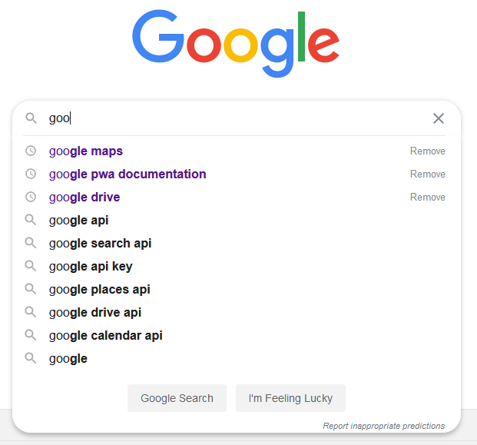
The technologies to start to make PWAs feasible came around the year 2000, and this was the creation of XMLHttpRequest [9]. Then another technology emerged in 2005 called Asynchronous JavaScript And XML (AJAX) [10]. Both these technologies being used together made it possible to asynchronously send and receive data from the server without the need to refresh the page or affecting what is being shown [9][10]. This allowed developers to obtain data and update the page in real-time. An example of this being used is when searching for a result, the page updates as each letter is typed, as shown in Figure 1.
Figure 1 - Illustration of asynchronously exchanging data

The initial idea for a PWA was announced to the world by Steve Jobs in the 2007 conference when the first iPhone was introduced. The availability of apps would help the iPhone market growth within the population, so enabling developers to quickly make PWAs increased the need and usage of iPhones, simultaneously encouraging developers to use the most modern web standards at the time [11]. At the time when Jobs said this, there was no Apple App Store, so this method was the most modern way for developers to get their applications on iPhones.
In 2015 the Google Chrome developer Alex Russel released an article trying to give users a better web experience on their phones, essentially taking Apple’s idea and reinventing it with modern web technologies for the time [12]. The article [13] caught the eye of major tech companies like Google and Microsoft, and PWAs exploded on the scene. Then in 2018, Microsoft made PWAs standard in Microsoft Edge and made them available in the Windows 10 Store, for use on desktops [14].
2.3.2 Who has adopted PWAs?
PWAs are gaining traction with major web companies as they are implementing PWAs for their advantages over native phone apps. The use of applications on phones is huge, from both leading application stores, the Google Play Store, and the Apple App Store. On these stores, there are over 5 million applications offered to be downloaded [15]. The average user on their phone spends 3.5hours out of the 4.5hours of daily use on applications from one of these app stores [16].
Companies like Twitter, Starbucks and Forbes have rolled out versions of their applications as PWAs for uses to download and utilise [12]. They are not all standard as there are still versions of these applications on all major application stores, but these companies adopting PWAs brings light to their advantages.

2.4 Features of PWAs
2.4.1 Performance
As PWAs are written in the modern web technology languages, they can improve the performance of a PWA and a higher-performing PWA will engage the user for longer. The CSS and JavaScript can be optimised in different ways by extracting and loading critical code first then secondary non-critical code after. Also, using a Networking Information API, the user’s network connection can be assessed, therefore serving the features that will give the user the best experience like preloading assets [17]. Images can be optimised for the user-specific devices and screen size making loading the image very efficient.

2.4.2 Accessible and Usability
PWAs can be easily found by searching the internet for a web application that can be downloaded, or there is a specific PWA store. These stores can be used to access the applications and for developers to upload their PWAs. As the pages at the core of a PWA are web pages, the languages offer ways to make the pages responsive to any screen size. Therefore, cutting down the development process as there does not need to be different versions of the application for the specific OS or screen size. The use of CSS media queries can make the page react responsively to the screen size of the device, as it will get the exact pixels of the screen size and show the content in the most aesthetically pleasing way [18]. Another way usability is improved using PWAs is the use of HTML5 full-screen capabilities, it allows the application to use the full screen of a device, giving the application a native application feel [19].

2.4.3 Installable
PWAs can be installed on the user’s local device using the browser than is used to access the application. This action is referred to as ‘Adding to home screen’, and it adds the application to the application manager or home screen of the device, allowing it to run as any other installed application would. Once installed, the application can be run in full-screen mode and offer an app icon and name, giving the app a more native feel [18]. The main advantage of this is for the users that decide to install the application, they are the more engaged audience and boost the engagement metrics better than typical users. This metric includes repeated visits and a more extended engagement when using a PWA [20].
Specific web browsers have different criteria for allowing the PWA to be installed and need to be fulfilled before the browser enables the application to be installed. For Google Chrome and Microsoft’s Edge, the criteria follows:
- Hypertext Transfer Protocol Secure (HTTPS). This makes the connection from the users to the server secure by firstly, encrypting the data so nobody can track, and steal data being transferred. Also, by using data integrity, making the data unchangeable without being detected either intentionally or otherwise. Then finally using authentication, proving the communication with the correct server and not allowing ‘man-in-the-middle attacks [21][22][23].
- The application has not already been installed [22].
- It provides a service worker and a web manifest. The service worker must provide offline support, caching, push notifications, background data sync and page loading performance optimisation [22]. The web manifest must provide essential information for the application.
Mozilla Firefox and Samsung Internet both slightly differ from these requirements but still include some of the main points. Mozilla Firefox does not require a service worker but requires added information in the web manifest, such as a background colour attribute for the full-screen mode [24][25]. The Samsung Internet requires one application icon size and requires the application to be viewed in either standalone or full screen [24][26].

2.4.4 Offline Content
PWAs offer a feature called offline content, giving the user the ability to use the application when they have a slow internet connection or are offline providing a more seamless experience [18]. The PWA will inform the user that there is no internet connection and show them cached content. This functionality is provided by the service worker as the service worker can cache pages, images, code and other media for offline use [24].
When the PWA then has an internet connection, the service worker can update the cached content, so next time the user’s device is offline it will show relevant content. This also speeds up the performance as when the network connection is slow, the application can use cached content for static elements, rather than requesting real-time. Apple has been slow to implement the features of PWAs to its mobile platform, IOS. However, in some recent beta releases, some of these features are being supported, ready for a public release [19].

2.4.5 Push Notification
One of the major features offered by PWAs is push notifications, as in the past this could only be achieved by hybrid or native applications. These consist of sending the user messages even if the application is not currently actively running on the device [24] rather than waiting for the user to open the web application. As the messages are in real-time, they keep the user involved and up to date to the context of the application.
To deliver push notifications to the user’s device, there are two separate APIs that are used. These are Push API and Notification API. The first API is used to receive the messages that have been pushed from the server [27], then the second API is responsible for displaying the notification on the local user’s device [28]. For the user to receive the notification there must be a registered service worker with the application [24] and they must accept a prompt asking if they give the application permission to send the user notifications, this prompt is only asked once so if it is denied then there is no way to change the setting unless the app is re-installed [29].

2.4.6 On-Board Device Hardware
As a PWA acts as a Native Phone application when installed on the device, they can access the on-board hardware and use it to the advantage of the application, but not all web browsers have implemented the support for all device hardware.

2.4.6.1 Geolocation
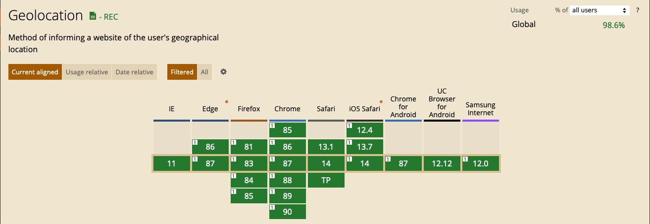
This is access to the location of the device by sending requests to the geolocation API. The API uses the device location capturing approaches on the device, such as Wireless Fidelity (Wi-Fi) and Global Positioning System (GPS). This API then will return speed, longitude and latitude, the direction the device is travelling and watch the position for a given time [30]. As this is important for many major applications, the browser support is high, as shown in Figure 2 below.
Figure 2 - Geolocation Browser Support

2.4.6.2 Vibration
This PWA feature is the easiest to implement, and it gives access to vibrate the device if it has the feature. Either one vibration or a series of vibrations. All browsers except Safari support this feature [31].

2.4.6.3 Camera and Microphone
Most browsers support access to all basic camera and microphone functions, like taking images and recoding small sound snippets [31]. There are more advanced features that an on-board camera and microphone offer such as advanced camera controls, this is the ability for the device to change settings such as zoom, ISO, and focus points, and the ImageCapture API gives web applications the ability to change these settings [32].
Another advanced feature is the shape detection that is broken into three sections, Text Detection, Barcode Detection and Face Detection. These all are experimental features for web applications as the ShapeDection API has only recently surfaced [33].
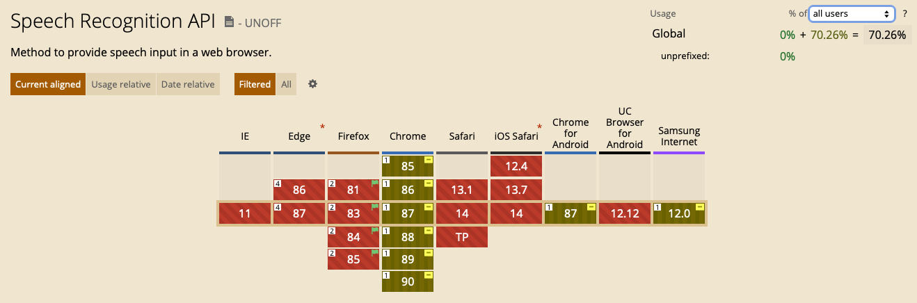
An advanced microphone feature is speech recognition using the WebSpeech API. This will allow web applications to produce a transcript of the voice that the microphone is recording [34]. There are many use cases for this, including accessibility such as input control for users that can use a keyboard or touchscreen. This API has the least support for browsers, as seen in Figure 3.
Figure 3 - Browser Support for SpeechRecognition API

2.4.6.4 Device Orientation and Motion
Most devices have a built-in accelerometer, gyroscope and compass. To access the device orientation, motion and coordination this hardware needs to be accessed. The device frame coordination gives three values, X, Y and Z. These refer to the different planes on the screen, as seen in Figure 4 [35]. The orientation can be based on the typical orientation for tablets and phones, but laptop orientation is considered in relation to the keyboard attached. Device motion returns the acceleration of the device with or without gravity, and the orientation returns the amount the device is tilting front to back and side to side. If the device has a built-in compass, then it can also give the bearing the device is pointing [36].
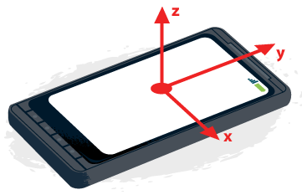
Figure 4 - Device Frame Coordination
2.4.7 App Maintenance
As PWAs are accessed by connecting to the server through a web browser, the device is always fetching the latest files, so there is no need for the user to manually update the application, through an app store. This will always make sure that the user is not using an outdated app that could have security flaws[37]. Also giving the developer an advantage as bugs can be quickly changed without submitting updated for auditing by the app store, the files on the server can simply be updated.

2.5 Technical Features
2.5.1 Web Manifest
A web manifest is a file included in the public folder of the web application, but it is not accessible and cannot be viewed by the client. The file is written in a JSON format and it hold information on the app that is necessary for it to be downloaded. Some of the key information is the version number, description and all the resources like image icons [38]. The web manifest is defined in the meta tags of the html in the index page. When the app is then installed the manifest defines the characteristics to make the experience for the user as close to a native application as it can be.

2.5.2 Service Worker
A service worker is a JS file that run separate from the web page, in the background, therefore opening up access to features than do not need a web page or interaction from the user [39]. As it runs in the background, the file cannot access the DOM, so it does not affect the main JS of the page [40]. Service workers rely on different elements for support, firstly only the mainstream used browsers support service workers and some mobile browsers. Secondly, as service workers are so powerful, they require HTTPS, making it a secure environment [40].
The service workers use a set of APIs so it can respond to requests [41]. The service worker is the main part of PWA and allows the features of a PWA to work like the offline content, install-ability, notifications and more [42].

2.6 Technologies
2.6.1 JS Framework
There are multiple JS frameworks available for frontend development, each of them with different advantages and disadvantages.

2.6.1.1 React
React is a JS library that was developed by Facebook in 2013. It can be used to create the UI for the web. The most popular use of the open-source library is Instagram and WhatsApp. React pages are built of components that include JS and HTML and has a hierarchy of pages staring from a ‘App.js’ and filtering down to components that hold simple things such as forms or even titles [43].
React integrates well with Node Package Manager (NPM) which enhances the capabilities as the third-party library can add extra functionality [44].

2.6.1.2 Vue
Vue relies on HTML pages and injects the data in using double curly brackets. Then everything in these brackets is called a Vue instance and runs the JS attached. Vue is a very lightweight JS framework and does not add much too the functionally but offers better ways of injecting dynamic data to HTML pages [44].

2.6.1.3 Angular
Angular was one of the first JS libraries created by a Google employee. It was created to solve the stat problem of HTML pages as when a navigation link was presses a new request went to the server, but when implementing angular the JS dynamically swapped the on-page information out creating the first SPAs. Now Angular 2 is the newest version that is a complete rewrite of Angular 1 but using the same concepts. It is thought of as the most complex and heavy-weight framework that implements scopes and controllers as the main architecture and is written in Typescript [43][44].

2.6.2 Database Service
2.6.2.1 NoSQL
NoSQL are non-relationship databases, and the data is stored in collections of documents. These documents then store objects and variables [45]. The different collections have documents in them, and the documents can hold the unique identification code of other documents in other collections so when they are interacted with, they act as one document.
NoSQL mainly uses a database service called MongoDB and have different advantages over SQL databases. Firstly, the performance of the read and write is quick due to the format they are designed in [45]. Secondly, NoSQL databases can store a large amount of data and finally they are low cost [46].

2.6.2.2 Structured Query Language (SQL)
SQL is designed for holding data in relationship databases and is the industry standard for data storage. It uses tables to store the data in columns and rows. This type of storage has been available for many years. SQL database are fast to process the data and manipulate it as is based on data indexing to give it the speed advantage [47]. A disadvantage to using SQL is the cost implications to storing a large amount of data.

2.7 Usability in Software Application User Interface
The usability is how a human can interact with the application. It is important as it can range from the initial installation of the PWA to the OS as this is the first step of using the application. After the user completes this task on the application, measures of how successful the performance was will be evaluated. This is mostly looked at by the design of the UI, and there are different usability models that can be used to evaluate the usability of software UIs. The most relevant one is PACMAD and is broken down into seven sections.
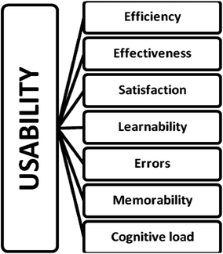
Figure 5 - PACMAD Usability Model
2.7.1 Effectiveness
This section measures the ability a user had to complete a task. It can be measured by analysing whether the user can complete the set of specified tasks [48].

2.7.2 Efficiency
This measures the speed, time, and accuracy of completing certain tasks in the software UI. This produces the productivity of the application’s interface. It can be measured by timing or the number of touches and keystrokes the users take to complete a task [48].

2.7.3 Satisfaction
This section identifies comfort and ease regarding the interface of the software. Although this variable is subjective to the users’ specific attitudes for the UI, it can be measured using different qualitative and quantitative techniques [48].

2.7.4 Learnability
Learnability is vital as there is a vast range of applications on the market to choose from. Therefore, if this is not fully achieved then the users will switch to a different platform or application. This aspect will reflect how long it will take a user to learn the interface and therefore use it efficiently. This can be measured by looking at the performance a user can have using the application when completing a series of tasks [48].

2.7.5 Memorability
The memorability attribute is about the user’s ability to effectively use the application after not using it for a long period of time, so they will not have to relearn it in any way. This can be measured by getting users to complete tasks, then after a long period of time getting to retake the same task and see if there is a difference. A study found that 50% of applications are used on the phone once a month, being classed as inconsistent use [49]. Therefore, meaning this attribute is important as it could affect a uses recollection of the function of the application and how it was used.

2.7.6 Errors
This discovers the number of errors that are made by the user. This firstly allows developers to see areas most prone to errors and therefore implement changes to fix them. But secondly, reflects how well the user can use the application without errors. The error rate can be measured by simply analysing the number of errors, if any, made by the users and measure the nature of the error. This section can also measure how quickly a user can recover from made errors [48].

2.7.7 Cognitive Load
The main section of the PACMAD model is the cognitive load. When accessing an application, not on a mobile device the user is normally fully focused on the task and not doing anything secondary, whereas on mobile the user can be walking or doing another task as well.
Cognitive load specifies the cognitive processing requires to use the application. Before developing mobile applications, this was not a problem, but now as the user could be preforming multiple tasks, the user interface needs to be developed with this in mind. While using the application, it may affect the user’s movement and ability to use the application correctly. Therefore it is important to consider both dimensions [48].

2.8 Stock Tracker Apps
There are a number of different web applications and native phone applications with the main function of tracking stocks, three popular apps are listed below. None of them hit all the main points of a stock watchlist, contain a large amount of historical data, user alerts of current prices and are user friendly. All of these apps hit different points very well but no app hits them all, and none implement a PWA for this. The user is looking for a well-rounded application that can do all of this on all their device.
- https://www.hl.co.uk
- https://www.trading212.com
- https://uk.tradingview.com

Chapter 3 – Methodology
3.1 Chapter Introduction
The section will provide information on the methods used to gather the most reliable information for the study. The philosophy, approach, strategy, time horizon, data choice and collection of the research were explored in different subsections to prove a higher understanding of how the study would collect the relevant data. This was looked at through the six-layer research onion provided in Figure 6.


Figure 6 - Research Onion
The section following the research methodology is the development methodology. It outlines the way the development was undertaken and how the chosen software development methodology improved the project, also stating the advantages and disadvantages with ways of working around the negative aspects. The subsequent section summarises the tools and packages that are appropriate to use when developing the system and how they improved the overall development.

3.2 Research Methodology
3.2.1 Research Philosophy
The theoretical approach of this study was positivism. When this approach is used, the study takes advantage of analytical or logical analysis through observing the results using an experiment [50][51]. It was appropriate for this project to use positivism as the research philosophy because it allowed for the results to be evaluated to draw a conclusion. The experiment produced quantitative and qualitative data to assess [52].

3.2.2 Research Approach
The approach made to the study was deductive reasoning. This type of approach is the method of using existing theory to formulate and test a hypothesis [53]. As this study strived to meet the aims and objectives, the users were observed when testing the PWA in order to assess the feature functionality and feature usability of the PWA. Therefore, it was possible to derive a conclusion from this information.

3.2.3 Research Strategies
There were three research strategies used in the study. The first one was a questionnaire that was used to gather information on the PWA, such as the feature functionality and feature usability attributes. This was chosen as a research strategy as it provided different qualitative and quantitative information, helping towards the data method being taken [54]. Also, a questionnaire can be accessed by many people independently without the researcher`s guidance. Therefore, a questionnaire is able to generate many results quickly with little input needed [55].
The second research strategy that was used was a focus group. Completing a focus group meant gathering individuals to test, discuss and comment on the topic at hand from personal experiences [56]. The focus group provided the data that can be assessed giving the study an evaluation on the impact it is having and its usefulness [57]. Normally a focus group would consist of multiple people grouping together all interacting with the same tasks and commenting on them [58], but as Covid-19 restrictions do not allow multiple people to group together, these focus groups were undertaken online and recording the data one by one. As the tasks the users needed to complete could be hindered by others, they could not all be in the same online call as that would result in the data collected not being reliable because they could copy each other’s screens being shared.
The final research strategy used was a software development evaluation tool. This tool is called ‘Lighthouse PWA Analysis Tool’ and is used to audit a PWAs features, is open source and developed by Google [59]. When it is run on a PWA, it provides the tester with a set of metrics on how the PWA is able to give a full application experience.

3.2.4 Choices
The strategies chosen for this study allowed for multimethods. The different research strategies provided a wide range of qualitative and quantitative that can be used for analysis to derive the relevant conclusions from. A multi methods approach is similar to the mixed methods of collecting qualitative and quantitative data, but from multiple sources [60]. This was applied to the project as there will be qualitative and quantitative data from the questionnaire and focus groups giving two different sources and quantitative from the software evaluation tool.

3.2.5 Time Horizons
The time horizon for this study was cross-sectional and longitudinal as the different research strategies allowed for different testing over time. The cross-sectional time horizon was completed by the focus group and the questionnaire. The reason for this is that the focus group took place within days of each other alongside the questionnaire that the user had a week of app use then one chance to answer it.
The longitudinal came from the PWA evaluation tool. The tool was used to test the application and gather results throughout the development stage allowing the development to keep on track. These results were documented with the development changes to show how the results were affected.

3.2.6 Data Collection
A data collection strategy that was adopted was document review. Therefore, going through documents and studies in the subject area and looking at the conclusions created. These conclusions already in the field helped guide the project in the current direction.
The questionnaire produced included closed and open-ended questions. The questions gathered information on two major points, the PWA functionality and usability with a small section collecting information on the user themselves. The sampling techniques used is quota sampling, which is the process of the researcher choosing the necessary number of people per stratum [61]. This sample technique was chosen for the questionnaire as it allowed the researcher to sample the subgroup of the population that are the highest interest to the study, as the application is specific not everybody will be use only a niche subgroup [62]. Also, if too many people were chosen that do not have knowledge in the applications background, the technical features could be overlooked by the users.
The software evaluation tool will provide numeric data allowing for statistical analysis. This type of quantitative analysis will include interpreting the data so that trends and correlations will be uncovered [63].
Once the PWA was developed, there was a series of focus groups conducted. The was the data was collected was analysing how the users undertook the task provided. The type that was undertaken was synchronous online focus grouping. There are many benefits for synchronous, the main ones being that it is simple, they are fast to conduct, cost-effective and the moderator can direct the flow encouraging the participants to provide the most reliable results [64]. The way the data will be collected is by analysing the effectiveness, efficiency, satisfaction, learnability, memorability, errors, and cognitive load. To test these attributes the users will perform multiple tasks to test each component specifically and therefore will provide data that can be analysed thoroughly. An example of this is the efficiency, the users will perform a task and the time taken, touches and keystrokes made will all be recorded. This method of data collection is reliable as the PACMAC usability model is highly used throughout the industry [49] thus a trust worthy bases.

3.3 Development Methodology
3.3.1 Agile Methodology
When developing a project, using an agile methodology helps manage the projects flow. When implementing agile it allows the software development team to improve efficiently especially when the project is complex [65]. Agile breaks down the project in to more manageable chunks, called iterations [66]. Once one of these iterations have been completed, the success is measures by the production of something of value.
The development methodology that was chosen for this project is an agile methodology called feature driven development (FDD). This follows the agile standards but is more suited to smaller development projects. FDD consists of five main steps, these steps are:
- Develop overall model [67].
- Build feature list [67].
- Plan by feature [67].
- Design by feature [67].
- Build by feature [67].
The first two steps are done once, then the last three are repeated for each of the features in the feature list. Each of these strategies take elements of the main agile methodology and apply it the FDD [68]. When in the planning by feature stage there are different approaches taken to get the most out of the process. Firstly, a task analyses of the future users to get an understanding of what they are looking for and then developing these into user stories to make them more accurate. User stories are a big part of the agile methodology as it can break the problems down and allow the developer to understand the process in smaller chunks [69]. This is another reason why FDD will support the project being completed as the project has many small features and it is very user orientated [67].
Another reason for implementing FDD using the agile methodology framework was the wireframe diagrams. As this project has some usability features being addressed the chosen methodology allows for wireframe design which is a user interface design process that allows for a hierarchy of design, making it easier to propose how the user will process the data [70]. A wireframe will determine the layout of the components going on the screen allowing the screen to meet the users’ needs [71]. This can then be built on when the paper prototype is developed as the components will already be planned and placed correctly. Using this methodology will give the project a better frontend design as both of these processes will improve the final overall interactive software design.
The development of the application was completed in sprints using the agile methodology. The user stories and feature driven development ensured that the coding was clean and efficient. This was the case as the developer could understand how each feature worked and how it interacted with the other aspects of the application.

3.3.1.1 Advantages of Appling FDD Using Agile Methodology
The FDD using the agile methodology for development has given the project many advantages. Firstly, after every sprint the success is measured by new features or elements. This ensures the development is moving quickly and there are always visual changes being added.
Another advantage that came from implementing agile was the four principles of agile that need to be met. These are:
- Individuals and interactions over processes and tools [72].
- Working software over comprehensive documentation [72].
- Customer collaboration over contract negotiation [72].
- Responding to change over following a plan [72].
One main benefit of these four principles is the fast response to change. This gives the project the ability to adapt to change and implement it over a plan made that does not support the change. The second principle guarantees that the long delays caused by documentation do not affect the timescale of the project. Agile does not take all the documentation away from the developer but streamlines the process by only producing and using what is needed, such as the user stories and the designs. The value of working code is higher than the value of the documentation [73].
Finally, a befit added by implementing the FDD agile methodology is the user stories. As there were many requirements to the application that was being built the user story bridge the gap with the potential customer and the developer by them being written in a common language. The user stories are short, concise and accurate giving the developer a better understanding of the requitements [69]. Also, the user stories improve the project by allowing them to individually have a timeframe as each of the user stories can be used as a sprint.

3.3.1.2 Disadvantages of Appling FDD Using Agile Methodology
One of the main weaknesses of using this methodology is the potential for wasting resources. As agile is quick to adapt to changes, if the developer spends time designing screens and user stories for development these could be useless. The reason for this is the requirements or an unforeseen bug could arise making the developer have to redo all the rescores. To avoid this disadvantage to using the methodology, the process will have to planned well but also know this could occur, so it can be expected and reacted to quickly.
An element of FDD agile methodology is class-responsibility-collaboration (CRC) cards. These cards provide the developers with a plan of the classes that are needed to implement the system. CRC cards are not needed for the project as the development has no need for classes as the framework that is needed does not rely on classes.

3.3.2 Software
3.3.2.1 Design Software
3.3.2.1.1 Adobe XD
A tool that is important to this project is Adobe XD. This tool can be used in many ways, but the main way is the design use. Adobe XD is a rapid software prototyping tool, which is the proof of concept, by designing, reviewing and refining [74]. XD handles the rapid prototyping well with all the different functionalities and the ease of use. The whole application is designed intuitively and very simple to use.
It will be used in the project to design all the different screens needed throughout the system. The easy of the duplication of elements allows for a consistent design and quick changes so the screens that are similar can all be based off a default style. Another important feature Adobe XD offers, is the speed of change, as the project has may pages the design of them will change as more features are added, so this application will allow for these changes to easily be implemented without the need of a full redesign. The final use of the application is the software interaction and implementation feature, this will improve the project as the screens that are designed can be linked so an interactive walk thought can be undertaken. This will highlight if any information is too hard to reach with too many clicks.

3.3.2.1.2 Adobe Photoshop and Adobe Illustrator
These two packages, Adobe Photoshop and Adobe Illustrator have improved the projects logos. Illustrator is a vector editing tool that can make logos and icons and photoshop is a photo editing tool than can further edit them. They will be needed throughout the project for use on creating the logo, favicon, app icons and other icons needed.

3.3.2.2 Development Software
3.3.2.2.1 Visual Studio Code
Visual Studio Code (VSCode) is code editor with many features built in. Using this application to develop the project will give it many improvements. VSCode is streamlined for quick coding so the first improvement is time, there will be a reduction in developing time just from using the application. The application has a built-in bash terminal allowing for commands to be run on the code that is being developed in the editor when it is being saved.
VSCode is lightweight and not heavy on hardware so there is no need for extra hardware when developing the project using this application. VSCode also allows for third part extensions or plugins developed by others that use the application. These extensions can be under to improve the project from allowing the use of boilerplate code, testing, finding syntax and may more things.
Finally, VSCode has access to a built-in version control that links with Github, version control will be used in the application and explored on more in the next section. Overall, using VSCode will improve the project development by the ease of use, making the main focus the development and not setting the environment up or completing mondain task to get the development working.

3.3.2.2.2 Node and Node Package Manager
Node JS is a backend JavaScript environment. Node JS is built for scalable networking application effortlessly as it is lightweight and efficient and good for data extensive application that run across different devices [75].
Node Package Manager (NPM) is bundled with Node JS. NPM provides opensource packages to developers, these can range from icon sets to full development frameworks. They are publicly available from repositories and installed using the NPM CLI tool [75].
These two tools are appropriate to use in the project as the Node JS backend is firstly written in JS, as the client is, therefore reducing code content switching as the backend and client are written in the same language. The NPM tool is one of the main ways why this tool is used as the packages provide on the repositories are developed for web applications so there are many that can be implemented to improve all the parts of the application being built.
The way that Node JS is built will improve the web application as the tool’s architecture consist of layers, and the top one being a JS API, the communication layer. As JS also works very well with JSON all the data is native JS and converted in to JSON when being transferred.

3.3.2.2.3 Postman
Postman is a platform for testing and developing APIs. When the backend and the frontend of the application are communicating postman can hit the endpoints and give test data then show the result. It is a very useful tool for testing and giving the correct errors if there are any.
Postman can send REST requests so if the endpoint is not yet developed the tool can stand and proved the data needed to then carry on with the development without needing to develop the endpoint. A good use for this is the login system and cookie offload. When the backend is being developed and the user login is being used to then developer the cookie that is being deployed postman can mock the front-end request with the username and password to allow development when the user is logged in without have a frontend. Then postman can show the cookie that it has received.

3.3.2.3 Other Software
3.3.2.3.1 Version Control
Using a version control system improves the reliability of the development files as a version control system (VSC) saves a complete snapshot of the project when its triggered too [76] and holds it in a repository. A VCS tracks and manages all the changes that are made to the code, this gives the developer the ability to roll back and compare the earlier version of the files. This causes less disruption therefore improving the development process [77].
The VCS that will be used in this project is Github and the Git CLI. Together these allow the code to be pushed to the remote repository on Github from the command line. This will give a backup of the code in case of a failure with any local storage it is on. The main improvement that using the Github VCS gives to the project is the roll back feature. When a bug harms the code files it is easy to roll back getting the old working code. Also, this will be used for backwards testing, if a bug is found and there is no root of the problem a roll back can be made to see if it was working previously and what new code was added.
3.3.2.3.2 Mongo Compass
Mongo Compass is a tool used for accessing a MongoDB Attles database that is storied in the cloud. This tool can perform all the queries from a graphical user interface (GUI), create, remove, update and delete data. Using this tool though the project will allow the viewing of the data in a GUI over a CLI.

Chapter 4 – Design and Implementation
4.1 Chapter Introduction
This section provides the design requirements with the process of choosing the final design. All the user interface design steps taken are justified with the requirements to improve the overall usability. The design techniques that follow the requitements is the wireframe diagram, paper prototype, software version one then software version two.
Succeeding the design is the implementation section. This section highlights the technologies used to develop the application and reasons for it. Then the section also provides information on the successes and any errors encountered with the development. Using this the testing of the application and major sprints are shown.

4.2 Design
4.2.1 Design Requirements
To start the design process, the requirements were drawn up. As one of the aims and objectives refers to a usability aspect of the application produced for the project, completing relevant and accurate design requirements is critical. A list of the generated design requirements are below:
- Simple design so the user can focus on the main content the app provides [78].
- Use a colour scheme that does not interfere with the chart data or colour ticks.
- Include icons on the application so it is easy to navigate and can scale to small screens easily.
- Design the navigation with limited clicks intended so the user can move through the application quickly and without much thinking.
- Use a background colour, so the main content is what the user’s eye is attracted to.

4.2.2 Wire Frame
A wireframe allows for a hierarchy of design, making it easier to propose how the data will be processed by the user [70]. It determines the component layout allowing the user interface to meet the user’s needs [71]. As seen in Appendix 1 – Wire Frame Diagram, the overall design is simple, with all the content in a place that is it is expected to be, making it familiar to the user. As this wireframe is simple, it meets the first design requirement. This requirement is essential to the application because an intuitive and straightforward design allows the users to understand the page immediately [79].
When the wireframe was designed, the content types are consistent throughout the pages. The header is always at the top of the page with the navigation in a sidebar panel. Many advantages are brought to the application through this design, but mainly the user will be able to predict where the content is as these panels stay in a consistent place.
Creating the wireframe as the first step in the design process allowed for an overview of how the data flows and how the user will initially view the content panels. This then allows the paper prototype to follow the effective hierarchical design and continually meets the wireframe requirements.

4.2.3 Paper Prototype
The second step in the design process was paper prototyping, as shown in Appendix 2 – Paper Prototype. By developing a paper prototype, the human factors can be applied to the paper prototype allowing a better insight into how the design is successful.

4.2.3.1 Theory of Visual Perception
Users look at web pages from the left to the right of the screen [80]. Therefore, the sidebar gives a tabbed order of hierarchy from left to right as, intuitively, the left panel will control the content on the right panel. Also, when the human eyes look at the screen they scan for the main sections of the page that will change, the section in the design is therefore the most significant section drawing the eyes in [81].

4.2.3.2 Human Memory
All the icons on the paper prototype are designed with intent of what will happen when these icon buttons are pressed [82]. These icons are in the sidebar and one on the header once the user logs in. When the application is viewed on a smaller screen, the responsiveness makes the description of the pages in the sidebar disappear, the icons will show where the navigation will take the user. Finally, the human memory can only hold and make decisions on seven pieces of information in their short term memory [83]. As seen in the paper prototype, the sidebar navigation links are kept below to keep the user’s cognitive load down.

4.2.3.3 Human Reasoning
The prototype uses deductive reasoning throughout the design. As the user can use logic to understand when they click on the navigation link on the sidebar, the content will show to the right. Also, the prototype keeps an overall house style that also relies on deductive reasoning.

4.2.3.4 Interface Metaphors
Interface metaphors are attributes of the interface that explain what the task will do by mimicking real like items or events. Throughout the paper prototype design, all the icons do this as the navigation icons show the home page as a house icon and adding an item to the watchlist is a plus icon. By implementing interface metaphors into the design, the usability can show the functions the element will carry out when interacted with.

4.2.3.5 Affordance
The paper prototype gives the user visual clues in different areas of design [84][85]. An example of this is on the details page when the user is logged in, the add to watchlist button is green showing that proceeding this button, the action is positive, whereas when it is being removed the button will be red.

4.2.4 Software Design
4.2.4.1 Version One
The following process in the design stage was developing the design into a rapid prototyping application. The application chosen was Adobe XD. This process took the paper prototype and developed it further to enhance the design and improve on it. This section is referring to the Appendix 3 – Software Prototype Version 1.
4.2.4.1.1 Colour Scheme
The first significant improvement made on the paper prototype is colour, adding colour made the design more realistic so it could be pictured easier. The dark blue header was chosen to show that high contrast with the rest of the website making it standout. Then the sidebar colour got added to a grey. This help divide it from the main content on the screen.

4.2.4.1.2 Sidebar
The sidebar had usability improvements from the previous paper prototype as all the navigation links are added. This allows the user to see all the available links to the pages on the application in one place. This improves the cognitive load aspect of usability so the user can view all the options and decide rather than looking in more than one pace to find navigation links.

4.2.4.2 Version Two
The software paper prototype version one was updated with some minor usability improvements. See Appendix 4 – Software Prototype Version 2 to view what this section is referring too.

4.2.4.2.1 Colour Scheme
The main change to the updated version was the overall colour scheme. The sidebar, header and background had improved colours. The header bar was a lighter blue, the lightened the whole app feel and allows content like the logo to stand out better.
The following colour change is the sidebar, that was a light grey and is updated to white. As the background is now a light grey this adds contrast and makes the sidebar standout but not overtake the cards, as the cards are overlayed on the background colour. The final colour change was the addition of shadowing effects, this adds depth to all the layers adding a hierarchy to the design.

4.2.4.2.2 Pages Layouts
As seen from the updated design all the pages now have a background colour and use cards. This improves the design and usability in multiple ways. Firstly, with the cards the content can stand out more, these cards use shadow and are a lighter colour than the background therefore the users are drawn to them. Also using these cards all the pages to have sections of content, as there can be multiple cards on the same page showing different content. These cards also allow the responsiveness to improve as the cards can react to the screen size more naturally so all the other sizes can see consistent content.
These cards are used on every page for the main content giving consistency on all the pages. An advantage of this is that the user knows where the content will be and knows anything outside these cards is not the main content.

4.3 Implementation
4.3.1 MERN Stack
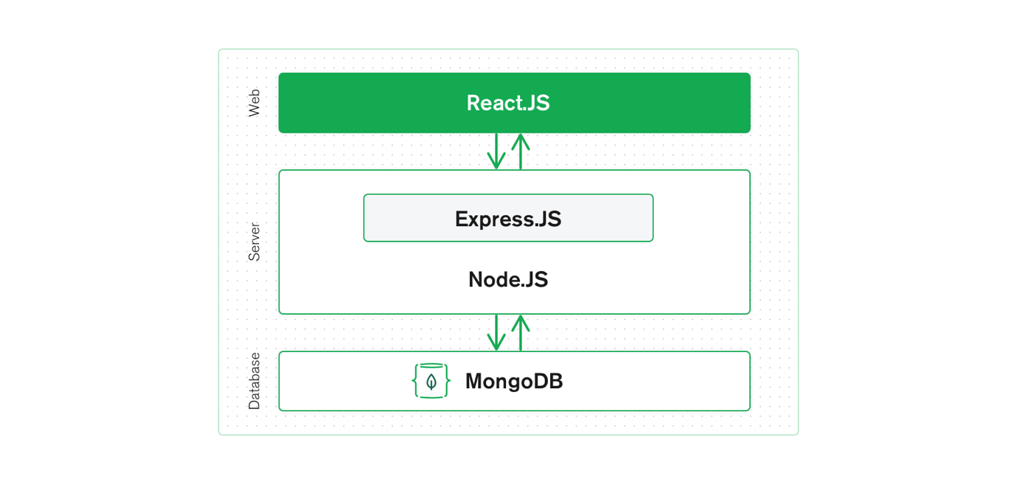
For the development of this project the MERN stack was chosen. It consists of MongoDB as the database server, ExpressJS as the web framework, ReactJS as the client-side framework and NodeJS as the web server.
Figure 7 - MERN Stack
By combining these open-source technologies it allows for an end-to-end framework for developing web applications [86]. An advantage to deploying the MERN stack is react, express and node all use JS allowing for common technologies, the JSON and JS objects can all be read without converting and all the technologies use asynchronous calls.

4.3.1.1 Frontend
As previously stated, the frontend framework used for the implementation is ReactJS. There are many advantages of using this framework for the frontend of the application. Firstly, React works well with stateful, data-driven interfaces and can easily pass the data between the different components [87]. This was one of main factor for choosing React as the framework over the others as the application is heavily built high data interfaces.
Another advantage React offers over the other frameworks is a prebuilt service worker for its own configuration and files. All the developer needs to implement is the UI and the desired code for the added content in the service worker, not the content that is bundled with the framework.

4.3.1.2 Backend
The backend for the implementation was developed using NodeJS. It was chosen for the backend of the development application mainly for asynchronous event driven engine, allowing for parrel computing through the use of pushback functions [86] allowing advantage of a blazing fast backend.
This type of server allows for the installation of third-party open-source modules via NPM. One of these that is heavily relied on is ExpressJS. ExpressJS is a server side framework that allows URL routing and handles all the HTTP requests and responses [87]. It is also developed in JS so JSON objects can be passed form the front end to the server, then to the database seamlessly.

4.3.1.3 Database Server
The database server to store all the applications data is MongoDB. It is a non-relationship database and stores all the data in a JSON also showing the seamless speed as all the datatypes are the same. MongoDB can be used in Atlas, their own cloud provider giving a setup and speed advantage to the project. As shown in Figure – 8 there is a database diagram.
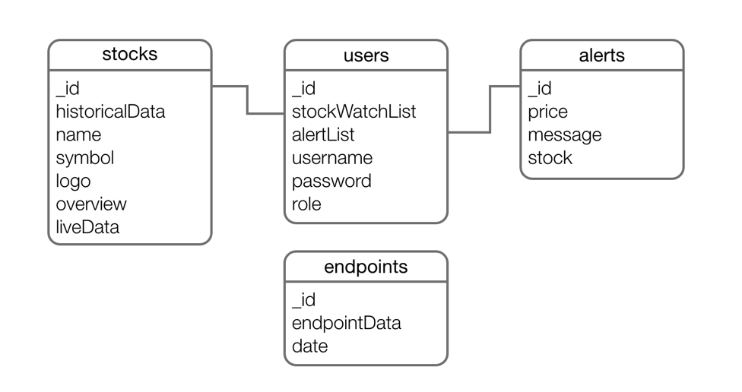
Figure 8 - Database Diagram
4.3.2 Successes
4.3.2.1 Push Notifications
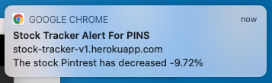
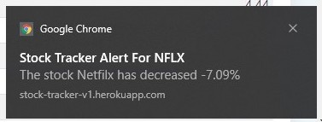
A success of this project was implementing the push notifications to the user. An example of the push notification is Figure – 9 and Figure – 10.
Figure 9 - Push Notification MacOS
Figure 10 - Push Notification Windows 10
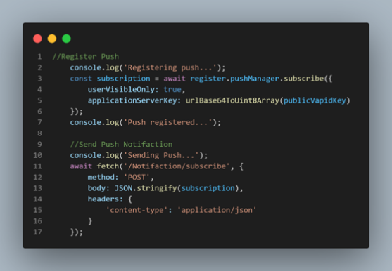
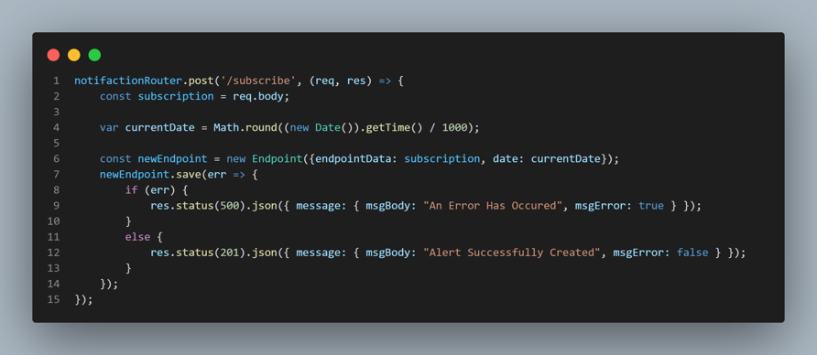
The way push notification was implemented was firstly by getting the unique endpoint of the active service worker and sending it to the backend, as shown in Figure – 11. This unique endpoint is what needs to be hit for the notification to deploy to the user frontend. Then this unique endpoint is saved in the database for later use when the notification needs to be sent, seen in Figure – 12. With the endpoint, the date and time that the endpoint was created, and expiry time is saved.
Figure 11 - Registering Client Endpoint
Figure 12 - Saving Endpoint from Backend to Database
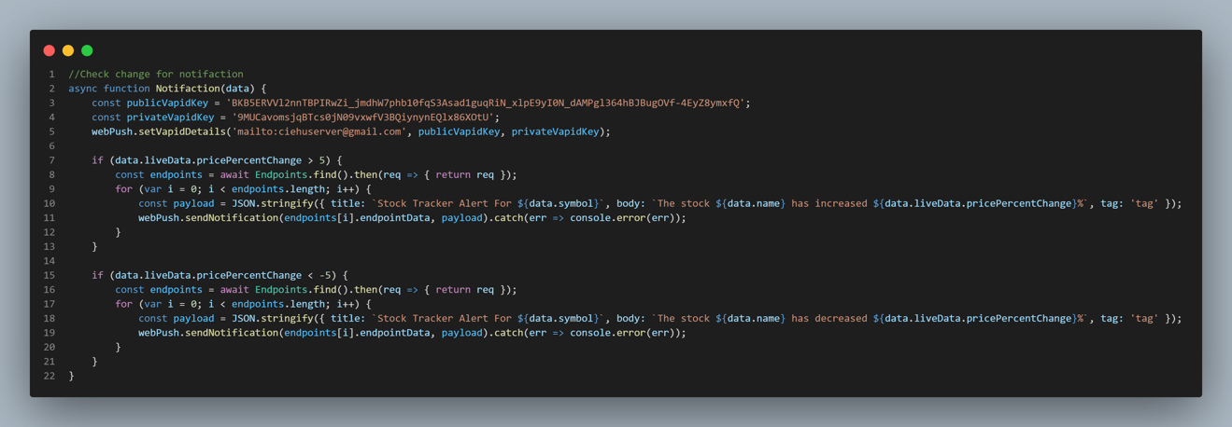
Following this, each time the live data is collected the backend searches for if a notification needs to be sent. As seen in Figure – 13, the condition for this is, if a stocks percentage change has increased or decreased by five percent. If so, the payload is created and sent to the endpoint using the webpush module installed using NPM.
Figure 13 - Notification Checking
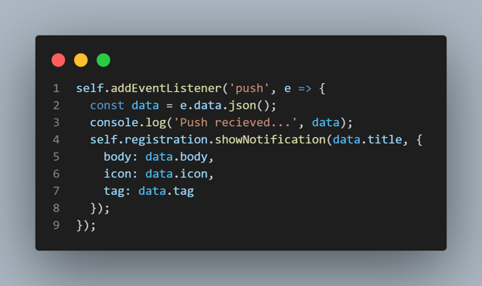
The service work, when active, has an event listener that is looking for a push event to take place. As seen in Figure – 14, once it receives this push event the notification is shown on the screen for the user. The only downside to this is the service worker needs to be actively running, this is done by keeping the browser running in the background and not quitting it. If it is not running, then the notification will be shown next time the browser opens.
Figure 14 - Service Worker Push Notification

4.3.2.2 Installability
Another success for the development was the ability to install the application locally to the client’s device. This was done in one file called ‘manifest.json’. The file is a json file and stated how the application will show when it is installed, as seen in the Figure – 15. The main aspects of this file are the icons and logos so they will show correctly in the different situations and the starting URL the installed app will fall to.
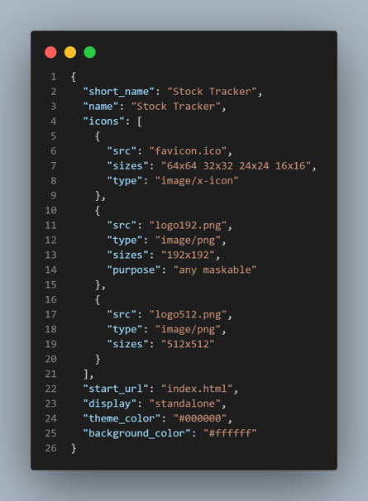
Figure 15 - Manifest File
4.3.3 Errors
4.3.3.1 Caching Content
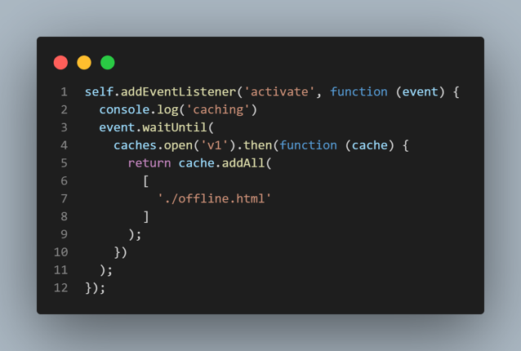
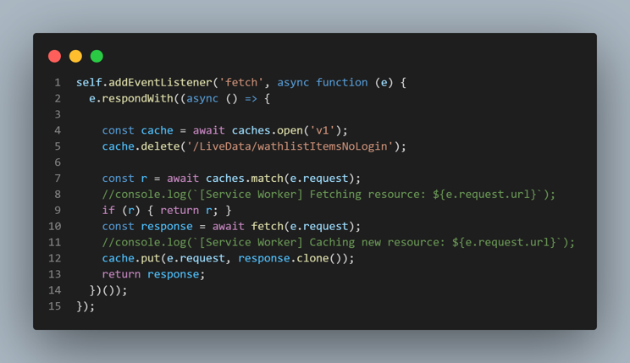
One of the main problems that was encountered when developing the application was the caching content for the user to be able to view it offline. There are two main ways to develop this into the application, the first is caching static pages for offline use. The other method is caching all the fetch requests from the server and if the networking speed is slow this content is shown until the new content is delivered, also when it is fetched the cached content is updated. As seen below both ways mentioned are shown in code, Figure – 16 and Figure – 17.
Figure 16 - Caching Static Pages
Figure 17 - Caching Fetch Requests
The main error encountered with caching the static pages was the browser not knowing to server the offline page when over the default page of ‘No connection to the server.’. When looking at the caching of fetch requests, the problem that was confronted, was when cached data interrupting and ignoring the client-side variables. An example of this was the sidebar showing the correct links for a user not logged in, but once they were logged in the local variable that authenticated them, then setting the links to show was being ignored and the fetched sidebar component was being shown.
Also, sometimes when the JSON data being fetched was slightly changed, it would not be served on the front end, implying that the old, cached data was being shown.

4.3.4 Testing
There were two types of testing that were undertaken on the application. The first and main testing strategy being acceptance testing. Then following this standard system testing was undertaken.

4.3.4.1 Acceptance Testing
After each sprint was completed the process of acceptance testing was undertaken on the newly added feature. The process of non-user acceptance testing is when the developer accepts the code will work how it was intended to for the user to get the feature that they strive for in the user story that was developed in the sprint.

4.3.4.2 System Testing
Once the software application was developed system testing was undertaken, this consisted of end-to-end testing of the system application as a whole and all the peripherals and inputs and outputs. Two types of system testers took place, usability testing and functional testing. This consisted of going through the application as a user is expected to, entering all the data in the input forms and getting the desired outputs, clicking on all the links and using all the features.

4.3.5 Feature Driven Sprints
As this project was developed using feature driven development through the agile methodology, all the major sprints consisted of a feature that was defined by a user story. Some of the main sprints are expanded on.

4.3.5.1 Register, Login and Authentication
The first major sprint was implementing a register, login and the authentication to go with it. The reason for this being one of the first sprints is that the application was built off having user functionality, so logically the login system was the first step. There is essentially an application that shows when the user is authenticated and not authenticated.
The main development of this sprint was the backend and database as the best ways build applications is backend first. The application Postman was very helpful here are the endpoints could be tested without a frontend, then a very simple frontend could be built using the same POST method Postman used.
Once the user registers the NPM module Bcrypt hashes the password and saves it in the database. Then the user logs the backend compares the hashed passwords and if they are correct, authenticated the user and sends a cookie. The cookie is a JSON Web Token (JWT) and stores the username, role, authentication and expiry time, allowing the frontend to access this data. When this cookie expires the user is automatically logged out.
To complete this feature with high security, there was a YouTube playlist of helpful videos that provided inspiration [88]. These videos allowed the security and the password to be hashed correctly and cookie to be stored as an industry standard would.

4.3.5.2 Details Page
One of the next major FDD sprints was completing the user story as follows.
“As a user, I want to view company details such as a twenty-year historical chart and descriptions, so I can conduct proper analysis on the company before investing.”
This user story is set in to two major requirements, the chart and description data. These are both on the same page and function the same, but the data collection is where they differ. When the admin user adds a stock, the backend intercepts it and uses the name as a parameter for three different APIs. These APIs get the historical data, logo, and company details as seen in Figure – 18, Figure – 19 and Figure – 20.
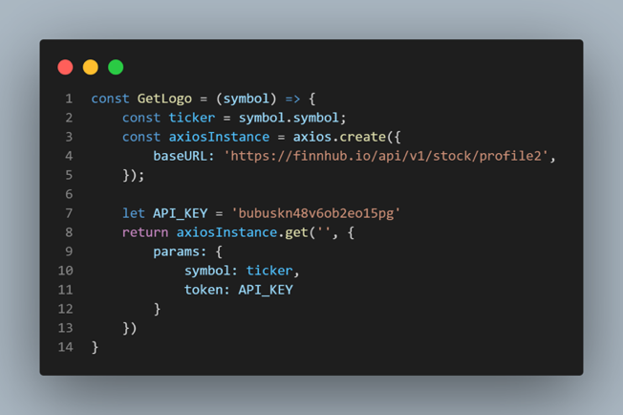
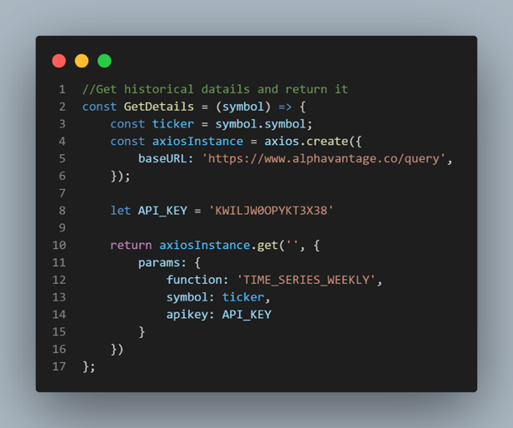
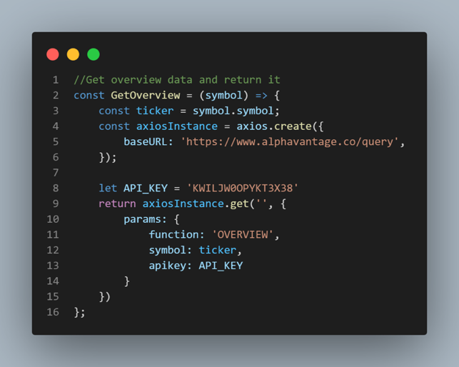
The data is then formatted, and the newly added stock is updated with this data in the MongoDB. Once the stock is added these three APIs are hit using a script that runs every week, so the weekly historical data can be updated and the logo and company description if changed.
Figure 18 - Logo Code API
Figure 19 - Historical Data Code API
Figure 20 - Overview Data Code API

4.3.5.3 Watchlist
The watchlist is an important feature to this application with lots of different functionality. The watchlist needed to show different data depending on whether the user is logged in or not, if they are then their personalised watchlist is needed to be shown, otherwise the default watchlist.
When the user is not logged in there is a component shown that requests the data from the backend and then it is served. If the user is logged in, then a different component is shown. This component requests from the backend watchlist, the backend uses the cookie attached to the request for the user id and complied an array with all the relevant data.
Once this was working the watchlist then needed to show the live data which is the stock price, date the price was updated, percentage change and price change. The live data is gathered by the backend, there is a script running that sends an API request for all the stocks in the database every ten minutes, this equates to each individual stock price being checked every twenty seconds. This data is then passed into the database and updates the live data object for the stock with the new data.
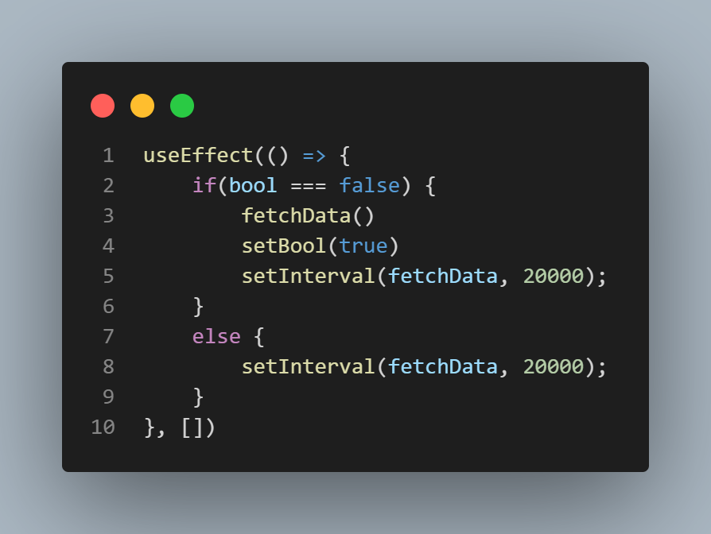
Separate from this the frontend uses the previously stated watchlist requests to get the live data from the backend that gets it from the server. The frontend page runs the function holding the request on page load using a ‘useEffect’ function that is built in the ReactJS. This function runs when the page is initially loaded, or when a state gets updated. Also, within the ‘useEffect’ function there us an interval timer that runs the fetch request function for the watchlist data every twenty seconds, the ‘useEffect’ function can be seen in Figure – 21.
Figure 21 - useEffect Function
All this equates to the user seeing the watchlist on the home page of the application and the watchlist then updates dynamically without the page reloading every twenty seconds. Furthering this each watchlist item is linked to the details page of the company where the accompanying button is placed so the user can add or remove the company from the watchlist.

Chapter 5 – Analysis
5.1 Chapter Introduction
This section will provide analysis on the data gathered. The first method of gathering data was using the open-source lighthouse testing tool. The results from the final application version will be looked at and shown why they are not at one hundred.
The second data gathering method was a questionnaire. These results are looked at question by question and any correlations pick up on. Then finally, the last section is the focus group results. This section will look at the results gathered from the user and compare them to the questionnaire results.

5.2 Lighthouse
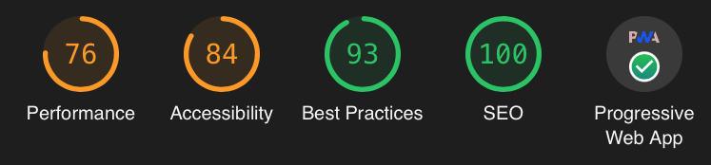
There were a few lighthouse tests conducted through the project development to get results. These tests were mainly user taken after the bulk of the development was done as the tool evaluates the application as a whole and without the main codebase completed it would not score. The tool evaluates the application in five different aspects. These aspects are performance, accessibility, best practice, SEO and PWA.
Figure 22 - Lighthouse Results
The results shown in Figure – 22 are the final results taken on the application when launched on desktop. Starting with the most important metric that this tool was used for, the PWA section. As seen, there is a green tick on the PWA section on the results of the tool. This indicates that the application met the two main aspects of the section, installable and PWA optimised. Looking at Figure – 24, all the testing points for the desktop PWA are hit successfully bar the mobile responsiveness. When redeploying the tool on a mobile interface all the points are now hit including the mobile responsiveness, as seen in Figure – 23. Hitting this assessment point of the tool was the most important to hit fully as it shows the application that was developed is officially a PWA by Googles standards. Also, this meets the objective of implementing a PWA.
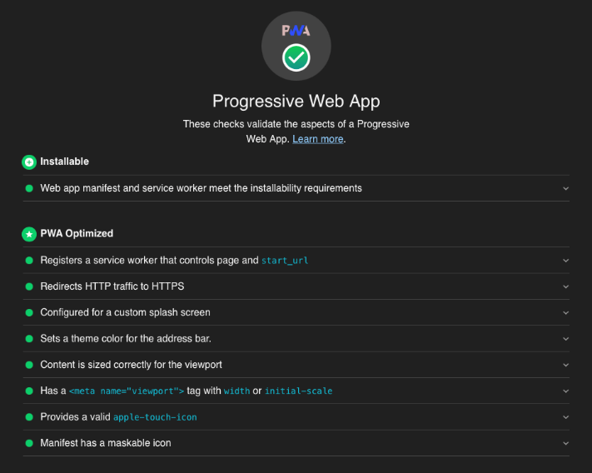
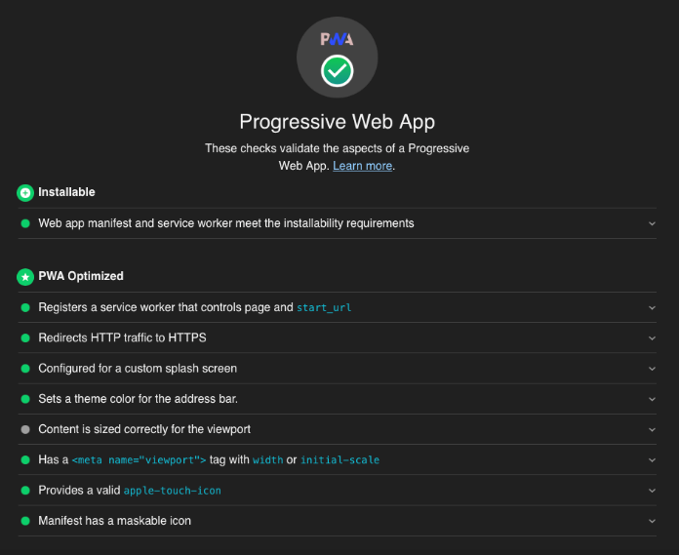
The second result that lighthouse gives is accessibility. On desktop the tool gives a ‘84’ and gives a mobile score of ‘72’. Both of the scores cannot get any higher as they have the same code that is not looked at as common practice. This code stops the user interface zooming to page in on a touchscreen device when the user presses a form to make it the width of the page. It was chosen to take a lower score but keep this in the code as there are forms in the frontend that are only big enough for numbers. Also, if the screen zoomed in for the form was the width of the screen on a smartphone, then the user would have to use the pinch to zoom gesture to zoom back out to view any more content and move on with the form. The only other point that was flagged up by the testing tool in this section was on mobile. When the screen width goes down so the sidebar menu cannot be shown, there is a hamburger menu to make navigation section appear and disappear. As this menu icon does not have a text to describe what the icon does the accessibly score is brought down.
Figure 23 - Lighthouse PWA Mobile
Figure 24 - Lighthouse PWA Desktop
The performance section of the lighthouse analysis tool measures different metrics relating to the performance and give an overall score. This section is important to every application but the way the tool gave the score is not as expected. The desktop score is ‘76’ and the mobile is ‘32’. As the code is the same the mobile score is so low as the tool uses a Moto G4 and simulates a low network speed making the test not as reliable as it is expected to be.
The final two sections are not as important for the application, but it still gets them in the green. The best practise and search engine optimization (SEO) have ‘93’ and ‘100’. The SEO was simple to meet as it checks the HTML page is correct and uses tags like title and meta correctly, with all the images having an alt attribute. The best practice has not scored the full ‘100’ as there are some errors that are logged to the console. This was a problem that was encountered as one of the ways that the authentication was developed was fetching a backend endpoint, and if there was no cookie from the frontend then the endpoint is unauthorised causing a 401 error in the console.
Overall, the project performed well against the testing of the lighthouse tool developed by Google. The tool itself was unreliable in a few instances as it firstly it does not take the page and concept into consideration when doing the analysis. As seen from the examples the mobile responsiveness is marked as a pass on the mobile test but not the desktop. Also, the accessibility was an improvement to the overall system and user’s usability, but the tool marked it down as it would be a disadvantage to another system in a different instance. Finally, the performance is an interesting point as the tool marks mobile metrics with a 7-9x disadvantage as the hardware it is tested on is old and not the standard speed of mobile devices.

5.3 Questionnaire
The questionnaire had three main sections all covering general questions, PWA functionality and usability. There were fourteen questions, and these will all be broken down individually. The full results are included in the Appendix 5 – Questionnaire Results.

5.3.1 Question 1
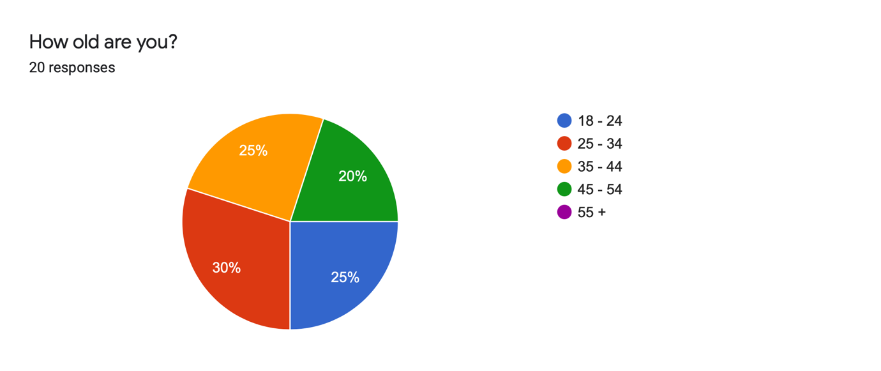
This question is the age of the user undertaking the questionnaire. Looking at Figure – 25 shows the spread of ages is close to being equal through all the sections up to age fifty-five. This ensures all the people who answered the questionnaire have a wide variety of ages ensuring more reliable results.
Figure 25 - Question 1 Results

5.3.2 Question 2
This question was used to see what device the user accesses the application on. The main reason for the question is to draw correlations from further on. These results show what was expected as all the device types were used several times.

5.3.3 Question 3
The third question in the questionnaire assesses the computer knowledge the user has. This is done by asking the person to pick one of six levels of literacy. The aim for this question was to get a spread of results with more towards the top end. As seen in the Figure – 26, the results show that there are over half that are advanced and proficient computer users. Also, there is no correlation with the more advanced a user is the older or younger their age is, it is all mixed.
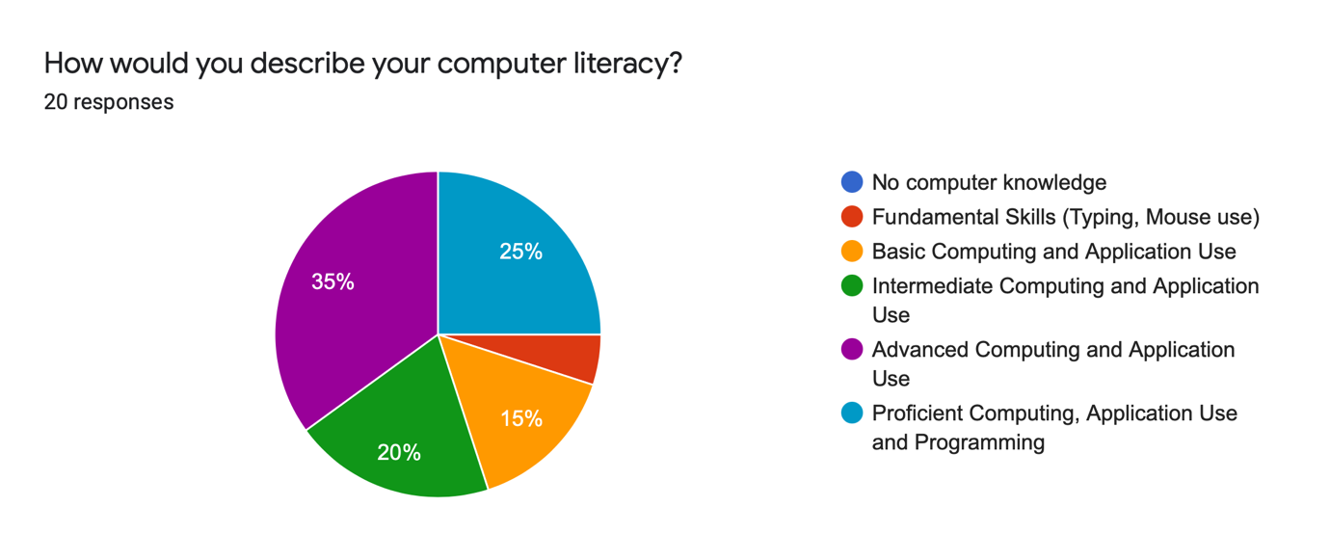
Figure 26 - Question 3 Results
5.3.4 Question 4
The fourth question in the questionnaire is the first question in the second section. This section has the title ‘PWA Functionality’, giving the users an insight to what the section is asking. After this there is the subtitle of ‘Ease of Installation’ with three questions under it.
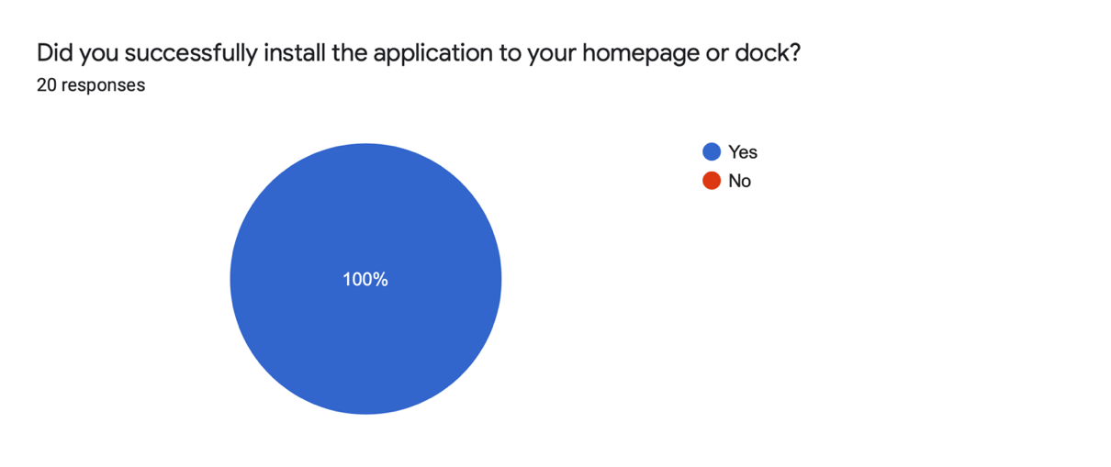
This question asks how successful the user was at installing the application locally to their device. As seen from the results in Figure – 27 all users successfully installed the application. This was a result that was expected showing that all the different OSs and devices used were capable of installing the application.
Figure 27 - Question 4 Results

5.3.5 Question 5
The next question in the questionnaire was following on from the previous one, asking for a description of the install experience. All the results are positive as seen from the results in Appendix – 5 Questionnaire Results. Most of the results say how easy the install was on their device, also some of them compare the install experience to the native app stores and say how it was an improvement on them. These results were expected as the install experience is only two clicks from the user’s point of view. The main take away from this question is all the users from low end of computer knowledge to the high end all found it easy, showing it can be understood by anyone.

5.3.6 Question 6
The sixth question was gathering results on what application type the users found more engaging. The results that were expected was a higher proportion of users finding the installed application more engaging over the web application. The actual results showed that only eight people found the application more engaging as eleven found it equally engaging. These results are very similar to the results that were expected, as the main goal of the question was to ensure that the PWA preformed when installed. A reason for the results being as they are is if the users used the application overtime the ease-of-use factor would apply so the launching the app and so on would mean more people picking the installed app as more engaging.
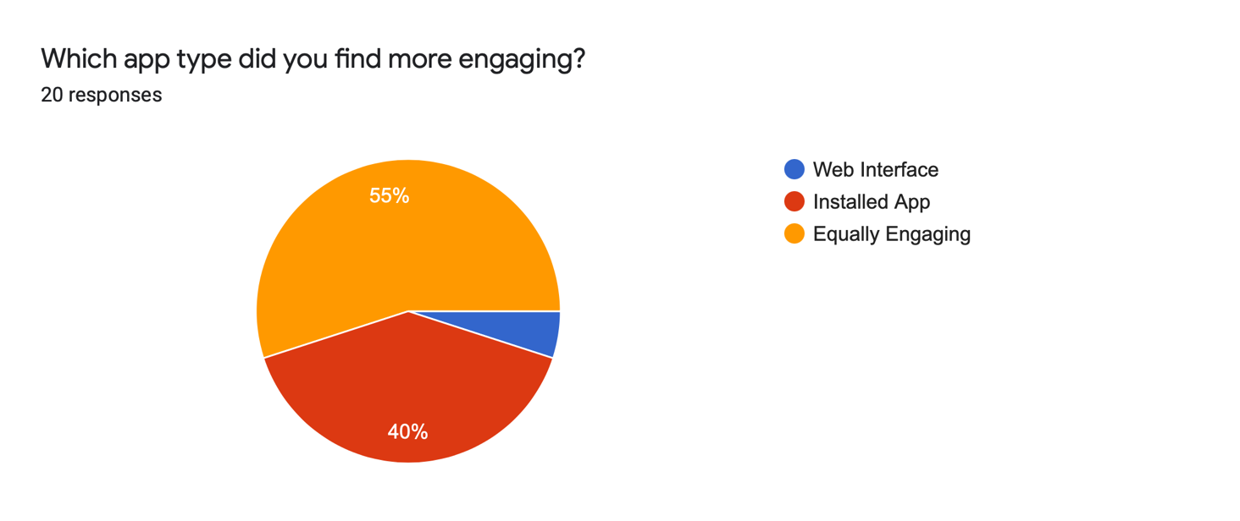
A correlation that was spotted on this question was the minority of user that picked the installed application as being more engaging were on a laptop. A reason for this could be that viewing the application in the browser has lost of panels that come with the browsers such as toolbars but when it is installed then the user is only view the page in a separate window. Also, this window is resizable so the user could have resized it on the screen with better accuracy than in the browser.
Figure 28 - Question 6 Results

5.3.7 Question 7
The next sub section of the PWA functionally touches on the security of the application. Figure – 29 shows that all the security answers, as seen they are all in the top fifty percent of the available choices. These were the results that were expected, there is not much on the application that is a security risk, only the login details. The main advantage that can be taken away from these results is the face that all user installed the application and found that process to be secure.
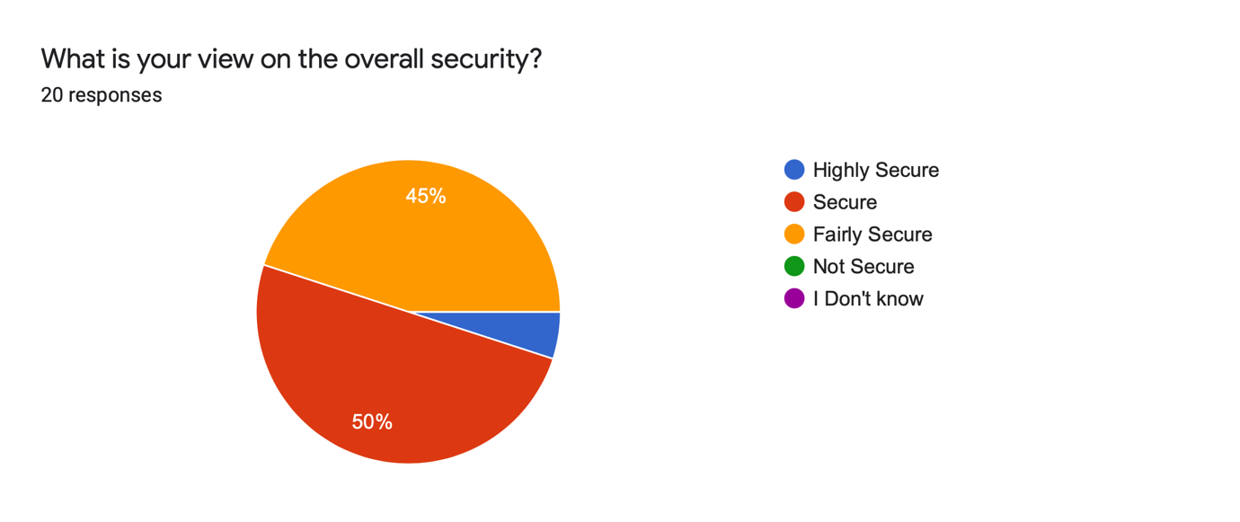
Figure 29 - Question 7 Results
5.3.8 Question 8
The question of the questionnaire is asking the user if they received a push notification while using the application. As seen from the results in Figure – 30 only twenty percent did not receive a notification from the application that was expected too, this equates to four users. It was expected that all users would have received a notification that was not using iOS. So, a reason for this result is that these users did not accept the push notification, so the service worker did not register the endpoint. This was stated in the literature review the user needed to accept push notification when viewing the first page of the application, if they do not then no notification can be sent to them.
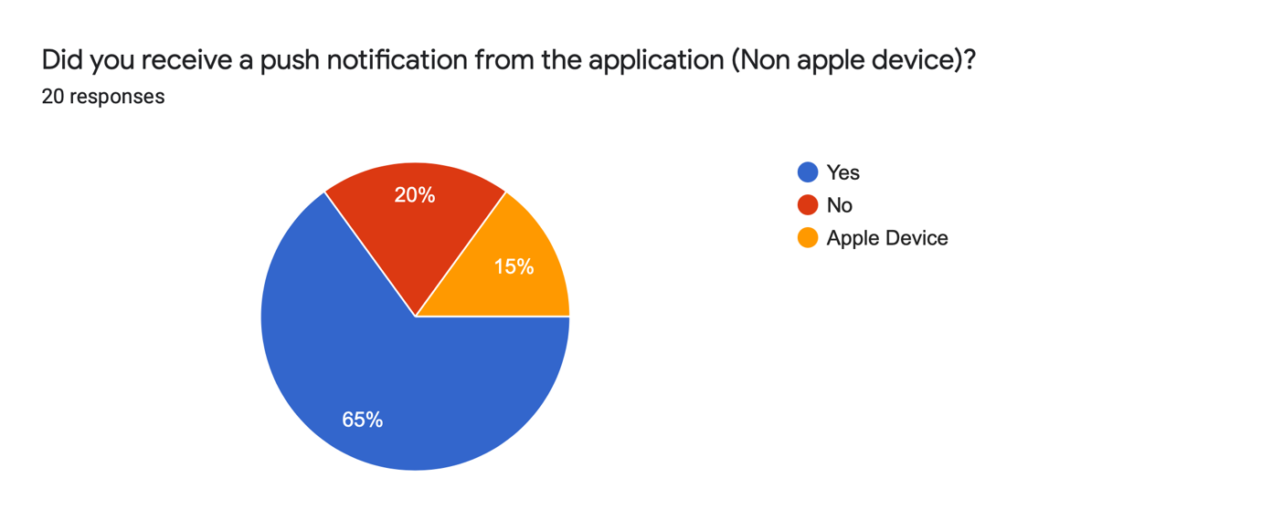
The other reason why the users did not receive a notification is that they could have used the application on a day where no stock dropped or increased by five percent or more. Therefore, no push notification needed to be sent meaning the application worked as intended.
Figure 30 - Question 8 Results
5.3.9 Question 9
The next major section of the questionnaire starts with this question looking at the usability attributes of the application. The first sub section is colours, and the question was asking the users opinion of the overall design of the website. As seen from the results in the Appendix 1 – Questionnaire Results all the responses are positive with good feedback expected. There was one response, R10 that stated some improvements.
R10: “Overall design is ok, but there's no click through on the top performers list, you cannot add them to a watchlist, and you cannot jump to the alerts with that stock prepopulated. The stocklist could be sorted alphabetically. You cannot see your alerts when looking at a specific stock. There's no daily/todays trade view, and there's no high-low range for the day and where it's currently positioned.”
These improvements do not hinder the use of the application, just give small functional features that could be added to system.

5.3.10 Question 10
This question is gathering data on the colours of the website. All the users that answered the questionnaire gave positive feedback on the colours. This was expected as the required research was done and development of the colours through the design and implementation section ensured that the colours were aesthetically pleasing to the users.

5.3.11 Question 11
The question that was asked was “Do you think you had to click too much to get what you were looking for?”. The results for this question were very positive as the all the users bar one user answered no, equating to ninety five percent as seen in Figure – 31. The only user that answered this question was with ‘No’ was R6. This user also answered question nine regarding the design as, “Very Clear” implying that that the navigation was the only problem. It can be assumed that this user is referring to searching for a stock taking too long to get to the details page.
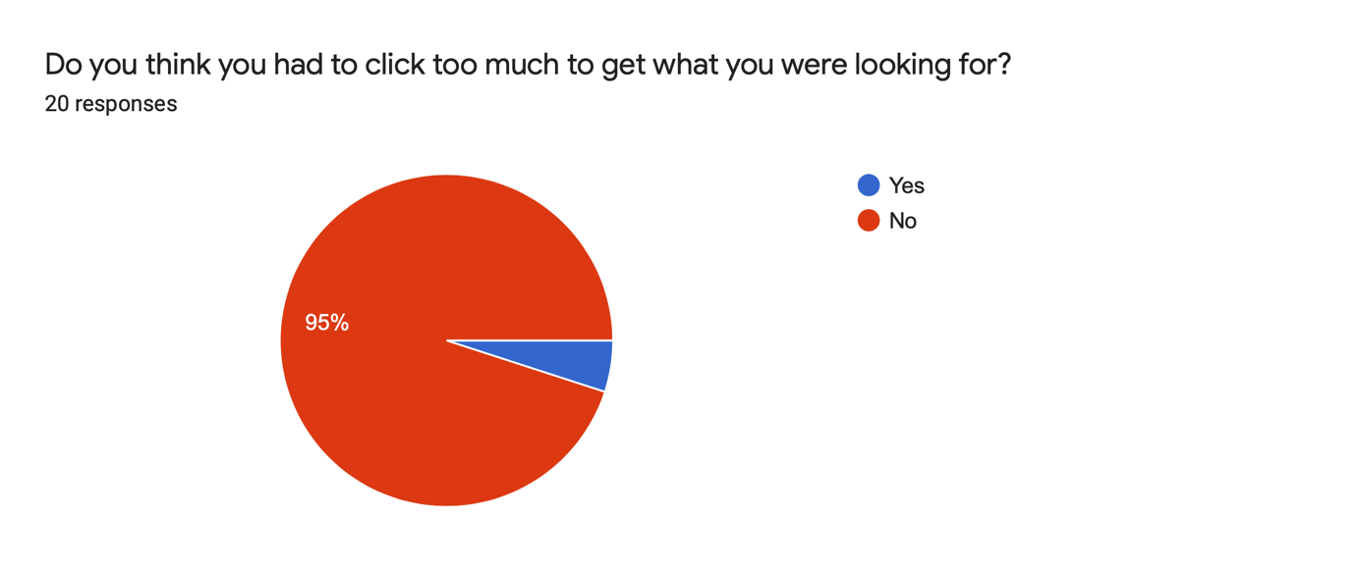
Figure 31 - Question 11 Results
5.3.12 Question 12
This question was expecting to get results on how well the pages rendered on the device the user is completing the tasks on. As seen in Figure – 32 all the users stated the paged rendered well in the browser and when it was installed. This shows that a PWA can be used successfully as an application for every device screen size.
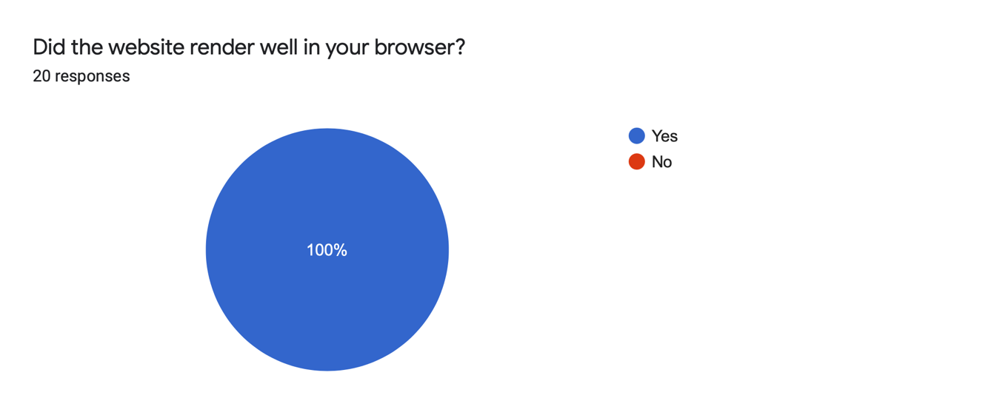
Figure 32 - Question 12 Results
5.3.13 Question 13
This question is in the subsection of performance. The aim for this was a high performance score with the majority of the users answers to be over seven out of ten. The reason for these expected results is the lighthouse score for desktop is high. The results, as shown in Figure – 33 demonstrate that ninety percent of the users thought the performance of the application was over six out of ten.
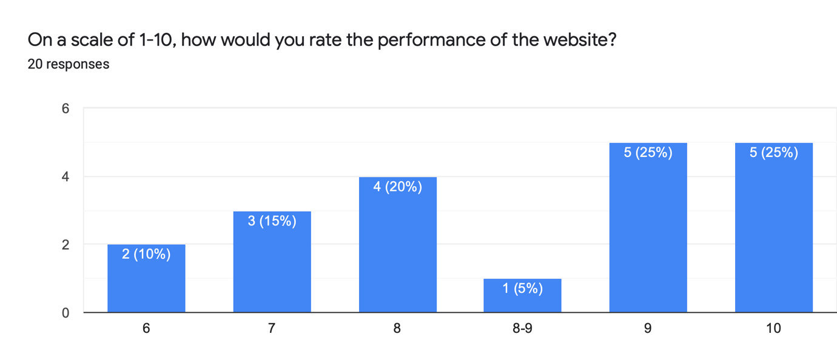
Figure 33 - Question 13 Results
A correlation in the data is that every user who accessed the application on a smartphone or tablet all gave the performance of the application an eight or above. This shows that a PWA can contend with a native application as the performance is so high. Also, this shows that even though the lighthouse score was low the frontend users marked the application as well performing.

5.3.14 Question 14
When looking at the results in the Appendix 5 – Questionnaire Results, only two users stated that they encountered errors while using the application. One of the errors they both mentioned in the comments, that the alerts page needed to be refreshed. This error is caused by the component on the screen not updating when the user inputs a new alert. The second error that only one user flagged up was the stock chart. It cannot be fully extended to the current date, the ‘all’ tab needs to be selected to see the full chart.
These errors do not affect the overall use of the application and only a small function of it and it is still usable with these bugs.

5.4 Focus Group
The results for the focus group can be found in the Appendix 6 – Focus Group Results. There were around 15 tasks that the user completed, a full list of all the tasks can be found in the Appendix 7 – Focus Group Tasks but only the main task is being used for analysis.

5.4.1 Task 1
The first task that the user completed was registering for an account and then logging in to the account that was previously created. This task was testing how many clicks the user needed to take to log into an account. The expected amount was seven as they needed to navigate to the register, click to type the username, click to type the password, press the form button, then repeat this on the login page. The first user completed this task as expected with the correct number of clicks, whereas the second user tabbed through the form leaving them with five click. Then the last user clicked the login page rather than waiting for the page to auto navigate them to it.
When looking at these results and comparing them to question eleven of the questionnaire, the results agree as the users did not feel like they had to click too much to get what they were looking for.

5.4.2 Task 2
Task two timed the users to see how long it would take for them to add an item to their watchlist. The results showed that the uses all took under seven seconds. This was expected to be short as the button stands out so much it is hard for the users to miss it on the page.

5.4.3 Task 3
For the final task there were two results taken, the number of clicks to install and the amount of time it took the users to work out how to install the application. As seen in Figure 34, it took all the users two clicks to install the application, the install button in the taskbar then confirming the install. The place where these results differed is the time it took the user to work out how to install the application. The first user was computer literate and knew how to install PWAs, therefore only taking him five seconds. The second user found the button simply and installed it without a problem. The third user took a while looking for the button, but with no help they located and installed it after fifteen seconds. These results agree with the questionnaire as all the results in the questionnaire are positive saying how easy the installation was of the application.

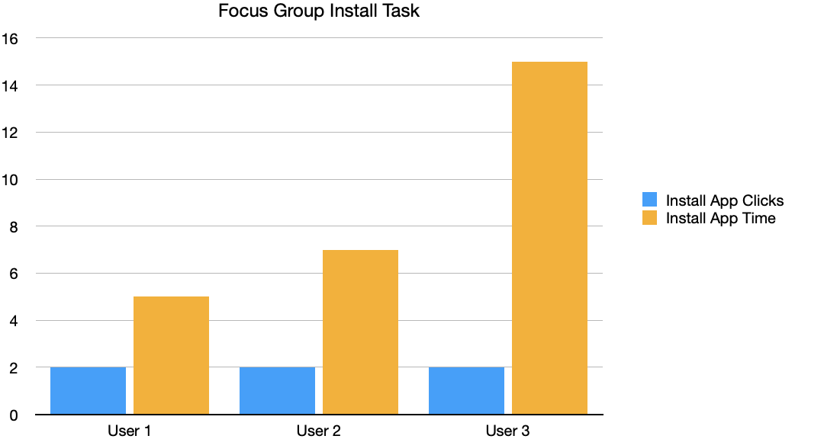
Figure 34 - Focus Group Task 3 Results
Chapter 6 – Evaluation
6.1 Chapter Introduction
This section breaks down the conclusion drawn from the study looking at all the data collected. Following the conclusion there is a section to analyse if the data met the literature review in the beginning of the study. Then an evaluation on the aims and objectives to see of the study met these points. Finally, a small section on the overall study and if there are any changes if the project was to be redone.

6.2 Conclusions Drawn
From the data that was collected on the usability aspects of the application developed, a positive conclusion can be drawn. When looking at the results gathered about the usability standpoint of the PWA, the conclusion can be positive as all the answers on the design and colour scheme were positive. Also, the focus group showed that the usability design was at a high quality. Therefore, the results show that the usability side of the PWA can be used as an application alongside or over a native application for the OS.
The PWA functionality covered the majority of things that a native application can also do. Firstly, the application can be installed with ease over a native phone application. This is backed up by the focus group data collected on the time taken and amount of taps it takes the users to install the PWA. Also, the questionnaire shows that all the users found the install process to be seamless and found the installed PWA more engaging over the web based version. Another conclusion that can be drawn from the data collected is that all the users installed the application no matter how computer literate they are. This shows that the installation process was understandable and easy from every user’s knowledge point.
The second aspect of the PWA is the push notification, this worked as a native application would have with two downfalls. The first downfall being that the notifications are only sent if the PWA is active when installed or if not installed then the browser used to install it is open. The second minor downfall of the push notifications is the compatibility of OS and devices. The notifications will not work if the application is being used on an iPhone, iPad or used in Safari. This is where a native application would work as its developed for each specific device and OS. Overall, when looking at the results from the data gathered all the users except from four that were expected to receive a notification did. Therefore, when using PWA push notifications they can hold up well against native applications.
The final aspect of the PWA when comparing it to a native application is the offline content. There was a problem incorporating this in the project, but native applications have an easier way of doing it because those application types have more access to onboard storage.

6.3 Back up Research
As mentioned in the literature review PWAs have a shorter development time than rivalling applications. This is the case as the one PWA that was developed for this project can be run on any device that has a web browser and can be installed to any device that supports it. Also, it was developed using one codebase whereas a native application is developed differently for each device and devices OS.
When looking at the literature review the data collected backs up the performance mentioned of a PWA. The review states that using the modern web technology languages it can improve performance therefore engaging the user for longer. The lighthouse score for desktop performance is high and all the user that used the PWA and answered the questionnaire scored the performance high.
The literature review states that the accessibility and usability is easy to implement. As the PWA uses CSS so when the page is resizes the windows can dynamically react to show the content in the best way. This makes the responsiveness reliable and keeps consistency through the PWA when viewed on any screen size.
As mentioned this study was unable to implement caching content for offline use as the feature is still in its infancy. It was observed in the literature review that some devices and OS support showing the user offline cached content and informing them that the device is offline and the content they are seeing is from the offline content.

6.4 Project Aim
The project aim was to research and evaluate the functionally, feature usability and requirement specification criteria for a PWA. The aim was met throughout the project as the all the objectives are broken down from the main aim and they were all met successfully. The main evaluation of the features and use of the features was done by analysing all the available data collected and ensuring that it supports the successful use of these features.

6.5 Project Objectives
The first objective of this paper was to research the technologies and specification criteria that a web application needs to meet to qualify as an official PWA. This was gathered in the literature review and backed up by the lighthouse testing criteria.
Using the results of the first objective, the second objective of the paper was to design, develop and implement a PWA using requirements, therefore allowing all the functionality a PWA requires to be included in the development. This objective was met as the lighthouse testing tool states that the developed application meets all the requirements and is an official PWA. These features that were included are installability, PWA optimised and performance.
The third and final objective of this study was to evaluate the functionality and usability of a PWA from the user’s point of view, looking at the ease of installation and usability comparing it to the other application offered. This objective was complete in multiple sections, firstly the gathering of data was undertaken so that the user’s point of view could be evaluated. Once this was complete the evaluation of installing the PWA and usability was complete in the analysis and evaluation section.

6.6 Expected Outcomes
When looking at the study all the answers except one or two were as expected. One of the answers that was not expected was the cashing content. This was expected to work so the user could access content when the device was offline. As the result was not expected the question needed to be cut from the questionnaire and the focus group.

6.7 Further Work
If this study was repeated, the first change would be focusing more on the process behind the PWA and how they work over the frontend. This change would make the study more in depth to the technologies behind a PWA and therefore may give different results. The problem with this change would be there would be a lesser understanding on the whole process of the PWA and more on the backend and how they work rather than the implementation.
Another change would be to complete more focus groups. A reason for completing so little is COVID-19 did not allow for meeting of people and completing these focus groups. If the study had a wider audience the results could have potentially been more reliable or shown different conclusions when analysing the data.
Chapter 7 – Conclusion and Recommendations
7.1 Chapter Introduction
This chapter concludes the study. The first section is the summary of the project, following this is the conclusion of the main aims and objectives. The final section then covers any further work and recommendations.

7.2 Summary
This project was set out to research the specification criteria and develop a functional PWA. Chapter two was used to research and gather the knowledge required to complete the study. The following chapter was used for the main methodology for the project, looking at the research onion and then development methodology. The fourth chapter was the design and implementation, ensuring that the design and development meet the requirements. Then chapter five, this chapter was the data collection from the different methods used.

7.3 Conclusion
The aim for this project was to research and evaluate the functionality, feature usability and requirement specification criteria for a progressive web application. This allowed for the gathering of the specification criteria of what a PWA is defined as. Using this the author was able to implement a successful PWA to be used for data collection. The overall objectives of the project were as follows:
- To research the PWA technology and specification criteria that a web application needs to meet to qualify as an official PWA.
- To design, develop and implement a PWA using all the requirements researched. This will allow all the functionality a PWA requires to be included. It will be achieved by developing the PWA using web technology languages and a JavaScript library.
- To evaluate the functionality usability of a PWA from the user’s point of view. Looking at the ease of installation and usability comparing it to the other applications offered.
These objectives gave structure to the study as the second chapter was able to meet the first object by researching the main criteria that was needed. Following this the third chapter was the data collection methods, which ensures an accurate evaluation. The design and implementation section allowed for planning of the main development of the PWA and how it would work.
The key result from this project was the development piece, the developed PWA was a considered a success that allowed the testing on.

7.4 Further Work and Recommendations
This project outlined different areas for further research. One of these being the commercial use of PWAs for a major application type like a social media application. Another area is the content of a PWA and if it is able to successfully include offline storage on the local device. This will allow the application to stand against a native application with more strength. The final area for further research is looking in to if the frontend of the PWA stays the same using ReactJS, but the backend and database server changed to PHP and SQL. This would be an interesting item to test and analyse the speed difference and performance of the application when the backend is different, but the user’s interaction is the same.

Chapter 8 – Reflection
8.1 Chapter Introduction
This chapter is used to discuss my feelings of the project. The chapter will look at the overall positive and negatives of the project after completion then conclude the outcome of the project.

8.2 Positives
I had many positives to take away from this project. Firstly, the collection of the related work in the second chapter. This section gave me the knowledge that I did not previously have. From gathering this background knowledge, I was clearer on how the project was going to be formulated. Following this I undertook the methodology chapter. This gave me a clear understanding on the methods to follow to complete the project to a high standard.
Another positive that I found is the implementation process. I had very limited experience in the technologies used in this study therefore completing a working PWA was considered a success. Finally, a positive skill that I developed was time management. The project required many actions to be completed by a fixed dead-line so managing the time spent on each individual item was essential, the project was completed on-time so the time-management planning can be considered a success. Using a Gantt chart enabled the me to plan the written chapters and also the implementation. The development of the PWA was hard to plan as there can be many unforeseen issues that can occur during a large project, but detailed planning with some contingency ensured the project was completed on-time.

8.3 Negatives
I found the deployment part of the PWA a difficulty. If there was research completed on the way PWAs are deployed in chapter two this could have helped, but there was an oversite on the research of the development looking at this aspect. The second negative for the project is looking at different technologies for the backend of the project as this could have improved the overall performance of the lighthouse score.

8.4 Conclusion
The skills learnt from conducting this study will ensure that any other large project that I complete will be finished to a high standard. The time management aspects of this project will allow all future project to be planned extensively and correctly as this one was. Finally, the development skills that I learnt in this study will carry me on to any other development task in the future. The ability to improve development skills and languages not previously known by completing side projects that build knowledge and understanding documentation, will allow for the quick understanding of new development techniques and languages.
I believe the completion of the project can be considered an overall success. The main reason for this being that the aims and objectives of the study, which were set out in the introduction, have all been met. Also, the data gathered from the study was as expected which can be a key factor when deciding on a project's success. On reflection, one improvement of the project could have been to allocate more time to the development phase to address any small bugs and improve the overall performance.
Chapter 9 – References
[1] W. S. El-Kassas, B. A. Abdullah, A. H. Yousef, and A. M. Wahba, “Taxonomy of Cross-Platform Mobile Applications Development Approaches,” Ain Shams Eng. J., vol. 8, no. 2, pp. 163–190, Jun. 2017.
[2] L. Corral, A. Janes, and T. Remencius, “Potential advantages and disadvantages of multiplatform development frameworks - A vision on mobile environments,” Procedia Comput. Sci., vol. 10, pp. 1202–1207, 2012.
[3] F. Ricca and P. Tonella, “Analysis and testing of web applications,” Proc. - Int. Conf. Softw. Eng., pp. 25–34, 2001.
[4] J. W. Ligman, M. Pistoia, J. Ponzo, and G. Thomas, “Automatically Rendering Web or Hybrid Applications Natively,” vol. 2, no. 12, 2016.
[5] P. Saccomani, “Native Apps, Web Apps or Hybrid Apps? What’s the Difference?” [Online]. Available: https://www.mobiloud.com/blog/native-web-or-hybrid-apps. [Accessed: 12-Oct-2020].
[6] E. Toonen, “What is a progressive web app (PWA)? Why would you want one?,” 2020. [Online]. Available: https://yoast.com/what-is-a-progressive-web-app-pwa/. [Accessed: 12-Oct-2020].
[7] P. LePage and S. Richard, “What are Progressive Web Apps?,” 2020. [Online]. Available: https://web.dev/what-are-pwas/. [Accessed: 27-Oct-2020].
[8] S. Kapoor, “Progressive Web Apps 101: the What, Why and How,” 2018. [Online]. Available: https://www.freecodecamp.org/news/progressive-web-apps-101-the-what-why-and-how-4aa5e9065ac2/. [Accessed: 27-Oct-2020].
[9] “XMLHttpRequest,” 2020. [Online]. Available: https://javascript.info/xmlhttprequest. [Accessed: 19-Oct-2020].
[10] S. Morris, “AJAX—What It Is, How It Works, and What It’s Used For.” [Online]. Available: https://skillcrush.com/blog/what-is-ajax/. [Accessed: 20-Oct-2020].
[11] S. Jobs, “Steve Jobs introducing PWA in 2007,” 2007. [Online]. Available: https://www.youtube.com/watch?v=QvQ9JNm_qWc. [Accessed: 28-Apr-2021].
[12] ScandiPWA, “History of Progressive Web Apps,” 2019. [Online]. Available: https://medium.com/progressivewebapps/history-of-progressive-web-apps-4c912533a531. [Accessed: 29-Oct-2020].
[13] A. Russell, “Progressive Web Apps: Escaping Tabs Without Losing Our Soul,” 2015. [Online]. Available: https://infrequently.org/2015/06/progressive-apps-escaping-tabs-without-losing-our-soul/. [Accessed: 29-Oct-2020].
[14] Microsoft, “Welcoming Progressive Web Apps to Microsoft Edge and Windows 10,” 2018. [Online]. Available: https://blogs.windows.com/msedgedev/2018/02/06/welcoming-progressive-web-apps-edge-windows-10/. [Accessed: 30-Oct-2020].
[15] I. Blair, “Mobile App Download and Usage Statistics (2020),” 2020. [Online]. Available: https://buildfire.com/app-statistics/. [Accessed: 22-Oct-2020].
[16] N. D. Kho, “Everything You Need To Know About Progressive Web Apps,” 2018.
[17] M. Mihajlija, “Adaptive serving based on network quality,” 2019. [Online]. Available: https://web.dev/adaptive-serving-based-on-network-quality/. [Accessed: 05-Nov-2020].
[18] P. LePage and S. Richard, “What makes a good Progressive Web App?,” 2020. [Online]. Available: https://web.dev/pwa-checklist/. [Accessed: 05-Oct-2020].
[19] Hume Alan Dean, “Progressive Web Apps: A New Hope,” Google, no. December, p. 1, 2018.
[20] P. LePage, “How to provide your own in-app install experience,” 2020. [Online]. Available: https://web.dev/customize-install/. [Accessed: 06-Oct-2020].
[21] V. Radhakishan and S. Selvakumar, “Prevention of man-in-the-middle attacks using ID based signatures,” Proc. - 2nd Int. Conf. Netw. Distrib. Comput. ICNDC 2011, pp. 165–169, 2011.
[22] Microsoft, “Progressive Web Apps on Windows,” 2020. [Online]. Available: https://docs.microsoft.com/en-us/microsoft-edge/progressive-web-apps-chromium/. [Accessed: 06-Oct-2020].
[23] Google, “Secure your site with HTTPS.” [Online]. Available: https://developers.google.com/search/docs/advanced/security/https?hl=en&visit_id=637407814248454906-1726372053&rd=1. [Accessed: 06-Oct-2020].
[24] O. Linden, “Achieving native-like experience on the web with progressive web apps,” 2020.
[25] Mozilla, “Add to Home screen.” [Online]. Available: https://developer.mozilla.org/en-US/docs/Web/Progressive_web_apps/Add_to_home_screen. [Accessed: 06-Oct-2020].
[26] Samsung, “Ambient Badging.” [Online]. Available: https://hub.samsunginter.net/docs/ambient-badging/. [Accessed: 06-Oct-2020].
[27] Mozilla, “Push API.” [Online]. Available: https://developer.mozilla.org/en-US/docs/Web/API/Push_API. [Accessed: 06-Oct-2020].
[28] Mozilla, “Notifications API.” [Online]. Available: https://developer.mozilla.org/en-US/docs/Web/API/Notifications_API. [Accessed: 06-Oct-2020].
[29] Mozilla, “How to make PWAs re-engageable using Notifications and Push.” [Online]. Available: https://developer.mozilla.org/en-US/docs/Web/Progressive_web_apps/Re-engageable_Notifications_Push. [Accessed: 06-Oct-2020].
[30] L. Vu, “How to Integrate Geolocation Into Your PWA,” 2020. [Online]. Available: https://www.simicart.com/blog/pwa-geolocation/. [Accessed: 30-Nov-2020].
[31] L. Vu, “PWA Hardware Access,” 2020. .
[32] A. Bar, “Advanced Camera Controls,” 2020. .
[33] A. Bar, “Shape Detection,” 2020. [Online]. Available: https://whatwebcando.today/shape-detection.html. [Accessed: 30-Nov-2020].
[34] A. Bar, “Speech Recognition,” 2020. [Online]. Available: https://whatwebcando.today/speech-recognition.html. [Accessed: 30-Nov-2020].
[35] P. LePage, “Device Orientation & Motion - Device coordinate frame,” 2020. [Online]. Available: https://developers.google.com/web/fundamentals/native-hardware/device-orientation#device_coordinate_frame. [Accessed: 30-Nov-2020].
[36] P. LePage, “Device Motion,” 2020. [Online]. Available: https://developers.google.com/web/fundamentals/native-hardware/device-orientation#device_motion. [Accessed: 30-Nov-2020].
[37] D. Sarria, “Benefits of Progressive Web Apps (PWAs),” 2020. [Online]. Available: https://www.hammer.net/blog/benefits-of-pwas/. [Accessed: 14-Dec-2020].
[38] Mozilla, “Web app manifests.” .
[39] M. Gaunt, “Service Workers: an Introduction,” 2020. [Online]. Available: https://developers.google.com/web/fundamentals/primers/service-workers. [Accessed: 17-Apr-2021].
[40] N. Lama, “Providing Native Experiences in Mobile with PWA,” vol. 20, no. November, p. 37, 2019.
[41] I. Malavolta, G. Procaccianti, P. Noorland, and P. Vukmirovic, “Assessing the Impact of Service Workers on the Energy Efficiency of Progressive Web Apps,” Proc. - 2017 IEEE/ACM 4th Int. Conf. Mob. Softw. Eng. Syst. MOBILESoft 2017, pp. 35–45, 2017.
[42] A. Biørn-Hansen, T. A. Majchrzak, and T. M. Grønli, “Progressive web apps: The possibleweb-native unifier for mobile development,” WEBIST 2017 - Proc. 13th Int. Conf. Web Inf. Syst. Technol., no. Webist, pp. 344–351, 2017.
[43] E. Wohlgethan, “Bachelorarbeit Comparing Three Major JavaScript Frameworks,” 2018.
[44] E. Saks, “JavaScript frameworks: Angular vs React vs Vue,” 2019.
[45] J. Han, E. Haihong, G. Le, and J. Du, “Survey on NoSQL database,” Proc. - 2011 6th Int. Conf. Pervasive Comput. Appl. ICPCA 2011, pp. 363–366, 2011.
[46] M. Stonebraker, “SQL databases v. NoSQL databases,” Commun. ACM, vol. 53, no. 4, pp. 10–11, 2010.
[47] “Advantages and Disadvantages of SQL,” 2020. [Online]. Available: https://www.geeksforgeeks.org/advantages-and-disadvantages-of-sql/. [Accessed: 17-Apr-2021].
[48] R. Harrison, D. Flood, and D. Duce, “Usability of mobile applications: literature review and rationale for a new usability model,” J. Interact. Sci., vol. 1, no. 1, p. 1, 2013.
[49] A. Saleh, R. Bintiisamil, and N. B. Fabil, “Extension of pacmad model for usability evaluation metrics using goal question metrics (Gqm) approach,” J. Theor. Appl. Inf. Technol., vol. 79, no. 1, pp. 90–100, 2015.
[50] Warwick, “Positivism,” 2020. [Online]. Available: https://warwick.ac.uk/fac/soc/ces/research/current/socialtheory/maps/positivism/. [Accessed: 12-Mar-2021].
[51] N. Blaikie and J. Priest, Designing Social Research, 3rd ed. Cambridge: Polity Press, 2019.
[52] L. Pham, “A Review of key paradigms: positivism, interpretivism and critical inquiry.,” ResearchGate, no. April, pp. 1–7, 2018.
[53] J. Dudovskiy, “Deductive Approach (Deductive Reasoning),” 2018. .
[54] L. Doyle, A. M. Brady, and G. Byrne, “An overview of mixed methods research,” J. Res. Nurs., vol. 14, no. 2, pp. 175–185, 2009.
[55] B. Gillham, Developing a Questionnaire, 2nd ed. A&C Black, 2008.
[56] R. Mazza, “Evaluating information visualization applications with focus groups: The CourseVis experience,” Proc. BELIV’06 BEyond time errors - Nov. Eval. methods Inf. Vis. A Work. AVI 2006 Int. Work. Conf., 2006.
[57] A. Gibbs, “What are focus groups ? Why use focus groups and not other methods ?,” Soc. Res. Updat., no. 19, pp. 1–8, 1997.
[58] A. F. Marrelli, “Collecting data through focus groups,” Perform. Improv., vol. 47, no. 4, pp. 39–45, 2008.
[59] Google, “Lighthouse PWA Analysis Tool,” 2019. [Online]. Available: https://developers.google.com/web/ilt/pwa/lighthouse-pwa-analysis-tool. [Accessed: 06-Apr-2021].
[60] J. Crossley and D. Jansen, “Saunders’ Research Onion: Explained Simply,” 2021. [Online]. Available: https://gradcoach.com/saunders-research-onion/. [Accessed: 07-Apr-2021].
[61] S. M. Sincero, “Methods of Survey Sampling,” 2012. [Online]. Available: https://explorable.com/methods-of-survey-sampling. [Accessed: 07-Apr-2021].
[62] Explorable.com, “Quota Sampling,” 2009. [Online]. Available: https://explorable.com/quota-sampling. [Accessed: 07-Apr-2021].
[63] TechTarget, “statistical analysis,” 2020. [Online]. Available: https://whatis.techtarget.com/definition/statistical-analysis. [Accessed: 09-Apr-2021].
[64] E. Myers, “How to Conduct Online Focus Group Interviews,” 2020. [Online]. Available: https://www.rev.com/blog/how-to-conduct-online-focus-group-interviews-2. [Accessed: 09-Apr-2021].
[65] S. Kulshrestha, “What Is Agile Methodology — Know the What and How?,” 2019. [Online]. Available: https://medium.com/edureka/what-is-agile-methodology-fe8ad9f0da2f. [Accessed: 05-Jan-2021].
[66] R. H. Sampieri and T. E, “Agile Handbook,” p. 634, 2016.
[67] R. Lynn, “What is FDD in Agile?” [Online]. Available: https://www.planview.com/resources/articles/fdd-agile/. [Accessed: 11-Apr-2021].
[68] A. F. Chowdhury and M. N. Huda, “Comparison between adaptive software development and feature driven development,” Proc. 2011 Int. Conf. Comput. Sci. Netw. Technol. ICCSNT 2011, vol. 1, pp. 363–367, 2011.
[69] M. Cohn, User stories applied : for agile software development. 2004.
[70] W. Lim, “A Beginner’s Guide to Wireframing,” 2020. [Online]. Available: https://webdesign.tutsplus.com/articles/a-beginners-guide-to-wireframing--webdesign-7399. [Accessed: 06-Jan-2020].
[71] J. Chen et al., “Wireframe-based UI Design Search through Image Autoencoder,” ACM Trans. Softw. Eng. Methodol., vol. 29, no. 3, 2020.
[72] K. Beck et al., “Manifesto for Agile Software Development,” 2001. .
[73] M. Rouse, “Agile Software Development,” 2019. [Online]. Available: https://searchsoftwarequality.techtarget.com/definition/agile-software-development. [Accessed: 05-Jan-2021].
[74] N. Babich, “What is Rapid Prototyping?,” 2019. [Online]. Available: https://xd.adobe.com/ideas/process/prototyping/rapid-prototyping-efficient-way-communicate-ideas/. [Accessed: 01-Apr-2021].
[75] A. K. Hota and D. M. Prabhu, “NODE.JS: Lightweight, Event driven I/O web development As,” Informatics, vol. 22, no. 3, pp. 30–31, 2014.
[76] Tower, “What is Version Control?” [Online]. Available: https://www.git-tower.com/learn/git/ebook/en/command-line/basics/what-is-version-control/#start. [Accessed: 07-Jan-2021].
[77] Tower, “Why Use a Version Control System?” [Online]. Available: https://www.git-tower.com/learn/git/ebook/en/command-line/basics/why-use-version-control/. [Accessed: 07-Jan-2021].
[78] Usability, “User Interface Design Basics.” [Online]. Available: https://www.usability.gov/what-and-why/user-interface-design.html. [Accessed: 21-Apr-2021].
[79] InteractionDesign, “Intuitive Design.” [Online]. Available: https://www.interaction-design.org/literature/topics/intuitive-design. [Accessed: 21-Apr-2021].
[80] T. Fessenden, “Horizontal Attention Leans Left,” 2017. [Online]. Available: https://www.nngroup.com/articles/horizontal-attention-leans-left/. [Accessed: 01-Apr-2021].
[81] O. Akindunjoye, “Visual perception in user experience design,” 2019. [Online]. Available: https://uxdesign.cc/visual-perception-in-user-experience-design-7943c97b14f4. [Accessed: 01-Apr-2021].
[82] G. C. Stanczak, “Visual Representation,” in American Behavioral Scientist, 2nd ed., vol. 47, no. 12, 2004, pp. 1471–1476.
[83] J. Nielsen, “Short-Term Memory and Web Usability,” 2009. .
[84] V. Kaptelinin, “Affordances,” in The Encyclopedia of Human-Computer Interaction, 2nd ed., .
[85] I. E. Gordon, Theories of Visual Perception. Psychology Press, 2004.
[86] S. Aggarwal and J. Verma, “Comparative analysis of MEAN stack and MERN stack,” Int. J. Recent Res. Asp., vol. 5, no. 1, pp. 127–132, 2018.
[87] MongoDB, “MERN Stack.” [Online]. Available: https://www.mongodb.com/mern-stack. [Accessed: 20-Apr-2021].
[88] NoobCoder, “MERN Stack : Authentication and Authorization(JWT),” 2020. [Online]. Available: https://www.youtube.com/playlist?list=PLvTjg4siRgU0HS3cANo7KZ52Wkud083TL. [Accessed: 28-Apr-2021].

10 Appendices
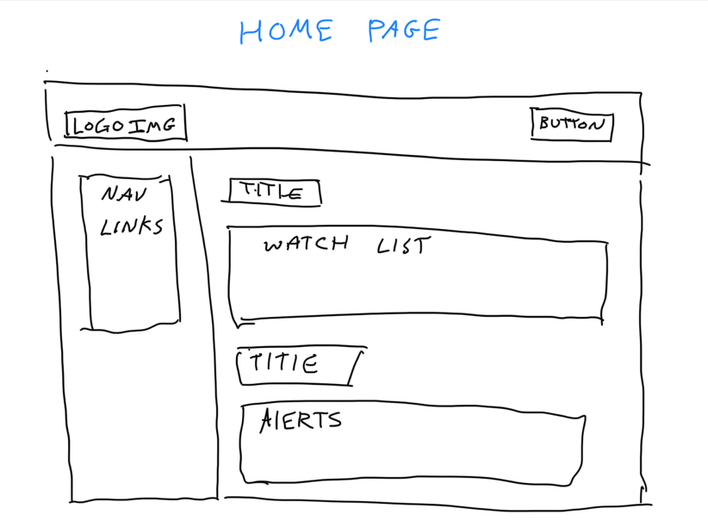
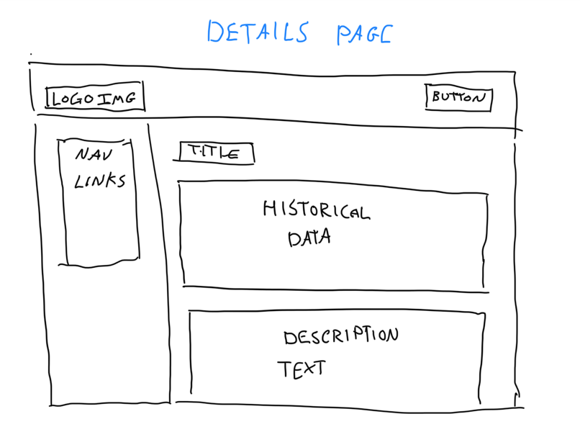
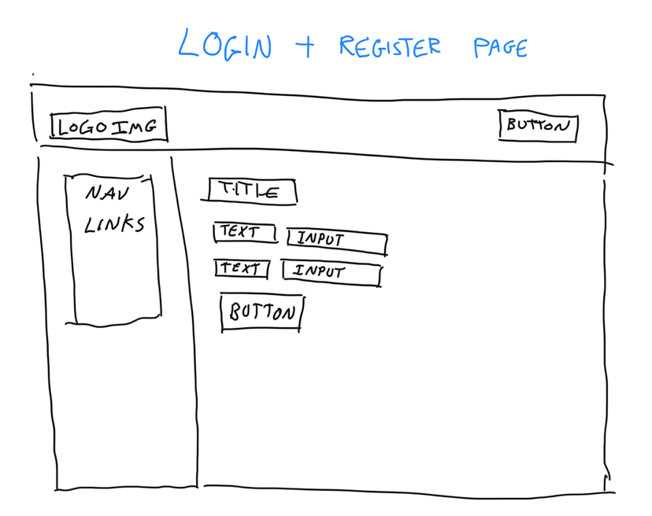
10.1 Appendix 1 – Wire Frame Diagram
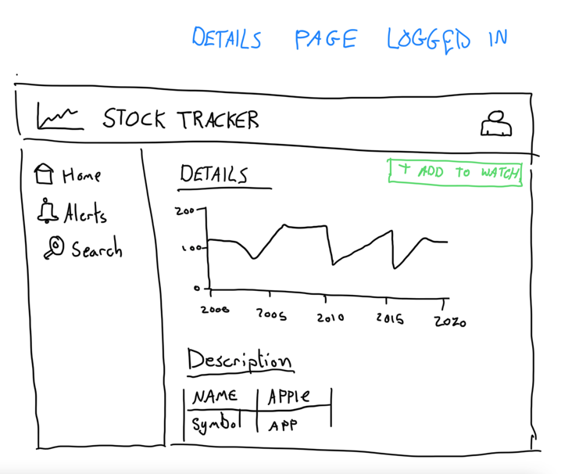
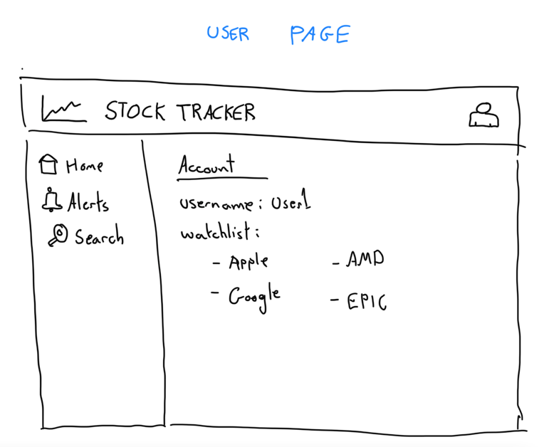
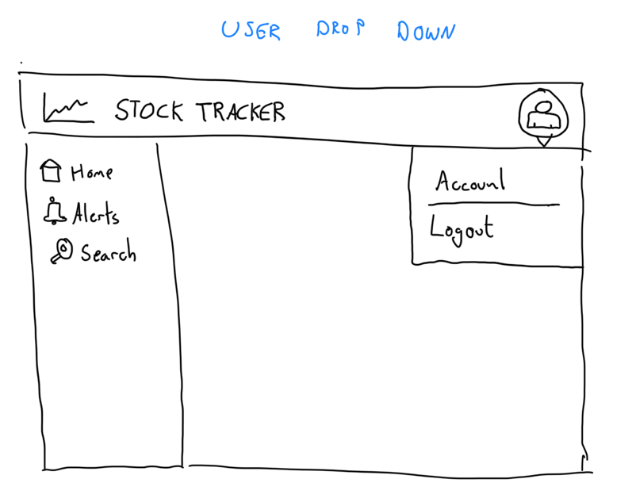
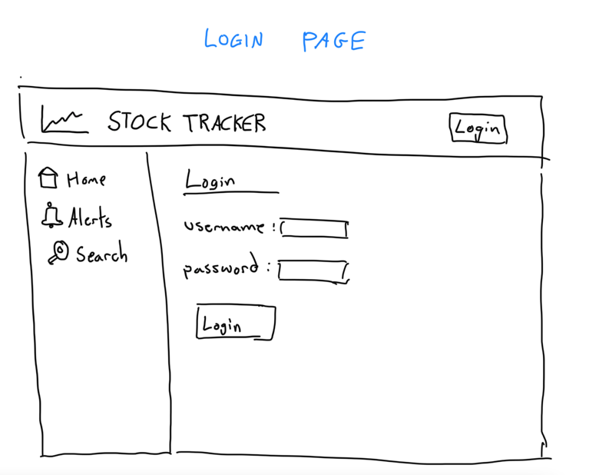
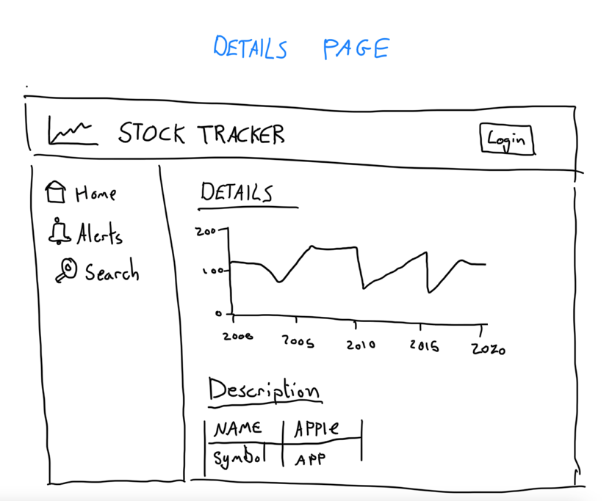
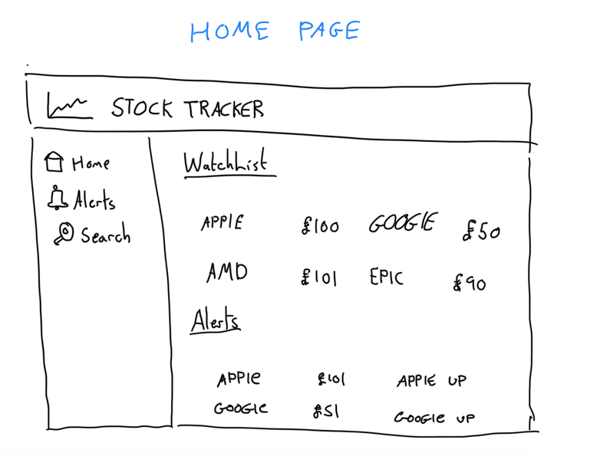
10.2 Appendix 2 – Paper Prototype

10.3 Appendix 3 – Software Prototype Version 1
10.3.1 Home Page
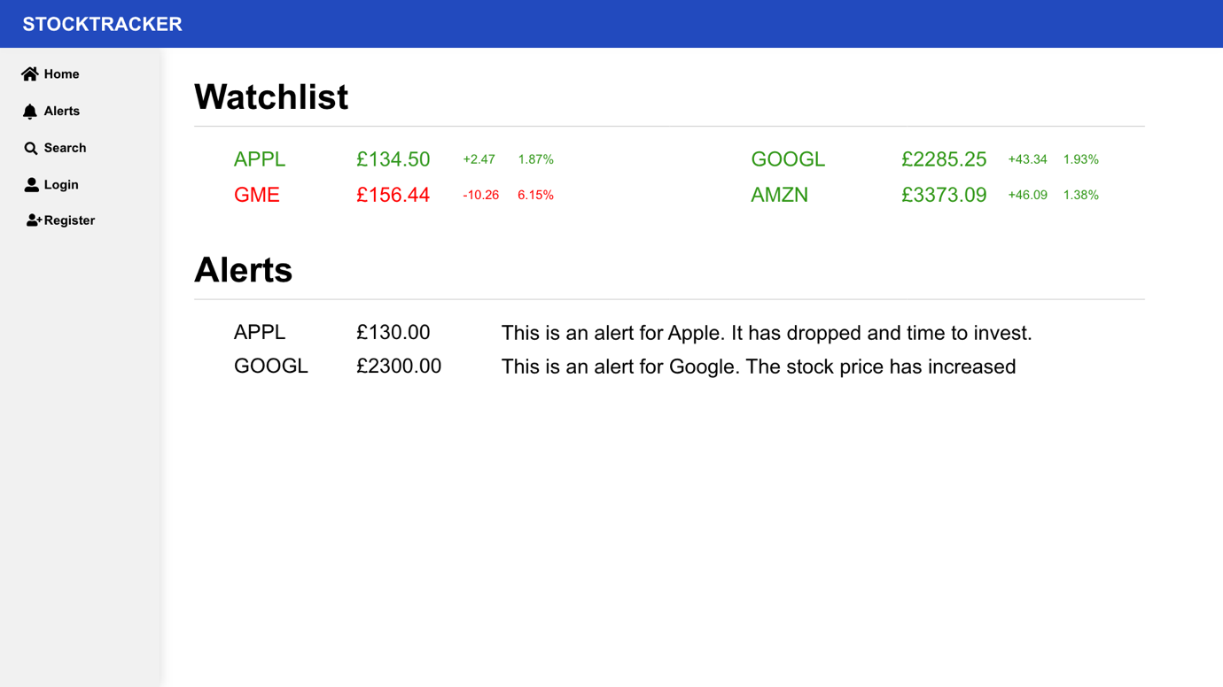

10.3.2 Details Page
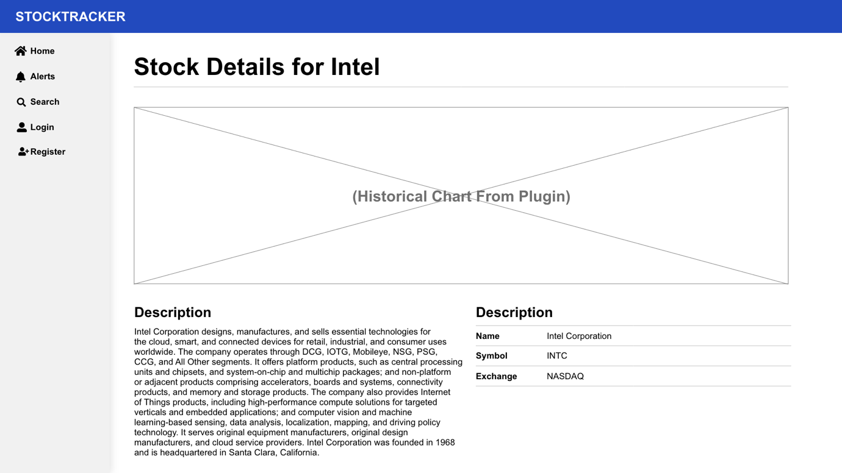

10.3.3 Details Page Logged in
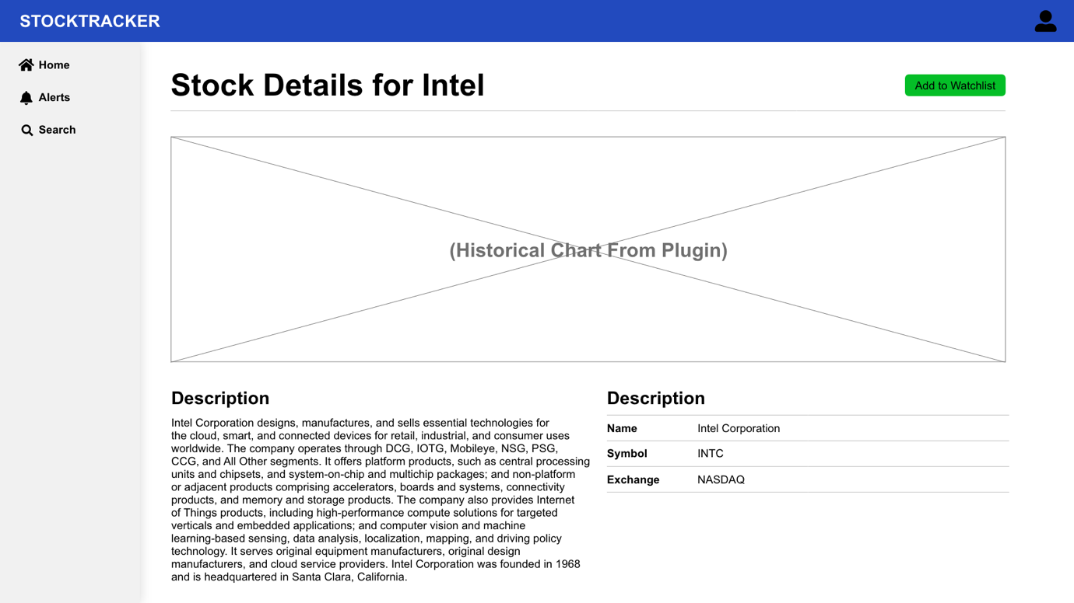

10.3.4 Login Page
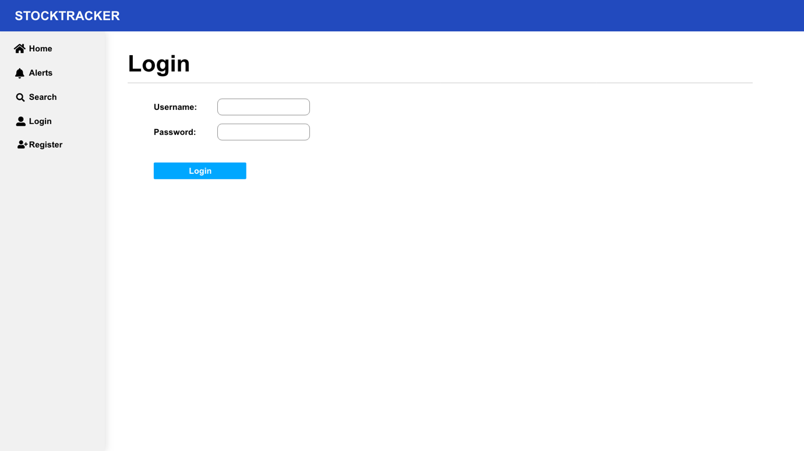

10.3.5 User Dropdown Page
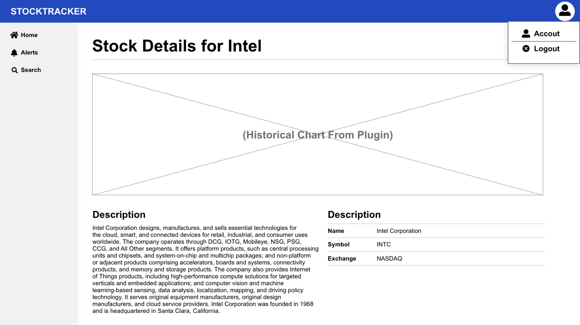

10.3.6 User Page
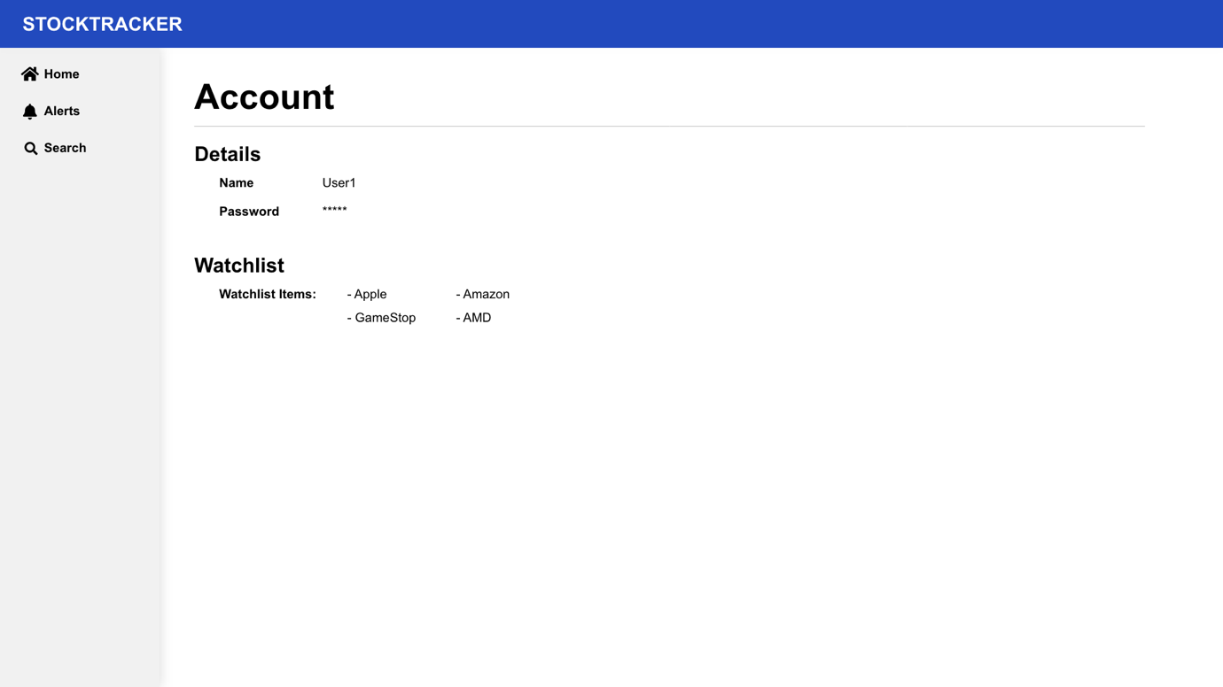

10.4 Appendix 4 – Software Prototype Version 2
10.4.1 Home Page
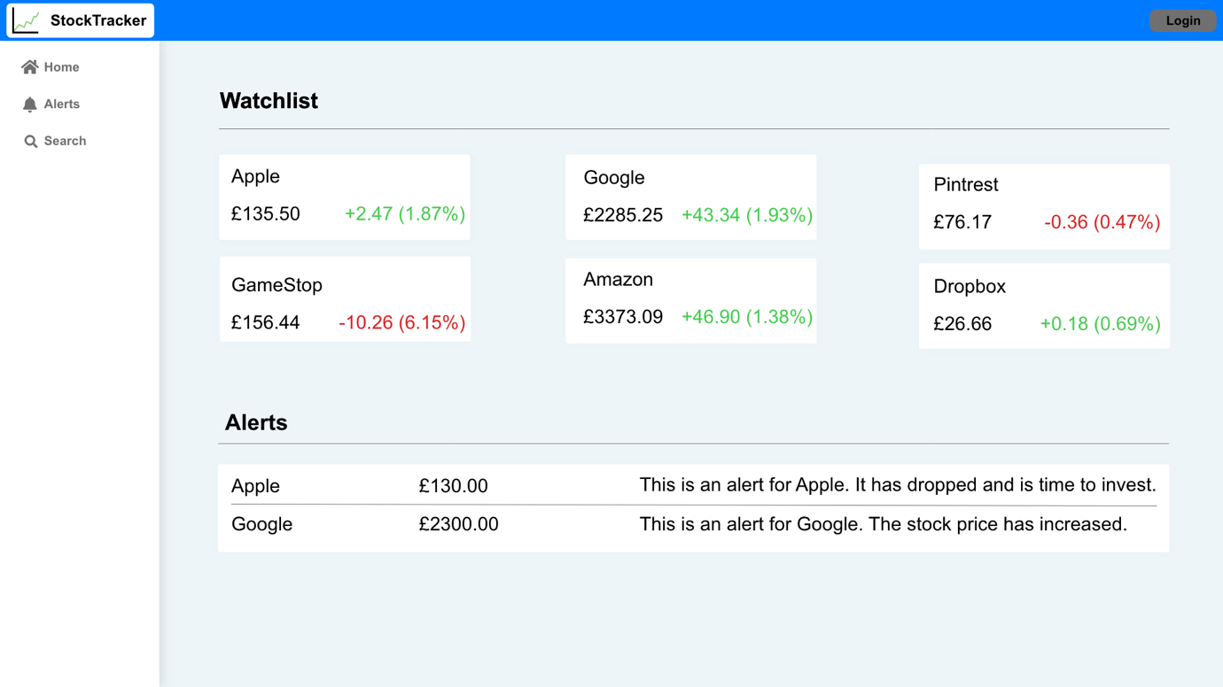

10.4.2 Details Page
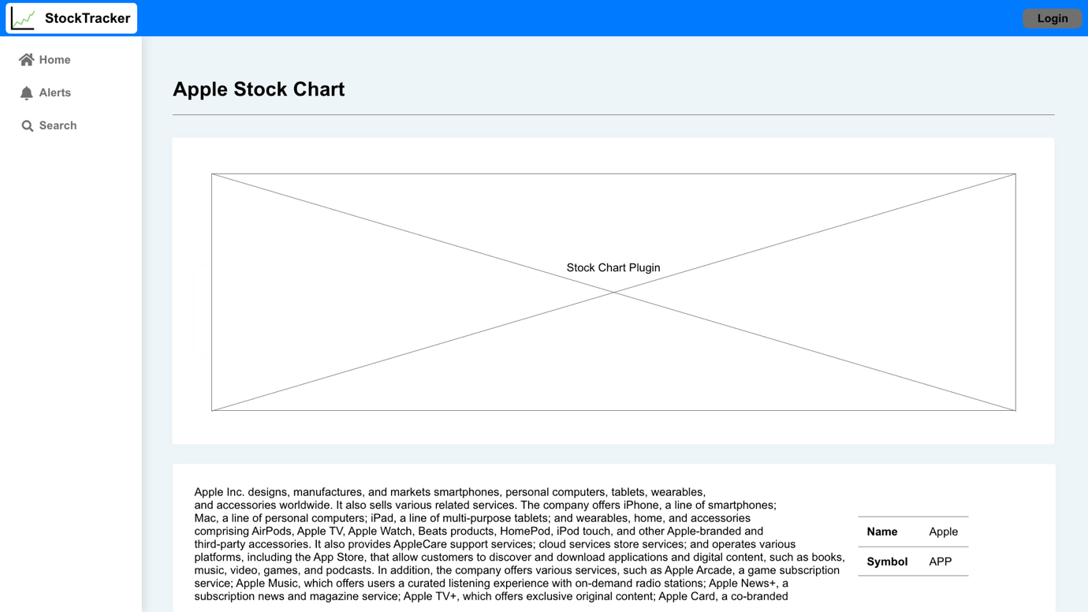

10.5 Appendix 4 – Questionnaire Results
10.5.1.1 Question 1
Table 1 - Questionnaire Results Question 1
User | How Old Are You?
R1 | 18 - 24
R2 | 18 - 24
R3 | 45 - 54
R4 | 35 - 44
R5 | 25 - 34
R6 | 45 - 54
R7 | 45 - 54
R8 | 35 - 44
R9 | 25 - 34
R10 | 18 - 24
R11 | 18 - 24
R12 | 35 - 44
R13 | 35 - 44
R14 | 25 - 34
R15 | 25 - 34
R16 | 25 - 34
R17 | 18 - 24
R18 | 25 - 34
R19 | 45 - 54
R20 | 35 - 44

10.5.1.2 Question 2
Table 2 - Questionnaire Results Question 2
User | What device have you used to access the application?
R1 | Desktop PC
R2 | Laptop
R3 | Tablet
R4 | Laptop
R5 | Desktop PC
R6 | Tablet
R7 | Desktop PC
R8 | Tablet
R9 | Desktop PC
R10 | Smart Phone
R11 | Tablet
R12 | Desktop PC
R13 | Desktop PC
R14 | Smart Phone
R15 | Laptop
R16 | Laptop
R17 | Laptop
R18 | Laptop
R19 | Smart Phone
R20 | Desktop PC

10.5.1.3 Question 3
Table 3 - Questionnaire Results Question 3
User | How would you describe your computer literacy?
R1 | Proficient Computing, Application Use and Programming
R2 | Proficient Computing, Application Use and Programming
R3 | Advanced Computing and Application Use
R4 | Intermediate Computing and Application Use
R5 | Advanced Computing and Application Use
R6 | Basic Computing and Application Use
R7 | Proficient Computing, Application Use and Programming
R8 | Advanced Computing and Application Use
R9 | Proficient Computing, Application Use and Programming
R10 | Basic Computing and Application Use
R11 | Advanced Computing and Application Use
R12 | Advanced Computing and Application Use
R13 | Proficient Computing, Application Use and Programming
R14 | Advanced Computing and Application Use
R15 | Advanced Computing and Application Use
R16 | Intermediate Computing and Application Use
R17 | Basic Computing and Application Use
R18 | Intermediate Computing and Application Use
R19 | Fundamental Skills (Typing, Mouse use)
R20 | Intermediate Computing and Application Use

10.5.1.4 Question 4
Table 4 - Questionnaire Results Question 4
User | Did you successfully install the application to your homepage or dock?
R1 | Yes
R2 | Yes
R3 | Yes
R4 | Yes
R5 | Yes
R6 | Yes
R7 | Yes
R8 | Yes
R9 | Yes
R10 | Yes
R11 | Yes
R12 | Yes
R13 | Yes
R14 | Yes
R15 | Yes
R16 | Yes
R17 | Yes
R18 | Yes
R19 | Yes
R20 | Yes

10.5.1.5 Question 5
Table 5 - Questionnaire Results Question 5
User | How would you describe the installation experience?
R1 | Very easy
R2 | simple only took 2 clicks
R3 | Simple and straight-forward
R4 | Very easy, one click install
R5 | Straight forward, no problems with the installation
R6 | Very easy
R7 | Very Easy
R8 | Trivially easy
R9 | Easy
R10 | SImple on a iPhone
R11 | installed on an iPad was very quick
R12 | Very easy, one click install
R13 | Very smooth indeed - installed to Edge in Windows 10
R14 | Very quick to install as a chrome app
R15 | Easier than an app from an official app store
R16 | installed on to MacOS
R17 | simple
R18 | better than installing an app from the OS App Store
R19 | Straight forward
R20 | easier than expected

10.5.1.6 Question 6
Table 6 - Questionnaire Results Question 6
User | Which app type did you find more engaging?
R1 | Equally Engaging
R2 | Installed App
R3 | Equally Engaging
R4 | Web Interface
R5 | Equally Engaging
R6 | Equally Engaging
R7 | Equally Engaging
R8 | Installed App
R9 | Equally Engaging
R10 | Equally Engaging
R11 | Installed App
R12 | Equally Engaging
R13 | Equally Engaging
R14 | Equally Engaging
R15 | Installed App
R16 | Installed App
R17 | Installed App
R18 | Installed App
R19 | Equally Engaging
R20 | Installed App

10.5.1.7 Question 7
Table 7 - Questionnaire Results Question 7
User | What is your view on the overall security?
R1 | Secure
R2 | Fairly Secure
R3 | Secure
R4 | Fairly Secure
R5 | Fairly Secure
R6 | Secure
R7 | Secure
R8 | Highly Secure
R9 | Secure
R10 | Secure
R11 | Fairly Secure
R12 | Fairly Secure
R13 | Fairly Secure
R14 | Fairly Secure
R15 | Fairly Secure
R16 | Secure
R17 | Secure
R18 | Secure
R19 | Secure
R20 | Fairly Secure

10.5.1.8 Question 8
Table 8 - Questionnaire Results Question 8
User | Did you receive a push notification from the application (Non apple device)?
R1 | Yes
R2 | Yes
R3 | Yes
R4 | Yes
R5 | Yes
R6 | Yes
R7 | Yes
R8 | Yes
R9 | No
R10 | Apple Device
R11 | Apple Device
R12 | Yes
R13 | No
R14 | Yes
R15 | Yes
R16 | No
R17 | Yes
R18 | Yes
R19 | Apple Device
R20 | No

10.5.1.9 Question 9
Table 9 - Questionnaire Results Question 9
User | Did you like the design of the website and why?
R1 | Yes, very usable design
R2 | Yes the main content was easy to view on the screen
R3 | Yes, very clean and intuitive
R4 | Yes clean and simple
R5 | Yes, very clear
R6 | Yes, structured and easy to follow
R7 | Visually appealing - clean design
R8 | Yes - easy to read and navigate
R9 | Overall design is ok, but there's no click through on the top performers list, you can't add them to a watchlist, and you can't jump to the alerts with that stock prepopulated. The stocklist could be sorted alphabetically. You can't see your alerts when looking at a specific stock. There's no daily/todays trade view, and there's no high-low range for the day and where it's currently positioned.
R10 | Yes looked good on the small iPhone screen
R11 | Yes all content fitted on the screen well
R12 | Yes, clean and simple
R13 | Yes, very clean UI and easy to find what you're looking for quickly
R14 | Yeah it looks great on phone screen!
R15 | Yes suited different widow sizes once installed
R16 | yes, all content was easy to see
R17 | yes could make it more obvious what page is begin shown
R18 | yes, liked the cards operating the components
R19 | Yes, Easy to move around the website and to follow.
R20 | Yes all content was grouped together

10.5.1.10 Question 10
Table 10 - Questionnaire Results Question 10
User | Did you like the colours of the website and why?
R1 | Good easy on the eye colour scheme
R2 | Yes the colours allowed the main content to stand out
R3 | Yes, easy on the eye
R4 | Yes plain and not distracting
R5 | Yes, made reading the information easy
R6 | Yes, they complement each other
R7 | Bold - good contrast
R8 | good use of whitespace
R9 | The colours are co-ordinated well and it's easy on the eyes, but some users may additionally like a dark-mode version.
R10 | Yes clear difference in the content using the colours
R11 | yes
R12 | Yes, plain and easy to read/understand
R13 | Colours are good and easy on the eye although header black-on-blue text could be adjusted
R14 | Very much, very clear interface - dark mode would be great also!
R15 | yes all easy on the eye
R16 | yes
R17 | yes, logo text could be white tho
R18 | Yes, all contented was correctly contrasting
R19 | Yes, didn’t distract from the text and diagrams. All worked well together.
R20 | Yes simple to see all content

10.5.1.11 Question 11
Table 11 - Questionnaire Results Question 11
User | Do you think you had to click too much to get what you were looking for?
R1 | No
R2 | No
R3 | No
R4 | No
R5 | Yes
R6 | No
R7 | No
R8 | No
R9 | No
R10 | No
R11 | No
R12 | No
R13 | No
R14 | No
R15 | No
R16 | No
R17 | No
R18 | No
R19 | No
R20 | No

10.5.1.12 Question 12
Table 12 - Questionnaire Results Question 12
User | Did the website render well in your browser?
R1 | Yes
R2 | Yes
R3 | Yes
R4 | Yes
R5 | Yes
R6 | Yes
R7 | Yes
R8 | Yes
R9 | Yes
R10 | Yes
R11 | Yes
R12 | Yes
R13 | Yes
R14 | Yes
R15 | Yes
R16 | Yes
R17 | Yes
R18 | Yes
R19 | Yes
R20 | Yes

10.5.1.13 Question 13
Table 13 - Questionnaire Results Question 13
User | On a scale of 1-10, how would you rate the performance of the website?
R1 | 10
R2 | 10
R3 | 9
R4 | 7
R5 | 6
R6 | 8
R7 | 10
R8 | 10
R9 | 8
R10 | 8
R11 | 9
R12 | 7
R13 | 9
R14 | 9
R15 | 10
R16 | 9
R17 | 8
R18 | 6
R19 | 8-9
R20 | 7

10.5.1.14 Question 14
Table 14 - Questionnaire Results Question 14
User | Did you have any errors while using the application?
R1 | No, seamless experience.
R2 | no
R3 | No
R4 | No
R5 | No
R6 | No
R7 | No
R8 | No
R9 | Couldn't fully extend the stock-chart when manually dragging the date range on the canvas. When entering alerts, if you don't enter in a field, it just says "An error has occured" rather than validating the form, and to continue you have to exit out of the alerts screen and try again. When you add an alert, you have to reload the page for it to appear in the current alerts section.
R10 | no
R11 | no
R12 | No
R13 | No errors
R14 | None
R15 | no
R16 | no
R17 | no
R18 | the alerts page needed to be refreshed once an alert was added
R19 | No
R20 | no errors

10.6 Appendix 5 – Focus Group Results
Table 15 - Focus Group Results
User | Clicks To log in | Time to add to watchlist (s) | Install App clicks | install app time (s)
1 | 7 | 6 | 2 | 5
2 | 5 | 7 | 2 | 7
3 | 8 | 4 | 2 | 15

10.7 Appendix 6 – Focus Group Tasks
Navigate to register page
Register for an account
Navigate to login page
Login to previously made account
Navigate to the search page
Search for Apple
Open Apple's details page
Add Apple to watchlist

Install app

Open installed app
Login
Navigate to the search page
Search for Microsoft
Open Microsoft details page
Add Microsoft to watchlist
Navigate to Alerts Page
Add alert for a company of your choice

