Artificial Intelligence

Yiwen Zhou-2008597

- Introduction
Artificial intelligence is a branch of computer science. It is dedicated to understanding the nature of human learning and allowing machines to make judgments about unknown things after a certain amount of training, which is equivalent to allowing machines to respond in a human way. It involves a wide range of applications, such as image recognition, natural language processing, etc. Since the birth of artificial intelligence, more and more scientific researchers have conducted in-depth research on it, the theory and technology of machine learning have become more and more mature, and the field of application has also been expanding. Neural Networks mathematically emulate part of our biological neural system and with its huge number of parameters utilized in engendering the model [1]. This article mainly involves two aspects. One is to use Convolutional Neutral Networks and Recurrent Neutral Networks to process time series and compare these classification effects. The second is to use Deep Neutral Networks to process natural language and evaluate the DNN network structure used.

- Main body
  - Time Series Forecasting and Classification

2.1.1 CNN
This paper uses the UCI-HAR data set to develop a one-dimensional Convolutional Neural Network model (1D CNN) to achieve multi-classification tasks. The CNN model is mainly used to solve the problem of image classification, and the convolutional layer in its network structure is used to learn the representative features in the image in the feature extraction stage. Although it is called a one-dimensional CNN model, it supports multi-dimensional input as a separate channel, similar to the color channel of an image. The one-dimensional CNN model can perform the same processing on one-dimensional data sequences, such as processing multi-dimensional sensor data sequences. The model extracts features from the observation sequence and maps internal features to different types of activities.
The model is defined as a sequential model structure, with two 1D CNN layers, then the dropout layer for normalization, and then the pooling layer. Usually, the CNN layer is defined as a group of two, so that the model has a good chance to learn features from the input data. The learning speed of CNN is very fast, so the dropout layer is designed to help slow down the learning process, reduce the risk of overfitting, and help improve the generalization ability of the model. The pooling layer down samples the learned features to a quarter of the original size. After the convolutional layer and the pooling layer, the learned features are converted into long vectors, then the fully connected layer, and then the output is used to complete the prediction. A buffer area is provided between the learned image features and the output prediction, the purpose of which is to interpret the learned features before making predictions.
For this model, 64 filters are used as the standard configuration, and the kernel size is 3. The size of the Feature Map is the number of times the image input is processed or interpreted, and the kernel size can be considered as the input time step. Read or process the input sequence on the Feature Map. For multi-class classification tasks, the stochastic gradient descent algorithm Adam is used to optimize the network, and the classification cross-entropy loss function is used to improve the generalization ability. The model definition is shown in Fig. 1.
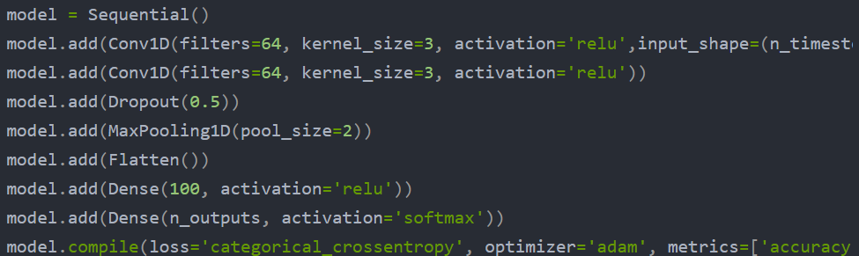
Fig. 1 Model definition
The data was not processed before, and an accuracy of 90.4% was obtained. Next, the data was standardized before fitting the model.
Standardization is the transformation of the distribution of variables so that the mean of the established target is zero and the standard deviation is 1. The purpose is to make each variable form a Gaussian distribution, that is, a normal distribution, which is determined by the mean and variance. The main difficulty of this method is that the data needs to be divided into 128 samples at equal intervals. Therefore, in order to have a clearer understanding of the data distribution, duplicate observations (overlapped data in each sample) must be removed.
It can be implemented using numpy array slicing, keeping only the second half of each window, and then flattening the window of each variable into a long vector. The array slicing code implementation is shown in Fig. 2.
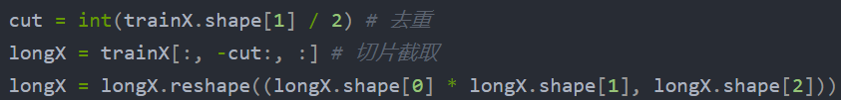
Fig. 2 Array slicing code
The data is Gaussian. Exploring standardized conversions helps the model extract important signals from the original observations. The purpose of the custom function is to standardize the data before fitting and evaluating the model. You can use the StandardScaler class in scikit-learn to implement it. It first fits the training data (for example, finds the mean and standard deviation of each variable), and then applies it to the training and test sets. Standardization is optional.
It may take a while to run the example, depending on the hardware, and the performance will be printed for each evaluation model. At the end of the run, the performance of each test configuration is summarized, and the average value and standard deviation are displayed. It can be seen that standardizing the data set before modeling does result in a small performance improvement, from an accuracy of approximately 90.4% (closer to that seen in the previous section) to an accuracy of approximately 91.5%. The result is shown in Fig. 3.
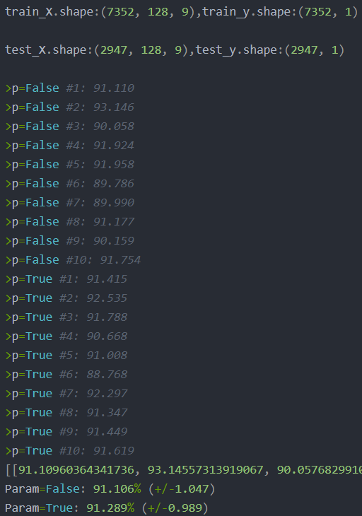
Fig. 3 Result

2.1.2 RNN
LSTM is a recurrent neural network that can learn and remember long sequences of input data. They are designed to be used with data containing long data sequences (up to 200 to 400 time steps), and they may be a good fit for this problem. The model can support multiple parallel sequences of input data, such as each axis of accelerometer and gyroscope data. The model learns to extract features from observation sequences and map internal features to different activity types. LSTM-FCN has improved the performance of FCN by augmenting the FCN module and has a high performance for time series classification [2]. LSTM and GRU have been used on real time data sets and the results are compared with ARIMA and SVM [3].
I define the model as an LSTM model with a single hidden layer. Next is a dropout layer designed to reduce the model's overfitting to the training data. Finally, before using the output layer for prediction, the fully connected layer is used to interpret the features extracted by the LSTM hidden layer. For multi-class classification tasks, stochastic gradient descent Adam is used to optimize the network, and the classification cross-entropy loss function is used. The model definition is shown in Fig. 4.
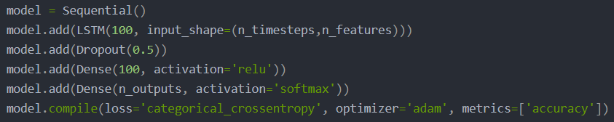
Fig. 4 Model definition
In this case, the appropriate epoch is 15, batch_size is 64, and 64 data windows are input to the model before updating the model weight. After the model is fitted, it is evaluated on the test data set, and the accuracy of the fitted model on the test data set is returned. When fitting an LSTM, the sequence data is usually not shuffled. But in this model, During the training, I will randomly adjust the input data window (default).
In this problem, I am interested in using LSTM's capabilities to learn and extract features across time steps in a window, rather than features across Windows.
The skill of the model cannot be judged from a single estimate.This is because the neural network is random, which means that when training the same model configuration on the same data, different models will be generated.This is a function of the network because it makes the model adaptable, but requires a slightly more complex evaluation of the model.
I'll repeat the evaluation of the model several times, and then summarize the performance of the model at each run.First load the data set, create and evaluate models, and print debugging information for each model. Then, print a sample of scores, and finally print the mean and standard deviation. It can be seen that the model works well. The classification accuracy trained on the original data set is about 89.7%, and the standard deviation is about 1.3. It is a good result. The running result is shown in Fig. 5.
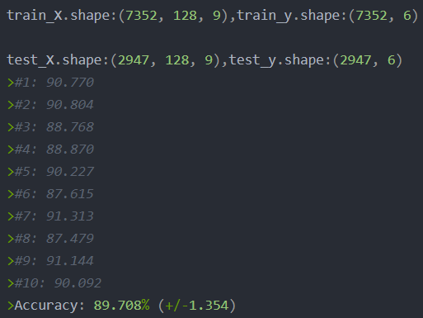
Fig. 5 Result for LSTM

2.1.3 Compare and Contrast
The advantage of using CNN and LSTM for sequence classification is that we can learn directly from the original time series data, professional signal processing and feature engineering related knowledge. The model can learn the internal representation of time series data and, ideally, can achieve performance similar to traditional machine learning methods on feature engineering data sets.
From the results, we can know that CNN can not only be applied to the field of image processing, but also can successfully and effectively analyze time series. CNN is a network originally created for image tasks where you can learn to capture specific features regardless of local features.
LSTM is a time recursive neural network, which is suitable for processing and predicting important event networks with relatively long intervals and time series delays.
It has a memory that can remember previous data in the input and make decisions based on this knowledge.
The network is more directly suited to entering written data.CNN achieved high accuracy in identifying human activity, but the difference between the two was not significant. Preprocessing the time series is of great help to the improvement of the results. Future work can consider combining CNN and LSTM to detect its impact on the accuracy of the system.
  - Natural Language Processing
Among all promising technologies which take advantage of those resources, the advent of deep learning has been a major paradigm shift in how speech signal and natural language processing (NLP) techniques work [4]. An Artificial Neural networks or Deep Neural Networks (DNN) are extremely powerful machine learning models that achieve excellent performance on complex problems such as speech recognition, visual object recognition etc [5]. This part uses the data set published by Cornell. This data set is used for sentiment classification. It contains 5331 positive texts and 5331 negative texts.

2.2.1 Pre-processing
First, load the data and perform descriptive statistics. You can see that there are 5331 positive and negative comment texts, with an average length of 20. The next step is to build a dictionary based on these corpus. The step of constructing a dictionary is generally to segment the text and then de-duplicate it. When I count the words in the text, I will find that there are many words that appear only once. Such words will increase the capacity of our dictionary and also bring a certain amount of noise to the text processing. Therefore, in the process of constructing the dictionary, only the words that appear more than 1 in the corpus are retained. Among them, pad and unk are two initialized tokens, pad is used for sentence filling, and unk is used to replace words that have not appeared in the corpus. After removing these words, on the one hand, the dictionary capacity will be greatly reduced, speeding up the model training, and on the other hand, it will also reduce a certain amount of noise. After processing, a dictionary containing 10384 words is finally obtained. After having a dictionary, it is necessary to construct a mapping from word to token and a mapping from token to word.
Based on the mapping table, the original text can be converted, the text can be converted into a machine-recognizable code. In addition, in order to ensure that the sentences have the same length, the sentence length needs to be processed. In the descriptive statistics stage, it can be found that the average length of the sentence in the corpus is 20 words, so I set 20 as the sentence standard length: Truncate sentences with more than 20 words; perform PAD completion for sentences with less than 20 words. Then construct a function, which can receive a complete str type sentence and convert it into tokens according to the mapping table.
The pre-trained 300-dimensional word vector will be used as the word embeddings of the model. It can be found that in the dictionary constructed from the corpus, 9801 words have pre-trained word vectors, and 583 words have no corresponding pre-trained word vectors. Therefore, I will construct a vocab_size * embedding_size based on pre-trained word embeddings. The size of the matrix, each row of this matrix is the word vector (300 dimensions) corresponding to a word in the dictionary. At this point, the data preprocessing part is basically completed. In this part, two main tasks are mainly completed: converting the original text into tokens; constructing word embeddings.

2.2.2 DNN structure
The DNN model processes sentences in a very simple way. For each word in the sentence, the word vector is first obtained, and then these word vectors are added together to finally get the sentence vector. Connect this vector to a fully connected layer and finally output the result at the output node. As shown in Fig. 6.
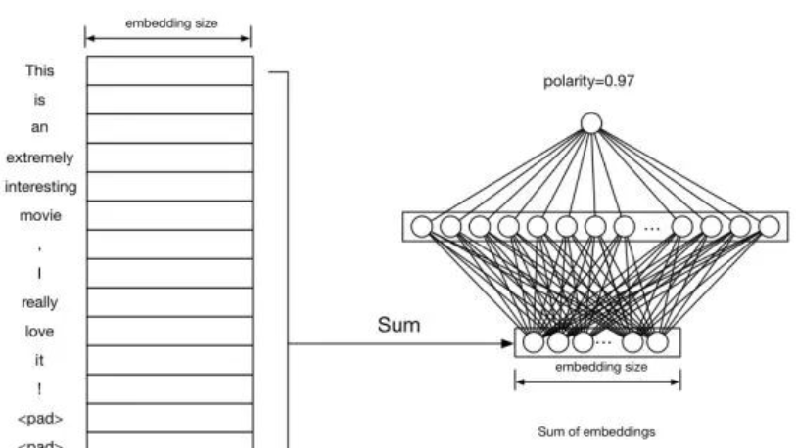
Fig. 6 The structure of DNN
For example, the input is a sentence, that is, "This is an extremely interesting movie, I really love it!", and use pad to complete the sentence length to 20, and perform word embedding for each word in it, and get a 20 * embedding_size matrix. Add all rows of this matrix to get sentence embedding, which is a vector of length embedding_size. Then connect this sentence embedding to a fully connected layer, and finally a single node outputs the probability value.
During the model building process, I divided several scopes, and each scope contained a set of ops.
Two tensors, inputs and targets are defined in placeholders, where inputs are inputs, and the shape is [batch_size, sentence_len], where sentence_len is 20. If the targets are 1 or 0, the shape is [batchz_size, 1].
In embeddings, I defined embedding matrix and fill it with pre-trained values. Since these word vectors are trained, I explicitly specified trainable=False. After lookup, each word vector of the input sequence is obtained, and then these vectors are added to obtain sum_embed.
In the model, the weights of the fully connected layer and the output layer are defined and the results are calculated. The fully connected layer uses relu as the activation function. The sigmoid cross entropy loss function is defined in loss. The op for calculating accuracy is defined in the evaluation. Since the pos and neg samples are 1:1, the predicted probability exceeds 0.5, which is considered pos, otherwise it is neg.
After the model is built, the hyperparameters are set and the model is trained. In this model, I used 80% of the data as train and the remaining 20% as test. I trained a total of 50 epochs. The accuracy of the model on train and test is plotted as shown in Fig. 7.
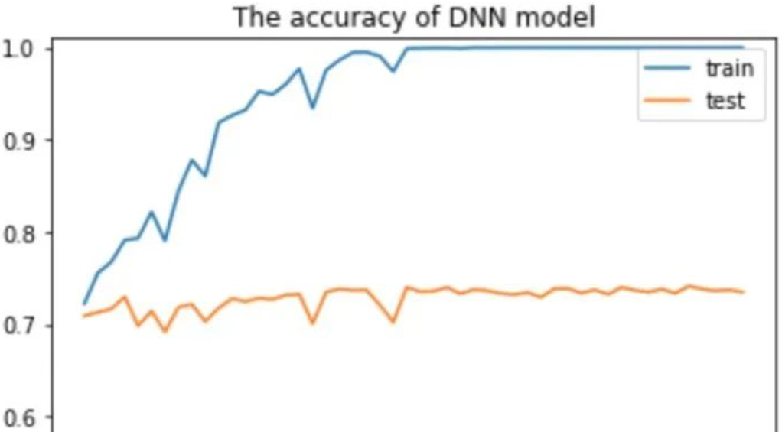
Fig.7 The accuracy of DNN model
It can be seen from the results that the DNN model has a certain degree of overfitting on the train. As the training progresses, when it reaches about 25 rounds, the accuracy of the model on the train reaches 100%, and the accuracy on the test. It is also relatively stable, and the final accuracy rate on the test is 73.46%. It can be seen that the effect of the DNN model is not bad, of course, this effect mainly comes from word embeddings. Over-fitting in the model can be alleviated with dropout or adding l2 regularity.

2.2.3 LSTM structure
The RNN model can handle sequence problems, and LSTM is better at capturing long sequence relationships. Due to the existence of gates, LSTM can learn and master the before and after dependencies in sequences well, so it is more suitable to deal with long sequence NLP problems. The model structure is shown in Fig. 8.
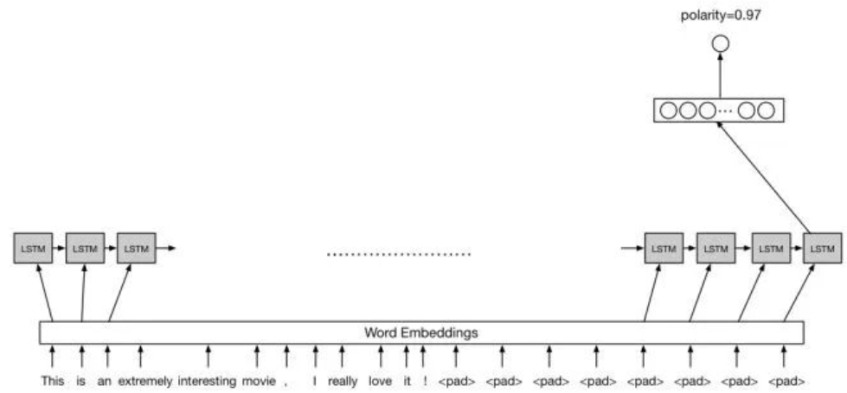
Fig. 8 LSTM structure
After the sentence is word embedding, the LSTM sequence is passed in for training, the last hidden state of the LSTM is taken out, and the fully connected layer is added to obtain the final output result.
In embeddings, unlike the word vector summation in DNN, LSTM does not need to sum the word vector, but directly learns the word vector itself. Regardless of whether it is summing or averaging, this aggregate operation will lose a certain amount of information. In the model, I first constructed the LSTM unit, and in order to prevent over-fitting, added dropout, after executing dynamic_rnn, I will get the final state of lstm, which is a tuple structure, including cell state and hidden state (after the output gate The result of), here only take the hidden state output, that is, lstm_state.h, connect this vector, and finally get the output result.
After the model is built, set the hyperparameters for training. Here I used a single-layer 512-node LSTM. The accuracy rate of each round of training data and the accuracy rate of test data are plotted as shown in Fig. 9.
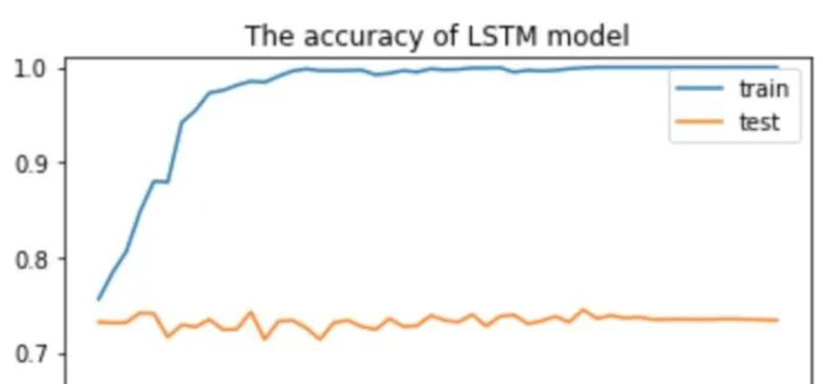
Fig. 9 The accuracy of LSTM model

2.2.4 Identifying and analyzing
The results of LSTM and DNN are similar. LSTM is a bit over-fitting, but this also shows that the pre-trained word vector brings a great effect to the DNN model, making it close to the accuracy of LSTM. In addition, compared to DNN, LSTM model converges faster on train.
My models are relatively simple, but in general, these two models have achieved good accuracy, which is largely derived from pre-trained word embedding, which shows the importance of word embedding in the NLP model.
I will further understand the difference in NLP processing between DNN and RNN from an intuitive point of view. Let's take sentiment analysis as an example. DNN is the simplest model, and it does not have the function of dealing with sequence relationships, so it does not perform very well in many tasks of NLP. DNN processes text by adding word vectors, so when the positive vocabulary in the sentence is greater than the negative vocabulary, the model is easy to make a mistake. The advantage of RNN is that it can capture long sequence relationships, and the capture of such long sequence relationships relies on gates. Because of the existence of the gate, the model will learn which information needs to be retained and which information needs to be forgotten. In the process, when the model sees "good", it still remembers that there was a negative word "no" before, and in the same way, it can also learn the relationship between "like" and "no".
All in all, DNN cannot capture sequence relationships, RNN (LSTM) can capture long dependent sequence relationships, and the establishment of word embeddings and corpus has a great effect on improving accuracy.

- Conclusion
By studying the application of DNN in time series and natural language processing, I have a new understanding of the structure of DNN and the function of each neural layer. The CNN and RNN (LSTM) structures used in this article are crucial to problem solving. Important role. In addition, I have also realized the importance of preprocessing the data. The processed data can effectively improve the performance of the system. This will be of great help to my future research. In the future, I can consider combining a variety of neural networks, in order to get a higher accuracy rate.

References


