

Programme: MSc Public Health and Social Care in Practice Module: Health Care System Organisation and Leadership Module code: LCHS7002
Chosen Case study: Case Study Number 1

Student Name: Sahid Shabbir Ahmad Bhaiyat Student ID: 2525517

Table of Contents

- Introduction.................................................................................................................
3

- Main Body ..................................................................................................................
5

  - Identifying the Problem Using Systems Thinking ................................................. 5

  - Centralisation vs. Decentralisation .......................................................................
9

  - Leadership Theory Application .............................................................................
11

  - Critique, Improvements, and Lessons Learned .................................................... 16

- Recommendations .....................................................................................................
19

- Conclusion..................................................................................................................
20

Reference list ................................................................................................................. 22

Introduction

The issue of medication safety is a significant issue in the healthcare system globally due to the damage inflicted by unavoidable mistakes which are substantial (Sharma et al., 2024). The World Health Organisation (WHO) estimates that unsafe medication practices cause significant patient harm and financial cost in the global healthcare system, and better systems and leadership are necessary (WHO, 2026). The present report is devoted to a severe case of infant morphine overdose in NHS England, during which a 4-week-old baby was exposed to a dose of morphine 20 times higher than that which was supposed to be given as a result of the malfunction of the prescription, communication, and governance systems (NHS North Yorkshire CCG, 2026). This case study aims to critically examine how leadership, system design, and governance have contributed to this incident and how the situation can be improved to assist patient safety.
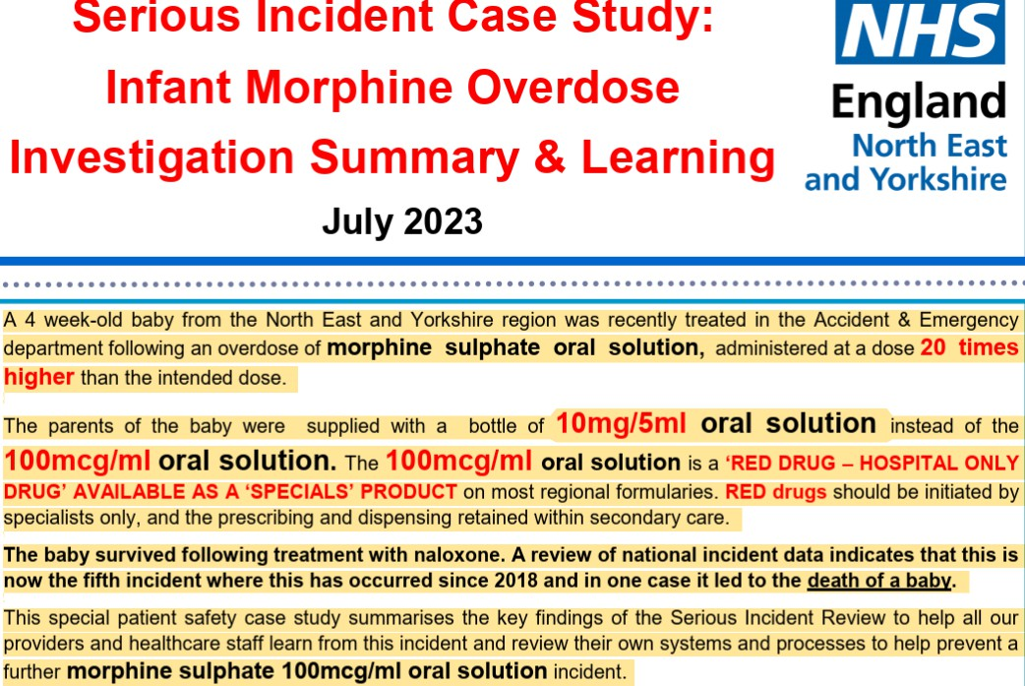

Figure 1: NHS Case study
(Source: NHS North Yorkshire CCG, 2026)

Healthcare leadership may be seen as the capacity to influence people and groups to accomplish common objectives, especially in providing safe, effective, and patient-centred care (NHS England, 2026). Leadership is critical in the management of complex healthcare systems, particularly in high-risk scenarios like medication management and patient transfers (Bourne et al., 2023).

The form of healthcare systems is usually centralised and decentralised. Centralisation is the centralisation of decision-making to the higher organisational levels with an intention to foster standardisation and control, and decentralisation is the decentralisation of authority throughout the various levels, which gives flexibility and responsiveness. In this regard, different leadership theories like transformational, transactional and situational leadership offer conceptualisations to comprehend how leaders react to challenges and bring about change (Phillipson et al., 2025).

The choice of the leadership style is essential, especially when it comes to crisis cases, because it directly affects the way of communication, decision-making, and patient safety outcomes, however,systemic failures may be caused by ineffective leadership, whereas adaptive and proactive leadership can avoid harm and ensure that the quality of services improves (Keshtkar et al., 2025).

This report will discuss the case study in terms of the systems thinking approach, study the existing governance structures, critique the leadership strategies, and make evidence-based recommendations to enhance healthcare performance and patient safety. The analysis will identify the factors that contributed to the occurrence of the incident, determine how centralisation versus decentralisation were involved, and evaluate the effectiveness of leadership based on data collected during an investigation into the occurrences. Additionally, it will identify any lessons learned from this incident which can be applied to improving patient safety, improving governance within the health system and improving overall health system performance.

Main Body

Identifying the Problem Using Systems Thinking

Main problem and context

The main issue in the chosen case study is a severe medication error of a four-week-old baby who received an overdose of morphine, in a direct proportion of about 20 times the required dose. This event happened because of the filling of the wrong formulation 10mg/5ml oral solution as opposed to the 100mcg/ml solution ordered, but mixed with a lack of clarity in communication and systemic breakdowns at different levels of care (NHS North Yorkshire CCG, 2026). Even though the baby survived after the emergency intervention, the case raises essential patient safety concerns and indicates more profound systemic vulnerabilities in healthcare delivery (NHS North Yorkshire CCG, 2026).

Medication errors are of great concern from a global standpoint (Giannetta et al., 2022). WHO (2026) has indicated that unsafe medication and mistakes rank among the top causes of preventable harm globally, costing about 42 billion dollars each year. This goes to show that these incidents are not isolated cases but are among a wide global problem associated with inefficiencies in the systems, human factors and ineffective systems of governance. Any mistake in the medication process may take place at any point. This refers to prescribing, dispensing, administration, and monitoring, which explains why sound systems thinking techniques are essential.

NHS patient safety data at the national level showcases the extent of the issue (NHS England, 2026). According to NHS England (2026), incidents of patient safety, such as medication errors, are still documented in large numbers via systems like the Learn from Patient Safety Events (LFPSE). It means that it is still a systemic issue in healthcare systems, especially in the practice of safe medication. The repetition of similar morphine-related cases, five incidents have been reported since 2018, including one case that resulted in the death of a person, proves that the lessons of the previous mistakes are not learned properly and sustainable preventive measures are not implemented (NHS North Yorkshire CCG, 2026).
It is possible to explain this issue with the help of systems thinking, according to which failures are interconnected instead of single mistakes (Cabrera and Cabrera, 2023). The incident was caused by a number of system weaknesses. On the one hand, there were problems with communication between the hospital personnel, general practitioners (GPs), and community pharmacists (Phillipson et al., 2025). The discharge summary was written by hand and used vague terms like Oramorph, which, combined with the fact that the handwritten discharge summary was ambiguous, resulted in confusion in taking the right strength of medication. Secondly, accountability and transparency in decision-making were lacking as various professionals made decisions based on unverified or incomplete information. Thirdly, the lack of proper training and awareness of the use of high-risk medications that are limited to the secondary care environment, the RED drugs, was one of the factors that led to improper prescribing and dispensing (Phillipson et al., 2025).

Systems Thinking Perspective

The incident is best viewed as a series of failures across a number of interconnected components of the health system rather than one point of failure. Systems thinking considers how the various components (people, processes, technology and governance) function and influence the overall results produced by the system (Sánchez-Castro et al., 2023).

The two failures identified were: (1) the prescribing and dispensing processes did not ensure that the correct formulation was prescribed and dispensed, (2) there was a communication breakdown between the health care providers and the patient's caregivers resulting in the administration of an incorrect medication dosage, and (3) the governance structure was not implemented correctly resulting in the inability to restrict access to the 'red drug' designation to a single site of care (the hospital) (NHS England, 2026).

Additionally, the system did not have effective feedback loops which are critical to allowing near misses to translate into actual events. In spite of multiple incidents of this nature occurring since 2018, there has not been sufficient prevention measures put in place to prevent these incidents from occurring. This indicates that this is another example of an organisation not learning and continuously improving (Sánchez-Castro et al., 2023).
Another significant issue is that the system is very dependent on personnel at each stage (prescribing, dispensing, and administering) performing their jobs accurately. Therefore, if one person at one stage of the process fails, the likelihood of harm increases exponentially by the failure of subsequent stages. In this case, the incorrect dispensing directly impacted on the administration error; this clearly illustrates the cascading nature of tightly coupled processes (NHS North Yorkshire CCG, 2026). As Table 1 below demonstrates, medication errors are a global phenomenon causing considerable harm and expense, while the NHS has reliable data documenting what appear to be persistent failures (Annex 5), highlighting the case for system-level improvements in safety mechanisms.

Table 1: National and International Data Supporting Problem Analysis

Source | Statistic | Relevance
W H O (2026) | M e d i c a t i o n e r r o r s c o s t approximately $42 billion globally each year | Highlights the global scale and economic burden of unsafe medication practices, showing the issue is  widespread and critical
W H O (2026) | Medication-related harm is among the leading causes of  avoidable injury in healthcare | Demonstrates the seriousness of medication safety as a global public  health concern
N H S  England (2026) | Thousands of patient safety  incidents reported annually through LFPSE system | Indicates ongoing systemic challenges  within the UK healthcare system related to patient safety
N H S  England (2026) | F i v e s i m i l a r m o r p h i n e overdose incidents reported since 2018, including one  fatality | Shows recurrence of similar errors, reflecting gaps in learning and system improvement
N H S  England (2026) | Medication errors occur a c r o s s p r e s c r i b i n g , d i s p e n s i n g , a n d  administration stages | Emphasises that failures are system-wide rather than isolated, requiring a systems thinking approach

Table 1: National and International Data Supporting Problem Analysis

(Source: Author)
A Rich Picture framework can also be used to analyse the problem. The main participants are the doctors in the hospital, the pharmacists, GPs, the staff in the community pharmacy and the parents of the infant. The processes involve prescribing, discharge communication, dispensing and administration of medication. Weak feedback loops (poor incident reporting systems and the absence of real-time communication between professionals) exacerbated failures in these processes. As an illustration, the issues identified by the pharmacist were not reported to the GP directly, which points to the lack of appropriate escalation protocols.
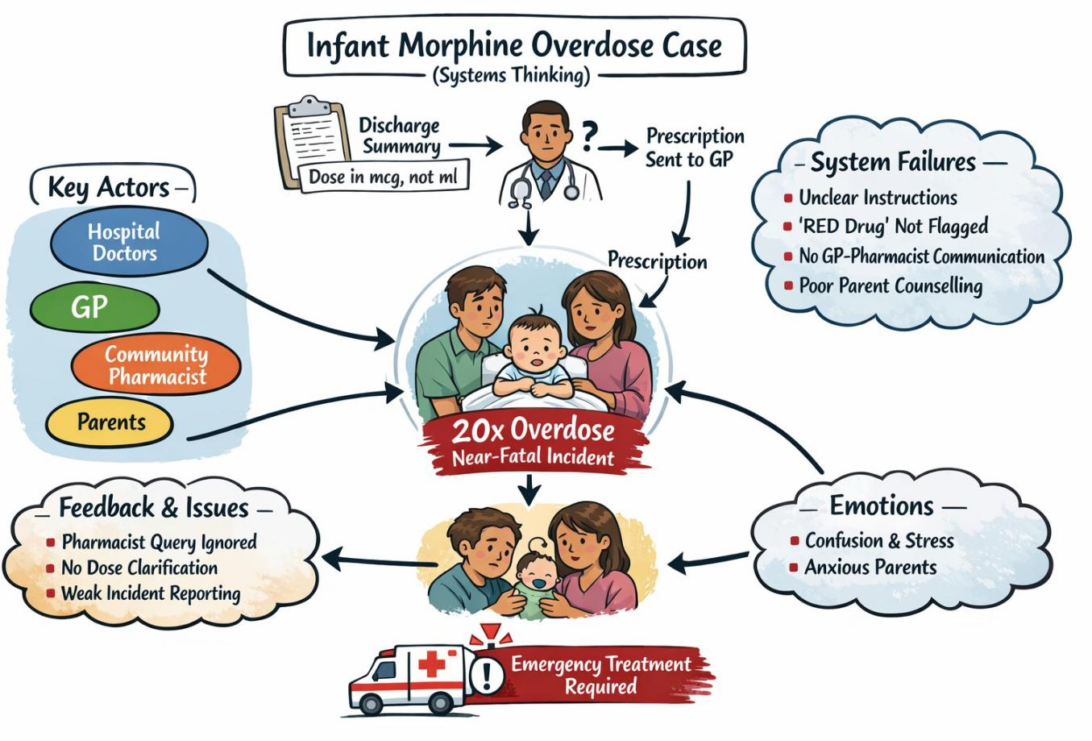

Figure 2: Rich Picture

(Source: Author)

The emotional factors were also involved, as staff members were feeling insecure and pressured, and parents did not know how to provide safe administration of the medication, which did not help. Hierarchical systems and crumbly IT infrastructure are structural factors that contributed to the problem. The lack of electronic
prescribing systems and proper governance systems enabled the errors to go through various checkpoints without being detected.

Moreover, the problem of governance may be detected on the local and regional levels. The inability to implement policies on the issue of the use of the so-called RED drugs and the absence of standardised discharge practices indicate the flaws in organisational control. The national structures like the NHS Discharge Medicines Service are meant to enhance communication between care transfers, but since they are not applied consistently, this has led to this incident (NHS England, 2026).

To sum up, this case demonstrates that medication errors are not only isolated cases of failures on the part of individuals, but rather a complicated interplay of factors in healthcare systems. Through systems thinking, one will see that the enhancement of communication, accountability, training, and governance is critical in averting such incidents. The issue is significant locally and globally, which justifies the necessity of effective leadership and interventions across the entire system to increase patient safety.

Centralisation vs. Decentralisation

The infant morphine overdose case illustrates a complicated interplay between centralised control and decentralised clinical practice in the NHS system. Although the NHS has robust centralised policies regarding medication safety, there is usually decentralisation in the implementation of the policies in the local organisations, which is a gap that led to this incident.

Centralisation in healthcare is a concept that involves the decision-making power being centralised at the leadership levels in the country or the organisation. Here, national medication safety frameworks and classification systems like the so-called RED drugs were centralised in that they are supposed to be prescribed and handled in the secondary care only. The purpose of these policies is to standardise the high-risk pharmacological operations and reduce the variability in organisations. To illustrate, medication safety management advice focuses on compliance with the national law and prescription guidelines to minimise harm and provide consistency in
care provision (NHS England, 2026). Nevertheless, even with these centralised controls, the mistake still took place, which points to the inability to translate national policy into practice. There was poor enforcement and monitoring of centralised guidelines, as the discharge summary wrongly advised the GP to order a hospital-only drug. This is indicative of a larger issue in the world because medication errors still inflict great harm and financial weight on the world, with an estimated cost of 42 billion dollars a year (WHO, 2026).

Decentralisation, conversely, entails devolution of the decision-making power to local providers like hospitals, GP practices and community pharmacies. Decentralised decision-making was also a major factor in the mistake in this case. The GP alone read the discharge summary and gave the wrong formulation, whereas the community pharmacists dispensed the drug without having a complete check on dosage accuracy and explaining discrepancies. The absence of direct communication between clinicians and the use of intermediaries also weakened the system. Other local processes were also inadequate, that is the process of double-checking, pharmacist counselling, and documentation were also inconsistent at the level of the frontline practice. It has been indicated that patient safety incidents are largely caused by communication failures, especially when transferring care (Keshtkar et al., 2025).

The decentralised organisation also exposed the lack of accountability. A variety of actors were included, such as hospital clinicians, GPs, pharmacists and support staff, but there was no single point of responsibility that guaranteed safe transfer of care. The national data systems, including the Learn from Patient Safety Events (LFPSE), reveal how often such incidents are reported, as medication-related errors are commonly reported throughout the NHS, implying that the system is vulnerable, and not particular failures (NHS England, 2026). Moreover, it was the fifth similar event since 2018, which proves a recurring inability to find the proper lessons out of the past and introduce regular improvements at the local level.

Importantly, the relationship between centralisation and decentralisation helped and impeded the performance of the system to a critical degree. The centralisation had
clear policies and safety structures, which were not well implemented and monitored. Decentralisation gave flexibility and responsiveness at the local level but created variability, breakdown of communication and accountability gaps. This lack of balance negatively affected crisis management in that no unified system was used to guarantee the correct transfer of information, verifying it, and providing assurances of patient safety.

To sum up, as the case demonstrates, centralisation or decentralisation is not enough. Rather, successful healthcare systems must have close coordination between the national policy and the local practice. Better coordination and lessening of errors could be achieved by better digital systems, including electronic discharge summaries and enhanced integration through services such as the Discharge Medicines Service. Finally, it is necessary to support the alignment between centralized governance and strong local practices to increase accountability, enhance communication, and avoid the possibility of future harm caused by medication.

Leadership Theory Application

The leadership was also critical in determining the outcome of the baby morphine overdose case, especially in the manner in which decisions were made, communicated and put into practice in various care settings. An implementation of leadership theories shows the strengths and some critical gaps in the system.

The Great Man Theory is echoed in the use of senior clinicians to inform the decision-making process, particularly in discharge planning (Miller, 2022). The discharge summary in this instance was a type of authoritative order to be complied with without adequate questioning by the GP and pharmacy staff. Although this style of command-driven leadership may be useful in emergency cases in clinical settings, it becomes an issue if it is overly used. The lack of collective verification proves that the reliance on personal authority constrained the resiliency of the system and was a factor in the spread of errors. This is consistent with the international issues where medication errors are usually caused by poor systems, and not by personal failures (WHO, 2026).
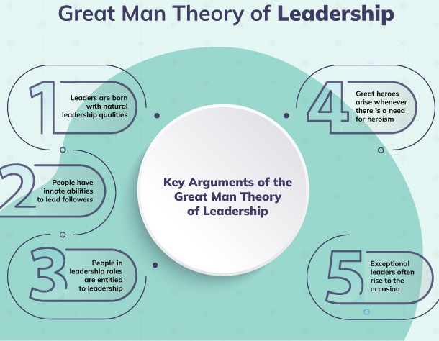

Figure 3: Great Man Theory (Source: Miller, 2022)
In the light of Trait Theory, a good leader must be confident, decisive, and emotionally intelligent. Nevertheless, despite the GP making the right mathematical calculations on the dosage, there was no critical awareness and communication on the differences in drug formulation. On the same note, pharmacists detected discrepancies but did not take direct action. This implies that although technical competence existed, some of the important leadership qualities, like assertiveness and proactive communication, were not utilised adequately. NHS safety frameworks were effective in maintaining leadership behaviours which are responsible for overcoming medication risks (NHS England, 2026).

The lack of balance in the task-oriented and people-oriented approach is emphasised in behavioural leadership theory. In this scenario, the healthcare professionals paid much attention to the accomplishment of tasks such as prescription and dispensing the medication, and forgot about communicating with patients and engaging in an interdisciplinary conversation. As an example, the
inability to effectively counsel parents and unclear instructions like PRN can be viewed as poor people-oriented leadership. It has been demonstrated that poor communication is a leading cause of patient safety events, which has further strengthened the idea that leadership behaviours are directly related to outcomes (Keshtkar et al., 2025).

There seems to be a lack of application of the Situational/Contingency Theory since leadership was not adequately adapted to the high-risk situation. A neonate should be prescribed a RED drug with an increased level of vigilance, coordination of actions among multiple disciplines, and a specific approach to communication. Nevertheless, it was done without any adaptation of the same routine processes, meaning the absence of adaptive leadership. Decision-making would have been more flexible and situation-sensitive, which might have averted risks, especially in the transfer of care.

Table 2: Leadership Theory Application with Examples and Supporting Data

Theory / Model | Application Example | Supporting Data & Critique
Great Man Theory | A senior clinician took | While effective in urgent care,
 | control during the infant | over-reliance on individuals
 | morphine overdose | reduces system resilience and
 | incident, relying on | sustainability, particularly in
 | a u t h o r i t y a n d r a p i d | c o m p l e x h e a l t h c a r e
 | decision-making to | environments (WHO, 2026).
 | stabilise the situation.

Trait Theory | The leader demonstrated confidence, empathy, and d e c i s i v e n e s s w h e n coordinating between d e p a r t m e n t s a n d reassuring parents. | E v i d e n c e s u g g e s t s e m o t i o n a l l y i n t e l l i g e n t leadership improves team s a t i s f a c t i o n a n d communication, which are critical in preventing medication errors (Gautam et  al., 2026).
B e h a v i o u r a l Theories | Leadership focused on t a s k c o m p l e t i o n (prescribing, dispensing) b u t n e g l e c t e d communication and collaborative verification  processes. | Studies show that imbalance between task and people orientation increases safety r i s k s , p a r t i c u l a r l y i n medication management systems (Keshtkar et al.,  2025).
S i t u a t i o n a l / C o n t i n g e n c y Theories | Leadership responses varied across settings (hospital, GP, pharmacy), adapting inconsistently to context and risk level. | Lack of consistent adaptation reduced coordination, highlighting the importance of context-sensitive leadership in crisis response (Thapa et al.,  2026).
Ta n n e n b a u m & Schmidt Continuum | D e c i s i o n - m a k i n g remained largely clinician-led with limited staff or patient involvement. | M o r e p a r t i c i p a t o r y a p p r o a c h e s i m p r o v e accountability and reduce e r r o r s t h r o u g h s h a r e d responsibility (NHS England,  2026).
Transformational Leadership | Opportunities existed to implement system-wide improvements such as electronic prescribing and staff training. | Transformational leadership enhances safety culture, innovation, and long-term improvement in patient outcomes (Phillipson et al.,  2025).

Table 2: Leadership Theory Application with Examples and Supporting Data

(Source: Author)

On the same note, the Tannenbaum and Schmidt Continuum indicates that a leader ought to alternate between an autocratic and a participative style of leadership regarding the situation at hand. Here, leadership was mostly hierarchical with very little involvement of pharmacists or parents. There should have been a more participative style, such as the encouragement of questioning, doing a second check, and being accountable to oneself as a team and so on; this should have averted the mistake.

Lastly, Transformational (purpose-driven) leadership was also very evident even before the incident. Medication safety had no clear vision of what was required or a proactive system improvement. Nonetheless, measures taken after the incident, like the introduction of electronic discharge summaries and employee training, are a sign of a transition to transformational leadership. There is evidence that these methods enhance the safety outcomes and staff involvement through the creation of a learning and continuous improvement culture (Reynolds and Waldrop, 2025). Inspiration and motivation of employees to complete a common vision, encourage innovation, and create a working environment that encourages safety and ongoing development are the primary goals of transformational leadership. This type of leadership is critical in encouraging patient-centered healthcare and encouraging employees to report errors without the fear of being blamed.

This case study reveals the lack of transformational leadership within the organisation. The absence of strong transformational leadership is evident through the lack of prevalence of a strong safety culture; a critical outcome that is expected from transformational leadership (Reynolds and Waldrop, 2025). Studies have also shown that organisations with a positive safety culture tend to have significantly lower rates of medication errors. For instance, NHS staff surveys have indicated that environments in which employees perceive they are supported and encouraged to speak up, produce better patient safety outcomes. However, transformational
leadership alone may not be sufficient in managing high-risk clinical processes, where strict adherence to protocols is essential.

In general, the leadership demonstrated in this situation was more or less reactive, disjointed, and inadequately adaptive. A more decentralised, emotionally aware, and action-oriented leadership style with effective communication and system-wide responsibility would probably have minimised the likelihood of a severe medication error.

Critique, Improvements, and Lessons Learned

The case of infant morphine overdose points to a very serious failure of interaction between leadership and governance when both the structural vulnerability and the leadership constraints played a role in the unsafe results. There were systems of governance (e.g., the classification and the prescribing of the RED drugs), but the leadership was not able to enforce them and monitor them throughout the care transitions. Such a lack of connection is indicative of a lack of a cohesive system in which accountability was not imposed explicitly.

One of them was the inability to have integrated governance across organisational boundaries. The national and local policies also limited the prescribing of high-risk medications, but they were not communicated and implemented at the point of care. The discharge summary, which was a governance document, was vague and incomplete, and this exhibited how ineffective leadership management allowed bad documentation practices to continue. It has been demonstrated that medication errors are often the result of system-level vulnerabilities and lack of coordination, and not individual errors (WHO, 2026).

Failure of communication and absence of escalation were other significant issues. The GP and pharmacists detected discrepancies but used the indirect communication channels instead of the direct clinician-to-clinician conversation. It is indicative of the absence of psychological safety and a poor culture of strong leadership in which employees might be afraid to question decisions. It has been found that the quality of communication can have a profound effect on patient safety
outcomes, where low-quality communication predisposes the probability of adverse incidents (Keshtkar et al., 2025).

Also, the use of data and reporting systems was not efficient enough to add to the problem. Although national patient safety systems are in existence, like the LFPSE, their effectiveness depends on prompt reporting and integration of learning. In this instance, similar incidents that occurred five times since 2018 indicate that the lessons have not been adequately integrated into practice. NHS data systems are set to facilitate learning and prevention, yet they cannot perform their functions to the best without effective leadership that will take action based on the insights (NHS England, 2026).

Table 3: Problem–Evidence–Improvement Analysis

Problem | Evidence/Data | Improvement Strategy
P o o r communication and escalation | Pharmacist queries not directly communicated to G P ; r e l i a n c e o n  intermediaries | Introduce mandatory direct clinician communication for high-risk drugs; structured  escalation protocols
Weak discharge governance | Handwritten discharge summary lacking clear  dosage (mg + ml) | Implement electronic discharge systems with standardised  templates
Lack of awareness  of ‘RED drug’ protocols | G P a n d p h a r m a c i s t s  unaware of 100mcg/ml formulation | M a n d a t o r y t r a i n i n g a n d  decision- support alerts in prescribing systems
Inadequate patient counselling | P a r e n t s u n a w a r e o f  dosage dif ferences, leading to overdose | Strengthen counselling  protocols and use teach-back methods
F r a g m e n t e d accountability | Multiple professionals involved without clear  ownership | Establish shared governance f r a m e w o r k s a n d d e f i n e d  accountability roles

Table 3: Problem–Evidence–Improvement Analysis (Source: Author)
More importantly, the relationship between centralisation and decentralisation was an important factor. The policies (e.g., national prescribing regulation) were not effectively implemented, and decentralised decision-making on GP and pharmacy levels was not properly controlled. This left a loophole of a lack of responsibility and inconsistent safety checks. The leadership was more reactive as it was concerned with actions taken after the incident and not before it occurred.

There are a number of missed opportunities that can be seen. The Discharge Medicines Service (DMS), which aims at enhancing communication in the process of care transition, was not used, which is a clear failure in the area of governance and leadership. It is indicated that organised communication about discharge leads to a substantial decrease in the number of medication-related harm (NHS England, 2026). In addition, computerised tools like electronic prescribing and barcode systems might have prevented incorrect interpretation of the strength of drugs.

The most important point is that systems cannot be based on the competence of the individual. Rather, it needs strong structures of governance that are backed by aggressive and decentralised leadership. Psychological safety should be supported by the leadership, as the staff should not be afraid to question and report the issues. Also, the ongoing utilisation of the data, incident reporting, audits, and feedback loops is essential to organisational learning and improvement.

Overall, this case indicates that the issue of patient safety is rooted in the compatibility of leadership, governance, and system design. The health organisations should employ the centralised policies and empowered local decision-making that is backed by effective communication, data-driven insights and an accountability culture to avoid such occurrences in future.

Recommendations

To avoid the recurrence of medication-related harm and enhance system-wide safety, the organisation must focus on a change in the practice of reactivity and individual-led practice to proactive and system-led leadership and governance. As the case shows, the use of personal judgment and discontinuous communication channels were the factors that led to the overdose. Thus, it is very important to adopt a transformational and distributed leadership style. A culture of openness, learning, and psychological safety can be created to encourage staff to challenge prescriptions and escalate issues without the fear of reprisal by transformational leadership. This is consistent with the findings that an effective developmental process of leadership enhances a culture of safety and workforce involvement (Phillipson et al., 2025).

The system of governance should be enhanced by accountability and standardisation. The organisation needs to put in place mandatory electronic discharge summaries with the decision support systems embedded to guarantee that all the prescriptions encompass the drug strength, dosage, and volume (NHS England, 2026). Also, barcode medication administration systems and electronic prescribing can be integrated to decrease errors in transcription and enhance accuracy in cross-care transitions.

The communication and integration of the system should be enhanced. It is also important that the NHS Discharge Medicines Service (DMS) is fully integrated to provide a smooth flow of information between the hospital, GP and community pharmacy. This would allow pharmacists to perform medication reconciliation and detect discrepancies at an early stage, minimising the amount of harm that might be caused during a transition of care (NHS England, 2026). Moreover, it is possible to introduce daily multidisciplinary safety huddles that can improve real-time communication, facilitate shared decision-making, and facilitate the detection of risks in the initial stages.

The organisation needs to invest in digital infrastructure and training of the staff to improve technical and allocative efficiency. High-risk medications, including so-called
RED drugs should be strengthened with the use of constant professional education and training based on simulations. It has been indicated that quality improvement strategies, along with the capacity building of the staff, contribute greatly to improving patient safety outcomes (Reynolds and Waldrop, 2025). The improvement of allocative efficiency can also be achieved by proper distribution of resources, i.e. by having access to the right dosing (e.g. 1ml syringes) and specialist pharmacists.

The system of constant learning must be integrated with the strong system of incident reporting and feedback loops. The organisations need to use patient safety data to track trends, measure interventions and promote iterative improvement. Medication errors in the world are a significant source of preventable damage, so the level of interventions requires a long-term system-wide approach (WHO, 2026). Co-production of safety strategies by the stakeholders, such as clinicians, pharmacists, and patients, will also promote accountability and effectiveness.

Finally, the built-in mechanisms of constant learning, enhanced governance, and transformational leadership, combined with digital integration, will help the organisation develop a resilient, safe, and high-performing healthcare system.

Conclusion

The case study illustrates some of the major leadership and system failures that led to a serious medication error, which is an infant morphine overdose. One of the weaknesses of the leadership was the fact that they had been relying on fragmented and reactive decision-making as opposed to proactive and system-oriented leadership. The lack of open communication, poor supervision, and lack of escalating concerns were indicators of the gaps in leadership effectiveness and psychological safety. The leaders were unable to maintain clarity in prescribing practices, and they were not able to create a culture in which the staff could easily challenge possible errors.

In a systems thinking approach, it was found that there are several interconnected areas of weakness, such as poor discharge communication, absence of standardised prescribing protocols, inadequate cross-sector coordination, and ineffective utilisation
of digital safety systems. These failures show that errors are not often single but happen as a result of failures in interrelated processes. The systems of governance were also a very important factor since the ambiguous accountability and poor oversight did not stop the error from continuing on the path through primary and secondary care without any appropriate intervention.

The analysis demonstrates that leadership and governance had a direct impact on patient outcomes, as they affect organisational culture, the quality of communication, and the reliability of the system. Notably, the case supports the idea that it is not enough to concentrate on individual performance. Systems thinking is more sustainable, as it handles root causes, enhances processes, and incorporates lifelong learning. It is therefore imperative to strengthen leadership, governance and integrated systems to deliver safer and high-quality healthcare. The predominance of reactive leadership, combined with weak enforcement of protocols and limited organisational learning, contributed to the occurrence of the incident. Applying a more integrated leadership approach, supported by data and evidence, is essential to improving patient safety and preventing similar errors in the future.

Reference list
[Accessed on: 01.04.2026].
Ahn, J.Y., Sim, M.W.C., Foo, Z.S.T. and Tan, K.H., 2025. Patient Safety Leaders’ Perception of Patient Safety Practices in Eight Asia-Pacific Countries: Survey Based on the Global Patient Safety Action Plan Framework. Risk Management and Healthcare Policy, pp.2217-2231.
Best, K., Shuweihdi, F., Alvarez, J.C.B., Relton, S., Avgerinou, C., Nimmons, D., Petersen, I., Pujades-Rodriguez, M., Conroy, S.P., Walters, K. and West, R.M., 2025. Development and external validation of the electronic frailty index 2 using routine primary care electronic health record data. Age and Ageing, 54(4), p.afaf077.
Bolwell, J.S., 2025. A review of healthcare challenges in the UK and the US: medical errors, aging, private healthcare and governance. Health Sciences Review, 14, p.100211.
Bourne, R.S., Jeffries, M., Phipps, D.L., Jennings, J.K., Boxall, E., Wilson, F., March, H. and Ashcroft, D.M., 2023. Understanding medication safety involving patient transfer from intensive care to hospital ward: a qualitative sociotechnical factor study. BMJ open, 13(5), p.e066757.
Cabrera, D. and Cabrera, L., 2023. What is systems thinking?. In Learning, design, and technology: An international compendium of theory, research, practice, and policy (pp. 1495-1522). Cham: Springer International Publishing.
Day, F., Snape, V., Gardner, D., Vinchenzo, C., Dalili, M.N., Baird, S.G., Udu, K. and McManus, J., 2026. Evidence-based public health leadership development: A systematic review and urgent call to include psychological theory. Public Health, 253, p.106178.
del Castillo, J., 2025. Social Movements and Healthcare Innovation. The Oxford Handbook of Healthcare Innovation, p.330.
Duane, B., Steinbach, I., Stancliffe, R., Barna, S., Cameron, D., de Barbieri, I., Noruisiene, E., Mortimer, F., Gerritsen, K., Vanholder, R. and Donati, G., 2025. Improving the sustainability and quality of kidney health care through life cycle assessments, quality improvement, education and technical innovations: the KitNewCare approach. Journal of Nephrology, 38(1), pp.87-99.
Eii, M.N. and Winder, M., 2026. Redefining medicines optimisation: driving sustainable medicines use with the Greener Pharmacy Toolkit. International Journal of Pharmacy Practice, p.riaf137.
Emicke, R., Shepherd, A. and Powell, D., 2025. Exploring the opportunities and challenges of healthcare innovation in UK higher education: a narrative review. Nursing Reports, 15(5), p.171.
Gautam, S., Nazir, M.A. and Zhu, X., 2026. Leadership, organisational culture and workforce engagement in the NHS: a qualitative study of healthcare management dynamics. Journal of Health Organization and Management, pp.1-23.
Giannetta, N., Dionisi, S., Tonello, M., Di Simone, E. and Di Muzio, M., 2022. A worldwide bibliometric analysis of published literature on medication errors. Journal of Patient Safety, 18(3), pp.201-209.
Harding, D., Lycett, H., Avery, L., Kumaresan, T. and Madden, V., 2025. Building allied health professions' leadership self-efficacy through authentic experiential learning: a participatory evaluation of allied health professions leadership fellow secondments. BMJ leader, 9(2), pp.198-201.
Hindocha, C.N. and Harris, M., 2025. Identifying Innovation. The Oxford Handbook of Healthcare Innovation, p.17.
Ho, L., Mercer, S.W., Henderson, D., Donaghy, E. and Guthrie, B., 2025. Effect of UK Quality and Outcomes Framework pay-for-performance programme on quality of primary care: systematic review with quantitative synthesis. bmj, 389.
Jeffries, M., Naylor, F., Tyler, N., Robinson, C., Panagioti, M. and Keers, R.N., 2026. Exploring Medicines Optimisation and Safety in the Community Following Mental Health Hospital Discharge: A Qualitative Interview Study. Health Expectations, 29(1), p.e70535.
Johnson, M.J., Williams, B., Keerie, C., Tuck, S., Hart, S., Bajwah, S., Chaudhuri, N., Pearson, M., Cohen, J., Evans, R.A. and Currow, D.C., 2025. Morphine for chronic breathlessness (MABEL) in the UK: a multi-site, parallel-group, dose titration, double-blind, randomised, placebo-controlled trial. The Lancet Respiratory Medicine, 13(11), pp.967-977.
Johnson, M.J., Williams, B., Keerie, C., Tuck, S., Hart, S., Bajwah, S., Chaudhuri, N., Pearson, M., Cohen, J., Evans, R.A. and Currow, D.C., 2025. Morphine for chronic breathlessness (MABEL) in the UK: a multi-site, parallel-group, dose titration, double-blind, randomised, placebo-controlled trial. The Lancet Respiratory Medicine, 13(11), pp.967-977.
Keshtkar, L., Bennett-Weston, A., Khan, A.S., Mohan, S., Jones, M., Nockels, K., Gunn, S., Armstrong, N., Bostock, J. and Howick, J., 2025. Impacts of communication type and quality on patient safety incidents: a systematic review. Annals of Internal Medicine, 178(5), pp.687-700.
Kyrimi, E., Mossadegh, S., Wohlgemut, J.M., Stoner, R.S., Tai, N.R. and Marsh, W., 2025. Counterfactual reasoning using causal bayesian networks as a healthcare governance tool. International journal of medical informatics, 193, p.105681.
Miller, K. (2022). A Comprehensive Guide on The Great Man Theory of Leadership. Available at: https://crowjack.com/blog/strategy/leadership-theories/great-man-theory [Accessed 1 Apr. 2026].
NHS England (2026). Discharge Medicines Service. Available at: https:// www.england.nhs.uk/primary-care/pharmacy/pharmacy-services/nhs-discharge-medicines-service/. [Accessed on: 01.04.2026].
NHS England (2026). Infant Morphine Overdose Case Study. Available at: https:// northyorkshireccg.nhs.uk/wp-content/uploads/2023/07/July-2023-NHS-NEY-INFANT-MORPHINE-OVERDOSE-CASE-STUDY.pdf?UNLID=193374120245125844.
NHS England (2026). Medication Safety Management. Available at: https:// www.england.nhs.uk/long-read/medication-safety-management/. [Accessed on: 01.04.2026].
NHS England (2026). NHS management and leadership. Available at: https:// www.england.nhs.uk/leaders/. [Accessed on: 01.04.2026].
NHS England (2026). Patient safety data. Available at: https://www.england.nhs.uk/ statistics/statistical-work-areas/patient-safety-data/. [Accessed on: 01.04.2026].
NHS North Yorkshire CCG (2026). Serious Incident Case Study: Infant Morphine Overdose Investigation Summary & Learning . Available at: https://northyorkshireccg.nhs.uk/wp-content/uploads/2023/07/July-2023-NHS-NEY-INFANT-MORPHINE-OVERDOSE-CASE-STUDY.pdf?UNLID=193374120245125844. [Accessed on: 19.04.2026].
Nouis, S.C., Uren, V. and Jariwala, S., 2025. Evaluating accountability, transparency, and bias in AI-assisted healthcare decision-making: a qualitative study of healthcare professionals’ perspectives in the UK. BMC Medical Ethics, 26(1), p.89.
Olawade, D.B., Weerasinghe, K., Teke, J., Msiska, M., Boussios, S. and Hatzidimitriadou, E., 2025. Evaluating AI adoption in healthcare: Insights from the information governance professionals in the United Kingdom. International journal of medical informatics, 199, p.105909.
Phillipson, J., Pinto, A.C., Kingsley-Smith, H., Krachler, N., McGivern, G. and Lyons, O., 2025. Leadership training in healthcare: a systematic umbrella review. BMJ leader, 9(4), p.e001269.
Radcliffe, E., Mckelvie, S., Ibrahim, K. and Giles, G., 2026. Medicines optimisation and deprescribing in older people: personalised, proactive and preventative.
Reynolds, S.S. and Waldrop, J.B., 2025. Optimizing quality improvement methods in practice: a case study approach. Journal of Nursing Care Quality, 40(1), pp.8-14.
Sánchez-Castro, I., Molina, L., Prieto-Fernández, M.Á. and Segura, A., 2023. Past, present and future trends in the remediation of heavy-metal contaminated soil-Remediation techniques applied in real soil-contamination events. Heliyon, 9(6).
Sharma, L., Prakash, A. and Medhi, B., 2024. Ensuring medication and patient safety for better quality healthcare. Indian Journal of Pharmacology, 56(6), pp.375-378.
Thapa, A., Gyawali, P. and Kalauni, D., 2026. Leadership strategies to foster innovation in healthcare organizations of the UK: a systematic review. BMC Health Services Research.
WHO (2026). Medication Without Harm. Available at: https://www.who.int/initiatives/ medication-without-harm. [Accessed on: 01.04.2026].
Wynne, R., Omarit, R. and Crowe, S., 2025. Bridging practice and research: differentiating quality improvement, quality assurance, and quality improvement research in a learning health system. European Journal of Cardiovascular Nursing, 24(7), pp.1182-1187.

