1701611 – Chelsea Summers

The Drastic Impact Modern Photography Has Made on Body Image

Throughout this proposal of researching and stating the drastic growth of body dysmorphia, I want to explore the reasons and the role that media has. I have chosen 3 key words which defines my subject and will help me further into my investigation. I aim to state the factors and causes modern photography has made on young females and males and how the statistics of body dysmorphia has increased. I want to explore photographers, the media and how people in the world observe themselves due to the body image that is being fantasised about.

My first key word is exploring the idea of ‘perfectionism’. The word means a numerous amount of things but in terms of this proposal, it explains the idea of being a certain way or to obtain a specific appearance to become accepted. Over the years, there has been a huge impact on the word perfectionism that is being portrayed through magazines, images and online through the media.
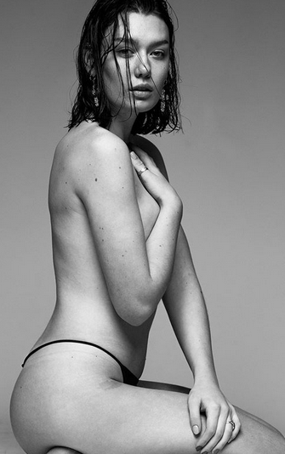
I decided to begin with some research that would help myself when constructing my dissertation in the future. I firstly began by researching the negativity of the word perfectionism and how it has been affecting society as a whole. The article conveys many different aspects of the word itself and how it can be used in alternative ways. It connotes the demoralising affects it can give and how it can develop illnesses. https://www.livescience.com/6724-dark-side-perfectionism-revealed.html
The same appearance of the female and male body which includes a certain weight or body shape. This ranges from being ‘skinny’ with females and aspiring to have a muscular body with males. It’s quite a disappointment because of the negative changes it’s made with society and how people now view themselves. Mental Health has become worse in the past 5 years and still is rocketing to this day. Bulimia, Depression, Self-harm, Anxiety and Starvation has been increasing and still is. Counselling and tablets have been distributed to maintain mental health. I decided to research the symptoms and causes of Body Dysmorphia and how it could be prevented. I decided to look at the website from the NHS about the illness and it states that it is most common in young teenagers and adults because of individuals becoming self-conscious and developing a self-hatred which can then be dangerous if it increases. https://www.nhs.uk/conditions/body-dysmorphia/

The word ‘Perfectionism’ also implies a certain way to act or to possibly change personalities. This has been noticed especially in young adults or teenagers as they feel like they would have to become someone different to have friends. It’s changing the appearance or becoming someone entirely new that seems to drive people into a different outlook on life. Perfectionism, can be characterized by a person’s strive for flawlessness and them setting high standards which are then accompanied by self-evaluations. Getting concerned about other’s opinions and thoughts which unfortunately then leads to self-hatred.
Whilst researching photographer’s, images or the ideal ‘body image’, I came across a photographer which seems to fit the description of pushing the idea of ‘the perfect body’. He seems to photograph women all throughout his body of work and in addition, the subjects in his photograph all have a certain appearance which contains a minimal amount of clothing. The photographs are being sexualised and representing an incorrect view of the female body which is demoralising and quite distressing considering the effect’s that It has made on human society with the younger generation. Jamie Thomas, the photographer which I’m not fond of to say the least, has a huge body of work that includes majority women and then being dressed in clothing such as lingerie. It gives view’ a strong impression that they need to look like them, not want. They feel the need to change their appearance and to aspire to be a model in the magazine or the muscular model in the Calvin Klein adverts. Individual’s becoming extremely preoccupied with a flaw in their appearance and feeling the need to change.

The 2nd work involves the word, ‘time’. This is an important key word for this dissertation proposal because of the changes in body dysmorphia throughout the era’s over the years. Through every era, the ideal ‘body image’ with men and women always change. In addition, studio photography or capturing the human body as models in the 19th century had an alternative perspective. I decided to research the trend’s that happen every era and how the appearance of a male and female body changes. I discovered a website that shows statistics and states the changes and how it has affected mental health. In addition, it gives an insight on what every era was like in terms of appearance and what was considered as beautiful and ‘perfect’. It gives an alternative outlook and it shows that nothing will change in the future if the trend of a female or male body is online and prioritised. Even with the body image problem that has been re-occuring for many years, the photographers involved were and are the problem in itself. They made the images the way they were and photographed the models in a particular way to show a certain figure or representation of the image of the perfect human being.
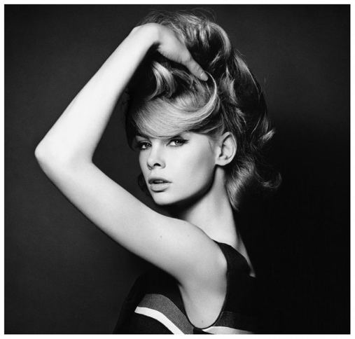
http://femalebodyimageacrosstime.blogspot.com/
A photographer who I have admired for many years done this when he was photographing models in the studio or outside in the 60’s. David Bailey was a fashion photographer who documented models, expression and fashion. However, the representation of some of his images can be deceiving and gives a wrong interpretation of what grace, confidence and self-love looks like.
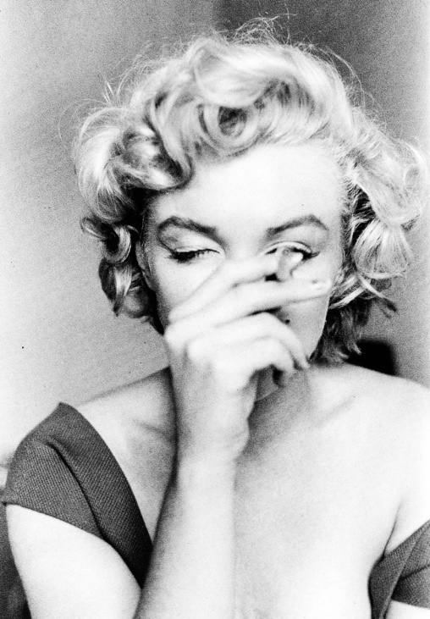
On another note though, I would like to highlight and mention an influencer who people still look up to till this day. A role model who gave confidence and self-love to others and made sure that she appeared natural and realistic in the photographs that were taken of her, Marilyn Monroe. Monroe was a model who gained her fame throughout the 1950’s. Although she became one of the most popular sex symbols of the 1950’s, she shared her love and confidence to the nation worldwide. She took part in other roles throughout television and performing on stage but the part I want to look further into to help develop my point further would be her modelling and how she was seen and captured by the photographers. Throughout observing the images that were taken of her in the 50’s, you can already notice that she is embracing her beauty and her appearances. Full of laughter and character, Monroe delivers humour and comfort through the photographs which is extremely important because you receive a humbling feeling instead of wanting to change your appearance because of how a certain human being looks or how they are shown.
Both female and males are shot and taken in a certain way where the body and the shape of them looks best. They are told by photographers to appear a particular way to appear beautiful or to be striking for their work and although that isn’t shown at all in the real world, photographers are sometimes to blame. The models are sometimes told to eat less, to work out or to change a few features just to be able to be eligible to be photographed for a campaign. It’s discomforting in a sense because they are human beings just like any other person. I understand that the viewers develop a mental health problem because of these issues but I decided to also pay attention to the model and wonder how they feel within themselves. I aimed to look at both perspectives with the title of this dissertation proposal and I want to be able to understand all of issues that make this problem re-occur, if not increase. Although Monroe carried on with her chirpy and outgoing charm which is emitted through the images, I’m sure she felt a certain way on the inside after a long time of being in front of the lens for campaign photo shoots.
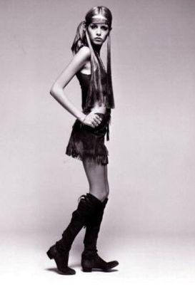
On the other side of the spectrum, I want to mention a model who lost quite a lot of weight due to attending that role so she would be eligible enough to be photographed. Twiggy. Twiggy became famous for her pixie hair cut and her quirky attitude that she carried through the photo shoots of the 1960’s. She lost quite a lot of weight because that was the trend throughout that era. The 60’s were absorbed around bright colours, patterns, a quirky style and a slim figure. However, after a long period of time throughout those 10 years, it became clear that it wasn’t all that it seemed as the photographs developed of her.

The 3rd word which I have chosen for research and to generate ideas for this proposal is the word ‘media’. This is a very important and significant word for this dissertation proposal piece because the media is one of the main factors that involves body image and dysmorphia. It’s the puppet that allows to send the world, who the majority are young adults, a visual representation of what ‘perfect’ is. It’s the weapon in society and for many more reasons other than what I’m researching and discussing. The media is a strong role in the world at the moment and is still growing significantly fast. Technology has grown also and is still improving which means in the future, the BDD could still grow and become even worse.
The media is full of many things. It’s everywhere across the globe that every individual is a part of and will see. Magazines, social media, articles, television and music is improving by the minute which connotes that the message of body appearance and image will only get worse.
Many articles across the globe for the past 7 years have mentioned the growth and the impact that it has had on individuals. I visited a link on the internet that provides many recent articles that discuss the body image and how its recently increased. https://www.journals.elsevier.com/body-image/recent-articles
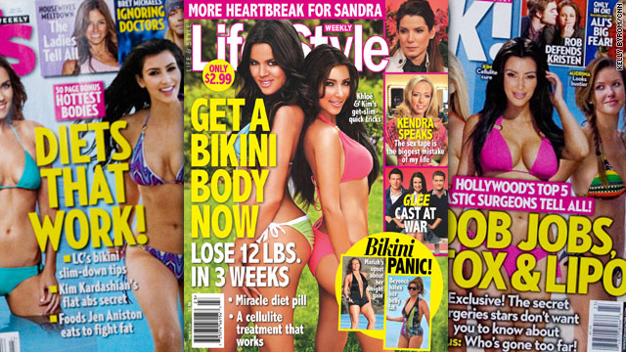
Eating disorders, depression and many more mental health illnesses have risen and it’s finally been noticed online. Sometimes the media can be a useful tool to send a message to the world and to make sure to put a point across regarding a problem, but however it can also become lethal if used in the wrong context.
My other point in regards to the media and it’s issue with increasing the problem of body image is social media apps. Although many photographers and artists use these as a platform to promote their body of work and interests, it’s also a dangerous tool to use because of the significant amount of people who use it. Some artists who post their work to be viewed and noticed, their work contains images or pieces of work that relates back to the push of becoming a certain appearance to be accepted as beautiful or perfect. This is a main factor in mental health as a whole anyway but with my issue of discussing the drastic increase of body image and modern photography, this would be vital to mention. Throughout my dissertation essay in the future, I will discuss the issues more and the problems that occur frequently to highlight this point further.
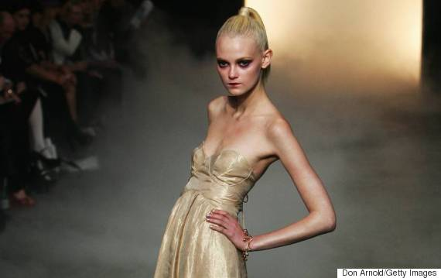
In addition to the problem of the media and how it represents the idea of body image, I would also like to address a huge issue which is a problem to society and has made a huge negative impact. Catwalks. Fashion catwalks are a huge problem which is really important to the statement of the increasing of body dysmoprhia/image and how modern photography has a role within it. Every year, thousands people gather in either America, Paris, Italy or London to witness a fashion show which is constructed of about 20 models. Many photographers and journalists attend to document the event and to capture the magnificence of the clothing that is being portrayed and shown. However, not many people notice the human beings behind the garments. Starved and thin models wearing heavy clothing as their job just to promote the brand. For myself and for this topic that I’ve decided to chose, it’s an important issue that strongly needs to be addressed because of the amount of attention it has received; nothing. I personally feel that it needs to be discussed because not long ago, a male model collapsed and became deceased on the catwalk due to dehydration and the lack of nutrients in the system. Unfortunately, after the model passed away because of broken bones and lack of hydration in the system, the media published and decided to then let the world know what happened regarding his death. It’s extremely unfortunate because it took a death for the problem to be noticed and talked about instead of discussing the issue in the first place. It’ a shame and I hope that in the future, the media will be able to represent and show the people in the world the realistic points that need to be made and to speak up about problems that need to be addressed instead of making matters worse for other human beings.
Hopefully the media will improve as it is a huge cause of mental health and I aim to research this matter in the future more because it is a big part of the world that causes problems and issues to innocent people.

After discussing my 3 key words that I have chosen to include for the dissertation proposal, I have managed to conclude my thoughts and contextualise how these have led me to a question I wish to research and write about in the following year. Although I originally wanted to talk about how modern photography has had a huge impact on the drastic change of body image and dysmorphia, I started to become more invested in the idea of the media itself. The media is a huge problem within the world and I began to feel so strongly towards that specific key word. There is so much involved under the umbrella of the media and how many issues and problems it can cause throughout the world and the individuals who live in it. The question I would like to research for the dissertation next year would be, “Why does photography sometimes cause problems within the modern world and the media?”. This would be my question to answer and explore further into because there would be so much to research and discuss that fall under it.
Although I have already explored the main factors and issues throughout this proposal, I aim and wish to research more in the future to continue my development and state facts which are extremely important to hopefully make a change.
This question will be useful in the development in the future because of how open it is and how much research I can retrieve. I would be able to discuss both positive and negative impacts which is extremely important.

