

MODULE CODE:ECEW7001

STUDENT NAME: Rachael Lee

STUDENT NUMBER: 2000206

ASSIGNMENT TITLE: (The summative assessment for this module is a research enquiry proposal of 4,000 words)

Use of Generative AI in Assessment

RESEARCH | For this assessment, you can use Generative AI to support you in research, including searching for bibliography, using tools to summarise, compare and interrogate materials. | Yes ☒  No ☐
STRUCTURE | For this assessment, you can use Generative AI to support you in structuring your submission, including creating a draft argument structure, identifying parts and headings, etc. | Yes ☒  No ☐
PROOFREADING | For this assessment, you can use Generative AI to check your own text/creation for grammatical and syntactical mistakes, including rephrasing of your own work within specific standards. | Yes ☒  No ☐
WRITING | For this assessment, you can use Generative AI to create text for submission. | Yes ☐  No ☒
CREATIVE | For this assessment, you can use Generative AI to create creative materials, such as images. | Yes ☐  No ☒
PROGRAMING | For this assessment, you can use Generative AI to create and check code. | Yes ☐  No ☒
NONE | For this assessment, you are not allowed to use any type of Generative AI support. This includes research support, structure support, writing/proofreading support and creative support. | Yes ☐  No ☒

AI Acknowledgement

I have not used any AI tools or any form of AI in my work at all.

Another great teaching tool or simply digital overload? Investigating the use of digital devices in the school environment in Wales post Covid-19.

During the academic year of 2024 to 2025, as a supply teacher I acquired a long-term placement in a mixed secondary school in south Wales (Estyn, 2025). Having previously taught in schools within the same Local Authority (LA) that had reserved approaches to digital devices in the classroom I was taken aback with the complete opposite approach within this current school who have intensely ‘embraced’ the Digital Competence Framework (DCF) set out within the Curriculum for Wales (2021). As seen in the School Development Plan (SDP) under its Whole School Digital Action Plan (WSDP) (Appendix A) whereby to further develop and embed digital skills across the curriculum every pupil was provided with an iPad. However, I observed many major problems: the amass of time consumed by these iPads, how they enable to use of mobile phones to be used in the classroom, the quality versus quality experiences on these digital devices for ‘learning’, the lack of control a teacher has on what learners are really accessing in lesson time and the change in mood by the learners from constant daily use across the school. Tripp states that “an interpretation of the significance of an event” (2011, p.8) needs to be observed and then reflected upon to understand the bigger picture and the wider impact. Undeniably, it is through reflecting (Schӧn 1987, Woods 2012 and Zwozdiak-Mayers, 2012) on these critical incidents (Tripp, 2011) that have led me to identify a problem which as Walliman (2010) states is the first stop on the research journey: identifying a problem. Indeed, identifying the problem is imperative for the then creating the aims and objectives of any research. Undeniably, it was these observations that led to deeper digging into how other education systems have approached, used and implemented digital devices successfully in the classroom without compromising learner’s health and well-being. On a local level I discovered a neighbouring school within the same LA has implemented a complete ban on all digital devices in the classroom, yet it is too soon to ‘see’ the results of this. The UK Charity Digital Youth (2025) have conducted a deep examination of the use and impact on digital devices in the classroom, namely mobile phones as an educational tool, yet the literature is conflicting and inconclusive. However, there has been a growing movement on a smartphone free childhood in the UK organised on grassroots level by over 350,000 parents since February 2024 (SmartPhone Free Childhood, 2025) arguing the damages that screen times causes children and young people. In England, Birmingham University conducted a long research project exploring how digital devices are used in the classroom (Wood G, Goodyear V, Adab P, et al, 2023) citing problematic overuse. I found also on an international scale, that The Danish Government (2024) had banned digital devices from the school environment and provided a 12-point review citing learner wellbeing as its rationale. The World Health Organization in 2019 recommended to keep screen time to a minimum so not to impact cognitive overload. Yet, learners are using these digital devices almost every single lesson, five hours a day in school alone. How can we allow this overuse to happen to our learners? I could see there was a problem and perhaps a correlation between digital devices and challenging behaviours. I wanted to explore this further, but where to start?

Literature Review:
The initial research brought attention to three different aspects within the literature:
- Welsh Government Curriculum Policy and Guidance, including the Digital Competence Framework (DCF);
- The role and implementation of digital devices in the classroom; and,
- Screen time, young people and health.

Welsh Government Curriculum Policy and Guidance, including the Digital Competence Framework (DCF).
In 2015, Professor Graham Donaldson published his Successful Futures review into the education reform in Wales. Within this review Donaldson (2015) argued that for learners to succeed in the future they must be prepared for the ever-changing world around them by developing their digital skills. The DCF part of the Cross-Curricular Skills Framework published by Welsh Government (2021), a result of Donaldson’s Successful Futures (2015), aims to help guide and support schools in their planning and delivering of digital skills within the Curriculum for Wales. The DCF has been categorised by Welsh Government as having the same core skill standards of that of numeracy and literacy, thereby, placing digital skills and digital literacy as a fundamental learning skill within the Curriculum for Wales. Despite the DCF being broken down into four separate areas of focus (which includes a three progression pathway within each section): Citizenship, Interacting and Collaborating, Producing, and, Data and Computational Thinking, the DCF’s ‘clear’ guidance ‘aims’ to steer the aims and objectives of the DCF for Schools to imbed within their own curriculum design without giving any details of what this looks like in practice. The Welsh Government has however emphasised that the DCF is not to replace ICT or Computer Science but to sit “alongside ICT and computer science and encourage the integration of digital skills across the full range of lessons” (Joe Champion, 2016, National Assembly for Wales Research Service), therefore, being taught within all the AoLE’s. The issue we are facing is the misunderstanding of the DCF by schools. As an example, the Senior Leader Team and experienced teaching staff who are perhaps not as open-minded (and are used to teaching in a particular way) compared to those who have been trained under the Curriculum for Wales (who have had the benefit of discussing with academics), have interpreted the DCF to simply ‘use as much digital devices as we can in the classroom’ and create a divide in delivery of DCF within a school. As such, this has highlighted the lack of staff’s own knowledge of the four sections of the DCF and has been mismanaged in delivery, therefore, creating an excessive use of digital devices with not always meaningful experiences that do not incorporate digital skills required for real-world experiences across all six AoLEs within the school. This can be seen in the recent curriculum design attached (Appendix B). The inspectorate body here in Wales, Estyn, published their findings in 2019 highlighting the challenges that schools are facing regarding the DCF which mainly were of clarity of how the DCF was interpreted and communicated school-wide amongst staff and the SLT and that staff’s digital literacy skills were not sufficient enough to help deliver quality and meaningful opportunities for learners.
Indeed, if we have excessive digital device usage in the classroom based on staff’s misinterpretations of the Curriculum for Wales (2021) and the lack of clarity from Welsh Government of how the DCF looks in practice, how is this impacting our learners and staff mentally, physically and socially? Are we doing more harm than good to simply try to tick a box for Welsh Government?

The role of digital devices in the classroom
Covid-19 brought about the ‘digital classroom’ and upon the return to the physical classroom, it appears the dominance of digital devices have also attached themselves as a core fundamental within the classroom. The role of these devices to facilitate and allow learners to access education during a global pandemic was key and as such, digital technology and digital devices are becoming “central to education” (Qureshi et al 2021:2). Yet, it is the role of these digital devices in the classroom that needs to be explored, exposed and the positive aspects harnessed. Dudar et al (2021) argues that digital devices in the classroom allow for mixed learning and creating bespoke curriculum in real-time, thus, helping to connect the learner with understanding, if effectively managed. Yet, it is very dependent on the budget of the school and the attitudes of that of management if and what digital technologies and devices are accessed within the school setting (Somekh, 2004). High tech and low-tech lessons again are dependent upon the skillset of the teacher delivering them and therefore, the quality of this experience for learners becomes dependant on socio-economic and socio-political factors. Camilleri and Camilleri (2017) argue that the use of digital technologies in the classroom has its place in helping to aid environmental impacts such as using less paper, sustainable use by reusing resources and keeping department costs down. Of course, this is the appeal to schools in Wales and the UK widely due to stretched budgets from consecutive years of austerity from the UK Conservative Governments since 2009. The excessive use of digital devices in the classroom as a means for keeping school costs down is certainly something I experience in my professional context. The literature has shown a wealth of ways in the way and the role of digital devices in the classroom. However, the Welsh context is yet to explored thoroughly and therefore has a gap in the research field.

Screentime, young people and health.
Screens have dominated all aspects of our lives and our young people’s lives and as such, there has been a wave of research into screentime and the impact on young minds in recent years. Academic research projects exploring the impact on child development, speech and language, social development, mental health and well-being down to socio-economic impacts have thrown up corresponding yet differing results (Priftis and Panagiotakos, 2023). Sheri Madigan et al (2022) has argued that there has been a 52% increase in screentime amongst young people post Covid-19 and it appears within the literature that it is widely accepted that screentime correlates with childhood obesity (Ponti, 2023, Zhang et al 2016 and Khajeheian et al 2018). However, Stiglic and Viner (2018) argue that excessive screentime has had damaging consequences on the health and well-being of young people. The Welsh Government has published guidance on screentime on Hwb (2025) stating that excessive screentime can cause sleep, behaviour and concentration issues in children, yet acknowledges that it can only become an issue when a child is ‘dependent’ on such devices and it begins to impact other aspects of their lives. Indeed, this is vague as there are no clear markers on what ‘dependent’ looks like. What has become apparent from this preliminary research is the conflicting conclusions and how such evidence has been collated. As an example, data has been collated by participants self-reporting their evidence and it is sometimes hard to establish reliable data regarding how young people feel that screentime is impacting them. My skills as a teacher during interview stage of collating data I will use effective questioning to help draw out deeper questioning and deeper thinking from learners like I would do in the classroom when probing their opinions about a complex subject.

This research study will be proposing to explore the following fundamental questions:
- How has the DCF been interpreted in schools in Wales and what does this look like in practice in a mixed secondary school in south Wales?
- Is there a correlation between the use (academic and personal) of digital devices in the school environment (classroom, outside of classroom, the whole school space) and the health and well-being crisis in young people? How is this modelled to the learners?
- How is the school environment reflective of society: is there a clearly defined gap between digitally affluent learners and learners who are in digital poverty? What does this look like in practice?

These research questions are essential to ascertain the measurable impact on the use and potential overuse of these digital devices in the classroom in a Welsh context. As the research questions feed into each other from different contexts, Education, Health, and Society as they are overlapping and are intrinsic to each other, this will help understand the impact of digital devices on young people by considering the complex systems they operate within (Thomas, 2023). Indeed, as it has been established from the literature, the subjective interpretation of the DCF by schools and what this looks like in practice without considering the wider impact on learners, therefore, these research questions drive into the heart of the core issue of interpretation of the DCF, the DCF in practice and how the DCF in practice is making learners feel and witness modelled behaviour around digital devices. By including the wider school context not just the classroom, these questions allow a fluid movement of research to be obtained of the use and impact of digital devices as these devices are not limited to one space. The design of these research questions will help to discover ‘understandings’ not ‘truths’ of the critical acceptance of the data generated (Alvesson & Skoldberg, 2000).
By asking the why and how questions this research aims to help identify the reasoning behind challenging behaviour in the classroom that schools are witnessing since Covid-19. It is Furlong (2015) who remarks that within education that it is teachers “who understands the ‘why’ and the ‘how’ of teaching as well as the ‘what’” (Furlough 2015:19), as such, as a teacher, and an expert in the classroom, it is this through this unique position as a researcher that I can observe and better understand the complex situation surrounding the use of digital devices in the classroom and the complex ecosystem they are attached to within the school environment. These research questions will help to contribute to the vastly growing academic research within this field and help to generate data from a Welsh context which is vital for Wales’s global reach within academic research and understanding more widely digital devices within the education system so to positively inform my practice moving forward.

Methodology
This research project will use a mixed methods approach by employing both qualitative and quantitative research methods. A qualitative method will be used in lesson observations, learning walks around the school environment and through discussions with learners (Silverman, 2016 and, Buckler and Moore 2016). A quantitative method will be used to collate data through the application of questionnaires sent to learners, teaching staff and parents/carers (Kumar, 2019 and Cohen et al, 2018). It is worth noting that by not being restricted to one methodology and comparing and analysing data from two methodologies will allow me to dig deeper into the bigger picture that is operating by highlighting trends that may not be clear with the exclusive use of one data set methodology, therefore, alleviating the limitations only one data methodology approach would present (Walliman, 2010, Abowitz and Toole, 2010). Due to the numerical and at times clinical nature of quantitative data, trends that may arise in such data sets may not be so easily teased out standing alone but working along qualitative data, which is language based data such as thoughts and feelings, can help explain such trends arising and help provide insight and context to the research data (Bryman, 2016, Cohen, 2018, Walliman, 2010). As an example, in schools, teachers measure progress by using empirical data such as data from pupil voice questionnaires alongside raw numerical data to help explain and understand the overarching bigger picture due to the social and complex factors at play. This mixed approach is a well proven way of understanding data in the school setting. Therefore, using a mixed methods approach becomes the obvious and coherent way to approach research in an educational setting (Cohen, 2018, Bryman, 2016).
It was clear from the literature review that the only piece of research that has taken place around the aims of this study I am proposing is through the inspectorate body in Wales which is Estyn. However, their findings are merely observational and limited. My research design proposes to be exploratory to help understand those initial insights and understand further the reasons for the choices made around digital devices in the classroom. This initial exploratory research design is preliminary in nature as it will then help to form the basis of further proposed research for my doctorate in Education proposal, to build further understanding around this area of research (Swedberg, 2020).

This proposed research will be using action research in its inquiry due to the self-reflective nature undertaken by participants in social situations (such as teachers) that gives way to understanding factors influencing their “educational practices their understanding of these practices, and the situation in which these practices are carried out” (Carr and Kemmis, 1997, p.162). When effectively managed action research can allow change to happen due to it being “fluid, open and responsive” (Kemmis and Wilkinson, 1998, p.21) as research carried out is generated from research questions that are specific to the educational setting. Therefore, are not ridged in a traditional sense and are engaged openly and constructively in that community so to bring about required changes, thus, allowing the educational setting to evolve (Bradbury and Divecha, 2020, Buckler, S. & Moore, 2023). However, limitations I am aware of is that in practice schools historically have been restricted on the changes they can make based from teacher’s action research findings due to Government policy and the implementation of standardisation requirements. Yet, now with the arrival of the Curriculum for Wales it appears that some schools are far more open to embracing wider changes of such action research findings but that is dependent upon the senior team’s overall openness and understanding of the Curriculum for Wales. As such, wider changes do run the risk again of becoming dormant findings, and the research becomes again merely another tick box activity. However, action research still has value as it can inform and change an individuals practice (as continuous professional development) which makes it a worthwhile experience (Carr and Kemmis, 1997). When conducting my own action research, I will aim to be critical, reflective and use the data collated to inform my change in practice. The process of action research is an intense cycle of planning, acting, observing, and reflecting on the problem identified therefore providing me with a deeper understanding of the cause of effect of the problem I am investigating (Danermark et al, 2019). This allows me to have control over the research and be deep within the process, therefore allowing for effective change in my practice to be naturally inevitable.

I will be employing a range of tools and procedures to collect primary data: lesson observations, learning walks through the school environment during and outside of lesson time and discussions and questionnaires with learners, teaching staff and parents/carers. I will be collating data from teaching staff through questionnaires so to gain an insight into their understanding, implementation and thoughts regarding the DCF and digital devices in the school environment. I will also collate data from staff from the student support services in school through the means of discussions and questionnaires on their professional insights into incidents surrounding digital devices in the school environment and their observations of learners mental and health and wellbeing around these incidents. Data will be collated from learners through sampling interviews and questionnaires with learners from a cross-section of the key stages in the school (Kvale, 2007). Lesson observations and learning walks during movements between lessons will be broken up by Key Stages so to collate a cross-section of learners and have an opportunity for representation:

Observation Day Number | Key Stage 3 | Subject | Subject | Subject | Subject | Subject
1 | Class A
1 | Learning Walk (movement between lessons)
 | Key Stage 4
2 | Class B
2 | Learning Walk (movement between lessons)
 | Key Stage 5
3 | Class C
3 | Learning Walk (movement between lessons)

This approach will allow me to have a clear insight and a transparent representation into the spaces these digital devices operate within the school environment and the impact they are having. I aim to acquire data from a range of staff and teaching staff to further provide this insight and so that all voices are heard equally within the school environment. I will conduct interviews in person so to put people at ease and increase engagement (Bryman, 2016). The questionnaire will be sent via email to all staff, digitally to all learners in form time who I have targeted, and through the parent app in school for parents/carers who have expressed an interest in participating (to be discussed initially during parents evening). This questionnaire will have a range of open and closed questionnaire, and I will also be using the Likert Scale to help measure responses in a numerical standardised way, e.g., From a scale of 1 to 5 how confident are you with using digital devices in your classroom? Since the school has allowed iPads in lessons, how do you feel this has impacted your lessons, why? I will be conducting a range of observations both in and outside the classroom but from a reserved standpoint so not to interfere with the lesson and allow business as usual to unfold. I will make it clear to the teacher that I am not there to judge their teaching but to merely observe the lesson and the learner’s interactions, this is to reassure the teacher, especially if they are an NQT. This will be recorded on an observation checklist so I can track and reflect on the events unfolding (Bryman, 2016).
As the sample size will be large, I will be completing conclusions based upon this data set only but also mindful that this sample is not representative of the population in Wales but of this particular context (Bryman, 2016). The data will be measured using nominal and ordinal measures: as an example, nominal will enable me place data from yes or no questions into categories. Ordinal will allow me to order and present data from the questionnaire where I have used the Likert Scale. The qualitative data will be statistically sorted and placed into categories referred to as nodes (which I have previously used working in qualitative research at Cardiff University) so to clearly help sort and present this data set ready for analysis by myself (Dhakal, 2022).

For this research to be completed, research ethics must be considered and adhered to so to protect those individuals, organisations and stakeholders involved. I will be adhering to the British Educational Research Association (BERA) guideline and following the “..ethic of respect.. ethic of care…(and maintaining) trust..” during this research (BERA, 2024). It is imperative that participants know that their participation in this study is completely voluntary and they can withdraw at any stage. Consent and assent will be obtained during this study before any participant will be allowed to take part. Participants will be provided with all the relevant information (consent, assent, handling of their personal data) will be explained thoroughly before they agree to take part. I will make sure that learners clearly understand their rights and that their involvement can be withdrawn by them at any given time without any negative impacts (Brooks et al, 2014). They will also be made aware that by withdrawing their data will also be destroyed as per GDPR guidelines and BERA guidelines. This will be communicated in an information sheet and an informal round table discussion so they can ask any questions they have before joining the study. Potential participants will be selected from a larger sample size I have identified from the lesson observations. Potential participants will be made aware that during the research study and through to publication that their data will be stored securely, encrypted and then destroyed upon publication. All participants will be provided with anonymity so to protect their identity.

Plan of work and indicative time schedule
Research Phase | Objectives | Deadline
Preparing for DCF analysis in new school | In September 2025 I will be teaching in a new setting (still in the same LA) so will need to conduct a new baseline research analysis in this school around their interpretation of the DCF, read the school policy around digital devices and read up on the school’s learning objectives in the School Development Plan (SDP) around the DCF/ digital devices. | End of September 2025
Background research and literature review | To undertake a deeper dive and critical examination with the literature surrounding digital devices in the classroom and screentime in young people  To refine research questions based on further examination of critical research into the literature  To undertake an observation in the neighbouring school who has banned all digital devices in the school environment. This will just be an observation to see how it is done in practice, and no data will be collected. This is part of background research.  To meet with supervisor for initial discussion and planning of Ethics Form that will need to be submitted before any data collation can take place | December 2025
Research design planning | Design and create questionnaire for chosen staff members  Design and plan interview questions for interviews  Make final decisions regarding data collection and sampling methods as discussion with supervisor | January 2026
Data collection and preparation | Send out questionnaire to staff, parents/carers and learners.  Recruit participants for interview and ensure BERA and UWTSD ethics guidelines are followed as agreed in the ethics form submitted to the ethics committee in UWTSD.  Undertake interviews  Record and transcribe audio collected from interviews  Undertake learning walks in the school environment, observations of lessons and discussions with learners making sure all ethical regulations are met and always followed  Sort and place qualitative data from the observations, questionnaires and interviews into node categories to help with analysis (from raw data to statistical data).  Sort and categorise qualitative data from the questionnaire ready for analysis.  Reflect on the action research conducted and allow myself the space to process this so to feed into informing my teaching practice in a positive way | March 2026
Data analysis | Analyse all data collected in questionnaires, observations and transcripts.  Reflect on the data analysed ready for the write up process | April 2026
Writing | Complete a full dissertation draft and submit to tutor for feedback  Meet with tutor to discuss feedback and revisions | July 2026
Final draft and submission | Redraft based on final meeting with dissertation tutor  Submit for final approval  Proofread and submit | September 2026

Reference List:
Abowitz, Deborah & Toole, T., (2010), “Mixed Method Research: Fundamental Issues of Design, Validity and Reliability in Construction Research”. Journal of Construction Engineering and Management, 136, pp.1-23.
Alvesson, Mats and Skoldberg, Kaj, (2000) Reflexive Methodology: New Vistas for Qualitative Research. London: Sage Publications LTD.
Bradbury, H., Divecha, S. (2020). “Action methods for faster transformation: Relationality in action”, Action Research, 18(3), pp.273–281. Available at: https://doi-org.ergo.southwales.ac.uk/10.1177/1476750320936493 (Accessed: 10th August 2025).
British Education Research Association (2024) Ethical Guidelines for Educational Research. Available at: https://www.bera.ac.uk/publication/ethical-guidelines-for-educational-research-fifth-edition-2024 (Accessed: 30th July 2025)
BØrne – OG Undervisningsministeriet, Styrelsen For Undervisning OG Kvalitet (Dannish Government Ministry for Education), (2024), Skærmbrug I grundskolen, Available at: https://www.uvm.dk/-/media/filer/uvm/aktuelt/pdf24/feb/240205anbefalinger-grundskole-final.pdf Accessed on 12th July 2025.
Bronfenbrenner, U. (2000). Ecological Systems Theory. Oxford: Oxford University Press.
Buckler, S. and Moore, H. (2023), Research Methods in Education, London: SAGE Publications Ltd
Camilleri.,M.A, Camilleri., A.C, (2017) “Digital learning Resources and Ubiquitous Technologies in Education”, Technology, Knowledge and Learning, 22 (1), pp.65-82
Carr, W., and Kemmis., S. (1997) Becoming Critical: Education, Knowledge and Action Research. London: Routledge
Champion, Joe, National Assembly for Wales Research Service (2016) Curriculum Reform: The Digital Competency Framework. Available at: https://research.senedd.wales/research-articles/curriculum-reform-the-digital-competence-framework/ Accessed on 12th July 2025.
Cohen, L., Manion, L. and Morrison, K. (2018), Approaches to Quantitative Data Analysis. Abingdon: Routledge
Cohen, L., Manion, L. and Morrison, K. (2018), Research methods in education (8th ed). Abingdon: Routledge
Children’s Commissioner for Wales (2021) The Right Way: A Children’s Human Rights Approach to Education in Wales. Available at: TheRightWayEducation_ENG.pdf (Accessed on 1st December 2024).
Danermark, B., Ekström, M., & Karlsson, J. C. (2019), Explaining Society: Critical Realism in the Social Sciences. Abingdon: Routledge
Donaldson, G. (2015) Successful Futures. Available from: https://gov.wales/sites/default/files/publications/2018-03/successful-futures.pdf. (Accessed: 22 March 2025)
Dhakal K. (2022). NVivo. Journal of the Medical Library Association : JMLA, 110(2), 270–272. Available at: https://doi.org/10.5195/jmla.2022.1271 Accessed on 26th May 2025
Estyn (2025) Inspection report for Redacted School, School, Available at: https://estyn.gov.wales/education-providers/Redacted-comprehensive-school/
Accessed on 12th July 2025.
Haleem, Abid., Javaid, Mohd., Qadri, Asmin Mohd., Suman, Rajiv. (2022) “Understanding the role of digital technologies in education: A review”, Sustainable Operations and Computers 3, Science Direct, 3, pp. 275-285
Khajeheian D., Colabi A.M., Ahmad Kharman Shah N.B., Bt Wan Mohamed Radzi C.W.J., Jenatabadi H.S. Effect of Social Media on Child Obesity: Application of Structural Equation Modeling with the Taguchi Method. Int. J. Environ. Res. Public Health. 2018;15:1343. Available at: doi: 10.3390/ijerph15071343. Accessed on 26th May 2025
Kumar, R. (2019), Research Methodology. 5th ed. London: SAGE Publications Ltd
Kvale, S., (2007), Doing Interviews, London SAGE Publications Ltd
Lune, H., & Berg, B. L. (2016), Qualitative Research Methods for the Social Sciences. London: Pearson Higher
Madigan S., Eirich R., Pador P., McArthur B.A., Neville R.D. (2022) Assessment of Changes in Child and Adolescent Screen Time During the COVID-19 Pandemic: A Systematic Review and Meta-analysis. JAMA Pediatr. 2022;176:1188–1198. Available at: doi: 10.1001/jamapediatrics.2022.4116 Accessed on 26th May 2025
Ponti M. (2023) “Screentime and preschool children: Promoting health and development in a digital world”. Paediatr. Child Health. 2023;28:184–202. Available at doi: 10.1093/pch/pxac125. Accessed on 21st June 2025.
Priftis, N., & Panagiotakos, D. (2023). “Screen Time and Its Health Consequences in Children and Adolescents.” Children (Basel, Switzerland), 10(10), 1665. Available at: https://doi.org/10.3390/children10101665 Accessed on 21st May 2025
Qureshi, M.I. (2021) “Digital Technologies in Education 4.0. Does it Enhance the Effectiveness of Learning? A Systematic Literature Review.”, International Journal of Interactive Mobile Technologies (Ijim), 15 (04), pp. 31-47.
Schӧn, D.A. (1987) Educating the Reflective Practitioner: Toward a New Design for Teaching and Learning in the Professions. San Francisco: Josse Bass Higher and Adult Education.
Silverman, D. (Ed.). (2016), Qualitative Research. London SAGE Publications Ltd
Hwb, Welsh Government (2025) Hub: Screen Time. Available at: https://hwb.gov.wales/keeping-safe-online/screen-time/ Accessed on 12th July 2025.
Somekh., B. (2004) “Taking the Sociological imagination to school: An analysis of the (lack of) impact of information and communication technologies on education systems”, Technology, Pedagogy and Education, 13, pp. 163-179
Stiglic N., Viner R.M. (2019) Effects of screentime on the health and well-being of children and adolescents: A systematic review of reviews. BMJ Open. 2019;9:e023191. Available at: doi: 10.1136/bmjopen-2018-023191 Accessed on 21st May 2025
Smart Phone Free Childhood (2025) Smart Phone Free Childhood. Available at https://www.smartphonefreechildhood.org/ Accessed on 12th July 2025.
Thomas, G. (2023), How to do your Research Project (4th Ed). London: SAGE Publications Ltd
Tripp, D. (2011) Critical Incidents in Teaching: Developing Professional Judgement. Oxford: Taylor & Francis Group.
Welsh Government (2021) Curriculum for Wales. Available at: https://hwb.gov.wales/curriculum-for-wales/ (Accessed: 20th May 2025)
Welsh Government (2020) Curriculum for Wales Guidance. Available at curriculum-for-wales-guidance.pdf (Accessed: 20th May 2025).
Wood G, Goodyear V, Adab P, (2023) “Smartphones, social Media and Adolescent mental well-being: the impact of school policies Restricting day Time use—protocol for a natural experimental observational study using mixed methods at secondary schools in England (SMART Schools Study)” BMJ Open, Available at: doi: 10.1136/bmjopen-2023-075832 Accessed on 21st May 2025

Woods, P. (2012) Critical Events in Teaching and Learning. Oxon: Routledge.
Zwozdiak-Mayers, Paula. (2012) The Teachers Reflective Practice Handbook. Becoming an Extended Professional through Capturing Evidence-Informed Practice. Oxford: Taylor & Francis.

Appendix:
Appendix A:
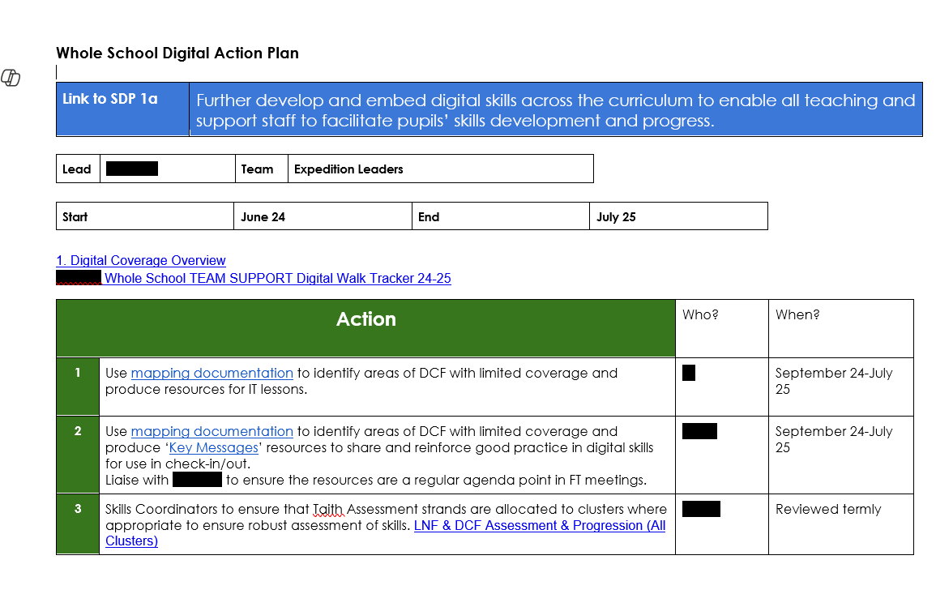
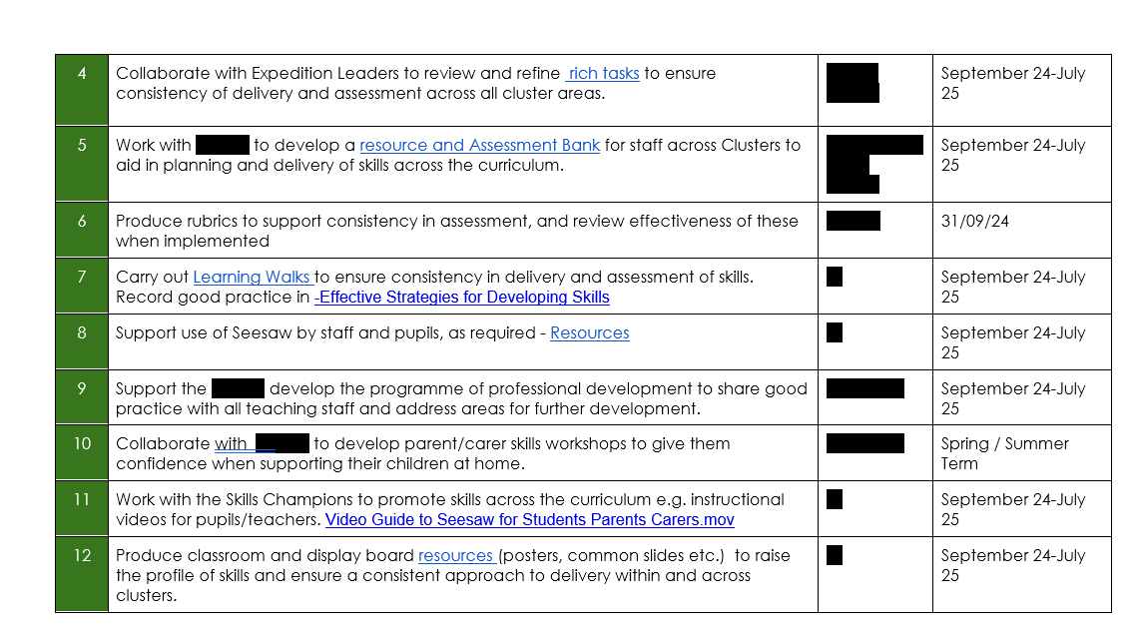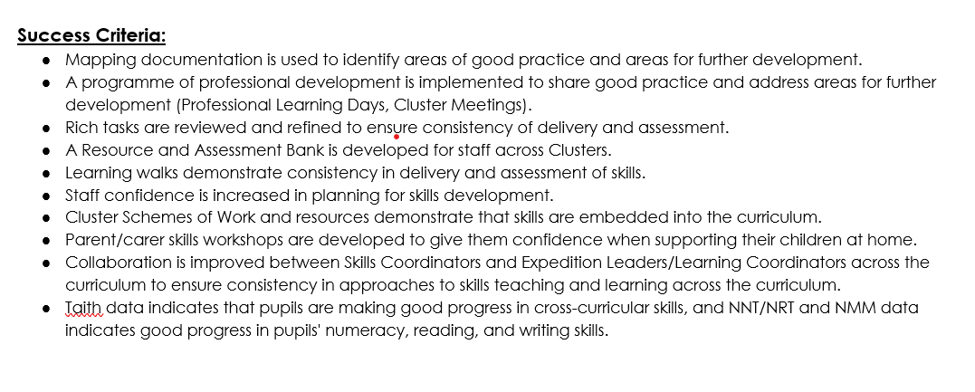

Appendix B:


