

Course Title: MBA - International Business

Term 2

Student Name: Vishal Ramjibhai Bhalala

Student ID: 2509170

Module Name: Strategic Management

Module Code: LCMB7003

Lecturer’s Name: Amare Desta

Work Count: 5203/5000

Table of Content
Section 1 5
1. Organisational Context and Overview 5
1.1 Introduction to Amazon 5
1.2 Mission, Vision, and Core Values 6
1.3 Business Model 7
1.4 Industry Overview and Market Position 7
2. External and Internal Environment Analysis 8
2.1 PESTEL Analysis (External Environment) 8
2.2 Critical Success Factors & Strategic Challenges 11
2.3 Internal Environment Analysis 13
2.4 VRIO Framework Analysis 14
2.5 Contribution to Competitive Advantage 15
3. CSR and Sustainability Objectives 16
4. Balanced Scorecard Analysis 18
4.1 Financial Perspective 18
4.2 Customer Perspective 19
4.3 Internal Business Processes 20
4.4 Learning and Growth 21
5. Strategic Choices and Implementation 22
5.1 Business-Level Strategies 22
5.2 Corporate-Level Strategies 22
5.3 Change Management Evaluation 23
6. Strategic Evaluation and Recommendations 24
6.1 SWOT Analysis 24
6.2 Strategic Framework (Ansoff Matrix) 26
6.3 Recommendations 27
Section 2: Reflective Account 28
1. Description 28
2. Feelings 28
3. Evaluation 29
4. Analysis 30
5. Conclusion 30
6. Action Plan 31
References 33

List of Figures
Figure 1: Amazon Logo 5
Figure 2: Amazon Evolution Timeline 6
Figure 3: Amazon Mission and Vision Statement 6
Figure 4: Amazon Business Model Ecosystem 7
Figure 5: Top Amazon Competitors 8
Figure 6: E-commerce Growth Trends Chart 10
Figure 7: Amazon Supply Chain and Logistics Network 11
Figure 8: Amazon Personalization and Data Processing Architecture 12
Figure 9: Amazon Web Services (AWS) Services Ecosystem 14
Figure 10: Amazon Data Analytics and Forecasting Workflow 15
Figure 11: Amazon Climate Pledge and Sustainability Initiatives 17
Figure 12: Amazon Revenue Segmentation by Business Segment (Q1 2024) 18
Figure 13: Amazon Exclusive Pricing and Promotional Strategy 19
Figure 14: Amazon Warehouse Automation and Robotics System 20
Figure 15: Amazon R&D Investment Leadership 21
Figure 16: Amazon Global Presence and Market Reach 23
Figure 17: Amazon Organisational Culture and Innovation Pillars 23
Figure 18:Ansoff Matrix 26

List of Tables
Table 1: PESTEL Analysis of Amazon 9
Table 2: VRIO Framework Analysis of Amazon 14
Table 3: Summary of Amazon’s CSR and Sustainability Strategy 16
Table 4: SWOT Analysis of Mazon 25
Table 5:Strategic Recommendations and Expected Outcomes for Amazon 27
Table 7:Personal Development Plan 32

Section 1

1. Organisational Context and Overview

1.1 Introduction to Amazon

Figure 1: Amazon Logo
Source: Amazon (2025)
Amazon is a technology driven company that started in 1994 and has since expanded to one of the most influential companies globally as an online bookstore. With time, the company grew to be more than a retail company into cloud computing, digital streaming, artificial intelligence, and logistics. This evolution represents the strategic emphasis on innovation and diversification by Amazon, which allows the company to create a multi-sided platform ecosystem (Nowfeek, 2025). The rapid expansion of the company has been encouraged by the fact it has continued to invest in technology infrastructure and data analytics enabling it to take control of various industries at once.
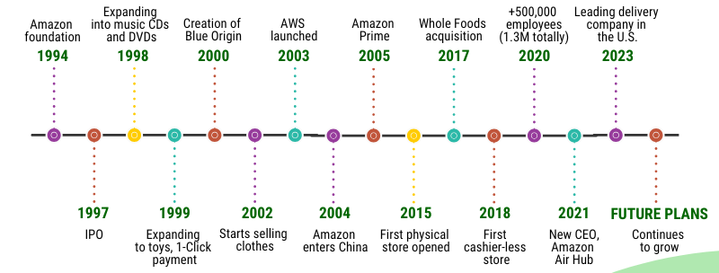
Figure 2: Amazon Evolution Timeline
Source: Amazon (2025)

1.2 Mission, Vision, and Core Values
Amazon has a mission of being the most customer-focused company on the planet, a focus that underlines its commitment to provide the best customer experience in terms of convenience, affordability, and the product mix (Amazon, 2025). It has a long-term innovation and global expansion vision, which is supported by digital transformation and technological leadership. Its strategic choices and organisational culture are directed by the core values, including customer obsession, operational excellence, and continuous innovation (Cao et al., 2025).
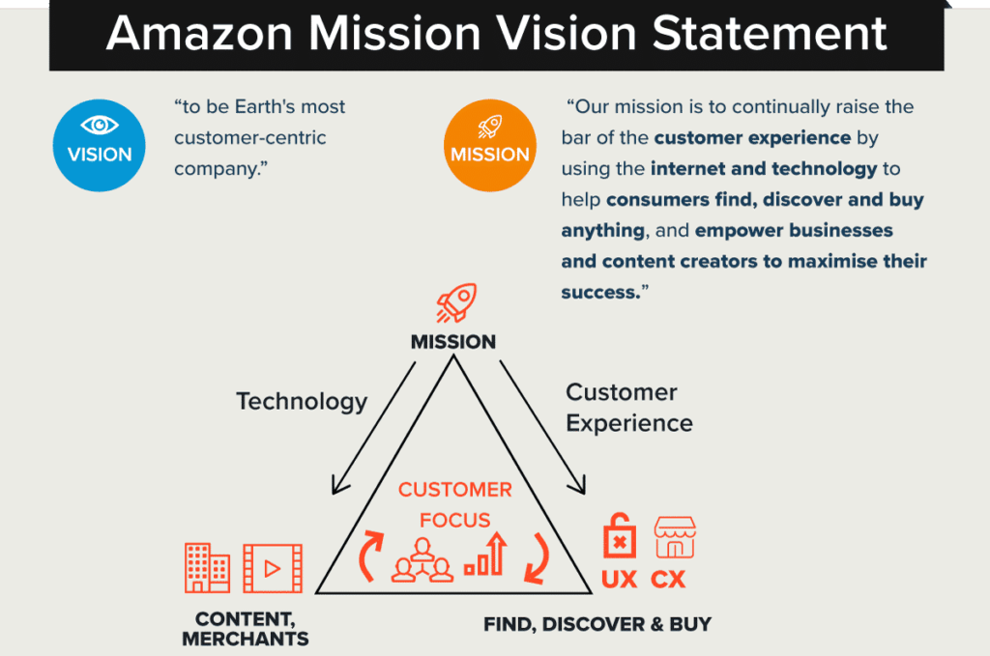
Figure 3: Amazon Mission and Vision Statement
Source: Amazon (2025)

1.3 Business Model
Amazon has diversified business model which is a combination of multiple revenue streams. Its leading division is the global e-commerce platform, which is backed by a market place model in which third party sellers make a substantial contribution to sales. Moreover, Amazon Web Services (AWS) also offers cloud computing services and becomes a key source of profit because it is scalable and generates high margins (Kadaskar et al., 2024). These subscription plans like Amazon Prime increase customer loyalty via added value like expedited delivery and online content. This combined model helps Amazon to generate network effects and maintain competitive advantage (Hamlaoui et al., 2025).
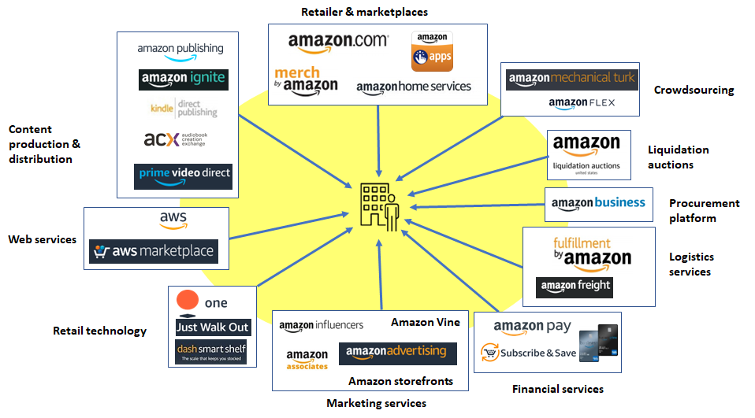
Figure 4: Amazon Business Model Ecosystem
Source: Boardmix (2025)

1.4 Industry Overview and Market Position
Amazon is involved in some of the most competitive sectors such as e-commerce, cloud computing, and digital entertainment. The key competitors in retail are Walmart and Alibaba, and cloud service providers are Microsoft Azure and Google Cloud. As stated by Niu et al. (2023), Amazon has been able to keep a dominant position on the market worldwide despite all the competition, and it is assisted by its comprehensive logistics and technological infrastructure (Niu et al., 2023). Its capability to integrate the scale, innovation and customer-centric strategies has made it a force in various digital markets (Nowfeek, 2025; Niu et al., 2023).
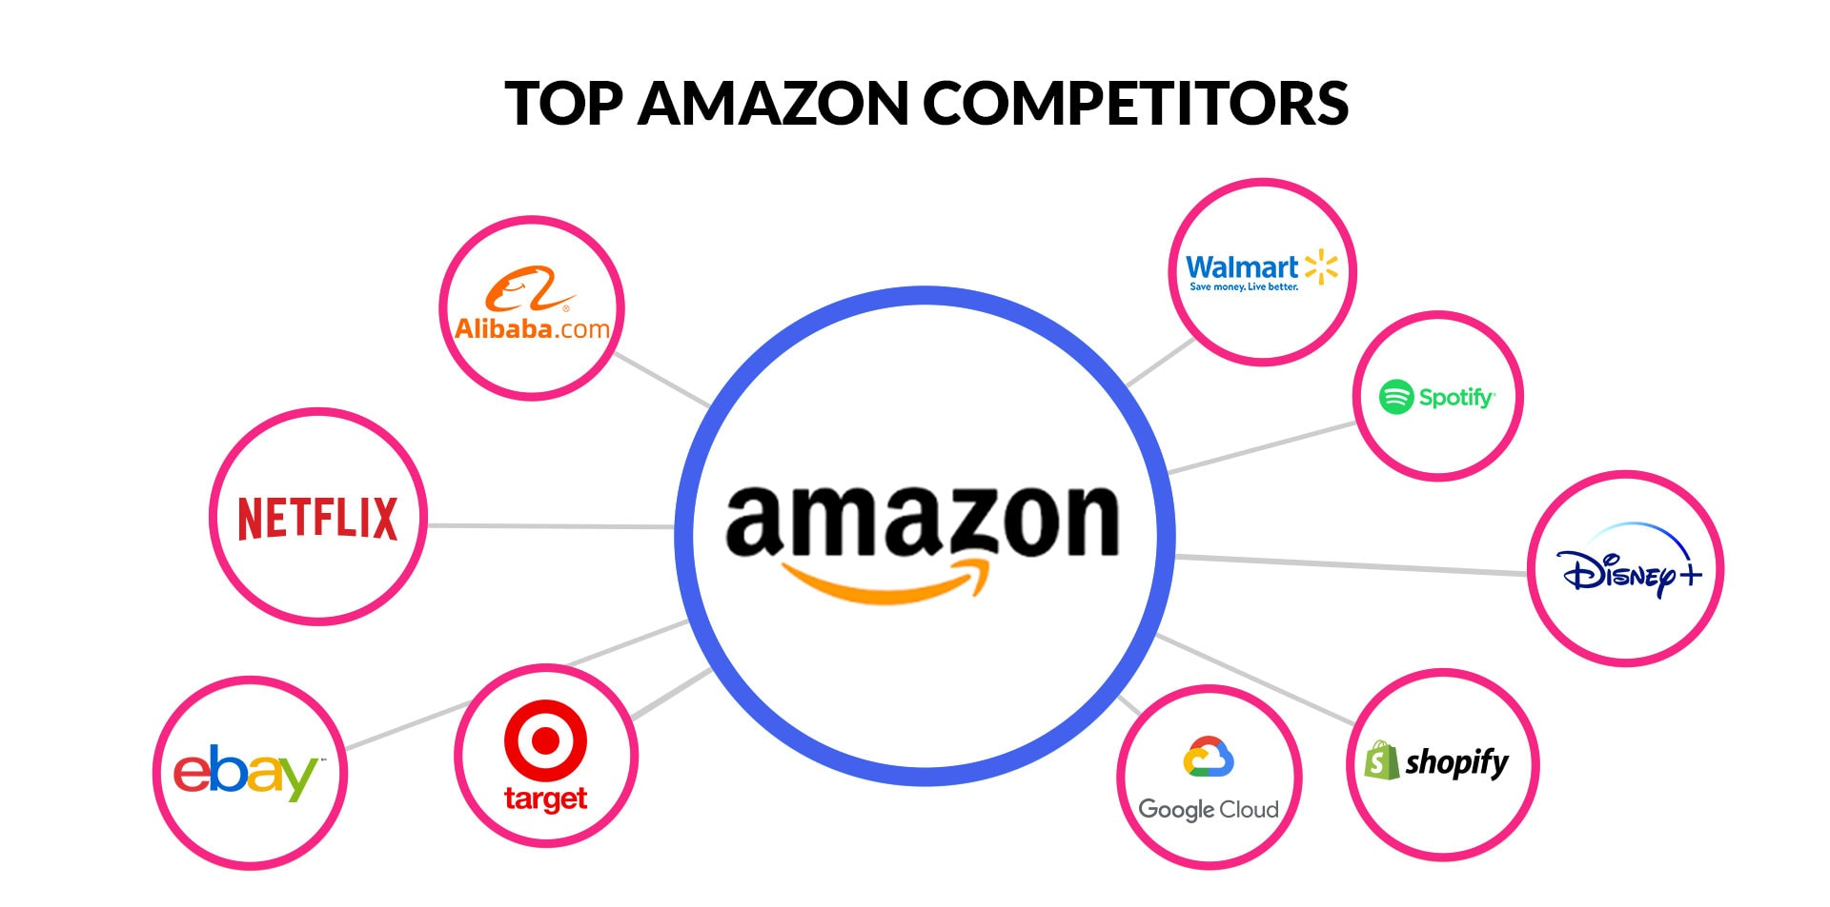
Figure 5: Top Amazon Competitors
Source: Titan Network (2026)

2. External and Internal Environment Analysis

2.1 PESTEL Analysis (External Environment)
Factor | Key Issues for Amazon | Strategic Implications
Political | Trade policies, digital taxation, government regulations (Rao et al., 2025) | Expansion decisions influenced by tariffs and geopolitical risks
Economic | Inflation, global demand fluctuations, logistics costs (Rakiman et al., 2023) | Pressure on pricing strategies and operational efficiency
Social | Growth of online shopping, digital lifestyles, changing consumer expectations (Nowfeek, 2025) | Increased demand for convenience, speed, and personalization
Technological | AI, automation, cloud computing, big data (Nama et al., 2023) | Drives innovation and efficiency improvements
Environmental | Carbon emissions, sustainable packaging, climate commitments (Wang et al., 2026) | Need for green supply chains and ESG compliance
Legal | Antitrust scrutiny, labour laws, and data privacy regulations across Amazon’s global operations (Khan, 2017; Rao et al., 2025) | Limits expansion, increases compliance costs, and pressures governance reforms.
Table 1: PESTEL Analysis of Amazon
Source: Author (2026)
The external environmental forces largely determine the strategic choices that Amazon makes. The escalating antitrust rules in the US and EU have triggered a political and legal change that has compelled the company to re-evaluate its expansion and acquisition strategies, especially in the digital markets (Rao et al., 2025). As an illustration, marketplace dominance has been regulated and thus Amazon has increased the transparency of third-party sellers. Economic conditions like inflation and increasing logistics prices have a direct impact on the cost leadership strategy of Amazon. The increased cost of fuel and supply chain would decrease the margins, forcing the company to invest in automation and efficiency additions to offer competitive prices (Rakiman et al., 2023).
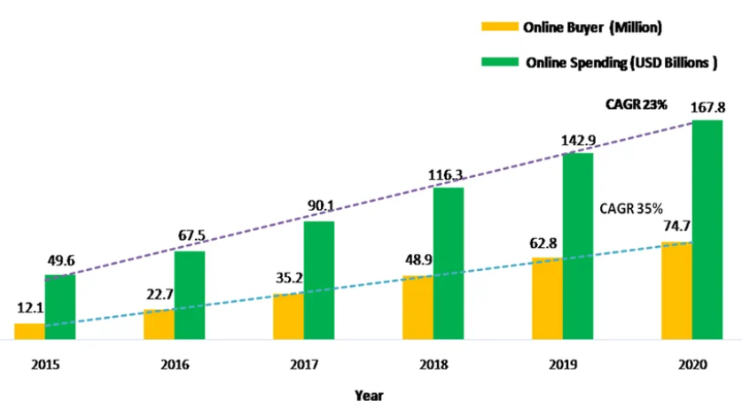
Figure 6: E-commerce Growth Trends Chart
Source: Statista (2024)
The social trends are very favourable to the growth of Amazon. The accelerated trend toward online purchasing and digital lifestyles has heightened the expectations of quick delivery and smooth user experiences (Titan Network, 2026). Amazon is capitalizing on such trends by offering such services as Prime which allows increasing retention and involvement of customers (Nowfeek, 2025). One of the most important opportunities is technological advancement. Scalability, operational efficiency, and information-informed decision-making of Amazon are made possible by its investment in artificial intelligence and cloud computing via AWS (Nama et al., 2023). This gives it a good competitive advantage as well as a need to constantly innovate to stay ahead of the other players.
There are challenges and opportunities presented by environmental pressures. Growing demands around the idea of sustainability have challenged Amazon into promising to be carbon neutral and invest in renewable energy (O’Rourke, 2025). According to Wang et al. (2026), although it makes the operations more expensive, this builds a better brand and meets the expectations of stakeholders (Wang et al., 2026). Overall, the PESTEL analysis shows that Amazon has been functioning in a very dynamic environment where opportunities like technological innovation and digital demand exist simultaneously with threats such as regulatory pressure and increasing costs.

2.2 Critical Success Factors & Strategic Challenges
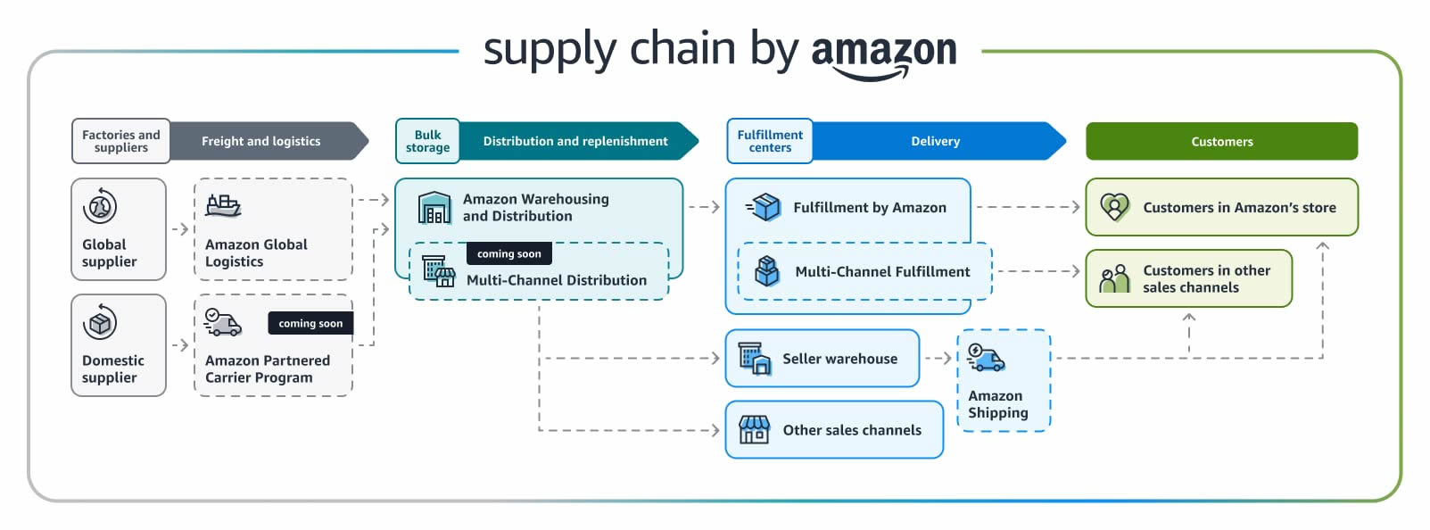
Figure 7: Amazon Supply Chain and Logistics Network
Source: Amazon (2025)
Amazon has been successful due to a number of critical reasons. To begin with, its strategy revolves around logistics excellence. The firm has developed one of the best global chain of supply chains that facilitate quick and efficient delivery (Amazon, 2025). Operation performance and consumer satisfaction are optimised through the infrastructure investments like fulfilment centres and the last-mile delivery system (Maddock-James, 2025).
Second, Kadaskar et al. (2024) states that one of the success factors is the innovation capability. Amazon is a company constantly engaged in innovative technologies, such as AI, automation, and cloud computing, to enhance service quality and develop additional sources of income. One of the good examples is AWS, which has been adding a lot of profitability because of its high margins (Kadaskar et al., 2024).
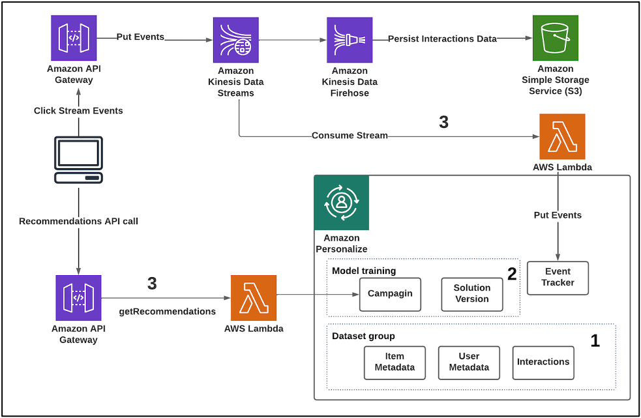
Figure 8: Amazon Personalization and Data Processing Architecture
Source: Amazon Web Services (AWS) (2025)
Third, customer experience is the centre of the Amazon strategy. Personalized recommendations, convenient returns, and rapid delivery are some of the features that promote loyalty of customers. This customer-focused strategy is generally known to be a key factor in the competitive advantage (Hamlaoui et al., 2025). Fourth, Rakiman et al. (2023) notes that cost efficiency helps in the cost leadership strategy of Amazon. The company is able to provide competitive prices and profitability through the economies of scale and hi-tech supply chain management.
Amazon, however, has a number of strategic challenges also. The growing regulatory friction and antitrust enquiries restrict its control over the market and market growth potential. The need to be more innovative due to the competition of world players like Alibaba, Walmart, and Microsoft is getting tougher and tougher (Yang, 2022). Also, labour problems and working conditions, as well as unionisation, are reputational risks and operational challenges (Theodore et al., 2025).

2.3 Internal Environment Analysis
Amazon has a good internal environment that is marked by resources, capabilities and well-developed organisational structure. The analysis perspective shows that the competitive advantage of this company is majorly determined by the ability to make the most of its tangible and intangible resources (Mailani et al., 2024).
Among the strengths of Amazon, its financial resources and the worldwide revenue base are influential factors that allow the company to consistently invest in innovation, infrastructure, and expansion. This is complemented by the fact that it has a sophisticated technological framework especially the Amazon Web Services (AWS) which offers scalable cloud-based services and creates considerable profitability. The customer trust and loyalty are also boosted by strong brand reputation of the firm that strengthens market leadership of the company (Kamthe, 2024; Nowfeek, 2025).
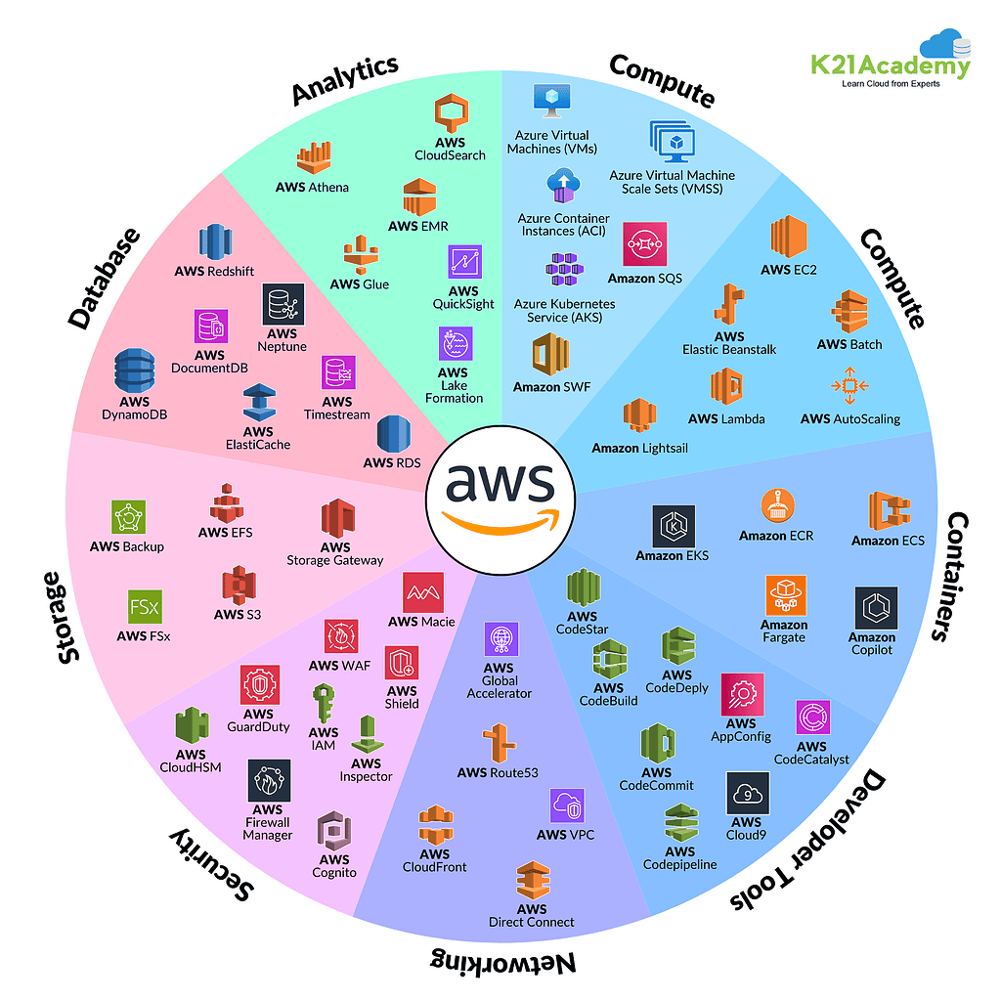
Figure 9: Amazon Web Services (AWS) Services Ecosystem
Source: K21Academy (2025)
Amazon has outstanding capabilities in terms of supply chain and logistics management. The company has vast fulfilment network and last-mile delivery systems that enable it offer quick and dependable services that is a vital consideration to the customer satisfaction. Also, Amazon uses big data analytics to streamline operations and predict demand, as well as customise customer experiences, reinforcing its strategic position (Amazon, 2025).
Nevertheless, there are still some internal constraints. The e-commerce business of the firm is run at a comparatively low profit margin because of its cost leadership approach that exerts pressure to the profitability. There is also the persistent issue of high costs of operations and logistics and this has continued to pose a challenge especially as the business is making further expansion in the world. Additionally, the use of third-party sellers involves the risks of quality control and governance of the platform (Amazon, 2025; Niu and Zhao, 2023).
Reputational and operational risks are also caused by labour related issues such as employee relations and working conditions (Theodore et al., 2025). These problems depict the necessity to have better human resource practices and organisational sustainability. On the whole, the internal environment of Amazon represents a high level of match between resources and capabilities to bring about a prolonged competitive advantage. Nonetheless, cost structure issues and operational complexity will have to be tackled in a bid to ensure long-term efficiency and competitiveness.

2.4 VRIO Framework Analysis
Resource/Capability | V | R | I | O | Outcome
AWS Infrastructure | ✔ | ✔ | ✔ | ✔ | Sustained competitive advantage
Logistics Network | ✔ | ✔ | ✔ | ✔ | Sustained competitive advantage
Brand Reputation | ✔ | ✔ | ✖ | ✔ | Temporary competitive advantage
Table 2: VRIO Framework Analysis of Amazon
Source: Author (2026)
The AWS infrastructure of Amazon is among the largest strategic resources of the company. This is useful because it adds to its revenue and profitability, it is unusual because of its size, and it is hard to copy because of the investment and skills involved (Kadaskar et al., 2024). Equally, its logistics network offers a robust competitive advantage in its efficiency and speed that its competitors cannot easily duplicate (Andreli-Versbach et al., 2024).
Conversely, Amazon has a strong brand reputation that is worthwhile and established but not inimitable because new entrants can develop strong brands in the long run. Hence it offers merely a short-term competitive edge (Navaia et al., 2024).

2.5 Contribution to Competitive Advantage
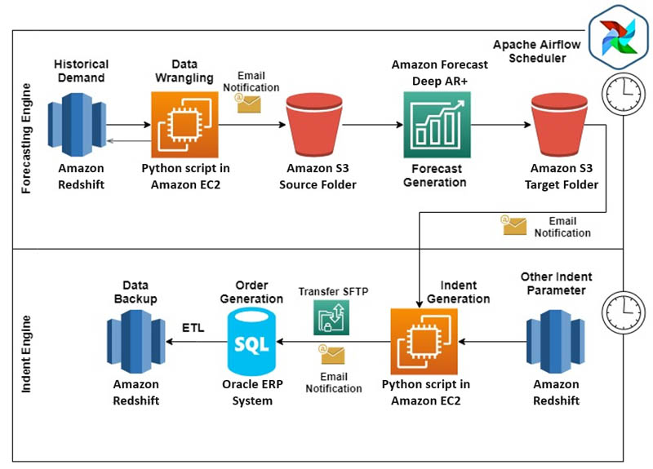
Figure 10: Amazon Data Analytics and Forecasting Workflow
Source: Amazon Web Services (AWS) (2025)
Integration of technology and logistics is the key factor which contributes to the competitive advantage of Amazon. Integration of both innovative data analytics and a streamlined supply chain would enable the company to provide excellent customer experiences and remain operational to its advantage. Being able to make personalized recommendations and predict demand, big data analytics contributes to higher sales and customer satisfaction (Hamlaoui et al., 2025).
The Economies of scale also provide Amazon with a stronger standing. The advantages of its big business operations are lower unit prices as it is able to offer competitive prices as it invests in innovation and growth (Niu et al., 2023). Lastly, customer obsession strategy at Amazon makes it stand out against the rest. The commitment to the needs of its customers allows the company to constantly enhance its services, customer loyalty, and improve its position in the market. Such a fit between resources, capabilities and external opportunities allows Amazon to remain competitive in the highly competitive global markets (Mailani et al., 2024).

3. CSR and Sustainability Objectives
CSR Area | Key Initiatives | Strategic Implications
Climate Pledge | Net-zero carbon by 2040 | Enhances brand value and ESG alignment
Renewable Energy | Investment in clean energy and efficient data centres | Reduces long-term costs and improves efficiency
Sustainable Logistics | Electric vehicles and green supply chains | Improves competitiveness in eco-conscious markets
Labour & Ethics | Ethical sourcing and workforce management | Addresses stakeholder expectations but poses risks
Overall CSR Strategy | Integration with business strategy | Supports competitive advantage but driven by regulatory pressure
Table 3: Summary of Amazon’s CSR and Sustainability Strategy
Source: Author (2026)
Amazon has been increasingly embedding Corporate Social Responsibility (CSR) and sustainability into its strategic agenda via such initiatives as the Climate Pledge. The company has also made the determination to reach net-zero carbon emissions in 2040 that is a decade earlier than that of the Paris Agreement (Amazon, 2025). It also involves a lot of investment in renewable energy, electric delivery fleet, and sustainable logistics to decrease its impact on the environment (O’Rourke, 2025). Amazon has also been keen on enhancing the level of energy efficiency in its data centres and supply chain operations which make sustainability and operational efficiency to go hand in hand.
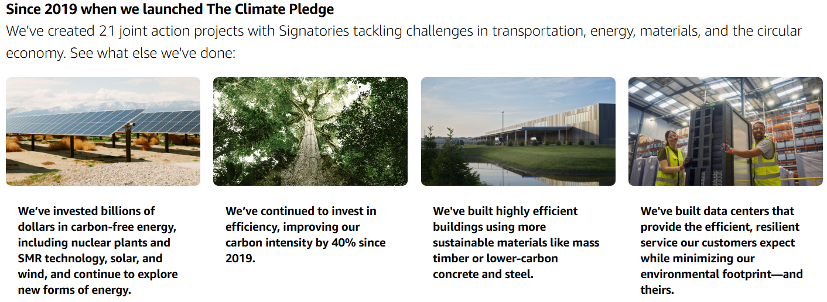
Figure 11: Amazon Climate Pledge and Sustainability Initiatives
Source: Amazon (2025)
Nonetheless, strategic alignment and challenges are faced with CSR implementation. On the one hand, sustainability initiatives contribute to the long-term business strategy of Amazon by minimizing expenses, improving the brand image, and achieving the expectations of the stakeholders. Ecologically considerate markets can rely on sustainable supply chain operations and green logistics to enhance efficiency and competitive edge (Wang et al., 2026). Conversely, there are still concerns about ethical sourcing and labour practices and one of the areas is the working conditions of fulfilment centres. These problems reveal a discrepancy between the commitments of CSR and the realities of operations (Theodore and Gutelius, 2025).
More importantly, the CSR strategy at Amazon can be considered as an element of competitive strength and as a reputation requirement. Although sustainability boosts the brand value and differentiation, it is also motivated by the regulatory pressure and scrutiny of the stakeholders, making it critical to sustainability in sustaining legitimacy in the world markets.

4. Balanced Scorecard Analysis
Balanced Scorecard (BSC) model, which was created by Kaplan and Norton, helps organisations to strategise and translate strategy into both financial and non-financial performance (Madsen, 2025). In the case of Amazon, the BSC indicates their strategic emphasis on growth, customer experience, operational efficiency and innovation (Wadud et al., 2025).

4.1 Financial Perspective
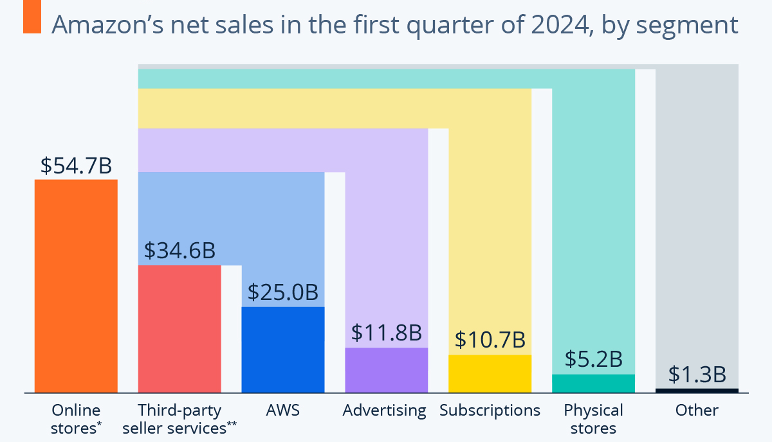
Figure 12: Amazon Revenue Segmentation by Business Segment (Q1 2024)
Source: Statista (2025)
The main financial goal of Amazon is the long-term profitability and the continuation of revenue growth. The firm is still growing in the world market and consolidating high-margin businesses like Amazon Web Services (AWS) (Amazon, 2025). Among the key performance indicators (KPIs), it is possible to include the total revenue increase, operating profit margin, and the share of AWS in total income. To illustrate this, AWS has continued to provide the company with a considerable portion of Amazon operating profits despite having a lower share of the total revenue (Amazon, 2025).
Market expansion, cost optimisation and improvements in efficiency are addressed by strategic initiatives. Automation and investments in logistics infrastructure can be used to minimize the costs of operation and facilitate scalability. This is in line with cost leadership strategy and long-term value creation of Amazon.

4.2 Customer Perspective
At Amazon, customer satisfaction is the core of the strategy, which is indicative of its customer obsession mission. The main KPIs will be the level of customer retention, the speed of delivery, and the level of user engagement. Amazon Prime is a key factor in increasing customer loyalty, as it provides a range of benefits like expedited delivery, streaming platforms, and discounts (Nowfeek, 2025).

Figure 13: Amazon Exclusive Pricing and Promotional Strategy
Source: Amazon (2025)
Another significant project is personalisation with the help of data analytics. Big data offers Amazon an opportunity to recommend a product and enhance the customer experience that leads to heightened satisfaction levels and purchasing reactions (Hamlaoui et al., 2025). The strategies increase the competitive edge of Amazon through the establishment of customer relationships in the long-term.

4.3 Internal Business Processes
One of the objectives of the internal processes of Amazon is operational efficiency. KPIs are speed of order fulfilment, inventory turnover and supply chain performance. Amazon has also invested in the implementation of automation like robotics within warehouses and AI-based logistics to improve efficiency (Maddock-James, 2025).
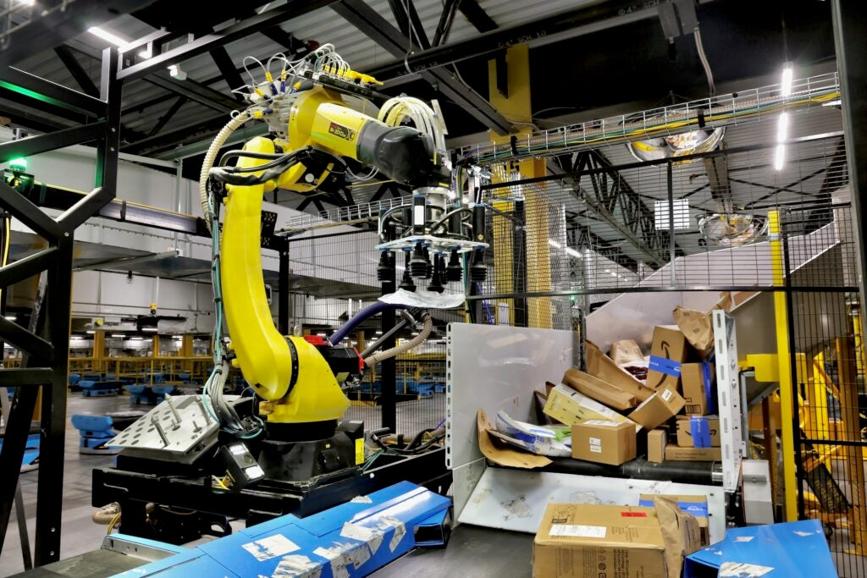
Figure 14: Amazon Warehouse Automation and Robotics System
Source: Amazon (2025)
These projects enhance precision, cut down delivery time and save on costs. Technological installation into logistics processes enables Amazon to keep its commitment to provide the promise of fast and reliable delivery, and this is a significant success factor in the e-commerce business.

4.4 Learning and Growth
The constant innovation and the development of the workforce are the long-term success factors of Amazon. The most important KPIs are the research and development (R&D) spending, staff productivity, and the product of innovations. The company spends a lot of money on AI, cloud computing, and digital technologies to retain its technological advantage (Nama et al., 2023).
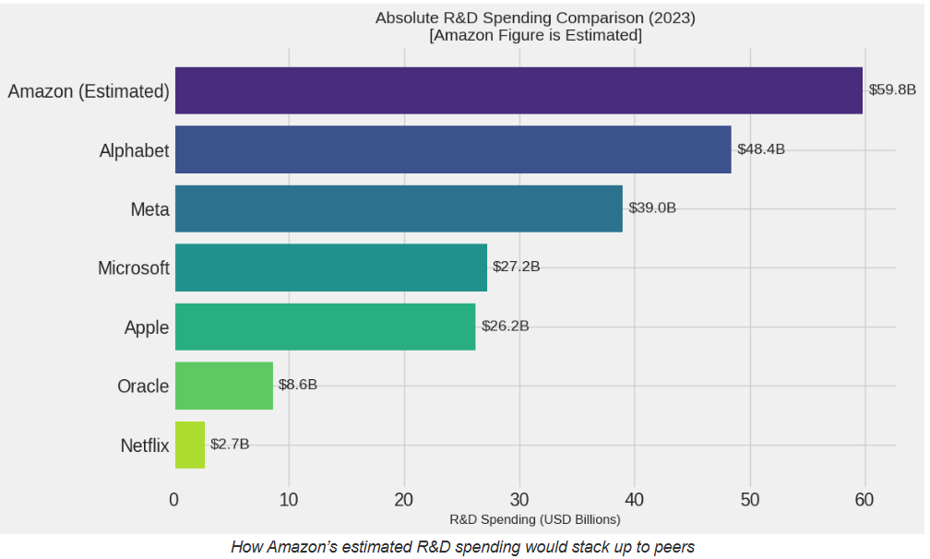
Figure 15: Amazon R&D Investment Leadership
Source: Visual Capitalist (2025)
Besides that, Amazon places emphasis on training and skill development of employees to help with innovativeness and operational excellence. Existence of a robust organisational culture to promote experimentation and learning also leads to long term competitive advantage (Cao et al., 2025). On the whole, the Balanced Scorecard of Amazon evidences a high level of compatibility of strategic goals with performance indicators, which guarantee the effective involvement of financial and non-financial indicators to the long-term development and competitiveness.

5. Strategic Choices and Implementation

5.1 Business-Level Strategies
Amazon is a business with a hybrid business-level strategy which is both cost leadership and differentiation. This firm uses economies of scale, effective management of its supply chain, and high-quality logistics systems, which make the firm provide some of the competitive prices in a broad range of products. Large scale operations bring down the unit cost which helps to sustain its low-price policy besides dominating the market (Niu et al., 2023).
Meanwhile, Amazon is very aggressive in differentiation. Amazon Prime is a type of service that builds a special ecosystem through the combination of quick delivery, entertainment, and personal gains that contribute to customer retention. Moreover, Amazon Web Services (AWS) has ensured the company is being innovative in cloud computing, whereby it is a scaled and reliable service to businesses around the globe (Kadaskar et al., 2024). This two-pronged approach enables Amazon to receive price-sensitive buyers, as well as provide them with high-quality value across innovation.

5.2 Corporate-Level Strategies
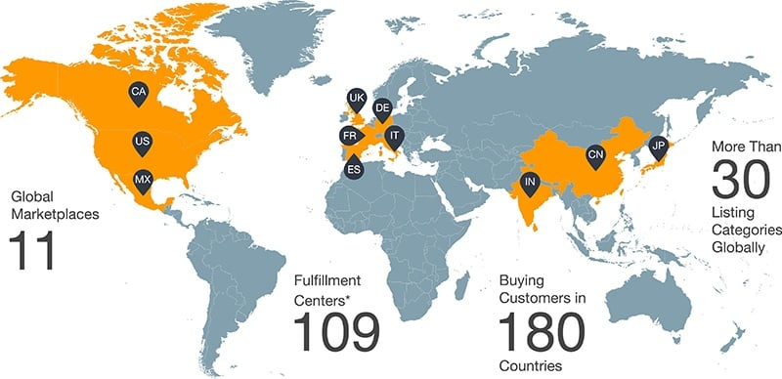
Figure 16: Amazon Global Presence and Market Reach
Source: Amazon (2025)
Amazon is interested in diversification and international expansion on the corporate level. The company has been diversifying into various markets such as cloud computing, digital streaming, smart devices and artificial intelligence. This helps it to decrease reliance on its core retail business and establishes new sources of revenue (Rong et al., 2026). The other important strategy is international expansion, which has helped Amazon to tap into emerging markets and expand the market share globally. But it needs to be adjusted to the local regulations, consumer behaviour and infrastructure challenges in order to expand (Larsson et al., 2024).
To maintain a competitive edge in the long term, Amazon ought to enhance further differentiation based on AI-powered services and digital innovation. The growth of AI in the sphere of personalised suggestions, automation, and cloud-based solutions can improve the experience of customers and efficiency (Nama et al., 2023).

5.3 Change Management Evaluation
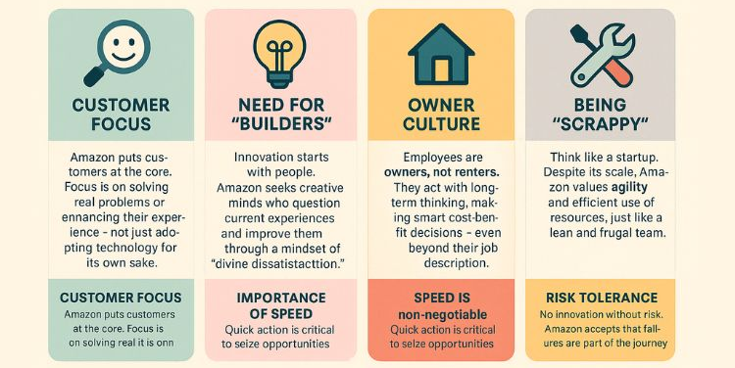
Figure 17: Amazon Organisational Culture and Innovation Pillars
Source: Panmore Institute (2025)
Amazon also shows great abilities in changing management, especially digital change management. The management of the company values the idea of innovation, experimentation, and agility, which allows it to effectively respond to the development of the markets and changes in technologies (Cao et al., 2025). Strategic change management is evident in its capacity to keep changing, the store has turned to become an online bookstore to a worldwide technological powerhouse.
A culture that is agile and innovation-oriented is supportive of this change. There is a culture of experimenting and making calculated risks among the employees, which would lead to creativity and a culture of constant improvement (Hossain et al., 2022).
Nonetheless, problems exist. Employees may be resistant to change and this may impact on implementation especially in operational settings. Also, the overall rise of regulatory pressure and criticism in the international markets can inhibit the flexibility in strategies and decrease the speed of the decisions (Rao et al., 2025; Hindistan et al,. 2025). In general, the strategic decisions and actions of Amazon show that the company has high levels of integration between the innovation, diversification and customer-centricity, yet the issues of internal and external threats will be vital in the maintenance of the competitive edge.

6. Strategic Evaluation and Recommendations

6.1 SWOT Analysis
Strengths | Weaknesses
Strong global brand recognition and customer trust (Nowfeek, 2025) | Low profit margins in core e-commerce operations (Amazon, 2025)
Advanced logistics and fulfilment network (Maddock-James, 2025) | Labour issues and employee relations concerns (Theodore et al., 2025)
Market-leading AWS infrastructure and profitability (Kadaskar et al., 2024) | High operational and infrastructure costs (Rakiman et al., 2023)
Strong data analytics and technological capabilities (Hamlaoui et al., 2025) | Dependence on third-party sellers (Andreoli-Versbach et al., 2024)
Opportunities | Threats
Expansion of AI and cloud-based services (Nama et al., 2023) | Increasing regulatory and antitrust scrutiny (Rao et al., 2025)
Growth in emerging international markets (Bao et al., 2025) | Intense competition (Walmart, Alibaba, Microsoft) (Yang, 2022)
Sustainability and green innovation initiatives (Wang et al., 2026) | Rising operational and logistics costs (Rakiman et al., 2023)
Diversification into healthcare and fintech sectors (Anwar Adem et al., 2026) | Cybersecurity and data privacy risks (Yu et al., 2025)
Table 4: SWOT Analysis of Mazon
Source: Author (2026)
According to the SWOT analysis, Amazon occupies a good strategic position due to its global brand presence, developed logistics network, and highly profitable segment of AWS (Nowfeek, 2025; Maddock-James, 2025; Kadaskar et al., 2024). Its data analytics also provide increased efficiency and customer experience to operations (Hamlaoui et al., 2025). Nevertheless, internal factors like low profitability in their usual e-commerce business, expensive infrastructure and labour issues could limit the profitability in the long term (Amazon, 2025; Rakiman et al., 2023; Theodore et al., 2025). Also, the governance risks are brought about by dependence on third-party sellers (Andreoli-Versbach et al., 2024).
Externally, Amazon has a strong opportunity to grow through AI, cloud computing, and emerging markets (Nama et al., 2023; Bao et al., 2025). There is also future potential in sustainability initiatives and diversification (Wang et al., 2026; Anwar Adem et al., 2026). Nevertheless, the regulatory pressure, tough competition, cost increase, and cybersecurity issues are the main threats (Rao et al., 2025; Yang, 2022; Yu et al., 2025).

6.2 Strategic Framework (Ansoff Matrix)
The Ansoff Matrix provides a structured approach to evaluating Amazon’s growth strategies.
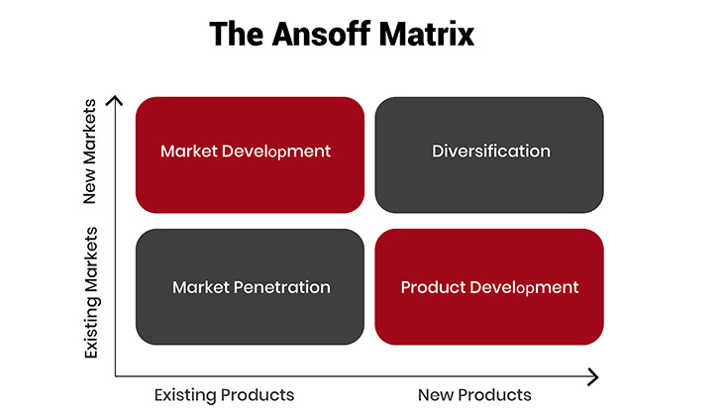
Figure 18:Ansoff Matrix
Source: Corporate Finance Institute (CFI) (2025)
Market Penetration: Amazon is in the process of building its presence in existing markets by developing Amazon Prime. Improved delivery products, exclusive content and personalised offerings boost customer retention and market share (Nowfeek, 2025).
Product Development: The company is putting much money on artificial intelligence-based services, such as machine learning applications, voice assistants, and sophisticated cloud services. These technologies enhance the customer experience and functional effectiveness (Nama et al., 2023).
Diversification: Amazon has expanded its business operations to areas like healthcare (Amazon Pharmacy) and fintech services. The approach minimizes the use of traditional e-commerce and develops new revenues, which is consistent with platform ecosystem strategies (Rong et al., 2026).

6.3 Recommendations
Amazon ought to implement a number of strategic improvements in order to maintain and improve its competitive advantage.
Recommendation | Expected Outcome
Enhance sustainability integration | Reduced operational costs, improved brand reputation, and stronger alignment with global sustainability standards, leading to long-term value creation.
Strengthen regulatory compliance | Lower legal risks, improved stakeholder trust, and sustained legitimacy in global markets, supporting stable expansion.
Invest in employee welfare | Increased productivity, reduced employee turnover, and enhanced corporate reputation, supporting sustainable organisational performance.
Expand AI-driven services | Enhanced customer experience, operational efficiency, and innovation capability, leading to sustained differentiation and competitive advantage.
Table 5:Strategic Recommendations and Expected Outcomes for Amazon
Source: Author (2026)
To begin with, the integration of sustainability in the areas of operations should be improved. The introduction of sustainable logistics and supply chains helps Amazon to minimize expenses and create more value to the brand, which is in line with stakeholder expectations and ESG models (Wang et al., 2026).
Second, it is important to improve regulatory compliance. Antitrust issues can be proactively tackled and enhanced transparency is a tool in minimizing the legal risks and keeping the market legit (Rao et al., 2025).
Third, investment in employee welfare should be done to tackle labour challenges. The working conditions and employee engagement could be increased to boost productivity and decrease reputational risks, which is aligned with the stakeholder theory.
Lastly, the growth of AI-oriented services should be an overarching strategy. Utilizing AI to enhance personalisation, automation and cloud innovation can enable a firm to enhance the differentiation and its long-term competitiveness (Hamlaoui et al., 2025).
Theoretically, the recommendations coincide with the Resource-Based View (RBV), that focuses on using valuable and inimitable resources, and the competitive strategy proposed by Porter which assumes that differentiation and cost efficiency are critical to the creation of long-lasting competitive advantage.

Section 2: Reflective Account

1. Description
In this assignment, a thorough strategic analysis of Amazon was done based on the main strategic management models. It started with the identification of useful academic journals, industry reports, and company data including the Amazon Annual Report. I conducted an analytical research on the external and internal environments of the organisation by applying PESTEL, SWOT, and VRIO tools.
After that, I analyzed the strategic positioning, CSR activities and performance of Amazon through the Balanced Scorecard. The evaluation of strategic options and recommendations with the help of theory and practical evidences were the last steps. It took me a process of synthesising the theoretical ideas with real-life illustrations in the writing process to give the report a logical structure, and academic coherence.

2. Feelings
When I first started the assignment, I found the task very complex and daunting because of the size and complexity of analysing a global organisation such as Amazon. The company has various industries to operate on e-commerce, cloud computing and digital services and it proved hard to establish the most pertinent components to concentrate on. There was also the confusion of the need to implement various strategic models and how to effectively intertwine them without repeating or duplicating each other.
Some concern over the balance between descriptive and critical analysis was also present to me. In the beginning, I was more inclined to describe the concepts instead of critically assessing it and this made me doubt whether my work was up to the required academic standards.
My confidence however increased as I continued with the assignment. Reading academic literature and realizing the role of other frameworks in complementing one another facilitated the process of gaining clarity in me. I started to be more confident using theoretical models in real life contexts. Later on, I have become less hesitant about my capability to synthesise information and draw meaningful conclusions, as well as to offer a properly structured analysis.

3. Evaluation
The credible and recent sources of academic information were one of the strongest features of my approach that enhanced the quality of analysis. Using of systematic models, including PESTEL, VRIO, and SWOT, were useful to structure the discussion in a logical way and to cover all major areas of strategy.
Also, the additional use of the real-life case, like the growth and sustainability initiatives at Amazon AWS, enhanced the level of analysis. The Balanced Scorecard also helped in offering a beneficial means of linking financial and non-financial performance measures.
Nevertheless, certain difficulties could be seen. Sometimes, the propensity to concentrate on description and not to evaluate critically was there. It was also hard to incorporate several frameworks and not repeat oneself. Moreover, it was necessary to exercise caution in editing and prioritisation of main points to ensure that word limits were not exceeded, whilst at the same time ensure that the analysis was deeper.

4. Analysis
This experience taught me the relevance of making a connection between theoretical frameworks and real business contexts. Indicatively, the Resource-Based View (RBV) was used to describe how the source of competitive advantage can be sustained through the influence of specific capabilities of Amazon, including AWS and Amazon logistics network. Likewise, the PESTEL analysis showed the impacts of the external factors e.g. regulation and technological change on strategic decisions.
The Balanced Scorecard application highlighted the need to balance organisational strategy and the performance results that can be measured. It also demonstrated the close relationship between financial success and customer satisfaction, internal efficiency, and continuous learning.
In addition, the reinforcement of the necessity to give organisations the chance of finding the balance between growth opportunities and possible risks was achieved by the application of the Ansoff Matrix and SWOT analysis. This is a process of analysis that enhanced my skills in critically evaluating strategies as opposed to describing them.

5. Conclusion
All in all, this assignment was a learning experience and greatly helped me to enlighten my knowledge and realization about strategic management as a dynamic and an integrated process. I also got to know that competitiveness can be attained and maintained by a delicate balance of internal strengths, external opportunities and continuous innovation.
The application of various strategic frameworks has helped me to create a whole of organisational strategy. It also showed how various analytical tools can be used in supplementing effective decision-making. Notably, the experience has led to my realization of the significance of critical thinking, analysis that is based on evidence, and organized writing in writing good academic work.
In the future, I hope to become more efficient in my critical assessment of information and combine the theoretical concepts more efficiently, which will not only help me in my further academic and professional growth.

6. Action Plan
Area for Improvement | Action Steps | Expected Outcome
Enhance critical analysis | Evaluate arguments instead of describing concepts  Compare multiple academic perspectives  Apply theory to real-world examples | Stronger academic writing and deeper insights
Improve research skills | Use peer-reviewed journals (Scopus, ScienceDirect)  Access advanced databases (Google Scholar, Emerald)  Critically assess source credibility | Higher quality and more credible sources
Time management | Create a structured timeline for each section  Allocate time for drafting and editing  Set deadlines for completion | Better structure and adherence to word limits
Framework integration | Practice linking models (PESTEL, SWOT, VRIO)  Avoid repetition across sections  Focus on critical connections | More coherent and concise analysis
Academic writing style | Read high-quality journal articles  Improve Harvard referencing accuracy  Use clear and formal academic language | Clearer and more professional writing
Table 7:Personal Development Plan
Source: Author (2026)
By engaging in this reflective practice, I have gained quite useful information about my strengths and weaknesses in terms of analyzing as well as the aspects of further growth, which helps me keep enhancing my academic and professional practice.

References
Amazon (2025) Amazon 2024 Annual Report. Available at: https://s2.q4cdn.com/299287126/files/doc_financials/2025/ar/Amazon-2024-Annual-Report.pdf (Accessed: 31 March 2026).
Andreoli-Versbach, P. and Gans, J. (2024) ‘Interplay between Amazon store and logistics’, European Competition Journal, 20(2), pp. 460–497. doi:10.1080/17441056.2024.2312494.
Anwar Adem, A., Battisti, G., Driffield, N. and Schroeder, A. (2026) ‘Choice versus necessity: understanding service diversification and firm performance in manufacturing’, Journal of Business Research, 206, 115949. doi:10.1016/j.jbusres.2025.115949.
Bao, M., Latif, S., Bao, D., Latif, Z. and Lu, J. (2025) ‘Overcoming e-commerce barriers in developing markets: A review of data-driven strategies for sustainable growth’, Sustainable Futures, 10, 101408. doi:10.1016/j.sftr.2025.101408.
Cao, G., Duan, Y. and Edwards, J.S. (2025) ‘Organizational culture, digital transformation, and product innovation’, Information & Management, 62(4), 104135. doi:10.1016/j.im.2025.104135.
Hamlaoui, S., Boussouak, A., Salah, R.B. and Hamiti, N. (2025) ‘Utilizing big data analysis to drive digital commerce: Insights from Amazon's model’, Journal of Information Systems Engineering and Management, 10(4).
Hindistan, Y., Ercan, H., İskender, T., Özdemir, H. and Yıldırım, R. (2025) Transforming Customer Service in e-Commerce: The Case of Hepsiburada’s Bespoke Platform.
Hossain, M.B., Alhanakta, R., Hervie, D., Nor, K. and Illés, C. (2022) ‘Exploring the key success factors for sustainable e-commerce adoption in SMEs’, Polish Journal of Management Studies, 25(1), pp. 162–178. doi:10.17512/pjms.2022.25.1.10.
Kadaskar, H. and Kamthe, V. (2024) ‘An overview of AWS’, International Journal of Scientific Research in Modern Science and Technology, 3(7), pp. 22–30. doi:10.59828/ijsrmst.v3i7.223.
Khan, L.M. (2017) Amazon’s antitrust paradox, Yale Law Journal. Available at: https://yalelawjournal.org/pdf/e.710.Khan.805_zuvfyyeh.pdf (Accessed: 31 March 2026).
Koilakonda, R.R. and Franklin, M. (2025) Global Trends in Change Management: Insights and Key Takeaways for 2025. doi:10.13140/RG.2.2.33437.01762.
Larsson, D., Ratnayake, R.M.C. and Samarakoon, S.M.S.M.K. (2025) ‘Agile balanced scorecard and strategy map framework for engineering-to-order projects’, Engineering Management Journal, pp. 1–22. doi:10.1080/10429247.2025.2538065.
Maddock-James, J. (2025) ‘Supply-chain infrastructure as architecture: a case study of Amazon in Darlington, UK’, Mobilities, 20(5), pp. 986–1001. doi:10.1080/17450101.2025.2477173.
Madsen, D. (2025) ‘Balanced scorecard: History, implementation, and impact’, Encyclopedia, 5(1), p. 39. doi:10.3390/encyclopedia5010039.
Mailani, D., Hulu, M., Simamora, M. and Kesuma, S. (2024) ‘Resource-based view theory to achieve a sustainable competitive advantage of the firm: Systematic literature review’, International Journal of Entrepreneurship and Sustainability Studies, 4. doi:10.31098/ijeass.v4i1.2002.
Nama, P., Pattanayak, S.K. and Meka, H. (2023) ‘AI-driven innovations in cloud computing: Transforming scalability, resource management, and predictive analytics in distributed systems’, International Research Journal of Modernization in Engineering Technology and Science, 5. doi:10.56726/IRJMETS47900.
Navaia, E., Moreira, A. and Ribau, C. (2024) ‘The mediating roles of cost leadership and cost focus strategies on innovation capabilities and export performance’, Cogent Business & Management, 11. doi:10.1080/23311975.2024.2375410.
Niu, B. and Zhao, J. (2023) ‘E-commerce industry: A comprehensive analysis of its competitive advantages’, Highlights in Business, Economics and Management, 15, pp. 93–98. doi:10.54097/hbem.v15i.9322.
Nowfeek, M.R.M. (2025) ‘A survey: Amazon’s digital commerce evolution and its potential impact on Sri Lanka’, International Journal of Latest Technology in Engineering, Management & Applied Science, 14(6), pp. 198. doi:10.51583/IJLTEMAS.2025.140600026.
O’Rourke, D. (2025) ‘Can “sustaining innovation” deliver sustainability? Amazon’s innovation processes on corporate decarbonization’, California Management Review, 67(2), pp. 58–81.
Rakiman, U., Kumar, R. and Rasi, R. (2023) ‘The impact of supply chain management practices on competitive advantage’, International Journal of Business and Social Science, 14(4). doi:10.30845/ijbss.v14n4p1.
Rao, I. and Gautam, P.K. (2025) ‘The economic impact of antitrust laws in the digital age’, International Journal of Law, Policy and Social Review, 7(2), pp. 117–124.
Theodore, N. and Gutelius, B. (2025) ‘The e-commerce labour regime: Amazon and beyond’, Work Organisation, Labour & Globalisation, 19(2), pp. 291–308. doi:10.13169/workorgalaboglob.19.2.0011.
Titan Network (2026) Competitors of Amazon Company. Available at: https://titannetwork.com/competitors-of-amazon-company/ (Accessed: 31 March 2026).
Wadud, I., Liang, Y.D. and Polkinghorne, M. (2025) ‘Digital transformation in the UK retail sector’, Encyclopedia, 5(3), p. 142. doi:10.3390/encyclopedia5030142.
Wang, X., Hassan, H., Sampene, A.K. and Xu, L. (2026) ‘Driving environmental sustainability: The effects of sustainable supply chain management, fossil fuel consumption, and trade openness’, Environmental and Sustainability Indicators, 29, 101112. doi:10.1016/j.indic.2025.101112.
Yang, Z. (2022) ‘Amazon vs. Alibaba: Comparisons of two e-commerce giants based on SWOT analysis’, Highlights in Business, Economics and Management, 2, pp. 497–503. doi:10.54097/hbem.v2i.2409.
Yu, R., Wu, L., Li, W. and Ou, L. (2025) ‘Research on the impact of e-commerce on corporate ESG performance: disclosure mechanism, greenwashing behavior and substantive performance’, Environmental Research Letters, 20. doi:10.1088/1748-9326/adc146.

