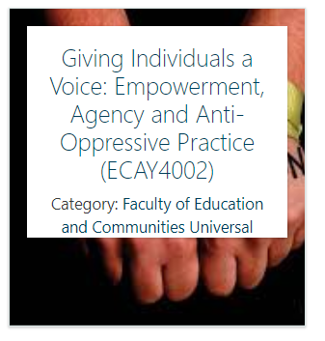

Problematising to problem solving: Solution Focussed Work

Sometimes, people do not know the problem. Sometimes they know the problem but cannot find the solution. An advocate’s role is to support both conscious raising and problem solving.

Last week we discussed marginalisation and mainstream. This week we will look at how an advocate can help their client or group in finding solutions to their problems

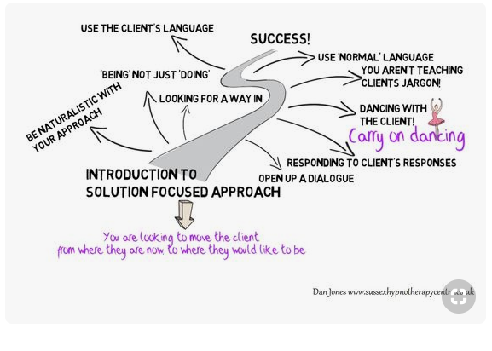

THE MIRACLE QUESTION

The “Miracle Question” is the opening piece of the process of developing well-formed goals. It gives clients permission to think about an unlimited range of possibilities for change. It begins to move the focus away from their current and past problems and toward a more satisfying life.

“Now, I want to ask you a strange question. Suppose that while you are sleeping tonight, and the entire house is quiet, a miracle happens. The miracle is that the problem which brought you to the attention of us is solved.
However, because you are sleeping, you don’t know that the miracle has happened. So, when you wake up tomorrow morning, what will be different that will tell you that a miracle has happened, and the problem is solved?”
(adapted from de Shazer, 1988)

FOLLOW-UP QUESTIONS

Through follow-up questions, the interviewer further extends and amplifies the impact of the miracle by a series of questions designed to guide the client in exploring the implications of the miracle in the client’s life. Examples: “What will be the first thing you notice that would tell you that a miracle has happened, that things are different?”

- “What might others (mother, father, spouse, partner, siblings, friends, work associates, teachers, etc) notice about you that would tell them that the miracle has happened, that things are different or better?”

- “Have there been times when you have seen pieces of this miracle happen?”

- “What’s the first step that you can take to begin to make this miracle happen?” The Pennsylvania Child Welfare Programme (2013)

Scaling Questions

Solution focussed work can help people to recognise their strengths and build on them. This strategy is conducive to personal problems as well as group/community problems. This can be used as a scale to measure the feeling of empowerment as you go along with the client(s).
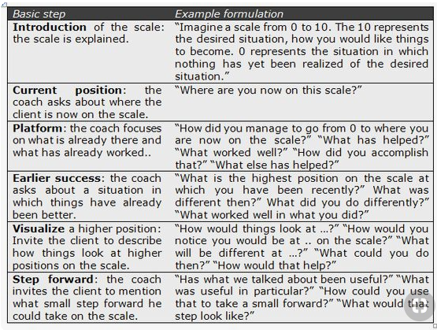

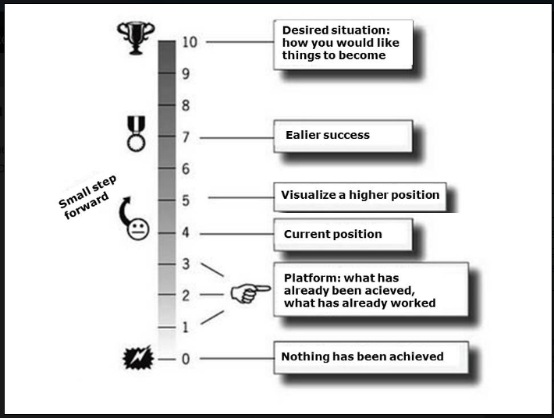

Matrix Questions.
Sometimes you have a person who says “I don’t know” to anything personal. Move the question outside of the personal if they cannot think about themselves (some people with low confidence find it very difficult to think personally).
The power of this matrix is that it generates an abundance of useful question from which to choose. The different solution-focused ingredients help to create a sense of purpose and direction, help identify some ideas for solutions, and help choose which next step to take. Focusing on these ingredients from the three different perspectives is particularly powerful because it helps to see the situation in a different light which often leads to more understanding for the other's perspective. Also, it often leads to more ideas for possible solutions.

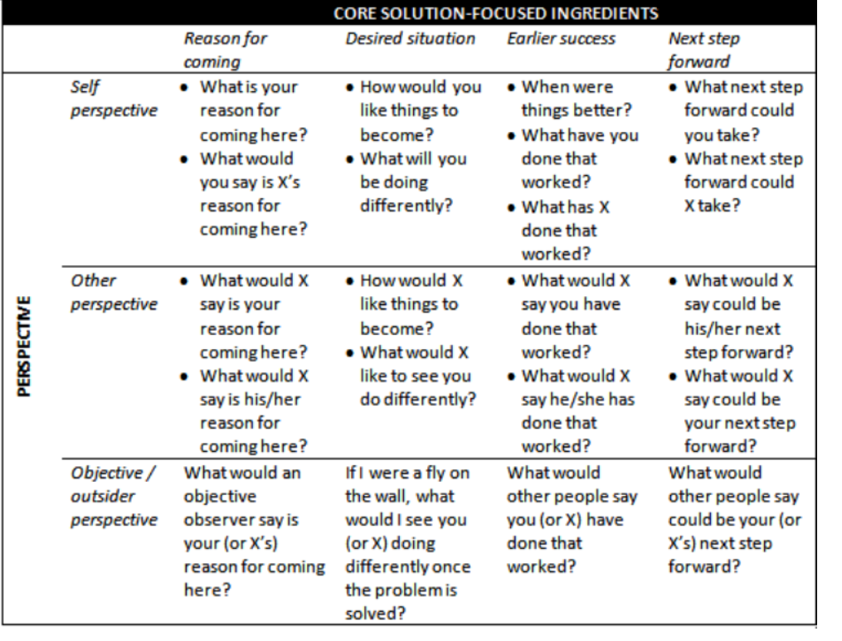

Vissier (2010) adapted from Walter and Peller (1992)

INDIRECT QUESTIONS

Indirect questions invite the client to consider how others might feel or respond to some aspect of the client’s life, behaviour or future changes. Indirect questions can be useful in asking the client to reflect on narrow or faulty perceptions without the worker directly challenging those perceptions or behaviours. Examples:
“How is it that someone might think that you are neglecting or mistreating your children?”

References:

de Shazer, S. (1988). Clues: Investigating solutions in brief therapy. New York, NY, US: W W Norton & Co.

The Pennsylvania Child Welfare Programme (2013) Solution Focussed Interviewing Skills. Handout no.9. Online. http://www.pacwcbt.pitt.edu/Curriculum/301EnggngClntsFrmAStrngthBsdSltnFcsdPrspctv/Hndts/HO9SltnFcsdIntrvwngSklls.pdf [Accessed: 11/11/18]

Vissier, C. (2010) Solution-focused interaction matrix. The Progress-Focussed Approach. Coert Vissier Blog. http://www.progressfocused.com/2010/09/solution-focused-interaction-matrix.html [Accessed 11/11/18]

Walter, J. L. and Peller, J. E. (1992) Becoming solution focussed in brief therapy. London. Routledge.

