Essential skills for Study and employment
A range of important skills is key for success in today's academic environment and job market. An individual's employability will not only improve with these skills but also improve their ability to perform well in all jobs and academic settings. Punctuality, critical thinking, problem solving, communication teamwork adaptability and digital literacy are key skill that will contribute to employment and study success.

Punctuality
Punctuality is crucial for students and employees. Time management will help with punctuality for deadlines and being on time for lectures and jobs. In academic settings, student must balance lectures, revision and assignments. In a workplace, employees need to manage tasks and deadlines efficiently. Research by Macan (1994) suggests that effective time management enhances performance and reduces stress, as individuals are better able to allocate their time to high-priority activities. Tools such as calendars, task lists, and time-blocking are commonly used to improve time management skills.

Digital literacy
Being digitally literate is essential in today's technologically advanced society. Effective use of digital tools and platforms for communication, problem-solving, and research is part of this competence. According to Hargittai (2010), digital literacy is essential for navigating the modern workforce, where technologies such as data analytics, artificial intelligence, and cloud computing are increasingly prevalent. Students and employees must be proficient in software, databases, and digital communication tools to remain competitive.

Adaptability and resilience
In a world that moves quickly, the capacity to adjust to changing conditions is essential. Situations that call for adaptability and resilience frequently occur in both schooling and the workplace. While professionals frequently experience changes in their positions or organisational changes, students may meet unforeseen obstacles in their schoolwork or study. As Duckworth et al. (2007) suggest, resilience, or grit, involves maintaining effort and interest in long-term goals despite obstacles, contributing to personal and professional growth.
Critical thinking and problem solving
Critical thinking refers to the ability to analyse information objectively, assess arguments, and make informed decisions. This skill is vital for both academic success and professional effectiveness. In an academic context, students use critical thinking to evaluate sources, synthesise information, and develop coherent arguments. In the workplace, employers value employees who can approach problems logically, consider different perspectives, and devise innovative solutions (Paul & Elder, 2014). Critical thinking often leads to more effective decision-making and strategic planning in business environments

Communication skills
A fundamental ability in both academic and professional contexts is effective communication. Students in academic settings are required to properly communicate their thoughts in both written assignments and presentations. Employees must be able to express themselves clearly, participate in group discussions, and interact with clients and coworkers in a professional manner.
According to Guffey and Loewy (2019), clear communication reduces misunderstandings and enhances productivity. Good communication also involves listening skills, where the ability to understand others', viewpoints is equally important.

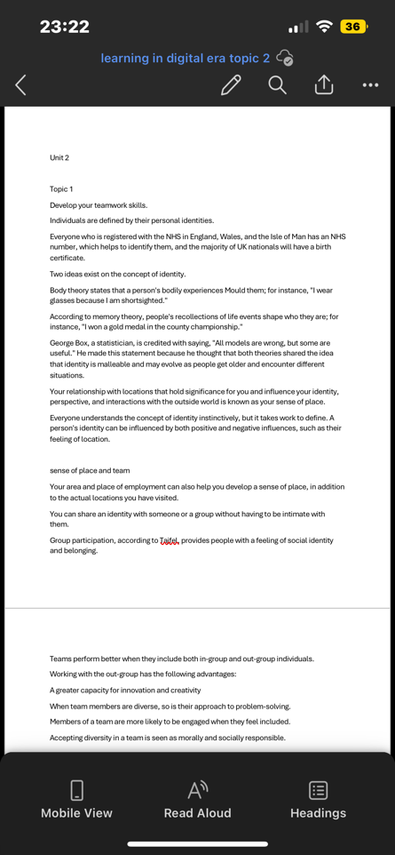
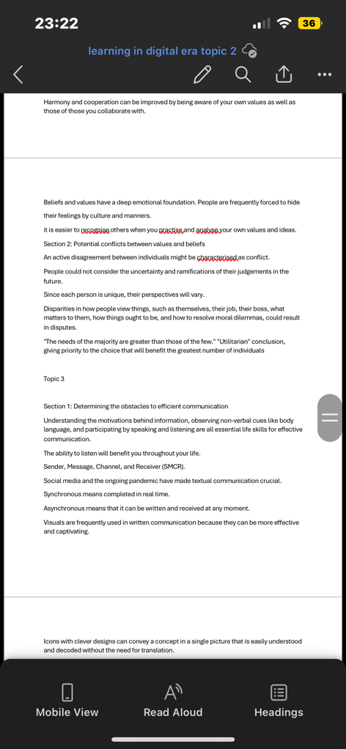
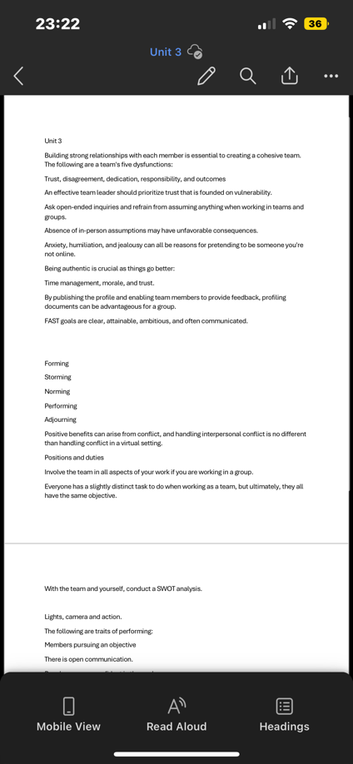
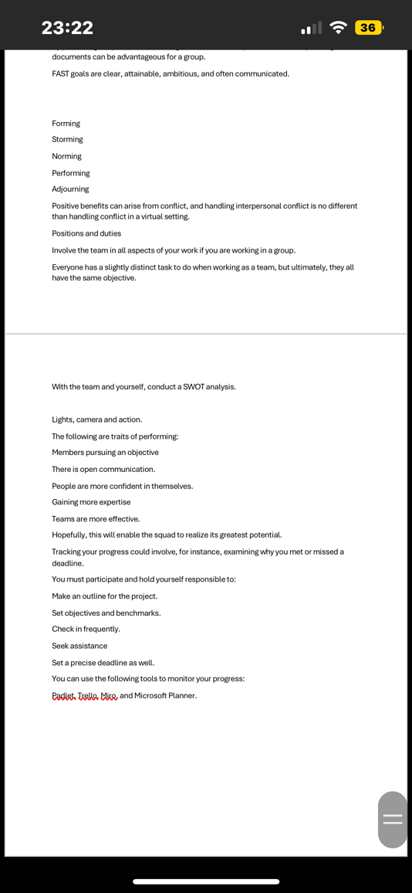
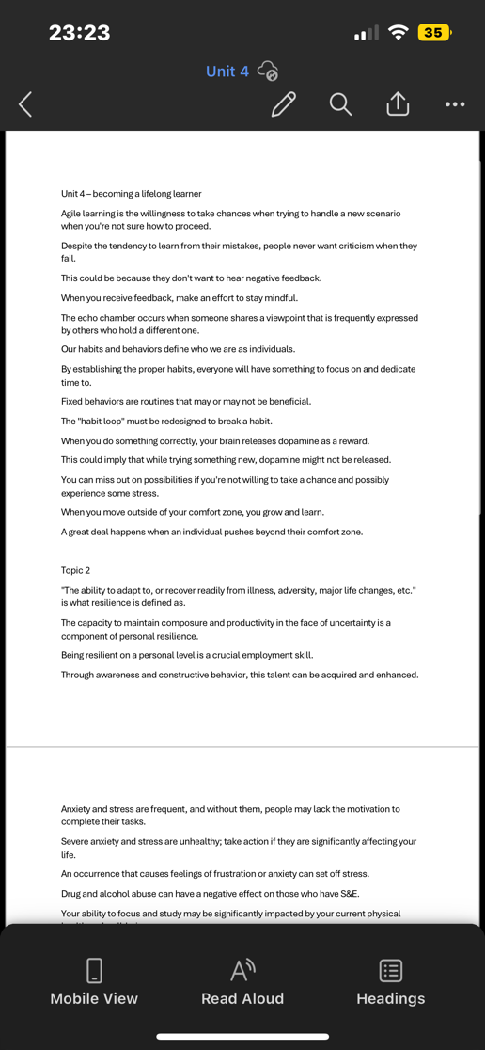
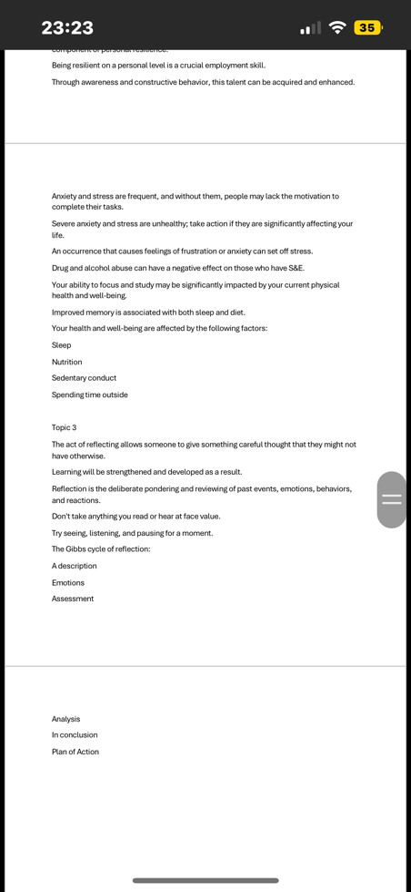
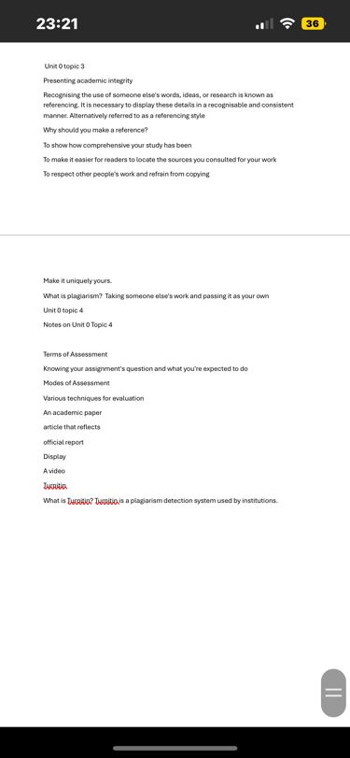
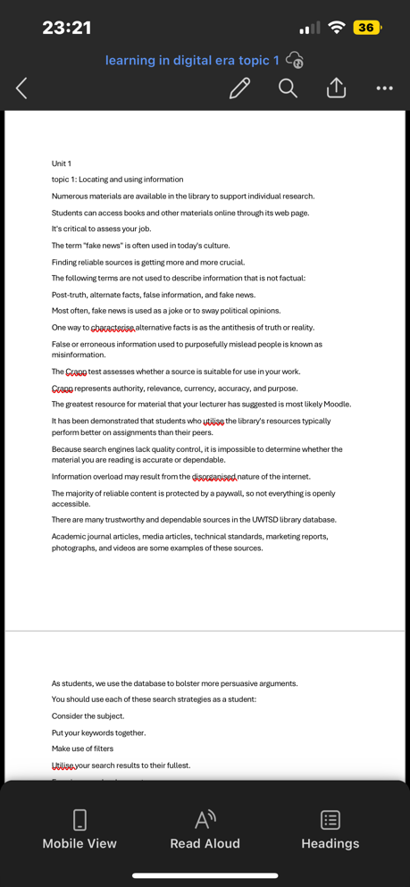
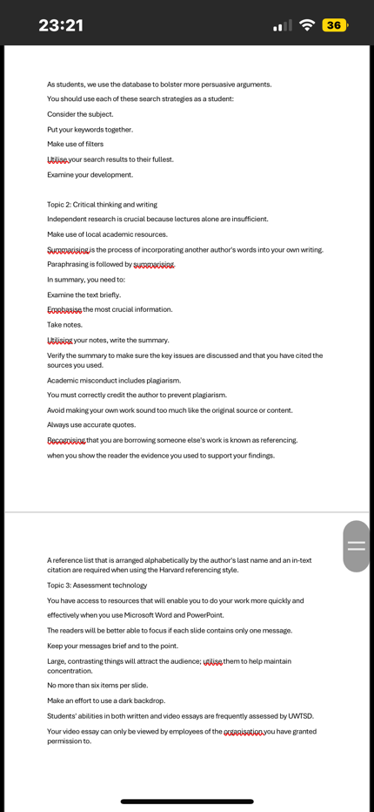
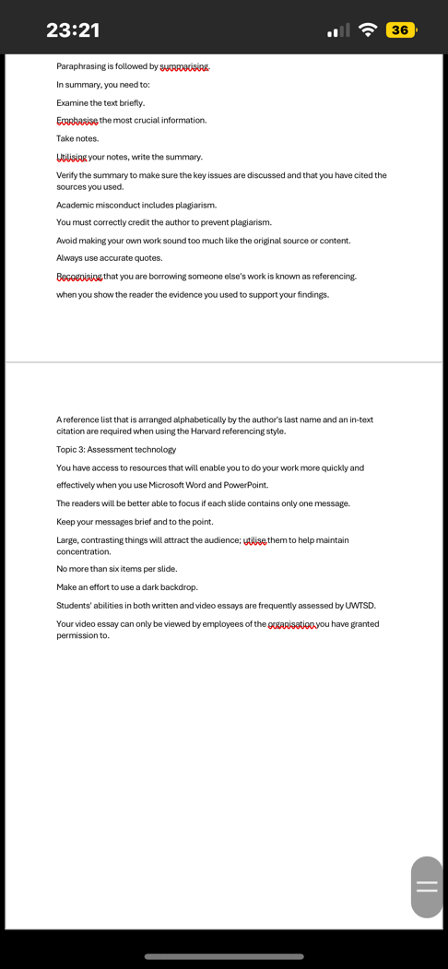
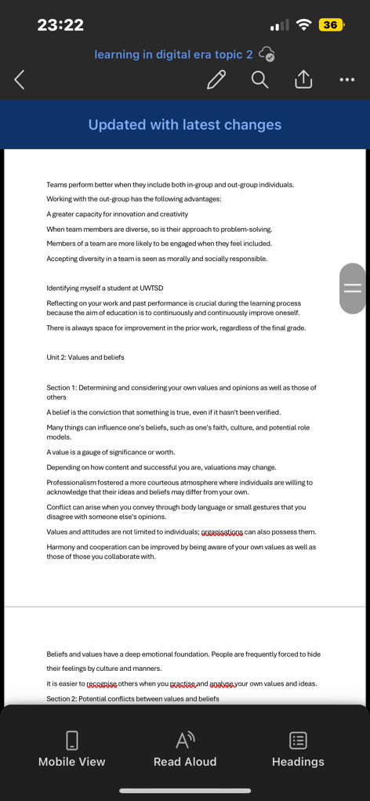
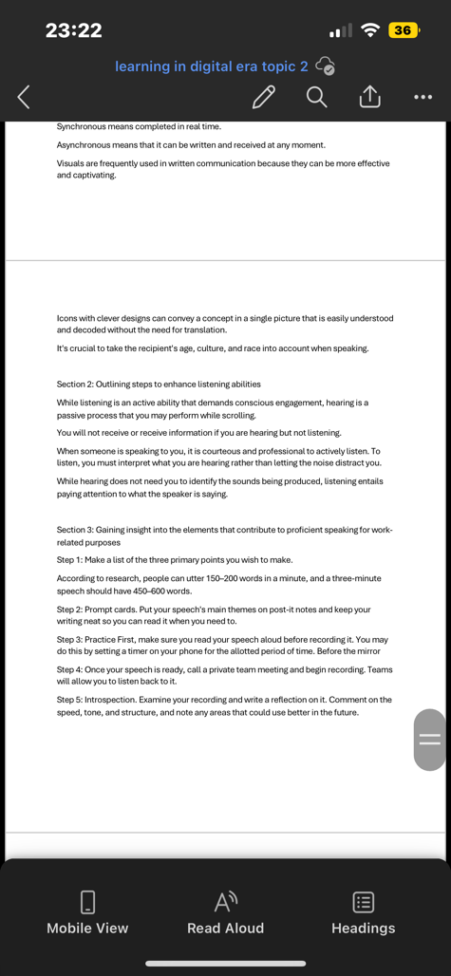

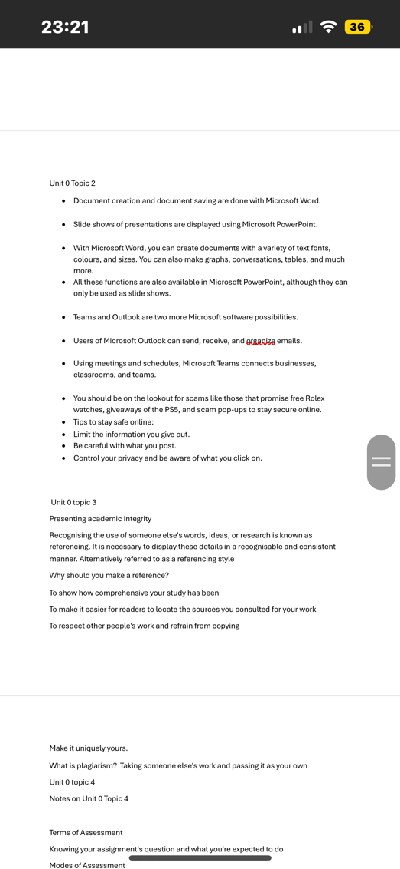
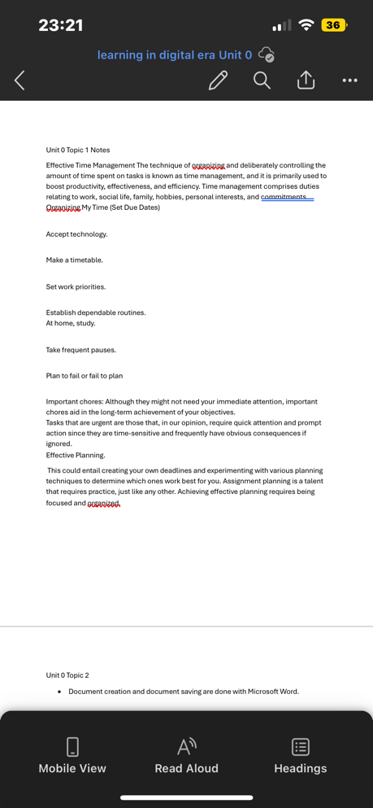

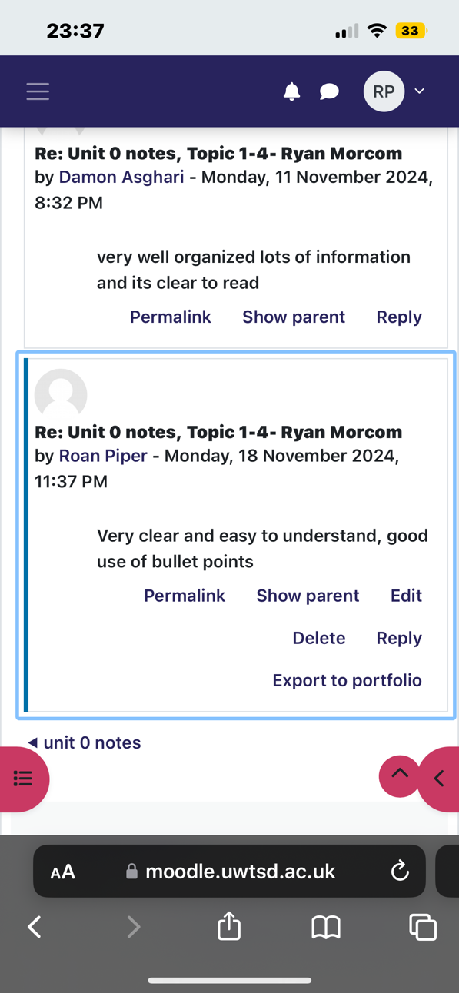

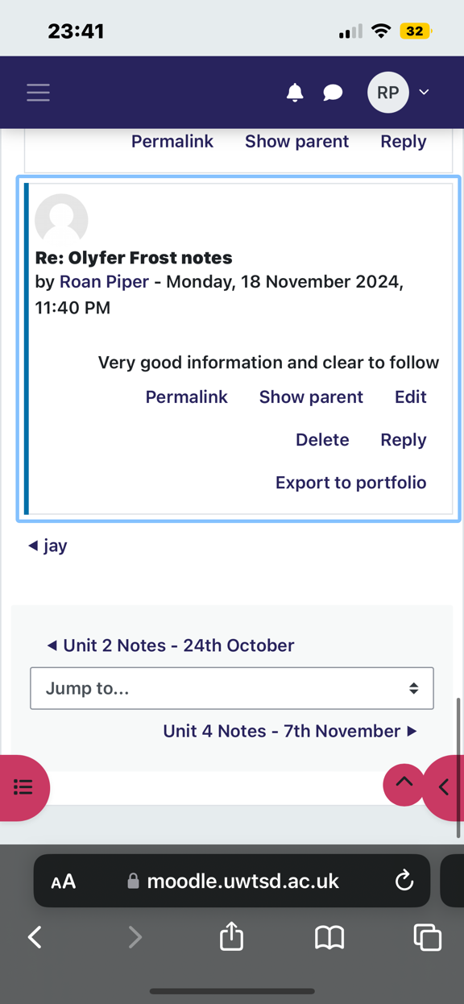

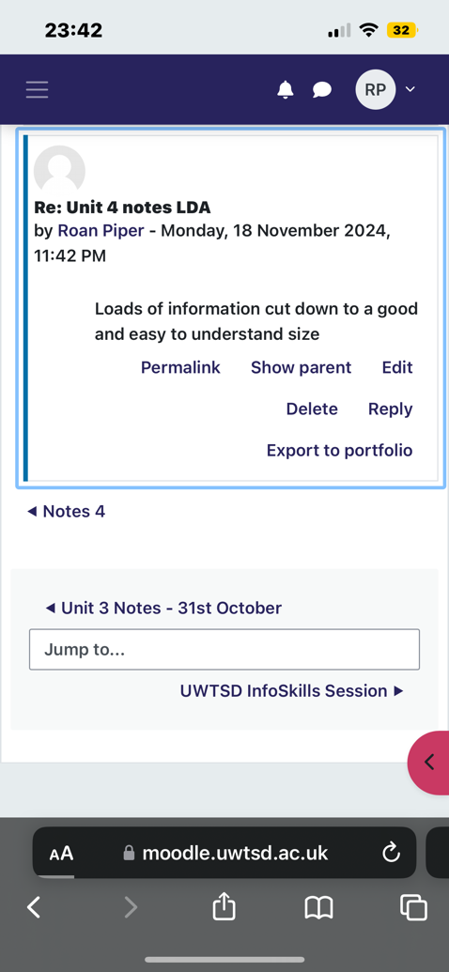

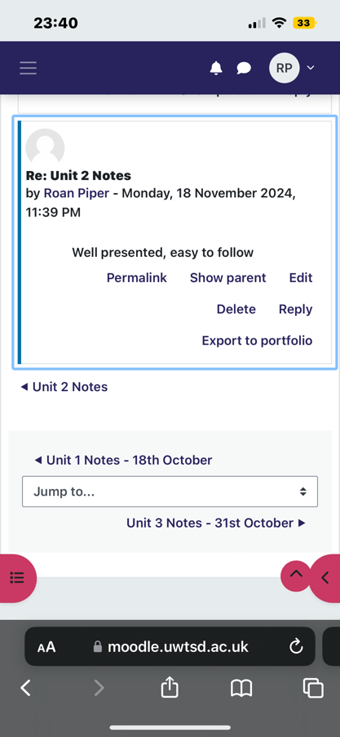
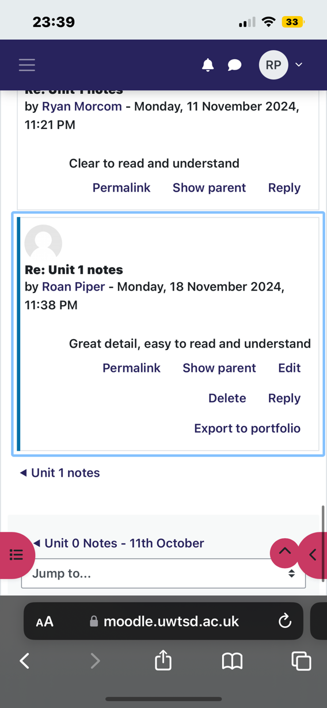
Reference list

Duckworth
, A. L., Peterson, C., Matthews, M. D., & Kelly, D. R. (2007)
'Grit: Perseverance and passion for long-term goals', Journal of Personality and Social Psychology, 92(6), pp. 1087-1101.
Guffey, M. E., & Loewy, D. (2019) Essentials of Business Communication. 11th edn. Boston: Cengage Learning.
Hargittai, E. (2010) 'Digital literacy and political participation', The Information Society, 26(5), pp. 311-318.
Macan, T. H. (1994) 'Time-management: Test of a process model', Journal of Applied Psychology, 79(3), pp. 381-391.
Paul, R., & Elder, L. (2014) Critical Thinking: Tools for Taking Charge of Your Learning and Your Life. 4th edn. Pearson.

