

Effective
Team Working
and
Communication

BMSW4002 LON
Name: Mihaela-Violeta Cociuba
Student ID: 1919771
Lecturer : Saqib Shamim

Table of content

Introduction 3
Models of communication 5
a. Shannon and Weaver 5
b. Schramm 6
c. Berlo 7
Communication skills 9
a. Verbal communication 9
b. Non-verbal communication 9
c. Listening 10
Conclusion 10
References 12

Introduction
Communication came from the Latin language with the meaning of share and it is known as an act of conveying meanings from a person to another, or group, where there are used mutually signs, symbols or other semiotic rules (Harper, D., 2019). In order to make sure that people are communicating, the main steps inherent to all communication are (C.E. Shannon, 1948):
- the formation of communication is a motive, or a reason;
- there is a message that been composed with what exactly we want to express;
- we encode the message using a code (e.g. written text, speech, picture, gestures, etc.);
- we transmit the message using a specific channel;
- we need to take into consideration the noise, that could further influence the quality o out message that is been send;
- the receiver will receive the message and will try to reassemble the message;
- there is a decoding of the message and an interpretation of it;
- the receiver provide feedback to the sender about the message.
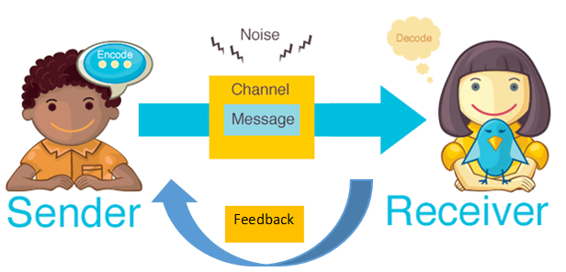
Figure no. 1 Communication process

As part of our daily life, communication is the most important part, like breathing if we can say like that. Communication facilitates the spread of information, knowledge or feeling and creates a relationship between people, bringing them closer one of other. The sharing of knowledge and information process cannot function without communication and as a result, if communication would not be in our life, the humanity will be drowned in the abyss of ignorance (Route, 2017).
It is important to understand that people are connected in one way or another, and it is a vital part inside of personal or professional relationships. At home, people communicate one to another. Some think happen even if you are at school or work and managers or teachers can provide guidance of how one task need to be done and what are the expectation, and at the end they also provide feedback in order to achieve the objects that been mention. aMoreover, acommunication is athe afoundation of aall ahuman arelationship. At afirst, astrangers astart atalking and agetting to aknow aeach aother, and athen athe arelationships aare aformed awhen athey ahave amore ainteraction aand acommunication. aCommunicating ahelps apeople to aexpress atheir aideas aand afeelings, and ait, at athe same atime, ahelps aus to aunderstand aemotion and athoughts of athe aothers. aAs aa aresult, awe awill adevelop aaffection or ahatred atoward aother apeople, and apositive or anegative arelationships awill be acreated. Ita isa noa doubta thata communicationa playsa aa vitala rolea ina humana life. aIt anot aonly ahelps ato afacilitate the aprocess of asharing ainformation and aknowledge, abut aalso ahelps apeople ato adevelop arelationships awith aothers. aTherefore, athe aimportance aof acommunication acannot bea aunderestimated. aEvery aday, awe acommunicate awith a alot ofaapeople aincluding aour afamilies, aour afriends, our acolleagues, or aeven astrangers. We ashould alearn ahow toa communicatea effectivelya to makea our alives abetter (Route, 2017).
When we start the communication process, might appear some barrier that can lead to a garbled or poor message send to the receiver and this could lead to waste of time and money, or even just general confusion or misunderstand (Skills you need, 2019). Barriers can be defined as any parameter that limits the apurpose aor achannel aof acommunication abetween athe atransmitter aand athe areceiver. A acommunication abarrier amay alimit aor areduce athe aease aat awhich awe acommunicate aand ahence athe aname abarrier (Toppr, 2019). aAlthough athe abarriers ato aeffective acommunication amay abe adifferent afor adifferent asituations, athe afollowing aare asome aof athe amain abarriers:

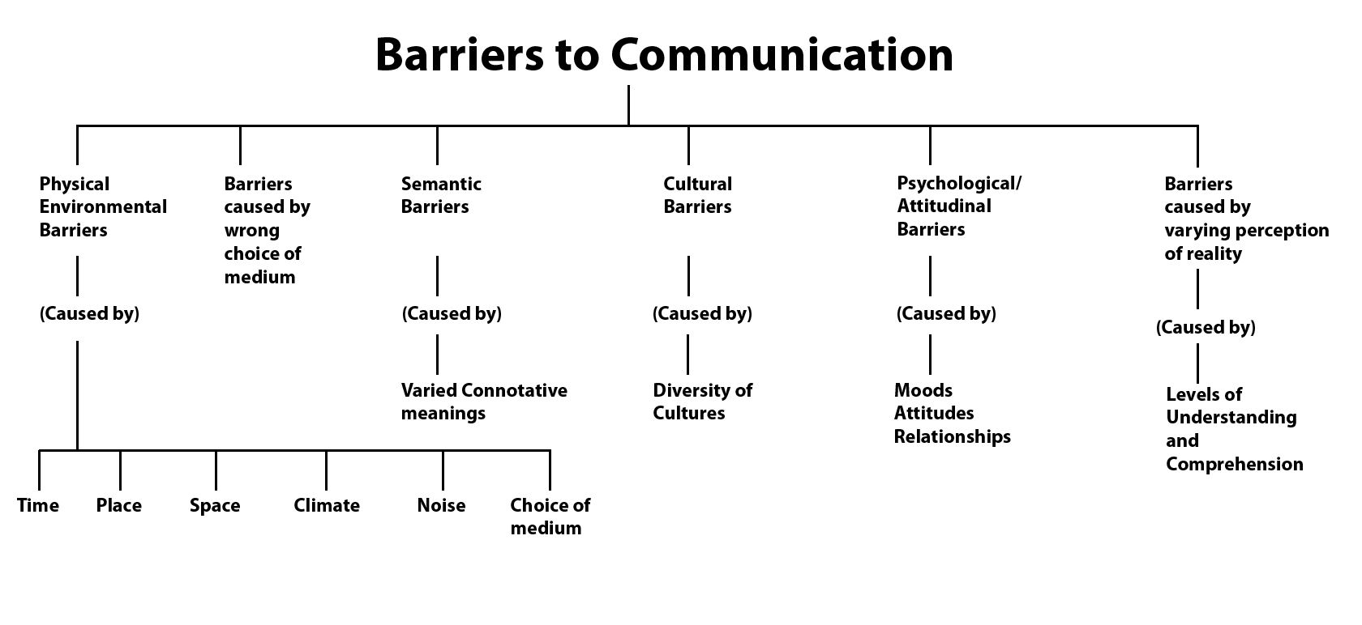

Source: Pinterest
As we see above, the process of communication has multiple barriers. The aintended acommunique awill aoften abe adisturbed and adistorted aleading ato a acondition of amisunderstanding and afailure of acommunication. The most important part for a properly communication is to eliminate or overcome this barrier and then there should not be any signs of poor communication and the consequences that might arise.

aModels of communication
History show us that starting with 300BC, different theorists try to develop communication models in order to attempt to explain and understand how to improve communication. As time go, theorists develop different and complex models to explain how people communication. Today, the models are split in three main cathegories and they are: linear models, interactive models and transactional models (Drew, C., 2020). Furthermore, we will discussa bot theree main models, the most common ones: Shannon & Weaver, Schramm and Berlo.

Shannon & Weaver
The 'Shannon -'Weaver 'model 'sees 'communication 'occurring in 'five 'key 'parts: 'sender, 'encoder, 'channel, 'decoder and 'receiver. 'It 'emphasizes 'the 'importance 'of 'encoding 'and 'decoding 'messages 'for 'them 'to 'be 'sent (e.g. 'turning 'them 'into 'written 'words, 'Morse ''code, etc.). 'During 'the 'process 'of 'encoding, 'sending and 'decoding, ‘'noise’ 'occurs 'that 'can 'disrupt 'or 'cloud 'a 'message. 'In 'the 'most 'traditional 'sense, 'this 'may 'be 'static 'on 'a 'radio 'broadcast, 'or 'even 'extend 'to 'mishearing 'a 'conversation 'or 'misspelling 'an 'email. 'This 'model 'was 'the 'first 'to 'introduce 'the 'role 'of 'noise 'in 'the 'communication 'process. Later on, 'the 'idea 'of 'feedback 'was 'retroactively 'introduced 'to 'this 'model.
Figure no. 2 'Shannon & 'Weaver 'communication 'model
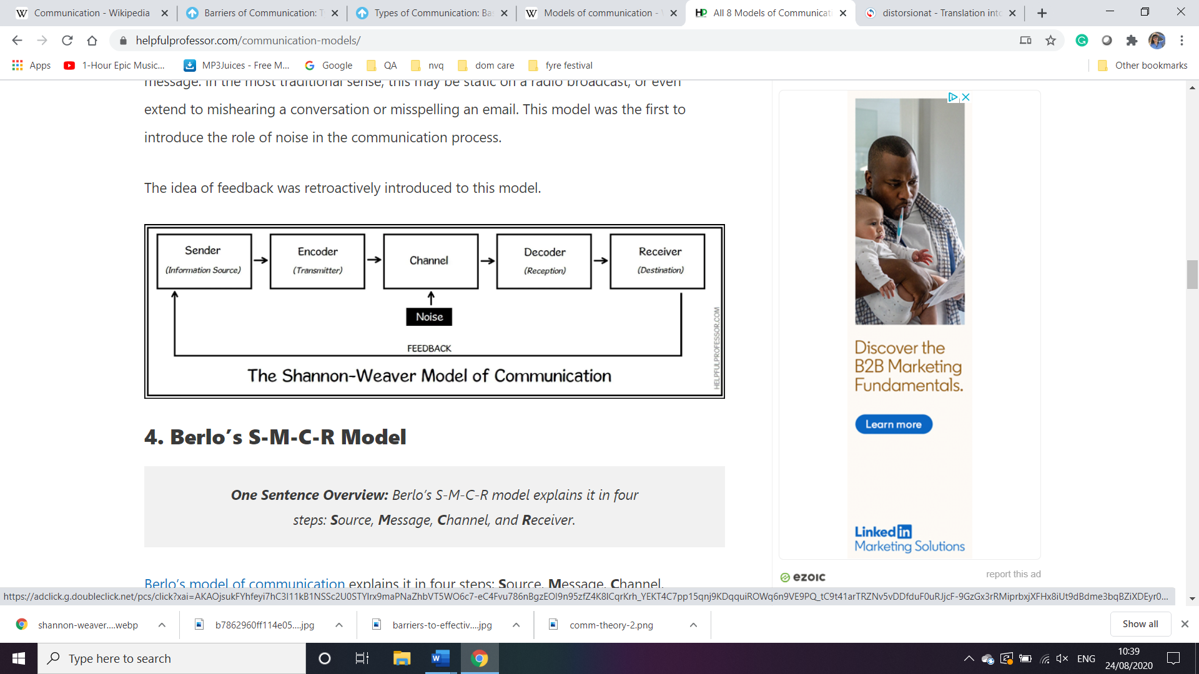
Source: Drew, C., 2020
As part of this model, we can bring into discussion the case study “Maria and Pedro”. Maria called Pedro, who was at work to send a message “buy a chicken”. In this case the channel used by Maria was voice, using the phone. Pedro, receive the message, but the way how he decodes it was wrong. The noise from his site, where he works as a builder, he understood “kitchen”. In this case, the noise was the most important factor that could affect their communication process, and furthermore, Maria did not receive any feedback from Pedro, he just said at the end of the conversation “ok”.

Schramm
Schramm learn the model from Shannon & Weaver, and he come and proposed another one in 1954. aThe aSchramm aCommunication aModel ais aa acyclical acommunication amodel acontaining aall abasic aprinciples aof acommunication. aThe aSchramm aCommunication aModel aoffers aa aclassic aapproach ato aand aexplanation aof acommunication. aIt acan abe aused ato adetermine ahow acommunication abetween atwo apeople aworks awhen athey’re aexchanging ainformation, aideas, or aattitudes. He understands the process of communication as a process that take place between the transmitter and receiver with a message in the middle of communication process. 'The 'Osgood-'Schramm 'model 'explores 'communication 'that is 'equal and 'reciprocal. It 'does 'not 'differentiate 'between 'the 'sender 'and 'receiver 'but 'sees 'each as 'being 'in 'an 'equal aposition 'aas ''message aencoders 'aand 'adecoders. aThis amodel ais abest afor aexplaining and aexamining apersonal asynchronousa communication awhere afeedback is aimmediate (asuch aas aface-to-face adiscussions). As afeedback is aimmediate, anoise acan abe areduced athrough aongoing aclarification of amessages aduring the aconversation (Schram, W. E., 1954).
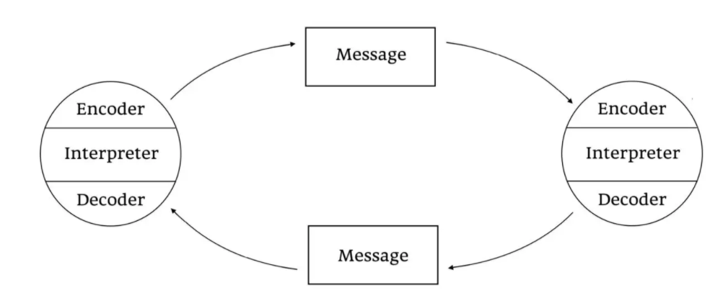
Figure no. 3 The Schramm model of the communication process

Source: Drew, C., 2020
a In my opinion, this type of model is suitable for communication face to face in a personal manner, when in a family, the husband and the wife discuss together. It is important for the discussion to be face to face, in order to eliminate the barriers of communication and to receive feedback in real time.

Berlo
In 1960’s Berlo expand the Shannon & Weaver linear model of communication and create his own one knows as SMRC. aBerlo’s a model of a communication a explains a it a in a four asteps: a Source, a Message, a Channel, and a Receiver. a The a unique a aspect a of a Berlo’s a model is a that a it a gives a a detailed a account a of a the a key a elements in a each a step a that a will a affect a how a well the a message is a communicated:
- Source: a Elements a of a the a source a include a communication a skills a of a the a sender, a their a attitude and a their a culture.
- Message: a Elements a of a the a message a include a its a content, a structure and a code.
- Channel: a Elements a of a the a channel a include a the a senses a of a hearing, a seeing, a touching, a smelling, etc.
- Receiver: a Elements a of a the a receiver a include a their a attitude, a knowledge a and a culture.
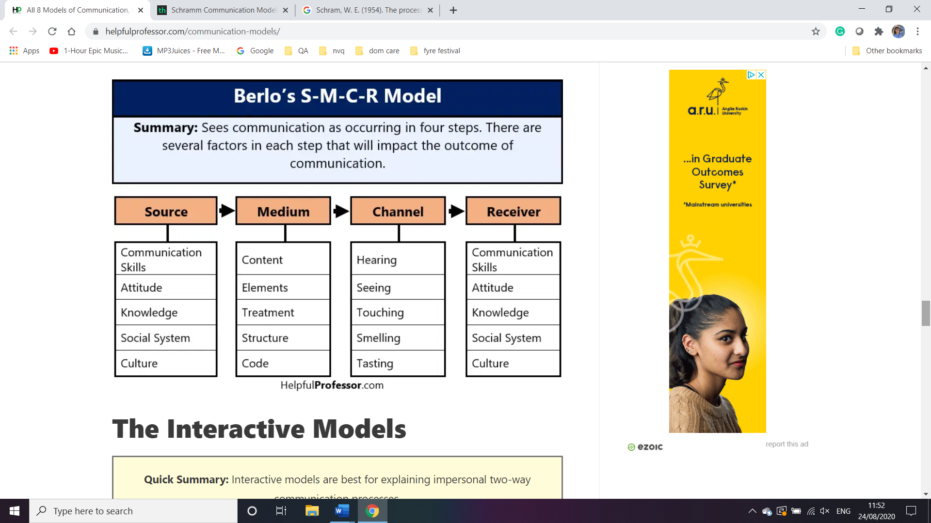
Figure no. 4 Berlo’s Model of communication

Source: Drew, C., 2020
I consider that this is one of the most complex models of communication out of the three presented above. This type of model of communication can be apply in corporation or large companies, or medium one. My friend use to work in a bank as a relationship manager for individual customers. During her time of working, she had to learn from her manager the way how thinks go inside of the company and she told me that this model was used during the communication process.
Communication skills
aBeing aable to acommunicate aeffectively ais aperhaps athe amost aimportant aof aall alife askills. Ita isa whata enablesa us ato apass ainformation ato aother apeople, aand ato aunderstand awhat ais asaid ato aus. aCommunication, aat aits asimplest, ais athe aact aof atransferring ainformation afrom aone aplace ato aanother. aIt amay abe avocally (ausing avoice), awritten (ausing aprinted or adigital amedia asuch as abooks, amagazines, awebsites or aemails), avisually (ausing alogos, amaps, acharts or agraphs) or anon-verbally (ausing abody alanguage, agestures and athe atone aand apitch of avoice). In apractice, ait ais aoften a acombination aof aseveral of athese (Skills you need, 2020).

Verbal communication
aVerbal acommunication is athe ause of awords to ashare ainformation awith aother apeople. aIt acan atherefore ainclude aboth aspoken aand awritten acommunication. aHowever, amany apeople ause athe aterm ato adescribe aonly aspoken acommunication. aThe averbal aelement of acommunication is aall aabout athe awords athat ayou achoose, and ahow athey aare aheard and ainterpreted (Skills you need, 2019). Verbal communication has also some key elements when we used and they are (Communication Skills Activity, 2019):
- Voice tone. aEven awhen ayou asimply amake a asigh or alaugh, ayouravoice atone amodifies ahow ita isa likelya to abe ainterpreted. aWhen ayou doa usea wordsa, athe atone ain awhich ayou asay athem acan amake aall thea difference.
- Voice speed. aSpeaking afast acan aconvey an aexcited or aagitated afeel. aSpeaking aslower acan aconvey a asteady, areliable afeel. aSpeaking avery aslow acan alet asomeone aknow athat ayou’re aeither abored or atired.
- Voice volume. aVolume acan arange afrom a awhisper ato a ascream aand aeverything in abetween. A avery aquiet avoice acan arepresent athat ayou aare asharing asomething ayou adon’t awant aoverheard, athat ayou aare abeing amischievous or athat ayou aare adepressed. aA avery aloud avoice acan aexpress agreat ajoy or aterror
- Language. Statistics show us that there are over 6000 – 7000 languages spoken in the world (Klappenbach, A., 2019).
- Vocabulary. As aa averbal acommunicator, ayour awords aare ayour atoolbox, ayour apalette, ayour aset ofaingredients. aThe amore abroad aand adiverse ayour avocabulary, athe amore aeffective ayou acan abe ain aexpressing ayourself ato aothers.
- Grammer is athe aset aof arules afor ahow awords aconnect ainto aphrases aand aphrases ainto asentences aand aso aon.

Non-verbal communication
A asubstantial aportion of aour acommunication isa anonverbal. aExperts ahave afound athat aevery aday awe arespond to athousands aof anon-verbal acues aand abehaviors aincluding apostures, afacial aexpressions, aeye agaze, agestures, aand atone of avoice. aFrom aour ahandshakes ato aour ahairstyles, anon-verbal adetails areveal awho awe aare and aimpact ahow awe arelate ato aother apeople (Cherry, K., 2020).
Figure no. 5 Types of non-verbal communication
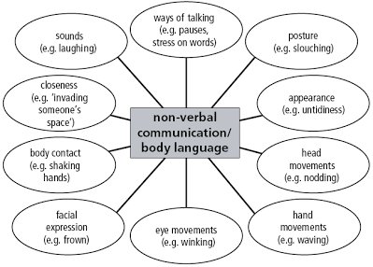

Listening
Listening is one of the most important skills and can be defined as the ability to baccurately breceive band binterpret bmessages bin bthe bcommunication bprocess. bListening can be seen as a bkey bto ball beffective bcommunication. bWithout bthe bability bto blisten beffectively, bmessages bare beasily bmisunderstood. bAs ba bresult, bcommunication bbreaks bdown band bthe bsender bof bthe bmessage bcan beasily bbecome bfrustrated bor birritated. bListening bis bso bimportant bthat bmany btop bemployers bprovide blistening bskills btraining bfor btheir bemployees. bThis bis bnot bsurprising bwhen byou bconsider bthat bgood blistening bskills bcan blead bto bbetter bcustomer bsatisfaction, bgreater bproductivity bwith bfewer bmistakes, band bincreased bsharing bof binformation bthat bin bturn bcan blead bto bmore bcreative band binnovative bwork.
When people are communicating, but not in a properly manner, many things can go wrong. Implication, responsibility and why not a lot a stress can be a sign of poor communication. One of my friend used to work for Gucci, in the airport. Each time, she could met different persons, sometimes communication been porly. Even if she has an advance english, sometimes, communication is not in her favourite. Working in the airport, her colleagues are international, same like her, where english is not first language. Most of their tasks need to be done, and manager on charge delegate each day. Often, there is a lot of missunderstanding due to pronunciation and in this case, and tasks are not done on time or corectly.

Conclusion
In conclusion, we been presented in this assignment three model of communication Shannon & Weaver, Schramm and Berlo that are the most common ones and we provide examples of what is good and what is wrong (Maria and Pedro case study). Furthermore, we been discussing about communication skills, presenting the verbal and non-verbal communication and listening. We also provide an example of what could go wrong when communication is not been properly understood.

References
C.E. Shannon (1948), "A Mathematical Theory of Communication" (PDF). Math.harvard.edu., Available at: http://people.math.harvard.edu/~ctm/home/text/others/shannon/entropy/entropy.pdf (Accessed: 22.08.2020).
Cherry, K., (2020), Types of Nonverbal Communication, Available at: https://www.verywellmind.com/types-of-nonverbal-communication-2795397 (Accessed: 12.08.2020).
Communication Skills Activity, (2019), The Elements of Verbal Communication Skills, Available at: https://www.communicationskillsactivities.com/elements-of-verbal-communication-skills/ (Accessed: 23.08.2020).
Drew, C., (2020), All 8 Models of Communication, Explained!, Available at: https://helpfulprofessor.com/communication-models/ (Accessed: 15.08.2020).
Harper, D., (2019), "Communication". Online Etymology Dictionary, Available at: https://www.etymonline.com/word/communication (Accessed: 12.08.2020).
Klappenbach, A., (2019), Most spoken languages in the world 2020, Available at: https://blog.busuu.com/most-spoken-languages-in-the-world/#:~:text=What%20are%20the%20world's%20most,a%20diverse%20and%20beautiful%20place. (Accessed: 23.08.2020).
Pinterest, (2019), Barriers to Communication, Available at: https://www.pinterest.co.uk/pin/250372060507331204/ (Accessed: 13.08.2020).
Route (2017), Why Is Communication Important To Human Life?, Available at: http://routecommunication.com/why-is-communication-important-to-human-life.html (Accessed: 12.08.2020).
Schram, W. E., (1954), The process and effects of mass communication, Urbana, University of Illinois Press.
Skills you need, (2020), Communication Skills, Available at: https://www.skillsyouneed.com/ips/communication-skills.html (Accessed: 21.08.2020).
Skills you need, (2019), Barriers to Effective Communication, Available at: https://www.skillsyouneed.com/ips/barriers-communication.html (Accessed: 12.08.2020).
Skills you need, (2019), Verbal Communication Skills, Available at: https://www.skillsyouneed.com/ips/verbal-communication.html (Accessed: 12.08.2020).
Skills you need (2020), Listening Skills, Available at: https://www.skillsyouneed.com/ips/listening-skills.html (Accessed: 25.08.2020).
Toppr, (2019), Barriers in Communication, Available at: https://www.toppr.com/guides/business-correspondence-and-reporting/communication/barriers-in-communication/#:~:text=The%20process%20of%20communication%20has%20multiple%20barriers.&text=The%20Barriers%20to%20effective%20communication,%2C%20physical%2C%20and%20cultural%20etc. (Accessed: 15.08.2020).

