Analysis of the impact of employee training on guest satisfaction in
Ibis Hotel Northampton

Sebastian Garbaty

Student number: 2211131

Placement Project BMIH6008
—
Lecturer: Christopher Wilkin
—
Word Count: 8021

AI Acknowledgement statement
I Declare the usage of the library PRIMO App for research and source findings on relevant topic as well as the usage of Grammarly for spelling errors.
I confirm I have copies of my work.

Abstract
This study examines the influence of employee training on the satisfaction of guests at the Ibis Hotel Northampton, a member of the recognised Accor Group. This research examines how training strategies, focussing on both technical skills and interpersonal abilities, enhance service quality, employee performance, and customer experience within the competitive and service-oriented hospitality industry. This study utilises a quantitative methodology grounded in secondary data, encompassing guest reviews, and industry benchmarks, to analyse the link between training initiatives and guest perceptions through established theoretical frameworks, including Herzberg’s Two-Factor Theory, the Service Profit Chain, and the SERVQUAL model.
The findings indicate that Ibis' existing training program, mostly conducted through Accor's e-learning platform and on-the-job mentoring, effectively enhances operational competencies but inadequately fosters the soft skills necessary for personalised service delivery. This weakness correlates with diminished guest satisfaction ratings in domains necessitating emotional intelligence, cultural sensitivity, and communication skills. The study emphasises the significance of employee involvement and managerial support as critical mediators in converting training into enhanced service quality. A SWOT and PESTEL analysis elucidates the findings in relation to the hotel’s internal competencies and external obstacles, uncovering strategic potential for innovative training delivery, including virtual reality, blended learning, and local educational collaborations.
The study confirms the assumption that thorough, well-supported training markedly improves visitor satisfaction, especially when it integrates functional skills with emotional and cultural competence. It finishes by providing actionable solutions, such as incorporating soft skills into the fundamental training curriculum, adopting role-specific and performance-oriented training models, and establishing collaborative learning initiatives with local institutions. These initiatives are essential for enhancing service quality and personnel development, as well as for maintaining Ibis Hotel Northampton’s competitiveness and brand recognition in a dynamic hospitality environment.

Table of contents

AI Acknowledgement statement 2
Abstract 3
Table of contents 5
Introduction 6
Case Study Overview of Ibis Hotel Northampton 8
Hypothesis 11
Objectives 12
Research questions 12
Literature review 13
Industry best practises 18
Industry theories 19
PESTEL Analysis 23
Methodology 26
Theories 27
Methodology applied 28
SWOT Analysis 29
Feedback Management and Employee training in Reputation management 31
Conclusions 36
Recommendations 40
References 42
Appendix 43

Analysis of the impact of employee training on guest satisfaction in
Ibis Hotel Northampton

Introduction
In the service-oriented and highly competitive hotel business, frontline personnel performance is directly tied to visitor experience quality (Singh, 2021). Employee training and internal policies influence service delivery, which are critical components that affect both operational efficiency and customer satisfaction (Bajaj et al., 2023). To maintain a competitive advantage, hotels like the Ibis Hotel in Northampton, which is part of the worldwide known Accor Group (Accor, 2019), must provide consistent, individualised service. The Ibis Hotel, a budget-friendly hotel that is committed to meeting its customers' rising expectations by encouraging true human interaction and displaying technical expertise, provides a safe deposit box at reception, drycleaning, and express check-in and out (See appendix 1). The Ibis Hotel Northampton is designed to fulfil the demands of both business and leisure travellers. The hotel normally has more than 100 guest rooms, a 24-hour reception desk, a lounge bar, meeting rooms and basic facilities such as dry cleaning, quick check-in and out and on-site parking. The operating structure consists of fundamental divisions such as housekeeping, food and beverage, maintenance, and the front desk. All of these divisions rely on frontline employees to offer excellent service to guests. Departmental managers oversee each of these departments, while a general manager ensures that operational standards meet the brand's global requirements.
The Ibis Hotel Northampton is a strategically located, mid-range hotel that is part of the world-renowned Accor Group. As an Ibis brand member, the hotel adheres to Accor's international norms for cheap lodging, offering dependable and consistent service to both corporate and leisure visitors. The hotel is conveniently placed near Northampton's commercial and transport hubs, serving to a wide range of guests, including conference attendees, individual travellers, and visitors.
The hotel features over 100 guest rooms, a 24-hour lobby, meeting rooms, a lounge bar, express check-in/out and on-site parking. The front office, cleaning, food and beverage, and maintenance are all operational departments, which are controlled by department heads who report to the general manager. This streamlined structure enables successful service delivery and responsiveness to visitor needs.
The Ibis Hotel Northampton uses Accor's standardised training procedures, which include e-learning and practical education. The training plan efficiently addresses technical competencies; however, inadequacies remain in the development of soft skills, particularly emotional intelligence, cultural awareness, and personalised service delivery. As consumer expectations rise, especially for personalised experiences, it is critical to assess how current training strategies improve employee performance and visitor satisfaction. This case study features Ibis Northampton as a prime example of a modern budget hotel that balances uniformity and service personalisation.

Ibis trains its staff with a combination of Accor's e-learning platform and on-the-job training that emphasises on both technical skills and corporate operations. However, as tourist expectations rise and the industry shifts towards more customised service, interpersonal skills such as cultural comprehension, emotional intelligence, and communication become increasingly important.

Case Study Overview of Ibis Hotel Northampton
In the hospitality industry, which is service-oriented and highly competitive, the performance of frontline personnel is inextricably linked to the quality of the guest experience (Singh, 2021). The delivery of services is influenced by employee training and internal policies, which are fundamental components that not only affect operational efficiency but also customer satisfaction (Bajaj et al., 2023). Delivering consistent, personalised service is essential for hotels such as the Ibis Hotel in Northampton, which is a member of the globally recognised Accor Group (Accor, 2019), in order to preserve a competitive advantage. The Ibis Hotel, a budget accommodating hotel, which is obligated to satisfy the increasing expectations of its customers by fostering genuine human interaction and demonstrating technical proficiency, offers safe deposit box at reception, drycleaning and express check in and out (See appendix 1).
The Ibis Hotel Northampton is set up to meet the needs of both business and leisure travellers. The hotel usually has more than 100 guest rooms, a reception desk open 24 hours a day, a lounge bar, meeting rooms and basic services like dry cleaning, quick check-in and check-out and parking on site. Its operational structure is made up of basic departments like housekeeping, food and drink, maintenance, and the front desk. All of these divisions depend on frontline staff to provide smooth service to guests. Departmental managers oversee each of these departments, while a general manager makes sure that operational standards satisfy the brand's global requirements.
The Ibis Hotel Northampton is a centrally situated, mid-range establishment affiliated with the globally known Accor Group. The hotel, as a member of the Ibis brand, adheres to Accor's international benchmarks for affordable accommodation, providing dependable and uniform service to both corporate and leisure guests. The hotel is strategically located near Northampton's commercial and transportation centres, catering to a varied clientele, including conference participants, individual travellers, and visitors.
The hotel has more than 100 guest rooms, a 24-hour lobby, meeting spaces, a lounge bar, rapid check-in/out services and on-site parking. Operational departments encompass the front office, housekeeping, food and beverage, and maintenance, each overseen by departmental heads under the general manager's direction. This optimised framework facilitates effective service provision and adaptability to guest requirements.
The Ibis Hotel Northampton employs Accor's standardised training systems, integrating e-learning courses with practical instruction. The training strategy effectively addresses technical competencies; yet, deficiencies persist in the development of soft skills, notably in emotional intelligence, cultural awareness, and personalised service delivery. As consumer expectations grow, particularly with personalised encounters, it is crucial to evaluate how current training techniques enhance employee performance and guest pleasure. This case study presents Ibis Northampton as a quintessential example of contemporary budget hotels balancing uniformity and service customisation.
Ibis trains its employees using a mix of Accor's e-learning platform and on-the-job training that focusses on both technical skills and how things work in the company. But as visitor expectations rise and the industry moves towards more personalised service, it has become more and more clear that interpersonal skills like cultural understanding, emotional intelligence, and communication need to be included.
This study looks at how the design and implementation of training programs at Ibis Hotel Northampton affect employee performance, satisfaction, and, in the end, guest satisfaction. This study looks at the hotel's structure and training methods to see how well they work and to make suggestions for how to make them better based on what is now considered best practice in the hospitality industry.

This study examines the critical role that employee training plays in improving the quality of service (Bajaj et al., 2023), based on secondary research and the contentment of guests reviews (See Appendix 2 and 5) at the Ibis Hotel. This research employs a quantitative methodology (Matović and Ovesni, 2023), utilising secondary data such as guest satisfaction reviews, employee satisfaction, and industry research. Critical analysis is applied to examine correlations between training effectiveness, employee satisfaction, and service quality. The approach enables objective evaluation of training outcomes at the Ibis Hotel, Northampton. Particular emphasis is placed on the attainment of a balance between the development of interpersonal competencies, including emotional intelligence (Auld, 2024) and cultural sensitivity (Joshi & Munghantiwar, 2024), and the acquisition of technical skills. In addition to preparing employees to meet job demands, effective training programs also considerably enhance their satisfaction, motivation, and long-term engagement (Schroeder, 2025). In turn, these employee-centric outcomes are essential for providing exceptional visitor experiences. While Accor (2024) internal policy strongly focuses on employee training and customer focus initiatives some cracks seem to be present in a day to day operations (See appendix 4).

The study employs secondary data and establishes theoretical frameworks to investigate this dynamic. Described by Galanakis and Peramatzis (2022) the Herzberg's Two-Factor Theory offers insight into the factors that drive job satisfaction and motivation among employees, while the Service Profit Chain (Patel et al., 2020) model is employed to investigate the impact of employee development on customer loyalty and profitability. Furthermore, the SERVQUAL model discussed by (Elsayeh, 2020) implemented to evaluate service delivery from the guest's perspective, providing a structured method for comparing differences between anticipated and actual experiences.
The objective of this research is to identify strengths, uncover areas for improvement, and provide practical, evidence-based recommendations within the hospitality industry by critically evaluating the current service delivery training systems in place at the Ibis Hotel.
The goal is to improve customer satisfaction, employee performance, satisfaction, and retention, all of which are essential for delivering consistently positive visitor experiences. The study thereby provides meaningful insight for this research project with valuable insights that can be used to integrate internal staff development strategies with external service excellence in an increasingly demanding market.

Hypothesis
This research hypothesises of this research project is the effective employee training at the Ibis Hotel, Northampton significantly enhances guest satisfaction, particularly when training programs address both technical competencies and interpersonal skills. It is focused on staff awareness of proficiency not only in operational tasks but also in emotional intelligence, cultural awareness, and communication are better equipped to meet diverse guest needs and expectations. By fostering both skillsets, training initiatives can improve service consistency, increase employee confidence and engagement, and create more meaningful guest interactions. As a result, the training approach is expected to lead to higher levels of guest satisfaction, contributing positively to the hotel's overall service quality and reputation.

Objectives
- To evaluate the efficacy of the existing employee training programs at the Ibis Hotel in Northampton, with a focus on both technical skills and interpersonal competencies.
- To analyse secondary data using established theoretical frameworks to investigate the correlation between employee training, staff satisfaction, and visitor satisfaction.
- The study endeavours to provide evidence-based recommendations for the improvement of training strategies that enhance the overall quality of service and the visitor experience.
These objectives are intended to emphasise the significance of comprehensive staff development in the hospitality industry, as it is essential for sustaining competitive service standards and driving performance.

Research questions
- In what ways should employee training at the Ibis Hotel, Northampton affect customer satisfaction, particularly in terms of service quality?
- What are the advantages and disadvantages of the present training programs at the Ibis Hotel, particularly in terms of the development of soft skills and how are guest interpreting the employees customer service skills?
- How does employee satisfaction influence the relationship between training effectiveness and passenger experience?

Literature review

The study conducted by Waqanimaravu and Arasanmi (2020) examines the correlation between service quality and employee training in the hospitality sector. The research evaluates the impact of three fundamental dimensions perceived access to training, perceived benefits of training, and perceived support for training on service quality. The study, which was conducted in the hotel sector of New Zealand, addresses a lacuna in the literature that pertains to the direct impact of employee training on service outcomes in culturally diverse contexts.

A matched survey technique was employed to collect data, A questionnaire was administered to frontline hotel employees to evaluate their training dimensions, while customers evaluated the service quality of the same employees. Out of the 126 matched surveys, 120 were suitable for analysis. The study employed SPSS software and established Likert scale instruments to conduct multiple regression analyses and ensure validity and reliability. The internal consistency of all constructs was confirmed by Cronbach's alpha values (UCLA, 2021), and no substantial common method bias or multicollinearity was identified.
The results indicated that service quality was substantially influenced by perceived benefits of training and perceived support for training, while perceived access to training did not. The lack of alignment between the training content and the job-specific requirements of employees or the employees' readiness and motivation to learn may account for the insignificant impact of access. Improvements are not guaranteed by mere access to training; rather, they necessitate that the training be perceived as advantageous and pertinent.

The most influential factor was the perceived benefits of training, employees who acknowledged that training improved their job performance, career advancement, and personal development were more likely to exhibit enhanced service behaviours. This is consistent with social exchange theory, which posits that employees are compelled to reciprocate through positive job performance when organisations invest in employee development. Similarly, organisational support including managerial encouragement and resource allocation for training encourages employee commitment, motivation, and the practical implementation of acquired skills, all of which are essential for delivering high-quality service.

Theoretical implications encompass a more profound comprehension of the direct impact of specific training variables on service quality. Prior research frequently neglected critical dimensions, including perceived benefits and support, or examined indirect effects. This research contributes to the field of HRD and hospitality literature by illustrating the importance of employees' subjective experiences with training, particularly their perceptions of the benefits and support, in determining customer satisfaction.

The study underscores the importance of active managerial support and tailored, pertinent training programs from a managerial perspective. Human resource policies should prioritise the provision of training opportunities, as well as the guarantee that these trainings are well-supported and plainly beneficial to the roles and development of employees. This can improve the quality of service and the overall client experience, which are essential components of the competitive hospitality industry.
Additionally, Johnson, Park, and Bartlett (2018) conducted an additional study that investigates the correlation between employee engagement, customer service training, and service orientation in the hospitality sector, with a particular emphasis on all-inclusive resort hotels in Jamaica. The research emphasises the critical role of frontline employees in influencing organisational performance and service quality in the face of increasing global competition and heightened customer expectations. It is essential to comprehend the factors that motivate frontline service personnel, as they are essential to customer satisfaction.

In a competitive business environment, the principle of reciprocity responding to positive actions with positive responses provides a potent approach to enhancing employee loyalty and retention (Segro 2024). Organisations that prioritise employee recognition, development opportunities, supportive environments, equitable compensation, and transparent communication are more likely to foster a sense of commitment and appreciation among their workforces (Imran, Ghazwan and Firmansyah, 2024). A culture of mutual respect is fostered by actions such as commemorating milestones, providing training and mentorship, promoting mental well-being, and ensuring work-life balance (Sanfilippo, Pomeroy and Bailey, 2023). Survey by (Alexander, 2024) suggest these endeavours not only improve employee engagement but also decrease turnover, increase productivity, lower employment costs, and fortify the organisation's reputation. Ultimately, the adoption of reciprocity is instrumental in the development of a devoted workforce and the guarantee of long-term organisational success as described by (Segro, 2024).
The quality of service is significantly influenced by engagement, a state in which employees invest physical, emotional, and cognitive energy into their work (Huang, Huang and Chang, 2022). In hospitality contexts, empirical research (See appendix 6) linking engagement to organisational practices conducted in the case study of Waqanimaravu and Arasanmi (2020), used as secondary research to better understand this case study, particularly training and service orientation, is limited, despite the widespread acknowledgement of its significance. This study employs two theoretical frameworks to resolve that gap: the Job Demands-Resources (Bhat, 2018)
model and Social Exchange Theory (Alexander, 2024). The JD-R paradigm posits that engagement can be enhanced by job resources such as training and a service-oriented culture, while it can be depleted by high job demands (Deepalakshmi et al., 2024). Social Exchange Theory underscores the importance of reciprocal relationships; employees are more inclined to reciprocate with increased engagement when they perceive organisational investment in their personal growth which is backed up by a previous discussion by (Jin and McDonald, 2016).

An organization's policies and procedures that emphasise the provision of exceptional service are referred to as service orientation discussed by Lytle and Timmerman, (2006) then mentioned again by (Jin and McDonald, 2016). This encompasses service systems, human resource management (HRM) practices, consumer interaction strategies (service encounters), and leadership behaviour (Bowen, 2024). The investigation in the research by Waqanimaravu and Arasanmi (2020) determined that employee engagement and customer service training are positively influenced by service orientation. Employees experience increased motivation and support when they observe leadership that prioritises service and HRM practices that incentivise quality interactions, thereby increasing their engagement levels (Sonnenberg, 2023).

Customer service training is an additional critical factor, It encompasses the motivation of employees to learn, the perceived benefits of training, and the support of their peers. Training equips employees with the requisite knowledge and abilities to satisfy changing customer expectations and improves motivation. The research above substantiates a robust, beneficial correlation between employee engagement and training. Furthermore, training serves as a mediator between service orientation and engagement, implying that a service-oriented culture (Luu, 2019), indirectly enhances engagement by virtue of its influence on training.

Another research conducted by (Bajaj et al., 2023) were data collected from 231 frontline employees at 13 establishments in Jamaica, describes service orientation, training, and engagement were assessed through validated survey instruments that were completed by participants. The postulated relationships' significance and strength were verified through statistical analysis, which included structural equation modelling (SEM). All four hypotheses which established a connection between training and engagement and service orientation were validated. (Akinre. B, 2024). (See appendix 7).

The results have substantial managerial implications, in order to increase employee engagement, hospitality leaders should prioritise customer service training and cultivate a strong service orientation (Silva and Gonçalves, 2025). Employees who are engaged are more likely to provide superior service, which leads to increased customer satisfaction, loyalty, and organisational success according to Khwaja and Yang (2022). HR professionals also play a critical role by fostering peer support networks and designing training that is consistent with service objectives (Fortuna, Solomon and Rivera, 2022).

Limitations include in the research by Bajaj et all (2023), as it is based on a single-industry and country context, cross-sectional data, and reliance on self-reporting however its relevance is strong due to proving the point when compared to research by Waqanimaravu and Arasanmi (2020). In order to further investigate the dynamics between service orientation, training, and engagement, future more in this case study of employee training impact in Ibis hotel Northampton the researcher noticed similarities in staff morale therefore these two research above prove to be relevant to this case study as it is investigate additional job resources, cultural contexts, and employ longitudinal or qualitative methods. However, this investigation offers significant insights for ibis hotel employee training impact on guest services and enhancing service performance and employee engagement in the hospitality sector when followed.

Industry best practises
In the hotel industry, which is both competitive and dynamic, best practices are constantly evolving to accommodate evolving visitor expectations, regulatory requirements, and technological advancements. Hotels worldwide and in the United Kingdom are implementing strategies that prioritise employee development (Belias, Vasiliadis and Mantas, 2020), sustainability (CBRE, 2023), digital transformation (Alrawadieh, Alrawadieh and Cetin, 2020), Corporate social spinnabilities (CSR) (Ko, Chan and Wong, 2019) and visitor personalisation in order to deliver exceptional service and remain competitive.
The transition to personalised visitor experiences is one of the most significant global trends (Ivanov and Velkova, 2025). Advanced Customer Relationship Management (CRM) systems are employed by international hotel chains such as Marriott and Hilton to gather and evaluate guest preferences (Dudnyk, S, 2024). This allows them to customise services, amenities, and interactions to meet the unique requirements of each guest. This degree of customisation cultivates loyalty (Khan, 2024) and improves visitor satisfaction (Iyengar and Venkatesh, 2024) by ensuring that each stay is memorable and distinctive.

Industry theories
Modern hospitality is significantly influenced by the adoption of technology (Piccoli, Lui and Grün, 2017). Hotels worldwide are implementing mobile check-in/check-out systems, digital room keys, AI-powered concierge services, and smart room controls. Marriott's mobile services (Marriott Bonvoy, 2025) and Hilton's "Connected Room" (Hilton, 2025) are prominent examples of how digital tools are improving contactless experiences, efficiency, and convenience, particularly in the post-COVID era.
Sustainability is another essential component of global best practices. It is now expected that operations be conducted in an environmentally sustainable manner (Singh, Mishra and Yadav, 2024), Energy-efficient lighting, water-saving systems, and refuse reduction programs are implemented by international hotel brands. Numerous individuals pursue ecological certifications, including ecological Globe and LEED. Accor's "Planet 21" (Accor 2018) initiative is a prime example of how sustainability is integrated into all aspects of operations, including food procurement and construction.
Additionally, employee engagement and development continue to be of paramount importance. In order to optimise service delivery, prominent hotel organisations prioritise ongoing training in cultural competency, emotional intelligence, and soft skills. Hyatt's Corporation (2024) "RiseHY" initiative is a prime example of a program that prioritises the development of under-represented talent and youth. Companies such as Marriott International (2017) and IHG Career (2025) provide leadership development paths to retain and develop their internal talent.
In the United Kingdom, these global trends are mirrored and adapted with a strong emphasis on local sourcing, accessibility, and employee well-being. Hotels in the United Kingdom are increasingly emphasising sustainable and local practices, such as procuring food and supplies from nearby producers and reducing their carbon footprints. The Pig Hotels (2025) and The Zetter (The Zetter, 2025), are among the boutique hotel brands that are pioneering the integration of local character with eco-conscious operations.
Additionally, the hotel industry in the United Kingdom prioritises apprenticeships and staff training, frequently with the assistance of government-funded initiatives (Marriott International 2025, Accor2018). Hotels are fostering the development of experienced hospitality professionals through structured apprenticeships (McLean, 2025), which are facilitated by partnerships with training providers like Green Pearls GmbH (2023).
These programs not only address skill deficiencies but also provide young individuals entering the industry with opportunities for career advancement (Venzin, 2023).
Additionally, the United Kingdom's hotels are leaders in the fields of mental health awareness and employee welfare (Ghazali et al., 2024). Many establishments offer mental health first-aid training, employee assistance programs, and work-life balance initiatives to promote the overall well-being of their teams, with the assistance of organisations (MHFA England, 2022). This emphasis improves the quality of service and employee retention (CIPD, 2023).
Hotels in the United Kingdom are committed to establishing inclusive environments that exceed compliance with the Equality Act 2010 (Equality and Human Rights Commission, 2020).
Additionally, accessibility is a critical concern, inclusivity is becoming an increasingly significant component of the hospitality strategy in the United Kingdom, ranging from the provision of adaptive technologies and trained personnel to wheelchair-accessible accommodations.
Emotional intelligence is increasingly recognised as a critical element of personalised service in a growing corpus of literature (Collamar, 2025). Staff members who possess high emotional intelligence are more adept at comprehending and responding to the emotions of guests, thereby transforming routine stays into unforgettable experiences, as per Zhu et al., (2021). This personalised approach not only improves guest contentment but also fosters brand loyalty and encourages return visits. (Wang and Goh, 2020) emphasise the growing significance of cultural competency in the context of international travel, as the diversity of travellers continues to expand. Staff members who are adept at navigating cross-cultural interactions are more likely to provide guests from a variety of backgrounds with comfortable and gratifying experiences.
Numerous theoretical frameworks substantiate the significance of these subtle skills. For instance, the Resource-Based View (RBV) underscores the strategic value of employees and their capacity to generate a competitive edge (Barney, 1991). In congested markets, hospitality businesses can distinguish themselves by providing training that improves employee capabilities. Similarly, the Service Profit Chain (Heskett et al., 2008) illustrates that employees who are satisfied and well-trained are more productive and engaged, which results in greater customer satisfaction and a higher quality of service. This model emphasises the long-term profitability that is linked to investing in comprehensive employee development.
Herzberg's Two-Factor Theory provides additional evidence for the importance of training in enhancing job satisfaction by providing opportunities for growth and recognition. Employees are considerably more inclined to interact with visitors in a constructive manner when they perceive themselves as capable and valued.
Ali and Anwar (2021) contributes to this by elucidating how employees' motivation is enhanced when they are confident that their endeavours will result in success and financial rewards. This confidence is directly influenced by effective training, which in turn enhances service performance.
(Business Information Review, 2018), underscores the significance of adaptability and continuous learning in dynamic environments where consumer expectations are constantly changing. Hospitality organisations that prioritise continuous training and innovation are more adept at confronting emerging obstacles. Furthermore, Demerouti et al. (2001) elucidates how training enhances job resources, including self-efficacy and skills, while simultaneously decreasing tension and burnout, thereby enhancing both employee well-being and guest satisfaction.
Aligning training content with real-world visitor interactions is also a best practice. In order to enhance service delivery, Huang et al. (2021) prioritises the development of soft skills, including communication and empathy. Practical experience such as the work placement initiatives at the Ibis Hotel in Northampton, demonstrates by the researcher the potential of customised training programs, particularly those that integrate digital tools like AI and virtual reality, to improve both the visitor experience and the capabilities of staff.
In spite of these insights, the current literature demonstrates deficiencies, particularly in the absence of longitudinal studies and the underemphasis of soft skills. Future research and practice should prioritise well-rounded training approaches that incorporate emotional intelligence, cultural awareness, and technological innovation to ensure sustained excellence in hospitality service delivery, in order to address these limitations.

PESTEL Analysis
Political Factors
- Apprenticeship and Training Support: The UK government offers various incentives for apprenticeship schemes and vocational education, which can support Ibis in strengthening staff development through structured learning (McLean, 2025).
- Brexit Impact on Staffing: Post-Brexit immigration policies have significantly reduced access to EU hospitality labor, intensifying local training demands (CIPD, 2023).
- Public Health & Safety Regulations: Legal obligations require consistent training in hygiene and health protocols, especially post-COVID, to ensure safe service delivery (MHFA England, 2022).
- Tourism Policy: Local authority-led tourism development initiatives in Northamptonshire may increase demand, necessitating responsive and scalable staff training systems (CBRE, 2023).
Economic
- Budget Hotel Constraints: As a low-cost operator, Ibis must balance affordability with quality, often limiting advanced training innovations (Accor, 2019).
- Economic Volatility: Economic downturns reduce guest volume and hotel revenue, which may result in cuts to training investments (Ramphal and Nicolaides, 2021).
- High Staff Turnover Costs: Consistently high turnover in the hospitality sector leads to repeated onboarding, inflating costs and affecting service consistency (Bajaj et al., 2023).
- Competitor Investment: Premier Inn and Travelodge invest more heavily in advanced training tools and leadership programs, potentially putting Ibis at a competitive disadvantage (Premier Inn, 2023; Harrison, 2021).
Social Factors
- Diverse Guest Demographics: Increased cultural diversity among guests necessitates staff training in emotional intelligence and intercultural communication (Joshi and Munghantiwar, 2024; Wang and Goh, 2020).
- Soft Skills Gap: Guest expectations now include personalised, empathetic service, highlighting the need for training in soft skills (Auld, 2024; Collamar, 2025).
- Younger Workforce Expectations: New hospitality employees favour engaging, tech-driven, and fast-learning environments (Alexander, 2024).
- Employee Well-being: Training that promotes work-life balance, mental health awareness, and well-being can improve morale and reduce attrition (Sanfilippo, Pomeroy and Bailey, 2023; Ghazali et al., 2024).
Technological
- E-Learning Standardisation: Accor’s global e-learning platform provides baseline consistency in staff training (Accor, 2024).
- VR and AI Integration: Virtual reality (VR) and AI-driven training can improve engagement and scenario-based preparedness, yet remain underused at Ibis (Anthony Kong and Feng, 2024; Mayer-Schönberger and Cukier, 2013).
- Digital Customer Interactions: Increasing reliance on mobile check-ins and AI concierge services requires updated digital literacy training (Piccoli, Lui and Grün, 2017).
- Training Analytics: Utilising guest review data to refine training can enhance effectiveness but is currently underexploited (Creswell and Creswell, 2017).
Environmental Factors
- Sustainability Initiatives: Accor’s “Planet 21” sustainability program drives the need for staff awareness on eco-friendly operations (Accor, 2018).
- Green Guest Expectations: Visitors increasingly demand hotels operate sustainably, and employees must be trained to meet these expectations (Singh, Mishra and Yadav, 2024).
- Local Sourcing Practices: UK hotel brands are aligning with environmental goals by sourcing locally and reducing carbon footprints, requiring related staff engagement (The Zetter, 2025; Pig Hotels, 2025).
Legal Factors
- Equality & Inclusion Compliance: Under the Equality Act 2010, Ibis must ensure staff are trained in inclusive practices and accessibility (Equality and Human Rights Commission, 2020).
- Employment Law: Compliance with UK employment laws mandates training on workplace rights, GDPR, and health and safety protocols (CIPD, 2023).
- Licensing & Safety Standards: Ongoing staff training in food hygiene, fire safety, and emergency procedures is essential to meet operational regulations (Galanakis and Peramatzis, 2022).

Methodology
The systematic strategies and techniques employed to collect, analyse, and interpret data within a study are referred to as research methodologies. They are broadly classified into qualitative, quantitative, and mixed-methods approaches. Qualitative methodologies emphasise context and depth by examining phenomena through non-numerical data, such as interviews and texts. Statistical analysis and measurable variables are the primary focus of quantitative methodologies, which are designed to identify patterns and relationships. Mixed-methods research integrates both approaches to offer a more thorough comprehension. The methodology selected is contingent upon the research query, objectives, and available data. The foundation for credible academic inquiry and practical application is established by sound research methodology, which guarantees ethical integrity, reliability, and validity.

Theories
Bieńkowska and Sikorski (2024) offer a critical viewpoint on the prevalence of quantitative methods in social science research, with a particular emphasis on management studies. They contend that the complexity of human and organisational behaviour is frequently oversimplified by quantitative approaches, which are widely respected for their objectivity, measurability, and statistical generalisability, and are anchored in positivism. Quantitative methods, which are frequently associated with numerical analysis and surveys, can provide comprehensive overviews; however, they frequently fail to reveal the underlying motivations, values, and social contexts that influence the actions of individuals or groups.
Conversely, qualitative methodologies are situated within humanistic and interpretivist paradigms. These methodologies underscore the significance of comprehending subjective experience, context, and meaning. The authors argue for a reintroduction of qualitative research into the field of management sciences, recognising its ability to investigate intricate social interactions, informal organisational structures, and cultural dynamics that are frequently inaccessible to quantitative tools.
It is crucial to note that the article advocates for a balanced approach through mixed methodologies research, which is consistent with pragmatic philosophical traditions. This method provides more robust insights by combining quantitative scope with qualitative depth. For example, the preservation of contextual richness is facilitated by the conduct of both surveys and in-depth interviews, which enables statistical validation. Methods such as social network analysis and embedded case studies are emphasised as effective methods for integrating the two paradigms.
Ultimately, Bieńkowska and Sikorski advocate for a methodological change. They encourage researchers and publishers to abandon rigorous formalism and adopt methodological pluralism. Researchers can make more significant and innovative contributions to the field of management science by selecting methods that are appropriate for the nature of the research problem, rather than adhering to academic conventions.

Methodology applied
This study employs a quantitative research methodology to explore the relationship between employee training and visitor satisfaction at the Ibis Hotel in Northampton. Quantitative approaches are particularly well-suited to hospitality research due to their capacity to generate objective, statistically analysable data with broader relevance across the sector (Creswell, 2014).
Data were gathered from secondary sources, including aggregated guest feedback from review platforms such as TripAdvisor and Google Reviews, along with publicly accessible industry reports and operational benchmarks from comparable hotel chains. Review data were extracted using predefined service quality indicators—such as professionalism, responsiveness, and guest engagement—and were numerically coded using Likert-type scales to enable statistical analysis.
In addition, training-related documentation from comparable hotels and corporate-level summaries were used to quantify training intensity, module completion rates, and frequency of refresher programs. These data allowed researchers to explore patterns and perform regression analysis to assess the relationship between training practices and guest satisfaction ratings across various platforms.
Statistical tools, including correlation coefficients and linear regression models, were applied to evaluate the significance and strength of associations between training input and service quality outcomes. These techniques facilitated robust pattern identification and increased the generalizability of the results.
By relying solely on quantifiable secondary data, this methodology reduces bias and enhances the validity and reliability of the study’s findings. It provides a rigorous, data-driven perspective on how employee training impacts measurable guest satisfaction, offering valuable insights applicable across the broader hospitality industry.

SWOT Analysis
Strengths:
- Employs Accor's standardised e-learning platform to guarantee uniformity across all operational divisions and staff levels.
- Mentorship through practical experience: Experienced staff supervise employees, providing them with the opportunity to develop valuable skills.
- Operational Focus: Prioritises essential functional domains, including maintenance, room service, and front desk, to guarantee proficiency in these areas.
- Flexibility and Accessibility: Employees commend the convenience of self-paced learning, which is provided by e-learning modules.
- Brand Support: Capitalises on the global resources and reputation of the Accor Group to increase the credibility and reach of the training.
Weaknesses
- High staff turnover results in recurrent onboarding, which reduces consistency and dilutes the impact of training over time.
- Soft Skill Gaps: A lack of emphasis on soft skills, such as communication, empathy, and cultural awareness, which are essential for meeting the expectations of contemporary guests.
- Insufficient Customisation: The training content is generic and does not cater to the unique learning requirements or roles of each individual.
- Infrequent Performance Feedback: The absence of consistent performance evaluations restricts the ability to monitor growth and improve through feedback.
- Negative feedback online (See Appendix 9).
- Low & non-existence feedback action and management (See Appendix 10).
- Current systems are largely dependent on traditional e-learning and do not utilise immersive tools such as VR, resulting in minimal innovation.
Opportunities:
- Adoption of Emerging Technologies: The integration of AI-powered training and VR can enhance the preparedness and engagement of staff.
- Academic Partnerships: Custom training programs and apprenticeships could be facilitated through partnerships with local institutions.
- Leadership Development Tracks: The implementation of career progression pathways can enhance performance and retention.
- Guest Experience Training: The quality of service could be improved by incorporating customer personalisation techniques into the modules.
- Mixed-Method Learning: The integration of seminars, peer reviews, and scenario-based learning would enhance both technical and interpersonal skills.
Threats:
- Premier Inn and Travelodge prioritise training, providing more advanced or expedited onboarding options.
- Budgetary Constraints: The quality and competitiveness of training investments may be jeopardised by economic downturns or corporate cutbacks.
- Changing Guest Expectations: The lack of updated training may result in the rapid exposure of skill deficiencies due to the growing demand for hyper-personalised service.
- Reputation Risks: The brand's local perception could be negatively impacted by negative visitor feedback resulting from untrained or underprepared staff.

Feedback Management and Employee training in Reputation management

In a time of digital interaction and the widespread use of social media, reputation has emerged as one of the most precious assets an organisation can hold (Peláez et al., 2023). It is not solely an abstract notion but a concrete element affecting consumer behaviour, staff engagement, investor confidence, and overall business performance. An effectively managed CSR reputation (Obeng et al., 2025) may draw elite talent (Gerald and Wharff, 2025), foster consumer loyalty, and facilitate strategic alliances. A tarnished reputation can lead to diminished income, heightened turnover, and prolonged brand degradation (Eccles, Newquist and Schatz, 2007).
Two interrelated factors are crucial to good reputation management:
- feedback management
- personnel training
When properly integrated, they establish the basis for a proactive and resilient strategy to maintain and improve a company's public image and internal culture.

Feedback, in its diverse manifestations from customer evaluations and social media engagements to employee recommendations and satisfaction assessments serves as both a reflection and a guide for organisations (Harahap et al., 2023). It illustrates stakeholders' perceptions of the firm and provides guidance for ongoing enhancement. Organisations that adeptly monitor and handle feedback get critical insights into consumer and staff values, identify existing gaps, and assess the company's real-world performance (Maurer, Mitchell and Barbeite, 2002).

A multitude of feedback sources might impact a company's reputation, Online review systems like Google, and Trustpilot TripAdvison provide users with a venue to express their experiences, whether positive or negative Which are often visited by guest prior booking an accomodation. Social media platforms offer an instantaneous and prominently accessible forum for public discourse, frequently in real time. Tis is not just the case of potential guest but also future employees, input obtained from engagement surveys and workplace review platforms such as Glassdoor (2025) can illuminate the organisation's internal health and culture Ibis hotels currently rank 3.8 star reviews (See Appendix 11) management seem to be actively actioning the reviews left by former employees (See Appendix 12). Furthermore, direct communications such as emails, support tickets, and chat transcripts frequently disclose particular, actionable issues. By proactively monitoring these channels, organisations acquire a thorough comprehension of their external and internal perceptions.

An essential element of feedback management is the promptness and calibre of response. A company's response to criticism, particularly negative comments, can profoundly impact public perception (Marcuta, 2024). Prompt, compassionate, and solution-oriented reactions can convert dissatisfied customers into loyal proponents. Conversely, delayed, defensive, or dismissive responses can exacerbate the situation and intensify reputational damage. A discernible, considered answer exhibits accountability and indicates that the organisation prioritises its customers and staff. It demonstrates to prospective clients and potential employees that the organisation is attentive and considerate, these are all factor described by Marcuta (2024).
Organisations should utilise feedback patterns to guide strategic decisions, in addition to addressing individual comments. For example, persistent grievances regarding a product feature should necessitate a reassessment of its design, similarly, recurrent internal issues related to work-life balance should push HR to reconsider policy. This feedback to action cycle enhances credibility and fosters trust over time.

Although technologies and processes can facilitate feedback management, the genuine stewards of a company's image are its personnel (Andrews, 2024). Each interaction between an employee and a stakeholder shapes the overall perception of the brand. Consequently, employee training is essential for reputation management (Menard, 2025), A well trained personnel is not only more proficient in managing daily tasks but also serves as a safeguard against reputational issues.
The establishment of a reputation-oriented culture commences with fostering a sense of ownership among employees. All personnel, from customer service representatives to behind-the-scenes engineers, must recognise that their activities directly affect the organization's perception. Training programs must underscore that even minor actions such as an additional effort to aid a client, a courteous engagement with a colleague, or a prompt email response enhance the overall brand experience.

Effective training programs integrate fundamental company principles and brand tone into daily operations. Employees gain from practical illustrations, including narratives of exemplary customer service or cases where ineffective communication resulted in adverse consequences. Recognition programs that incentivise employees for exemplifying the brand's values further solidify preferred behaviours. Ultimately, these initiatives foster a culture in which reputation is a collective obligation (Helm, 2011).
Targeted skill enhancement is crucial for employees to effectively foster a favourable reputation and is necessary to include training in customer service excellence equips staff to manage difficult conversations with empathy, patience, and professionalism (Marques and Monteiro, 2024). Proficient communication abilities both oral and written are essential for consistent, straightforward, and polite interaction, in the contemporary digital environment, when a single post can achieve viral status, social media etiquette is increasingly vital. Employees must comprehend what is suitable to disclose publicly, even on personal accounts, as their internet conduct can reflect upon the organisation. Furthermore, personnel must be instructed on crisis management practices to ensure they understand how to respond or whom to escalate to when confronted with potential reputational issues, such as data breaches or public grievances.

Leadership is essential in instilling these beliefs and practices, managers and senior leaders must exemplify leadership by actively engaging in training programs, modelling suitable behaviour, and displaying the company's commitment to its reputation. When leadership is involved, it conveys a definitive message that reputation management is a strategic imperative rather than a mere branding endeavour (Davies and Chun, 2009).

Feedback management and employee training are intricately linked, each element strengthens and elucidates the other (Cravens and Oliver, 2006). Practical feedback offers significant educational opportunities and can be utilised in training sessions to emphasise both achievements and areas needing growth. Employees are more inclined to regard the feedback process with seriousness when they observe direct correlations between feedback and operational modifications. Similarly, trained personnel are more proficient at eliciting feedback efficiently as they possess the ability to solicit reviews, address criticism constructively, and interact with stakeholders in manners that cultivate trust.

This establishes a perpetual enhancement cycle: feedback identifies training requirements, and training elevates the quality of interactions that produce feedback (London, 2014), This dynamic ultimately results in enhanced client experiences, elevated workforce morale, and a strengthened reputation.
Technology can improve feedback management and training by rendering them scalable and data-driven (Narayan et al., 2022), customer relationship management (CRM) systems and reputation monitoring technologies may monitor and analyse substantial amounts of input across several channels, highlighting critical concerns and recognising emerging trends. E-learning solutions facilitate the provision of uniform and adaptable training experiences to employees across various locations and positions. Data analytics assist organisations in evaluating training efficacy and modifying content according to evolving requirements.

To guarantee that feedback and training initiatives yield significant results, organisations must establish and track key performance metrics. These may encompass customer satisfaction indices, Net Promoter Scores, employee engagement measures, average response durations to grievances, and sentiment trends in digital evaluations (Rajapakshe, 2024). Systematic audits and evaluations of feedback mechanisms and training materials guarantee that programs remain pertinent and consistent with the company's changing objectives.

Conclusions
This study investigated the effect of employee training on guest satisfaction at Ibis Hotel Northampton, seeking to identify how training affects service performance, employee engagement, and consumer perceptions. The study claimed that successful employee training, especially when integrating technical competencies and interpersonal skills, substantially improves client satisfaction. The idea is robustly substantiated by thorough analysis.

The study employed a quantitative methodology to examine secondary data, encompassing guest reviews, employee insights, and training material. Models such SERVQUAL (Elsayeh, 2020), Herzberg’s Two-Factor Theory (Galanakis and Peramatzis, 2022), and the Service Profit Chain (Patel et al., 2020) were utilised to analyse the impact of employee development on customer loyalty, motivation, and organisational performance. These frameworks demonstrated a constant theme: proficient, motivated staff provide superior service quality, leading to enhanced client happiness.

Research indicates that the training system at Ibis Hotel, bolstered by Accor’s e-learning platform and practical training, successfully enhances operational competence in essential domains such as reception, room service, and cleaning (Accor, 2019; Brown et al., 2021). Nevertheless, the program inadequately equips workers to navigate the emotional and cultural intricacies of guest relationships. Deficiencies in soft skills—specifically in communication, emotional intelligence, and conflict resolution—were associated with reduced guest satisfaction levels (Auld, 2024; Joshi and Munghantiwar, 2024).

The literature corroborates these apprehensions. Waqanimaravu and Arasanmi (2020) determined that the perceived advantages and managerial endorsement of training are the most significant predictors of service quality, surpassing access alone. Bajaj et al. (2023) and Johnson, Park, and Bartlett (2018) also underscore the significance of training in fostering employee engagement, contending that supportive settings and chances for personal growth enhance motivation and professional performance. This corresponds with Herzberg’s idea, wherein development and recognition serve as intrinsic motivators (Galanakis and Peramatzis, 2022).

The SWOT analysis corroborated these findings, highlighting strengths including adaptable e-learning, international brand endorsement, and essential technical training (Accor, 2024). Weaknesses were elevated worker turnover, insufficient development of soft skills, and limited performance feedback. Areas for enhancement encompass the incorporation of VR training and partnerships with local colleges for tailored education (Doherty et al., 2022), whereas challenges comprise competitor innovations (Premier Inn, 2023) and financial limitations that may impede training investments (Ramphal and Nicolaides, 2021).

The PESTEL analysis situated these findings within wider external influences. Politically, apprenticeship programs exist but are underutilised (McLean, 2025). Socially, increasing visitor expectations and generational shifts in the workforce necessitate more flexible training methodologies (Alexander, 2024). Unexploited technological prospects persist, including AI instruments and training analytics (Piccoli, Lui and Grün, 2017; Anthony Kong and Feng, 2024), while legal and environmental imperatives highlight the necessity of inclusivity and sustainability in training initiatives (Equality and Human Rights Commission, 2020; Accor, 2018).
Finally, in the digital age, where online exposure and stakeholder perceptions drive corporate results, reputation is crucial (Peláez et al., 2023). Reputation affects consumer behaviour, employee happiness, and investor confidence, affecting a company's competitiveness and longevity (Obeng et al., 2025). Effective reputation management relies on robust feedback management mechanisms and deliberate personnel training. Feedback helps identify stakeholder views and guide improvements (Harahap et al., 2023; Maurer, Mitchell and Barbeite, 2002).
Engagement with varied feedback sources including consumer reviews, social media, and internal staff assessments helps organisations understand their public and internal image (Glassdoor, 2025; Marcuta, 2024). Organisations reduce reputational risks and build trust and loyalty by responding to feedback quickly, empathetically, and creatively (Marcuta, 2024). Feedback patterns can also inform strategic decisions, maintaining the cycle of listening and evolving (Eccles, Newquist and Schatz, 2007).
Without qualified and empowered staff, feedback mechanisms are insufficient. Employees represent the brand daily, and their actions and decisions shape its image (Menard, 2025). Businesses empower their teams to protect and improve reputation by fostering a culture of accountability and providing targeted training in customer service, communication, social media etiquette, and crisis management. This method requires leadership commitment to implement reputation management at all levels of the organisation, not just branding (Davies and Chun, 2009).
Feedback reveals holes, training fills them, and increased employee performance improves feedback (Cravens and Oliver, 2006; London, 2014). This reciprocal relationship boosts service delivery, employee morale, and brand resilience. CRM platforms, reputation monitoring tools, and e-learning systems enable scalable feedback analysis and customisable, data-driven training solutions (Narayan et al., 2022).
To continue these efforts, organisations need measurable success indicators. Customer happiness, Net Promoter Scores, employee engagement, and digital sentiment analysis reveal reputation strategy effectiveness (Rajapakshe, 2024). Regular reviews and modifications align with changing expectations and company goals.
In an environment where public image can change quickly, organisations must be proactive and interconnected. Companies defend and strengthen their reputation in the views of customers, employees, and the market by recognising feedback as a strategic asset and empowering personnel via ongoing development.
This study validates the hypothesis that extensive training in both operational and interpersonal skills directly enhances client satisfaction at Ibis Hotel Northampton. Ibis must enhance its training approach to emphasise soft skills, innovation, and ongoing development in order to maintain competitiveness and address changing expectations. These initiatives will improve service quality, staff involvement, and sustained organisational performance.

Recommendations
Ibis Hotel Northampton must implement a more thorough and flexible strategy for employee training. The current training methodology, focused on Accor’s e-learning platform and on-the-job mentorship, provides a robust foundation in operational skills but fails to sufficiently meet the increasing need for personalised, emotionally intelligent guest experience.
Essential Recommendations:
Incorporate Soft Skills Training into the Fundamental Curriculum:
Emotional intelligence, cultural awareness, conflict resolution, and guest empathy must be integrated into the training sessions. These interpersonal skills are essential for crafting individualised visitor experiences, augmenting contentment, and strengthening brand loyalty.
Establish Regular Performance Evaluations and Feedback Mechanisms:
Implement organised performance evaluations biannually to monitor employee development, identify skill deficiencies, and enhance accountability. This enhances service consistency while fostering employee growth and engagement
Embrace Blended Learning through Cutting-Edge Technologies:
Implement virtual reality simulations and artificial intelligence-driven educational technologies to facilitate authentic, scenario-based training. Immersive experiences can enhance retention, decision-making, and readiness for intricate visitor interactions
Establish Role-Specific and Hierarchical Training:
Tailor training materials for various job roles (e.g., front desk, housekeeping, management) and establish hierarchical advancement plans that correspond with career progression. This not only caters to individual learning requirements but also enhances uniformity across departments.
Formulate Local Educational Collaborations:
Engage with local colleges and hospitality establishments to provide accredited apprenticeships and training. This can enhance recruitment pipelines, diminish onboarding expenses, and promote sustained talent development.
Foster an Environment of Ongoing Education and Acknowledgement:
Strengthen a culture focused on learning by implementing rewards, peer recognition, and "employee of the month" initiatives. Enable employees to assume responsibility for their professional growth and uphold elevated service standards, particularly during periods of significant turnover.

References
Accor (2018). Accor – Newsroom | North, Central America & Caribbean | AccorHotels Celebrates Planet 21 Day with Rollout of New Global & Regional Commitment. [online] Accor – Newsroom | North, Central America & Caribbean. Available at: https://press.accor.com/americas/accorhotels-celebrates-planet-21-day-with-rollout-of-new-global-regional-commitment/?lang=en.
Accor (2019). Rates - ibis Northampton Centre ALL - Accor Live Limitless. [online] Accor.com. Available at: https://all.accor.com/ssr/app/ibis/rates/3657/index.en.shtml?destination=northampton-uk&compositions=1&dateIn=2025-07-25&dateOut=2025-07-26&nights=1&hideWDR=false&accessibleRoom=false [Accessed 25 Jul. 2025].
Accor (2024). Accor - Careers - Learning & Development. [online] Accor.com. Available at: https://group.accor.com/en/careers/join-accor/learning-development [Accessed 22 May 2025].
Akinre. B (2024). Structural Equation Modeling: What It Is and When to Use It. [online] Datacamp.com. Available at: https://www.datacamp.com/tutorial/structural-equation-modeling.
Alexander, K. (2024). How Employee Engagement Drives Growth - The Survey Initiative. [online] The Survey Initiative. Available at: https://surveyinitiative.co.uk/how-employee-engagement-drives-growth/ [Accessed 26 Jul. 2025].
Ali, B.J. and Anwar, G. (2021). An Empirical Study of Employees’ Motivation and Its Influence Job Satisfaction. International Journal of Engineering, Business and Management, 5(2), pp.21–30.
Alrawadieh, Z., Alrawadieh, Z. and Cetin, G. (2020). Digital transformation and revenue management: Evidence from the hotel industry. Tourism Economics, [online] 27(2), p.135481662090192. Available at: https://journals.sagepub.com/doi/abs/10.1177/1354816620901928.
Andrews, M. (2024). The power of feedback: A catalyst for growth in leadership and employee development. Forbes. [online] 12 Aug. Available at: https://www.forbes.com/councils/forbesbusinesscouncil/2024/07/18/the-power-of-feedback-a-catalyst-for-growth-in-leadership-and-employee-development/ [Accessed 3 Aug. 2025].
Auld, D. (2024). Tableside. [online] Tableside. Available at: https://www.tablesidedev.com/blog/the-importance-of-emotional-intelligence-in-hospitality [Accessed 25 Jul. 2025].
Bajaj, K.K., Arulsamy, A.S., Singh, I., Kumar, M.S. and Panchal, J. (2023). Employee Training and Development Enhancing Employee Performance – a Study. Employee Training and Development Enhancing Employee Performance – A Study, [online] 16(3), pp.406–416. Available at: https://www.researchgate.net/publication/373775939_Employee_Training_and_Development_Enhancing_Employee_Performance_-_A_Study [Accessed 25 Jul. 2025].
Barney, J. (1991). Firm Resources and Sustained Competitive Advantage. Journal of Management, [online] 17(1), pp.99–120. Available at: https://dn721803.ca.archive.org/0/items/barney-1991/Barney%20%281991%29_text.pdf [Accessed 11 May 2025].
Belias, D., Vasiliadis, L. and Mantas, C. (2020). The Human Resource Training and Development of Employees Working on Luxurious Hotels in Greece. In: V. Katsoni and T. Spyriadis, eds., Cultural and Tourism Innovation in the Digital Era. Cham: Springer International Publishing, pp.639–648.
Bhat, A. (2018). Empirical research: Definition, methods, types and examples | questionpro. [online] QuestionPro. Available at: https://www.questionpro.com/blog/empirical-research/.
Bieńkowska, J. and Sikorski, C. (2024). Integrating qualitative and quantitative methods: a balanced approach to management research. Eastern Journal of European Studies, [online] 15(1), pp.345–360. doi:https://doi.org/10.47743/ejes20240115.
Bowen, D.E. (2024). An organizational behavior/human resource management perspective on the roles of people in a service organization context: frameworks and themes. Journal of Service Management, 35(1), pp.1–21. doi:https://doi.org/10.1108/josm-10-2023-0424.
Business Information Review (2018). The importance of continuous learning for innovation, progression and survival. Business Information Review, [online] 35(1), pp.6–8. doi:https://doi.org/10.1177/0266382118762967.
CBRE (2023). Sustainability and ESG Adoption in the Hotel Industry: A Global Status Update. [online] www.cbre.com. Available at: https://www.cbre.com/insights/reports/sustainability-and-esg-adoption-in-the-hotel-industry.
CIPD (2023). CIPD | How can HR and OH collaborate to improve mental health and wellbeing at work? [online] CIPD. Available at: https://www.cipd.org/uk/views-and-insights/thought-leadership/cipd-voice/mental-health-wellbeing-work/ [Accessed 27 Jul. 2025].
Collamar, C. (2025). Mastering Emotional Intelligence: A Path to Personal and Professional Growth. European Journal of Personality, [online] 1(1), p.4. doi:https://doi.org/10.5281/zenodo.14876658.
Cravens, K.S. and Oliver, E.G. (2006). Employees: The key link to corporate reputation management. Business Horizons, [online] 49(4), pp.293–302. doi:https://doi.org/10.1016/j.bushor.2005.10.006.
Davies, G. and Chun, R. (2009). The leader’s role in managing reputation. Reputation Capital, pp.311–323. doi:https://doi.org/10.1007/978-3-642-01630-1_21.
Deepalakshmi, N., Tiwari, D., Baruah, R., Seth, A. and Bisht, R. (2024). Employee Engagement and Organizational Performance: a Human Resource Perspective. Educational Administration Theory and Practice Journal, [online] 30(4), pp.5941–5948. doi:https://doi.org/10.53555/kuey.v30i4.2323.
Demerouti, E., Bakker, A.B., Nachreiner, F. and Schaufeli, W.B. (2001). The Job Demands-Resources Model of Burnout. Journal of Applied Psychology, 86(3), pp.499–512. doi:https://doi.org/10.1037/0021-9010.86.3.499.
Dudnyk, S (2024). INNOVATIONS IN HOTEL MANAGEMENT: THE IMPACT OF NEW TECHNOLOGIES ON IMPROVING CUSTOMER SERVICE. Економіка та суспільство, [online] (66). Available at: https://economyandsociety.in.ua/index.php/journal/article/view/4611.
Eccles, R.G., Newquist, S.C. and Schatz, R. (2007). Reputation and its risks. [online] Harvard Business Review. Available at: https://hbr.org/2007/02/reputation-and-its-risks.
Elsayeh, Y. (2020). Measuring Service Quality Using SERVQUAL Method In Tourism And Hospitality Industry. [online] doi:https://doi.org/10.13140/RG.2.2.11440.79361.
Equality and Human Rights Commission (2020). Equality law - Hotels, restaurants, cafés and pubs | EHRC. [online] www.equalityhumanrights.com. Available at: https://www.equalityhumanrights.com/guidance/business/guidance-businesses/equality-law-hotels-restaurants-cafes-and-pubs.
Fortuna, K.L., Solomon, P. and Rivera, J. (2022). An Update of Peer Support/Peer Provided Services Underlying Processes, Benefits, and Critical Ingredients. Psychiatric Quarterly, [online] 93(2), pp.571–586. doi:https://doi.org/10.1007/s1112602209971w.
Galanakis, M. and Peramatzis, G. (2022). Herzberg’s Motivation Theory in Workplace. Journal of Psychology Research, [online] 12(12), pp.971–978. Available at: https://www.davidpublisher.com/Public/uploads/Contribute/63c8ac817a47d.pdf [Accessed 20 Jul. 2025].
Gerald, G. and Wharff, D. (2025). The Brand WithIn and Out: An Exploration of Management Strategies in Shaping Employee Perception. [online] ProQuest Dissertations and Theses, University of Maryland University College, p.160. Available at: https://media.proquest.com/media/hms/PFT/2/3SeDc?
Ghazali, H., Siti Fatimah Mohamad, Mohd and Ishak, M. (2024). Hospitality Employees’ Mental Health Issues: A Review. International Journal of Academic Research in Business and Social Sciences, 14(7). doi:https://doi.org/10.6007/ijarbss/v14-i7/21850.
Green Pearls GmbH (2023). Training in the hospitality industry | Green Pearls® Hotels. [online] Training in the hospitality industry | Green Pearls® Hotels . Available at: https://www.greenpearls.com/newsroom/en/apprenticeship-in-the-hospitality-industry-challenges-sustainability-and-wishes-for-the-future/ [Accessed 27 Jul. 2025].
Harahap, M.A.K., Sutrisno, S., Mahendika, D., Suherlan, S. and Ausat, A.M.A. (2023). The Role of Emotional Intelligence in Effective Leadership: A Review of Contemporary Research. Al-Buhuts, [online] 19(1), pp.354–369. doi:https://doi.org/10.30603/ab.v19i1.3429.
Helm, S. (2011). Employees’ awareness of their impact on corporate reputation. Journal of Business Research, [online] 64(7), pp.657–663. doi:https://doi.org/10.1016/j.jbusres.2010.09.001.
Hesket, J. (2008). The Ownership Quotient. [online] Google Books. Available at: https://books.google.co.uk/books?hl=en&lr=&id=n0u9ZdGcuV0C&oi=fnd&pg=PA1&dq=+Service+Profit+Chain+(Heskett+et+al. [Accessed 27 Jul. 2025].
Hilton (2025). Hilton Honors App with Contactless Check-In - Download Today. [online] Hilton.com. Available at: https://www.hilton.com/en/p/hilton-honors-mobile-app/?msockid=07632c6f69a162e419983f47685a6342 [Accessed 26 Jul. 2025].
Huang, D., Chen, Q., Huang, J., Kong, S. and Li, Z. (2021). Customer-robot interactions: Understanding customer experience with service robot. International Journal of Hospitality Management, 99(103078), p.103078. doi:https://doi.org/10.1016/j.ijhm.2021.103078.
Huang, S.Y.B., Huang, C.-H. and Chang, T.-W. (2022). A New Concept of Work Engagement Theory in Cognitive Engagement, Emotional Engagement, and Physical Engagement. Frontiers in Psychology, [online] 12(1). doi:https://doi.org/10.3389/fpsyg.2021.663440.
Hyatt Corporation (2024). More Than 5,700 Careers Created: Hyatt’s Opportunity Youth Advancement Program Marks Major Milestone. [online] Hyatt Newsroom. Available at: https://newsroom.hyatt.com/news-releases?item=124476.
IHG Career (2025). IHG leadership development - Search Videos. [online] YouTube. Available at: https://www.bing.com/videos/riverview/relatedvideo?q=ihg+leadership+development&mid=86AA6A1E85821E6DD9DD86AA6A1E85821E6DD9DD&mcid=184F4413F71345A3BA55523F265F6868&FORM=VIRE [Accessed 27 Jul. 2025].
Imran, U.D., Ghazwan, M.F. and Firmansyah, F. (2024). The Effect of Recognition and Appreciation on Employee Motivation and Performance. Economics and Digital Business Review, [online] 6(1), pp.1–18. doi:https://doi.org/10.37531/ecotal.v6i1.1890.
Ivanov, R. and Velkova, V. (2025). Analyzing Visitor Behavior to Enhance Personalized Experiences in Smart Museums: A Systematic Literature Review. Computers, 14(5), pp.191–191. doi:https://doi.org/10.3390/computers14050191.
Iyengar, M.Srividya. and Venkatesh, R. (2024). A Brief Report on Building Customer Loyalty in Luxury hotels: A Universal Approach. Management, [online] 2, pp.20–20. doi:https://doi.org/10.62486/agma202420.
Jin, M.H. and McDonald, B. (2016). Understanding Employee Engagement in the Public Sector: The Role of Immediate Supervisor, Perceived Organizational Support, and Learning Opportunities. The American Review of Public Administration, 47(8), pp.881–897. doi:https://doi.org/10.1177/0275074016643817.
Johnson, K.R., Park, S. and Bartlett, K.R. (2018). Perceptions of customer service orientation, training, and employee engagement in Jamaica’s hospitality sector. European Journal of Training and Development, 42(3/4), pp.191–209. doi:https://doi.org/10.1108/ejtd-11-2017-0094.
Joshi, S. and Mr Chetan Munghantiwar (2024). Cultural Sensitivity in Hospitality. Cultural Sensitivity in Hospitality, [online] Volume 19(Issue 1), pp.2324–7657. Available at: https://www.researchgate.net/publication/386324169_CULTURAL_SENSITIVITY_IN_HOSPITALITY [Accessed 25 Jul. 2025].
Khan, H.A. (2024). Innovative Services, Processes and Product Design Crucial for Enhancing Customer Experience. Emerald Publishing Limited eBooks, [online] pp.63–81. doi:https://doi.org/10.1108/978-1-83797-276-020241006.
Khwaja, A. and Yang, N. (2022). Quantifying the link between employee engagement, and customer satisfaction and retention in the car rental industry. Quantitative Marketing and Economics, [online] 20(3), pp.275–292. doi:https://doi.org/10.1007/s11129022092536.
Ko, A., Chan, A. and Wong, S.C.K. (2019). A scale development study of CSR: hotel employees’ perceptions. International Journal of Contemporary Hospitality Management, 31(4), pp.1857–1884. doi:https://doi.org/10.1108/ijchm-09-2017-0560.
London, M. (2014). The power of feedback. Routledge. doi:https://doi.org/10.4324/9781315813875.
Luu, T.T. (2019). Service-oriented high-performance work systems and service-oriented behaviours in public organizations: the mediating role of work engagement. Public Management Review, 21(6), pp.789–816. doi:https://doi.org/10.1080/14719037.2018.1526314.
Lytle, R.S. and Timmerman, J.E. (2006). Service orientation and performance: an organizational perspective. Journal of Services Marketing, 20(2), pp.136–147. doi:https://doi.org/10.1108/08876040610657066.
Mărcuță., C. (2024). The Impact of Negative Feedback on Businesses - How to Turn Criticism into Growth. [online] Moldstud.com. Available at: https://moldstud.com/articles/p-the-impact-of-negative-feedback-on-businesses.
Marques, G.S. and Monteiro, A. (2024). Soft and Interpersonal Skills for Development as Professional in the Service Industry. Springer international handbooks of education, pp.393–413.
Marriott Bonvoy (2025). You Tube Marriott’s mobile services - Search Videos. [online] Bing.com. Available at: https://www.bing.com/videos/riverview/relatedvideo?q=Marriott%27s+mobile+services&mid=26885DA8814E91A6F99126885DA8814E91A6F991&mcid=92A5A820748B4F69A4FC7DF51AB17194&FORM=VIRE [Accessed 26 Jul. 2025].
Marriott International (2017). Marriott International Careers | Find Job & Career Opportunities. [online] Marriott Careers. Available at: https://careers.marriott.com/ [Accessed 19 May 2025].
Mat, Y. and Alwani, S. (2021). The importance of digital skills training towards employees’ development in hospitality industry / Siti Alwani Mat Yaacob - UiTM Institutional Repository. Uitm.edu.my. [online] doi:https://ir.uitm.edu.my/id/eprint/100252/1/100252.pdf.
Matović, N. and Ovesni, K. (2023). Interaction of quantitative and qualitative methodology in mixed methods research: integration and/or combination. International Journal of Social Research Methodology, 26(1), pp.1–14. doi:https://doi.org/10.1080/13645579.2021.1964857.
Maurer, T.J., Mitchell, D.R.D. and Barbeite, F.G. (2002). Predictors of attitudes toward a 360-degree feedback system and involvement in post-feedback management development activity. Journal of Occupational and Organizational Psychology, 75(1), pp.87–107. doi:https://doi.org/10.1348/096317902167667.
McLean, D. (2025). Case study: Clare Sheppard, Talent Development Manager, Kew Green Hotels - Inspiro Learning. [online] Inspiro Learning. Available at: https://www.inspirolearning.co.uk/case-study-kew-green-hotels/ [Accessed 27 Jul. 2025].
Menard, D. (2025). Why Train Employees for Reputation Management. [online] Search Scope. Available at: https://searchscope.com.au/why-train-employees-for-reputation-management/ [Accessed 3 Aug. 2025].
MHFA England (2022). MHFA England launches new Mental Health First Aid course. [online] MHFA Portal. Available at: https://mhfaengland.org/mhfa-centre/news/MHFA-England-launches-new-Mental-Health-First-Aid-course/?msclkid=318c53bd5f0f1d01aaad3b3b69de4a60 [Accessed 27 Jul. 2025].
Narayan, R., Gehlot, A., Singh, R., Akram, S.V., Priyadarshi, N. and Twala, B. (2022). Hospitality Feedback System 4.0: Digitalization of Feedback System with Integration of Industry 4.0 Enabling Technologies. Sustainability, [online] 14(19), p.12158. doi:https://doi.org/10.3390/su141912158.
Obeng, H.A., Arhinful, R., Mensah, L. and Mensah, C.C. (2025). The Mediating Role of Service Quality in the Relationship Between Corporate Social Responsibility and Sustainable Competitive Advantages in an Emerging Economy. Business Strategy & Development, 8(1). doi:https://doi.org/10.1002/bsd2.70099.
Patel, P.C., Sahi, G.K., Gupta, M. and Jayaram, J. (2020). Service profit chain and throughput orientation: a manageremployeecustomer triad perspective in services. International Journal of Production Research, [online] 58(17), pp.5196–5217. doi:https://doi.org/10.1080/00207543.2019.1708991.
Peláez, R.M., Brust, A.O., Rivera, S., Félix, V.G., Ostos, R., Brito, H., Félix, R.A. and Mena, L.J. (2023). Role of Digital Transformation for Achieving Sustainability: Mediated Role of Stakeholders, Key Capabilities, and Technology. Sustainability, [online] 15(14), p.11221. Available at: https://www.mdpi.com/2071-1050/15/14/11221.
Piccoli, G., Lui, T.-W. and Grün, B. (2017). The impact of IT-enabled customer service systems on service personalization, customer service perceptions, and hotel performance. Tourism Management, 59, pp.349–362. doi:https://doi.org/10.1016/j.tourman.2016.08.015.
Rajapakshe, W. (2024). Performance Management Process. Advances in logistics, operations, and management science book series, pp.31–56.
Sanfilippo, F., Pomeroy, C. and Bailey, D.N. (2023). Promoting Work-Life Balance. Lead, Inspire, Thrive, pp.53–56. doi:https://doi.org/10.1007/978-3-031-41177-9_9.
Schroeder, J. (2025). Employees to meet job demands, effective training programs also considerably enhance their satisfaction, motivation, and long-term engagement - Search Videos. [online] YouTube. Available at: https://www.bing.com/videos/riverview/relatedvideo?q=employees+to+meet+job+demands%2c+effective+training+programs+also+considerably+enhance+their+satisfaction%2c+motivation%2c+and+long-term+engagement&mid=530778A49E748A711AD4530778A49E748A711AD4&mcid=CF310097C74B4EF89CDC8AADC5D4428C&FORM=VIRE [Accessed 30 Jul. 2025].
Segro, D. (2024). The Power of Reciprocity in Building Employee Loyalty and Increasing Retention - True North Consultants. [online] True North Consultants. Available at: https://truenorthconsultants.com/the-power-of-reciprocity-in-building-employee-loyalty-and-increasing-retention/ [Accessed 22 Jun. 2025].
Silva, S. and Gonçalves, M. (2025). How Human Resources Management Practices Affect Employee Satisfaction and Motivation: A study in the Hospitality Sector. International Conference on Tourism Research, [online] 8(1), pp.299–304. Available at: https://media.proquest.com/media/hms/PFT/1/Aj1gc?
Singh, A.B., Mishra, Y. and Yadav, S. (2024). Toward Sustainability: Interventions for Implementing Energy-Efficient Systems into Hotel Buildings. Engineering Proceedings, [online] 67(1), pp.80–80. doi:https://doi.org/10.3390/engproc2024067080.
Singh, K. (2021). Service Quality and Customer Satisfaction in Hospitality, Leisure, Sport and Tourism: An Assessment of Research in Web of Science. Journal of Quality Assurance in Hospitality & Tourism, [online] 24(1), pp.1–27. doi:https://doi.org/10.1080/1528008x.2021.2012735.
Sonnenberg, S. (2023). How leaders impact employee engagement. Forbes. [online] 24 Jul. Available at: https://www.forbes.com/councils/forbesbusinesscouncil/2023/07/24/how-leaders-impact-employee-engagement/.
The PIG (2025). Efforts & Ethos - THE PIG. [online] Thepighotel.com. Available at: https://www.thepighotel.com/about-us/efforts-ethos/.
The Zetter (2025). Sustainable Hotels London. [online] The Zetter Hotels & Lounges. Available at: https://thezetter.com/sustainable-hotels/ [Accessed 27 Jul. 2025].
UCLA (2021). What does Cronbach’s alpha mean? [online] stats.oarc.ucla.edu. Available at: https://stats.oarc.ucla.edu/spss/faq/what-does-cronbachs-alpha-mean/ [Accessed 26 Jul. 2025].
Venzin, M. (2023). Boosting Hospitality Profitability with a Learning and Development Strategy. [online] hospitalityinsights.ehl.edu. Available at: https://hospitalityinsights.ehl.edu/learning-and-development-strategy [Accessed 27 Jul. 2025].
Wang, K.T. and Goh, M. (2020). Cultural Intelligence. The Wiley Encyclopedia of Personality and Individual Differences, pp.269–273. doi:https://doi.org/10.1002/9781119547181.ch310.
Waqanimaravu, M. and Arasanmi, C.N. (2020). Employee training and service quality in the hospitality industry. Journal of Foodservice Business Research, [online] 23(3), pp.216–227. doi:https://doi.org/10.1080/15378020.2020.1724850.
Zhu, D., Doan, T., Kanjanakan, P. and Kim, P.B. (2021). The impact of emotional intelligence on hospitality employees’ work outcomes: a systematic and meta-analytical review. Journal of Hospitality Marketing & Management, 31(3), pp.1–22. doi:https://doi.org/10.1080/19368623.2021.1978914.

Appendix
Appendix 1
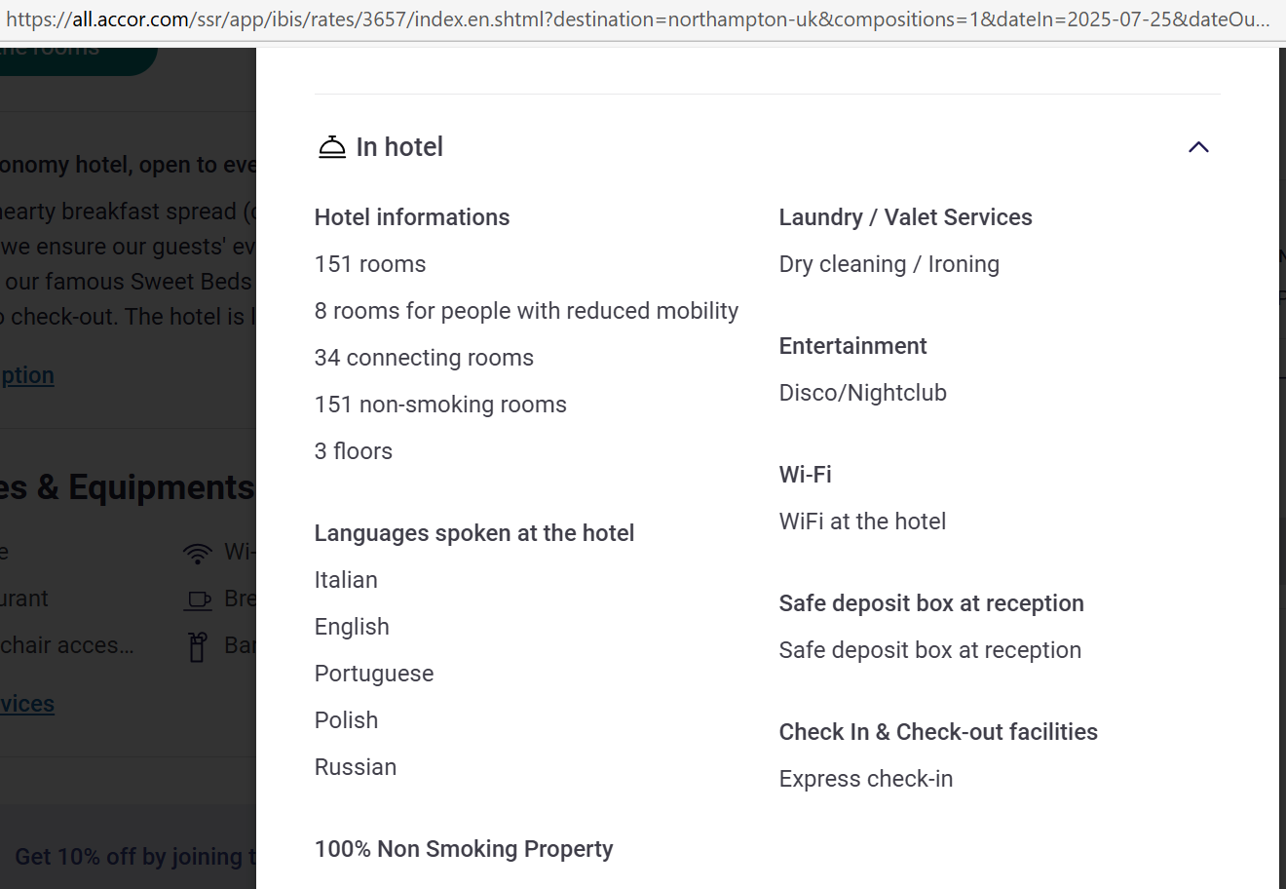
Appendix 2
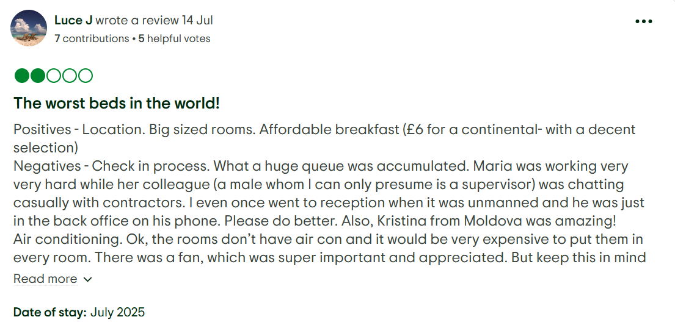
Appendix 3

Appendix 4
Appendix 5

Appendix 6
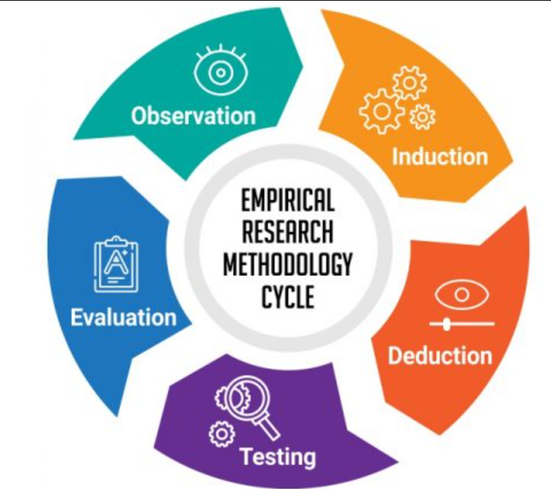

Appendix 7
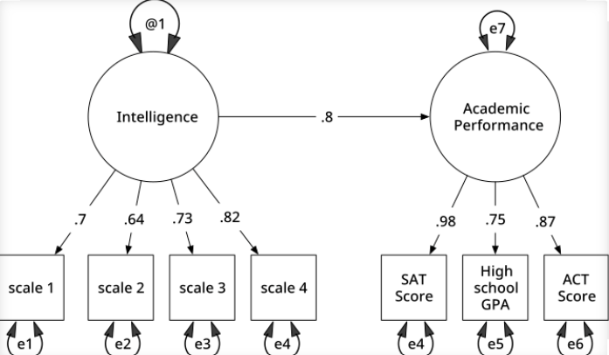
Appendix 8
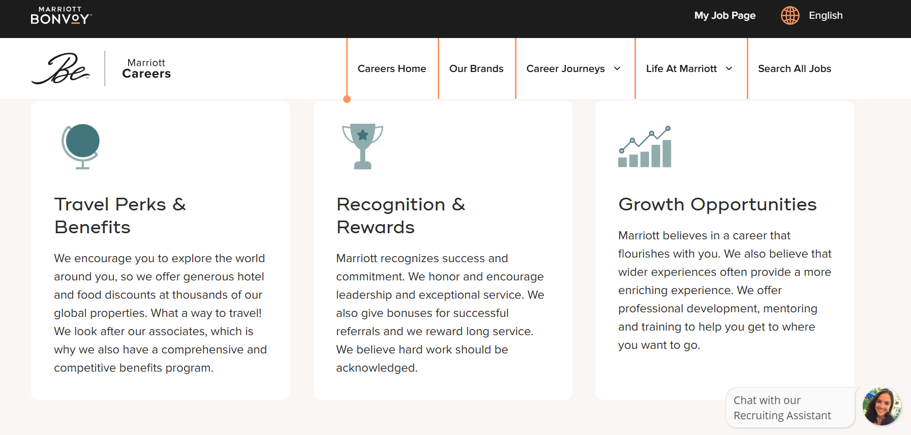
Appendix 9
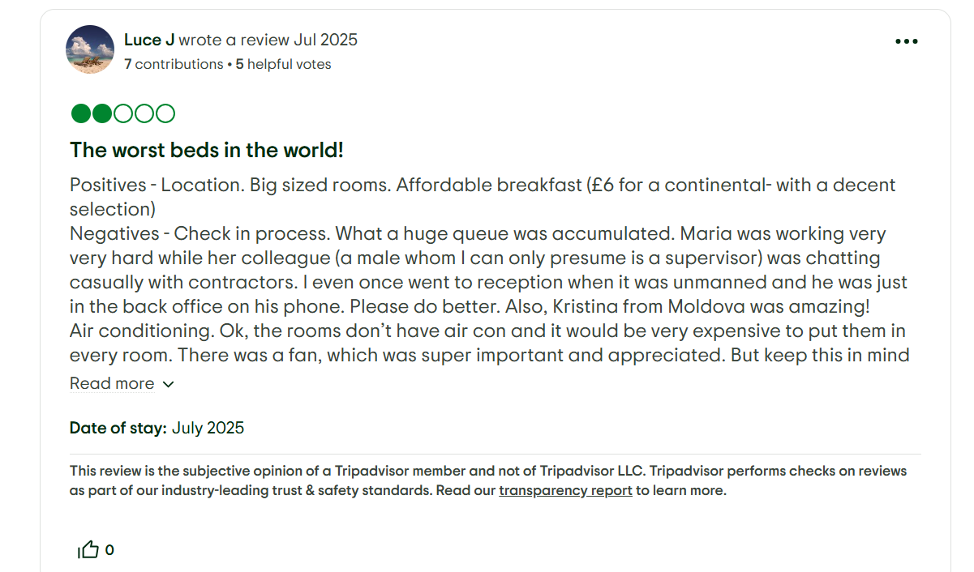
Appendix 10
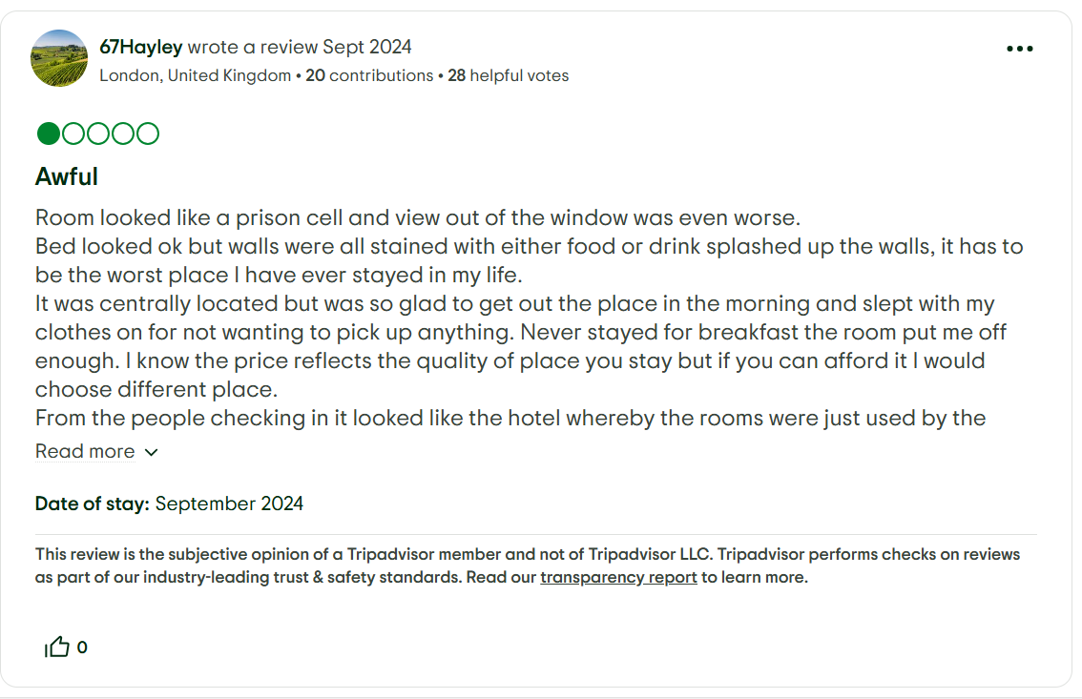
See Appendix 11
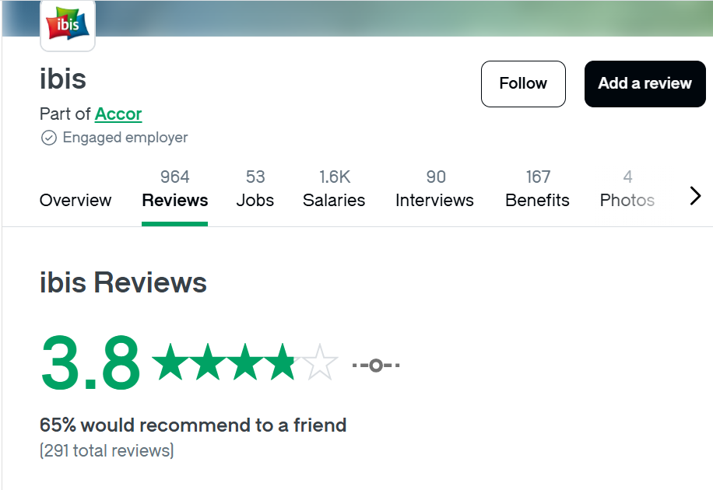
Appendix 12


