
Strat Robert , 2538626
Task 1 – Reading Task Template
Upload your photo of your A3 in-class notes here:
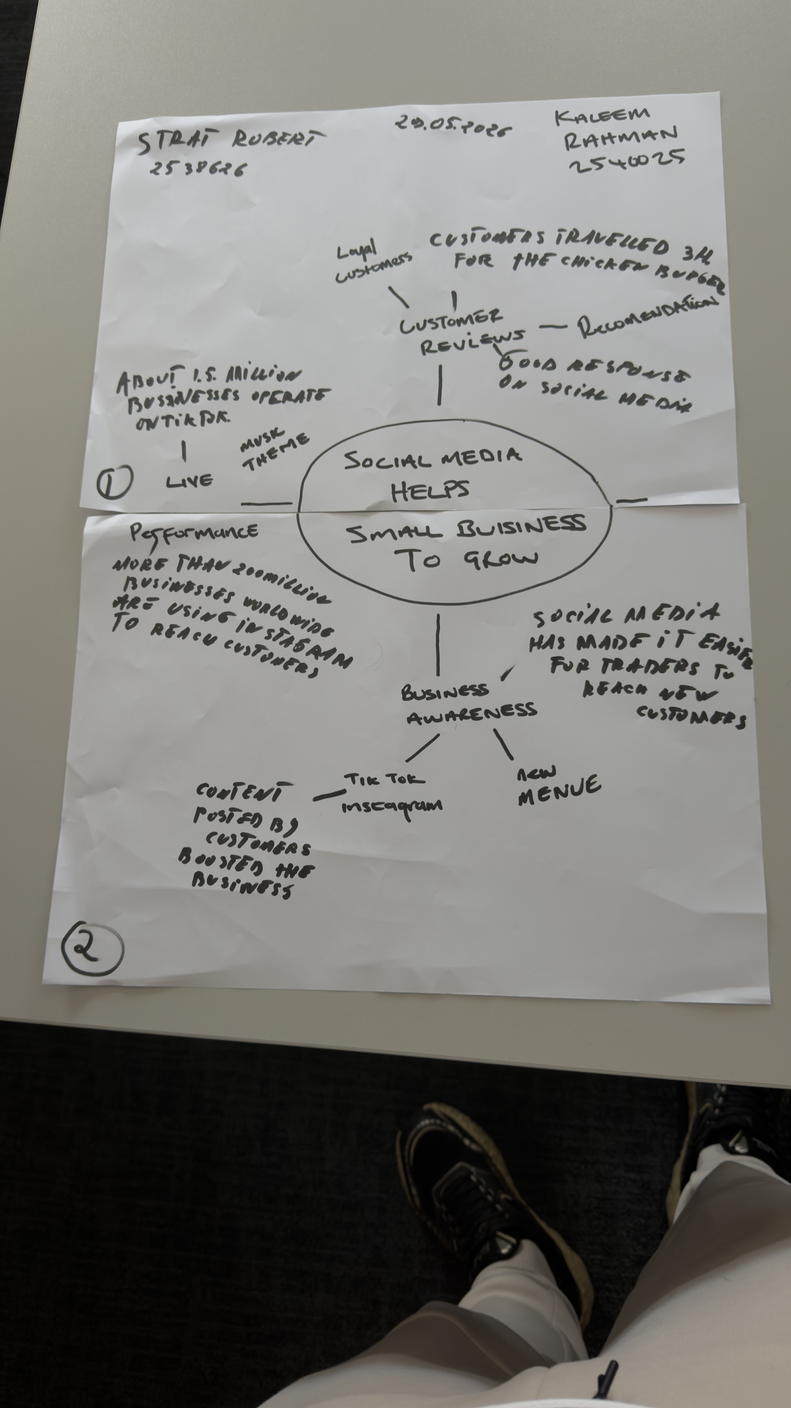

1. Answer these questions using the sentence starters below
a. What is the main idea of the text?
The main idea is that social media helps small businesses to grow.
b. What are two key points?
One key point is posting on online platforms such as Instagram or tiktok . ‘’ Linda Hunter started posting on the platform during the pandemic, and after 46 years selling clothes on markets in Essex , Kent and London , was eventually able to pack up her stall. And she has moved the business fully online and ships outfits across the UK and even to Australia.
Another key point is good customers reviews and good response on social media . Posting on social media helped the businesses to get more customers. ‘’ Owner Murat Mutlu , says customers started travelling long distance to try his food after one of his regulars posted about the shop and others customers followed suit. ‘’
c. What part of the text did you find most important? Why?
The most important part is what Elliot Deady write on the article of BBC News , published 19 October 2025 , ‘’SociakSocial media platforms such as TikTok and Instagram have made it easier than ever to get noticed by the world . ‘’ Because this paragraph helps us understanding the main idea of the text.
d. Was anything unclear or difficult to understand?
No , because everything was clear and easy to understand which was the main idea of the text and the key points.
e. How did your group help you understand the text better?
My group helped me by making the mind map and sharing ideas and notes to understand the text better .
3. One sentence reflection
Question: What did you find challenging about this task?
As I said on point d , everything was clear and not that challenging to understand and not even the whole task to complete.

