

RESULT
ASSIGNMENT DETAILS AND FEEDBACK
SOUTH WEST WALES CENTRE FOR TEACHER EDUCATION
Sections marked with * should be completed by module lead
Student name: |  | Student P number:
Programme: * | PGCE Primary
Module: * | School Development and Pupil Progress | Module Level (6 or 7):* | 7
Module code: * | M7X02153 | Contribution to Overall  Module Assessment (%): * | 70%
Module Lead:* | Helen Lewis
Assignment Title:* | Written assessment 4,500 words | Assignment No (x of x):* | 1/2
Start date:* | 5/3/17 | Submission deadline:* | 30th May 2018
Return date of provisional marks & written feedback:* | 27th June 2018

Referencing: | In the main body of your submission you must give credit to authors on whose research your work is based. Append to your submission a reference list that indicates the books, articles, etc. that you have read or quoted in order to complete this assignment (e.g. for books: surname of author and initials, year of publication, title of book, edition, publisher: place of publication).
Submission: | All assignments must be submitted to Turnitin unless otherwise instructed by the Lecturer.  Note: the Turnitin version is the primary submission and acts as a receipt for the student. Late submission of the electronic version of the assignment will result in a late penalty. Penalties for late submission: Up to one week late, maximum grade D. Over one week late, Refer. Only the Extenuating Circumstances Panel may grant an extension. | Date: | 30th May 2018

Module lead to tick to indicate if a hard copy version of the assignment must be submitted.* | YES
 | NO

Learning Outcomes tested  (from module syllabus) | Assessment Criteria: To achieve each outcome a student must demonstrate the ability to:
• critically reflect upon teachers’ professional responsibilities in working closely with parents governors, local authorities and agencies which support schools and the wider community  • synthesise and analyse performance data accurately to inform decision-making, illustrating a comprehensive understanding of national requirements relating to progress within the statutory and non-statutory curricula  • identify, apply and evaluate appropriate formative and summative assessment strategies, and critically reflect on the effectiveness of selected strategies in their own classroom practice  • reflect critically upon their own learning, drawing upon relevant theories and personal experience | - Discuss the intended professional data collection justifying its suitability and purpose;  - Support the discussion by referring to a range of relevant literature;  - integrate theory and practice with regard to the pedagogic context;  - Discuss the ethical issues that should be considered during the assessments  - Write a well-structured piece of work in a coherent writing style

marking criteria and Student FEEDBACK
Common Assessment Criteria Applied | Grade  awarded
1. Subject Knowledge and Understanding (which includes using research-informed literature and knowledge and understanding of the subject)
Extent of research and/or own reading, selection of credible sources, application of appropriate referencing conventions. Extent of knowledge and understanding of concepts and underlying principles associated with the discipline.
2. Intellectual Skills (Analysis)
Analysis, evaluation and synthesis; logic, argument and judgement; analytical reflection; organisation of ideas and evidence
3. Pedagogic and Professional Applications (Practical Application and Deployment)
Deployment of pedagogic methods, materials, tools and techniques; application of concepts; formulation of innovative and creative solutions to solve problems. Attributes in professional practice: individual and collaborative working
4.Key Transferable Skills
Deployment of appropriate media; presentation and organisation.

Assignment Grade (Assessment grades are subject to ratification at the Exam Board. These comments and marks are to give feedback on module work and are for guidance only until they are confirmed. ) | Late Submission Penalties (tick if appropriate)
 | Up to 1 week late | D Max
 | Over 1 week late | Fail

1200616
Word Count – 4,086

Supporting pupil progress: a detailed analysis of one child’s holistic development, with justification for the next steps in learning.’

Introduction
The key aspect discussed in this assignment is supporting pupil’s progress, a comprehensive study of the holistic development of a single child. Pupil A which the child will be labelled as for data protection purposes will be analysed from a range of different medias, academic performance through examining the work in their book and reviewing end of year and national tests. In addition to this, noticing behaviour patterns through observations and getting to know the child on a personal level within a variety of social situations.
The school in which this study is based upon is situated in the centre of a small town in South Wales. The school caters for children from the ages of three to eleven years of age with just under fifty pupils attending a part time nursery. There are over four hundred pupils on roll at the school with a free school meal percentage of seventeen which is marginally below the national average (Estyn, 2017). The school has two classes for every age group which are split evenly and not by ability.
He lives at home with mum, his brother and two sisters. He also has additional siblings who do not live in their house and has had issues regarding his father. Pupil A is of mixed nationality with his father being Welsh and his mum being Indian. His mother has health issues that the school caters for by liaising with her through email and telephone. The main point of contact for the school and the pupil is through the older brother.
The pupil in question is a ten-year-old boy who is in one of the two year five classes. He is high attaining across all subjects and is a high attender in school with over 98% attendance. Within numeracy the two year five classes are streamed together and groups have been created based on a rage of factors such as their national test scores; behaviour management concerns and mathematical understanding. He attends breakfast club in the morning and afterschool clubs and specifically enjoys sports club on a Thursday. He has no additional learning needs (ALN) and although he is of mixed nationality is not classed as English as an Additional Language (EAL).

Data Collection
The Mosaic Approach
Within this section of the assignment the various data collection processes will be explored, due to the Mosaic approach epitomising several different ways of retrieving data, this will highlight which ones will be used and the benefits and limitations of them. To gain the most extensive and reliable results the focus must be the views and experiences of the child. Therefore, the focal data collection method is through the Mosaic Approach (Clark and Moss, 2011). This will draw from several avenues to demonstrate different perspectives on a child’s experiences and practises.
Throughout the entirety of this approach there will be various data collection techniques used, the integration of both interviews and observation will only strengthen claims and enhance judgments made. Supporting information such as images and dialogue from a learning walk and examples of the pupils’ work will support the results from the interviews and observation. Furthermore, data and information will be supplied from additional adults that encounter Pupil A, this will demonstrate different perspectives about the child.
Utilising the Mosaic approach will provide the study with a more explicit insight into the understanding and development of the pupil, as children are skilful communicators and ‘experts in their own lives’ (Clark and Moss, 2005). This is expanding on the notion that they are in the best position to explain their own feelings and progression. This tactic combines different forms of knowledge and aims to enhance the findings to provide wholesome conclusions on one idea (Heffernan, 2008).
When critically evaluating a data collection method it is crucial to consider the potential limitations during the study. The Mosaic Approach for its numerous advantages does however have areas of inconsistencies in relation to this study, the approach was initially instated as a tool to enable children seen to be EAL learners around the age of two and younger learn English (Clark and Moss, 2001). This is an area that needs to be highlighted because this would question the relevance in relation to this study as it is a large difference in age range and topic that is under investigation. In addition to this Baird (2013) eludes to an obvious yet significant factor especially in the teaching profession which is simply time, due to the various data collection techniques all of them take time to carry out and process which would be ineffective and unrealistic in confines of the real-life classroom environment.
Observations
A key data collection technique in this process will be participant observation which means that the observer would be actively involved in the lesson, this is articulated that this method of observation can lead to biased and subjective interpretation leading to a lack of quantifiable data (Bell, 2014). However, through using The Mosaic Approach the areas that are not unequivocally justifiable will potentially be made clear with alternative information through a different data collection method. A strength of observation is documented in the work by Alderson (2005) that it is a documentation of things that happen in real life with no adaptations to them. It is suggesting that no behaviours are being altered if the participant does not know necessarily that they are being observed.
Interviews
Numerous conversations will take place between both the target pupil and the leader of the assignment, these will be delivered in a semi structured format. Semi structured interviews are viewed to be a more personable and flexible tool which is particularly effective in small scale studies (Drever, 1995). This has direct relevance to this study as it is only based on one pupils’ holistic development and progress in a short space of time in one establishment. Additionally, elements that need to be considered when carrying out semi structured interviews is that a rapport is built with the pupil (Spencer et al, 2003). This will allow the conversational element to flow which provides a deeper level of understanding between interviewer and interviewee. Again, this is another strength relating back to this assignment because the connection between the two people in question has already been made because they have worked together for over a month.

Anonymity
Due to the sensitive nature of working with young children and their personal information, all specific details regarding the child have been anonymised. To ensure all ethical considerations are met this assignment information will be cross referenced against key ethical documents such as the Data Protection Act (1998) and British Educational Research Association (BERA, 2011) guidelines.
Throughout this assignment it was pivotal that specific information on the child was gathered, this meant speaking with the child at length in both teaching and non-teaching situations in school time. The pupil responded inquisitively so I explained the process and the nature of my study, he was intrigued and willing to aid the research process in anyway. He was reassured on numerous occasions that he could withdraw from the process at anytime if he ever felt anxious or under pressure relating to the assignment. The pupil in questions flourished in the thought that he was part of something which only gave greater credence to the assignment as it gave a greater insight to the subject in question and to their holistic development.
An added resource that was used insisted by the university to comply with their data protection rules was to submit and permission letter on behalf of the student for the school to sign and the class teacher that I was working with. To uphold the agreement made by the university and myself to the school and the pupil revealing information has been blacked out for example the teachers and mentors name as well as the school name and my name. Example of this can be seen in (appendix 1)

Figure 1.
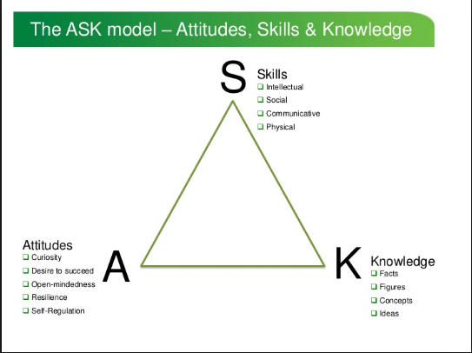

Analysis of the Learner

Within this section of the assignment all the data gathered on the pupils will be presented in a clear and coherent manor, this will be analysed and synthesised into overall viewpoint of the child’s current progression and accolades in their own learning. Benefits and limitations will also be derived from the data in how valuable and efficient it is.
A specific way of structuring the analysis on the child that will be used is the Nottingham’s (2013) ASK model seen in Fig 1. This will almost act as success criteria that the analysis of the child can be reviewed against and scrutinised too. Employing the ASK model (figure 1) will aid our understanding of the individual’s skills, attitudes and knowledge towards teaching and learning. It is proposed that the ASK model allows students to gain a deeper understanding by learning how best to learn. This is a direct link to the notion of ‘metacognition’ which is at the forefront of the progression in education currently. This idea of pupils thinking about thinking and become aware of how best to learn and become competent and independent people.
Generally, the pupil in question is a punctual attentive learner who is constantly trying to better himself. He holds a sense of maturity even at a young age as shown in both semi structured interviews and observing him in lessons. His ability to demonstrate a level of understanding about his strengths and his areas for improvements which is not always an easy aspect for children of a young age, this is detriment to the character of Pupil A. Recurring instances that the pupil displayed in classroom that when warned for negative behaviour or been given a warning he can get totally dejected and complete shutdown in engagement and effort for a short period of time afterwards. This was displayed in observations in many classes in literacy, numeracy and topic lessons.
Having reviewed the additional information on the School Information Management System (SIMS) it displays that he has attended every single day of school since this process began. He is not overly athletic but enjoys playing football at lunchtimes and breaktimes and attends the sports club afterschool on a Thursday every week. Within the class collectively there are some strong characters within the group and depending on who is sitting next to Pupil A this can slightly alter the amount of work and the standard of what he produces. He often gets frustrated when specific pupils sit next to him as it hinders his ability to complete tasks, but recently having been able to speak to him on his own he has started to change his attitude from a frustrated figure to one to offering help and advice to peers when he has completed a task.
Interviews
As previously mentioned all the interviews that took place were under semi structured conditions, this was carried out gain a more natural environment whereby the pupil could speak freely about almost anything which could provide us with truthful and interesting data. To create that type of atmosphere it is suggested by Pathak and Intratat (2012) that few pre planned questions was the proficient idea with those questions being broad so that it was easier to answer at first then moving onto more specifics. An additional precautionary measure that was taken in the study to remain the pupil at ease was the decision to eliminate note taking from the process, this was explained to the pupil and the pupil responded themselves saying they would prefer it if I did not take any notes.
Initially during the interview, a broad simple question was posed about the enjoyment at lunchtimes and what he did. This then lead to the information of not feeling part of the group that plays football, that he feels there is several pupils who play together, and the others are just there. Another key element to consider when conducting interviews with pupils of a younger age is to build and initial rapport with them, Rubin and Rubin (2011) state this is imperative in being able to get the most out of a semi structured interview. This was already built as the two knew each other as a teacher and a pupil for over a month prior to the interviews.

Learning Walk
A crucial aspect of The Mosaic Approach involving this research was a learning walk, this is where the pupil and the researcher had a tour of the school grounds and learning environment. Key areas within the school were highlighted for various reasons, some were where he felt safe; where he enjoyed being during play times; quiet places he could relax and focus or simply places he would go to complete unfinished work. These areas could be exploited to develop and enhance some of the areas of the ASK model (figure 1), comfortable environments are where Pupil A could flourish and be creative, so it is vital these places are well known for a pupils’ holistic growth.
The first place he highlighted as seen in (appendix 2) was where he could finish any work off that he had not completed in the lesson or where he likes to take a book to read and relax if he is feeling stressed. His next area that he highlighted as seen in (appendix 3) was the area that is marked out at lunchtimes and breaktimes for playing football. He has a keen interest in football and enjoys playing it at lunchtimes, having observed his behaviour socially at these times and spoken to him about these situations he revealed some interesting insights. He eluded to, although he enjoys being involved he does not feel totally part of the group that plays, he spoke about a specific group like a hierarchy that governs and controls the unstructured times in the yard, a sense gathered during these conversations was that it affected his confidence.
The strengths of this data collection process and the information given was that there was nobody else around, so it would have been affected by anyone else, he was being truthful and honest because he had no reason not to be and he not only told me the places and why he had chosen then but expanded on them and explained what those places meant to him. However, there are always limitations in any study or analysis of information, because it was just the two of us and I did not make notes I could have potentially missed a key piece of information or forgotten it when I was note taking after the event. Also, as the learning walk only took place once the places he was describing could have reflected his mood at the time on that day which would not necessarily be a true reflection on his attitudes towards those areas.

Book Reviews
As previously stated The Mosaic Approach encompasses a range of different medias on which to base judgements, another area reviewed by the researcher regarding Pupil A was to assess the learners written work documented in books. I believe within numeracy the child is working at a strong level 4, another element of The Mosaic Approach is to gain secondary opinions from adults relating to the person in question. So, having discussed at length with the class teacher we agreed that a strong level 4 was appropriate for this child. The judgements we came too were based on many factors such as classwork, test scores, confidence in answering questions and ability to respond positively to problem solving scenarios during specific lesson, this is evident in (appendix 4) where he was one of few that completed the problem solving ‘milk’ task. In addition to this, his numeracy across the curriculum is a strong aspect and a key skill. As shown in (appendix 5) he was one of few who completed the graph from the table of results that he created with very little input from myself. Relating this back to the ASK model (figure 1) he has mastered specific skills within that which he has done so with the correct attitude.
Regarding pupil A’s literacy level, it is slightly weaker than the numeracy, a major benefactor for this is simply down to handwriting and presentation. Both myself and the teacher have highlighted this as a serious area for improvement. This is echoed in the pupils skill slip in his Maths book, a skill slip is a school specific tool that has a success criteria, learning objective and assessment for learning (AfL) section for both teacher, self and peer marking. As shown in (appendix 6) his own response for a ‘feed forward’ which area for development is to “make my work neater”. His oracy is a strong aspect with the literacy strand as he is confident in speaking in front of the class, but this obviously is not documented in the books.
Book work and test scores are strong sources of information on a pupil as they are tangible statistics that can used to compare either with previous years on projected scores for the future. Using this process in The Mosaic Approach is a hugely rewarding method as it is not a stand alone process this information is one piece of the puzzle alongside many other forms of data. Nevertheless, it is important to say that large judgements should not be made solely based on this, it does not provide the study with the whole picture.
Next Steps
Moving on from the collection and analysis of data phase is the final stage which is moving the pupil forwards. Operating the next steps based on all the information gathered is the crucial element in the progress of Pupil A. Throughout this section of the assignment several aspects will be identified and explained as to how it will benefit the child in their holistic development in education.
A specific area that has been highlighted in both observations and discussions with the child is the hatred of getting any answers wrong. This relates directly to the theory of ‘Growth Mindset’, this notion is highlighted in the work by Dweck (2000) and her idea of ‘flearning’ where initially we fail for our brains to grow to help us learn and understand. Specifically, out of that study is a resource called the learning pit, which is something you get entered into when you do not understand something or get it wrong and must show key skills such as perseverance and fortitude in order to progress victorious (Nottingham, 2017). An additional positive to this idea is that the school is already aware of growth mindset and the learning pit but it is not a whole school initiative, and it also needs to be brought to the attention of the specific pupil and he needs to track his own progress in relation to the learning pit. This is agreed in the work by McLaughlin (2008) that the use of this type of mindset supplies pupils with a range of skills that are transferrable in a variety of situations such as resilience and emotional intelligence.
As well as build on an individual’s strengths it is also pivotal to put greater emphasis on weaknesses to turn them into strengths. One weakness highlighted throughout the book reviewing process is handwriting, this is a simple area that needs constant attention for it to improve. Interventions for this area of improvement are already happening within the classroom such as specific pens that are said to be more comfortable for students to hold, handwriting books where they get to practice their coercive handwriting. It is suggested that poor handwriting can be the most common reason for referring children to an occupational therapist and is a key criterion for the diagnosis of developmental coordination disorder (Overvelde and Hulstijn, 2011). A study concurs with the work by Overvelde and Hulstijn (2011) in that failure to obtain competent handwriting skills during crucial school years can have significant effects on both self esteem and academic performance (Feder and Mainemer, 2007). This would have direct influence to Pupil A within this study because although he maybe come across as an extraverted character in the classroom as highlighted above in interviews and observations on the yard that self-esteem and inner self belief is not always there.
Leading directly on from the previous point of boosting self-esteem and efficacy to the feeling of almost belonging and feel part of something, you could clearly see how much Pupil A enjoyed being part of this process for example, so to feel part of something automatically gives you a sense of fulfilment and engagement. Through observations and discussions with the target pupil there are clear social ineptitudes, he does not have a best friend in school and feels like an outsider of some friendship groups rather than having a close-knit group of friends.
In a comprehensive study that investigates the impact that social relationships have on pupils overall feeling towards school and academic performance from nursery throughout school. Ladd (1990) states that peer rejection at a young age linked to decreased performance levels and school avoidance. This is not the case with Pupil A as we have seen because he is a high attender, but the lack of a social group could deteriorate his academic performance. This is where initiatives such as a buddy system could be put in place or more team building exercises within the class could aid the forming of friendships, pupils working collaboratively which incidentally is one of the school’s core purposes and is highlighted in their mission statement and ethos.
Finally, the last intervention that I believe that would be pivotal in the holistic progression of Pupil A is a form of emotional literacy support. Due to the vacant nature the pupil has after either being reprimanded or told no to something this is something that needs addressing especially moving into year 6 then to comprehensive school. Emotional Literacy Support Assistant (ELSA) is a programme aimed at educating teaching assistants to run session with specific pupils, it helps pupils deal with a variety of situations by giving them almost training in real life scenarios. I feel that this extraction programme would not only help Pupil A deal with specific frustrations that cause the shutdown in class but also help build friendships, the programme is run by teaching assistants in groups.
Cohen (2001) holds social and emotional literacy in high regard and discusses how it can alleviate the stresses faced by pupils in schools so they can progress and achieve in education. This is particularly valuable in our study as the amount of time wasted and key elements of the lesson missed when Pupil A resorts to the head on the desk because he has been warned about something is a large period that is inhibiting him from his true potential. This is also agreed in the work by Coppock (2007) that highlights emotional literacy work in schools can tackle issues that may not be visible to class teachers as their normally hidden behind other reasons. It also suggests that it is difficult for class teachers to get to the root of the problem and deal with it in the confines of classroom environment.
Conclusion
Throughout this assignment I have developed a broadened appreciation of listening to the learner and using the learner’s own ideologies on concepts to further progress them. The use of The Mosaic Approach is a tool which enhances information by collating it into one picture of information, to show a child from a variety of perspectives which gives a more resounding reflection.
The focal point of this research was Pupil A, I thoroughly enjoyed working closely with Pupil A and found it a richly rewarding experience for the both of us. Where we see the progression is developing him from a high achiever potentially into the More Abled and Talented (MAT) group within the class which are the highest achievers. Specific aspects that have been highlighted throughout this assignment are more to work on his social and emotional skills to be able to unlock the highest level of learning. Relating back to the ASK model (figure 1), improving his attitudes, skills and knowledge of the non-education side of things in school like friendships, temperament and character. I feel that with the next steps that have been highlighted and explored he will go on to achieve great things in both his final year in primary school and further on in education and life.

Reference List
Alderson, P. (2005) Designing ethical research with children. Ethical research with children, pp.27-36.
Baird, K. (2013). Exploring a methodology with young children: Reflections on using the Mosaic and Ecocultural approaches. Australasian Journal of Early Childhood, 38(1), 35.
Bell, J. (2014). Doing Your Research Project: A guide for first-time researchers. McGraw-Hill Education (UK).
British Educational Research Association. (2011). BERA Ethical Guidelines for Educational Research 2011.
Clark, A., & Moss, P. (2001). Listening to young children: The Mosaic approach.
Clark, A., & Moss, P. (2011). Listening to young children: The mosaic approach. Jessica Kingsley Publishers.
Cohen, J. (2001). Caring Classrooms/Intelligent Schools: The Social Emotional Education of Young Children. Series on Social Emotional Learning. Teachers College Press
Coppock, V. (2007). It's good to talk! A multidimensional qualitative study of the effectiveness of emotional literacy work in schools. Children & Society, 21(6), 405-419.
Data Protection Act 1998. (online) Available at
http://www.legislation.gov.uk/ukpga/1998/29/contents (Accessed at 23/05/18)
Estyn, (2017). School Report on a Primary School. Neath, Port Talbot
Feder, K. P., & Majnemer, A. (2007). Handwriting development, competency, and intervention. Developmental Medicine & Child Neurology, 49(4), 312-317.
Heffernan, C. (2008). Building synergies in development research: is it time for the Mosaic Approach? Development in Practice, 18(6), 686-700.
Ladd, G. W. (1990). Having friends, keeping friends, making friends, and being liked by peers in the classroom: Predictors of children's early school adjustment?. Child development, 61(4), 1081-1100.
McLaughlin, C. (2008). Emotional well-being and its relationship to schools and classrooms: A critical reflection. British Journal of Guidance & Counselling, 36(4), 353-366.
Nottingham, J. (2013). Encouraging Learning: How you can help children learn. Routledge.
Overvelde, A., & Hulstijn, W. (2011). Handwriting development in grade 2 and grade 3 primary school children with normal, at risk, or dysgraphic characteristics. Research in developmental disabilities, 32(2), 540-548.
Pathak, A., & Intratat, C. (2012). Use of semi-structured interviews to investigate teacher perceptions of student collaboration. Malaysian Journal of ELT Research, 8(1), 1.
Rubin, H. J., & Rubin, I. S. (2011). Qualitative interviewing: The art of hearing data. Sage.

Appendices
Appendix 1
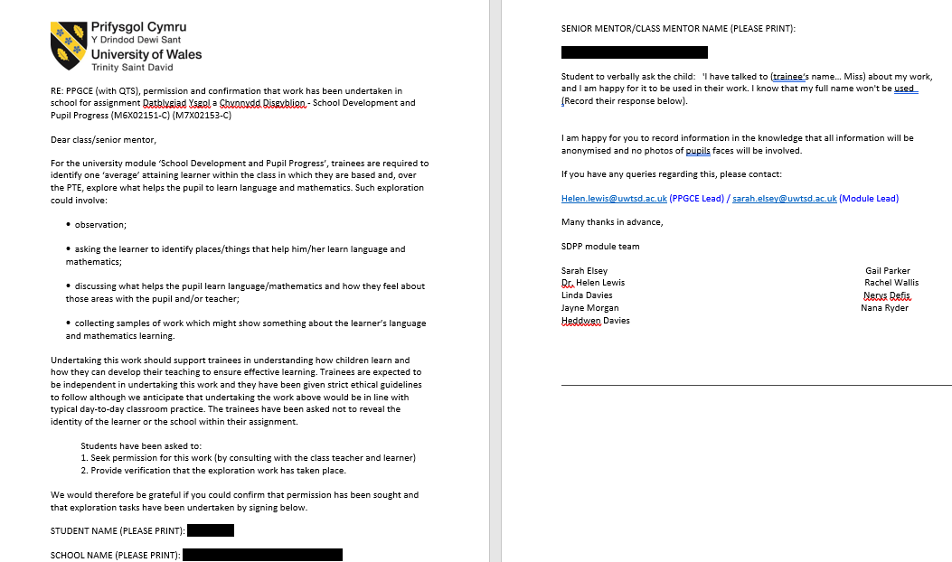
Appendix 2
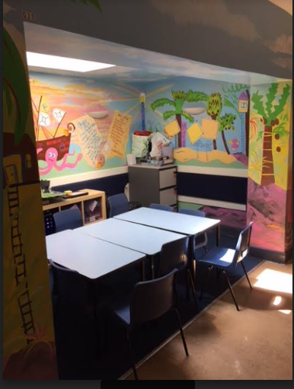

Appendix 3
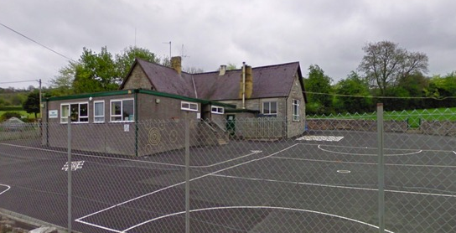
Appendix 4
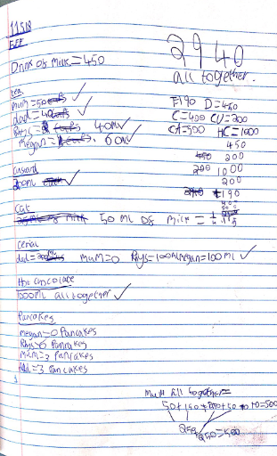

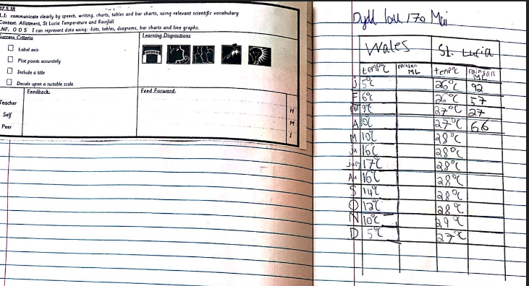
Appendix 5

Appendix 6


