Physics Assignment – Computational Modelling of Ballistic Impact

University of Wales Trinity Saint David
OME Physics

Table of Contents
Physics Assignment – Computational Modelling of Ballistic Impact 0
Introduction 2
Description of the Problem 2
Material Models 3
Johnson-Cook Parameters 3
Results 4
Discussion 5
Limitations and Future Recommendations 6
Conclusion 7
References 7

Introduction
Ballistic impact refers to the high-speed collision between a projectile and a target, this is very important in fields such as defence and material engineering. Studying impacts behaviour by doing experiments can cost a lot of money and be limited in capturing detailed responses. Computational modelling is a way that allows the same testing to be carried out without the challenge of costing a lot of money. Due to Abaqus’ ability to handle high strain-rate effects and large deformations, it is one of the most popular applications for simulating ballistic impacts.
This literature review compares the ballistic performance of two target materials, AZ31 Magnesium Alloy and Copper when impacted by a steel projectile using Abaqus Explicit to simulate this. The reason for the selection of these two materials are, magnesium is lightweight and relatively soft whereas copper is dense and ductile. By simulating identical impact scenarios for both plates, stress distribution, plastic deformation and energy absorption can be studied. By simulating the same impact scenarios for the two selected materials, tensile and shear stress can be studied along with plastic deformation to then compare the two materials.

Description of the Problem
In this project Abaqus Explicit was used to simulate a ballistic impact scenario between a steel bullet impacting two different metal plates. The first material of choice for the plate was AZ31 Magnesium Alloy and the second choice being copper. The purpose of this simulation was to compare how the two selected materials respond to a high-speed impact from a bullet.
The same model was used for both simulation with only the target plate material being changed. The bullet was created as a cylindrical body with a rounded tip, the full length approximately 0.1 metres and a thickness of 0.032 metres with a defined initial velocity of 800m/s directed straight at the centre of the plate. The plates were created as rectangular with a length of approximately 0.3 metres and a thickness of 0.026 metres with deformable characteristics. For this simulation the plate would be fixed in place so it couldn’t move during the simulation. This setup represents a simplified ballistic test that will mainly focus on the stress distribution and deformation of the plate.
By comparing the results for each material under identical conditions, the simulation aimed to evaluate the differences in penetration depth, deformation of the plate as well as damage to the bullet itself.

Material Models
To accurately simulate the impact response from the bullet and plates, the Magnesium alloy and copper plates were modelled using Johnson-Cooks damage and plastic parameters with the elastic behaviours and density of each material. This model is common for the use of metal simulations like ballistic impacts as it uses parameters of the selected materials to show how each metal would respond to the conditions of the simulation. Seen below are the main parameters imputed onto the plate for each material to simulate this impact with accuracy, these parameters were found through online experimental data.

Johnson-Cook Parameters
[1]
Materials | A (MPA) | B (MPA) | n | C | m
AZ31 Magnesium Alloy | 175.33 | 2332.227 | 0.350 | 0.063 | 1
Copper | 90 | 292 | 0.31 | 0.025 | 1.09

[2]
Materials | D1 | D2 | D3 | D4 | D5 | m
AZ31 Magnesium Alloy | 0.12 | 0.22 | -0.55 | 0.015 | 1.2 | 1
Copper | 0.54 | 4.89 | -3.09 | 0.012 | 1.12 | 9

[3]
Materials | Melting Temperature (°C) | Transition Temperature (°C) | Reference Strain Rate
AZ31 Magnesium Alloy | 630 | 200 | 1
Copper | 1084 | 200 | 1

[4]
Materials | Young’s Modulus (MPa) | Poisons Ratio | Density (Kg/m^3)
AZ31 Magnesium Alloy | 4500 | 0.34 | 1730
Copper | 1170 | 0.34 | 8930

Results
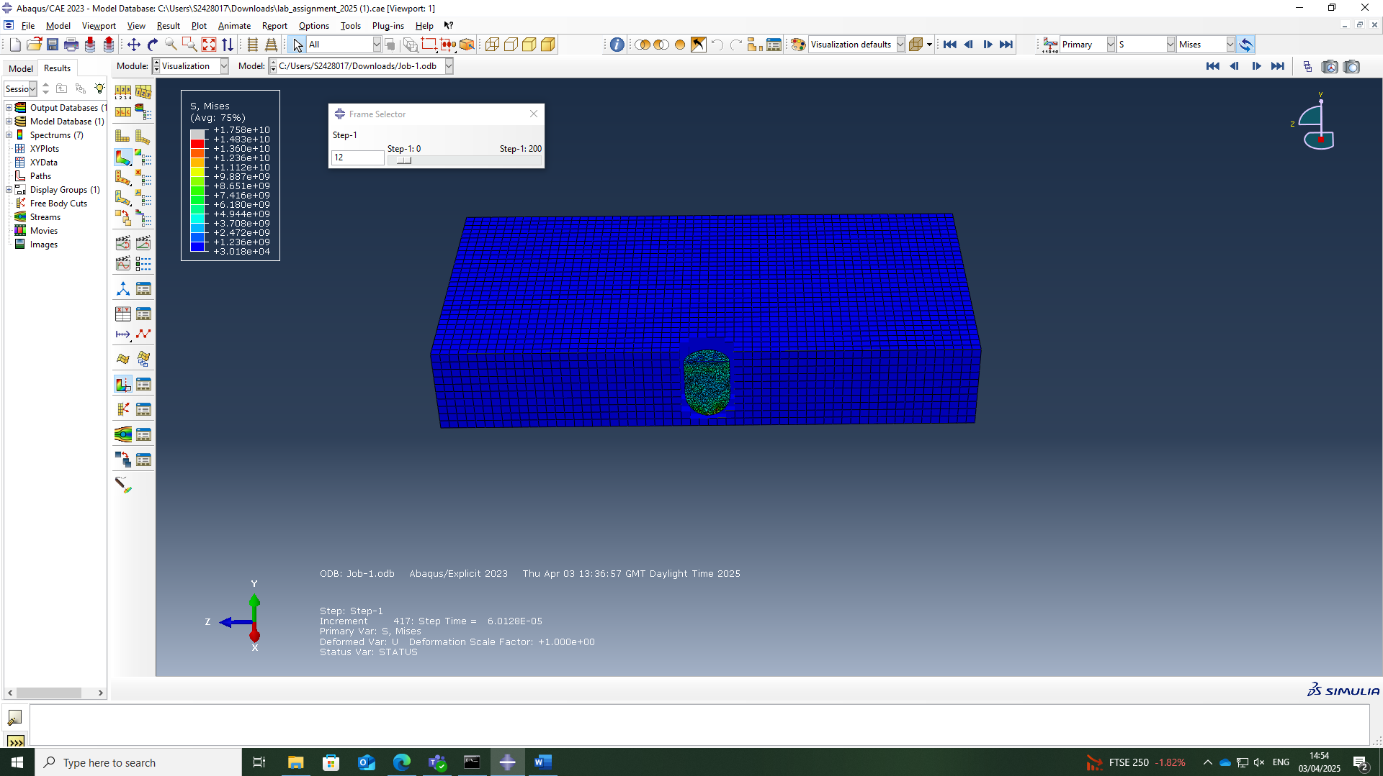
Figure 1: AZ31 Magnesium Alloy Full Penetration
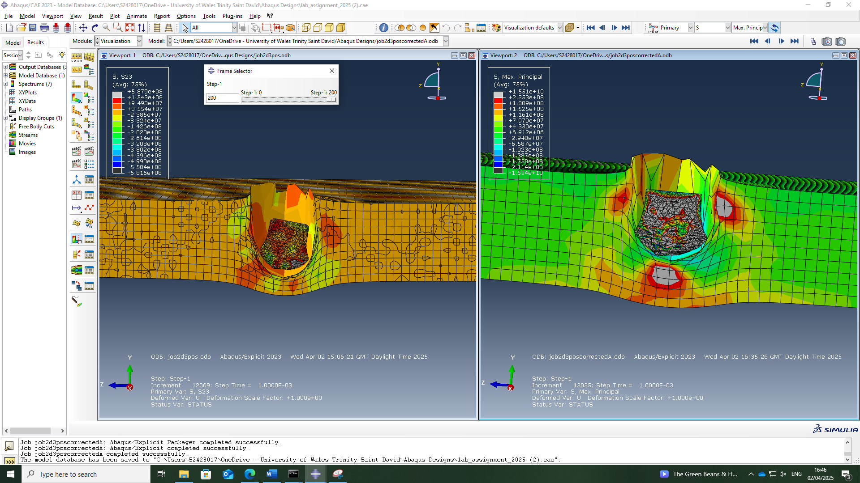
Figure 2: The copper plate undergoing plastic deformation and preventing the steel bullet from full penetration causing damage to the bullet ti

Discussion
The results show clear differences between the ballistic performance of the magnesium alloy and the copper plates when impacted by the high-speed bullet. These differences can be caused due to mechanical properties, mainly their resistance to tensile and shear stress.
As shown in Figure 1, The AZ31 magnesium plate showed low resistance to both tensile and shear stress. Once the plate was impacted by the bullet the plate failed straight away, allowing the bullet to go through it with ease creating a perfect a perfect hole in the centre of the plate. This shows that tensile failure occurred behind the impact, where the material was pulled apart due to the rapid forward motion of the bullet. There was also shear failure around the edge of the hole which contributed to the smooth hole. This shows that the magnesium alloy lacked enough toughness or ductility to absorb the bullets energy.
As shown in Figure 2, The copper plate withstood the impact without being fully penetrated. The plate experienced a lot of plastic deformation with the material flow and bulging at the area of impact. This response is because of coppers high ductility and toughness, which allowed it to absorb a greater amount of the bullet’s energy.
The copper plate behaved very differently compared to the magnesium alloy as the material was not fully penetrated by the bullet. Instead, it made a crater with material bulging up from the area of impact. This shows that copper is much stronger and ductile than Magnesium Alloy as it was able to absorb much more of the bullet’s energy without being penetrated. The plate resisted by spreading out the force through the material which caused it to bulge and stretch out.
In the simulation of the copper plate the bullet itself was also damaged after impacting the plate. The tip of bullet became flattened and squashed, which did not happen during the simulation with the magnesium alloy plate. This means that the copper material not only stopped the bullet from penetrating but also pushed back on the bullet with enough force to deform it showing again that copper is the stronger material of the two.
Overall copper showed much better performance in withstanding the impact of the bullet’s energy, while magnesium failed quickly due to its lower strength and energy absorption. These results match with what is expected based on the known properties of the two selected materials.

Limitations and Future Recommendations
An area in which could be improved on is lack of experimental data there is on these materials such as the parameters. Although the Johnson-Cook model was useful in the simulation, the desired outcome is accurate results and if the quality of the experimental data is not the best then the results will not be as accurate as what it could have been. To improve future studies more experimental data on the selected materials would be needed.

Conclusion
In conclusion, this study proved successful as computational modelling using Abaqus Explicit was applied to compare the ballistic impact response of copper vs AZ31 magnesium alloy plates. From looking at the simulation results there were clear differences material response between the two plates under the same impact conditions. The copper plate managed to prevent the bullet from fully penetrating the material by successfully absorbing the bullets energy but showed a lot of deformation to the plate and damaging the bullet deforming the tip. Whereas the magnesium plate failed with ease allowing the bullet to pass through creating a perfect hole in the material showing lack of resistance and minor deformation from the plate.
An area in which could be improved on is lack of experimental data there is on these materials such as the parameters. Although the Johnson-Cook model was useful in the simulation, the desired outcome is accurate results and if the quality of the experimental data is not the best then the results will not be as accurate as what it could have been. To improve future studies more experimental data on the selected materials would be needed.

References

[1] | V. Y. G. U. S. G. G. S. K. M. B. Vasu Kumar Reddy Sirigiri, “Materials Today: Proceedings,” 23 June 2022. [Online]. Available: https://www.sciencedirect.com/science/article/pii/S2214785322024191. [Accessed 10 May 2025].
[2] | A. M. M. N. P. L. A. T. H.B. Boubaker, “Science Direct,” 27 September 2021. [Online]. Available: https://www.sciencedirect.com/science/article/pii/S2212827121008295. [Accessed 10 May 2025].
[3] | The Engineering ToolBox , “Metals and Alloys - Melting Temperatures,” 2005. [Online]. Available: https://www.engineeringtoolbox.com/melting-temperature-metals-d_860.html. [Accessed 10 May 2025].
[4] | Z. L. Y. W. P. M. X. K. Z. Z. Y. J. X. X. Feng Zhang, “The modified temperature term on Johnson-Cook constitutive model of AZ31 magnesium alloy with {0002} texture,” 10 March 2020. [Online]. Available: https://www.sciencedirect.com/science/article/pii/S2213956719300866. [Accessed 10 May 2025].

