

BSc Health and Social Care
Module: Changemakers: Building your Personal Brand for Sustainable Employment
Module Code: BMHP5015
Component 1: Online Portfolio of Set Exercises
Student Name: Surayya khan
Student id: 2323459
Lecturer’s Name: Olufemi Oluranti

Task 1 – Personal Brand
Personal branding refers to the deliberate process of building your professional image; that is how others view you, the best traits you have, value, and aspiration. A brand as Blackett (2004, p.13) outlines is basically a name, a term, sign, a symbol, or a design that is supposed to identify the goods or services offered by a single seller. When applied to people, it implies that our professional identity, the way we do show our values and experiences and capabilities, becomes our individual brand (Rampersad, 2008).
I am an extroverted person naturally, and I like being the center of attention and in a social environment. These characteristics have enabled me to establish warm and involving relationships with individuals that I work and serve. I am a self-motivated, compassionate, and committed worker who is studying at UWTSD and my vision in life is to become a mental health support worker. My background experience, such as having a son with Type 1 diabetes, has enhanced my compassion and strength, which is the key to my professional identity (Fitzgerald, 2020).
Nevertheless, I also acknowledge that my network does not have enough professional contact at present. My family network, friends and community are strong; however, I should be able to build upon bridging and linking capital, especially with professionals and organizations in the mental health sector (Putnam, 2000). In response to this, I intend to proactively strive to accomplish work experience placements, become a member of professional networks, and undertake CPD activities during Level 5 and Level 6.

Task 2 - Network Map and Rationale
Part 1: Network Map
My personal network map shown in the diagram below was created as a sociogram model. It visualizes my major relationships in three types of nodes, and distinguishes between stronger ties (thick lines), weaker ties (thin lines), and latent or potential ties (dashed lines).
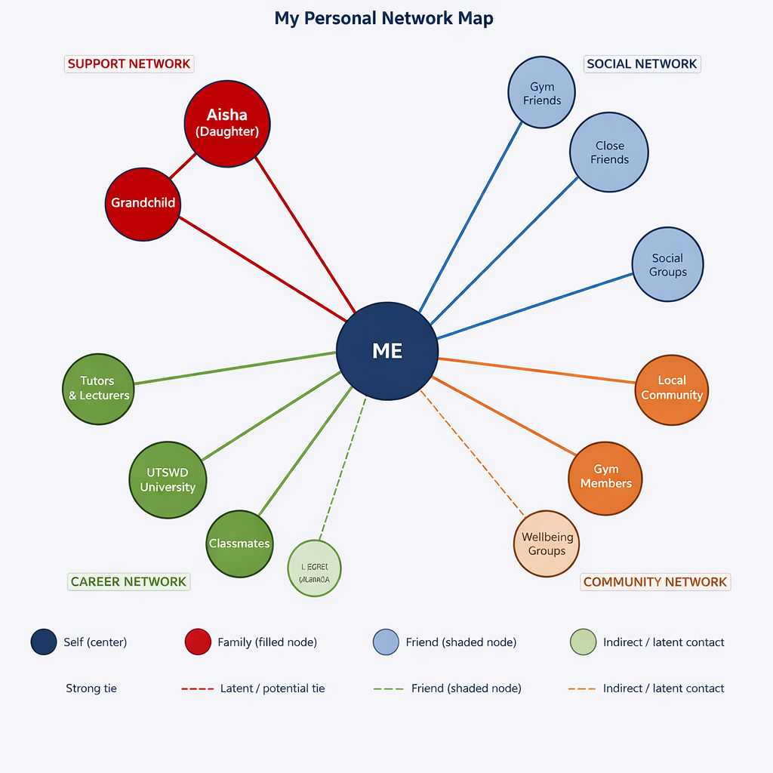

Filled node (dark) | Family — core emotional support, strongest ties
Shaded node | Friends — social support and peer connection
Light / outline node | Indirect or latent contact — not yet fully activated
Thick solid line | Strong, frequent tie
Thin solid line | Moderate tie
Dashed line | Latent or potential tie — opportunity to develop
Part 2: Rationale
Considering my network, I would present it as a hybrid network, a network that is characterized by strong bonding capital in close relations with personal relationships, and a developing but restricted professional aspect. The most valuable relationships are with my daughter Aisha and her child who serve as the key to emotional support and friends who constitute my circle of friends. The gym is also a part of my wellbeing and belongings since I do work with my community there.
My network is seen as strong bonding capital, dense ties in a small group in the sociological terms, but weak in bridging and linking capital (Putnam, 2000). Bridging capital is a network between various social classes whereas linking capital is associated with relation to people holding influential or power positions in professions (Lin, 2001). The dotted lines on the map denote latent ties: industry acquaintances, community leaders, and industry contacts that may join a bigger network in case I take time to foster relationships.
In the future, I will search for work experience, work with mental health organizations, as well as meet mental health professionals (Lin, 2001). My network map is also characterized by the social aspect, which as Pogorzelski (2018) refers to as the social layer of branding. The social aspect of branding determines our career path and professional identity.

Task 3- Blog
Breaking Point: The Youth Mental Health Crisis in the UK.
Target Audience: General population, parents, and youths within the age of 16-25 years of age, Target Audience: Mental Health, Health and Social Care Student, UWTSD.
State of Mental Health of Young People.
Mental health crisis among the youth in the UK is an issue that is increasingly becoming larger, and it is the debate we cannot afford not to discuss any more. In 2023, NHS England (2023) announced that one in five children and young people aged 8 to 25 had a likely mental disorder which is a large figure compared to one in nine a decade later. The impact is a devastating and catastrophic one for the family and youths who must live with this reality.
So, what is driving this rise? Some of them are the growing academic stress, exposure to social media, and financial unpredictability, as well as the long-term psychological impacts of the COVID-19 pandemic. Most youth state that they are isolated, anxious, and overwhelmed, but when they seek specialist NHS mental health services, they must wait months to sometimes years to become clients (Mind, 2023).
Why This Matters for All of Us
Mental health is not an isolated phenomenon. It defines our learning processes, our relationships with others, and our day-to-day life. The impact of a struggling youth spills into a family, school, workplace, and the community. Being a student of health and social care, I have learned that our values define our professional identity, who we are and what we stand (Fitzgerald, 2020).
What Needs to Change
The importance of early intervention cannot be overestimated. Studies have demonstrated that early intervention in the case of mental health problems results in much more positive outcomes on a long-term basis (NHS England, 2023). Such solutions as community-based services, peer support programmed, and school-based mental health teams are all within the solution, but they take long-term investment and political will to be effective. As is known in the NHS EDI Improvement Plan (NHS England, 2023), structural disadvantage is coupled with the issues of health inequality, and any serious approach to the issue needs to consider them.
What Can You Do?
Each of us has a role to play. There are three things you can do now, and these are:
- Be publicly discussing mental health - make mental health a household, school-going, and workplace conversation.
- Be sensitive to the symptoms - withdrawal, mood swings, poor performance or hopelessness statement.
- Signpost to services - go to one of the following websites; mind.org.uk or youngminds.org.uk and use free resources.
Adolescents should receive effective, prompt, and support-based solutions. The crisis is a fact - and so are we all, in the duty of responding.

Task 4- NHS Equality, Diversity and Inclusion Quiz (250 words equivalent)
- What is the primary goal of the NHS Equality, Diversity, and Inclusion Improvement Plan?
The key purpose of the NHS EDI Improvement Plan is to introduce a fairer and more inclusive NHS workforce and service culture where all members of staff and patients despite their background, identity, or protected characteristic are treated with dignity, equity and respect. It will assist in embedding EDI principles throughout the levels of NHS activity (NHS England, 2023).
- How does the NHS EDI Improvement Plan propose to tackle the gender pay gap?
The strategy implies that the gender pay gap must be addressed through bringing in greater clarity in pay reporting, actively motivating women to accept top jobs and review the arrangements within organizations to keep perpetrating inequity. This will entail mentoring programmes and projects that can assist women to experience the growth of careers in all levels of NHS.
- What is meant by the term ‘intersectionality’ as used in the NHS EDI Improvement Plan?
The term intersectionality refers to the fact that several aspects of the identity of an individual such as race, gender, disability and socioeconomic status may interact and add together to cause another discrimination or disadvantage (Crenshaw, 1989). The NHS EDI Plan has realized that equality cannot be addressed on a one-fit basis.
- Why is it important for the NHS to create a psychologically safe work environment?
Psychologically safe work environment lets employees’ question, present their ideas and report without fear of being blamed or punished. This directly influences patient safety and staff wellbeing - when the individuals are comfortable raising their voices, their mistakes are bound to be detected and structural issues tackled.
- How does the NHS EDI Improvement Plan suggest improving the experience of internationally recruited staff?
The plan suggests offering culturally sensitive induction programmes, mentorship schemes, and distinct reporting strategies on discrimination. It is also an advocate of inclusive workplace cultures that appreciate the contribution of international colleagues and acknowledge the special challenges they experience when accommodating in a new country and healthcare system.
- What role does leadership play in advancing EDI objectives according to the NHS Improvement Plan?
EDI development centers on leadership. The leaders are supposed to lead by example in terms of promoting inclusive behaviors, being accountable to EDI outcomes like themselves and their teams and being proactive in promoting diversity on all levels. The strategy insists on the need to integrate EDI within the culture and performance systems of leaders rather than delegating it.

- Identify one way the NHS EDI Improvement Plan aims to reduce health inequalities within the workforce.
Some of the strategies include the workforce data that covers the nature of the data that is safeguarded to disclose the areas in which there exist disparities in recruitment, promotion, and staff experience. NHS organizations, through this analysis of data, will be in a better position to concentrate on interventions with greater efficiency and to monitor progress.
- Why does the NHS EDI Improvement Plan emphasize the importance of collecting and analyzing data on protected characteristics?
The collection of evidence about attributes that are endorsed by equips organizations with evidence-based decision making on areas where inequalities are rampant, and those who need to be actioned. Without such data, there is no capacity to measure progress or to hold organizations to account for fair outcomes.
- Explain how flexible working policies can contribute to equality and inclusion in the NHS workforce.
Flexible employment would enable employees who have caring and family commitments, disabilities and illnesses to remain at or re-enter the labour force. This is particularly so on the women and the marginalized groups that are overburdened by the rigid work schedules.
- What is one strategy mentioned in the NHS EDI Improvement Plan to combat bullying and harassment in the workplace?
The plan suggests open and transparent reporting systems with regards to bullying and harassment and effective system of investigation and culture of zero tolerance. It also makes managers train to know how to detect and fix such inappropriate behaviors, so that he or she who reports against him or her is not victimized.

Task 5- A Letter to Yourself
Dear Younger Me,

I am writing to you out of an acquired knowledge of a kind that I hope you should have known when you were during it. I would like to discuss with you the moment when we were informed that your son was diagnosed with Type 1 diabetes. I recall the fear, the bewilderment, the strong feeling of obligation that hit me with a crash. You were terrified. You kept saying to yourself: how will I cope?
Now I see how it must have been then a great ordeal of emotional intelligence and endurance- two traits you possessed, even though you may not have been able to identify them at this time. Emotional intelligence refers to the capacity of identifying, interpreting, and controlling not only your emotions but also that of other people (Goleman, 1995). You were doing this instinctively, keeping your fear to a long enough state that you made yourself available to your son, reading his anxiety, and adjusting the way you communicated to reassure your son.
The ability to endure and rebuild oneself despite bad things is called resilience (Southwick and Charney, 2012). You were incredibly strong during those first few months, when you were learning about insulin regimes, going to healthcare appointments, and still carrying on with your day-to-day duties, but I wish that you had been nicer to yourself about it. You did not need to drive it by yourself.
One piece of advice I would offer you in case I can is to reach out. Communicate with the professionals, to fellow parents who are in the same situation, to anybody who can share the burden. Your outgoing personality - your affection to contact is a superpower. Use it.
You came through it. It is that strength which is going to be what will push all that follows.

With love and pride,
Your Future Self

Task 6- GANTT Chart
The following Gantt chart shows the systematic course that I am going to follow to reach my career objective to become a qualified mental health support worker. Arranged in three stages, Academic Pathway, Work Experience, and Job Search and Employment, it relies on color-coding and levels of hierarchy to differentiate section headings, key milestones and sub-tasks. This is a goal-oriented and time-oriented initiative which can be attributed to the goal-setting theory by Locke and Latham (2002) which asserts that clear, specific, and measurable goals cause much better performance outcomes.
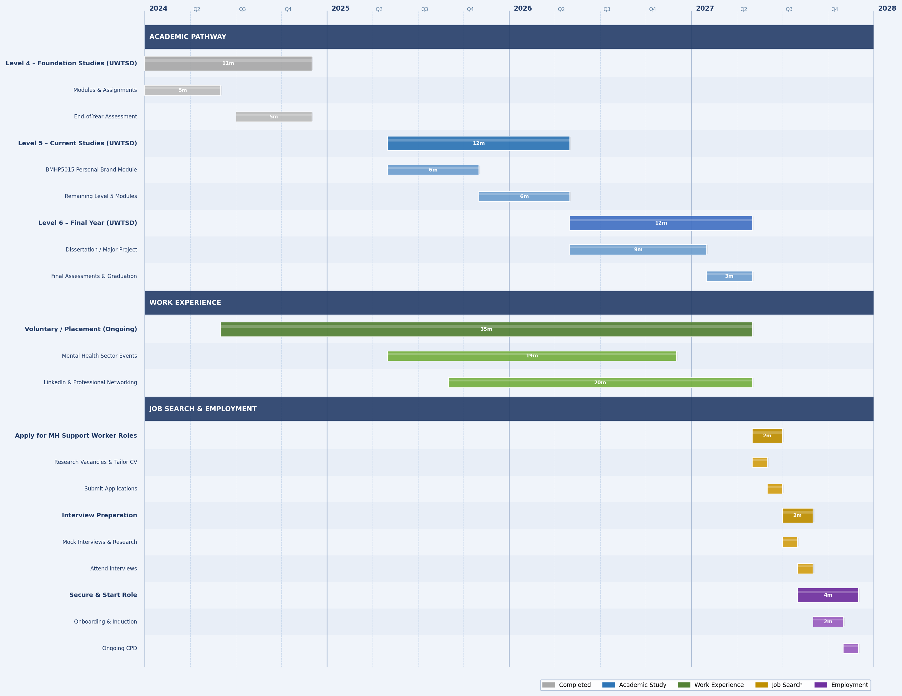
Figure 2: Personal Career Development Gantt Chart (2024–2028)
Task | Start Date | End Date
Completed Level 4 (UWTSD) | Jan 2024 | Dec 2024
Complete Level 5 (UWTSD) | May 2025 | May 2026
Complete Level 6 (UWTSD) | May 2026 | May 2027
Gain Work Experience | Ongoing | Ongoing
Apply for MH Support Worker Jobs | May 2027 | Jul 2027
Prepare for Interviews | Jul 2027 | Aug 2027
Secure and Start Role | Aug 2027 | Onwards
The chart is separated into three phases of color. The Academic Pathway (blue) includes the Level 4 to Level 6 graduation and sub-tasks include module block and assessment blocks. The green year of the Work Experience phase (green) is a multi-year phase. The experience of developing professional experience and networking is realized to be a priority that cannot be delayed until the end of the studies. Lastly, the Job Search & Employment (amber and purple) commences with the Level 6 approaches completion and ends with the accomplishment of an employment and a mental health support worker position. This hierarchical and layered structure means that all the milestones are considered, and nothing is left to chance.

Task 7- Making Changes- Report
Introduction
My suggestion as manager of a care home is to introduce a systematic whole-home mental health awareness and wellbeing promotion to staff members. This reform is necessary since employees working in the care facilities often endure a significant amount of stress and burnout negative impacting not only their well-being but also the quality of the services they offer to the residents (NHS England, 2022).
Planning the Change
The suggested modification is to implement routine wellbeing cheque-ins, peer-support groups of the staff, and the possibility of receiving mental health first aid training by all members of the team. To implement the change, I would use the 8-Step Change Model (Kotter, 1996) that suggests the establishment of a sense of urgency that the current data on staff sickness and turnover would be shared, the guiding coalition would be established, and a clear vision would be communicated to all the teams.
Skills Required
To be effective, one must communicate well, listen, show empathy, and be a leader. I will also have to show transparency and sensibility to handle resistance where all staff members will feel heard and appreciated in the process.
Barriers and Solutions
The barriers that may occur are the resistance of the staff, time constraint, which is already a stressful environment, and lack of funding. To resolve resistance, I would include the staff in all levels of planning and generate a sense of ownership (Kotter, 1996). The issue of time may be alleviated by booking the wellbeing sessions during current staff meetings. The problem of funding can be solved with the help of NHS workforce wellbeing grants or local mental health charities.
Conclusion
By focusing on the mental health and wellbeing of the staff, this care home will be able to better the staff's retention, lessen sickness absence and eventually provide a higher quality of care to the residents. An excellent workforce is supported.

Task 8- Self-Reflection
To conduct this reflection, I decided to apply the model of reflective practitioner, that is, Gibbs, Reflective Cycle (Gibbs, 1988), which consists of six steps: description, feelings, evaluation, analysis, conclusion and action planning. The future practice of a practitioner who takes part in reflection-on- action is more profound in insight and builds better practice in the future as Schoen (1983) asserts.
Description: The most impactful experience that I had in this module was the creation of the network map, which is Task 2. It made me look objectively at the extent and scope of my existing professional relationships, which I had not been doing in an organized manner.
Feelings: At the first moment, I was rather uneasy. Being an outgoing person who is proud of having people around, it came as a shock to me how my professional network was rather small. It was a time of weakness in admitting that I had high interpersonal relationships and low connecting relationships.
Evaluation: My strengths were that I was not afraid to be open in my self-assessment as opposed to exaggerating my relationships. It is this candor that was significant and conformed to the principles of integrity that I related to good professional practice. What was not as good was the discovery of the amount of work I will have to undertake in this area.
Analysis: I think this is because I have been less involved in the sector since I have been concentrated on family and my academic work with less time to visit the professional events or rather the larger sector. The experiences that I had, especially assisting my son with his Type 1 diabetes diagnosis, have helped me to become more compassionate and resilient, but now I will have to apply these attributes to professional relationships.

Conclusion: I might have begun to develop professional relationships at earlier stages of my education. In the future, I will be deliberate on this.
Action Plan: Within the six months, I will make sure to attend at least two events or webinars in the mental health sector, engage practitioners via LinkedIn and request a work experience placement which will allow me to start forming my professional network.

Full Reference List
Blackett, T. (2004) What Is Brand. New York: Interbrand.
Crenshaw, K. (1989) ‘Demarginalizing the intersection of race and sex’, University of Chicago Legal Forum, 1989(1), pp. 139–167.
Fitzgerald, A. (2020) ‘Professional Identity: a Concept Analysis’, Nursing Forum, 55(1), pp. 1–26.
Gibbs, G. (1988) Learning by Doing: A Guide to Teaching and Learning Methods. Oxford: Oxford Polytechnic.
Goleman, D. (1995) Emotional Intelligence: Why It Can Matter More Than IQ. New York: Bantam Books.
Kotter, J. P. (1996) Leading Change. Boston: Harvard Business School Press.
Lin, N. (2001) Social Capital: A Theory of Social Structure and Action. Cambridge: Cambridge University Press.
Locke, E. A. and Latham, G. P. (2002) ‘Building a practically useful theory of goal setting and task motivation’, American Psychologist, 57(9), pp. 705–717.
Mind (2023) Mental health facts and statistics. Available at: https://www.mind.org.uk (Accessed: 10 March 2026).
NHS England (2022) NHS Staff Survey Results. Available at: https://www.nhsstaffsurveys.com/results/ (Accessed: 10 March 2026).
NHS England (2023) Mental Health of Children and Young People in England 2023. Available at: https://digital.nhs.uk (Accessed: 10 March 2026).
NHS England (2023) NHS EDI Improvement Plan. Available at: https://www.england.nhs.uk (Accessed: 10 March 2026).
Pogorzelski, J. (2018) Managing Brands in 4D: Understanding Perceptual, Emotional, Social and Cultural Branding. Bingley: Emerald Publishing Limited.
Putnam, R. D. (2000) Bowling Alone: The Collapse and Revival of American Community. New York: Simon & Schuster.
Rampersad, H. K. (2008) ‘A new blueprint for powerful and authentic personal branding’, Performance Improvement, 47(6), pp. 34–37.
Schön, D. A. (1983) The Reflective Practitioner: How Professionals Think in Action. New York: Basic Books.
Southwick, S. M. and Charney, D. S. (2012) Resilience: The Science of Mastering Life’s Greatest Challenges. Cambridge: Cambridge University Press.
Temporal, P. (2019) Advanced Brand Management. London: Herman House Limited.
Yakup, D. and Sevil, Z. (2011) ‘Theoretical Approach to the Concept of Brand’, Contemporary Marketing Review, 1(3), pp. 1–5.

