

Is poverty having an adverse effect on education?
Analysis of the Millennium Cohort Study showed big differences in cognitive development between children from rich and poor backgrounds at the age of three, and this gap widened by age five. (JRF 2010)
This Photo by Unknown Author is licensed under CC BY-NC-SA
Is this a pipe dream?
Should poverty be redefined?
Yet there are various ways in which individuals can suffer from deprivation, such as through disability or discrimination, even if you have access to a reasonable level of resources. Hence philosophers such as Amartya Sen and Martha Nussbaum argue that poverty needs to be redefined as ‘capability deprivation’, however it comes about, rather than low income. (JRF 2015)
Is Flying Start reaching the most in need?
IMPROVING OUTCOMES FOR CHILDREN AND IT IS WELL DOCUMENTED THAT CHILDREN’S EARLIEST EXPERIENCES HAVE A REAL INFLUENCE ON THEIR ACHIEVEMENTS AS THEY GROW UPLX
. INITIATIVES SUCH AS FLYING START HAVE BEEN DESIGNED TO GIVE DISADVANTAGED CHILDREN BETTER OPPORTUNITIES FROM AN EARLY AGE, BUT THESE ARE NOT AVAILABLE IN EVERY AREA. MANY CHILDREN AND PARENTS NEED ONGOING SUPPORT TO HELP THEM MAINTAIN EARLY GAINS.
(TACKLING CHILD POVERTY IN WALES 2017)

(PINTEREST 2018)
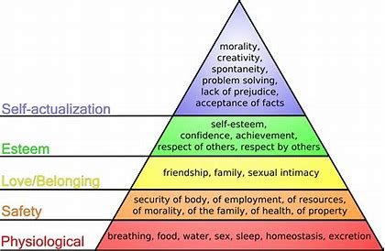

Chuc,B. (2017) Uk Poverty: Six charts that show the true state of low income Britain [online] Available at http://www.independant.co.uk (Accessed 14/07/18)
Dyson, A, Gunter, H, Hall,D, Jones,L, and Raffo,C. (2007) A review of research on the links between education and poverty [online] Available at http://www.jrf.org.uk (Accessed on 12/07/18)
Full Fact, (2017) Poverty in Wales [online] Available at http://www.fullfact.org (Accessed 14/07/18)
Goodman,A, Gregg,P. (2010) Poorer children’s educational attainment: how important are attitudes and behaviour? [online] Available at http://www.jrf.org.uk (Accessed 25/07/18)
Graf,G, and Schweiger,G (2014) Poverty and Freedom [online] Available at http://www.link.springer.com (Accessed 05/08/18)
Image of Maslow triangle (2018) [online] Available at http://www.pinterest.com (Accessed 25/07/18)
Lamb,E, Wolff, J, Zur-Szpiro, E. (2015) A philosophical review of poverty [online] Available at http://www.jrf.org.uk (Accessed 14/07/18)
Poverties.org (2011) Relative vs Absolute Poverty: Why and How To Measure Poverty [online] Available at http://wwwpoverties.org (Accessed on 05/08/18)
Wales, Child Poverty, (2017) Tackling Child Poverty in Wales [online] Available at http://moodle.uwtsd.ac.uk (Accessed on 12/07/18)
Wales, Department for Education, Education, (2017) Flying Start: Children and Young People. Cardiff: Welsh Assembly Government. []online] Available at http://www.gov.wales (Accessed 12/07/18)
Williams Y, (2012) Relative Poverty Definition [online] Available at http://www.study.com (Accessed 05/08/18)

