Carmen Todireasa (1917099)

Module: Developing Relationships and Workplace Achievements (BMSW5102)

Teacher: Modak Koushik

Contents Page

Introduction ..................................................................................................................................3

Background....................................................................................................................................4

Learning and development............................................................................................................4

Purpose of career planning............................................................................................................6

Importance of career planning......................................................................................................6

Human resources and management models.................................................................................7

Employee’s knowledge, skills, and competences..........................................................................9

Individual employees career plan .................................................................................................10

Annual review and performances assessment plan.......................................................................11

Conclusion .....................................................................................................................................14

References .....................................................................................................................................15

Appendix ........................................................................................................................................17

Introduction

The aim of this report is to talk about the strategies of improvement that are utilised for each organization to create individual needs. The report moreover centres on the benefits of improvement strategies within the working environment, which lead to business openings and organisational victory. Improvement strategies advantage the organization as a whole and people within the work environment. Well-developed workers with redress preparing and gifted objectives ordinarily perform higher than those who get small improvement or preparing through a leader. High-activity workers can encourage the victory of companies, and people are more propelled and work harder to reach the objective, recommended by Jenkins, (2019). The strategies of improvement most utilised in an organization are inspiration, execution administration and worker support.

The report will cover my employment with Mitchells and Butlers (M&B), where I have been working for the last six years. I have started working in 2015 as a waitress in one of the M&B restaurants called Toby Carvery; due to great work in 2016 I have been transferred to Harvester and promoted to supervisor. M&B has developed a Training Academy Preparing Foundation at their Retail Back Middle in Birmingham. The Foundation prospective utilised by M&B 38,000 central back and retail workers for acceptances, education, and advancement programs, and can oblige street appears, and gatherings for up to 250 individuals. The office incorporates a preparing bar, employments the most recent IT innovation, as well as using a few of the vitality sparing hones established in Mitchells & Butlers' businesses such as Driven lighting. The Institute highlights the fundamental part that learning, and advancement takes part inside Mitchells & Butlers to create fulfilling groups and the finest pioneers within the corporation.

According to Kadisha Lewis (2012), Director of Talent Development at Mitchells & Butlers, said: "Developing our people is absolutely critical to our success and the launch of the Training Academy underpins our commitment to be one of the best companies to work for where our employees feel that they are continually learning."

Background

Mitchells & Butlers begun in 1898 and within the to begin with year the brewery utilised around 300 individuals and possessed a location covering about fourteen sections of land and within the 50's it had developed to 90 sections of land with over 1800 individuals working within the brewery itself and it had over more than 3,500 retail premises. The unique accomplices were 0Henry Mitchell and William Butler (Breweries et al., 2021). In 2021, M&B is running over 1660 pubs and restaurants in United Kingdom with over 42,000 employees divided within all the sizzling pubs they own.

Learning and development

Improvement of human assets refers to helping individuals to obtain the competencies essential to perform their obligations in an well planned manner and to allowing the firm to prepare natural products for their knowledge and talents. Human resource development (HRD) as a procedure and as a laboratory that plays a pivotal and vital role that distinguishes the covered capabilities of the workforce used within the organization and to clean up their capabilities, and the information specialised in arranging for its establishment and preparing for it to face challenges on its own (Sampras, 2021).

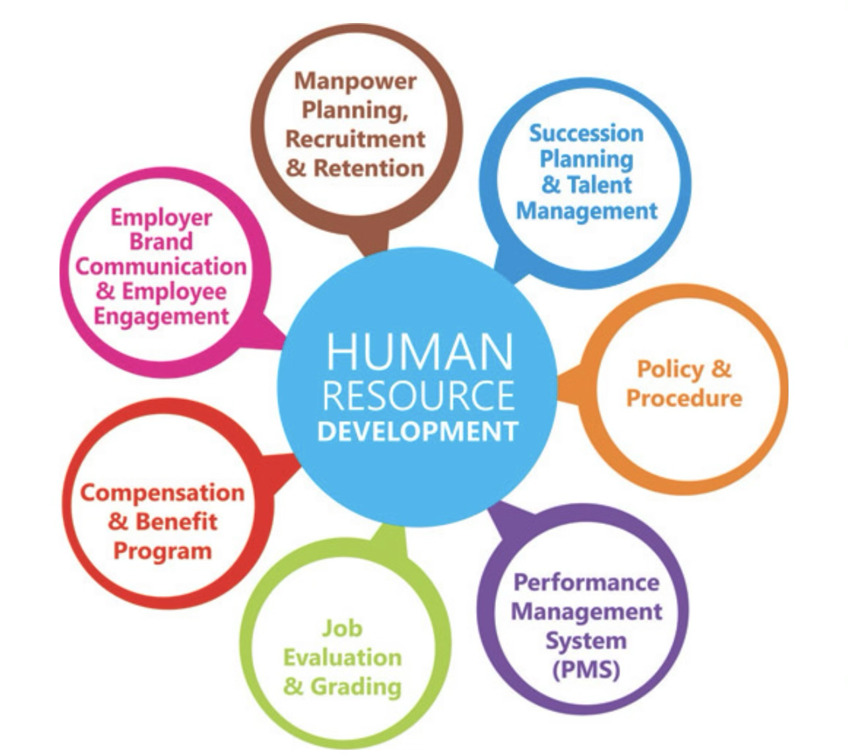

Source: (Human Resources Development VS. Human Resources Management - HRM Exam, 2021)

At the large-scale level, learning-and development (L&D) is around understanding the association procedure and its future capability needs in arrange to distinguish learning needs over the association. On a person level, it’s almost making learning situations where workers can persistently create to be their best. L&D pros put in put learning activities that empower associations to always advance and create. Motivational and behavioural science are key to impactful learning, whereas learning is almost much more than fair going to courses. An L&D master exceeds expectations at recognising the present moment and future abilities necessities of an association and makes adaptable learning intercessions (through advanced and other implies) to meet the differing requirements of the workforce (CIPD,2021).

M&B HR department has continuously been near to the trade; furthermore, it has embraced a think insurgency within the way it oversees careers and benefits its individuals, the comes about of which have not as it were given it reason to be hopeful approximately long-term, they landed both the leading ability administration activity and the pined for generally victor prizes at this year’s CIPD Individuals Administration Grants. Mitchells
& Butlers presented a modern learning administration framework that energised computerised L&D over the trade, with an accentuation on social learning. Each worker would benefit a fix ‘learning plan’ beginning with a figure of key webinars in them to begin within months, which Smallbone says constituted a ‘back to basics’ mentality that accentuated commercial aptitudes (Jeffrey, 2019).

Purpose of career planning

Career planning records Short- and long-term career goals and the activities undertaken to achieve them. Career plans can assist making choices about the classes required, highlighting extracurricular exercises, investigation, and internships that will make you a strong candidate for the job. A career can be created by a person inside one organization or a few others. Considering career arranging as a prepare inside the organization, career arranging is that portion of work force adminis­tration which points at creating ways through which workers may advance within the organization over time.
Douglas T. Hall states that, “An individually perceived sequence of attitudes and behaviours associated with work related experiences and activities over the span of the person’s life.”
For a great career in Human Resources Management department, it should be following few steps, such as:
1. To supply reasonable special openings to the representatives who are truly merit for it.
2. To pull in competent able, gifted prepared candidate toward the company and to hold them within the organisation.
3. To move forward and increment inspiration and resolve among the employees. 4.
To empower the representatives to create themselves and keep them prepared to meet the different future challenges.
5. To rectify worker situation in the event that there are mistakes in situation of a few representatives.

Importance of career planning

Career arranging could be a stepwise prepare which empowers an person to centre on where to need to be in life professionally. With the short-term objective and the long-term objectives in put, It can offer assistance to arrange their travel in their proficient life. Self-assessment is vital to get it one’s capabilities and downsides. The different career choices ought to be investigated in detail to discover a fit between one’s capacities and the openings given by a career choice. It includes persistent learning and enhancement to construct and development within the chosen career way. A great career arranging makes a difference a individual develop in life in their proficient career, which too offer assistance them develop personally.
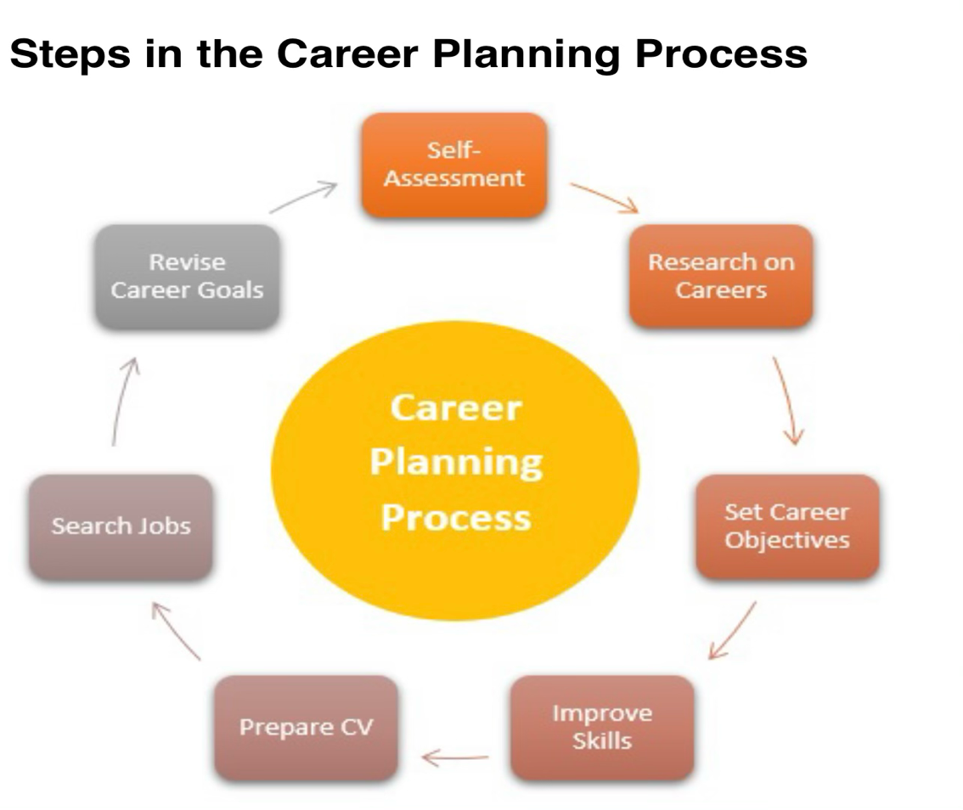

Source: Zigu, 2020

Human Resources Management Models

HRM is considered an alternative to the term faculty management in institutions. Considering this, specialists such as Armstrong (1987) view HRM "old wine in unused bottles"; While the Guest (1987) asserted that human asset management is not an alternative but rather contradicts in one way or another with college management. For all intents and purposes, it recommends that human assets tasks (HR) be a major concern for organisational exercises such as scoring, reward frameworks, progression, etc. However, it does not make HR managers "have a spot on the table" which means that HR chiefs are not respected as a vital business partner, and in this way, it does not contribute to the business victory.

Moreover, the four main measures of HRM as assumed by guest (1987) include the following:

Commitment: It is anticipated by leaders to understand the organisations' interface and goals, and to be flexible and dedicated to achieving these aims.

Adaptability: Representatives should be able to quickly respond to changes within the organisation’s structure without disagreement or prejudice.

Quality: The ability of a company to achieve high standards of execution is dependent on the quality of its employees. (Guest, 1987).

HR activities are measured in a variety of ways; Purcell and Ahlstrand (1994) identified nine (9) core activities that HRM divisions need to focus on. They said that, depending on the nature of their activities, these exercises should be suitable for most medium and large businesses. Mathis and Jackson (2006) show that the HR department's function is important.

Employees knowledge, skills and competencies

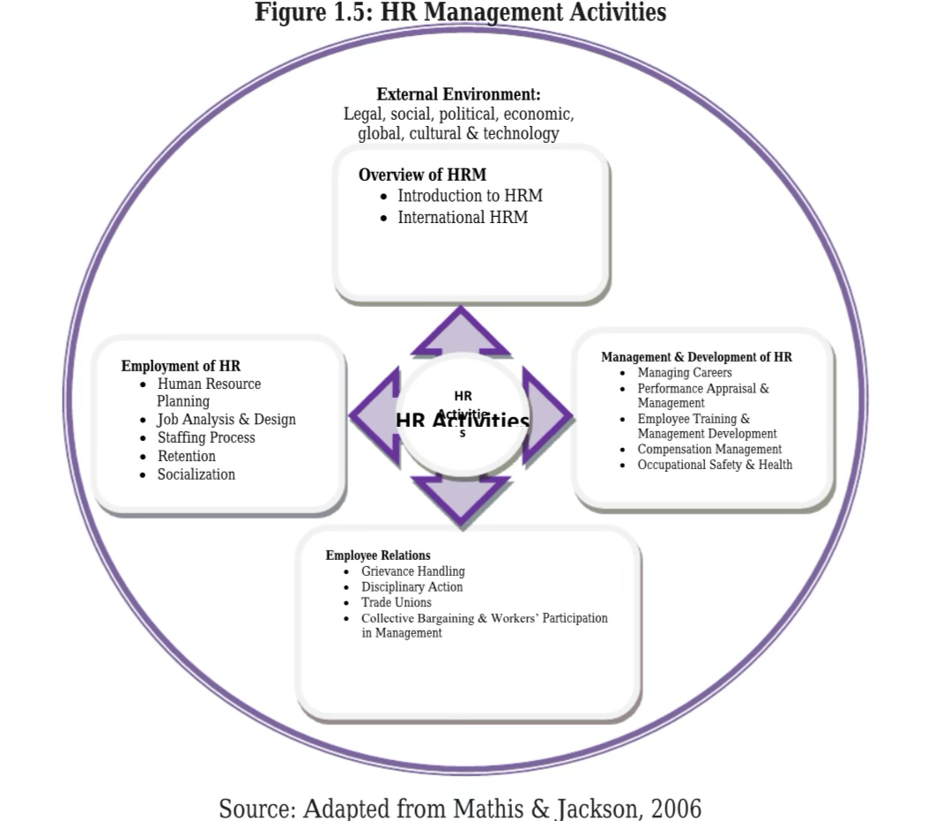

HR information administration is the hone of centralising all HR archives, approaches, data, and information, and making that imperative data simple for anybody within the company to get to and upgrade from anywhere. The key to this central store is that it permits employees—regardless of division, area, or tenure—to rapidly get to the HR data they require by means of a 24/7 self-service entry. This diminishes dissatisfaction for representatives, the chance of getting obsolete or deception, and workload for HR staff (Software, 2021).

HR professionals are contacts between individuals, division heads and CEOs. They oversee errands that ought to be completed by distinctive individuals and offices. Here are a few organisational abilities HR experts cultivate: Time administration. Drawing up work contracts and overseeing finance and protections plans are time-sensitive errands.

Records administration. HR groups oversee data and reports, like business assertions in physical and computerised formats.

calendar administration. In-between gatherings with colleagues and administrators, HR experts have to be crush in other critical assignments, like setting up worker preparing and advancement and organising firms occasions. Great calendar administration aptitudes offer assistance active HR groups remain productive (Pavlou, 2017).

HR groups connected with individuals on a everyday premise in-person, over the phone and by mail. HR experts with great communication abilities smooth over issues some time recently they raise and pass on company measures clearly.

Competency-based assessments aren't a new concept or approach, but they're a perfect way to improve your skills. Representative competency appraisals have been available long enough to have stood the test of time and proven to be an extremely useful tool in the HR professional's toolbox. Worker capabilities are a collection of specific and well-defined skills and behaviours.

Individual employees career plan

A career advancement arrange may be a personalised methodology utilised to help individuals in performing their career aspirations. A career development arrange comprises of brief and long-term objectives related to the representatives work and ought to join that representatives’ qualities and career goals. (Pope,2021). Having a career arrange is crucial to career victory. The foremost fruitful individuals, such as Tim Ferriss, Jeff Bezos, and Check Zuckerberg, all routinely arise with plans for the career victory (Stahl,2021).

If overseeing a farther group, it is vital to communicate regularly with the labourers. That interaction ought to incorporate assembly frequently with group individuals on a face-to-face premise so that individuals just can remain adjusted to chosen career goals and desires. This type of top support will make employees feel valued, which can contribute to increased productivity and loyalty. Assist employees in laying out a prospective career path within the company so that they can better envision their future there. Recognise key transition points for success, as well as the resources that employees would need to use along the way. Clear, coordinate, and steady communication from the management approximately career progression steps can offer assistance specialists feel more engaged (Half,2017).

Annual review and performance assessment plan

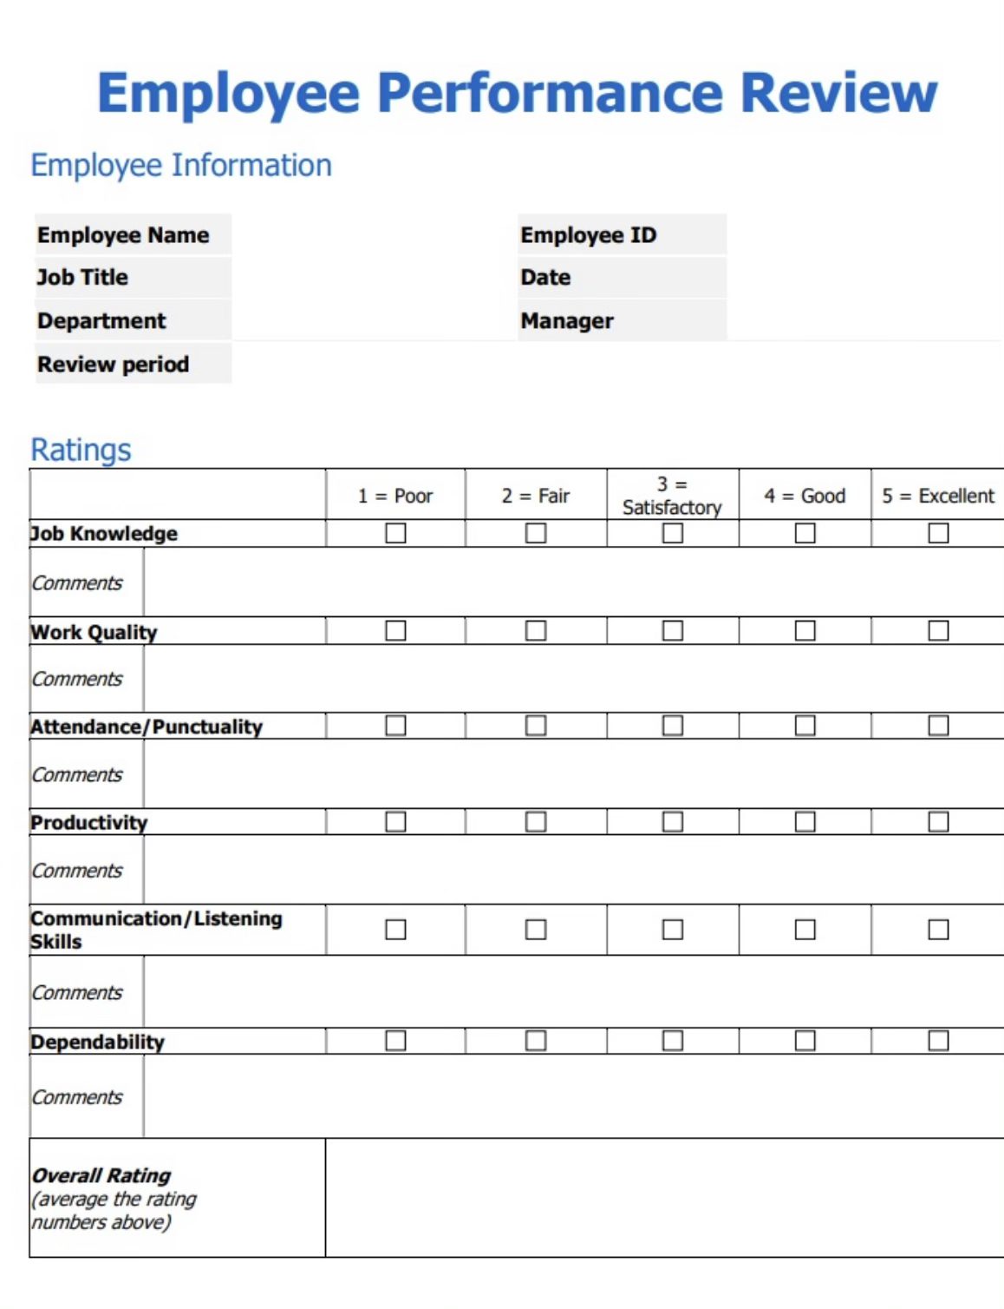
Source: Brown, 2019

Representative implementation surveys are essential for any company, but their effectiveness is determined by how they are performed. They can involve your representatives to achieve previously unattainable levels – or they can push them away from your business. It takes a special audit to make a difference. Your employees recognise career opportunities and future growth paths without jeopardising employee-manager relationships, but creating a good survey isn't easy. Directors are often given little guidance on how to conduct an effective and detailed survey. An employee execution audit, also known as an execution review or an execution evaluation, is a systematic assessment of an employee's work over a period. Supervisors evaluate an individual's overall execution, recognise their strengths and weaknesses, provide feedback, and assist them in setting goals in a representative execution audit. Although execution surveys are conducted once or twice a year on average, criticism should not be limited to such brief audit times. You should have consistent reviews across the year so that there are no surprises when it is time for the audit.
(Peek, 2019).

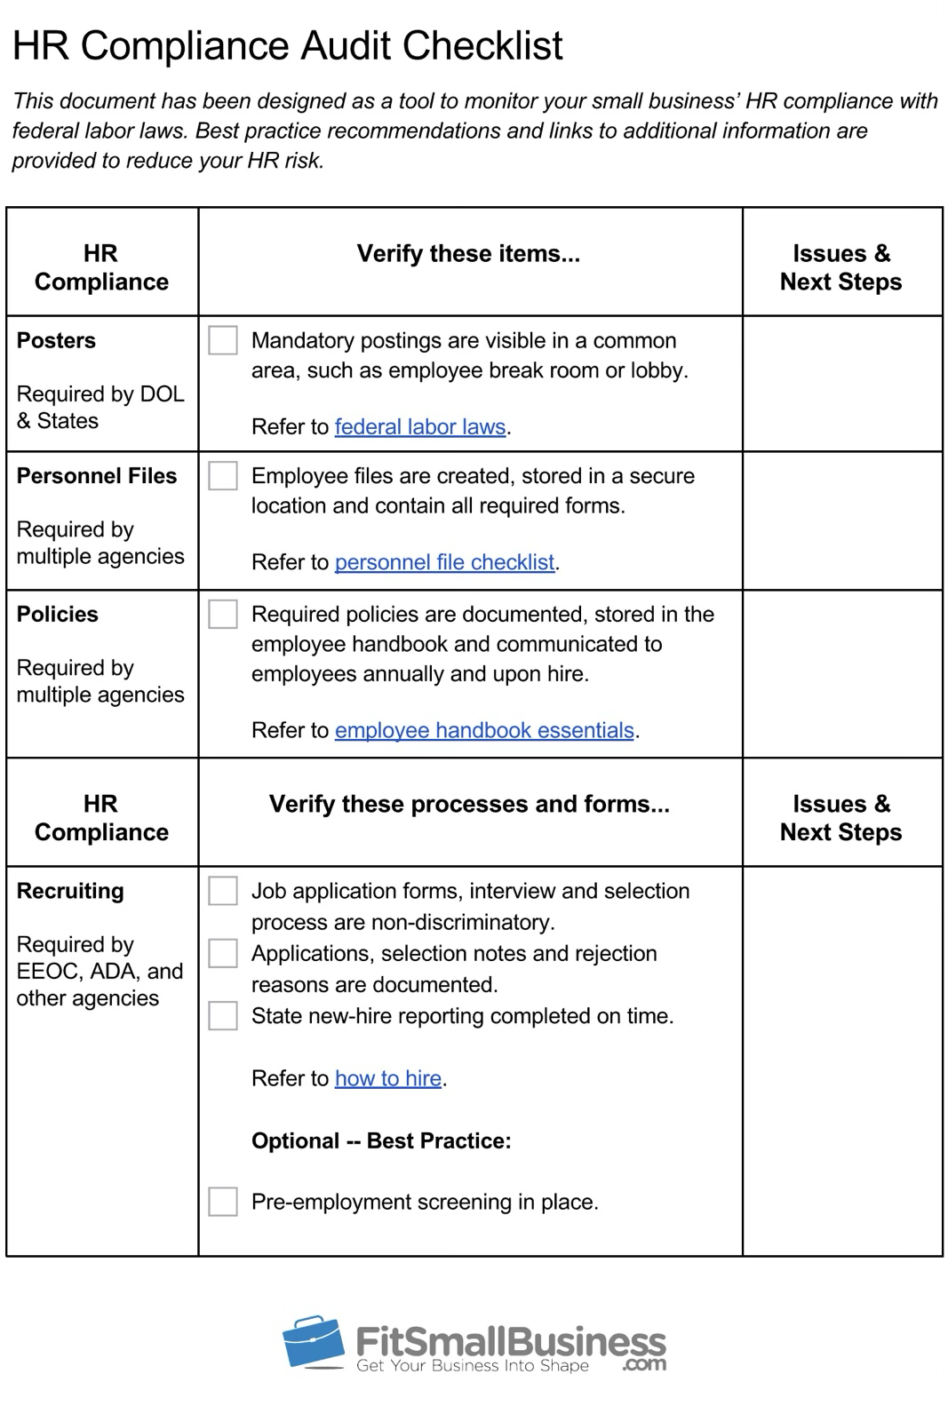

Conclusion

Human resources play a critical role in achieving their goals for monitoring programs. Soon, monitoring programs become stagnant without an appropriate approach to improving human capital and recruiting highly qualified personnel. Although a decrease in the quality of the workforce in a water quality management program can present a broader problem with hiring industry personnel, no attempt should be made to invest in personnel. on all levels. Human resource planning can go beyond preparation to encompass topics including work dynamics and professional development. It can also provide all kinds of workers with internet access. With HR planning and monitoring success, human resource management plays an important role in achieving organisational goals.

HRM selects the right workers for the company through recruitment, preparation and growth, and plays a key role in achieving strategic goals. HRM Performance appraisal improves the organisation’s efficiency. It not only focuses on the overall strategic objective of the enterprise, but also manages the Human Resources. It also assists with keeping track with globalisation and the consequences or advantages it might have, while also monitoring and reviewing the organisations HR policies and procedures. The HR department is responsible for not only attracting, recruiting, selecting, training, and developing employees, but also assisting with the management of the workforce.

References

Brown, J., (2019). The Perfect Employee Evaluation Form: Templates + How-To. [online] Helpjuice.com. Available at: https://helpjuice.com/blog/employee-evaluation-form [Accessed 12 May 2021].

Breweries, B., Lad, K., nick, b., McNeill, R. and Breweries, B., (2021). Mitchells & Butler Ltd. [online] Birmingham History Forum. Available at: https://birminghamhistory.co.uk/forum/index.php?threads/mitchells-butler-ltd.4057/ [Accessed 11 May 2021].

CRG emPerform. (2012). The Importance of Employee Competency Development. [online] Available at: https://employee-performance.com/blog/the-importance-of-employee-competency-development/ [Accessed 12 May 2021].

CIPD. (2021). Learning and development roles | CIPD. [online] Available at: https://www.cipd.co.uk/careers/career-options/learning-development-roles#gref [Accessed 11 May 2021].

HRM Exam. (2021). Human Resources Development VS. Human Resources Management - HRM Exam. [online] Available at: https://www.hrmexam.com/2021/01/22/human-resources-development-vs-human-resources-management/ [Accessed 11 May 2021].

Half, R. (2017). 7 Ways to Support Employees’ Career Advancement. [online] Roberthalf.com. Available at: https://www.roberthalf.com/blog/management-tips/7-ways-to-support-employees-career-advancement. [Accessed 11 May 2021].

Handrick, L.,( 2018). HR Compliance: Definition [+ Free HR Audit Checklist]. [online] Fit Small Business. Available at: https://fitsmallbusiness.com/hr-compliance-audit/ [Accessed 12 May 2021].
Indeed (2018). SMART Goals: Definition and Examples | Indeed.com. [online] Indeed.com. Available at: https://www.indeed.com/career-advice/career-development/smart-goals [Accessed 12 May 2021).
‌
Jeffrey, R., (2019). The best of HR: How rethinking youth recruitment made Mitchells & Butlers overall winners at the CIPD People Management Awards. [online] People Management. Available at: https://www.peoplemanagement.co.uk/long-reads/articles/best-hr-rethinking-youth-recruitment-mitchells-butlers-overall-winners-cipd-pmas-2019#gref [Accessed 11 May 2021].

MentorGuru (n.d.). A powerful Personal Development Plan. [online] Mentoring and mentorprogram. Available at: https://mentorguru.info/a-powerful-personal-development-plan/ [Accessed 12 May 2021].

‌Mitchells & Butlers. (2012). New Training Academy opens. [online] Available at: https://www.mbplc.com/newsandmedia/companyarticle/trainingacademyopens/ [Accessed 11 May 2021].

Pavlou, C. (2017). The most important HR skills and how to master them. [online] Recruiting Resources: How to Recruit and Hire Better. Available at: https://resources.workable.com/stories-and-insights/most-important-hr-skills [Accessed 11 May 2021].
‌
Pope, L., (2021). 5 Steps to Creating a Career Development Plan (+3 Things to Avoid). [online] Google.co.uk. Available at: https://www.google.co.uk/amp/s/learn.g2.com/career-development-plan%3fhs_amp=true [Accessed 12 May 2021].

Peek, S. (2019). How to Write Effective Employee Performance Reviews. [online] Business News Daily. Available at: https://www.businessnewsdaily.com/5760-write-good-performance-review.html. [Accessed 12 May 2021].
‌
Research Papers and Articles on Business Management. (2019). What is Career Planning in HRM? [online] Available at: https://www.businessmanagementideas.com/human-resource-management-2/career-planning/what-is-career-planning-in-hrm/20695.
‌[Accessed 11 May 2021]

ResearchGate. (n.d.). (PDF) Human Resource Management: Theory and Practice. [online] Available at: https://www.researchgate.net/publication/305954894_Human_Resource_Management_Theory_and_Practice. [Accessed 12 May 2021].
‌
Software, C., (2021). Why HR Knowledge Management Is So Important for Your Organization. [online] Cherwell Software. Available at: https://www.cherwell.com/hr-service-delivery/library/blog/hr-knowledge-management/ [Accessed 12 May 2021].

Stahl, A., (2021). 3 Steps To Develop Your Career Plan. [online] Forbes. Available at: https://www.google.co.uk/amp/s/www.forbes.com/sites/ashleystahl/2018/08/29/3-steps-to-develop-your-career-plan/amp/ [Accessed 12 May 2021].

‌

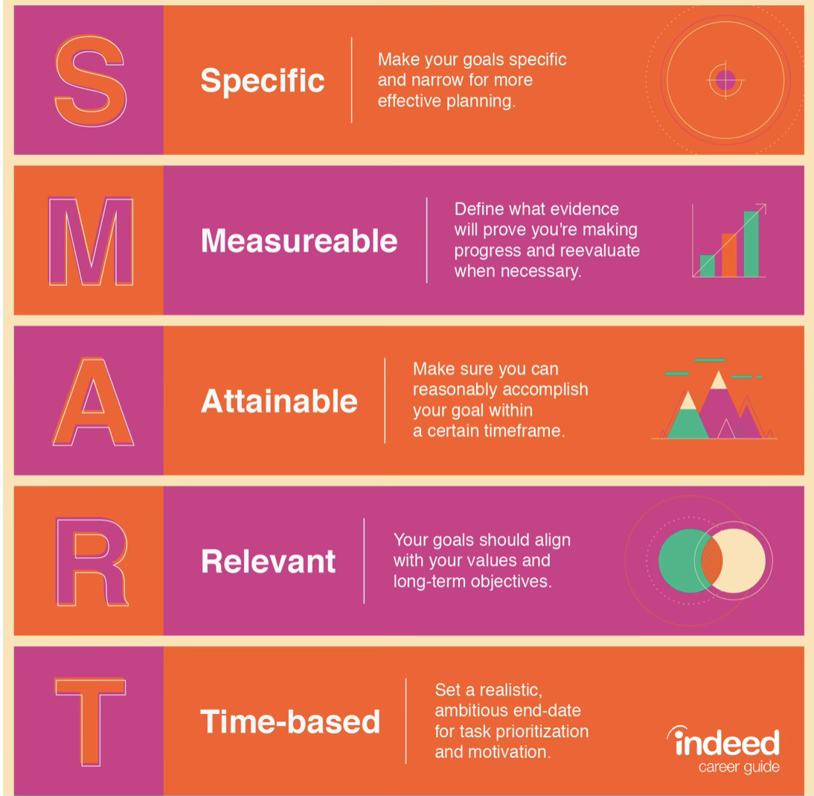
Source: (Mentorguru,2013)

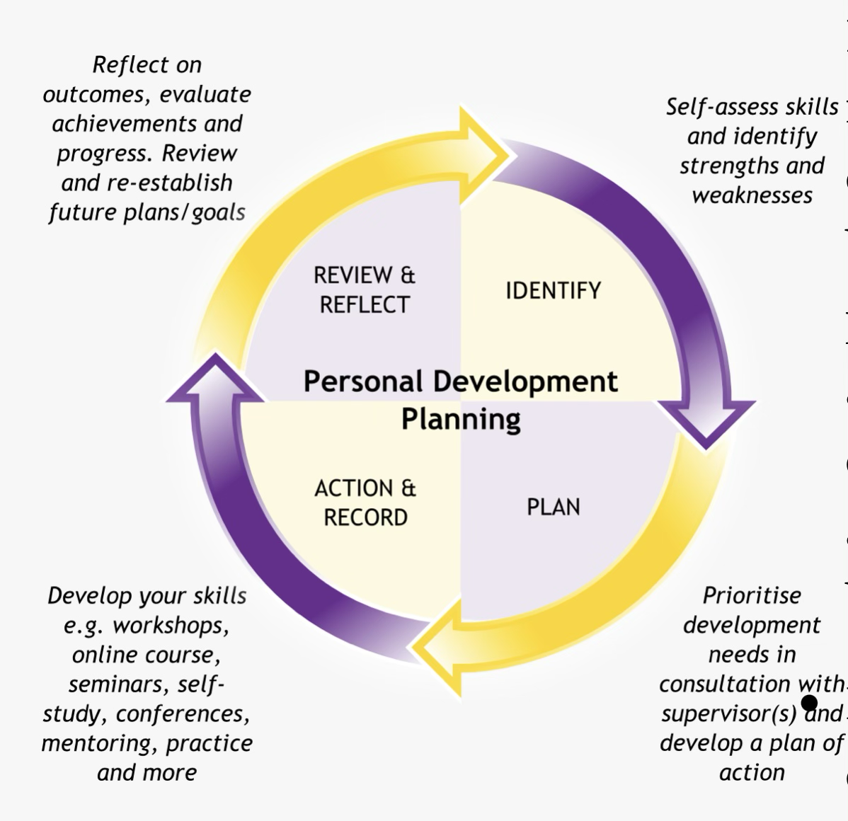
Source: (Indeed,2018)

