Assignment Element 2: ‘The Science of the perfect pint’
A report on Water Cooled & Integral Remote Coolers.

By Rhys L Stevenson

CONTENTS

INTRODUCTION
BEER GAS SYSTEM
BEER PUMP
PSI OF THE SYSTEM
CLIMATE CONTROL
REMOTE COOLER
COMPONENTS OF THE COOLER
FUNCTION OF THE ICE BANK
PRIMARY REFRINGENT
TEMPERATURE MEASUREMENT
GLYCOL SECONDARY COOLING SYSTEM
CONCLUSION
REFERENCES
BIBLIOGRAPHY

Introduction
There are a number of ways to achieve the perfect pint, but which is used is dependent on what product is being sold along with the how complex the system require. This report will cover the most complex of these systems, a long draw, glycol cooled draught dispenser system utilised in hospitality settings around the world. The long draw system has three sections that work together to attain this. A beer gas system, glycol cooling system and a remote beer unit.
The beer gas system
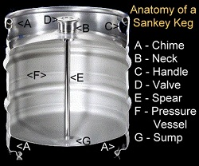
The beer gas system is used to extract the product from the cask or keg and force it along the beer lines to the tap. This is done with compressed CO2 gas that forces the product out of a keg through a central spear into a vinyl line to the remote cooler. Nitrogen gas can be mix with the CO2 at a 30/70 ratio for nitro beers, in which end product require small bubbles to produce a micro foam head (e.g., Guinness/ales) (brewers association Draught beer quality manual, 2011). Mixed gas cannot be used in other products such as lagers and ciders as the nitrogen will change the balance within these products and lower the carbonation of the liquid.
Figure 1 - Internal diagram of a beer keg.

Beer pump
To generate the pressure needed to run the product from barrel to tap, a compressed air drive double-membrane pump is used. The membrane is to ensure that the compressed CO2 and product remain separate and a constant draw pressure can be maintained with dampening for the pulses given by the suction/compression cycles of the pump (Borremans, 2019).
PSI of the system
Gas pressure used in the system is subject to the elevation above sea level, as the low atmospheric pressure means higher dispense pressure is needed to give the same result of carbonation in the end product. This can be highlighted in the table below, assuming the beer needs to be 15 psi at sea level
Elevation (feet above sea level) | Atmospheric Pressure (PSI) | Dispense Pressure (PSIG) | Absolute Pressure  (PSIA)
0 | 14.7 | 15 | 29.7
2000 | 13.7 | 16 | 29.7
4000 | 12.7 | 17 | 29.7
5000 | 12.2 | 17.5 | 29.7
8000 | 10.7 | 19 | 29.7
10000 | 9.7 | 20 | 29.7
Figure 2 – Table of pressure changes by elevation
Climate control
The environment in which the barrels are stored also effects the carbonation, as gases become less soluble at higher temperatures (Smith and Hong-Shum, 2011) and thus a higher PSI is needed to offset this. Alternatively, temperature regulation is often used to store the product at below 12C to combat this. To regulate the temperature, it is often that cellars are constructed underground, or have climate control built in.
The remote cooler
Once the product has left the barrel on its way to the tap, it must pass through a remote cooling system. Stainless steel coils containing the product are submerged in a glycol/water cold bath which rapidly cools the product. The ice bath is created by a refrigeration system which condensing coils on the perimeter of the box to maintain a climate between -2.0c and 0.5c within the box.

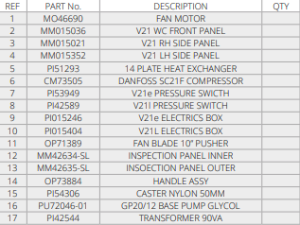
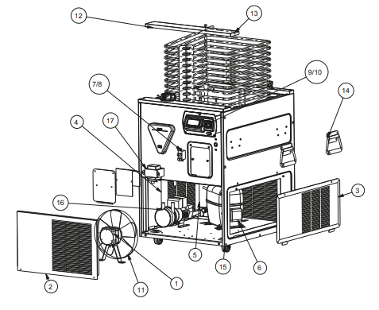
Figure 3 – diagram of a V21e remote cooler.
Components of the cooler
The above diagrams illustrate the workings of the cooler. The DFX S1 control unit is functions as an input-output system which is fed data from the temperature probe and telemetry. This data will be used to operate the heat exchange, lid pump, compressor and fan motor. These work to produce a cold bath for the cooler coils to rest in. The cold bath is made from a 50/50 mono propylene glycol (which is non-toxic) and fresh water solution which tolerates temperatures down -15C (P156908 Vision user manual,2011)
Function of the ice bank
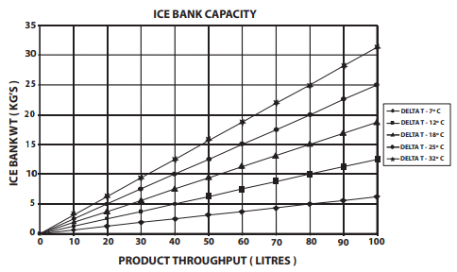
Whilst the condensing coils are in operation, an ice bank is formed around them. This ice bank acts as a heat sink for any product passing through the cold bath. The table below shows the ice bank capacity needed against the amount of product passing through at various temperature differences.
Figure 4 – ice bank capacity graph.
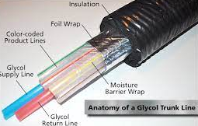
This states that the more product and the larger the temperature difference being achieved, the more ice per weight is needed to be produced. In addition, the cold bath is also used to cool the product between the remote cooler and the faucet by cooling it in beer line trunks. These trunks are glycol cooling lines, either two or four divided between supply and return surrounding beer lines encased in insulation. These are usually buried between the cellar and bar to provide protection and additional insulation.
Figure 5 – diagram of a glycol beer trunk line.
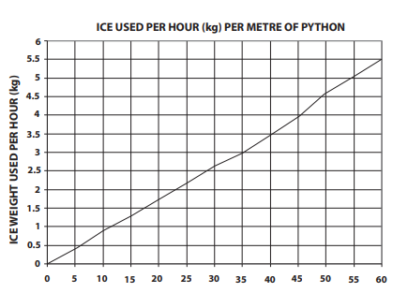
This constant circulation of cold bath coolant will result in the degradation of the ice bank as shown in the graph below.
Figure 6 – ice consumed per hour to length of python tubing.
The ice bank capacity and weight used per hour is then used to calibrate the control unit to produce and maintain the required weight needed to keep the product cooled optimally.
Primary refringent
A compressor is an essential component in a refrigeration system. It has two main functions, to pump refrigerant from the evaporator to maintain temperature and pressure, plus increase the pressure of the refrigerant to increase its temperature to help it flow through the system. This allows the creation of a condenser to absorb heat and an evaporator to release it. (Dinçer, 2017)
The fan provides cooling for the heat exchanger aiding in the removal of excess heat from the system. Thus, it is required that the environment be maintained for this cooling to be efficient.
Temperature measurement
The probe is a digital thermometer measuring the resistance in a material changing with temperature, with the resistance decreasing at higher temperatures. This is essential for the control unit to cycle on or off.

The glycol secondary cooling system
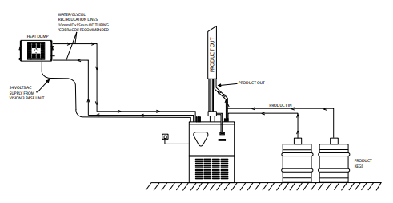
The Glycol cooling system is a secondary cooling system desigened to transfer energy from the primary refidgeration system to an external heat dump terminal.
Figure 7 – layout of Glycol secondary cooling system
A glycol pump circulates a 30/70 glcol solutions between a 14 plate heat exchanger which conducts hear from the primary refridgerant to the secondary system. This is them flows fo the extenal heat exchanger which is air cooled via a fan before returning to the remote cooler. This system prevents the build up of waste heat within the cellar.

Conclusion
In general the system aims to maintain a balance between pressure and temperature to give the highest quality outcome, only needing initial setup calibration for the PSI used, operating times for the control unit and temperature thresholds for the ice bath to give both excellent carbonation and refeshing chilled crispness. This is essential in any fixed hospitailty setting as there is no rival for its outstanding delivery. However a main drawback is the need for trained technicians to carryout anything other than the most basic of maintinance tasks,

References
2011. brewers association Draught beer quality manual. 2nd ed. Brewers Publications.
2011. P156908 VISION Range V21, V34 Water Cooled & Integral Remote Cooler USER, INSTALLATION & MAINTENANCE MANUAL. 2nd ed. Manitowoc: Multiplex. Available at: https://www.welbilt.uk/asset/?id=jnykn&regions=uk&prefLang=en
2017. P67574 Vision Series Installation Manual. 4th ed. Multiplex. Available at: https://www.welbilt.uk/asset/?id=xckej&regions=uk&prefLang=it
Borremans, M., 2019. Pumps and compressors. 1st ed. Wiley.
Dincer, I. (2017) Refrigeration Systems and Applications. 3rd edn. Wiley.
Figure 1. Available at: https://www.probrewer.com/library/kegs/keg-systems/
Figure 2. 2011. brewers association Draught beer quality manual. 2nd ed. Brewers Publications. Pg 18
Figure 3. 2017. P67574 Vision Series Installation Manual. 4th ed. Multiplex. Pg 32
Figure 4. 2011. P156908 VISION Range V21, V34 Water Cooled & Integral Remote Cooler USER, INSTALLATION & MAINTENANCE MANUAL. 2nd ed. Manitowoc. Pg 22
Figure 5 – Available from: http://www.cleanbeertechnology.com/glycol-systems/
Figure 6 - 2011. P156908 VISION Range V21, V34 Water Cooled & Integral Remote Cooler USER, INSTALLATION & MAINTENANCE MANUAL. 2nd ed. Manitowoc. Pg 22
Figure 7. 2017. P67574 Vision Series Installation Manual. 4th ed. Multiplex. Pg 10
Smith, J. and Hong-Shum, L., 2011. Food additives data book. 2nd ed. Chichester, West Sussex: Wiley-Blackwell.

Bibliography
2011. brewers association Draught beer quality manual. 2nd ed. Brewers Publications.
2011. P156908 VISION Range V21, V34 Water Cooled & Integral Remote Cooler USER, INSTALLATION & MAINTENANCE MANUAL. 2nd ed. Manitowoc: Multiplex. Available at: https://www.welbilt.uk/asset/?id=jnykn&regions=uk&prefLang=en
2017. P67574 Vision Series Installation Manual. 4th ed. Multiplex. Available at: https://www.welbilt.uk/asset/?id=xckej&regions=uk&prefLang=it
Borremans, M., 2019. Pumps and compressors. 1st ed. Wiley.
Dincer, I. (2017) Refrigeration Systems and Applications. 3rd edn. Wiley.
Hundy, G. (2016) Refrigeration, Air Conditioning and Heat Pumps. 5th edn. Elsevier Science.
Smith, J. and Hong-Shum, L., 2011. Food additives data book. 2nd ed. Chichester, West Sussex: Wiley-Blackwell.
Ukele, D. (2020) Refrigeration &#38; Air Conditioning 101. 1st edn. Page Publishing, Inc.

