 BSc Applied Computing

Project Management & Innovation.

Module Name: Changemakers: Creativity and Value Creation
Module Code: ACCA5033
Component 2: Project Management & Innovation
Student Name: Mariana Silva Martins
Student ID: 22319931
Lecturer Name: Dr Osman Elgawi

Submission date: 24/07/2026

Table of Contents
Introduction 3
Task 1 – Project Management 3
1.1 Project Scope 3
1.2 Technologies and Resources 3
1.3 Project Timeline, Schedule and Constraints 4
1.4 Development Method 4
Project Schedule 5
2.1 Innovation Analysis – Introduction 7
PEST Analysis for DeepConnect 8
2.2 Legal and Ethical Issues 9
2.3 Concepts, Methods, Practices and Tools 9
Task 3 – Project Reflection 11
3.1 Developing New Skills 11
3.2 Positive Impact on Society 11
3.3 Risks and Challenges 12
Conclusion 13
References 14

Introduction
AI is revolutionizing digital services to offer more user-centric and personalized solutions. However, many online dating services continue to prioritize appearance-based decision-making, leading to superficial chats rather than genuine compatibility [1], [2]. DeepConnect overcomes this restriction by using an AI-powered mobile platform that matches users based on their personality traits, their shared values and their relationship preferences. This report expands on Component 1 and describes the project scope, technology, development approach and design artefacts. It also analyzes innovation management, implementation issues and project risks before reflecting on professional skills and social value that comes with producing an ethical AI solution.
Task 1 – Project Management
1.1 Project Scope
DeepConnect is an AI-powered mobile application that prioritizes personality compatibility over physical attraction to aid in forming long-lasting partnerships. The platform is designed based on a Human-Centred Design approach where users are prompted to connect with each other based on common values, interests, communication styles and long-term relationship goals before the profile photographs are made available, thus helping to reduce appearance bias and facilitate more authentic interactions [1], [2].
DeepConnect brings together an explainable AI recommendation engine with progressive profile disclosure to provide transparent compatibility scores based on personality traits, behavioral preferences, and relationship goals. Furthermore, AI conversation prompts facilitate meaningful communication and enhance user trust in automated recommendations [3], [4].
The project scope is to construct a prototype of mobile application, secure cloud based backend, AI based recommendation engine and user friendly UI. The main features are: user registration, profile creation, personality tests, AI compatibility scoring, secure chat, and progressive profile unlocking. For the first release we are excluding premium subscriptions, video calling, multilingual help and social network integration to keep the scope realistic and achievable.
1.2 Technologies and Resources
DeepConnect is the fusion of software technology, development tools and trained people to produce a powerful, scalable and maintainable solution. We develop flutter for different mobile devices. FastAPI is used to build backend services including authentication, data processing, and communication with the AI recommendation engine. User profiles, personality scores, and interaction data are maintained in Postgres. Firebase Authentication is used to handle sign up and login.
The machine learning algorithms say that they are mentally compatible couples, not physically compatible. AWS ( Amazon Web Services ) is scalable cloud infrastructure. GitHub is a version control and software collaboration platform.
The project team includes the following specialists: project manager, mobile developer, backend developer, AI engineer, UI/UX designer and software tester. Support tools include development software, testing equipment, project management tools and cloud services. These technologies provide a strong ground for design and development of DeepConnect according to the Human-Centred Design principles [1], [5].
1.3 Project Timeline, Schedule and Constraints
Proper project planning ensures that development activities are carried out within the available time, budget and resource restrictions and supports progress monitoring and risk management [6]. DeepConnect is designed in six phases over the span of sixteen weeks.
The project starts with the requirements analysis and planning. Then the system design is done with UML diagrams, wireframes and database modeling. Then the work continues with the implementation of the mobile application, the backend services and the AI recommendation engine. Functional, usability and security testing is performed. Evaluation and final documentation is completed before to release.
Development time, financial resources, AI skills and compliance with data protection legislation limit project development. There are also technological challenges to combining AI services with safe cloud infrastructure. The Agile approach provides continual feedback and incremental improvements that help to address these constraints during the project lifecycle [6], [7].
1.4 Development Method
DeepConnect will be developed using Agile Project Management with Scrum as the development framework. Agile is well suited to AI-based software projects because it supports iterative development, stakeholder collaboration and the flexibility to respond to changing requirements [7], [8].
Scrum organizes development into four three-week sprints, each producing a working increment of the program. Sprint Planning, Daily Scrums, Sprint Reviews and Sprint Retrospectives help communication, transparency and continual development in the project [7].
This iterative approach allows regular testing, feedback from users and early identification of technical or usability problems, reducing the risks of the project and improving the quality of the system. By applying Agile Project Management, Scrum and Human-Centred Design concepts, DeepConnect is able to adapt and meet user needs continuously while offering dependable and ethical AI driven capabilities [8].
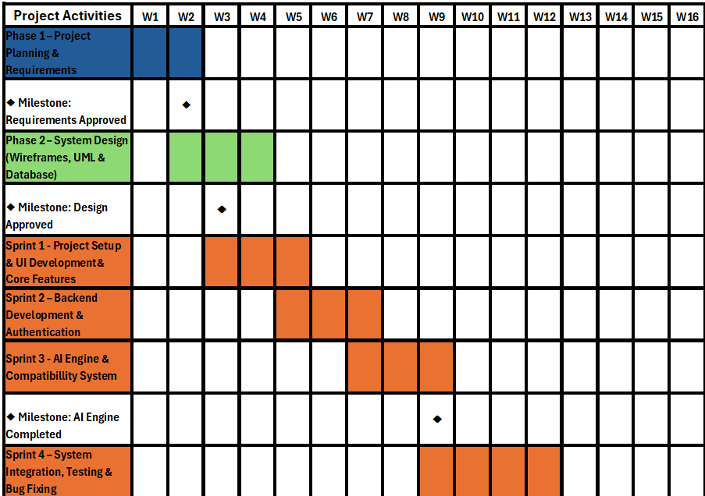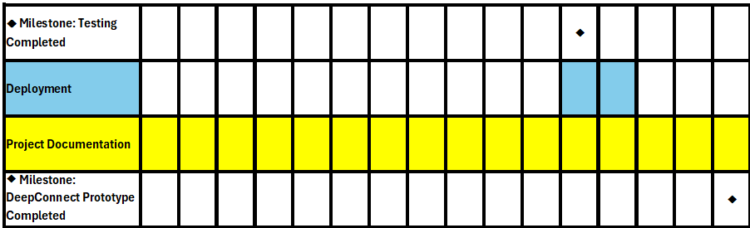

Figure 1. DeepConnect Project Gantt Chart (Proposed Agile development timeline in 4 Scrum sprints over 16 weeks).
Project Schedule
Figure 1: Proposed 16-week project schedule. The project starts with requirements analysis and system design, followed by 4 Scrum sprints for interface development, backend services and AI integration and testing. Milestones are useful to track progress, provide continuous feedback and iteratively manage risk throughout development [6], [7]. The project is completed with documentation and deployment.

Figure. UML Use Case Diagram for the DeepConnect System
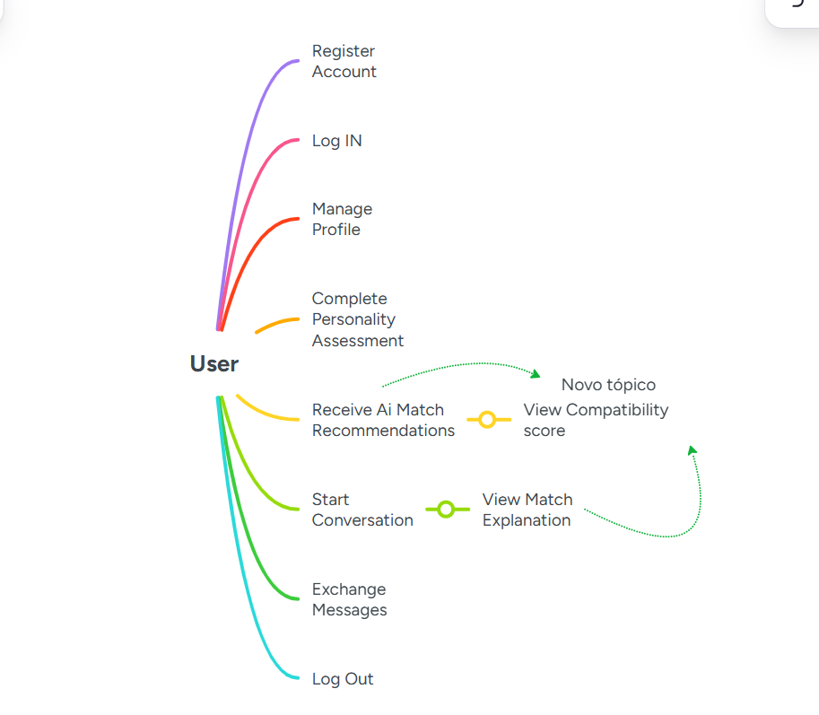

Figure 2. UML Use Case Diagram of DeepConnect. The UML Use Case Diagram for DeepConnect is depicted in Figure 2. It highlights the major interactions between the users and the system such as registration, authentication, profile management, personality evaluation, AI-powered suggestions and messaging. View Match Explanation is an example of the platform’s commitment to Explainable AI, with transparent suggestions. The graphic is useful for communicating the functional needs of the system during development.

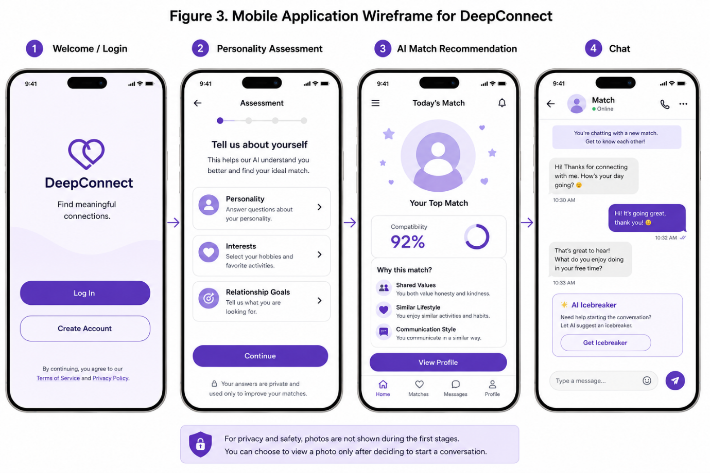
Figure 3.
The wireframe illustrates the application of Human-Centred Design by DeepConnect in stressing usability, transparency and meaningful engagement. They’re shown before the profile photos, compatibility scores, shared values and AI-generated explanations, encouraging people to focus on personality rather than appearance. This design promotes informed decision-making and affords an intuitive and accessible user experience [1], [2], [11].

2.1 Innovation Analysis – Introduction
New technologies are a competitive advantage and can be exploited to meet the need of users with innovation. Before you try something new, think about external circumstances and your own strengths. We employ structured frameworks – such as PEST and SWOT analysis – to assess opportunities, risks and strategic priorities. This study analyzes DeepConnect, an AI dating platform that emphasizes on personality compatibility, transparency and Human-Centred Design [9].

PEST Analysis for DeepConnect

PEST analysis examines the external political, economic, social and technological factors that may influence the successful implementation of DeepConnect [9].

Table 1. PEST Analysis for DeepConnect

Factor | Analysis DeepConnet
Political | Compliance with GDPR, AI governance and consumer protection legislation is essential to ensure responsible data processing and maintain user trust.
Economic | More investment in AI and subscription based services conceivable but competition and acquisition costs are still important challenges.
Social | Privacy, Safety and Meaningful Connections are driven by Social-Personality-based matching and transparent AI suggestions.
Technological | AI, Explainable AI, cloud computing and mobile technologies enable scalable, transparent and continuously improving recommendation systems.

Table 2. SWOT Analysis for DeepConnect

Table 2 indicates that DeepConnect's personality-based approach and Explainable AI provide competitive advantages, while competition, technical complexity and regulatory compliance remain significant challenges. The analysis supports strategic planning and long-term sustainability [9].

Strengths | Weaknesses
Unlike the other dating apps, this one uses personality matching powered by AI instead of looks. | ow brand awareness and limited initial user base.
Explainable AI increases transparency and user trust | Quality recommendations rely on accurate data given by users.
Human-Centred Design is about access and meaningful relationships for all. | Scaling AI and cloud infrastructure is an ongoing investment and a technology problem.
Opportunities | Threats
The interest in ethical AI and genuine interactions on the internet is booming and so is the market. | There is a lot of competition from existing dating sites.
Language support and global expansion will help to grow the user base. | Evolving privacy and AI regulations may increase compliance requirements.
Trust. Relationship & Mental Health Experts | Cyber security attacks and data breaches can erode the trust for users.

2.2 Legal and Ethical Considerations
DeepConnect being an AI-powered platform has to comply with the GDPR and protect the personal information of users through secure data collection, storage, and processing. Users must give their informed consent and have control over their data. The recommendation method should also be clear, explainable and routinely evaluated in order to minimize bias and foster fairness. Responsible AI governance results in greater legal compliance, user trust, and the long-term viability of the platform [10].

2.3 Concepts, Methods, Practices and Tools
DeepConnect will utilize proven software engineering practices and tools throughout its development lifecycle to ensure scalability, security, and continuous improvement.

Table 3. Development Lifecycle for DeepConnect

Stage | Concepts & Methods | Practices & Tools
Develop | Scrum, Agile Project Management, Human-Centred Design | FastAPI, Flutter, PostgreSQL, Github, Figma
Deploy | DevOps, Continuous Integration / Continuous Deployment (CI/CD) | AWS, Docker, GitHub Actions
Maintain | Security Management, Software Maintenance, Continuous Monitoring | Automated Testing, Bug Tracking, Performance Monitoring
Evolve | Iterative improvements, user feedback, and AI model optimization. | Sprint Reviews, Analytics, AI Re-trainings, Feature Updates

Table 3, we have grouped the necessary methods and tools for the entire lifecycle of DeepConnect. Agile and Scrum promote iterative development, DevOps enables deployment and maintenance, and Human-Centred Design provides usability and ongoing improvement based on user feedback [6]–[11].

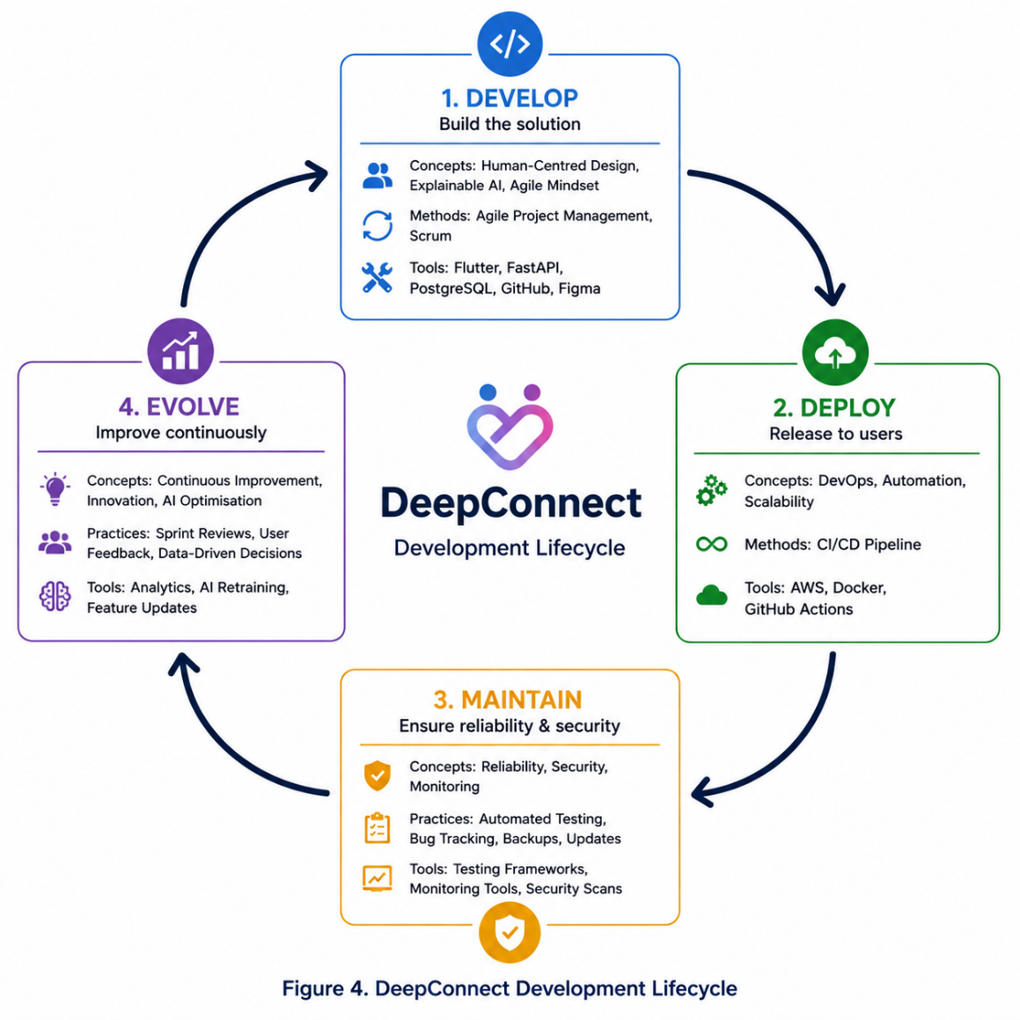
Figure 4 – DeepConnect Development Lifecycle

Task 3 – Project Reflection

Introduction
Building DeepConnect has been an opportunity to reflect on the technical, professional and ethical issues of AI-powered software development. The project is yet hypothetical, but it shows that successful systems require not just technical expertise, but also efficient project management, Human-Centred Design and responsible Artificial Intelligence. The reflection covers the acquired skills, the possible social value of the project, and the implementation risks of an AI-based platform [8], [10].

3.1 Developing New Skills
I will learn to improve my technical and professional skills while working on DeepConnect. Technicalities: Experience with Flutter, FastAPI, database administration, AI integration and a better understanding of Explainable AI, Data Privacy and Ethical Software Development [10].
With Agile Project Management, Scrum and Github I would improve my planning, cooperation and communication skills. Encouraging a deeper focus on usability and user expectations through Human-Centred Design would better prepare me for future software development projects requiring both technical capability and responsible decision making [7], [8], [11].

3.2 Positive Impact on Society
DeepConnect highlights how technology may generate social value, not through interactions based on appearance but through the creation of meaningful relationships. We match users on personality traits, shared values and communication styles to create more real connections and a more inclusive user experience.
The project also demonstrates how Artificial Intelligence may be used responsibly, with Explainable AI allowing consumers to understand the compatibility recommendations and so building trust in automated decision-making. Working on this project would turn me into a computing expert able to produce ethical, user-centred digital solutions with commercial and societal value [9]–[11].

3.3 Risks and Challenges

Table 4. Risks and Mitigation Strategies for DeepConnect
Risk | Potential Impact | Mitigation Strategy
AI bias and inaccurate recommendations | Reduced user trust and unfair matching outcomes | Regular AI model evaluation, diverse training data and fairness testing before deployment.
Data privacy and security breaches | Exposure of sensitive personal information and reputational damage | Implement GDPR compliance, encryption, secure authentication and regular security audits.
Low user adoption | Limited platform growth and reduced commercial viability | Apply Human-Centred Design principles, gather continuous user feedback and introduce features iteratively.
High development and maintenance costs | Slow deployment, limited scalability | Build fast with scalable cloud infrastructure, and focus on what matters most.
Rapid changes in AI regulations | Additional compliance requirements and increased operational costs | Continuously monitor legal requirements and update policies and AI governance practices accordingly.

Table 4 highlights the importance of DeepConnect’s effectiveness in managing AI bias, privacy, cybersecurity, user adoption and regulatory compliance. Risks would be mitigated and reliability and long-term sustainability enhanced by regular AI governance reviews, continuous testing, and secure development procedures. This reflection has pointed to the need to combine technical knowledge with competent project management [6], [10].

Conclusion
The development of DeepConnect has shown that technological expertise needs to be combined with ethical responsibility, good project management and user-centered design. The project has demonstrated that constructing an AI-powered application is not just about developing software capabilities, but also about understanding users’ needs, data privacy, transparency and ethical innovation. This chance would help me improve my technical and professional skills and obtain better understanding of how technology can be used to tackle real-world challenges. Overall DeepConnect has enhanced my ambition to become a computer expert able to build creative, ethical and socially-beneficial digital solutions that give positive user experience and support the responsible use of Artificial Intelligence [9]–[11].

References
[1] Q. Zhang, J. Lu and Y. Jin, “Artificial Intelligence in Recommender Systems,” Complex & Intelligent Systems, vol. 7, no. 1, pp. 439–457, Feb. 2021, doi: 10.1007/s40747-020-00212-w.
[2] C. Bandinelli and A. Gandini, “Dating Apps: The Uncertainty of Marketised Love,” Cultural Sociology, vol. 16, no. 3, pp. 423–441, Sep. 2022, doi: 10.1177/17499755211051559.
[3] S. Dhelim, N. Aung, M. Bouras et al., “A Survey on Personality-Aware Recommendation Systems,” Artificial Intelligence Review, vol. 55, pp. 2409–2454, Mar. 2022, doi: 10.1007/s10462-021-10063-7.
[4] R. Lukyanenko, W. Maass and V. C. Storey, “Trust in Artificial Intelligence: From a Foundational Trust Framework to Emerging Research Opportunities,” Electronic Markets, vol. 32, pp. 1993–2020, Dec. 2022, doi: 10.1007/s12525-022-00605-4.
[5] R. Patrício, P. Gomide and L. Rocha, “Taking the Digital Innovation Journey beyond Technology: A Human-Centered Design Approach,” Journal of Innovation Management, vol. 10, no. 4, pp. 26–46, 2023, doi: 10.24840/2183-0606_010.004_0002.
[6] Project Management Institute, A Guide to the Project Management Body of Knowledge (PMBOK® Guide), 7th ed. Newtown Square, PA, USA: Project Management Institute, 2021.
[7] K. Schwaber and J. Sutherland, The Scrum Guide: The Definitive Guide to Scrum: The Rules of the Game, Nov. 2020.
[8] H. Dong, N. Dacre, D. Baxter and S. Ceylan, “What Is Agile Project Management? Developing a New Definition Following a Systematic Literature Review,” Project Management Journal, vol. 55, no. 6, pp. 668–680, 2024, doi: 10.1177/87569728241272479.
[9] F. R. David, F. R. David and M. E. David, Strategic Management: A Competitive Advantage Approach, Concepts and Cases, 17th ed. Harlow, U.K.: Pearson, 2020.
[10] National Institute of Standards and Technology, Artificial Intelligence Risk Management Framework (AI RMF 1.0), NIST AI 100-1. Gaithersburg, MD, USA: National Institute of Standards and Technology, Jan. 2023.
[11] International Organization for Standardization, ISO 9241-210:2019 Ergonomics of Human-System Interaction—Part 210: Human-Centred Design for Interactive Systems. Geneva, Switzerland: ISO, 2019.

