

Module Name: Digital Skills for Personal and Professional Growth
Module Code: (BMSW4008)
Student Name: Patrycja Torunska
Student Number: 2431559
Analysis Report
Lecturer: DR. Gareth Hughes
Deadline: Monday 16th March


AI Acknowledgement
I acknowledge the use of ChatGPT (https://chatgpt.com/) in March 2026 to write my notes into submission format using the prompt(s):
Do not change my work, only please check Grammar,
translating languages.
I confirm that I have not presented any AI generated text as my own work. I confirm that I have copies of my drafts, notes, and other resources I used before, and after the use of AI tools which I may be asked to provide in evidence.

Table of Contents

1. Introduction 4
1.1 Report Remit 5-6
2. Analysis report 6-11
2.1 Findings 6-11
2.2 Personalised Products 11-12
2.3 Segmentation and Marketing and SEO Strategy 12
3. References 13

List of Figures

Figure 1: Factors influencing the choice of hair salon
Figure 2: Platforms used to discover salons
Figure 3: Expected price range for colouring services
Figure 4: Preferred booking methods for hair appointments

APPENDICES
Appendix A – Questionnaire
Appendix B - Website screenshots
Appendix C - Canva marketing material
Appendix D - social media platforms, Instagram and Facebook

1. INTRODUCTION

The hairdressing industry is highly competitive and understanding customer behaviour is essential for developing effective marketing strategies. Businesses must identify the needs and preferences of their target audience to design services and marketing approaches that attract and retain clients. Market research therefore plays an important role in helping businesses better understand customer expectations and improve service quality.

This report presents the findings of a questionnaire conducted to explore customer preferences when choosing a hair salon. The questionnaire was designed to gather information about customer behaviour, including the factors influencing salon choice, preferred booking methods, pricing expectations and the ways in which customers discover new salons. The results of the questionnaire were used to support the development of a website and marketing materials for the hair salon Hairway to Heaven.

The report analyses the key trends identified from the questionnaire responses and discusses how these findings influenced the business concept, website design and marketing strategy. In addition, the report explores how market segmentation and search engine optimisation (SEO) strategies can support the promotion of the salon in the local market. Market research helps businesses better understand customer needs and develop strategies that improve competitiveness and customer satisfaction (Kotler et al., 2020).

1.1 REPORT REMIT

The purpose of this report is to analyse the results of a questionnaire designed to understand customer preferences in the hairdressing industry. The questionnaire collected responses from participants regarding their expectations when choosing a salon, preferred booking methods and acceptable price ranges for colouring services.

The data collected from 50 respondents was analysed to identify key trends and patterns. These insights were then used to support the development of a page website and marketing materials for the Hairway to Heaven salon.

Furthermore, the report evaluates how the research findings influenced decisions related to website content, branding and marketing strategies. It also examines the role of market segmentation and digital marketing tools such as social media and SEO strategies in reaching the salon’s target audience.

2. ANALYSIS REPORT

2.1 FINDINGS

The questionnaire provided valuable insights into customer preferences when choosing a hair salon. The responses highlighted several important trends related to service quality, salon discovery methods, pricing expectations and booking preferences.

One of the most significant findings relates to the factors that influence the choice of a hair salon. As shown in Figure 1, many respondents identified quality of service as the most important factor when selecting a salon, with 33 responses. Stylist experience was the second most frequently selected factor. In comparison, aspects such as price, salon atmosphere and customer reviews were considered less important. This suggests that customers prioritise professional expertise and high service standards when choosing a salon. For Hairway to Heaven, this highlights the importance of promoting professional skills, specialised colouring services and the use of high-quality products in marketing communications.

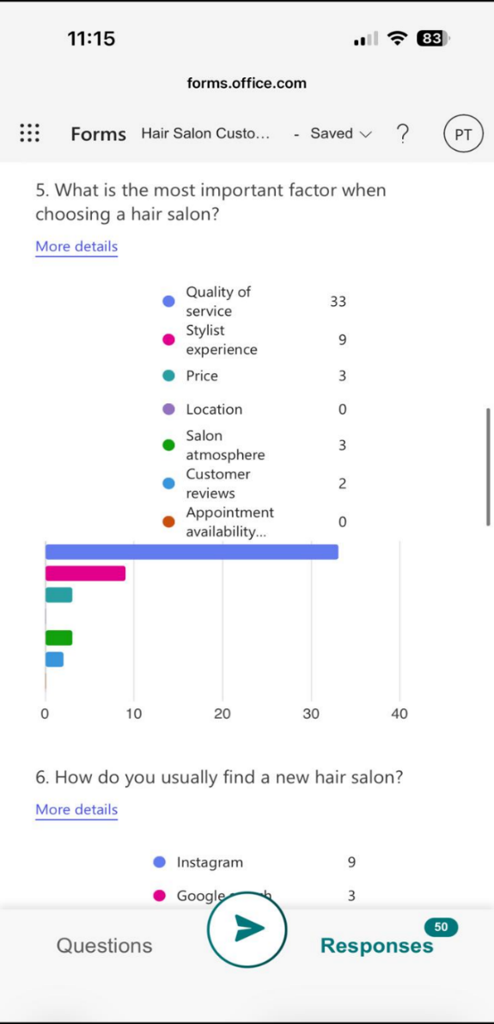
Figure 1: Factors influencing the choice of hair salon

Another important finding relates to how customers discover new hair salons. As illustrated in diagram in Figure 2, most respondents indicated that they find new salons through recommendations from friends, which received the highest number of responses 54%. Social media platforms such as Instagram and Facebook were also mentioned as important sources of information. These results demonstrate the strong influence of word-of-mouth marketing in the hairdressing industry. For Hairway to Heaven, this suggests that providing excellent service experiences is essential, as satisfied clients are more likely to recommend the salon to others.
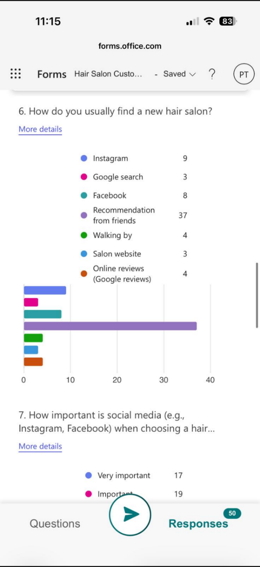
Figure 2: Platforms used by customers to discover new salons

The questionnaire also explored how much customers expect to pay for colouring services such as highlights, foils or balayage. As shown in Figure 3, the most common price expectation among respondents was £80 to £120, selected by 24 participants. A further group of respondents indicated that they would expect to pay between £120 to £160 for colouring services. These results suggest that many customers are willing to invest in professional colouring services when they perceive the value and quality of the treatment. For Hairway to Heaven, these findings provide useful guidance when developing pricing strategies that remain competitive while reflecting professional service quality.
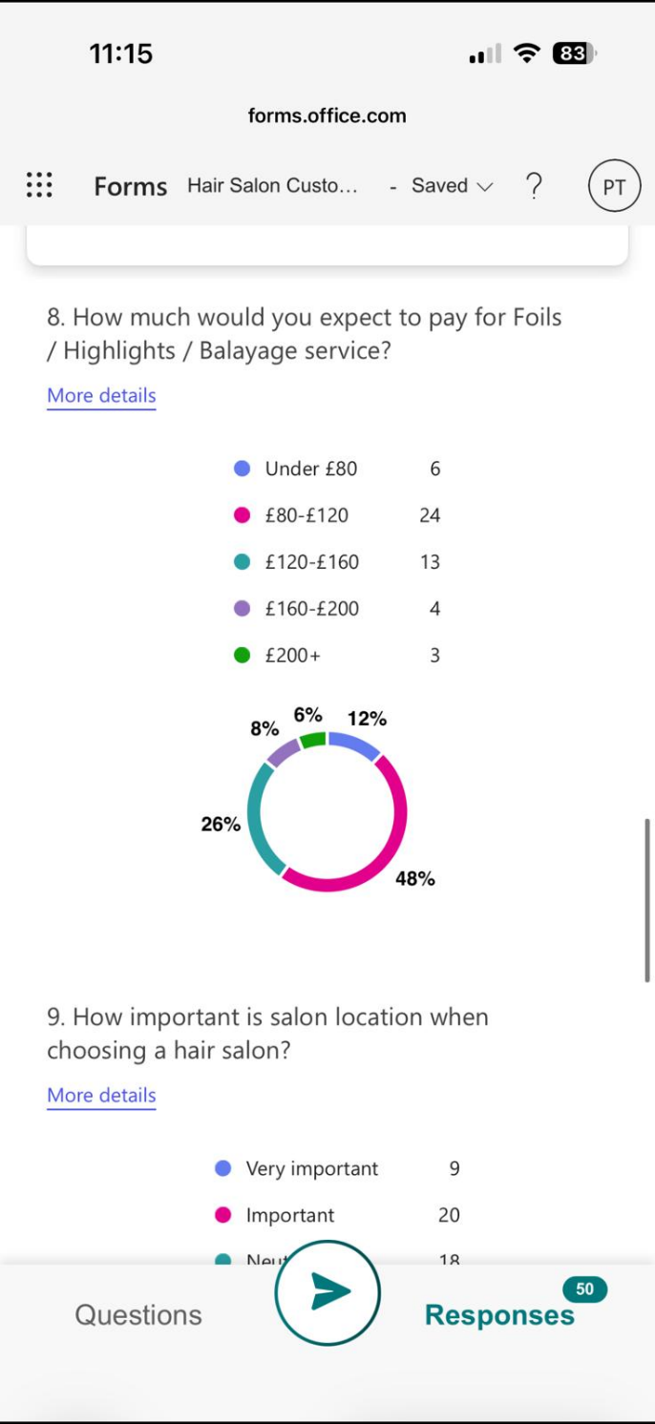
Figure 3: Expected price range for hair colouring services

Finally, the questionnaire examined customers’ preferred methods of booking hair appointments. As presented in Figure 4, the most popular option was text message or WhatsApp, followed by online booking through a website or application. Traditional booking methods such as telephone calls or visiting the salon in person were less frequently selected. This indicates that customers increasingly prefer quick and convenient digital communication when booking appointments. For Hairway to Heaven, offering booking options through messaging platforms and online systems may improve customer convenience and accessibility.
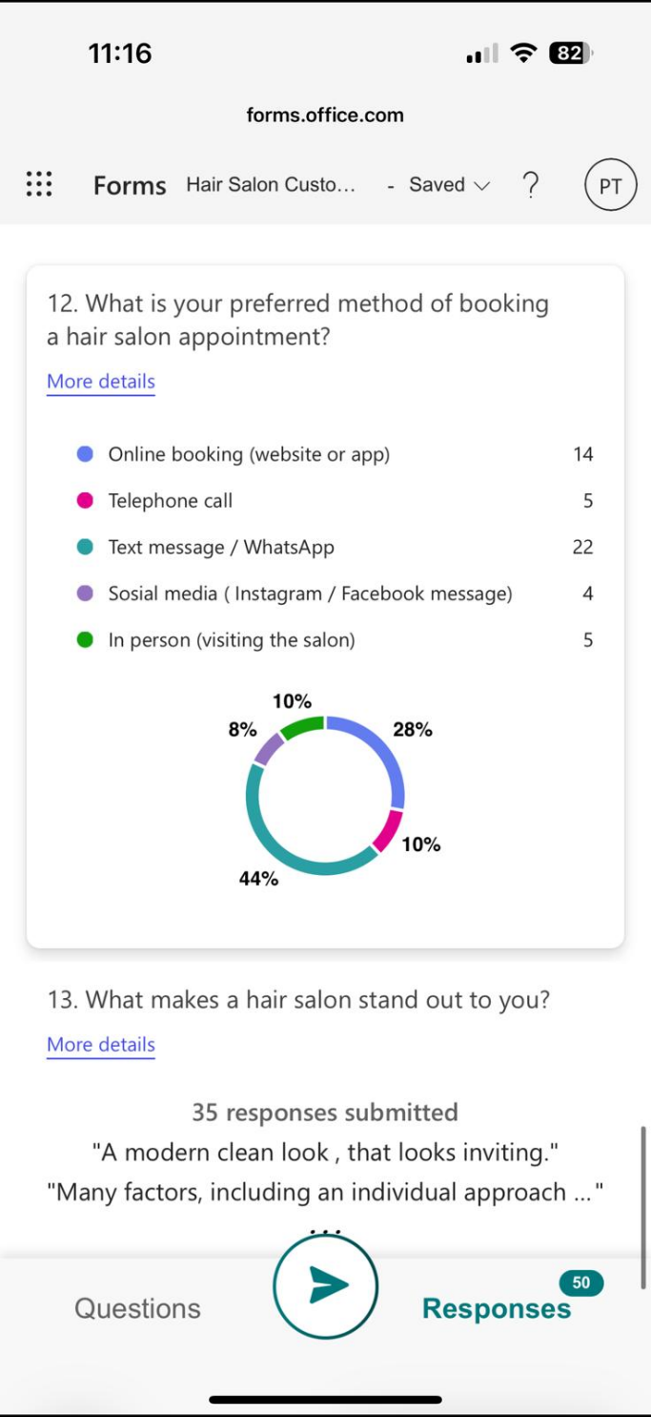
Figure 4: Preferred booking methods for hair appointments

Overall, the findings indicate that successful hair salons should focus on high service quality, competitive pricing and effective digital communication to meet customer expectations.

2.2 PERSONALISED SERVICES

The questionnaire findings suggest that customers value personalised services and tailored hair treatments. Many clients expect professional consultations that consider their individual hair type, lifestyle and desired results.

Personalised services allow hair professionals to better understand customer needs and recommend suitable treatments, colours and aftercare products. This approach can improve customer satisfaction and strengthen long-term relationships between the salon and its clients. Kotler et al. (2020) explain that businesses that understand customer needs and provide customised services are more likely to build stronger customer loyalty.

For Hairway to Heaven, personalised consultations form is very important part of the salon’s service concept. The website highlights consultation services, specialised colouring techniques and professional hair care solutions. These elements communicate expertise, attention to detail and a client focused approach.

Personalisation can also contribute to creating a premium customer experience. Atwal and Williams (2009) explain that service businesses can enhance customer satisfaction by focusing on memorable experiences rather than simply delivering functional services. In the hairdressing industry, this may include individual consultations, comfortable salon environments and professional product recommendations.

2.3 SEGMENTATION, MARKETING AND SEO STRATEGY
Based on the questionnaire results, a clear target audience can be identified for Hairway to Heaven. The findings suggest that the salon primarily targets clients who value professional colouring services, personalised consultations and high-quality treatments.
Market segmentation allows businesses to focus their marketing efforts on groups of customers with similar needs and behaviours. Kotler et al. (2020) explain that effective segmentation helps businesses create more relevant marketing messages and services for their target audience.
Social media platforms play an important role in the salon’s marketing strategy. Instagram and Facebook are particularly effective for hair salons because they allow businesses to showcase visual examples of their work, including before and after transformations and colour results. Visual content is especially influential in the beauty industry, where customers often want to see examples of previous work before choosing a salon (Tiago and Veríssimo, 2014).
The website design also incorporates search engine optimisation SEO strategies to improve online visibility. Keywords such as “hair salon Llanelli, balayage Llanelli” and “blonde specialist Llanelli” were included in the website content to improve search engine rankings. SEO strategies can help businesses reach potential clients who are searching online for local hair services (Vieira et al., 2022).
In addition to the website, the marketing strategy includes sharing examples of salon work on social media and encouraging clients to contact the salon through messaging platforms such as WhatsApp or Instagram. This approach reflects the booking preferences identified in the questionnaire.
Overall, the combination of market segmentation, social media marketing and SEO strategies helps Hairway to Heaven reach its target audience and increase its visibility in the local market.

3. REFERENCES
Atwal, G. and Williams, A. (2009) “Luxury brand marketing – The experience is everything,” The journal of brand management, 16(5), pp. 338–346. Available at: https://doi.org/10.1057/bm.2008.48.

Bulent Ozturk, A. (2023) Digital marketing and social media strategies for tourism and hospitality organizations. 1st ed. Edited by A.B. Ozturk and M. Hançer. Oxford: Goodfellow Publishers Limited.

Kulikovskaja, V. et al. (2023) “Driving marketing outcomes through social media-based customer engagement,” Journal of retailing and consumer services, 74. Available at: https://doi.org/10.1016/j.jretconser.2023.103445.
Kotler, P. et al. (2020) Principles of marketing. Eighth European edition. Harlow, England: Pearson.

Kotler, P. et al. (2025) Marketing management. 5th European edition. Harlow: Pearson. Available at: https://ezproxy.uwtsd.ac.uk/login?url=https://www.vlebooks.com/product/openreader?id=TrinityStD&accId=8886856&isbn=9781292458786&uid=^u.

McGruer, D. (2021) Dynamic digital marketing : master the world of online and social media marketing to grow your business. Chichester, West Sussex, United Kingdom: John Wiley & Sons Ltd.

Suyama, N. and Namatame, T. (2016) Competitive advantages of hair salon business influencing consumer behaviour. Asia Pacific Industrial Engineering & Management Systems Conference. APIEMS2016_FullPaper_suyama_camera_ready-libre.pdf

Tiago, M.T.P.M.B. and Veríssimo, J.M.C. (2014) “Digital marketing and social media: Why bother?,” Business horizons, 57(6), pp. 703–708. Available at: https://doi.org/10.1016/j.bushor.2014.07.002.
Vieira, V.A. et al. (2022) “Optimising digital marketing and social media strategy: from push to pull to performance,” Journal of marketing management, 38(7–8), pp. 709–739. Available at: https://doi.org/10.1080/0267257X.2021.1996444.
Wibowo, A. et al. (2021) “Customer Behavior as an Outcome of Social Media Marketing: The Role of Social Media Marketing Activity and Customer Experience,” Sustainability, 13(1), p. 189. Available at: https://doi.org/10.3390/su13010189.

Appendix A - Questionnaire used for market research
1. What is your gender?
2. What is your age group?
3. How often do you visit a hair salon?
4. Which hair service do you use most often?
5. What is the most important factor when choosing a hair salon?
6. How do you usually find a new hair salon?
7. How important is social media (e.g., Instagram, Facebook) when choosing a hair salon?
8. How much would you expect to pay for a highlights or balayage service?
9. How important is salon location when choosing a hair salon?
10. How important is parking availability when visiting a hair salon?
11. Which online platform do you use the most when choosing a hair salon?
12. What is your preferred method of booking a hair salon appointment?
13. What makes a hair salon stand out to you?

Appendix B - Website screenshots

First page of the Hairway to Heaven website
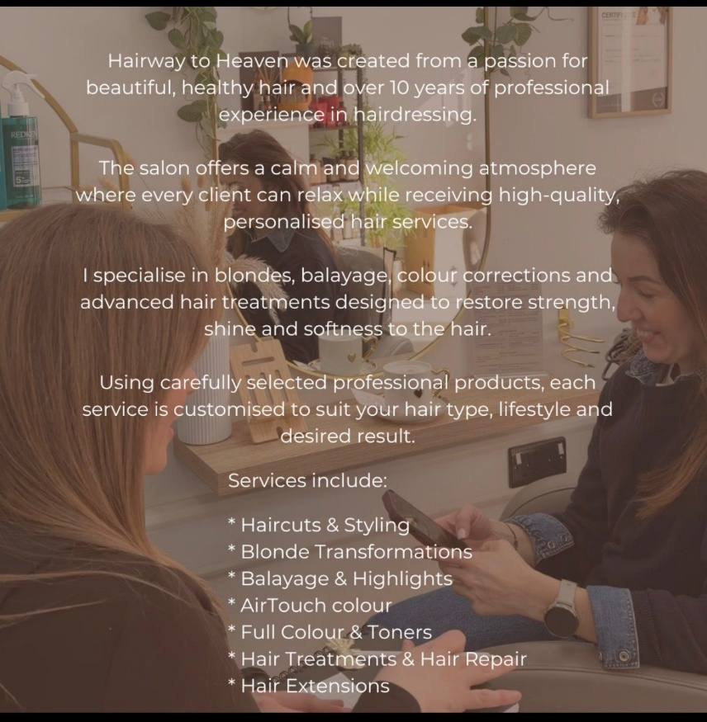
Second page of the website showing services
Appendix C - Canva marketing material

Marketing materials created in Canva (price list and business card)

Appendix D - social media platforms, Instagram and Facebook 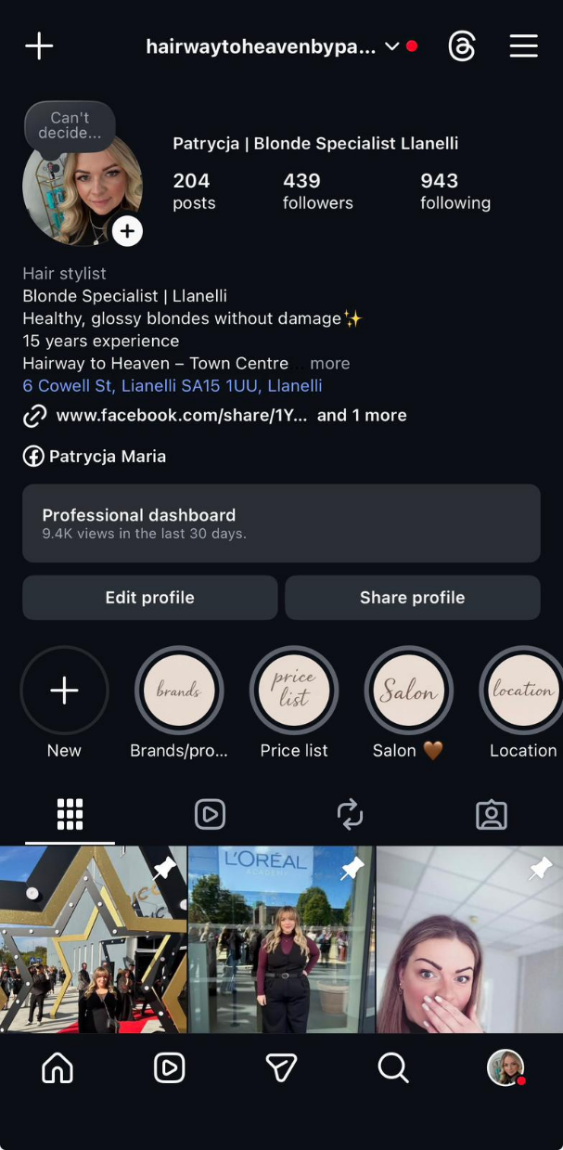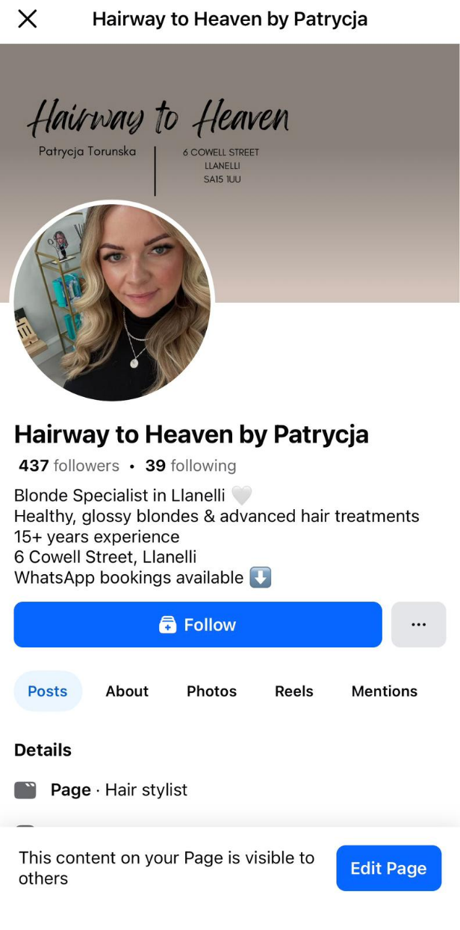
Social media platforms used for salon promotion (Instagram and Facebook)

The Importance of Microsoft Excel in the Digital Era for Small Business Management

In the modern digital era businesses rely heavily on digital tools to manage information, analyse data and support decision making. One of the most widely used tools in business environments is Microsoft Excel. Excel is a spreadsheet software that allows users to organise data, perform calculations and visualise information. For small businesses Excel plays a particularly important role because it provides an accessible and efficient way to manage financial data. This essay discusses the importance of Excel in the digital era and explains how it can support financial management and decision making for small businesses.

Microsoft Excel is commonly used to organise and analyse financial information. Businesses must monitor their income, expenses and profits to remain financially stable. Financial management involves planning, controlling and analysing financial resources within an organisation (Laws, 2018). Excel allows businesses to record financial transactions in a structured format and to track financial performance over time. For example, a business owner can create spreadsheets that show monthly income, operating costs and overall profit. By using formulas such as SUM and subtraction functions, businesses can quickly calculate totals and identify financial trends.

One of the key advantages of Excel is its ability to support data analysis and financial decision making. Spreadsheet systems are widely used in business environments because they help managers organise complex data and analyse different scenarios (Irawati, Andrian and Dewantoro, 2020). In small businesses, spreadsheets can be used to estimate costs, forecast revenue and monitor financial performance across different months of the year. For example, a salon owner may track service income, product sales and operational expenses in a spreadsheet. By analysing this data, the business owner can identify which services generate the most profit and which costs need to be controlled.

Another important benefit of Excel is its role in supporting business planning and financial forecasting. Financial forecasting allows businesses to estimate future income and expenses to make better strategic decisions. Excel provides various tools such as formulas, charts and tables that allow users to visualise financial information clearly. According to Siddiqui (2026), digital tools that support financial accounting help organisations make more informed decisions. By using Excel spreadsheets, business owners can analyse financial performance and identify potential risks or opportunities.

In addition to financial analysis, Excel also supports data visualisation. Charts and graphs allow businesses to present financial information in a clear and understandable format. For example, bar charts can be used to compare monthly income and expenses. Visual data helps business owners quickly understand patterns and trends within their financial data. This can improve decision making because it allows managers to identify problems and opportunities more easily. The ability to convert raw data into visual insights is one of the reasons why spreadsheet tools remain important in modern digital environments.

Excel is also widely used in education and professional training because it helps individuals develop digital and analytical skills. Spreadsheet software allows students and professionals to learn how to organise data, perform calculations and interpret financial information. According to Mansouri and Hornblower (2026), tools such as Excel play an important role in accounting and financial education because they help users move from confusion to clarity when analysing financial data. These skills are particularly valuable in business environments where data driven decision making is extremely important.

Furthermore, digital technologies are transforming how businesses operate and manage information. Modern organisations rely on digital systems to improve efficiency and productivity (Mahmoud et al., 2025). Tools such as Excel support digital transformation by enabling businesses to process large amounts of data efficiently. Even small businesses can use spreadsheets to manage operations, track performance and improve financial transparency. This is particularly important in competitive markets where businesses must respond quickly to changes in demand and costs.

For small business owners, Excel can also support marketing and customer analysis. Data collected from customers, sales and services can be organised in spreadsheets and analysed to identify patterns in consumer behaviour. Understanding customer preferences can help businesses improve services and develop better marketing strategies. Research shows that digital technologies are increasingly used to analyse consumer behaviour and improve marketing activities (Sidra and Wagan, 2026). Therefore, tools like Excel can support not only financial management but also strategic planning and business growth.

In conclusion, Microsoft Excel remains one of the most important digital tools for business management. It allows businesses to organise financial data, perform calculations and analyse information in an efficient way. Excel supports financial management, decision making and data visualisation, which are essential for successful business operations. For small businesses, such as independent salons or service providers, Excel provides a simple and cost-effective solution for managing finances and analysing performance. In the digital era, developing spreadsheet and data analysis skills is increasingly important for business success and long-term sustainability.

References:
Mahmoud, M.H. et al. (2025) “The impact of digital HRM system and digital transformation on HR efficiency with organizational agility as a moderator,” Discover sustainability, 6(1). Available at: https://doi.org/10.1007/s43621-025-01713-9.

Irawati, D.Y., Andrian, D. and Dewantoro, A.D. (2020) “SPREADSHEET BASED BUSINESS DECISION MAKING SYSTEM (CASE STUDY IN BONOROWO LAND, LAREN, LAMONGAN),” Spektrum industri, 18(2), pp. 195–202. Available at: https://doi.org/10.12928/si.v18i2.16967.

Siddiqui, S.A. (2026) “Accessing Research‐Informed Instructional Strategies to Teach Financial and Managerial Accounting: A Review and Recommendations,” Accounting perspectives, 25(1), pp. 147–190. Available at: https://doi.org/10.1111/1911-3838.70004.

Sidra, S. and Wagan, S.M. (2026) “How artificial intelligence enabled marketing activities will change consumer behavior,” Discover Artificial Intelligence, 6(1). Available at: https://doi.org/10.1007/s44163-025-00735-6.

Kouame, J.M. et al. (2025) “Modeling in R: a practical application using a cost-effectiveness analysis,” Health Economics Review, 15(1). Available at: https://doi.org/10.1186/s13561-025-00686-9.

Laws, J. (2018) Essentials of Financial Management. Liverpool: Liverpool University Press. Available at: https://doi.org/10.3828/9781786942050.

Yousefvand Mansouri, R. and Hornblower, S. (2026) “From Chaos to Clarity: ‘Excel’ in Accounting,” Issues in accounting education, pp. 1–15. Available at: https://doi.org/10.2308/ISSUES-2024-041.

Video advert
link below
20260315_080951000_iOS.MOV

