Olesia Tarytsa (2024821)
Digital skills and Research Methods (BMSW4003)
John Malagila
Digital skills in Healthcare

The use of contemporary technology in healthcare (diagnostic, administrative and care support)
Technology has brought about a massive and welcome change to the healthcare industry. Patients now have access to some of the best diagnostic tools, new and cutting-edge treatments, and a myriad of minimally invasive procedures resulting in less pain and quicker healing.1.
The following aspects explain how technology has changed the healthcare industry.
Digitization of Health Records
Digitization of health record facilitates efficiency and delivery of healthcare to remote or inaccessible locations. This digitization has the potential to streamline processes, improve patient outcomes, and reduce costs.
Mobile App Technology in the Medical Field
Not only do patients have access to quick and accurate medical information using their handheld devices, but they can also use apps to keep track of doctor’s appointments, get reminders to take their medications.
Electronic Medical Records
Electronic medical records or Electronic Health Records consist of digital summaries of a patient’s medical records. They could include diagnoses, lab reports, and details about hospital stays, surgical interventions, and prescriptions.
Big Data and the Cloud
Cloud storage of data helps improve efficiency and accessibility while reducing wastage. This also helps in research and development of new treatment protocols and lifesaving pharmaceutical formulations. 2.
Health information technology improves patient safety by reducing medication errors, reducing adverse drug reactions, and improving compliance to practice guidelines. There should be no doubt that health information technology is an important tool for improving healthcare quality and safety, but healthcare organizations need to be selective in which technology to invest in, as literature shows that some technologies have limited evidence in improving patient safety outcomes.3.

The use of technology during Covid-19
Covid-19, an infectious disease caused by the novel severe acute respiratory syndrome coronavirus is a global pandemic. With high transmissibility, a case fatality rate greater than 1% and no effective antiviral therapy, the mainstay of pandemic management has been containment and mitigation.
However, despite relying on established public health principles, countries across the world have had varying degree of success in managing the burden of COVID-19.7.
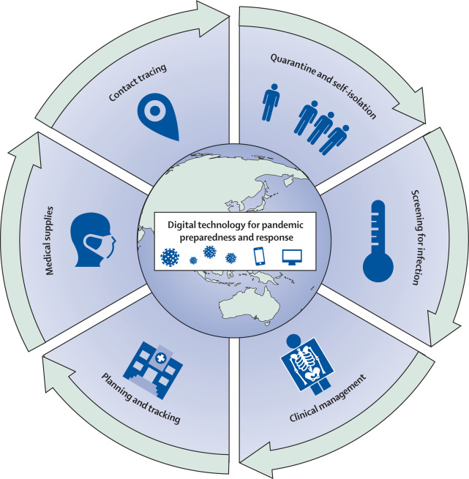
Figure 1: Digital technology as a tool for pandemic preparedness and response
Source: URL https://ars.els-cdn.com/content/image/1-s2.0-S2589750020301424-gr1.jpg
[Accessed 25 April 2021]

Table 1. Digital technology initiatives used in pandemic preparedness and response.
 | Functions | Digital technology
Planning and tracking | Track’s disease activity in real time | Data dashboards, migration maps, machine learning, real-time data from smartphones and wearable technology.
Screening for infection | Screen’s individuals and populations foe disease | Artificial I intelligence, digital thermometers, mobile phone applications.
Contact tracing | Identifies and tracks individuals who might have came into contact with an infected person | Mobile phone applications, real-time monitoring of mobile devices.
Quarantine and self-isolation | Identifies and tracks infected individuals, and implements quarantine | Cameras and digital recorders, global positioning systems, mobile phone applications.
Clinical management | Diagnoses infected individuals; monitors clinical status; predicts clinical outcomes; provides capacity for telemedicine services and virtual care | Machine learning; virtual care or telemedicine platforms

The integration of digital technology into pandemic policy and response could be one of several characteristic features of country that have flattened their COVID-19 incidence curves and maintained low mortality rates. In the race to contain the spread of a highly transmissible virus, country that have quickly deployed digital technologies to facilitate planning, surveillance, testing, contact tracing, quarantine, and clinical management have remained front-runners in managing disease burden.8.

The use of digital communication, collaboration, and participation
Digital Communication, Collaboration and Participation involves behaviours and attitudes for working with others in digital spaces. For example, communicating in text-based forums or building digital networks through social media.
Below in the table 2 I compare how each aspect we can use.
Digital Communication | Digital Collaboration | Digital  Participation
Use digital communications to support learning example through webinars, tutorials, mentoring, online lectures, email, chat. | Participate in digital teams and working groups example around curriculum development and review. | Participate actively in social media relevant to your professional role and interests.
Communicate ideas in a range of digital media and in accordance with different cultural, social and communication norms. | Collaborate effectively in digital spaces example building shared resources, wikis, web pages, digital writing, and presentations. | Share learning and teaching materials, presentations, resources etc on appropriate digital sites and networks.
Respect others in public communications; maintain privacy in private communications.

So, we can use digital communicate effectively in digital media and spaces; digital collaboration to participate in digital teams and working groups and digital participation to participate in, facilitate and build digital networks.6.

Digital identity, well-being, and safety
I would imagine that most of us, when we are posting on Facebook, Twitter, or Instagram, are not aware that we are developing and projecting digital identities. We are aware that what we post is seen and reacted to, but do we consider how this shapes our identity or an identity of ours? And if we aren’t even aware we are doing this, how can we be expected to manage it?
To me, Digital Identity Management is all about awareness. It is being aware of what we are already doing on social media, how accessible and far-reaching that is and deciding what we are happy to broadcast and what we would prefer to keep private.
Digital Identity and Wellbeing are not the only digital capabilities. Below is a diagram of the six key elements of the digital capability framework and how they relate to each other.
We can see that Digital Identity and Wellbeing form a key element which encompasses all others.4.
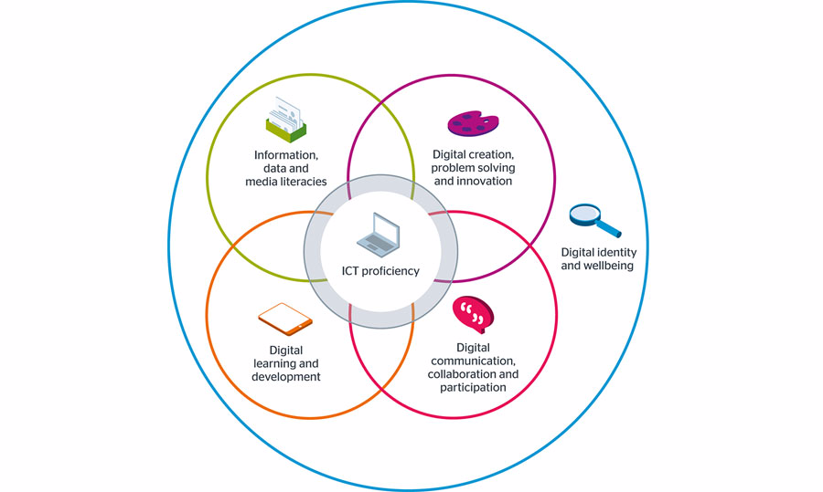
Figure 2: Building digital capability
Source: URL https://blogs.qub.ac.uk/digitaldiscovery/wpcontent/uploads/sites /156/2019/10/digital-capability-model-wide.png [Accessed 25 April 2021]
The capabilities of Digital Identity and Wellbeing harness and support all others. If you can protect yourself online, regarding privacy, data, identity, wellbeing, and mental health, then you have the essential foundations on which you can begin to build and develop your other capabilities. This makes Digital Identity and Wellbeing a very good place to start when it comes to digital capabilities, as they allow you to thrive in all other aspects of digital use.

The use of digital literacy for professional career development (teaching, e-learning and self-development)
Digital literacy means having the skills you need to live, learn, and work in a society where communication and access to information is increasingly through digital technologies like internet platforms, social media, and mobile devices.9.
Digital literacies encompass a range of other capabilities represented here in a seven elements model:
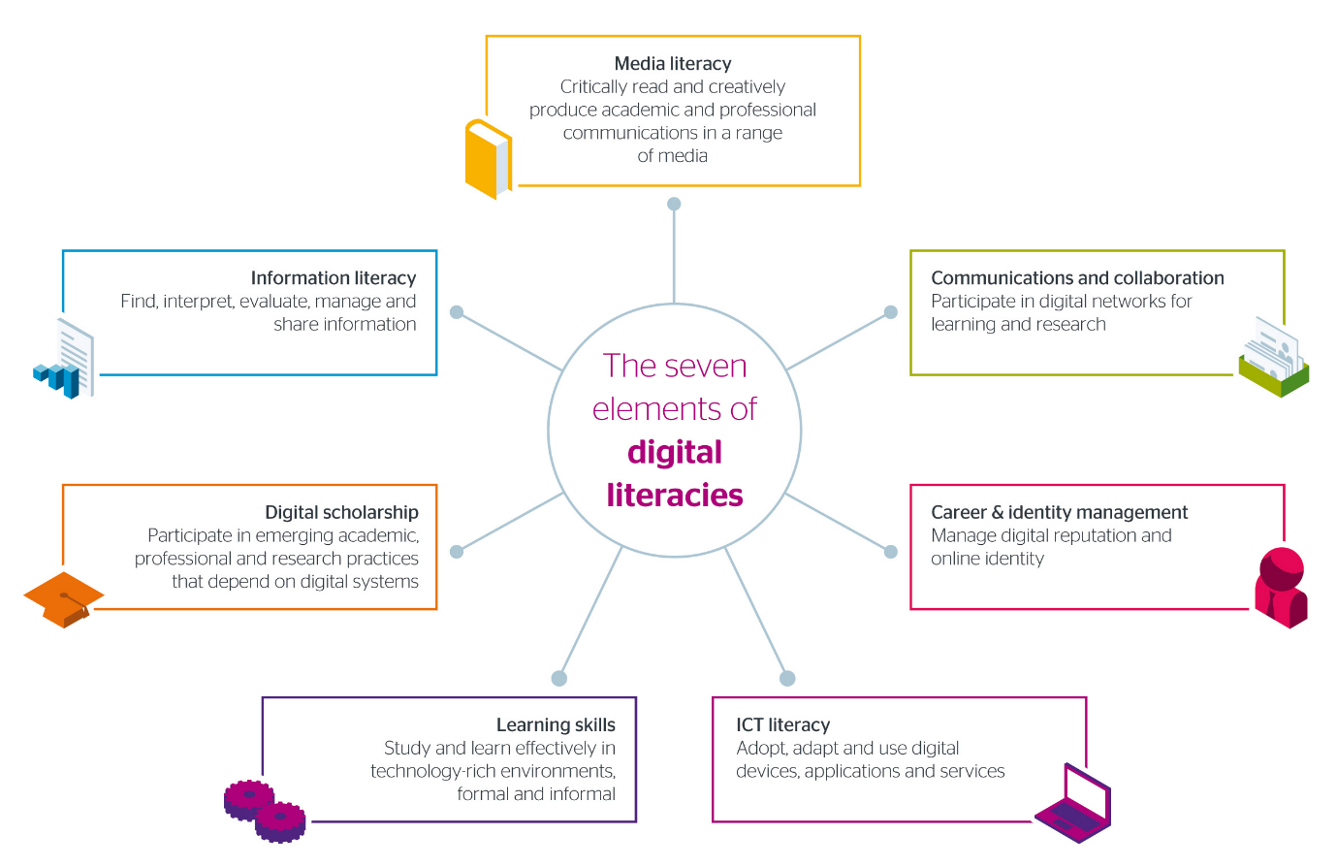
Figure 3: The seven elements of digital literacies
Source: URL https://www.jisc.ac.uk/sites/default/files/7-elements.png
[Accessed 25 April 2021]
Digital literacy is an important and evolving concept directly related to the open’s employability and prospects for keeping the job in the long term. Since the first definition of digital literacy appeared, the labour market has changed significantly demanding from researchers, educators, employers, and students to advance their understanding of digital literature and related skills. The results are many views on digital literacy and its different applications in education, at work and in private life. Today, when an increased number of jobs has moved online, educational systems worldwide are comp with changes to respond to the current needs of their national and global labour market.10.
The relevance of technical proficiency for information, data handing
Technical skills are the expertise and competence required to perform specific digital or physical tasks. No matter what industry you or employees are in, knowledge of some technical skills will be required to fulfil day-to-day performance.
Technical skills might include:
- Programming languages
- Common operating systems
- Software proficiency
- Technical writing
- Project management
- Data analysis
Technical skills are important because nearly every job relies on difference tools, programs, and processes. If you have sought-after technical knowledge and skills common in your industry, you will be a more competitive candidate.11.
Data handling is the process of ensuring that research data is stored, archived, or disposed of in a safe and secure manner during and after the conclusion of a research project. This includes the development of policies and procedures to manage data handled electronically as well as through non-electronic means.
Data handling is important in ensuring the integrity of research data since it addresses concerns related to confidentially, security, and preservation/retention of research data. Proper planning for data handling can also result in efficient and economical storage, retrieval, and disposal of data. In the case of data handled electronically, data integrity is a primary concern to ensure that recorded data is not altered, erased, lost, or accessed by unauthorized users.

References:
- Litt, E. (2013). Measuring users’ internet skills: a review of past assessments and a look toward the future.
- Godoe, P, Johansen, TS. (2015). Understanding adoption of new technologies: technology readiness and technology acceptance as an integrated concept.
- URL https://www.ncbi.nlm.nih.gov/pmc/articles/PMC5787626/ [Accessed 23 April, 2021]
- URL https://blogs.qub.ac.uk/digitaldiscovery/2019/10/11/digital-identity-manage ment-and-digital-wellbeing-unpacked/ [Accessed 25 April, 2021]
- Moore, N. (2016). Digital Career Management Skills. Career Matters.
- URL https://tel.yorksj.ac.uk/digital-communication-collaboration-and-participat ion/ [Accessed 25 April, 2021].
- Ferretti L., Wymant C., Kendall M., et al. (2020). Quantifying SARS-COV-2 transmission suggests epidemic control with digital contract tracing.
- URLhttps://www.sciencedirect.com/science/article/pii/S2589750020301424 [Accessed 25 April, 2021].
- Bhatt I., (2012). Digital literacy practices and their layered multiplicity. Education all media international.
- URL https://www.indeed.com/career-advice/resumes-cover-letters/technical-skills [Accessed 25 April, 2021].
- URL https://ars.els-cdn.com/content/image/1-s2.0-S2589750020301424-gr1.jpg [Accessed 25 April 2021].
- URL https://blogs.qub.ac.uk/digitaldiscovery/wpcontent/uploads/sites /156/2019/10/digital-capability-model-wide.png [Accessed 25 April 2021].
- URL https://www.jisc.ac.uk/sites/default/files/7-elements.png [Accessed 25 April 2021].

