10 learning reinforcement activities focusing on understanding research philosophy:

1. Paradigm Exploration
Take any business news article from today's Guardian Business pages https://www.theguardian.com/uk/business
Identify how the same business phenomenon could be studied from both objectivist and subjectivist positions. Write two potential research questions - one from each position.



From an Objectivist Position:
- Ontology: Reality exists independently of social actors
- Epistemology: Knowledge is discovered through measurable facts
- Research Question: "What is the quantifiable impact of executive-led business cuts on organizational performance metrics across technology companies between 2020-2024?"
- This approach would focus on measuring concrete variables like:
- Financial performance metrics
- Employee turnover rates
- Market share changes
- Productivity indicators

From a Subjectivist Position:
- Ontology: Reality is socially constructed
- Epistemology: Knowledge is created through interpretation of meanings
- Research Question: "How do employees and managers make sense of and navigate their changing organizational identities during periods of significant business cuts?"
- This approach would explore:
- Individual experiences
- Power dynamics
- Cultural shifts
- Narrative construction

Both approaches would yield valuable but different insights into the business cuts phenomenon. The objectivist approach would provide measurable impacts, while the subjectivist approach would reveal deeper understanding of human experiences and organizational meaning-making.

2. Personal Philosophy Reflection
Write a one-paragraph reflection on your initial thoughts about reality in your research area. Is your natural inclination towards seeing your research phenomenon as objective or subjective or both ? Why?
From a subjective perspective, problem gambling is deeply rooted in individual experiences, personal triggers, and social contexts that shape addictive behaviours. My natural inclination is subjective because each gambler's journey, motivations, and recovery needs are unique, influenced by their personal circumstances, emotional states, and social relationships. Understanding these individual realities is crucial for developing effective management interventions.

3. Research Question Analysis
In pairs, examine three published thesis titles or abstracts (below). Identify whether each appears to take an objectivist or subjectivist approach. What clues led you to this conclusion?

4. Methodology Matching
List three different business phenomena you're interested in studying. For each, write how you might study it using:
- A purely objective approach
- A purely subjective approach
What different insights might each approach offer?
From a purely objective perspective, problem gambling can be measured through quantifiable metrics and observable behaviors independent of individual interpretations. I view this phenomenon objectively because it can be studied through concrete data points like frequency of gambling, monetary losses, time spent gambling, physiological responses, and statistically significant patterns of behavior. Understanding these measurable variables is essential for implementing evidence-based interventions and control measures.
Problem gambling can be objectively measured through concrete data: frequency of transactions, monetary losses, time spent gambling, and physiological responses. These measurable variables exist independently of individual interpretations, allowing for statistical analysis and evidence-based interventions based on verifiable patterns of behavior rather than personal experiences.
5. Values Exercise
Choose one business issue you care about (e.g., sustainability, workplace diversity). Write down:
- Your personal values about this issue
- How these values might influence your research
- How you could acknowledge these values in your research
Your personal values: I value empathy, individual dignity, and believe addiction recovery requires understanding each person's unique story and circumstances.

Influence on research: These values could lead me to prioritize personal narratives and emotional experiences over quantitative data, potentially overlooking measurable patterns.

Acknowledging values: Being transparent about my empathetic approach while incorporating multiple data collection methods to ensure balanced research perspectives.

6. Knowledge Source Identification
For your research interest:
- List three objective sources of knowledge
- List three subjective sources of knowledge
- Explain how each type of knowledge would contribute differently to understanding your topic
Objective Sources of Knowledge:
1. Transaction records from gambling operators showing exact amounts spent and frequency of bets
2. Medical brain scans showing neurological responses during gambling activities
3. Database statistics of self-exclusion programs and their success rates in preventing relapse

Subjective Sources of Knowledge:
1. In-depth interviews with gamblers about their personal experiences and recovery journeys
2. Personal diaries/journals of problem gamblers documenting their emotional triggers and thought processes
3. Support group observations capturing shared narratives and meaning-making among problem gamblers

7. Research Alignment Check See Tile 1 Week 3 Research Philosophy
Look at the article - "Identity Work and Legitimacy by Tracey and Phillips (2016) published in Organization Science) a published business research article and create a table showing the alignment (or misalignment) between its:
- Research question
- Philosophical position
- Methodology
- Data collection methods

8. Cultural Context Mapping
For your research interest:
- List three ways societal context might influence your research
- List three ways your own background might influence how you interpret data
- Suggest how you might address these influences
Societal Context Influences:
1. Current social media glamorization of gambling might bias participant responses
2. Cultural attitudes toward addiction as moral failing vs. medical condition
3. Economic climate affecting gambling behaviors and accessibility

Personal Background Influences:
1. My middle-class background might affect understanding of financial risk perceptions
2. Having known problem gamblers could create preconceptions about typical behaviors
3. No personal gambling experience might limit understanding of the attraction

Addressing These Influences:
1. Use reflexive journaling to document and examine my assumptions
2. Include diverse participants from different socioeconomic backgrounds
3. Have findings reviewed by researchers with different perspectives and gambling industry experience
9. Phenomenon Breakdown
Choose one business phenomenon (e.g., leadership, innovation, consumer behaviour). Create a mind map showing:
- Observable elements
- Measurable aspects
- Interpretive elements
- Subjective aspects

10. Paradigm Practice
Take one simple business event (e.g., a company's share price falling). Write two short paragraphs explaining this event:
- One from an objectivist viewpoint
- One from a subjectivist viewpoint

Example 1 Flexibility and line manager relationships with staff

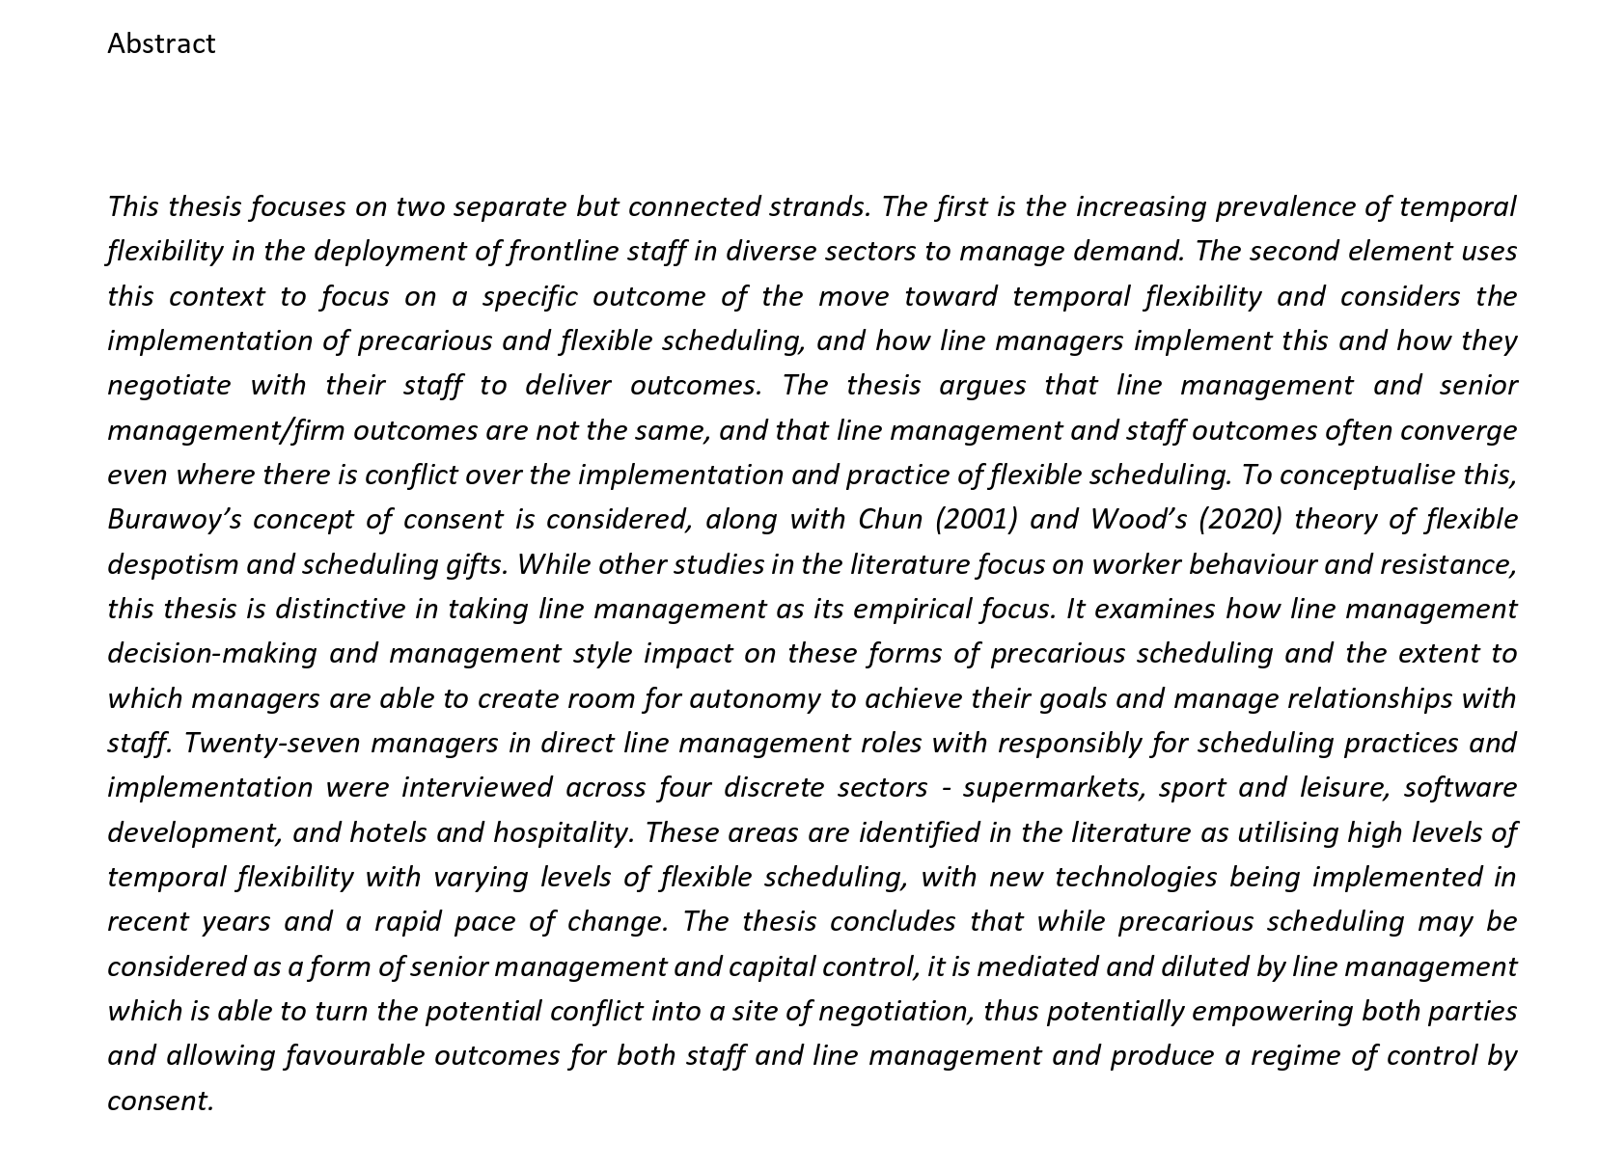

Example 2 Public Accountability: Management Consultants in the NHS

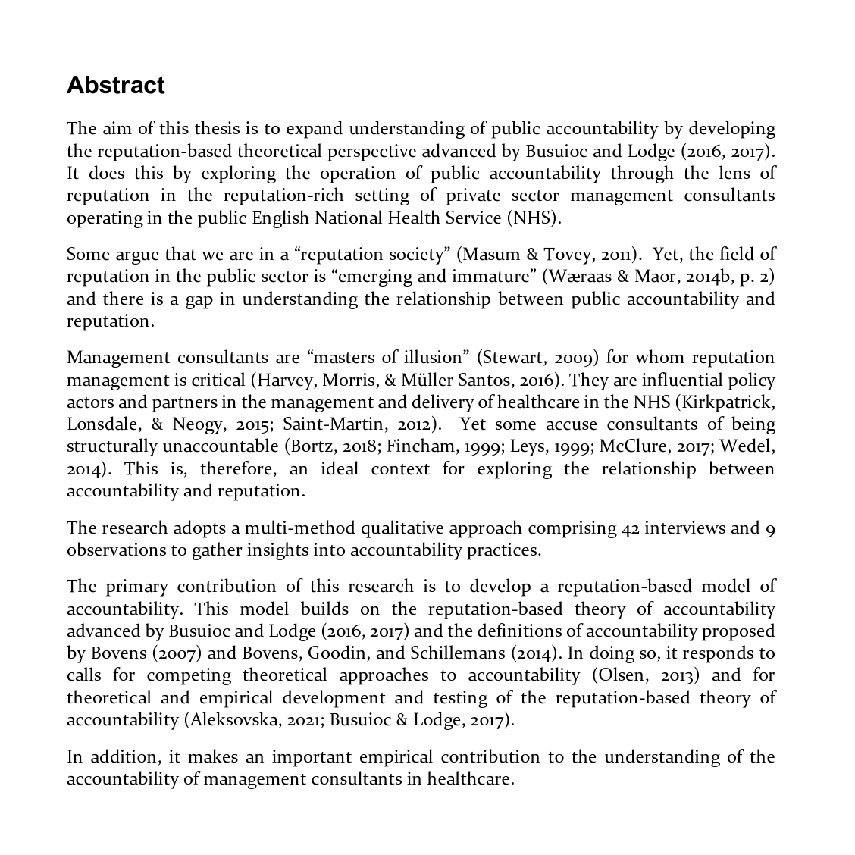

Abstract 3 Corporate social responsibility, employee identification and organisational identification

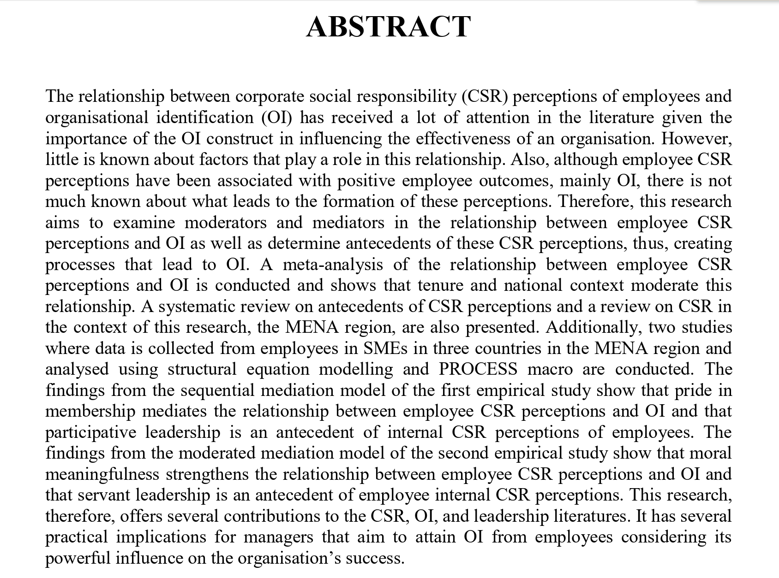

Example 4 Ecopreneurship and sustainability



