SALES MARKETING PLAN

Marriott Stanton South Beach

Iris P. Barreiro Ekoro
ID: 2127100
Marketing Essentials (BMIH4005 RESIT)
Chris Wilkin

The goal of the hotel is to generate new customers as we come out of the pandemic. Taking advantage of the Spring Break season, easter holidays. The mission is to achieve a high quality service for the costumers through an exceptional experience. Providing FREE updates to those who have been affected by of COVID-19. For new customers, the hotel will offer discounts on attractions and amenities related to the company. Offering discount bonus to spend within the company or with brands external to the company, but that are associated with it. That is why, it is important as a business to partner with local brands that live up to what we offer. For example; an excursion to the famous Everglades Safari Park. Also, the activities at the beach discounted prices at the time to rent a jet sky. These packages will help us attract new customers. Also, the experience as we mentioned before. Our staff will be prepared to offer an experience beyond accommodation.

The Marriott Stanton is a four start beachfront hotel situated in the glamorous Ocean Dr, Miami Beach, USA. The hotel, is in one of the most prestigious Art Deco neighbourhoods of south beach, it is ten minutes walk from south beach nightlife and shops. Easy access to the airport, the property counts with 224 rooms, some with balconies and ocean view. All rooms are provide with high speed internet, mini bar, hairdryer, coffee maker. We are gladly to announce that the hotel is pet friendly. Clients that will love to travel with their pets, will have to let the hotel know in advance. Stanton hotel also counts with a business centre and meeting rooms for our business events. These rooms are adapted with the necessary security measures to offer a safe environment, coming from a pandemic. The Marriott Stanton is committed to environmental sustainability.
Our on-site cigar shop, Starbucks and gelato shop are one of the best attraction in the hotel. Also the restaurant, Deco Blue, offering and working with local products.

Businesses have to make competitive analysis, to look at the hotel and the competitors it may have. The similarities the hotel can have with the others competitors are in terms of price, facilitates and proximity to other amenities in the area. For instance, having the Hilton and Fontainebleau as direct competitors. The hotel, our hotel, should analyse competitors in terms of the location, guest and staff facilities, service, price. All this are points to take into consideration. This type of analysis can be used more than once, hotels use it to study their competence.

The SWOT analysis is a tool in hospitality that will help planning and decision making, where the team will observe the strength, weakness, opportunities and threats of our business and competitors too.
Strength:
Workers are train to provide customer excellent service.
- Excellent teamwork.
- Prepare to multitask at busy times.
- Attention to detail.
- Great communication skills
Weakness:
Crucial part in our SWOT analysis giving us a competitive in the market knowing where we stand. For example; ensure hotel prices are reasonable for our customers. High prices can push customers away.
Opportunities:
Focus on Millennials first to travel. First to risk the adventure of travelling. Also, work with domestic tourism to attract more customers. Take advantage during the pick season to attract new domestic and international customers. Keep promotions during off season as well. Offer landmarks that other hotels are not, that are worth to visit.
Treats:
Another important part for the analysis. COVID-19, it is a clear example of the biggest treats the industry is going through right now. We are fighting with the unknown.

As we all know, there are some external forces that influence the economy of a country. These also affect the hospitality industry. PESTLE stands for the six external factors that affect the business.
Political: The hotels depend on tourism and it is up to the regulations of the country. For example; a open government attracts more tourists. Government carry out policies that benefit the industry.
Economic: Part of this industry counts with numerous luxury resorts. So, an economic change will impact the hotel industry. Inflations and other economic problems affect the ability of our customers to afford hotels. Currency exchange it’s another element that affect travellers.
Sociological: People are able to share their experiences and attract other costumers to the business. For instance; discount packages allows customers to stay longer and upgrade their staying. Hotels are becoming more prepared with the different types of cultures and they are ensuring to be prepared for them. Discrimination is not allow in the business.
Technological: All hotels provide CCTV for security services. Also, WI-FI, phones, intercoms are example of technological services the business offers. The facility to book a hotel from different points of the world, just with a button. The reviews of customer improve the services and problems the hotel may have and can notice it.
Legal: This point is very important for the growth of the business. For example; city fees, tax deductions or discrimination laws. Some of the countries that enjoy government benefits are European and American hotels. Here is where health and safety laws apply as well. The use of identification becomes more strict to use the facilities. Staff members should always carry their identification.
Environmental: Countries with severe conditions are the most affected at the time to growth in the sector. For example; the weather is one of the environmental issues. The use of disposable objects inside the business can cause environmental concerns
All these factors can have an effect in the business. Short and long term goals duration can be affected. PESTLE analysis will provide us with a clear view into our industry.

At Marriott Stanton, customer value is a must. It is essential to interact with the customers through the right marketing channels. Keeping our clients engaged with the promotions and during the purchase process. Create great relationship with the clients to build a strong brand loyalty. That is why, we will create a great live experience to the customers while they staying with us.
Keeping customers reservations and offering a FREE update to those who are loyal to the hotel. In this way we will increase loyalty to our brand.

Digital marketing will help the business services to create smooth relationships with the customers. Through other platforms such as:
- Social Media
- Blogs
- Webs
- Radio
- Promoters
- Facebook, Instagram…
Digital Marketing plays an important role in the hospitality industry, it is the way business communicate with customers. We are in a word, where marketing plays an important role to the business. Nowadays, marketing and design are very important for any project. It makes the brand stronger.

In conclusion, the importance to create a strong marketing plan is crucial for the business. To retain and attract customers, to generate prestige and be above our competitors. Furthermore, is very important to send a clear and understanding message to our customers. Prioritised and make it easier for the customer. Promote our product an explain the advantages, the company offers them. Those affected during the pandemic, will also be able to enjoy it, even if the promotion was not when you purchased the reservation. Everybody is scared of the new normality and they do not know what to expect from it.

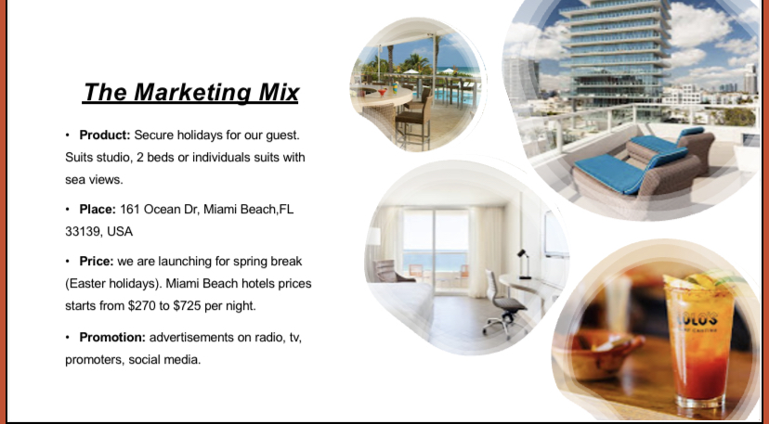
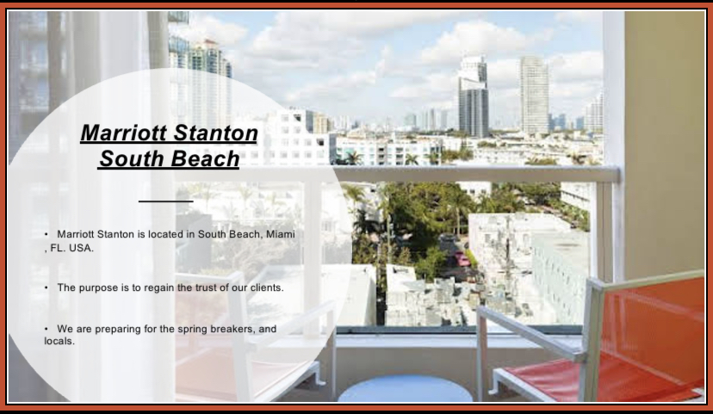
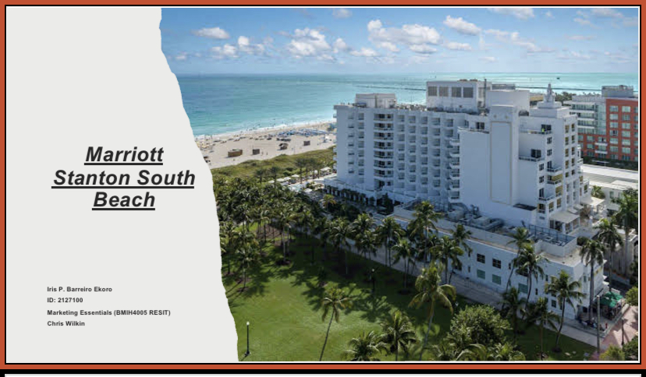
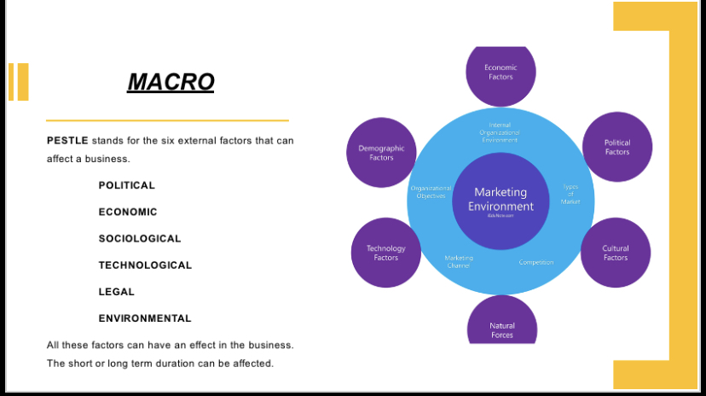
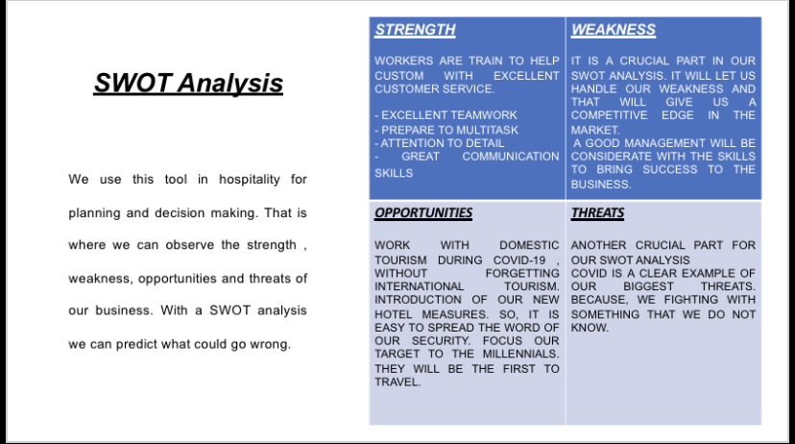
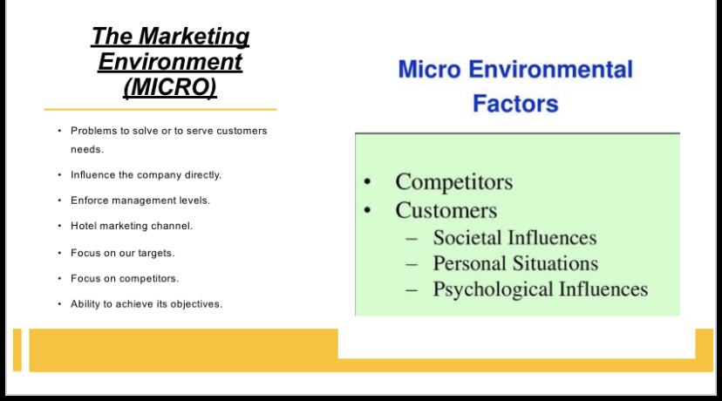
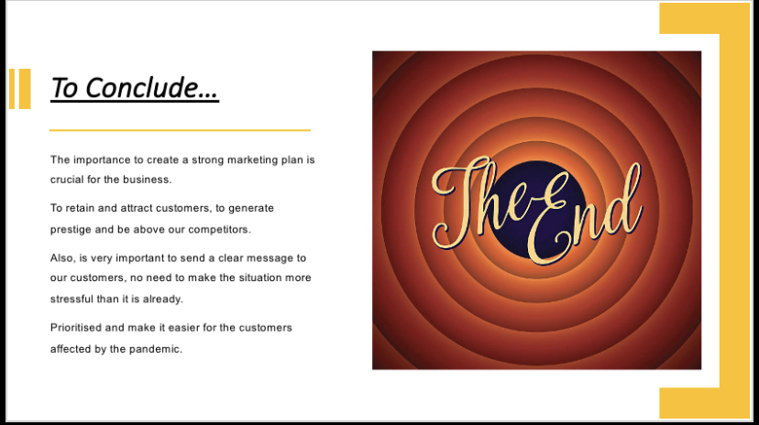
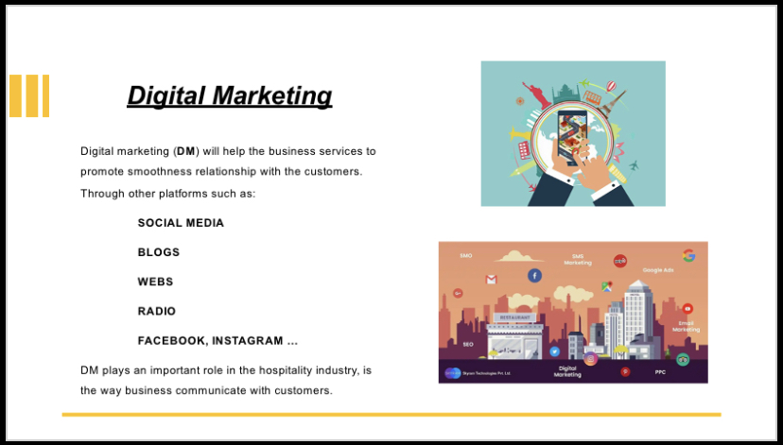
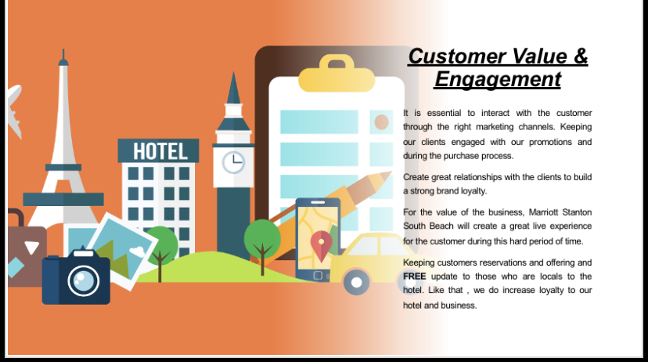
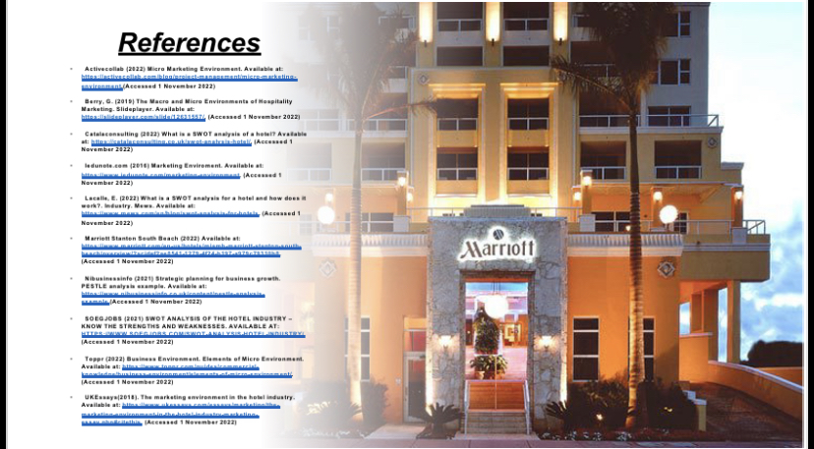

References

- Activecollab (2022) Micro Marketing Environment. Available at: https://activecollab.com/blog/project-management/micro-marketing-environment.(Accessed 1 November 2022)
- Berry, G. (2019) The Macro and Micro Environments of Hospitality Marketing. Slideplayer. Available at: https://slideplayer.com/slide/12631557/. (Accessed 1 November 2022)
- Catalaconsulting (2022) What is a SWOT analysis of a hotel? Available at: https://catalaconsulting.co.uk/swot-analysis-hotel/. (Accessed 1 November 2022)
- Iedunote.com (2016) Marketing Enviroment. Available at: https://www.iedunote.com/marketing-environment. (Accessed 1 November 2022)
- Lacalle, E. (2022) What is a SWOT analysis for a hotel and how does it work?. Industry. Mews. Available at: https://www.mews.com/en/blog/swot-analysis-for-hotels. (Accessed 1 November 2022)
- Marriott Stanton South Beach (2022) Available at: https://www.marriott.com/en-us/hotels/miamb-marriott-stanton-south-beach/overview/?scid=f2ae0541-1279-4f24-b197-a979c79310b0. (Accessed 1 November 2022)
- Nibusinessinfo (2021) Strategic planning for business growth. PESTLE analysis example. Available at: https://www.nibusinessinfo.co.uk/content/pestle-analysis-example.(Accessed 1 November 2022)
- SOEGJOBS (2021) SWOT ANALYSIS OF THE HOTEL INDUSTRY – KNOW THE STRENGTHS AND WEAKNESSES. Available at: https://www.soegjobs.com/swot-analysis-hotel-industry/. (Accessed 1 November 2022)
- Toppr (2022) Business Environment. Elements of Micro Environment. Available at: https://www.toppr.com/guides/commercial-knowledge/business-environment/elements-of-micro-environment/. (Accessed 1 November 2022)
- UKEssays(2018). The marketing environment in the hotel industry. Available at: https://www.ukessays.com/essays/marketing/the-marketing-environment-in-the-hotel-industry-marketing-essay.php#citethis. (Accessed 1 November 2022)

