University of Wales Trinity Saint David
London Campus
BA (HONS) Business Management
LCBB6000
Student Name: Greti Anita Popescu

Student ID: 2114613

Supervisor: Olusoyi Richard Ashaye

Dissertation
Exploring the Challenges and Opportunities of Managing Remote Workforces: HR Strategies for Success

Abstract
The aim of this study is to analyse the challenges faced by the HR team to maintain the collaboration between the remote employees of an organisation. The research problem is about the lack of motivation and communication between the team members who worked as remote employees. The HRM strategies related to digital tools of communication like Google Meet help in establishing monitoring and tracking the progress of the productivity of the team members.
Remote workforces constitute the people who are working from home, or specifically in a place that is not an office premises. It constitutes different opportunities for individuals like providing work-life balance, and also, it provides the individuals freedom of choosing their own hours of work. However, it also presents challenges concerned with challenges like lack of communication, as well as problems that are connected with the training procedures. Thus, it is seen that digital collaboration is required to be enhanced in order to improve management practices.
Owing to the nature of the study, the application of the positivism philosophy is found as efficient in addressing the link among variables and the adherence to the deductive approach has also made it easier to assess trends over remote working. On another side, the use of explanatory design has guided in assessing the challenges relevant to remote and the ways trending solutions are applied in mitigating the challenges. The quantitative data collection and analysis have been performed based on the primary source of data. The survey was conducted with 50 participants and the consideration of the 20 Responses was executed. The quantitative data analysis has been executed in this study to identify the HR challenges within the organisation for remote employees. The narrative analysis was performed based on the primary data collected from the participants.
The business has seen several changes in the business setups and even changes in every functional aspect of the operational work and even reached a new setup in terms of enhancing the chances for workforce performance and even maintaining the efficiency of the workplace. To mitigate workplace issues and even make an effective way to maintain effective communication between the employees, the leaders of the businesses implement the new leveraging technology and even the remote work processes through online meetings.
Based on the progression of primary data, it has been discovered that integrating remote working may provide some obstacles to enhancing employee learning and development, cooperating with others, and interacting with senior management. However, it has been discovered through the evolution of secondary data that the remote working practices of the company cause problems for both employers and employees in terms of communication hurdles and excessive reliance on technology. Here, the absence of encounters, the isolated and deceptive misunderstanding, and the decline in cohesiveness within the team have an impact on morals as well as business productivity over the course of time.

Table of Contents
Chapter 1: Introduction 6
Research Background 6
Research Rationale 6
Research Aim and Objectives 7
Research Questions 7
Research Structure 7
Chapter 2: Literature Review 9
Overview 9
Conceptual Framework 9
Impact of Remote Working Process on Modern Business Workforce Performance 10
Key Challenges Associated with Either Remote Working Process in Modern Workplaces 11
Strategic Moves in Modern HRM Processes to Mitigate Challenges Related to Remote Working 13
Summary 14
Chapter 3: Research Methodology 15
Overview 15
Research Philosophy 15
Research Methods 15
Data Collection and Data Analysis 16
Validity and Reliability 17
Ethical Consideration 17
Summary 17
Chapter 4: Findings and Discussion 19
Overview 19
Primary Data Analysis 19
Secondary Data Analysis 24
Discussion 25
Summary 27
Chapter 5: Conclusion and Recommendations 28
Inferences 28
Linking with Objectives 28
Recommendations 29
Future Scope of the Research 29
References 30

Chapter 1: Introduction

Research Background
The research background includes the key insights about the problem along with the facts related to the HRM strategies for remote workers. The problem investigated within the study is the lack of collaboration and communication among the team members. The challenges faced by the HR management team are due to the absence of consistent supervision of remote employees within the workplace (Gigauri, 2020). The factors associated with the offerings of remote working are less energy consumption and cost of office premises that impacted in declination of the expenses of the organisation. For instance, organisations are introducing remote working facilities during the COVID-19 period specifically (James Sillars, 2024). The key benefit in terms of introducing remote working is delivering flexibility to the team members that helps them maintain the work-life balance among the team members. The benefit of this strategy is the improvement of employee retention reflected in their increment productivity margin (Jihad Fraij, 2021). The HRM strategies related to supervision and monitoring using virtual platforms like Google Meet and Zoom. These virtual platforms are convenient in terms of sharing knowledge and skills along with the discussion about the work schedule. This ensures partially to the management team resolves the issues related to team collaboration and communication between the team members.

Research Rationale
The rationale of this study is to identify the problem related to the challenges such as lack of collaboration motivation, and communication among the team members. The identification of these issues is associated in terms of maintaining the collaboration between the remote workers. The rationale of this study is to highlight the key benefits in terms of the application of remote work-from-home policies. The highlight of the key benefits and challenges ensures in building conclusion that whether the HRM strategies are feasible in terms of mitigating the challenges with remote working employees within an organisation. The rationale of this study is to investigate the practical information collected from the key stakeholders of multiple organisations that ensures the challenges faced by HR in managing remote workforces. The research rationale is about the major HRM strategies that ensure improving the productivity of remote workforces.
In several organisations in the UK, “human resources management” provides several practices such as providing training as well as development which is one of the basic needs for the organisation and even it helps the employees in terms of updating their skills and even focusing on the talents that ensure the benefits for both employees as well as organisation (Saks, 2021). It even focuses on establishing various practices in the workplace in terms of managing the objectives of the workplace and even reducing the chances of the changing behaviour of the employees.

Research Aim and Objectives
Aim:
The study aims to identify the challenges associated with remote working in modern business organisations and ways the feasible HRM strategies to mitigate these challenges
Research objectives:
The objectives of the study are mentioned below,
- To analyse the impact of remote working process on modern business workforce performance
- To analyse the key challenges associated with either remote working process in modern workplaces
- To analyse the strategic moves in modern HRM processes to mitigate challenges related to remote working

Research Questions
- What are the key challenges associated with the implementation of remote working in modern business organisations?
- Why are HRM practices effective in handling the challenges associated with remote working?
- How does remote working influence performance management in modern business practices?

Research Structure
The structure of this study is segmented into five parts which include the introduction, literature review, methods, results analysis and conclusion. The significance of the first chapter is to highlight the problem that was investigated and briefly highlight the target or aim of this research study. The literature review section includes theoretical information about the challenges faced by HR in terms of managing the remote workforce to achieve desired productivity. The method chapter includes the process of collecting the data and the result chapter includes the key insights generated from the study objectives. The conclusion chapter signifies the key points of the study.

Chapter 2: Literature Review

Overview
This study is based on identifying the effective challenges associated with remote working in the case of the remote business and even the effective as well as efficient ways HRM practices diminish the challenges. This chapter provides an overview of modern business and even the remote work processes enhance the chances for increasing work performance and even enhancing the chances for the organisations to enhance their profitability in the UK. It even focuses on gathering information about the key challenges faced by the organisation in terms of implementing the remote work culture and even focuses on the HRM practices that enhance the chances of mitigating the challenges in the modern workplace as well as enhance workplace productivity and even enhance the efficiency of the workforce.

Conceptual Framework

The HRM practices in the workplace, maintain the workplace culture as well as maintain the employee engagement and even productivity by enhancing their satisfaction level. During the time of COVID-19, the companies in the UK focused on implementing remote work in terms of maintaining employees’ well-being as well as providing a proper way to maintain their health. Remote work helps employees maintain their work-life balance and even helps improve their productivity as well as efficiency. It even provides some challenges in the workplace such as reducing the chances for effective collaboration among the employee which increase conflict scenarios and even reduces the opportunities for new employees to gain more knowledge to achieve success in their careers. To mitigate those challenges, the HR management implements a “virtual mentoring program” which enhances the self-growth of the employees and even changes the leadership style for establishing employee engagement.

Impact of Remote Working Process on Modern Business Workforce Performance
In recent years, the business has seen several changes in the business setups and even changes in every functional aspect of the operational work and even reached a new setup in terms of enhancing the chances for workforce performance and even maintaining the efficiency of the workplace. According to Narayanamurthy and Tortorella (2021), the pandemic situation all across the world enhances the several crises in the workplace that enhance the chances to promote remote work in the workplace and even reduces the several challenges in the workplace and between the leaders as well as employees to maintain health and work. To mitigate workplace issues and even make an effective way to maintain effective communication between the employees, the leaders of the businesses implement the new leveraging technology and even the remote work processes through online meetings. From the "Resource-based theory", it is identified that there are several advantages of the resources, especially the human resources which enhance the chances for gaining a competitive edge in the market (Varadarajan, 2023). In this case, during the pandemic, the remote work culture among the workforce enhances the chances for improving workforce performance and even maintaining satisfaction through maintaining effective communication with the help of online meetings. For example, during the time of COVID-19, the company Morrison focus on the remote culture at work in terms of continuing the business processes as well as changing its business for the betterment of the employees and even enhancing workforce productivity (Morrisons PLC, 2023).
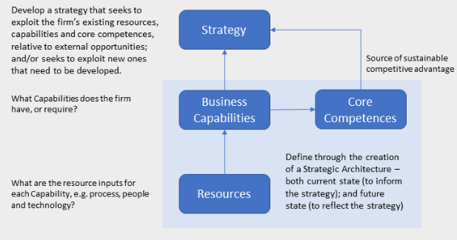
Figure 1: Resource-based Theory, Source: (Barney, Ketchen and Wright, 2021)
In contrast, Wang et al. (2021), is stated that the remote work culture in the workplace makes a positive impact on the worker and their output in the workplace and even it helps them to maintain their work-life balance which enhances the chances for the organisations to maintain their satisfaction that one of the reasons behind enhancing the performance of the workforce. In the case of the remote workers work extra hours in terms of completing the daily tasks and even the objective of the organisation which enhances the profitability of the organisation and even reaches the main goals.

Key Challenges Associated with Either Remote Working Process in Modern Workplaces
In the workplace, the remote working processes provide several positive outcomes as well as negative outcomes and even establish some challenges in the workplace which reduce the productivity of the workplace. According to Ferreira et al. (2021), in the case of remote work, the main key challenge faced by the organisation is maintaining effective communication between the employees. In this process, written communication is one of the key techniques that are used in maintaining effective communication and is even used in the case of daily interaction. Without "non-verbal interaction", it may impact the workforce which leads to miscommunication as well as enhances the chances for conflict in the workplace which reduces the efficiency of the workforce and even reduces productivity. It is becoming more challenging for the workforce in terms of maintaining the relationship face-to-face as well as maintaining it which reduces their engagement. From the "human capital theory", it is found that the valuable asset of an organisation is the employees and it is important to maintain their satisfaction level to increase the likelihood for increased profitability (Kang and Mok, 2022). In this case, without effective communication, it is not possible to maintain employee satisfaction and even enhance the chances of a conflict scenario. For example, the company Tesco, implement remote work in terms of the well-being of the employees to maintain their work-life balance but faces challenges in terms of maintaining effective communication between them which even reduces the productivity of the workforce (Tesco, 2023).
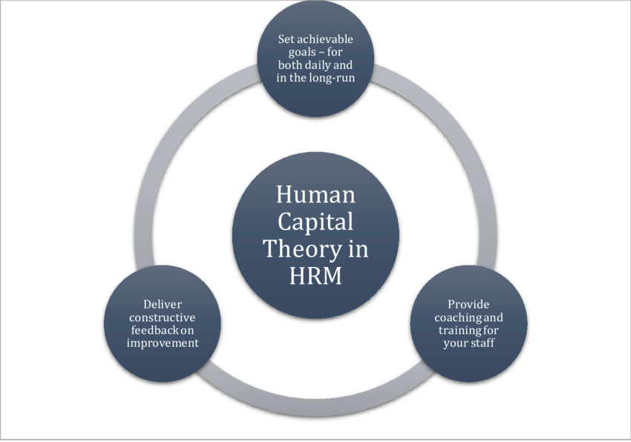
Figure 2: Human Capital Theory, Source: (Mats Carlbäck et al., 2023)
In contrast Aloisi and De Stefano (2021) state that in the workplace, newly joined employees and even interns take guidance from their senior as well as assessor in terms of enhancing their productivity in the workplace which can be reduced by the implementation of the remote work culture in the workplace. Remote work culture reduces their chances to gain this exposure and even gain effective knowledge in the workplace to betterment their future and even they miss out on the effective information that can be useful for them for further work which reduces their satisfaction level and even reduces their productivity.

Strategic Moves in Modern HRM Processes to Mitigate Challenges Related to Remote Working
In the case of remote working, it is important to implement effective strategies for maintaining employee engagement as well as maintaining the productivity of the workforce. According to Caligiuri et al. (2022), during the pandemic scenario, companies need to focus on the remote work scenario in terms of maintaining the well-being of the employees and even the HR management becomes more disorganised. In the case of the remote working culture, the HRM faces issues in terms of maintaining employee engagement and it becomes more challenging in terms of measuring their satisfaction level. During remote work, the lack in the case of a work-from-home structure as well as disturbance from the background reduces engagement. The HRM uses the right materials such as helping the employees for better work from infrastructure and even providing the employees effective guidelines and even providing new leveraging technology for enhancing their engagement level. From the “AMO theory”, it is found that this theory highlights employee success which depends on the right skills as well as the motivation of the employees and even the opportunities (Cui and Yu, 2021). In this case, effective HRM strategies provide the employee's motivation as well as opportunities during remote work in terms of mitigating their issues such as maintaining effective collaboration with their colleagues and even maintaining effective communication.
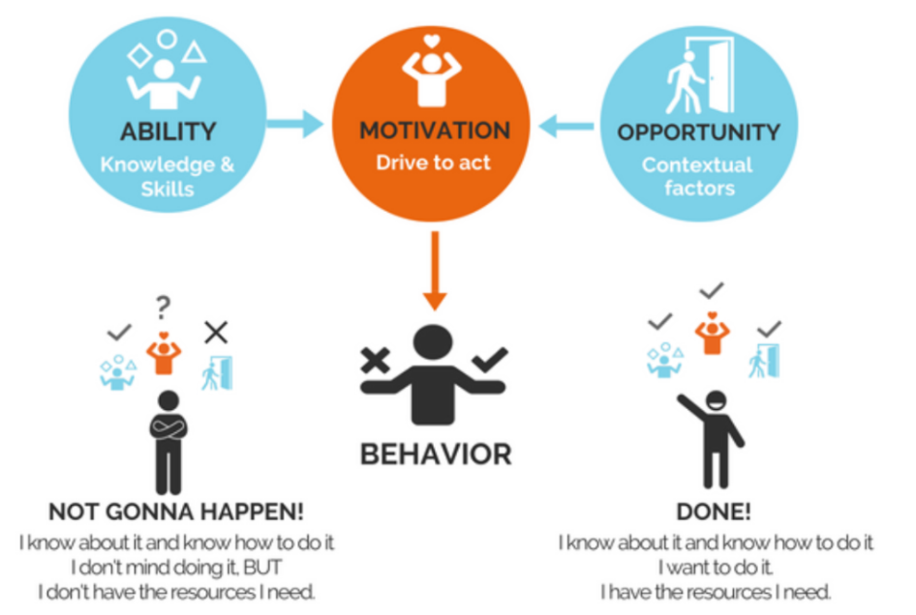
Figure 3: AMO theory, Source: (Cui and Yu, 2021)
In contrast, Harney and Collings (2021) state that to maintain effective collaboration with the employees and even enhance their engagement, the employees focus on maintaining effective communication with the team members which is not done through the remote work processes. The HR management implemented the “virtual monitoring” as well as the hybrid work arrangements to maintain the personal growth of the employees.

Summary
From this chapter, it is seen that the pandemic situation all across the world enhances the several crises in the workplace that enhance the chances to promote remote work in the workplace and even reduces the several challenges in the workplace and between the leaders as well as employees to maintain health and work. The remote work culture in the workplace makes a positive impact on the worker and their output in the workplace and even it helps them to maintain their work-life balance which enhances the chances for the organisations to maintain their satisfaction that one of the reasons behind enhancing the performance of the workforce.

Chapter 3: Research Methodology

Overview
The aim of this section is to identify the key strategies associated in terms of collecting the information to fulfil the objectives of the study. This section includes insights into the data collection method and strategies associated in terms of identifying the challenges and opportunities associated with managing remote workforces. This section includes the philosophy, approach and strategies involved in the collection of the significance of the HR strategies that bring success. This section includes data collection and analysis strategy with the support of reliability and validity in terms of identifying the research objective related to effective HR strategies to improve organisational performance.

Research Philosophy
Research philosophy means the ideological stance that is useful in order to conduct a particular study, and without considering this aspect, the study loses its academic relevance (Keightley, 2020). In this regard, it has four specific categories, which are positivism, realism, pragmatism, and interpretivism (Snyder, 2019). In this particular consideration, positivism is selected for this study because it is totally based on factual information about the remote working procedures in an organisation, and its opportunities, and challenges without relying on abstract ideas or theories. Along with that, the positivism philosophy is chosen for this study because the analysis of the impact of remote-working procedures is being analysed by means of a survey, which generates complex quantitative data that are useful for the research.
Other than that, the quantitative information that is linked with the process of doing the research is analysed statistically, and the inference is generated (Snyder, 2019). The statistical analysis of highly complex datasets is possible only with the help of positivism philosophy because it relies completely on the mathematical quantification of results that are involved in the matter of conducting a particular study. Along with that, it is also observed that positivism helps in generating an understanding from the quantitative dataset with the help of deriving the complex information that is connected with the process as a whole.

Research Methods
The researcher is highly committed to conducting a robust investigation of the research questions and following that scope, the adoption of Saunders's research onion is quite clear. The first step in approaching methodology is to select the philosophy and this study has adopted the positivism philosophy in order to explore fragmentable and tangible information. The application of positivism is found to be efficient in assuring the exploration of replicable and standardised data which identifies the inclusion of reliable findings (Maksimovic and Evtimov, 2023). Followed by this, the nature of the study has led the researcher to apply the deductive approach in getting conclusive evidence over collected information by developing a significant hypothesis (Hall, et al., 2023). The reason behind the rejection of the inductive approach is identified through a lesser scope of assessing the scope and challenges relevant to remote working. In addition to that the deductive approach has made it possible to determine the strategies to be incorporated in dealing with the challenges related to the remote working concept (Fife and Gossner, 2024).
There is another selection of methods and that is design and this study has adopted the explanatory research design with the intention of highlighting the relation amongst all variables engaged within the research area. This is the reason behind the rejection of exploratory and descriptive research design which might not be feasible in getting the trends over remote working and its implications on the workplace. In response to that the explanatory design has guided in assessing the ways through which remote working has empowered the business communication aspect at the workplace (Özaydın and Siyez, 2024). Whereas, this design is well explored with the integration of cross-sectional time horizon which is quite specific in conducting research with a significant group of samples for a single time.

Data Collection and Data Analysis
The technique to collect information related to student objectives is called data collection (Mazhar et al., 2021). The data collection technique is identified based on the data sources like primary and secondary. The primary sources of information are collected for this study where the collection of the information is performed by conducting the survey process. The quantitative type of data has been collected for this study where the close-ended questions are asked to the participants. The 10 close-ended questions are asked to the students which ensures in collection of the information related to the HR strategies that help in delivering the effective performance of the remote employees. The survey is conducted with a population of 50 population who deliver information about the adaptation of suitable HRM strategies that resolve the challenges and opportunities to manage remote employees within the workplace. 20 sample sizes have been selected for this study where participants deliver information about the hindrances, they faced after initiation of the regulation related to remote working.
The process of analysing the collected qualitative and quantitative data is termed a data analysis (Mezmir, 2020). The quantitative data analysis process is selected as suitable for this study where the collection of the numeric data has been collected related to the challenges faced by HR in terms of maintaining collaboration with the remote team members. The collection of the data was executed by using the Microsoft Form where the collection of the information along with the download of the Excel data was executed. The Microsoft Form API has generated the pie and bar chart as per the data collected related to the study objectives. Apart from that, the visual and graphical representation of the collected primary information is identified as a quantitative data analysis technique. Apart from that, the secondary data have been collected from search engines like PubMed, ScienceDirect and Google Scholar enabling in terms of performing the qualitative analysis related to the HR strategies for resolving the collaboration issues between the remote team members.

Validity and Reliability
The validity is maintained in the research by the consideration of the data which has been collected from the primary source and the secondary. The consistency and redundancy and the collected data represent the valid aspects of another argument in terms of the HR strategies for the improvement of organizational performance. Apart from that the reliability is maintained by the research by a reliable source of information and the agreement of theoretical aspects with the data which is collected and terms of the HR strategies which are applied for the improvement in organization performance. The chapters of the theoretical expression represent the proper reliability of the research in terms of its objective.

Ethical Consideration
Consideration of the ethical aspects in the research is very important as it helps to maintain ethical activity and consistency in the search. In this research, the ethical aspects have been applied in the process of Data collection in which the data which is collected through a survey must be gathered with the help of the consent form. Apart from that it is very important to maintain proper rights to the participant if they want to withdraw their response or change their response. Any alteration of the data which is collected from the respondents also needs to be avoided to maintain authenticity in the outcome.

Summary
This chapter of the studies represents the different methods and approaches which is applied in the research and to gather the data primary data collection has been selected with the application of the survey process. Apart from that quantitative data collection and analysis are applied to evaluate the data and make a proper conclusion in relation to the study. This research study is also based on the inductive approach and positivism philosophy is applied to complete the study.

Chapter 4: Findings and Discussion

Overview
The chapter mainly focuses on the findings, and interpretation that are possibly retrieved from the primary as well as the secondary sources of data. It also helps in performing the analysis and deriving the best kind of outcome that is related to the study. Also, there are other kinds of understanding about the opportunities, and challenges that exist in managing a remote workforce, where understanding the HR strategies is quite necessary in order to achieve success. The primary as well as secondary data analysis are required to be considered in order to generate the results in a proper way.

Primary Data Analysis
The outcomes that are mainly collected for the primary research are given below:-
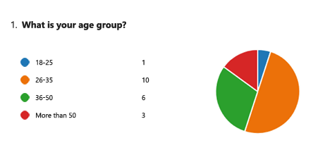
Figure 4: Age, Source: Self-made
From the given analysis, it is understood that most of the people are from the age group of 26-35, and a few of the people are from the age group of 36-50, which indicates that most of the people providing their opinions are highly mature. Thus, the maturity of all the people who have been respondents is high, and their opinions about the remote working procedure are valuable, and it helps in conducting this specific research.
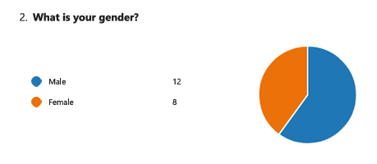
Figure 5: Gender, Source: Self-made
Based on the interpretation that is gender-based, it is seen that most of the people who are involved are males, and then, there are females who are lesser in number. Therefore, a bias towards the male members is possible to be present in the research interpretation, but when the opinion from females is taken, the bias of male members would not be very powerful in the report.
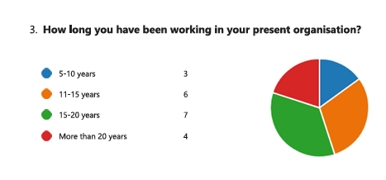
Figure 6: Working length, Source: Self-made
Most of the people who have been working are seen to be from 15-20 years, and some of them are also working for more than 20 years. Also, all the respondents have actually worked in the organisation for 5 years or more, which indicates that significantly the participants have a better knowledge about working procedures, and they have a higher opinion in order to develop the research process.
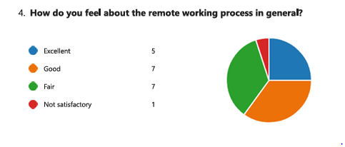
Figure 7: Generic opinion about remote working, Source: Self-made
In regards to the remote-working process, it is seen that most people have the opinion that it is good and fair in general, and also, there are other people who have considered the remote-working system to be excellent. It indicates that the benefits of such a working procedure are quite higher than the system that its disadvantages to a much higher extent.
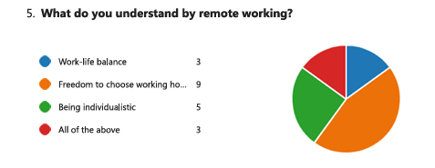
Figure 8: Understanding about remote working, Source: Self-made
While getting options about the understanding in terms of remote working, it is seen that most of the people have chosen the option of having freedom in choosing their working hours. Other than that, the situation of being individualistic also gains importance. It ensures that such facilities, along with a proper work-life balance are possible to be interpreted by individuals with remote working processes.
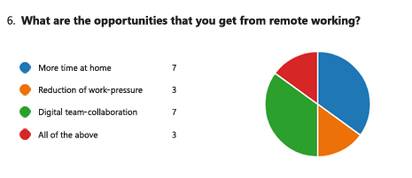
Figure 9:opportunity in remote working, Source: self-made
From the graph, it has been found that most of the respondents of the survey session agreed that remote working provides them the opportunity to spend more time at home and balance their work-life activities in the long run. In the COVID-19 situation, the work-life balance for the employees become more important to maintain the health and wellness of the workers. So, the approach of developing remote working helps the employees to improve their welding by staying at home.
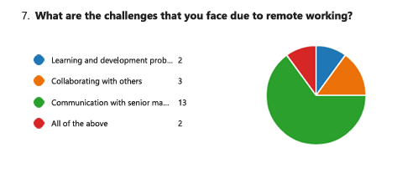
Figure 10:Challenges in remote working, Source: Self-made
The objective of asking this question to the respondents of the survey is to understand what are the issues or challenges that are faced by the employees during remote working. From the survey response from the respondents, it has been found that most of the employees have faced the issues of communicating with the senior management and it leads to lower efficiency in the decent making process apart from that some of the employees also faced by issues of planning and development as well as collaborating with other employees over the internet which may impact the overall work slow as well as productivity in the workplace.
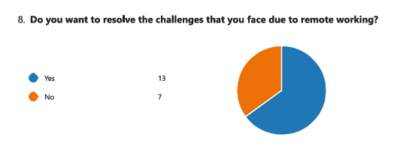
Figure 11:resolving the challenges, Source: Self-made
The purpose of asking this question to the survey respondents is to gain knowledge regarding their suggestions or recommendations on resolving the challenges faced by employers and employees during remote working. From the survey session, it has been found that most of the participants agree the petticoats want to resolve the challenges that are faced during the remote working policies and after the remote working.
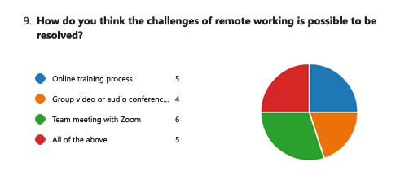
Figure 12:challenges in remote working, Source: Self-made
From the survey session, it has been found that there are some challenges faced by the participants who are engaged in the survey. It has been found that most of the people are facing the challenges in the team meeting with Zoom and others mention that during the online training process as well as an audio and video conference with the employees in the workplace, the participants are facing the challenges. It has been found that most of the employees in the business may have used those traditional ways to complete the work as well as communicate with others. In this case, lack of knowledge regarding accessing the communication technologies as well as different platforms creates issues of communicating through Zoom calls as well as accessing the video of the audio conference.
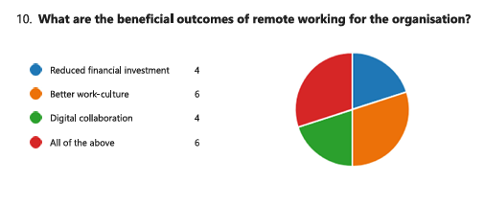
Figure 13:Remote working benefits, Source: Self-made
From the survey result, it has been found that by integrating remote working in the businesses the engaged stakeholders like the employees for the employers may have faced some different benefits. From the result, it has been found that most people agree that remote working helps to improve the work culture as it also impacts the financial investment on the infrastructure in businesses as well as improves the digital collaboration among the stakeholders.

Secondary Data Analysis
From the secondary data, it has been found that there has been a significant shift in HRM practices with the rise of remote working, particularly since the COVID-19 epidemic. It has given commercial organisations more leeway to avoid putting regulations into place that require employee presence in the workplace. It has also helped to lower workplace administration expenses. Furthermore, it has been discovered that workers prefer these remote and hybrid working arrangements since they allow them to use their commute time to ensure their own well-being (Caligiuri et al. 2022). Additionally, it creates opportunities for people to use the time to enhance their work-life balance and grow their professional skills. In the United Kingdom, remote work has also become popular, with 10% of employees reporting that they work remotely full-time. By raising employee satisfaction, HRM strategies help to sustain not only the workplace culture but also employee engagement and even productivity. Businesses in the UK concentrated on implementing remote work during COVID-19 in order to preserve employees' well-being and give them a suitable means of keeping their health.
Employees who work remotely are able to better balance their personal and professional lives and are also more productive and efficient. The global pandemic scenario exacerbates a number of workplace crises that present opportunities to encourage remote work (Varadarajan, 2023). It also lessens the number of workplace conflicts between managers and staff on how to balance work and health. Business leaders use modern technologies and even remote work processes through online meetings to reduce workplace concerns and even create an effective means of maintaining effective communication among employees. When it comes to remote work, the organisation's biggest problem is keeping staff members' effective lines of communication open. One of the most important methods in this process for preserving good communication is written communication, which is also utilised in everyday interactions. Lack of "non-verbal interaction" can have an effect on the workforce, increasing the likelihood of miscommunication and conflict, which lowers worker efficiency and even lowers production. In addition to providing options for remote work, successful HRM practices also help employees stay motivated by addressing challenges like maintaining effective communication and collaboration with coworkers.

Discussion
The research helps in gaining the findings, as well as the interpretation that is linked with the sources of primary and secondary data, which helps in providing insights within remote workforce management. In regards to the primary data, is collected by means of a survey, and it indicates different trends, as well as perceptions from the respondents. The analysis of age demographics facilitates an understanding that most of the respondents are within the 26-35-year-old bracket, which helps in creating a suggestion that the feedback reflects an experienced, and mature perspective. The distribution of gender, in regards to the predominance of male respondents has also introduced the bias, and also, the working experience of participants is shown to be at an average of 15-20 years, which means that the respondents are highly experienced in providing opinions.
In regards to the process of remote working, the primary data helps in suggesting a positive reception, whereas there are other respondents who rate the system as good or excellent. It has also aligned with the understanding that is procured from remote working, as well as it has an emphasis on the flexibility in terms of working hours that is selected, and also, for achieving a better kind of balance. In regards to such findings, it is observed that the benefits of remote working reflect how autonomy, as well as flexibility, is provided.
While considering the secondary data, it is seen that the insights are complemented by means of offering a wider context. It has inclusion about academic research, industry reports, and case studies to highlight similarities in trends for different organisations. The data has reinforced the findings that are primary, and it also shows remote work, which is increasingly used for potential in enhancing production, and employee satisfaction (Cui and Yu, 2021). The secondary data is also linked with helping the validation of positive perception in terms of primary data that provides evidence in successful working, and implementation for other kinds of settings.
Comparing the primary as well as secondary findings helps in the creation of a coherent picture of the advantages of working in remote areas. When the primary data is linked with specific, as well as insights that are first-hand from the respondents, the secondary data helps in providing an offer wider validation about such insights (Ferreira et al. 2021). In regards to the data source convergence, the entire understanding of impact in terms of remote working is done, which confirms effectiveness in increasing the satisfaction of employees, as well as the efficiency of operations. The approach is very comprehensive in the matter of data analysis about a perspective that is well-rounded on challenges, and benefits of remote working.
Furthermore, it has been discovered that 29% of other UK workers occasionally work from home. Nevertheless, despite all of the advantages, working from home has also been linked to certain difficulties. HR managers frequently find it more difficult to oversee remote workers since they can only keep an eye on them via virtual apps. Working remotely gives employees more opportunities to cut down on the amount of time they spend travelling, allowing them to conserve energy and use that time to improve their own skills. Businesses frequently put more job pressure on remote workers, which has an adverse effect on their personal well-being (Ferreira et al. 2021). People prefer to work more happily in flexible environments, which are created via remote working. It has gained popularity, particularly when the COVID-19 pandemic broke out, since companies have found that it is a workable solution to carry on with operations during times of lockdown. It has been discovered that contemporary HR managers create successful plans to fend off the dangers. By putting tactics like Zoom and Google Meet into practice, companies have been able to regularly hold team meetings virtually, which helps to break down barriers to collaboration.
From the primary data, it has been found that most of the employees agree that they have knowledge regarding remote working in the present organisation and it reflects on the remote working after COVID-19 has been used till now. From the secondary data evolution, it has been found that most of the businesses from different industries are developing the policy to improve flexibility by integrating remote working. The integration of remote working not only helps the employees to manage their time in the work and personal life better. It also helps to improve the overall job satisfaction and business production. From the primary data, it has been also found that the integration of remote working in the business helps the employees to spend more time at home which reflects the secondary data on improving the work-life balance of the workers of the businesses from different industries. From the secondary data, it has been found that remote working policies in the business help to improve the talent for the companies and allow the employees to hire skilled workers from different locations (Kang and Mok, 2022). In this case, remote working means the integration of the technology as well as the software to operate all the works remotely so the integration of the software certainly allows the businesses to improve the business productivity and the engagement of the stakeholders more accurately.
From the primary data evolution, it has been found that the integration of remote working may raise some of the challenges related to improving the learning and the development of the employees as well as collaborating with others were communicating with the senior management. On the other hand, from the secondary data evolution, it has been found that due to the remote working process in the business, the employers or the employees face issues regarding communication barriers as well as the high dependence on technology. In this case, the lack of interactions, misleading and isolated miscommunication, and reduction in team cohesion affect both business productivity and morality what the specific product of time. Apart from that from the primary and secondary data it has been found that remote working may include some challenges but it certainly impacts the overall business practices as well as the protective over the times (Harney and Collings 2021). Most of the effective approaches of remote working which benefits the business is that it has to reduce the operational cost by declining the financial investment as well as improve the digital collaboration. It ensures that all the employees are engaged with the businesses are have digital literacy and improves the business performance over the years.

Summary
The possibility of a worldwide pandemic makes some workplace issues worse, which offers chances to promote remote work. It also reduces the frequency of disputes at work over how to strike a balance between work and health between managers and employees. Enterprise executives leverage contemporary technologies, such as virtual meetings and remote work procedures, to mitigate workplace anxieties and establish productive channels of communication between staff members.

Chapter 5: Conclusion and Recommendations

Inferences
This research more focused on the opportunities for the employees in terms of implementing remote work in the workplace. It even focuses on identifying the challenges faced by the companies during remote work as well as the ways those are mitigated by HRM practices. It is becoming more future to gather data from more authentic sources and even gather effective data from the company’s websites.

Linking with Objectives
“To analyse the impact of remote working process on modern business workforce performance”
In recent years, the business has seen several changes in the business setups and even changes in every functional aspect of the operational work and even reached a new setup in terms of enhancing the chances for workforce performance and even maintaining the efficiency of the workplace. To mitigate workplace issues and even make an effective way to maintain effective communication between the employees, the leaders of the businesses implement the new leveraging technology and even the remote work processes through online meetings which is linked with objectives such as the impact of remote working process on modern business workforce performance.
“To analyse the key challenges associated with either remote working process in modern workplaces”
The remote work culture in the workplace makes a positive impact on the worker and their output in the workplace and even it helps them to maintain their work-life balance which enhances the chances for the organisations to maintain their satisfaction that one of the reasons behind enhancing the performance of the workforce. In this process, written communication is one of the key techniques that are used in maintaining effective communication and is even used in the case of daily interaction which is linked with the objective such as the key challenges associated with either remote working process in modern workplaces.
“To analyse the strategic moves in modern HRM processes to mitigate challenges related to remote working”
During the pandemic scenario, companies need to focus on the remote work scenario in terms of maintaining the well-being of the employees and even the HR management becomes more disorganised. In this case, effective HRM strategies provide the employee motivation as well as opportunities during remote work in terms of mitigating their issues such as maintaining effective collaboration with their colleagues and even maintaining effective communication which is linked with the objective such as the strategic moves in modern HRM processes to mitigate challenges related to remote working.

Recommendations
This study mainly focuses on the key factors that can be done by the HRM in every organisation in the UK in terms of maintaining their profitability as well as helping in maintaining the effective way to reach the organisational goal. During the pandemic, companies focus on remote work in terms of maintaining the health as well as the well-being of the employees. The HRM practices several challenges in terms of maintaining employee engagement as well as enhancing the chances to maintain effective collaboration between the employees. It is recommended HRM implement new leveraging technology and even provide more focus on virtual programs for maintaining effective collaboration with the employees and even provide various learning to enhance the knowledge of the new employees.

Future Scope of the Research
This research is mainly based on the HRM practices in the organisations in the UK in terms of enhancing the chances for employee engagement as well as their satisfaction level. In this case, the research mainly focuses on gathering information about the several remote work challenges faced by the organisation and even the mitigation strategies established by the HRM in terms of maintaining the employee satisfaction level and even enhancing the chances to increase employee engagement. It needs to be done by gathering information about specific companies in the UK such as “TESCO, Sainsbury and even Morrison” in terms of making this study more precise and even making it future-proof.

References
Aloisi, A. and De Stefano, V. (2021). Essential jobs, remote work and digital surveillance: addressing the COVID‐19 pandemic panopticon. International Labour Review, 161(2), pp.289–314. doi:https://doi.org/10.1111/ilr.12219.
Barney, J.B., Ketchen, D.J. and Wright, M. (2021). Resource-Based Theory and the Value Creation Framework. Journal of Management, 47(7).
Caligiuri, P., Cieri, H.D., Minbaeva, D., Verbeke, A.L. and Zimmermann, A. (2022). International HRM Insights for Navigating the COVID-19 Pandemic: Implications for Future Research and Practice. JIBS special collections, 11(3), pp.417–454. doi:https://doi.org/10.1007/978-3-030-80383-4_17.
Cui, Y. and Yu, G. (2021). A cross-level examination of team-directed empowering leadership and subordinates’ innovative performance: an AMO theory perspective. International Journal of Manpower, 42(7), pp.1257–1278. doi:https://doi.org/10.1108/ijm-03-2020-0099.
Ferreira, R., Pereira, R., Bianchi, I.S. and da Silva, M.M. (2021). Decision Factors for Remote Work Adoption: Advantages, Disadvantages, Driving Forces and Challenges. Journal of Open Innovation: Technology, Market, and Complexity, 7(1), p.70. doi: https://doi.org/10.3390/joitmc7010070.
Fife, S., and Gossner, J. (2024). Deductive qualitative analysis: Evaluating, expanding, and refining theory. International Journal of Qualitative Methods, 23, 16094069241244856, DOI: 10.1177/16094069241244856.
Gigauri, I. (2020). REMOTE WORKING CONCERNS DURING THE COVID-19 PANDEMIC. International Journal of Social Science and Economic Research, 5(10), pp.2803–2818. doi: https://doi.org/10.46609/ijsser.2020.v05i10.005.
Hall, J., Savas-Hall, S., and Shaw, E. (2023). A deductive approach to a systematic review of entrepreneurship literature. Management Review Quarterly, 73(3), 987-1016, DOI: 10.1007/s11301-022-00266-9.
Harney, B. and Collings, D.G. (2021). Navigating the shifting landscapes of HRM. Human Resource Management Review, [online] 31(4), p.100824. doi: https://doi.org/10.1016/j.hrmr.2021.100824.
James Sillars. (2024). COVID-19: People working from home in UK more than doubled as pandemic struck - but at what cost? Retrieved August 26, 2024, from https://news.sky.com/story/covid-19-8-4-million-were-working-from-home-last-year-as-pandemic-struck-12309068
Jihad Fraij (2021). E-HRM TO OVERCOME HRM CHALLENGES IN THE PANDEMIC. SEA - Practical Application of Science, 9(25), pp.41–49.
Kang, Y. and Mok, K.H. (2022). The Broken Promise of Human Capital Theory: Social Embeddedness, Graduate Entrepreneurs and Youth Employment in China. Critical Sociology, 48(7-8), p.089692052210888. doi:https://doi.org/10.1177/08969205221088894.
Keightley, E. (2020). Remembering research: Memory and Methodology. International Journal of Social Research Methodology, 13(1), pp.55–70.
Maksimovic, J., and Evtimov, J. (2023). Positivism and post-positivism as the basis of quantitative research in pedagogy. Research in Pedagogy, 13(1), 208-218.
Mats Carlbäck, Nygren, T. and Peder Hägglund (2023). Human resource development in restaurants in western Sweden – A human capital theory Perspective. Journal of Human Resources in Hospitality & Tourism, 23(2), pp.1–26. doi:https://doi.org/10.1080/15332845.2024.2282215.
Mazhar, S.A., Anjum, R., Anwar, A.I. and Khan, A.A. (2021). Methods of Data Collection: A Fundamental Tool of Research. Journal of Integrated Community Health, [online] 10(1), pp.6–10. doi:https://doi.org/10.24321/2319.9113.202101.
Mezmir, E.A. (2020). Qualitative Data Analysis: An Overview of Data Reduction, Data Display and Interpretation. Research on Humanities and Social Sciences, [online] 10(21), pp.15–27. doi:https://doi.org/10.7176/RHSS/10-21-02.
Morrisons PLC (2023). Strategy | Morrisons Corporate. [online] Morrisons. Available at: https://www.morrisons-corporate.com/about-us/strategy/.
Narayanamurthy, G. and Tortorella, G. (2021). Impact of COVID-19 outbreak on employee performance – moderating role of industry 4.0 base technologies. International Journal of Production Economics, [online] 234(108075), p.108075. doi:https://doi.org/10.1016/j.ijpe.2021.108075.
Özaydın, S., and Siyez, D. (2024). Narrative based online career group counseling program: an explanatory sequential design. International Journal for Educational and Vocational Guidance, 1-27, DOI: 10.1007/s10775-024-09672-9.
Saks, A.M. (2021). Caring human resources management and employee engagement. Human Resource Management Review, [online] 32(3), p.100835. Available at: https://www.sciencedirect.com/science/article/abs/pii/S1053482221000140.
Snyder, H. (2019). Literature Review as a Research methodology: an Overview and Guidelines. Journal of Business Research, [online] 104(1), pp.333–339. Available at: https://www.sciencedirect.com/science/article/pii/S0148296319304564.
Tesco (2023). Tesco becomes first major supermarket in UK to offer right to request flexible working for any colleague. [online] www.tescoplc.com. Available at: https://www.tescoplc.com/tesco-becomes-first-major-supermarket-in-uk-to-offer-right-to-request-flexible-working-for-any-colleague/.
Varadarajan, R. (2023). Resource advantage theory, resource based theory, and theory of multimarket competition: Does multimarket rivalry restrain firms from leveraging resource Advantages? Journal of Business Research, 160(3), p.113713. doi:https://doi.org/10.1016/j.jbusres.2023.113713.
Wang, B., Liu, Y., Qian, J. and Parker, S.K. (2021). Achieving Effective Remote Working during the COVID‐19 pandemic: a Work Design Perspective. Applied Psychology, 70(1), pp.16–59.

Declaration
I, Greti Anita Popescu, declare that this dissertation titled 'Exploring the Challenges and Opportunities of Managing Remote Workforces: HR Strategies for Success' is my original work. I confirm that it has not been submitted elsewhere for any degree or academic credit. All sources and references used in this research have been properly acknowledged.
Student Name: Greti Anita Popescu
Student ID: 2114613
Signature: __Greti ANITA POPESCU____
Date: __30.08.2024__________

