Do Video Games Still Use Traditional Character Design Theories?



Creative Computer Games Design

Author: David Williams
P No. P146751
Date: 13/12/2017
Module Code: M6X01791
Module Tutor: Julian Hainsworth
Word Count: `

This document is all the work of David Williams. Any work that is not, is correctly referenced with the Harvard system.
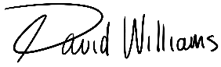
Signed: _______________
David Williams
Date: 13/12/2017

Abstract
This dissertation examines whether video games still use traditional game design theories. This is done by first examining and outlining these theories using movies, animation and comic books, The principles covered are; colour, shape and movement.
The outlined theories are then applied to two different modern video games and each one is discussed along with their effect on gameplay.
The conclusion reached is that games don’t always apply traditional character design theories. The ones that do, benefit from better, more engaging gameplay.

Contents
Abstract 3
Introduction 5
Literature Review 6
Part 1: Character design Theory and Practice 11
Colour 11
Shape 13
Movement 17
Part 2: Characters and Game Design 19
DOOM (2016) 19
The Elder Scrolls V: Skyrim 24
Conclusion 26
Further Work 27
References 28
Bibliography 29

Introduction
Characters are an important part of any visual medium that tells a story or engages its audience in a tailored entertainment experience. Well-written and well-designed characters can drastically improve a player’s experience in a video game. Characters have been part of film and comics since their conception, meaning that there is a lot of established theory available to game designers to make use of in the design of their characters.
This dissertation will set out to answer the question; ‘Do video games still use traditional character design theories?’
This will be achieved by first outlining and defining the traditional theories themselves; colour theory, shape theory and movement principle. Then, part one will give examples of how these theories are used in traditional visual media like film, animation and comic books. Part two will continue on to discuss the uses of traditional character design theories in video games themselves. The goal is that by the end of this dissertation, an understanding of the theories that guide character designers can be reached.

Literature Review
Designers need ways to make sure their characters are easily and instantly recognisable, they can do this by using different aspects of semiotics. Semiotics is a very wide-reaching subject and is very difficult to define exactly. The most basic definition is that it is the study of signs and symbols and their interpretation. Semiotics allows a designer to reach a deeper understanding of how signs and symbols might be used to subtly enhance how a viewer or audience experiences or sees one of their characters.
“We seem as a species to be driven by a desire to make meanings: above all, we are surely Homo significans - meaning-makers. Distinctively, we make meanings through our creation and interpretation of 'signs'. Indeed, according to Peirce, 'we think only in signs' (Peirce 1931-58, 2.302). Signs take the form of words, images, sounds, odours, flavours, acts or objects, but such things have no intrinsic meaning and become signs only when we invest them with meaning.” (Chandler, 2004)
For the purpose of this dissertation not all aspects of semiotics are going to be covered, just the principles that designers use when creating characters. So although terms like semantics and pragmatics cover a wide range of different theories, only a few of those topics are relevant to the dissertation topic. The areas that will be discussed are colour, shape and movement. It can be said that storytelling is also important to character and character design, but this dissertation will only be covering the visual aspects of character design, not writing, and therefore will only look at characters that occupy visual mediums like Film, Animation and Comic books.
To understand semiotics, first, some keywords and their definitions in the context of semiotics are needed. This excerpt from Charles S. Pierce’s ‘Selected Writings’ explains them with extreme clarity:
[Semiotics is] “Based on “semiosis,” the relationship between a sign, an object, and a meaning. The sign represents the object, or referent, in the mind of an interpreter. “Interpretant” refers to a sign that serves as the representation of an object. Signs can be verbal (words) or nonverbal.” (Peirce, 1958)
There are many different areas within semiotics, defined here are; semantics and pragmatics along with discursive and non-discursive symbols.
Semantics is simply the study of meaning. This branch of semiotics deals with the relationships between signs and what they mean. It often deals with metaphor in literature and art.
Pragmatics deals with the meaning of a sign in relation to the context of its use. Whereas semantics implies that all of the meaning of a sign, is contained within the sign, pragmatics takes into account external contexts like where and when a person sees the object or sign. For example, if we assume the object is a spoken sentence, the meaning of the sentence can depend on the manner, place, time etc. of its initial utterance (Mey, 2001).
The difference between discursive and non-discursive symbols is most often described or defined using linguistics and literature as the medium for understanding, although the principles can still be translated into non-verbal or visual mediums. Perhaps the easiest way to explain this often very inaccessible topic is to say, for example, that the English language represents the discursive, and ancient Egyptian hieroglyphics represent the non-discursive. This is merely a metaphor however as there are examples of the English language being used in non-discursive ways. What this comparison is meant to show is that discursive symbols are more literal in their representation of meaning. They have rigid definitions that cannot really be misinterpreted. But, non-discursive symbols, although they may not necessarily be conventional or standardised in any way, still manage to convey deep meaning. They often rely more on societal context than an official definition.
Characters are often most distinguished by their colour, and the way a designer chooses what colours to use is dictated by Colour Theory.
Colour Theory is the study of colours and their relationships with each other and our brains. A very important aspect of character design, colour can have adverse effects on the way people think and perceive things around them.
“Colour, which is created by light, is therefore a form of energy, and this energy affects body function just as it influences mind and emotion.” (Mahnke and Mahnke, 1999)
Just as an example, here is a brief description of some of the more important colours:
Red can be described as having many qualities; Fire, Strength, Life, Aggression, Masculinity, Combat, War, and Dominance. Red is the most dynamic colour however. If the hue is shifted slightly to pink, suddenly its gender is changed to female and it changes to become gentle and acquiescent. (Mahnke and Mahnke, 1987)
Blue is considered to be the exact opposite of Red. Blue is calm, secure, transparent, cold, wet. Blue will decrease heart rate and blood pressure, while Red will increase them.
Green shares some associations with blue, both are relaxing and promote concentration. However green is the most restful colour for the eye. The lens of the eye focuses green light directly on the retina. Green is also wrought with contradictions. On one hand it symbolises nature and life but on the other hand, it is used to depict mould, decay and sickness. (Mahnke and Mahnke, 1987)
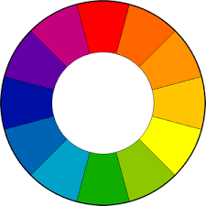
The colour wheel is the primary tool for choosing colours. The first colour wheel was created by Sir Isaac Newton in 1666. Over time, many different versions have been created, the most common though is the 12 colour, RYB (or Artistic) colour model. There are a large number of established colour combinations that have been found to be especially pleasing. These are called ‘colour harmonies’, they consist of two or more colours with a fixed relation in the colour wheel. There are five types of colour harmony; complementary, analogous, triadic, split-complementary and tetradic. (Tigercolor.com, 2000)

The Colour Wheel
Complementary colours are straight across from each other on the colour wheel, for example, red and green. This combination is very vibrant due to the high contrast between the colours, especially when at full saturation. It is very difficult to use in large amounts but is very useful when a design needs to stand out. (Tigercolor.com, 2000)
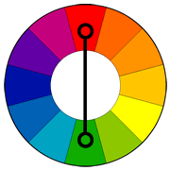

Complementary colours
Analogous colours are found next to each other on the colour wheel. They are commonly found in nature and are harmonious and pleasing to the eye. (Tigercolor.com, 2000)
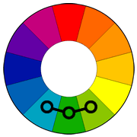

Analogous colours

Triadic colours are evenly spaced around the colour wheel. They are very vibrant, even if they are made pale or unsaturated. (Tigercolor.com, 2000)
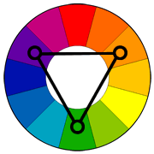

Triadic colours
Split-complementary takes the two colours either side of the complementary colour. This colour scheme benefits from the same, high-level visual contrast as a complementary colour scheme but it is not as intrusive or vibrant. (ZevenDesign.com, 2015)
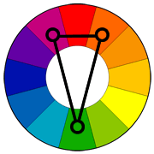

Split-complementary colours
Tetradic colour schemes are similar to triadic, except they draw from four points instead of three. This type works best if you let one colour be dominant. (Tigercolor.com, 2000)
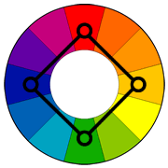
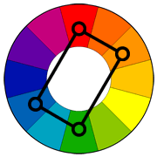

Tetradic colours
(Colour wheels courtesy of Tigercolor.com)
Another important feature of a designer’s toolkit is shape. Shapes have many different semantic and pragmatic connotations that stem from human instinct and human evolution. Humans perceive each of the primary shapes as having certain characteristics. For example; round shapes are perceived as charismatic, harmless and endearing, square shapes are reliable, uniform and stable, and triangular shapes are cunning, dynamic and competent. (GraphicMama, 2016)
A character’s basic shape is most easily identified in its silhouette. A silhouette is a dark shape or outline of an object against a light background. If a character has an interesting silhouette or it can be recognised only by its outline, it must be a well-designed character.
“When we see an object at a great distance, the first thing we notice is its shape. We do not see specific lines, values, or colours, because details at a distance blend together to form a basic shape.” (Hashimoto and Clayton, 2009)
Designers can use the primary shapes and their perceived connotation to create a character’s silhouette. This method of character design is helpful when a large number of variations are needed in a character’s design. It also helps to ensure that a character’s personality is immediately recognisable.
“Whether consciously or subconsciously we are always designing through the use of interesting dominate shapes that work well together. One of the best ways to go about this is through the basic silhouette.” (Corriero, 2011)
The final feature of character design that will be covered is movement and gesture. Character movement covers everything from how they walk or run, to things like facial expression and hand gestures. Movement is what breathes life into a character and is the final piece of the puzzle that makes a character become believable to an audience.
In animation, there are two parts to any given animation; primary movement and secondary movement. Primary movement is the main aspect of the animation, the part that conveys the most information to the viewer. Secondary movement is always subordinate to the primary movement and its purpose is to emphasise or compliment the primary movement. It helps with providing realism and believability. (Animationbrain.com, 2008)
“A secondary action is an action that results directly from another action. Secondary actions are important in heightening interest and adding a realistic complexity to the animation.” (Animationbrain.com, 2008)
‘Squash and stretch’ is perhaps the most important animation principle. It indicates the level of an object’s rigidity. Everything has different levels of rigidity. Things like furniture for example are very solid and don’t move very much. Organic objects and creatures though will all have a certain degree of this squashing and stretching going on when they move. (De Stefano, n.d.)

Part 1: Character design Theory and Practice
This chapter will outline the traditional theories that guide character designers in disciplines from Comics to Film and Animation. It will also cover how one might express a fictional character or personality as a real or relatable person.
Colour
Colour is used in character design to add depth and symbolism. It is used to subtly give the audience ways of identifying a character and their personality.
When it comes to character design one of the most important aspects is colour. As is said by Frank and Rudolf Mahnke in their book ‘Color and Light in Man-Made Environments’; “Colour, which is created by light, is therefore a form of energy, and this energy affects body function just as it influences mind and emotion.” Designers and artists in many disciplines can use this to help communicate their characters to their audience. They do this by taking advantage of how colours affect the human brain. An example of this is in ‘Star Wars Episode IV: A new hope’ when Darth Vader battles Obi-Wan Kenobi. Vader wields a red lightsabre, signifying anger and dominance, and Obi-Wan uses a blue one, signifying calm and peace. This simple difference helps us to identify that Vader is the antagonist almost immediately, even just from a still image taken from this scene. Even without any context or prior knowledge of the story, or these two characters, the use of colour makes it very easy for the viewer to piece together.
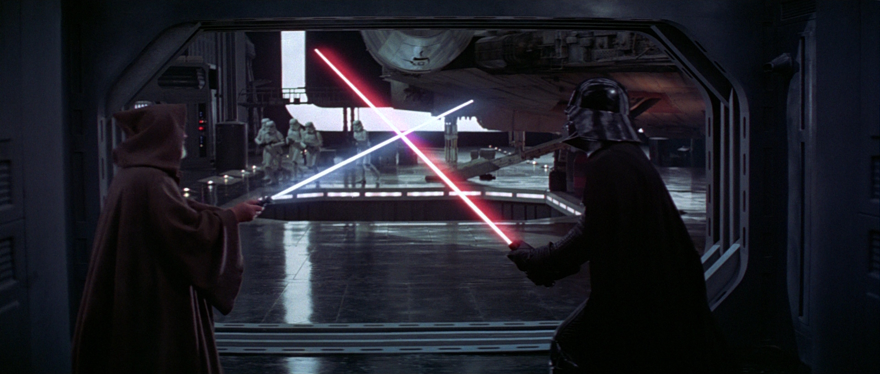

Obi-Wan Kenobi versus Darth Vader. ‘Star Wars Episode IV: A New Hope’ (Lucas Film Ltd, 1977)
This contrast of colour is present throughout the whole of the original Star Wars trilogy. Later, in ‘Episode VI: Return of the Jedi’, Luke Skywalker reveals a new green lightsabre. This is perhaps a reference to green’s symbolic similarity to blue as a relaxing, meditative colour, but green also symbolises a withdrawal from stimulus, reflecting Luke’s newfound emotional maturity and his growth as a Jedi. Blue and green are analogous colours, meaning they are harmonious and similar. Whereas red and green are complementary showing that they are natural opposites.
Another example of colour theory use, in relation to character, is in the anime ‘Samurai Champloo’. The show’s three main characters Fuu, Mugen and Gin all have specific colour schemes that represent their personalities very well.
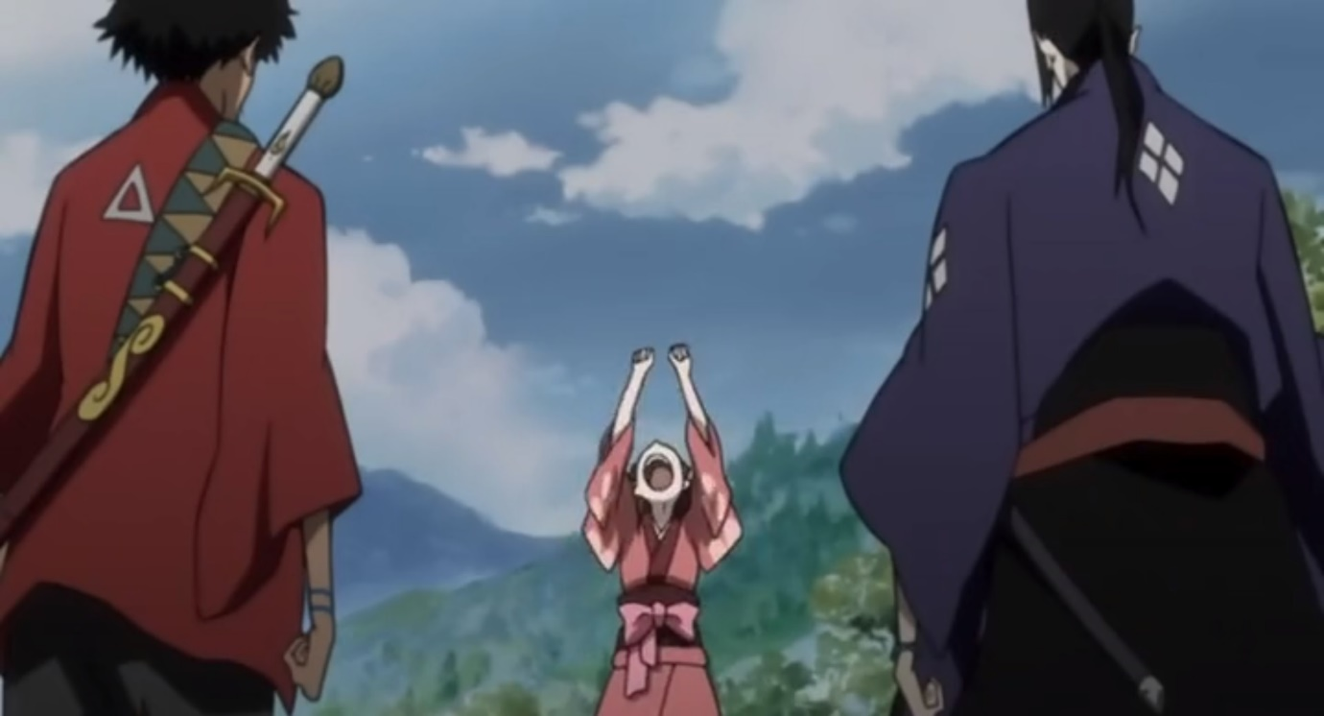

Mugen, Fuu and Gin. Samurai Champloo (Kadokawa Shoten, 2004)
Fuu (centre) dons a pink Yukata that represents her femininity and even her innocence. The slight accents of red are reflective of her fiery temper and eccentricity.
Mugen (Left) has a colour scheme that is predominantly red. He is aggressive, masculine a very skilled fighter and he has very little respect for authority, all qualities associated with the colour Red.
Gin (Right) is seen as Mugen’s direct and total opposite. The first time the two meet they are fighting within seconds. It makes sense then that all of Gin’s clothing is blue. He is focused, calm and cold. He is a noble and skilled samurai with a tragic past. Any episode or scene written to develop his character that features him heavily is melancholic and depressing, again reflected by his predominantly blue visual design.
The same colour symbolism is used throughout the show, with some added extras like the colours purple and yellow. Pompous, arrogant characters are often seen wearing purple clothing and characters who exhibit madness or insanity are seen wearing yellows, all qualities associated with traditional colour theory.

Shape
Although colour can give us a lot of information about a character, shape is what our eyes identify first (Hashimoto and Clayton, 2009). It is what allows us to identify a character’s personality or purpose at a glance. This is due to our instinctual association with shapes and the way we see them.
Characters will generally fit into three basic shape categories; square, round and triangular.
Square characters are seen as tough and masculine. They are typically warriors who are dependable and solid. Examples would include; Hellboy, The Punisher and The Hulk. These characters are built using wide rectangular bodies that show off their strength and stability. Each of these characters can be recognized as such from the instant the reader sees them.
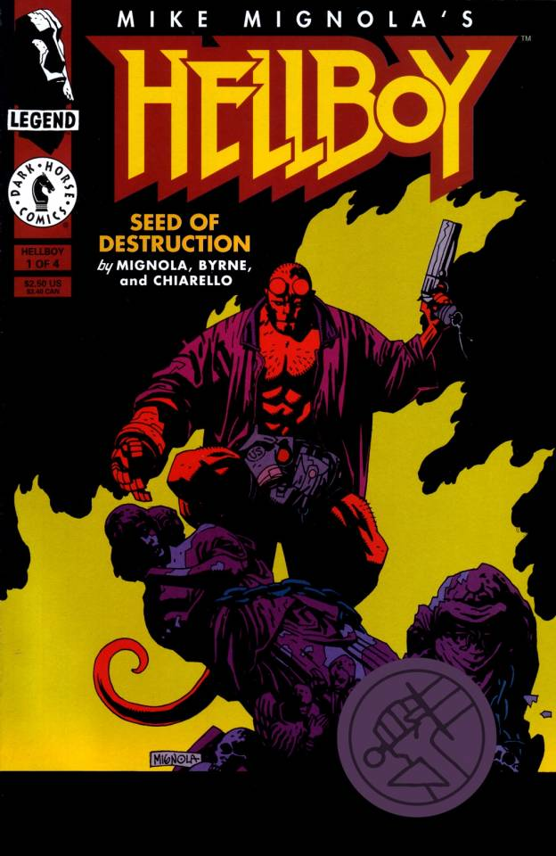

Hellboy: Seed of Destruction # 1 (Dark Horse Comics, 1994)
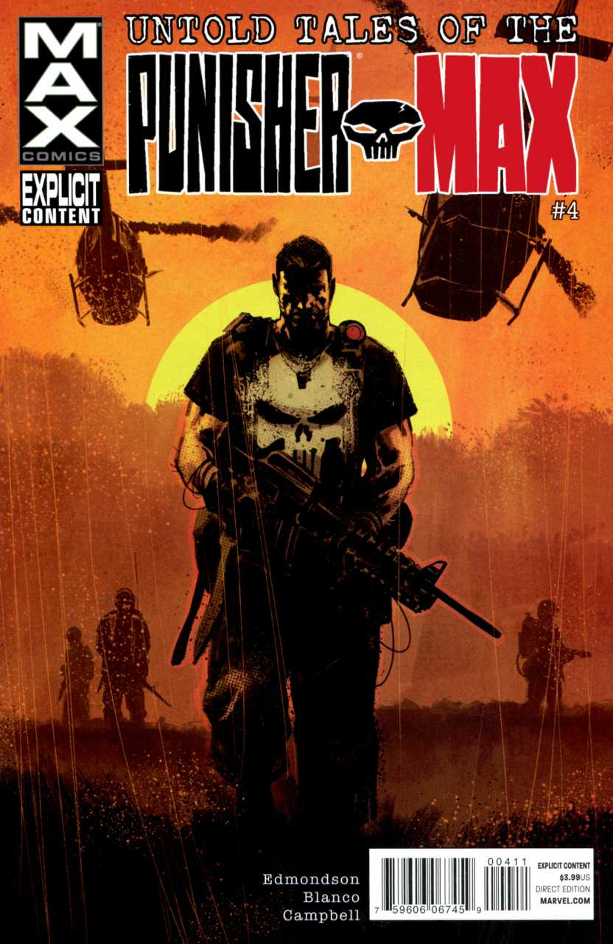

Untold Tales of Punisher #4: ‘Manhunt’ (MAX comics, 2012)

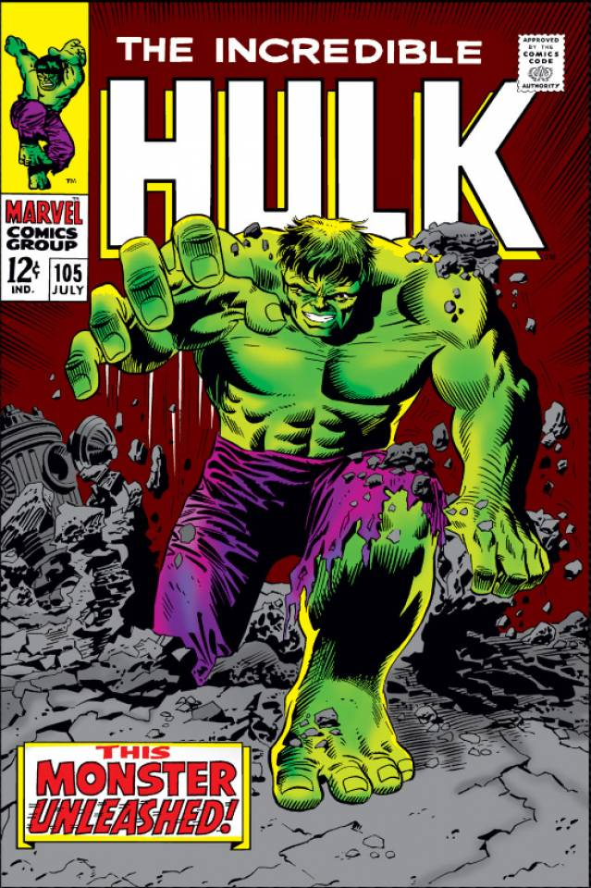

The Incredible Hulk #105: ‘This Monster Unleashed’ (Marvel Comics, 1968)
Triangular characters are skilful and cunning. They are fast and agile. More often than not they are the fast-talking, snarky characters like Spider-man, The Joker or X-men’s Nightcrawler. These characters are composed of triangular shaped bodies and quite often their faces are similarly shaped, like The Joker. His sly, demented personality can be picked up on just by looking at the shape of his face. Triangles can be used to show a character’s agility and competence too. Spider-man and Nightcrawler are both known for their quick wit and speed.
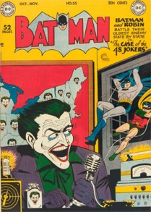

Batman Vol.1 #55: The case of the 48 Jokers! (Detective Comics, 1949)

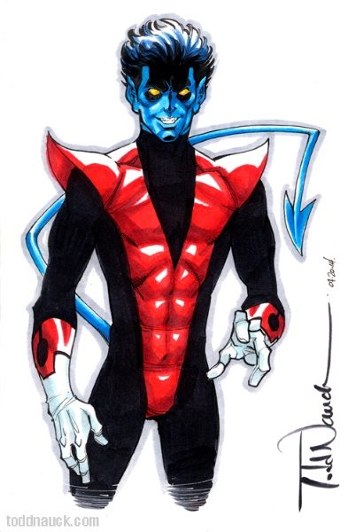

Nightcrawler (Todd Nuack, 2014)
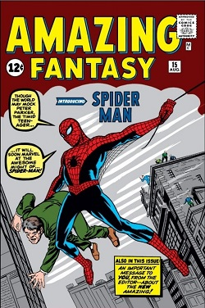

Spider-man. Amazing Fantasy Vol.1 #15 (Marvel Comics, 1962)
Curved and circular shapes are considered the friendliest as they have no sharp or dangerous corners. Circular shapes in nature have a tendency of being soft and harmless and evoke likeable characters. (Solarski, 2014) Characters like this include; Obelix, Charlie Brown and Astro Boy.

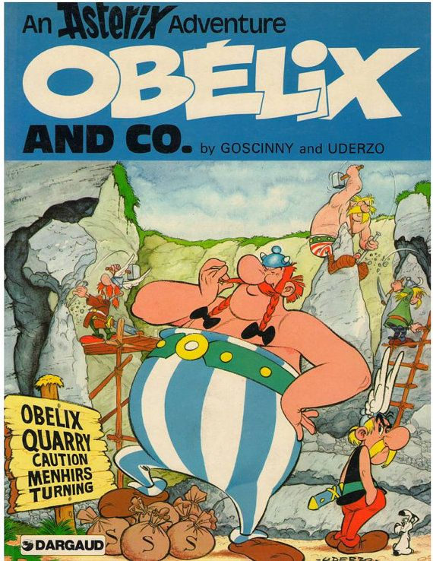

Obelix. Asterix and Obelix (Darguad, 1959)
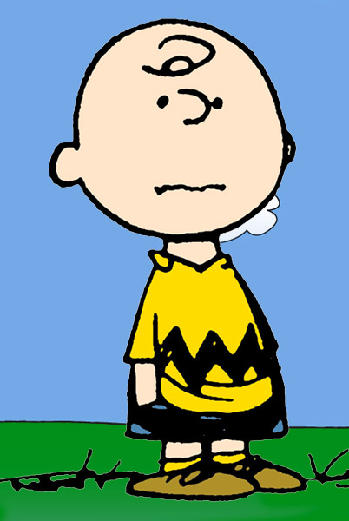

Charlie Brown. Peanuts (Charles M. Schulz, 1950)
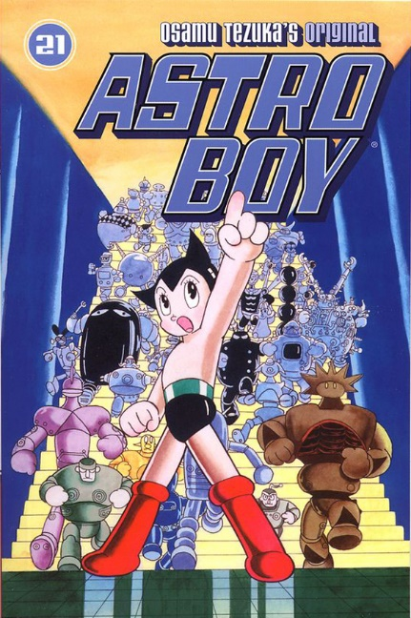

Astro Boy. Osamu Tezuka’s Original Astro Boy #21 (Osamu Tezuka, 1952)

“A good animated character, in any medium, will have a recognizable shape. When we can identify it instantly in silhouette, we say that it can be read well.” (Beiman, n.d.)
Creating a rough silhouette at the start of the design process will avoid the creation of weak, 2-dimensional characters. Creating these silhouettes of multiple characters from the same project together will help to make sure all the characters fit into the same style.

Movement
Movement is an important feature of character design because it is the stage of design that brings the character to life. To do this, a character’s movement needs to be believable.
The animated Pixar short ‘Luxo Jr.’ is an example of movement principles used to create character. The short features a desk lamp called Luxo Jr, who is shown playing with a small bouncy ball.
One piece of the animation in particular demonstrates good character movement. The part of the short when Luxo Jr hops away to screen right and disappears out of frame after his ball is flattened. The hop that Luxo performs is an example of primary and secondary movement. The primary movement is the hop itself. This is the main action that Luxo Jr is performing and it makes up the most obvious and important part of the animation. Examples of secondary movement in this sequence are how Luxo’s head hangs slightly making him look sad and how the cable plugging him into the wall flicks and jumps as it is dragged behind him. Luxo’s slight head hang serves to reinforce the emotion felt by the character. The primary hop may be slow and depressing by itself but without the drooping of his head, the emotion wouldn’t be felt as strongly. The dragging of his power cord helps to ground the scene in reality. It adds a seemingly unnecessary detail that undoubtedly helps to improve the character’s believability.
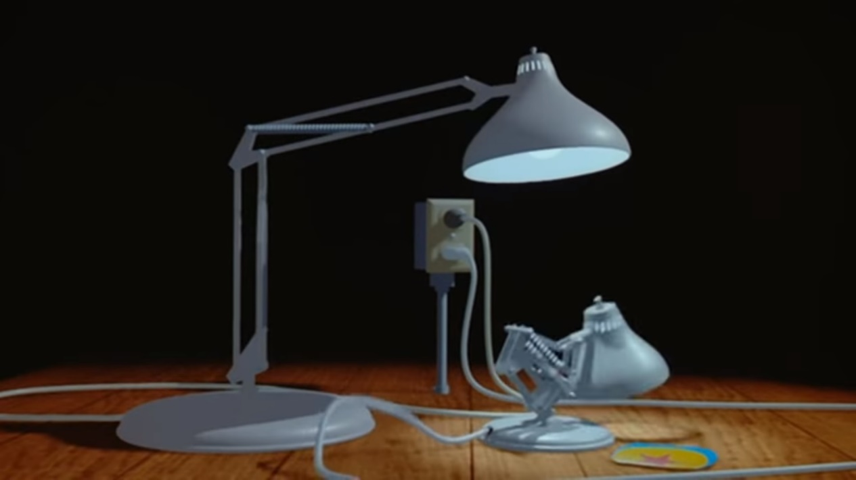

Luxo Jr. (Pixar, 1986)

The ‘Luxo Jr.’ short also demonstrates the animation principle of ‘squash and stretch’. It can be seen as part of Luxo’s movement but it is more apparent when he is jumping on the little ball he plays with. When he jumps onto the ball the ball squeezes down under his weight and on Luxo’s upward movement the ball actually extends a little when his weight is lifted. This detail is important as it allows the viewer to see that the character they are seeing has weight, it has a real physical presence within the scene.
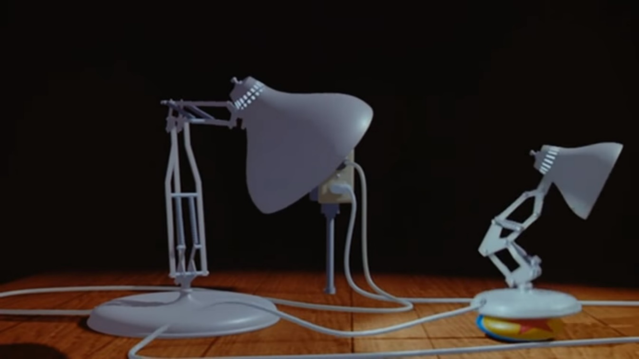

Luxo Jr. (Pixar, 1986)

Part 2: Characters and Game Design
This chapter will look at two, popular video games to see whether the techniques discussed earlier are also used in the design of game characters. In addition to this, how the principles discussed earlier can affect gameplay will also be looked at and examined.

DOOM (2016)
The first game to be examined is Id Software’s ‘DOOM’ released in 2016. A reboot of the original ‘Doom’ of 1993, the game often hailed as the grandfather of modern first-person shooters. ‘DOOM’ takes place in both a research facility on Mars and in Hell. The basic premise of the game is to defend Mars from the, recently unleashed, demon hordes of Hell. Its gameplay is blisteringly fast and brutally violent.
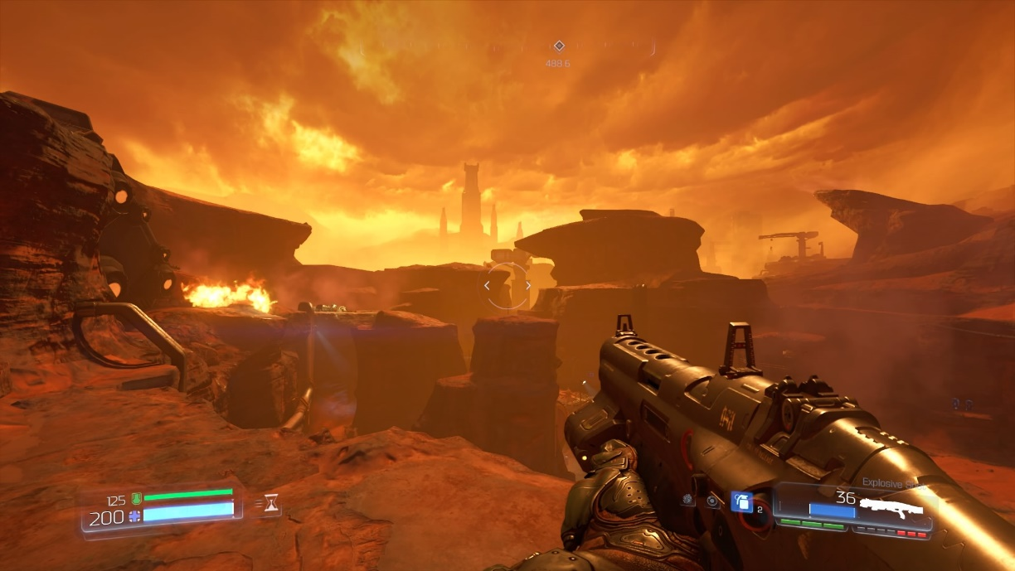

Mars UAC Base. “The UAC”, DOOM (Id Software, 2016)
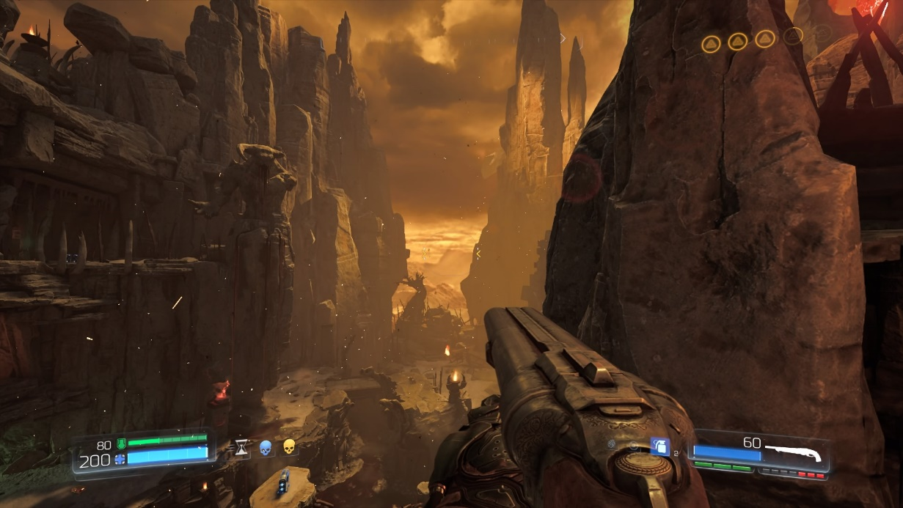

Hell. “Kadingir Sanctum”, DOOM (Id Software, 2016)
The player character is simply known as ‘The Doom Slayer’. The ancient defender of our dimension against the evil denizens of hell. He is a blank slate, face-less and voiceless, he is meant to be a figure the player can project themselves onto. A combination of this mysterious ‘Doom Slayer’ and the games many variations of demon make up DOOM’s primary gameplay.
Despite there being a story to the game, it takes a back seat to the gameplay. The non-verbal conversation between the player and the game’s enemies is communicated solely through their visual design and gameplay rules.
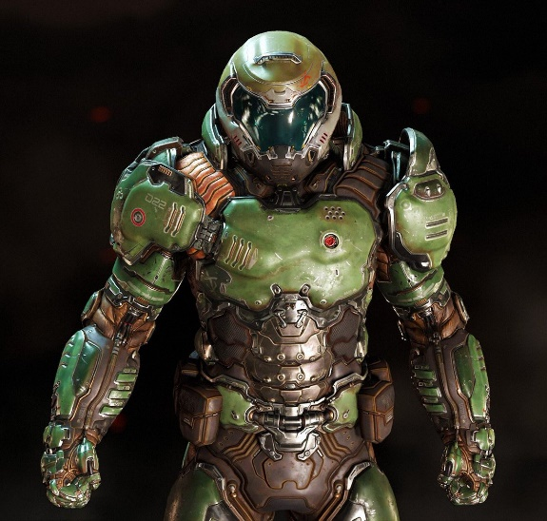
The first thing to notice is that the primary colour elements of the player character and most of the demons follow a split-complementary colour scheme. The Doom Slayer’s armour is green and the demons’ primary shared colour scheme generally falls between purple and orange. This means that the player can already identify a distinct difference between protagonist and antagonist due to split-complementary colours creating a natural colour contrast.

Doom Slayer. DOOM (Id Software, 2016)
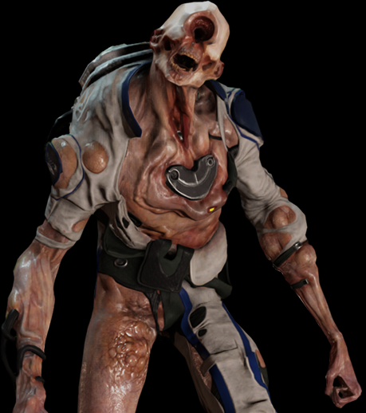
Another point to notice when it comes to colour is that the game tells the player how dangerous an enemy is using colour. Each enemy fits into a spectrum of colour. Beginning with the light fleshy pinks and whites of the possessed, ending with the deep reds and browns of the Barons of Hell.

Possessed Scientist. DOOM (Id Software, 2016)
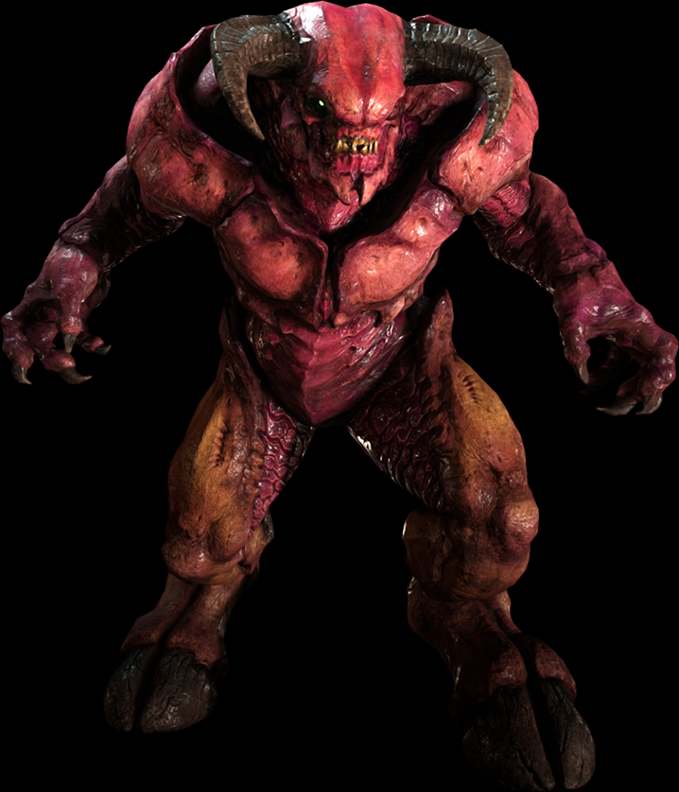

Baron of Hell. DOOM (Id Software, 2016)
This colour spectrum teaches the player to prioritize enemies by colour during combat. This priority order often changes dynamically during a combat section. Some enemies have powerful ranged attacks that should be avoided at all costs. This is reflected by the attacks often being very bright, glowing red or oranges, warning the player to act quickly or suffer the consequences. This dynamic colour changing during gameplay creates an atmosphere of constant danger from all levels of enemy, keeping the player on their toes.
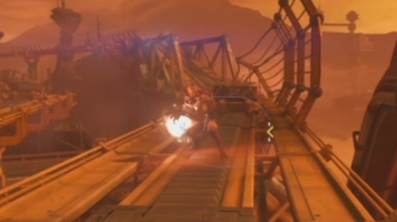

Imp charge attack. DOOM (Id Software, 2016)

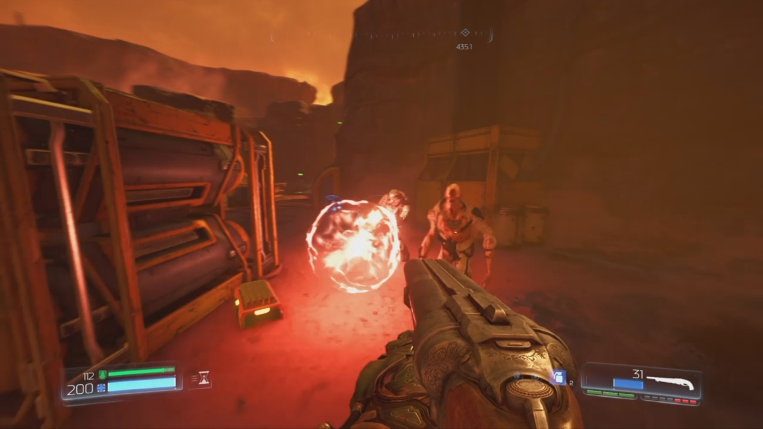

Possessed Soldier charge attack. DOOM (Id Software, 2016)
DOOM’s use of shape in its character design is also worth noting. Each enemy’s shape and size allows the player to quickly gauge how fast an enemy is, how much health they have or how much damage they can dish out. Faster enemies typically have more triangular shaped bodies and heads. These are the enemies that leap around and dodge the player’s attacks. Enemies that do a lot of damage have a more square shape to their silhouette. These enemies are ones that the player needs to watch out for and try not to get too close too as they have high damage outputs at close range. Demons with circular features tend to have a lot of health and are usually slow and very easy to hit, but never really appear on their own. Some demons have several different primary shapes and the traits that go along with them.
This system of shape identification allows the player to learn how to deal with certain enemy types even if they are entirely new. The system is a rigid signifier of how each enemy is going to act. Take for instance the Summoner demon. As shown in the image below, this demon is comprised of three separate triangles. The player has learned from the smaller Imp demons earlier in the game, that a triangle shaped body means increased movement speed and evasion. So the player can rightly assume that the Summoner is going to act in a similar way, using movement to try and stay away from the player and attack from a distance using ranged moves.
The character animation in DOOM helps immensely to engage the player. The demons move as if they were alive, with each type of demon having its own unique set of animations that reflect the qualities established by the other elements of their visual design. The Imp demons mentioned earlier, leap around throwing fireballs at the player. Their movement is smooth and flowing, further highlighting their visual qualities. Another demon that hasn’t been mentioned yet is the Mancubus. This enemy is large and tank-like, featuring both square and circular elements. It is also an example of primary and secondary movement. It walks just like its design suggests it would. It is slow and waddles around after the player, this and its sluggish attempts at using melee when the player gets too close are examples of primary movement. The wobbling of its flesh is the perfect complement to its visual design and an example of secondary movement.
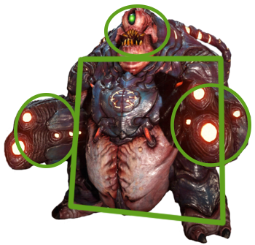
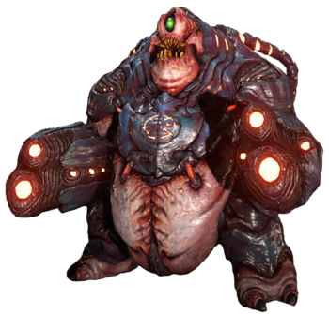

Mancubus Demon. DOOM (Id Software, 2016)

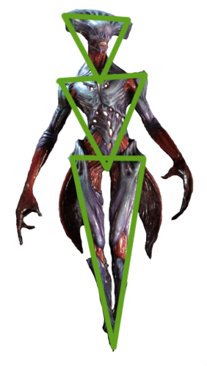
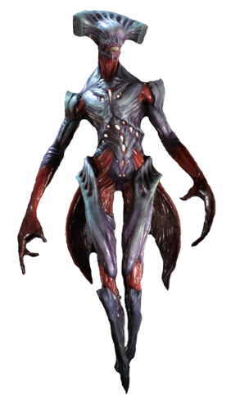

Summoner Demon. DOOM (Id Software, 2016)

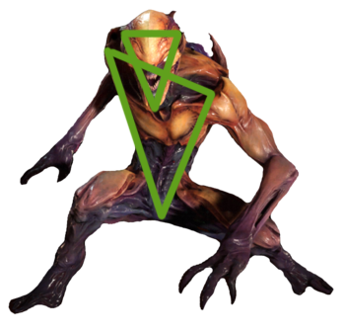
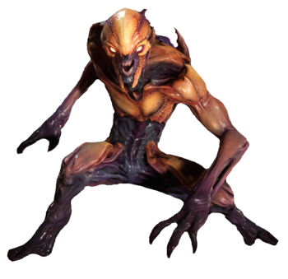

Imp Demon. DOOM (Id Software, 2016)

The Elder Scrolls V: Skyrim
The second game being examined is ‘The Elder Scrolls V: Skyrim’, developed by Bethesda Game Studios. Skyrim (as it is often shortened to), is by far Bethesda’s greatest success to date. Since its release in 2011, it has sold over 22.7 million copies and has been the recipient of numerous awards and accolades. Despite the success however, Skyrim’s character design is rather bland and doesn’t make use of previously established theory. It features quite a few well-written characters whose story is engaging and interesting but when it comes to visual design there is much left to be desired. There is nothing inherently wrong with how the characters are designed or presented, the examination here is to see how the game could be improved upon.
Skyrim’s colour palette is one based purely on ‘realism’ and function within the game’s established lore. There is nothing wrong with this method, but it leaves its characters dull and uninteresting. Skyrim features 10 playable races in total. Each one has minor stat differences to the others, but overall it makes little difference to gameplay which race is chosen. This is reflected by their skin colours. Each one is different but none necessarily stand out. When it comes to shape the same approach is used. All the races tend to be the same body shape and size regardless of how the game’s story, and the world, tells the player each race is supposed to behave. Orcs, for instance, are said to be exceptionally strong warriors, often seen wielding huge axes and swords. Ultimately though there is little difference between them and wood elves who live in the forest and are associated with sneaking and hunting.

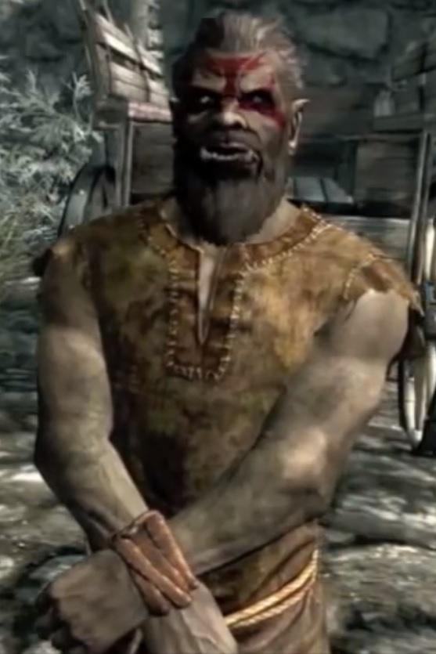
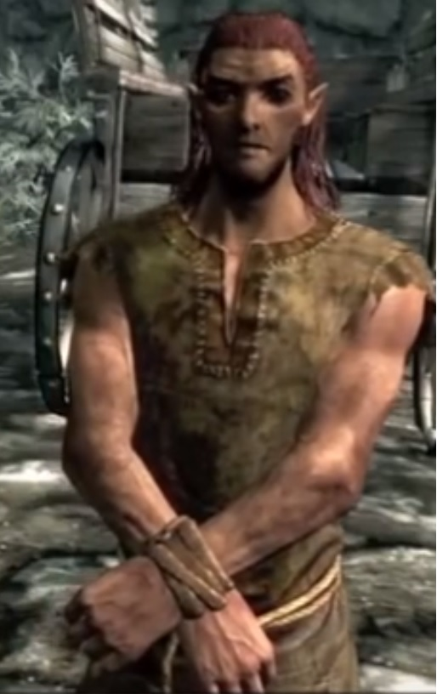

Orc (Left). Wood Elf (Right). The Elder Scrolls V: Skyrim (Bethesda Game Studios, 2011)
The choices surrounding colour and shape here can be excused though as they don’t take away from the experience of playing the game. The one aspect that is more of an issue when playing Skyrim is movement. Character animations in Skyrim are clunky and stiff. When characters move, they look robotic and not at all how a real, living creature would move. It is clear to see when a character walks that there is no natural ‘squash and stretch’ of the body, making the movements look like a puppet or like an animatronic. This is due to there being little to no secondary movement taking place. When a character runs there is a primary running animation happening but the characters clothes don’t move and their hair doesn’t move. There also isn’t any more facial expressions other than the standard blank face.
Another point is when characters move they never quite look as if they are actually touching the ground. They move as if they are merely sliding around while the running animation is played at the same time. The game as a whole is plagued by visual bugs and glitches especially the characters. This detracts massively from the experience and a lot of players will find it difficult to re-immerse themselves in a game if something like this happens.

Conclusion
To conclude, video games do indeed use traditional character design theories, although not all of them do. As demonstrated, some video games do use traditional character design theories. When video games do take advantage of semiotics, colour theory and movement principles it can benefit the player greatly. It helps to communicate important information to the player without having to bombard them with text based explanations and it helps to create a more immersive and believable world for the player to explore. Using traditional character design theories could help developers and designers to create more engaging game experiences for players.
It is also made apparent that successful video game titles could be improved upon further by adopting the outlined principles when designing their characters.

Further Work
As part of further study on this topic, it would be beneficial to include many more contemporary video games. The examination of more titles would mean increased potential for learning.
It would be important to include some tests into further research of the topic as well. Conducting tests to find out first-hand how players feel about and react to the implementation of the discussed theories would provide valuable insight into the mind of the player. The player is the centre of any gameplay experience and therefore the methods by which the player and their brain interacts with the game and the world within should be thoroughly researched.
Learning more about the topic of semiotics would also need to be focused on in any further work. This is a very expansive topic and is only briefly touched upon in this dissertation. Semiotics provides both a scientific and a philosophical view of the world and the information gathered in its study could be useful in game design.
The information gathered and presented can be applied to further studies in the field of video game design.

References
Mahnke, F. and Mahnke, R. (1987). Color and light in man-made environments. New York: Van Nostrand Reinhold.
Tigercolor.com. (2000). Basic color schemes: Color Theory Introduction. [online] Available at: http://www.tigercolor.com/color-lab/color-theory/color-theory-intro.htm [Accessed 6 Dec. 2017].
ZevenDesign.com. (2015). Color Harmony: Why Hulk Wears Purple Pants - ZevenDesign. [online] Available at: https://zevendesign.com/color-harmony-hulk-wears-purple-pants/ [Accessed 6 Dec. 2017].
Mahnke, F. and Mahnke, R. (1999). Color and light in man-made environments. London: Academy.
Chandler, D. (2004). Semiotics: The Basics. Psychology Press.
Peirce, C. (1958). Selected Writings.
The Game Theorists (2015). Game Theory: Red vs Blue, The SECRET Color Strategy. [online] YouTube. Available at: https://www.youtube.com/watch?v=X31K6jammH0 [Accessed 7 Dec. 2017].
Mey, J. (2001). Pragmatics: An Introduction. 2nd ed. Blackwell Publishing.
Oregonstate.edu. (n.d.). Semiotics Theories. [online] Available at: http://oregonstate.edu/instruct/comm321/gwalker/semiotics.htm [Accessed 8 Dec. 2017].
Solarski, C. (2014). Drawing basics and video game art. Johanneshov: MTM.
GraphicMama. (2016). How to Convey Character's Personality Through Shape, Variance and Size. [online] Available at: https://graphicmama.com/blog/conveying-characters-personality/ [Accessed 9 Dec. 2017].
Corriero, M. (2011). The use of Silhouettes in Concept Design. [online] Characterdesignnotes.blogspot.co.uk. Available at: http://characterdesignnotes.blogspot.co.uk/2011/03/use-of-silhouettes-in-concept-design.html [Accessed 9 Dec. 2017].
Animationbrain.com. (2008). SECONDARY ACTION: 2D Animation principle | 2d Animation Principles | Animation Tutorials. [online] Available at: http://www.animationbrain.com/secondary-action-2d-animation-principle.html [Accessed 12 Dec. 2017].
De Stefano, R. (n.d.). The Prinicples of Animation, Squash and Stretch. [online] Evl.uic.edu. Available at: https://www.evl.uic.edu/ralph/508S99/squash.html [Accessed 12 Dec. 2017].

Bibliography
Stevens, M. (2012). Why Are Things Cute?. [online] YouTube. Available at: https://www.youtube.com/watch?v=Z0zConOPZ8Y [Accessed 5 Dec. 2017].
Lee, S. and Buscema, J. (2008). How to draw comics the marvel way. [Bridgewater, N.J.]: Paw Prints.
Șopov, I. (2013). The Basic Principles for Great Character Design | InkyDeals Blog. [online] Blog.inkydeals.com. Available at: https://blog.inkydeals.com/basic-principles-for-great-character-design/ [Accessed 5 Dec. 2017].
Facweb.furman.edu. (n.d.). Susanne Langer. [online] Available at: http://facweb.furman.edu/~dcummins/Susanne%20Langer%20.htm [Accessed 7 Dec. 2017].
Newworldencyclopedia.org. (2014). Susanne Langer - New World Encyclopedia. [online] Available at: http://www.newworldencyclopedia.org/entry/Susanne_Langer [Accessed 7 Dec. 2017].
Ladusaw, W. (2012). Meaning (Semantics and Pragmatics) | Linguistic Society of America. [online] Linguisticsociety.org. Available at: https://www.linguisticsociety.org/resource/meaning-semantics-and-pragmatics [Accessed 7 Dec. 2017].
Hill, R. and Barton, R. (2005). Red enhances human performance in contests. Nature, 435(7040), pp.293-293.
Choi, C. (2017). What is product semantics and why is it important?. [online] CHOi Design. Available at: https://www.choidesign.com/blog/2017/6/2/design-semantics [Accessed 8 Dec. 2017].
Nordquist, R. (2017). Semiotics: The Study of Signs and Symbols. [online] ThoughtCo. Available at: https://www.thoughtco.com/semiotics-definition-1692082 [Accessed 9 Dec. 2017].

