The Design and Construction of an Autonomous Ground Vehicle
Universitey of Wails Trinatey St David (UWTSD) | IQ Campus University of Wales, Swansea Waterfront, Trinity Waterfront, Swansea, SA1 8EW
Group Development Project (ACDA5017)
Joseph Gillespie (2214885)
2024

Abstract
This report follows the design, development, construction, and testing of a preprogrammed smart autonyms vehicle. The construction of this vehicle is to demonstrate the capabilities of a device that is not dependent on radio frequency communications to reach its objective even when obstacles are blocking its pre-defined path.
The following report begins with research into similar and existing designs followed by the construction, testing, and a breath comparison to off-the-shelf similar products.

Table of Contents
Abstract 1
Introduction 3
(1:0) Background Research 4
(2:0) Development Methodology 5
(3:0) Design and Construction 6
(3:1) Hardware Construction 6
(3:2) Software Development 10
(4:0) Testing and Results 10
(5:0) Evaluation 11
Conclusion 12
Reflection 12
References 13
Bibliography 13
Appendices 13

Table of Figures
Figure 1 Self-Delivery Robots [3] 4
Figure 2 Robot Waiters [8] 5
Figure 3 Single Motor and H gate Set-up 7
Figure 4 Fully Constructed Shazzy 8
Figure 5 Version 1 9
Figure 6 Veroboard Apon Shazzy 10
Figure 7 Completed Vehicle with Code (Background) 11

Introduction
Autonomous robotic and unmanned vehicles are becoming more and more prevalent in today's world. With the likes of corporations such as Amazon choosing automation within their distribution plants and even expanding out to their delivery services [1]. To military applications of autonomous fighting vehicles [2] and supply/casualty support vehicles.
As these systems grow in popularity, a vast majority of them use Radio Frequency (RF) controller systems aver in the form of a remote user or, for the truly autonomous systems, to communicate to Global Positioning Systems (GPS). This method of control is why autonomous systems are being favoured across the working environment, but this communication method can become over-saturated, jammed, and interfered with within the different environments they operate in.
It is within this report that the possibility of constructing an autonomous vehicle that depends on pre-set commands and has the intelligence to overcome obstacles that may appear on its prey-set route without hindering its ability to reach its objective will be tested. The reasoning behind this is to show an alternative option of control for autonomous vehicles. This alternative control method can be used in areas of high RF traffic like within cities and in areas that lack RF/GPS connections such as tunnel systems and dens wilderness.
The report itself has been broken down into sections with the first of which looking into similar and pre-existing systems. This is then followed by the development methodology stage where components will be discussed and compared alongside a breakdown of the construction development and specifications. The next stages will be broken down into the construction of the system, followed by its testing and results before finishing with a comparison of the performance of the system to existing products and the conclusion.
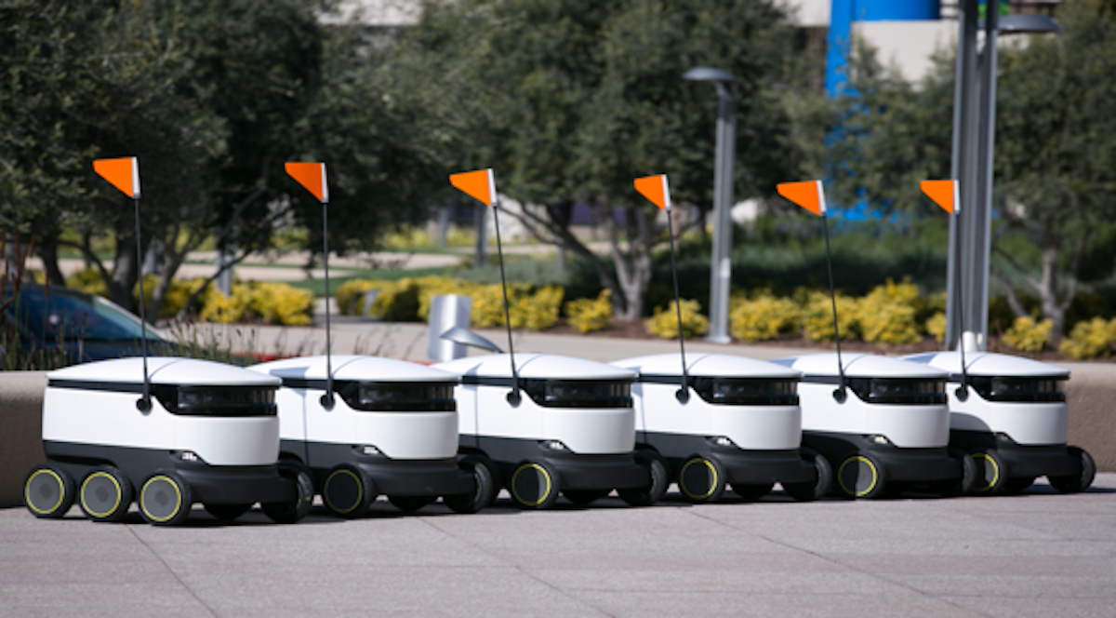
Figure 1 Self Delivery Robots [3]

(1:0) Background Research
The existence of autonyms pre-programs vehicles is not uncommon, and many of these pre-existing designs have paved the way for today's smarter systems. With this being said, it is within this section of the report that these similar projects and existing products will be explored. The following has been broken down into 3 sections the first of which looks into basic pre-programmed autonomous vehicles, followed by the systems that utilize sensors to improve their autonomy, before ending on autonyms vehicles that are used within the public.
Owens section – Pre-programed vehicles
Alex section – Systems that used sensors
As already explored in the previous sections, pre-programmed vehicles, and sensor systems are used in a vast array of projects and for educational use. But this is not their only purpose, when combined these systems can make autonomous vehicles of varying capabilities that are used within industry and amongst the public.
A popular example of the use of autonym vehicles amongst the public can be seen within hospitality, especially in countries such as Singapore and Japan [4]. These autonomous vehicles come in the form of robot waiters and are produced by several organizations like Alpha Robotics and their Scud, Amy, and Panda designs [5] also Keenon offers their Dinerbot T10 design [6] to name a few. But it is not just the previously mentioned countries that are utilizing robot waters, as of 2022 the hospitality chain Bella Italia turned to autonyms waiters in their Center Parcs Whinfell Forest branch located in Cumbria. This was in response to the lack of serving staff after the Covid 19 pandemic and Brexit [7].
With the prayer binge a global issue and the choice of autonomy being favoured to relieve pressure off people performing repetitive menial jobs. It is crucial to understand how these systems work, and this will be explored via the waiter example.
Most robot waiters utilize three methods to aid them in their movement, collision control and table location. The first of which is that of pre-coding the floor plan of the restaurant that the waiter will be operating in. This floor plan can then be controlled through a package known as ROS-RVIZ [4] which is pre-programmed into the waiter. But this is not done as a stand-alone, the waiter also utilizes “eyes” in the form of lidar to aid it in the production of its own map of the floorplan and to aid in its obstacle avoidance [4]. This method of movement operates similarly to that of the project that this report is based upon.
As for the table location, the use of RFID tags is utilized to allow the waiter to accurately locate where the food will be delivered. These RFID tags are also connected into a mess network which aids the waiter when pathing to the table giving it reference points to triangulate its location [4]. Once the waiter has reached the location, the tags also work as a lining up point to aid the waiter in placing the products onto the table.
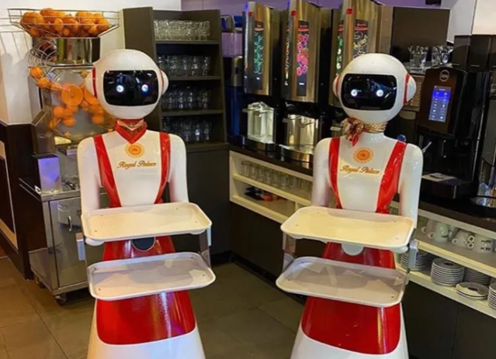
Figure 2 Robot Waiters [8]

(2:0) Development Methodology
This report is based upon the development of an autonyms vehicle that does not depend on RF communications for movement and problem-solving capabilities. Due to this, several components and software apps had to be considered and compared to see if they matched the project requirements. It is within this section that the hardware and software used within the project will be explored with comparisons to their alternatives.
To begin with, the critical choice or the “Braine” of the vehicle had to be chosen. This decision landed on the choice of the raspberry PI Pico WH. The reason behind the choice of a Pico PI over the standard Raspberry PI was down to size, the project intention was to make a small vehicle and the Pico allowed for a smaller frame to be used as the body of the vehicle. The second reason for the choice of the WH model was due to the WiFi capabilities it has. All thou the project was to prove a fully RF-independent vehicle, the WiFi capabilities open up the potential for further development. The added feature to the WH is that it came with the header pines all already connected, removing the potential possibility of faulty connections when soldering up the Pico [9].
As a Pico PI was chosen to be the driving force behind the vehicle, the issue arose that the Pico may not have enough amps or voltage behind it to drive the motors. This came with the added issue of the Pico not having the capability to switch the direction of rotation when required as well. Due to this issue, the procurement of a H-gate circuit was put in place. During the research stage, three capable systems were identified for what was required. These systems were the DRV8833, L298D, and the L9110S. Each of the systems allowed for an external power supply to be connected but kept separate from the rest of the system and also allowed for up to two motors or one three-phase motor to be connected. With this requirement being meat, the choice came down to voltage range and size. This resulted in the L9110S being chosen due to its medium size, compared to the DRV8833 and L298D, and its voltage range spanning from 2.5V to 12V [10] making it more than capable of handling the intended external voltages with the possibility of testing the output voltage of the Pico as a driving power source for the motors.
Owens section – Power supplies and batters
Alex section – Sensor systems

(3:0) Design and Construction
This section of the report aims to break down the construction and design of the autonomous vehicle project vier splitting it into two sections. The first of these sections will look into the hardware aspects of the project and the second section will explore the code driving the project from behind the scenes.

(3:1) Hardware Construction
Day 1 – The initial stage of construction started with the development, understanding, and prototyping of the motor system that is used to provide the project with movement. This stage of construction used the flowing components:
- X2 Drive wheels
- X2 Bearing wheels
- X2 Tracks
- Metal shazzy and assembly parts
- 6V to 12V Motors
- L9110S DC Motor Controller (H Circuit)
- Breadboard and connecting wires
- Pico PI WH
- Power supply
To begin with, each of the components went throw basic and simple tests to first grasp an understanding of how each component worked and behaved. These tests are further elaborated upon within section 4:0.
After the tests were conducted, a simple breadboard construction of the motor system was built. This construction connects the H gate system and the larger motor together as one system (as seen in Figure 3), which was then powered and triggered by a bench power supply. It was during this stage that it became relevant to colour coordinate the wiring for the H gate and the motor to allow for easier identification of the direction rotation of the motor when it came to further tests.
This colour coordination was achieved by choosing the same wire coloured throughout the system that corresponded with the direction of rotation. For example, ante clockwise rotation had a brown wire from the motor to the H gate throw to the trigger. This adjustment was achieved due to the choice of constructing upon the breadboard as the initial construction platform. As breadboard allows for easy wiring and component adjustment due to its push-to-connect design.
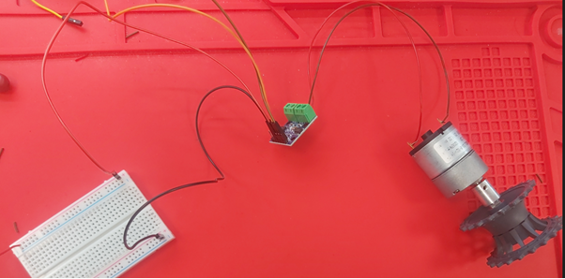
Figure 3 Single Motor and H gate Set-up
Once the clockwise and anti-clockwise rotations of the singular motor were achieved, a second motor was added to the system. This second motor followed a similar wiring set-up as the first but was inverted. The reasoning behind this is due to the motors sitting on opposite sides to one another when connected to the shazzy. This meant when the command to move forward was given, the motors would work in the opposite direction to drive the vehicle forward.
At this stage, the Pico PI was added to the motor systems replacing the bench power supply as the trigger for movement. This addition was easily achieved due to the wiring colours matching up with the designated Pins that had been programmed as the triggers upon the Pico PI. With the Pico in place, the motor system was almost completed excluding the battery power supply that will be used as the external power to the motors. The battery connection was still being simulated by the bench power supply. The motor system plus its shazzy can be seen in Figure 4.
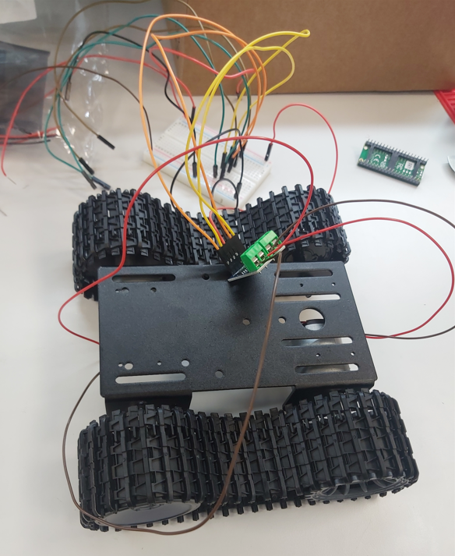
Figure 4 Fully Constructed Shazzy
Day 2 – The second day of construction focused on the ultrasound sensor and its movement capabilities. During this construction phase, the following components were used:
- Ultrasound sensor
- Small motors
- Breadboard and connectors
- Pico PI
To begin with, each of the GPIO pines had to be identified, upon the Pico, that was going to be used for the operation of the sensor system. The purpose behind this was to match the code with the wiring/breadboard design that was being constructed to allow for testing to be carried out. This was achieved by a similar method as to what was used for the motor system by utilizing different colour wires to represent the Trigger (Dark Blue) and Echo (Light Gray) functions on the sensor. It is also to note that the sensor did not require an external power source and utilized that of the 5V output pin on the Pico (Pin 40).
Once the sensor was set up and tested, the next stage was to apply the movement method. While doing this, it became apparent that the smaller motors were not efficient in allowing the sensor to observe its surroundings, due to their difficulty in predicting movement speeds and their lack of capability to self-centre itself accurately without the use of intensive coding. This resulted in a re-design of the movement method that resulted in the procurement of a Micro Servo.
Day 3 – The third day of construction was split into two parts with the first focusing on the addition of the servo, and the second half looking into the formatting of the Veroboard that was to replace the breadboard prototype. This followed on from the previous day's construction with the addition of the servo to replace that of the small motor. For this addition to work, one more GPIO pine (Pin 4, GPIO 2) was allocated on the Pico to act as the command wire. Once the servo was in place, the beadboard prototype named V1 was completed.
Before any full-body tests were carried out, the full system was attached to the tracked body via electrical tape. This was to prevent the breadboard from sliding off during movement but still allowed for adjustments to be made easily in positioning. The servo was fixed to the front (Forward) of the body with a damaged WiFi antenna connected to it as an elevated stroke to hold up the ultrasound sensor to allow for sensor movement. All of these components were fixed in place with electrical tape as a temporary connection. This can be seen in Figure 5.
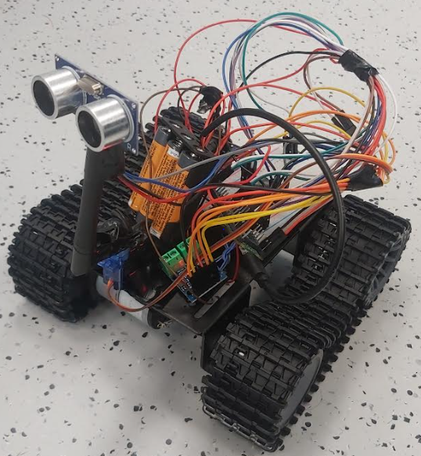
Figure 5 Version 1
After full body tests were carried out on version 1 of the vehicle, the design of the Veroboard went underway. This stage was just a simple component mapping on the board with the use of a marker pen to signify wire layouts and pin connection points prepping the board for future construction.
Day 4 - This was the final day of construction and focused on the soldering of the Veroboard and the fitting of the circuitry to the body of the vehicle ready for its final tests.
As the Veroboard had already been mapped on the previous day of construction, the components just needed to be placed in their delegated spots on the board. Making the process quick and simple. This left the breaking of the tracks as the last task to be carried out, this was critical to prevent short circuits when the system was in operation but was another simple task once all components were in place.
It was also during this construction phase that header pines were added to the design to prevent the Pico from being directly soldered onto the board. This addition was to prevent damage to the Pico and to allow for the changing of the Pico in the event of a fault or to allow another 40-pin controller to be added to the system. Figure 6 shows a top-down view of the Veroboard when attached to the body of the vehicle.
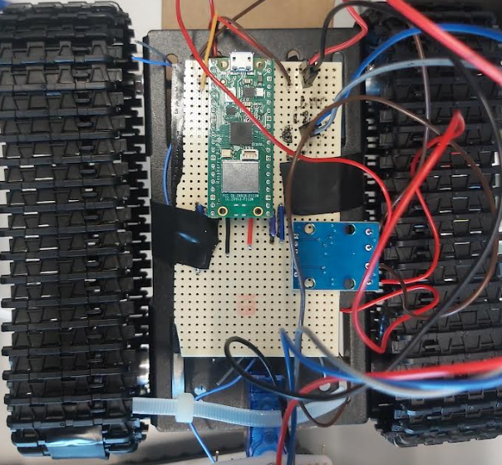
Figure 6 Veroboard Apon Shazzy
On completion of the Veroboard, the system was attached to the body of the vehicle. This required the underside of the board to be covered in electrical tape to prevent short-circuiting when touching the metal frame of the shazzy. To fix the board in place, two fine stripes of electrical tape were used. For the servo, a zip tie was threaded from the body and tightened to keep it in place and to minimize the unwanted movement of the sensor when it scanned its environment.
Figure 7 shows the completed vehicle receiving its final piece of code before being put into ground testing.
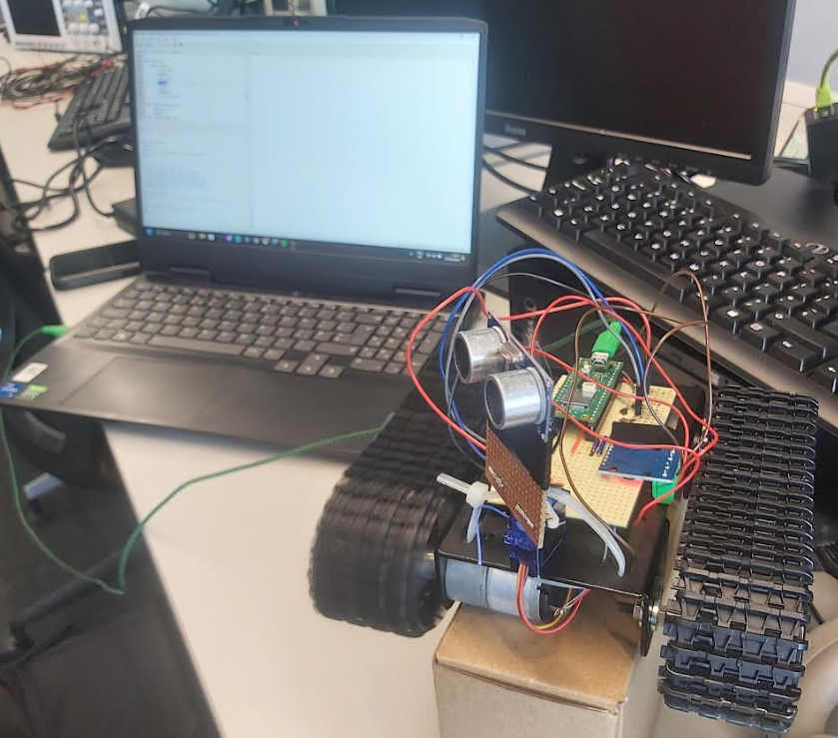
Figure 7 Completed Vehicle with Code (Background)

(3:2) Software Development
Alex section – Software construction + flow charts

(4:0) Testing and Results
During and through the construction phase of the project, small tests were conducted to see if procedures and system setups worked as intended. This test ranged from code debugging and running, bench tests of components, and full body/ system shakedowns combining both the software and hardware aspects as one.
Day 1 - On the first day of construction, several smaller tests were conducted on the motors and H gate systems that were being used as the movement systems for the vehicle. The first of these tests focused on the motors as individuals and comprised of a simple setup of a bench power supply, connecting wires, and a motor. This was to see the minimum limits of the motor's capabilities by first setting the voltage and amps of the power supply to the motor's recommended operation values and then decreasing the amps, followed by voltage until the motor stopped rotating. The purpose behind this was to see what the physical lower limit that an external power supply could be at that still was capable enough to drive the motors and the rest of the vehicle.
The next stage of testing that took place on day one was that of the combination of the H gate system, motors, external power supply, and the Pico PI. This test first started by connecting the H gate system to the bench power supply and to the motors, while also using the bench power supply as the trigger for the motor's movement. This was to gain a basic understanding of the operation of the H gate before connecting it to the Pico and to see if the predicted pin high, pin low technique would be sufficient to trigger the system. It was during this test that one of the H gates circuits became damaged due to a sudden voltage spice. This resulted in identifying the max voltage and current inputs for the H gate.
After positive results using the bench power supply as a trigger showed the clockwise and anti-clockwise rotation of the motor, the addition of the Pico was made. This test was to see if an external power supply could be used alongside the Pico if they shared a common ground. This proved to be successful and with further investigation, it became apparent that the Pico could also be used as the power supply to drive the motors too. This discovery was only apparent for the operation of the larger motors and not the smaller ones as they required a higher current flower that the Pico was incapable of producing.
Owens section – Day 3 full shakedown test
Alex section – Day 1 motor code tests, Day 2 sensor test, Day 4 coding adjustments
Day 4 – The final day of testing consisted of a full system test, much like the one carried out on day 3 but this time the project was in what can be said its final form. During this test, the vehicle was challenged to drive in an extended straight line, longer than its previous tests, and to avoid four different types of obstacles, namely the lab desks, walls, people, and lab stools.
While carrying out the extended straight test, it became apparent that the vehicle tracks were moving at two different speeds resulting in the vehicle pulling over to one side when moving. On recognizing this, amendments to the tracks were made, making sure both were at the same length as one another. After this was done, the distance between the drive and bearing wheels was checked to make sure their distances were the same. This only slightly improved the drifting and led to an investigation into the code where it became apparent that the power distribution between the two motors was not even. This was quickly resolved.
When the vehicle was then tested against its obstacle recognition, it successfully detected and maneuvered around the issue. This event proved successful when the vehicle found itself trapped in between the elevated feet of the lab stools, where it managed to maneuver its way out of the issue and back onto its original trajectory. But it was during this test that the code used to identify the best possible position to move to when avoiding an obstruction was off, resulting in the vehicle favoring right turns over the more sensible options. This issue was amended slightly but resulted in the obstacle detection of objects in front of the vehicle not responding. To solve this issue an older version of the collision detection code was returned to and, as of writing this report, the pathfinding is still not at its optimal performance.

(5:0) Evaluation
The Autonomous ground vehicle proves to be effective in its capability of detecting and avoiding obstacles without the need for RF communications. In comparison to similar products, it works successfully thou it is not as smooth if the vehicle were to go head-to-head with an off-the-shelf comparison. This can be rectified with more time spent on the project to fine-tune its detection and its pathfinding capabilities. It will also be noted that most off-the-shelf existing products will use RF communications to help guide their vehicles.

Conclusion
To conclude, this project has successfully proven that a preprogrammed autonomous vehicle that does not depend on RF communications can successfully navigate, detect, and avoid obstacles when set on a pre-determined route. This has been proven by simple tests held within a lab environment that have tested and strained the capabilities of the vehicle and have indicated to the authors where adjustments are needed to improve the vehicle's performance.
All thou the project works to a basic degree, there are still improvements and fetches that will be added to the vehicle. These improvements range from hardware, such as the addition of a secondary external power supply to improve motor performance, and a made-for-purpose body so that it is no longer just an open-top shazzy. Making the vehicle more professional-looking.
On the side of future software development, there will be the addition of a gue to allow users to interact with the vehicle and to easily instruct the vehicle with new instructions as to its pre-determined route. There will also be the intention to add a mapping function to the vehicle so that once it has identified the path to take to get to the objective, it can then follow its newly mapped route back to its start point.

Reflection
(JG) – Looking back at the group project, I believe I developed several skills but also highlighted areas, to myself, in which I need to improve.
Some of these improved skills were those of my soft skills that were developed through being the team leader for the project. One of the more prominent skills that were tested during this role was that of adapting to sudden changes in planes. This resulted in me having to redistribute the workload between myself and my team while also considering the varying strengths/learning styles of each team member. This played a big role in my time management too.
An improvement I believe I need to develop is my capability to structure my research. I noticed on several occasions I would carry out research upon a subject/components, gather what I needed but then not note the process instead opting to continue with the task that drove me to the research to begin with. I believe I can improve upon this by making a logbook in which I note down key steps/research as I go along instead of waiting to write it in the report.

References
[1]S. Jung, “Journal of Knowledge Information Technology and Systems,” Apr. 2017, Available: https://www.researchgate.net/profile/Sunghun-Jung-2/publication/317389269_Analysis_of_Amazon_Prime_Air_UAV_Delivery_Service/links/5938954aaca272bcd19ffe20/Analysis-of-Amazon-Prime-Air-UAV-Delivery-Service.pdf
[2]Baesystems.com, 2024. https://www.baesystems.com/en-uk/feature/innovators/fully-autonomous-vehicles-in-battlefield-simulation
[3]M. Hossain, “Self-Driving Robots: A Revolution in the Local Delivery,” California Management Review Insights, Apr. 2022, Available: https://cmr.berkeley.edu/2022/04/self-driving-robots-a-revolution-in-the-local-delivery/
[4]“Development of a Robotics Waiter System for the food and beverage industry,” 2015, doi: https://doi.org/10.15224/%20978-1-63248-066-8-57.
[5]“China Delivery Robot Factory, Delivery Robot Supplier,” www.alpharobotics.com.cn. https://www.alpharobotics.com.cn/delivery-robot/?gad_source=1&gclid=CjwKCAjwyJqzBhBaEiwAWDRJVBnKy7xCn0fQjOUFtDQSM-OQbl8aSGxmf61G4g8MfmY78f0LwADnDhoCb7AQAvD_BwE (accessed Jul. 01, 2024).
[6]“KEENON Robotics Global Official Website,” www.keenon.com. https://www.keenon.com/en/product/T10/index.html?gad_source=1&gclid=CjwKCAjwyJqzBhBaEiwAWDRJVAdkC7YlesB0wtx-6mr6qRA0RCK0kgGSOfkeSIm00igHkOV6euO5OxoCIkUQAvD_BwE (accessed Jul. 01, 2024).
[7]S. Butler, “Not-so dumb waiter: UK restaurant chain Bella Italia trials robot service,” the Guardian, Jun. 10, 2022. https://www.theguardian.com/business/2022/jun/10/uk-restaurant-bella-italia-robot-waiter
[8]K. Lyons, “A restaurant in the Netherlands is using creepy robot waiters for social distancing,” The Verge, May 31, 2020. https://www.theverge.com/2020/5/31/21276318/restaurant-netherlands-robot-waiters-social-distancing-pandemic
[9]Raspberry PI, “Raspberry Pi Documentation - Raspberry Pi Pico,” www.raspberrypi.com. https://www.raspberrypi.com/documentation/microcontrollers/raspberry-pi-pico.html
[10]“L9110 2-CHANNEL MOTOR DRIVER.” Accessed: Jul. 01, 2024. [Online]. Available: https://www.laskakit.cz/user/related_files/l9110_2_channel_motor_driver.pdf

Bibliography
S. Jung, “Journal of Knowledge Information Technology and Systems,” Apr. 2017, Available: https://www.researchgate.net/profile/Sunghun-Jung-2/publication/317389269_Analysis_of_Amazon_Prime_Air_UAV_Delivery_Service/links/5938954aaca272bcd19ffe20/Analysis-of-Amazon-Prime-Air-UAV-Delivery-Service.pdf

]“Development of a Robotics Waiter System for the food and beverage industry,” 2015, doi: https://doi.org/10.15224/%20978-1-63248-066-8-57.

