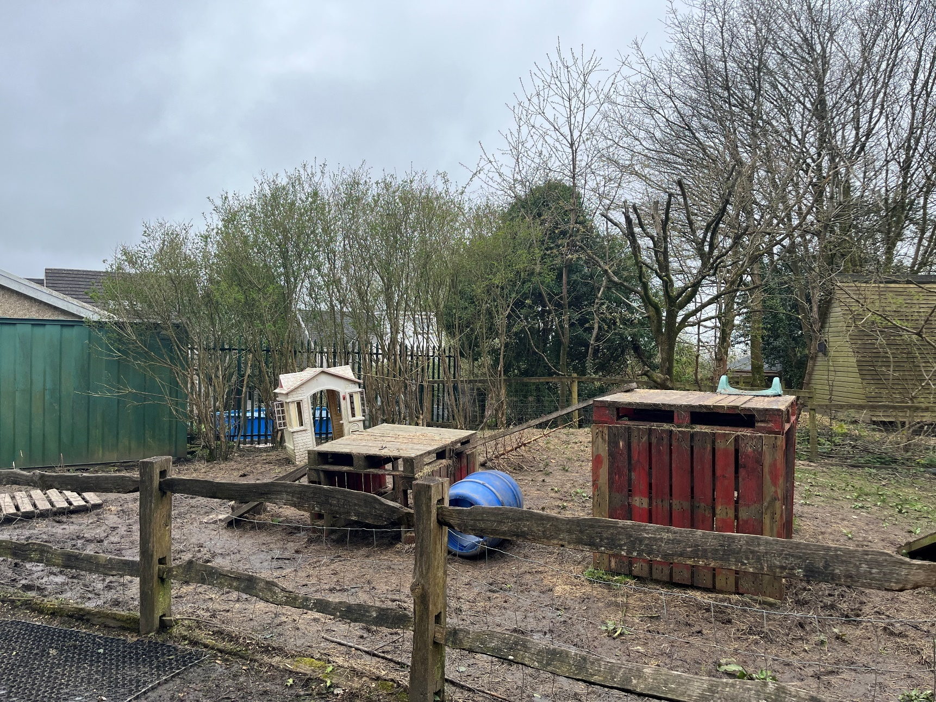
Part 1
(James, 2024).

Part 2
On Friday 5th April 2024 at 10 a.m., five children (aged 4-6) at Pitter Patter Nursery went on a trip to Swansea Community Farm with two practitioners. It was a rainy morning, so the children put on suitable clothing for the trip such as waterproof overalls and wellies. The children were very excited to go to the farm to explore and investigate the great outdoors. Some of the children mentioned that they were excited to jump into puddles and get muddy. Before leaving the nursery to visit the farm, one of the practitioners read a book to the children about exploring the outdoors, ‘Look what I found in the woods’ by Moira Butterfield. After this book was read, the children became very excited for the forthcoming adventure. One of the children said that they were going to see how many leaves they could find just like the character in the book had done.
The Welsh Government (2022) states that the great outdoors can evoke a sense of wonder and awe for children which enables them to build mathematical and scientific skills (National Resources Wales, 2022). Moreover, The Welsh Government (2022) states that the outdoors enables children to investigate and explore the notion of sustainability. Furthermore, the outdoors can help children cultivate a feeling of belonging in their local surrounding and the world around them. The planned activities for this visit were to see if a ball rolls up and down a plank and for them to understand the meaning of ‘gravity’ and exploring weight and size in the mud kitchen. The children brought different size balls with them to the farm. Upon arrival, instantly the children noticed a loose parts area that had planks and wooden crates. “Wow! let’s go and climb the plank,” said the children. The children carried out their intentions with great enthusiasm. They were very careful and took their time balancing on it. The Welsh Government (2022) states that children can explore their physical potential, develop motor skills, and enhance their balance and coordination in outdoor environments. Furthermore, children can develop resilience and confidence by risk taking in the outdoors.
They all took turns and were helping each other up onto the wooden crates. The practitioners were observing the children and made sure that they played safely. The practitioners scaffolded the children’s learning, when necessary, by posing open ended questions to the children to enhance their comprehension of the activity. For example, I asked the children how they could walk up and down the plank without falling off it. One of the children replied saying “we are balancing” and another child said, “I am walking slowly and carefully”. “Well done, you are taking your time and balancing on the plank, so you do not fall off” I replied. “I wonder if a ball can roll up and down the plank?” I asked. One of the children picked up the ball and gently rolled it down the plank. They then tried to roll the ball up the plank. However, the ball kept rolling back down. “Why isn’t the ball going up?” the girl asked. “That’s a very good question, why do you think the ball isn’t going up the plank?” I replied. “Because the plank is not flat” a boy replied. Another boy replied saying “because it is easier to go down it than up it”. “Excellent answers, great job, gravity is the force that pulls the earth and the ball together which does not allow the ball to roll upwards” I replied. The children thought this was fascinating. Therefore, they then experimented with different objects such as, a larger ball, a smaller ball, and a toy car to see if the outcome would be different or the same. Welsh Government (2022) implies that young children should be exposed to materials for experimenting with hard and soft, sink and float, light and heavy, push and pull, and other forces and motions for them to develop scientific skills. This experience enabled children to think and use their imagination. They learnt the meaning of gravity and they showed a good understanding of why a ball could not roll up a plank.

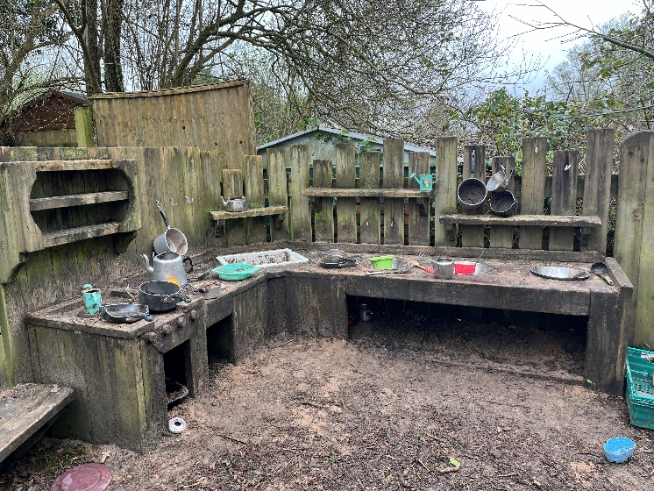
After playing on the wooden crates and planks, the children made their way into the mud kitchen. The children put aprons on and started playing with the mud and accessories. The mud kitchen contained many kitchen accessories, such as spoons, measuring jugs, bowls, and pans, which were great for the children to explore and to trigger their imagination. The children started to fill different sized cups and pans with water and mud. One of the children mentioned that the cup filled with mud was heavier than the cup filled with water. The children enjoyed filling, emptying, measuring, and investigating capacity with water and mud.

(James, 2024).
“Why do you think that cup is heavier than the other?” I asked. “Because water is lighter than mud” the child replied. “That’s a really good answer” I replied. “Could there be another reason why the cup filled with water is lighter than the cup filled with mud?” a girl replied: “There is more mud than water” Excellent answer, good work!” I replied. The children then filled different sized pots, cups and pans with mud and water and counted how many they could fill. One of the children filled a large cup with water. I asked what would happen if they poured that amount of water into a smaller cup. The child responded with: “It wouldn’t fit as there is too much water” “That is a great answer, well done” I replied. One child said: “I am going to make jelly” and the other child said, “I am going to make soup”. I asked how much mud and how much water they were going to put in. “I am going to put two cups of mud and three cups of water in mine” said one girl. Then with a measuring jug she filled the water up to three millilitres and filled another measuring jug up with mud using her hands. “What does the mud mixed with water feel like?” I asked. “It feels lumpy and sticky, but it was dry without water”. The other child responded with “It feels gooey and soft”.

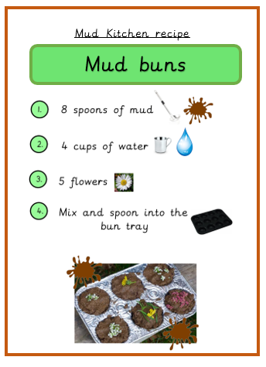
The other practitioner handed out a recipe on how to make mud buns. The children were excited to make the buns, so they gathered the equipment that they needed to make them. The children matched the numbers on the recipe to quantities counted eight spoonsful of mud, measured four cups of water, and found five flowers from the nearby grass, and then mixed them together in a bowl. The children were very careful and precise with the amount of mud and water they were measuring to make the buns. According to The Welsh Government (2022), it is important to provide children with regular opportunities for outdoor play, so they can continue to explore mathematical ideas in their daily lives. The Welsh Government (2020) suggests that to help children acquire mathematical abilities and apply their knowledge in practice, nurseries must use hands-on activities that include, for example, counting. The mud kitchen enabled the children to recognise numbers, spaces, measurements, and shapes. This opportunity and experience greatly enhanced children’s scientific and mathematical skills. To expand further learning in the mud kitchen, the children could add powdered chalk or paint to the mud to make it colourful which could, for example, represent different foods and make different recipes for the children. This would include maths and science concepts such as weight, size and measuring to further promote and enhance their mathematical and scientific skills.

(Tes, 2024).

Part 3

RISK BENEFIT ASSESSMENT

Location / Activity: | Loose parts area and mud kitchen. | Date: | 1st April 2024
Assessor: | Hannah James | Review date: | 1st October 2024

The boxes in the table below will expand as you type into them; pre-entered text is simply for illustration. You should delete irrelevant items and replace with text relevant to your circumstances.
Your overall risk rating – Low, medium or high – is based on your judgement about whether the BENEFITS of the activity or opportunity outweigh the RISKS.
Experience exploring outdoor space in photograph | How will young people BENEFIT from this activity? | Hazards and associated risks | Who is at risk? | PRECAUTIONS in place to reduce the risk or injury | Overall risk after precautions  RATING: L/M/H
Dirty/ wet clothing and shoes | Children practise putting on clothes and taking off their shoes independently and take ownership of their possessions. | Children will get cold and uncomfortable. | Children | Children should be dressed in appropriate clothing and should be provided with waterproof overalls.  Appropriate footwear should be kept at nursery for outdoor activities.  Nursery should provide spare clothing when needed. | Low
Slippery surfaces | Children can have the opportunity to explore the science of friction by slipping and sliding and bouncing in muddy puddles. | Children could fall, slip or trip causing cuts, strains, or injury. | Children and adults. | Children and adults must wear adequate footwear to eliminate the risk of falling or slipping.  Shoes that are muddy or wet must be taken off before entering indoors.  Adults must monitor the areas and determine when intervention is necessary.  First aid box. | High
Water | Children can tip, pour water, and pretend to make soups and potions.  Helps children comprehend maths, science, volume, and capacity. | Flooding during periods of persistent rain.  Water stagnation, contamination consumption and absorption. | Children | Teachers should enforce the water safety guideline and observe the area during rain or flooding.  At the end of each session or day, water containers are emptied and not allowed to become stagnant.  Water containers are routinely cleaned and inspected for algae, mould, and strange objects.  Children are reminded to refrain from consuming anything in the playing area. | High
Children washing up | Children can develop healthy hygiene habits. | Wet ground causes falls, trips, and slips. | Children and adults. | Adults should provide the children with a bucket of warm, soapy water for hand washing outside.  Children and adults must wear suitable footwear to avoid slipping.  Children and other adults are informed about the potential for slip hazards.  First aid box | High
Washing up equipment such as utensils, pans, pots, jugs, and spoons | Children participating in cleaning up time fosters a feeling of space ownership and imparts important life skills.  Helps to develop children’s motor skills. | Accidental bump using resources.  Harm caused by a sharp, rusted object. | Children and adults. | To prevent rusting, pots, utensils, and equipment should be cleaned and dried.  Adults must always monitor the area.  First aid box | Low
Contact with mud and soil | Exposure to bacteria can help to develop immune systems.  Open-ended sensory materials.  Mud play enables children to use all their senses. The various textures of mud and soil can develop children’s curiosity | Consuming mud and soil.  Sharp material in the mud/soil. | Children | Adults should ensure that they setup for hand cleaning both during and after play.  Routines created for children for hand washing.  Children are reminded to refrain from consuming anything the playing area.  First aid box. | Low
Mud/soil contamination | Children visually inspect the area before they play, which fosters a sense of ownership and increases awareness of potential hazards. | Consuming or absorbing contaminated mud/soil. | Children | The soil should be examined by staff for pollutants before children play in the area. This must be on an inspection checklist and carried out before children play in the area. | Low
Pieces of natural materials such as stones/ gravel, bark | Improves children’s gross motor skills through lifting, pouring, gathering, carrying, and sorting patterns.  Enhances imaginative and creative skills through exploring. | Children consuming or absorbing harmful fungus or plants.  Children with allergies. | Children and adults. | Children must be informed about the potential dangers of consuming unfamiliar plants or fungi.  Children must be urged to abstain from consumption in this area.  Children must be told to wash their hands before touching their faces. | High
Uneven surfaces | Improves children’s balance and coordination.  Children can learn about gradients and slopes which can encourage and promote an understanding of forces. | Fall or trip which could cause bruises, sprains, cuts, or other injury. | Children and adults | Staff explain to children to be careful and taking their time when walking on uneven surfaces by walking slowly at first until they become accustomed to uneven surfaces.  Engaging in an enjoyable game that can aid equilibrium.  Children wearing the correct clothing and footwear such as trousers and wellingtons.  First aid box. | Low
Planks and crates, wooden blocks, tyres | Children can investigate through touch to experience different textures, sizes, and properties.  Promotes children’s mathematical development as the parts can be used to add and subtract numbers.  Visual aids to help children understand measurements, number formation and recognition. | Children and adults could slip, fall, or cut themselves when handling loose parts.  Loose parts may be sharp and could cause a cut.  Loose parts could fall on top of a child if not stacked properly. | Children and staff. | When accessing the equipment, weather conditions should be considered.  Area to be inspected to make sure the surface is level, and the surroundings are clear and that there is no damage on the equipment.  First aid box. | Moderate

Part 4
This essay will critically evaluate how adults working with early years children can encourage and support them to engage with mathematical and scientific concepts in an outdoor environment. It has been established that outdoor play helps children develop their scientific and numeracy abilities as it encourages them to learn through exploration and investigation (Bento and Dias, 2017). The Welsh Government (2022) emphasises the significance of children experiencing multiple opportunities to play and learn by exploring and investigating the great outdoors, where they can experience awe and wonder in the natural world. This complies with Article 31 of the United Nations Convention on the Rights of the Child (UNCRC), which states that every child deserves the right to play (UNCRC, 2021). According to Loughborough University (2017) and Wilson (2018) engaging in outdoor activities such as mud kitchens and forest schools helps foster children's scientific and mathematical abilities. Robertson (2017) and White and Edwards (2018) agree that opportunities like these can enhance and enrich children’s knowledge that enable them to comprehend scientific and mathematical concepts.
In contrast, Copeland et al. (2012) and Erdem (2018) state that children are being deprived from playing outside as many practitioners are scared that children might get hurt. Moreover, not all practitioners enjoy being outdoors especially when it is raining. However, Watts (2020) states that children love playing outdoors in all weathers and playing in the rain boosts children’s immune systems, creates appropriate sleep habits, and fosters basic motor abilities and creative thinking. To guarantee that practitioners comprehend the value of outdoor surroundings and the advantages they offer for children's reading and numeracy skills, they must undergo frequent training (Bento and Dias, 2017).
For children to experience stimulating opportunities, McGillivray (2015) states that it is the role of the adult to encourage, promote and provide children with enabling environments, where they can explore the outdoors. This is supported by Froebel as Tovey (no date) highlights that he believed that if adults act apathetically or with contempt towards the natural world, the child's developing curiosity and knowledge may be negatively impacted. Therefore, adults should be knowledgeable and astute observers of both children and the natural world. This is supported by The Welsh Government (2022) as it states that adults should encourage and support children’s innate curiosity by modelling an enjoyable approach to learning. Furthermore, adults should take advantage of the educational moments that develop when they observe or participate in children’s play. Similarly, Waite-Stupiansky and Cohen (2020) state that when children participate in some aspects of science exploration and related practices through play, adults should model, mentor, challenge, guide, and provide engaging environments and thoughtfully construct experiences with the natural world to support and enhance this work. Montessori (1965) and Piaget (1962) both reinforce the idea that an adult's role is to enable children to explore and learn on their own before pursuing their interests. This is further supported by Vygotsky's (1986) Zone of Proximal Development, which emphasises children's abilities as a foundation for extending and promoting learning. According to Farland-Smith (2019) when adults provide children with invigorating environments that foster curiosity and active learning, this helps them improve science and mathematics skills. The Welsh Government (2022) states that children can learn and comprehend that maths is all around them by creating an enabling environment. Furthermore, adults that promote appropriate mathematical language and abilities in children can aid in the development of their strategic competency (The Welsh Government, 2022).
Evans (2016) implies that it is imperative that adults allow children to explore and investigate the outdoors and high play affordance surroundings, where children can use the environment and materials in a variety of creative ways. Similarly, D’Ascoli and Hunter (2022) state that Froebel strongly believed that adults must allow children to explore the outdoors and learn independently whilst supporting them by being alongside them when they make discoveries and treating those findings with reverence. The Welsh Government (2022) suggests that children's comprehension of mathematical ideas should be scaffolded by a well-planned and organised environment, which includes providing them with opportunity to encounter number, form, and pattern in real-world situations outdoors.
According to Ouvry and Furtado (2020) outdoor settings, such as parks, fields and woodlands are dynamic and provide an array of open-ended materials that inspire children to think creatively and imaginatively while fostering an understanding of science and maths. The Welsh Government (2022) states that children require a hands-on experience that motivate them to explore quantity, number, shape, and pattern by using basic mathematical language. Moreover, these experiences can help children develop cognitively by giving them the opportunity to compare, sort, and categorise both live and non-living things. Evans (2018) implies that Piaget described children as "little scientists" who acquire knowledge through play-related experimentation and trial-and-error in their immediate environment. Furthermore, Piaget believed that children acquire knowledge through play and by doing practical activities that help them comprehend the world around them (Evans, 2018).
There are many outdoor activities for children that can support children’s mathematical and scientific development. White and Edwards (2018) emphasises that playing in mud kitchens can help children's mathematical development. According to Wilson (2018) children can measure and experiment with weight in mud kitchens by pouring mud and water from containers. This is crucial as it aligns with The Welsh Government’s objectives for mathematical growth as it states that children should engage in a variety of activities that can enhance their numeracy abilities (The Welsh Government, 2022). Similarly, according to McGrath (2014) children should be given numeracy rich activities as this would aid in their mathematical development. Mud kitchens can therefore facilitate this as practitioners can ask children how many mud pies they have made and by using mathematical vocabulary such as long and short (White and Edwards, 2018).

Furthermore, White and Edwards (2018) emphasise the significance of the adult acting as a facilitator by letting children build their own mud kitchens and giving them support and encouragement. It is critical for early years practitioners to facilitate discussions and activities with children. This is known as sustained shared thinking (Neale and Pino-Pasternak, 2017). Neale and Pino-Pasternak (2017) highlight that sustained shared thinking emphasises the value of children's curiosity, motivation, and inspiration to advance their own learning. Therefore, creating opportunities for sustained shared thinking expands and enhances children’s learning, including learning about other people and their expertise (Fleer, 2021). Thus, children become more capable of actively participating in both their own and others' education.
White (2020) implies that when children and practitioners engage in in-depth conversations, children naturally gain a greater understanding of their environment, the materials, or resources they are using or a specific concept or idea. Children can learn about the world around them by participating in a simple activity through the two-way conversation (Tovey, no date). Watts (2020) suggests that early year’s practitioners can encourage children to think outside the box by posing open-ended questions to them that might include "why?" "Who?" "When?" "Where?" or "what." This is supported by the Welsh Government (2022) as it states that practitioners can promote and encourage the development of numeracy by questioning children about sizes, shapes, and the number of materials they have found in an outdoor environment. By fostering conversation with children, it can enhance their learning (The Welsh Government, 2022).
According to White and Edwards (2018) for children to experience the most from being outdoors, practitioners must make sure they give children enough time to play, explore, and learn on their own. The theories of Vygotsky (1986) and Bruner (1996) support the argument that adults should give children the chance to learn on their own and scaffold when needed to advance their learning. Spencer et al. (2019) state that children can explore, take chances, create, and learn in an outdoor play area that is stimulating and has loose parts in a childcare setting which can enhance children’s overall development. The Reggio Emilia approach consider the outdoors as the third teacher as it stresses that playing with natural materials helps children learn as they are flexible and allows them to share ideas and learn from each other about what they can create (McNally and Slutsky, 2017).
The Welsh Government (no date) implies that Gibson believed that children's affordances and perceptions are supported by loose parts as they have total control over them which evolves based on what each child designs and makes with it. For example, a child can pretend that a brick is a bed. Moreover, according to Nicholson, loose bits are all the things that satisfy one's curiosity and gives an individual the joy that comes from invention and discovery (The Welsh Government, no date). According to Cankaya et al. (2023) playing with loose parts is crucial for children's cognitive development and is a key aspect of childhood as it is an open-ended activity that encourages diverse thinking and adaptable problem-solving techniques. According to research, problem-solving, critical thinking, and trial-and-error scientific inquiry are the main cognitive skills in early childhood science involvement in constructive play. Thus, children's comprehension of mathematics, physics, and architectural principles can be enhanced as a result (Cankaya et al., 2023). Gibson et al. (2017) Materials such as blocks, bricks, and planks can help enhance scientific, mathematical, and technological foundations for children's cognitive development instead of structured play areas. Providing children with the opportunity to investigate loose parts materials can enable them to apply and expand their knowledge (Gibson et al., 2017). England (2019) implies that loose parts play can develop children's scientific skills as they can learn by playing with loose parts, which provides them with the resources they need to comprehend science ideas more deeply.
This can include their ability to recognise and ask questions, organise, carry out, and reflect on their research, as well as their ability to process, analyse, and interpret information (Hanif and Pramudyani, 2023). Furthermore, Hanif and Pramudyani (2023) infers that children can examine concepts, resolve issues, conclude, and create arguments supported by facts. McMahon and Dyer (2018) state that when children play with loose parts, they can gain knowledge on numeracy. Loose parts play can help children learn key numeracy skills and concepts such as matching and classifying, comparing, and ordering collections, estimating, measuring, investigating shapes and position and location, and connecting number names and numbers (McMahon and Dyer, 2018). However, Cankaya et al. (2023) and Robertson (2017) state that early year’s practitioners play a significant role in loose parts play. Practitioners should provide age-appropriate activities that include loose parts which supports the learning objectives of the curriculum, when children are engaged with loose parts play, it is important to observe and collect data, and help children learn and think more deeply through scaffolding and sustained shared thinking (Cankaya et al., 2023).

To conclude, it is evident that outdoor play is essential for children’s learning development as it can enhance children’s mathematical and scientific skills as stated by the Welsh Government (2022). Furthermore, theorists such as Frobel and Montessori believed that the outdoors is stimulating and gives children the opportunity to learn about the world around them. There are many activities that can promote maths and science in the outdoors such as providing children with the opportunity to play and explore in mud kitchens and loose parts. These activities can enrich children’s skills as they promote maths and science as they can use equipment to measure, count and find out about weight and size (White and Edwards, 2018).
Moreover, it is evident that adults play a critical part in children’s learning. Many sources and theorists have concluded that the adult must provide enabling outdoor entertainments for children to enrich their learning. It is suggested that the adult must scaffold children and ask open-ended questions to encourage them to think for themselves and to further their learning. Finally, early years practitioners should implement these ideas into practice to become an outstanding practitioner and to ensure children are given the opportunity to reach their full potential.

Reference list
Bento, G. and Dias, G. (2017) ‘The importance of outdoor play for young children’s healthy development’, Porto biomedical journal, 2(5), pp. 157–160. Available at: https://doi.org/10.1016/j.pbj.2017.03.003 (Accessed: 18 April 2024).
Bruner, J. (1996) The culture of education. Cambridge: Harvard University Press.
Cankaya, O., Rohatyn-Martin, N., Leach, J., Taylor, K., & Bulut, O. (2023) ‘Preschool Children’s Loose Parts Play and the Relationship to Cognitive Development: A Review of the Literature’, Journal of intelligence, 11(8), pp. 151. Available at: https://doi.org/10.3390/jintelligence11080151 (Accessed: 12 April 2024).

Copeland, K.A., Kendeigh, C.A., Saelens, B.E., Kalkwarf, H.J. and Sherman, S.N. (2012) ‘Physical activity in child-care centers: do teachers hold the key to the playground?’, Health education research, 27(1), pp. 81–100. Available at: https://doi.org/10.1093/her/cyr038 (Accessed: 12 April 2024).

D’Ascoli, H. and Hunter, D. (2022) Re-engaging with nature. Available at: Froebel Trust | Re-engaging with nature (Accessed: 18 April 2024).

England, L., (2019) Looking for learning: Loose parts. Bloomsbury Publishing.
Erdem, D. (2018) ‘Kindergarten Teachers' Views about Outdoor Activities’, Journal of education and learning, 7(3), pp.203-218. Available at: ERIC - EJ1174375 - Kindergarten Teachers' Views about Outdoor Activities, Journal of Education and Learning, 2018 (Accessed: 12 April 2024).

Evans, K. (2016) ‘Beyond a logic of quality: Opening space for material-discursive practices of ‘readiness’ in early years education’, Contemporary issues in early childhood, 17(1), pp. 65–77. Available at: https://doi.org/10.1177/1463949115627904 (Accessed: 18 April 2024).

Farland-Smith, D. (2019) Early Childhood Education. Available at: http://dx.doi.org/10.5772/intechopen.73467 (Accessed: 18 April 2024).

Fleer, M. (2021) ‘Conceptual Playworlds: the role of imagination in play and learning’, Early years (London, England), 41(4), pp. 353–364. Available at: https://doi.org/10.1080/09575146.2018.1549024 (Accessed: 18 April 2024).

Gibson, J.L., Cornell, M. and Gill, T. (2017) ‘A Systematic Review of Research into the Impact of Loose Parts Play on Children’s Cognitive, Social and Emotional Development’, School mental health, 9(4), pp. 295–309. Available at: https://doi.org/10.1007/s12310-017-9220-9 (Accessed: 12 April 2024).

Hanif, F. and Pramudyani, A.V.R., (2023) ‘Scaffolding on the use of loose parts in post-pandemic learning for age 5-6 years old’, Journal of Early Childhood Care and Education, 6(1), pp.14-35. Available at: Scaffolding on the use of loose parts in post-pandemic learning for age 5-6 years old | Journal of Early Childhood Care and Education (uad.ac.id) (Accessed: 12 April 2024).

James, H. (2024) Loose parts area [Image].
James, H. (2024) Mud Kitchen [Image].
Loughborough University (2017) Study reveals how Forest Schools can benefit children’s development. Available at: Study reveals how Forest Schools can benefit children’s development | News and events | Loughborough University (lboro.ac.uk) (Accessed: 13 April 2024).

McGillivray, G. (2015) ‘The role of the adult in early years settings’, International Journal of Early Years Education. Routledge, pp. 222–223. Available at: https://doi.org/10.1080/09669760.2013.768455 (Accessed: 12 April 2024).

McGrath, Caroline. (2014) Teaching mathematics through story: a creative approach for the early years. New York: Routledge.

McMahon, S. and Dyer, M. (2018) Advanced Work-based Practice in the Early Years: A Guide for Students. First edition. Boca Raton, FL: Routledge.

McNally, S.A. and Slutsky, R. (2017) ‘Key elements of the Reggio Emilia approach and how they are interconnected to create the highly regarded system of early childhood education’, Early child development and care, 187(12), pp. 1925–1937. Available at: https://doi.org/10.1080/03004430.2016.1197920 (Accessed: 12 April 2024).

Montessori, M. (1965) Dr. Montessori's own handbook. New York: Schocken.
Neale, D. and Pino-Pasternak, D. (2017) ‘A Review of Reminiscing in Early Childhood Settings and Links to Sustained Shared Thinking’, Educational psychology review, 29(3), pp. 641–665. Available at: A Review of Reminiscing in Early Childhood Settings and Links to Sustained ...: EBSCOhost (uwtsd.ac.uk) (Accessed: 18 April 2024).

Ouvry, M. and Furtado, A. (2020) Exercising muscles and minds: outdoor play and the early years curriculum. Available at: https://ebookcentral.proquest.com/lib/trinity/detail.action?docID=5909927 (Accessed: 18 April 2024).
Piaget, J. (1962) Play, dreams, and imitation in childhood. New York: Routledge.
Robertson, J. (2017) Messy maths: a playful, outdoor approach for early years. Carmarthen, Wales: Independent Thinking Press.

Spencer, A., Joshi, N., Branje, K., McIsaac, J. D., Cawley, J., Rehman, L., Kirk, S. F., & Stone, M. (2019) ‘Educator perceptions on the benefits and challenges of loose parts play in the outdoor environments of childcare centres’, AIMS public health, 6(4), pp. 461–476. Available at: https://doi.org/10.3934/publichealth (Accessed: 12 April 2024).
Tes (2020) Mud Kitchen Recipe Cards [Image]. Available at: Mud Kitchen Recipe Cards | Teaching Resources (tes.com) (Accessed: 10 April 2024).
Tovey, H. (no date) A Froebelian Approach; Outdoor play and exploration. Available at: Layout 1 (froebel.org.uk) (Accessed: 18 April 2024).

UNICEF (2021) United Nations Convention on the Rights of the Child. Available at: https://www.unicef.org.uk/wpcontent/uploads/2010/05/UNCRC_united_nations_convention_on_the_rights_of_the_child.pdf (Accessed: 11 April 2024).
Vygotsky, L. and Kozulin, A. (1986) Thought and language. London: Massachusetts Institute of Technology Press.

Waite-Stupiansky, S. and Cohen, L.E. (2020) STEM in early childhood education: how science, technology, engineering, and mathematics strengthen learning.

Available at: https://doi.org/10.4324/9780429453755 (Accessed: 18 April 2024).
Watts, A. (2020) Outdoor learning through the seasons: an essential guide for the early years. London: New York. Routledge.
Welsh Government (2020) Mathematics and Numeracy. Available at: Mathematics and Numeracy: Introduction - Hwb (gov.wales) (Accessed: 18 April 2024).

Welsh Government (2022) A curriculum for funded non-maintained nursery settings. Available at: A curriculum for funded non-maintained nursery settings (gov.wales) (Accessed: 18 April 2024).

Welsh Government (no date) Schematic development: Noticing and supporting the repeated patterns of behaviour in children’s play. Available at: View - Hwb (gov.wales) (Accessed: 12 April 2024).
White, J. (2020) Playing and learning outdoors: the practical guide and sourcebook for excellence in outdoor provision and practice with young children. Third edition. London: Routledge.
White, J. and Edwards, L. (2018) Making a Mud Kitchen. Available at: Making_a_mud_kitchen_LowResAW.pdf (muddyfaces.co.uk) (Accessed: 12 April 2024).

Wilson, R.A. (2018) Nature and young children: encouraging creative play and learning in natural environments. Third edition. London: Routledge.

