Internet Technology and Security

Name: Katie Rees
Student Number: 1903413
Course: BSc Computer Science
Module: ACCA4018 Internet Technology & Security
Date: 20th July 2019

Table of Contents

Title | Page
- Introduction | 3
- Requirements | 3
2.1 Purpose | 3
2.2 Target Audience | 3
- Implementation | 3
3.1 HTML Validation | 11
3.2 CSS Validation | 11
- Evaluation | 12
4.1 Design | 12
4.2 Usability | 12
- Content | 13
- Accessibility Evaluation | 13
5.1 Web Accessibility | 13
5.2 ‘Doggy Duties’ Web Accessibility | 13
5.2.1 Perceivable | 13
5.2.2 Operable | 14
5.2.3 Understandable | 14
5.2.4 Robust | 15
- Conclusion | 15
- References | 15

- Introduction
The following report will discuss the principles and standards needed to create a successful website. Successful websites are arguably defined as a website which is user friendly, delivers the intended purpose and understands the target audience. It will also discuss and evaluate the standards which are used to ensure web accessibility.

- Requirements
Before designing any website, the developer must understand the requirements of the desired website. According to ‘Web Requirements’ [1], website requirements should be specific and testable. The requirements however should not include the design of the website. It would usually include what the website must do and what the users must be allowed to do.

  - Purpose
‘Doggy Duties’ is a website that informs potential customers of the services offered by the company and allows the user to send enquiries through to the owner of the business. It offers three different, yet all dog related, services; dog grooming, dog boarding and dog walking. It also displays any jobs that may be available for any prospering dog trainers. It must not allow users to book directly through the website as the owners have their own manual booking system in place.
  - Target Audience
The target audience is quite simply those who own a dog or potential employees. It targets all genders, from any degree of education, and any profession. Although the target audience may be of anyone from any profession, it may be catered towards those who are in full-time employment or those that live a busy lifestyle as these people may have less time to walk or groom their dogs themselves. This is one reason why the website must be responsive, mobile friendly and allow the user to send a query quickly and with ease to the owner. The website is targeted at those at home-owner age as young children may be involved in a house hold with dogs however will not be the dedicated owner of the dog. The website therefore can assume a basic education level and can include text selling their services. It should however include plenty of photos of dogs, so that the website is inviting and keeps the user engaged.

- Implementation
Below are screenshots of the ‘Doggy Duties’ finished website.

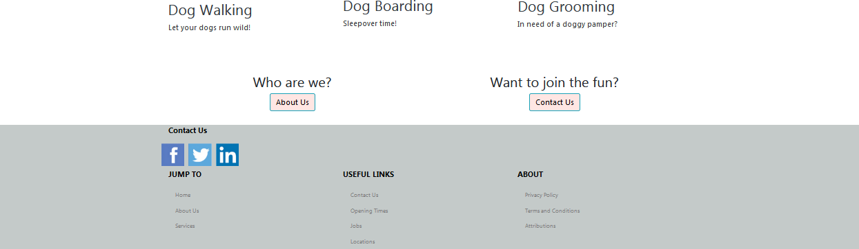

Fig 1.Index Page

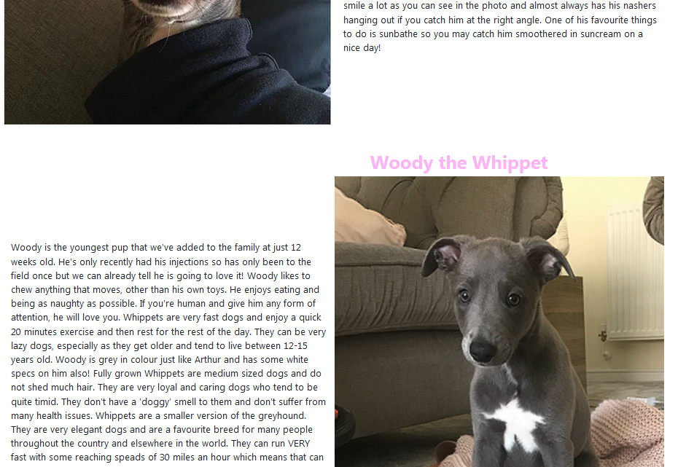
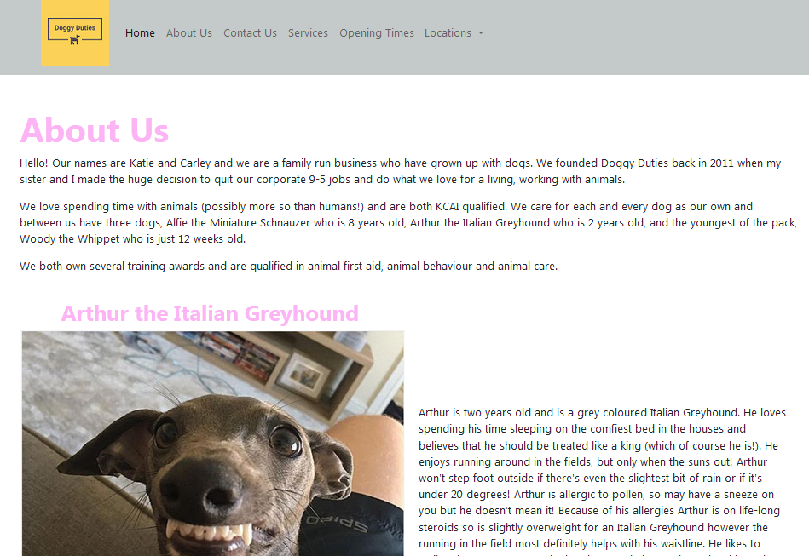
Fig 2.About Us Page

Fig 3.Contact Us
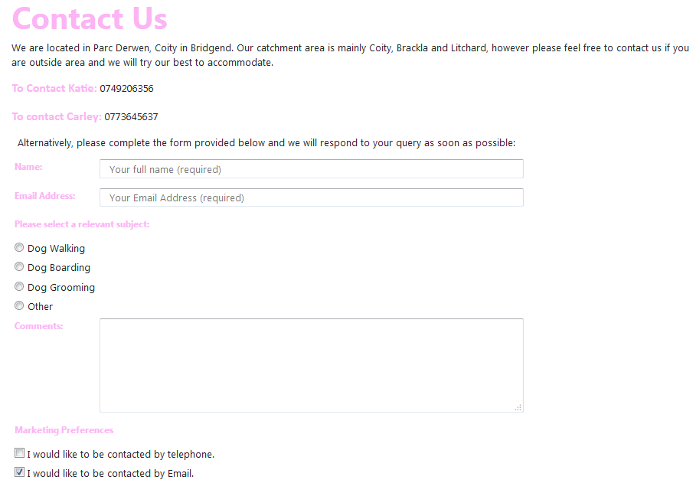

Fig 4. Services Page
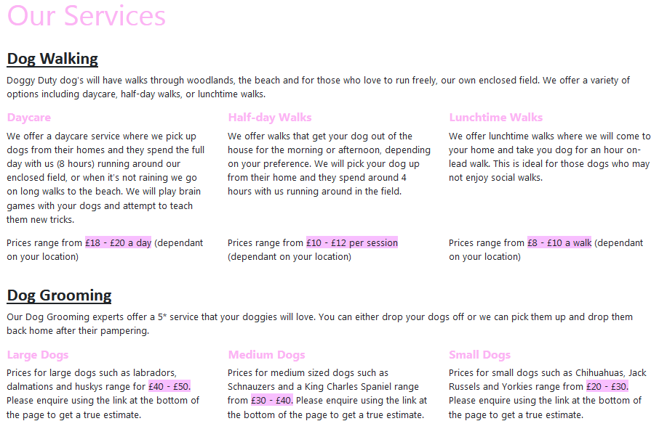
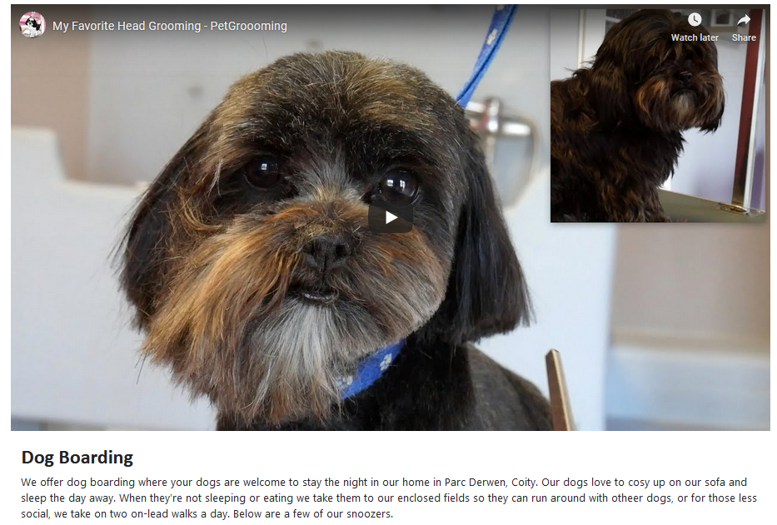

Fig 5. Opening Times Page
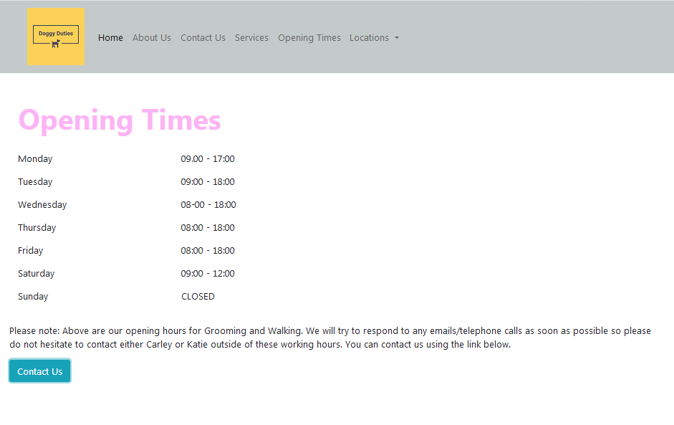

Fig 6. Coity (Location Page)
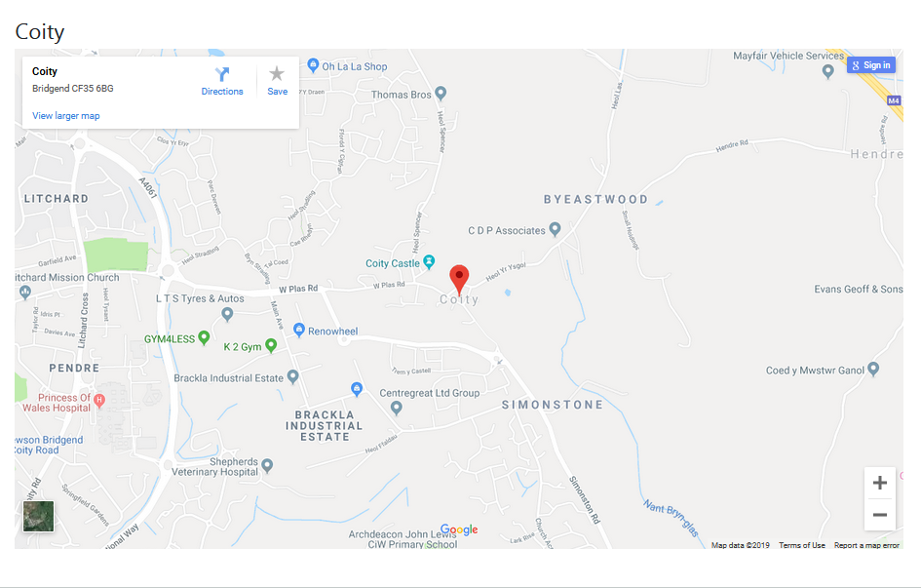

Fig 7. Brackla (Locations Page)
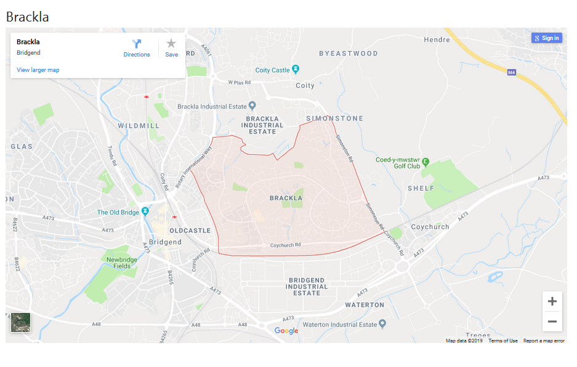

Fig 8. Litchard (Locations Page)
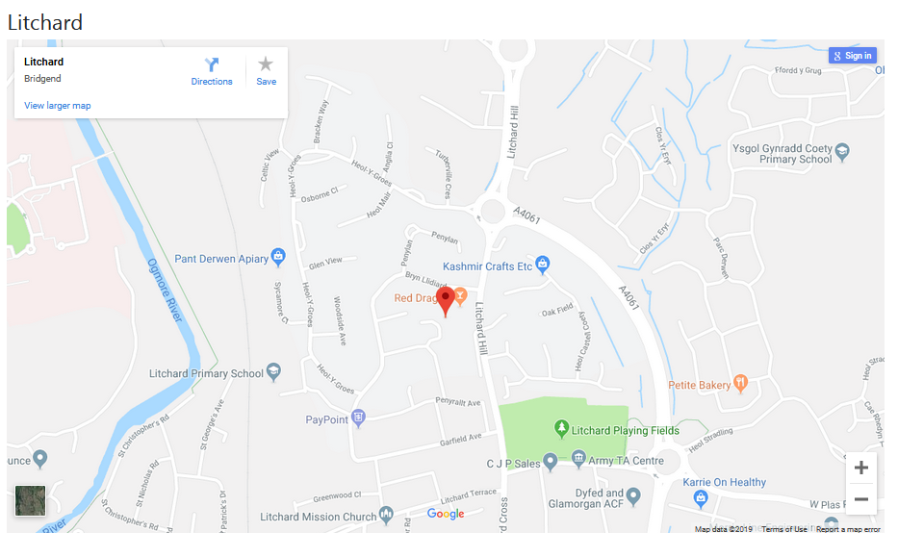

Fig 9. Confirmation Page
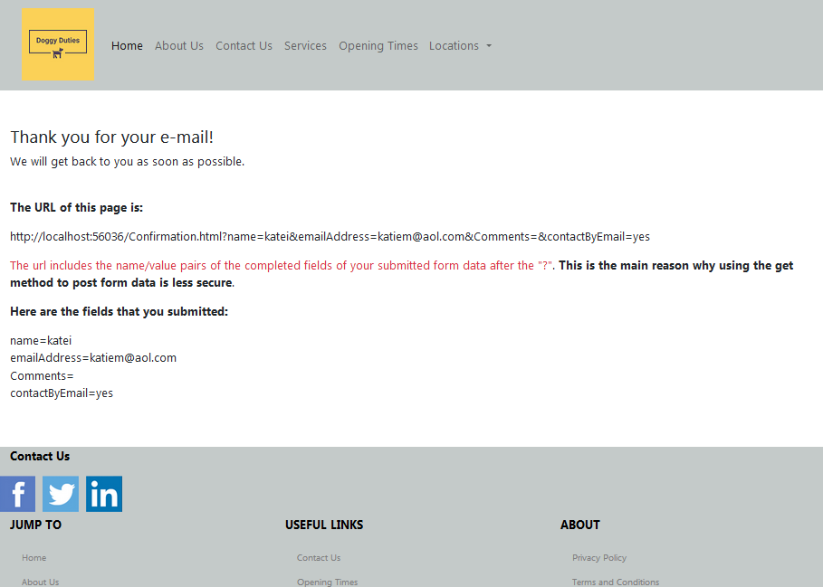

Fig 10. Jobs Page
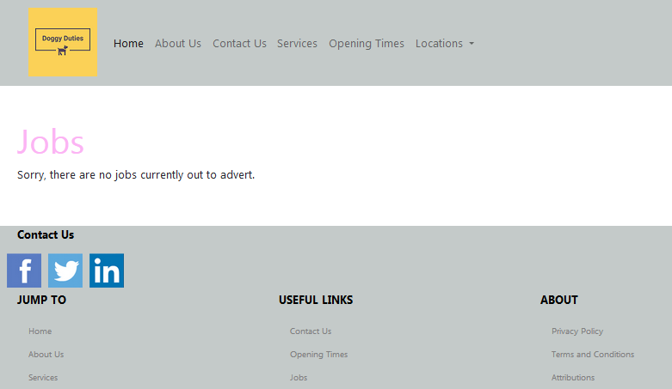

  - HTML Validation
The HTML used to create the ‘Doggy Duties’ produced nine errors in total using the W3 HTML Validator [2]. The first two errors were linked and were created through careless HTML.

Fig 10. HTML <title> errors
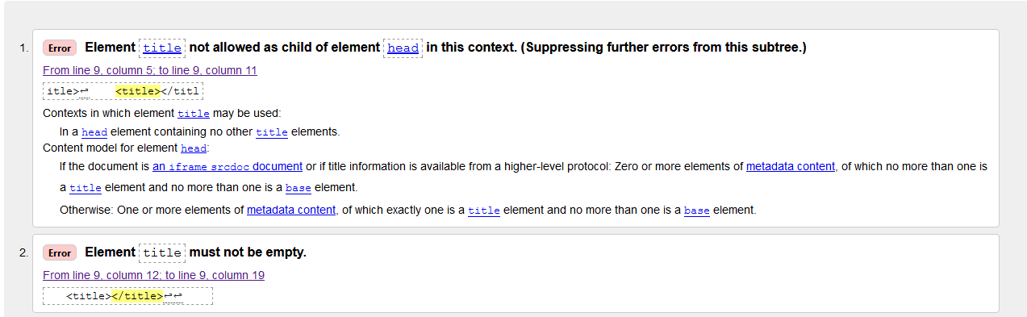
As you can see Figure 10 shows that the element <title></title> did not have any text included inside the element which has generated an error. This is a careless mistake and the title element was duplicated with the first <title> element including the text ‘Doggy Duties’ as shown in Figure 11.

Fig 11.HTML <title> code.
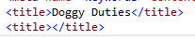

This can be avoided by proof reading code and taking more care when writing the code.
Errors 3-9 were also linked and were produced due to the name given to certain pages within the website, as they had a space in between the wording. For example, the About Us page is labelled ‘About Us.html’.

Figure 12. HTML ‘space not allowed’ error
Although the links work with a space between the names, this may not be supported on older browsers and is bad practice. To rectify this, an underscore could be included to the separate the words, or you could combine the word in to one. For Example, ‘About_Us.html’ or ‘AboutUs.html’.

  - CSS Validation
The CSS Validator [3] produced two errors shown in Figure 13 below.

Fig 13. CSS Validation Errors
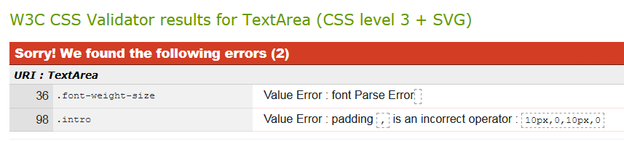
The first error was due to having the text ‘font’ underneath the original sequence as shown below in Figure 14. This was caused by poor coding and can be avoided by taking more care and time into writing the code. A web developer should always proof reading the code and be vigilant for the green line that highlights coding errors. To rectify this, the word ‘font’ needs to be removed.

Fig 14. Incorrect CSS Code

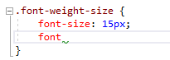

The second error shows that a comma has been used to separate padding pixels. A comma is not needed and this error can be resolved by simply separating the pixels using a space.

- Evaluation

  - Design
The ‘Doggy Duties’ website has been designed with a pink and grey colour scheme that runs throughout the website. It using a 12 column container and the footer and header backgrounds are the only object that spans the whole width of the screen. The headings on each page contain the same CSS design which creates consistency through the website. Although there is a common theme of pink and grey, the logo is, however, yellow. Yellow is not used anywhere else on the website and a pink logo would be better suited.

  - Usability
The header and footer is duplicated on every page throughout the website and these are designed the same on each page which creates consistency. By having the header and footer on every page, along with common elements such as similar designed headings, it makes it easy for the user to navigate throughout the website. However, the links on the header and footer page may be perceived as hard to read due to the similar background and font colour. The font on the header especially, is too small and could be increased to make it easier to read, as those who are visually impaired may struggle.
The main purpose of the website is to allow users to send a query to the owners regarding the services offered. The website allows the user to navigate to the ‘Contact Us’ form in just one click. As the target audience tends to be those with little spare time this allows the user to send a query quickly and easily. A link to ‘Contact Us’ is also on the Index page, along with a brief description regarding the services that they offer. The photos used on the index page to highlight the three main services also contain a link to send the user to the ‘Services’ page allowing the user to access more information, along with pricing. Depending what service you are interested in, the website is designed to take you to that exact piece of information on the ‘Services’ page. For example, if the user wishes to read about ‘Dog Grooming’ only, it will by-pass the start of the ‘Services’ page and take the user straight to the information regarding dog grooming. To improve, the ‘Services’ page, it should contain a link to the ‘Contact Us’ form. This means that those users who would like to read more information regarding the services on offer before contacting the owners, are able to do so without having to navigate back to the home page first.

  - Content
The website contains videos, images, text and maps. The website does not contain excess information that the user does not need to know. It briefly explains about the services and contains just enough information for the user to understand what service their dog would be receiving. The text is not overpowering and is usually followed by images. Certain images however, may be slightly too large for the web page. For example the ‘About Us’ page contains three images, all spanning 6 columns. For those using smaller devices, these pictures will span 12 columns and may force a user to scroll a lot just to read the entire content of the page. To improve this, the image size could be amended to a more sensible size, with smaller devices in mind.

- Accessibility Evaluation

5.1 Web Accessibility
According to Harper and Chen [4], Web Accessibility’s purpose is to support people with any disability to interact with the web. Web accessibility depends on several factors such as the content on the web page, the web developer creating the page and the software tools all working together. Although access to technologies such as screen readers have become easier, those who are visually impaired for example, still suffer loss of visual design when accessing a web page, such as images and graphics. The purpose of the website may be lost and usability becomes a lot more difficult. Brophy and Craven [5] state that any information that is displayed on the web page must be able to be interpreted by any access technology. They suggest that the need for web accessibility has increased alongside the introduction of multimedia interfaces which offer images and videos which have replaced websites predominantly communicating through text.
WCAG 2.1 has been designed by W3C to encourage developers to design a website with web accessibility at the forefront.

5.2 WCAG 2.1
According to W3C [6] WCAG 2.1 provides recommendations to web developers regarding how to produce more accessible web content. By following these guidelines, web pages will help people who are visually impaired, have speech disabilities, and are deaf, for example, interact with web pages without any barriers. It should also improve usability for general users. WCAG 2.1 follows four main principles, perceivable, operable, understandable, and robust and if these are not met, then the web becomes unusable to certain users.
5.2.1 Perceivable
WCAG 2.1 portrays that all information must be easily perceivable by the user. Using ‘Juicy Studio’ [7] against ‘Doggy Duties’ website it suggest that the contrast within the header section is sufficient and complies the WCAG 2.1 as shown in figure 15 below.

Fig 15. Header Contrast
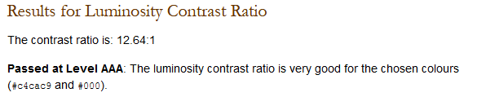

The footer section however may need to be reconsidered. The Juicy Studio tool has suggested that the contrast within the footer sector is not as accessible as shown in figure 16 below.

Fig 16. Footer Contrast
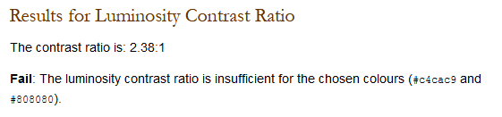
To improve, the font colour within the footer should be amended to the same colour as the header, this also provides consistency throughout the website.
The ‘WAVE’ tool identified that four images within the index page of the Doggy Duties website contains empty alternative text. This means that if the image is unloadable or unavailable then it is hidden from the user, which is recommended by WCAG 2.1.

5.2.2 Operable
WCAG 2.1 suggest that users must be able to navigate throughout a website and must not include any interactions that a user is unable to perform. Doggy Duties allows users to navigate through the website with a mouse click however this is the only way to navigate. Many may use access technologies to work around this such as a mouth stick for those who suffer with tremors however to comply with WCAG 2.1 it would be useful for website to include keyboard shortcuts. According to ‘Web Aim’ [8] keyboard accessibility is one of the main criteria’s to conform to web accessibility. Web sites should be able to navigate through using the ‘tab’ key and include many other keyboard shortcuts. A large proportion of disabled users rely on the keyboard to navigate through a website including those who are visually impaired. Web Aim goes on to suggest that developers have to keep in mind that navigation must follow a logical flow and may need to make the visual indicator more apparent.

5.2.3 Understandable
The third principle that WCAG 2.1 promotes is that all content within the interface must not go above the users understanding. As the target audience was identified before developing the interface, content within the web page is understandable to users and does not go above education-levels. Most navigation links are displayed with an understandable description to the user. However the ‘TOTALY11’ tool has identified that the social media links within the footer of the page do not display with any text and therefore may be confusing for users who are not aware of the page icons. To improve the website, it should include a description underneath the icons.

5.2.4 Robust
The final principle is to ensure that the interface will be interactive with current technology and future advances. To comply with this principle the Doggy Duties website must support a multitude of web browsers including, Chrome, Firefox and Internet Explorer. Visual Studio [9] has confirmed that the Doggy Duties website is Robust and successfully works on all above web browsers. However, the website has not been tested on other popular web browsers such as ‘Safari’ and ‘Opera’. To improve, the interface should be tested on these browsers also to ensure confidence that the website will work on all browsers.

- Conclusion
To conclude, the Doggy Duties website was created with purpose and usability at the forefront of the design. However after comparing the website against WCAG 2.1 recommendations, the web developer could have considered the four main principles with greater intent, with particular focus on the operable principle.

- References

[1] | “Website Requirements,” [Online]. Available: https://www.usability.gov/how-to-and-tools/methods/requirements.html.
[2] | “W3C Markup Validation Service,” [Online]. Available: https://validator.w3.org/.
[3] | “W3C CSS Validation Service,” [Online]. Available: http://jigsaw.w3.org/css-validator/.
[4] | C. A. Harper S, “Web Accessibility Guidlines,” World Wide Web, vol. 15, no. 1, pp. 61-88, January 2012.
[5] | P. Brophy and J. Craven, “Web Accessibility,” Library Trends; Baltimore, vol. 55, no. 4, pp. 950-972, 2007.
[6] | “Web Content Accessibility Guidelines (WCAG) 2.1,” 5 June 2018. [Online]. Available: https://www.w3.org/TR/WCAG21/.
[7] | “Juicy Studio,” [Online]. Available: http://juicystudio.com/services/luminositycontrastratio.php .
[8] | “Constructing a POUR Website,” 28 August 2013. [Online]. Available: https://webaim.org/articles/pour/operable.
[9] | “Visual Studio,” 2019. [Online]. Available: https://visualstudio.microsoft.com/.

