A technical report focussing on a new build dwelling
Accompanied by drawings.

Created for:
G. Traylor

Created By:
Ieuan Vokes

Completion date:
26/04/2023

Date due to be handed in:
27/04/2023

I have produced the attached drawings to illustrate the timber framed construction proposal for your property.
Drawing 001- The ground floor construction detail
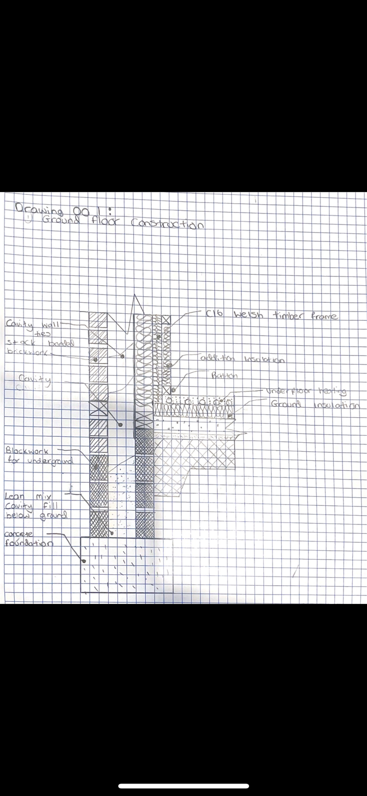

Drawing 002 – Detailed window section

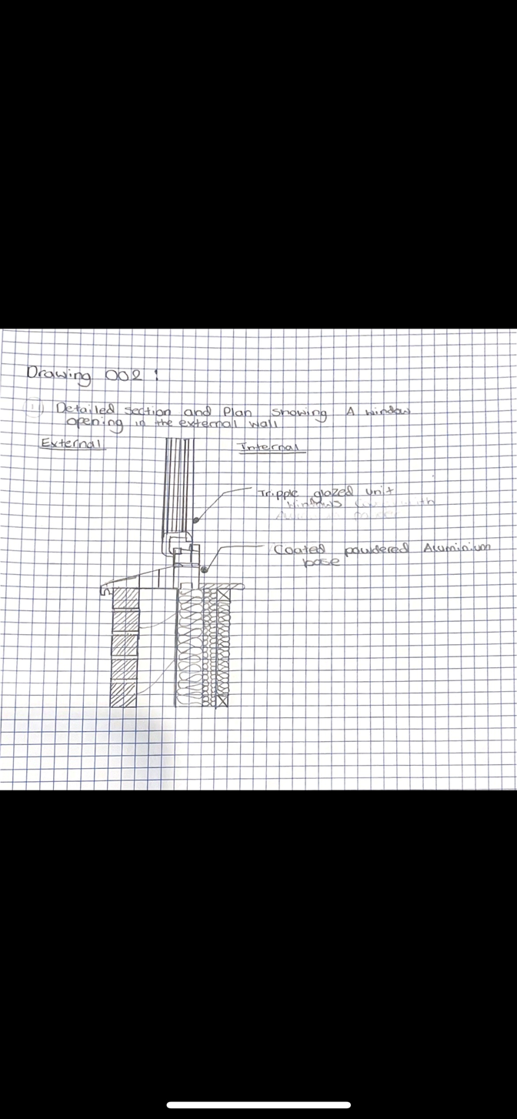
Drawing 003 – Eaves detailing and roof covering

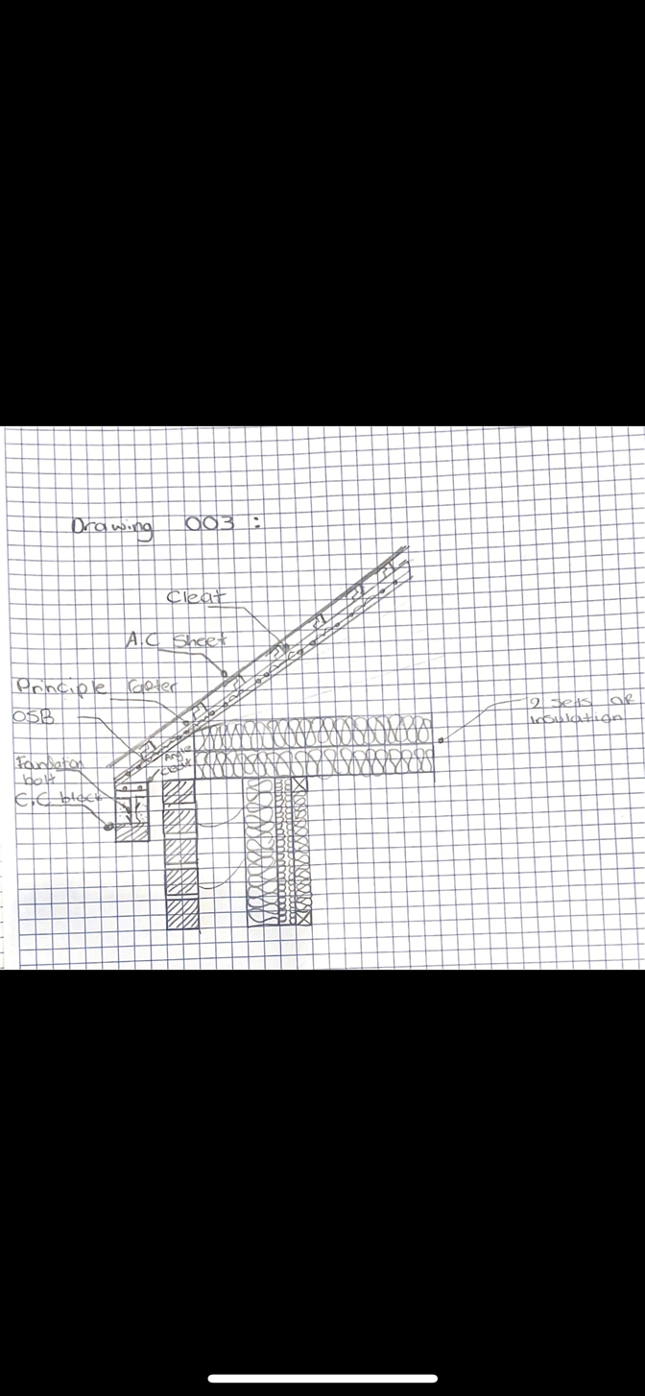

Drawing 004 – Main Roof structure
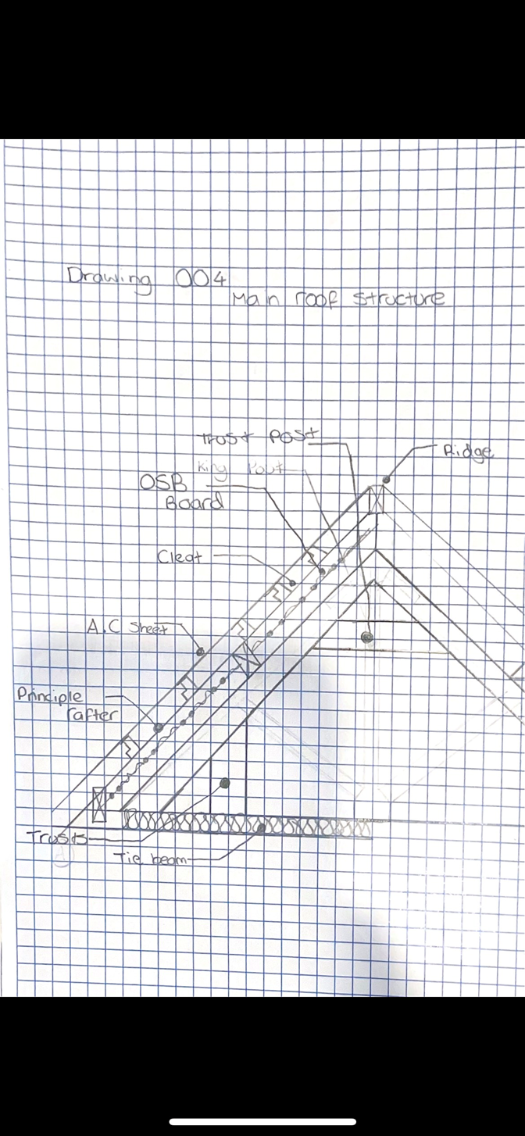
Building regulations in the UK allows timber framed constructions up to 3 stories including flats and maisonettes. Timber framed allows for off-site construction within a factory by semi-skilled labour this minimises human error, minimises waste of material and stops the construction being affected by weather. As most of the timber framed is built off-site this poses the added trouble of transportation to site to be constructed. But once on-site it is a very fast process to erect the timber fames with less labour needed compared to masonry construction.
There are several advantages for timber frame construction.
- Erection times are quick.
- Reduced requirement for site labour
- Reduced time to weather the structure.
- Trades are not delayed.
- Low embodied energy if constructed in local timber.
- Reduced construction waste through efficient controlled manufacturing
- Reduced amount of waste on site requiring removal
- Can be built to exceed 60-year design life.
- Energy efficient when constructed to current standards.
- Heating the property is speeded up due to low thermal mass.
- Reduced time on site reduces the nuisance and disruption to residents.
- It’s an Engineered product
- Factory controlled quality assurance in fabrication.
- Construction risk exposure is reduced due to the speed of construction.

Utilising the roof space
The current specification includes for trussed rafters. The image below from local architect’s direct website shows what an example section of a trussed roof.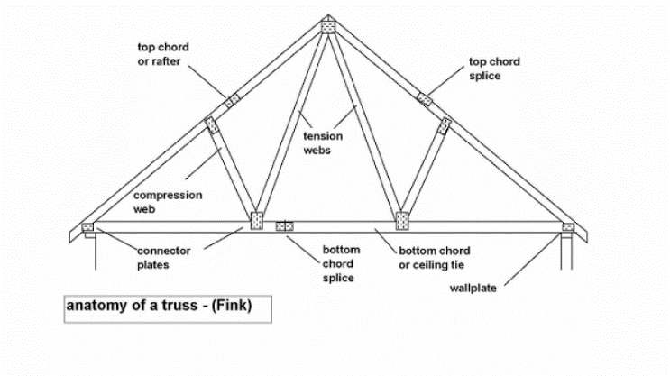
Whilst there are many benefits for a trussed roof system. The main advantages are:
- Flexibility and Versatility
- Eco-friendly
- Economy
- Durability and strength
- Energy Efficient
Whilst there are significant benefits, to ensure that you can utilise the significant roof space, the trussed system isn’t the most beneficial method when you want to utilise the space in the room.
To enable the roof space can be used as a room the following must be considered to ensure compliance with building control.
The regulations address matters such as whether:
- the structural strength of the new floor is sufficient.
- the stability of the structure (including the existing roof) is not endangered.
- there is safe escape from fire.
- there are safely designed stairs to the new floor.
- there is reasonable sound insulation between the conversion and the rooms below.
(WWW.Gov.Wales)
To maximise the roof space a mansard roof construction would provide the most space.
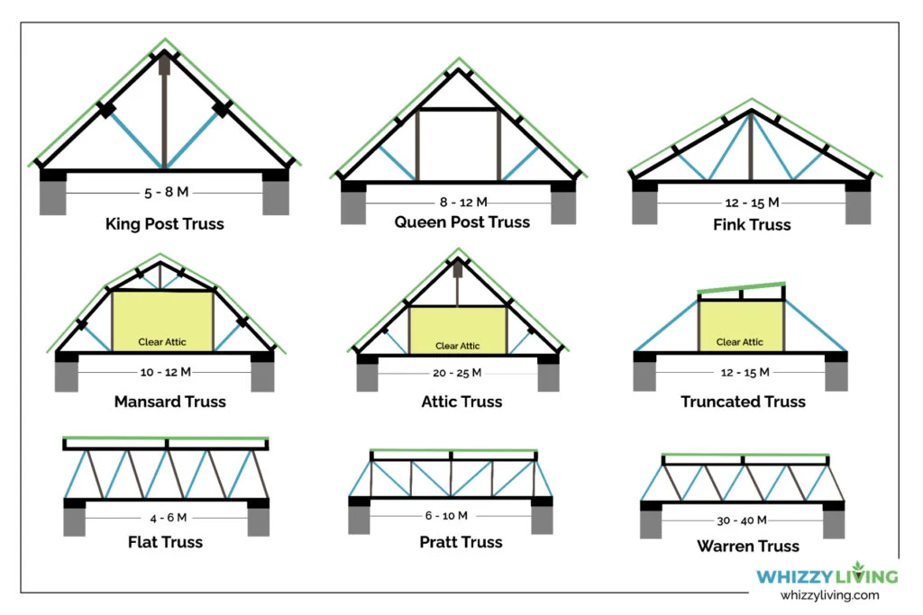
(whizzyliving.com/2022)
Shows the various roofing construction options. As you can see from the above the Mansard type roof provides far great room space.
Pros of Mansard Roofs
The most obvious benefit is the greater living space generated from the construction.
The mansard roof can provide a more elegant looking design to your property.
This roof design is perfect for dormer windows, which is effectively a normal window and provides the feel of a normal roof unlike roof lights.
With a dormer design you can ensure that you maximise the insulation within the roofing area, saving significant heat loss.
Cons of Mansard Roofs
Mansard roofs are prone to have poor weather resistance and maintenance of the roof can be costly.
They can also be expensive to build and install, due to the additional amount of works required.
Offsite construction otherwise known as Modern methods of Construction.
Modern methods of construction is a collective term used to describe a number of construction methods. Modern construction methods are methods that are developed in the construction industry with proper planning and design so that each project reduces the construction time, cost and maintain over all sustainability. The methods that have been introduced in the UK house building market differ in many ways. From conventional construction methods such as brick and block.
Modern methods of construction refer to offsite and prefabricated construction. As the construction industry looks to develop quicker, cheaper, and more sustainable construction techniques, modern methods of construction have increased. Sustainable technology has been incorporated into construction to preserve the environment. Modern Methods of Construction has been influenced by the Latham report (1994) and the Egan report (1998) Both of these criticised the UK’S Construction industry and a series of changes where necessary to improve the performance of the construction industry.
A wide variety of modern methods of construction techniques and products have been developed that have completely changed the behaviour of the construction industry. This in turn links with the environmental aspects of the quality management system and helps with sustainability within the industry. Modern constructions methods are method that have been developed within the construction industry with planning and design so that projects can reduce construction time, cost, and maintain sustainability.
Modern methods of construction have been reported as a way of working more efficiently to achieve more without using more. Modern methods of construction are about better products and better processes. They aim to improve business efficiency, quality, customer satisfaction, sustainability, and environmental performance. (Modern methods of construction, 2021) There are several different types of modern methods of construction these include:
- Precast flat panel system
- Hybrid
- Prefabrication
- Volumetric
- Tunnel
- Timber Frame
- Modular
Volumetric
Volumetric modular construction is a form of off-site construction in which buildings are put together by connecting a series of large pre-built sections, or 'modules'. It's often referred to as prefabricated building, although strict definitions may vary somewhat from source to source.
Timber Frame
Timber frame construction uses prefabricated (off-site manufacture) external and internal stud walls, floor joists and roof trusses to form the super-structure which is a complete structural frame that transfers the vertical and horizontal loads to the foundations. The timber frame structure can then be clad in brick, wood, fibre cement board, rendered or tiled which will act as the decoration for the home as well as weather protection. The external cladding would be installed on site.
Concrete panel system (Pre-cast Concrete)
Precast concrete is a construction product produced by casting concrete in a reusable mold or "form" which is then cured in a controlled environment, transported to the construction site, and lifted into place. Precast is used within exterior and interior walls.
Hybrid
Hybrid construction is also referred to as semi – volumetric construction. Hybrid concrete construction combines all the benefits of pre casting with the advantages of cast in-situ construction. By combining the two as a hybrid frame it allows for greater construction speed, quality, and overall economy. Hybrid construction offers clients lower costs, and higher quality by providing simple buildable and competitive structures offering consistent performance and quality. (Modern methods of construction, 2021)
Modular
Modular construction is a process in which a building is constructed off-site, under controlled plant conditions, using the same materials and designing to the same codes and standards as conventionally built facilities – but in about half the time. Buildings are produced in “modules” that when put together on site, reflect the identical design intent and specifications of the most sophisticated site-built facility – without compromise.
Modern Methods of construction is now a primary method of construction that that is used for many companies due to the sustainability on the environment, the skills shortages within the industry, building needs and affordability. This has created an environment where traditional methods are no longer the only options to consider within the construction industry.
Other methods of construction linked to sustainability can be seen through the integration of packages such as The RIBA Plan of works and BIM.
Modular V Traditional
The term traditional is often used to describe the types of linear construction where steps are constructed on site as well as completed before the project can move on to the next phase. Basically, traditional construction techniques refer to those methods that have been used for hundreds of years to build structures. Since there are a wide variety of ways to build a building, each method has its own unique characteristics.
Modular construction is an off-site-based construction method where components are manufactured in a factory and then transported to the site.
Both construction methods start by using the same steps, planning, design, site preparations and development and then the difference begin. (Modular vs traditional construction, 2020)
Below are a list of the advantages and disadvantages of using modular methods vs the traditional methods.
- Modular buildings can be more affordable than site buildings, an average modular building is constructed 50% quicker than using the traditional method.
- Health and Safety- factory conditions are far greater controlled compared to a traditional building site.
- Environmentally friendly- modular buildings are more energy efficient, create less waste and increase sustainable materials.
- Community friendly- traditional builds tend to create more noise, traffic, mess and disruption.
- Affordable living- modular buildings tend to cost less to live in as they are cheaper to run heat and maintain.
- Major parts of modular construction are handled in a factory, so it is not weather dependent unlike traditional methods working on site.
- Traditional buildings allow for late changes in design whereas modular construction is less likely to be able to change.
- Modular methods require far more planning for the project to run smoothly.
- Access to site must considered from the start as it will need to allow for the delivery of large modules. (Modular vs traditional construction, 2020)
The benefits tend to outweigh the negatives in modular building although there are pros and cons and limitations in both traditional and modular construction,
Traditional methods of construction have been the accepted method to use for a long time, by traditional it is conventional, customary, and established, whereas modular construction is revolutionised from cutting time and cost as well as changing attitudes. (Traditional vs Modular: deconstructing building methods, 2109)
Which offsite method of construction would be suitable for Miss A Clients property.
Having reviewed all the above methods I believe that Timber frame construction is the most cost-effective sustainable method of completing the build in accordance with the client’s specification. The benefits of timber the timber framed construction is clear and detailed within this technical report.

References
Gov.Wales (No date provided) Building regulations: Loft conversion. Available at: www.gov.wales/building-regulations-loft-conversions(Accessed on26/04/20323).
Whizzyliving(September 2022)Types of roof trusses. Available at: https://whizzyliving.com/types-of-roof-trusses/ (Accessed on 26/04/2023).

