

Assessment
Global Learning Institute Cloud Transition

Module: Cloud computing administration

Lecture: Student: Ivan Nikolov
Renuga Jayakumar 2125009 Cloud Computing
Content:

- For most enterprises, on-premises storage was the only choice prior to the cloud.
But, as more businesses embrace a "cloud-first" mentality, the times are changing.
Seventy-nine percent of IT managers are currently committed to cloud projects, according to Computerworld's Tech Forecast 2017 study of 196 IT managers. Furthermore, according to 58% of users, cloud-based systems are generating genuine commercial value.
On-premises solutions are useful, but the companies can maintain total control over their IT environment and corporate data and applications are kept safe on-site.
Nonetheless, a few significant disadvantages are impeding corporate innovation: Not being scalable.
Because on-premises storage isn't scalable, it can impede the expansion of your company. Updates typically necessitate hardware and software modifications. This process is laborious and slow, consuming a lot of your IT department's time that would be better used elsewhere.
Too costly. Installing on-premises systems requires a significant upfront investment. In addition, companies require specialized IT personnel to maintain their systems an minimize downtime. In addition, they require distinct infrastructure for disaster recovery and backup, which is costly and time-consuming to set up.
dangers to security. Having physical servers exposes you to "real-world" dangers in addition to the typical risk of cyberattack, such as damage, destruction, fire, water damage, or even "wear and tear" on the hardware.
standards for staffing. IT managers or support staff are needed to handle the local server and local area network for an on-premises storage setup. You don't require as many support workers while using the cloud.
Our modest opinion is that Microsoft Azure is the best option available when it comes to cloud computing. Ultimately, its cloud-based services are intended especially for commercial use. Businesses can choose to go entirely cloud-based or take a hybrid approach, moving from on-premises to the cloud gradually. These are five compelling arguments for moving to Azure and the cloud.
1. It operates far more quickly than on-premises options.
Azure outperforms on-premises in terms of deployment and scaling speeds. If you wish to increase operations or optimize workloads using an on-premises solution, you'll need new hardware, software updates, and a crew to put them into practice. Naturally, that also assumes you have adequate power, cooling, and physical storage space.
With Azure, you can dynamically scale programs to meet your changing needs by utilizing services like Azure Auto Scale. This lets you automatically adjust the scale according to any metric. For instance, you can instruct it to build ten times as many virtual machines ahead of time to meet the demand if you expect your traffic to increase dramatically within the next week. Azure can scale in a matter of moments to meet your business objectives, regardless of what you need. Because of this, it is far more efficient and versatile than on-premises alternatives.
2. You become more agile and productive with Azure VM With scalable, on-demand resources, Azure Virtual Machines offer you more control over your computing environment. To truly benefit from them, though, you must configure them properly, making sure that all software is installed correctly and updated on a regular basis. Azure VMs are among Azure's most potent features (Virtual Machines). It enables you to specify an operating system, language, and workload to quickly create your own personalised virtual computers. With on-premises, this is not feasible because you require numerous machines running different operating systems.
Your companies can now experiment more as a result. Working on various virtual computers allows you to develop, test, and receive feedback more quickly. As a result, your teams have greater freedom because of the capabilities of their devices. For employees, having the option to switch between Windows and Linux on the same system with separate tools and apps is a powerful benefit.
3. Azure is less expensive than on-site options.
Is it financially wising for your company to invest in cloud solutions? This is one of the main questions that organizations have.
It does in most circumstances, and it does so by a large margin. You can avoid investing in new hardware, infrastructure, or replacing outdated servers by using Azure. Additionally, there is no need to create room for servers and infrastructure.
Azure allows for flexible spending, which implies:
You make payments based on your needs.
To obtain more, you must pay more.
You save money on cooling, space, and energy.
Furthermore, you can be sure of your ongoing expenses because Microsoft charges a per-user fee for its Azure cloud services.
4. On-premises solutions are less secure than Azure.
Security is a major factor in the decision of many firms to remain on-premises. Some people think that local data hosting offers better data protection than cloud-based storage.
However, this is really a myth. Another benefit Azure offers over on-premises storage options is services like Azure Active Directory.
A cloud-based directory and identity management solution, Active Directory supports multiple tenants. IT administrators can use it to grant staff members single sign-on (SSO) access to a variety of cloud-based SaaS apps, including Office 365 and SharePoint.
Furthermore, it provides a wide range of identity management services, such as:
Registration of a device.
Multiple-factor verification.
Access control based on roles.
Group management via self-service.
Tracking the use of an application.
These services safeguard your company by making sure that only authorized individuals have access to your most private data.
Furthermore, since you won't have any on-premises servers to maintain in your facility, you also remove the risk of physical security when you choose the cloud over physical servers. Azure helps safeguard your company from two angles: that and your virtual security.
5. Azure is a business tool, not just a storage platform. Azure offers organizations far more than simply simple access to data, security, and cloud-based storage. It provides organizations with a full delivery pipeline, which consists of: Unit testing and source control.
Delivery of integration testing.
Real-time utilities and programs.
Not only is Azure a well-liked option, but it also makes financial sense for the company. Compared to on-premises alternatives, it delivers higher speed, dependability, and scalability along with stronger security features. Not only that, but the price is also lower. Not even upkeep is a concern for you. Everything is managed by Microsoft, including updates, security, physical servers, patching, redundancy, and Azure infrastructure. There are hybrid choices if you're not comfortable going all cloud. These are hybrid cloud and on-site storage solutions. By providing synchronization tools to build a bridge between on-premises and Azure, Microsoft takes care of this for you as well. [1]
We can use the pricing calculator on Azure. Pricing Calculator | Microsoft Azure [2]

Let's proceed with some general assumptions:
1. On-premises Servers:
• Let's assume GLI has 3 on-premises servers for hosting their user profiles, course materials, and administrative systems.
• Each server has the following specifications:
• CPU: 4 cores
• RAM: 16GB
• Storage: 1TB HDD
2. Database Usage:
• GLI is using a single database for storing user profiles.
• Assuming the database size is approximately 100GB.
3. Storage Requirements:
• GLI requires storage for user profiles, course materials, and administrative data.
• Total storage requirement is approximately 5TB.
With these assumptions, we can proceed to estimate the cost savings by migrating to Azure cloud services using the Azure TCO Calculator.

- servers
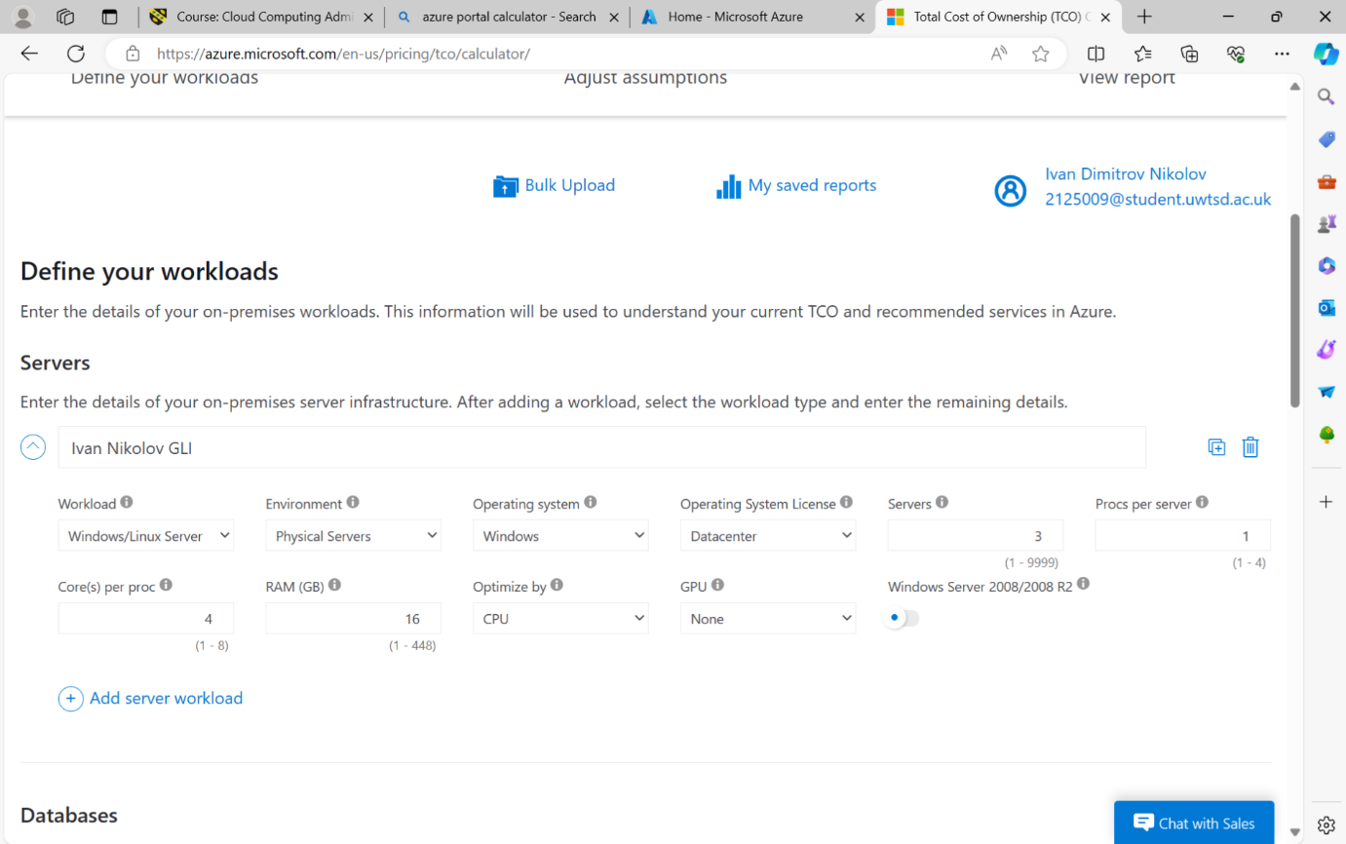

- databases

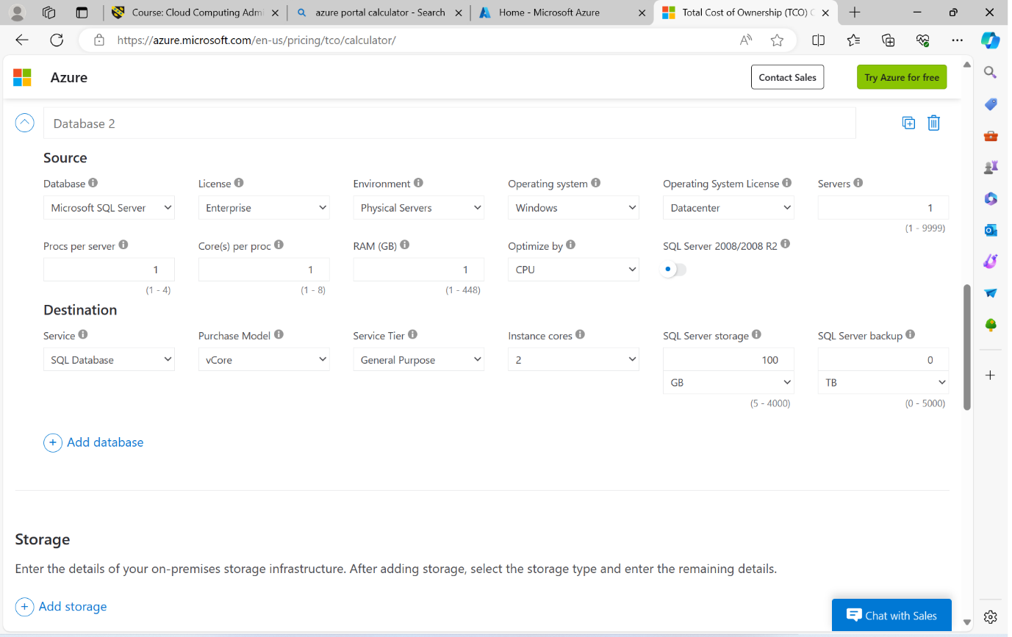
- storage
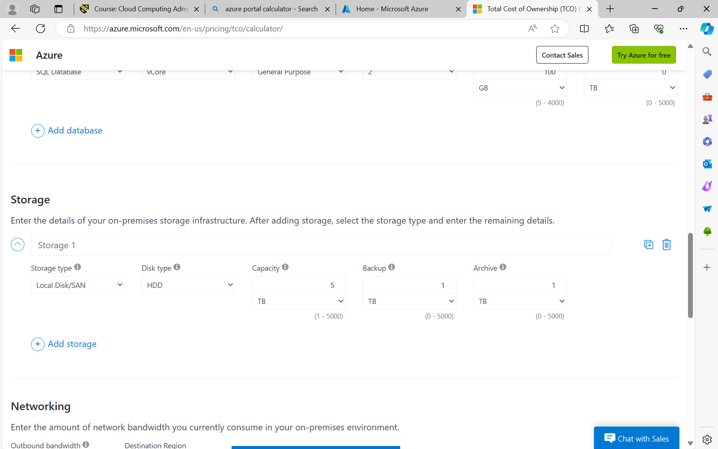

Next step is to provide the price for electricity in UK per kilowatt-hour.
Looking ahead, energy prices are expected to rise again in January 2024 due to typical seasonal fluctuations in energy demand. The Energy Price Cap is set to increase to £1,928 per year for a typical household from 1 January 2024, which translates to a per kWh cost of 28.6p for electricity. [3]
Then we need to exchange the rate.


Then to fill up the average price per kilowatt-hour in UK for April 2024 in dollars.
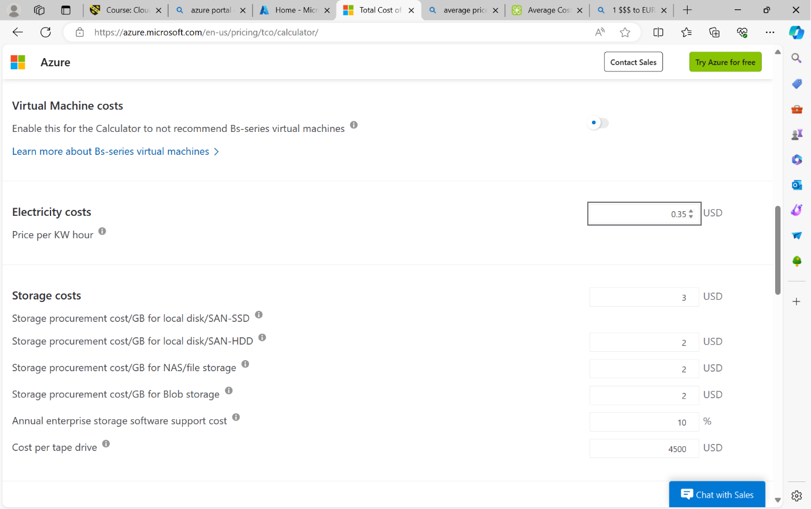
Then average salary of IT administrator.
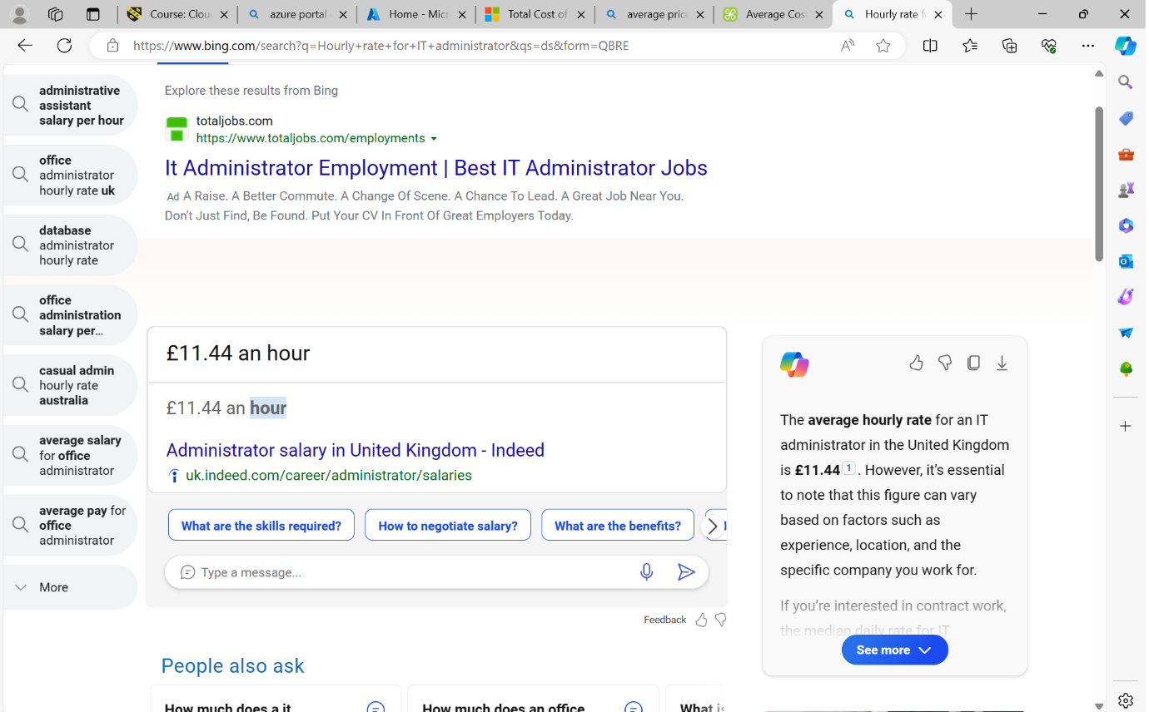

It filled up in dollars.
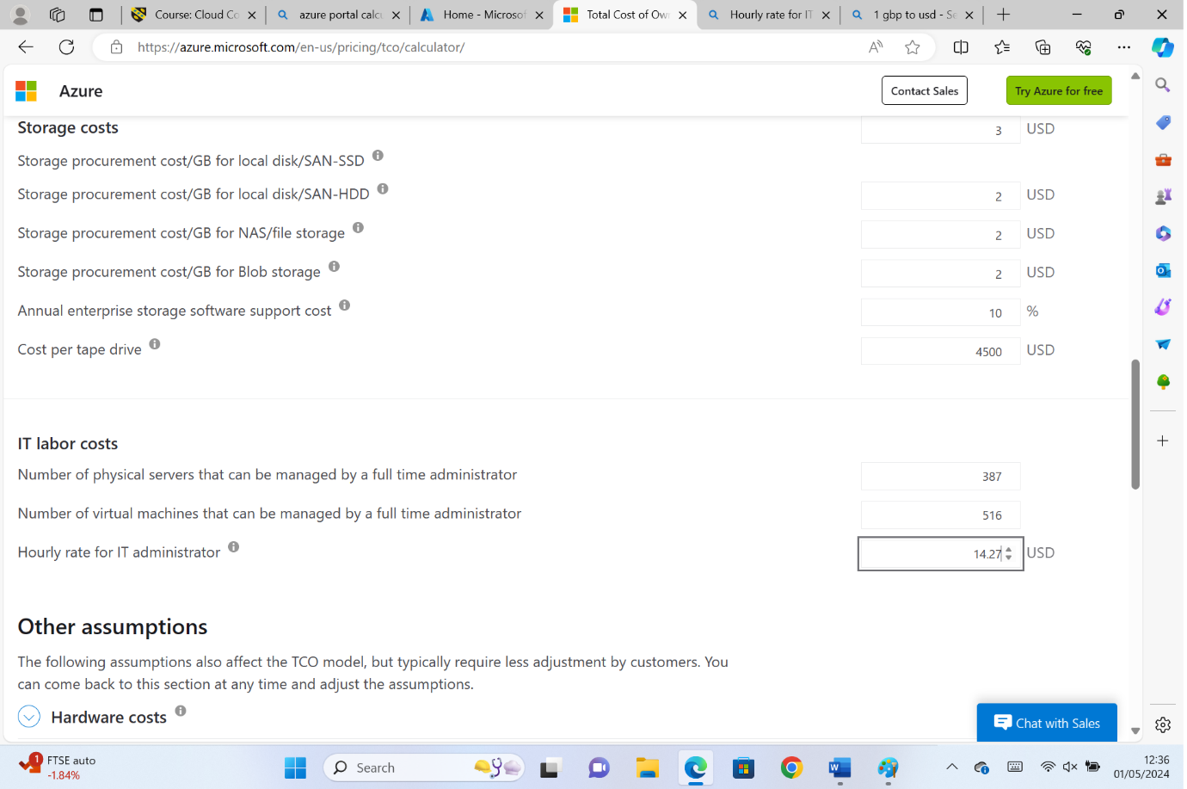

Then we will receive the final result how much we will safe if we use Azure cloud.
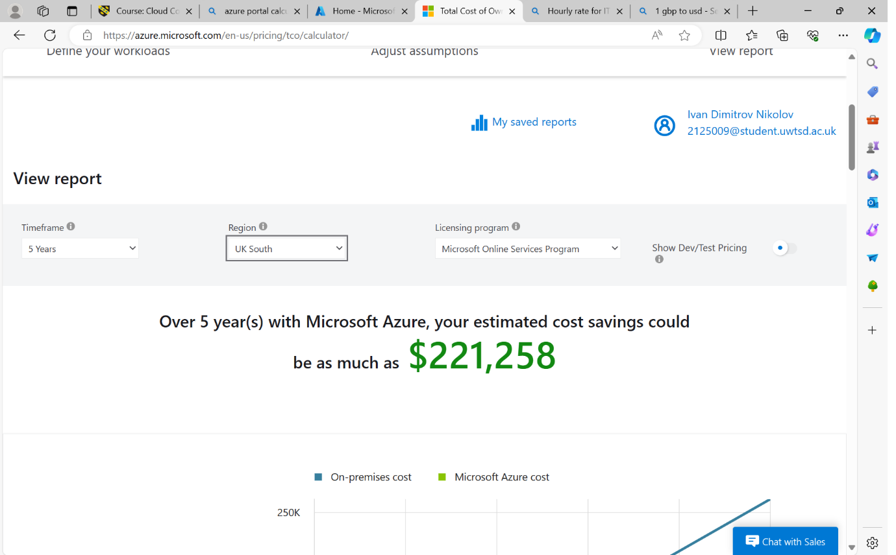
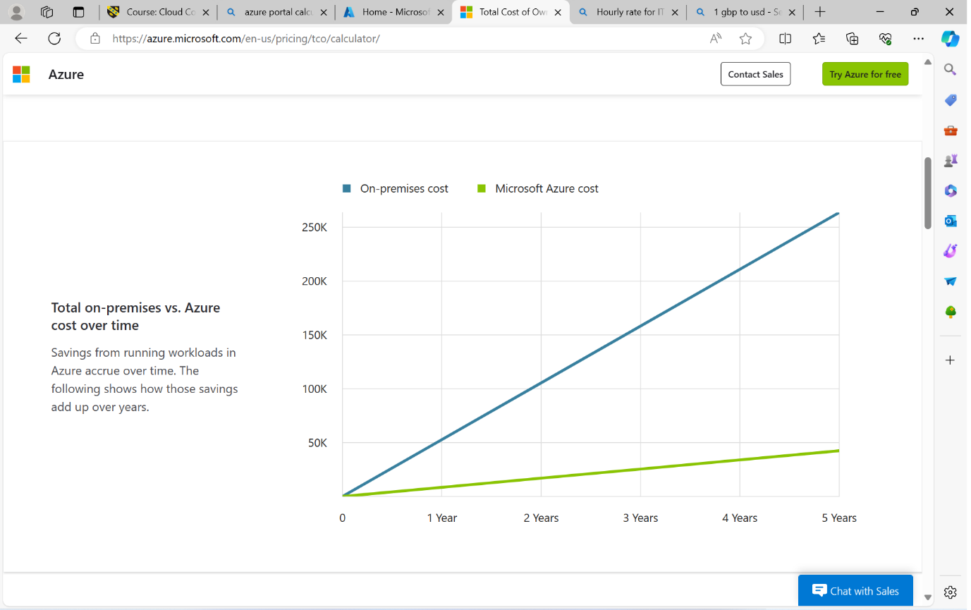
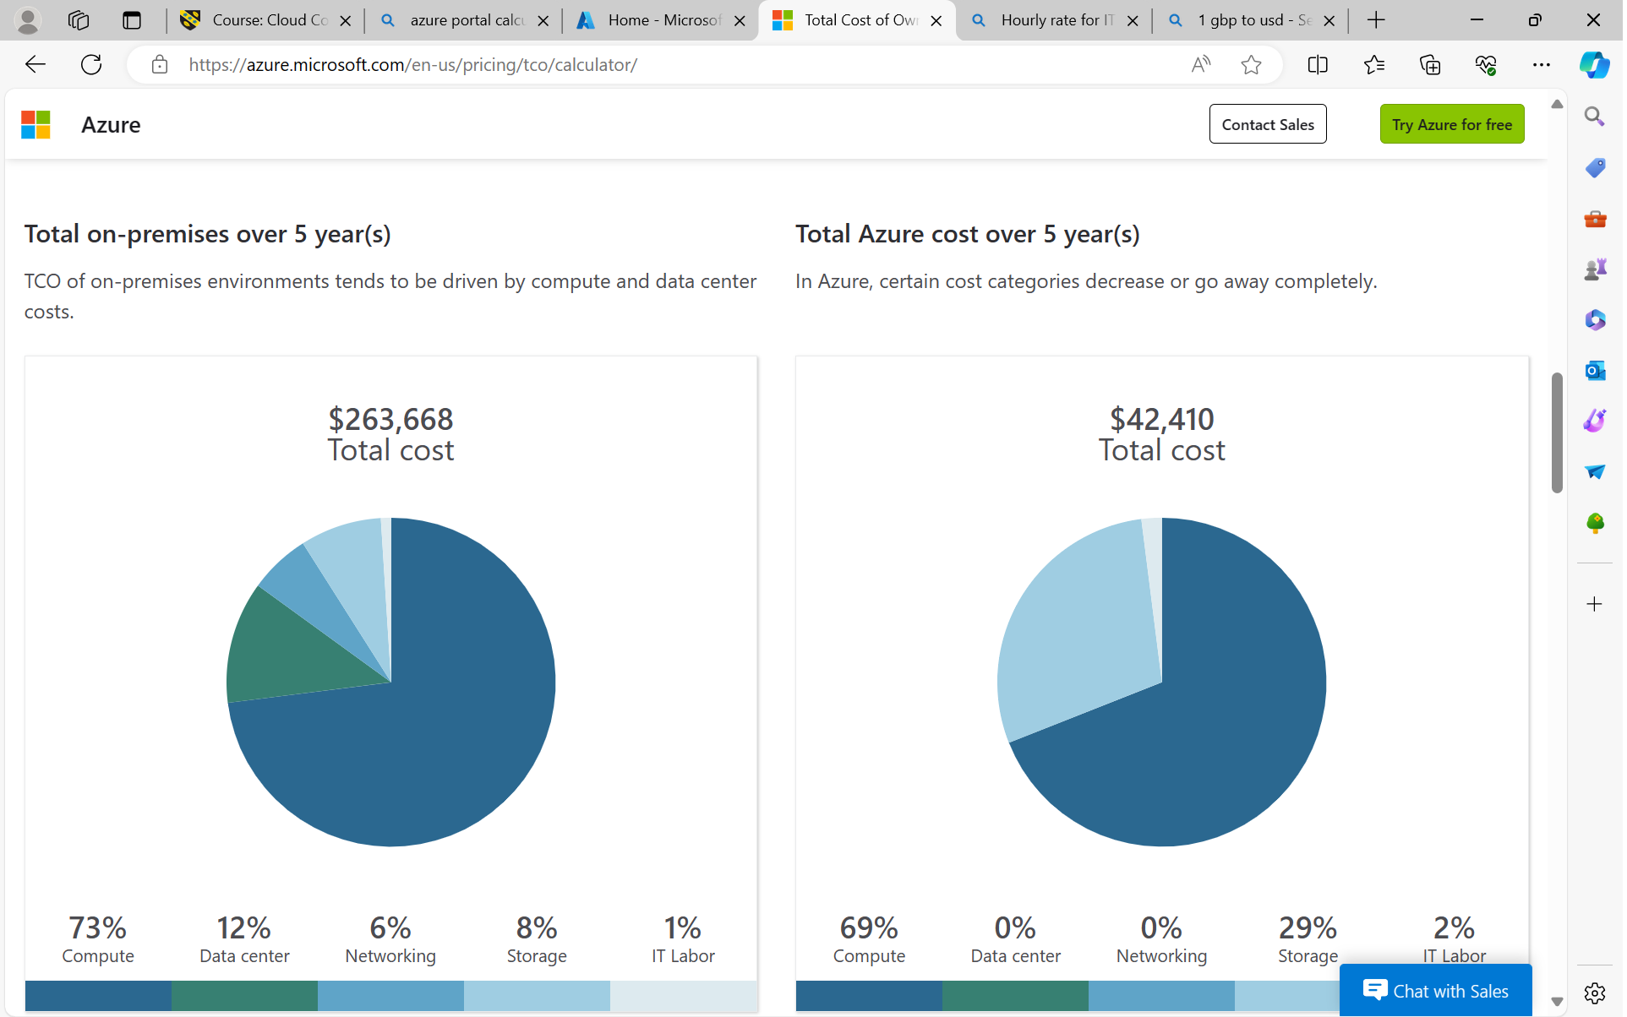
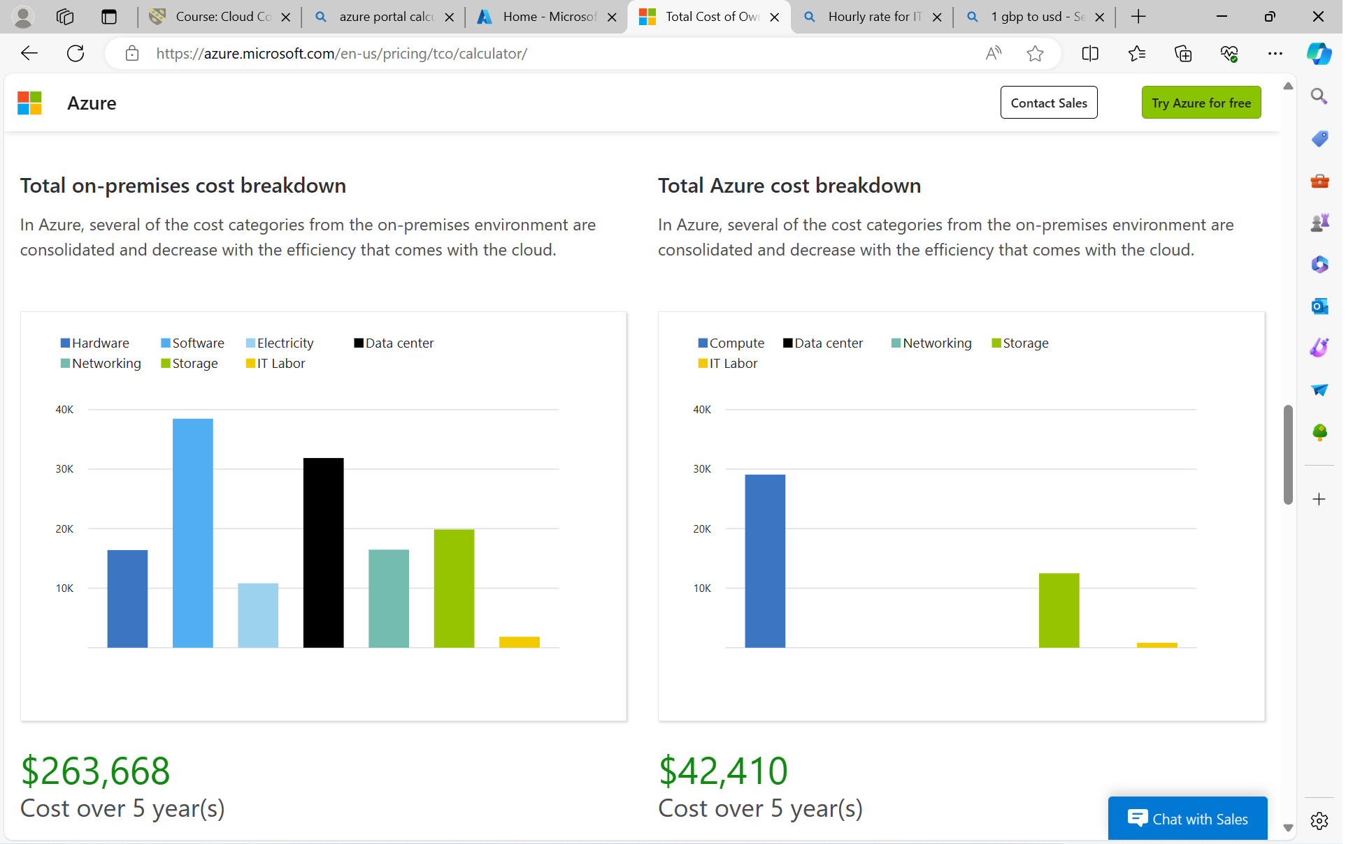
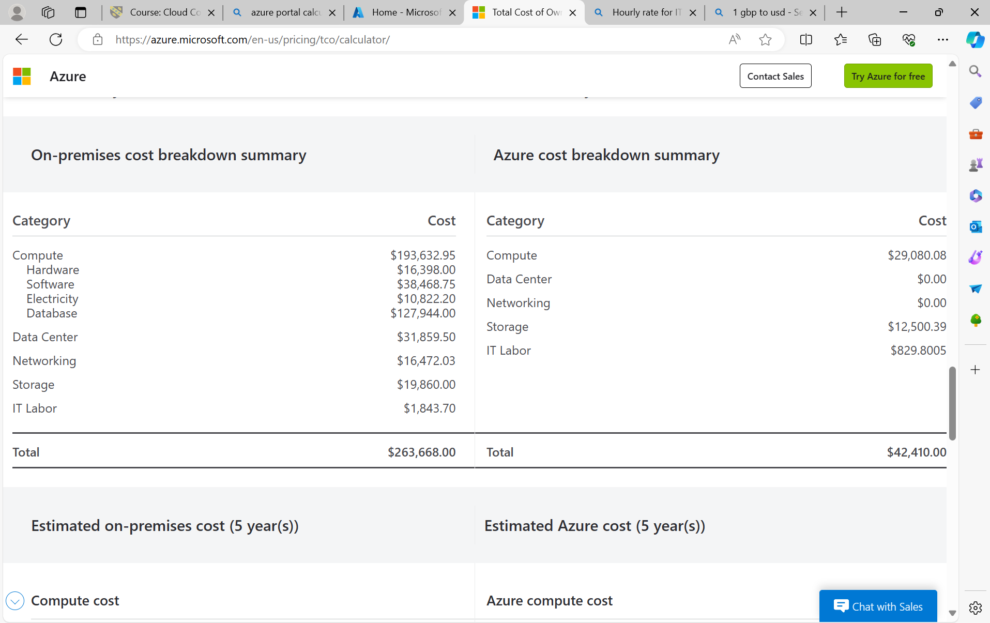
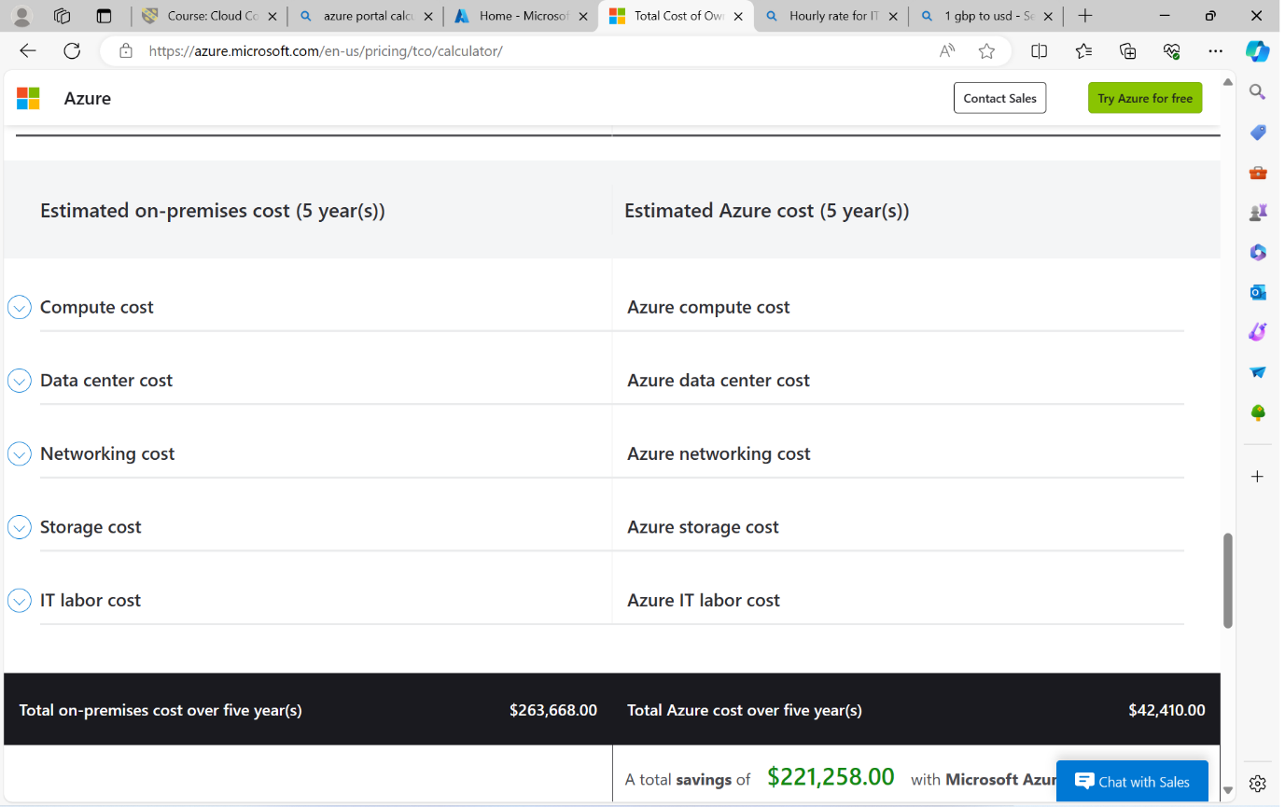

As we can see the difference is significant. For small or medium company that could be even “lifesaving”.

On-Premises Infrastructure Assumptions:
Server: A mid-range server with decent processing power and memory, capable of hosting multiple virtual machines.
Database: A relational database management system (RDBMS) like SQL Server or MySQL.
Storage: A network-attached storage (NAS) device or a storage area network (SAN) for storing data.
Network: A typical local area network (LAN) setup with routers, switches, and firewalls.
Azure Pricing and Offers:
Azure Virtual Machines: Pay-as-you-go pricing model with various VM sizes and pricing tiers based on CPU, memory, and storage.
Azure SQL Database: Options for single databases, elastic pools, and managed instances with different performance tiers and pricing levels.
Azure Storage: Blob storage, file storage, and disk storage options with different performance tiers and pricing based on usage.
Azure Networking: Virtual networks, load balancers, VPN gateways, and other networking services with pay-as-you-go pricing.
Now, let's compare the two:

Cost:
On-premises infrastructure requires upfront capital expenditure for purchasing hardware and ongoing operational costs for maintenance, electricity, cooling, and upgrades.
Azure offers pay-as-you-go pricing, where you only pay for the resources you use, with no upfront costs. This can be more cost-effective for businesses with variable workloads.
Scalability:
On-premises infrastructure scalability is limited by the capacity of the hardware and may require additional investment for expansion.
Azure provides scalability on-demand, allowing you to easily scale resources up or down based on workload requirements without needing to invest in new hardware.
Management and Maintenance:
On-premises infrastructure requires dedicated IT staff for managing and maintaining hardware, software updates, security patches, backups, and disaster recovery.
Azure offloads much of the management overhead to Microsoft, including infrastructure maintenance, security updates, and backups, freeing up IT resources for other tasks.
Reliability and Redundancy:
On-premises infrastructure reliability depends on the quality of hardware and local redundancy measures.
Azure offers built-in redundancy and high availability across its global data centers, reducing the risk of downtime due to hardware failures or disasters.
Security:
On-premises infrastructure security relies on the organization's ability to implement and maintain robust security measures, including firewalls, intrusion detection systems, and access controls.
Azure provides a range of built-in security features, including network security groups, encryption, threat detection, and compliance certifications, helping to protect data and applications hosted on its platform.
Overall, while on-premises infrastructure offers control and customization, Azure provides flexibility, scalability, and cost-effectiveness, making it an attractive option for many businesses, especially those looking to modernize their IT infrastructure and leverage cloud-based services.

- Azure File Storage Features:

Scalability: Azure File Storage offers scalable storage capacity, allowing GLI to increase or decrease storage as per their requirements without worrying about infrastructure management.
High Availability: It ensures high availability of data by replicating files across multiple Azure data centers, reducing the risk of data loss.
Integration: Azure File Storage integrates seamlessly with other Azure services such as Azure Active Directory, Azure Virtual Machines, and Azure App Services, facilitating easy deployment and management.
File Share Access: It provides SMB (Server Message Block) and REST interfaces, enabling easy access to files from anywhere and from various platforms.
Backup and Restore: Azure File Storage supports backup and restore mechanisms, ensuring data integrity and reliability.
Security Measures:
Encryption: Azure File Storage offers encryption at rest and in transit, ensuring that data is securely stored and transferred.
Access Control: It provides granular access control mechanisms, allowing GLI to define permissions at the file and folder level, thus ensuring data security and compliance.
Azure Active Directory Integration: GLI can leverage Azure Active Directory for authentication and authorization, enhancing security and centralizing user management.
Firewall and Virtual Networks: Azure File Storage supports network security by allowing access from specific IP addresses or virtual networks, reducing the attack surface.
Audit Logs: Azure File Storage generates audit logs, providing visibility into file access and changes, aiding in compliance and security monitoring.
Implementation for GLI:
Create Azure Storage Account: Create a storage account in the Azure portal. Choose the appropriate settings for redundancy, access tier, and performance based on GLI's requirements.
Enable Azure File Storage: Navigate to the storage account settings and enable the Azure Files service.
Create File Share: Create a file share within the storage account to store files and folders.
Configure Security: Set up access control using Azure Active Directory integration or Shared Access Signatures (SAS) to restrict access to the file share.
Access and Management: Access the file share from Azure Virtual Machines, on-premises systems using Azure File Sync, or other Azure services. Manage access, permissions, and monitoring from the Azure portal. [4]

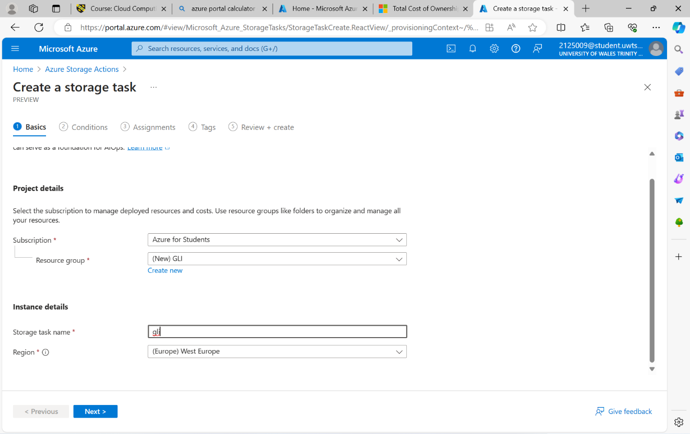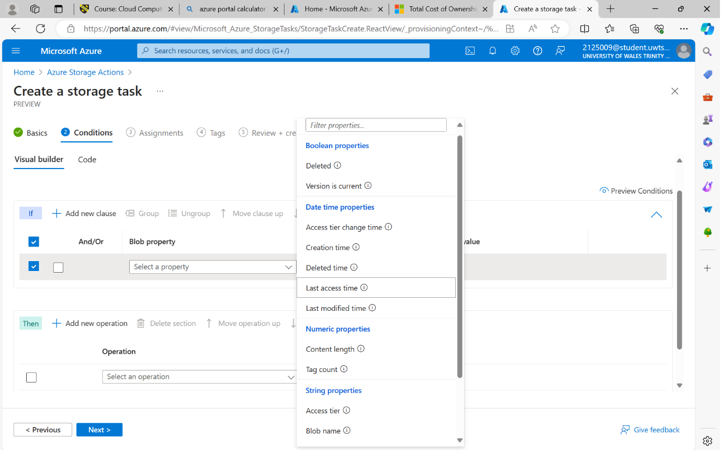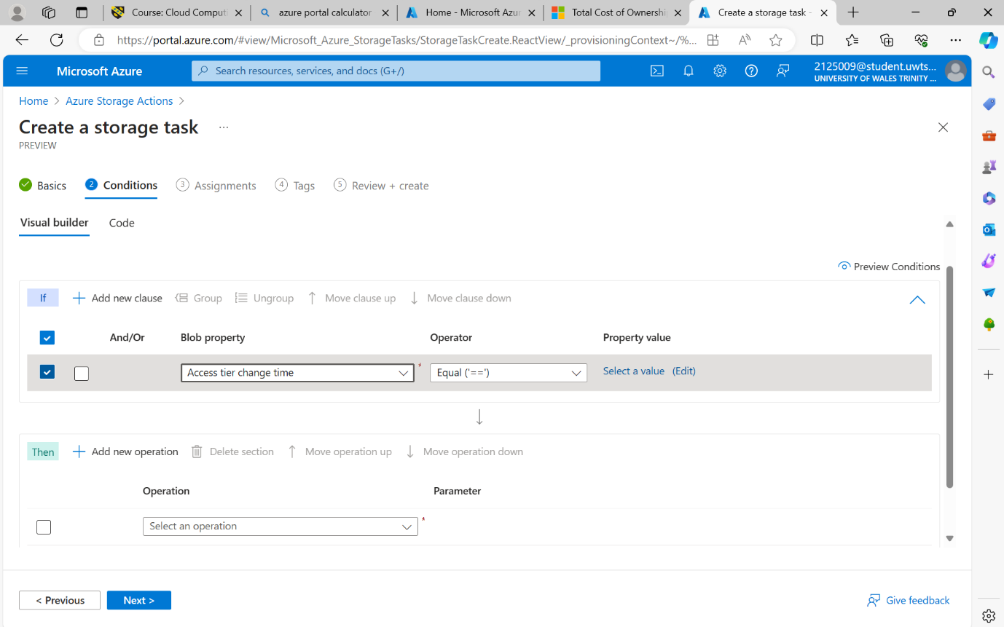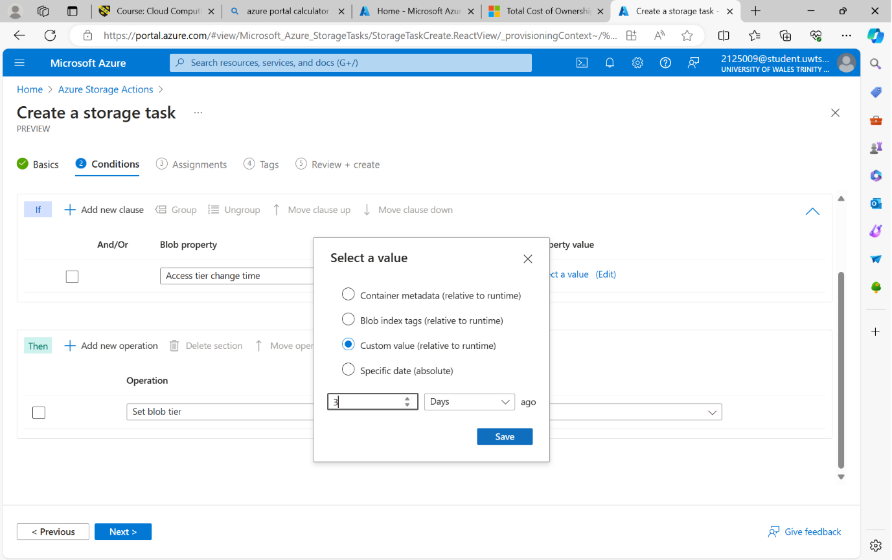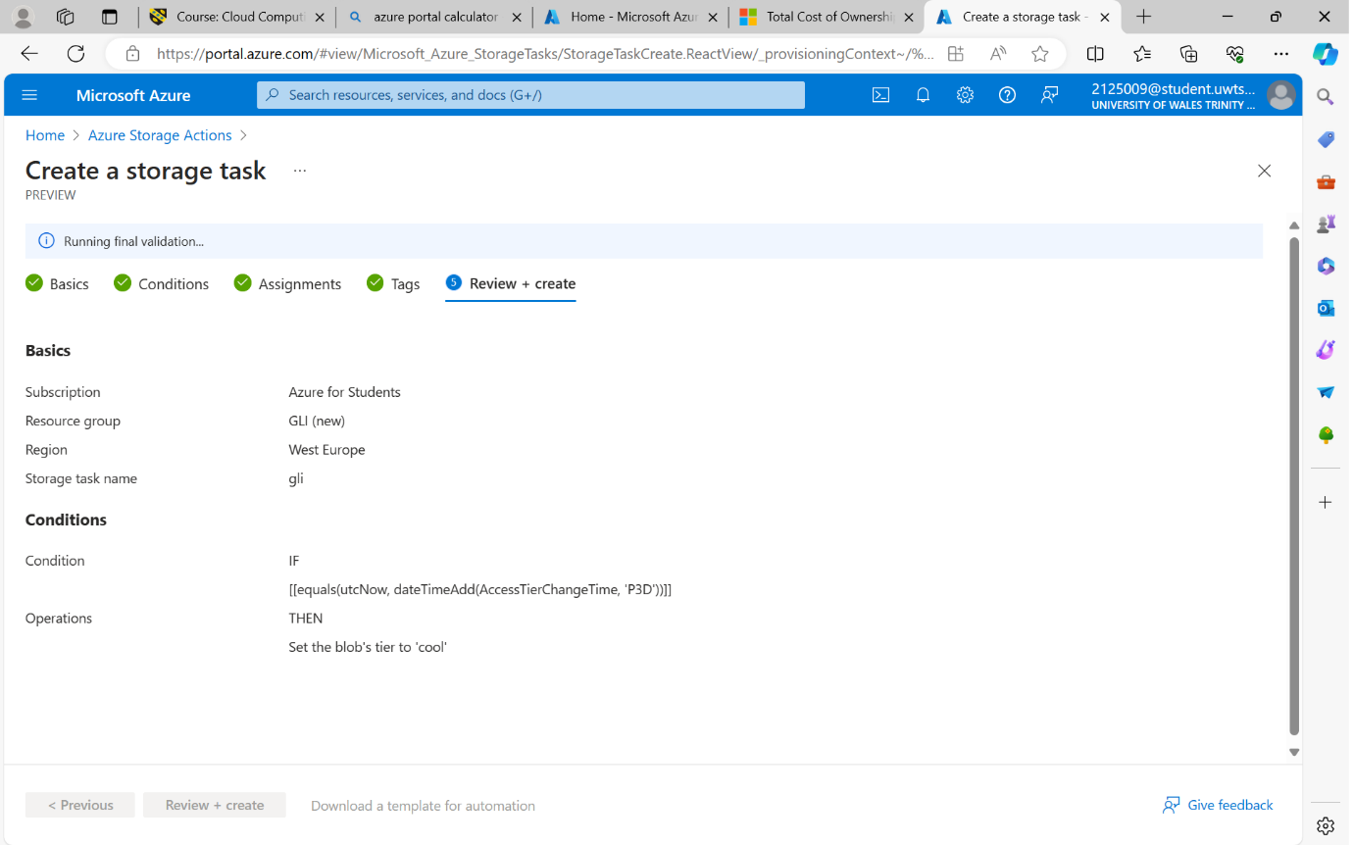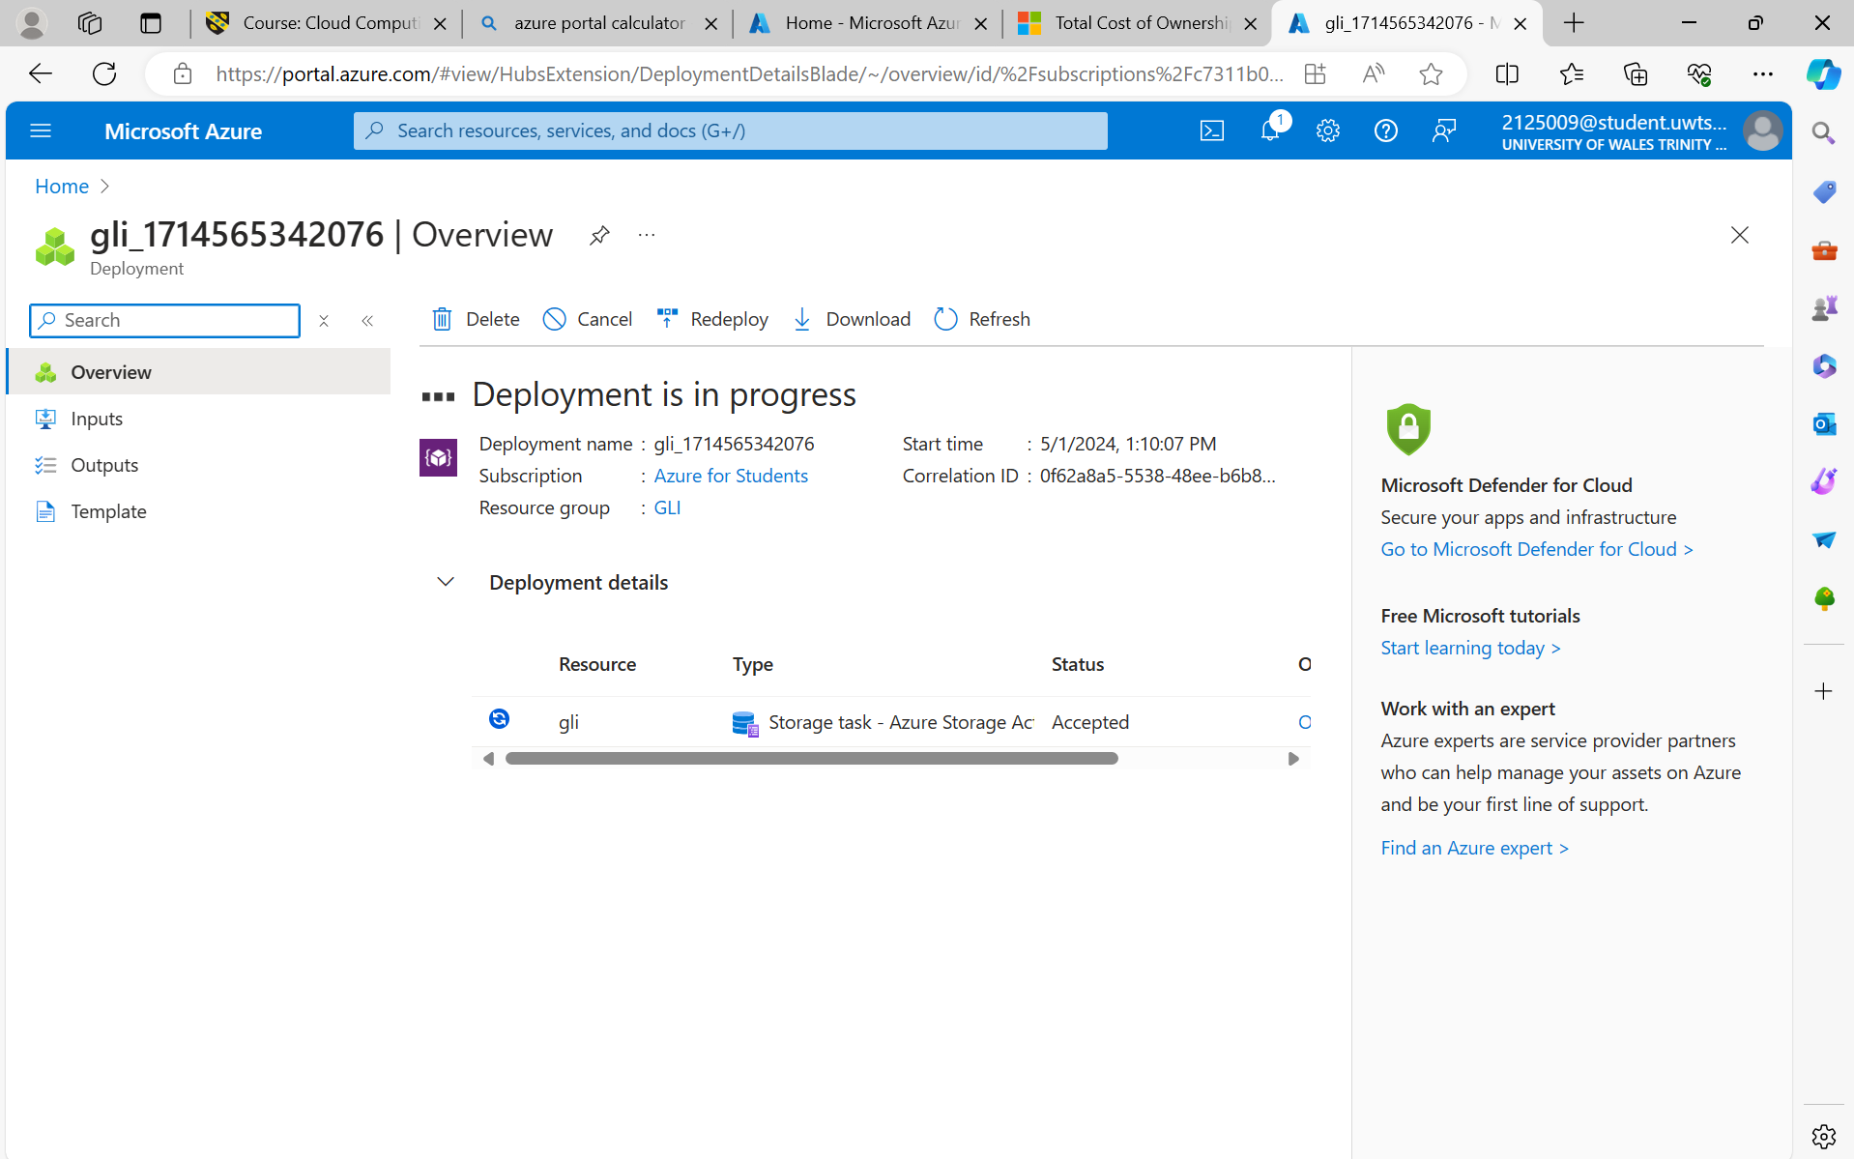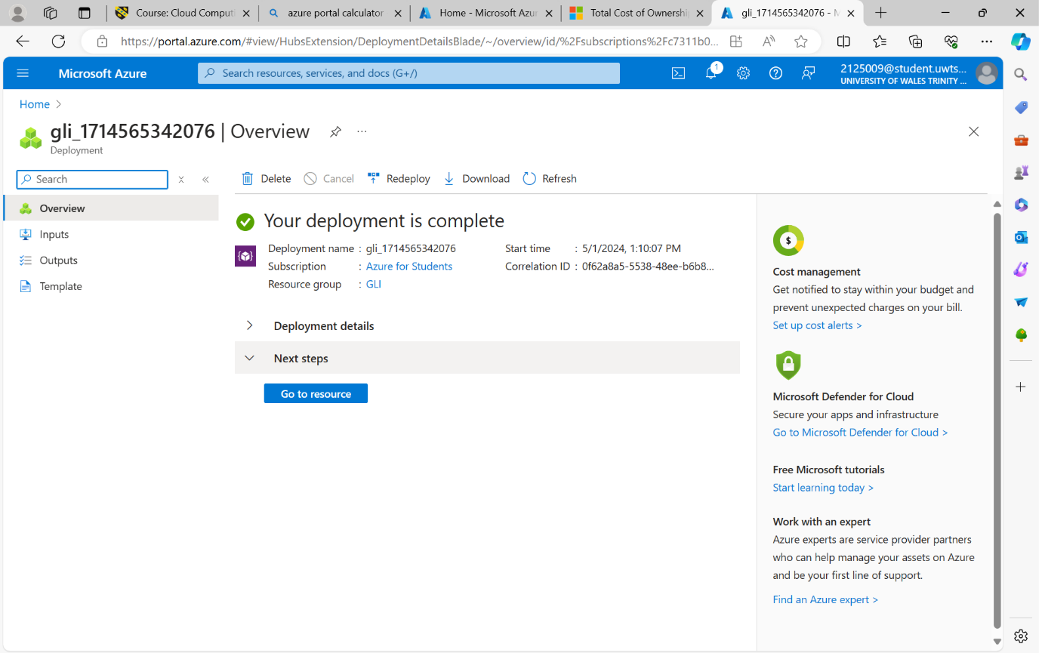

c)
Evaluation of Azure Database Options:
Azure SQL Database:
Fully managed relational database service.
Based on Microsoft SQL Server engine.
Provides high availability, automatic backups, and scalability.
Suitable for applications requiring relational database features and strong consistency.
Offers built-in security features such as advanced threat protection.
Azure Database for MySQL:
Fully managed MySQL database service.
Ideal for applications using MySQL as the backend database.
Offers high availability, automated backups, and scaling capabilities.
Supports open-source frameworks and tools.
Suitable for applications requiring the flexibility and familiarity of the MySQL ecosystem.
Azure Database for PostgreSQL:
Fully managed PostgreSQL database service.
Based on the open-source PostgreSQL database engine.
Provides features like high availability, automated backups, and scaling.
Suitable for applications needing advanced features of PostgreSQL such as JSONB data type, full-text search, and extensions support.
Offers compatibility with PostgreSQL tools and libraries.
Recommendation:
Based on the evaluation, since you're storing user profiles, a relational database like Azure SQL Database would be the most suitable option. It provides the necessary features for managing structured data efficiently, ensuring data integrity, and offering scalability as your user base grows.

Steps to Create Azure SQL Database using Azure Portal:
Create a new resource: Click on the "+ Create a resource" button on the Azure portal dashboard.
Search for "SQL Database": In the search bar, type "SQL Database" and press Enter.
Select "SQL Database": Click on the "SQL Database" option from the search results.
Fill in the database details:
Choose your subscription.
Create a new resource group or select an existing one.
Enter the database details like name, server, and pricing tier.
Configure additional settings such as collation, data source, and elastic pool (if needed).
Configure server settings:
Create a new server or select an existing one.
Enter server details like server name, admin username, and password.
Choose the location for your server.
Configure networking:
Define firewall rules to allow access to the database.
Choose whether to allow Azure services to access the server.
Review + create: Review all the configurations you've made, then click on the "Review + create" button.
Create the database: After reviewing, click on the "Create" button to start the deployment process.
Deployment: Wait for the deployment to complete. Once it's done, you can access your Azure SQL Database.
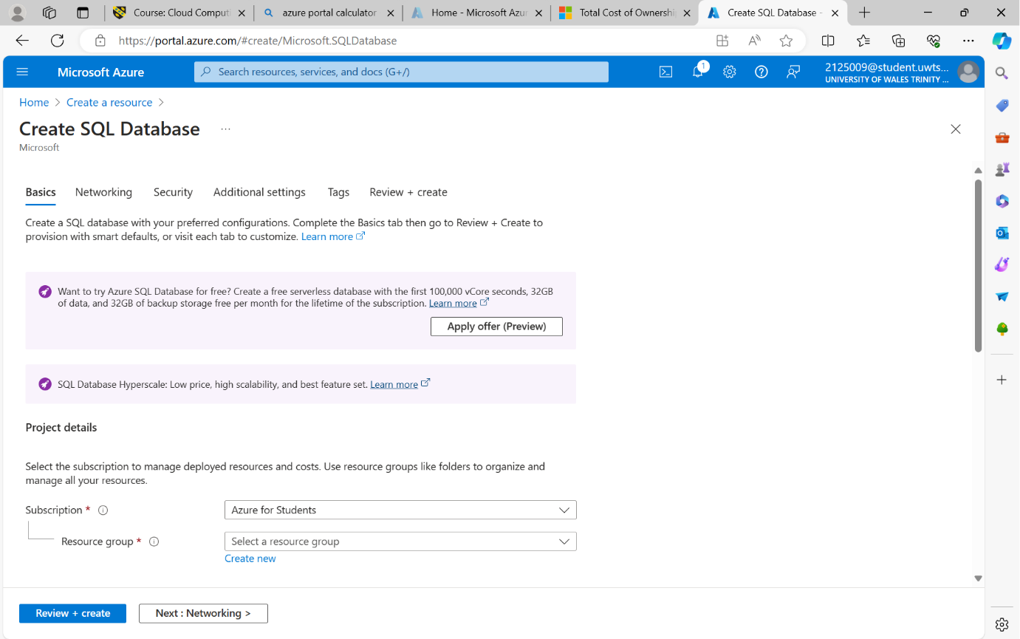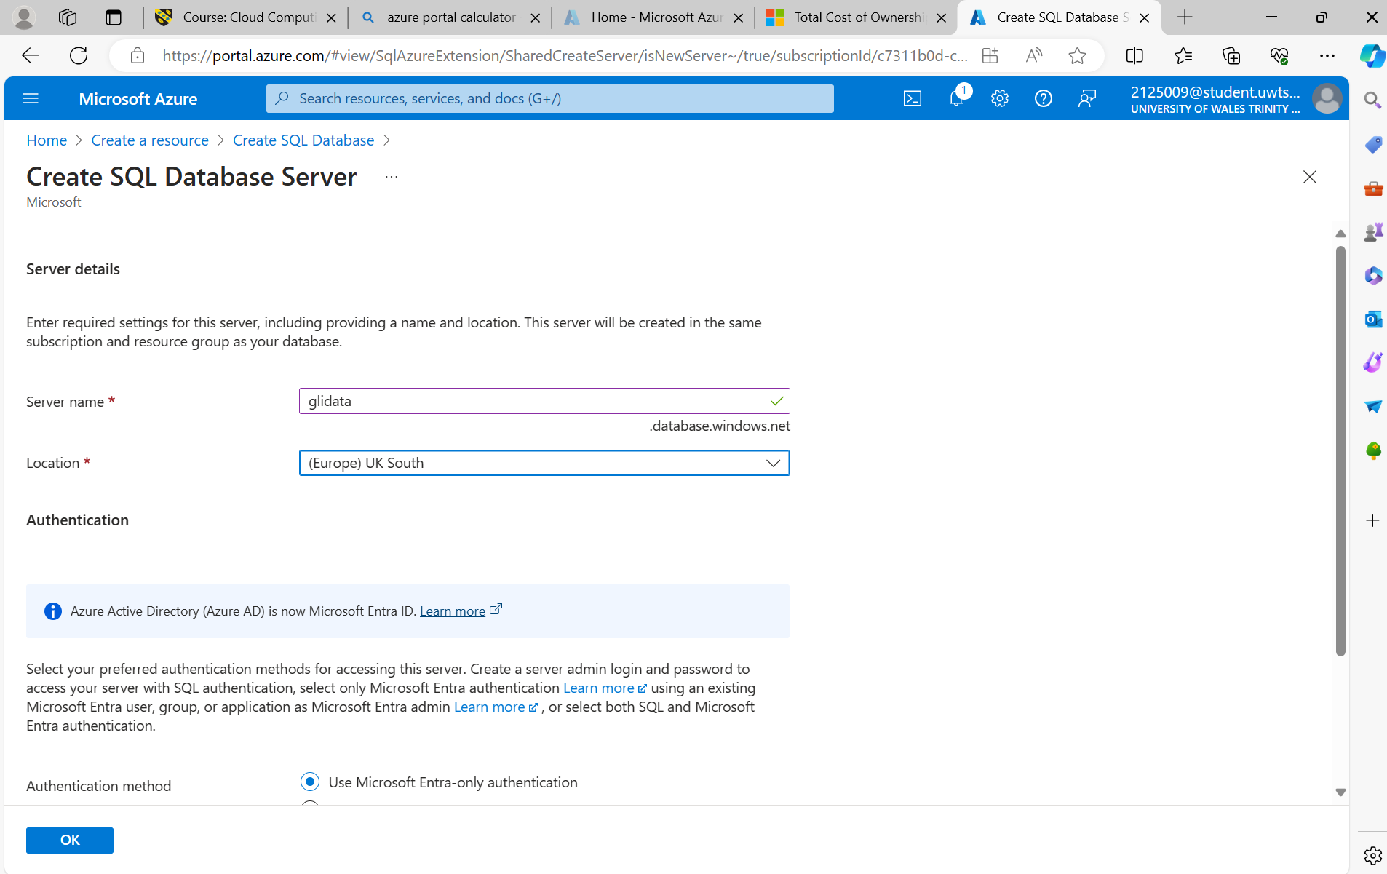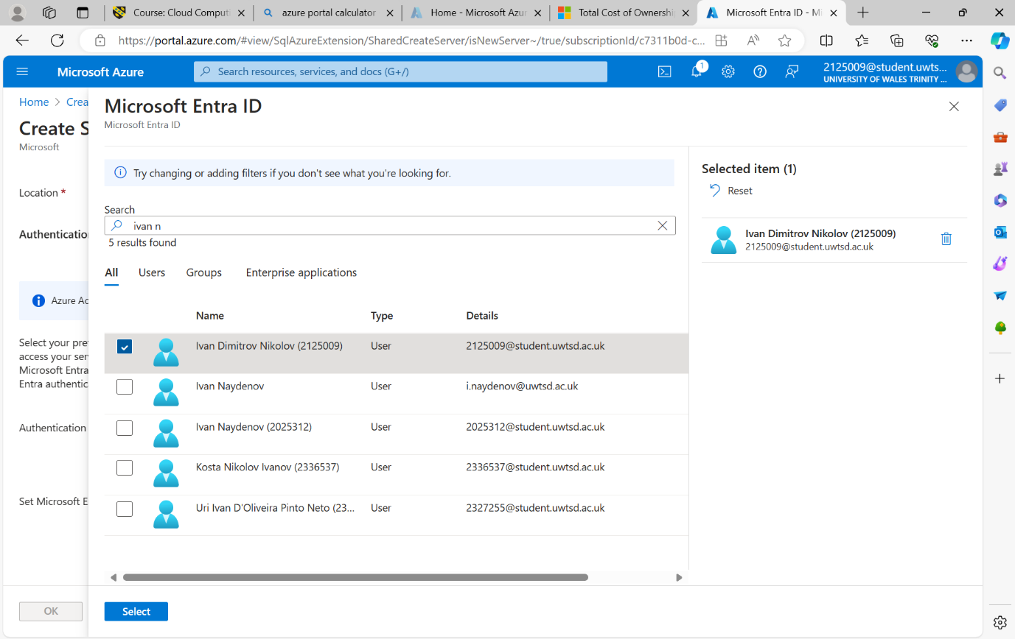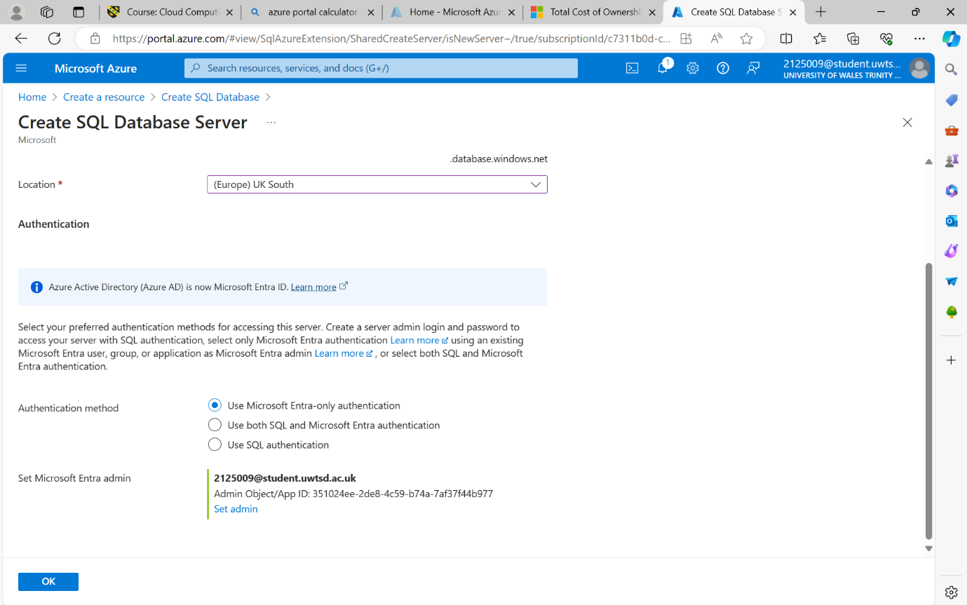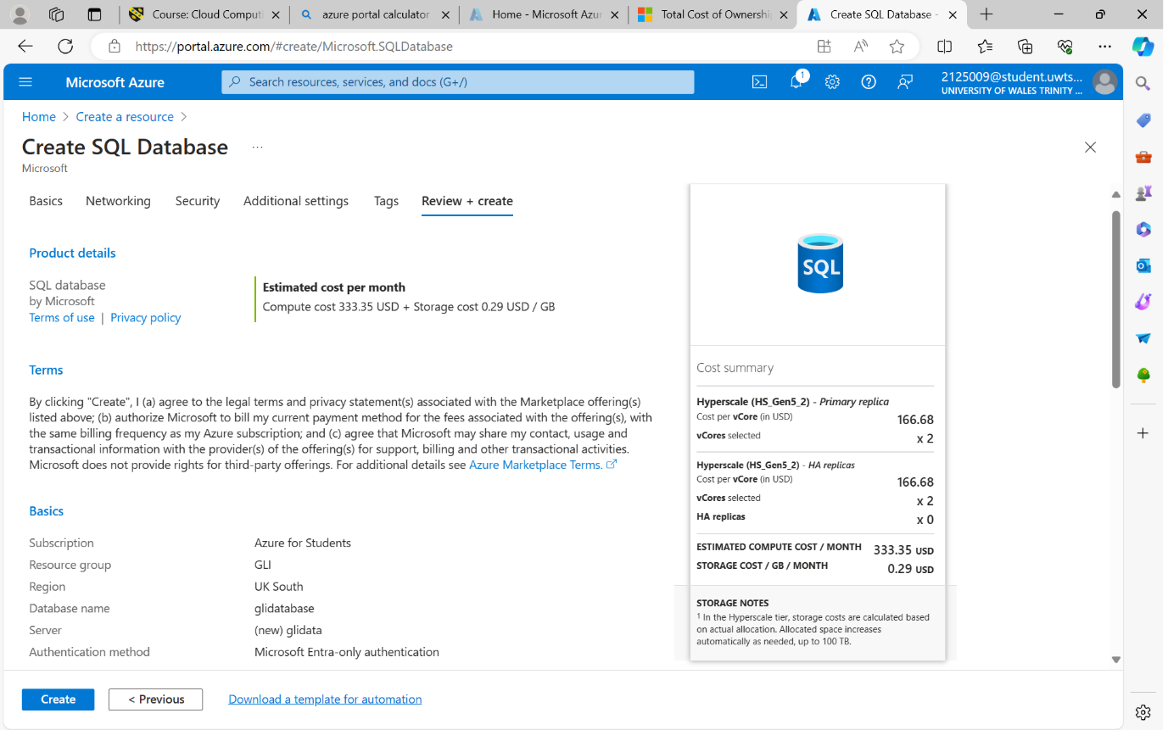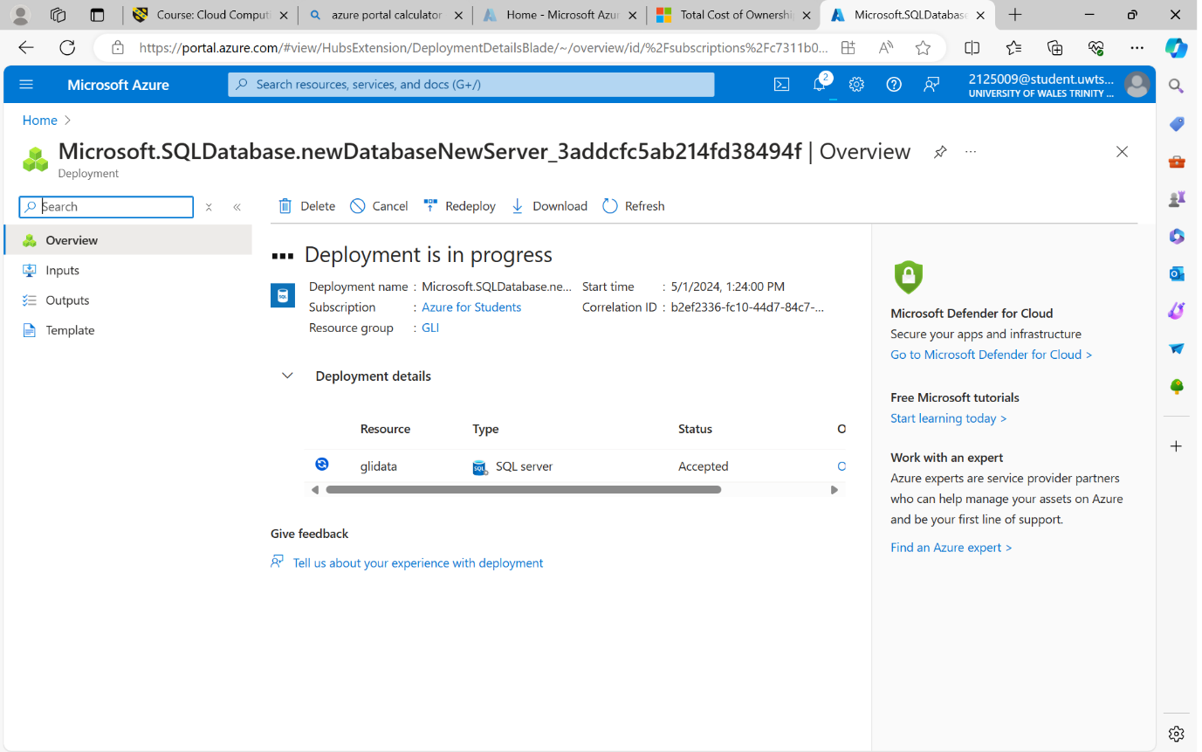
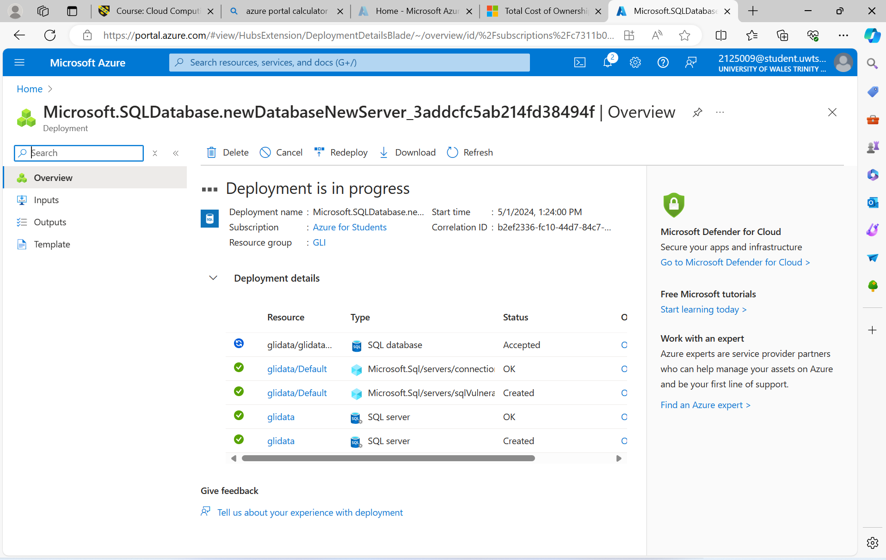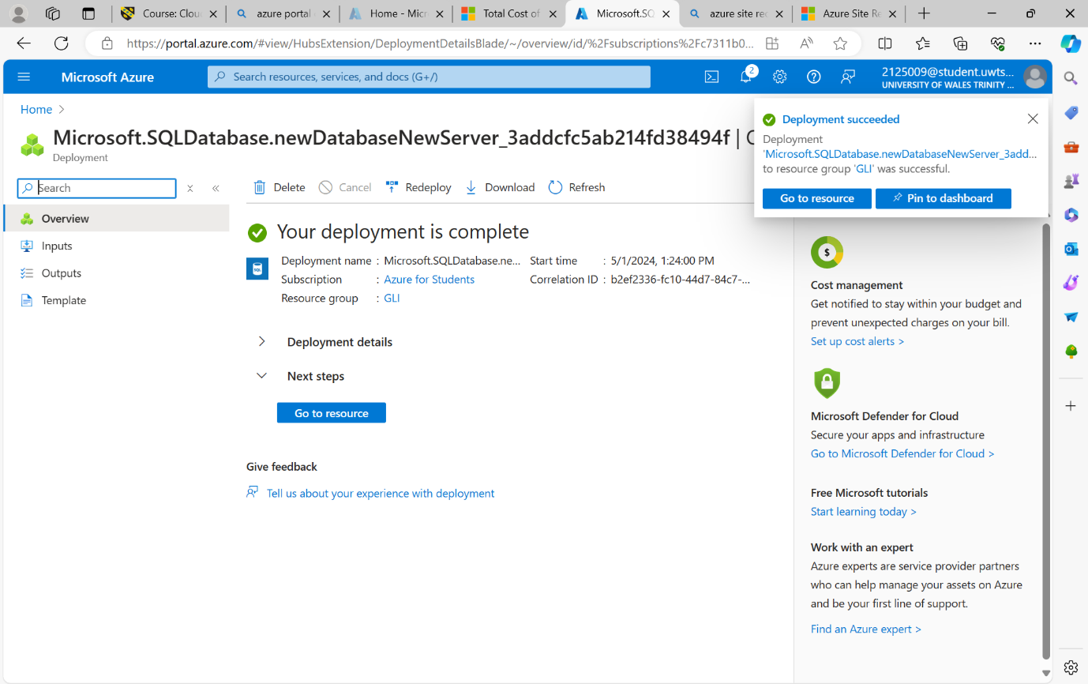

d)
Azure Backup offers several options for configuring backup schedules and retention policies for file shares and databases within Azure services like Azure Blob Storage and Azure SQL Database. Let's break down how Azure Backup can be used for both file shares and databases:

File Shares:
Azure Backup Agent:
For on-premises or Azure VM file shares, the Azure Backup agent can be installed.
Backup schedules can be configured using the Azure Backup agent interface, allowing you to specify when backups should occur (e.g., daily, weekly) and the frequency (e.g., every day at 8 PM).
Retention policies can also be defined, determining how long backups are retained (e.g., retain daily backups for 30 days, weekly backups for 12 weeks, etc.).
Azure File Sync:
Azure File Sync synchronizes files between on-premises servers and Azure File Shares.
Azure Backup integration allows you to enable backup of Azure File Shares synced using Azure File Sync.
Backup schedules and retention policies can be configured similarly to the Azure Backup agent.
Databases:
Azure SQL Database:
Azure SQL Database has built-in backup capabilities.
Automatic backups can be configured, where full, differential, and transaction log backups are taken automatically according to a predefined schedule.
Retention policies for backups can be set, specifying how long backups are retained before they are automatically deleted.
SQL Server on Azure Virtual Machines:
For SQL Server running on Azure VMs, Azure Backup can be utilized to back up the databases.
Backup schedules can be configured using Azure Backup policies, specifying the frequency and timing of backups.
Retention policies can be defined within the Azure Backup policy, determining how long backups are retained.
General Configuration:
Azure Backup Policies:
Azure Backup Policies allow you to define backup schedules and retention policies centrally.
Policies can be assigned to resources like file shares or databases, ensuring consistency across your environment.
Policies can be customized based on your organization's requirements, specifying backup frequency, retention period, and other parameters.
Retention Policies:
Retention policies dictate how long backups are retained before they are automatically deleted.
For compliance or regulatory purposes, you may need to retain backups for a certain period.
Azure Backup allows you to configure retention policies tailored to your organization's needs.
By leveraging Azure Backup options for file shares and databases, organizations can ensure data protection, compliance, and disaster recovery readiness. The ability to configure backup schedules and retention policies provides flexibility and control over data backup and retention strategies. [5]
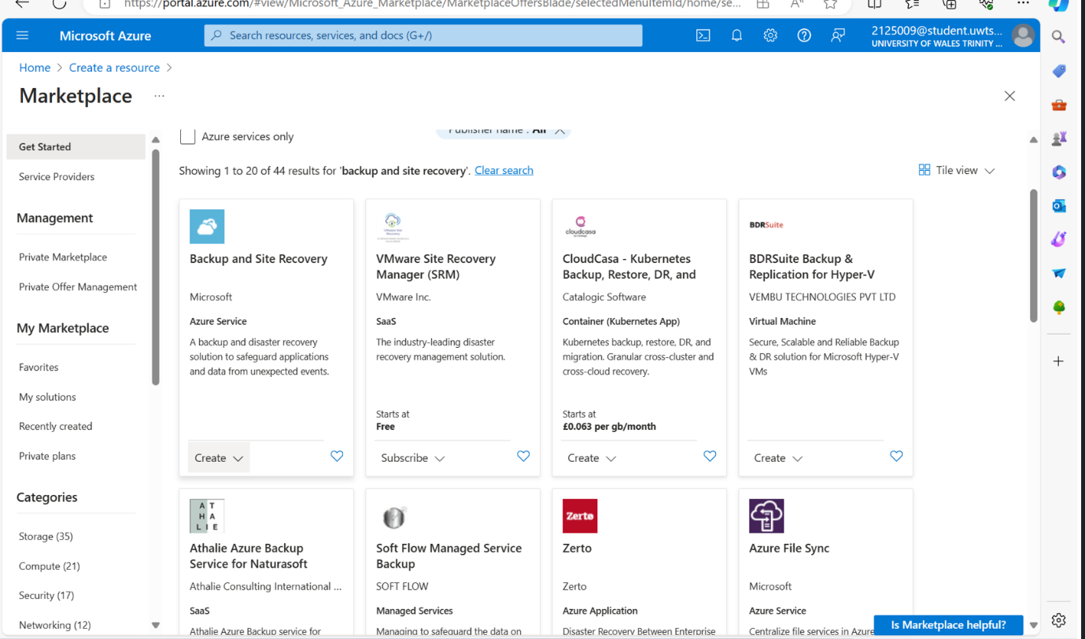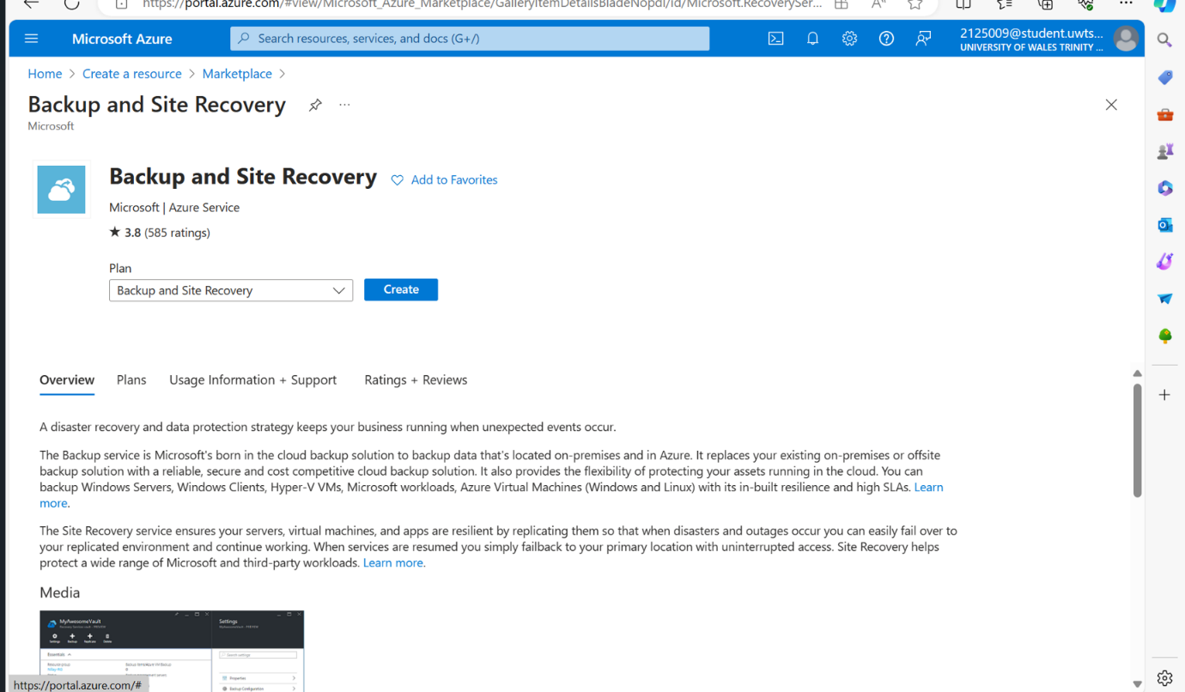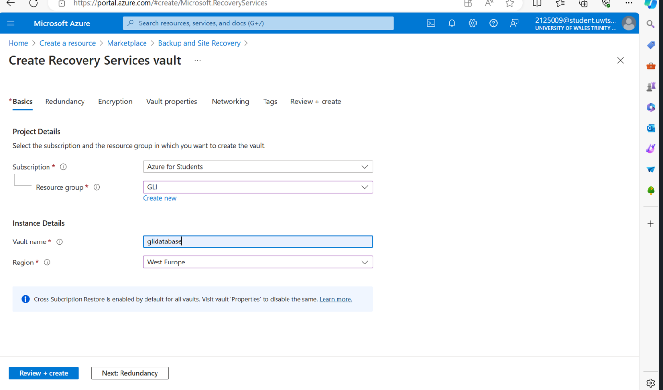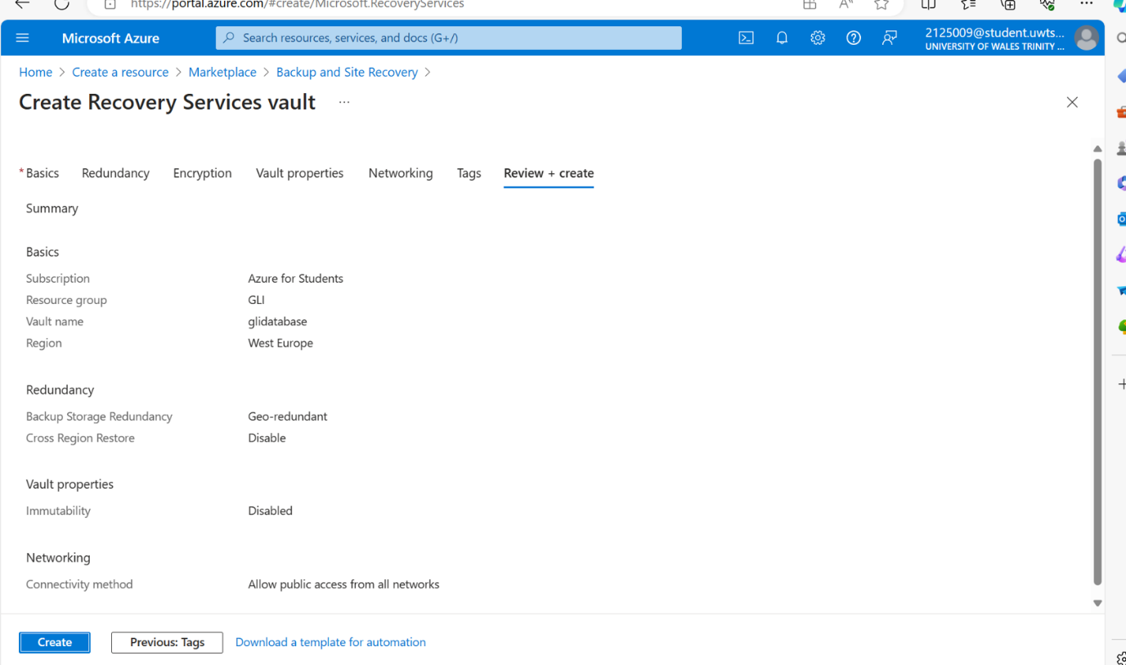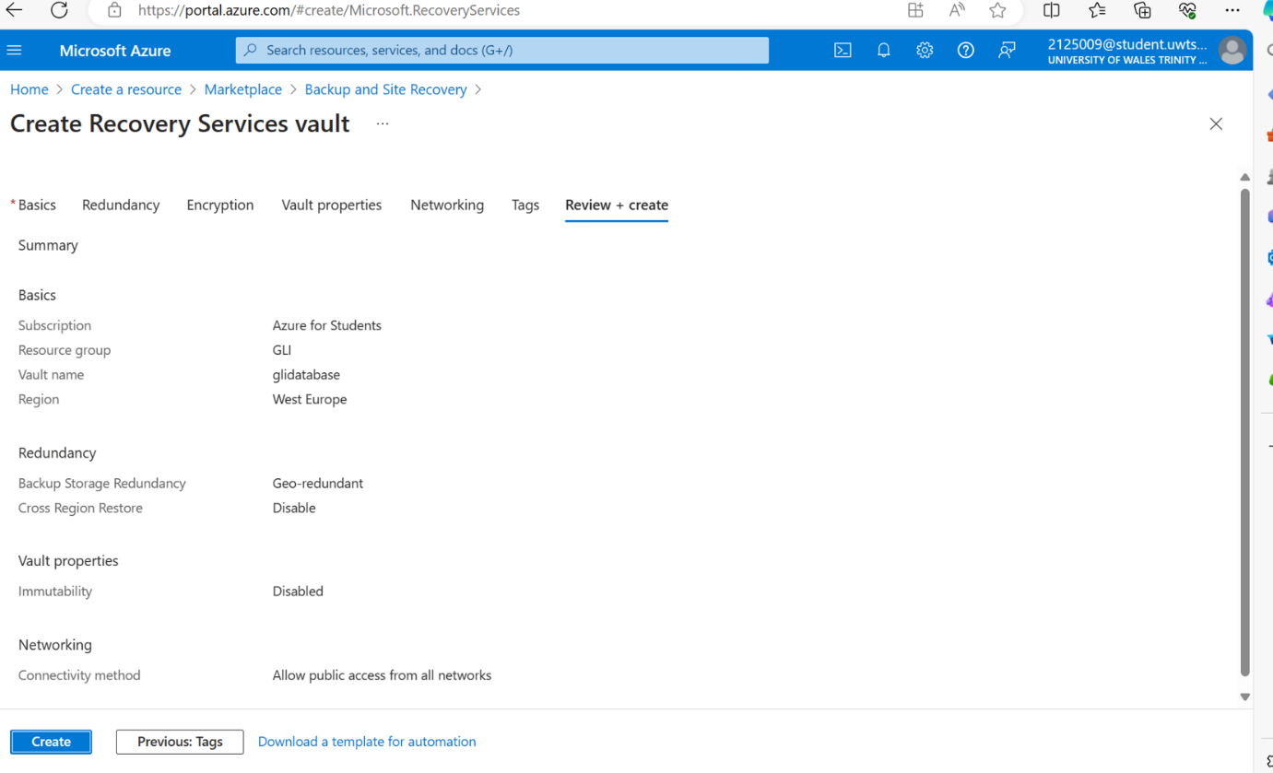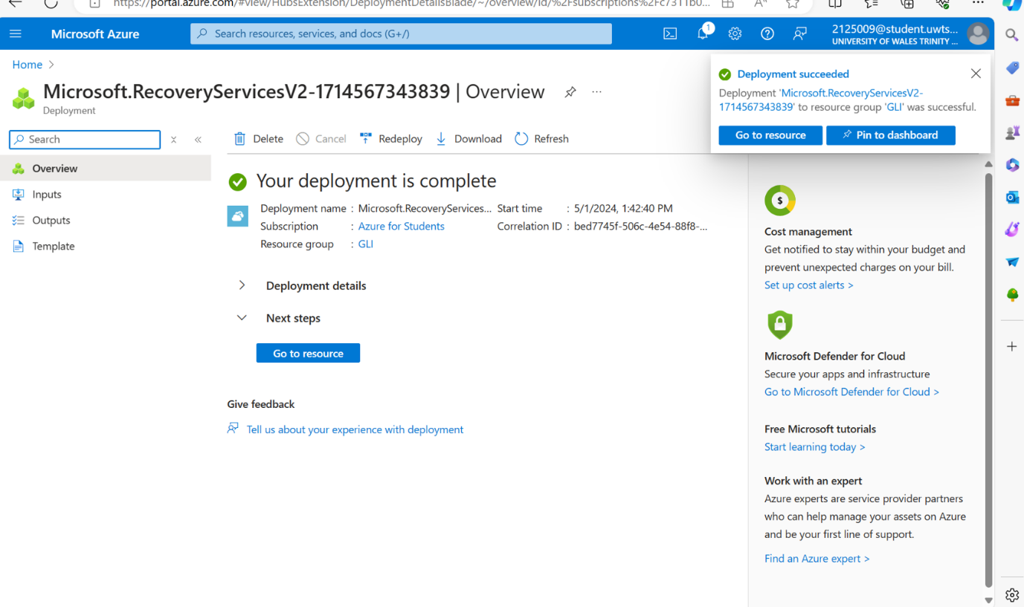

e)
Azure Site Recovery (ASR) can be a crucial component of GLI's disaster recovery strategy, particularly for protecting storage and databases. Here's how ASR would assist GLI:

Continuous Replication: Azure Site Recovery provides continuous replication of virtual machines and physical servers to Azure. This ensures that GLI's critical storage and database systems are constantly backed up, minimizing the risk of data loss in case of unexpected outages or disasters.
Automated Failover and Failback: In the event of an outage, ASR enables automated failover to a secondary Azure region. This ensures that GLI's storage and databases can quickly be brought back online in a geographically distant location, minimizing downtime and ensuring business continuity. Once the primary site is restored, ASR facilitates automated failback to ensure seamless transition back to the primary environment.
Orchestration and Testing: ASR provides orchestration capabilities, allowing GLI to create customized failover and failback plans based on their specific requirements. Additionally, ASR enables non-disruptive testing of disaster recovery plans, allowing GLI to validate the effectiveness of their recovery strategy without impacting production environments.
Integration with Azure Services: ASR seamlessly integrates with other Azure services, providing a comprehensive disaster recovery solution for GLI's entire infrastructure. This includes integration with Azure Backup for additional data protection, Azure Monitor for monitoring and alerting, and Azure Security Center for enhanced security and compliance.
Cost-Effective Solution: Azure Site Recovery offers a cost-effective disaster recovery solution for GLI, as it eliminates the need for maintaining a secondary data center for disaster recovery purposes. GLI only pays for the storage and compute resources consumed during replication and failover, providing cost savings compared to traditional disaster recovery approaches.
Overall, Azure Site Recovery would assist GLI in disaster recovery by ensuring continuous replication, automated failover and failback, orchestration and testing capabilities, seamless integration with Azure services, and cost-effective solution for protecting their storage and databases in case of unexpected outages or disasters. [6]

Bibliography:

[1] | D. I. S. Ltd, “Azure vs on-premise: Why you should choose the cloud,” Doherty associates, 2024. [Online]. Available: https://www.doherty.co.uk/blog/azure-vs-on-premise/.
[2] | Azure, “Pricing calculator,” Microsoft, 2024. [Online]. Available: https://azure.microsoft.com/en-us/pricing/calculator/.
[3] | I. Ukpanah, “What is the Average Cost of Electricity per kWh in the UK?,” Greenmatch, 17 04 2024. [Online]. Available: https://www.greenmatch.co.uk/average-electricity-cost-uk.
[4] | Azure, “Azure files,” Microsoft, 2024. [Online]. Available: https://azure.microsoft.com/en-gb/products/storage/files/?ef_id=_k_b0e152a6b9741a9c163b34949484cfea_k_&OCID=AIDcmm3bvqzxp1_SEM__k_b0e152a6b9741a9c163b34949484cfea_k_&msclkid=b0e152a6b9741a9c163b34949484cfea.
[5] | Azure, “Azure,” Microsoft, 2024. [Online]. Available: https://azure.microsoft.com/en-gb/products/backup/?ef_id=_k_848dc06b52a9113c083da65965b0cdb8_k_&OCID=AIDcmm3bvqzxp1_SEM__k_848dc06b52a9113c083da65965b0cdb8_k_&msclkid=848dc06b52a9113c083da65965b0cdb8.
[6] | Azure, “Azure site recovery,” Microsoft, 2024. [Online]. Available: https://azure.microsoft.com/en-gb/products/site-recovery/?ef_id=_k_98a22f5c3f8e13c137ed496e0a26a952_k_&OCID=AIDcmm3bvqzxp1_SEM__k_98a22f5c3f8e13c137ed496e0a26a952_k_&msclkid=98a22f5c3f8e13c137ed496e0a26a952.

