s
Changemakers: Building Your Personal Brand for Sustainable Employment
Assessment 2: Career Development Report
Analyzing a Health and Social Care Job Role: Service Improvement Officer, Adult Social Care

Student Name: ABDUL KHAN
Student Number: 2407946
Assignment Title: Career Development Report

Table of Contents
1. Introduction 4
2. Job Advertisement 4
3. Job Role Employability Skills 5
4. Evaluation of My Own Skills 5
5. Action Plan and Timeline 7
6. Building My Personal Brand 7
7. Promoting My Professional Identity 8
8. Building a Network for Successful Employment 8
9. Conclusion 9
REFERENCES 10
APPENDIX A: JOB ADVERTISEMENT SCREENSHOT 11
APPENDIX B: CV AND COVER LETTER 12

Introduction
This report focuses on a health and social care job role in the United Kingdom and reviews my skills and attributes against the requirements of this role, in relation to my future career aspirations. The role chosen is Adult Social Care and Safeguarding/ Service Improvement Officer (Staffordshire County Council, 2026). The role focuses on data, quality audits and service user feedback to highlight good practice and opportunities for improvement in adult social care, as well as assisting with the Care Quality Commission (CQC) assurance processes. It's key role is to analyse customer feedback, coordinate quality audits and transform insight into action. The position interests me because it directly supports my long-term career objective of being a strategic, compassionate and evidence-informed healthcare consultant. The job would enable me to gain hands-on experience in service evaluation and quality enhancement, a key component of the consultancy business in this field. This report outlines the opportunity, identifies the employability skills needed for this opportunity, compares my own skills with the identified skills, and outlines an action plan, personal branding strategy and networking strategy for moving forward into this opportunity and beyond.

Job Advertisement
The position being advertised is the Service Improvement Officer position (job reference staffscc/TP/78/3939) advertised by Staffordshire County Council in their Adult Social Care and Safeguarding directorate. It is a full-time, fixed-term job, working 37 hours per week, based at Staffordshire Place, and will be paid at the rate of £45,091 to £49,282 per annum until 1 February 2026 (Staffordshire County Council, 2026). The advertisement states that the team is responsible for assisting operational and senior managers in the best use of intelligence gathered from data, quality of practice audit, feedback and consultation and that the successful candidate will assist with preparation for future CQC inspection. The person specification is for analytical ability, excellent ICT skills (excellent knowledge of Excel and PowerPoint), curiosity and problem solving, excellent communication skills and strong relationship building skills. The job description and person specification are included as an Appendix A, which is included as a screen shot of the advertisement. As per good academic practice, the vacancy is referenced here and in full in the reference list.

Job Role Employability Skills
The person specification emphasises a number of employability skills. The first is analytical skills, the ability to read and process the quantitative and qualitative input from various sources and turn it into effective actionable advice. This skill is key as it enables service improvement to focus on the audit and survey evidence and not assumptions, which enables managers to make effective decisions (Staffordshire County Council, 2026). The second one is very good ICT skills, especially in Excel for analysis and PowerPoint for reporting results; digital confidence is becoming more vital across the sector because services are implementing new case-management systems (NHS England, 2024).
Communication is "the ability to present findings that influence decisions and build understanding" is the third skill. Good communication helps to ensure that improvement recommendations are not just reports on the table, but are understood and put into practice by front line staff and managers. The fourth is relationship-building skills, team working with colleagues, partner organisations and service users. In adult social care, change is dependent on trust and engagement between a number of stakeholders and where the voice of the service user is truly influencing the design of services (De Witte, 2023). Last but not least, a sense of curiosity and problem-solving skills are essential in asking the right questions and probing deeper to see what is working and what needs to be changed. These skills allow the post holder to demonstrate insight as a basis for meaningful and person-centred improvement, which is at the heart of the post. Importantly, the person specification also indicates that the employer will consider skills that they can transfer to the role and the correct mindset rather than ticking all the boxes, increasing the number of candidates they consider to be suitable (Staffordshire County Council, 2026).

Evaluation of My Own Skills
Self-Assessment: My educational and professional experience is relevant to this position. I have a Bachelor of Science in Human Nutrition and Dietetics, and a Masters of Philosophy in Food Science and Human Nutrition which honed my skills in research, data-analysis and evidence-appraisal. My work as a Research Associate helped me build my skills in data collection, analysis and interpretation, while also giving me exposure to academic curriculum and examination administration, honing my skills in organization, attention to detail and adherence to institutional standards. They are very similar to the analytical and quality assurance requirements that are required for the Service Improvement Officer position.
Strengths: My strengths are related to the job requirements. My research training has helped me develop my analytical skills, which is a direct requirement of the post that I am applying for. Synthesis of literature and presentation of results clearly showed in my post-graduate study, supporting the communication criterion. Person-centred, compassionate practice, informed by scientific, evidence-based reasoning, is my unique selling point, and is my personal brand as a healthcare consultant in the making. I am also confident in using Microsoft Office tools, such as Excel and PowerPoint that are explicitly required to do this role.
Areas for Improvement: There are areas that I know I need to improve. Much of my study and personal experience of the adult social care system has been outside of frontline adult social care settings within the UK, and of the CQC assurance frameworks. The advertisement states that quality-audit process and the case-management system of local-authority services are active areas of development for the team, and I need to do more of this. Although I have an analytical base, I would like to develop my analytical skills specifically in relation to complaints and compliments, consultation findings and social-care performance data. Having experience and knowledge of regulatory requirements specific to my sector in the UK, including the CQC single assessment framework, would enhance my competitiveness for this and other sector-specific appointments, and lend credibility to my applications.
Who can help: I could get support from a number of people and organizations. Academic mentors and previous supervisors can act as references and give guidance to help in getting into the sector, as can professionally contacts and recruitment consultants, through LinkedIn or other networks. Practical experience could be gained from placement supervisors and colleagues within care settings and there are training and resources available through professional bodies, such as Skills for Care, in relation to the standards for Adult Social Care in the UK (Skills for Care, 2024).

Action Plan and Timeline
Timeframe | Focus Area | Specific Action
Short term (0–12 months) | Sector knowledge | Complete quality-improvement and data-analysis courses
Short term (0–12 months) | Professional profile | Update CV and LinkedIn profile
Short term (0–12 months) | Practical experience | Secure an entry-level or voluntary role in adult social care to gain UK sector experience
Medium term (1–3 years) | Practical experience | Consolidate frontline experience
Medium term (1–3 years) | Skills development | Develop expertise in service evaluation and quality auditing; complete advanced Excel and PowerPoint training
Medium term (1–3 years) | Career progression | Pursue a Service Improvement Officer or similar quality-focused role
Long term (3–5 years) | Leadership | Move into a senior improvement or leadership position
Long term (3–5 years) | Entrepreneurship | Establish own health and social care consultancy, applying a strategic and evidence-informed approach
Ongoing | Networking | Engage on LinkedIn and attend sector events
Ongoing | Reflective practice | Evaluate progress and identify further development needs

Building My Personal Brand
Building a personal brand is vital to having a sustainable job and future career. My personal brand is a healthcare consultant that I build around the pillars of strategic thinking, ethical practice, and continuous learning that are linked to a compassionate and evidence-informed approach. In today's competitive landscape, where brand perception is the key to staying relevant and different, it is the individual's responsibility to cultivate and maintain a professional brand identity, according to Szántó, Papp-Váry and Radácsi (2025). I will promote my professional identity as a problem-solving type professional with a focus on improving services by leveraging LinkedIn, my own professional profile, and sector networking events to build my brand as a professional in the Service Improvement Officer role. I will post content that's relevant, so that I can demonstrate my expertise and commitment to the field, such as reflections on quality improvement, evidence-based practice and person-centered care. This is a brand and a visible, credible brand that will help employers recognize that I am a candidate that has both scientific rigour and a compassion.

Fostering My Professional identity
My presentation of skills and experiences to prospective employers will be through a combination of tailored application materials and a strong online presence. My CV and cover letter will be specific to each job, focusing on the analytical, research and communication skills that are specified in the person specification and my qualifications and experience relevant to this. The draft CV and cover letter for Service Improvement Officer are attached in Appendix B. My online profile will be kept alive with an updated LinkedIn profile which will include my brand as a consultant and I will explore having a personal website or portfolio to showcase my academic projects, research experience and professional accomplishments. Having a uniform and professional look in all these helps employers feel that I am credible and can stand out in a competitive marketplace.

Creating a pathway to successful employment
One of the essential elements of finding a sustainable health and social care job is networking. Employers tend to hire people they know and trust rather than individuals who rely solely on job listings.While often overlooked, a strong professional network can also help provide access to job opportunities, industry knowledge, references and mentorship which may be unavailable through traditional job applications. Those weaker bonds, like professional acquaintances or online contacts, often prove more effective in finding new jobs than strong bonds, as they are a way to access larger information and job networks (de Witte, 2023). In a sector with a lot of job pressures, it can be the key to a career stuck and a career moving forward to be seen and connected (Skills for Care, 2024).
In order to grow my career to become a Service Improvement Officer and beyond, I will seek out possible mentors, professional association and networking opportunities that will help me meet industry professionals. Previous academic supervisors and experienced improvement professionals can be mentors to provide guidance and referrals. There are a number of professional associations and bodies, such as Skills for Care, that offer training, events and networking opportunities for adult social care. I believe that by attending sector conferences, webinars and LinkedIn groups, I can connect with practitioners and managers, learn about the new opportunities in the sector and show my interest in the industry. I will also take advantage of the non-formal contact that many employers provide, like this ad does, where I can speak to the Quality and Performance Manager before I apply, to help develop rapport and demonstrate my interest in the job. This active and strategic networking will aid in my employment and future consultancy career.

Conclusion
This report has explored the role of the Service Improvement Officer in adult social care and considered my potential to carry out this role as a progression towards my career aim of becoming a consultant in the healthcare sector. Analytical ability, ICT and communications skills and relationship building and problem-solving were identified as the key employability requirements from the analysis of the job role. My self-evaluation highlighted good alignment with my research training and postgraduate qualifications and evidence-based approach and identified areas where I lack experience in the UK sector and regulatory knowledge which can be improved through targeted courses, practical experience and mentorship. The action plan and timeline provide realistic short-, medium- and long-term steps, accompanied by a clear personal brand, professional identity via targeted applications and online profile, and network of professionals. These combine to reinforce my drive and dedication to this career path and to create a sustainable, meaningful career in the health and social care industry in the UK.

References
Care Quality Commission (2023). The state of health care and adult social care in England 2022/23. [online] London: CQC. Available at: https://www.cqc.org.uk/publications/major-report/state-care.
De Witte, M. (2023). The strength of weak ties. [online] Stanford News. Available at: https://news.stanford.edu/stories/2023/07/strength-weak-ties.
Dizikes, P. (2022). The power of weak ties in gaining new employment. [online] MIT News. Available at: https://news.mit.edu/2022/weak-ties-linkedin-employment-0915.
Ferreira, T. and Collins, A. (2023). The NHS Long Term Workforce Plan: an ambitious leap or a misstep? Journal of the Royal Society of Medicine, 116(11). doi:https://doi.org/10.1177/01410768231198373.
Goleman, D. (1998). Working with emotional intelligence. New York: Bantam Books.
Hashmi, S., Tahir, O., Nasir, Z., Hasnain, H., Ullah Riaz, R.S., Ali Khan, H.M., Ramza, R., Alghzawi, H.M., Mukherjee, J. and Palav, A. (2024). Impact of emotional intelligence on professional performance and stress resilience among healthcare practitioners. Cureus, 6(11). doi:https://doi.org/10.7759/cureus.74113
NHS England (2024). NHS Long Term Workforce Plan. [online] NHS England. Available at: https://www.england.nhs.uk/long-read/nhs-long-term-workforce-plan-2/.
Skills for Care (2024). The state of the adult social care sector and workforce in England. [online] Leeds: Skills for Care. Available at: https://www.skillsforcare.org.uk/adult-social-care-workforce-data/Workforce-intelligence/publications/national-information/The-state-of-the-adult-social-care-sector-and-workforce-in-England.aspx.
Staffordshire County Council (2026). Service Improvement Officer (Job reference staffscc/TP/78/3939). [online] Careers at Staffordshire. Available at: https://careers.staffordshire.gov.uk/jobs/job/Service-Improvement-Officer/3939 [Accessed 5 July 2026].
Szántó, P., Papp-Váry, Á. and Radácsi, L. (2025). Research gap in personal branding: understanding and quantifying personal branding by developing a standardized framework for personal brand equity measurement. Administrative Sciences, 15(4), p.148. doi:https://doi.org/10.3390/admsci15040148.

APPENDIX A: JOB ADVERTISEMENT SCREENSHOT

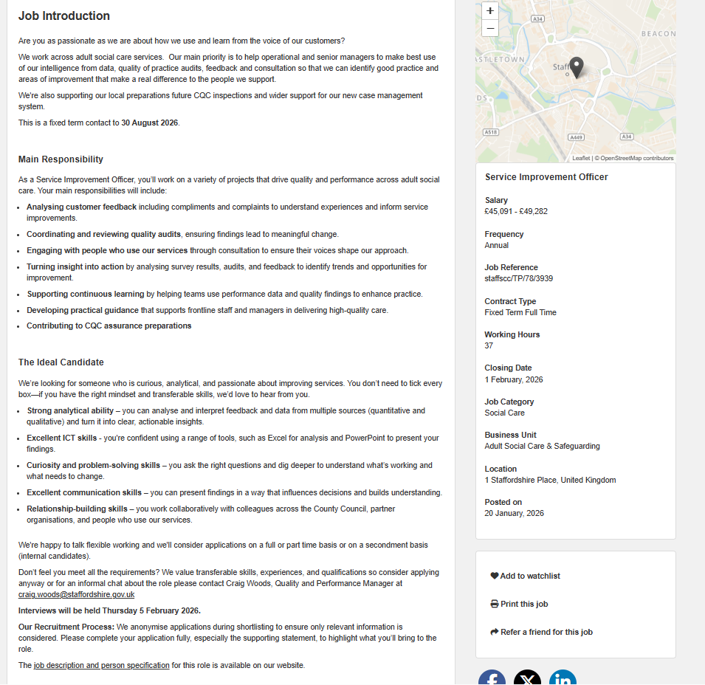

APPENDIX B: CV AND COVER LETTER
CURRICULUM VITAE (CV) 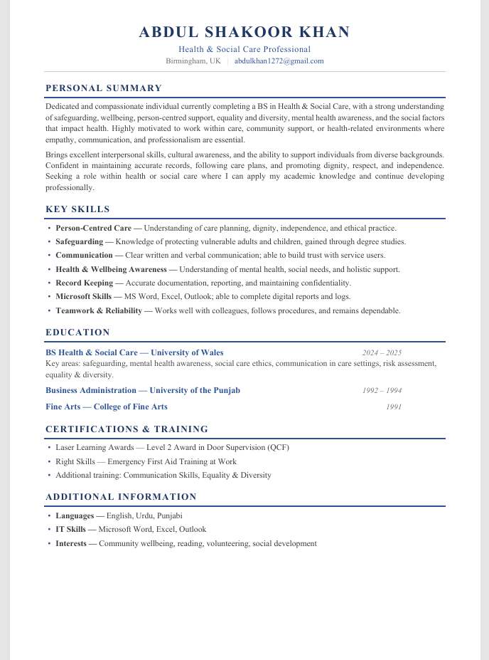
COVER LETTER
Dear Hiring Manager,
I am writing to apply for the Service Improvement Officer role within Adult Social Care and Safeguarding at Staffordshire County Council. As a nutrition and food science postgraduate with research experience, I am passionate about using data and feedback to improve the quality of care that people receive, and this role aligns closely with my long-term goal of working in health and social care service improvement.
My academic and research background has developed strong analytical skills in interpreting both quantitative and qualitative data, alongside confident use of Excel and PowerPoint to analyse and present findings. My experience in academic administration has strengthened my attention to detail, organisation and ability to work to defined standards, all of which are directly relevant to coordinating quality audits and supporting CQC assurance preparations.
I am curious, collaborative and committed to person-centred improvement, and I would welcome the opportunity to contribute to your team's work in turning insight into meaningful change for people who use adult social care services. Thank you for considering my application; I would be glad to discuss my suitability further at interview.
Yours faithfully,

