,

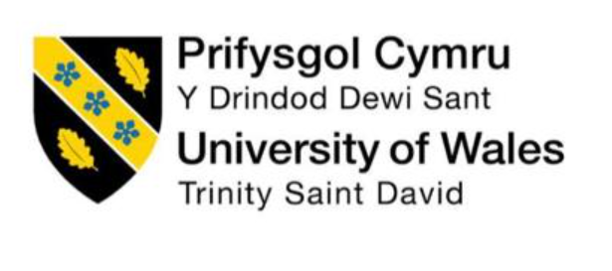

Module Name : Human Capital Management
Module code : LCMB7023
Assessment component 1: Individual report – HR strategy
Lecturer name: Dr. Eno Maycock
Student Name: JAYAKUMAR NAVINKUMAR
Student Id : 2506813

Table of Contents

PART 1: BUILDING A CULTURE OF INNOVATION & FUTURE WORK PRACTICES 4
1. Introduction: Strategic Context and HR Challenge 4
2. Critical Review: Culture and Work Practices in Contemporary Tech Firms 5
2.1 The Innovation Paradox in Technology Organisations 5
2.2 Theoretical Foundations for Culture and Performance 5
2.3 Identified Gaps at Aether Innovations 6
3. Cultural and Structural Initiatives to Embed Innovation 7
3.1 Innovation Sprint Architecture 7
3.2 Intrapreneurship Pathway 8
3.3 Cross-Functional Team Model 8
3.4 Leadership and Psychological Safety Programme 9
3.5 Cultural Risk Assessment and Trade-offs 9
4. Future of Work Model: Designing a Hybrid Innovation System 9
4.1 Structured Hybrid Framework 9
4.2 Performance Management Integration 10
4.3 Motivation and Engagement Implications 11
5. Integrated HR Architecture: Connecting Culture, Work and Performance 11
PART 2: REFLECTIVE ANALYSIS 13
6. Reflective Analysis Using Gibbs’ Reflective Cycle 13
6.1 Description 13
6.2 Feelings 13
6.3 Evaluation 13
6.4 Further Critical Analysis of My Learning Transformation 14
6.5 Conclusion 15
6.6 Personal Action Plan 15
7. AI, Human Capital and Staying Professionally Relevant 15
7.1 AI and the Transformation of HR and Managerial Roles 15
7.2 Human–AI Complementarity Strategy 16
7.3 Personal Relevance Strategy 16
7.4 Ethical and Societal Dimensions of AI in Human Capital Management 16
References 17

Integrated Human Capital Blueprint: Aligning People and Performance at Aether Innovations

PART 1: BUILDING A CULTURE OF INNOVATION & FUTURE WORK PRACTICES

1. Introduction: Strategic Context and HR Challenge

Aether Innovations has 300 employees and does well in a world that is always changing and very competitive. At first, things were going well for the business. But now, sales aren't going up, more employees are leaving on their own, and customers are unhappy. They mean more than just things aren't going well. They mean there is a bigger problem with how people work together and come up with new ideas. Not only does technology give companies in knowledge-based fields a long-term edge over their rivals, but a new study shows that human capital systems do the same thing (Collins, 2021; Jiang and Messersmith, 2018). When workers aren't motivated, they give worse service and come up with fewer new ideas. That also means things get worse for clients (Saks, 2022). They need to change how they work and think in order to get their employees to be more creative and dedicated. Based on current HRM theory, this article gives a full framework for human capital that can be used to increase engagement, spark creativity, and make sure that each person's work is in line with the organization's progress.

2. Critical Review: Culture and Work Practices in Contemporary Tech Firms

2.1 The Innovation Paradox in Technology Organisations

A lot of tech companies think they can change and adapt fast. But a study shows that there is a growing gap between what businesses say about innovation and how their employees really see it. Gallup (2023) and Mazmanian et al. (2019) both say that the so-called "agile revolution" has made things less clear, made people work harder, and tired them out instead of giving them power. Many companies put on "innovation theater," which means they hold hackathons and planning sessions but don't actually change how power and responsibility are distributed in the company. A lot of highly skilled people who want a lot of freedom are leaving the tech business around the world at a high rate (LinkedIn, 2024) to show this difference. Harter et al. (2020) discovered that how involved workers are directly impacts how pleased customers are with the service and extra work that was provided. Claims of new ideas in society are just empty words. There may not be a lack of new technology, but rather a lack of order and drive, since Aether Innovations is also having the same problems.

2.2 Theoretical Foundations for Culture and Performance

It is said that a person's job performance depends on how good they are at it, what drives them, and how many chances they have to make a change (Jiang and Messersmith, 2018). IT companies pay a lot of money to hire people with the right skills, but the way decisions are made makes it hard for those skills to be used. It's also important to keep workers safe mentally, because they won't try new things if they feel dangerous (Edmondson and Lei, 2014). Shin and Konrad (2017) study high-performance work systems and find that combined HR bundles lead to more creativity than separate HR bundles. Another idea is that people can get burned out when they have too much freedom and not enough means (Bakker & Demerouti, 2017). There is a big problem: people can come up with new ideas when they are free, but they lose drive when they have to do too much. To change society, people need to learn how to get power and help from the system.

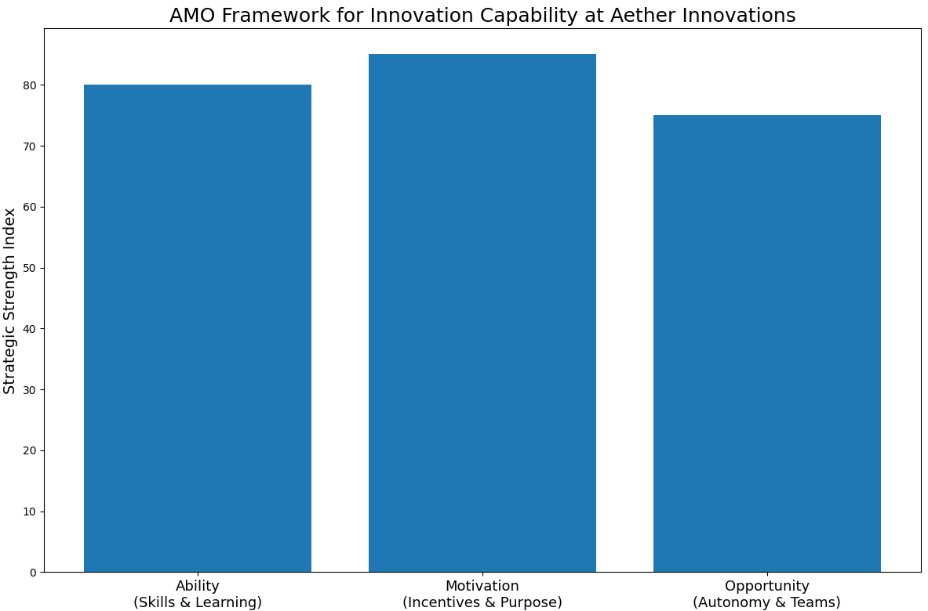
Source: Author’s own illustration based on AMO theory (Jiang and Messersmith, 2018)
Graphical representation of Ability, Motivation, and Opportunity dimensions as drivers of innovation strength

2.3 Identified Gaps at Aether Innovations

There are lots of unique ways that Aether Innovations teams work, which makes it tougher for AMO to do its job. It looks like performance systems are based on goals, but they don't have ways for people to improve. We can't say what to expect because we don't know how shared work will look yet. Because there aren't really any rules for making things, there are a lot of different projects instead of one clear plan. When there are holes, it's harder for staff to give people what they want and come up with new ideas.

3. Cultural and Structural Initiatives to Embed Innovation

3.1 Innovation Sprint Architecture

If Aether Innovations wants to be truly flexible, they need to plan their work in real 90-day innovation sprints. There should be people from marketing, tech, product, and customer experience on cross-functional teams. These people should work together to set goals and get important results for customers. This arrangement makes it more likely that new ideas will be useful (Locke and Latham, 2019). That's not all, though. The government should have a group that checks out new ideas. This group should give them tools and keep track of what they learn. Things are more adaptable to change when they have structured ways to recognize, seize, and change them (Teece, 2018). But if you run too fast, your mind will be too busy. To keep from getting too tired, you should set aside time to rest and write clear outlines of what you've learned. New thoughts will only come to you every once in a while if you don't have this plan.
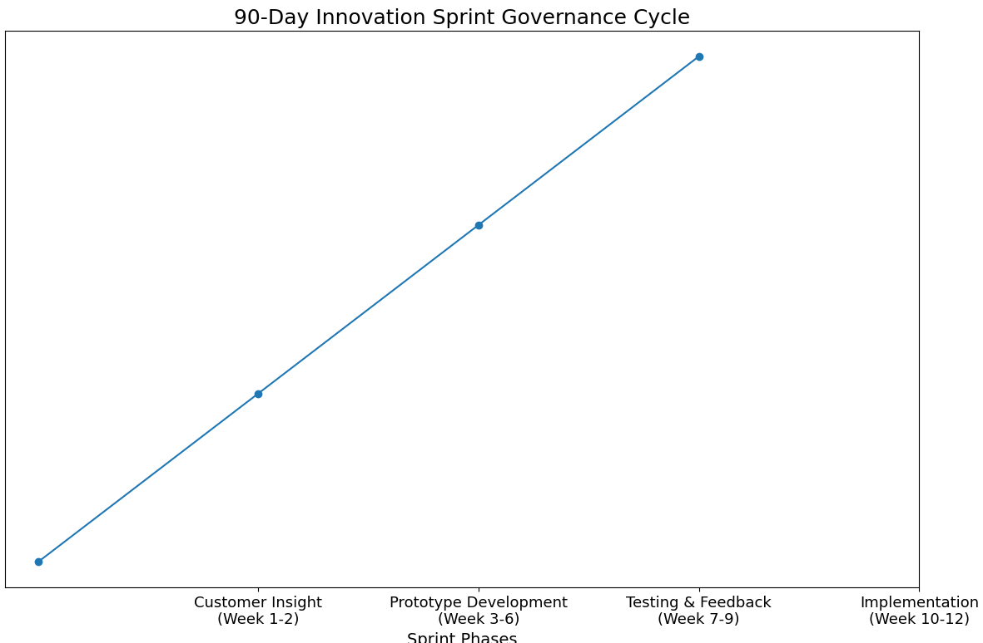
Source: Author’s own illustration (2026)
Process architecture diagram showing phased innovation sprint structure including customer insight, prototyping, testing, and implementation

3.2 Intrapreneurship Pathway

Aether Innovations employees should be able to use 10% of their time to work on new ideas. To do this, they should be able to use internal seed money and an organized intrapreneurship program. An Innovation Board is a place where workers can talk about their ideas. It is made up of top management and other experts. Decí et al. (2017) say that this way makes the AMO model's opportunity structures stronger and gives people more freedom, which makes them more deeply driven. If people can get rewards related to stock for making prototypes that work, they may stay interested for a longer time. If a company wants to stay important in markets that are always changing, dynamic capacities theory says it should try new things (Teece, 2018). But if teams fight too much, they might not get along as well. That's why it's important to set clear rules for how to work together.

3.3 Cross-Functional Team Model

The team needs to be reorganized right away. It's easier to pass work from one department to another when they are all in the same place. This also speeds up input. This model from Grant and Parker (2009) says that if you have a lot of skills, clear goals, and freedom, you may be much more driven. People are more likely to stay interested in their jobs if they can see how they help people right away. Let people trade jobs and share what they know. They could learn something new from this. Cross-functional teams, on the other hand, need good ways to settle differences because having people from different backgrounds on the team can make things harder. If two or more people work together, there should be clear rules about how well they do their jobs.

3.4 Leadership and Psychological Safety Programme

The people in charge should be changed. People can believe and learn from each other when leaders use coaching (Roche et al., 2020). Leaders should be able to take and give feedback, find solutions that work for everyone, and talk about what went wrong. People are more likely to share their ideas and be creative when they feel safe (Frazier et al., 2017). This is especially true in places that value new ideas. Social Exchange Theory (Cropanzano et al., 2017) says that people will care about leaders who help other people. But those in charge need to make sure people do their jobs so they don't get lazy. Still, you should find a balance between being strict and being sensitive when it comes to performance.

3.5 Cultural Risk Assessment and Trade-offs

New ideas that aren't well thought out can get old fast. Short-term resource stress might make it less likely to work. In the early stages of change, people might not know what they are supposed to do. Because of these issues, the adoption must happen in steps and be clear about what it is doing.

4. Future of Work Model: Designing a Hybrid Innovation System

4.1 Structured Hybrid Framework

If you want to find a good mix, have people work together in the office for three days and then hard from home for two days. This is where most people should go to get ideas, learn how to create things, and help make things. If you work from home for a few days, you'll get better at your job. It's easier for people to work together and get more done (Bloom et al., 2015; Allen et al., 2021). Some digital tools that make it easier to work together are shared screens and tools that let people talk to each other at different times. Trust grows when people are judged on what they do instead of how they act. If you want to stay fit, don't stress too much about having too much tech.

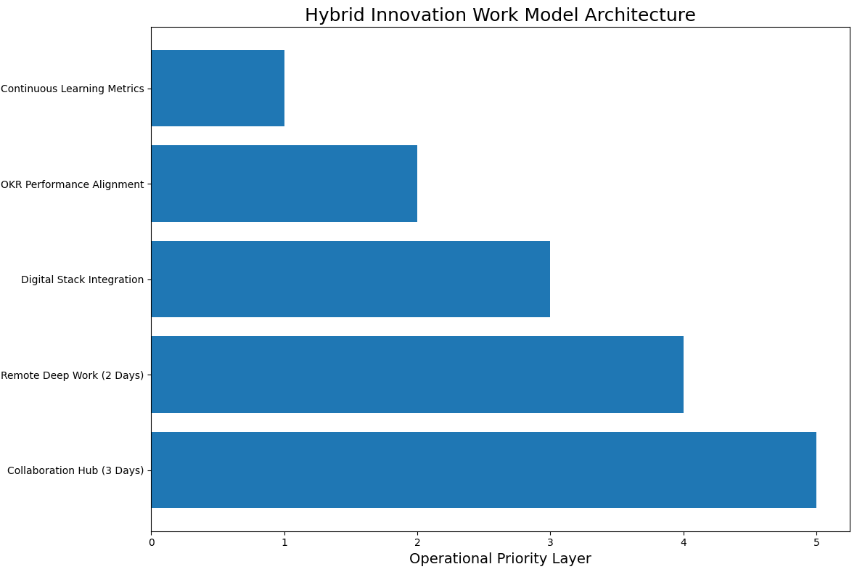
Source: Author’s own illustration (2026)
Operational layered model outlining structured hybrid framework, digital integration, and output-based performance alignment

4.2 Performance Management Integration

OKR-based goal alignment and comments from everyone around the person should be a part of tools that help them do better. There should be more than just dollars. You should also be able to see how people are still learning by seeing how they help each other out and how their skills are getting better. People are more likely to want to get better and be creative when they get developmental input (London, 2015). To get rid of bias, tests and measures need to be open and fair.

4.3 Motivation and Engagement Implications

Psychologist Ryan and Deci (2020) say that intrinsic drive is made up of three key parts: autonomy, competence, and relatedness. People learn new things and make new friends more quickly when they work together, which is how hybrid liberty boosts ability. They think that making clear lines between work and home can help them feel less worried (Ashforth et al., 2018). With better customer service and better work design, Aether Innovations can keep more workers and get more work done. If they don't have to, people will work harder.

5. Integrated HR Architecture: Connecting Culture, Work and Performance

Culture affects how people act, structure impacts how people see opportunities, and leadership impacts how people feel about their jobs. All of these things affect how many new ideas people have and how happy their customers are. When you look at it in terms of resources, it's hard to copy human capital that is part of united systems. This gives a business an edge over its competitors in the long run (Barney et al., 2021). When a company strategically aligns its HRM, it makes sure that its processes for hiring, training, performance, and rewards all work together to help the business reach its creative goals. When you have a human capital architecture that works together, engagement turns into growth.
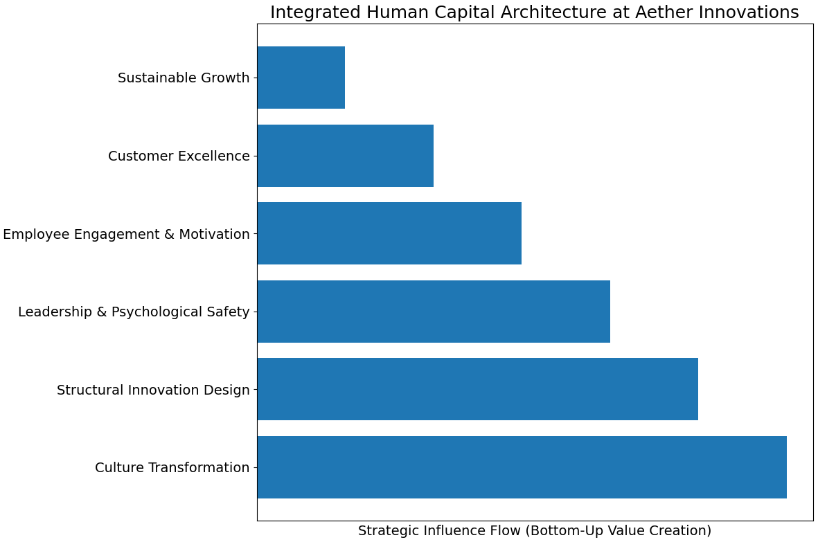
Source: Author’s own illustration (2026)
Layered strategic model demonstrating the systemic linkage between culture transformation, structural innovation design, leadership climate, employee engagement, customer excellence, and sustainable growth

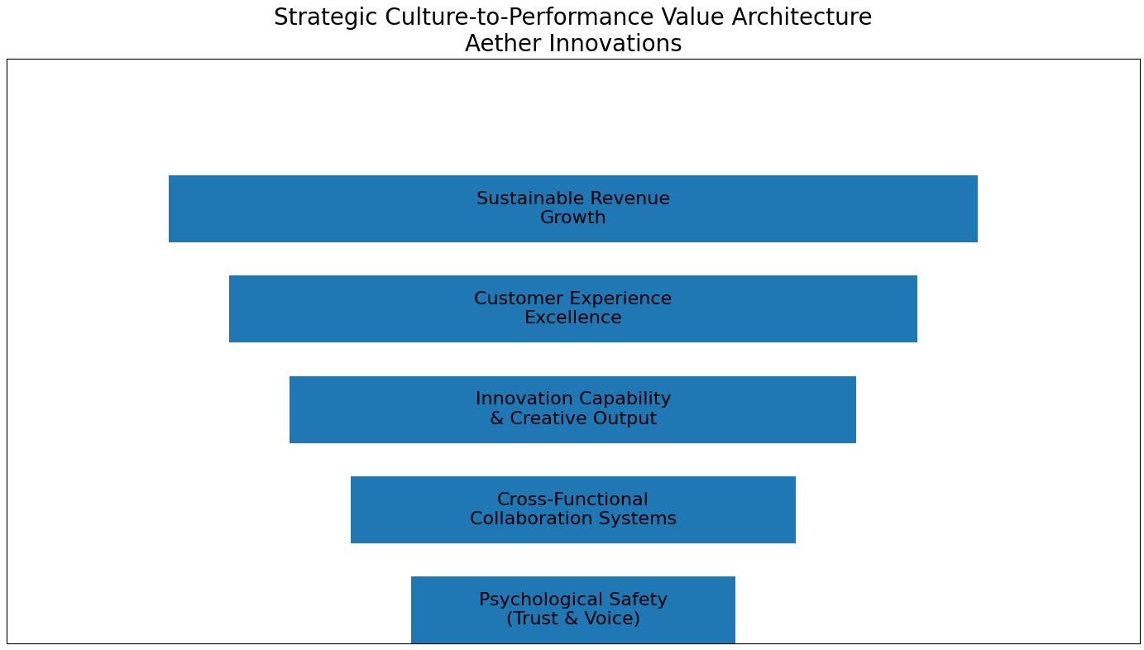
Source: Author’s own illustration informed by strategic HRM literature (Barney et al., 2021)
Causal chain diagram linking psychological safety, collaboration, creative output, customer satisfaction, and revenue growth

PART 2: REFLECTIVE ANALYSIS

6. Reflective Analysis Using Gibbs’ Reflective Cycle

6.1 Description

Before this school, HRM was mostly what I thought of as a way to deal with people. I thought HR's job was to hire people, pay them, and make sure everyone did what they were supposed to. I didn't see how it could add strategic value. I used to think that the best thing that could happen was new technology. How competitive a business is depends on how it is run, how jobs are set up, and how success is measured. This is something I didn't fully understand.

6.2 Feelings

I used to think that operations or finance had a bigger impact on KPIs than human resources. When there was money for R&D instead of society, I used to think that new ideas came about. However, as I went to class and learned more about cases, I started to question these ideas. I learned that even the best IT company can be hurt by careless workers.

6.3 Evaluation

How the AMO organization and High-Performance Systems work together was the most interesting thing I learned. When people talked about failed businesses in groups, it became clear that culture issues usually come up before money issues. Edmondson and Lei (2014) do a more in-depth study of the link between psychological safety and team learning. I thought it was interesting because being artistic is more than just writing catchy words. It also needs to be planned. A new study taught me how to question management styles instead of just following them.

6.4 Further Critical Analysis of My Learning Transformation

After going through this program, I no longer saw HR as a transactional role. Instead, I saw it as a way to manage people strategically. I now know that in knowledge-based economies, you have an advantage over your competitors if your systems work together instead of just having different rules (Jiang and Messersmith, 2018). People who can do something but don't get to do it get angry, and people who want to do something but don't have the skills to do it get worse at it. HR practices are not different tools, as the study of high-performance work systems showed; they are linked and work together. There are many thoughts about what makes people act on new ideas, but I think that people are most likely to do so when they feel safe and responsible. Every business wants to run things from the top down, but this goes against that. I can't just depend on my charm to be a good leader. I need to set up systems too. Reading real studies instead of stories has made me think more deeply.
One of the most useful things I learned in this class was how to link performance goals and business culture. I used to think that controlling performance was mostly about making sure that everything was in order. New research shows that performance systems help companies tell their workers what they need to do and change how they see themselves (Aguinis and Burgi-Tian, 2021). After I learned this, I changed a lot of the things I thought about. I learned that bad grading systems can keep people from being creative by rewarding them for doing what they're told instead of trying something new. The goal of performance management shouldn't just be to rate people; it should also be to help them improve and get ready for the future.
Reading new Strategic HRM books taught me how important it is to have alignment both up and down and left to right. This makes sure that HR practices are in line with the goals of the business. This also makes sure that the whole company follows the same HR rules (Delery and Roumpi, 2017). Ideas don't last long on their own; they need to be mixed in this way. You can't just have new ideas; you have to think about how they will work with your business first.
You should also know what kind of boss you are. I used to look up to tough and quick-thinking leaders. But more and more studies show that performance is more innovative and flexible when everyone is included and has power (Carmeli et al., 2019). After reading this, I'm not sure what I thought I knew about power. I started to think about how the way I talk to people might affect how safe the team feels. Nobody can come up with new ideas if they are scared to say what they think. This is true even if the plan is good. Setting goals is part of being a boss. People need to trust you too.

6.5 Conclusion

I now see HRM as a key area that is important for growth and new ideas. If I were the owner of a tech business, I would hire people, train leaders, and make it simple for people to learn. I wouldn't just make big plans; I would also work on making things that give people chances.

6.6 Personal Action Plan

How do I become a great innovator leader? I want to use facts better, think more deeply, and help other people more. I will learn more and move up at work by taking classes in HR analytics and leadership. You can make a better choice if you learn more about AI. I want to learn more about how to deal with change and start a business so that I can do my new job.

7. AI, Human Capital and Staying Professionally Relevant

7.1 AI and the Transformation of HR and Managerial Roles

AI has given us new ways to hire people, check their work, and keep track of how well they do their jobs. According to Upadhyay and Khandelwal (2018), predictive algorithms can easily check out job candidates who are likely to quit. But systems that are biased and have moral issues are still very big problems. Machines can do boring office work, but people are the only ones who can make good choices and keep the culture alive. It looks like managers aren't losing their jobs; they're just changing how they do their jobs.

7.2 Human–AI Complementarity Strategy

AI should make smart people even smarter, not smarter. People who are in charge need to know how the data results fit with the facts and morals. They still can't think like people do, which is artistic, smart, or caring. If leaders use AI along with their own skills, they may be able to use facts to make better decisions. Now that things are better, people trust each other more.

7.3 Personal Relevance Strategy

To keep up with the times, I need to always learn something new, know how to use technology well, and be able to think quickly. A machine can't have values, come up with new ideas, or know how people feel. I see AI as a tool, not a threat. This is why I think of myself as a person who strategically weaves together people and technology.

7.4 Ethical and Societal Dimensions of AI in Human Capital Management

We talked about how tough it can be to work with AI. There are new studies that show computer systems may be able to pick up on social biases that are already in the training data (Raghavan et al., 2020). People might think and value a company differently after reading this. When I'm a boss, I need to use AI to make things run more smoothly. But I need to think about what it wants and how fair it is. These days, ethical control isn't just something the law needs; it's a skill that every business needs to have.

A lot of people are scared that they will lose their jobs because of AI. When people understand changes in technology and have the chance to learn new skills, they are much less likely to fight them (Brougham and Haar, 2018). So, those who are in charge of human capital need to think of ways for people to learn new skills and make the change at the same time.

Because of this, I think my job's worth will depend on more than just how well I do it. Plus, I need to think about how well I can learn new things, decide what is right and wrong, and understand how things work. Leaders who want to make work better in the future need to be able to put people's needs before their own needs and combine technology with kindness.

References
Allen, T.D., Golden, T.D. and Shockley, K.M. (2021) ‘How effective is telecommuting? Assessing the status of our scientific findings’, Psychological Science in the Public Interest, 22(2), pp. 40–68. https://doi.org/10.1177/1529100621997731
Aguinis, H. and Burgi-Tian, J. (2021) ‘Measuring performance during crises and beyond: The performance management revolution’, Business Horizons, 64(5), pp. 641–652. https://doi.org/10.1016/j.bushor.2021.02.005
Ashforth, B.E., Kreiner, G.E. and Fugate, M. (2018) ‘All in a day’s work: Boundaries and micro role transitions’, Academy of Management Review, 43(3), pp. 392–410. https://doi.org/10.5465/amr.2016.0079
Bakker, A.B. and Demerouti, E. (2017) ‘Job demands–resources theory: Taking stock and looking forward’, Journal of Occupational Health Psychology, 22(3), pp. 273–285. https://doi.org/10.1037/ocp0000056
Barney, J.B., Ketchen, D.J. and Wright, M. (2021) ‘Resource-based theory and the value creation framework’, Journal of Management, 47(7), pp. 1936–1955. https://doi.org/10.1177/01492063211036319
Bloom, N., Liang, J., Roberts, J. and Ying, Z.J. (2015) ‘Does working from home work? Evidence from a Chinese experiment’, Quarterly Journal of Economics, 130(1), pp. 165–218. https://doi.org/10.1093/qje/qju032
Brougham, D. and Haar, J. (2018) ‘Smart technology, artificial intelligence, robotics, and algorithms (STARA): Employees’ perceptions of our future workplace’, Journal of Management & Organization, 24(2), pp. 239–257. https://doi.org/10.1017/jmo.2016.55
Carmeli, A., Sheaffer, Z., Binyamin, G., Reiter-Palmon, R. and Shimoni, T. (2019) ‘Transformational leadership and creative problem-solving’, Leadership Quarterly, 30(4), pp. 1–15. https://doi.org/10.1016/j.leaqua.2018.07.001
Collins, C.J. (2021) ‘Expanding the resource-based view model of strategic human resource management’, International Journal of Human Resource Management, 32(2), pp. 331–358. https://doi.org/10.1080/09585192.2019.1711442
Cropanzano, R., Anthony, E.L., Daniels, S.R. and Hall, A.V. (2017) ‘Social exchange theory: A critical review with theoretical remedies’, Academy of Management Annals, 11(1), pp. 479–516. https://doi.org/10.5465/annals.2015.0099
Deci, E.L., Olafsen, A.H. and Ryan, R.M. (2017) ‘Self-determination theory in work organizations’, Annual Review of Organizational Psychology and Organizational Behavior, 4, pp. 19–43. https://doi.org/10.1146/annurev-orgpsych-032516-113108
Delery, J.E. and Roumpi, D. (2017) ‘Strategic human resource management, human capital and competitive advantage’, Human Resource Management Review, 27(1), pp. 1–11. https://doi.org/10.1016/j.hrmr.2016.07.003
Edmondson, A.C. and Lei, Z. (2014) ‘Psychological safety: The history, renaissance, and future of an interpersonal construct’, Annual Review of Organizational Psychology and Organizational Behavior, 1, pp. 23–43. https://doi.org/10.1146/annurev-orgpsych-031413-091305
Frazier, M.L., Fainshmidt, S., Klinger, R.L., Pezeshkan, A. and Vracheva, V. (2017) ‘Psychological safety: A meta-analytic review’, Personnel Psychology, 70(1), pp. 113–165. https://doi.org/10.1111/peps.12183
Gallup (2023) State of the Global Workplace Report 2023. Accessed on 15/02/2026. Available at: https://www.gallup.com/workplace/349484/state-of-the-global-workplace.aspx
Grant, A.M. and Parker, S.K. (2009) ‘Redesigning work design theories’, Academy of Management Annals, 3(1), pp. 317–375. https://doi.org/10.1080/19416520903047327
Harter, J.K., Schmidt, F.L., Agrawal, S. and Plowman, S.K. (2020) ‘Employee engagement and business outcomes’, Gallup Meta-Analysis Report. Accessed on 15/02/2026. Available at: https://www.gallup.com/workplace/321032/employee-engagement-meta-analysis.aspx
Jiang, K. and Messersmith, J.G. (2018) ‘On the shoulders of giants: A meta-review of strategic human resource management’, International Journal of Human Resource Management, 29(1), pp. 6–33. https://doi.org/10.1080/09585192.2017.1384930
LinkedIn (2024) Global Talent Trends Report 2024. Accessed on 15/02/2026. Available at: https://business.linkedin.com/talent-solutions/resources/talent-strategy/global-talent-trends
Locke, E.A. and Latham, G.P. (2019) ‘The development of goal setting theory’, Organizational Dynamics, 48(2), pp. 100–115. https://doi.org/10.1016/j.orgdyn.2018.09.001
London, M. (2015) ‘The power of feedback’, Organizational Dynamics, 44(2), pp. 131–136. https://doi.org/10.1016/j.orgdyn.2015.02.008
Mazmanian, M., Orlikowski, W.J. and Yates, J. (2019) ‘The autonomy paradox revisited’, Organization Science, 30(4), pp. 807–827. https://doi.org/10.1287/orsc.2018.1276
Raghavan, M., Barocas, S., Kleinberg, J. and Levy, K. (2020) ‘Mitigating bias in algorithmic hiring’, Proceedings of the ACM Conference on Fairness, Accountability, and Transparency, pp. 469–481. https://doi.org/10.1145/3351095.3372828
Roche, M., Haar, J.M. and Luthans, F. (2020) ‘The role of coaching leadership’, Leadership & Organization Development Journal, 41(6), pp. 755–769. https://doi.org/10.1108/LODJ-07-2019-0323
Ryan, R.M. and Deci, E.L. (2020) Intrinsic and extrinsic motivation from a self-determination theory perspective. Contemporary Educational Psychology, 61, 101860. https://doi.org/10.1016/j.cedpsych.2020.101860
Saks, A.M. (2022) ‘Caring human resources management and employee engagement’, Human Resource Management Review, 32(3), 100835. https://doi.org/10.1016/j.hrmr.2021.100835
Shin, D. and Konrad, A.M. (2017) ‘Causality between high-performance work systems and organizational performance’, Journal of Management, 43(4), pp. 973–997. https://doi.org/10.1177/0149206314544746
Teece, D.J. (2018) ‘Business models and dynamic capabilities’, Long Range Planning, 51(1), pp. 40–49. https://doi.org/10.1016/j.lrp.2017.06.007
Upadhyay, A.K. and Khandelwal, K. (2018) ‘Applying artificial intelligence: Implications for recruitment’, Strategic HR Review, 17(5), pp. 255–258. https://doi.org/10.1108/SHR-07-2018-0051

