
University of Wales Trinity Saint David
School of Engineering

Reflective Report
Engineering Design (M4X01160)

Taylor Winter
1901843

06/03/2020

Table of Contents
1 Introduction ii
2 Teamwork iii
3 Time Management and Organisation iv
4 Communication v
5 Concept and Technical Design Activities vi
6 Prototype and Building Phase viii
7 Conclusion ix

1 Introduction

For this project we were given a design specification of a line launcher that we were put into groups for and had to design in CAD and produce. I focused on the energy release and trigger system.

2 Teamwork

I think that as a whole our group worked well together and had a good dynamic. We were able to communicate our ideas to each other as well as deciding on a final design which incorporated aspects from each team members original ideas. Everyone put an equal amount of work in and everyone helped to get each part of the project done well and on time.

3 Time Management and Organisation

For this project we struggled with our time management towards the end of the project. While designing the separate components we left plenty of time to make suitable adjustments such as measurements if needed. However, for the actual making of the line launcher we did not allow ourselves enough time as we failed to consider that we may have to adjust components, or even slightly redesign some aspects. If we had begun construction a week earlier, we would have had a better composed product to display our ideas. For future projects I would take this into consideration.

The organisation of our group was managed reasonably well. Each team member knew what they needed to do and when throughout the project. To improve on the organisation of our project we should have thought about the availability and delivery of the components that we were required to order, for example the motors.

4 Communication

Communication began slow however quickly picked up when the research report began. We all worked together to split the project up evenly for each team member. Once we had done so the project as well as communication seemed to flow much better. Each team member was able to talk freely and give input into the project. We also were able to have regular team meeting which helped us to look at the positives and negatives of our work so far. This enabled us to improve as we went along. This is something that I would wish to repeat in future projects.

A few days before each deadline, the whole team met, and we read over each other’s work and merged it together for the group submissions. This helped us to understand other aspects of the design so that we weren’t only focused on our own part, enabling us to gather a better understanding of the system as a whole.

5 Concept and Technical Design Activities

Our initial concept was great and would have worked well, however it was too complex for the time that we had as well as the £30 budget. We decided to simplify our designs for the base to make it easier to make in the time that we had. As seen below in figure one:

Figure 1: final base design
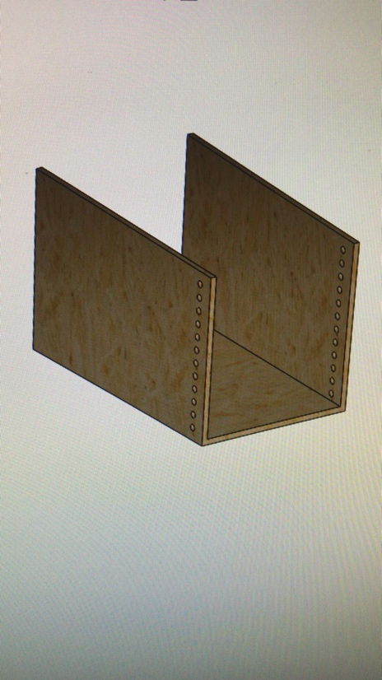

This design helped us to save a lot of time which was better spend building and adapting the motor system that fires the squash ball.

My design for the safety mechanism was also slightly altered to save time and to enable us to use products that we readily available for us.

Figure 2: original design of safety mechanism
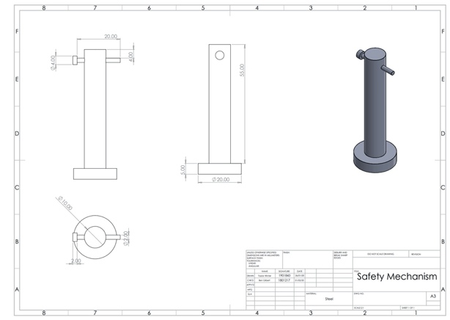

Figure 3: final safety mechanism
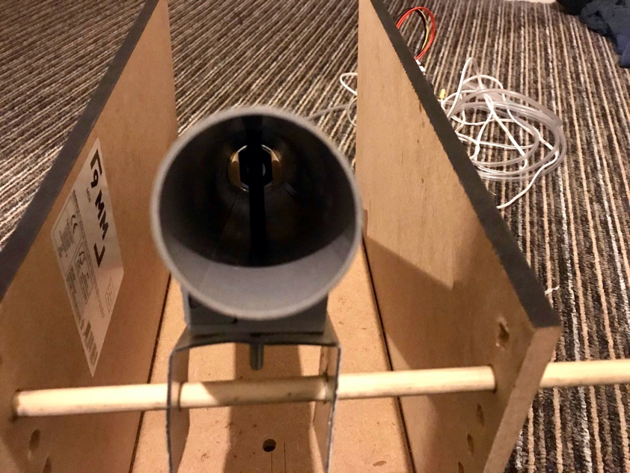

My original design was a steel pin put parallel through the barrel with an additional pin added to ensure that the primary pin isn’t accidentally removed. However, while building the line launcher I quickly realised that the same thing could be achieved with a bolt and nut. This idea saved us time and money; therefore, it was chosen. In future projects I would take into consideration that the materials that we have around us could be used instead of making something new.

6 Prototype and Building Phase

Figure 4 and 5: prototype of line launcher.
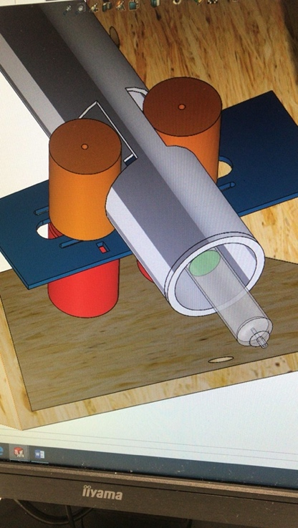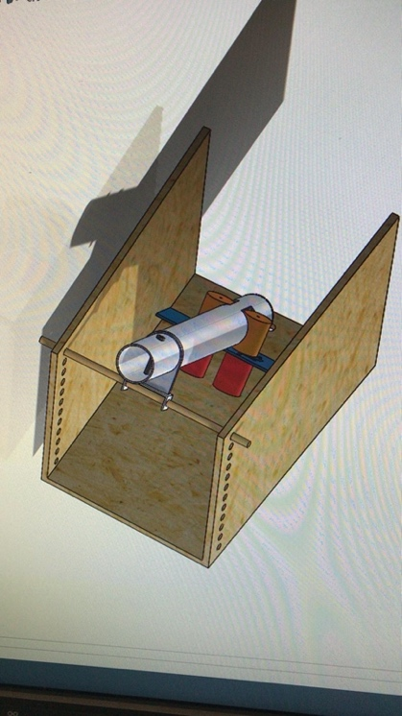

Figures four and five show our prototype. Figure five shows and overview and figure four shows the motors and trigger system.

As seen in figure four there is a syringe attached to the bottom of the barrel, this is part of the trigger system. The syringe works as a pressure system, when the other end of the syringe is pressed the pressure pushes the squash balls into the motors which are triggered by a battery. This prototype actually worked well however, when it came to testing, the battery was not giving enough power to actually propel the ball forward out of the barrel. For future projects I would think about using a larger battery to give more power.

The building process went very well, and all of our designs lined up and fit into the design specification. The only downside to this aspect is that we did not begin it soon enough to make room for improvement.

7 Conclusion

Overall this project was successful, although there is room for improvement especially with time management. For future projects I will consider the simplicity of the design as well as the material before deciding upon it to save time for the building process.

- Use products available to you to save money and time.
- Have frequent meeting to look at the positives and negatives for improvement.
- Give yourself more time do build a design and allow time for improvements and adjustments.

