

University of Wales Trinity Saint David (UWTSD)

Module Title: Introduction to Physiology

Module Code: BMHP5023

Assessment: Component 1 - Written Assignment (Case Study Report)

Student Name: Prince Jimoh Isidahomen

Student Number: 2509813

Lecturer’s Name: Mr. Robert Nartowski

Table of Contents

Contents Page Number
1.0 Introduction 3
2.0 Anatomy and Physiology 3
2.1 Regulation of Blood Glucose Levels 3
2.2 Cellular Energy Metabolism 4
3.0 Pathophysiology and Impact 5
3.1 Insulin Resistance and Impaired Glucose Regulation 5
3.2 Physiological Impact and Lifestyle Factors 6
4.0 Blood Glucose Monitoring and Data Use 7
4.1 Methods of Blood Glucose Monitoring 7
4.2 Importance of Recording and Interpreting Data 7
5.0 Evidence-Based Lifestyle Recommendations 8
5.1 Dietary Modifications 8
5.2 Physical Activity and Exercise 8
5.3 Smoking Cessation 8
6.0 Conclusion 9
Reference List 10

1.0 Introduction
Type 2 diabetes mellitus (T2DM) is a chronic metabolic condition in which body cells respond poorly to insulin (insulin resistance) while the pancreatic β-cells gradually lose the capacity to compensate by secreting more of it (Galicia-García et al., 2020). Glucose is the body's main metabolic fuel, absorbed from food, carried in the blood and taken up by cells to make adenosine triphosphate (ATP). When regulation fails, chronic hyperglycaemia develops and, over time, damages blood vessels and nerves.
Several factors increase the risk of T2DM, including increasing age, family history, physical inactivity and obesity, which is the strongest modifiable risk factor (Galicia-García et al., 2020). In Wales, adults with obesity were more than twice as likely to have diabetes compared with other adults (8.2% versus 3.6%), and 8.0% of adults aged 17 and over were living with diabetes in 2021/22 (Public Health Wales, 2023). By 2025 the number of diagnosed adults had reached 230,371, a rise of 3.5% in one year and faster growth than projected (Public Health Wales, 2026).
These trends matter to a practice nurse who has noticed more patients with diabetes attending the surgery, because understanding the underlying physiology explains why monitoring and lifestyle measures work and allows nurses to educate patients with confidence. This report aims to examine the physiology of T2DM and the evidence for its monitoring and lifestyle management in primary care.

2.0 Anatomy and Physiology

2.1 Regulation of Blood Glucose Levels
Blood glucose is held within a narrow range by the endocrine pancreas, the liver and insulin-responsive tissues (Dimitriadis et al., 2021). The pancreas contains islets of Langerhans, where β-cells secrete insulin and α-cells secrete glucagon. When plasma glucose rises, for example after eating, it enters pancreatic β-cells through GLUT2 transporters (Figure 1). Its metabolism raises the ATP/ADP ratio, which closes ATP-sensitive potassium channels, depolarises the membrane and opens voltage-gated calcium channels; calcium entry then triggers release of insulin (Galicia-García et al., 2020).
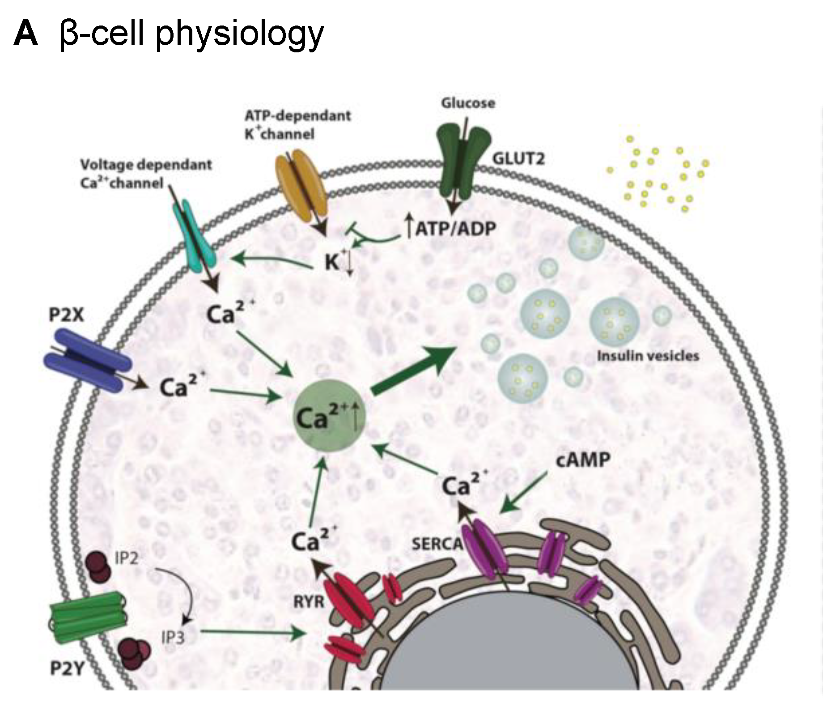
Figure 1: Insulin secretion by a pancreatic β-cell
Source: panel A of Figure 1 in Galicia-García et al. (2020)

Insulin lowers blood glucose in three ways. It moves GLUT4 transporters to the membranes of muscle and fat cells to increase glucose uptake, promotes storage of glucose as glycogen in the liver and suppresses hepatic glucose output (Dimitriadis et al., 2021). Skeletal muscle accounts for about 80% of glucose uptake in clamp studies (Genders et al., 2020), whereas the liver disposes of over half of an ingested glucose load (Dimitriadis et al., 2021).
When glucose falls, for example during fasting, pancreatic α-cells release glucagon, which stimulates glycogenolysis and gluconeogenesis so that the liver releases glucose into the blood. Adrenaline, cortisol and growth hormone also oppose insulin (Dimitriadis et al., 2021). Normal glycaemia is therefore maintained by negative feedback between opposing hormones, as rising glucose prompts insulin release and falling glucose prompts glucagon release. This explains why glucose can be normal when fasting yet high after meals if the insulin response is delayed or blunted, a pattern a practice nurse may see in patients' records.

2.2 Cellular Energy Metabolism
Glucose taken up by cells is converted into usable energy by cellular respiration (Figure 2). In the cytoplasm, glycolysis splits glucose into two pyruvate molecules and yields a small amount of ATP. Where oxygen is available, pyruvate enters the mitochondria and is oxidised in the Krebs cycle, producing the electron carriers NADH and FADH2. These pass electrons along the electron transport chain on the inner mitochondrial membrane, with oxygen as the final electron acceptor forming water, and the proton gradient created drives ATP synthesis (Betts et al., 2022). This oxidative phosphorylation produces most cellular energy (Genders et al., 2020). Without oxygen, glycolysis continues but pyruvate is converted to lactate (Betts et al., 2022), so tissues with high energy demand, such as skeletal muscle, depend on both glucose and oxygen supply for sustained ATP production. When insulin resistance limits glucose entry, cells have less fuel for this process, so tissues may be short of energy even while blood glucose is high.
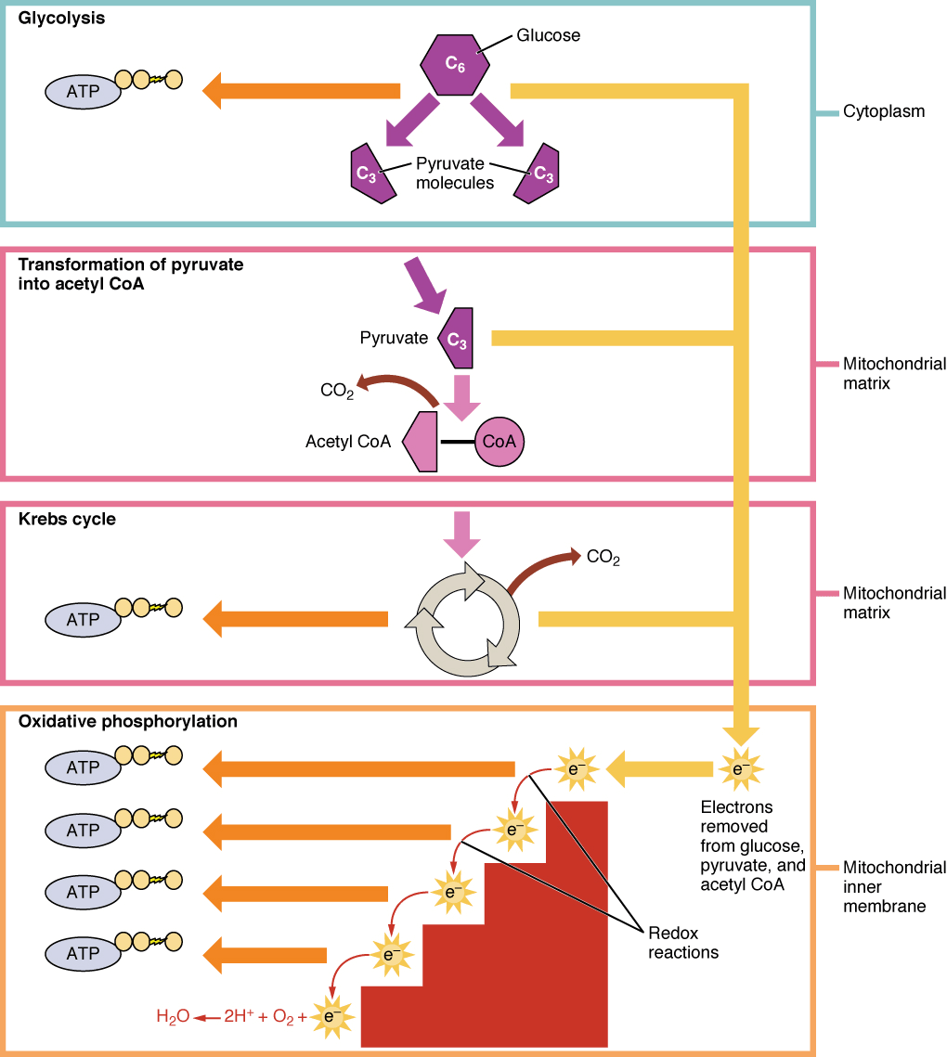
Figure 2: Cellular respiration
Source: Figure 24.4 in Betts et al., (2022)

3.0 Pathophysiology and Impact

3.1 Insulin Resistance and Impaired Glucose Regulation
In T2DM, insulin-responsive tissues respond inadequately to a given insulin concentration. In muscle, this reduces GLUT4-mediated uptake; in the liver, it fails to suppress glucose production, so glucose accumulates in the blood after meals and during fasting (Galicia-García et al., 2020). Altered skeletal muscle mitochondria have been implicated, although whether they cause or follow insulin resistance remains unresolved (Genders et al., 2020).
Initially, β-cells compensate by secreting more insulin, so glucose stays near normal. Over time this compensation fails (Figure 3). Histological studies report 30–65% lower β-cell mass in T2DM, with the decline beginning in prediabetes, and pancreatic fat has been linked to β-cell dysfunction (Inaishi and Saisho, 2020). Insulin secretion then falls below the body's demand and persistent hyperglycaemia follows. Because the defect is progressive, treatment usually has to be reviewed and intensified over time (NICE, 2026), which is why early recognition in primary care is valuable. Fasting hyperglycaemia mainly reflects excess hepatic glucose output, whereas post-meal hyperglycaemia reflects poor uptake in muscle, so both parts of the day are affected. The Welsh Quality Statement estimates that about 350,000 people in Wales are at high risk of developing the condition (Welsh Government, 2026).
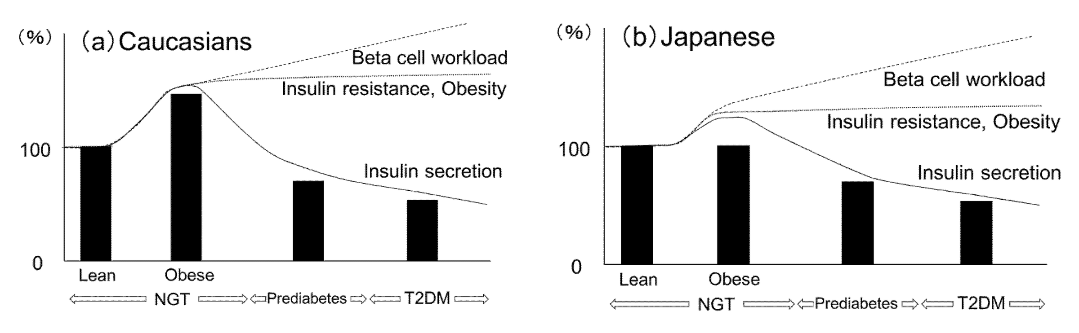
Figure 3. Changes in β-cell workload, insulin secretion and β-cell mass from obesity to prediabetes and T2DM
Source: Figure 2 in Inaishi and Saisho (2020)

3.2 Physiological Impact and Lifestyle Factors
Sustained hyperglycaemia damages the walls of blood vessels and peripheral nerves. In a Swedish register study of patients with T2DM, the risks of death, myocardial infarction, stroke and heart failure rose as HbA1c and other risk factors moved outside their target ranges, whereas patients meeting all five targets (HbA1c, blood pressure, LDL cholesterol, albuminuria and non-smoking) had little or no excess risk of death, myocardial infarction or stroke compared with the general population (Rawshani et al., 2018). Because early disease is often silent, an estimated 65,000 people in Wales remain undiagnosed (Welsh Government, 2026). The cost to services is substantial, as each hospital spell for a person with diabetes costs about £4,518 and £105 million was spent on diabetes medicines in Wales in 2022/23 (Welsh Government, 2026).
Lifestyle factors such as excess body fat, including fat deposited in the pancreas, are associated with impaired β-cell function (Inaishi and Saisho, 2020), while physical inactivity removes a major stimulus for glucose uptake into muscle (Galicia-García et al., 2020). In Wales, obesity and inactivity are most common in the most deprived areas (Public Health Wales, 2023), so risk is unevenly distributed. In UK Biobank (n = 93,722), current smokers had a hazard ratio of 1.73 for developing T2DM compared with never smokers, and 38.3% of the excess risk was mediated by a smoking-related metabolic signature, suggesting that smoking harms glucose metabolism directly (Wei et al., 2024).

4.0 Blood Glucose Monitoring and Data Use

4.1 Methods of Blood Glucose Monitoring
Two types of measurement are used. Capillary testing with a meter, or a continuous glucose monitor (CGM), shows glucose at a point in time or across the day, and CGM adds metrics such as time in range (Battelino et al., 2019). Readings vary with meals, activity and medicine timing, so a single value needs context. HbA1c, measured from a blood sample, reflects average glucose over the previous two to three months (Battelino et al., 2019). NICE (2026) advises HbA1c every three to six months until stable, then six-monthly, and recommends against routine capillary self-monitoring unless a person takes insulin, has hypoglycaemic episodes, has driving-related risk or is pregnant.

4.2 Importance of Recording and Interpreting Data
Data are useful only when read against an individual target. NICE (2026) sets 48 mmol/mol for people managed by lifestyle or non-hypoglycaemic medicines and 53 mmol/mol for those on medicines that risk hypoglycaemia, with intensification advised at 58 mmol/mol. A rising HbA1c over consecutive reviews signals that treatment or self-management is insufficient, whereas a stable value supports continuing the current plan.
HbA1c and individual readings answer different questions. HbA1c summarises the average but misses excursions and variability, and anaemia, haemoglobinopathy, iron deficiency or pregnancy can distort it (Battelino et al., 2019). It can also miss hypoglycaemia in people taking sulphonylureas (Holmes-Truscott et al., 2023), which is why monitoring needs differ by medication. In people not using insulin, structured self-monitoring, where readings are recorded and acted upon, lowered HbA1c by 0.29%, although study quality was low (Holmes-Truscott et al., 2023).
Routine records also evaluate services. In Wales, 4% of people offered the All Wales Diabetes Prevention Programme had HbA1c in the diabetes range at 12 months, against 26% of a comparison group, although the comparison was historical and unadjusted (Bailey et al., 2026).

5.0 Evidence-Based Lifestyle Recommendations

5.1 Dietary Modifications
Weight loss is the central dietary aim for patients with overweight. In the DiRECT trial, a primary-care-led programme of total diet replacement (825–853 kcal/day for 12–20 weeks) followed by food reintroduction achieved remission in 36% of participants at 24 months, against 3% of controls (Lean et al., 2019). Because pancreatic fat is linked to β-cell dysfunction (Inaishi and Saisho, 2020), losing weight plausibly restores insulin secretion and sensitivity. DiRECT enrolled adults aged 20–65 with under six years of diabetes, who were not taking insulin, so it will not suit every patient; the Welsh Quality Statement expects a remission pathway to be available (Welsh Government, 2026).
The evidence on carbohydrate restriction is contested. An umbrella review found low-carbohydrate diets no better than higher-carbohydrate diets for weight loss (Churuangsuk et al., 2022), whereas a narrative review concluded they are as effective or better for glycaemic control and medicine reduction (Wheatley et al., 2021). Patients taking SGLT2 inhibitors should not start a very low carbohydrate diet without discussion, because of ketoacidosis risk (NICE, 2026).

5.2 Physical Activity and Exercise
Muscle contraction increases glucose uptake, which helps to offset insulin resistance (Galicia-García et al., 2020). A network meta-analysis of 37 trials found that supervised aerobic and supervised resistance exercise each lowered HbA1c by 0.30% compared with no exercise (Pan et al., 2018). The UK Chief Medical Officers (2026) recommend at least 150 minutes of moderate or 75 minutes of vigorous activity weekly, plus muscle strengthening on at least two days, and note that benefits outweigh risks in long-term conditions and that risk falls even below 150 minutes.
Practical delivery matters. In Conwy, a diabetes technician signposted adults with prediabetes to the National Exercise Referral Scheme, but only 24 of 54 participants remained at eight weeks (Skinner et al., 2023), so nurses should agree achievable goals and follow up attendance.

5.3 Smoking Cessation
Smoking raises the risk of developing T2DM partly through metabolic changes (Wei et al., 2024), so stopping removes an independent and modifiable risk. Among adults with T2DM, recent quitters had a lower risk of cardiovascular disease (hazard ratio 0.83) and long-term quitters lower still (0.72) than current smokers (Liu et al., 2020). Weight gain after quitting reduced the cardiovascular benefit but not the mortality benefit (Liu et al., 2020), so concern about weight should not deter referral. NHS Wales services treated 17,763 smokers in 2024/25, and 18.03% were CO-validated as quit at four weeks (Welsh Government, 2025), so nurses can offer referral while setting realistic expectations.

6.0 Conclusion
This report has shown that T2DM arises when the regulatory systems described in Section 2 fail. Under normal conditions, insulin and glucagon keep blood glucose within a narrow range, and cells use glucose and oxygen to produce ATP. In T2DM, tissues become resistant to insulin and β-cells can no longer compensate, so glucose accumulates and the consequences develop progressively across the body. Obesity, inactivity and smoking contribute to these processes, which is why they are legitimate targets for intervention.
Monitoring translates this physiology into practice. HbA1c shows long-term control, whereas individual readings reveal variability and hypoglycaemia, so neither is sufficient alone and monitoring should be matched to each patient's medication and risk. Recorded data allow nurses and patients to judge whether treatment is working and when to intensify it.
The lifestyle evidence reviewed offers realistic options for a GP surgery, namely supported weight loss, regular and supervised activity, and referral to smoking cessation services. Each has a physiological rationale, although the strength of the evidence varies, some trials involved selected populations that may not match every patient, and some findings come from observational studies.
Practice nurses are well placed to educate patients, interpret monitoring data and signpost them to available services. Doing so supports patients to manage a progressive condition and may help the surgery respond to the growing number of people living with diabetes.

Reference List
Bailey, J., Grey, C.N.B., Davies, A.R., Mugweni, E., Carman, H., Cheung, W.Y. and Luzio, S. (2026) Findings from the outcome evaluation of the All-Wales Diabetes Prevention Programme. Cardiff: Public Health Wales NHS Trust. Available at: https://phw.nhs.wales/reports/findings-from-the-outcome-evaluation-of-the-all-wales-diabetes-prevention-programme/ (Accessed: 19 October 2026).
Battelino, T., Danne, T., Bergenstal, R.M., Amiel, S.A., Beck, R.W., Biester, T. et al. (2019) 'Clinical targets for continuous glucose monitoring data interpretation: recommendations from the International Consensus on Time in Range', Diabetes Care, 42(8), pp. 1593–1603. doi: 10.2337/dci19-0028.
Betts, J.G., Young, K.A., Wise, J.A., Johnson, E., Poe, B., Kruse, D.H., Korol, O., Johnson, J.E., Womble, M. and DeSaix, P. (2022) Anatomy and physiology 2e. Houston: OpenStax. Section 24.2 'Carbohydrate metabolism'. Available at: https://openstax.org/books/anatomy-and-physiology-2e/pages/24-2-carbohydrate-metabolism (Accessed: 19 October 2026).
Churuangsuk, C., Hall, J., Reynolds, A.N., Griffin, S.J., Combet, E. and Lean, M.E.J. (2022) 'Diets for weight management in adults with type 2 diabetes: an umbrella review of published meta-analyses and systematic review of trials of diets for diabetes remission', Diabetologia, 65(1), pp. 14–36. doi: 10.1007/s00125-021-05577-2.
Dimitriadis, G., Maratou, E., Kountouri, A., Board, M. and Lambadiari, V. (2021) 'Regulation of postabsorptive and postprandial glucose metabolism by insulin-dependent and insulin-independent mechanisms: an integrative approach', Nutrients, 13(1), article 159. doi: 10.3390/nu13010159.
Galicia-García, U., Benito-Vicente, A., Jebari-Benslaiman, S., Larrea, A., Siddiqi, H.F., Uribe, K.B., Ostolaza, H. and Martín, C. (2020) 'Pathophysiology of type 2 diabetes mellitus', International Journal of Molecular Sciences, 21(17), article 6275. doi: 10.3390/ijms21176275.
Genders, A.J., Holloway, G.P. and Bishop, D.J. (2020) 'Are alterations in skeletal muscle mitochondria a cause or consequence of insulin resistance?', International Journal of Molecular Sciences, 21(18), article 6948. doi: 10.3390/ijms21186948.
Holmes-Truscott, E., Baptista, S.N., Ling, M., Collins, E.G., Ekinci, E., Furler, J., Hagger, V.L., Manski-Nankervis, J.E., Wells, C. and Speight, J. (2023) 'The impact of structured self-monitoring of blood glucose on clinical, behavioral, and psychosocial outcomes among adults with non-insulin-treated type 2 diabetes: a systematic review and meta-analysis', Frontiers in Clinical Diabetes and Healthcare, 4, article 1177030. doi: 10.3389/fcdhc.2023.1177030.
Inaishi, J. and Saisho, Y. (2020) 'Beta-cell mass in obesity and type 2 diabetes, and its relation to pancreas fat: a mini-review', Nutrients, 12(12), article 3846. doi: 10.3390/nu12123846.
Lean, M.E.J., Leslie, W.S., Barnes, A.C., Brosnahan, N., Thom, G., McCombie, L. et al. (2019) 'Durability of a primary care-led weight-management intervention for remission of type 2 diabetes: 2-year results of the DiRECT open-label, cluster-randomised trial', The Lancet Diabetes & Endocrinology, 7(5), pp. 344–355. doi: 10.1016/S2213-8587(19)30068-3.
Liu, G., Hu, Y., Zong, G., Pan, A., Manson, J.E., Rexrode, K.M. et al. (2020) 'Smoking cessation and weight change in relation to cardiovascular disease incidence and mortality in people with type 2 diabetes: a population-based cohort study', The Lancet Diabetes & Endocrinology, 8(2), pp. 125–133. doi: 10.1016/S2213-8587(19)30413-9.
National Institute for Health and Care Excellence (2026) Type 2 diabetes in adults: management (NG28). Last updated 18 February 2026. Available at: https://www.nice.org.uk/guidance/ng28 (Accessed: 19 October 2026).
Pan, B., Ge, L., Xun, Y., Chen, Y., Gao, C., Han, X. et al. (2018) 'Exercise training modalities in patients with type 2 diabetes mellitus: a systematic review and network meta-analysis', International Journal of Behavioral Nutrition and Physical Activity, 15(1), article 72. doi: 10.1186/s12966-018-0703-3.
Public Health Wales (2023) Diabetes prevalence, trends, risk factors, and 10-year projection. Published 14 November 2023. Available at: https://phw.nhs.wales/reports/diabetes-prevalence-trends-risk-factors-and-10-year-projection/ (Accessed: 19 October 2026).
Public Health Wales (2026) Wales' diabetes crisis is growing faster than predicted – but it doesn't have to. 29 May 2026. Available at: https://phw.nhs.wales/2026/05/29/wales-diabetes-crisis-is-growing-faster-than-predicted-but-it-doesnt-have-to/ (Accessed: 19 October 2026).
Rawshani, A., Rawshani, A., Franzén, S., Sattar, N., Eliasson, B., Svensson, A.-M., Zethelius, B., Miftaraj, M., McGuire, D.K., Rosengren, A. and Gudbjörnsdottir, S. (2018) 'Risk factors, mortality, and cardiovascular outcomes in patients with type 2 diabetes', New England Journal of Medicine, 379(7), pp. 633–644. doi: 10.1056/NEJMoa1800256.
Skinner, A., Hartfiel, N., Lynch, M., Jones, A.W. and Edwards, R.T. (2023) 'Social return on investment of social prescribing via a diabetes technician for preventing type 2 diabetes progression', International Journal of Environmental Research and Public Health, 20(12), article 6074. doi: 10.3390/ijerph20126074.
UK Chief Medical Officers (2026) UK Chief Medical Officers' physical activity guidelines. London: Department of Health and Social Care. Updated 10 July 2026. Available at: https://www.gov.uk/government/publications/physical-activity-guidelines-uk-chief-medical-officers-report/uk-chief-medical-officers-physical-activity-guidelines (Accessed: 19 October 2026).
Wei, Y., Hägg, S., Mak, J.K.L., Tuomilehto, J., Zhan, Y. and Carlsson, S. (2024) 'Metabolic profiling of smoking, associations with type 2 diabetes and interaction with genetic susceptibility', European Journal of Epidemiology, 39(6), pp. 667–678. doi: 10.1007/s10654-024-01117-5.
Welsh Government (2025) NHS smoking cessation services: January to March 2025. Available at: https://www.gov.wales/nhs-smoking-cessation-services-january-march-2025-html (Accessed: 19 October 2026).
Welsh Government (2026) Quality statement for diabetes. First published 13 June 2023; last updated 3 February 2026. Available at: https://www.gov.wales/quality-statement-diabetes-html (Accessed: 19 October 2026).
Wheatley, S.D., Deakin, T., Arjomandkhah, N., Hollinrake, P.B. and Reeves, T.E. (2021) 'Low carbohydrate dietary approaches for people with type 2 diabetes – a narrative review', Frontiers in Nutrition, 8, article 687658. doi: 10.3389/fnut.2021.687658.

