Pamela Kotseva (2405343)
2405343@student.uwtsd.ac.uk

Abstract
What are the challenges and opportunities for students in the digital era, and how can adapt to succeed?
Lecturer: Scott James
Certificate of higher education in employability skills
Level 4

Academic skills for the digital era
Assignment title: Evidence of learning (E-portfolio)

Lecturer: Scott James

AI Statement

I confirm that I have not presented any AI generated materials as my own work.
I confirm that I have copies of my drafts, notes, and other resources I used, which I may be asked to provide in evidence.

Table of Contents
AI Statement 1
Section 1 – Research and Planning 3
1.1 Introduction. 3
1.2 Source exploration 3
1.3 Key Challenges for Students in the era of digital learning 3
1.4 Key benefits 3
1.5 Plan for the report 3
Section 2 – Answering the Question 3
2.1 Introduction 3
2.2 Challenges Faced by Students, 3
2.3 Opportunities Digital Tools Provide 3
2.4 How Students Can Adapt 4
2.5 Conclusion 5
3.0 Reflective Presentation 6
4.0 Reference List 10

Section 1 – Research and Planning

1.1 Introduction.
In this component of the work the author will explore the main question posed in this work as per the title. The author will choose a credible source that they will cite in this work and describe the challenges and opportunities that learning in the digital era can bring. Furthermore, they will plan for the creation of their report that will be written further in this work. Finally, the author will include a timetable for completing all their academic work.
  - Source exploration
For the purpose of this report the author is required to use a credible source for the answering of the above-mentioned question. They will be using the work of Mamdouh Alenzi (2023) called “Digital Learning and Digital Institution in Higher Education”. The author has chosen this source as it has passed the CRAAP test, (Van Kampen, 2023) namely:
- Currency – the article was submitted in late 2022 and was approved in early 2023 which makes it current and relevant for the time period.
- Relevance – the work explores how digital learning impacts both students and learning institutions and describes potential challenges and opportunities that it would bring.
- Authority – the topic was submitted in a reputable website and has been reviewed by moderators. Furthermore, the article has been cited in many other works.
- Accuracy – the work appears to be relevant to the topic and the understandings of the author with respect to the topic
- Purpose – the work appears to have no other purpose than to inform the reader of the potential benefits and possible downfalls of learning in the digital era. The author could not find any signs that the creator of the article has tried to advertise or sell any products.
The author has found this source by using “Google Scholar” which is widely considered as a reliable source of information (Cypris, 2023). They also believe that the topic is relevant and adequate for answering the question posed in this work.
  - Key Challenges for Students in the era of digital learning
In this part of the report the author will explain the main challenge that students face when learning in the digital era. They will mainly use their own experience so far to identify this challenge.
The main challenge that the author has faced so far in their studies if the technical side of using the software necessary for their course. This includes but is not limited to MS Word, PowerPoint, Excel, Outlook, Student Hwb, Turnitin, and Moodle. Since the author has grown up in the 90s of the last century when informational technology was not widely used, they find it hard to efficiently uses the software mentioned above. While the author acknowledges the benefits of using the applications they find it hard to use them. They plan on taking special measures and courses to improve their efficiency in the use of the software.

  - Key benefits
The biggest benefit that the author has identified when it comes to learning in the digital era is the ease of accessing information. The referenced article also acknowledges how easy it is to access information outside of libraries and universities. It also acknowledges the reduced costs and increased output of the staff that provides learning for the students (Astria Learning, 2024).

  - Plan for the report
Following this section of the report, the author will outline a plan for the making of their report. The general structure that the report will follow is Introduction-challenges-opportunities-solutions-conclusion. The main issue that the author will focus on is Digital Literacy and the use of the required software. They will also touch on the opportunities for the students. The main challenges that the author will investigate is the use of MS Word’s features and the creation of PowerPoint presentations. Following is an approximate timeline for the completion of Component 2:
Task | Deadline
Finish Research | By 10th of November
Draft Section 1 | By 14th of November
Complete first draft | By 15th of November
Final Edits | Until 20th of November

Section 2 – Answering the Question

2.1 Introduction
Nowadays digital learning is becoming increasingly prevalent in our society (Clark, 2024). The Florida virtual school suggests that virtual learning is a type of learning that facilitates the usage of IT in order to enable or support the students to have control over the time, place, path, and pace of their learning (Florida Virtual School, 2016). This is made possible by the use of the internet that provides access to plethora of resources at different times and at different places. Although digital learning provides many benefits it also comes with its potential cons and downfalls (Stecuła and Wolniak, 2022). This report will explore some of the benefits that digital students can receive from digital learning but will also explore some of the potential challenges that they might face.

2.2 Challenges Faced by Students,
In this section of the report the author will identify the one of the biggest challenges that students face when it comes to digital learning. In the author’s opinion this is the lack of knowledge and understanding of using the digital platforms and software and the limited access to appropriate hardware.
According to DynDevice TMS (2024) the lack of digital skills can lead to barriers and missed opportunities not only in the field of learning but also in our everyday life such as banking, communication, access to information etc. especially in the younger generation (Gen Z) (Graduate Recruitment Team, 2024) suggests that even though gen Z is more comfortable with using digital platforms, they are unable to perform basic tasks beyond the use of social platforms and especially when it comes to the workplace or education digital literacy (Shaima, 2025). This digital illiteracy is especially relevant when it comes to identifying false information from real one online. This is made significantly harder nowadays as software as Sora, ChatGPT, AI platforms are making it harder to distinguish reality from AI generated information.
Another challenge for the students in the 21st century is the ongoing cost of living crisis that restricts more and more students from acquiring the necessary technology for digital learning (i.e. laptops, tablets, smartphones). This is somehow addressed however through some university programmes that support students in acquiring said hardware such as bursaries (Uwtsd.ac.uk, 2025).

2.3 Opportunities Digital Tools Provide
In this section of the report the author will identify the biggest opportunity that students can take advantage of when in comes to digital learning. In their opinion this would be the ease of access to information. With only basic digital literacy the students could have access to numerous resources and opportunities for learning and development (www.northumbria.ac.uk, 2023).
The prerequisites for accessing these resources are the access to a suitable hardware such as a laptop or a smart phone and basic knowledge of search engines and MS Word, PowerPoint and Excel (Ferrier, 2023). Such opportunities include but are not limited to certificates (such as food hygiene, COSHH, Accounting, use of specific software etc.), degrees (even in higher education) Strong digital skills allow them to avoid being victims of phishing, fake information, and identity theft among others (Milk Education, 2024).

2.4 How Students Can Adapt
In this section of the report the author will identify three strategies that could help a student adapt in the digital learning era. They will be followed by an explanation and justification of why they would work and make a difference.
- Taking a course in the MS Office Package – the MS Office Package is a collection of different applications designed to support one in performing various work. Some of the more prevalent applications in this package are: MS Word (for text editing), MS PowerPoint (for creating presentations), MS Outlook (for managing e-mails), MS Teams (for creating virtual meetings), MS Excel (for data analysis). According to Future Connect Training (2024), proficiency in the use of this software package is essential for better employment prospects and enabling one to pursue better education. This is further backed up by Greenwood (2023) who also adds that MS Office knowledge increases work productivity. Courses in the use of MS Office are available for free on the official LinkedIn website (LinkedIn.com, 2025). However, according to the Savannah technical College (2020) basic knowledge in MS Office does not make one stand out anymore as more employers are requiring basic knowledge as a prerequisite.

- Familiarize oneself in basic online safety.

- Taking a course in recognising AI generated and fake content – as artificial intelligence is becoming more widely used, one must learn to recognize or at least fact check the information that it provides. Professor Nathalie Jabkowicz suggests that AI systems are not normally checked for accuracy and often the information even lacks common sense (Housman, 2025). This could easily lead to people online spreading misinformation and outright lies. East Central College (2023) investigated automatic AI recognition tools but concluded that they can often be unreliable when detecting AI text and imagery. They instead suggest that one looks for telltale signs that something might have been generated by AI. Some of these signs are looking out for excessive repetitions, check the referenced work used, look out for inaccurate data, and look out for sentences that lack common sense. The use of digital software for identifying AI generated content in conjunction with the above-mentioned signs are the best approach to unmask AI content.

2.5 Conclusion
Nowadays the use of digital materials is important and unavoidable, and everyone should do their best to take advantage of it but also stay safe when interacting with it. Digital learning and digital literacy in general provide one with enormous opportunities for development and success.
In conclusion the author would like to say that digital learning and digital skills in general are an extremely valuable tool in the arsenal of a modern student, but caution must always be taken when interacting with both people and information online.

3.0 Reflective Presentation
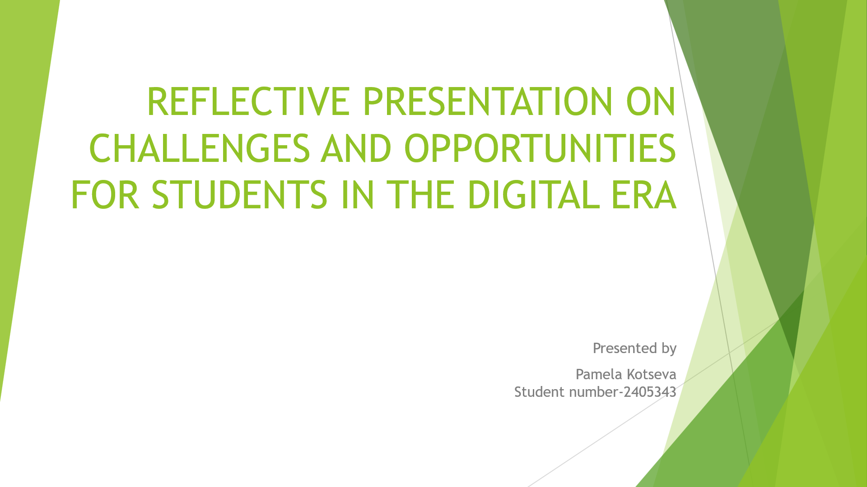
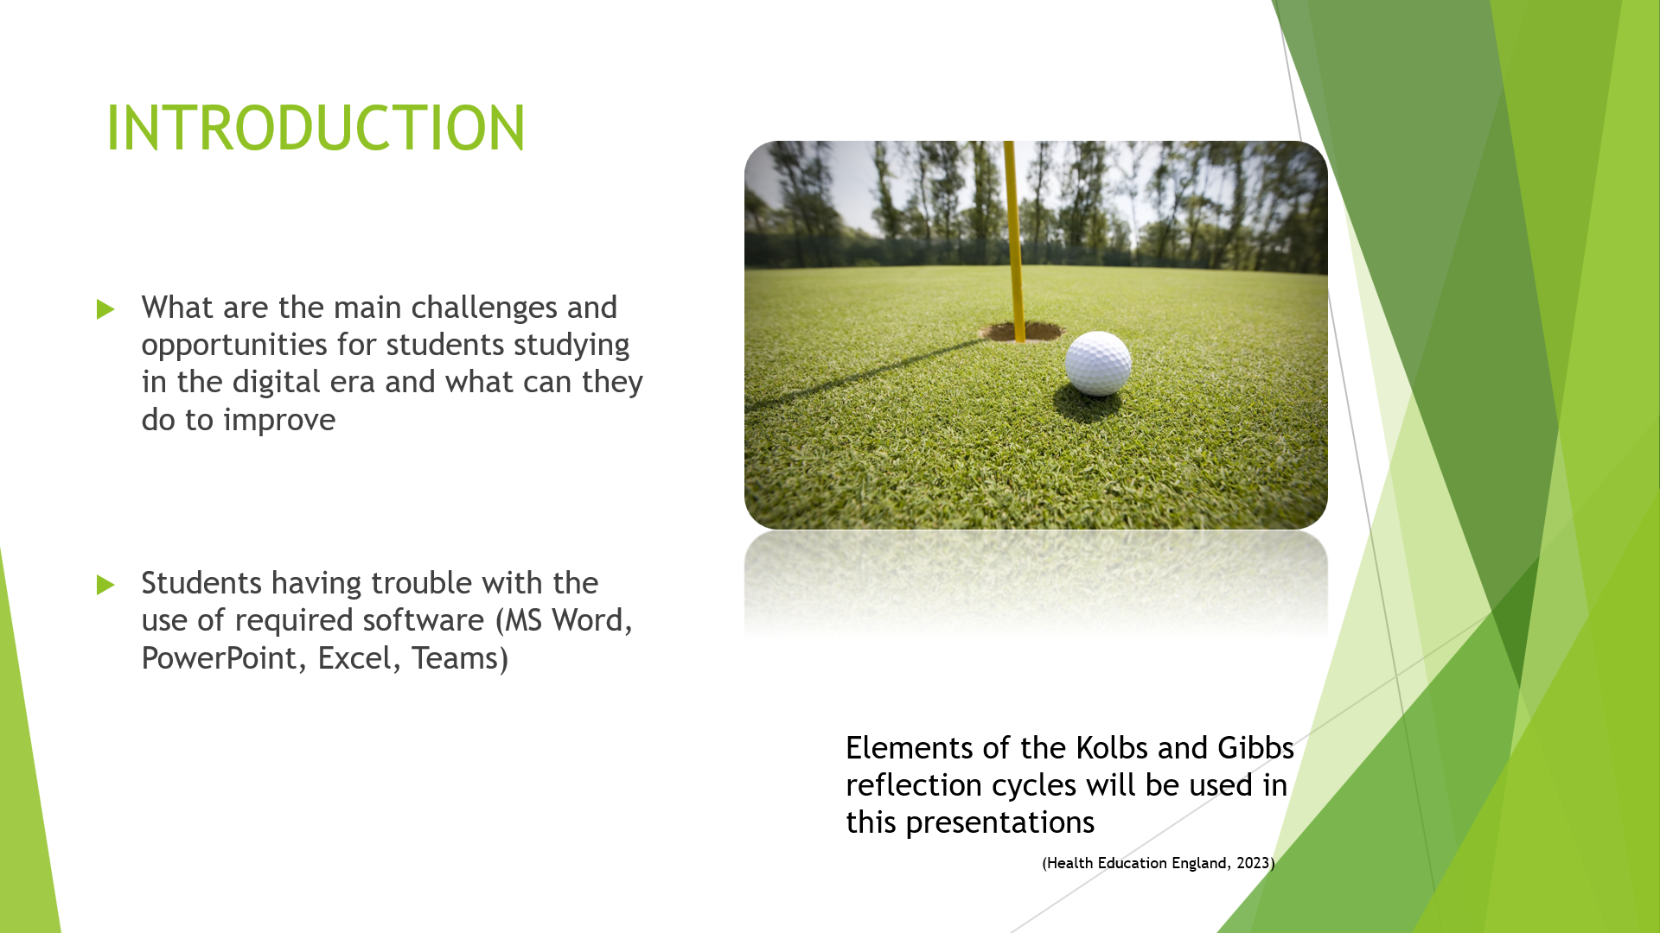
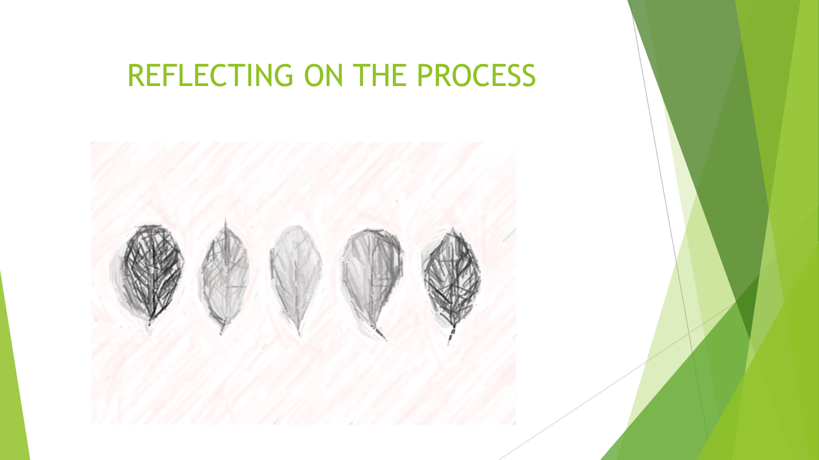
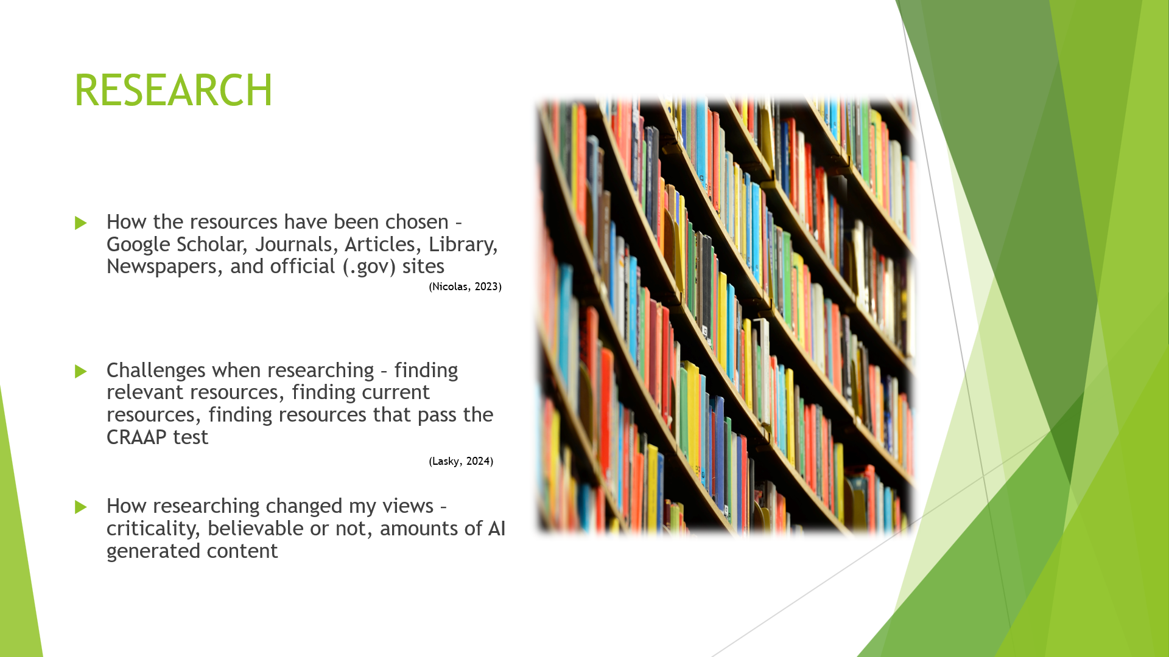
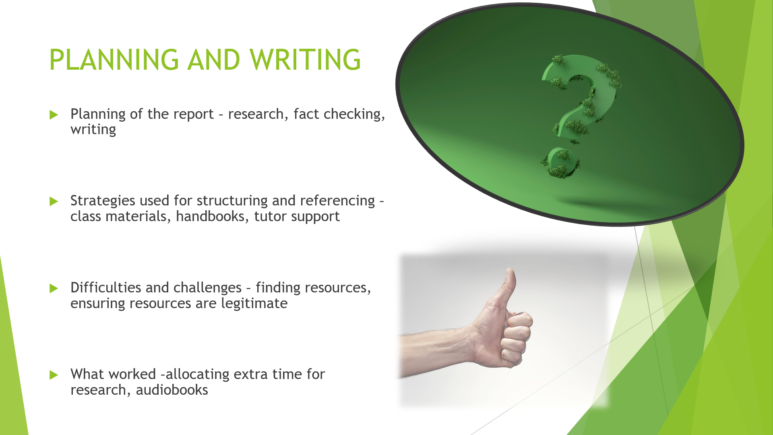
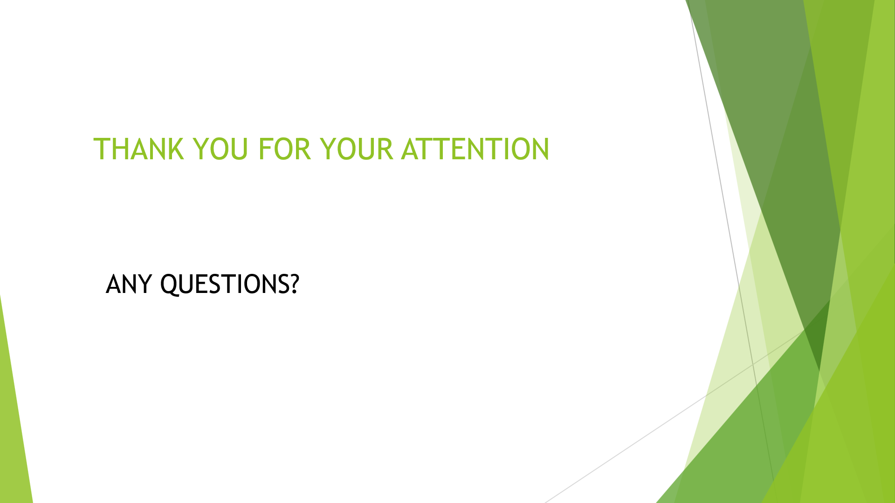
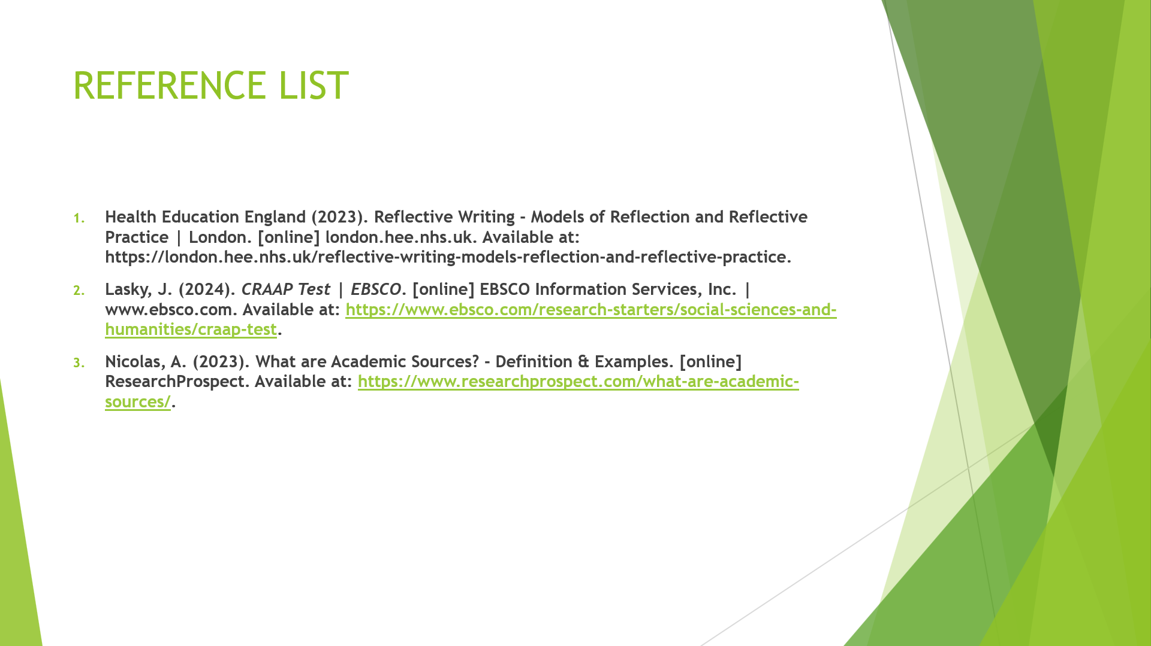

4.0 Reference List

- Alenezi, M. (2023). Digital Learning and Digital Institution in Higher Education. Education Sciences, [online] 13(1), p.88. Available at: https://www.mdpi.com/2227-7102/13/1/88.
- Astria Learning - E-Learning Solutions for Higher Education. (2024). Advantages And Disadvantages of Digital Libraries in Education. [online] Available at: https://astrialearning.com/blogs/blog/advantages-and-disadvantages-of-digital-libraries-in-education/.
- Clark, D. (2024). Topic: Digital learning in the UK. [online] Statista. Available at: https://www.statista.com/topics/8518/digital-learning-in-the-uk/.
- Crabtree, M. and Goodman, R. (2023). Digital Banking Statistics: UK Trends & Predictions For 2024. [online] www.comparebanks.co.uk. Available at: https://www.comparebanks.co.uk/resources/digital-banking-statistics/.
- Cypris (2023). How Reliable is Google Scholar for Research? | Cypris. [online] www.cypris.ai. Available at: https://www.cypris.ai/insights/how-reliable-is-google-scholar-for-research.
- Drennan, L. (2020). The Importance of Staying Safe Online- Aspire. [online] www.aspirepeople.co.uk. Available at: https://www.aspirepeople.co.uk/blog/2020/02/staying-safe-online?source=google.com.
- DynDevice TMS (2024). What is computer illiteracy? [online] Dyndevice.com. Available at: https://www.dyndevice.com/en/news/what-is-computer-illiteracy-ELN-2198/.
- East Central College (2023). Detecting AI-Generated Text: 12 Things to Watch For - Faculty Resources for Educational Excellence. [online] Faculty Resources for Educational Excellence. Available at: https://www.eastcentral.edu/free/ai-faculty-resources/detecting-ai-generated-text/.
- ‌Ferrier, G. (2023). A guide to digital learning | Xello Blog. [online] Xello. Available at: https://xello.world/en-gb/resources/blog-posts/digital-learning/ [Accessed 7 Nov. 2025].
- Future Connect Training (2024). Benefits of Pursuing Professional MS Office Training. [online] Future Connect Training. Available at: https://www.fctraining.org/benefits-of-microsoft-office-training.php.
- Greenwood, W. (2023). Reasons Why You Need to Know Microsoft Office as a Professional | Priority Management. [online] Priority Management. Available at: https://www.prioritymanagement.com.au/reasons-why-you-need-to-know-microsoft-office-as-a-professional/.
- Housman, P. (2025). american.edu. [online] American University. Available at: https://www.american.edu/cas/news/responsible-artificial-intelligence.cfm.
- LinkedIn. (2025). Microsoft Office Online Training Courses | LinkedIn Learning, formerly Lynda.com. [online] Available at: https://www.linkedin.com/learning/topics/microsoft-office.
- Lloydsbank.com. (2025). Buying online scams. [online] Available at: https://www.lloydsbank.com/help-guidance/protecting-yourself-from-fraud/buying-online-scams.html [Accessed 11 Nov. 2025].
- ‌Milk Education (2024). The Importance of Online Safety Education - Milk Education | Supply Agency. [online] Milk Education | Supply Agency - Education Recruitment Specialists for Schools and Nurseries in the North West. Available at: https://www.milk-education.co.uk/the-importance-of-online-safety-education/.
- savannah technical college. (2020). Three Reasons You Must Know Microsoft Office in the Workplace. [online] Available at: https://www.savannahtech.edu/continuing-ed-three-reasons-you-must-know-microsoft-office-in-the-workplace/.
- Shaima, H. (2025). Gen Z in the Flow of Technology: A Study on Addiction, Creativity, and Digital Literacy. [online] youthbreaktheboundaries.com/. Available at: https://youthbreaktheboundaries.com/gen-z-in-the-flow-of-technology-a-study-on-addiction-creativity-and-digital-literacy/#:~:text=The%20Ongoing%20Challenge%20of%20Digital,content%20you%20encounter%20every%20day. [Accessed 7 Nov. 2025].
- Statista (2024). Online banking usage in Great Britain from 2007 to 2022. [online] Statista. Available at: https://www.statista.com/statistics/286273/internet-banking-penetration-in-great-britain/.
- Stecuła, K. and Wolniak, R. (2022). Advantages and Disadvantages of E-Learning Innovations during COVID-19 Pandemic in Higher Education in Poland. Journal of Open Innovation: Technology, Market, and Complexity, 8(3), p.159. doi:https://doi.org/10.3390/joitmc8030159.
- Team, G.R. (2024). Addressing the Gen Z skills gap. [online] FDM Group. Available at: https://www.fdmgroup.com/news-insights/gen-z-skills-gap/.
- Uwtsd.ac.uk. (2025). myday. [online] Available at: https://hwb.uwtsd.ac.uk/pages/student/hwbcast/cymorthariannol_moneysupport/bwrsariaethau_moneysupport [Accessed 7 Nov. 2025].
- Van Kampen, K. (2023). Library guides: Evaluating resources and misinformation: CRAAP test. [online] UChicago Library. Available at: https://guides.lib.uchicago.edu/c.php?g=1241077&p=9082343.
- www.northumbria.ac.uk. (2023). The Future of Education: Five of the Biggest Benefits of Online Learning. [online] Available at: https://www.northumbria.ac.uk/distance-learning/distance-learning-blog/five-benefits-of-online-learning/.
‌

