Name student: Mariana Cocos
Student Number: 2024061
Module Title: Assessment 1- Essay LCBB6002

International Financial Management

Coca-Cola Corporation

Table of Contents
Introduction 3
The dividend distribution policy of Coca Cola 3
The analysis of the efficient market hypothesis theory 4
The corporate methods of appraising projects 6
Conclusion 7
Bibliography 8

Figure 1. Dividend Yield vs Market. Source: Stock Report, 2023 3
Figure 2. Efficient Market Hypothesis. Source: (Kumar Srivastav, 2023) 5

Introduction

Coca-Cola is a multinational corporation that produces carbonated soft drinks and distributes them worldwide. Over the years it has registered a significant growth despite Covid-19 challenges. According to Coca Cola annual report (2021) it has marked 119th year in business and generated record revenue which demonstrated effective leadership and financial management.
The purpose of this report is to reiterate the importance of continuous effective financial management to the Coca-Cola corporation. The objectives are to analyse and evaluate the dividend distribution policy, analyse the efficient market hypothesis theory in the context of the multinational corporation’s operations and critically analyse and evaluate corporation’s methods of appraising projects.

The dividend distribution policy of Coca Cola

Dividend distribution is a sign of sustainable development of an organisation. Coca-Cola is quite successful in paying dividends to its shareholders, therefore gaining trust in the company, and attracting even more investors. A relevant dividend policy plays a crucial role in the company financial health, it is about deciding the proportion of profits to be distributed (Arnold & Lewis , 2019). For example, paying too much from profits may hamper the growth of the company and paying too little may give a sign of poor performance. It is important to adopt a policy that will align with company objectives and long-term goals. Coca Cola pays its shareholders quarterly. Currently the Coca-Cola dividend paying yields at 3.0% and it is well covered by earnings (Stock Report, 2023). The average yield is expected to increase in the next three years (Figure 1. Dividend Yield vs Market. Source: Stock Report, 2023)

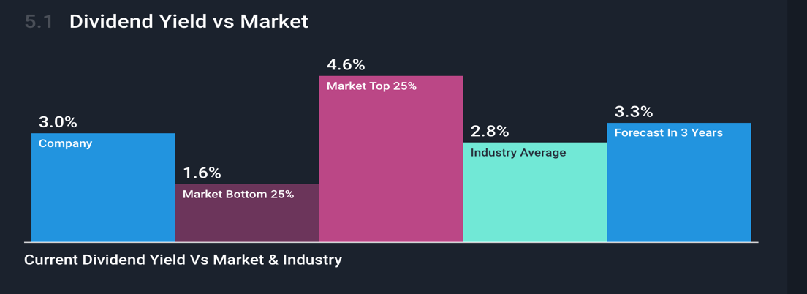
Figure 1. Dividend Yield vs Market. Source: Stock Report, 2023
An efficient distribution policy increases shareholders satisfaction and at the same time maintains a company performance. Chen (2020) suggested that weather the dividend policy is stable, constant, or residual it shows financial health even if companies are not required to pay dividends. It is important to acknowledge that each type of policy has its advantages and drawbacks, and the decision must be tailored to each company situation in collaboration with stakeholder if appropriate in order to minimise potentials risks or major damages to the organisation.
For example, in Coca-Cola case the constant policy allows shareholders to experience a full volatile of company earning, on the other hand if earning are down investors do not receive dividends (Chen, 2020). In consideration to earnings volatility, Coca Cola may meet challenges in maintaining a stable rising dividend level. According to this policy is most suitable for companies whose earnings are forecasted to remain stable in long term (Sharma, 2021, p. 168). Multiple factors must be considered in dividend policy choice among these are firm characteristics that comprise the company size, profitability, growth opportunities, maturity, equity, and many other aspects relevant in decisions making (Baker , 2009). Some scholars argue that in order to understand a company performance the efficient market hypothesis theory can be applied.

The analysis of the efficient market hypothesis theory
The efficient markets hypothesis theory is based on the assumptions that stock prices reflect information on the company value. A market is known to be “efficient” when the prices adjust quickly, without bias or dependence on new information, thus there is no reason to believe that prices are too high or too low (Clark, 2001).
As per the hypothesis, the efficient market does not provide profitable opportunities for trading. Therefore, it may be impossible to attain a consistent return in these conditions. Time is an important determinant within which the market shares data, a potential gap gives traders possibility to exploit the inefficiency (See Figure 2. Efficient Market Hypothesis. Source: (Kumar Srivastav, 2023). For example, if current price shares of Coca Cola are high but the company has difficulties in term of operations and the price is expected to decline and the investor kept its shares, the market modifies the available data, and the investors loses in price for share.
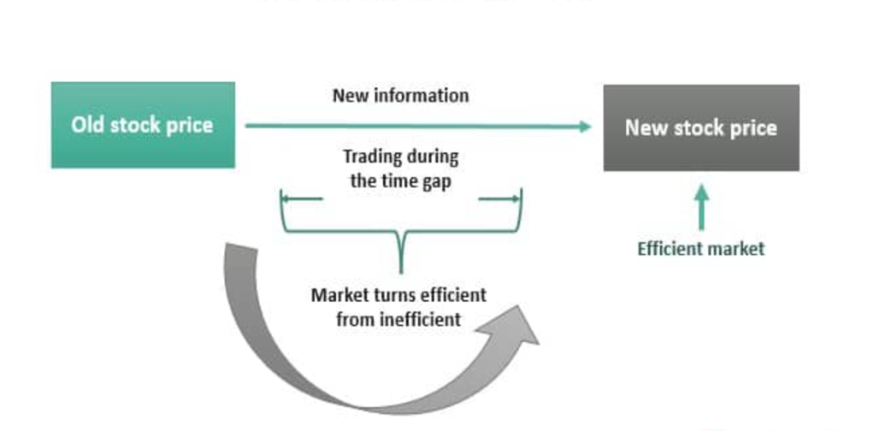
Figure 2. Efficient Market Hypothesis. Source: (Kumar Srivastav, 2023)
For example, if current price shares of Coca Cola are high but the company has difficulties and the price is expected to decline because of a project failure and the investors kept their shares, the market modifies the available data, and the investors lose in price for share. However, the theory may make sense in short term, its questionable whether the data is reliable in long term, the investors may lose money while company may face temporary challenges but in long term the share price may significantly grow. Of course, there are risks associated with and relying purely on this theory may not be enough while taking decisions.
According to Harder (2008) the theory comprises multiple forms; strong, semi-strong and weak. The strong reflects the stock prices and assumes that these prices project all relevant data on the firm, semi-strong is rather an opposite understanding, it suggests that publicly available data must be seen in the stock price. The weak form is about understanding of the stock prices as a reflection of all information which is obtained though investigations of market trading data. Clark (2001) argued that many financial believe that attempts to generate profits though study of what this hypothesis asserts is of not much value. Similarly, Downey & Scott (2021) suggest that it is of no value to look for undervalued stocks or to forecast market trends though technical analysis.
Despite controversial opinions on this matter many investors may base their arguments and decisions on financial behaviour of the company though efficient market hypothesis. The investors behaviour is not less important for the organisation particularly in the process of growth and expansion mainly because it impacts the company operations. Even if the company information is made available to them emotional factor may be overlooked. For example, when the stock declines in price it creates fear of losing money thus many could sell shares.

The corporate methods of appraising projects

As Coca Cola operates globally it must pay considerable attention to its projects to increase trust and make their project attractive to potential investment. This section investigates the company methods of appraising projects. Coca Cola has a reputation for innovation, and its success is largely due to its ability to adapt to changing consumer preferences and market trends. But it is important to acknowledge that not all projects are successful, and the company needs to have a system in place for appraising its projects to ensure that it is making informed decisions about where to invest its resources. As discussed by Tham (2010) project appraisal comprises the major components of project appraisal are financial analysis, economic analysis, and distributive analysis.
Coca Cola uses a variety of methods to appraise projects before making investment decisions. One of the methods used is the Net Present Value (NPV) technique (Hawkins, 1999), which involves calculating the present value of future cash flows generated by a project and subtracting the initial investment cost. If the resulting figure is positive, the project is deemed viable and worth investing in. The NPV method is widely used in finance and investment analysis because it considers the time value of money and allows for a more accurate assessment of a project's potential profitability (Fernando, 2022). Coca Cola also uses the Internal Rate of Return (IRR) method, which calculates the rate at which the net present value of cash flows equals zero (Corporate Institute, 2023). This method is useful for comparing projects of different sizes and investment amounts, and it can help Coca Cola determine the most efficient use of its financial resources.
Another method Coca Cola uses to appraise projects is the Payback Period technique, which is used to estimate the time required for a project to generate enough cash flows to cover its initial investment cost (Coca Cola, 2022). This method is particularly useful for shorter-term projects and provides a simple way to assess a project's potential profitability based on how quickly it can generate a return on investment (Finance Management, 2023). Coca Cola also considers other factors such as market trends, consumer preferences, and competition when appraising projects, as these can have a significant impact on a project's potential success. By using a range of different appraisal methods and considering a variety of factors, Coca Cola can make informed investment decisions and ensure that its resources are used appropriately.

Conclusion

In conclusion, continuous effective financial management is vital to the success of Coca-Cola Corporation. Coca-Cola's has a consistent and steady dividend distribution policy and it a crucial aspect of its financial management strategy, not only it provides a reliable source of income to shareholders but also contributes to the company's long-term financial stability. The corporation's methods of appraising projects, ensure that investments are sound and aligned with the company's financial goals.
In summary, Coca-Cola's continuous effective financial management is a cornerstone of its success. The corporation's dividend distribution policy, methods of apprising policy and keep investors happy all contribute to the company's financial stability and growth. By maintaining strong financial management practices, Coca-Cola is well-positioned to continue its success in the global beverage industry.

Bibliography
- Arnold, G., & Lewis, D. (2019). Corporate financial management (6th edition). Pearson Education.
- Baker, H. K. (2009). Dividends and dividend policy: History, trends, and determinants. Wiley.
- Chen, J. (2020). Dividend policy: What it is and how the 3 types of work. Investopedia. https://www.investopedia.com/terms/d/dividendpolicy.asp
- Coca Cola. (2022). Dividends for Coca-Cola Company (The) (KO). https://investors.coca-colacompany.com/stock-information/dividends
- Coca Cola. (2022). 2021 Annual Report. https://investor.cokeconsolidated.com/static-files/70870dd5-11b4-4792-a37f-9afbd0a57d7e
- Corporate Institute. (2023). Internal rate of return (IRR). https://corporatefinanceinstitute.com/resources/valuation/internal-rate-return-irr/
- Downey, L., & Scott, G. (2021). Efficient market hypothesis (EMH). Investopedia. https://www.investopedia.com/terms/e/efficientmarkethypothesis.asp#:~:text=The%20efficient%20market%20hypothesis%20(EMH)%20or%20theory%20states%20that%20share,low%2Dcost%2C%20passive%20portfolio.
- Fernando, J. (2022). Net present value (NPV): What it means and steps to calculate it. Investopedia. https://www.investopedia.com/terms/n/npv.asp
- Harder, S. (2008). The efficient market hypothesis and its application to stock markets. Grin Publishing.
- Hawkins, D. F. (1999). Coca-Cola Company. Harvard Business School Case, 100-001.
- Clarke, J. T. J. G. M. (2001). The efficient markets hypothesis. http://ww.e-m-h.org/ClJM.pdf
- Kumar Srivastav, A. (2023). Efficient market hypothesis. Wall Street Mojo. https://www.wallstreetmojo.com/efficient-market-hypothesis/
- Race, M., & Hooker, L. (2022). Which companies are pulling out of Russia? BBC News.
- Sharma, F. C. (2021). Business finance. SBPD Publications.
- Stock Report. (2023). Coca Cola dividend. Simply Wall St. https://simplywall.st/stocks/us/food-beverage-tobacco/nyse-ko/coca-cola/dividend.
- Tham, J. (2010). Assessing public expenditures: Applied project appraisal and risk management for economic development project appraisal simplified. Duke Center for International Development (DCID).

