ANALYSING THE IMPACT OF RELATIONSHIP MARKETING STRATEGIES ON BRAND LOYALTY: A CASE STUDY OF NESTLÉ COMPANY

DISSERTATION ON ANALYSING THE IMPACT OF RELATIONSHIP MARKETING STRATEGIES ON BRAND LOYALTY: A CASE STUDY OF NESTLÉ COMPANY

A case study of Nestlé.

By:

Prasanna Dhakal

Dissertation submitted to the
The University of Wales Trinity Saint David
For partial completion of an MBA in International marketing

Supervisor: Tushara Balendran


Master’s Degrees by Examination and Dissertation
Declaration Form.
1. This work has not previously been accepted in substance for any degree and is not being concurrently submitted in candidature for any degree.
Signed PRASANNA DHAKAL
Date 12/02/24

2. This dissertation is being submitted in partial fulfilment of the requirements for the degree of Master in Business Administration.
Signed PRASANNA DHAKAL
Date 12/02/24
3. This dissertation is the result of my own independent work/investigation, except where otherwise stated.
Other sources are acknowledged by footnotes giving explicit references.
A bibliography is appended.
Signed candidate: PRASANNA DHAKAL
Date: 12/02/24

4. I hereby give consent for my dissertation, if accepted, to be available for photocopying, inter- library loan, and for deposit in the University’s digital repository
Signed (candidate) PRASANNA DHAKAL
Date 12/02/24
Supervisor’s Declaration.
I am satisfied that this work is the result of the student’s own efforts.
Signed: Tushara Balendran
Date: 13/02/24

Abstract

This study intends to investigate the complex link that exists between brand loyalty with relationship marketing tactics, with a specific emphasis on Nestlé Corporation and it aims to close knowledge gaps regarding how relationship marketing supports this goal. Therefore, acknowledges how crucial it is to build brand loyalty within the cutthroat food and beverage sector perspective. The research seeks to give significant insights into educational scholarship practical applications within the business arena. by examining Nestlé's initiatives and their effect on consumer loyalties viewpoint. It is anticipated that the results will educate organisational decision-makers including impact marketing professionals. by offering practical suggestions for improving relationship marketing initiatives and building brand loyalty as well. In the end, this study advances our understanding of how relationship marketing promotes brand loyalty. It provides insights on how to improve marketing strategies and fortify customer bonds in modern corporate settings.
The results' validity as well as reliability are called into question by the study's recognised weaknesses. which include a small sample size, researcher bias, plus the lack of a mixed-method approach. In an obvious manner, there are a few suggestions made to solve these constraints perspective. It is recommended that researchers use a mixed-method approach in order to provide both quantitative as well as qualitative insights to the investigation and maintaining the integrity of the study's process requires minimising researcher bias via open, thoughtful procedures. Moreover, expanding the sample size will improve the study's statistical power as well as generalizability and the study may be made more robust and provide deeper insights into the intricate dynamics of relationship marketing including brand loyalty in the Nestlé context by putting these ideas into practice.

TABLE OF CONTENTS
Chapter 1: Introduction 9
1.1 Background of the study 9
1.2 Rationale 9
1.3 Research problem 10
1.4 Aims 10
1.5 Objectives 11
1.6 Research questions 11
1.7 Research Significance 11
1.8 Thesis Outline 12
Chapter 2: Literature Review 12
2.1 Introduction 12
2.2 Relationship Marketing 13
2.2.1 Definitions 13
2.2.2 Critical Review 13
2.2.3 Advantages and Disadvantages 14
2.3 Brand Loyalty 15
2.3.1 Definitions 15
2.3.2 Critical Review 16
2.2.3 Advantages and Disadvantages 17
2.4 Customer Engagement 18
2.4.1 Definitions 18
2.4.2 Critical Review 18
2.2.3 Advantages and Disadvantages 20
2.5 Objectives of the Study 20
2.5.1 Assessing Efficacy of Nestlé's Relationship Marketing 20
2.5.2 Influence of Customer Engagement on Brand Loyalty 21
2.5.3 Opportunities and Challenges in Implementing Relationship Marketing 22
2.6 Literature Gap 23
2.7 Models: Advantages and Disadvantages 23
2.7.1 Comparative Analysis 24
2.8 Conclusion 25
Chapter 3: Methodology 26
3.1 Introduction 26
3.2 Research Onion 26
3.3 Research Philosophy 27
3.4 Research Approach 28
3.5 Type of Investigation 28
3.6 Sampling Method 29
3.6.1 Sample type 29
3.6.2 Sample size 30
3.6.3 Sampling method 30
3.7 Data collection process 30
3.8 Data analysis technique 31
3.9 Ethical Consideration 31
3.10 Summary 32
Chapter 4: Data analysis 33
4.1 Introduction 33
4.2 Quantitative analysis 33
4.3 Conclusion 52
Chapter 5: Conclusion and Recommendation 53
5.1 Linking with objective 53
5.2 Limitation 57
5.3 Recommendation 57
5.4 Conclusion 58
Reference List 59
Appendices 70

LIST OF FIGURES
Figure 1: Thesis Outline 9
Figure 2: Brand loyalty 13
Figure 3: Customer engagement 16
Figure 4: Research Onion 23
Figure 5: How often do you participate with Nestlé's relationship marketing initiatives? 37
Figure 6: Please select your degree of agreement with this statement: "Nestlé's relationship marketing methods have favourably affected my devotion to the company. 38
Figure 7: On a scale of 1 to 5, how successful are Nestlé's relationship marketing strategies in developing consumer loyalty? 40
Figure 8: How often do you participate with Nestle's customer engagement strategies? 41
Figure 9: Please select your degree of agreement with this statement: "Nestle's consumer interaction methods significantly influence my loyalty towards the company. 43
Figure 10: On a scale of 1 to 5, how would you rank the impact of Nestle's customer engagement efforts on your brand loyalty, with 1 being "Not Influential" and 5 representing "Extremely Influential"? 45
Figure 11: What do you see as Nestle's key opportunity in adopting relationship marketing strategies? 46
Figure 12: Please indicate your agreement with the following statement: "Nestle faces challenges in adopting relationship marketing strategies. 48
Figure 13: On a scale of 1 to 5, how tough do you think Nestle's relationship marketing techniques will be to execute, with 1 being "Not Challenging" and 5 being "Extremely Challenging"? 49

LIST OF TABLES
Table 1: Correlation 32
Table 2: Model Summary 32
Table 3: ANOVA 33
Table 4: Coefficients 34
Table 5: Residuals Statistics 35
Table 6: Statistics 36
Table 7: How often do you participate in Nestlé's relationship marketing initiatives? 37
Table 8: Please select your degree of agreement with this statement: "Nestlé's relationship marketing methods have favourably affected my devotion to the company. 38
Table 9: On a scale of 1 to 5, how successful are Nestlé's relationship marketing strategies in developing consumer loyalty? 40
Table 10: How often do you participate in Nestle's customer engagement strategies? 41
Table 11: Please select your degree of agreement with this statement: "Nestle's consumer interaction methods significantly influence my loyalty towards the company. 43
Table 12: On a scale of 1 to 5, how would you rank the impact of Nestle's customer engagement efforts on your brand loyalty, with 1 being "Not Influential" and 5 representing "Extremely Influential"? 45
Table 13: What do you see as Nestle's key opportunity in adopting relationship marketing strategies? 46
Table 14: Please indicate your agreement with the following statement: "Nestle faces challenges in adopting relationship marketing strategies. 48
Table 15: On a scale of 1 to 5, how tough do you think Nestle's relationship marketing techniques will be to execute, with 1 being "Not Challenging" and 5 being "Extremely Challenging"? 49

Chapter 1: Introduction

1.1 Background of the study
The context of the investigation aims to examine the fundamental impact of relationship marketing techniques on “brand loyalty”, including an emphasis on the popular Nestlé Corporations (Waebuesar et al. 2022). As rivalry grows in the worldwide market, businesses increasingly respect the tactical significance of creating powerful relationships with consumers in order to generate "brand loyalty". Nestlé, which is a significant worldwide food plus beverage company, competes in an extremely rivals industry, wherein consumer loyalty provides an essential part of preserving market share as well as profitability. This research attempts to evaluate the many relationship marketing techniques used by Nestlé, evaluating how these actions impact consumer opinions and, afterwards, loyalty towards the business (Kee et al. 2021). Studying the structure of relationship advertising in the setting of Nestlé's operations may not just provide useful insights for research literature as well as offer practical applications for companies attempting to increase “brand loyalty”. By appearing in Nestlé's example, this study seeks to reveal the complicated connection between “relationship marketing techniques and brand loyalty”, offering light on effective methods that could act as standards for businesses navigating the challenges of current consumer stores.

1.2 Rationale
The incentive for carrying out an emphasis on the impact of related advertising techniques on brand reliability, particularly zeroing into the "Nestlé Organization", starts from the essential significance of such factors in current business situations (Siddique, 2021). In an era set aside by bringing up rivalry with growing customer preferences, businesses are gradually comprehending the significant role of related advertising in establishing "brand steadfastness". Nestlé, such a worldwide fascinating firm, fills up with suitable contextual research for trying to figure out the particulars of these relationships within an environment of the fundamentally serious food plus drink sector (Van Dam, 2022). By examining Nestlé's conjunction advertising methods, this research suggests that it reveals cases, components, plus accomplishment aspects that contribute to marking unwaveringly. The pieces of information learned from this investigation won't just increase the quality of academic work but also offer beneficial implications for organisations seeking to build as well as keep up regions of strength with devotion. Knowing how Nestlé investigates the particulars of relationship improvement could offer an important requirement to different companies trying to lay out persisting through affiliations with their consumers (Kshetri, 2023). Eventually, this investigation becomes motivated by the requirement to provide data to the industry and supply important experiences that could enhance brand dependability procedures in current business environments.

1.3 Research problem
The analysis of the problem pointed out in this investigation has roots in the necessity to fully comprehend plus evaluate the impact of conjunction showing strategies on brand unwaveringly within the particular context of “Nestlé Organization” (Flood, 2021). As companies gradually view the vital significance of cultivating brand faithfulness, there's also an absence in their understanding of how connections promoting, to be a dynamic as well as diverse methodology, provides this commitment, particularly within the fluctuating scene for the food plus refreshment business. This research seeks to answer the challenge of interpreting the subtle transaction among Nestlé's relationship-boosting systems with the fidelity demonstrated by its different consumer base (Haider, 2020). The challenge comes in disentangling the nuances including which explicit connection showcasing drives the greatest effect of brand steadfastness, as well as how these strategies materialise within a certifiable company atmosphere. Also, recognising the challenges and limitations of such approaches within a major market produces vital in terms of scholarly development with commonsense repercussions. According to Okoye-Chine, (2021), shows that digging through this investigation problem, the analysis attempts to provide encounters that can add to academic written form, advise marketing professionals in improving their approaches, as well as offer Nestlé interesting suggestions to improve its relationship encouraging motivation to cultivate plus encourage brand faithfulness.

1.4 Aims
The aim of this study is to evaluate the effect of Nestlé Relationship Marketing Strategies on customer loyalty. The objective of this case study-based investigation is to identify as well as assess the primary determinants that impact customer loyalty.

1.5 Objectives
- To assess the efficacy of Nestle's relationship marketing strategies in fostering and sustaining customer allegiance
- To determine the extent to which customer engagement strategies influence Nestle brand loyalty.
- To determine opportunities and challenges in Nestle's implementing relationship marketing strategies.

1.6 Research questions
- How effective are Nestlé's relationship marketing strategies in fostering and sustaining customer allegiance?
- To what extent do customer engagement strategies influence Nestlé brand loyalty?
- What are the opportunities and challenges in Nestle implementing relationship marketing strategies?

1.7 Research Significance
The significance of this inquiry stays in its probable responsibilities for the scholastic grant plus beneficial employees across the context of the company. Intellectually, the assessment wants to broaden the existing gathering of data by providing a nitty-gritty analysis of the impact of relationship-exhibiting methods on brand constancy, employing Nestlé Organisations as a full situational investigation (Van et al. 2021). This study could assist in promoting composing by supplying mind-boggling characteristics of conjunction showing across the surroundings of a highly esteemed organisation. Basically, the results of this investigation hold an impact on marketing researchers including chiefs, giving them important bits of data regarding the suitability of specific conjunction showcasing addresses used by Nestlé. By recognising the variables that influence brand devotion, businesses, including but not limited to Nestlé, can adapt their showcasing techniques and strengthen client connections. The evaluation's relevance reaches into Nestlé itself, proposing notable ideas to increase its connection promoting pushes for creating and maintaining brand fidelity, an important viewpoint within the profoundly competitive food as well as refreshment sector (Iglesias et al. 2023). Finally, the exploration's greater relevance rests in its power to highlight vital pathways, further improve advertising rehearses, as well as contribute to an even more expanded appreciation of the significance the connection showcasing suggests for brand constancy in business today.

1.8 Thesis Outline
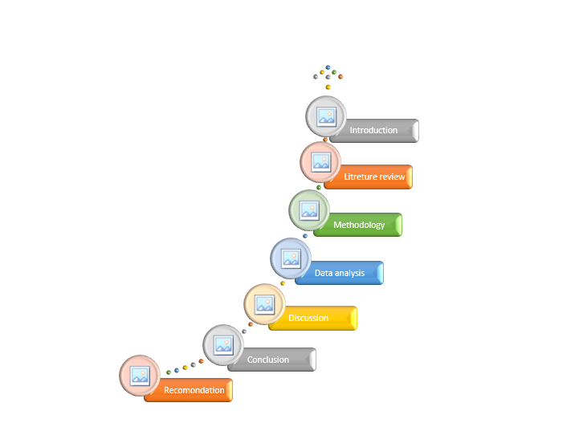

Figure 1: Thesis Outline
(Sources: Self-made)

Chapter 2: Literature Review

2.1 Introduction
Diving into the intricacies of Relationship Marketing (RM), Brand Loyalty (BL), and Customer Engagement (CE), the composing study exactly investigates existing definitions and scholastic talks. The fundamental goal is to spread out a strong foundation, offering both a thorough cognizance and an essential evaluation of these indispensable thoughts. Relationship Displaying, investigated according to the points of view of Gustavsson and Elshawa, (2023), is inspected for its client-driven techniques. MEKURIYA, (2023) perspectives work on the examination of Brand Resolve, including both the worth-based and up close and personal angles. Siu et al. (2022), guide the examination of Client Responsibility, highlighting dynamic help and worth co-creation. This total review clears a path for a positive evaluation of these thoughts inside the setting of Nestlé, significance to uncovering nuanced encounters that will add to a more significant perception of the impact of Relationship Advising on Brand Dedication according to the point of view of Client Responsibility.

2.2 Relationship Marketing

2.2.1 Definitions
Bettani, (2023), depicts relationship advancing as a fundamental perspective planned to foster persisting through client affiliations. In their unique work, they feature the importance of obtaining clients as well as rather similarly endlessly supporting associations for a really long time. Khosravian, (2022), further works on this perspective by underscoring the basic occupation of two-way correspondence and normal benefits in the relationship-advancing design. According to Khosravian, (2022), the special exchange of information and the integral worth made for both the client and the business are fundamental perspectives that perceive relationships advancing. This emphasis on normal coordinated effort and shared regard features the significance and interconnectedness characteristic in relationship advancement, arranging it as a crucial and helpful association among associations and their client base.

2.2.2 Critical Review
In this context, when relationship marketing has procured inevitable acknowledgment for its consumer-driven perspective, a fundamental perspective, as communicated by specialists like Khosravian, (2022), reveals explicit troubles that have ideas for its effective execution. The maxim "relationship marketing" has ended up being undeniable in exhibiting talk, as often as possible summoned as a catch-all articulation without a standardised, by and large recognized definition. This dubiousness and misuse have provoked anomalies in its utilitarian application across sectors and organisations. Khosravian, (2022), examination starts from the insight that the term has reached past its exceptional sensible cutoff points, debilitating its exactness and causing confusion. Overall relationship promotion, according to Khosravian, (2022), lies in developing huge, usually valuable correspondences among clients and associations. Regardless, the wide usage of the term to wrap different displaying practices has achieved a shortfall of distinction, making it attempting to frame what truly includes relationships advancing before long. The setback of a by and large settled upon definition carries a level of subjectivity into the comprehension and execution of “relationship marketing strategies”. Different experts and scientists could apply the term in habits that line up with their perspectives and targets, adding to the moved interpretations and executions found in the business scene (Schoen et al. 2022).
Also, the free usage of the term hampers the assessment of its suitability. Without a sensible and standardised definition, assessing the impact of relationship marketing transforms into a confounded task. Firms could purport to take on relationship-displaying strategies, yet the shortfall of an anticipated benchmark makes it attempt to become familiar with the significance and realness of these associations. In resolving these issues, scientists and experts ought to partake in a discussion highlighting the definition and limits of relationship exhibiting. Khosravian, (2022) review prompts a huge conversation about the necessity for a more nuanced and expressive understanding of relationship marketing, perceiving that one size doesn't fit all in this strong and creative field. By spreading out an all the more clear and more careful conceptualization, the field can push toward more tough and convincing execution, empowering genuine and enduring associations among associations and their clients.

2.2.3 Advantages and Disadvantages
Advantages of Relationship Marketing:
According to Shaw, (2022), benefits of relationship marketing increase client loyalty. That increase client loyalty results in a sizable amount of income from recurring business. Growth may be fueled by generosity, discounts, gifts, as well as humility without requiring a big financial outlay. Positive client experiences encourage social media sharing, word-of-mouth advertising, and favorable reviews. builds a personal rapport with clients. To increasing the possibility that they will make more purchases allows companies to get honest feedback. The honest feedback learns about the requirements and preferences of their customers. Requirements and preferences of their customers helps to resolve problems quickly by keeping in touch with clients (According to Shaw, 2022). The clients use a variety of platforms, including as digitalization plus technology. To communicate with customers creates connections that promote wise buying, which eventually increases income as well as sales. Positive reviews including word-of-mouth marketing are inexpensive forms of promotion. Positive reviews help with strategic decision-making by offering perspectives on market dynamics as well as client demands.
Disadvantages of Relationship Marketing:
According to Shaw, (2022), the disadvantages of relationship marketing that new customers may feel neglected as the focus is on existing loyal customers. Negative reviews and false rumors can spread quickly, damaging relationships with customers as well as building and maintaining relationships over time requires significant time and effort. Excessive closeness with customers may distract from business management as well as customer preferences evolve, posing a challenge to maintaining consistent relationships. Adapting to different cultures for relationship building can be challenging and therefore, Loyal customers may expect discounts, gifts, and free trials, impacting the business financially (According to Shaw, 2022). Training staff for relationship management is expensive and not all businesses can afford it in additional to Excessive promotional materials may overwhelm customers, leading to reduced effectiveness.

2.3 Brand Loyalty

2.3.1 Definitions
Tali et al. (2021) outline brand loyalty as a consumer's frequent devotion to opting for a single brand, emphasising the psychological aspect of regular purchases. Obiegbu et al. (2020), present the psychological component, highlighting the personal connection among a brand with its customers. This psychological part expands above transactional uniformity going right into the subjective as well as emotional connections consumers establish with businesses. Oliver's performance grows the concept of brand loyalty by highlighting the psychological impact that can influence customer choices, highlighting the complex relationship between reasonable buying behaviours plus the emotional connection consumers can develop with particular businesses.

2.3.2 Critical Review
Stephenson, (2020), approach to loyalty undermines the accepted view that permanence is only a superficial fabrication and their case shows loyalty is not solely reliant on close connections as well as can show through behaviour according to ideals. By bringing up a model that encompasses social plus attitudinal parameters, they propose an in-depth comprehension of loyalty that surpasses traditional emotions. According to Hwang et al. (2021), the interpersonal aspect of trustworthiness involves a persistent commitment to trades that mutual support and this attribute indicates that consumers can show constancy using how they shop, like repeatedly selecting a particular manufacturer repeatedly. This behaviour-driven dependence can frequently be quantitative as well as identifiable, offering an unambiguous sign of consumer commitment. Although the attitude aspect explores consumers' psychological or cognitive brand loyalty, this trait incorporates a psychological connection and characteristics like fulfilment, and trust, plus a genuinely favourable connection. Based on Dick and Basu, true loyalty consists of a combination of behavioural and attitude elements (Ibrahim and Abd Ghani, 2021). They acknowledge that a consumer can show devotion by constantly criticising a brand but nevertheless retain an excellent, intimate relationship towards it.
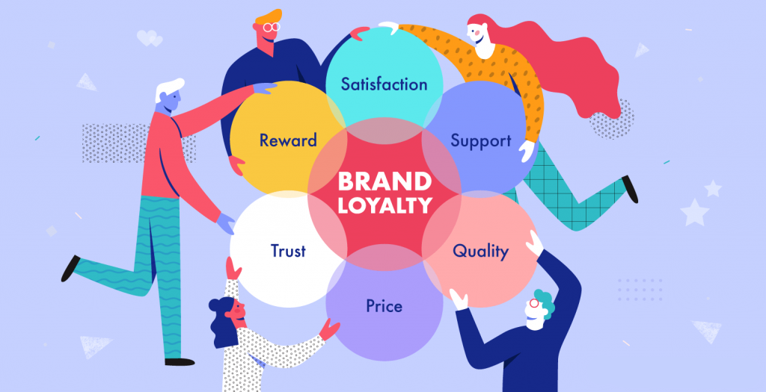

Figure 2: Brand loyalty
(Sources: https://www.creatopy.com/blog/brand-loyalty/?amp=1)
This model's importance relies on being able to accurately represent a deeper comprehension of trustworthiness plus companies can create tactics that surpass regional appeal by recognising the conditional concept of reliability as well as emphasising delivering significant advantages for consumers via product quality, simplicity, or other tangible advantages. This double approach to permanence additionally provides advice for executives as well as managers along with companies who have the ability to support approaches that influence combined social plus attitudinal perspectives, seeing how every element curiously increases total customer loyalty. It urges companies to implement an exhaustive strategy that respects the many facets of consumer responsibility. Overall, Campbell and Hartin. (2023) approach broadens the definition of steadfastness by presenting it as a special interchange between deep connections plus conditional methods of acting. This complex view leads organisations to think about both the observable behaviours and fundamental beliefs that characterise a loyal customer, which is crucial when trying to establish and encourage loyalty in a varied and competitive market.

2.2.3 Advantages and Disadvantages
Advantages
According to Aspiringyouths.com (2024), when people are loyal to a brand, individuals are more likely to purchase its items again, resulting in increased sales throughout the years. A brand has loyal consumers will keep people coming back, minimising their desire to find someone else. Loyal clients are less concerned with price fluctuations and are prepared to spend more over a brand that trust as well as love. Happy consumers frequently tell their friends as well as family regarding their favourite products, which may result in free prospective clients. A brand with a large number of devoted consumers is viewed as more valuable as well as may stand apart from the market.
Disadvantages
Aspiringyouths.com, (2024), when individuals are committed to one brand, they frequently overlook alternative possibilities that may be more effective or cheaper. Brands that loyal consumers may charge higher prices since their customers were less price sensitive. Whenever clients do not shop around, few enterprises dominate the market, making it difficult for new businesses to emerge. Loyal consumers may lose out on testing new items that better match their demands or have new features. This commitment might result in a few companies dominating the market, limiting diversity and innovation.

2.4 Customer Engagement

2.4.1 Definitions
According to Cheung et al. (2021), consumer involvement is an ongoing procedure when consumers contribute actively to their brand's collaboration of value. The importance of consumer engagement plus interaction within this concept of co-creation has been emphasised by Roy et al. (2022). This viewpoint extends above conventional transactional interactions by underlining the proactive contribution of satisfied customers with what companies provide, as well as with their experiences as individuals. By meaningful as well as interactive engagements with the company, Hollebeek's commitment to connecting with clients is in alignment with the emerging paradigm of consumers who are involved as co-creators, understanding their vital role in establishing and improving the total value offered.

2.4.2 Critical Review
Haydon et al. (2021) offer a comprehensive examination of the complicated setting that Nestlé competes in while they suggest that customer involvement should go well beyond the digital sphere to include every aspect of the client experience. In the present digital age, communication via the internet is unquestionably essential, however, an integrated approach towards customer engagement recognises the variety of interactions that influence how customers interact with Nestlé. Therefore, Haydon et al. (2021) encourage us to think about how thorough customer interactions are pre-, as well as post-purchase and they contend that each interaction from first knowledge to product use and post-purchase support contributes to the degree of engagement altogether. This viewpoint emphasises that engagement cannot be a one-time event but rather a continuous story that plays out across several channels as well as situations, which is in line with the evolving nature of customer-brand interactions. It's crucial to look at Nestlé's projects outside of social media as well as digital advertising when assessing its relationship marketing tactics.
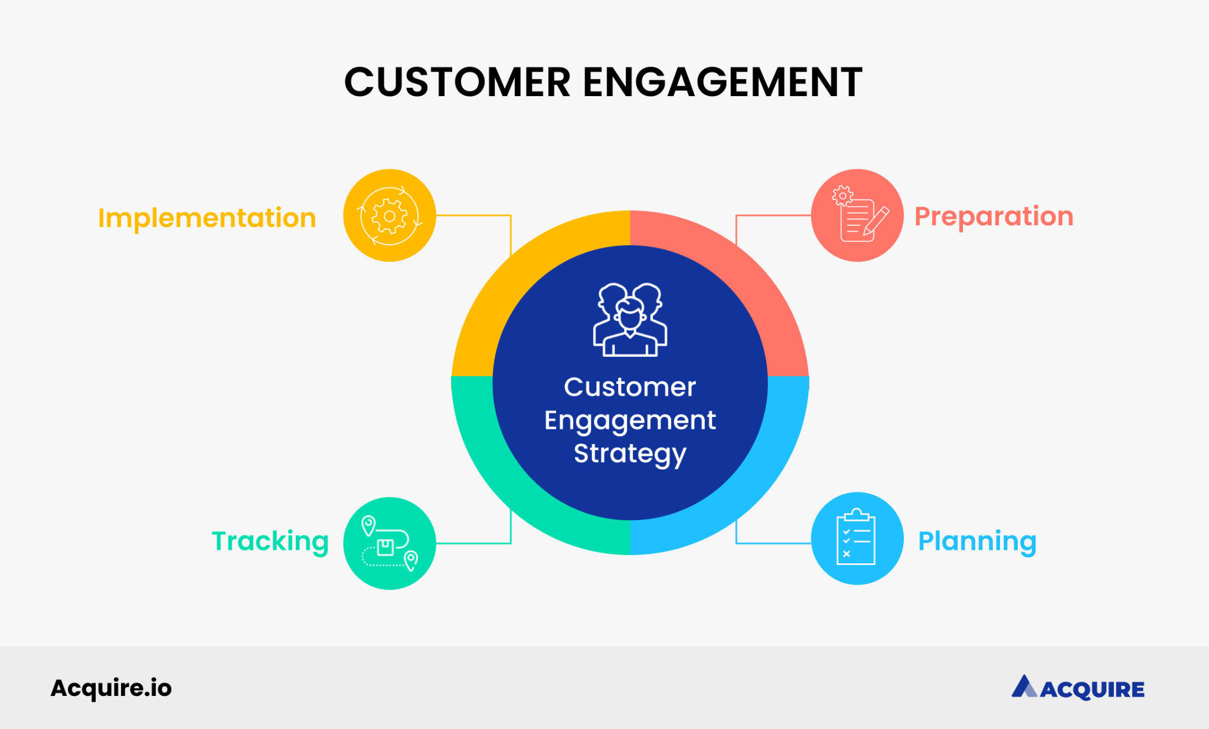

Figure 3: Customer engagement
(Sources: https://acquire.io/blog/customer-engagement-strategies)
According to Pugsley, (2023), Customer engagement must be observed as a coordination of experiences across the course of the consumer's whole journey, starting with their first introduction to Nestlé goods and continuing through to after-purchase interactions. Nestlé is inspired to investigate creative methods for building relationships at every touchpoint by this all-encompassing perspective of consumer interaction. Everything from interesting and educational pre-purchase material to smooth and customised post-purchase assistance turns every connection into a chance to boost engagement plus strengthen brand loyalty. Furthermore, this all-encompassing viewpoint is consistent with the modern perception that consumers want unified plus combined brand experiences. The connection that a consumer has with Nestlé does not boil down to a particular encounter. Instead, it is an ongoing series that comes across together and moulds views, preferences, as well as eventually, loyalty. Finally, academics such as Westreenen, (2022), draw emphasis on the broad scope of customer involvement and advise Nestlé to develop tactics that extend beyond digital bounds and include the whole customer experience. This all-encompassing strategy not only fits with changing customer expectations but additionally puts Nestlé in an advantageous position to create long-lasting connections outside of particular channels, encouraging consistent engagement as well as brand loyalty.

2.2.3 Advantages and Disadvantages
Advantages
The advantages of customer experience of Nestle encourage recurring business and satisfying encounters to cultivate client loyalty (Maria et al. 2023). Another advantage is to increased revenue is a result of engaged consumers' propensity for carrying out more purchases. Another advantage is Engaged and happy consumers as brand ambassadors may end up endorsing goods and services. Its gives users a way to collect insightful and useful consumer feedback.
Disadvantages
The disadvantages of customer engagement of Nestle are taking a lot of time and money. Time and money to continue engagement activities that are constant (Labrecque et al. 2020). Another disadvantage is Ineffective interaction tactics might cause a mismatch with client expectations and customers may get disinterested if excessive engagement attempts are made.

2.5 Objectives of the Study

2.5.1 Assessing Efficacy of Nestlé's Relationship Marketing
Studying Sharma and Fatima, (2024) research highlights the importance of comprehending client requirements while continually delivering superior value. An intriguing case study for evaluating the effectiveness of relationship marketing. Relationship marketing comes from Nestlé a well-known leader in the food and beverage sector as well as the business's capacity to satisfy customer requests and provide exceptional value are a result of its strategic method.
In this setting of Nestlé has shown achievement in relationship marketing. by understanding the wide range of demands that its customers have (Reza, 2020). Therefore, by concentrating on customer needs Nestlé has been able to adapt its products to meet the changing needs of its target market. This customer-focused strategy enables the business to build trust and encourage loyalty.
Another crucial element of Nestlé's relationship marketing effectiveness is the company's ongoing provision of outstanding value and also regularly surpasses customer expectations. Surpasses customer expectations via creative product creation, quality control, and attentive customer care (Uzir et al. 2021). Customer care dedication to quality helps to foster long-term client loyalty as well as satisfaction. Client loyalty as well as satisfaction which are essential components of relationship marketing.
On the other hand, Nestlé's involvement in environmentally and socially conscious initiatives enhances its relationship marketing approach as well as by conforming to those values that matter to customers. The business not only satisfies their needs but also improves its reputation, deepening the relationship with them (Balogun et al. 2020).
Nestlé's success with relationship marketing is closely linked to its sophisticated understanding of customer needs. Customer needs steadfast dedication to providing exceptional value. Therefore, the business's approach offers a valuable model for companies looking to establish long-lasting connections with their clients.

2.5.2 Influence of Customer Engagement on Brand Loyalty
According to KHOLIS and RATNAWATI, (2021), customer interaction may have a favourable impact on brand loyalty. The level of consumer interaction provides useful data about whether it promotes Nestlé brand loyalty. The research aims to discover subtle strategies that Nestlé may use to bolster and enhance its brand loyalty initiatives by examining the dynamics of client interactions.
One useful statistic for assessing the success of "Nestlé's brand loyalty" initiatives is customer engagement as well as Nestlé can determine areas for development (Kee et al. 2021). Get data on the performance of its present projects by evaluating the degree of customer input and participation as well as study not only recognises the value of consumer engagement. Therefore, but also seeks to identify subtle tactics that might improve Nestlé's attempts to build brand loyalty.
Nestlé must comprehend the changing nature of customer interactions in order to modify. Improve its strategy in order to satisfy customers' shifting expectations. Through analysing the details of these exchanges, Nestlé is able to spot trends, inclinations, and problem areas that affect customer loyalty (Fulgione, 2022). This perceptive analysis may guide the creation of focused tactics. This focused tactic will improve relationships with clients and encourage their enduring loyalty.
Aside from that, the research has provided Nestlé with a roadmap for improving its brand loyalty programmes as well as the organization capacity to form better and longer-lasting ties with its "consumer base" may be improved by using the enhanced strategies discovered. As a result, brand loyalty will improve in a highly competitive industry.

2.5.3 Opportunities and Challenges in Implementing Relationship Marketing
The problems identified by Richeri et al. (2021), reveal potential hurdles to relationship marketing approach of Nestlé's organization. According to Richeri et al. (2021), findings offer a valuable lens for evaluating the complexities, allowing for a full evaluation of its benefits and drawbacks of Nestlé's approach. In order to identify potential development opportunities and anticipate potential challenges in Nestlé's relationship marketing activities as well as this study becomes an invaluable tool.
Richeri et al. (2021), stated that the importance of successfully negotiating difficulties in the ever-changing sector of relationship marketing, as well as the Nestle organization is motivated by this understanding in additional to reassess its processes in order to keep them flexible and adaptable. Nestlé can increase its market position by improving its relationship marketing techniques and addressing issues straight on. The opportunities and difficulties uncovered by our research allow for a more detailed picture of "Nestlé's strategic environment" in addition to how Nestlé may leverage its advantages. It is finding new ways to create customer interactions (Rajagopal et al. 2020). Finally, by predicting potential challenges, Nestlé may proactively design solutions, ensuring a strong and long-term relationship marketing strategy. This detailed study gives Nestlé a competitive advantage and allows the company to fine-tune its relationship marketing approach. It is also strengthening customer relationships while minimising potential impediments by using the findings of Richeri et al. (2021) research. As a result, this tactical improvement puts Nestlé in a better position to manage the market's complexities and allows the business to continue developing and excelling in the area of relationship marketing.

2.6 Literature Gap
According to Kiss et al. (2022), the lack of an in-depth investigation aimed particularly at finding out when relationship marketing influences "Nestlé's brand loyalty" is a major gap in the research, especially since considering the realisation that the scholarship currently in publishing offers helpful data about the subject. Especially in instances when deeper investigation gives the spotlight on general topics, specialised research is required because of Nestlé's distinct place in the marketplace, industry specifics, plus consumer dynamics. While a focused investigation of the nuanced ways that "Nestlé's relationship marketing" strategies affect brand loyalty in a unique manner has not been done, further research is necessary. In addition to being necessary for academic advancement, obtaining these facts will help Nestlé make valuable adjustments to its strategy and manage the complexity of its customer connections (Noorlander, 2022). By offering a more sophisticated understanding of "Nestlé brand loyalty", the research seeks to fill this understanding gap. This information will guide practical applications as well as enrich discussions in academia.

2.7 Models: Advantages and Disadvantages
Relationship Marketing Theory
The Relationship Marketing Theory emphasises how important it is to build long-lasting relationships with clients (YEĞİN, 2020). It is done when it is building long-lasting relationships with clients by placing a high value on retention, loyalty, plus satisfaction. This theory offers a construction for grasping and trying effective relationship showcasing strategies through essential parts. Relationship promoting viable correspondence, trust-working, in addition to customized associations. These essential thoughts may be utilized by scientists to assess how Nestlé's specific exercises fit inside the hypothesis. It is likewise giving understanding into the elements influencing brand devotion inside the organization's current circumstance.
Customer Relationship Management (CRM) Models:
In this unique circumstance, all through their life expectancy CRM has an essential methodology and complete way of thinking that includes observing and dissecting client contacts (Czopek and Kazusek, 2020). CRM is an innovation that makes it conceivable to mechanize. Systematically organise, and synchronise processes related to advertising, marketing, customer service, plus technical support. Investigators looking at Nestlé's relationship marketing tactics might explore the ways in which the business uses CRM techniques and this study sheds light on the methods' efficacy in fostering brand loyalty among Nestlé's clientele.
Brand Loyalty Models:
According to Akanji et al. (2023), there are several models available for analysing and quantifying brand loyalty, including “the Customer-Based Brand Equity (CBBE) model”. These frameworks might be used by academics to evaluate how Nestlé's relationship marketing tactics affect several aspects of brand loyalty. Brand loyalty perceived value, brand awareness, brand associations, as well as brand loyalty behaviours.

2.7.1 Comparative Analysis
The comparison and contrast of the relationship advertising models offered forward by academics like Bayat Sahil and Holmén, (2023) gives an in-depth look at the positive and negative aspects of every paradigm. Grönroos emphasises co-creation with engagement with customers as essential elements of the service-dominant explanation. However, Peck et al. give a model that considers relational as well as transactional variables, giving an extensive perspective on relationship-based marketing. Tronvoll and Edvardsson, (2023), examination is great since it focuses a heavy emphasis on dynamic interactions along with value collaboration, which is in keeping with recent developments in customer involvement. Its substantial reliance on environments that are service-centric, yet, can pose an obstacle because it could limit its application to businesses that generate tangible goods. An additional balanced viewpoint is offered by Pellegrini et al. (2020), model, which includes both transactional as well as relational aspects. It provides versatility in an assortment of business situations by emphasising the crucial nature of both relational as well as transactional deals.
Achieving an appropriate equilibrium among both components may be difficult because focusing overly on commerce could harm connections plus vice versa. The task of settling about or creating a strategy that works with Nestlé's circumstance includes an in-depth assessment of both "the benefits and drawbacks". Nestlé's prominence in the food plus beverage industry needs a strategy that acknowledges both the physical aspect of its offerings as well as the interactions as well as engagement of its customers. A well-rounded strategy that includes components from Brennan et al. (2020) might prove beneficial when constructing a customised model that matches Nestlé's unique operational setting. Nestlé could apply this comparative analysis to evaluate relationship marketing strategies from a strategic standpoint, allowing for an intentional choice or adjusting that is consistent with the company's aims. "Nestlé's relationship marketing" techniques may be enhanced by recognising the "advantages and drawbacks" of every model, leading to long-term customer connections and increased operational effectiveness.

2.8 Conclusion
It can be concluded that the analysis of the literature analyses important topics such as customer retention as well as relationship advertising. A further significant concept for describing their meanings is growth throughout time, that involves shifting conceptual frameworks. The study investigates essential variables, approaches, as well as outcomes that have informed the discussions of "relationship marketing" addresses like brand loyalty through assessing key research as well as academic articles. Furthermore, it delves into the intricate nature of connections among consumers and companies, considering aspects such as sentiments of relationship, trust, and contentment. The incorporation of extant literature not merely reveals the relationships among different theoretical viewpoints but also exposes discrepancies or discrepancies in study outcomes and this sophisticated understanding makes it possible to pinpoint areas of knowledge gaps, which facilitates a concentrated and well-informed evaluation of the "Nestlé case study". The thorough literature review functions as a navigator for the subsequent sections, leading the investigation of research information and analysis in order to make significant improvements to the areas of brand loyalty with relationship marketing.

Chapter 3: Methodology

3.1 Introduction
In this methodological chapter, the research procedure is described via a methodical examination of the research onion structure. The debate opens with an explanation of the research philosophy, which takes a positivist approach, emphasising empirical inquiry as well as quantitative data analysis. The selected deductive research technique enables a systematic evaluation by developing and evaluating hypotheses based on existing ideas. The emphasis then changes to "the mono-system quantitative research" approach, which was selected for its structured framework in analysing the impact of relationship marketing initiatives on brand loyalty at Nestlé. The data gathering technique is then described, which includes the usage of a Likert scale inside a Google form, as well as a sampling approach using a random selection of 50 Nestlé workers. The data analysis approach uses SPSS to conduct a thorough examination of the complex relationships between marketing strategy with brand loyalty. Ethical issues highlight the need of safeguarding participants' rights including privacy. The chapter finishes with a brief description of the main components for the research approach.

3.2 Research Onion
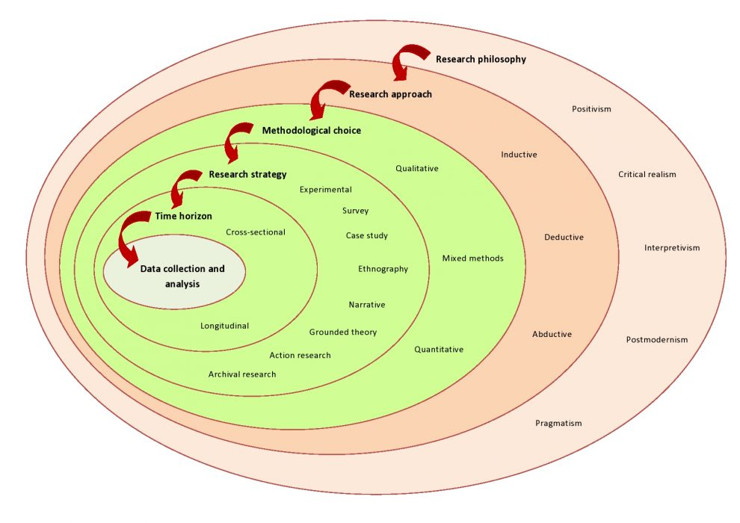

Figure 4: Research Onion
(Sources: https://www.aesanetwork.org/research-onion-a-systematic-approach-to-designing-research-methodology/)
According to Haydam and Steenkamp, (2020) research onion framework offers a systematic approach for building a strong research technique. Notably for analyzing the influence of relationship marketing initiatives on brand loyalty within the Nestlé Company scenario. The research onion has three tiers of decisions are as follows to doing the study, the outer rings from the study's onion include choices about the researcher's worldview as well as general strategy. On the other hand, the emphasis might lie on establishing the research philosophy with methodology chapter (Williams, 2021). This segment comprises methodological decisions, research strategies, and time horizons and these decisions made here influence the overall structure of the research. For the Nestlé instance, the researcher might select certain methodologies, tactics (such as case study design), as well as a time range for data collection as well as analysis. The research onion's deepest core includes realistic data collection and analysis strategies. This includes judgements on the actual gathering methods, like surveys or else interviews. The analytical processes used to extract useful insights from the information being gathered. The interconnection of each layer represents a methodical change from broad philosophical issues to particular data gathering as well as analysis strategies as well as by peeling the research onion in an organized way (Saini, 2020). The researcher assures a thorough and rationally sequenced investigation of the influence of relationship marketing methods on brand loyalty within the Nestlé case study.

3.3 Research Philosophy
The learner Positivism research philosophy is shown by this analysis. A focus on empirical inquiry as well as the utilisation of numerical data are two characteristics of positivism in research (Kumatongo and Muzata, 2021). It gathers objective numerical data and assesses the viability of developing frameworks as well as their effect on brand loyalty using quantitative methods.
The topic's decision to adopt a positivist research philosophy is essential to giving the investigation an organized and factual basis. The investigation an organized and factual basis focus on objective and quantifiable components of positivism fits in line with the necessity of measuring the effect of relationship marketing tactics on brand loyalty. This way of thinking makes it possible to use quantitative techniques. Quantitative techniques which let the researcher collect numerical data within an organized manner. By means of meticulous analysis, the research may ascertain causal linkages. Evaluate the efficacy of Nestlé's relationship marketing tactics, and provide significant empirical findings. The conclusions are more credible due to positivism's focus on empirical investigation as well as provides a scientific framework for comprehending the interplay among relationship marketing campaigns as well as brand loyalty inside the Nestlé setting.

3.4 Research Approach
It has shown the use of deductive research methodologies during this audit (Pearse, 2019). To evaluate the impact of relationship, display approaches on brand reputation with Nestlé, a conventional research approach is necessary. This involves evaluating hypotheses derived from well-established theories. This technique employs a precise assessment to support or criticise speculative assumptions utilising observational data obtained from the Nestlé organisation.
In this context, the investigation's structure as well as logic are improved by using a deductive research technique in this area as well as the process of deductive reasoning is formulating a hypothesis plus testing it using data analysis plus empirical observation. A deductive method in this case study probably starts with an existing relationship marketing as well as brand loyalty model or theoretical framework. After that, the researcher gathers and examines evidence in order to validate or invalidate the theories' resulting hypotheses as well as this approach offers a structured and methodical approach to investigating the particular effects of relationship marketing tactics on Nestlé brand loyalty. By improving the study's accuracy and enabling a targeted inquiry, the deductive technique helps to provide generalizable insights that go beyond the particular situation.

3.5 Type of Investigation
Quantitative research offers the advantage of offering information in numbers, statistical analysis for generalisation, plus objectivity. Yet, it also has an opportunity to simplify challenging phenomena, neglect historical context, and falls lack of digging into motivations as well as attitude. In addition, stiff construction and established inquiries could limit flexibility. Balancing these factors is essential for good study design as well as analysis of consequences. The learner has shown the cross sectional Quantitative within the setting of this subject (Farrah and Jabari, 2020). A cross sectional quantitative approach is used to analyse the influence of Relationship Displaying Methodology on Brand Resolution in the Nestlé context. This approach focuses only on using quantitative research methods. This analysis combines research investigations, and coordinated surveys, with rigorous evaluations to gather numerical data, providing a comprehensive and measurable assessment of the relationship between marketing strategies employed by Nestlé plus customer brand loyalty.
Based on the definition, the cross-sectional quantitative method is essential to the issue since it offers a well-organized and targeted framework for examination of the topic. The focus of a cross sectional approach centers around the statistical analysis as well as collecting of quantitative data inside a single system or environment. For example, Nestlé's relationship marketing tactics and their effects on brand loyalty. This strategy entails the methodical collection of numerical information pertaining to brand loyalty measurements plus relationship marketing campaigns as well as the use of statistical methods, the investigator may evaluate these numerical measurements and derive significant inferences on the correlation among the variables being studied. The study's accuracy is improved by the mono-system quantitative methodology, which enables a thorough analysis of certain components of Nestlé's relationship marketing initiatives and how they affect brand loyalty. This methodology decision guarantees a thorough and concentrated investigation, offering significant statistical information to the more comprehensive comprehension of relationship marketing dynamics inside the Nestlé environment.

3.6 Sampling Method

3.6.1 Sample type
In this study, the researcher can employ random sampling to pick individuals from the questionnaire. Whenever the "random sampling technique" is used, each person in the general population has an equal chance of being picked for the sample. This methodology diminishes predisposition in the information assortment process and guarantees that the number of individuals who partake is illustrative of the general populace (Hamilton, 2020). The examination's example type is Settle corporate specialists or volunteers. Workers were picked as their delegate bunch classification since they are most proficient about the organization's computerized promoting drives. Workers from various hierarchical divisions and levels take part in the review task to get a variety of points of view on the issue.

3.6.2 Sample size
The sample size for this study will be 50 Nestle customer. An adequate sample size not set in stone to guarantee the exploration's legitimacy and generalizability (Odeleye, 2021). The example size ought to be suitable to give helpful information to study while thinking about genuine requirements like time and assets. By picking 50 respondents, a commonsense information assortment and examination method is guaranteed while as yet getting a lot of information.

3.6.3 Sampling method
The sample approach utilized was random sampling, which guaranteed that each customer of the Nestle organization had an equivalent possibility being picked. This guarantees that the sample is both goal and agent of the populace. Scientists might utilize a variety of methodologies to pick respondents at irregular, for example, a random sample size, staff part task, including random determination processes (Babar et al. 2020). The survey utilizes an irregular examining way to deal with guarantee that the "sample of 100 respondents" chose accurately mirrors all customer of the Nestle organization. This technique grows the ends that can be inferred about what advanced showcasing means for inexpensive food undertakings by helping the legitimacy and generalizability of the discoveries. Since random sampling helps to eliminate bias, it is important to remember that there may still be constraints and other sources of sample error. It is critical to understand these limitations, and steps may be done to boost sample participation along with representativeness. The study findings must be reviewed taking into account the features of the sample as well as any potential disadvantages.

3.7 Data collection process
Primary research requires collecting data that originates from its sources of information, frequently by questionnaires. Advantages are customised data, rapid relevance, plus focused insights. But it may be lengthy and expensive. Secondary research takes utilisation of previously gathered data, that is frequently gathered using literature reviews. The advantages include cost-effectiveness plus time efficiency, but rules can arise owing to redundant or prejudiced data. Balancing each of the techniques promotes thorough investigation strategies. The student will demonstrate the primary process of the data collection process. In order to analyse the results from a Likert scale within a Google form, including a sample of 50 participants selected randomly, it is recommended to transfer the data to an Excel spreadsheet (Primahardani, 2022). Utilise Succeeds data assessment tools to calculate the mean scores, and standard deviations, plus conduct any necessary statistical tests. This process will facilitate the identification of patterns and instances in people replies, providing valuable insights into perspectives on the influence of Relationship Marketing Strategies on Brand Loyalty in the Nestlé study.

3.8 Data analysis technique
George and Mallery (2019), stated that using SPSS software improves the depth as well as accuracy of the data analysis procedure as well as this advanced analytical instrument functions as a verified examination device, allowing for a rigorous as well as methodical analysis of the data. Using SPSS, a multitude of statistical tools and procedures become available. It is allowing for a detailed exploration of the complicated dynamics of the link between link Marketing Strategies as well as Brand Loyalty within the Nestlé contextual analysis. The use of SPSS allows for a more sophisticated evaluation of the acquired data, "leveraging high-level objective criteria" and this technique enables a full study of the factors under inspection. It is resulting to a strong knowledge of the delicate interaction between marketing tactics and consumer loyalty inside the Nestlé environment. Using SPSS, the study aims to provide meaningful results. These meaningful results contribute to a deeper understanding of the elements driving brand loyalty, so improving the body of knowledge in marketing.

3.9 Ethical Consideration
Ethical consideration plays a huge component in the current exploration in ensuring the privileges in addition to government assistance of the people who participate as well as ethical ideas of intentionality, informed assent, and protection were straightaway. With practically no kind of commitment or impulse, members must be allowed to choose if they wish to take part in the review. Members will be made mindful of the objectives, strategies, and any downsides or benefits of the review and Members will not be expected to proceed and will continuously have the choice to stop or decline inclusion. Members are given all they need to be familiar with the examination, similar to its objectives, techniques, likely risks, in addition to benefits, prior to exploiting the exploration (Zhang et al. 2020). They get the opportunity to answer any vulnerabilities and answer questions. Each member has been requested their educated authorization, affirming that they comprehend as well as are wilfully partaking. The review needs to regard and protect members' security consistently. Any private data accumulated through the information gathering method will be kept hidden as well as safely documented. To safeguard the security of the subjects, just supported specialists approach the information, in addition to any recognizable data has been anonymised or pseudonymized.

3.10 Summary
It is summaries that, the research onion framework, as described a methodical and organised way to developing a strong research technique as well as the positivist research ethic is consistent with the goal of objectively assessing the effect of relationship marketing strategies on brand loyalty inside Nestlé. The deductive research technique strengthens the study's structure through developing and evaluating hypotheses based on known ideas and therefore, the mono-system quantitative technique is supported by its concentrated and organised framework. The mono-system quantitative technique which enables a full investigation of the link between marketing initiatives and brand loyalty. The data gathering technique uses a Likert scale inside a Google form to enable systematic analysis using Excel and statistical tools. The random sample of 50 Nestlé customer’s improves the study's validity and generalizability. Finally, using SPSS for data analysis provides depth and accuracy, providing valuable insights into the complex dynamics of relationship marketing tactics and brand loyalty within the Nestlé environment. Based on the above information, this the study process, ethical issues are given priority in order to protect participants' rights and privacy.

Chapter 4: Data analysis

4.1 Introduction
In this context of data analysis, the chapter has explained that analysing the impact of Relationship Marketing Strategies on Brand Loyalty is a Case Study of Nestlé Company. This chapter has also explained the data set analysis of the chapter which is gathered through surveys. This chapter has covered qualitative data analysis where the correlation, regression, and frequency table.

4.2 Quantitative analysis
Correlation
In this correlation table, the correlation study above examines the connection between multiple elements of Nestlé's relationship marketing techniques with consumer behaviour. Participation in Nestlé's relationship marketing efforts correlates with a positive effect on customer devotion (r = 0.463, p < 0.01) and perceived achievement in establishing loyalty (r = 0.293, p < 0.05) (Aoki et al. 2020). Participation in consumer engagement techniques has a favourable correlation with brand loyalty (r = 0.624, p < 0.01). Nestle's consumer contact strategies demonstrate a positive correlation with customer engagement tactics (r = 0.430, p < 0.01).
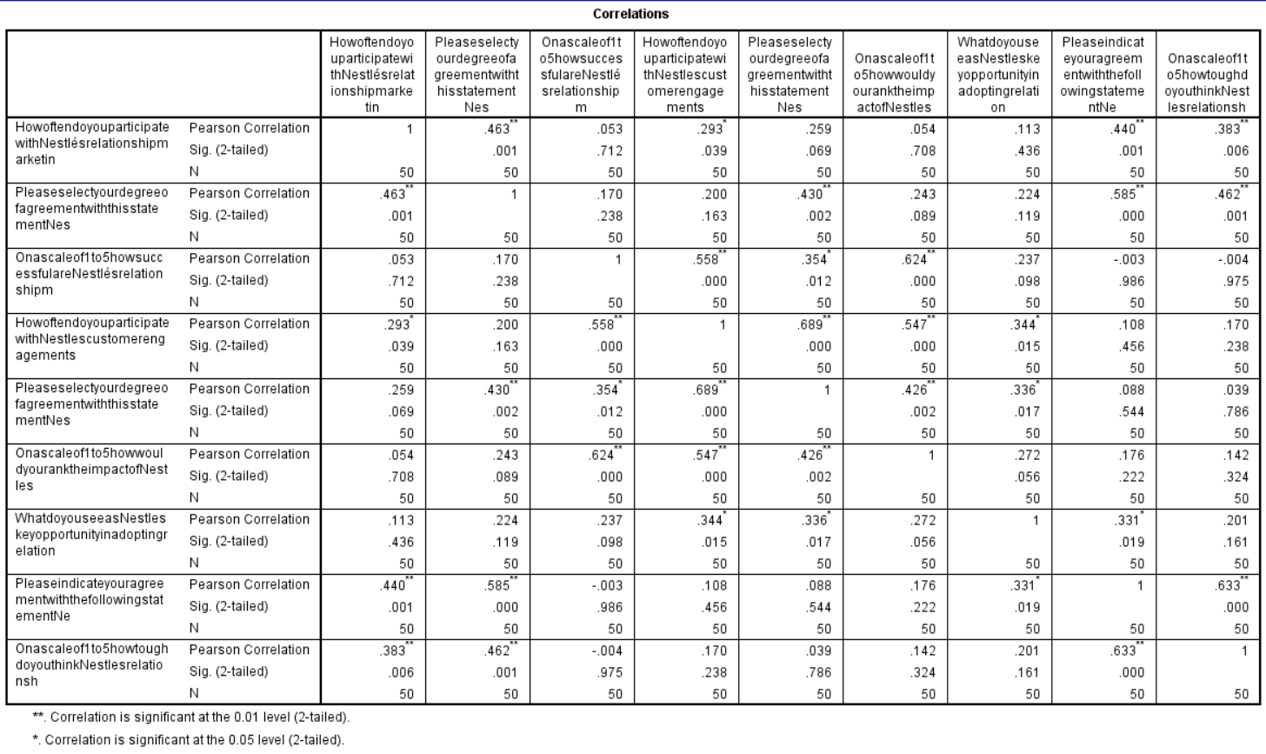

Table 1: Correlation
(Sources: SPSS work)
Nestle's relationship marketing techniques demonstrate a positive correlation with their perceived effectiveness in establishing customer loyalty (r = 0.440, p < 0.01). Implementing relationship marketing strategies provides issues that are negatively correlated with the perception of achievement (r = -0.633, p < 0.01) and positively correlated with the observed complexity of execution (r = 0.633, p < 0.01) (Minhas et al. 2023). Ultimately, these correlations demonstrate that proactive consumer engagement in Nestlé's relationship marketing efforts is correlated with positive opinions of loyalty building, however, adoption problems may impede effectiveness as well as execution.
Regression analysis
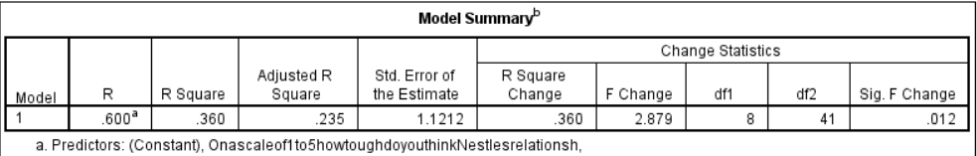

Table 2: Model Summary
(Sources: SPSS work)
The model summary demonstrates a significant correlation (R = 0.600, R Square = 0.360) among the dependent factors, "How often do you participate with Nestlé's relationship marketing initiatives," as well as the model's predictors. This adjusted R Square value of 0.235 demonstrates that predicted values account for about 23.5% of the variation in the dependent factor. The standard error for this estimate is 1.1212. The change statistics indicate the predictors' influence on the model (Kee et al. 2021). The R Square Change of 0.360 as well as the F Change of 2.879, with a significant p-value of 0.012, show that the predictors all contribute to describing the variation in the dependent variable. The model incorporates several predictors for Nestlé's relationship marketing techniques including their impact on customer loyalty, providing knowledge about the elements that drive consumer engagement in these activities.
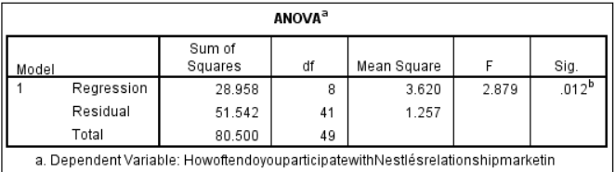

Table 3: ANOVA
(Sources: SPSS work)
The regression model's analysis of variance (ANOVA) table sheds light on the predictors' general importance in describing the variation in the dependent variable, "How often do you participate with Nestlé's relationship marketing initiatives?". The regression model is highly significant, with an F-statistic of 2.879 (p = 0.012), indicating that a minimum of one predictor provides a significant impact on the dependent variable (Maria et al. 2023). The sum of squares for regression is 28.958, with 8 df, yielding a mean square of 3.620. This reflects how much of the dependent variable's variation is explained through the predictors. The residual sum of squares is 51.542, with 41 df, yielding a mean square of 1.257, which represents unexplained variation. The total number of squares is 80.500. So, it is summarised that the ANOVA findings support the notion that the included variables together contribute considerably to understanding the heterogeneity in customer engagement in Nestlé's relationship marketing campaigns.
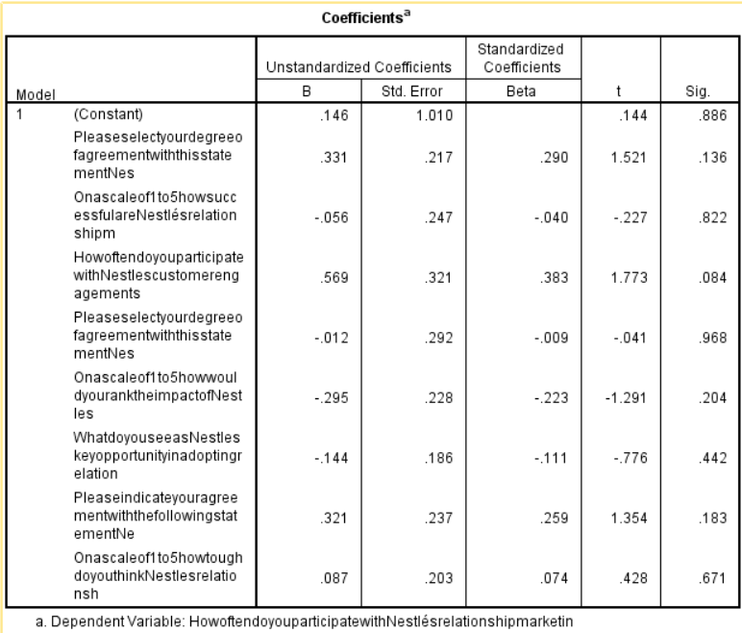

Table 4: Coefficients
(Sources: SPSS work)
The coefficients table shows how various predictors affect the dependent variable, "How often do you participate in Nestlé's relationship marketing initiatives?" The constant term cannot be considered statistically significant (B = 0.146, p = 0.886), suggesting that even though all predictors were zero, the predicted participation frequency was low (Arifine, 2020). The predictors that demonstrate positive correlations with participation frequency are the respondents' agreement that Nestlé's relationship marketing strategies positively impact their loyalty to the business (B = 0.331, p = 0.136) as well as the amount of participation in customer engagement tactics (B = 0.569, p = 0.084). The influence of customer engagement initiatives on brand loyalty (B = -0.295, p = 0.204) as well as the perceived effectiveness of Nestlé's relationship marketing methods in fostering consumer loyalty (B = -0.056, p = 0.822) show, however, lesser or non-significant relationships. A number of factors, including the perceived difficulties in implementing relationship marketing tactics (B = 0.321, p = 0.183) and Nestlé's significant chance to do so (B = -0.144, p = 0.442), do not statistically significantly support each other. Similarly, participation frequency is not substantially impacted by perceived toughness in using Nestlé's relationship marketing strategies (B = 0.087, p = 0.671) (Tan et al. 2022). In general, these coefficients provide valuable perspectives on the complex correlations that exist between distinct predictors and customer involvement in Nestlé's relationship marketing campaigns.
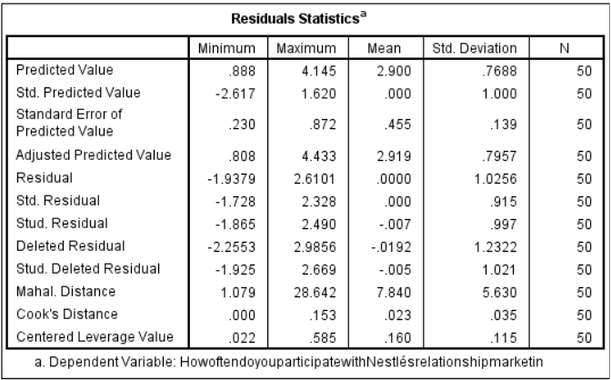

Table 5: Residuals Statistics
(Sources: SPSS work)
How well the regression model performed as well as the residuals distributed for the variable that was the dependent, "How often do you participate with Nestlé's relationship marketing initiatives?" are both shown by the residuals statistics. Considering a mean of 2.900 as well as a std dev of 0.7688, the projected values show substantial diversity in the expected participation frequency, ranging from 0.888 to 4.145 (Rollins et al. 2023). The residuals show a mean of 0.000 but a std dev of 1.0256, indicating that the model's predictions generally agree well with the observed data. Standardised residuals show that most residuals fall within a respectable range, ranging from -1.728 to 2.328. Cook's Distance, a metric for significant observations, is about a mean of 0.023 and a range of 0.000 to 0.153. This implies that the model is not significantly influenced by any one data item. The range for the Mahalanobis distance, which represents the breadth of multivariate unusual values, is 1.079 to 28.642 (Ireland et al. 2022). These figures together imply that the model operates rather well, given residuals distributed in a manner consistent with regular regression presumptions. The robustness any the model can be further demonstrated by the lack of extreme values within Cook's Distance as well as Mahalanobis's Distance. [Referred to Appendix 2]
Frequency
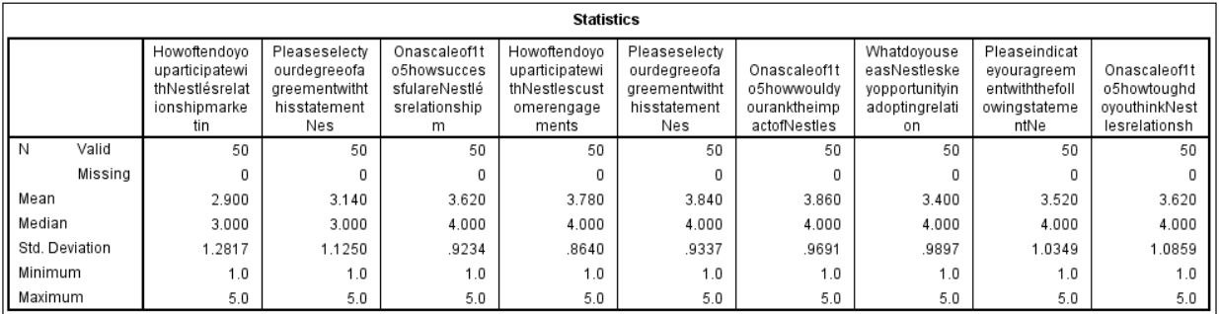

Table 6: Statistics
(Sources: SPSS work)
The data presents an overview of the answers given to several survey questions about Nestlé's relationship marketing campaigns. Considering a std dev of 1.2817 as well as a mean participation frequency of 2.900, Nestlé's relationship marketing shows a significant degree of response variation (Patoding and Muzammil, 2023). Overall a std dev of 1.1250 as well as a mean of 3.140, the consensus with the assertion about the beneficial effect of Nestlé's relationship marketing on dedication is strong. The std dev is 0.9234, as well as the mean rating for Nestlé's relationship marketing tactics, is 3.620. The average amount of participant involvement with Nestlé's consumer engagement methods is 3.780 (standard deviation = 0.8640). The average rating for the effect of customer engagement initiatives on brand loyalty is 3.840, via a std dev of 0.9337. The respondents rate their overall level of satisfaction with Nestlé's use of relationship marketing at 3.860 (standard deviation = 0.9691). The perceived difficulty of putting Nestlé's relationship marketing tactics into practice has a mean value of 3.520, while the agreement with the statement suggesting hurdles in implementing these methods has a mean of 3.400. With a std dev of 1.0349, people generally see Nestlé's relationship marketing as somewhat difficult (Wood et al. 2021). For each survey question, the replies show a range between a minimum rating of 1.0 through a maximum rating of 5.0.
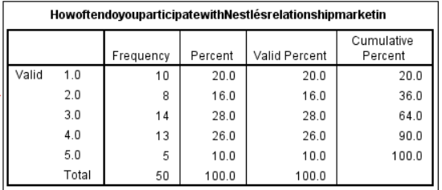

Table 7: How often do you participate in Nestlé's relationship marketing initiatives?
(Sources: SPSS work)
The frequency distribution illustrates the degree of participation in Nestlé's relationship marketing initiatives among participants. Regular engagement was indicated by a considerable number of the sample (28%) who reported a frequency of 3.0. On the other hand, 26% of respondents selected 4.0, indicating a high degree of participation. A frequency of 2.0, or 16% of the sample, suggested a modest level of engagement. Furthermore, 20% chose a frequency of 1.0, suggesting very little participation, while 10% chose a frequency of 5.0, indicating very strong involvement (Bakri et al. 2023). The total percentage shows that 64% of people connect with Nestlé's relationship marketing somewhat too often. The distribution shows a wide range of interests overall, and a significant percentage of them actively participate in Nestlé's relationship marketing campaigns.
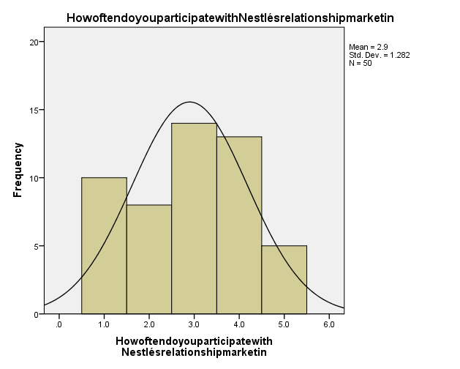

Figure 5: How often do you participate with Nestlé's relationship marketing initiatives?
(Sources: SPSS work)
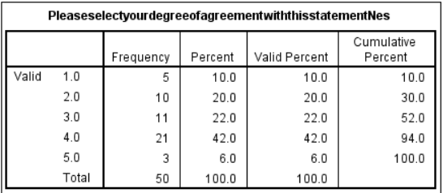

Table 8: Please select your degree of agreement with this statement: "Nestlé's relationship marketing methods have favourably affected my devotion to the company.
(Sources: SPSS work)
The frequency distribution shows how often respondents agreed with the following statement: "The company's relationship marketing strategies have positively impacted my loyalty to Nestlé." A considerable improvement in devotion was suggested by the majority of participants (42%) who scored 4.0, indicating strong agreement. In addition, 22% chose 3.0, which represents a moderate level of agreement, and 20% chose 2.0, which represents a lower level of agreement (Ghobadi and Sonenshein, 2023). Merely 6% of participants rated strong agreement as 1.0, whilst 10% of respondents rated strong disagreement as 1.0. There is a great range of viewpoints in these responses. The overall number indicates that 94% of participants agreed to some degree, demonstrating the broad agreement about the positive effects of Nestlé's relationship marketing on customer loyalty.
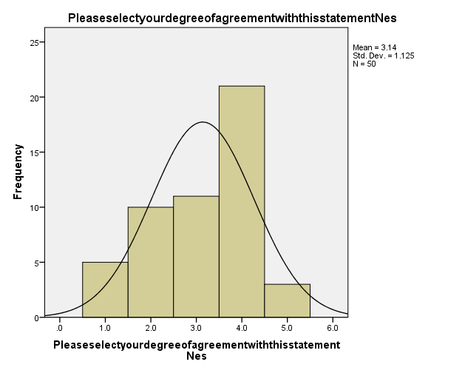

Figure 6: Please select your degree of agreement with this statement: "Nestlé's relationship marketing methods have favourably affected my devotion to the company.
(Sources: SPSS work)
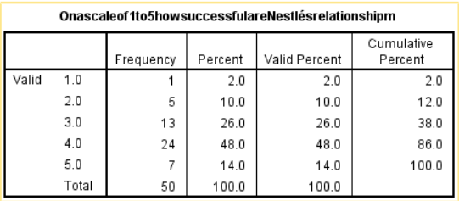

Table 9: On a scale of 1 to 5, how successful are Nestlé's relationship marketing strategies in developing consumer loyalty?
(Sources: SPSS work)
The way that participants perceive the effectiveness of Nestlé's relationship marketing methods in fostering customer loyalty is reflected in the frequency distribution. A sizable percentage (48%) gave the tactics a 4.0, signifying a high degree of effectiveness. Furthermore, 26% chose 3.0, which indicates a modest degree of achievement. 14% of respondents gave it a rating of 5.0, meaning it was very effective, while 10% gave it a rating of 2.0, meaning it was less effective (Pogacar et al. 2021). A mere 2% of respondents assigned a score of 1.0. 86% of the participants said Nestlé's relationship marketing tactics were moderate to extremely effective in building customer loyalty, according to the cumulative percent. The distribution as a whole shows that opinions on the efficacy of these tactics are mostly favourable.
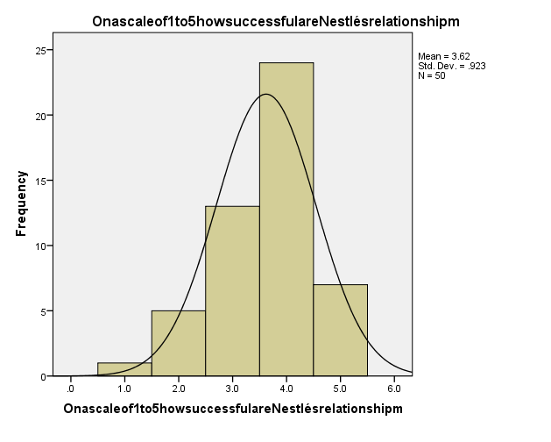

Figure 7: On a scale of 1 to 5, how successful are Nestlé's relationship marketing strategies in developing consumer loyalty?
(Sources: SPSS work)
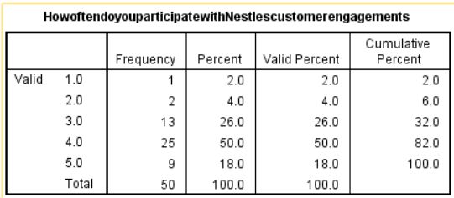

Table 10: How often do you participate in Nestle's customer engagement strategies?
(Sources: SPSS work)
The respondents' degree of participation in Nestle's customer engagement tactics is shown by their frequency distribution. Over half (50%) indicated a high degree of engagement with a frequency of 4.0. Furthermore, 26% chose 3.0, indicating a moderate degree of involvement. 18% of respondents gave their involvement a score of 5.0, meaning they were extremely regular participants, while 4% gave it a score of 2.0, meaning they were less frequent participants (Creaven et al. 2020). A mere 2% of respondents assigned a score of 1.0. 82% of participants, as shown by the cumulative percent, take part in Nestle's consumer interaction efforts on minimal to high frequency. While there is a wide range of involvement in the distribution as a whole, a sizable percentage is actively involved in Nestle's consumer engagement programmes.
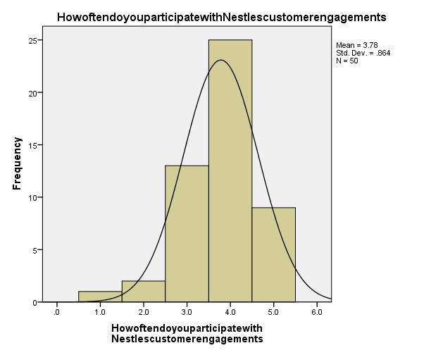

Figure 8: How often do you participate with Nestle's customer engagement strategies?
(Sources: SPSS work)
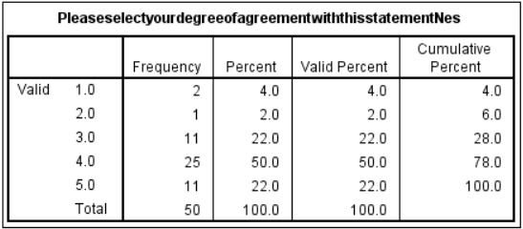

Table 11: Please select your degree of agreement with this statement: "Nestle's consumer interaction methods significantly influence my loyalty towards the company.
(Sources: SPSS work)
The frequency distribution shows the degree to which respondents agreed with the following statement: "My loyalty to Nestle is greatly influenced by the business's consumer interaction methods. "With a grade of 4.0, most respondents (50%) indicated strong agreement, suggesting a significant impact on loyalty (Adekuajo et al. 2023). Furthermore, 22% picked 5.0, indicating high agreement, whereas 22% selected 3.0, denoting moderate agreement. Six percent of respondents gave a grade of 1.0 or 2.0 for those that disagreed or strongly disagreed. The total percentage demonstrates that 78% of the participants agreed to some extent, highlighting the general consensus about the benefits of Nestle's customer engagement strategies for loyalty.
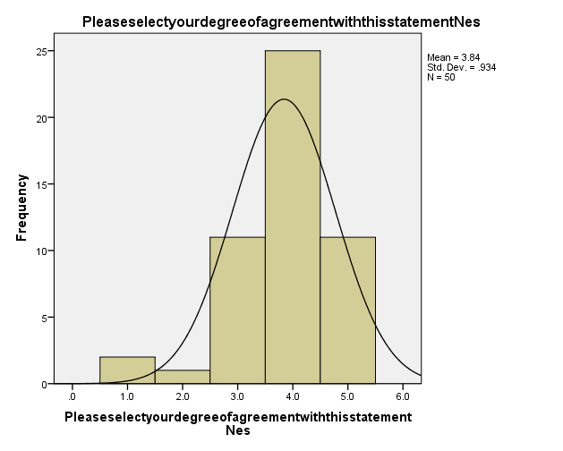

Figure 9: Please select your degree of agreement with this statement: "Nestle's consumer interaction methods significantly influence my loyalty towards the company.
(Sources: SPSS work)
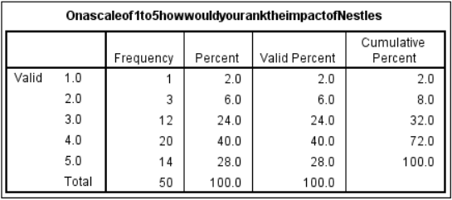

Table 12: On a scale of 1 to 5, how would you rank the impact of Nestle's customer engagement efforts on your brand loyalty, with 1 being "Not Influential" and 5 representing "Extremely Influential"?
(Sources: SPSS work)
The frequency distribution shows how respondents ranked Nestle's customer engagement initiatives in relation to the company's brand loyalty. A sizable percentage (40%) gave the effect a 4.0, indicating an important effect on brand loyalty. Furthermore, 28% of respondents picked 5.0, suggesting a very influential effect, and 24% selected 3.0, denoting a moderate degree of influence. Eight percent of respondents gave the effect a poor rating (scoring of 1.0 or 2.0) (Chukwu et al. 2023). According to the cumulative percentage, 72% of participants believe that Nestle's customer engagement initiatives have a moderate to high impact on their company's loyalty. The distribution, taken as a whole, emphasises positive opinions on how these initiatives affect brand loyalty.
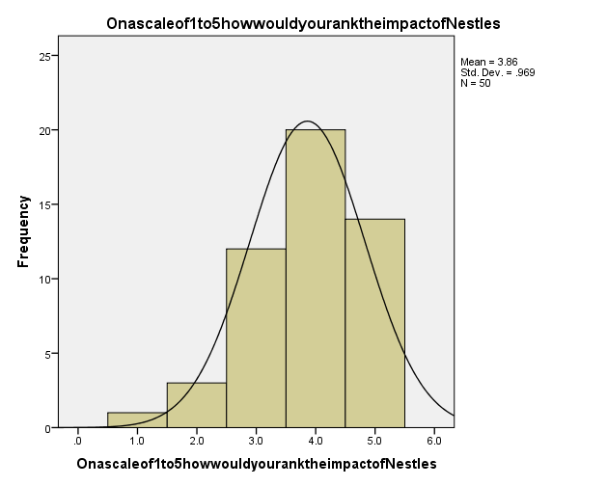

Figure 10: On a scale of 1 to 5, how would you rank the impact of Nestle's customer engagement efforts on your brand loyalty, with 1 being "Not Influential" and 5 representing "Extremely Influential"?
(Sources: SPSS work)
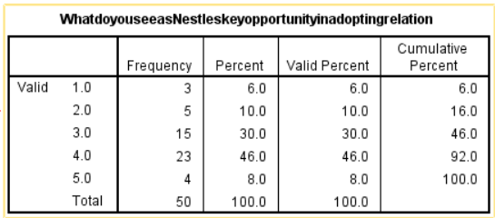

Table 13: What do you see as Nestle's key opportunity in adopting relationship marketing strategies?
(Sources: SPSS work)
The frequency distribution shows the opinions of those who responded to Nestle's main chance to use relationship marketing techniques. The majority (46%) determined that there was a significant possibility for improvement and gave the important opportunity a 4.0 rating. To further indicate a moderate amount of opportunity, 30% picked 3.0, while 10% picked 2.0, indicating a lesser level of potential (Ojha and Paliwal, 2023). Eight percent gave the opportunity a score of 5.0, meaning they thought it was extremely high, and six percent gave it a rating of 1.0, meaning they thought it was the lowest. The total percentage shows that 92% of participants believe Nestle has a chance to use relationship marketing techniques. All things considered, the distribution shows a wide variety of opinions on the most important chances for Nestle in this scenario.
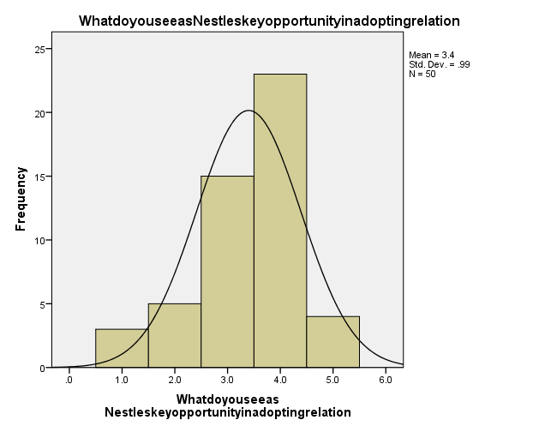

Figure 11: What do you see as Nestle's key opportunity in adopting relationship marketing strategies?
(Sources: SPSS work)
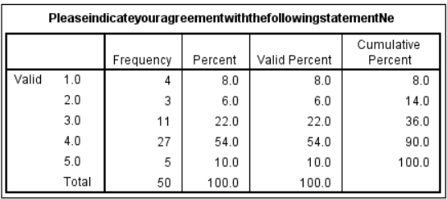

Table 14: Please indicate your agreement with the following statement: "Nestle faces challenges in adopting relationship marketing strategies.
(Sources: SPSS work)
The frequency distribution shows the degree to which respondents agreed that "Nestle faces challenges in adopting relationship marketing strategies". With a grade of 4.0, a sizable percentage (54%) indicated a high degree of agreement and a large awareness of issues. Furthermore, 22% picked 3.0, indicating a moderate degree of agreement, and 10% picked 5.0, indicating a significant degree of agreement (Rashid et al. 2021). 14% of respondents gave their disagreement or severe disagreement a grade of 1.0 or 2.0. The total percentage shows that 90% of participants admit that Nestle has some difficulty using relationship marketing techniques. Overall, the distribution indicates that respondents generally agree on the difficulties Nestle has in putting its relationship marketing tactics into practice.
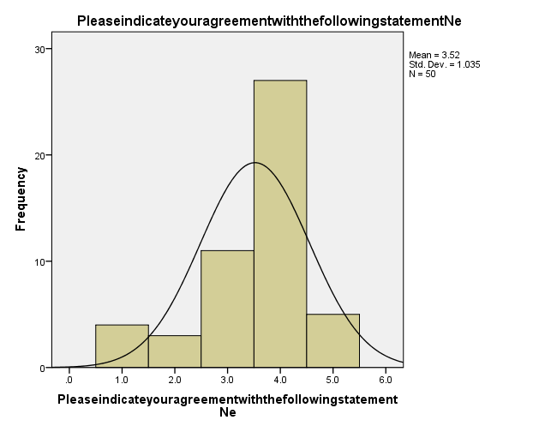

Figure 12: Please indicate your agreement with the following statement: "Nestle faces challenges in adopting relationship marketing strategies.
(Sources: SPSS work)
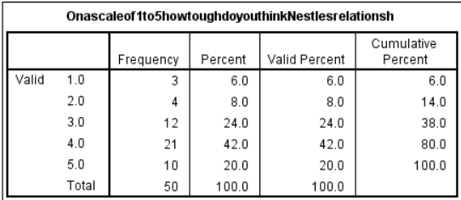

Table 15: On a scale of 1 to 5, how tough do you think Nestle's relationship marketing techniques will be to execute, with 1 being "Not Challenging" and 5 being "Extremely Challenging"?
(Sources: SPSS work)
The frequency distribution, which ranges from 1 to 5, with 1 denoting "Not Challenging" with 5 denoting "Extremely Challenging," shows respondents' opinions on how demanding Nestle's relationship marketing strategies are. Most (42%) gave the toughness a 4.0, suggesting a high degree of perceived difficulty. Moreover, 24% picked 3.0, showing a moderate degree of complexity, and 20% chose 5.0, showing a feeling of tremendous challenge (Adekuajo et al. 2023). Of the people who gave toughness a ranking of 1.0 or 2.0, 14% gave it a bad rating. Based on the cumulative percentage, 80% of participants consider Nestle's relationship marketing strategies to be somewhat too difficult. All things considered, the distribution shows different opinions on how hard it is to implement Nestle's relationship marketing strategies.
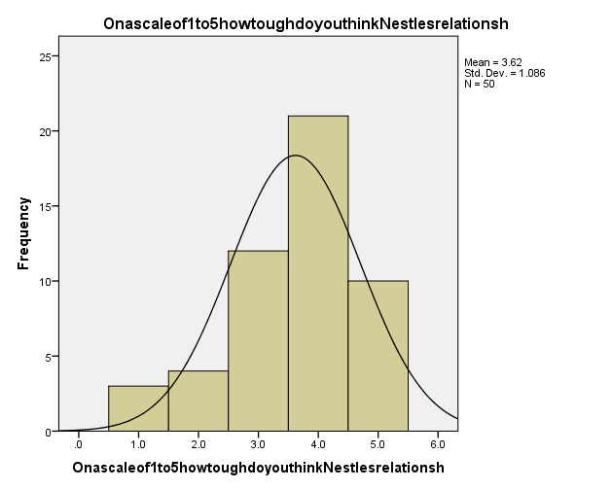

Figure 13: On a scale of 1 to 5, how tough do you think Nestle's relationship marketing techniques will be to execute, with 1 being "Not Challenging" and 5 being "Extremely Challenging"?
(Sources: SPSS work)

4.3 Conclusion
In conclusion, correlation research shows complex connections between customer behaviour with Nestlé's relationship marketing tactics as well as favourable impacts on dedication as well and the perceived effectiveness of loyalty-building tactics is favourably correlated with active engagement. This is further supported by the regression model, which shows a significant link with variables that together account for 23.5% of the variation in participation frequency as well the framework's importance in understanding variability is supported through an ANOVA. Consumer agreement as well as engagement frequency have a positive influence on participation, as shown by the coefficients. Which highlights the effect of determinants on it. The model's acceptable performance is shown by residual statistics, which closely match real values as well as responses from participants show a considerable degree of heterogeneity as well as generally favourable attitudes. Adoption difficulties have a negative effect on performance but a favourable one on toughness perception while most respondents acknowledge Nestlé's major potential, other perspectives point to a complex picture. All things considered, this thorough research offers insightful information on the complex dynamics surrounding Nestlé's relationship marketing programmes. It is laying the groundwork for future strategic decisions and advancements.

Chapter 5: Conclusion and Recommendation

5.1 Linking with objective
Objective 1: Analysing how well Nestlé's relationship marketing techniques work to build and maintain client loyalty requires. Therefore, a thorough examination that connects its objectives with its methods. As a multinational manufacturer of consumer products Nestlé is aware of how critical it is to cultivate enduring bonds. So, with its clients in order to win their loyalty in the face of intense competition. Nestlé places significant emphasis on personalised communication with client involvement (BAKARE and RAHIM, 2023). This client involvement is a key component of their relationship marketing strategies. Nestlé seeks to build deeper emotional ties by customising marketing messages. Which offers to each people customer's requirements and preferences. Apart from this, this approach strives to instil a feeling of worth and gratitude perspective. Nestlé, for instance, may use consumer data analytics to pinpoint buying trends and inclinations. It enables customised promotions plus suggestions that appeal to every client group. Moreover, Nestlé uses a range of loyalty plans and rewards to encourage. It is a recurring business and recognises client loyalty viewpoint. To entice clients to stick with the company over time these programmes. Therefore, often incorporate point-based systems, special invitations to new items or events, or special prices (Shinde, 2023). Nestlé strives to foster a feeling of reciprocity. it is thankful to its devoted consumers by continuously providing value and incentives, since this may help foster a long-term loyalty perspective.
Nestlé prioritises consumer input and involvement via a variety of channels. So, this includes social media sites, surveys, customer service contacts, as well as direct communication with loyalty programmes viewpoint. Nestlé endeavours to establish trust as well as credibility. Its client base by attentively listening to their issues, resolving their criticism, and exhibiting responsiveness to their requests. Additionally, Nestlé uses relationship marketing strategies. It goes beyond one-on-one encounters to include larger community involvement and CSR projects (Singh et al. 2021). Nestlé may bolster relationships with consumers who have similar beliefs. It is also improving its image by associating its brand values with issues. that appeal to its target market, like community development or sustainability. One way to assess the effectiveness of Nestlé's relationship marketing initiatives is to use a comprehensive approach. which takes into account consumer feedback systems, loyalty programmes, personalised communication, plus larger brand engagement methods (Chong and Patwa, 2023). Nestlé may improve its capacity to create enduring connections and keep customers loyal in a competitive market through consistently improving. Modifying these strategies in light of consumer insights as well as market realities.
Objective 2: Linking the goal entails drawing a distinct line in the sand between customer engagement programmes with brand loyalty via the Nestlé setting as well the purpose of this goal is to look at how different customer interaction tactics affect customers' brand loyalty to Nestlé (Kee et al. 2021). Projects aimed at actively involving and interacting with consumers include a variety of activities that might include consumer feedback methods, product sampling, community events, loyalty programmes, plus social media marketing. For businesses such as Nestlé, the success of these initiatives in cultivating customer brand loyalty is critical. As it impacts repurchase behaviour, brand advocacy, including overall brand image. Studies will be conducted to meet this purpose and various important areas will be investigated so, initially a list and analysis of the many kinds of consumer interaction initiatives that Nestlé has undertaken will be provided (Sia et al. 2022). In this context, examining these projects' breadth, and regularity, including reach across various marketplaces and customer categories is part of this as well. Furthermore, an evaluation of the degree of customer involvement and reaction to these initiatives will be conducted. Gaining insight into how consumers interact with Nestlé's. The organisation's activities may help determine how well they work to foster deep relationships within the brand.
Additionally, the study will examine how customer engagement initiatives relate to brand loyalty indicators including brand affinity (Bakshi et al. 2020). It is a readiness to promote Nestlé goods to others, plus a repeat purchase behaviour point of view. The degree of customer interaction initiatives affects Nestlé brand loyalty. It may be measured and assessed by examining data on several factors prospective. Linking the goal to ascertain how customer engagement projects affect Nestlé brand loyalty necessitates carrying out in-depth research (Aqila et al. 2022). It looks at the interaction between different engagement initiatives as well as consumer loyalty results. Thereby guiding the company's marketing as well as strategic decision-making processes.
Objective 3: In this context, understanding the complex connections among Nestlé's relationship marketing initiatives with their impact on customer satisfaction. As well as adherence measures are necessary for accomplishing the aim (Kee et al. 2021). The phrase "relationship marketing" describes the tactics. Initiatives used to establish and maintain enduring, solid bonds with clients. The investigation regarding the way Nestlé's relationship marketing strategies support customer satisfaction. As well as adherence goes to the centre of this goal. Relationship marketing is an assortment of tactics that aim to improve the relationship between Nestlé plus its clients as well these strategies include customised communication, loyalty plans, customer service, plus engagement campaigns (Aqila et al. 2022). The first step in the study will be to list and evaluate each component of Nestlé's relationship marketing plan. This entails assessing the business's methods for communicating with customers. the success of its loyalty initiatives and the standard of its encounters with customers. Researchers are able to assess the effects of Nestlé's customer relationship-building strategies on satisfaction. As well as adherence measures by comprehending the unique strategies that the company uses (AKINLEYE, 2022).
In addition, the research will examine customer satisfaction as well as loyalty indicators. It is measured and assessed in connection to Nestlé's relationship marketing initiatives. In a similar way, this entails evaluating metrics like Net Promoter Score (NPS), customer satisfaction surveys, repeat purchase behaviour, plus customer retention rates as well. Through the examination of these indicators, we may learn more about how well Nestlé's relationship marketing works. In this aspect, to keep consumers satisfied and increase their brand loyalty as well (Osidele, 2021). Apart from this, the investigation will look for causal links or connections between client satisfaction and retention measures with Nestlé's relationship marketing campaigns as well. It can spot patterns and trends that demonstrate how relationship marketing affects. These significant facets of customer behaviour via statistical analysis as well as data interpretation viewpoint. Linking this goal ultimately entails carrying out a comprehensive analysis that looks at the relationship among Nestlé's relationship marketing initiatives (Rîpa and Nicolescu, 2023). The results that follow in regard to customer satisfaction as well as loyalty. This analysis will provide insightful information. It will help shape future marketing strategies as well as initiatives as well.
Objective 4: Linking with the objective entails examining how client-centric strategies and customised communication. It is affecting building brand loyalty inside Nestlé's customer base. Apart from this, the main goal is to comprehend how Nestlé's customer-centric initiatives and tailored communication efforts affect its consumers' loyalty as well (Joshy and Bhudevi, 2024). Delivering customised messages provides, and encounters as well. It catered to each person's interests, behaviours, and requirements is known as a personalised communication perspective. In a similar way, consumer-centric tactics, on the other hand, put the requirements, preferences, as well as experiences of the consumer first across their whole brand contact journey viewpoint. First, a thorough review of Nestlé's customer-centric strategies as well as personalised communication activities will be part of the investigation which entails evaluating the channels. Therefore, this method for tailored communication, including social media engagement, email marketing, and targeted advertising (Mallik, 2023), in addition to putting customer-centric strategies like product customisation, and proactive customer support, along with user-centred design into action as well.
Additionally, the research will examine how these customer-centric initiatives and personalised communication efforts affect Nestlé's brand loyalty measures which include assessing metrics including frequency of purchases, customer retention rates, brand advocacy, and sentiment analysis from customer reviews. It can ascertain the degree to which customer-centric strategies and tailored communication help to strengthen brand loyalty within Nestlé's clientele by measuring these measures as well (Mikassi, 2022). Additionally, the investigation will look at how customer-centric initiatives and personalised communication work together to increase brand loyalty and it can learn more about these two factors' combined influence on brand loyalty. by looking at how they support and enhance one another to provide happy customer experiences as well as strengthen emotional ties with the company. The last step in achieving this goal is carrying out in-depth research on how brand loyalty, customer-centric tactics, and personalised communication interact in the setting of Nestlé's marketing initiatives In order to more effectively satisfy the changing requirements (Caiazza and Bigliardi, 2020). as well as demands of its consumers, Nestlé should adjust its marketing strategies as well as initiatives. It will promote long-term loyalty as well as brand advocacy. In an obvious way, this can be done by evaluating the degree to which these tactics contribute to the expansion of brand loyalty point of view.

5.2 Limitation
In this aspect of limitation, the lack of a mixed-method approach, that might combine quantitative and qualitative data gathering (Vindrola-Padros and Johnson, 2020). Its analysis techniques to give a more thorough insight is another study restriction. Due to this constraint, the study's depth of insight could be limited since it may miss important subtleties. Its views might have been recorded by using a more varied methodological approach. The validity as well as reliability of the results are further severely limited by researcher bias as well as the research method and findings may unintentionally be shaped by the subjective impact of the researcher's viewpoints, preferences, or preconceived conceptions (Vokinger et al. 2021). Which might result in distorted conclusions or interpretations. Moreover, the limited sample size compromises the study results' statistical power as well as generalizability as well as a small sample size might make it difficult to accurately reflect the variety (Zhang et al. 2021). Variability is found in the intended audience, which would undermine the validity as well as robustness of the study's results. In this setting, this constraint lowers the research's overall effect and relevance by restricting how far the results may be used or extended to larger settings or populations' points of view.

5.3 Recommendation
In this context of the recommendation, a number of suggestions may be made to improve the quality as well as rigour of the study in light of the constraints that have been identified prospectively.
- It is hereby recommended that researchers have to adopt a mixed-method technique. The integration of both quantitative as well as qualitative techniques for data gathering and analysis might give a more thorough comprehension of the subject matter under investigation as well as Researchers may get a wider variety of insights as well as views by using the strengths of every technique (Muñoz et al. 2021). In this context, this can result in a more nuanced as well as comprehensive analysis of the data.
- It is hereby recommended that researchers have to mitigate researcher biases technique. Use techniques to reduce researcher bias. For example, hiring a team of researchers or following established procedures for gathering and analysing data. Furthermore, identifying and addressing any biases during the study process (Kordzadeh and Ghasemaghaei, 2022). It may assist ensure the validity plus reliability of the results. In this setting, this can be achieved by engaging in reflexivity with a transparency viewpoint.
- It is hereby recommended that researchers have to increase the sample size technique. Increasing the sample size to boost the research's statistical ability as well as generalizability as well as its might include gathering additional data points or bringing in a more varied as well as representative group of people (Lakens, 2022). In this setting, greater trust in the reliability of the study results and more rigorous statistical analyses are made possible from a bigger sample size point of view.

5.4 Conclusion
It can be concluded that this study aims to shed light on the intricate link between relationship marketing techniques. In a similar way, brand loyalty uses a particular emphasis on Nestlé Corporation. In the highly competitive food as well as beverage business, cultivating brand loyalty is crucial. This research aims to fill in the knowledge gaps regarding how relationship marketing helps achieve this goal viewpoint. Through a thorough analysis of Nestlé's tactics and how they affect consumer loyalty. The study hopes to provide insightful information for both scholarly discussion and real-world corporate use. This research is important because it may influence marketing professionals as well as organisational decision-makers' tactics. by offering practical advice on how to improve relationship marketing campaigns and foster brand loyalty. In the end, this study advances our understanding of the critical role that relationship marketing plays in building brand loyalty. Which opens the door to better marketing strategies and stronger customer interactions in today's corporate environments.

Reference List
- Adekuajo, I.O., Udeh, C.A., Abdul, A.A., Ihemereze, K.C., Nnabugwu, O.C. and Daraojimba, C., 2023. CRISIS MARKETING IN THE FMCG SECTOR: A REVIEW OF STRATEGIES NIGERIAN BRANDS EMPLOYED DURING THE COVID-19 PANDEMIC. International Journal of Management & Entrepreneurship Research, 5(12), pp.952-977.
- Akanji, A.H., Asare, C., Sekyere, K.N. and Warden, B.H., 2023. Consumer-Based Brand Equity in the Services Sector: A Systematic Literature Review. ADRRI Journal of Arts and Social Sciences, 20(2 (8), April, 2022-June), pp.58-82.
- AKINLEYE, D.O., 2022. Product Quality And Customers' Satisfaction [Case Study Of Nestle Nigeria Plc] (Doctoral dissertation, Mountain Top University).
- Aoki, K., Tudor, R.K., Borders, A.L. and Lester, D., 2020. Why Build Sustainable Relationships with Customers?.
- Aqila, H., Syarmimi, I., Adawiyah, H., Akhtar, I., Alhesainan, M.S. and Altayyar, L.F., 2022. Customer satisfaction act upon the brand’s fame: A case study of Nestle. International Journal of Applied Business and International Management (IJABIM), 7(2), pp.59-71.
- Aqila, H., Syarmimi, I., Adawiyah, H., Akhtar, I., Alhesainan, M.S. and Altayyar, L.F., 2022. Customer satisfaction act upon the brand’s fame: A case study of Nestle. International Journal of Applied Business and International Management (IJABIM), 7(2), pp.59-71.
- Arifine, G., 2020. Multi-Brand Loyalty: Three Essays on the concept and its impact on loyalty strategies effectiveness.
- Aspiringyouths.com (2024). Advantages and Disadvantages of Brand Loyalty. [online] AspiringYouths. Available at: https://aspiringyouths.com/advantages-disadvantages/brand-loyalty/#google_vignette [Accessed 23 Jan. 2024].
- Babar, S.U., Ahmad, H.M. and Ahmad, M., 2020. Moderating Effect of Individual Team Member Creativity on the link of Team Diversity & Work Cognition Inventory with Team Performance. International Review of Management and Marketing, 10(4), p.125.
- BAKARE, R. and RAHIM, A., 2023. NICHE MARKETING AND OPERATIONAL PERFORMANCE IN THE NIGERIAN MANUFACTURING INDUSTRY: A STUDY OF NESTLE NIGERIA PLC. LAGOS. UNILAG Journal of Business, 9(2), pp.1-15.
- Bakri, N.H.S., Ahmad, M.F., Safwan, N.S.Z., Dahlan, N.D., Azli, N.E.M. and Kafrawi, M.H.A., 2023. Examining the Relationship of Customer Satisfaction and Brand Loyalty in Sports Products among University Students. Information Management and Business Review, 15(2 (I)), pp.29-34.
- Bakshi, D., Gupta, H. and Sharma, S., 2020. FACTORS AFFECTING BRAND LOYALTY OF NESTLE POLO (Doctoral dissertation).
- Balogun, A.O., Andel, S.A. and Smith, T.D., 2020. “Digging Deeper” into the relationship between safety climate and turnover intention among stone, sand and gravel mine workers: job satisfaction as a mediator. International journal of environmental research and public health, 17(6), p.1925.
- Bayat Sahil, A. and Holmén, M., 2023. How Relationship Marketing can Improve the Value Proposition and Increase the Sales of Organic Food: A Single Case Study Exploring How Different Actors in the Food Industry Can Implement Marketing Strategies.
- Bettani, G., 2023. RELATIONSHIP MARKETING IN INTERNATIONAL FOCAL FIRMS: A STRATEGIC PERSPECTIVE ON SUSTAINABILITY.
- Brennan, R., Canning, L. and McDowell, R., 2020. Business-to-business marketing. Sage.
- Caiazza, R. and Bigliardi, B., 2020. Web marketing in agri-food industry: Challenges and opportunities. Trends in Food Science & Technology, 103, pp.12-19.
- Campbell, J.C. and Hartin, P. eds., 2023. Exploring biblical kinship: festschrift in honor of John J. Pilch (Vol. 55). Wipf and Stock Publishers.
- Cheung, M.L., Pires, G.D., Rosenberger, P.J., Leung, W.K. and Sharipudin, M.N.S., 2021. The role of consumer-consumer interaction and consumer-brand interaction in driving consumer-brand engagement and behavioral intentions. Journal of retailing and consumer services, 61, p.102574.
- Chong, W.K. and Patwa, N., 2023. The value of integrity: Empowering SMEs with ethical marketing communication. Sustainability, 15(15), p.11673.
- Chukwu, N.C., James, E.E., Emmanuel, J.I. and Inyang, I.B., 2023. PACKAGING ATTRIBUTES AND CONSUMERS'PATRONAGE OF MILK PRODUCTS. Sustainable Development, 6(3), pp.160-178.
- Creaven, G., Mandy, J. and Botha, E., 2020. Conveniently healthy: The impact of health endorsements on brand trust, brand loyalty and brand equity in Fast Moving Consumer Goods convenience versus shopping goods. South African Journal of Business Management, 51(1), pp.1-9.
- Czopek, M. and Kazusek, M., 2020. Customer relationship management. Strategy and system perspectives. Informatyka Ekonomiczna, (3 (57)), pp.34-48.
- Farrah, M. and Jabari, S., 2020. Interaction in Online Learning Environment during Covid-19: Factors behind Lack of Interaction and Ideas for promoting it.
- Flood, A.K., 2021. The Effect of Corporate Social Responsibility Strategy on the Growth of Multinational Food and Beverage Companies in China.
- Fulgione, G., 2022. Aptamil´ s decline in the growing up milk category in the Uk: selecting an optimal pricing strategy to increase customer retention (Doctoral dissertation).
- George, D. and Mallery, P., 2019. IBM SPSS statistics 26 step by step: A simple guide and reference. Routledge.
- Ghobadi, S. and Sonenshein, S., 2023. Creating Collaboration: How Social Movement Organizations Shape Digital Activism to Promote Broader Social Change. Journal of the Association of Information Systems.
- Gustavsson, A. and Elshawa, A., 2023. How to mitigate negative changes on consumer behavior during crises.
- Haider, M.I., 2020. Corporate social responsibility and customer responses: Analyzing the role of cause related marketing, brand trust and brand attachment. Capital University of Science and Technology, Is Lamabad.
- Hamilton, J.B., 2020. Rigor in qualitative methods: An evaluation of strategies among underrepresented rural communities. Qualitative Health Research, 30(2), pp.196-204.
- Haydam, N.E. and Steenkamp, P., 2020. A methodological blueprint for social sciences research–the social sciences research methodology framework. EIRP Proceedings, 15(1).
- Haydon, S., Jung, T. and Russell, S., 2021. ‘You've been framed’: A critical review of academic discourse on philanthrocapitalism. International Journal of Management Reviews, 23(3), pp.353-375.
- Hwang, J.K., Kim, E.J., Lee, S.M. and Lee, Y.K., 2021. Impact of susceptibility to global consumer culture on commitment and loyalty in botanic cosmetic brands. Sustainability, 13(2), p.892.
- Ibrahim, A.N. and Abd Ghani, Z.N.H.H., 2021. Antecedents and Consequences of Brand Loyalty. Nasrul Aiman Bin Abd Aziz Web designer, p.483.
- Iglesias, O., Mingione, M., Ind, N. and Markovic, S., 2023. How to build a conscientious corporate brand together with business partners: A case study of Unilever. Industrial Marketing Management, 109, pp.1-13.
- Ihemereze, K.C., Ekwezia, A.V., Eyo-Udo, N.L., Ikwue, U., Ufoaro, O.A., Oshioste, E.E. and Daraojimba, C., 2023. BOTTLE TO BRAND: EXPLORING HOW EFFECTIVE BRANDING ENERGIZED STAR LAGER BEER'S PERFORMANCE IN A FIERCE MARKET. Engineering Science & Technology Journal, 4(3), pp.169-189.
- Ireland, R., Bunn, C., Chambers, S., Reith, G. and Viggars, M., 2022. How unhealthy commodity industries find a global audience in the English Premier League: three case studies of brand engagement. Soccer & Society, 23(4-5), pp.334-348.
- Joshy, A. and Banudevi, P.B., 2024. Consumer’s Price Sensitivity and Shrinkflation Strategy as A Trailblazer of Chocolate Market. Journal of Informatics Education and Research, 4(1).
- Kee, D.M.H., Gan, Z.W., Chan, Y.Q., Lee, H.T., Tan, X.Y. and Lee, S.W., 2021. Customer satisfaction and brand loyalty: A case study of Nestlé. Advances in Global Economics and Business Journal, 2(1), pp.13-26.
- Kee, D.M.H., Gan, Z.W., Chan, Y.Q., Lee, H.T., Tan, X.Y. and Lee, S.W., 2021. Customer satisfaction and brand loyalty: A case study of Nestlé. Advances in Global Economics and Business Journal, 2(1), pp.13-26.
- Kee, D.M.H., Gan, Z.W., Chan, Y.Q., Lee, H.T., Tan, X.Y. and Lee, S.W., 2021. Customer satisfaction and brand loyalty: A case study of Nestlé. Advances in Global Economics and Business Journal, 2(1), pp.13-26.
- Kee, D.M.H., Gan, Z.W., Chan, Y.Q., Lee, H.T., Tan, X.Y. and Lee, S.W., 2021. Customer satisfaction and brand loyalty: A case study of Nestlé. Advances in Global Economics and Business Journal, 2(1), pp.13-26.
- Kee, D.M.H., Syakirah, N.H., Najihah, N., Aliya, N.A. and Sikumbang, N.Z., 2021. How Nestle succeed in the food industry: A consumer perspective. International Journal of Tourism and Hospitality in Asia Pasific (IJTHAP), 4(2), pp.84-97.
- KHOLIS, N. and RATNAWATI, A., 2021. The effects of customer engagement and brand trust on brand loyalty: A case study of BPJS healthcare participants in Indonesia. The Journal of Asian Finance, Economics and Business, 8(11), pp.317-324.
- Khosravian, S., 2022. Exploring Relationship Marketing Strategies for Increasing Student Retention in For-Profit, Online Higher Education (Doctoral dissertation, Walden University).
- Kiss, M., Czine, P., Balogh, P. and Szakály, Z., 2022. The connection between manufacturer and private label brands and brand loyalty in chocolate bar buying decisions–A hybrid choice approach. Appetite, 177, p.106145.
- Kordzadeh, N. and Ghasemaghaei, M., 2022. Algorithmic bias: review, synthesis, and future research directions. European Journal of Information Systems, 31(3), pp.388-409.
- Kshetri, N., 2023. Blockchain’s Role in Enhancing Quality and Safety and Promoting Sustainability in the Food and Beverage Industry. Sustainability, 15(23), p.16223.
- Kumatongo, B. and Muzata, K.K., 2021. Research paradigms and designs with their application in education. Journal of Lexicography and Terminology (Online ISSN 2664-0899. Print ISSN 2517-9306)., 5(1), pp.16-32.
- Labrecque, L.I., Swani, K. and Stephen, A.T., 2020. The impact of pronoun choices on consumer engagement actions: Exploring top global brands' social media communications. Psychology & Marketing, 37(6), pp.796-814.
- Lakens, D., 2022. Sample size justification. Collabra: Psychology, 8(1), p.33267.
- Mallik, A.K., 2023. The future of the technology-based manufacturing in the European Union. Results in Engineering, 19, p.101356.
- Maria, E., Suryani, W., Lenggogeni, W.W. and Tondo, A., 2023. Experiential marketing and service quality, and customer loyalty: Social concept and application. Onomázein, (61 (2023): September), pp.1-8.
- Maria, E., Suryani, W., Lenggogeni, W.W. and Tondo, A., 2023. Experiential marketing and service quality, and customer loyalty: Social concept and application. Onomázein, (61 (2023): September), pp.1-8.
- MEKURIYA, E.B., 2023. THE EFFECT OF BRAND EQUITY ON CONSUMER CHOICE IN THE ETHIOPIAN TELEVISION INDUSTRY ON SELECTED TV CHANNALES IN ADDIS ABABA (Doctoral dissertation, HU).
- Mikassi, L., 2022. Effect of Digital Marketing Strategies on Business Growth in the Manufacturing Sector in Kenya: A Case of Selected Fast-Moving Consumer Goods Companies in Nairobi County (Doctoral dissertation, Daystar University School of Business and Economics).
- Minhas, S., Farooq, M. and Ullah, E., 2023. Analyzing Consumers Buying Behavior through Nestle Television Advertisements Approach. Pakistan JL Analysis & Wisdom, 2, p.197.
- Muñoz-Pascual, L., Curado, C. and Galende, J., 2021. How does the use of information technologies affect the adoption of environmental practices in SMEs? A mixed-methods approach. Review of Managerial Science, 15, pp.75-102.
- Noorlander, S., 2022. User complaint analysis on Twitter: assessing the usability of complaints for innovation on Nestlé Consumer Care’s Twitter page (Bachelor's thesis, University of Twente).
- Obiegbu, C.J., Larsen, G. and Ellis, N., 2020. Experiential brand loyalty: Towards an extended conceptualisation of consumer allegiance to brands. Marketing Theory, 20(3), pp.251-271.
- Odeleye, J.O., 2021. EFFECT OF WORKING CONDITIONS ON EMPLOYEE PERFORMANCE (A STUDY OF NESTLE NIGERIAN PLC. SAGAMU OGUN STATE).
- Ojha, A. and Paliwal, V., 2023. Brand Preference, Patanjali, and FMCG: A Bibliometric Analysis. Journal of Informatics Education and Research, 3(2).
- Okoye-Chine, M., 2021. The effect of sales promotion on marketing of Coca-Cola drinks In Anambra State. International Journal of Innovative Social Sciences & Humanities Research, 9(1), pp.117-129.
- Osidele, E.O., 2021. Impact of customer relationship management on customer loyalty: case study of Cadbury Nigeria Plc (Doctoral dissertation, Dublin, National College of Ireland).
- Patoding, A.A. and Muzammil, O.M., 2023. The Influence of Brand Awareness, Perceived Quality, Brand Association, Brand Loyalty on Purchase Intention Towards Bear Brand’s Consumers. Dinasti International Journal of Digital Business Management, 4(2), pp.370-380.
- Pearse, N., 2019, June. An illustration of deductive analysis in qualitative research. In 18th European conference on research methodology for business and management studies (p. 264).
- Pellegrini, M.M., Ciampi, F., Marzi, G. and Orlando, B., 2020. The relationship between knowledge management and leadership: mapping the field and providing future research avenues. Journal of Knowledge Management, 24(6), pp.1445-1492.
- Pogacar, R., Angle, J., Lowrey, T.M., Shrum, L.J. and Kardes, F.R., 2021. Is Nestlé a lady? The feminine brand name advantage. Journal of Marketing, 85(6), pp.101-117.
- Primahardani, I., 2022. Self-Efficacy of Social Science Education Teacher Candidates on Participating in Online Learning During the Covid-19 Pandemic. AL-ISHLAH: Jurnal Pendidikan, 14(2), pp.1493-1502.
- Pugsley, A.N., 2023. A Qualitative Exploration of Food Literacy in International Schools in Egypt (Doctoral dissertation, The American University in Cairo (Egypt)).
- Rajagopal, N.K., Qureshi, N.I., Durga, S., Ramirez Asis, E.H., Huerta Soto, R.M., Gupta, S.K. and Deepak, S., 2022. Future of business culture: an artificial intelligence-driven digital framework for organization decision-making process. Complexity, 2022, pp.1-14.
- Rashid, M., Ishfaq, Z., Zain, R., Zulfiqar, A. and Ras, S.A., 2021. Moderating Role of Covid-19 on Businesses Reputation Using Corporate Social Responsibility. Journal of Innovation and Emerging Technologies, 1(1), pp.1-37.
- Reza, M.H., 2020. Analysis of marketing strategy and quality policy of Nestlé. International Journal of Scientific Research and Engineering Development, 3(2), pp.1145-1152.
- Richeri, A., Liu, Y. and Chicksand, D., 2021. Agile route-to-market distribution strategies in emerging markets: the case of Paraguay. Journal of International Management, 27(1).
- Rîpa, A.I. and Nicolescu, L., 2023. Customer Relationship Management. Websites Analysis of the Top Ten Consumer Goods Companies. Management Dynamics in the Knowledge Economy, 11(4), pp.352-371.
- Rollins, N., Piwoz, E., Baker, P., Kingston, G., Mabaso, K.M., McCoy, D., Neves, P.A.R., Pérez-Escamilla, R., Richter, L., Russ, K. and Sen, G., 2023. Marketing of commercial milk formula: a system to capture parents, communities, science, and policy. The Lancet, 401(10375), pp.486-502.
- Roy, S.K., Singh, G., Hope, M., Nguyen, B. and Harrigan, P., 2022. The rise of smart consumers: role of smart servicescape and smart consumer experience co-creation. In The Role of Smart Technologies in Decision Making (pp. 114-147). Routledge.
- Saini, M., 2020. Simplified research methods: with exercises and examples.
- Schoen, A., White, N., Henrichs, C., Siebert-Evenstone, A., Shaffer, D. and Mutlu, B., 2022, March. CoFrame: A System for Training Novice Cabot Programmers. In 2022 17th ACM/IEEE International Conference on Human-Robot Interaction (HRI) (pp. 185-194). IEEE.
- Sharma, N. and Fatima, J., 2024. Influence of perceived value on omnichannel usage: Mediating and moderating roles of the omnichannel shopping habit. Journal of Retailing and Consumer Services, 77, p.103627.
- Shaw, A.A. (2022). Relationship Marketing Advantages and Disadvantages. [online] Business Management & Marketing. Available at: https://swotandpestleanalysis.com/relationship-marketing-advantages-and-disadvantages/ [Accessed 2024].
- Shinde, V., 2023. ANALYSIS OF SUCCESS FACTORS OF CAUSE-RELATED MARKETING IN INDIAN CONTEXT FOR NESTLÉ AND NANHI KALI-# EDUCATE THE GIRL CHILD. The Online Journal of Distance Education and e-Learning, 11(2).
- Sia, T.S.L., Teh, P.J., Teng, W.H., Munirah, T.A., Almutairi, N. and Shuaib, M., 2022. Nestle, A Staple Brand in Everyone's Life: A Case Study on Brand Loyalty. International Journal of Tourism and Hospitality in Asia Pasific (IJTHAP), 5(2), pp.99-113.
- Siddique, M.A.B., 2021. A study on the consumer behavior of health food drinks sachet packs.
- Singh, P., Sin, L.G., Kama’Aziri, N.S.B., Jian, O.Z., Azlan, N.A.S.B.M., Ibrahim, P.N.I.B.B., Sheng, D.H., Kee, D.M.H., Heng, J.T.S., Wee, L.S. and Ying, L.Y., 2021. A study on Nestle promotion strategy. International Journal of Accounting & Finance in Asia Pasific (IJAFAP), 4(1), pp.60-70.
- Siu, N.Y.M., Zhang, T.J. and Kwan, H.Y., 2022. Reference effects and customer engagement in a museum visit. International Journal of Contemporary Hospitality Management, 34(2), pp.482-508.
- Stephenson, A.W., 2020. Using the Net Promoter System Methodology to Deliver Cultural Change in Retail Organisations: Impacting both the Customer and Employee Experience (Doctoral dissertation, Staffordshire University).
- Tali, M.A., Wani, N.F. and IbrahimAssociate, A., 2021. The Power Of Branding Influencing Consumer Purchase Decision: A Comprehensive Literature Review. Ilkogretim Online, 20(6), pp.5362-5387.
- Tan, S.T., Tan, S.Y., Tan, S.C., Tan, W.E., Abdullan, M., Khadran, R. and Sharma, S., 2022. Factors that Influence Consumer Purchase Intention: A Case Study of 99 Speedmart in Malaysia. International Journal of Accounting & Finance in Asia Pasific (IJAFAP), 5(2), pp.85-96.
- Tronvoll, B. and Edvardsson, B., 2023. Critical examination of academic marketing and service research’s philosophical foundation. Journal of Services Marketing.
- Uzir, M.U.H., Al Halbusi, H., Thurasamy, R., Hock, R.L.T., Aljaberi, M.A., Hasan, N. and Hamid, M., 2021. The effects of service quality, perceived value and trust in home delivery service personnel on customer satisfaction: Evidence from a developing country. Journal of Retailing and Consumer Services, 63, p.102721.
- Van Dam, I., 2022. The interplay between market concentration and diversity, food environment related commitments and associated practices of major food companies across European, Belgian and French markets (Doctoral dissertation, université Paris-Saclay).
- Van Wassenaer, L., van Hilten, M., Van Ingen, E. and Van Asseldonk, M., 2021. Applying blockchain for climate action in agriculture: state of play and outlook. Food & Agriculture Org..
- Vindrola-Padros, C. and Johnson, G.A., 2020. Rapid techniques in qualitative research: a critical review of the literature. Qualitative health research, 30(10), pp.1596-1604.
- Vokinger, K.N., Feuerriegel, S. and Kesselheim, A.S., 2021. Mitigating bias in machine learning for medicine. Communications medicine, 1(1), p.25.
- Waebuesar, A.M.E., Rosli, A.B. and Azmi, A.N.B.M., 2022. Customer Satisfaction and Brand Loyalty: A Survey of Nestlé. International Journal of Tourism and Hospitality in Asia Pasific (IJTHAP), 5(2), pp.20-37.
- Waebuesar, A.M.E., Rosli, A.B. and Azmi, A.N.B.M., 2022. Customer Satisfaction and Brand Loyalty: A Survey of Nestlé. International Journal of Tourism and Hospitality in Asia Pasific (IJTHAP), 5(2), pp.20-37.
- Westreenen, M., 2022. The Double-Edged Sword of CSR Communication: A study of a truthful and complete CSR communication strategy for Nestlé’s Income Accelerator Program.
- Williams, H., 2021. The meaning of “Phenomenology”: Qualitative and philosophical phenomenological research methods. The Qualitative Report, 26(2), pp.366-385.
- Wood, B., Williams, O., Nagarajan, V. and Sacks, G., 2021. Market strategies used by processed food manufacturers to increase and consolidate their power: a systematic review and document analysis. Globalization and health, 17(1), pp.1-23.
- YEĞİN, T., 2020. Brand Loyalty in creating relationship marketing practices: a study on GSM Operators. Elektronik Sosyal Bilimler Dergisi, 20(77), pp.201-216.
- Zhang, J., Rao, Y., Man, C., Jiang, Z. and Li, S., 2021. Identification of cucumber leaf diseases using deep learning and small sample size for agricultural Internet of Things. International Journal of Distributed Sensor Networks, 17(4), p.15501477211007407.
- Zhang, Z., Lyles, M.A. and Wu, C., 2020. The stock market performance of exploration-oriented and exploitation-oriented cross-border mergers and acquisitions: Evidence from emerging market enterprises. International Business Review, 29(4), p.101707.

Appendices
Appendix 1: Questionnaire
How often do you participate with Nestlé's relationship marketing initiatives?
- Always
- Often
- Occasionally
- Rarely
- Never
Please select your degree of agreement with this statement: "Nestlé's relationship marketing methods have favourably affected my devotion to the company.
- Strongly Disagree
- Disagree
- Neutral
- Agree
- Strongly Agree
On a scale of 1 to 5, how successful are Nestlé's relationship marketing strategies in developing consumer loyalty?
- Rate 1. Very Ineffective
- Rate 2
- Rate 3
- Rate 4
- Rate 5. Very Effective
How often do you participate with Nestle's customer engagement strategies?
- Never
- Rarely
- Occasionally
- Frequently
- Always
Please select your degree of agreement with this statement: "Nestle's consumer interaction methods significantly influence my loyalty towards the company.
- Strongly Disagree
- Disagree
- Neutral
- Agree
- Strongly Agree
On a scale of 1 to 5, how would you rank the impact of Nestle's customer engagement efforts on your brand loyalty, with 1 being "Not Influential" and 5 representing "Extremely Influential"?
- 1
- 2
- 3
- 4
- 5
What do you see as Nestle's key opportunity in adopting relationship marketing strategies?
- Enhanced Customer Loyalty
- Increased Brand Visibility
- Improved Customer Satisfaction
- Better Targeted Marketing Campaigns
- Other (please specify)
Please indicate your agreement with the following statement: "Nestle faces challenges in adopting relationship marketing strategies."
- Strongly Disagree
- Disagree
- Neutral
- Agree
- Strongly Agree
On a scale of 1 to 5, how tough do you think Nestle's relationship marketing techniques will be to execute, with 1 being "Not Challenging" and 5 being "Extremely Challenging"?
- 1
- 2
- 3
- 4
- 5

Appendix 2: Histogram chart on Residual Statistics
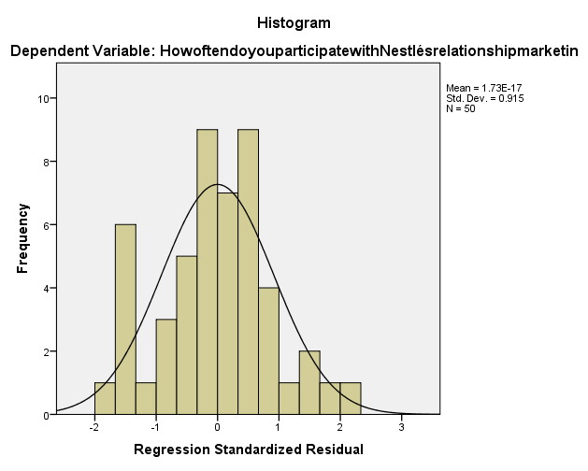
(Sources: SPSS work)

