Zakia aziz 2509429


Task 1 – Reading Task Template
Upload your photo of your A3 in-class notes here:
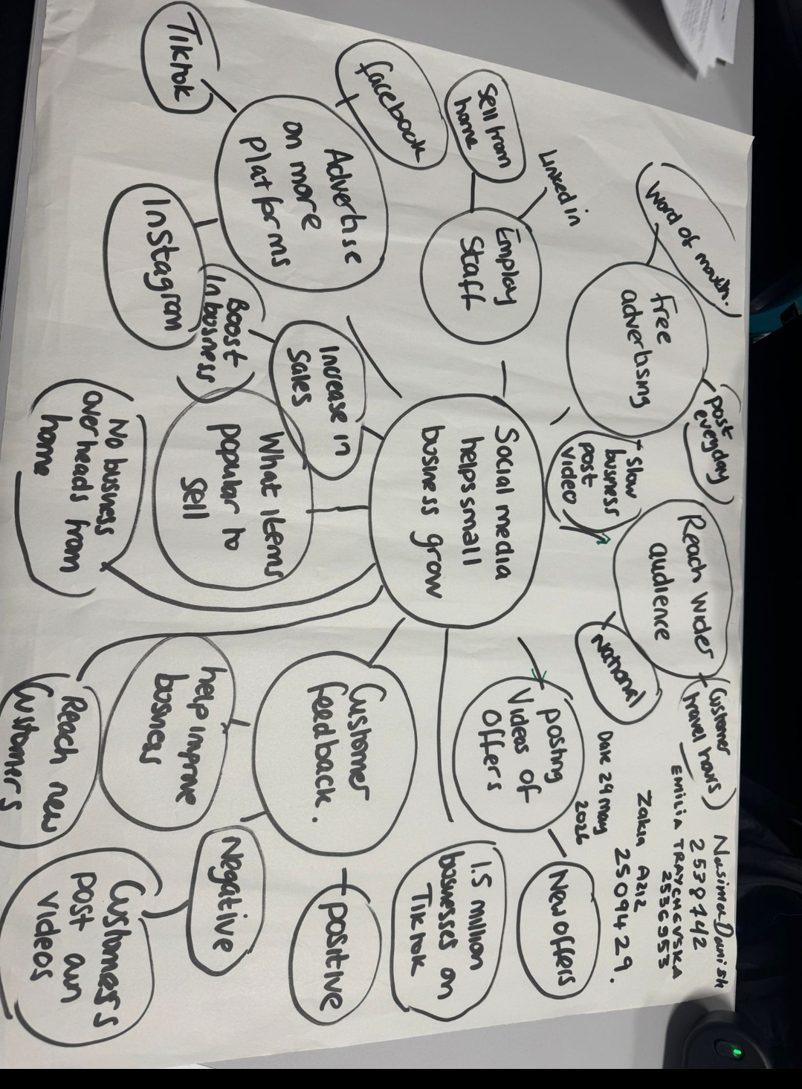

1. Answer these questions using the sentence starters below
a. What is the main idea of the text?
The main idea is that how does social media help small businesses grow also.
The article shows what you can do to advertise and what audience you can reach.
It also gives us examples of businesses that have become successful on social media.
b. What are two key points?
One key point is advertising will be free online where companies like TikTok and Instagram have made it simple to get noticed nationally.
Another key point is you can upload new offers on a daily basis at any time convenient to yourself.
c. What part of the text did you find most important? Why?
The most important part is how many businesses are online as that tells me its really good to advertise online as one business had over 45 million views which does make extra income. Some people have closed their business and moved online so saving overheads.
d. Was anything unclear or difficult to understand?
The whole article was simple and straight forward to understand, it all had similar stories
e. How did your group help you understand the text better?
My group helped me by identifying the key words.
3. One sentence reflection
Question: What did you find challenging about this task?
The hardest part was simplifying the bubble and finding the important points also known as scanning and skimming

