Student Name: Andreea Maria Crozolo  Student ID: 2226837  Module Title: Foreign Languages & Cultural Awareness  Module Code: BMIH5003  Lecturer: Lisa Bassler  Date: 09/02/2024 | 
ASSIGNMENT 1: PORTFOLIO
(4 Components)
Component 1: Professional Reflection (500 words +/- 10%)

Weighting: 25%
According to Lo Mauro & Profita (2017), cultural misunderstanding can be defined as a situation that occurs when individuals or groups from different cultures, with diverse perspectives, beliefs, and backgrounds, struggle to understand each other on sensitive topics. Cultural misunderstanding is not solely attributed to language diversity but extends to differences in gender, age, religious, political, and educational backgrounds. These differences can create challenges in communication and interpretation especially dealing with people in hospitality industry.
In a recent experience during dinner at a hotel restaurant, I observed a cultural misunderstanding unfold between a Spanish guest and a waitress. The situation highlighted the potential challenges that can arise in the food and beverage industry, especially when cultural differences come into play. The incident occurred when the waitress provided the guest with the wrong order, leading to a dramatic reaction from the client.
Cultural misunderstandings in this context arise from various factors, including language barriers, differences in dining etiquette, or variations in expectations regarding service. In this case, it seemed that the miscommunication resulted from a language gap, where the guest's preferences were not accurately conveyed to the waitress because the guest`s English level was almost non-existent, leading to the incorrect order being delivered. At the same time, the waiter does not know Spanish either.
Reflecting on this scenario, it becomes evident that developing strong communication skills is fundamental in preventing such cultural misunderstandings. As a witness to the situation, I understand the importance of being attentive and proactive in clarifying any potential confusion. This involves not only being proficient in the language spoken but also having a heightened awareness of cultural nuances that may impact guest interactions.
To address such situations effectively, it is essential to stay calm and composed, even in the face of a dramatic reaction from the guest. Maintaining a professional behaviour and expressing genuine empathy can go a long way in diffusing tension (Amissah et al., 2021). In this particular instance, I would intervene politely, acknowledging the guest's frustration, and offering immediate assistance in rectifying the mistake. Clear communication, coupled with a proactive approach to resolve issues, is key to ensuring guest satisfaction (Petty, 2023).
Moving forward, I recognize the need to continuously enhance my communication skills, especially in navigating diverse cultural interactions. This involves ongoing training and development to stay informed about different cultural norms and practices related to dining (Chang et al., 2010). Additionally, adopting a mindset of openness and adaptability is fundamental in creating a welcoming environment for guests from various backgrounds.
In conclusion, the observed cultural misunderstanding in the hotel restaurant underscores the importance of effective communication and cultural awareness in the food and beverage industry. By cultivating these skills and remaining composed in challenging situations, I aim to contribute to a positive dining experience for all guests, irrespective of their cultural background.
References:
Amissah, E.F., Blankson-Stiles-Ocran, S. and Mensah, I. (2021) Emotional labour, emotional exhaustion and job satisfaction in the hospitality industry, Journal of Hospitality and Tourism Insights. Available at: http://dx.doi.org/10.1108/JHTI-10-2020-0196 (Accessed: 23 January 2024).
Chang, R.C.Y., Kivela, J. and Mak, A.H.N. (2010) Attributes that influence the evaluation of travel dining experience: When East meets West, Tourism Management. Available at: http://www.sciencedirect.com/science/article/pii/S0261517710000439 (Accessed: 23 January 2024).
Lo Mauro, V. and Profita, G. (2017) Misunderstanding situations in culture and cultural care, World Futures The Journal of General Evolution. Available at: https://www.tandfonline.com/doi/full/10.1080/02604027.2017.1333852 (Accessed: 23 January 2024).
Petty, L. (2023) What is the importance of effective communication in the hospitality industry?, The Hub | High Speed Training. Available at: https://www.highspeedtraining.co.uk/hub/communication-in-the-hospitality-industry/ (Accessed: 23 January 2024).
Component 2: Training Plan (500 words +/- 10%)

Weighting: 25%

Identified cultural misunderstanding (in a few words) :
Culturally diverse teams bring unique perspectives and approaches, fostering creativity and innovation. However, global leaders face the challenge of navigating cultural barriers that can impede effective teamwork. Understanding that people from different cultural backgrounds think and act differently is crucial for harnessing the full potential of a diverse team. Cultural barriers, including language, stereotypes, signs and symbols, behaviors and beliefs, and ethnocentrism, can lead to misunderstandings and hinder collaboration (Glowacka, 2023).
Language differences, the most critical barrier, can cause misunderstandings if not addressed effectively especially in hospitality industry (Habas, 2020). Stereotypes and prejudices based on nationality, gender, race, religion, or age can create judgmental attitudes, hindering collaboration (Glowacka, 2023).. Non-verbal communication, such as signs and symbols, varies between cultures and may lead to unintentional cultural faux pas. Cultural differences in behaviors, beliefs, and understandings of time can result in miscommunication and conflict. Additionally, the ingrained "us" versus "them" mentality, known as ethnocentrism, can create a sense of alienation among team members.
Training plan (Why/What//Who/Where/When):
1. Why
- The training aims to address the challenges of cultural misunderstandings in the food and beverage industry, as highlighted by the recent incident at the hotel restaurant (Darby, 2023). By providing cultural communication training, seeks to enhance the skills of the staff, adopting an environment where guests from diverse backgrounds feel understood and valued.
2. What
The training program will cover:
Cultural Sensitivity and Awareness:
- Understanding the impact of diverse perspectives, beliefs, and backgrounds on communication in the hospitality industry (Joseph, 2023).
- Recognizing potential sources of cultural misunderstandings beyond language, such as differences in dining etiquette and service expectations.
Effective Communication Skills:
- Language proficiency training to bridge communication gaps.
- Strategies for clear and concise communication in situations where language diversity is prevalent.
- Developing active listening through 1 to 1 exercises skills to better understand guest preferences and expectations.
Conflict Resolution and Customer Service:
- Techniques for staying calm and composed in challenging situations.
- Expressing genuine empathy and understanding in response to guest frustrations.
- Proactive approaches to resolving issues and ensuring guest satisfaction.
3. Who:
- The training is designed for all staff members involved in guest interactions, including waitstaff, front desk personnel, and managers. It is crucial for every team member to contribute to creating a positive and culturally sensitive environment (Barten, 2023).
4. Where:
- Conduct the training sessions on-site in a designated training area within the hotel. Practical scenarios, role-playing, and case studies can be incorporated to simulate real-life situations.
5. When:
- The training program will be implemented quarterly, with each session lasting for two days. This frequency allows for continuous improvement and adaptation to emerging cultural trends and guest expectations.
6. Monitoring and Evaluation:
- Regular assessments will be conducted to measure the effectiveness of the training. Feedback from staff and guest satisfaction surveys will be used to identify areas for improvement.
7. Continuous Improvement:
- A feedback loop will be established to gather insights and suggestions for enhancing the training program. Regular updates will be made to keep the content relevant and aligned with the evolving needs of the hospitality industry (Andales, 2024).
- Permit to each employee to reproduce a situation that she/he really went through and that she/he can solve in practice improving their abilities to understand where they went wrong. Doing so, the employee will definitely remember the experience and the lessons will be much more understandable and logical for each individual.

References:
Andales, A. byJairus (2024) Training evaluation: Benefits & process, SafetyCulture. Available at: https://safetyculture.com/topics/training-evaluation/ (Accessed: 01 February 2024).
Barten, M. (2023) Hospitality training: 20 need-to-know courses to train your staff, Revfine.com. Available at: https://www.revfine.com/hospitality-training/ (Accessed: 29 January 2024).
Darby, J. (2023) The importance of cultural diversity in the Workplace, Thomas International. Available at: https://www.thomas.co/resources/type/hr-blog/importance-cultural-diversity-workplace (Accessed: 29 January 2024).
Glowacka, M. (2023) Intercultural misunderstandings: Causes and how to avoid them -preply business, Language learning with Preply Blog. Available at: https://preply.com/en/blog/b2b-intercultural-misunderstandings/ (Accessed: 29 January 2024).
Habas, C. (2020) Cultural & language barriers in the workforce, Small Business - Chron.com. Available at: https://smallbusiness.chron.com/cultural-language-barriers-workforce-11928.html (Accessed: 29 January 2024).
Joseph, Y. (2023) The role of cultural sensitivity in the hospitality industry, Medium. Available at: https://medium.com/@yvonnejoseph/the-role-of-cultural-sensitivity-in-the-hospitality-industry-32128a0a1788#:~:text=By%20training%20staff%20on%20cultural,guest%20satisfaction%20and%20repeat%20business. (Accessed: 29 January 2024).

Component 3: Student Self-Reflection (500 words +/- 10%)

Weighting: 25%
The Kolb's Learning Cycle provides a framework for understanding and integrating the observed incident, research findings, and training plan into my personal and professional growth (Main, 2022). Moving forward, I am committed to actively experimenting with new communication strategies and cultural awareness techniques to enhance my effectiveness in the hospitality industry.
Concrete Experience
In the hotel restaurant incident, I witnessed a cultural misunderstanding between a Spanish guest and a waitress. The guest's dramatic reaction to receiving the wrong order highlighted the real-world challenges of communication in a diverse environment. The experience itself was vivid and emotional, as it unfolded in a dynamic setting where cultural nuances and language barriers played a crucial role.
Reflective Observation
Reflecting on this experience, I've come to understand the intricacies of cultural interactions in the professional setting. The incident highlighted the importance of effective communication and cultural sensitivity, not only for guest satisfaction but also for fostering a positive environment in the workplace. The research by Lo Mauro & Profita (2017) and others deepened my understanding of how cultural nuances impact communication dynamics in the food and beverage industry.
Abstract Conceptualization
Drawing from the research and the observed incident, I conceptualize the need for continuous improvement in communication skills and cultural awareness. The theoretical framework provided by Amissah et al. (2021), Chang et al. (2010), and others forms the basis for understanding the broader implications of cultural differences in the hospitality industry. The training plan offers a structured approach to address these issues, emphasizing cultural sensitivity, effective communication, and conflict resolution.
Active Experimentation
As a student, I am eager to actively experiment with the skills and knowledge acquired through the training plan. The emphasis on language proficiency, active listening, and conflict resolution aligns with my goal of contributing positively to a multicultural environment. I plan to apply these strategies in my academic and future professional endeavours, seeking opportunities to improve communication and cultural awareness.
Moving forward, I am committed to integrating these lessons into my academic journey. Actively experimenting with new communication strategies and cultural awareness techniques will be an ongoing process, allowing me to navigate diverse environments effectively and contribute positively to the hospitality industry.

References:
Main, P. (2022) Kolb’s learning cycle, Structural Learning. Available at: https://www.structural-learning.com/post/kolbs-learning-cycle (Accessed: 01 February 2024).
Component 4: Training Presentation (6 Slides)

Weighting: 25%
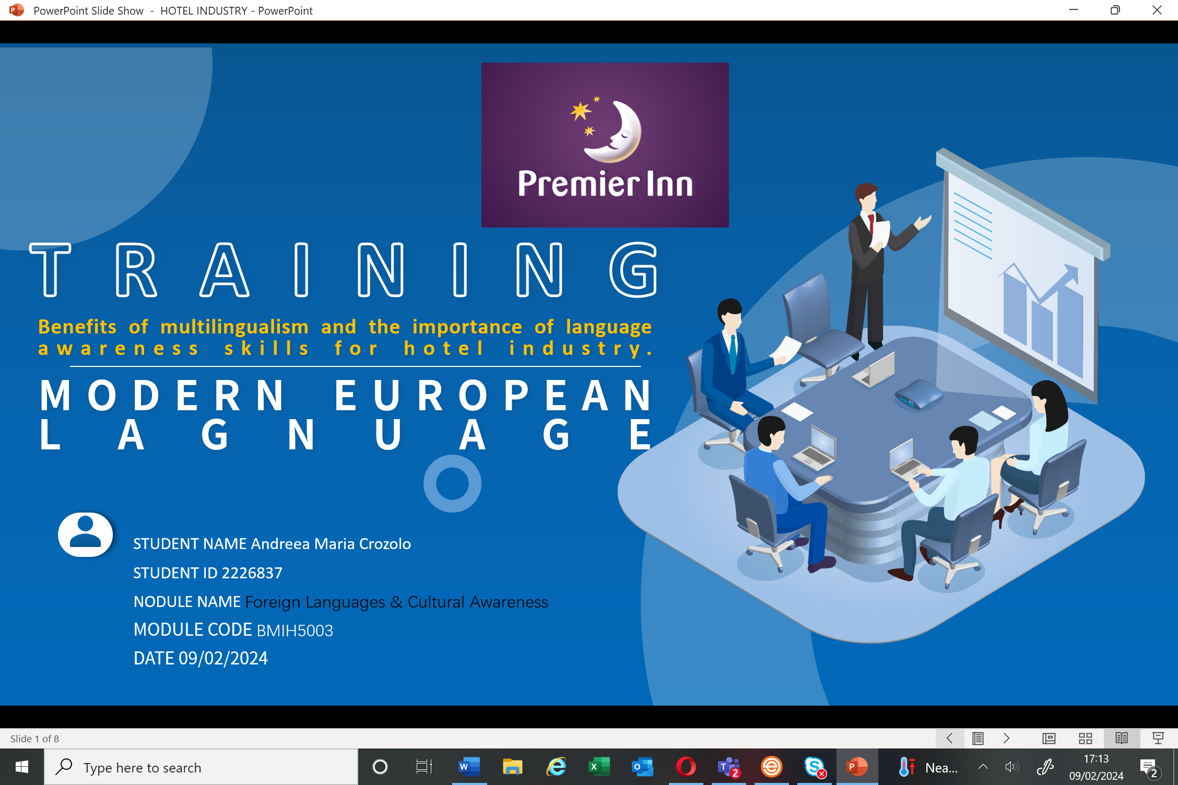
[Content Slide 1]
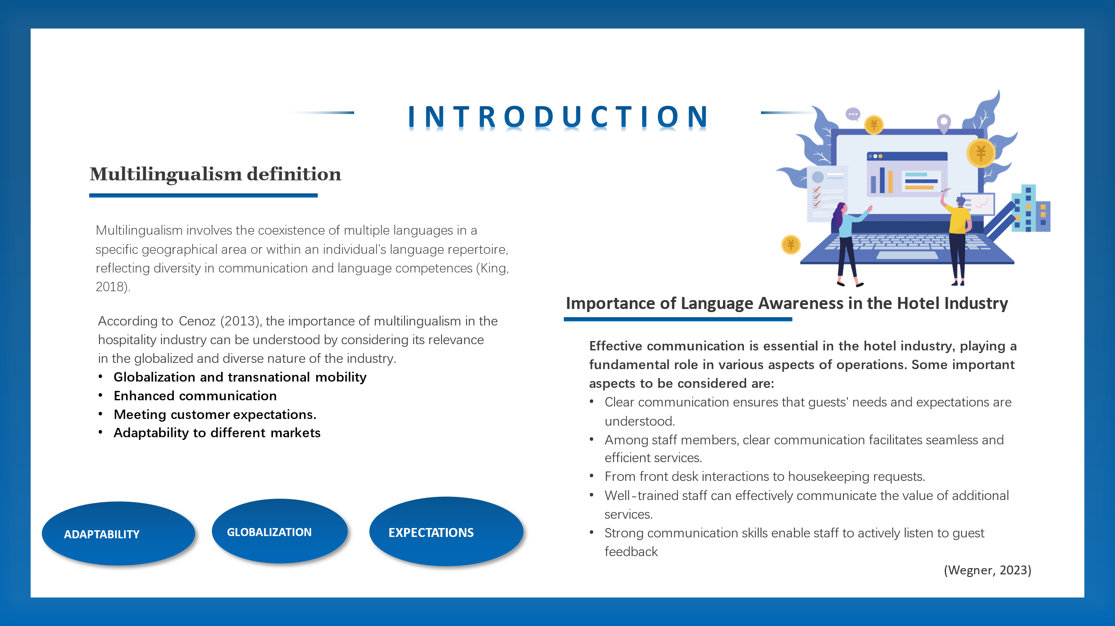

[Content Slide 2]
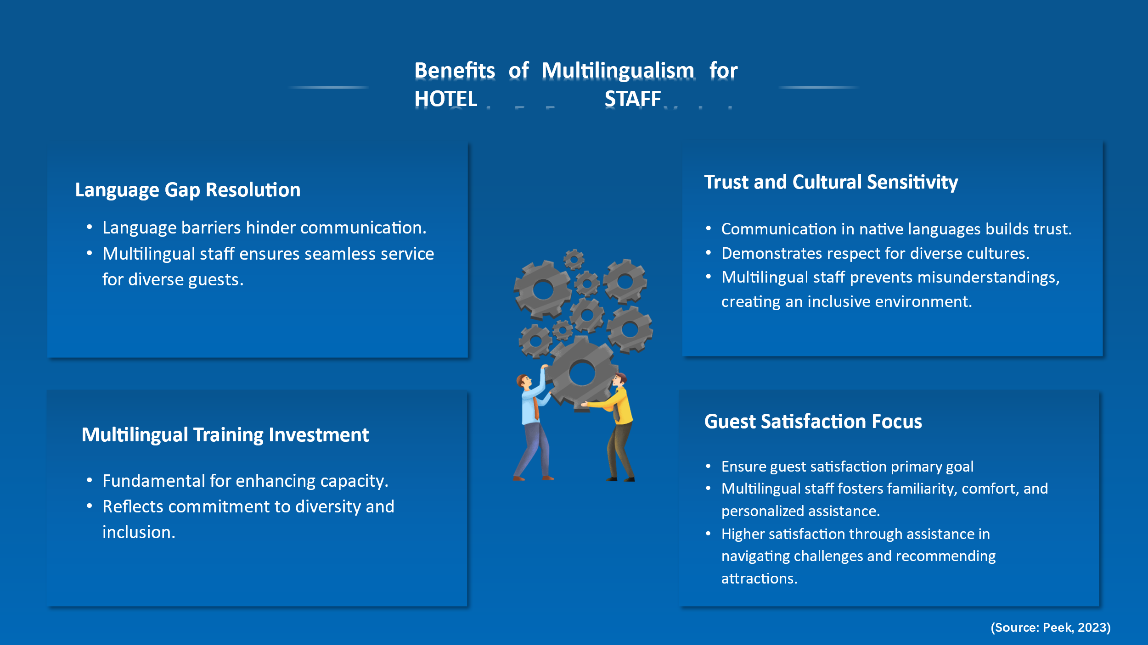

[Content Slide 3]
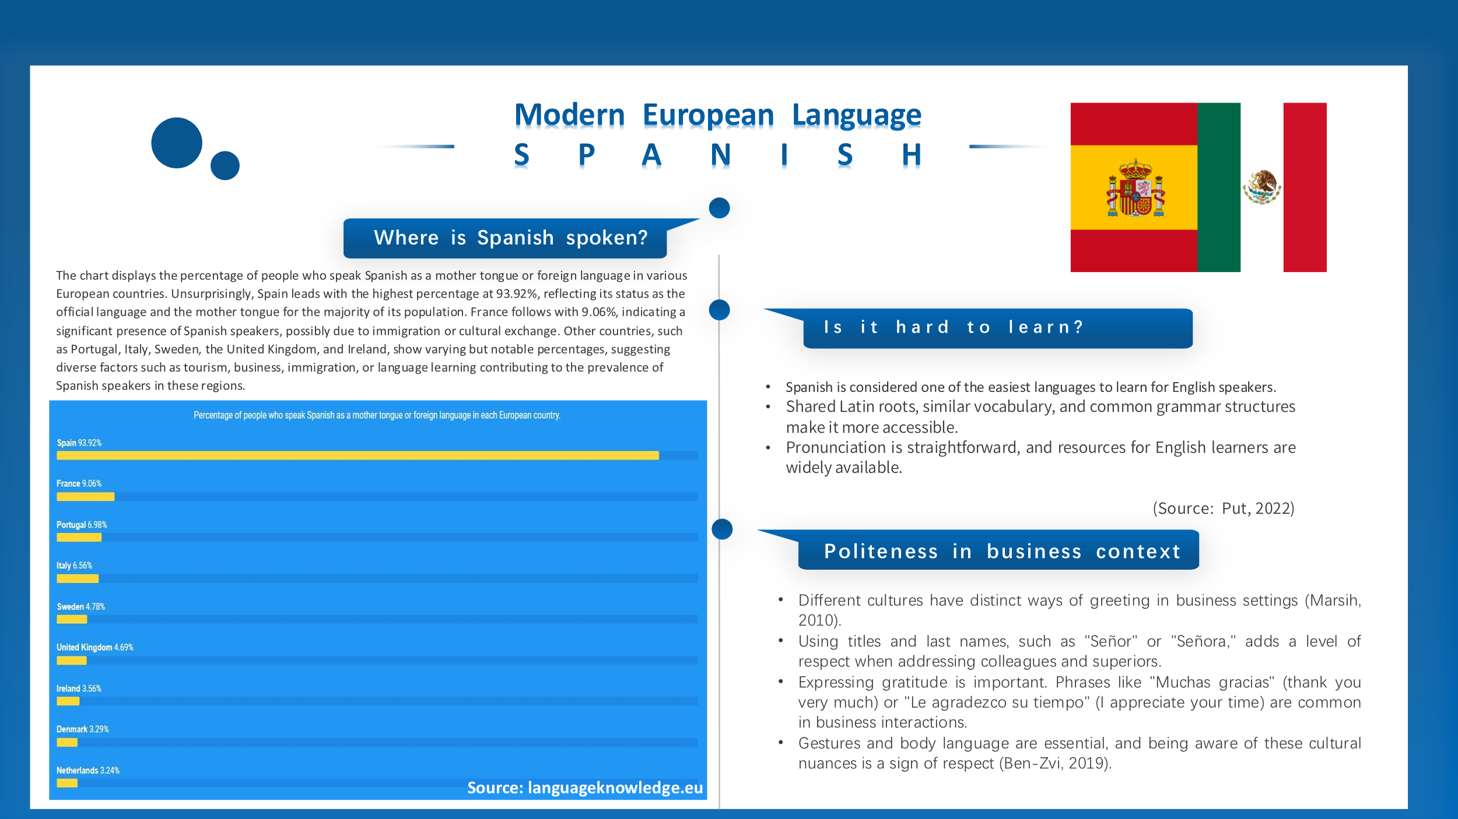
[Content Slide 4]
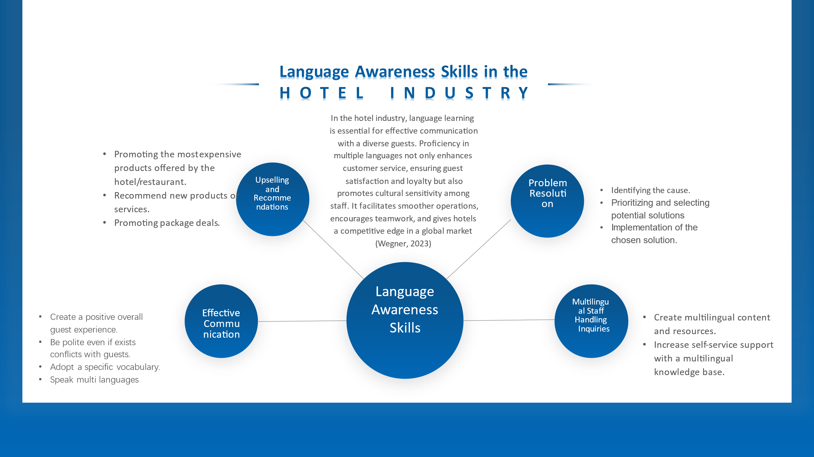
[Content Slide 5]
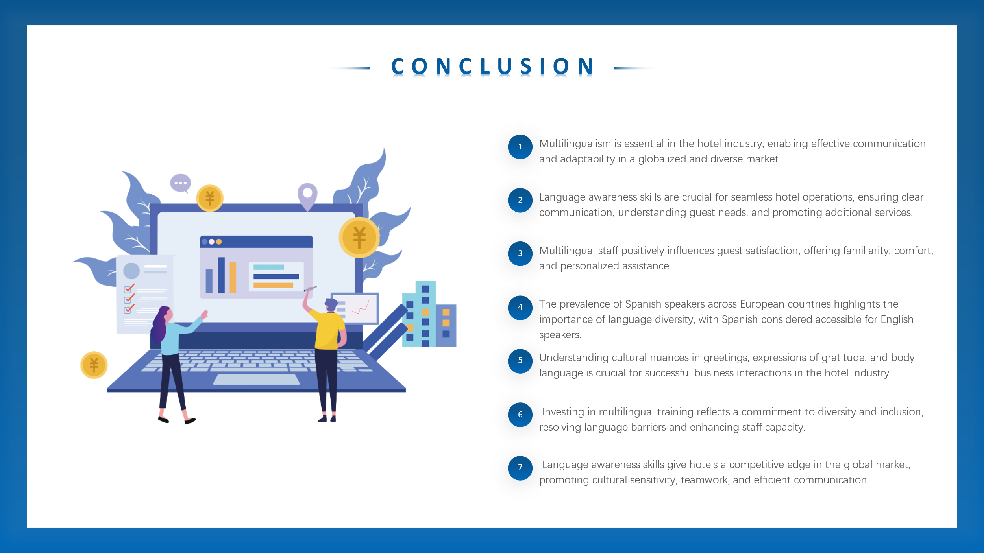
References (no screenshots):
Ben-Zvi, P. (2019) Spanish and Latin American hand gestures, LinkedIn. Available at: https://www.linkedin.com/pulse/spanish-latin-american-hand-gestures-perla-ben-zvi/ (Accessed: 03 February 2024).
Cenoz, J. (2013) Defining Multilingualism, ReseachGate. Available at: DOI:10.1017/S026719051300007X (Accessed: 03 February 2024).
Put, O. (2022) Is Spanish hard to learn? the reasons why it is and it isn’t, Homeschool Spanish Academy. Available at: https://www.spanish.academy/blog/is-spanish-hard-to-learn/#:~:text=No%20matter%20what%20your%20mother,Spanish%20is%20worth%20the%20effort! (Accessed: 03 February 2024).
Kingv, L. (2018) The Impact of Multilingualism on Global Education and Language Learning, The Languages Company. Available at: https://chrome.google.com/webstore/detail/adobe-acrobat-pdf-edit-co/efaidnbmnnnibpcajpcglclefindmkaj?hl=en-GB (Accessed: 03 February 2024).
Wegner, P. by A. (2023) Why language learning is a must in the hotel industry, Babbel for Business. Available at: https://www.babbelforbusiness.com/us/blog/why-babbel-is-a-must-in-the-hotel-amp-hospitality-industry/#:~:text=In%20essence%2C%20improving%20communication%20skills,success%20of%20the%20hotel%20business. (Accessed: 03 February 2024).
Spanish language knowledge in Europeexplore el conocimiento de la lengua española en Europa an interactive visualisation of language knowledge in Europe, based on the latest Europe-wide survey of languages in Europe by the European Commission. click any language to explore how widely it is spoken in each country or click a country to explore which languages are most spoken within in. (no date) Spanish in Europe · Spanish-speaking countries & Spanish language knowledge in Europe. Available at: https://languageknowledge.eu/languages/spanish (Accessed: 03 February 2024).

