Student: Name: Amanze EVA IZUOGU

STUDENT ID: 1814650

COURSE NAME: PSYCHOLOGY IN HEALTH AND SOCIAL CARE.

Lecturer: DR. GULNER ALI

There is different social and biological factor influencing human behaviour. Social roles are of major importance when we are talking about health and social care. Psychological theories help us to understand the metal disorders that can affect a person. Also it can enhance the development of relationship. In health and social care, it can be used as a means to provide a model for understanding the thoughts, sentiment and behaviours. The aim of this essay is to produce a logically organised research, to explain my understanding of psychological theories.
I would focus on the main proceed towards including the developmental stages, behavioural, cognitive developmental theories and psychodynamic theories, in order to understand this behaviour.
Through the use of some elements like psychology and sociology I would be identifying and explaining how to enable these factors maintain the social factors or valued roles in service such as in the health and social care.
What is psychology? A scientific study of human behaviour, either through thoughts and emotions, which can contribute in our understanding of ones self. Especially in the terms of our relationship with other people (Kalish 2010)
As a health and social worker, I spend most of my time when at work, dealing and interacting with other people both in the same profession and to the growing public (service user) in general. The main aim of the job is to promote health and patient well being (GSCC, 2010)
In trying to understand what influences human behaviour; one must be knowledgeable in aspect that we are dealing in contrary with, the lifespan development in order to understand the design of growth, change and stability. The behaviour which happens throughout the duration of life, can compass physical, cognitive, social and personality development (Feldman 2005) Also, the physical development is the lifespan development examining the body’s physical components like the brain, nerves system, muscles and sense. The need to consume food and liquid contents while cognitive development, involves growth and change in human’s capabilities influence person’s behaviour. And lastly, social development is the ability for one to seek understanding, in the way individuals interact with one another, via social relationships, change and remain stable one at a course of time.

Social cognition:-
- The operation involved in perceiving other people and how we come to know about the people in the world around us.
- The study of these mental processes helps us to get involved in perceiving, remembering, thinking, and attending to other people in our society.
- Psychologists are interested in why we attend to certain information in the way we do, especially, about the environment. Example, how information is stored in human’s memory, and how it is then used to interact with other people.
- Many scholars have seen this topic to be wider when researching within social psychology -
- Using a social-cognitive perspective, researchers can study a wide range of topics including attitudes, forming an impression of someone else, harm, physical characteristic, psychology, discrimination, motivation, decision-making, and many other areas.

Development psychology is the study of how and why human beings change over the course of their life (Baltes, Reese, and Lipsitt, 1980). It relates more on infants and children and how the field has expanded in order to include adolescence, and adult development through aging and the entire life span.
I would be discussing the two life span theories which is psychosocial and psychosexual theory of development.
Erikson theory of psychosocial development:-
According to Erik Erikson, he supported that there are eight stages of psychosocial development from the time of infancy to the time of adulthood. He also disagreed that during each stage, the person experiences psychosocial calamity which could have a good or bad end result for personality development. For example in cases where they are unable to identify or establish who their truly are, they become saddened and bewildered.
These can be classified as a psychosocial because it involves the psychological needs of the child that can as a result, dispute of the needs of the society. But despite this fact, a successful achievement of each stage will lead to a healthy manner, resulting to the individual’s typical strengths in which he/she uses to resolve sufficient crises.
Most cases where their has been a lack of success in completion of these stages, will result in unhealthy individuals which might result to wrong measures or decision in living.

Stage 5 age (12-20) adolescence

Identity vs Role Confusion
The teenage mind is fundamentally a temporary psychosocial stage between childhood and adulthood and between the rights and wrongs learned by the child and the morals to be developed by the adult. (Erikson, 1963)

One of the main roles of a teenager is to develop “a sense of” or to be part and parcel of a society.
They seem to ask hypothetical questions like. Who am I? They question themselves through a great investigation of personal values, beliefs and goals, and have been found to be a vital stage in they lives. Through origin, the individual becomes more self-sufficient, they begin to look into the time to come, in terms of developing a career, finding a relationship, having a family or renting a home, in other to play a necessary role in the society.
It is also important to point out that lack of success to establish a sense of identity within the society can lead to role confusion.
Role confusion evolves when the individual is not sure about him/her-self or their place in a given society.
An individual leaves in total separation from the rest of his family or group of peers. Also the idea of pressurising an individual into an identity crisis, can lead to trouble, and may result to creating an empty space in the person’s life. Another representative example can be if a child who has been pressurized by his parents into studying to become a pharmaceutical doctor, but has little or no interest. This can cause devastation in the life of the child and as a result can cause either a major set back or create a negative identity which will lead to sorrow.

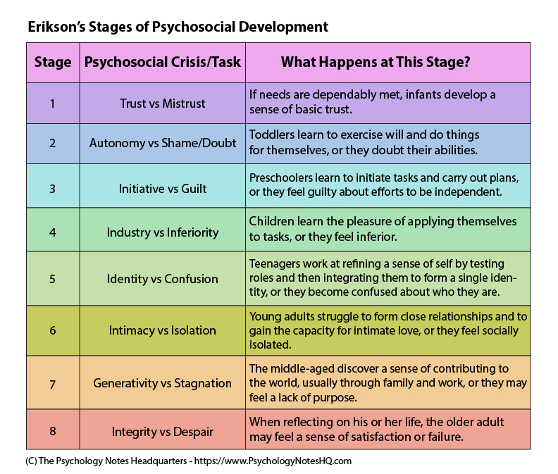

Critical thinking
Through extending the belief of originality development through birth to adulthood, Erikson’s outlines a real and more practical picture (Mc Adams 2001) this goes to show that what Erickson’s theory was implied is takes the period of the life stage in which it goes from the first to the middle and the last stage. And as the time the adult is in the last stage, development is reached which as a result, shows there are considered to be active and can carter for themselves.

Psychosexual theory of development
In 1856-1939, Sigmund Freud became one of the psychology men to study human motivation. He believed that mental illness was a result of essence around our surrounding, not what we were born with. Our needs help motivate us as human beings and the way we behave towards obtaining food, shelter, clothing, drives us to act in a setting way.

The behaviour of a human being in sexual issues is often an auto mobile in which other parts of the whole body manner reacts in life. (Sigmund Freund)

Freud believes there are conflict between the id, your natural instinct and super-ego (the moral principle or what societies condone) and your ego (the reality principle or what you end up doing.)

Genital puberty on- This is the last stage in Freud’s psychosexual theory of individual development, and it starts in puberty period. It is mostly the time of adolescent sexual experiments, the time in which the individual engages him/herself, in a loving one to one encounter with another person who is normally in their 20s. And its normally through heterosexual pleasure rather than phallic stage.

Freud’s Diagram
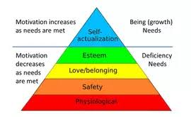

Maslow’s hierarchy of human needs, (from Maslow) (1970)

The psychological factors which influence human behaviour throughout the life span & how their apply to health and social setting.
Literally everybody has psychological needs such as being accepted, to aspire, be grateful, dependant and be supportive. And these psychological needs impacts the way in which human at or carry themselves. Similarly, the psychological illness such as depression and anxiety affects human behaviour. The physical disabilities are also accompanied with psychological irregularity such as inferior status which also affects human behaviour.

Mental health problem affects about one out ten (mental health foundation 2019) children and young people, this include depression, anxiety and conduct disorder, and are often a direct response to what is happening in their lives.
Causes of mental health in children
- Depression- Teenagers are more likely to experience depression if at the early stage in life their struggle to identify who they are.
- Self harm- this is a very common problem among young people some people feel ok after harming themselves, through cutting and burning in order to feel better, they might not wish to take their own life,

- Eating Disorder- This usually occurs in the teenagers early years and is widely common in girls than boys. Eating disorder can have serious consequences for their physical health and development.

Alarmingly, 70% of children and adolescence who experience mental health problem have not had appropriate interventions at a sufficiently early age.

The emotional well being of a child is just as important as their physical health. Good mental health allows children and young adolescence to develop the resilience to cope with whatsoever life throws at them and grow into well rounded and healthy adults.

There are a number of things that can help keep children and young teenagers mentally well, these include:-

- Being in good body condition and physical health -eating a balanced diet and getting regular exercise.

- Having time and the leisure - to play indoors and outdoors.

- Being part of a family that gets along well most of the time and engage in family activities together.

- Going to a school that looks after the welfare of all its students.

There are other ways one can get involve, by taking part in local activities for young people.
Other factors that are important includes-

- feeling appreciated , trusted, being understood, valued and accepted for who you are.
- Being interested in life and having opportunities to enjoy themselves.
- being hopeful and optimistic
- being able to learn and have opportunity to succeed
- They feel to have some control over they own life.

Thesis statement:
Erikson’s theory provides a framework for understanding human behaviour especially from a young age, through thought, and development. His theory helps us understand ourselves and others better and as well knowing how communicate effectively.
Freud’s theory is focused on the male development with little mention of the female’s psychosexual development. Furthermore, his theories were found to be too difficult to test scientifically. Freud’s theory good at explaining but not good in foreseeing the behaviour which is the main issues when it comes to theory related, which makes it not to be scientific enough.

Conclusion
In my opinion, I believe the two theories are both useful in our daily lives, and depending on which angle you view it from. Some are inspired and influenced by Freud, and went on to expand upon Freud's ideas and develop theories of their own, and where successful, according to a recent surveys. On the contrary, Erik Erikson's ideas have become perhaps the best known and applied in today’s world.
Erikson's eight-stage theory of psychosocial development describes growth and change throughout the lifespan, focusing on social interaction and conflicts that arise during different stages of development, and also expands narrates the stages we pass through from the early stage to the adulthood stage when the adult can now verge for him/her self.

References
Clifton, A, Davis, D, (1995) Psychosocial theory: Erikson, retrieved January 28, 2008

From Haverford university, department of psychology website:

http//www.haverford.edu/psych/ddavis/p109g/erikson.stage.html

Erikson, E.H (1950) childhood and society, New York: google scholar

Erickson E.H (1959) Identity and the life cycle New York: international university press. Stevens, R. (1983) Erik Erikson: An introduction New York, St Martins.
(Mental health 2019) cited.

